https://www.foxla.com/news/undercover-video-reveals-brutal-treatment-of-falun-gong-prisoners-inside-chinese-labor-camps
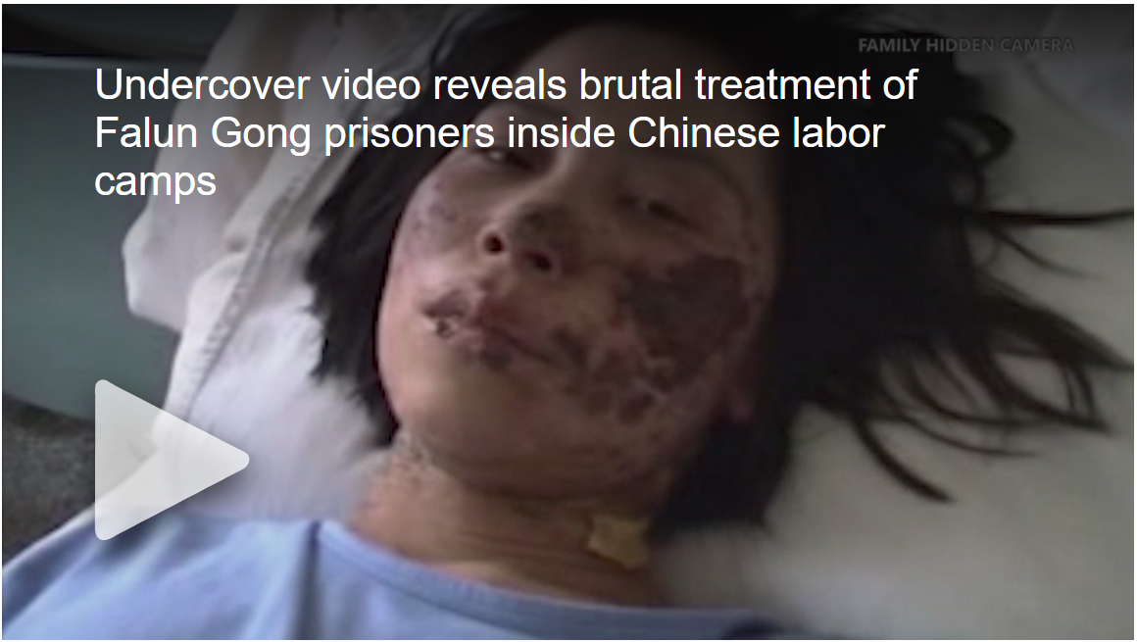
By Bill Melugin, FOX 11 Published May 24, 2019 California FOX 11 Los Angeles

Undercover video reveals brutal treatment of Falun Gong prisoners inside Chinese labor camps

A California family is taking their fight to the Chinese government after they say their loved one was tortured and killed inside of a Chinese labor camp nearly 20 years ago, simply for supporting the spiritual meditation practice known as Falun Gong. Now, never before seen undercover video given to FOX11 is revealing what life is like for political prisoners inside of those Chinese labor camps.
In 1999, the Chinese government ordered the eradication Falun Gong, calling ita "heretical" organization that threatened social stability.
The communist government began arresting and imprisoning hundreds of thousands of Falun Gong practitioners and shipped them to labor camps where they were to be "re-educated".
Video from Tiananmen square in 2001 reveals hundreds of Falun Gong supporters being arrested by government entities.
Yifei Wang was there with her sister that day. She's a former journalist for the Chinese communist party, now living in California after fleeing her home country.
Wang and her sister were holding signs in support of Falun Gong. Both were arrested, separated, and imprisoned for doing so.
Yifei was eventually released thanks to a sympathetic guard, but her sister, Kefei, never made it out. After four months spent in a Chinese labor camp, her family was told Kefei died of a heart attack. But after seeing her condition at the hospital, they allege she was tortured to death. Now, almost 20 years later, they believe her body is still being held by the labor camp.
In 2015, Yifei's husband, Gordon, traveled to China, and visited the Jilin women’s labor camp where Kefei died. There, he filmed undercover video, and waited an hour and a half with other family to meet with the new labor camp director.
"It's been 15 years and we haven't seen it, we just want to see the body," a family member said. "We want to know if it's still here, we write every year to request to see the body."
"It's still here," the director replies. "We pay the morgue fees every year, I sign for it every year, every six months."
During the course of the conversation, the director says the family can't see the body.
"You want to see the body, I can do that, if you agree she died naturally," the director says.
"You don't have proof it was natural," the family replies. "To put it simply, director, she didn't die of normal causes!"
The family ended up leaving the camp empty handed, but Gordon tells FOX 11, he’ll never stop trying.
"I wanted to get the truth out about Kefei's death," he said. "And I wanted to get her body released. I want to be able to give testimony about the things that happened to my family. The government doesn't follow any laws. I will never give up to get her body back."
The ordeal has been a burden on Yifei and the family over the years. At the very mention of Kefei, she begins to sob.
"I can't even think about her, because when I do, it always breaks my heart, “she said. "I think about when we were young and would play together, she was a brilliant girl."
Ming Yu is a friend of the family who was also imprisoned for supporting Falun Gong.
"I was a very successful businessman, I had a clothing factory, I employed over100 people, but after the persecution began, I lost my business," he said.
Yu told FOX 11 he was able to shoot undercover video at a labor camp he was imprisoned at by bribing a guard.
He says he filmed it at a notorious labor camp during the 2008 Beijing Olympics, alleging it shows Falun Gong practitioners being forced to work extremely long hours to make products sold all over the world.
Yu says the workers were given no breaks, and some were so exhausted they fell asleep under the tables they were working on. He also filed video of a Falun Gong practitioner he says was severely injured by guards at the camp. The man is shackled to his bed, and underweight, with lesions on his skin.
"If you're ever caught doing this kind of thing, videotaping the details of what’s happening in these camps, you would lose your life," he said. "The Chinese Communist party has a quota of people to be killed, and I am one of the."
Yu also used hidden cameras designed as different products, including car keys and a watch, to film other videos.
One was of a dying man shackled to his hospital bed. Yu says the man was incarcerated for supporting Falun Gong and was beaten and tortured until he had a stroke. He died in a vegetative state, shackled to his bed, as his wife wept over him.
"These are people who are just trying to live," said Kay Rubacek.
Rubacek is a producer with Swoop Films. The company is making a documentary called Finding Courage, which documents the government persecution of Falun Gong, and the family's struggle to get Kefei's body back.
"This is not someone who died of a heart attack,' Rubacek said. "We're talking about brutal torture, and for what? For standing up for freedom of belief, something we take for granted.
In Los Angeles, local Falun Gong practitioners rallied to call for the end of the persecution, some holding photos of those who are dead or imprisoned at the hands of the Chinese government.
And in New York City just last week, nearly 10,000 Falun Gong practitioners marched to also call for an end to the persecution, some held signs saying “Free Sister's Body", a reference to the remains of Kefei Wang.
"A heart attack on a 30-year-old woman is of course the typical like you get from totalitarian regimes," said Shawn Steel.
Steel serves as Republican National Committeeman of California. His wife is Orange County Supervisor Michelle Steel, whose family fled their own brutal regime in North Korea.
"We're talking about China, talking about them being an adversary for the 21stcentury, you've gotta talk about their human rights record," Steel said.
And according to Amnesty International, that record is amongst the worst.
"Amnesty International has documented severe and widespread human rights violations against Falun Gong practitioners," said Francisco Bencosme, Asia Advocacy Manager for Amnesty International. "We have documented cases of torture, inhumane practices, lack of freedom of expression, and unfortunately they’re sort of out of sight, out of mind."
"It's unbelievable, It's almost too much for television," Steel said. "But it's such an important story, because there's millions of people involved, but it's also personal, it's Los Angeles, it's California, it's what people in this state have been living with for years and finally the story is getting out. If we put a spotlight on it, maybe we can actually help save the lives of many people we don’t even know."
Steel told FOX 11 he will be reaching out to the Trump administration regarding this issue, and plans to make a presentation about the persecution of Falun Gong at the Republican National Committee next spring.
A request for comment left with the Chinese embassy in Washington D.C. was not returned.

