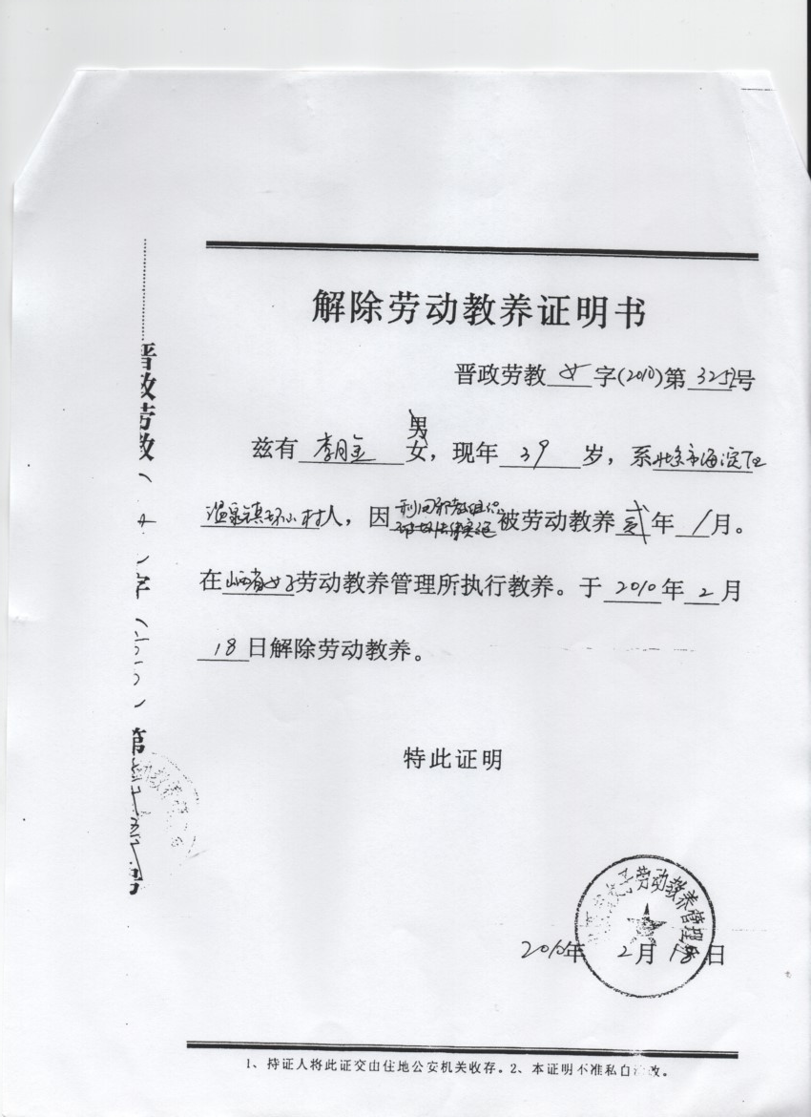
Letter stating the end of re-education through labor for Li Yuejin, dated 02/18/2010

