Analysis and Design of Resource Manager for Transport Module

Preface
We wanna design a graphic resource manager for the transport module. In transport module, the resource means: drivers, vehicles, trailers, prime-movers within a certain duration of time. Manage means to browse how much resource the company has got, or to add in new resource, or to set resource to un-available to prevent it from been used. This feature is designed for the planners.

Requirement Analysis
- The user interface should be friendly, intuitive and resourceful. Use graphics instead of text to present information.
- The program should be able to display two dimensions: Date and Resource.
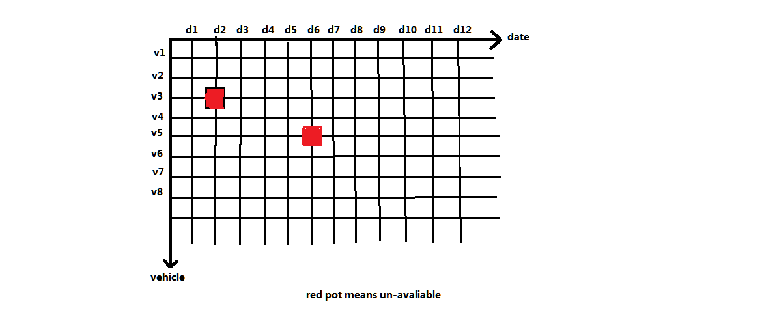
  - As the image above shows, one dimension is date, the other is one kind of resource, the vehicle. The color of the coordinate presents the availability of a vehicle at a certain date
  - The planner can change the second dimension vehicle to driver
  - The planner can combine two kinds of resource as the second dimension, meaning one dimension is date, the other is vehicle AND its default driver. The availability is: vehicle.IsAvailable && driver.IsAvailable
- The program allows the planner to click on the two dimension diagram to modify the availability.

Design
- We make use of the 3rd-party controls: XtraScheduler of DevExpress.
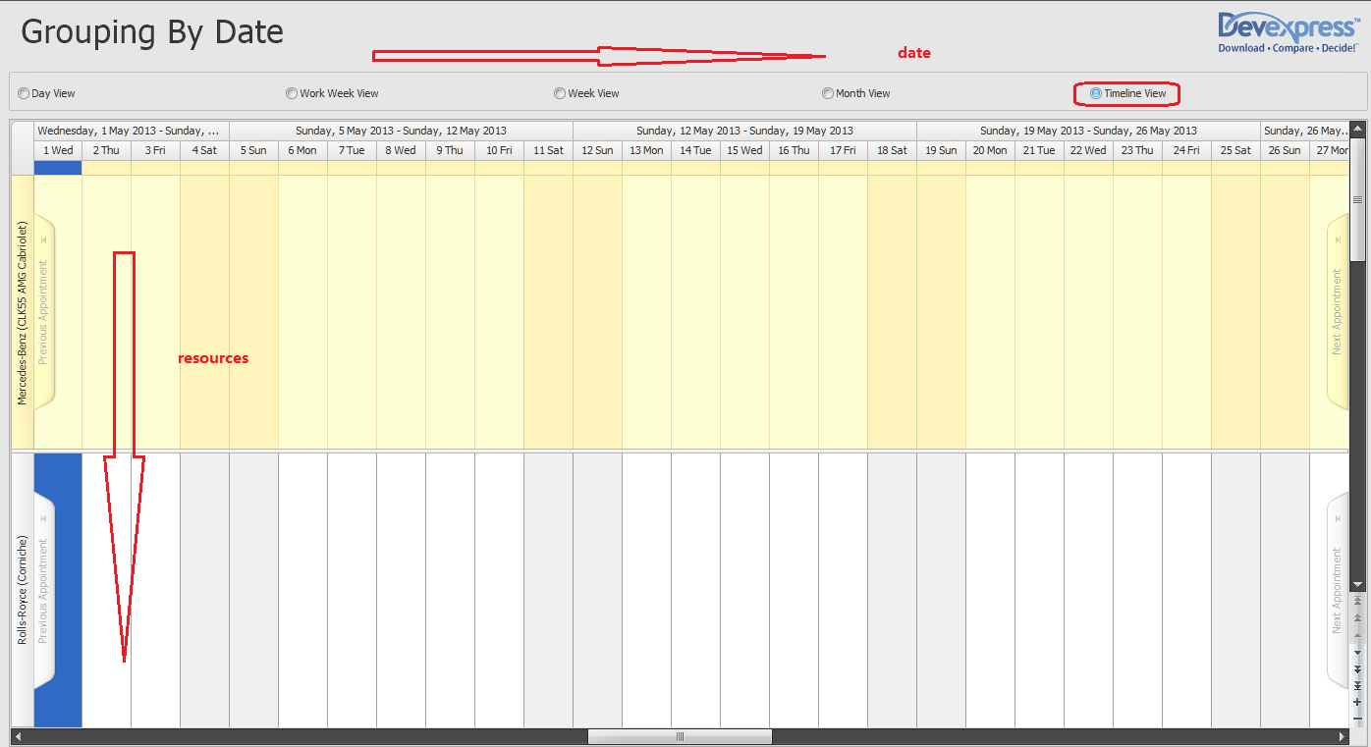
  - As the image shown above, the "TimeLine" view of a scheduer is just what we want. The horizontal dimension is date, the vertical dimension is a kind of resource.
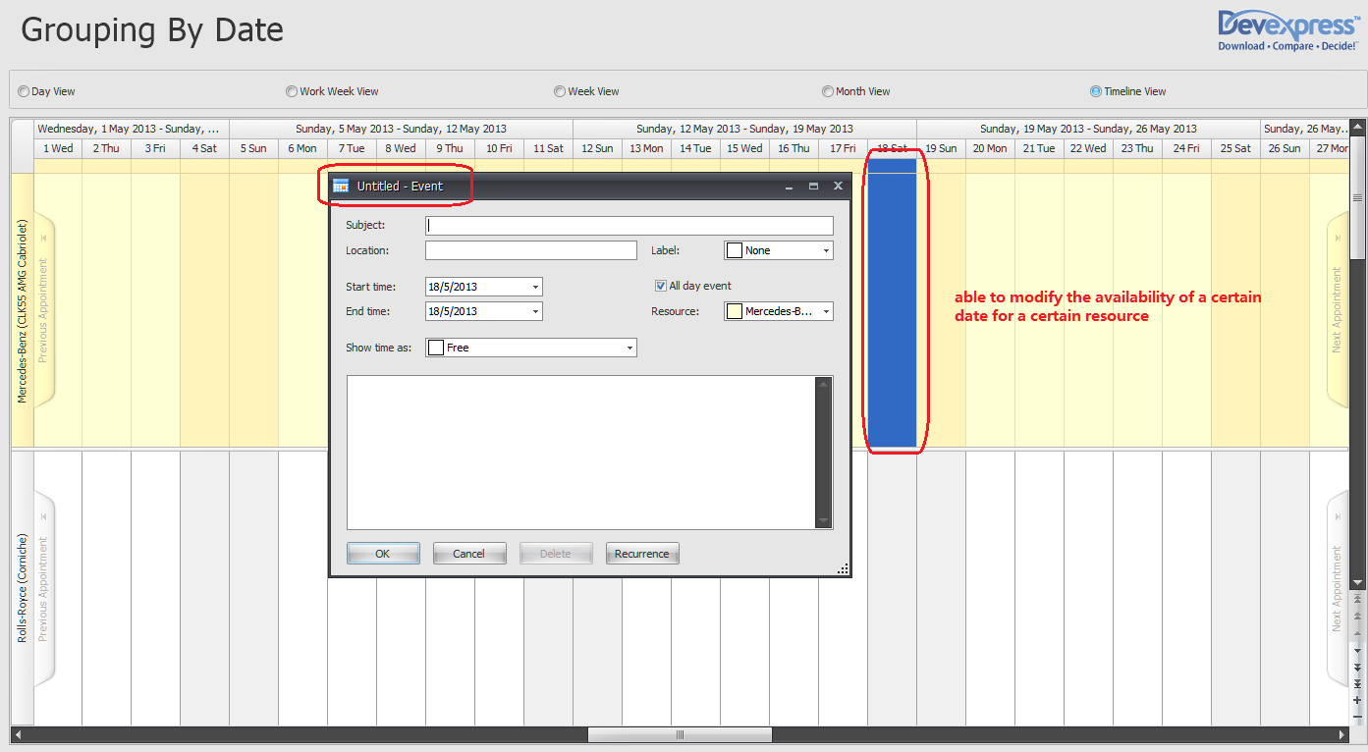
  - As the image shown above, we can also edit the availability a certain date for a resource.
  - We can use this "TimeLine" view to manage driver, vehicle, trailer, prime moviers separately.
  - We can combine two kind of related resource into one resource. For example, in our existing codes, the driver class contains a default vehicle(but it's only a vehicle number, not a whole vehicle object), then this driver class is a combined resource. It is available only when the driver and the vehicle are available. Otherwise, we mark a different color to it. The planner then can see clearly for a whole week / month, how much resource he has got.

Summary
As this "TimeLine" view is already there, we only make use of it in a very basic way, I think it won't be so hard to implement the requirements. I'm creating a demo right now, and will send you the updates.

