

FREIGHT MASTER 7.2

SUPPORT MANUAL

TRANSPORT HAULAGE

Prepared by :

Innosys Pte Ltd
10 Ubi Crescent, #06-01

Singapore

Dec 2009

CONTENTS

- Introduction

- Definitions

- Marketing

- Booking of Jobs

- Planning

- Invoicing

- Setup

  - Transport Special Data
  - Driver
  - Driver Incentive
  - Vehicle
  - Charge
  - Department

- Introduction

This manual is to enable internal support staff to support customers on this module.

  - Transport Haulage has 4 main major functions, and is covered in sections 2 through 5.

- Marketing
- Booking of Jobs
- Planning
- Invoicing

  - The setup of the following is required and is covered in section 6

    - Transport Special Data
    - Driver
    - Driver Incentives
    - Vehicle
    - Transport Department
    - Charge

  - The program exes and dlls are covered in section 7

- Definitions

  - Job - A job is a customer request for a transport service

  - Stop – A stop is a location

  - Job Type – There are 3 available
    - HLLO – Local jobs
    - HLSI – Sea import
    - HLSE – Sea Export

  - Job Trip – is a trip requiring a prime mover and a trailer. There are several types of job trips
    - Single Leg e.g. a request to send an empty container from port to container yard
    - Two-Leg e.g. a HLSI job requires 1 job trip from port to a stop to un-stuff. Following this, the empty container has to be sent to the container yard. The 1st part is the 1st Leg, and the 2nd part is the 2nd Leg

  - Plan Date – The date for scheduling job trips

  - Plan Trip – A plan trip is the schedule for 1 specific driver, and consists of one or more sub plan trips.

  - Sub Plan Trip – A sub plan trip is an instruction to send a container (and sometimes 2) from 1 stop to another. Each sub plan strip must have 1 or 2 job trips

  - Job Trip Status. There are 4:

    - Booked – the state when a job trip is added to a job
    - Ready – the state when a job trip is ready to be included in a Plan Trip
    - Assigned – the state then a job trip has been assigned a driver in a Plan Sub Trip
    - Complete – the state when a job trip has been completed

  - TrailerLocation – This refers to a specific trailer AND a specific location. TrailerLocations are needed to track the locations where a trailer was located and to which driver the trailer was assigned.

  - TrailerLocation status. There are 5

    - Trailer Park – trailer is parked. The stop at which the trailer is has to be specified
    - Assigned – Trailer is assigned to a driver, in a sub plan trip
    - Stuff – The trailer has a container being stuffed. The stop must be specified
    - Unstuff –The trailer has a container being unstuffed. The stop must be specified
    - Unavailable –The trailer is unavailable

k. Charge – This is a service e.g. container movement for a particular container type, processing of permits

- Marketing

  - This is the marketing form – Master tab - in Add mode

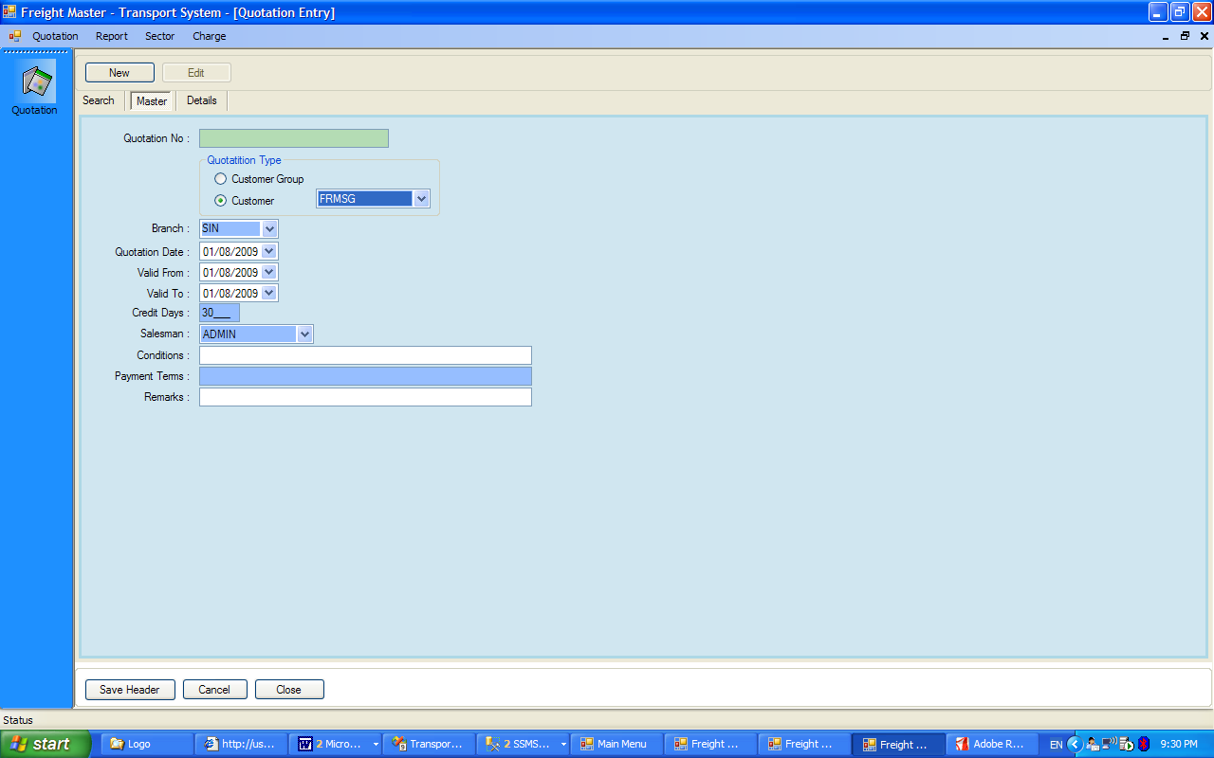

- 1 customer can have only 1 quotation for the same validity period
- The quotation number is auto-generated by the system – the next running number is taken from the table TPT_SPECIAL_DATA
- The running number is in the following format TRXXXXXYYMMNNNNN where
  - TR refers to Transport application
  - XXXXX is the customer code
  - YY = Year
  - MM = Month
  - NNNNN = running number
- The master has to be saved first before keying into the “Details” tab
- If the master is saved, but not details are added, the master will be deleted, with a warning message i.e. no header will be saved without details
- Please note that the “Customer Group” option is currently not available.

  - This is the Details tab

- Each of the Charge, must be created in the Sales Cost Item in FM System
- Additionally, the charge has to be also created in the Charge maintenance. The reason is that we need to distinguish Transport movement charges (e.g. container movement) from others (e.g. permits), and we do not want to change the FM existing table.

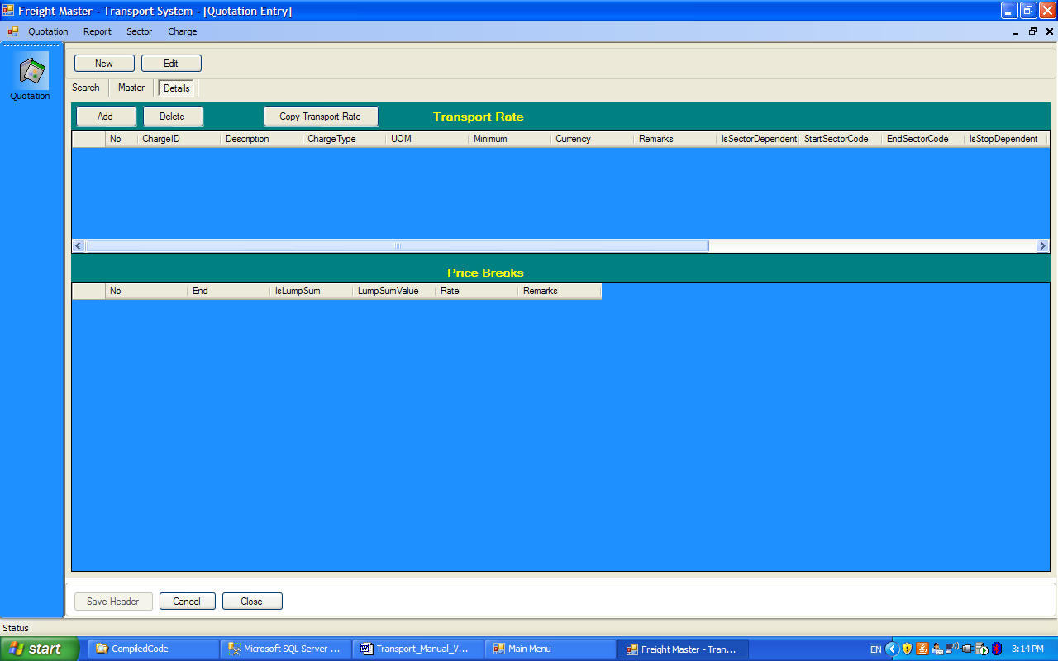

- If the Add button is pressed, the Rate Header is shown first. For each Rate Header, 1 price break (for Charge Type = R) or several price breaks (for charge Type = M) may be added
- Note that the panel “None, Sector Related, Stop Related” has not been implemented and has been disabled. This feature is for a future version.
- The “Copy Transport Rate” allows the user to copy all the rates from an existing quotation. This is useful if a user wishes to amend an existing quotation. The program does not allow existing quotations to be deleted as they may already have been used in Booking.

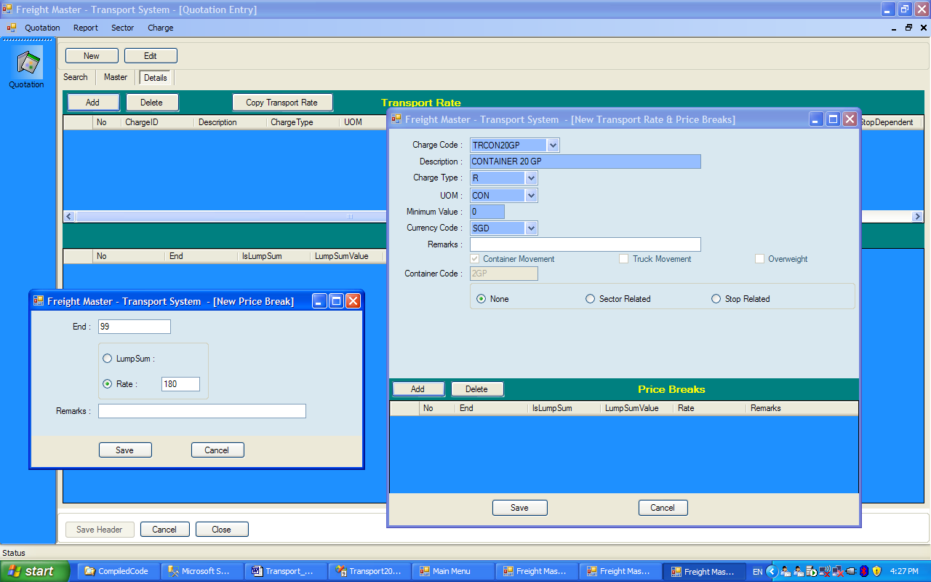

- The screen below shows 4 Charges. For the 1st one, TRCON4GP, which is of type R, there is only 1 price break, and the unit amount = 200 per CON

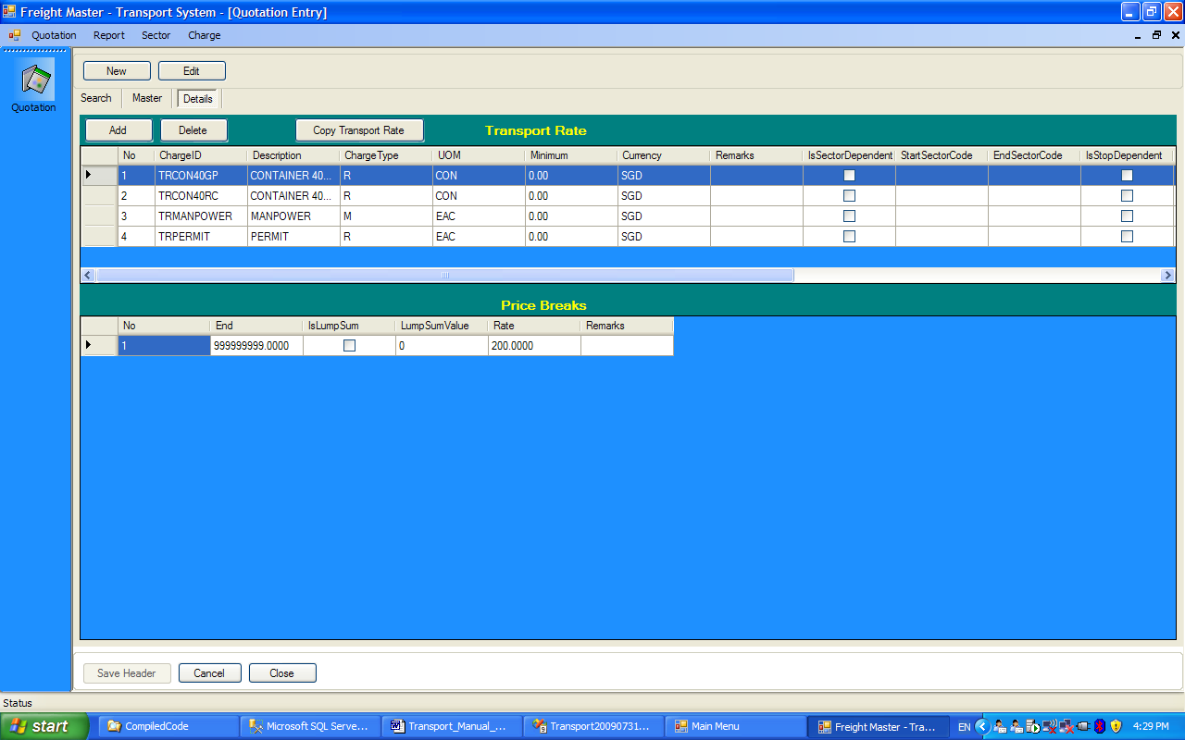

- The screen below shows 4 Charges. For the 3rd one, TRMANPOWER , which is of type M, there are 3 price breaks

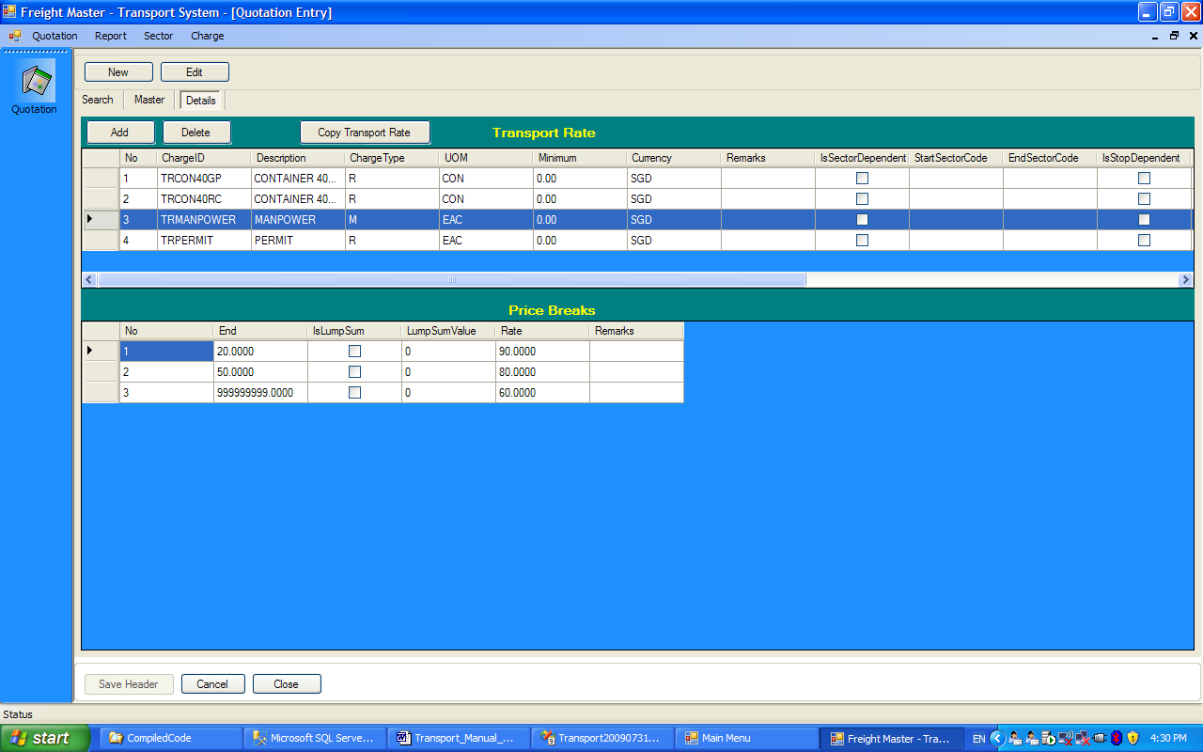

- There are 2 charge Types used
  - R, where the Amount = Unit Rate x amount, without any price breaks. A minimum is allowed.
  - M, where the multiple price breaks. A minimum is allowed
  - Effectively, R type has only 1 price break
- The following are examples of how this will be calculated.
  - R charge Type – for this type, only 1 price break is allowed.
    - Minimum = SGD 100
    - Unit Rate = 50
    - Example 1
      - Qty = 1
      - Amount = 1 x 50 is less than minimum, therefore amount = 100
    - Example 2
      - Qty = 3
      - Amount = 3 x 50 = 150
  - M Charge Type
    - Minimum = SGD 100
    - 1st price break
      - For qty, 0 to 20, unit rate = 4
      - For qty 21 to 50, unit rate = 3
      - Above 50, unit rate = 2
    - Example 1
      - Qty = 19, then amount = 100, since 19 x 4 < 100
    - Example 2
      - Qty = 25
        - 1st price break = 20 x 4 = 80
        - 2nd price break = 5 x 3 = 15
        - Amount = 100, since 95 < 100
    - Example 3
      - Qty = 40
        - 1st price break = 20 x 4 = 80
        - 2nd price break = 20 x 3 = 60
        - Amount = 140, as this exceeds minimum
  - M Charge Type
    - Minimum = 0
    - 1st price break, 0 to 20
      - LumpSum = 150
    - 2nd price break, 21 to 40
      - LumpSum = 100
    - 3rd price break, above 40
      - Unit price = 3
    - Examples
      - Qty = 15, Amount = 150
      - Qty = 25, Amount = 150 + 100
      - Qty = 45, Amount = 150 + 100 + (5 x 3)

- Booking

The program can create new jobs or import them from SE or SI.

  - New Transport Jobs

- The form below shows the main info tab
- Job Type
  - HLSI – Haulage Sea Import
  - HLSE – Haulage Sea Export
  - HLLO – Haulage Local
- Quotation panel
  - No quotation – then user has to enter rates in the “Services Required tab” and “Charge Items” tan
  - Customer – this is a quotation, for only that customer. 1 customer has only 1 valid quotation for a validity period. This is controlled within marketing
  - Customer Group – this is not a valid version for this version.
- The header (Main info and Additional Info tabs) must be saved first

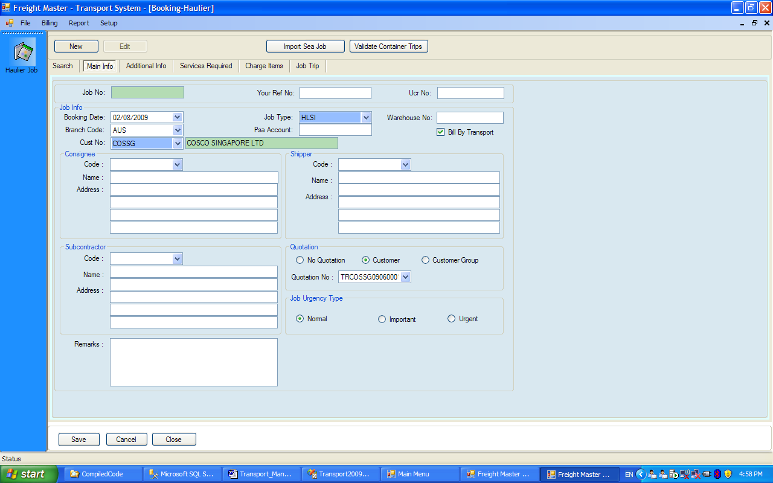

- This is the Additional Info tab, and is optional

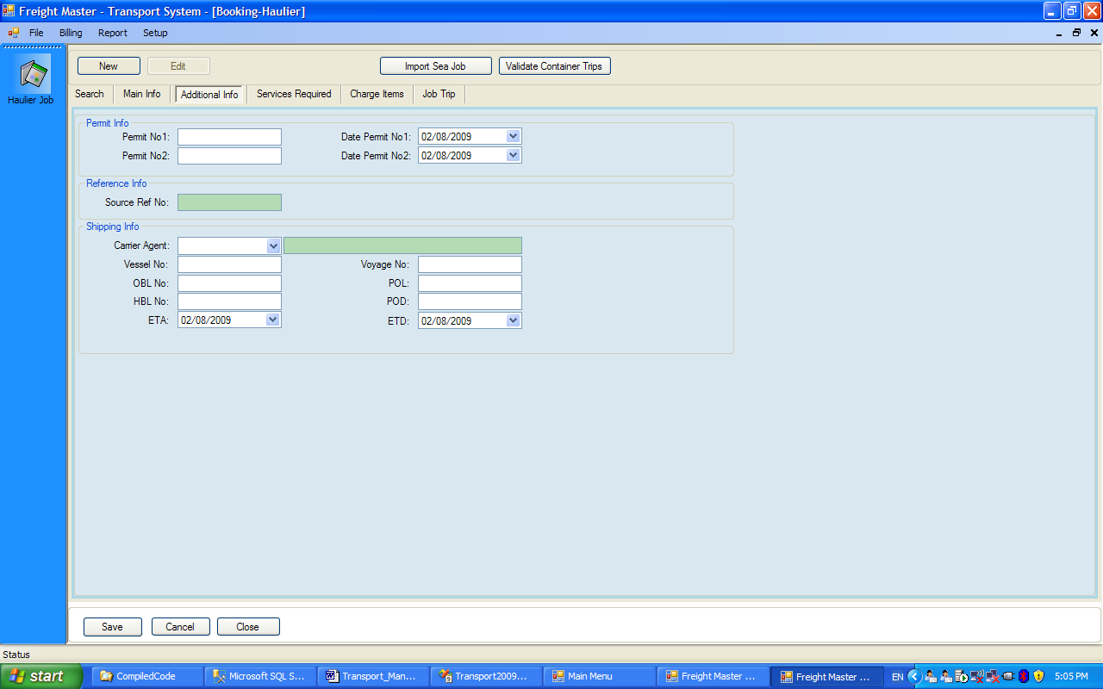

- Next the “Services Required” tab is keyed in. The form below shows the dialog form, when “Add” is pressed. If there is a valid quotation, and “Quotation” is selected, the drop down box will show only the valid charge codes. Note that the program calculates the actual amount. The unit rate is read only. User can associate a container number to a charge code.

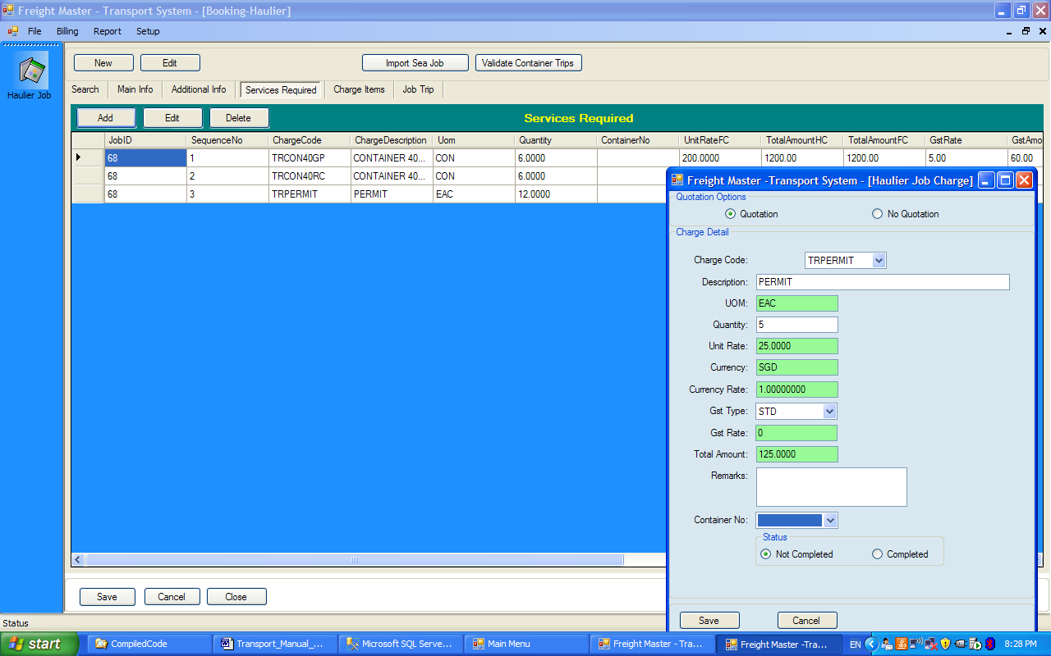

- The “Charge Item” tab is used to key in actual charges incurred on above of the customer. This tab and the “Services Required” tab share the same table. The “Services Required” tab is to key in services asked for in this job, while the “Charge Item” tab is used to key in actual unanticipated charges, paid on behalf of the customer

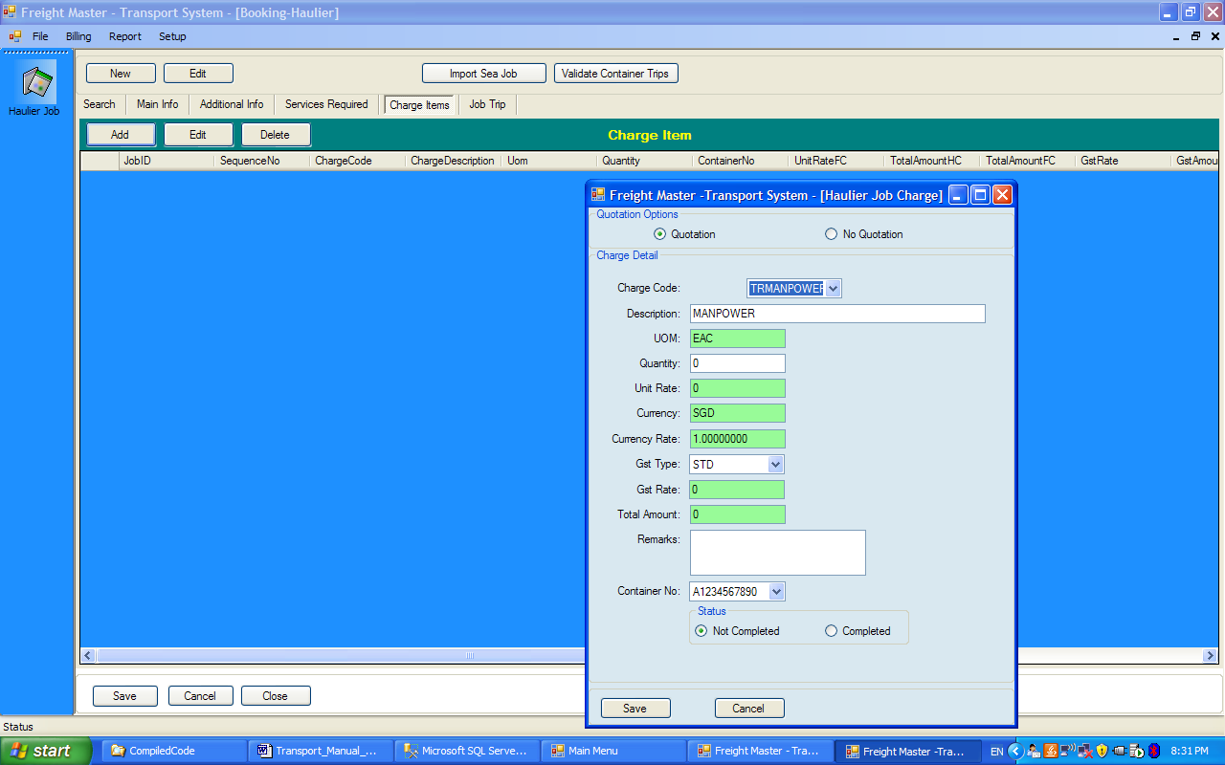

- Lastly the Job trip tab, shown below is used to key in container trips

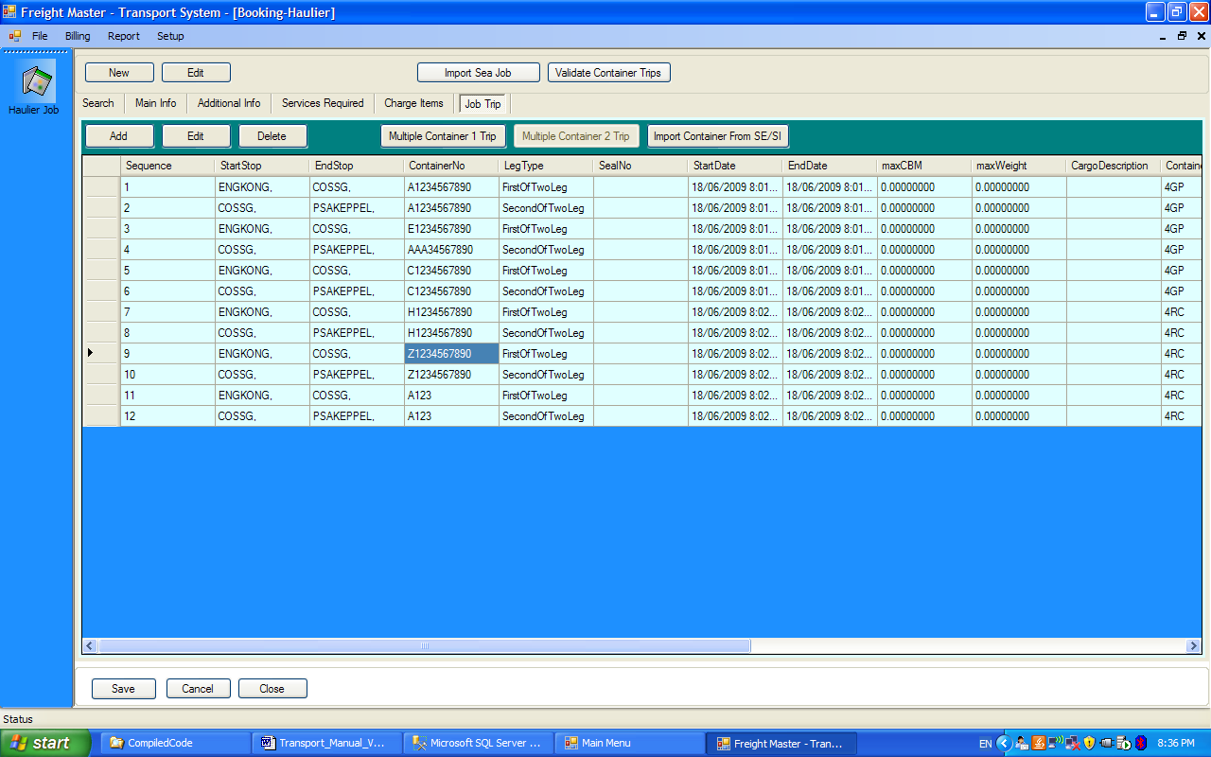

- A Job trip can be either a 2 leg or 1 leg. For a loaded container for import or export, there are typically 2 legs.
  - Import – Port to Customer to Container Yard
  - Export – Container Yard to Customer to Port

However there could be 1-leg trips, e.g. export of empty containers, from container yard to port

- To simplify the entry, 2 buttons, “Multiple Container 2 Leg” and “Multiple Container 1 Leg” buttons are provided so that the user need not repeat the information where 1 job require several containers.

- Shown below is the dialog form for a Multiple containers for a 2 leg trip

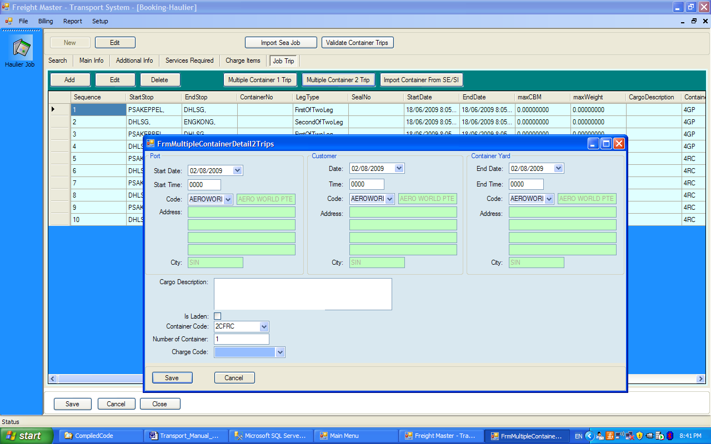

- Below is the form for a multiple containers for 1 leg trip

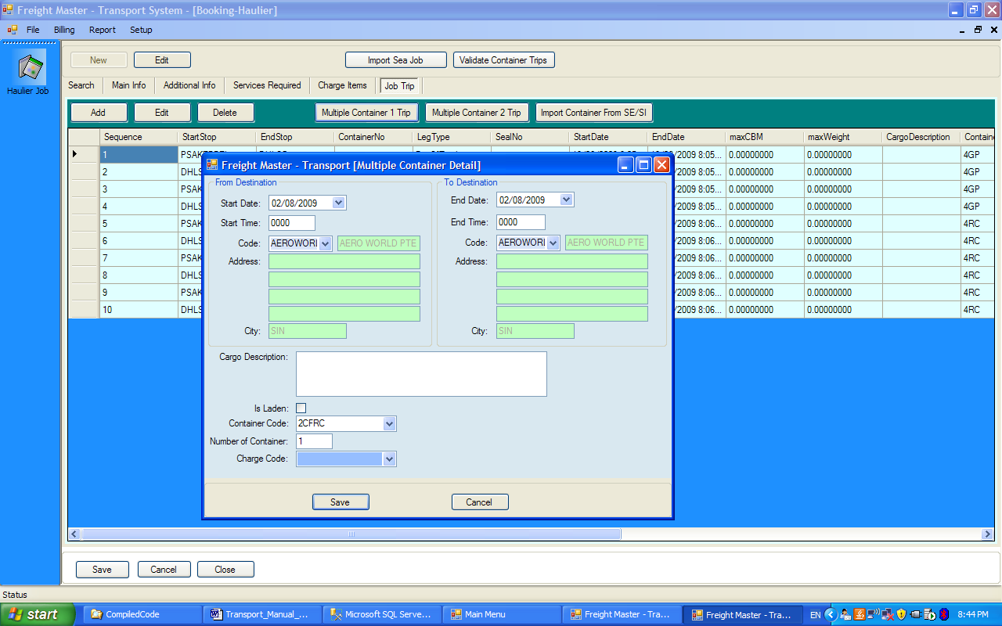

- In both cases
  - The codes for each stop has to be selected
  - The charge code may be selected. If so, the “Validate Container Trips” can verify if the number of trips is equal to what was stated earlier in the “Services Required” tab

  - Jobs transferred from SE or SI

The program allows jobs to be imported from SE or SI, when the “Import Sea Job” button is pressed. User has to select either Sea Import or Sea Export and select the job number.

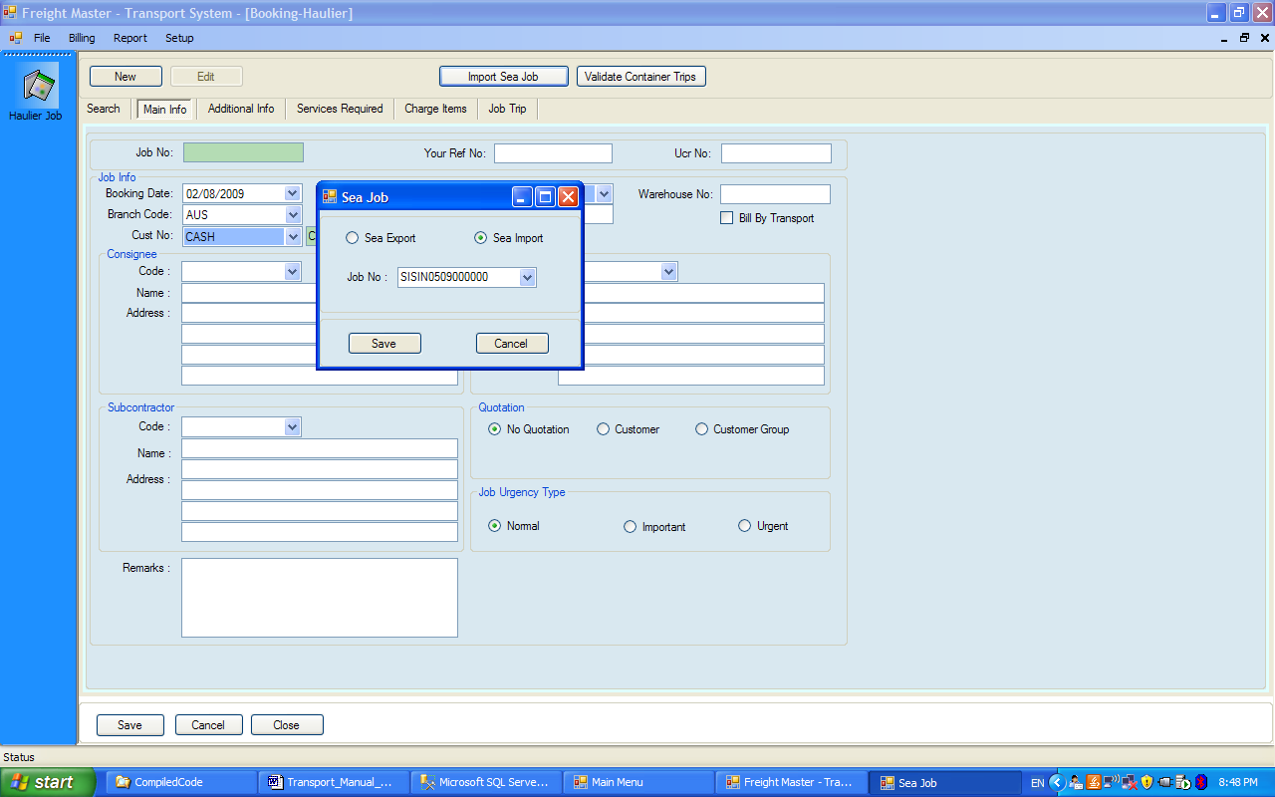

The following conditions stipulate what will be imported

- Sea Export
  - Export_Type = “MBL” or “DBL”
  - Shipment_Terms = “FCL”
  - SE_Job_Detail_Party_Tbl.Transport_Code = TPT_SPECIAL_DATA_Tbl.TPT_CODE i.e. the Transport_Code in Sea Export is set to the one, fixed in TPT_SPECIAL_Data. In the form below the Tranport_Code is set to “IPL”

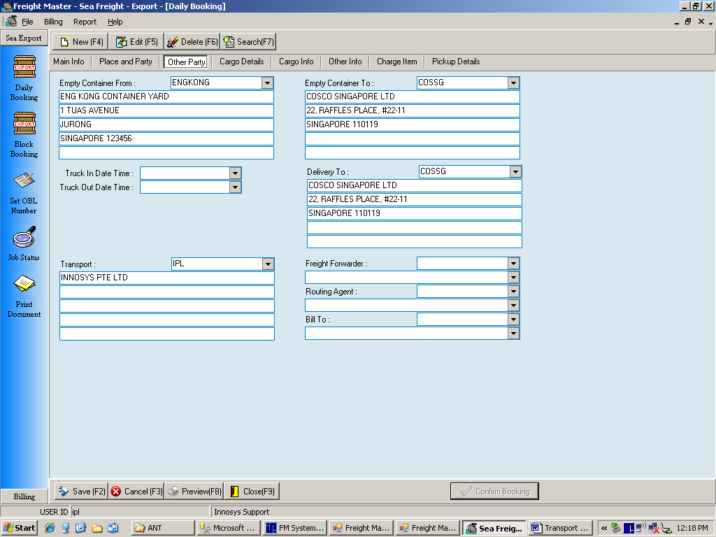

- Sea Import
  - Import_Type = MAA or DOA
  - Shipment_Terms = FCL
  - 1st row in SI_Job_Detail_Delivery_Tbl.Transporter_Code = TPT_SPECIAL_DATA_Tbl.TPT_CODE. (Note that Sea import allows multiple transporter_codes. Only the 1st one will be used to compare – see form below where the Transporter Code is set to “IPL”)

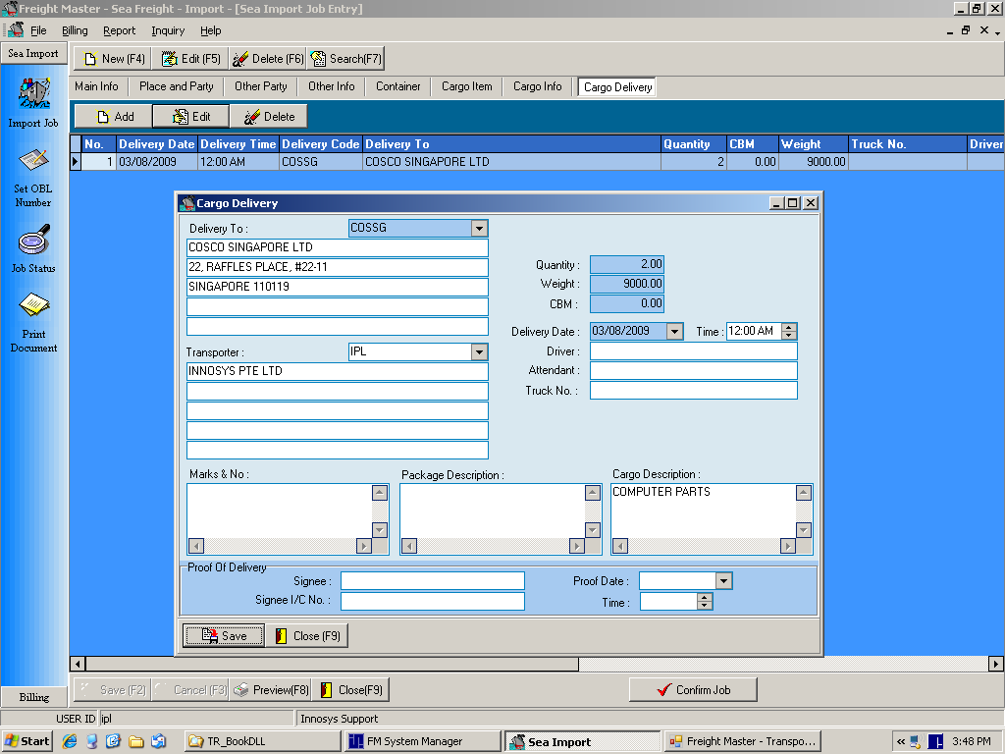

Note the following limitations

- The import is done at the master job level. The container information is transferred in only once. Hence if the user does not transfer all the container information to the master, before selecting the transport code in the Sea job, the container information will not be complete. This is a one-time transfer. There is no facility to update the container information.

On selection of the Sea job, the imported data will populate the “Main info” and “Additional Info” tabs as shown below.

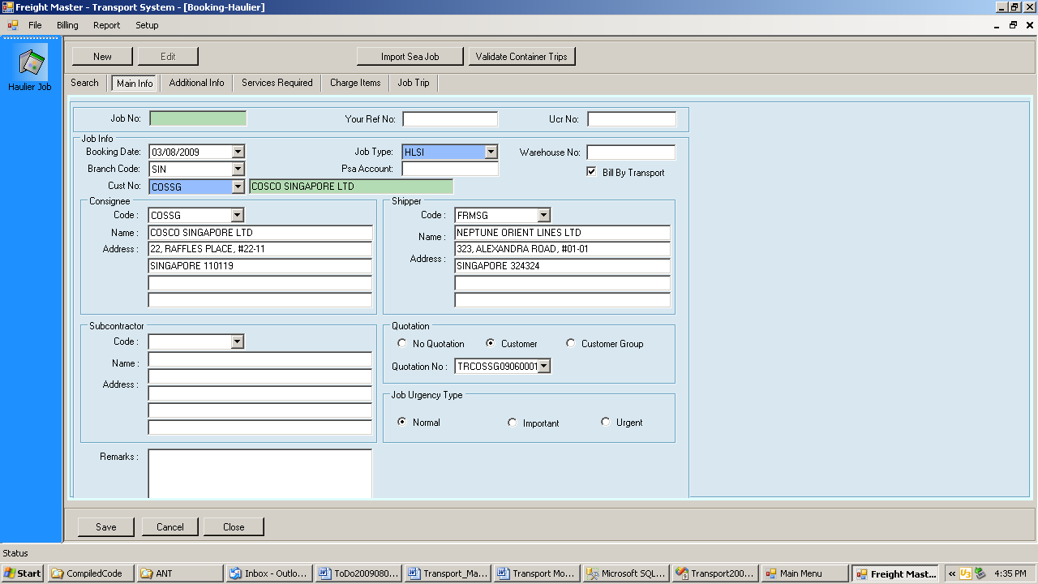

The user then has to check or uncheck “Bill By Transport”. If billing is done by Transport, then the user should select the quotation. If not, the user need not key in “Services Required”. The Sea Job number is shown in “Source Ref No” field

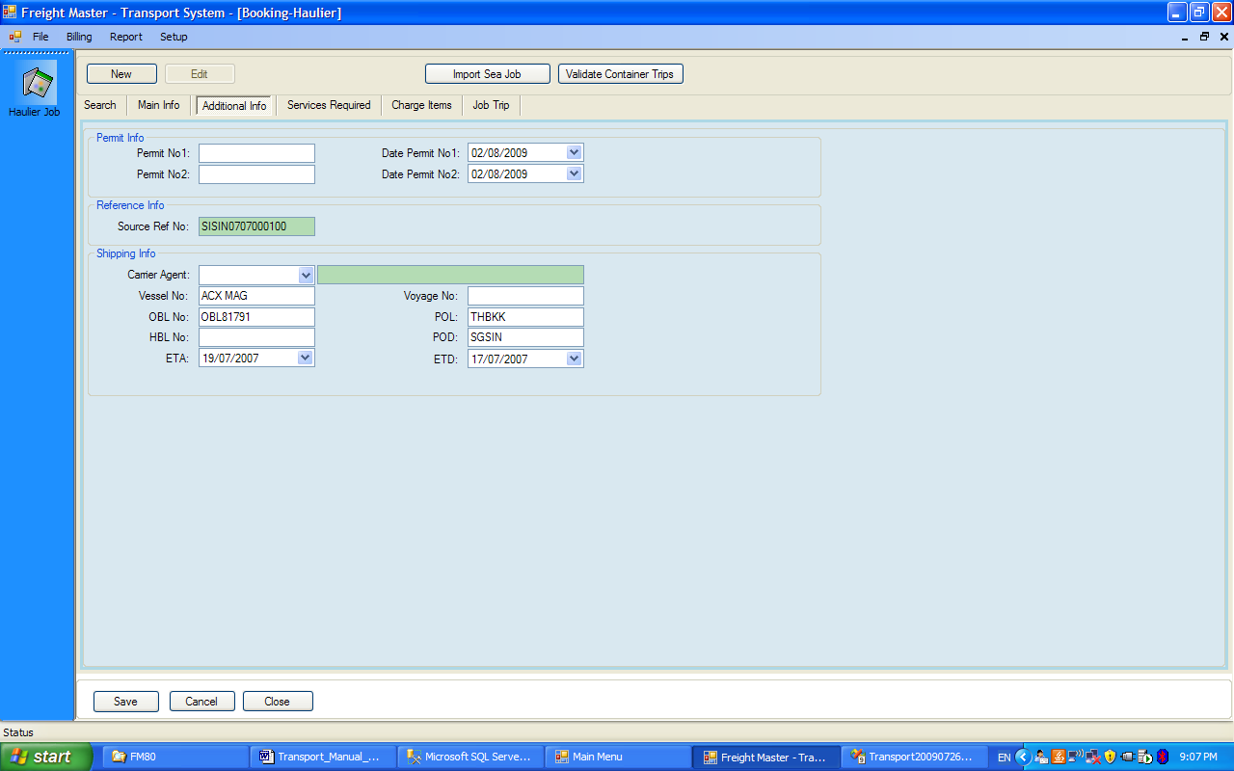

- When the header is saved, the user may go to “Job Trip” tab and then press the “Import Container from SE / SI”. A dialog box will appear as follows

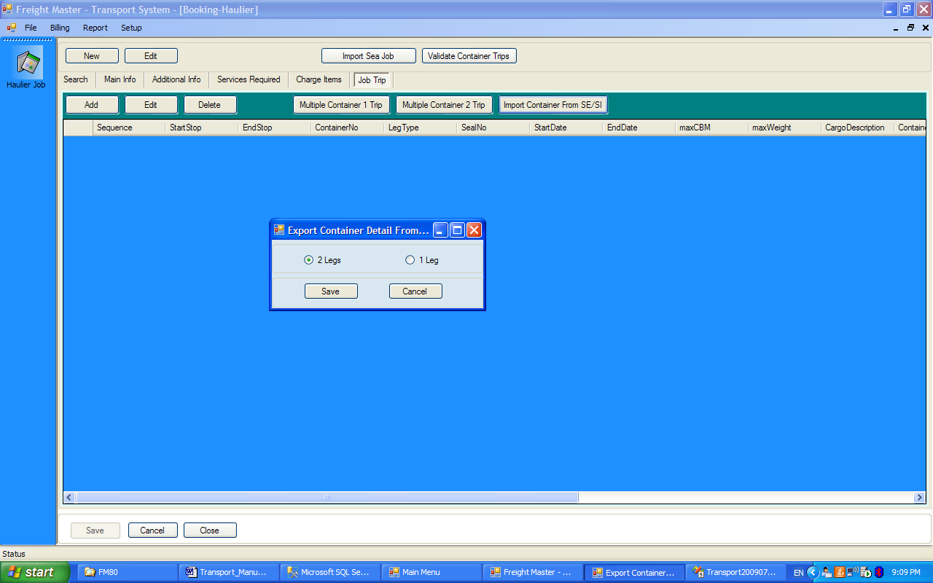

- And when saved, the container information is then imported. If the stop information is incomplete, the user should press the edit button, and modify.
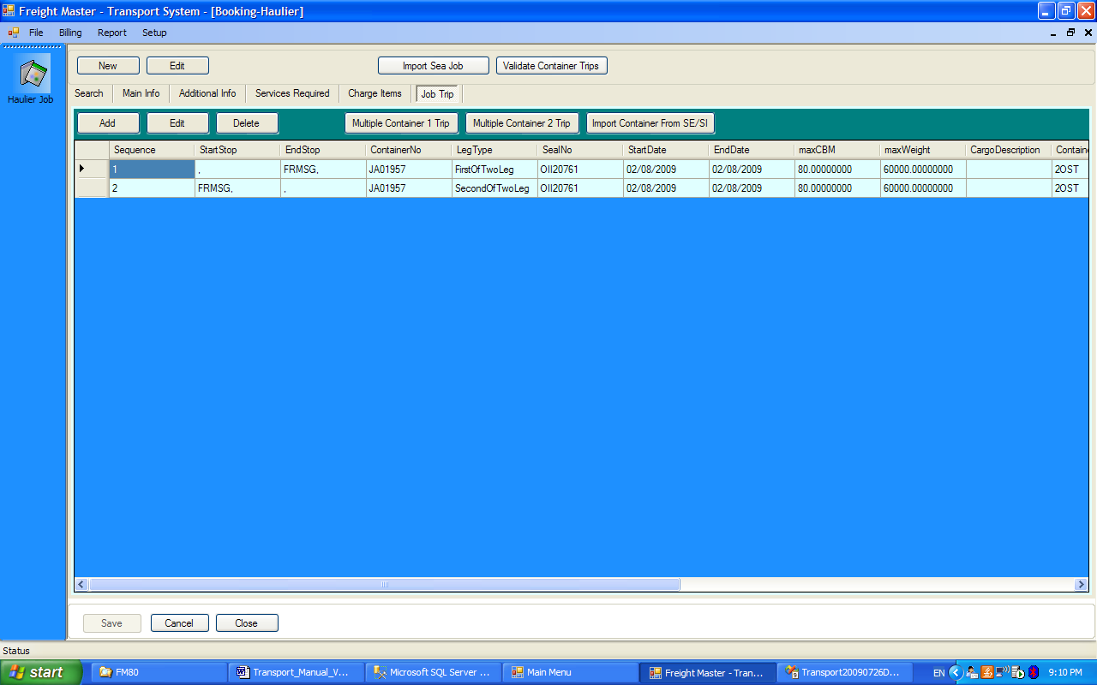

- Planning

  - Steps required for Daily Planning

- Select the Drivers and Trailers for the Plan Date
- Auto set all job trips from “Booked” to “Ready”
- Create the Plan Trips

  - Select the Drivers and Trailers for the Plan Date

- Select the option

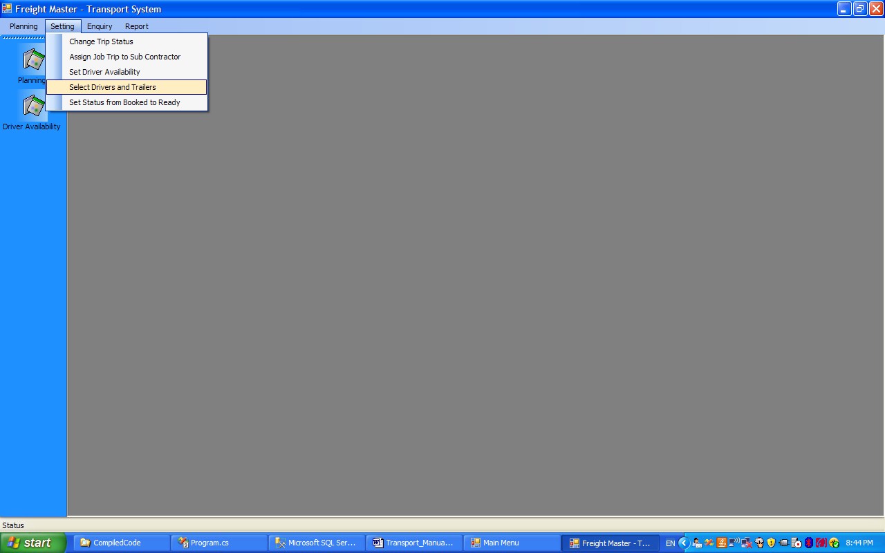

- Next select the Plan Date and the Dept

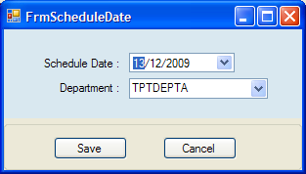

- Then use the arrows to select or deselect drivers and trailers

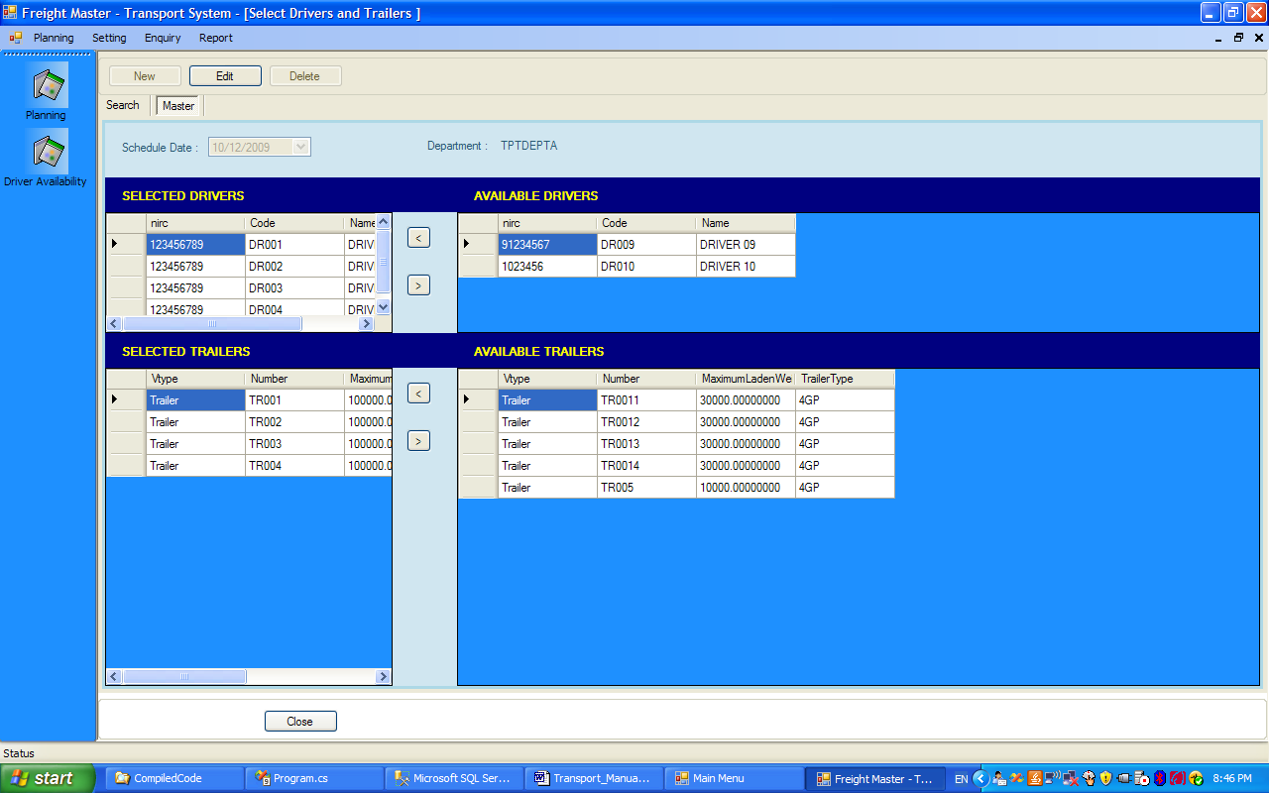

Note:

- Only the department to which these resources are allocated to, can use them for planning
- However the planner can use the above forms, to free up drivers or trailers, not required.

  - Auto Set Job Trips from “Booked” to “Ready”

- When a job trip is first created, its status is “Booked”. When the container is ready, the trip has to be set to “Ready”, before it can appear in the Planner’s list of job trips to be scheduled.
- A function is provided to auto set all job trips from “Booked” to Ready”

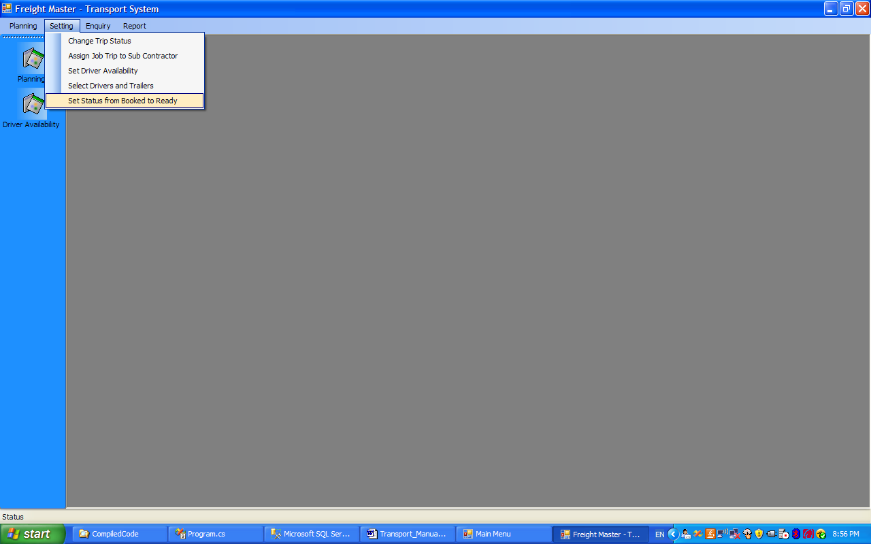

- User selects the Plan Date and the Dept, and then press “Process”

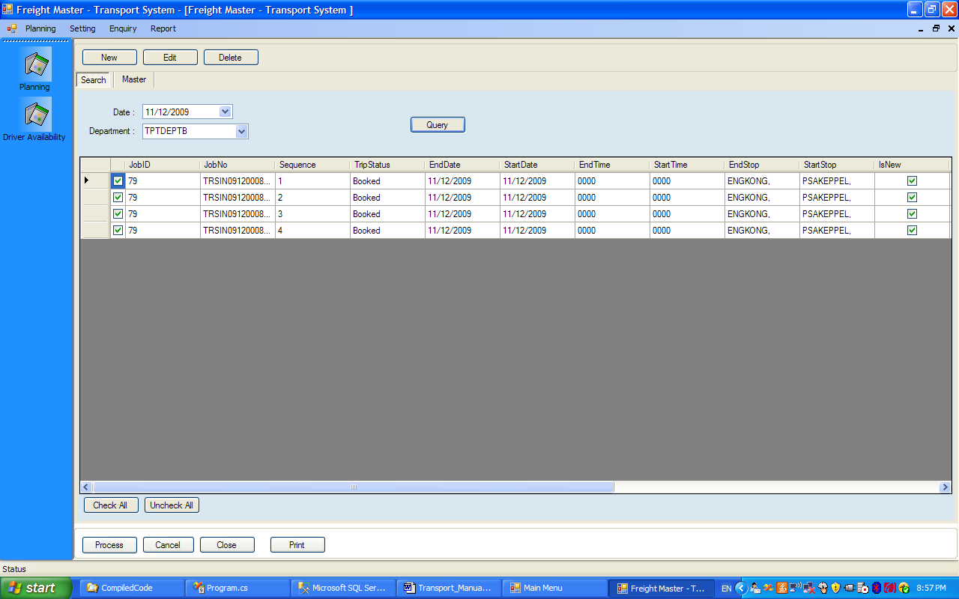
Note

- The 2nd Leg of a 2 Leg job trip will not be shown until its corresponding 1st Leg has been “Completed”. In other words, the 2nd Leg cannot be set to ready until the 1st Leg is completed.

  - Manually Setting of Job Trip Status

- To manually set individual job trips from “Booked” to “Ready” or to set back a job trip from “Ready” to “Booked”, the user goes to the following option

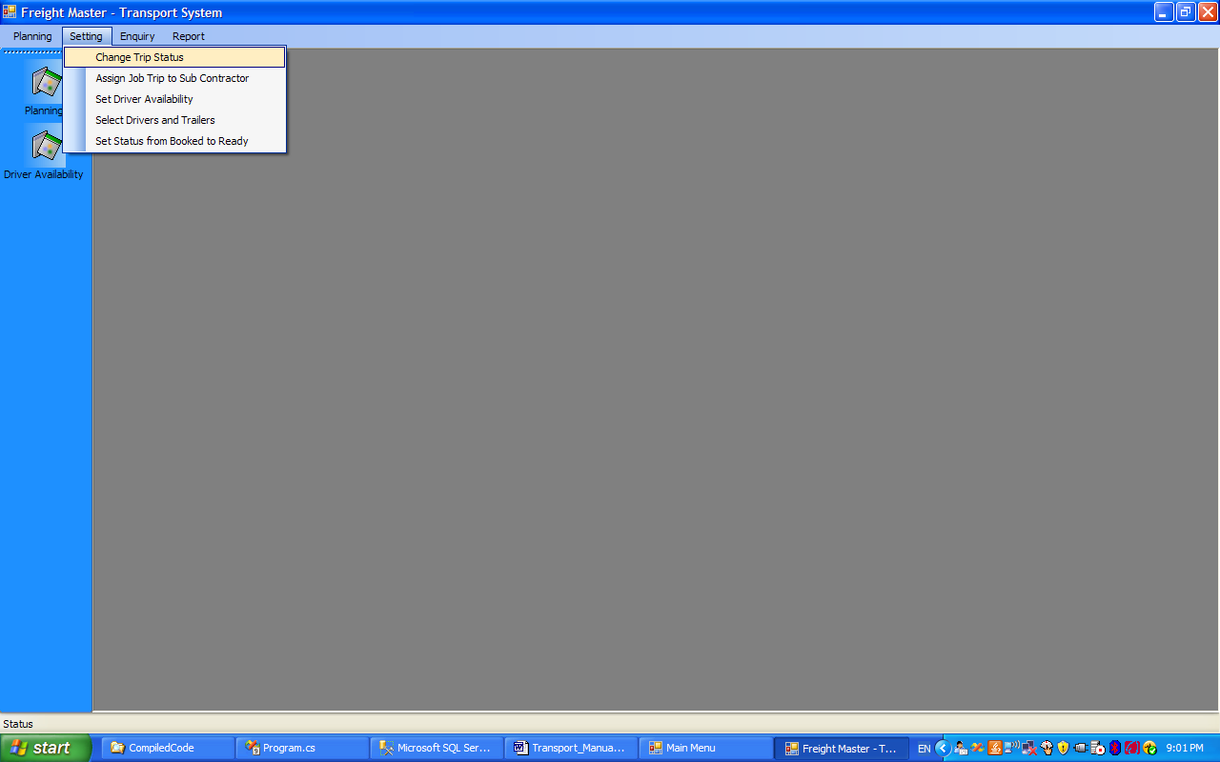

- User then selects an individual job trip

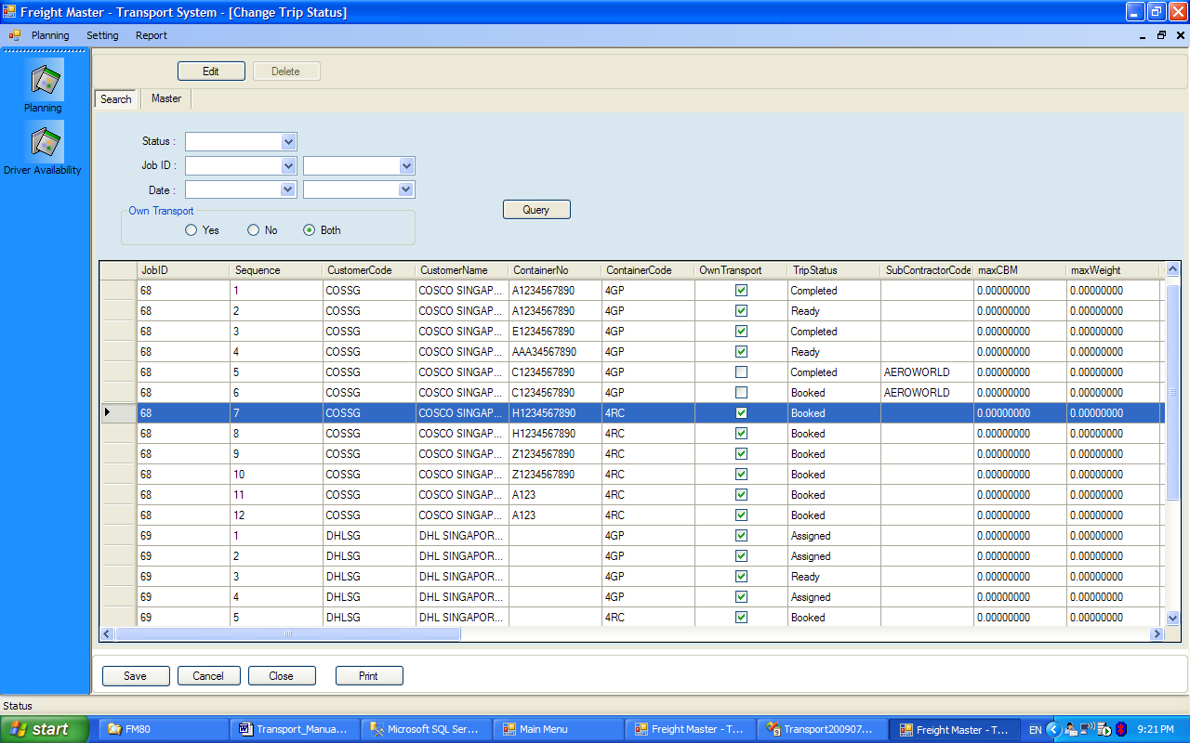

- Select a row, then press “Edit”. The form below appears. Set to “Ready”
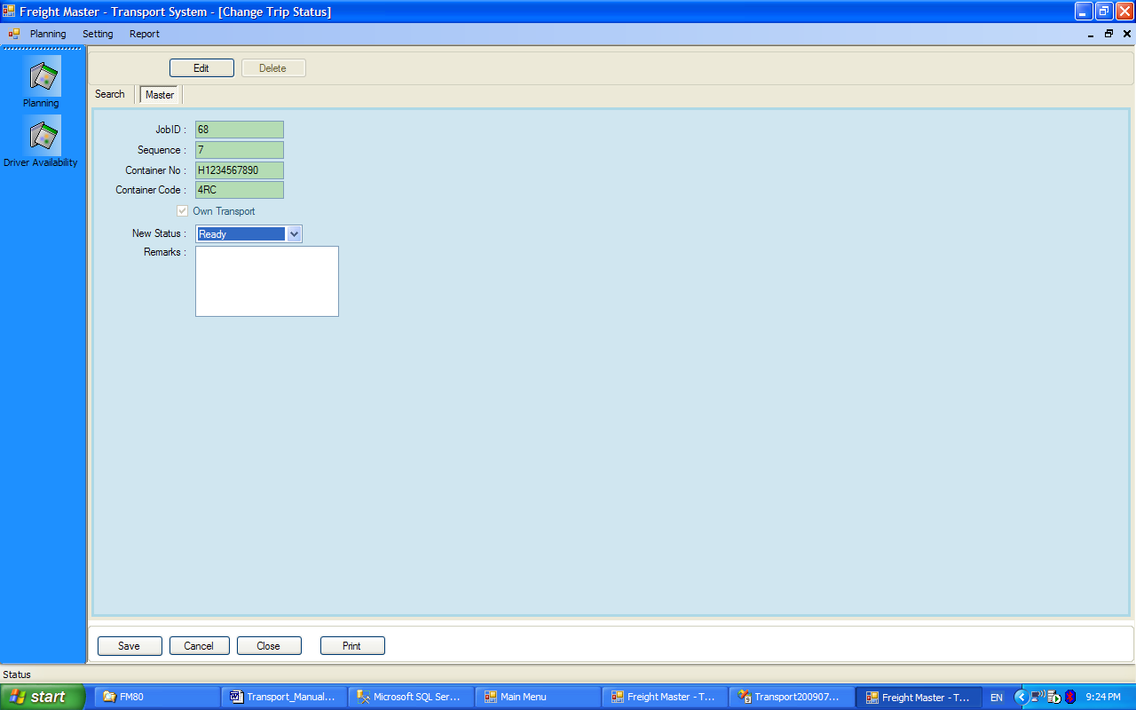

  - The planning form may now be started. Press New and choose the date, and the Dept

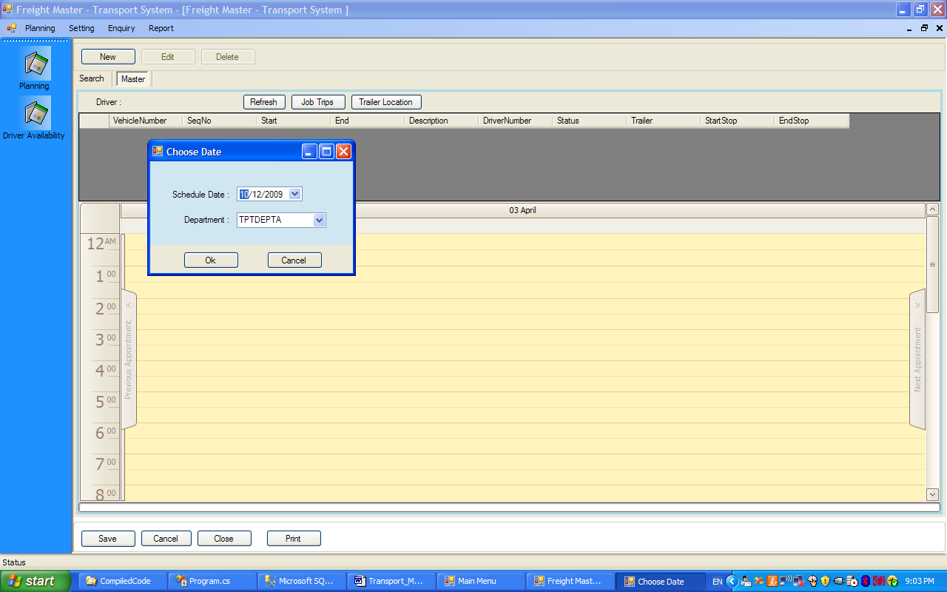

- There are 3 forms. The main scheduler form shows 1 column per driver. The vertical row shows the time of the day. We will ask the user to use 2 screens. One screen is for the scheduler form, and the second one for the List of Ready Job Trips, and the form showing the list of Trailer Locations

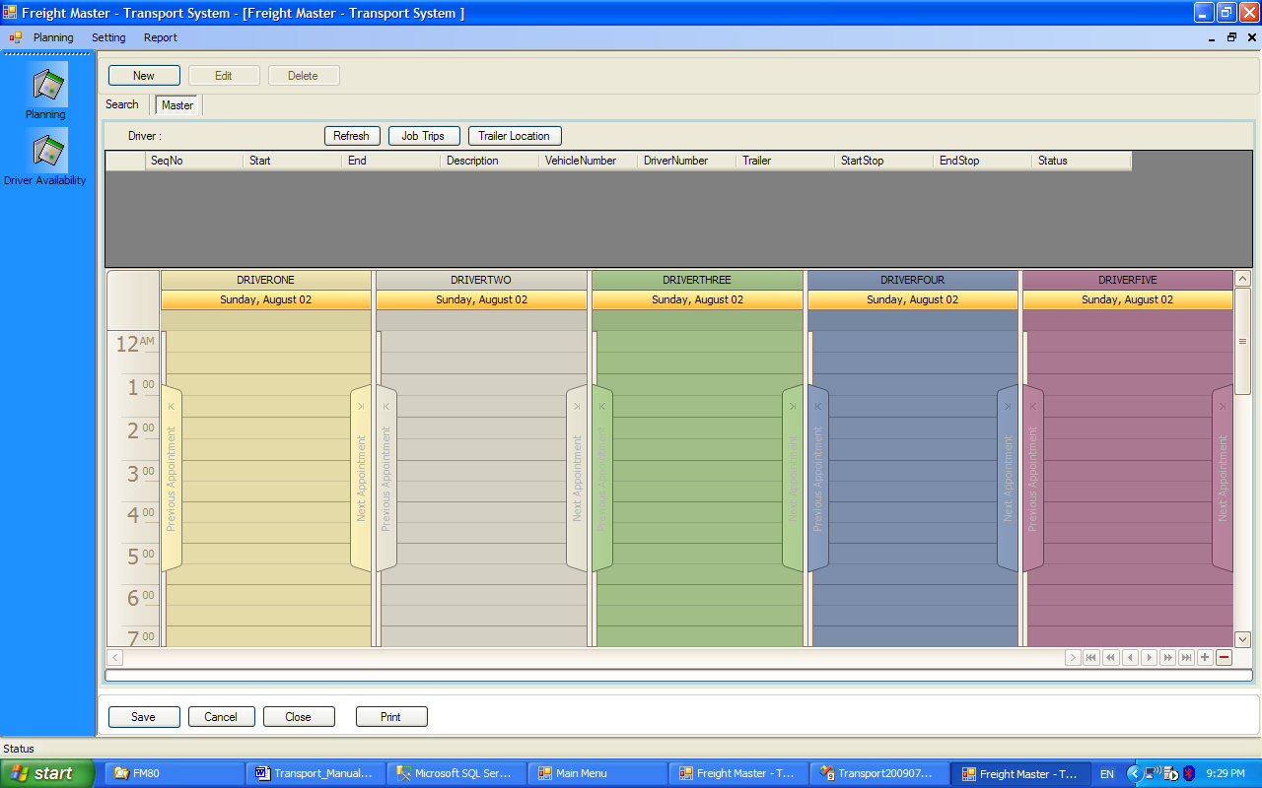

- The Job Trips button show the list of Job Trips which are ready, but not assigned yet, as shown below

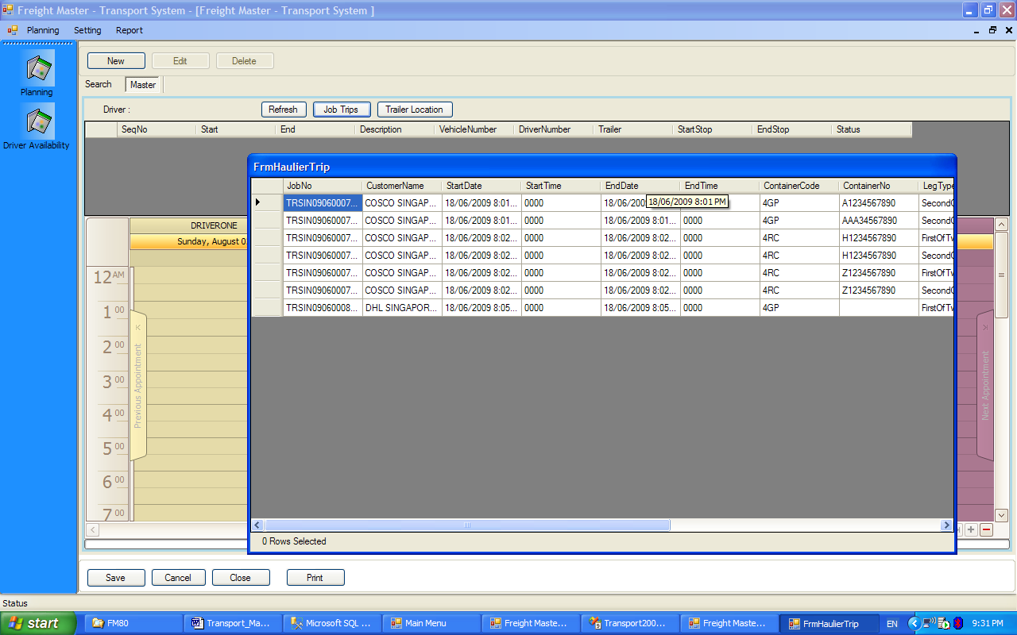

- The Trailer Location form is used to allocate trailers to prime movers or to set the location of trailers.
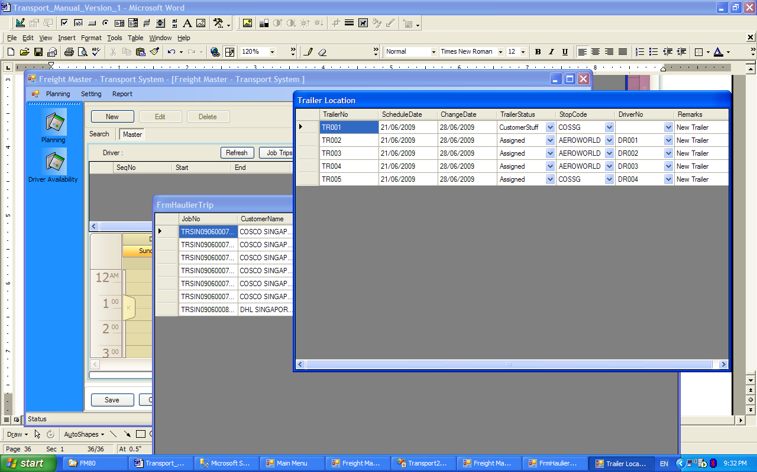

- The following functions are available

  - Drag a job trip from the FrmHaulierTrip to the scheduler and vice versa.
  - When a job trip is dropped into the plan, a Plan Sub Trip is automatically created. A Plan Sub trip is a trip from 1 stop to another stop.
  - A driver for any 1-day, has one or more Plan Sub Trips.
  - A Plan Sub trip may be dragged from 1 driver to another, provided it’s status is not complete.
  - To cancel a Plan Sub Trip (provided a trailer has not been assigned), drag it from the plan to the Form containing Job Trips
  - The time taken for a Plan Sub Trip may be changed by dragging its boundaries

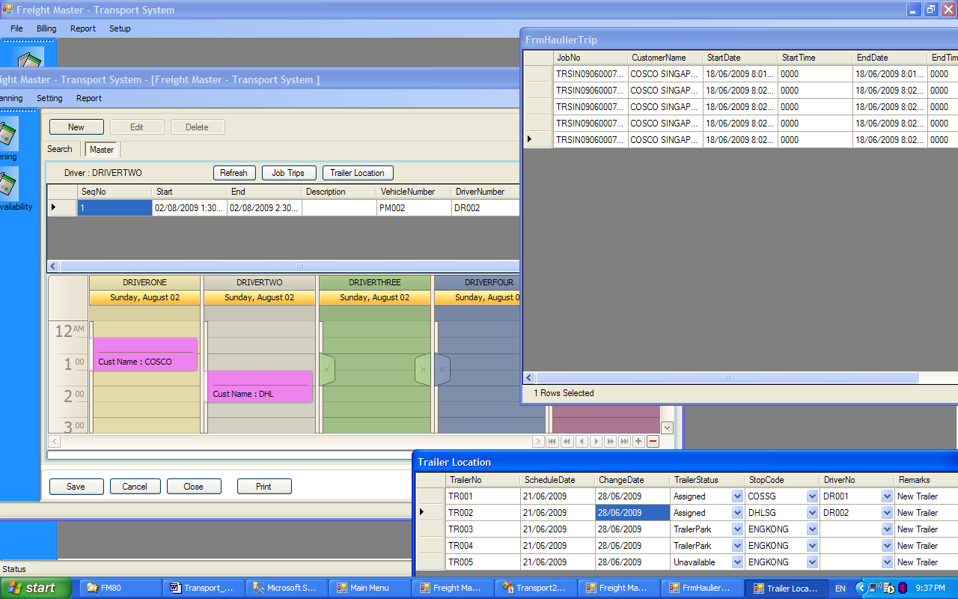

- A Plan Sub Trip may be set to “Complete”, by double clicking on the Plan Sub Trip and changing the status. A Plan Sub Trip that is set to Complete cannot be dragged.

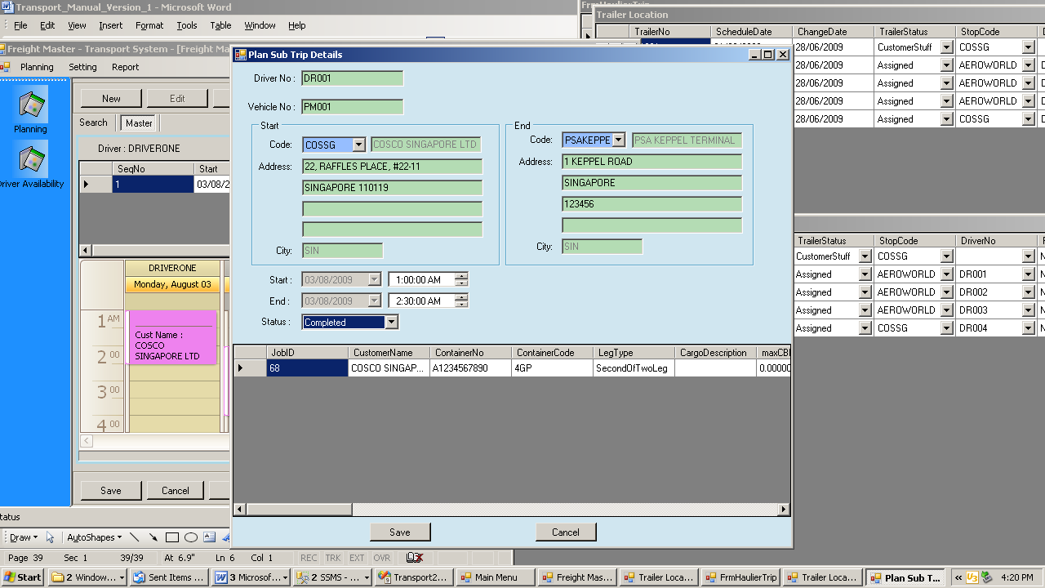

Notes:

- Unlike the other forms, the scheduler form can be saved periodically during a session. This meets the needs of most planners as they adjust to the changes in scheduling throughout the day
- Each time, the scheduler form is saved, the 2 child forms, “Trailer Location” and “FrmHaulierTrip” will close. The user has to press the button again, so that fresh data is extracted from the database
- The planner may close the planning form and call up for editing
- The planner may plan for the next day, while the current day is not completed
- The planner may free up trailer or drivers, which he initially reserved in paragraph 5b, for other planners, by using the form in paragraph 5b, to deselect drivers or trailers

- Invoicing

This function is within Booking menu. The invoicing function is very similar to FM 72 invoicing.

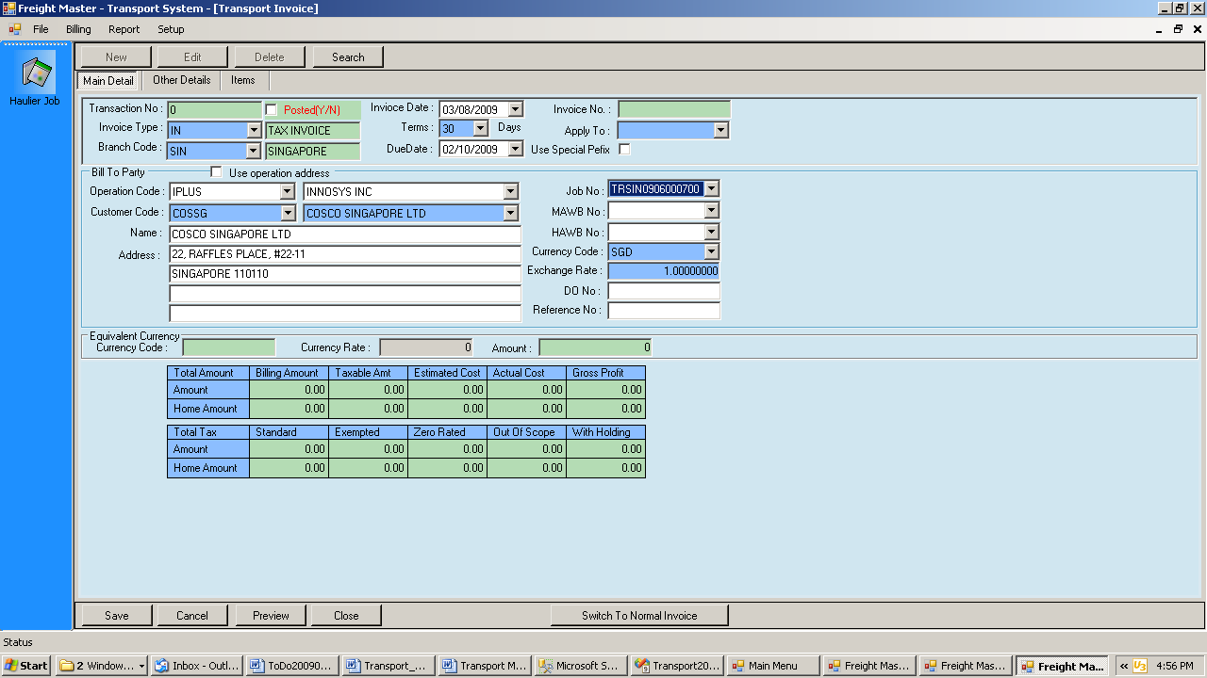

- When the header is saved, a dialog box will appear to retrieve the items in “Services Required” and “Charge Items” tab of the Booking form.
- Each job may be invoiced more than once.
- For each job, additional invoice items may be added
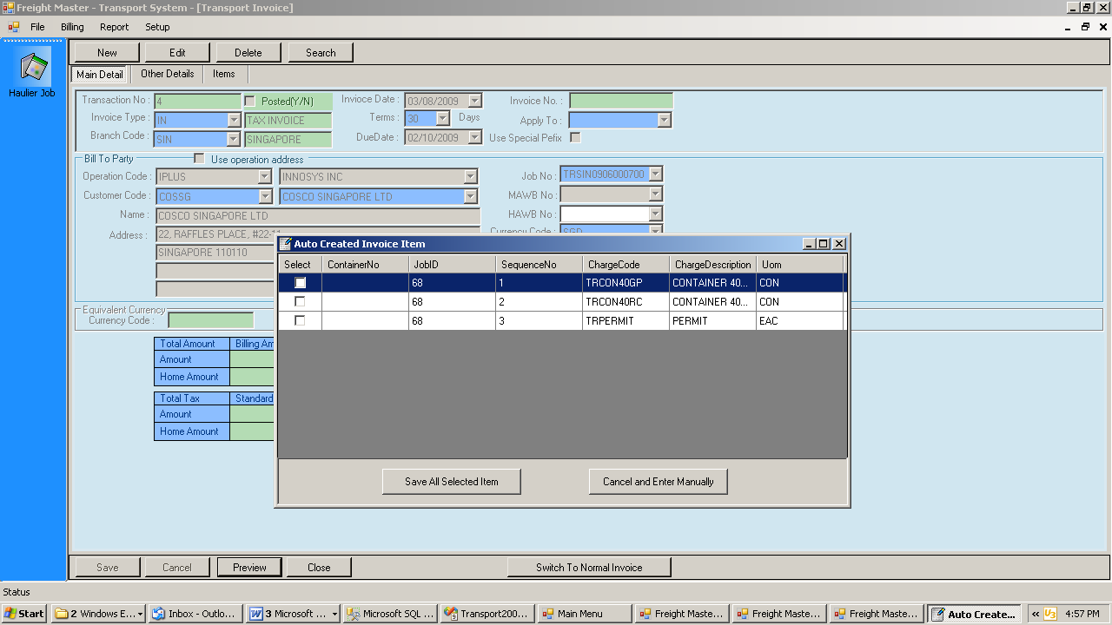

- Maintenance Forms

  - Driver

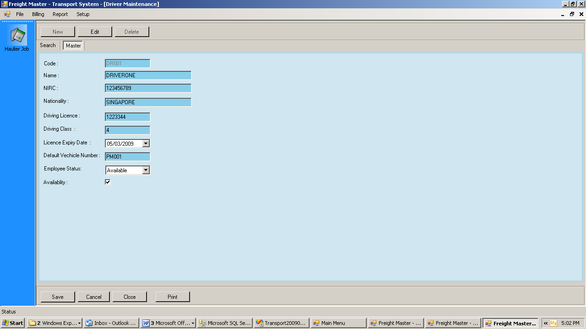

  - Vehicle

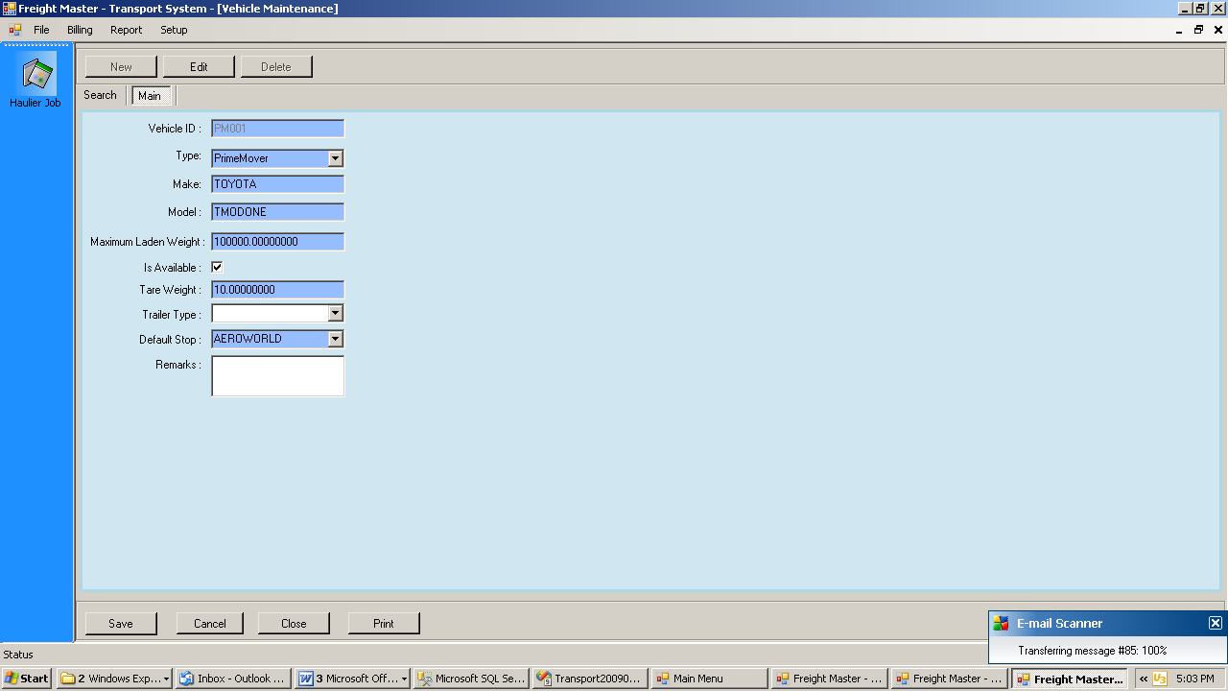

  - Driver Incentives

These incentives are based on a per trip basis

- Master

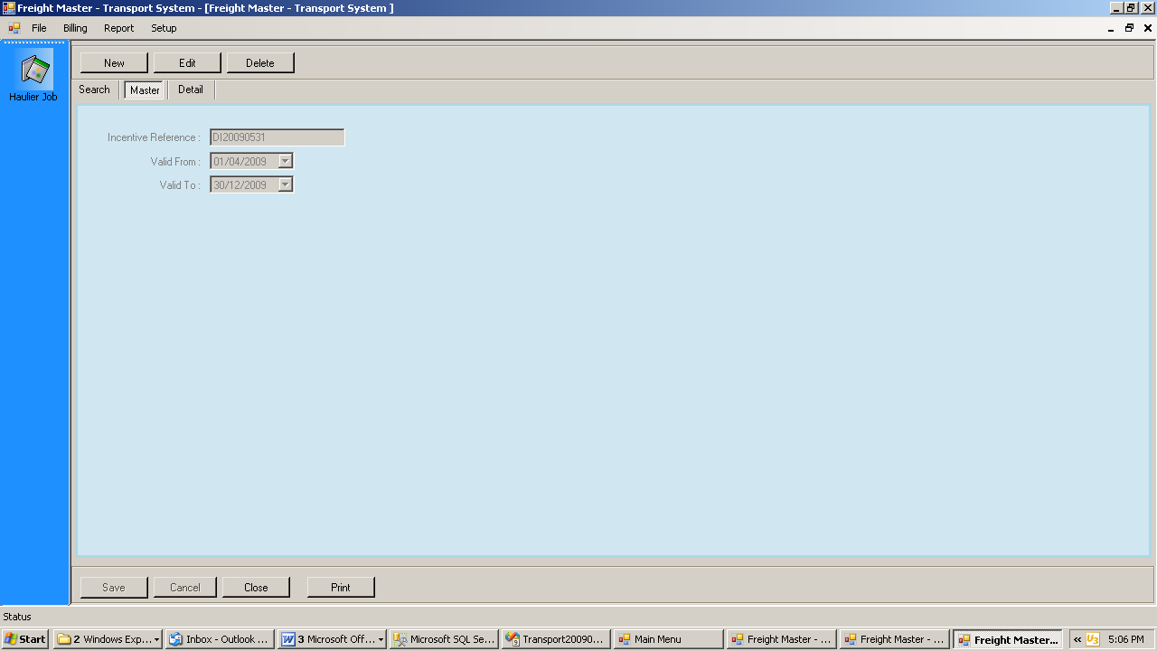

- Detail

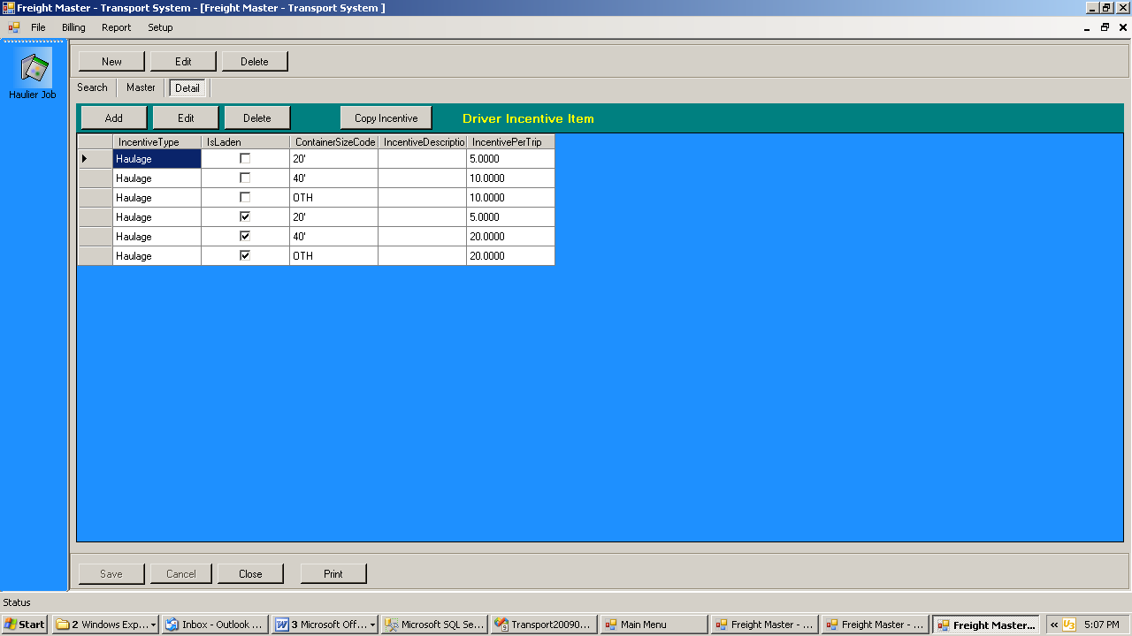

  - Charge

- Each charge code has to be first set up in FM System Manager – Sales / Cost Item
- Then at the form below additional information needs to be keyed in. This arrangement was to avoid changing the sales cost item table in FM
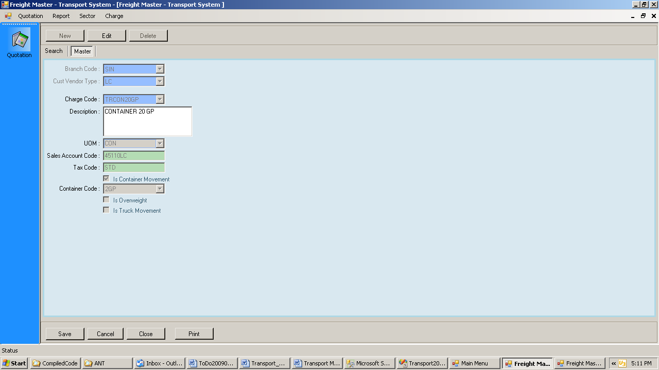

  - Department

- This is used to set several departments so that several planners may plan at the same time

