C# in a Netshell
Notes by Zhou Kai

Preface
Conventions:
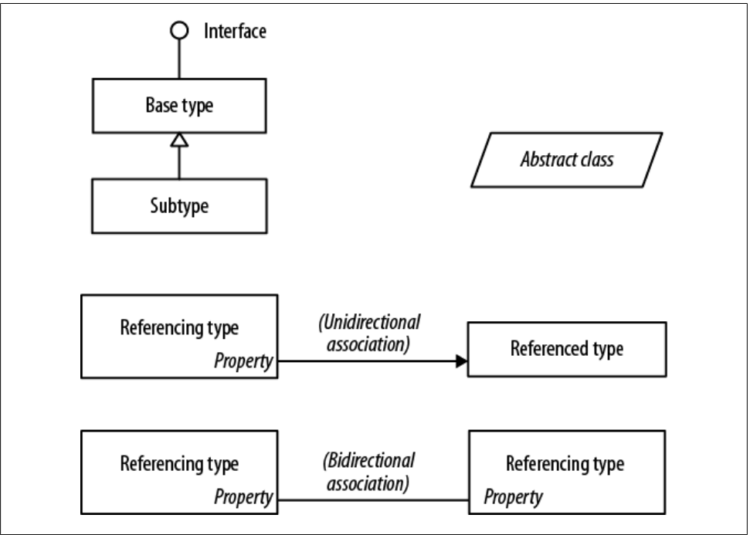

Chapter 1 Introducing C# and the .NET Framework
- The goal of the language is programmer productivity.
- The C# language is platform-neutral, but it was written to work well with the Microsoft .NET Framework
- C# is a rich implementation of the object-orientation paradigm, which includes encapsulation, inheritance and polymorphism. The distinctive features of C# from an object-oriented perspective are:
  - Unified type system
Which means all types ultimately shares a common base type: object.
  - Classes and interfaces
In C#, there're several types besides class, one of which is an interface. An interface is like a class, except that it only describes members. The implementation for those members comes from types that implement the interface.
  - Properties, methods and events
In C#, methods are only one kind of function member, it also has properties and events(and there're others too)
Properties are function members that encapsulate a piece of an object's state.
Events are function members that simplify acting on object state changes.
  - Type Safety
C# is primarily a type-safe language, meaning that instances of types can interact only through protocols they define, thereby ensuring each type's internal consistency.
Static typing eliminates a large class of errors before a program is even run. It shifts the burden away from runtime unit tests onto the compiler to verify that all the types in a program fit together correctly(Zhou Kai: but static typing also has shortcomings, comparing with Objective-C, an dynamic programming language)
C# is not only static typed, it's also strongly typed language, meaning its type rules are very strict(no implicit conventions).(Zhou Kai: there're implicit conventions, and it's enforced)
Strong typing also plays a role in enabling C# code to run in a snadbox-an environment where every aspect of security is controlled by the host. In a sandbox, it is important that you cannot arbitrarily corrupt the state of an object by bypassing its type rules.
  - Memory Management
C# relies on the runtime to perform automatic memory management. C# does not eliminate pointers: it merely makes them unnecessary for most programming tasks. For performance-critical hotspots and interoperability, pointers may be used, but they're permitted only in blocks that are explicitly marked unsafe.
  - Platform Support
C# can be used to write cross-platform code in the following scenarios:
a. Run on the server side the ASP.NET and creates HTML which can be used on any platform
b. Run on another runtime, the Mono project, which has its own C# compiler and runtime, running on Linux, Solaris, Mac OS X and also Windows.
c. C# code may run on a host that supports Microsoft Silverlight(supported for Winwos and Mac OS X)
  - C#'s Relationship with the CLR
Although C# is technically independent of the CLR, but The design of C# closely maps to the design of the CLR:
a. C# dependents on a runtime equipped with a host of features such as automatic memory management and exception handling.
b. C# type system maps closely to the CLR type system
- The CLR and .NET Framework
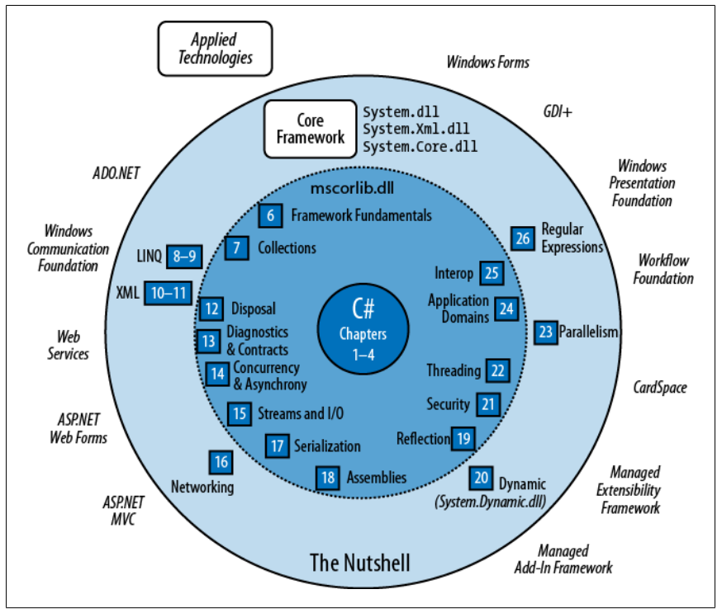
  - The .NET Framework consists of the CLR plus a vast set of libraries.
  - The CLR is the runtime for executing manamged code. Manged code is packaged into an assembly, in the form of either an executable file(an .exe) or a library(a .dll) along with type information, or metadata.
  - Managed code is represented in Intermediate Langauge or IL. When the CLR loads an assembly, it converts the IL into the native code of the machine, such as x86. This conversion is done by the CLR's JIT(Just-In-Time) compiler. An assembly retains almost all of the original source language constructs, which makes it easy to inspect and even generate code dynamically.
  - The CLR performs as a host for numerous runtime services. Including memory management, the loading of libraries, and security services. The CLR is language-neutral, allowing developers to build applications in multiple languages(e.g. C#, Visual Basic.NET, Managed C++, Delphi.NET, Chrome.NET and J#)
- C# and Windows Runtime(the WinRT)
      - WinRT also refers to a set of unmanaged WinRT libraries which serve as a framework for touch-enabled Metro-style applications. The WinRT library can be consumed not only from C# and VB, but C++ and Javascript.
      - WinRT also refers to a set of unmanaged WinRT libraries which serve as a framework for touch-enabled Metro-style applications. The WinRT library can be consumed not only from C# and VB, but C++ and Javascript.
      - WinRT has a range of core functionality that overlaps with parts of the .NET Framework. Because of this overlap, Visual Studio includes a reference profile for Metro projects that hides the portions of the .NET Framework that overlap with WinRT. The profile also hids large portions of the .NET Framework considered unnecessary for tablet apps(such as accessing a database).
      - WinRT/Metro does not supersede the full .NET Framework. The latter is still recommended(and necessary) for standard desktop and server-side development, and has the following andvantages:
      - Programs are not restrcted to running in a sandbox.
      - Programs can use the entire .NET Framework and any third-party library.
      - Application distribution does not rely on the Windows Store.
      - Applications can target the latest Framwork version without requiring users to have that latest OS version.

Chapter 2 C# Language Basics
- A First program
  - Methods are one of several kinds of functions in C#. There're also operator, constructor, property, event, indexer and finalizer.
  - Methods accepts inputs via parameters and return outputs via return or out, ref.
  - At the outermost level of a program, types are organized into namespaces. The .NET Framework is organized into nested namespaces.
- Compilation
  - The C# compiler compiles source code or a specified set of files into an assembly.
  - An assembly is the unit of packaging and deployment in .NET.
  - An assembly can be either an application or a library.
A library is a .dll and is equivalent to an .exe without an entry point. Its purpose is to be called upon by an application or by other libraries. The .NET Framework Class Library(FCL) is a set of libraries.
- Conversions
  - C# can convert between instances of compatible types. A conversion always creates a new value from an existing one.
  - Implicit conversions are allowed when both of the following are ture:
    - The compiler can guarantee they will always succeed.
    - No information is lost in conversion.
  - Conversely, explicit conversions are required when one of the following is ture:
    - The compiler cannot guarantee they will always succeed.
    - Information may be lost during conversion.
  - If the compiler can determine that a conversion will always fail, both kinds of conversion are prohibited.
- Value Types versus Reference Types
  - All C# types fall into the following categories:
  - Value types
  - Reference types
  - Generic type parameters
  - Pointer types
    - Value types comprise most built-in types(specifically, all numeric types, the char type and the bool type) as well as custom struct and enum types.
    - Reference types comprise all class, array, delegate and interface type. (This includes the predefined string type)
  - The fundamental difference between value types and reference types is how they are handled in memory.
- Value types
  - The content of a value type variable or constant is simply a value. You can define a custom value type with the struct keyword.
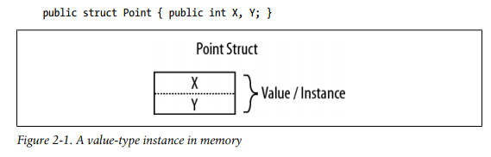
  - The assignment of a value-type always copies the instance.
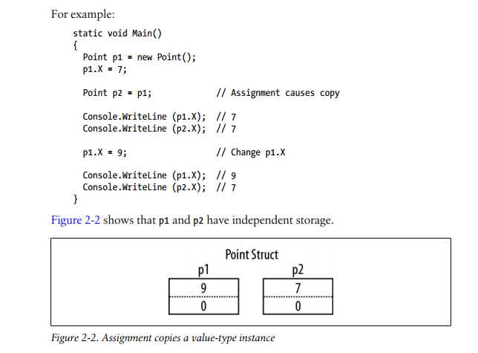
- Reference types
A reference type is more complex than a value type, having two parts: an object and the reference to that object. The content of a reference-type variable or constant is a reference to an object that contains the value.
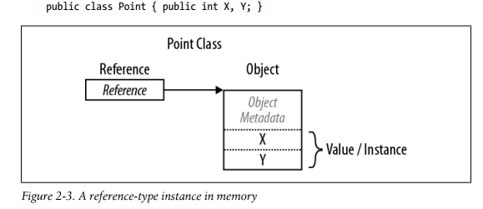
  - Assigning a reference-type variable copies the reference, not the object instance. This allows multiple variables to refer to the same object—something not ordinarily possible with value types. If we repeat the previous example, but with Point now a class, an operation to p1 affects p2.:
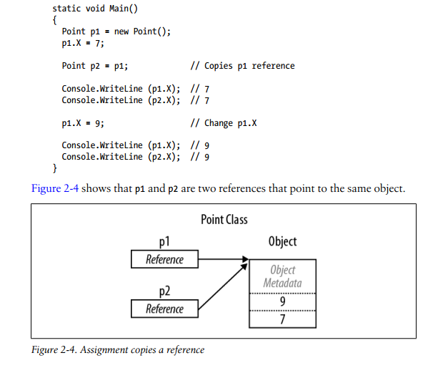
- Null
A reference can be assigned the literal null, indicating that the reference points to no object, in contrast, a value type cannot ordinarily have a null value(but C# also has a construct called nullable types for representing value-type nulls).
- Arrays
An array represents a fixed number of variables, the elements in an array are always stored in a contiguous block of memory, providing highly efficient access.
  - Whether an array element type is a value type or a reference type has important performance implications.
    - When the element type is a value type, each value is allocated as part of the array(every element is valid).
    - When the element type is a reference type, creating the array would have merely allocated null reference for each element(which is not valid).
- Stack and Heap
  - Stack
    - The stack is a block of memory for storing local variables and parameters.
    - The stack logically grows and shrinks as a function is entered and exited. Each time the method is entered, a new parameter is created on the stack, and each time the method exits, the parameter is de-allocated.
  - Heap
    - The heap is a block of memory in which objects reside. Whenever a new object is created, it is allocated on the heap, and a reference to that object is returned.
    - During a program's execution, the heap starts filling up as new objects are created.
    - The run-time has a garbage collector that periodically de-allocates objects from the heap. An object is eligible for de-allocation as soon as it's not referenced by anything that's itself “alive”.
- Definite Assignment
  - Local variables must be assigned a value before they can be used
  - Function arguments must be supplied when a method is called, unless marked as optional.
  - All other variables(such as fields and array elements) are automatically initialized by the run-time.
- ref and out
  - By default, arguments in C# are passed by value, this means a copy of the value is created when passed to the method.
  - To pass by reference, C# provides the ref parameter modifier.
  - A parameter can be passed by reference or by value, regardless of whether the parameter type is a reference type or a value type.(Zhou Kai: think about how to pass a reference type as a value type parameter? Maybe create a copy of that reference object manually?)
  - An out argument is like a ref argument, except it:
    - need not be assigned before going into the function
    - must be assigned before it comes out of the function
- Optional parameters
  - Adding an optional parameter to a public method that's called from another assembly requires recompilation of both assemblies – just as though the parameter were mandatory.
- Named arguments
- var – Implicitly Typed Local Variables
  - If the compiler is able to infer the type from the initialization expression, you can use the keyword var in place of the type declaration.
- extern and global
  - extern aliases allow your program to reference two types with the same fully qualified name(i.e. the namespace and type name are identical). This is an unusual scenario and can occur only when the two types come from different assemblies.
  - The global namespace – the root of all namespaces(identified with the contextual keyword global) new A.B() → new global::A.B() creates different B object, the former B is in class A, the latter is a class in namespace A

Chapter 3 Creating Types in C#

Implementing an indexer
To write an indexer, define a property called "this", specifying the arguments in square brackets.
A type may declare multiple indexers, each with parameters of different types. An indexer can also take more than one parameter.

Constants
A constant is evaluated statically at compile time and the compiler literally substitutes its value whenver used(rather like a macro in C++). A constant can be any of the built-in numeric types, bool, char, string, or an enum type. A constant must be initialized with a value while been declared.

Static Classes
A static class must be composed solely of static members and cannot be sub-classed.

Finalizers
Finalizers are class-only methods that execute before the garbage collector reclaims the memory for an unreferenced object.

Inheritance and Polymorphism
- Inheritance
  - A class can inherit from another class to extend or customize the original class.
  - Inheriting from a class lets you reuse the functionality in that class instead of building it from scratch.
  - A class can inherit from only a single class, but can itself be inherited by many classes, thus forming a class hierarchy.
- Polymorphism, references are polymorphic, an object reference can be:
  - Implicitly up-cast to a base class reference
    - An up-cast operation creates a basic class reference from a subclass reference
    - After the up-cast, the variable still references the same subclass object.
    - The referenced object is not affected.
  - Explicitly down-cast to a subclass reference-type
    - A down-cast operation creates a subclass reference from a base class reference
    - A down-cast requires an explicit cast because it can potentially fail at runtime
    - The referenced object is not affected
    - If a down-cast fails, an InvalidCastException is thrown

as and is
The as operator performs a downcast that evaluates to null(rather throwing an exception) if the downcast fails.
The is operator tests whether a reference conversion would succeed.

virtual and abstract
- A function marked as virtual can be overridden by subclasses wanting to provide a specialized implementation. Methods, properties and events can all be declared virtual.
- virtual method has a body and can be called
- Calling virtual methods from a constructor is potentially dangerous because when someone inherits your class, the author of the subclasses are unlikely to know, when overriding the method, that they are working with a partially initialized object.
- abstract class and abstract methods
  - abstract class can not be initialized
  - abstract class is able to define abstract methods, a class consists an abstract must be abstract class and abstract methods
  - abstract class can not be initialized
  - abstract class is able to define abstract methods, a class consists an abstract must be declared as abstract
  - The abstract methods do not have body(implementation), the implementation must be provided by the subclass, unless that subclass is also declared as abstract.

Hiding Inherited Members
- The new modifier communicates your intent to the compiler—and other programmers—that the duplicate member is not an accident.
- If you want to hide a member deliberately, in which case you can apply the new modifier.
- new versus override

Sealing Functions and Classes
An overridden function member may seal its implementation with the sealed keyword to prevent it from being overridden by further subclass.

The base Keyword
The base keyword is similar to the this keyword. It serves two essential purposes:
- Accessing an overridden function member from the subclasses
- Calling a base-class constructor

The object Type
object(System.Object) is the ultimate base class for all types. Any type can be up-cast to object. The example of a general-purpose stack.

Boxing and Unboxing
Boxing is the act of converting a value-type instance to a reference-type instance. The reference type may be either the object class or an interface.
Unboxing reverses the operation, by casting the object back to the original value type. Unboxing requires an explicit cast. The runtime checks that the stated value type matches the actual object type, and throws an InvalidCastException if the check fails.
Boxing copies the value-type instance into the new object, and unboxing copies the contents of the object back into a value-type instance.

Static and Runtime Type Checking
C# programs are type-checked both statically(at compile time) and at runtime(by the CLR). Runtime type checking is possible because each object on the heap internally stores a little type token. This token can be retrieved by calling the GetType method of object.

The GetType Method and typeof Operator
All types in C# are represented at runtime with an instance of System.Type. There are two basic ways to get a System.Type object:
- Call GetType on the instance, it's evaluated at runtime.
- Use the typeof operator on a type name, it's evaluated statically at compile time(when generic type parameters are involved, it's resolved by the just-in-time compiler).
- System.Type has properties for such things as the type's name, assembly, base type, and so on.

Structs
A struct is similar to a class, with the following key differences:
- A struct is a value type, wheras a class is a reference type
- A struct does not support inheritance(other than implicitly derving from object, or more precisely, System.ValueType)
A struct can have all the members a class can, except the following:
- A parameterless constructor
- A finalizer
- Virtual members
A struct is used instead of a class when value-type semantics are desirable.

Access Modifiers
To promote encapsulation, a type or type member may limit its accessibility to other types and other assemblies by adding one of five access modifiers to the declaration:
- public
Fully accessible. This is the implicit accessibility for members of an enum or interface.
- internal
accessible only within containing assembly or friend assemblies. This is the default accessibility for non-nested types.
- protected
Assessible only within containing type or subclasses.
- protected internal
The union of protected and internal accessibility. Eric Lippert explains it as follows: Everything is as private as possible by default, and each modifier makes the thing more accessible. So something that is protected internal is made more accessible in two ways.
- private
Accessible only within containing type. This is the default accessibility for members of a class or struct.
- Friend Assemblies
In advanced scenarios, you can expose internal members to other friend assemblies by adding the System.Runtime.CompilerServices.InternalsVisibleTo assembly attribute, specifying the name of the friend assembly as follows:
[assembly: InternalsVisibleTo("Friend")]

Accessibility Capping

Restrictions on Access Modifiers

Interfaces
An interface is similar to a class, but it provides a specification rather than an implementation for its members. An interface is special in the following ways:
- Interface members are all implicitly abstract. In contrast, a class can provide both abstract members and concrete members with implementations.
- An interface can contain only methods, properties, events, and indexers, which non-coincidentally are precisely the members of a class that can be abstract.
- Interface members are always implicitly public and cannot declare an access modifier. Implementing an interface means providing a public implementation for all its members.
- A class(or struct) can implement multiple interfaces. In contrast, a class can inherit from only a single class, and a struct cannot inherit at all(aside from deriving from System.ValueType)
- You can implicitly cast an object to any interface that it implements.
- Interfaces may derive from other interfaces.
- Explicit Interface Implementation(resolve collisions caused by implementing multiple interfaces)
- Implementing Interface Members Virtually
  - An implicitly implemented interface member is, by default, sealed. It must be marked virtual or abstract in the base class in order to be overridden.
- Reimplementing an Interface in a Subclass
  - A subclass can re-implement any interface member already implemented by a base class.
- Writing a Class versus an Interfaces
  - Use classes and subclasses for types that naturally share an implementation.
  - Use interfaces for types that have independent implementations.

Enums
This paragraph and all the paragraphs below are incomplete. Need to re-read all those paragrahps.

Enum Conversions

Flag Enums

Nested Types

Generic Types
A generic type declares type parameters – placeholder types to be filled in by the consumer of the generic type, which supplies the type arguments.
Open type and close type
At runtime, all generic type instances are closed—with placeholder types filled in.

Why Generics Exist

Generic Methods

Chapter 4 Advanced C#

Delegates
- A delegate is an object that knows how to call a method.
- A delegate type defines the kind of method that delegate instances can call. Specifically, it defines the method's return type and its parameter types(more than the function signature).
- Technically, we are specifying a method group when we refer to a method name without brackets or arguments. If the method is overloaded, C# will pick the correct overload based on the signature of the delegate to which it's being assigned.
- Plug-in Methods
- Multi-cast Delegates
- Instance Versus Static Method Targets
  - When an instance method is assigned to delegate object, the latter must maintain a reference not only to the mothod, but also to the instance to which the method belongs. The System.Delegate class's Target property represents this instance(and will be null for a delegate referencing a static method).
- Generic Delegate Types
- Delegates Versus Interfaces

Events
- Standard Event Pattern
  - The .NET Framework defines a standard pattern for writing events.
  - Its purpose is to provide consistency across both Framework and user code.
  - System.EventArgs, it's a base class for conveying information for an event.
- An example:
  - Subclass EventArgs to convery the old and new prices when a PriceChanged event is fired:
public class PriceChangedEventArgs : System.EventArgs
{
public readonly decimal LastPrice;
public readonly decimal NewPrice;

public PriceChangedEventArgs (decimal lastPrice, decimal newPrice)
{
LastPrice = lastPrice;
NewPrice = newPrice;
}
}
  - For reuseability, the EventArgs subclsss is named according to the information it contains(rather than the event for which it will be used). It typically exposes data as properties or as read-only fields.
  - With an EventArgs subclass in place, the next step is to choose or define a delegate for the event. The delegate must:
    - have a void return type
    - accept two arguments: the first of type object, and the second a subclass of EventArgs(in this case, PriceChangedEventArgs).
      - the first argument indicates the event broadcaster
      - the second argument contains the extra information to convey
    - be named end with EventHandler
      - the Framework defines a generic delegate called System.EvnetHandler<> that satisfies these rules:
public delegate void EventHandler<TEventArgs>(object source, TEventArgs e)
      - TEventArgs : EventArgs
  - The next step is to define an event of the chosen delegate type. Here, we use the generic EventHandler delegate.
    - public class Stock
{
...
public event EventHander<PriceChangedEventArgs> PriceChagned;
}
  - Finally, the pattern requires that you write a protected virtual method that fires the event. The name must match the name of the event, prefixed with the word On, and then accept a single EventArgs argument:
    - public class Stock
{
...
public event EventHandler<PriceChangedEventArgs> PriceChanged;
protected virtual void OnPriceChanged (PriceChangedEventArgs e)
{
var tmp = PriceChanged;
if (tmp != null) tmp(this, e);
}
}

Chapter 5 Framework Overview

