Chapter 1 ASP.NET MVC as a Service Framework
- Starting back in 2002 with the original release of .NET, a developer could fairly easily create an ASP.NET ASMX-based XML web service that allowed other .NET and non-.NET clients to call it.
- Those ASMX-based XML web services implemented various versions of SOAP, but were only available for use over HTTP.
- In addition to web services, the 1.0 release of .NET provided support for Remoting. This allowed developers to write services that weren't necessarily tied to the HTTP(REST / SOAP) protocol(TCP/IP, MSMQ and many other protocols, ZK).
- Similar to ASMX-based web services, .NET Remoting essentially provides object activation and session context for client-initiated method calls. The caller uses a proxy object to invoke methods, and the .NET runtime handles serialization and marshaling of data between the client's proxy object and the server's activated service object. (Which means not using HTTP directly to access the web service? ZK)
- Towards the end of 2006, Microsoft released .NET 3.0, which included the Windows Communication Foundation(WCF). WCF not only replaced ASMX web services and .NET Remoting, but also took a giant step forward in the way of flexibility, configurability, extensibility, and support for more recent security and other SOAP standards.(WCF uses SOAP standards instead of ASMX or .NET Remoting, ZK)
- If you need to set up communication between two applications, whether they are co-located or separated by thousands of miles, REST-assured WCF can do it(Because it supports various of protocols).
- In the land of Javascript and mobile devices:
  - During much of the growth of the Internet over the past two-plus decades, websites and pages have relied on server-side code for anything but basic HTML manipulation. But more recently, various AJAX-related tools and frameworks—including but not limited to JavaScript, jQuery, HTML5, and some tricks with CSS—have given rise to the need for services that are less about complex enterprise applications talking to each other and more about web pages needing to get and push small amounts of data.
  - In those cases, communicating with a service over HTTP is pretty much a given, since the websites themselves are HTTP applications.
  - In addtion to simpler protocal(and security needs), web pages typically communicate with other applications and services using text-based messages rather than binary-formatted messages. As such, a service needs only to support XML or JSON serialization.
  - Byond web applications, today's smartphones and tablets have created a huge demand for services in support of small smart-client mobile applications. These services are very similar in nature to those that support AJAX-enabled websites.
    - They typically communicate via HTTP
    - They send and receive small amounts of text-based data
    - Their security models tend to take a minimalist approach in order to provide a better user experience(they strive for less configuration and fewer headaches for users).
    - The implementation of these services encourages more reuse across the different mobile platforms.
  - Because of the trend stated above, there is now a desire for a service framework that, out-of-the-box, provides exactly what is needed for these simple text-based HTTP services. While WCF can be used to create such services, it is definitely not configured that way by default. Unfortunately, the added flexibility and configurability of WCF make it all too easy to mess something up.(Is that the only "shortcoming" for WCF? ZK)
  - And this is where the ASP.NET MVC Framework comes into the picture.
- If under some certain scenarios, you aren't interested in many of the capabilities of WCF, you can start thinking of a framework like ASP.NET MVC –with fewer service-oriented bells and whistles –as being advantageous.
- Advantages of Using the MVC Framework
  - Configuration
    - Like the case when building a web site, there isn't much to configure to get an MVC-based service up and running.
    - The concept of endpoints or contracts doesn't exist.
    - An MVC-based service is pretty loose in comparison to a WCF service.
    - You pretty much just need a REST URL, a set of inbound arguments, and a response JSON or XML message.
  - A quick overview of REST
    - REST is meant to take better advantage of standards and technologies with HTTP than SOAP does. For example, rather than creating arbitrary SOAP methods, developers of REST APIs are encouraged to use only HTTP verbs:
      - GET
      - POST
      - PUT
      - DELETE
    - REST is also resource-centric; that is, RESTful APIs use HTTP verbs to act on or fetch information about resources. The resources would be the nouns in REST parlance(e.g., Tasks, Users, Customers, and Orders). Thus, you have verbs acting on nouns. It's can be simply said as:"Perform actions against a resource".
    - Additionally, REST takes advantage of other aspects of HTTP systems, such as the following:
      - Caching
      - Security
      - Statelessness
      - Network layering(with various firewalls and gateways in between client and server)
    - (You can also create REST services with WCF)
  - REST by Default
    - Building services with ASP.NET MVC and the Web API provides most of what you need to adhere to the constraints of the REST architecture, due to the URL routing feature provided by the MVC Framework(unlick WCF, where a service is an address to a physical file, i.e., an address that maps directly to a service class or .svc file).
    - Service addresses with MVC are REST-style routes that map to controller methods.
    - The concept of routing is critical to understanding how MVC can be used for building services.
    - The methods to do something exist on the Controller in MVC, unlike in WCF, they're defined by a contract, which makes the codes much simpler.
    - The base class for a MVC controller is ApiController, while it's Controller for a WCF Controller.
    - The URL of a WCF: http://MyServer/Task/Get/123
    - The URL of an MVC: http://MyServer/Tasks/123
    - The base class(ApiController) was bulit specifically for enabling RESTful services, and you simply return the object(or, objects in a collection) of the data being requested.
    - Note that the MVC URL no longer needs to include the controller's method name. This is because with the Web API, HTTP verbs(e.g. GET, POST, PUT) are automatically mapped to corresponding controller methods. This helps you create an API that adheres more closely with the tenets of the REST architecture.
    - For now, the important thing to realize is that the entirety of this service call is contained in the URL itself; there is no SOAP message to go along with the address. And that is one of the key tenets of REST: resources are accessible via unique URIs.
  - Abstraction with Routes
    - Routes give the MVC service developer a layer of abstraction between what the callers see and the underlying implementation. In other words, you can map any URL to any controller method.
    - When the API signature(i.e., the REST URL) isn't hard-wired to a particular interface, class, or .svc file, you are free to update your implementation
  - Controller Activation
    - Whether the subject is the older XML Web Services(a.k.a. ASMX services), WCF, or services with ASP.NET MVC, the concept of service activaction is present.
    - Essentially, since by-and-large all calls to a service are new requests, the ASP.NET or WCF runtiime activates a new instance of the service class for each request. This is similar to object instantiation in OO-speak. Note that service activation is a little more involved than simply having the application code create a new object.
    - ASP.NET MVC provides a simple mechanism for pre- and post-processing called filters. These filters are essentially classes that contain a few methods allowing you to run some code before and after the controller methods are invoked.
    - Those action filters take the form of attributes, and they are either decorated on specific methods or configured globally for all mothods.
  - Interoperability of JSON, XML, and REST
    - REST is based solely on existing HTTP standards, so it is extremely interoperable across all platforms capable of making HTTP requests.
    - Compared to SOAP, the JSON and XML technologies require very little in the way of proper formatting or an understanding of message specifications. Technically speaking, SOAP is an XML-based protocol. However, constructing a valid SOAP message(including envelope, header, and body) is quite a bit more complex than simply representing just your data with XML. That same can be said of parsing XML or JSON versus full-blown SOAP messages.
    - One of the main advantages of JSON, other than its drop-dead simplistic formatting, is that, for a given data package, it is much smaller in size than the same data represented as XML / SOAP. Again, this makes JSON very appealing for occasionally-connected or low-power devices, as well as those that are most often used over cellular networks.
- A brief introduction to the Web API
  - The ASP.NET MVC itself—without the Web API—can also provide a simple yet powerful framework for building REST-based services.
  - But the new Web API available in MVC4 kicks things up yet another notch. It brings a whole slew of features that make it even easier and faster to build REST services.
    - Convention-based CRUD actions: HTTP actions(e.g. GET and POST)
    - Built-in Content Negotiation: In MVC, controller methods that return JSON or XML have to be hard-coded to specifically return one of those content types. But with the Web API, the controller method need only return the raw data value, and this value will be automatically converted to JSON or XML, per the caller's request.
      - The caller simply uses an Accept or Content-Type HTTP header to specify the desired content type of the return data
      - The Web API ensures your return value gets formatted appropriately. Rather than returing an object of type JsonResult, you simply return your data object(e.g., Product or Ienumerable<Product>).
    - Automatic support for Odata: By simply placing the new [Queryable] attribute on a controller method that returns IQueryable, clients can use the method for OData query composition.
    - Self-hosting: With the Web API, you no longer need to use IIS to host HTTP services. Now your REST services can be hosted in a custom Windows service, console application, or any other type of host you need.
- Summary
  - ASP.NET MVC Framework is a great platform for building REST-style Web APIs.
  - In scenarios where much of the power and flexibility of WCF and SOAP aren't needed, MVC can be a very simple and elegant alternative.
  - The scenarios mentioned above includes the application that needs to support only HTTP communication, as well as those that focus heavily on text-formatted messages.
  - The differences between WCF and MVC
  - The differences between MVC web services and MVC Web API services
  - REST
  - custom URL routes
  - The interoperability of REST- and JSON-based services

Chapter 2 What is RESTful
Although there are many benefits to the REST architecture, it will take some work to realize those benefits. Creating a REST API is not as simple as just converting your RPC methods into REST URLs, as many like to imagine. You must work within the constraints of the architecture. And in this case, you must also work within the constraints of the HTTP protocol because that will be your platform.
In this chapter we will learn:
- Leonard Richardson's maturity model for REST
- Working with URIs and resources
- Working with HTTP verbs
- Returning appropriate HTTP status codes

From RPC to REST
Richardson's REST Maturity Model(RMM) provides service API developers the same type of improvement map for building RESTful web services.
His model starts at level 0 with a RPC-style interface, and then progresses up through three more levels—at which point you've achieved an API interface design that is, at least, according to Roy Fielding, a pre-condition for a RESTful service. You cannot claim to have a RESTful service if you stop at levels 0, 1, or 2 of the RMM.
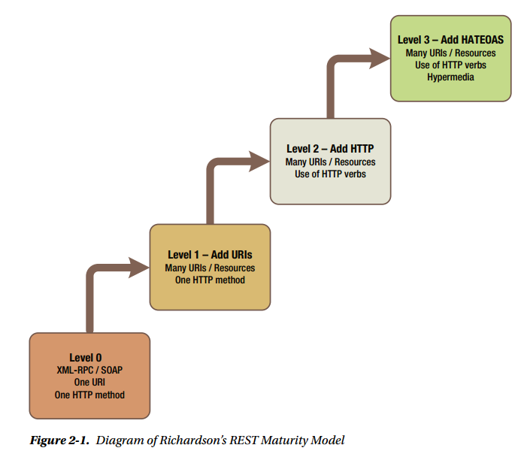

XML-PRC and SOAP
- At level 0, the API resembles most SOAP services. That is, the interface is characterized by having a single URI that supports only a single HTTP mothod or verb.
- At level 0, there's no sense of resource or resource addressability in the URI-- that is, there's no URI that points directly to a specific resource or list of resources.
- At level 0, the architecture also does not utilize HTTP verbs as intended. To be RESTFul on HTTP, you need to avoid creating custom actions and instead support actions that are consistent with HTTP. In other words, you need to use GET, PUT, POST, and DELETE...
- Finally, at level 0, the clients are required to know all of the available actions ahead of time. This means there is an implicit binding between client and server, in that the caller is dependent on a contract and a given set of actions from the service. Again, this does not feel very Web-like.
  - When you browse to a public website, all you are required to remember is the root address. From there, everything else is discoverable and linked to other elements via hypermedia(i.e., links and forms).
  - Indeed, hypermedia is the engine of application state. You can transition from one state to the next(where the state machine is a website or the broader Internet)based solely on links and forms. You are not required to remember or know ahead of time the specific addresses for all of the pages you intend to traverse.
  - The website should guide us thorugh available resources and provide all the information we need in order to make any changes or requests.
  - In short, the HATEOAS is key to a service's RESTfulness;
- URIs and Resources
  - Building a RESTful interface means you end up with an API that is very resource-centric. As such, you need to intentionally design the interface with resources being at the center.
  - Unlike RPC-style interfaces, where arbitrary service methods(i.e.,the verbs)and their associated request and response messages rule the day, a REST interface will revolve around the resources(i.e., the nouns).
  - The actions available to those resources are constrained by the use of HTTP. This is why you must map the available HTTP verbs into the API; you don't have the freedom to create other actions or verbs.
  - The concept above is central to a REST design.
  - After adding URIs and Resources to the design(level 1), we still must rely on specific messages for operations.The request message uses verbs to dictates actions.
- HTTP Verbs
  - You must look beyond URIs and their resources to the actions needed by the service. These actions will help you identify the HTTP verbs you need to use.
  - If you are going to follow the REST architecture and the HTTP protocol, you must choose from the verbs available in that protocol, namely:
    - GET
    - PUT
    - POST
    - DELETE
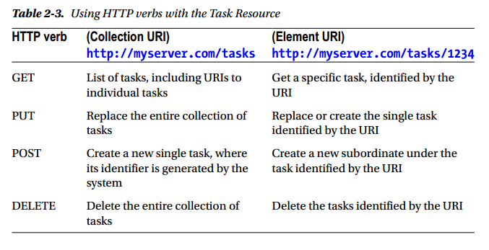
  - At this point(level 2), the service is utilizing unique URIs for individual resources and you've switched to using HTTP verbs instead of custom request message types. However, the client must still have prior knowledge of the API in order to traverse the domain and to perform any operations more complex than creating, updating, or completing a task.
  - In the true nature of the Web, you should instead fully guide the client, providing all available resources and actions via links and forms. This is what is meant by HATEOAS
- HATEOAS
  - Given a root or starting URI, the caller should be able to navigate the collection of resources without needing prior knowledge of the URI scheme.
  - Thus, whenever a resource is returned from the service, whether in a collection or by itself, the returned data should include the URI required to turn around and perform another GET to retrive just that resource for the caller.
- HTTP status
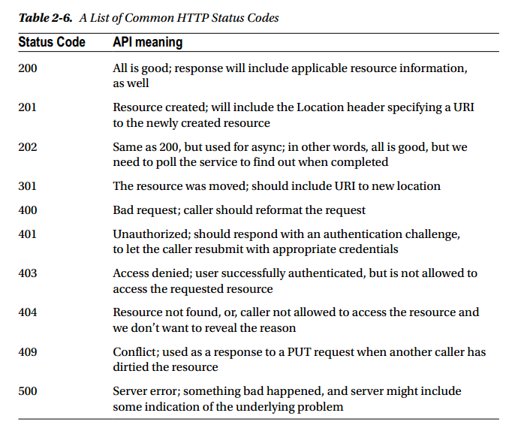

Chapter 3 Designing the Sample REST API
- The simplified steps to design an REST API(it pays to think it through and get it right)
  - modeling the types will be the most important part when creating a web service
  - first of all, create a table of resource types
  - determining the available HTTP actions, and associated URIs.
  - Modeling a database
- The Rest Maturity Model(RMM) by a programmer named Leonard Richardson
  - Using the maturity model will help you map from something most developers know—i.e., non-REST --into something new and different—i.e., REST.
  - You will also need to be on the outlook for the natural tendency to degenerate into an RPC API.
- Try to develop a Task Management service
  - Note that one of the guiding rules of the REST architecture is to avoid coupling the client to the server by sharing type definitions.
    - So even though you will be using classes within server code to represent the resources you receive from and send to the caller, these definitions are purely internal.
    - This is markedly different from SOAP, where a WSDL document defines all service interfaces, methods and their signatures, and all message types very explicitly.
    - The SOAP agreement is a contract, and it couples the client to the definitions on the server. But in REST you want to avoid this coupling as much as possible, and do your best to keep the "contractual" elements of your service constrained to those defined by the HTTP protocol(i.e., the HTTP verbs, using URIs for accessing resources, and utilizing hypermedia as the engine of application state).

