The Design of the Transport Module
prepared by Zhou Kai, 2014-09-26

Summary
The whole system is called the Freight Master, and the Transport is one module of it. The other modules are: Sea Freight, Air Freight, Finance and kinds of System Setting programs.
The entrance of the Freight Master System is a program called: System_Manager.exe, it simply is a windows form with a lot of menus and icons which are entrances of sub modules, including the Transport Module.
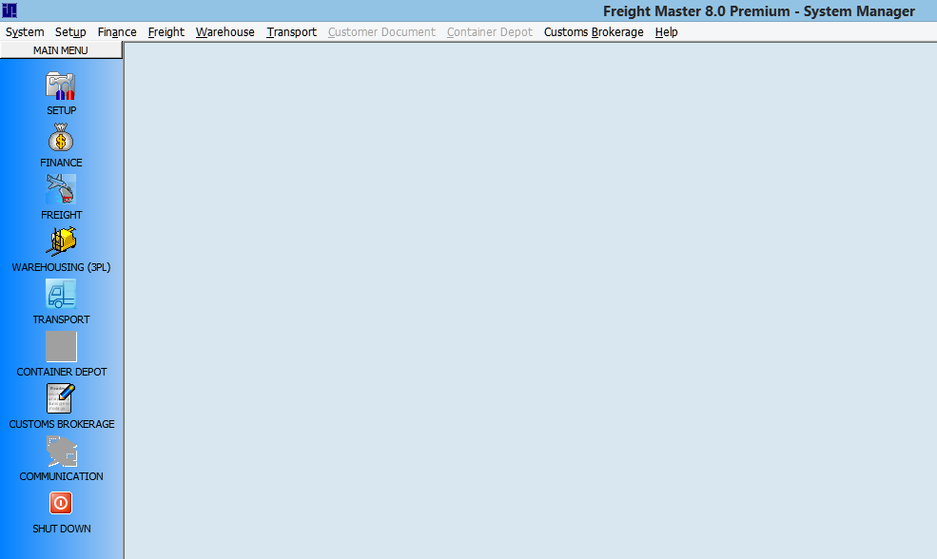
img_01 the System_Manager.exe
The System_Manager.exe manages the:
- User Login / Logout of the Freight Master System
- User access rights
- System wide settings, such as users access rights, system special settings and so on...
- Module specific settings, such as settings for the Transport Module or the Finance Module
- The entrances of other sub modules
Once the user login the Freight Master System via the System_Manager.exe, his / her information is registered in the Pubs database. And his / her module access rights are assigned depending on his / her role. The entrances of the modules are then enabled / disabled according to his / her access rights.
The user then clicks an icon or menu item to enter a module, the module then uses his / her login information to direct him / her to the correct SQL Server / database. And the user now can work on his / her data via the functionality of the sub module.

The Log in System
The log in logic consists two parts:
- Log in to the database(in order to get the user information for step 2)
- Log in to the Freight Master System(referred as the FMS in the following text)
An .ini file is provided to keep the instance names of SQL Servers and Databases:
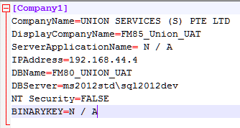
img_02 the System_Manager.ini file
For the whole FMS, we have one and only one System_Manager.ini file.
In the structure of the .ini file, the DisplayCompanyName is assumed to be unique(like a primary key), and each DisplayCompanyName corresponds to a combination of (CompanyName, IPAddress, DBServer, DBName), such combination is sufficient to identify an SQL Server / Database instance.
When the System_Manager.exe starts up, it reads all the DisplayCompanyName, and when the user selects one of them, the combination of(CompanyName, IPAddress, DBServer, DBName) is confirmed, but onlythe DBName is displayed(and it's read-only).
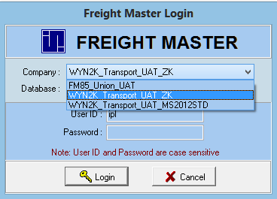
The last section of the .ini file is the user_id \ password used to login to the SQL Server \ Database combination.
Now that the use has selected a DisplayCompanyName, the DBName is determined, he / she is going to fillin the UserID and Password.
When the user clicks Login, the System_Manager.exe firstly gets the combination of (CompanyName, IPAddress, DBServer, DBName) from the .ini according to the DisplayCompanyName the user has chosen, and then gets the SQL Server login information from the last section of the .ini file(it's a user_id \ password pair).
If System_Manager.exe connected to the designate SQL Server \ Database instance correctly, it then uses the user_id and password the user keyed in to match the information in the database. If they match, the user is log in, and he / she is then registered in the Pubs database(The Pubs database is shared across a SQL Server). If they don't match, the user_id or password incorrect message will pop up. The user is left on the Log In UI.

Design Bugs of the Log In System
There are at least 3 bugs in the design of the Log In System.

Bug 1: The DisplayCompanyName in .ini file may duplicate
The DisplayCompanyName is served as the primary key, and assumed to be unique across the .ini file. But the user is allowed to define duplicated DisplayCompanyNames, if one user did so, the other won't know how to select among the duplicated DisplayCompanyNames.

Bug 2: There should be a user_id \ password for each DisplayCompanyName in the .ini file
Different DisplayCompanyName corresponds to different combination of ( CompanyName, IPAddress, DBServer, DBName), they won't always share the same user_id \ password.

Bug 3: There should be an Error Message for Database Connecting Failure for the System_Manager.exe
There are two steps as stated above when the user logs in via System_Manager.exe, but the error message appears only when the user connected to the SQL Server \ Database successfully but the user_id \ password do not match those in the database.
If the System_manager.exe failes at the first step, means when the Database Connecting failed, the user should also get an exact error message, saying that the program is not able to connect to the SQL Server \ Database, please either check the .ini or the SQL Server configuration.
Some knowledge on Connectiong a pgraom to a database

The Correct Design of the .ini should be:
[CompanyName]
[DisplayCompanyName]
[SQLServerIP]
[SQLServerName]
[DatabaseName]
[SQLLogInID]
[SQLLogInPSW]
For our client, if not a company group, they only have one CompanyName node. But they can have more than one DisplayCompanyName, the value of the DisplayCompanyName property can't duplicate(in XML, a property under one element can't have more than one value, although we're using .ini).

The Pubs Database
In the Log In System, there is another database called Pubs. It's shared across the SQL Server used by all databases under that SQL Server.
There is a table called: FM_Login. Once the user logs in successfully, it will be registered in this table, and when another user wants to login to the FMS using the same user_id, that user will fail because the user_id is already logged in.
I'm not sure what the System_Manager.exe checks is the user_id only or the combination of (user_id, DatabaseName), but I think we should allow the same user_id to work on different databases simultaneously.

The workflow of the Log In System

