Part 1: Introduction to Windows Forms

Chapter 1 Introduction to Windows Forms

Windows Development and .NET

Why Microsoft decided to deprecate all the APIs used by vast majority of programs?
- Win32 API itself is procedural with C function calls, hard to use.
- MFC or WTL, it's just not possible to write a non-trivial C++ windows application without having to deal with real Win32 API sooner or later.
- Visual Basic doesn't deal with Win32 API, but it relies on ActiveX controls or COM components to exploit certain platform services, which is fine when such a component exists, but when it doesn't exist, the VB developers must wait for a C++ developer to write them an ActiveX control.
- .NET, in .NET, the API itself is the second element---the platform's services are exposed through an object-oriented programming interface called the .NET Framework Class Library.

The Common Language Runtime and Managed Code

ILDASM.exe

Components
For a component system to be workable, it must define two things: what constitutes a component and how components communicate with one another.

The .NET Type System, reference types and value types
--> System.Object, all objects in .NET inherits directly or indirectly from it
--> System.ValueType, which inherits from System.Object, it contains value types such as enum, int, double and so on…
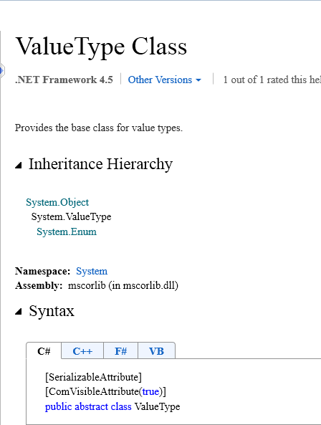

--> Boxing and unboxing. Boxing is to convert value types into reference types, unboxing is the way opposite. P.S. usually, the reference type is more efficient than value types when the data is huge

1.6 .NET Framework Class Library
--> System.Windows.Controls, the core object of the WinForm technology
--> System.Windows.Forms is a namespace, most classes inside it derive from Control class.
a. The Control class is also inside Forms namespace.
b. There's a class called Form, is inside Forms namespace, it derives from Control class repersents a windows form.
--> System.Drawing.Graphics : System.MarshalByRefObject : System.Object
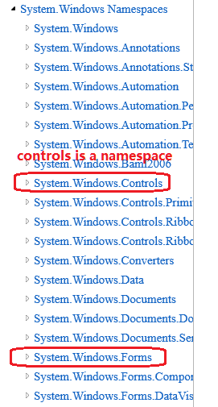
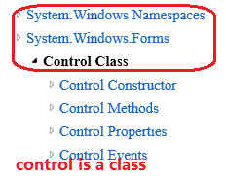
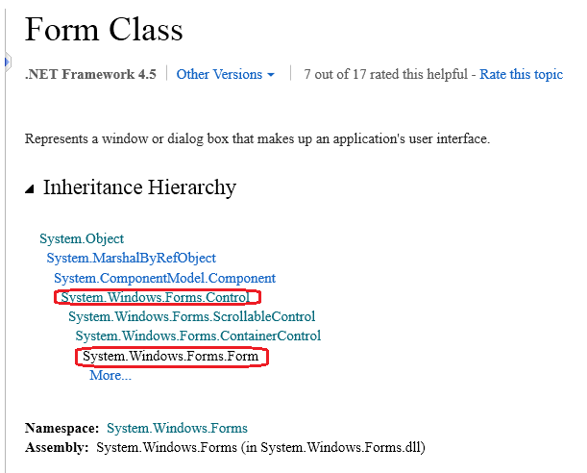
P.S. Controls and Forms are namespaces in System.Windows namespace. And Form, Control are two classes under System.Windows.Forms namespace

Chapter 2 Controls

2.1 Windows Forms and the Control Class
--> Each different type of user interface element is represented by a specialized class deriving from Control, either directly or indirectly.

2.2. Standard Control Features
→ Location and size, point, x, y, Width, Height
- Automatically layout, Anchor, Dock, Align… Layout containers
- Appearance, Color, Text, Images, Mouse cursors, Handling Input, Mouse Input
- Images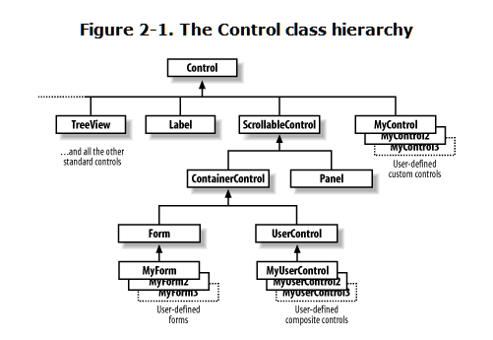
- Mouse cursors
- Input handling, mouse input, keyboard input
- Drag & drop, DataFormats.Text, DataFormats.UnicodeText, DataFormats.MetafilePict, DataObject, DataObject.SetData()
- Accessibility, to enable people with disabilities to use computers
- Validation: Validating, Validated event, CancelEventArgs object, CauseValidation property

Chapter 3. Forms, Containers, and Applications

3.1. Application Structure
All Windows Forms applications have something in common, regardless of whether they’re created with Visual studio or written from scratch, they:
- All have at least one form, the main application window
- All need to display the main form at start up
- Must be shut down correctly at the appropriate time.
3.1.1 Start up and shut down
> Application.Run(), [STAThread] static void Main(string [] args)
(what does “[STAThread]” do: http://stackoverflow.com/questions/1361033/what-does-stathread-do?newreg=366736122a754ef0a93d0b12e6f4481e)
> Application class, Application.Exit(), DoEvents(), ThreadException
> Environment class, Environment.GetCommandLineArgs

3.2 Forms and Threads
You can only use a control’s methods or properties from the thread on which it was created. In other words, you must never call any methods on a control from a worker thread. The only exceptions to this rule are calls to the Invoke, BeginInvoke methods and to the InvokeRequired property, which can all be used from any thread.

Chapter 10 Data Binding

1 definition of data binding:
a. The connection between a control property and a data source property is called a binding.
b. Any property of any control can be bound to any property of any data source, including any properties you define for your own controls.
c. A single control could have many bindings associated with it(In theory, each property associates with one data source property)
d. Any single control property cannot be bound to more than one data source.
e. A single data source property can be bound to any number of control properties.

2. Synchronizations between the data source property and the control property
a. when a control property changed, the associated data source property will always changes automatically
b. when a data source property changes, it looks for an associated event whose name will be the property's namae with "Changed" appended. And if such event exists, it will register an event handler, and every time the event is raised, it will refresh any controls that are bound to this data source property.
c.

