ProGit
Reading Notes by Zhou Kai

Chapter 1 Getting Started
- About Version Control
  - Version control is a system that records changes to a file or set of files over time so that you can recall specific version later.
  - Using a version control system generally means that if you screw things up or lose files, you can easily recover, with very little overhead.
- Local Version Control Systems(The VCS)
  - It's is to copy files into another directory on the same or another hard-disk or portable disk.
  - The local version control diagram:
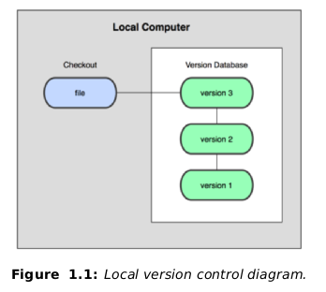
  - One of the most popular VCS tools was a system called rcs, which is still distributed with many computers today.
  - This tool(the tools like rcs) basically works by keeping patch sets(that is the differences between files) from one change to another in a special format on disk; it can then re-create what any file looked like at any point in time by adding up all the patches.

