The Messaging System Simulator Status
msss, 2015-03-21, ZK

Documentation

Business logic and technical documents
So far we have:
- Mr. Chong's document, on messages and message fields, called: “Innosys GPS Link Tpt module 20140716 Union Svcs.doc”.
- Growth Venture's latest document, called "Web Service Interface -Innosys and USP Ver 1.0.pdf", it's also about the messages and message fields. Besides, it contains screen-shot of the MDT(mobile device terminal).
- Zhou Kai's description on the message types, conventions and samples, called “Messaging_System_Samples.odt”. This document will be shared with Growth Venture, and we both can modify it.
- Zhou Kai's class diagram, called “Messaging_System_Simulator.asta, this is the class diagram, which is already been implemented in C#.
- Zhou Kai's message interaction diagram, it's a diagram describing message flows and user interactions. It's unfinished, it's meant to be optimized as we learn more on the logic.
- Zhou Kai's technical design document of the simulator, called “Design_of_The_Messaging_System.odt”, it contains the architecture of the simulator, including database tables design and class design.
- And other ad-hoc documents, recording temporary issues.
The documents are kept save with the help of a software called Git, and the layout of the documents on my local pc is:
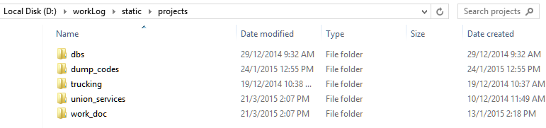
img 1.0: the root path of the project documents
And under work_doc, there are the messaging system related documents:
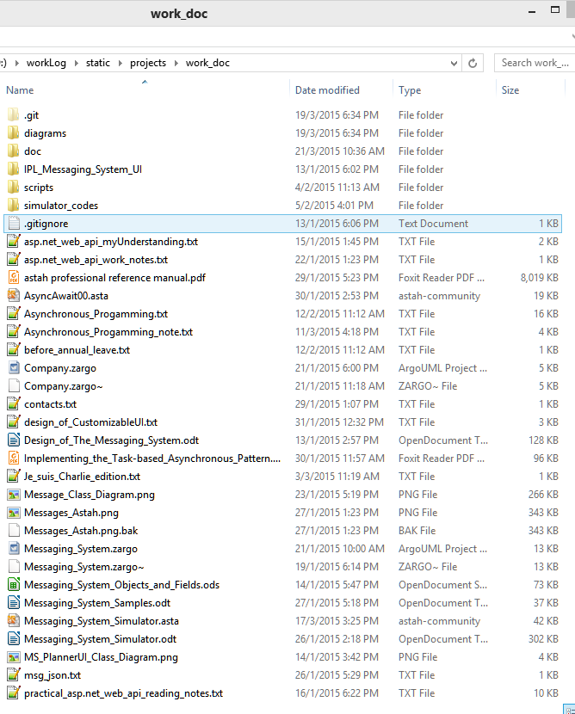
With the help of the documents, we always know where we are.

Source codes management

The code base

