**E9 Standard Operating Procedures**

**Table of Contents**

Table of Contents

Version History 3

1 Summary and terminologies 4

1.1. Roles in the daily production: 4

1.2. Resources: 4

1.3. Activities: 4

1.4. Terminologies: 5

2.0 Testing and Deployment Procedure 6

2.1 Testing Procedure Diagram – for support cases 7

2.2 Deployment Procedure Diagram 8

2.3 Production access 9

2.3.1 Project Centre cases 9

2.3.2 Production access diagram 9

3 Creating a local copy of Project Database 11

3.1 Diagram 11

4 Preventive measures and procedures regarding email function 11

5 Data Patching Procedures 12

6 Service Level Agreement for support cases 13

# Version History

|  |  |  |  |
| --- | --- | --- | --- |
| **Date** | **Description of change** | **Version** | **Author** |
| 19 Mar 2014 | Update | 1.0 | Ronnie Lee |
| 07 May 2014 | Page 5 of document to include source compare step | 1.1 | Ronnie Lee |
| 31 Mar 2015 | Reorganize paragraphs, update menu, add terminologies, font-type: Consolas | 1.2 | Zhou Kai |

# 1 Summary and terminologies

‘e9sop’ describes **roles** and their daily **activities** upon kinds of **resources** in earth9.

An activity is a role operates on certain resource, a procedure standard = the sequences of {role, operation, resource} combination. See the rest of chapter 1 for detailed definition of roles, activities, and resources.

## Roles in the daily production:

1. Customers
2. Developers
3. Senior developers
4. PM / PE
5. Head(Shirley and Ronnie)

## Resources:

1. Local pc
   1. Local database
   2. Local IDE
   3. Local source codes
   4. Test cases, test result screen shots, source code compares
   5. Deployment plan, scripts and other documentation
2. Staging environment
   1. UAT database
   2. The latest set of applications(version >= production server)
   3. Deployment plan
   4. MasterDepolyment.xls
3. Project centre
   1. Support cases(may require access to production server)
   2. MasterResourcePlan.xls
4. Production server
   1. Live database
   2. Live set of applications
5. Solar
   1. Production access approvals from clients
   2. Production access logs

## Activities:

1. Support cases opened in project centre
2. Support cases confirmed and assigned
3. Make a local copy of the UAT database
4. Coding
5. Unit testing
6. Verifying unit testing
7. Plan of deployment to staging environment
8. Access staging environment
9. Deploy to staging environment
10. System integrate testing
11. Test and confirm in Staging environment
12. Check in source codes into SVN
13. Plan of deployment to production server
14. Schedule development and update it to Solar
15. Update MasterDeployment.xls
16. Confirm development schedule with client and get approval for production server access.
17. Access production server, log
18. Deploy updates to production server, log
19. Close unnecessary applications, log, exit production server
20. Update production server access log to Solar
21. Verify data and inform clients
22. Close support case in Project centre

## Terminologies:

**Staging environment:** staging environment is a copy of the production server, but with two differences:

1. The version of applications, settings, configurations >= those of the production server
2. The data is not live data, but UAT data

PM / PE uses staging environment doing SIT, customers use it to verify and confirm fixes.

**Project centre:** an interface for clients and PM / PE to deal with support cases and upload production server access logs. (Sometimes, the developers also login to do some data patching, data extraction, bug validation under permission)

**Production server:** the live server running by the customers to run business.

**Solar:** a server where global logs are uploaded to.

The following chapters will describe the standards for each activity in sequenced text and diagrams.

# 2.0 Testing and Deployment Procedure

1. Developer to prepare unit test result before passing over to PM/PE for verification. (It can be simple screen shots with description).
2. Developer to prepare source compare for seniors to review before deploying to staging.
3. PM/PE to do SIT, screen shots as proof of testing and testing must be done on Staging Environment.
4. User Testing and acceptance confirmation.(From now all issues have to be deployed to staging and the user must test and verify and confirm ok, in order to assist the user provide the SIT with valid test cases where they can test in staging)
5. Deployment will only be done on Tuesday and Thursday (Exception to critical issues, PM/PE has to justify)
6. Developers are required to prepare the Deployment Plan (DB changes, code to deploy, data patching, web.config changes, SP changes, New SP, new table) as attached for PE or PM to go through at least 3 hours before deployment. Deployment plan must be as detailed as possible
7. All deployment schedules have to be supervised by a senior developer.
8. Developers will use the verified plan to do the deployment
9. PM/PE to update MasterDeployment excel for features and functionalities to deploy.
10. All the above document and activities must be in place before deployment.
11. Deviation requires approval from myself( If I am not around you may escalate to Shirley)

## Testing Procedure Diagram – for support cases

(ut & sit 🡪 staging 🡪 user verify & confirm 🡪 check in source codes)

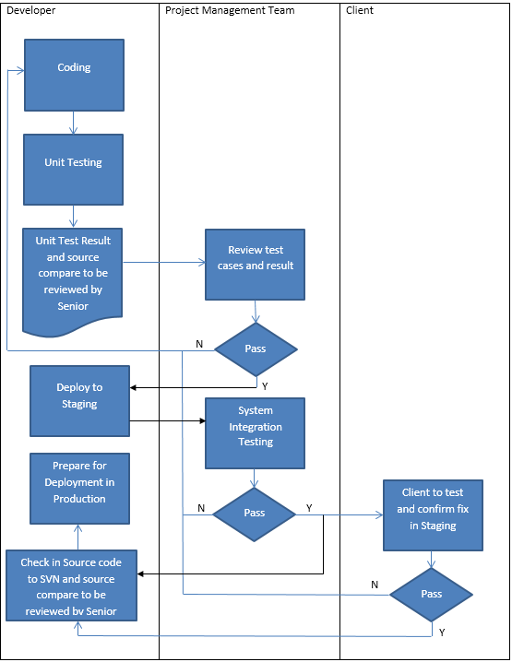

## Deployment Procedure Diagram

Lead time for deployment is 1 day for planned cases to prepare necessary document and database scripts.

(staging 🡪 production)

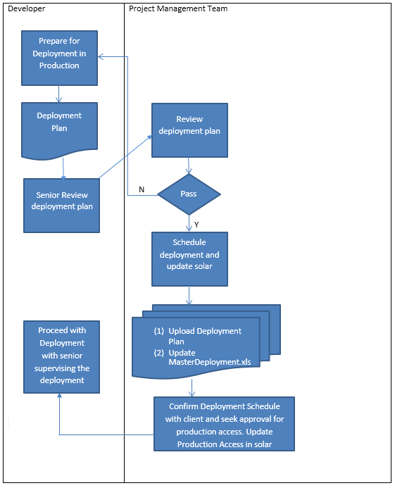

## Production access

## Project Centre cases

1. Data Patching
2. Data Extraction
3. Inquiry/Bug Validation
4. All cases must be logged in the project centre.
5. If case/request came from email, PM team is to advise client to log a case. Otherwise, PM team can log on behalf of client in the project centre and attach email received and advise client to do the same for future cases.
6. PM Team must assign case to respective developer according to Master resource plan.
7. If developer would need to access Production Server, there should be an acknowledgement email from client (e.g. email request, project centre case). Otherwise, seek permission from Ronnie or Shirley.
8. Developer must perform the following during Production Server access:
   1. Record login/logout time
   2. Screenshot before and after query result
   3. Save query
   4. Send collated document to PM team
9. Developer must close all application used in production server, unless there are dependencies on the application running.
10. PM team to log Production Access request in Solar

## Production access diagram

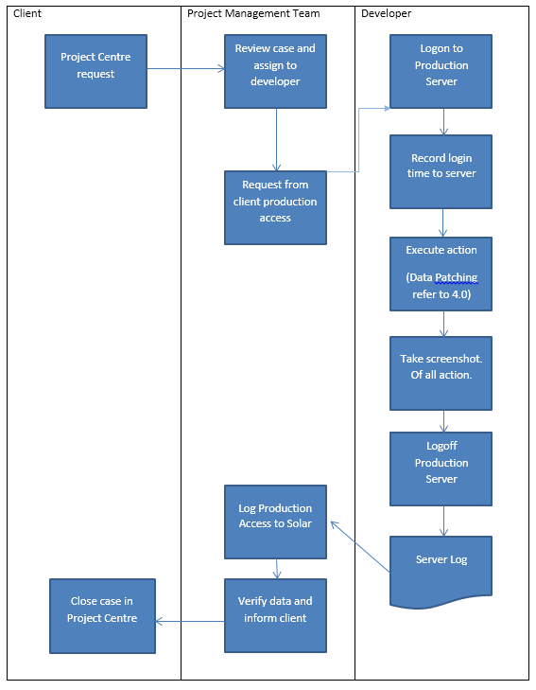

# Creating a local copy of Project Database

1. Developer cannot backup production server data
2. Developer must backup UAT server data.
3. For SG Enable project, no one is allowed to perform data extraction from Production Server. If necessary, seek permission from Project Group Head Ronnie.
   1. For SG Enable project, automated backup script can be used.
   2. Automated backup script is to be run by senior developers only (i.e. Wen Ming).
   3. For other projects, developers to perform backup database
   4. When developer restores backup database, all email address must be changed to earth9.com
4. Developer to send PM team proof of email fields changes (i.e. screenshot, excel file)

## Diagram

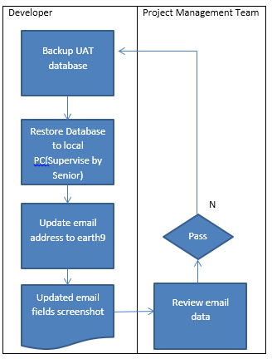

# Preventive measures and procedures regarding email function

1. ***Webconfig*** cannot be check out from SVN or check in to SVN.
2. Local PC ***web.config*** is set to read-only. ***Emailenabled*** set to False. Only administrator can have access to the web.config
3. Only senior developers will have local administrator rights.
4. If you need to check out a project that you do not have locally from SVN, you will need to request senior developer to place the web.config for that application to your PC, the senior developer will then restrict the access locally after placing it.
5. SMTP server must be disabled in the server.

# Data Patching Procedures

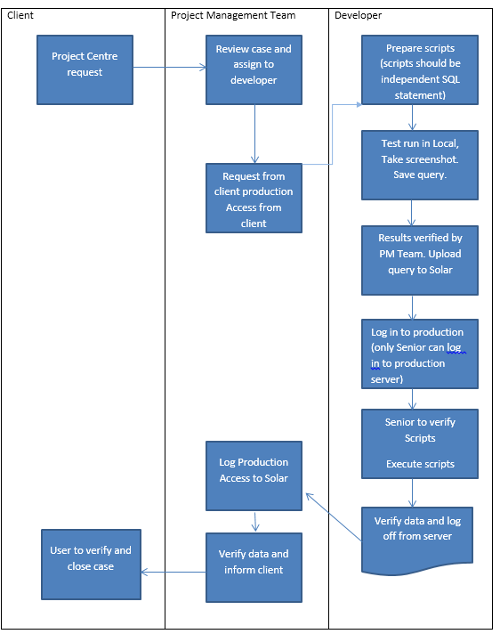

# Service Level Agreement for support cases

|  |  |  |  |
| --- | --- | --- | --- |
| **Priority** | **Rule** | **Example** | **Acknowledge / resolution** |
| **CRITICAL** | The issue has **CRITICAL** direct impact on **external customers** and**/**or **immediate** impact on **revenue.** The production environment is down and there is no business workaround.  A majority of external customers are not able to access the tool or Web site. | * Tool or site completely inaccessible to external customers * Loss of service or situations where a core part of the system fails to function and no business can be conducted * Customer privacy compromised | * Acknowledgement 2 hours(By Project Management Team) * Workaround 1 day * Solution 3 days * If a critical case is received PM team has to make a call immediately to the client to understand the issue further, and to analyse if it should be a critical case client should be advised to lower the priority. |
| **HIGH** | The issue has **SOME** direct impact onexternal customers and**/**or **immediate** impact on **revenue**.  The system is down; however there is a business process workaround.  Some external customers are not able to access the tool or Web site. | * + Loss of service or situations where a core part of the system fails to function but business can still be conducted   + Bad or missing customer data but business is still able to operate   + Critically degraded response time affecting the majority of external customers and internal users | * Acknowledgement 1 day(By Project Management Team) * Workaround 2 days * Solution 3 days * If a critical case is received PM team has to make a call immediately to the client to understand the issue further, and to analyse if it should be a critical case client should be advised to lower the priority. |
| **MEDIUM** | The issue has nodirect impact on external customer, and/or no **immediate** impact on **revenue.** A majority of internal users are not able to access/use certain functions of the tool or Web site. | * + Unable to view reports or inaccurate reports   + Internal users encounter errors when using certain functions of the tool | * Acknowledgement 1 day(By project management Team) * Solution 5 days |
| **LOW** | The issue has nodirect impact on external customer, and/or no **immediate** impact on **revenue.** Some internal users are not able to access/use certain functions of the tool or Web site. | * + Research or informational request on process or contacts   + Creation of database or objects in an existing database   + General usability questions not addressed in documentation   + Enhancement, change or training requests | * Acknowledgement 3 day(By project management Team) * Solution 10 days * Please note 10 days should not be used up fully if the developer do not have many cases being assigned. This will be monitored. |