The Design of the Messaging System Simulator
Table of Contents
Requirements analysis 1
The three parties 1
The activities of the three parties 1
Specifications of the Simulator 2
Back ends and front ends 2
MS_PlannerUI 2
MS_GrowthVentureUI 2
MS_DriverUI 3
MS_GeneralWebAPIClient 3
MS_GenralWebAPIServer 3
Object-oriented Design of the applications(Draft) 3
Database tables design 4

Requirements analysis

The three parties
The Messaging System simulator(referred as the Simulator hereafter) is used to simulate the three parties and their activities in the Messaging System:
- Transport Module
- Union Services Driver
- Growth Venture

The activities of the three parties
And the activities are:
- Transport Module
  - Create trip plans on the scheduler control.
  - Send messages to Growth Venture indicating 1 or some trips are ready to be carried out. → Msg1
  - Receive “job request” messages from Growth Venture
  - Send "proceed" message to Growth Venture when Growth Venture forwarded a valid job request from Union Service Driver. → Msg2
  - Send “retry” message to Growth Venture when Growth Venture forwarded an invalid job request from Union Service Driver. → Msg3
- Union Service Driver
  - Receive messages(work instructions) from Growth Venture, and those instructions are based on Msg1.
  - Send “acknowledged” message to Growth Venture when he / she received Msg4. → Msg5
  - Send “job request” message to Growth Venture when he / she confirms a job and before he / she proceeds to do the job. → Msg6
  - Receive Msg2 or Msg3.
  - Optional, resend Msg6.
- Growth Venture
  - Receive Msg1, and stores it
  - Send message to Union Services driver saying there are jobs available. → Msg7
  - Receive Msg6, format it and forward it to Transport Module. → Msg8
  - Forward Msg2 or Msg3 to Union Services driver → Msg9
These 3 parties will be implemented as individual applications, and distributed on different computers on the Internet. And they communicate via the HTTP protocol.

Specifications of the Simulator

Back ends and front ends
Create a general ASP.NET Web Server for all three parties, it'll listen to and process all the messages sending throughout the Messaging System, as the back end.
Create a general Web API Client package for all three parties to send messages.
Create a .NET WinForm solution for all visible User Interfaces for each party, as the front ends.
The .NET WinForm solution will have 3 projects: MS_Planner, MS_Driver and MS_GrowthVenture. The 3 projects will be compiled into 3 applications, and these 3 applications can be distributed into different computers. The front end is for each party to send or receive messages.

MS_PlannerUI
The MS_Planner application provides the scheduler control to the planner, the planner creates plans on it and send messages(Msg1) to MS_GrowthVenture Web API server.

MS_GrowthVentureUI
The MS_GrowthVenture application monitors the messages flow. It has a Message Monitoring Form which displays all unprocessed messages. The user can select one of the messages and click send(Msg7).

MS_DriverUI
The MS_Driver application provides the driver with a MDT form, such MDT form works exactly likes the physical MDT device.

MS_GeneralWebAPIClient
The MS_GeneralClientWebAPI application wraps a .NET HttpClient class, and it will be used to send all kinds of messages for all parties.

MS_GenralWebAPIServer
The MS_GeneralServerWebAPI application will be deployed to IIS(the Internet Information Service) as the back-end of the Simulator. It will keep listening to all message flows and dispatch the messages to correct front-end.

Object-oriented Design of the applications(Draft)
The basic ideas of OOD are:
- Make use of the existing packages in the Transport Module
- Identify and classify all messages in the Messaging System into Message Types
- Create a class for each of the Message Type, for details of each message type, please refer to another document: Messaging_Systems_object_Fields.ods.
- When there are new message type entered the ring, just add another class to represent it, all the existing messages will not be affected.
- When an existing message is going to be changed(e.g. adding fields), only the corresponding class is due to be changed. All the rest messages are not affected.
- The Class Diagram of an Sea-Export Message as an example:
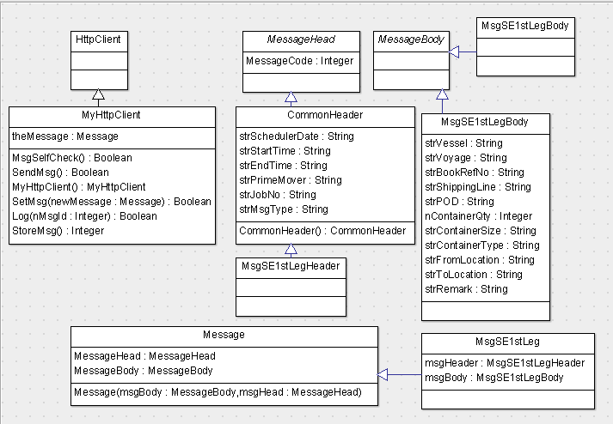

Database tables design
The basic ideas of database tables design are:
- Identify and classify all messages in the Messaging System into Message Types
- Create a database table for each Message Type
- So that when one of the message in the Messaging System is subject to be changed(possible), we only modify that single table, the rest tables, messages will not be affected.

