2015-03-30
this is a small demo of the functions of the messaging system simulator(mss)

1 The planner UI, select a date first, we choose 2014-11-24:
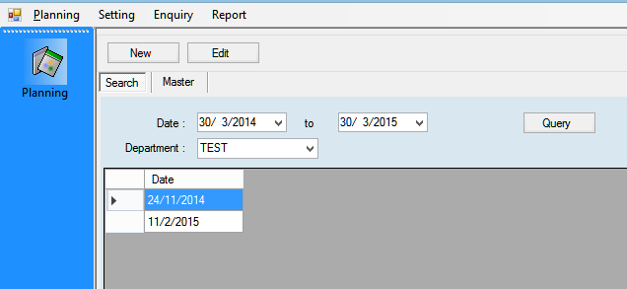
2 Go to the schedule control page:
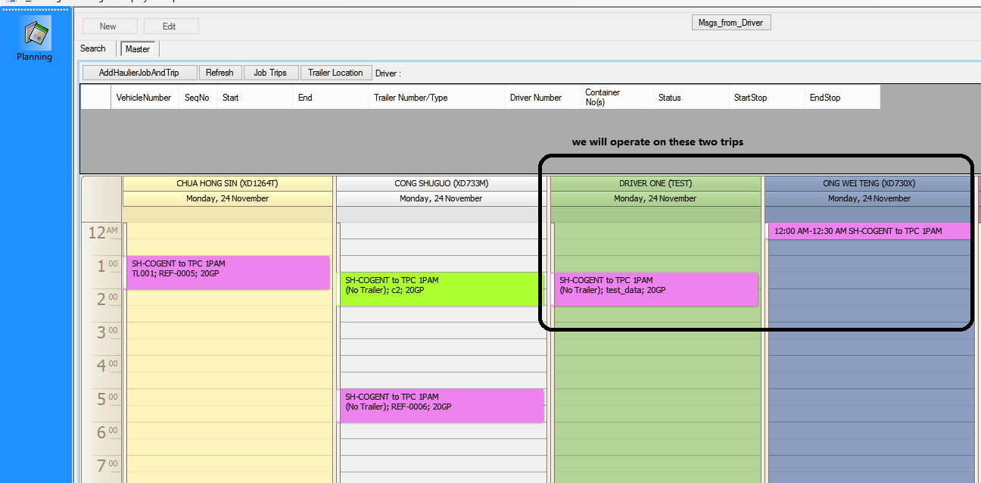
3 See trip details of the two trips highlighted in black frame:
In the details, we have job number, job trip sequence number.
And we also have a new button called "send message".
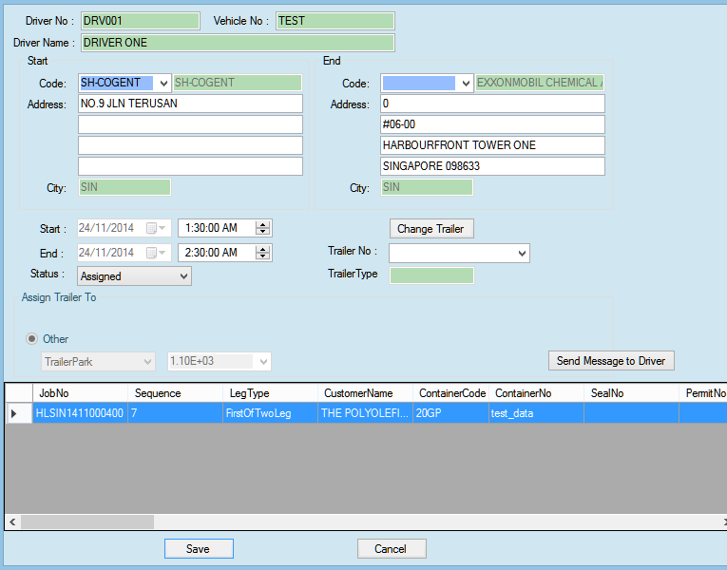
4 the details of the other trip:
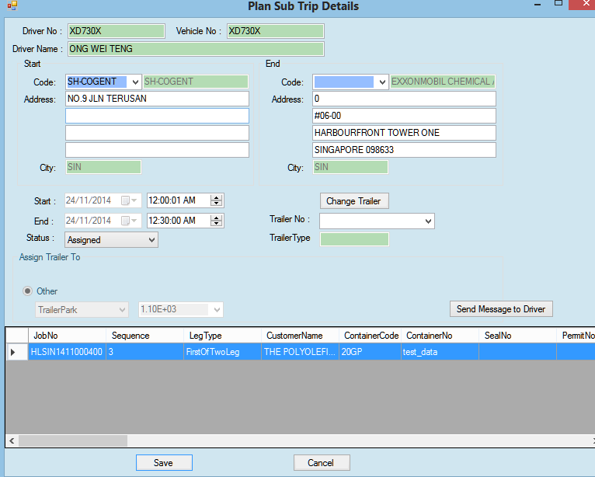
5 The MDT simulator:
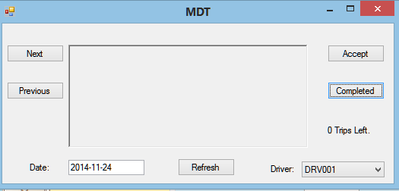
first, we fill in the date, then we will have all the available drivers on that date listed to the bottom-right corner.

6 We can open multiple drivers and they work on the same time.
But none of the drivers have any messages so far, we will send messages from the planner side.
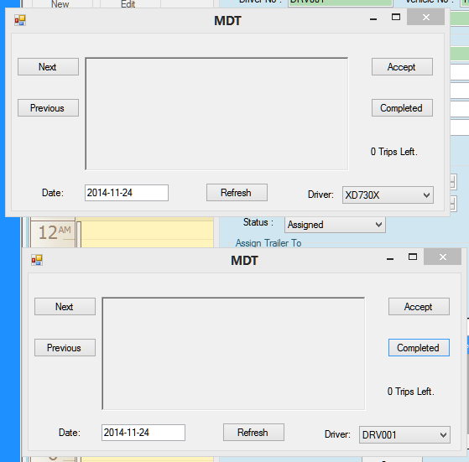
7 We send a trip to the driver:
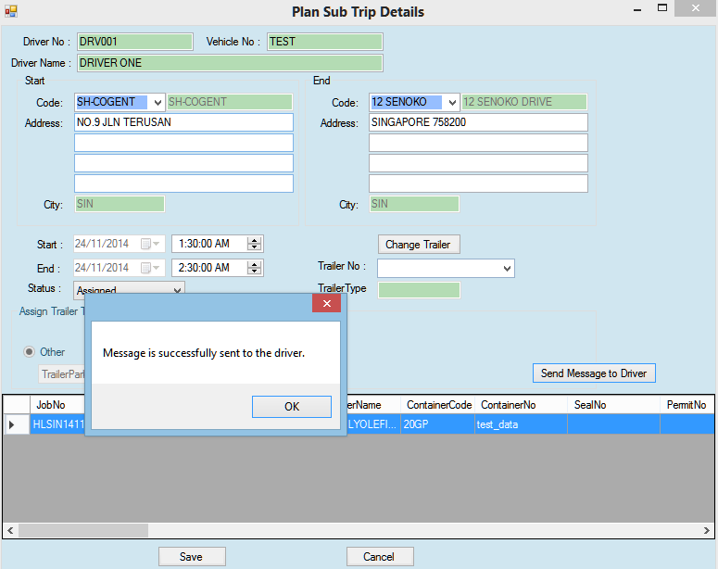
If the planner click the button “Send Message” again, the program will refuse, because the trip is already sent to the driver.
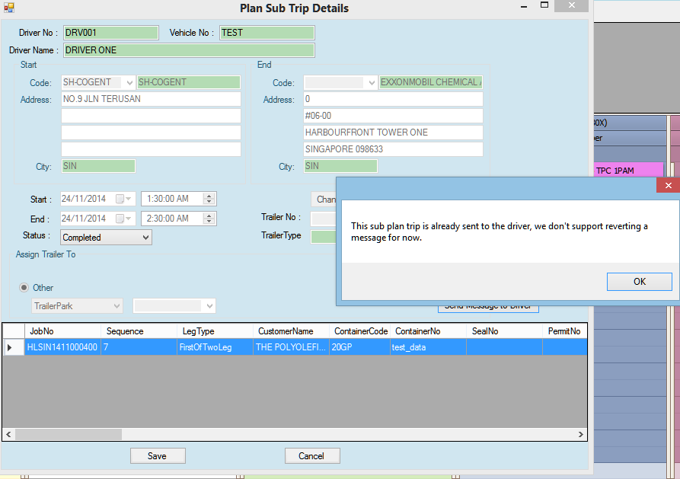

8 The trip is sent to the driver via web service. But the planner has no response message from the driver so far.
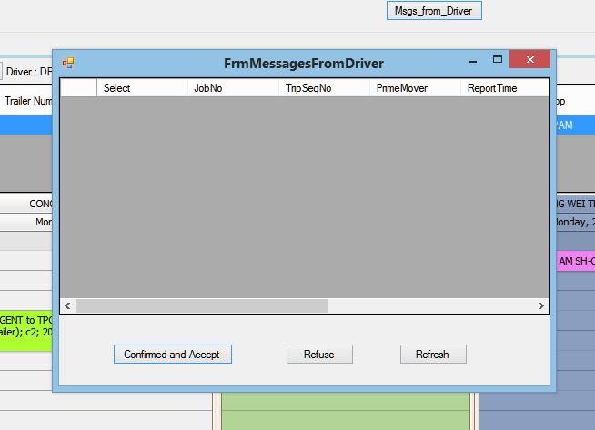

9. Now the correct driver has got a message, the other driver has none.

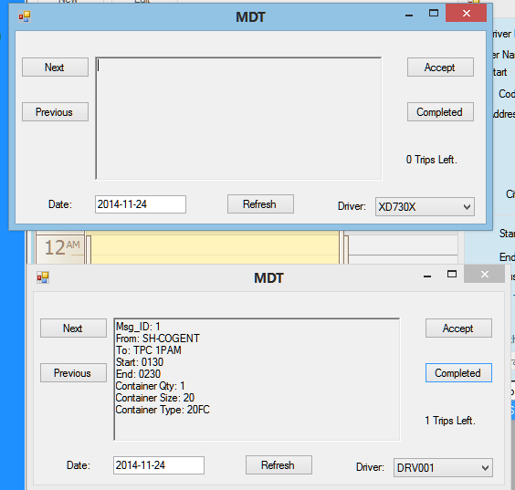
10. The two drivers we opened just now:
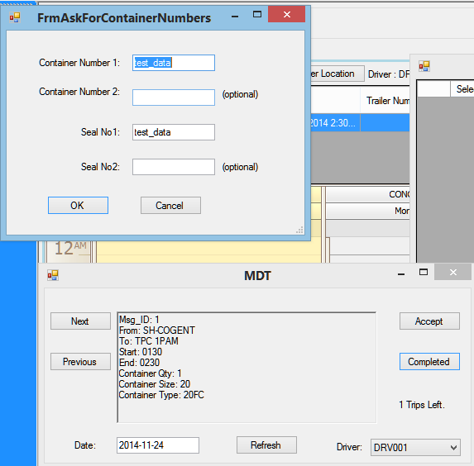
Now Driver001 press button “Completed” to send a message to the planner.
To tell the planner the trip is completed.
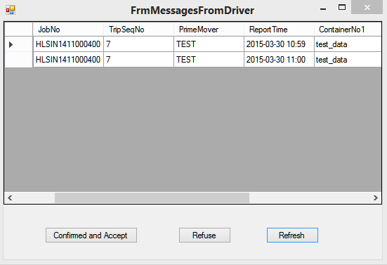
Now the planner got 2 messages from the driver. The two messages are of the same trip, only the report time is different. Which means the driver clicked “Complete” twice.

11 Now it's the planner to verify if the trip information is correct. If so, the planner will accept the complete message from the driver, and the above two message will be gone from the list.
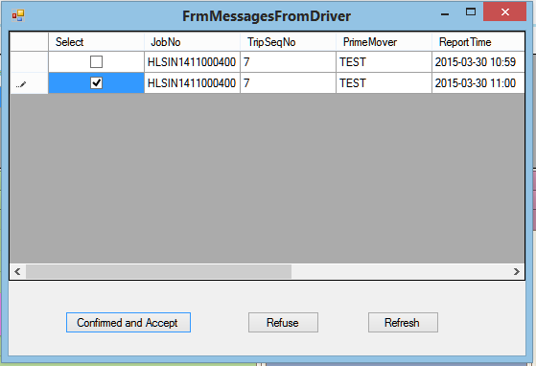
the planner selected the second message, and click “Confirm and Accept”

12. The planner clicked confirm and accept, so the program prompt that the planner to refresh the UI because the data is updated.
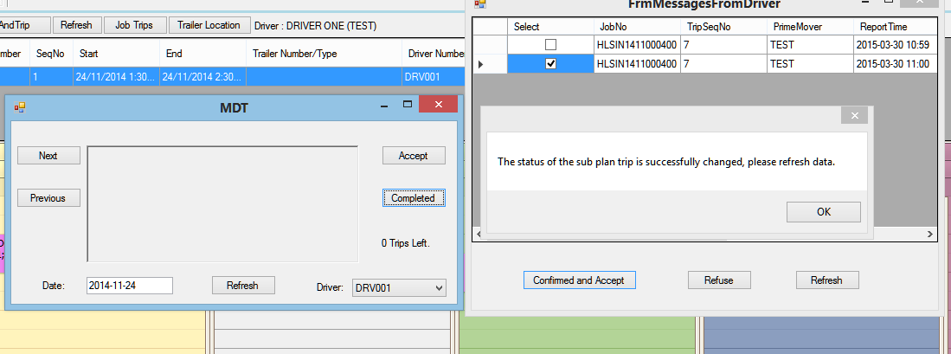
see the above picture, the driver has no message now, because he completed the instruction(message) just now.

13 And the schedule control is also updated(the trip is set to yellow, which means it's completed):
