Design of the Messaging System
prepared by Zhou Kai, IPL
Table of Contents
Requirement Analysis 2
A Brief Introduction to the Messaging System 2
Typical Use Cases of the Messaging System 2
New User Interface Required 2
Other Requirements 3
System Design 4
Components of the Messaging System 4
Front Ends and Back Ends 4
Message Flow 4
New User Interface 5
Implementation Specifications 6
New Projects and Classes 6
Details on each new project and class 6
MS_Simulator Project 6
MS_Simulator_BLL Project 7
TripInstruction01 Class 7
The CreateTripInstruction() Method 7
TripUpdate01 Class 8
GetAllUnprocessedTripUpdates() Method 8
PerformTripUpdate() Method 8
TPT_PlanningUI Project 8
TPT_Planning_BLL Project 8
Database Tables Design 9
MS_TripInstruction01_Tbl 9
MS_TripUpdate01_Tbl 9

Requirement Analysis

A Brief Introduction to the Messaging System
The Messaging System is a set of functions and service. It provides a solution for the planners in the office, and the drivers in their vehicles to cooperate using information technology.
It enables the planners to send instructions to his or her drivers, and receive real-time updates from drivers.
The Messaging System also records all the messages sent and received by each party for audit purpose.

Typical Use Cases of the Messaging System
There are only two users of the System: the planner and the driver.
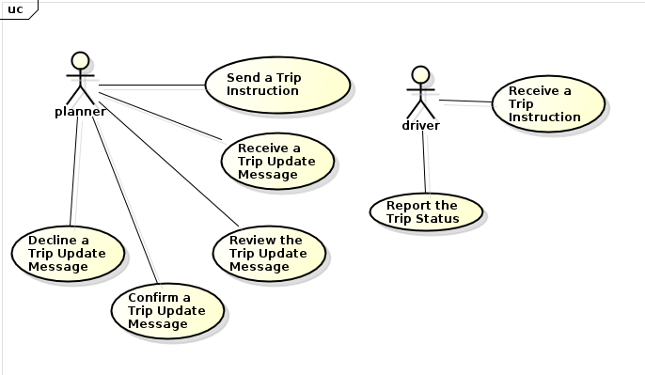
Img 1.0 Use Case Diagram

New User Interface Required
There will be new user interface for the user(the planner) to send, retrieve and process HTTP messages.
- A new button, to send a job trip to a driver as a Job Trip Instruction.
- A new text-box, to key in remarks attached with the Trip Instruction.
- A new form, to retrieve all in-coming Trip Update messages from the driver. This form also provides functions to process a message.
- A new form, to send casual messages to a driver.
- Friendly prompt messages after each operation, to give the user(planner) a clue.

Other Requirements
All the message flow will be recorded in database for auditing.
Provide friendly user interface for the planner to retrieve incoming Trip Update messages and historically messages.
Always give intuitive prompts to the user(the planner) when his or her operation either succeeded or failed
If succeeded, tells the planner what data has been updated explicitly; if failed, tells how to deal with the failure -- always provide a clue to the user.

System Design

Components of the Messaging System
The Messaging System is not a signle application, it is a solution built on top of the existing Transport Application project, plus two other projects:
The ASP.NET Web API 2 project plus a new class library project. So the architecture of the Messaging System can be simplified as(in project level):
The Messaging System Solution
|-- The Messaging System
|-- Innosys Pte Ltd Side
|-- The Transport Application UI --> it's a WinForm application project
|-- The Transport Application class library --> it's a class library project
|-- MS_Simulator --> it's a ASP.NET Web API 2 projects
|-- MS_Simulator_BLL --> it's a class library
|-- Growth Venture Side
|-- The Mobile Device Terminal --> the MDT, UI for drivers
|-- A Web Service --> listening to Trip Instructions from The Transport Application.
These projects can be divided into two categories, the front ends and the back ends.

Front Ends and Back Ends
Front ends are designed for the users to interact with the system, and back ends are designed to support the functionalities(such as sending and receiving messages).
- Front end: the Transport Application, the TA. The planner uses it.
- Front end: the Mobile Device Terminal, the MDT. The vehicle driver uses it.
- Back end: the Web Service hosted by Innosys Pte Ltd, the WS_IPL. Listen to Trip Update messages from Growth Venture side.
- Back edn: the Web Serivce hosted by Growth Venture, the WS_GV. Listen to Trip Instruction messages from the Transport Application.
IPL only handles the TA and the WS_IPL, so this document only describes TA and WS_IPL.

Message Flow
The message-flow is defined as below:
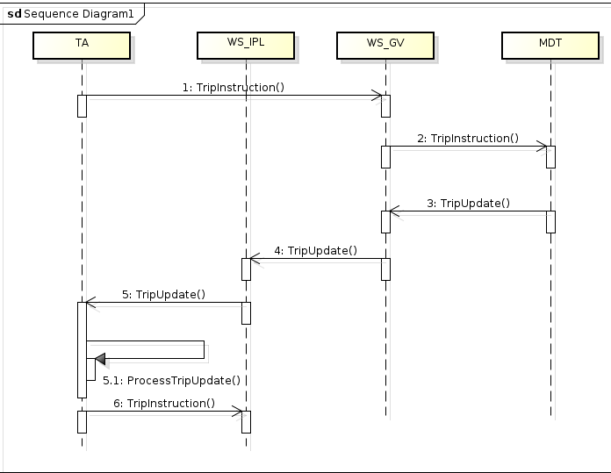
Img 2.0 sequence diagram
A brief explanation of the above sequence diagram:
- The planner initializes the message-flow by sending a message called a Job Trip Instruction via the front end: the TA.
- WS_GV receives and forwards the instruction to the corresponding driver at the background.
- The driver, on receiving the instruction, starts to work on the Job Trip, and report trip information to the TA by sending messages via the front end, the MDT. Such messages are called the Trip Update messages.
- Before reaching the TA the front end, the Trip Update message goes through WS_GV and WS_IPL the back ends first.
- The planner on TA side verifies the Trip Update messages, and proceed with Confirming or Declining the trip update accordingly. (When the planner confirms the trip update message, the business data will be updated accordingly, while if the planner declines it, a remark will be attached to the driver, the driver will have to send the trip update message again).

New User Interface
Attach some screen-shots of the new user interface here.

Implementation Specifications

New Projects and Classes
Add two new projects to the current TA solution: the first one is an ASP.NET Web API 2 project called MS_Simulator, the other is a class library, called MS_Simulator_BLL.
The MS_Simulator project represents an MVC architecture, it keeps listening to Trip Update messages.
The MS_Simulator_BLL project is a class library. It contains the entity model and business logic for the MS_Simulator project.
The class diagram:
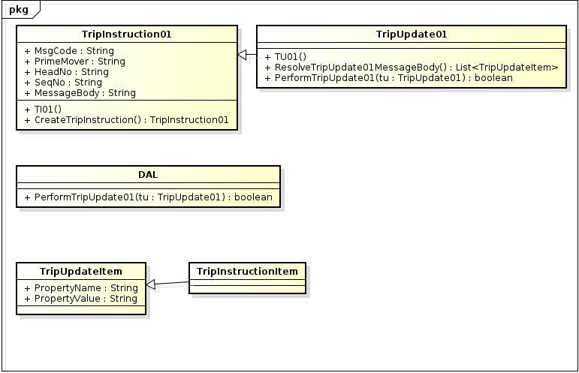
img2.0 class diagram

Details on each new project and class

MS_Simulator Project
It's an ASP.NET Web API project, serves as the back end, keeps listening to Trip Update messages from Growth Venture side.
It has a typical MVC architecture, there is only one default web page testifies that the web service is up and running well in View. The Controller contains only one controller named: TripUpdate01Controller.cs, which is used to redirect incoming Trip Update messages to Models in MS_Simulator_BLL project(which contains business logic) to process.
So MS_Simulator project only listens and forwards the Trip Update messages.

MS_Simulator_BLL Project
It's a class library, serves as the Model of the MS_Simulator web service. It contains entity models and business logic. It represents messages, validate messages, update messages to database, and so on. It's the place where in-coming messages are processed.
It contains these classes: TripInstruction01, TripUpdate01, TripInstructionItem, TripUpdateItem, DAL.

TripInstruction01 Class
TripInstruction01 class represents a Job Trip Instruction sent by the planner. It contains five fields:
Field Name | Field Meanning | Remarks
MsgCode | Identify the message type. | For now, it's always "TI01".
PrimeMover | The prime mover number, decides the destination of the message. | “Instruction” and “Message” is used interchangeably in this document.
HeadNo | It's either the HaulierJobNo or CarrierReferenceNo, it's company based(or installation based). | Once decided, it cannot be changed.
SeqNo | It's the Trip Sequence No, uniquely identifies a job trip of a certain Haulier Job. | Together with HeadNo, a job trip is globally identified.
MessageBody | It's the detailed information of an Instruction. Such as start and end location of this trip, how many containers should be carried, remarks, and so on. | Instructions for different Job Trip types contains different fields. For example, instructions for the 2nd leg of an Sea-Export job should contain container number in the message body, while instructions for the 1st leg only contains container quantity and container type.
Table 1.0 Fields of TripInstruction01 class

The CreateTripInstruction() Method
It's a public method, it has two parameters: a PlanHaulierSubTrip object, and a string of PlannerId. The logic of this method is:
- Get a list of HaulierJobTrip inside the PlanHaulierSubTrip object
- Generate the common fields for each job trip instruction: MsgCode(always “TI01”), PrimeMover, PlannerId(passed in).
- For each HaulierJobTrip, generate the HeadNo, SeqNo fields.
- Following Step 3, continue to generate the MessageBody field. Detect the leg type first, and see Appendix A for the required fields different types of leg type. Use '^' as the separator to concatenate all the required fields, and it's the MessageBody. And the whole TripInstruction01 object is initialized, each HaulierJobTrip corresponds to a TripInstruction01 object.
- Put all the TripInstruction01 objects into a List, and return that List.
This method is critical, when the planner clicks the button to send a Trip Instruction, it is invoked.

TripUpdate01 Class
This class represents a Job Update message from the driver. It contains exactly the same fields as TripInstruction01 class does. The only difference is the fields(or say formats)of the Message Body, see Appendix B.

GetAllUnprocessedTripUpdates() Method
This method gets all un-processed Trip Updates. The new form FrmTripUpdates.cs will show these un-processed Trip Update objects, and the planner can select one of them, see its details, choose Confirm or Decline it.

PerformTripUpdate() Method
When the planner selects a Trip Update object, reviewed and confirms it, this method is going to perform the data update operation.
The method has a TripUpdate object as parameter, it resolves the TripUpdate object first, and generate the T-Sql string, pass it to DAL class and perform the database operation finally.
After this method is invoked, the user(planner) will be asked to Refresh the daily plan screen.

TPT_PlanningUI Project
It's the front end of TA, served as user interface for the planner to manipulate daily plans and deal with messages.
On the form FrmPlanHaulierSubTrip, add a button called SendTripToDriver. The planner clicks this button to send a Trip Instruction to the corresponding driver.
There will be a text-box to attach remarks with that Trip Instruction.
There will be a independent form, for the planner to review and manipulate incoming Trip Update messages.
There will be a form to retrieve historical in-coming and out-going messages.
Attach screen-shots of TransportUI here:

TPT_Planning_BLL Project
A few methods will be added to the file: PlanHaulierSubTrip.cs.
public Action SendTripInstruction(object toBeSent);
public void SendTripInstrcutionAsync();

Database Tables Design
Two database tables will be added to the existing database design:

MS_TripInstruction01_Tbl
Field Name | Date Type | Meaning of The Field
Msg_Code | nvarchar(4)
Prime_Mover | nvarchar(8)
Head_Number | nvarchar(26)
Seq_Number | nvarchar(7)
Planner_Id | nvarchar(10)
Msg_Time | char(19)
Message_Body | nvarchar(250) | This is the only field be displayed on MDT, the remark from planner will be incorporated in this field.
Status | smallint | Represents the status of this instruction, it can be 0:Accepted, 1:Started, 2:Rejected, 3:Ongoing, 4:Completed, 5:Canceled,6:Failed, and so on...
Table 2.0 MS_TripInstruction01_Tbl

MS_TripUpdate01_Tbl
Has the same database table design as MS_TripInstruction01_Tbl.

