The Design of the Messaging System
for Transport Module to Work With Growth Venture for Union Services, document by Zhou Kai
Table of Contents
Summary 3
What is the Messaging System 3
The roles involved in the Messaging System 4
The Message Flows 5
Sea-Export message flow 5
Sea-Import message flow 6
Hubing Job message flow 8
Fields and formats of each messages 9
Format Conventions 9
Sea-Export Job messages 9
Msg1 9
Msg2 9
Msg3 9
Msg4 10
Msg5 10
Msg6 10
Msg7 10
Msg8 11
Sea-Import Job messages 11
In special, if for displaying on a MDT device 11
There are 2 other kinds of special messages 11
What is MDT 11
The architecture and class diagram of the Messaging System 12
Terminologies 15

Summary
This document describes the flows, fields and formats of the messages in the Messaging System.
It also describes the OOD(Object-oriented Design) of the Messaging System.
After reading the document, the reader(programmers / supports / project manager) should know what is the messaging system, how it works and the detailed design of its implementation.

What is the Messaging System
The Messaging System is an individual package that it can be used to send and receive HTTP messages.
In our case, Union Services planners and drivers will use our Messaging System to send and receive messages(work instructions and feedback). And the Messaging System package is integrated to the Transport Module.

The roles involved in the Messaging System
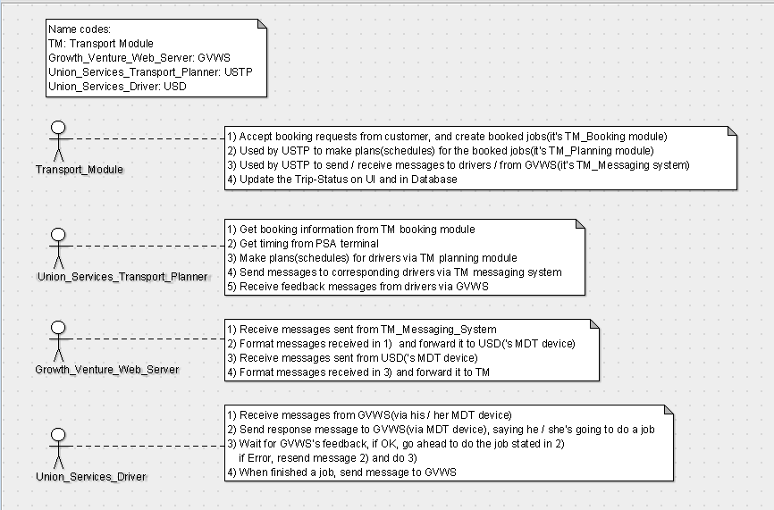

The Message Flows
When Union Services does Sea-Export / Sea-Import haulage jobs, messages are sent / received by the Messaging System among Transport Module, Growth Venture Web Server, and Union Services drivers(who interface with the MDT device).

Sea-Export message flow
For a Sea-Export Job:
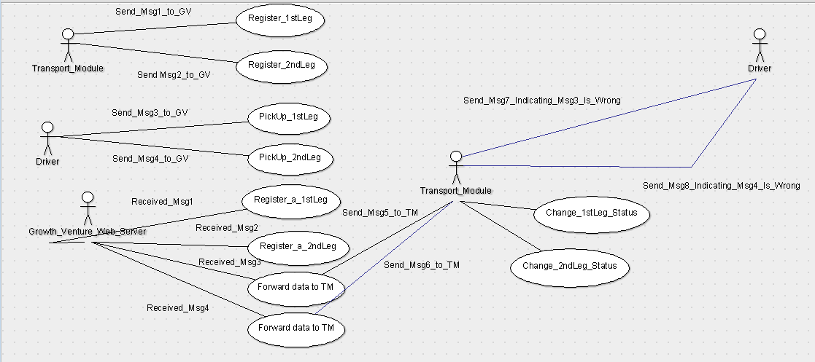
Msg1:
Transport Module sends registering message to Growth Venture, indicating that a number of containers are booked, and to be carried out by its drivers from the container yard to the customer side later on.
Msg2:
Transport Module sends registering message to Growth Venture, indicating that a number of containers are to be carried out by its drivers from the customer side to port later on.
Msg3:
The driver sends verifying message from MDT to Growth Venture, says that he / she is going to pick up 1(or 2) container(s) with the following information:
1) Reference → the last 5 characters of the Booking Ref No
2) Container Number → 1 or 2 container numbers, separated by '–' if there are 2
3) Seal Number → 1 or 2 seal numbers, separate by '–' if there are 2
4) Trailer number → up to 5 characters of trailer reference(only this field is not mandatory)
The driver will then wait for Growth Venture<1> to verify the message.
Msg4:
The driver sends verifying message from MDT to Growth Venture, says that he / she is going to pick up 1(or 2) container(s) with the following information:
1) Reference → the last 5 characters of the Booking Ref No
2) Container Number → 1 or 2 container numbers, separated by '–' if there are 2
3) Seal Number → 1 or 2 seal numbers, separate by '–' if there are 2
4) Trailer number → not mandatory for the second leg
The driver will then wait for Growth Venture<1> to verify the message.
Msg5:
The forwarding message, Growth Venture forwards Msg3 to Transport Module to verify if the Msg3 sent by Driver is correct.
Msg6:
The forwarding message, Growth Venture forwards Msg4 to Transport Module to verify if the Msg3 sent by Driver is correct.
Msg7:
The feedback message, from Growth Venture to Driver(MDT device), red light blinks, indicating that Msg3 is wrong, prompt the driver to re-key in.
Msg8:
The feedback message, from Growth Venture to Driver(MDT device), red light blinks, indicating that Msg4 is wrong, prompt the driver to re-key in.
Notice that, after Msg5 / Msg6, if Transport Module accepted the data delivered by Msg3 / Msg4, the Transport Module will proceed to change the Leg-Status.
**** Notice that, for Msg5 / Msg6
If we implement the Transport Module Messaging System as a pure client, then Growth Venture cannot forward messages to it, because a client does not listen.
So the it(the Messaging System) has to fetch data periodically from Growth Venture and decides if the drivers have sent any data(Msg3 / Msg4) to Growth Venture.
If yes, pops up a windows form, the planner verifies and decides whether accepting it:
>> If yes, go ahead to change the Leg-Status on schedule-control and in database;
>> If no, give feedback to the driver indicating that the driver may have picked up a wrong container(s)(via Msg7 / Msg8).

Sea-Import message flow
For a Sea-Import job:
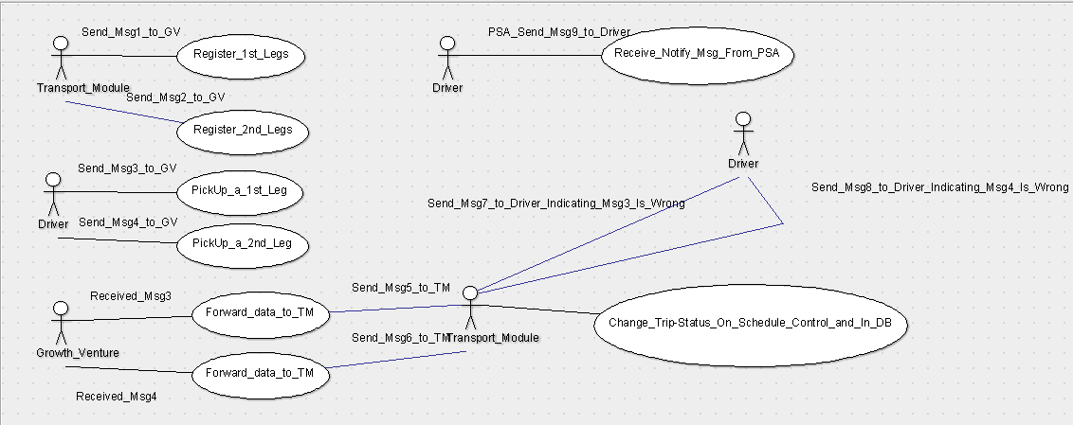
Msg1:
Transport Module sends registering message to Growth Venture, indicating that a number of containers are booked, and to be carried out by its drivers from the port to the container yard later on.
Msg2:
Transport Module sends registering message to Growth Venture, indicating that a number of containers are to be carried out by its drivers from the customer side to container yard later on.
Msg3:
The driver sends verifying message from MDT to Growth Venture, says that he / she is going to pick up 1(or 2) container(s) with the following information:
1) Reference → blank
2) Container Number → 1 or 2 container numbers, separated by '–' if there are 2
3) Seal Number → 1 or 2 seal numbers, separate by '–' if there are 2
4) Trailer number → no need
The driver will then wait for Growth Venture<1> to verify the message.
Msg4:
The driver sends verifying message from MDT to Growth Venture, says that he / she is going to pick up 1(or 2) container(s) with the following information:
1) Reference → the last 5 characters of the Booking Ref No, where is it from??
2) Container Number → 1 or 2 container numbers, separated by '–' if there are 2
3) Seal Number → 1 or 2 seal numbers, separate by '–' if there are 2
4) Trailer number → no need
The driver will then wait for Growth Venture<1> to verify the message.
Msg5:
The forwarding message, Growth Venture forwards Msg3 to Transport Module to verify if the Msg3 sent by Driver is correct.
Msg6:
The forwarding message, Growth Venture forwards Msg4 to Transport Module to verify if the Msg3 sent by Driver is correct.
Msg7:
The feedback message, from Growth Venture to Driver(MDT device), red light blinks, indicating that Msg3 is wrong, prompt the driver to re-key in.
Msg8:
The feedback message, from Growth Venture to Driver(MDT device), red light blinks, indicating that Msg4 is wrong, prompt the driver to re-key in.
Notice that, after Msg5 / Msg6, if Transport Module accepted the data delivered by Msg3 / Msg4, the Transport Module will proceed to change the Leg-Status.
**** Notice that, for Msg5 / Msg6
If we implement the Transport Module Messaging System as a pure client, then Growth Venture cannot forward messages to it, because a client does not listen.
So it(the Messaging System) has to fetch data periodically(WHICH MEANS GV NEEDS TO AGREE TO STORE ITS DATA SOMEWHERE, INSTEAD OF FORWARDING THE DATA ONLY) from Growth Venture and decides if the drivers have sent any data(Msg3 / Msg4) to Growth Venture.
If yes, pops up a windows form, the planner verifies and decides whether accepting it:
>> If accept, go ahead to change the Leg-Status on schedule-control and in database;
>> If do not accept, give feedback to the driver indicating that the driver may have picked up a wrong container(s)(via Msg7 / Msg8).

Hubing Job message flow
Undone

Fields and formats of each messages
In the Messaging System, all messages should have a header(cannot be empty) and a body(may be empty). The messages will be forwarded and formated internally, and have a limitation of the maximum length to be 310 characters.

Format Conventions
XYZ: the value is literally itself
(): the content in () is going to be filled in with value
{}: the content in {} is the format and maximum length of the field
<>: the content in <> is the special symbol to separate two fields.
For example: SAMPLE<space>(MSGCODE){2 digits}<space>(SCHEDATE){yyyy-MM-dd}<space> may be translated to: SAMPLE 79 2014-12-30

Sea-Export Job messages

Msg1
Transport Module sends registering message to Growth Venture, indicating that a number of containers are booked, and to be carried out by its drivers from the container yard to the customer side later on.
Msg Header:
(MSGCODE){2 digits}<space>(SCHEDATE){yyyy-MM-dd,10 chars}<space>(PRIMOVER){8 chars}<space>(JOBNO){26 chars}<space>(SEQNO){7 chars}
Msg Body:
COL<space>VSEL-VOYG:(VSEL-VOYG){vessel-voyage, 71 chars}<space>BKREF:(BKREF){20 chars}<space>AGT:(ShippingLine){20 chars}<space>POD:(PortOfDestination){15 chars}<space>CONT:(ContainerInfo){ContainerQty-Size-Type, 15 chars}<space>FROM:(FromLocation){12 chars}<space>TO:(ToLocation){12 chars}<space>REMARK:(Remark){30 chars}
An example of Msg1:
79 2014-12-30 PM000001 HLSIN1412000200 0001 COL VESEL-VOYG:vessel0001-voyage0001 BKREF:bookingref0001 AGT: shippingline0001 POD:pod0001 CONT:2-20-20FC FROM:CHINA TO:SIN REMARK:remark0001

Msg2
Transport Module sends registering message to Growth Venture, indicating that a number of containers are to be carried out by its drivers from the customer side to port later on.
Msg header:
(MSGCODE){2 digits}<space>(SCHEDATE){yyyy-MM-dd,10 chars}<space>(PRIMOVER){8 chars}<space>(JOBNO){26 chars}<space>(SEQNO){7 chars}
Msg Body:
EXP<space>CONT:(Container_info){ContainerQty-Size-Type, 15 chars}<space>FROM:(From location){12 chars}<space>To:(To location){12 chars}<space>RMK:(remark){30 chars}

Msg3
The driver sends verifying message from MDT to Growth Venture, says that he / she is going to pick up 1(or 2) container(s).
Msg header:
(Reference){last 5 chars of BKREFNO}<space>(ContainerNumber){containerNo1-containerNo2, <= 20 chars}<space>(SealNo){sealNo1-sealNo2, <= 20 chars}<space>(TrailerNumber){last 5 chars of Trailer Reference number}
Msg body:
No message body

Msg4
The driver sends verifying message from MDT to Growth Venture, says that he / she is going to pick up 1(or 2) container(s).
Msg header:
(Reference){blank}<space>(ContainerNumber){containerNo1-containerNo2, <= 20 chars}<space>(SealNo){sealNo1-sealNo2, <= 20 chars}
Msg body:
No message body

Msg5
The forwarding message, Growth Venture forwards Msg3 to Transport Module to verify if the Msg3 sent by Driver is correct.
Msg header:
(MSGCODE){2 digits}<space>(SCHEDATE){yyyy-MM-dd,10 chars}<space>(PRIMOVER){8 chars}<space>(JOBNO){26 chars}<space>(SEQNO){7 chars}(BKREFNO){5 chars}<space>(ContainerInfo){containerNo1-containerNo2, <= 20 chars}<space>(SealNumbers){SealNo1-SealNo2, <=20 chars}<space>(TrailerNumber){last 5 chars of the trailer reference number}

Msg6
The forwarding message, Growth Venture forwards Msg4 to Transport Module to verify if the Msg3 sent by Driver is correct.
Msg header:
(MSGCODE){2 digits}<space>(SCHEDATE){yyyy-MM-dd,10 chars}<space>(PRIMOVER){8 chars}<space>(JOBNO){26 chars}<space>(SEQNO){7 chars}<space>(BKREFNO){5 chars}<space>(ContainerInfo){containerNo1-containerNo2, <= 20 chars}<space>(SealInfo){SealNo1-SealNo2, <=20 chars}<space>(TrailerNumber){last 5 chars of the trailer reference number}
Msg body:
No message body

Msg7
The feedback message, from Growth Venture to Driver(MDT device), red light blinks, indicating that Msg3 is wrong, prompt the driver to re-key in.
Msg header:
(MSGCODE){2 digits}<space>(SCHEDATE){yyyy-MM-dd,10 chars}<space>(PRIMOVER){8 chars}<space>(JOBNO){26 chars}<space>(SEQNO){7 chars}<space>
Msg body:
(MSGBODY){<= 320 chars}

Msg8
The feedback message, from Growth Venture to Driver(MDT device), red light blinks, indicating that Msg4 is wrong, prompt the driver to re-key in.
Msg header:
(MSGCODE){2 digits}<space>(SCHEDATE){yyyy-MM-dd,10 chars}<space>(PRIMOVER){8 chars}<space>(JOBNO){26 chars}<space>(SEQNO){7 chars}<space>
Msg body:
(MSGBODY){<= 320 chars}

Sea-Import Job messages

In special, if for displaying on a MDT device
The messages should be formated to 4 lines, and 20 characters at most each line:
1) Reference Number(booking reference number)
2) Container Number
3) Seal Number
4) Trailer Number

There are 2 other kinds of special messages
1) Union_Services manual message, this kind of messages are sent by Union_Services from the Transport Module to MDT device directly. The format is:
a) MSGCODE, the message code, 2 digits
b) SCHEDATE, the schedule date, in yyyy-MM-dd format
c) PRIMOVER, the prime-mover name or reference
d) JOBNO, optional, default to blank
e) SEQNO, optional, default to blank
f) MSGBODY, the message body, not exceeding 320??? characters
2) PSA notifying message, not clear yet, it's beyond the Messaging System. It is that the PSA sending messages to Union_Services drivers(but how??) says that some containers are ready to be picked up.

What is MDT
MDT is a device fixed on a vehicle, the driver use it to receive / send messages from Transport Module / Growth Venture Server.
It can only display 4 lines of text, each 20 characters at most.

The architecture and class diagram of the Messaging System
(Draft only)
The architecture:
(1) The Messaging System will be an individual class library package added to the Transport Module, the Transport Module can access and invoke the classes and functions within the Messaging System package.
|--Transport Module
|----Marketing
|----Haulage
|------Haulage Booking
|------Haulage Planning
|----Trucking
|------Trucking Booking
|------Trucking Planning
|----Messaging System
(2) Inside the package
a) There will be a MyHttpClient class, which wraps the HttpClient class of the DOT NET Framework, by adding new fields and functions.
b) Create a class for each Message, for example: class SeaExportMsg1, SeaExportMsg2, SeaExportMsg3... By separating each message into an individual class so each source-code file won't get too long, it helps to make the source codes to be loose coupled, the codes will be more maintainable, testable and reusable. And inside each message class, there will be its own fields and functions to process / format its own field values.
c) Create a data access layer, to help the Transport Module to achieve the new database operations. In this way, we separate the new database operations solely for the Messaging System from those for the existing logic.
d) Create a Logger class, to record each critical operations.
(3) So the structure will be:

|--Transport Module
|----Marketing
|----Haulage
|------Haulage Booking
|------Haulage Planning
|----Trucking
|------Trucking Booking
|------Trucking Planning
|----Messaging System
|------MyHttpClient(folder)
|--------MyHttpClient
|------SeaExportMessages(folder)
|--------SeaExportMsg1
|--------SeaExportMsg2
|--------SeaExportMsg3
|--------SeaExportMsg4
|------SeaImportMessages(folder)
|--------SeaImportMsg1
|--------SeaImportMsg2
|--------SeaImportMsg3

|--------SeaImportMsg4

|------DataAccessLayer(folder)

|---------CRUD (create, replace, update, delete operations)

|------Logger(folder)

|----------Logger

(4) Database tables design:

a)Create a table for each kind of message, for example SeaExportMsg1_Tbl, Sea-ExportMsg2_Tbl, Sea-ImportMsg1_Tbl... The advantage of doing so are:

>> each message can have its own fields

>> when there are new kind of messages added into the messaging system, we just add a class for it and a corresponding table for it, the existing messages are not affected

>> when there are modifications to one of the existing messages, we just modify that class and the table for that messages, the existing messages are not affected

>> in this way, our system is very loose coupled and very flexible, it's also very testable and maintainable

>> notice that, the message sender will not be included in a message, but the receiver(the driver_id) should be. And in the table for each message, there should a column with a string as type, to store either message sender(planner_id) or message receiver(driver_id).

b)Create a table to store the “raw data”. This table will store the table name + MessageID + MessageDateTime only, and (table_name, MessageID) is the primary key.

C)the logging table is not considered now

Terminologies

