Documentation – DTD Data Pipeline and Model Implementation

Overall Approach, Workflow Design, Assumptions and Limitations

1.1 Overall Approach
The project implements an end-to-end pipeline for extending the historical dataset and calculating Greentown China Holdings Limited’s Distance-to-Default (DTD). The workflow separates raw data ingestion, validation, transformation, DTD calculation and presentation so that the historical dataset can be updated incrementally rather than rebuilt manually for each new trading day.
The supplied historical data and model parameters are treated as the starting point. New observations are collected from public data sources, transformed into a format consistent with the historical inputs, validated, and appended to the processed dataset. DTD is then calculated using the Merton-model framework and the supplied model parameters. CRI’s historical DTD is used as a reference for comparison and interpretation.
The Streamlit interface provides a simple front end for running the pipeline to a selected cutoff date and reviewing the resulting calculations.

1.2 Workflow Design
The project is organised into separate raw, processed and source-code components.
`data/raw/` stores source inputs, including the original historical dataset, model parameters and manually maintained financial-statement updates.
`data/processed/` contains pipeline-generated datasets. `dtd_inputs.csv` stores the combined and transformed inputs used by the model, while `dtd_output.csv` stores the resulting DTD calculations and related model outputs.
The source code separates the main responsibilities of the pipeline:
- Data ingestion: `ingestion.py` retrieves external market and risk-free-rate data from the relevant public data sources.
- Data preparation: `data_prepare.py` loads manually maintained financial-statement inputs, aligns them and newly ingested market data with the historical dataset, applies required transformations, and carries forward financial information when no new statement is available.
- Validation: `validation.py` checks the required fields and data quality before model calculation.
- DTD calculation: `dtd.py` calculates implied asset value and DTD using the supplied parameters.
- Application layer: `app.py` coordinates the update process and displays the resulting data through Streamlit.
For the first pipeline run, the raw historical dataset can be used as the base and extended with newly collected observations up to the selected cutoff date through the ‘Build From Raw’ button. For subsequent incremental updates, the existing processed dataset can be used as the base where available through the ‘Build From Processed’ button, and only the additional observations required to extend it to the new cutoff date are collected and processed. This design avoids repeatedly reconstructing the full historical dataset while preserving the raw historical data as the initial starting point.

1.3 Key Assumptions
Several assumptions are made across the data preparation, model implementation, incremental-update workflow and event-study analysis.
Data and model parameters. The supplied historical dataset and model parameters are treated as the starting point for the analysis. The supplied parameters are used directly to reproduce CRI's published DTD. CRI's DTD series is therefore treated as a reference for comparison and analysis, not as a target for parameter fitting.
Financial-statement inputs. Financial-statement variables are assumed to remain applicable until new financial information becomes available. Between reporting dates, the latest available financial inputs are carried forward. This enables daily DTD calculation despite the lower reporting frequency of accounting information and avoids introducing information before its availability date.
DTD calculation. The selected market and accounting variables are assumed to provide reasonable proxies for the inputs required by the model. Market capitalisation is derived from closing share prices and shares outstanding, while the 364-day Exchange Fund Bill yield is used as the risk-free-rate proxy. The time horizon to default, τ, is assumed to be one year, and the supplied equity volatility, σ, is treated as annualised, consistent with the one-year modelling horizon.
Event-study interpretation. The event-study analysis assumes that movements in DTD can provide information about changes in perceived credit risk, but does not assume that individual movements are caused by specific corporate events. DTD may respond simultaneously to changes in equity value, volatility, leverage, interest rates and broader market conditions. Event-level comparisons are therefore interpreted as associations rather than definitive causal relationships.

1.4 Limitations
Mixed data frequencies. The pipeline combines inputs with different publication frequencies. Market variables can respond immediately to new information, whereas financial-statement variables remain unchanged between reporting dates. Consequently, daily changes in DTD between reporting dates are primarily driven by market-based inputs rather than contemporaneous changes in the firm's reported financial position.
Dependence on external data sources. The pipeline relies on external public data sources whose availability, format and observations are outside the control of the implementation. Temporary API failures, publication delays or differences between data providers may affect data retrieval or create small discrepancies relative to CRI's reference data.
Shares-outstanding assumption. The use of the latest shares-outstanding figure for market-cap calculations is only appropriate where the share count remains unchanged over the relevant batch-update period, as verified for Greentown in this project. This approach should not be applied to stocks whose shares outstanding change during the period; in such cases, historical shares-outstanding figures corresponding to each date would be required.
Model and interpretation limitations. DTD is a model-based credit-risk indicator whose movements reflect changes in multiple inputs, including market capitalisation, equity volatility, liabilities and interest rates. It therefore does not directly measure default probability or changes in reported financial performance. Accordingly, in the event study, DTD is interpreted alongside publicly available information as one indicator of credit risk, rather than treating individual DTD movements as definitive evidence of changes in the firm's credit quality.

Data Sources and Processing Methodology

2.1 Market Data
Daily equity-price data are obtained using Yahoo Finance (yfinance). Closing prices are combined with the latest shares-outstanding figure to calculate market capitalisation. When extending the dataset from the historical data in batch, shares outstanding were verified over the full period that no change occurred. For subsequent daily incremental updates, the latest available shares-outstanding figure is therefore used directly.
Using Yahoo Finance makes automated daily updating straightforward and avoids manual collection of market prices. The trade-off is that its historical observations can occasionally differ from the data source underlying CRI's calculations for unusual trading sessions. In the observations reviewed, such discrepancies were associated with trading days for which Yahoo Finance reports zero trading volume, particularly Hong Kong half-day trading sessions (eg. 24 December 2025 and 31 December 2025). Outside these identified zero-volume observations, no discrepancy was observed during the period reviewed.

2.2 Risk-Free Rate
The risk-free-rate input is based on the Hong Kong Monetary Authority (HKMA) Exchange Fund Bills 364-day yield (`efb_364d`).
The HKMA API provides the historical series through its Monthly Statistical Bulletin data, which covers observations through the end of the latest available monthly reporting period. These API observations are used as the primary source where available. However, requests to the API often fail due to timeouts or HTTP errors.
For more recent trading dates not yet covered by the monthly series, or when the HKMA API is unavailable, data are obtained from the HKMA Daily Monetary Statistics archive as a fallback source. The pipeline downloads the corresponding Indicative Pricing file and extracts the yield of the longest-maturity Exchange Fund Bill, which is consistent with the corresponding risk-free-rate observations provided in the CRI dataset. These daily statistics are refreshed at approximately 2:30 PM on each business day.
The design prioritises the official HKMA source throughout while allowing the pipeline to extend through recent trading dates before those observations enter the monthly historical dataset. The main trade-off is additional ingestion complexity because the two official HKMA sources require different retrieval procedures.

2.3 Financial-Statement Data
Financial-statement inputs are manually maintained in:
data/raw/financial_updates.csv
The underlying source is official financial reporting published through HKEXnews. Manual entry was chosen because financial statements are released infrequently and only two updates are required per year. This also allows the relevant balance-sheet fields to be checked directly against company filings rather than relying on a third-party financial-data provider.
The financial statements are reported in CNY, whereas the model inputs require HKD values. The relevant financial variables are therefore converted to HKD using the next day FX following the financial reporting period date, which was inferred from the financial statement values provided by CRI.
Each financial update has an availability date. Once information becomes available, it is applied to subsequent daily observations until a newer financial statement becomes available. This prevents the pipeline from using future accounting information before it would have been observable to the market.

DTD Output Comparison
The calculated DTD series was compared against the DTD values provided by CRI to validate the implementation and assess the effect of independently updating the model inputs. The comparison covers 677 trading dates from 2 January 2024 to 2 October 2026. Detailed comparison results are available in data/processed/comparison.csv, with the comparison and diagnostic analysis implemented in notebooks/comparison.ipynb.
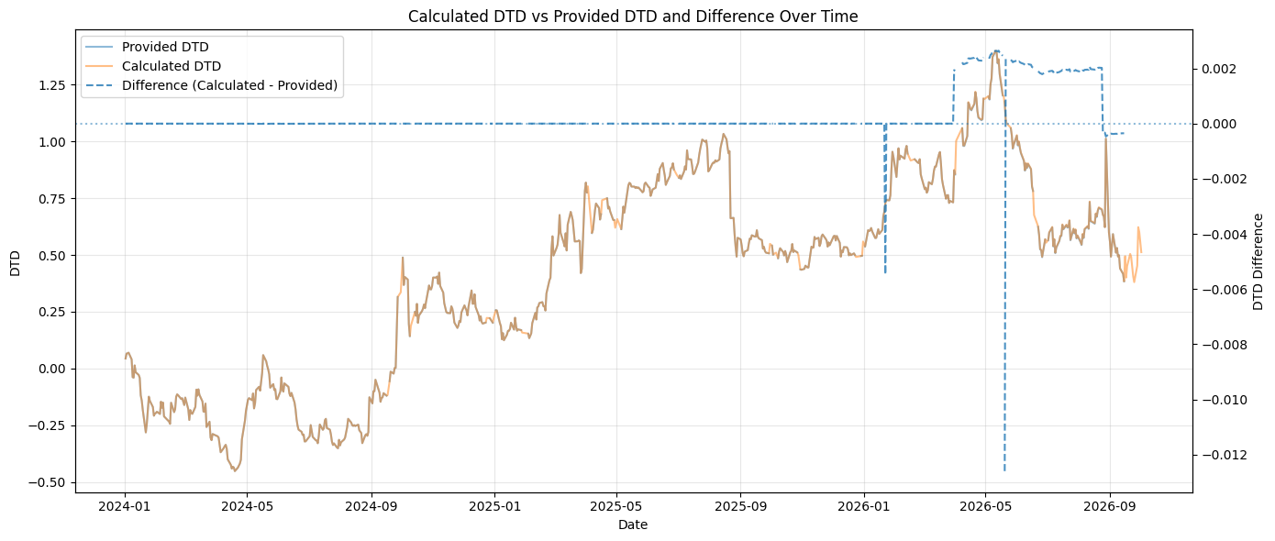
Overall, the results indicate that the implemented DTD calculation is able to reproduce the CRI output closely when the same underlying inputs are used, with differences generally limited to approximately 10⁻¹⁵ to 10⁻⁶. The remaining systematic errors are concentrated in observations where independently sourced financial-statement inputs are introduced, with differences remaining within 0.003. Occasional larger discrepancies are also observed on isolated dates due to differences in the closing prices used for market-capitalisation calculation. Even in these cases, however, the discrepancies remain small, with the largest absolute difference being approximately 0.01, around 1% of DTD, indicating that they are not material to the overall DTD results.

3.1 Missing CRI DTD observations
CRI does not provide a DTD value for 35 of the 677 observations in the comparison period. The calculated series nevertheless produces a DTD value on all these dates.
Checks of the available historical inputs and supplied model parameters did not identify an obvious abnormality that would explain these missing CRI observations. In particular, the required inputs appear to be available and sufficiently normal for the implemented model to complete the calculation. The missing values therefore cannot be reproduced or fully explained from the information supplied for this exercise.

3.2 Discrepancy after introducing new financial-statement inputs
A discrepancy emerges when newly downloaded financial statements are incorporated instead of carrying forward the historical financial inputs supplied by CRI. During these periods, the difference becomes systematic rather than random, although it remains small relative to the level and movement of DTD.
Review of the financial-statement inputs suggests that this difference is primarily attributable to differences in data precision rather than a change in the DTD methodology. In particular, financial-statement values require currency conversion from CNY to HKD, and the FX rates used may not exactly match those underlying the CRI dataset. For example, I use an exchange rate of 0.9400, whereas the corresponding CRI financial-statement values appear consistent with a more precise rate such as 0.9398 for 20241231 report period (can refer to data/processed/financial_statement_check.xlsx). Small differences of this type propagate through liabilities, the default threshold and implied asset value, and ultimately produce a small systematic difference in DTD.
The comparison data are consistent with this interpretation. From 31 March 2026, when independently updated inputs become relevant, the median DTD difference rises to approximately 0.0019, compared with effectively zero during the historical reproduction period. When the next financial statement becomes available on 25 August 2026, the DTD difference decreases substantially to approximately -0.00036 and remains broadly stable at this level thereafter. The step changes in the discrepancy around financial-statement update dates further suggest that the systematic differences are primarily attributable to differences in the independently prepared financial inputs.

3.3 Occasional discrepancies due to close price differences
In addition to the systematic differences associated with financial statement inputs, a small number of isolated dates show relatively larger DTD discrepancies. In particular, larger differences are observed on 22 January 2026 and 20 May 2026, with DTD differences of approximately −0.0055 and −0.0126, respectively.
Further review of these dates did not identify abnormalities in the financial-statement inputs, model parameters or risk-free rates. The financial-statement inputs were unchanged from surrounding trading days, while the model parameters and risk-free rates also remained within their normal ranges. This leaves the daily market price, and consequently market capitalisation, as the most likely source of the isolated discrepancies. As discussed in the Data section, closing prices obtained from Yahoo Finance can differ from the price observations underlying the CRI inputs on certain special trading days. The occasional larger DTD discrepancies are therefore likely attributable to similar source-specific differences in closing prices, which affect market capitalisation and subsequently propagate through the DTD calculation.

Event Study
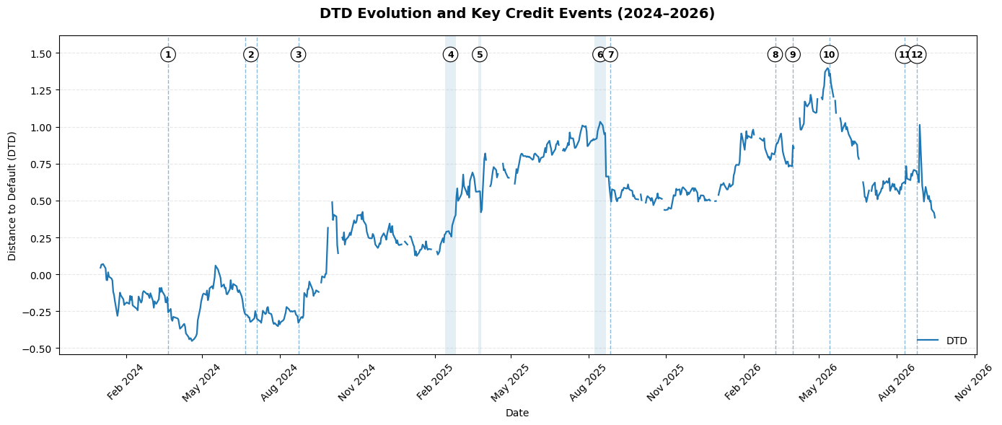

Overall, the historical DTD trajectory provides a useful but imperfect signal of changes in Greentown’s credit conditions. In several cases, DTD moved broadly consistently with observed developments. It weakened following the FY2023 results, strengthened following the February 2025 refinancing process, and declined during the August 2025 earnings deterioration. There is also evidence of anticipatory behaviour. DTD had already fallen before the August 2025 Morgan Stanley downgrade and declined substantially ahead of the August 2026 profit warning. This suggests that market-based inputs may have incorporated some deterioration in underlying conditions before it was reflected in subsequent formal announcements.
However, the relationship is not consistent across all events. The response to the 2024 bond repurchases was relatively muted, while DTD increased despite the March 2026 profit warning and very weak FY2025 profitability, providing a notable counter-intuitive signal. These differences suggest that DTD should not be interpreted as a direct measure of reported operating performance. As a market-based model, it may reflect changing equity values, volatility, leverage, interest rates and broader market expectations simultaneously.

AI Use Statement
I used ChatGPT as an AI-assisted development and review tool throughout this task. Its main uses included discussing the project structure and implementation approach, explaining aspects of the Merton-model and DTD methodology, assisting with Python and Streamlit development, troubleshooting coding and data-processing issues, and reviewing the clarity and structure of the written analysis.
For the technical implementation, I worked with ChatGPT iteratively by providing my existing code, project structure, error messages and intermediate outputs, and asking for explanations, debugging support and possible implementation approaches. I evaluated the suggestions, adapted relevant ones to my existing code, and tested the resulting implementation locally.
AI outputs were reviewed carefully before use. For the technical implementation, I focused on whether suggested changes were consistent with the existing code structure and function dependencies, and verified them by running the code, examining intermediate outputs and testing the final pipeline and application. Numerical outputs were generally cross-checked against other available sources or reference data where possible to assess their consistency.
For the written analysis, I manually checked key facts, figures and event descriptions against the calculated results and original or cited sources. Rather than directly adopting AI-generated text, I extracted useful points from the responses, and used follow-up prompts to develop wording that better reflected my own analysis. The final written content was then reviewed and edited by me before inclusion in the submission.
Accordingly, AI was used as a supporting tool for development, debugging, reasoning and communication, while the final implementation, validation, interpretation and conclusions were reviewed and determined by me.

