**Name**: Kaif Ali Sayyad

**UID**: 2021300109

**Batch**: H

**Exp:** 10

**Aim**:

Design Big Data Dashboards using Power BI / Power BI / R / Python / D3.js on the datasets - Education sector

* Basic - Bar chart, Pie chart, Histogram, Time line chart, Scatter plot, Bubble plot
* Advanced - Word chart, Box and whisker plot, Violin plot, Regression plot (linear and nonlinear), 3D chart, Jitter
* Write observations from each chart

Theory:

## Dataset:

<https://www.kaggle.com/datasets/lainguyn123/student-performance-factors>

# Dataset Overview:

This dataset provides a comprehensive overview of various factors affecting student performance in exams. It includes information on study habits, attendance, parental involvement, and other aspects influencing academic success.

# Column Descriptions:

1. **Hours_Studied**: Weekly hours the student spends studying.
2. **Attendance**: Percentage of classes attended by the student.
3. **Parental_Involvement**: Level of parental engagement in the student’s education (Low, Medium, High).
4. **Access_to_Resources**: Availability of educational resources for the student (Low, Medium, High).
5. **Extracurricular_Activities**: Participation in extracurricular activities (Yes, No).
6. **Sleep_Hours**: Average number of hours the student sleeps per night.
7. **Previous_Scores**: Scores from previous exams taken by the student.
8. **Motivation_Level**: Self-reported motivation level of the student (Low, Medium, High).
9. **Internet_Access**: Access to the internet at home (Yes, No).
10. **Tutoring_Sessions**: Number of tutoring sessions attended per month.
11. **Family_Income**: Family’s income level (Low, Medium, High).
12. **Teacher_Quality**: Perceived quality of teachers (Low, Medium, High).
13. **School_Type**: Type of school the student attends (Public, Private).
14. **Peer_Influence**: Impact of peers on the student’s academic performance (Positive, Neutral, Negative).
15. **Physical_Activity**: Weekly hours the student spends on physical activity.
16. **Learning_Disabilities**: Presence of any learning disabilities (Yes, No).
17. **Parental_Education_Level**: Highest educational attainment of the student’s parents (High School, College, Postgraduate).
18. **Distance_from_Home**: Distance from the student’s home to school (Near, Moderate, Far).
19. **Gender**: Gender of the student (Male, Female).
20. **Exam_Score**: Final score obtained in the exam.

# Charts:

## Impact of Hours Studied and Motivation Level on Exam Scores:

* 1. 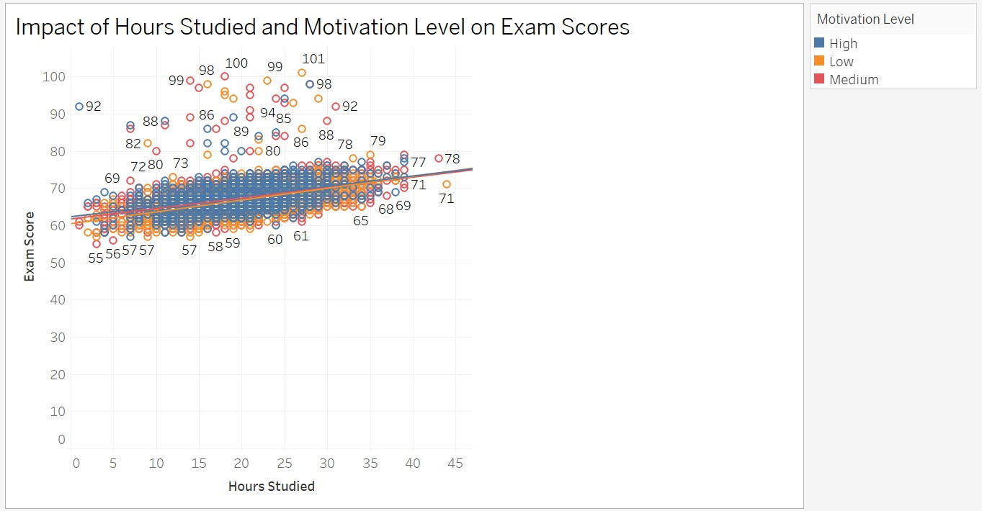Chart:
  2. Observations:

## Positive Correlation between Hours Studied and Exam Scores:

The overall trend shows that as the number of hours studied increases, exam scores tend to improve. This suggests that consistent study habits are crucial for academic success.

* + - **Motivation Level Influences Performance:** Students with high motivation levels tend to cluster towards the upper end of the graph, indicating a stronger correlation between hours studied and exam scores. In contrast, students with low motivation levels exhibit a wider spread, suggesting that motivation plays a significant role in how study time translates into exam performance.
    - **Individual Variation Exists:** Even within a specific motivation

level, there is variability in exam scores for a given number of hours studied. This suggests that factors other than hours studied and motivation, such as learning strategies, subject difficulty, and

individual learning styles, also influence academic outcomes.

# Impact of Parental Involvement on Exam Scores:

* 1. 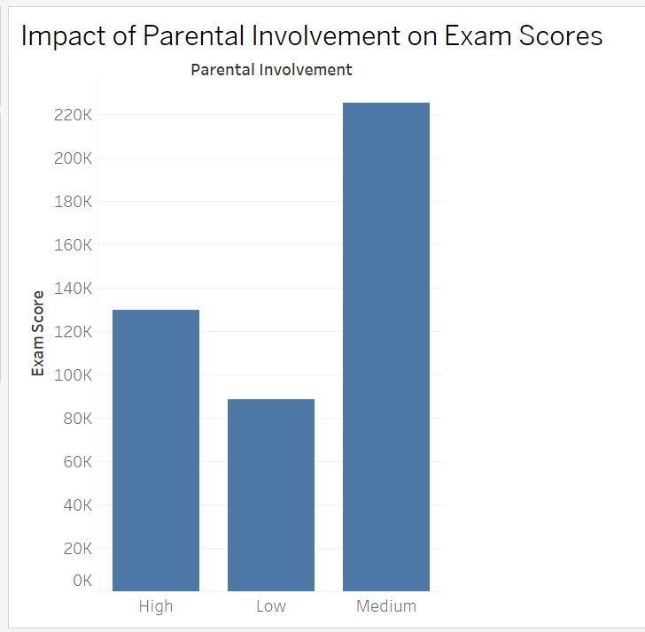Chart:
  2. Observations:
     + **High Parental Involvement Leads to Highest Exam Scores:** Students with high parental involvement demonstrate the highest average exam scores, indicating a strong positive correlation between parental engagement and academic success.

## Low Parental Involvement Results in Lowest Exam Scores:

Students with low parental involvement have the lowest average exam scores, suggesting that a lack of parental support negatively impacts academic performance.

## Medium Parental Involvement Shows Moderate Impact:

Students with medium parental involvement exhibit moderate exam scores, highlighting the importance of a balanced level of parental engagement for optimal academic outcomes.

# Impact of Internet Access and Access to Resources on Exam Scores:

* 1. 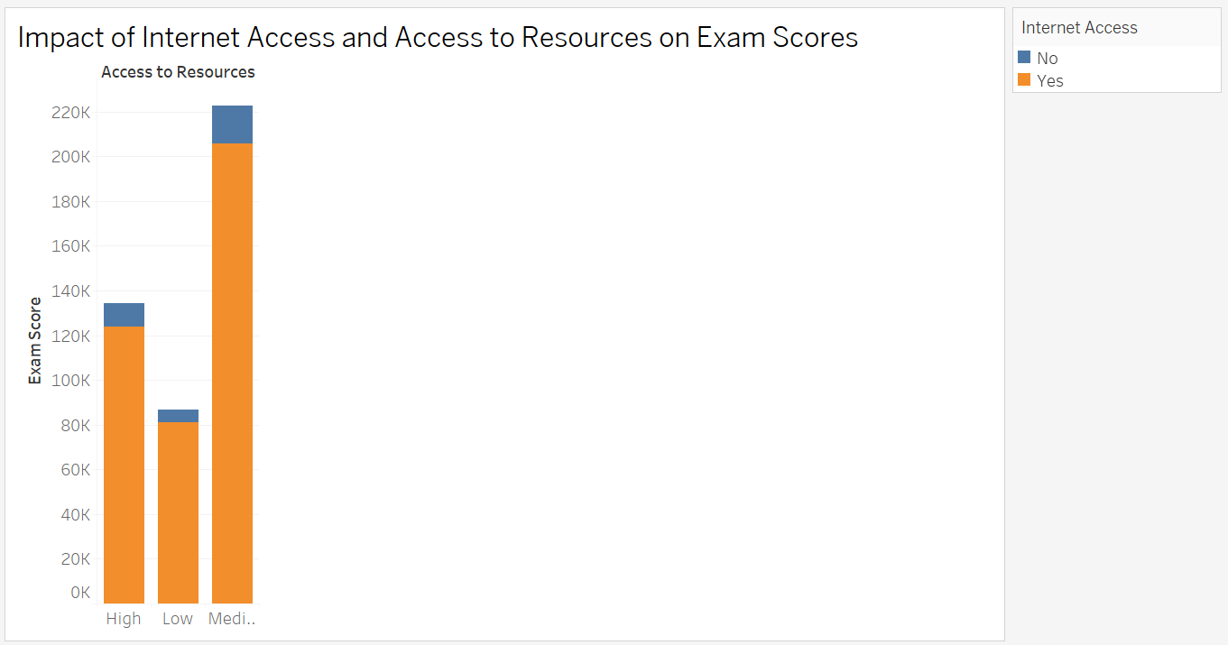Chart:
  2. Observations:
     + **Internet Access Boosts Exam Scores:** Across all levels of access to resources, students with internet access consistently outperform those without. This highlights the significant role of internet access

in facilitating learning and improving academic outcomes.

* + - **Better Access to Resources Leads to Higher Scores:** Students with high access to resources, regardless of internet access, tend to achieve higher exam scores compared to those with low or medium access. This suggests that having adequate resources is crucial for academic success.
    - **Combined Impact of Internet Access and Resources:** The highest exam scores are observed among students who have both internet access and high access to resources. This emphasizes the synergistic effect of these two factors on student performance.

# Distribution of Students Across Family Income Levels:

* 1. 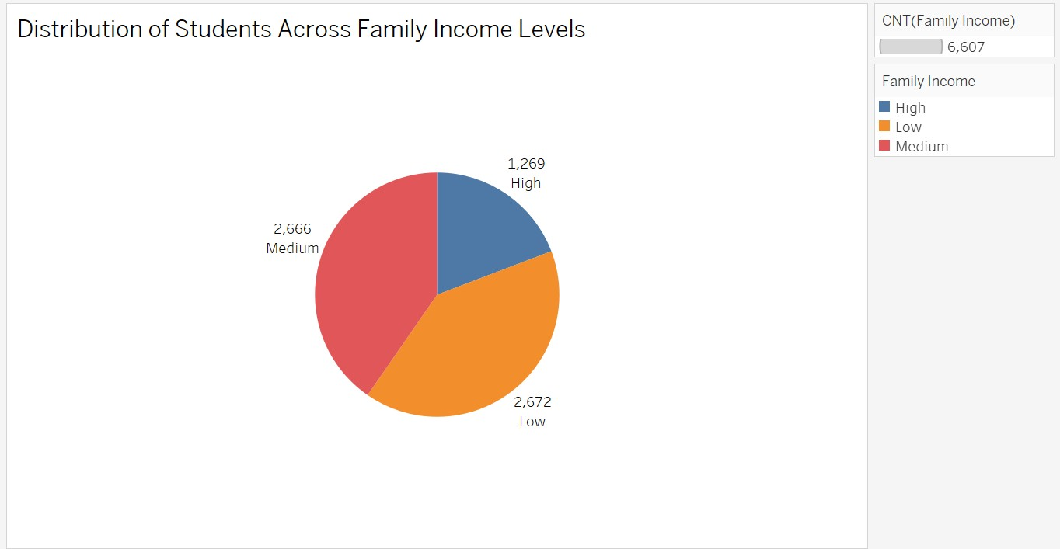Chart:
  2. Observations:
     + **Low Family Income is Most Prevalent:** The majority of students in the dataset come from families with low income levels. This suggests that socioeconomic factors may play a significant role in influencing student outcomes.
     + **High and Medium Income Groups are Smaller:** Students from high and medium income families represent smaller proportions of the dataset. This highlights the need to consider how socioeconomic disparities might impact educational opportunities and student achievement.
     + **Need for Further Analysis:** It is important to explore how family income level interacts with other factors, such as access to resources, parental involvement, and teacher quality, to better understand its impact on student performance.

# Impact of Peer Influence on Exam Scores:

* 1. 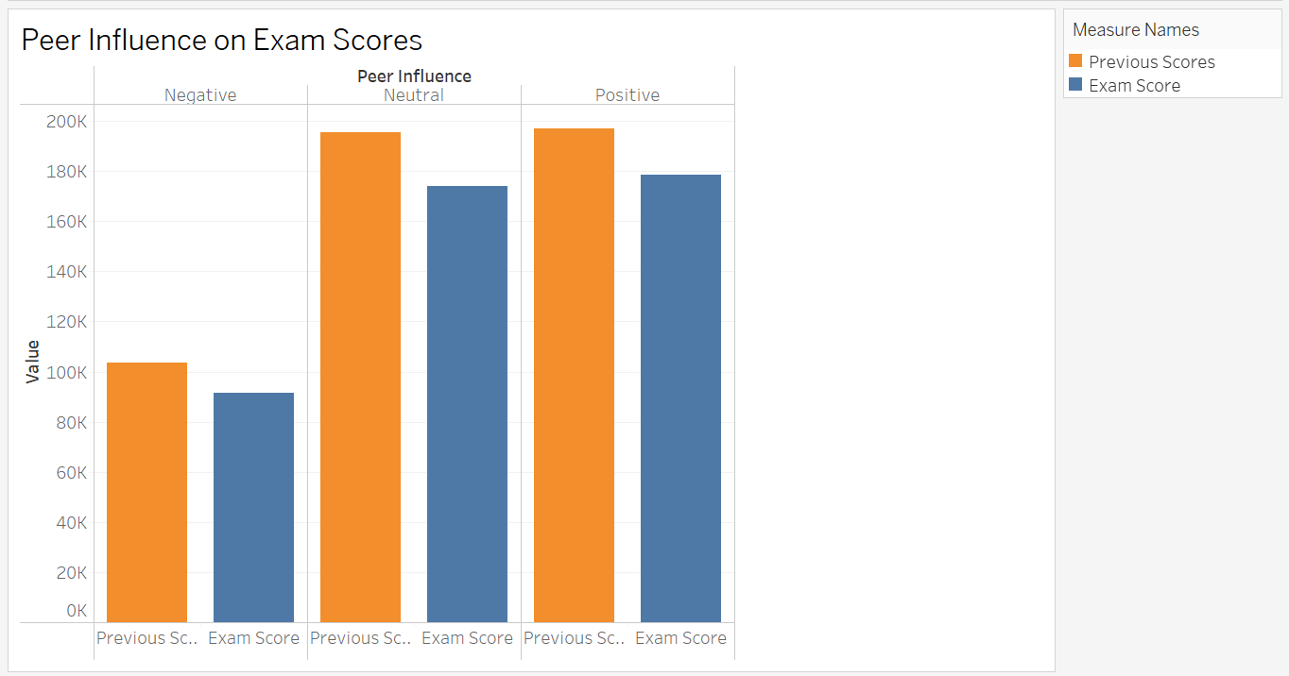Chart:
  2. Observations:
     + **Positive Peer Influence Boosts Exam Scores:** Students with positive peer influence tend to have higher exam scores compared to those with neutral or negative peer influence. This suggests that a supportive and encouraging peer environment can significantly

impact academic performance.

* + - **Negative Peer Influence Hinders Exam Scores:** Students with negative peer influence demonstrate the lowest exam scores, highlighting the detrimental effects of a negative peer environment on academic achievement.
    - **Neutral Peer Influence Has a Moderate Impact:** Students with neutral peer influence have moderate exam scores, suggesting that while a neutral environment may not hinder performance, it may also not provide the same level of support and motivation as a positive peer environment.

# Dashboard:

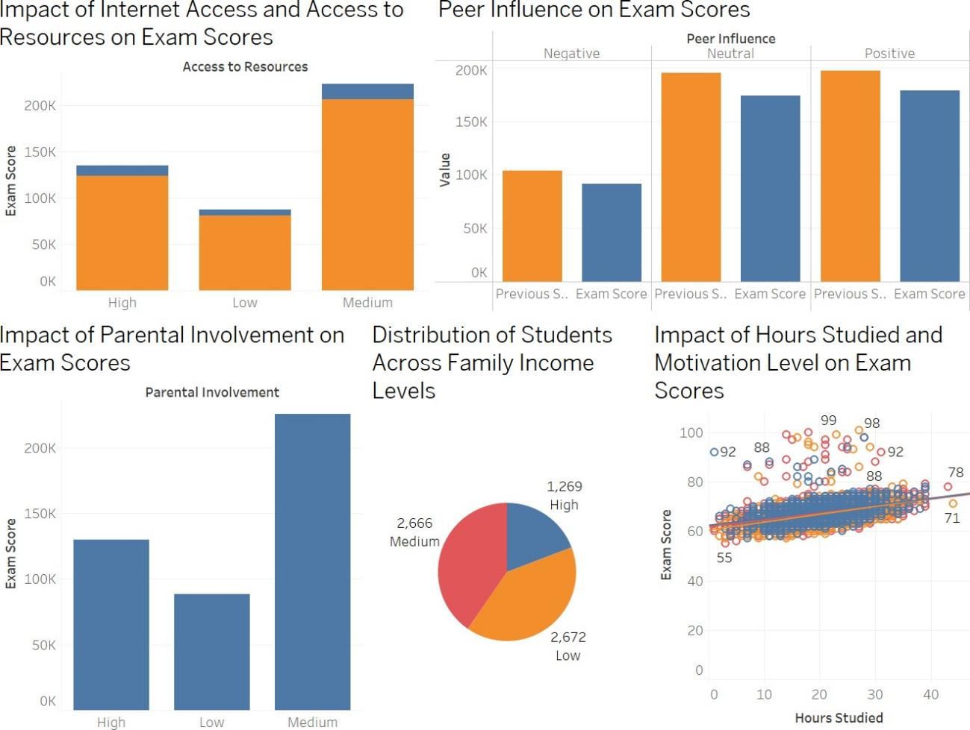

**Conclusion:**

From this experiment and the subsequent Tableau dashboard, we have identified several key factors that significantly influence student performance. Consistent study habits, high motivation, parental involvement, access to resources, positive peer

influence, and conducive learning environments were found to be strongly correlated

with higher exam scores. Additionally, socioeconomic factors such as family income and internet access play a role in shaping student outcomes. These findings emphasize the need for a holistic approach to education that addresses both academic and

socio-emotional factors to optimize student success. The Tableau dashboard provides a visual representation of these findings, enabling a deeper understanding of the complex interplay between various factors and their impact on student performance.