

Master’s Thesis

Development and Evaluation of a Python-Based Signal Processing Pipeline for Frailty Classification from PPG Signals

Kaifeng Xu
Matriculation Number: 403139
Program of study: M.Sc. Produktionstechnik
Submission Date: 26.08.2026

Supervisors
Prof. Dr. Charmayne Mary Lee Hughes
M.Sc. Ali Pourhossein

Faculty V - Mechanical Engineering and Transport Systems
Institute of Psychology and Ergonomics
Age-Appropriate Human-Machine Systems
Technische Universität Berlin

Eigenständigkeitserklärung
Hiermit versichere ich, dass ich die vorliegende Arbeit ohne Hilfe Dritter und ausschließlich unter Verwendung der aufgeführten Quellen und Hilfsmittel angefertigt habe. Alle Stellen die den benutzten Quellen und Hilfsmitteln wörtlich oder inhaltlich entnommen sind, habe ich als solche kenntlich gemacht.
Sofern KI-Tools verwendet wurden, habe ich Produktnamen, Hersteller, die jeweils verwendete Softwareversion und die Art der Nutzung (z.B. sprachliche Überprüfung und Verbesserung der Texte, systematische Recherche) benannt. Ich verantworte die Auswahl, die Übernahme und sämtliche Ergebnisse des von mir verwendeten KI-generierten Outputs vollumfänglich selbst.
Die Satzung zur Sicherung guter wissenschaftlicher Praxis an der TU Berlin vom 8. März 2017. https://www.static.tu.berlin/fileadmin/www/10002457/K3-AMBl/Amtsblatt_2023/Amtliches_Mitteilungsblatt_Nr._16_vom_30.05.2023.pdf habe ich zur Kenntnis genommen. Ich erkläre weiterhin, dass ich die Arbeit in gleicher oder ähnlicher Form noch keiner anderen Prüfungsbehörde vorgelegt habe.

Berlin, den ……………………………………………………………

Unterschrift ……………………………………………………………

Abstract
Frailty is an age-related, multidimensional condition characterised by diminished physiological reserve and increased vulnerability to stressors. It is associated with adverse outcomes including falls, disability, hospitalisation, loss of independent living, and death. Early and repeatable assessment is therefore important for preventive care and geriatric medicine. Conventional frailty instruments incorporate physical-performance tests, symptoms, comorbidities, or clinical judgement and remain an indispensable component of clinical assessment. However, assessment is generally intermittent and depends on the frailty construct adopted. Photoplethysmography (PPG) enables peripheral blood-volume pulsations to be recorded non-invasively and at low-cost using wearable optical sensors. Pulse timing and morphology may reflect cardiovascular and autonomic regulation, while synchronised inertial measurement units (IMUs) characterise motion and the acquisition context. Their combined use may therefore provide complementary vascular and movement-related information suitable for repeated measurement. However, extracting physiologically meaningful information from PPG remains challenging because of ambient light, sensor attachment, motion artefacts, and other acquisition-related disturbances. Against this background, the present study aims to develop a transparent Python-based signal-processing pipeline that integrates synchronised PPG and IMU signals to investigate their potential for reproducible participant-level classification of frailty-related groups and, subject to independent validation, their suitability for remote monitoring applications.
The study considers the three groups defined in the project repository: Pre-Frail, Robust/Non-Frail, and Young. The dataset comprises 29 participants and 261 recordings, including 145 motion-minimised static recordings and 116 dynamic recordings. The cohort includes 9 Pre-Frail, 12 Robust/Non-Frail, and 8 Young participants. Each recording contains eight synchronised channels: red and infrared PPG, three-axis acceleration, and three-axis angular velocity. The Python pipeline implements channel-specific preprocessing, robust window-wise normalisation, motion detection, initial motion-artefact reduction, cardiovascular feature extraction, leakage-safe participant-level data partitioning, deep-learning-based time-series classification, signal-quality-based window selection, probability aggregation, and participant-level evaluation. The classification performance of one-dimensional convolutional neural networks (1-D CNNs) and InceptionTime was compared across different windowing and sampling configurations. Performance was assessed primarily using balanced accuracy, macro-F1, class-specific recall and F1, confusion matrices, and repeated grouped evaluations.
Across multiple grid-search rounds, InceptionTime applied to five-second windows of the raw eight-channel signals consistently ranked among the strongest configurations. The highest-ranked configuration achieved a mean participant-level balanced accuracy of 0.719 ± 0.047 and a macro-F1 of 0.704 ±0.044, with a lowest class-specific F1 score of 0.621. Aggregated class recalls were 0.833 for Pre-Frail, 0.533 for Robust/Non-Frail, and 0.800 for Young. These results indicate moderate internal discriminative performance, with some sensitivity to data partitioning, but are insufficient to support claims of clinical utility. For the dynamic recordings, the IMU-assisted motion detectors achieved balanced accuracies of 0.789 and F1 scores of 0.718, respectively, on an additional holdout set. The better-performing detector achieved a ROC AUC of 1.000 and a PR AUC of 1.000.
Overall, participant-independent evaluation indicated that the synchronised PPG and IMU recordings contained group-related information that was detectable across internal grouped evaluations, although separation between the three groups remained limited. InceptionTime showed the strongest performance on the full recordings, with a mean participant-level balanced accuracy of approximately 0.719. However, given the small cohort of 29 independent participants, evidence of overfitting and limited generalizability warrants cautious interpretation. The findings nevertheless provide preliminary evidence that synchronised PPG and IMU signals capture physiological and movement-related information associated with the investigated frailty-related groups. These associations, however, should not be interpreted as evidence of a frailty-specific physiological biomarker or clinical utility. The thesis therefore provides an auditable participant-level feasibility framework and evaluation workflow for investigating frailty-related patterns in wearable sensor data.

Kurzfassung
Frailty (Gebrechlichkeit) ist ein altersassoziierter, multidimensionaler Zustand, der durch verringerte physiologische Reserven und eine erhöhte Vulnerabilität gegenüber Stressoren gekennzeichnet ist. Frailty steht mit ungünstigen Folgen wie Stürzen, Behinderungen, Krankenhausaufenthalten, dem Verlust einer selbstständigen Lebensführung und Tod in Zusammenhang. Eine frühzeitige und wiederholbare Erfassung ist daher für die Prävention und die Geriatrie von hoher Bedeutung. Konventionelle Frailty-Instrumente beziehen Tests der körperlichen Leistungsfähigkeit, Symptome, Komorbiditäten oder klinische Beurteilungen ein und bleiben ein unverzichtbarer Bestandteil der klinischen Bewertung. Ihre Anwendung erfolgt jedoch meist punktuell und hängt von dem jeweils zugrunde gelegten Frailty-Konzept ab. Mithilfe der Photoplethysmographie (PPG) lassen sich periphere Blutvolumenpulsationen durch tragbare optische Sensoren kostengünstig und nichtinvasiv erfassen. Die zeitliche Struktur und Morphologie der Pulswelle können kardiovaskuläre und autonome Regulationsprozesse widerspiegeln, während synchronisierte inertiale Messeinheiten (Inertial Measurement Units, IMUs) Bewegungen und den Messkontext beschreiben. Ihre kombinierte Nutzung kann daher komplementäre vaskuläre und bewegungsbezogene Informationen für wiederholte Messungen liefern. Die Gewinnung physiologisch aussagekräftiger Informationen aus PPG-Signalen wird jedoch durch Umgebungslicht, Sensoranbringung, Bewegungsartefakte und weitere aufnahmebedingte Störungen erschwert. Vor diesem Hintergrund zielt die vorliegende Arbeit auf die Entwicklung einer transparenten Python-basierten Signalverarbeitungspipeline für synchronisierte PPG- und IMU-Signale. Untersucht wird, ob diese Signale eine reproduzierbare Klassifikation Frailty-bezogener Gruppen auf Teilnehmendenebene unterstützen und nach einer unabhängigen Validierung eine Grundlage für Remote-Monitoring-Anwendungen bilden können.
Die Untersuchung betrachtet die drei im Projekt-Repository definierten Gruppen Pre-Frail, Robust/Non-Frail und Young. Der Datensatz umfasst 29 Teilnehmende und insgesamt 261 Aufzeichnungen, davon 145 bewegungsarme statische und 116 dynamische Aufzeichnungen. Die Kohorte besteht aus 9 Pre-Frail-, 12 Robust/Non-Frail- und 8 Young-Teilnehmenden. Jede Aufzeichnung enthält acht synchronisierte Kanäle: PPG mit rotem und infrarotem Licht, dreiachsige Beschleunigung und dreiachsige Winkelgeschwindigkeit. Die Python-Pipeline implementiert eine kanalspezifische Vorverarbeitung, robuste fensterweise Normalisierung, Bewegungserkennung, eine initiale Reduktion von Bewegungsartefakten, die Extraktion kardiovaskulärer Merkmale, eine Datenaufteilung auf Teilnehmendenebene zur Vermeidung von Datenleckage, die Zeitreihenklassifikation mittels Deep Learning, eine signalqualitätsbasierte Fensterauswahl, die Aggregation von Wahrscheinlichkeiten sowie die Auswertung auf Teilnehmendenebene. Die Klassifikationsleistung eindimensionaler Convolutional Neural Networks (1-D CNNs) und von InceptionTime wurde unter unterschiedlichen Fenster- und Sampling-Konfigurationen verglichen. Als primäre Bewertungsgrößen dienten die Balanced Accuracy, der Makro-F1-Wert, klassenspezifische Recall- und F1-Werte, Konfusionsmatrizen sowie wiederholte gruppenbasierte Auswertungen.
Über mehrere Grid-Search-Runden hinweg gehörte das InceptionTime-Modell mit fünfsekündigen Fenstern der achtkanaligen Rohsignale zu den bestplatzierten Konfigurationen. Die höchstplatzierte Konfiguration erreichte eine mittlere Balanced Accuracy von 0,719 ± 0,047 auf Teilnehmendenebene und einen Makro-F1-Wert von 0,704 ± 0,044; ihr niedrigster klassenspezifischer F1-Wert betrug 0,621. Die aggregierten Recall-Werte lagen bei 0,833 für Pre-Frail, 0,533 für Robust/Non-Frail und 0,800 für Young. Diese Ergebnisse sprechen für eine moderate interne Trennfähigkeit, die gegenüber der konkreten Datenaufteilung empfindlich bleibt; eine klinische Nutzbarkeit wird dadurch nicht belegt.
Bei den dynamischen Aufzeichnungen erreichten die IMU-gestützten Bewegungsdetektoren auf einem zusätzlichen Holdout-Datensatz eine Balanced Accuracy von 0,789 sowie einen F1-Wert von 0,718. Der leistungsstärkere Detektor erzielte eine Fläche unter der Receiver-Operating-Characteristic-Kurve (ROC AUC) von 1,000 und eine Fläche unter der Precision-Recall-Kurve (PR AUC) von 1,000.
Insgesamt zeigen die Ergebnisse, dass die synchronisierten PPG- und IMU-Aufzeichnungen bei teilnehmendenunabhängiger Auswertung gruppenbezogene Informationen enthalten, die in den internen gruppenbasierten Auswertungen wiederholt nachweisbar waren, wobei die Trennung zwischen den drei Gruppen jedoch begrenzt blieb. InceptionTime zeigte auf den vollständigen Aufzeichnungen die stärkste Leistung und erreichte eine mittlere Balanced Accuracy von ungefähr 0,719 auf Teilnehmendenebene. Angesichts der kleinen Kohorte von 29 unabhängigen Teilnehmenden erfordern Hinweise auf Überanpassung und eine eingeschränkte Generalisierbarkeit jedoch eine vorsichtige Interpretation. Zugleich liefern die Ergebnisse vorläufige Hinweise darauf, dass synchronisierte PPG- und IMU-Signale physiologische und bewegungsbezogene Informationen enthalten, die mit den untersuchten Frailty-bezogenen Gruppen assoziiert sind; ein Frailty-spezifischer physiologischer Biomarker oder eine klinische Nutzbarkeit wird dadurch nicht belegt. Die Arbeit schafft einen nachvollziehbaren Machbarkeitsrahmen und einen Auswertungsablauf auf Teilnehmendenebene für die Frailty-bezogene Signalanalyse mit Wearables.

List of Figures
Figure 1 Vulnerability of frail older adults to external stressors (Clegg et al. 2013; Health 2017) 20
Figure 2 Basic cardiovascular anatomy from (LLC, 2019) 22
Figure 3 The classic ECG wave. The classic ECG wave illustrates the essential components of cardiac electrical activity, including the P-wave, QRS complex, and T-wave, as well as their respective intervals (Kołodziej et al. 2017 (the figure below); Stone et al. 2024 (the figure above)). 24
Figure 4 Configuration for photoplethysmography measurement: (A) transmissive type and (B) reflective type (Park et al. 2022a). 27
Figure 5 The PPG Waveform and Information (Park et al. 2022a) 29
Figure 6 PPF waveform from elder participant (left) and from a young participant (right) 30
Figure 7 The overlay of PPG and ECG signals. Due to the pulse arrival time, the PPG waveform exhibits a lag relative to the ECG signal (Chapter 4: The differences and similarities between ECG and PPG 2025) 31
Figure 8 The nested hierarchy of artificial intelligence (AI), machine learning (ML), neural networks, and deep learning (DL) (Frazier and Song 2024) 35
Figure 9 The main types of machine learning (Peng et al. 2021) 36
Figure 10 Architecture of Fully convolutional network by Wang et al. (2017) 38
Figure 11 Inside details of one inception module with a 1×1 bottleneck layer (Ismail Fawaz et al. 2020) 39
Figure 12 Architecture of an Inception network with 6 different Inception modules (Ismail Fawaz et al. 2020) 39
Figure 13 The general architecture of ShapeFormer. (a) Framework of ShapeFormer and (b) Shapelet Filter (Le et al. 2024) 40
Figure 14 Classification Workflow 45
Figure 15 Example raw PPG signal (below) and corresponding preprocessed PPG signal (above) in the time domain 51
Figure 16 Principle of photoplethysmogram generation and waveform (Park et al. 2022a). 66
Figure 17 Confusion Matrix of file-level aggression prediction by Frailty_29 model (left) and PTT_22 model (right) 85
Figure 18 Pooled confusion matrices of the input-representation screening routes (participant out-of-fold predictions, five repeats × 29 participants). 90
Figure 19 Distribution of participant-level balanced accuracy by 1-D CNN, InceptionTime and ShapeFormer-PISD. InceptionTime shows the widest dispersion (whiskers 0.509–0.833); the 1-D CNN and ShapeFormer-PISD show a comparably narrower spread, with the ShapeFormer-PISD distribution shifted towards lower values. 92
Figure 20 A Learning Curve plot from InceptionTime with loss curve on left and BA curve on right 101

List of Tables
Table 1 Major frailty operationalisations and their implications for sensor-based modelling. 18
Table 2 Overview of ECG study results in the context of frailty (Eifert, 2026). 21
Table 3 Operational cohort used by in this thesis. Participant characteristics are from Eifert (2026); recording counts are derived from the audited repository structure. 47
Table 4 PhysioNet PTT-PPG v1.0.0 content and its project role (Mehrgardt et al. 2022). 48
Table 5 Signal representations created by preprocessing and their downstream use. 49
Table 6 Rules used to assign each segment to the Excellent, Acceptable, or Unfit quality class. 56
Table 7 Feature extraction hierarchy and aggregation level. 60
Table 8 HR/PPI/PRV feature definitions, modeled after the systematic domain organization used by Eifert (2026) and the Task Force (1996). 64
Table 9 pulse-morphology and dual-wavelength features 67
Table 10 Statistical, spectral, and inertial features 69
Table 11 The four data representations used for classification. 70
Table 12 Default 1-D CNN baseline. 71
Table 13 InceptionTime-modules used in the pipeline and their parameters. 73
Table 14 Default ShapeFormer-port parameters. 75
Table 15 Audited grid dimensions. Not every Cartesian combination was run in every sweep; each result is tied to its recorded configuration. 76
Table 16 Metric priority for frailty-related classification. 79
Table 17 Detail list of Hardware and software environments 80
Table 18 Beat-detector performance on the static recordings of the Pulse Transit Time PPG dataset, reported as median [Q1, Q3] over 22 subject recordings per channel. Execution time is expressed as a percentage of the PPG signal duration. 83
Table 19 Holm–Šidák-adjusted p-values for the comparison between the MSPTDfast (v.2) Python port and the Aboy++-inspired detector. Ten comparisons (five endpoints × two channels) form one correction family; α = 0.05. 83
Table 20 Architecture of the LightCNN binary motion detector 84
Table 21 Motion-detector performance in the two transfer directions. Values are balanced accuracy / F1. 85
Table 22 Denoiser results on the dynamic recordings. An asterisk marks the best value of a metric. 86
Table 23 Denoiser results on the static recordings. 87
Table 24 Input-representation screening. Participant-level metrics, five repeats × five folds. 89
Table 25 End-to-end model comparison under matched conditions (5 s windows, 50 % overlap, patience 20, no extra PPI/HRV input). 91
Table 26 Four tested routes in SQI-Motion module 92
Table 27 Effect of SQI gating and motion-detector routing on the default 1-D CNN. 94
Table 28 Details of B0-B7 96
Table 29 InceptionTime B0–B7 comparison 97
Table 30 CNN B0–B7 comparison 98
Table 31 Batch size and learning rate. 100
Table 32 Regularisation grid over weight decay (wd), dropout (do) and label smoothing (ls). 102
Table 33 Differences between the Top5 configurations 104
Table 34 Final configuration results. Participant-level metrics over five repeats of participant-grouped five-fold cross-validation. 105
Table 35 Public shared Configuration in Top5 models 141

Nomenclature
Abbreviation | Meaning
AC / DC | Pulsatile / slowly varying component of a PPG signal
AI | Artificial intelligence
AUC | Area under a receiver operating characteristic curve
AX–AZ / GX–GZ | Tri-axial accelerometer and gyroscope channels of the IMU
BA | Balanced accuracy
BP | Blood pressure
CES-D | Center for Epidemiologic Studies Depression scale
CI | Confidence interval
CLI | Command-line interface
CNN | Convolutional neural network
CSV | Comma-separated values file format
CV | Cross-validation
DL | Deep learning
ECG | Electrocardiography
EKF | Extended Kalman filter
EMD | Empirical mode decomposition
F1 | Harmonic mean of precision and recall
FWER | Family-wise error rate
GAP | Global average pooling
GELU | Gaussian error linear unit
HF / LF | High-frequency / low-frequency spectral band
HR | Heart rate
HRV | Heart rate variability
IBI | Inter-beat interval
ICA | Independent component analysis
IMF | Intrinsic mode function
IMU | Inertial measurement unit
IQR | Interquartile range
IR | Infrared PPG channel
ISTFT | Inverse short-time Fourier transform
LED | Light-emitting diode
LR | Learning rate
LS | Label smoothing
MA | Motion artifact
MAD | Median absolute deviation
ML | Machine learning
MLP | Multilayer perceptron
MSPTD | Multi-scale peak and trough detection; MSPTDfast denotes the accelerated variant
NLMS | Normalized least-mean-squares adaptive filter
NMF | Non-negative matrix factorization
NN50 / pNN50 | Number / proportion of successive intervals differing by more than 50 ms
NNI | Normal-to-normal interval
OOF | Out-of-fold prediction
PAT | Pulse arrival time
PCA | Principal component analysis
PI | Perfusion index
PPG | Photoplethysmography / photoplethysmogram
PPI | Pulse-to-pulse interval
PPV | Positive predictive value
PR-AUC | Area under the precision–recall curve
PRV | Pulse rate variability
PSD | Power spectral density
PTT | Pulse transit time
QRS | QRS complex of the ECG
RBF | Radial basis function
RED | Red-wavelength PPG channel
ReLU | Rectified linear unit
RMS | Root mean square
RMSE | Root-mean-square error
RMSSD | Root mean square of successive interval differences
ROC | Receiver operating characteristic
ROC-AUC | Area under the receiver operating characteristic curve
RQ | Research question
RR | R-peak-to-R-peak interval of the ECG
SD | Standard deviation
SD1 / SD2 | Short-term / long-term Poincaré-plot variability descriptors
SDNN | Standard deviation of NN or accepted pulse intervals
SDSD | Standard deviation of successive interval differences
SI | International System of Units
SOS | Second-order-sections filter representation
SpO₂ | Peripheral oxygen saturation estimate
SQI | Signal-quality index
STFT | Short-time Fourier transform
SVD | Singular value decomposition
TSC | Time-series classification
VLF | Very-low-frequency spectral band
VMD | Variational mode decomposition
WD | Weight decay
WFDB | WaveForm DataBase record format

Table of Contents
Eigenständigkeitserklärung 2
Abstract 3
Kurzfassung 5
List of Figures 7
List of Tables 8
Nomenclature 10
Table of Contents 12
1. Introduction 14
2. Theoretical Background 17
2.1 Frailty 17
2.1.1 Definition and Assessment 17
2.1.2 Multisystem Dysregulation, Physiological Reserve and Stress Response 18
2.1.3 Cardiovascular Parameters as Biomarkers for Frailty 20
2.2 Cardiovascular System 22
2.2.1 Basic Principles of Cardiovascular Anatomy and Physiology 22
2.2.2 ECG and Heart rate 24
2.2.3 Heart rate variability 25
2.3 Photoplethysmography 26
2.3.1 Definition and Optical Principles 26
2.3.2 Hardware and Acquisition 27
2.3.3 Waveform Information 29
2.3.4 PPG and ECG 30
2.3.5 Motion Artifacts and Cancellation 32
2.4 Machine Learning and Deep Learning 34
2.4.1 Concept of AI and ML 34
2.4.2 Supervised Time Series Classification Models 36
2.4.3 One-Dimensional Convolutional Networks 37
2.4.4 InceptionTime 38
2.4.5 ShapeFormer 40
3. Pipeline Design and Implementation 42
3.1 Overall workflow 42
3.2 Datasets 46
3.2.1 Internal Main Datasets 46
3.2.2 Open-source motion-artifact development dataset 47
3.3 Signal Preparation 48
3.3.1 PPG preprocessing 50
3.3.2 IMU preprocessing, attitude estimation, and gravity removal 51
3.3.3 Windows segmentation 52
3.3.4 Centering, normalization and standardization 53
3.3.5 Motion artifact-reduction modules 53
3.4 Feature Engineering 59
3.4.1 Pulse detection 60
3.4.1.1 Project Aboy++-inspired algorithm 60
3.4.1.2 MSPTDfast PPG beat detection algorithm 61
3.4.2 HR, PPI and PRV features 64
3.4.3 Pulse morphology and dual-wavelength features 65
3.4.4 Statistical, spectral, and IMU window features 67
3.4.5 Signal–feature fusion 69
3.5 Time-series classifiers and model optimization 70
3.5.1 Imbalance and calibration 70
3.5.2 Model architecture 71
3.5.3 Optimization and grid search 76
3.6 Evaluation Design 77
3.6.1 Participant-grouped data splitting 77
3.6.2 Benchmark hierarchy, aggregation, and metrics 78
3.7 Implementation details 80
4. Results 80
4.1 Dynamic processing 81
4.1.1 Peak detector 81
4.1.2 Motion detection 84
4.1.3 Motion artifact denoiser 86
4.2 Time series Classification 88
4.2.1 Data representation screening and evaluation 90
4.2.2 End-to-end deep learning models comparison 91
4.2.3 SQI-Gating and Motion Detector routing 92
4.2.4 Grid search and ablation tests 96
5. Discussion 107
5.1 Robustness analysis and Sensitivity analysis 107
5.2 Limitations 109
5.3 Future directions 111
6. Conclusion 113
7. Resource Availability 114
8. Software reference 115
References 115
Appendix A: Comparison of Peak Detectors 124
Appendix B: Motion Detector Evaluation 127
Appendix C: Motion artifact Denoiser Evaluation 131
Appendix D: Grid search results 134
Appendix E: Configurations of Final Top 5 Cases 141

- Introduction
Population ageing makes preservation of function and independence an increasingly important public-health objective. By 2030, one in six people worldwide is expected to be aged 60 years or older, and the population in this age group is projected to reach 2.1 billion by 2050 (World Health Organization 2025). This demographic shift increases the importance of identifying conditions that threaten independence in later life.
Frailty is a state of increased vulnerability to stressors and impaired restoration of homeostasis that emerges from cumulative decline across multiple physiological systems. As homeostatic reserve is depleted, comparatively minor stressors can produce disproportionate changes in health status (Clegg et al. 2013). Because frailty is associated with adverse outcomes and can change over time, repeated recognition of frailty and pre-frailty is clinically relevant for targeting preventive and supportive interventions (Hoogendijk et al. 2019).
Frailty, however, is not defined by a single biomarker, and heterogeneity in definitions and study populations further complicates its measurement. Community studies produce markedly different prevalence estimates when age thresholds, recruitment frameworks, application settings, and operational criteria vary (Collard et al. 2012). Frailty status can also change over time, with transitions towards both deterioration and improvement (Gill et al. 2006). Together these characteristics create a practical need for repeated, low-cost, and routine assessment methods.
Clinical frailty assessment remains the primary basis for identifying frailty, but assessment is typically intermittent and may involve questionnaires, physical-performance tests, clinical judgement, or supervised assessment (Buta et al. 2016). These characteristics motivate complementary measurement approaches that are non-invasive, repeatable, compatible with wearable sensing, quantitatively evaluable, and sufficiently transparent for their signal-processing and modelling steps to be reproduced and inspected.
Photoplethysmography (PPG) is well suited to such investigation because it provides a non-invasive measure of peripheral blood-volume pulsations and can be integrated into compact wearable optical devices. Its timing and morphology are influenced by haemodynamics, respiration, autonomic regulation, tissue optics, contact, and motion (Park et al. 2022). Failty, in particular, has been associated with changes in several physiological processes that may influence PPG-derived measures, including autonomic regulation, vascular function, and physiological recovery. PPG may therefore provide non-invasive information about physiological patterns associated with frailty, although these patterns are not expected to be frailty-specific.
The interpretation of PPG nevertheless presents important technical challenges. Raw PPG signals are sensitive to measurement site, device geometry, contact pressure, skin properties, activity, and acquisition conditions, and a change in measurement site alone may alter PPG morphology and timing (Bent et al. 2020; Hartmann et al. 2019). Motion is particularly important in wearable applications because it can alter the optical measurement and obscure physiologically relevant waveform characteristics.
Additional sensing channels can help characterise both the acquisition context and participant movement. A synchronised six-axis inertial measurement unit (IMU), comprising a three-axis accelerometer and a three-axis gyroscope, provides information about translational and rotational motion. These signals can support activity-context recognition, motion detection, and motion-artefact mitigation, while also providing movement-related information that may complement the physiological information contained in the PPG. When IMUs are sufficiently correlated with motion-induced optical contamination, they may additionally serve as reference inputs for adaptive noise-cancellation methods. The recordings considered in this thesis also contain two PPG wavelengths; multiple wavelengths provide complementary optical measurements that can support noise-separation approaches (Nitzan et al. 2014).
Beyond the signals themselves, the software and methodological procedures used to process them introduce separate considerations. Reliance on high-level toolkit outputs or dataset-specific empirical rules can make individual processing decisions, assumptions, and failure modes difficult to inspect, potentially limiting reproducibility and transferability. Transparent and auditable preprocessing and evaluation procedures are therefore important when physiological interpretations or classification results are derived from wearable signals. In particular, classification using multiple recordings from the same individuals requires participant-independent data partitioning to prevent information from the same participant appearing in both training and evaluation data.
These considerations motivate the central question addressed in this thesis: whether synchronised PPG and IMU recordings can support reproducible participant-level analysis and exploratory discrimination of frailty-related groups when signal processing, modelling, and evaluation are performed within a transparent and auditable framework.
The analysis dataset comprises 29 participants: 21 older participants assigned to either the pre-frail or non-frail group and 8 young participants included as an age-reference group. The older cohort comprises 9 pre-frail and 12 non-frail participants. Each participant contributed nine synchronised recordings under a fixed protocol spanning a baseline, four post-exercise recovery periods, and four movement tasks. The complete acquisitionprotocol and record counts are described in Section 3.2. Each recording contains eight synchronised channels: red and infrared PPG, three-axis acceleration, and three-axis angular velocity (Esther 2026).
Motivated by the identified methodological requirements and the available multimodal data, this thesis develops and evaluates a transparent and modular Python-based pipeline for analysing synchronised PPG and IMU recordings across the pre-frail older, non-frail older, and young reference groups. Core signal-processing operations are implemented explicitly using standard scientific-computing libraries rather than delegated to an opaque end-to-end PPG toolkit. The study is framed as a participant-level feasibility investigation: its purpose is to determine whether the available signals contain reproducibly detectable group-related information under leakage-safe internal evaluation and to establish an auditable workflow through which such information can be investigated.
The thesis has three main objectives. First, it develops a transparent and reproducible signal-processing pipeline for synchronised PPG and IMU recordings, including preprocessing, peak detection, motion detection, and motion-artefact reduction. Second, it investigates physiological and movement-related information in the recordings through PPG-derived features and participant-level classification of the pre-frail older, non-frail older, and young reference groups. Third, it evaluates the reliability of the resulting workflow through participant-independent data partitioning, comparison with established reference implementations, and assessment across different modelling and signal-processing configurations. These components are integrated into a maintainable Python pipeline, with its current limitations and requirements for future wearable applications explicitly documented.
At its current stage, the resulting pipeline is intended to support transparent and reproducible engineering analysis, comparison of signal-processing methods, and exploratory classification of frailty-related groups within the available dataset. It does not establish a frailty-specific physiological biomarker or clinical diagnostic validity. With larger and more representative cohorts, longitudinal measurements, external participant-level validation, and prospective clinical evaluation, the framework could provide a basis for further investigating the role of wearable PPG and IMU sensing in repeated frailty assessment.

- Theoretical Background
  - Frailty

2.1.1 Definition and Assessment
Frailty is a clinical state characterized by diminished physiological reserve and increased vulnerability to stressors (Fried et al. 2001). In the pathophysiological model described by Clegg et al. (2013), cumulative decline across multiple physiological systems progressively reduces homeostatic reserve, such that a comparatively minor stressor may precipitate a disproportionate deterioration in health status. This heightened vulnerability has important clinical consequences, as frailty is associated with an increased risk of falls, hospitalizations, disability, and death (Dent et al. 2019, 2024).
The relevance of frailty is further amplified by global population aging. By 2030, one in six people worldwide is expected to be aged 60 years or older, and the population in this age group is projected to reach 2.1 billion by 2050 (World Health Organization 2025). As the number of older adults increases, the identification and management of conditions that threaten functional independence, including frailty, will become increasingly important.
Frailty has no single universally adopted operational definition, and assessment instruments differ in their conceptual basis, purpose, and application (Buta et al. 2016). The Fried Frailty Phenotype classifies five observable components: exhaustion, weakness, slowness, low physical activity and unintentional weight loss (Fried et al. 2001). Under this model, the absence of all five components defines a robust state, one or two components define pre-frailty, and three or more define frailty (Fried et al., 2001). The phenotype therefore operationalises frailty primarily in terms of physical characteristics and provides a categorical classification. It remains the most widely used approaches to frailty assessment and has been described as the "gold standard" in frailty research (Benzinger et al. 2021).
The Deficit-Accumulation Model takes a different approach to measuring frailty. It constructs a frailty index as the proportion of a predefined set of age-related deficits present in an individual (Mitnitski et al. 2001). The included deficits may span symptoms, diseases, impairments and functional limitations, so the score expresses the overall burden of accumulated health problems rather than a particular physical syndrome (Mitnitski et al. 2001). A further approach, the Clinical Frailty Scale, assigns an ordered clinical judgement of fitness and frailty using information from a comprehensive assessment (Rockwood et al. 2005).
These approaches represent distinct operationalisations of frailty and should not be treated as interchangeable measures of an identical construct. For sensor-based modelling, this distinction is important because the reference instrument determines the meaning of the labels used to train and evaluate a classifier. Consequently, findings based on one operationalisation should not automatically be generalised to other definitions of frailty.

Table 1 summarizes these differences in frailty operationalisation. The different underlying representations and resulting outputs affect the interpretation and limitations of the reference labels used in sensor-based modelling.

Table 1 Major frailty operationalisations and their implications for sensor-based modelling.
Operationalisation | Core representation | Typical output | Principal source
Physical frailty phenotype | Five physical components | Robust, pre-frail or frail | Fried et al. (2001)
Frailty index | Proportion of accumulated deficits | Continuous deficit burden | Mitnitski et al. (2001)
Clinical Frailty Scale | Global clinical judgement supported by assessment | Ordered clinical category | Rockwood et al. (2005)

Frailty can change over time, with transitions occurring towards both greater frailty and lower levels of frailty, indicating that its progression is not necessarily unidirectional (Clegg et al. 2013). Early identification of pre-frailty may enable targeted strategies, including exercise and nutritional interventions, aimed at preventing or delaying further progression (Dent et al. 2019). Clinical assessment instruments nevertheless remain the reference for defining frailty status and, consequently, the groups examined by sensor-based models (Buta et al. 2016). This motivates the investigation of reliable and scalable sensor-based approaches that could complement clinical assessment by supporting repeated measurements in clinical and real-world settings.

2.1.2 Multisystem Dysregulation, Physiological Reserve and Stress Response
Frailty is increasingly understood as a loss of coordinated regulation across multiple physiological systems. Inflammation, endocrine regulation, metabolism, musculoskeletal function, neural control, cardiovascular regulation, and repair mechanisms may all contribute to its development and expression. The central idea is not a single abnormality that accounts for frailty, but that interacting deficits across multiple systems progressively reduce physiological redundancy and compensatory capacity. Empirical work has demonstrated nonlinear associations between the number of dysregulated systems and frailty, supporting the proposition that the cumulative burden of multisystem dysregulation may be more informative than abnormalities within individual systems considered in isolation (Fried et al. 2009).
Physiological reserve may not be fully apparent from measurements obtained at rest: two people can display similar resting values while differing in their capacity to respond when physiological demand increases. The stimulus–response paradigm proposed for frailty therefore uses a controlled physiological challenge to probe this reserve and the capacity to maintain or restore homeostasis (Varadhan et al. 2008). Such an assessment can be conceptualized in three phases: a pre-challenge reference state, the response to the challenge, and subsequent recovery towards the reference state. Fried et al. (2021) subsequently described physical frailty in terms of dysregulation in the complex adaptive dynamics of interacting physiological systems, further linking frailty to the organisation of physiological responses rather than to isolated static measurements.
Figure 1 illustrates this concept. Following exposure to a stressor, a frail older adult may experience a greater deterioration in health or functional state and a slower or incomplete recovery towards baseline homeostasis. With increasing frailty, the consequences of a stressor may become progressively more severe and can include loss of functional independence or death (Clegg et al. 2013). The magnitude and temporal pattern of physiological responses and recovery following a stressor, such as physical exertion, may therefore provide information about physiological reserve and resilience that is not apparent from resting measurements alone. This motivates the investigation of measurable physiological signals that can characterize these responses repeatedly and with minimal burden.
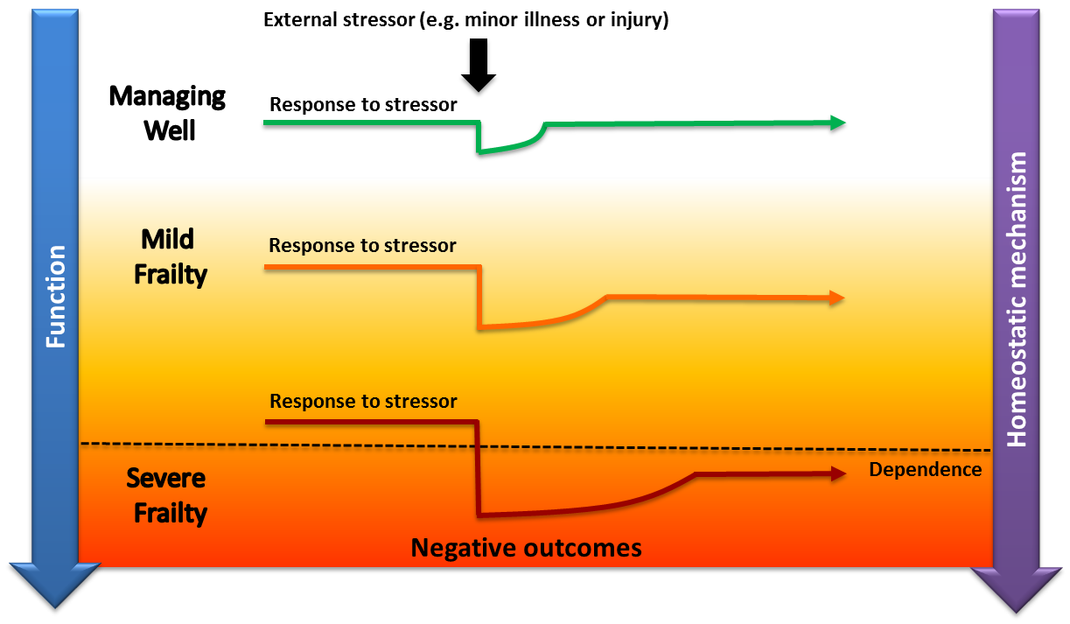
Figure 1 Vulnerability of frail older adults to external stressors (Clegg et al. 2013; Health 2017)

2.1.3 Cardiovascular Parameters as Biomarkers for Frailty
Biomarkers associated with aging and frailty can be classified into several categories, including molecular, digital, functional, and physiological measures (Moqri et al. 2023; Tagliafico et al. 2026). Among physiological measures, cardiovascular dynamics are of particular interest because they reflect regulatory processes that may be altered with declining physiological reserve. Heart rate variability (HRV), which describes variations in the time intervals between successive heartbeats, is one such measure (Álvarez-Millán et al. 2022; Kwon et al. 2022). When derived from electrocardiography (ECG), these intervals are conventionally measured between successive R-waves and are referred to as RR intervals.
Early evidence from community-based cohorts indicates that frailty is associated with reduced HRV and decreased heart rate complexity, suggesting that altered autonomic nervous system regulation may be one physiological characteristic associated with frailty (Chaves et al. 2008). HRV should not, however, be regarded as a frailty-specific diagnostic biomarker. Current evidence primarily supports its investigation as a physiological measure associated with frailty status and related changes in autonomic regulation (Tagliafico et al. 2026).
Some studies report that time-domain HRV indices decrease as frailty severity increases (Tagliafico et al. 2026), whereas findings regarding frequency-domain indices (particularly the low-frequency/high-frequency [LF/HF] ratio) have been inconsistent across populations and recording protocols. In ambulatory ECG recordings, lower approximate entropy of heart-rate dynamics was associated with frailty in older women (Chaves et al. 2008), and a principal component combining conventional HRV indices was associated with frailty in the same broad cohort context (Varadhan et al. 2009).
Evidence also suggests that differences in physiological regulation associated with frailty may become more apparent during or following a physiological challenge than under resting conditions alone. Variation between studies may reflect differences, data acquisition methods, recording durations, participant characteristics, and clinical populations (Tagliafico et al. 2026). Table 2 summarizes reported cardiovascular findings associated with frailty together with their measurement conditions and corresponding references (Esther Eifert 2026).

Table 2 Overview of ECG study results in the context of frailty (Eifert, 2026).
Note: Upward arrows mark higher values in the listed HRV indices in frail and pre-frail participants, and downward arrows mark lower values in the listed indices or reduced recovery or response performance following physical activity in frail and pre-frail participants.
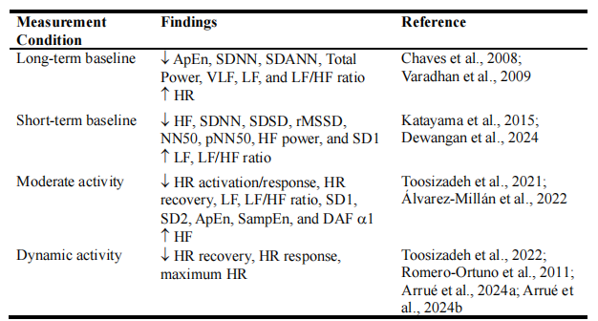
Taken together, these findings motivate the measurement of cardiovascular dynamics under both resting and physiologically challenging conditions. Rather than providing a standalone measure of frailty, such parameters may provide interpretable information about physiological regulation, reserve, and recovery that can be investigated in relation to clinically defined frailty status. Their potential derivation from wearable sensors further makes them relevant to repeated and minimally burdensome physiological monitoring.
  - Cardiovascular System
    - Basic Principles of Cardiovascular Anatomy and Physiology
The cardiovascular system maintains the circulation of blood throughout the body, enabling the delivery of oxygen and nutrients to tissues and the removal of metabolic products. Perfusion describes the delivery of blood to a tissue or organ and is considered adequate when blood flow is sufficient to meet its metabolic requirements (LLC 2019).
Figure 2 illustrates the basic anatomy of the heart and the major structures involved in pulmonary and systemic circulation. The heart is divided into left and right sides by a muscular wall called the septum and consists of four chambers: the right atrium, right ventricle, left atrium, and left ventricle. Four valves maintain predominantly unidirectional blood flow through these chambers and into the major arteries. The tricuspid valve (on the right) and mitral valve (on the left) separates the atria from their corresponding ventricles (the atrioventricular valves), while the pulmonary and aortic valves separate the ventricles from the pulmonary artery and aorta, respectively. Opening and closing of these values occur primarily in response to pressure differences across them during the cardiac cycle (Varela and Davos 2019).
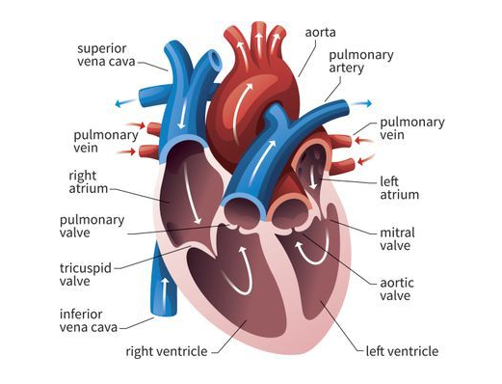
Figure 2 Basic cardiovascular anatomy from (LLC, 2019)
The cardiac cycle refers to the sequence of electrical, mechanical, hemodynamic, and molecular events that occur during a single heartbeat. Electrical activation of the heart initiates a coordinated sequence of mechanical events that enables the chambers to fill with and eject blood. These events are commonly divided into two principal phases: diastole, during which the ventricles relax and fill, and systole, during which ventricular contraction generates the pressure required to eject blood into the pulmonary and systemic circulations (Varela & Davos, 2019).
The right side of the heart is responsible for pumping blood into the pulmonary circulation for oxygenation. The left side pumps oxygenated blood into the systemic circulation, where oxygen is delivered to the body's tissues to support cellular metabolism. Once oxygen has been delivered to the tissues, deoxygenated blood returns to the right atrium. Blood flows from the right atrium through the tricuspid valve into the right ventricle. The right ventricle then contracts, pumping blood through the pulmonary valve into the pulmonary artery and ultimately to the lungs. In the lungs, blood is reoxygenated and flows back to the left atrium via the pulmonary veins. The blood then passes through the mitral valve into the left ventricle. The left ventricle contracts, pumping oxygenated blood through the aortic valve into the aorta, from which it is distributed throughout the body to supply oxygen to tissues and organs (LLC, 2019). The pumping action of the heart generates pressure within the arteries, commonly referred to as blood pressure. Blood pressure is typically expressed as two values: systolic pressure, which reflects arterial pressure during ventricular contraction, and diastolic pressure, which reflects arterial pressure during ventricular relaxation (Gekle et al. 2010).

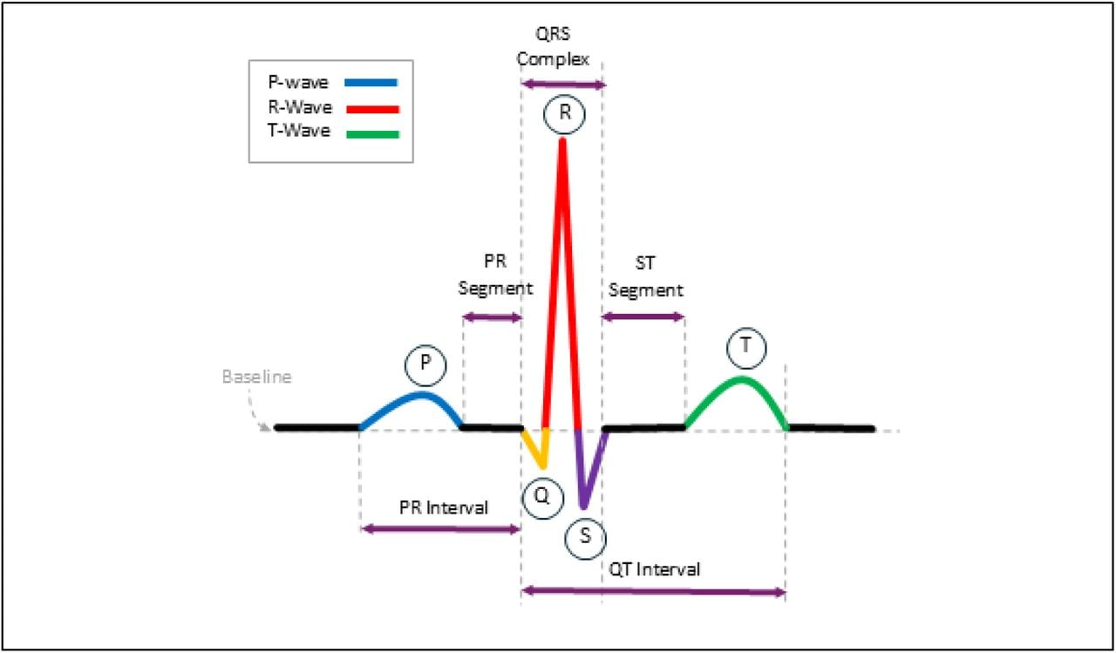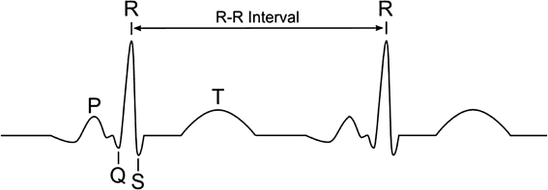
Figure 3 The classic ECG wave. The classic ECG wave illustrates the essential components of cardiac electrical activity, including the P-wave, QRS complex, and T-wave, as well as their respective intervals (Kołodziej et al. 2017 (the figure below); Stone et al. 2024 (the figure above)).
    - ECG and Heart rate
The electrocardiogram (ECG) is an important tool for assessing cardiac electrical activity and diagnosing a range of cardiac conditions. ECG signals provide information about the electrical processes occurring during each cardiac cycle and are widely used to study normal and pathological conditions of the heart (Kaplan Berkaya et al. 2018; Stone et al. 2024). A typical ECG waveform reflects sequential depolarisation and repolarisation of the atria and ventricles and is characterised by the P-wave, QRS complex, and T-wave (Kligfield et al. 2007). These characteristic components of the cardiac electrical cycle are illustrated in Figure 3.
Heart rate can be derived from the time intervals between successive R-waves of the ECG. R-waves are typically used because they form the most prominent component of the QRS complex and can therefore be identified reliably under suitable recording conditions. The time between two successive R-waves is referred to as the RR interval. If the RR interval is expressed in samples, instantaneous heart rate in beats per minute (bpm) can be calculated as
$$HR=\frac{60f_{s}}{I_{RR}}\left[\text{bpm}\right]$$
where $f$ is the sampling rate, $I$ is the instantaneous value of the R-wave interval, and 60 the resulting rate from beats per second to beats per minute. If the RR interval is instead expressed directly in seconds, heart rate is given by ($HR=\frac{60}{RR}$). (Kołodziej et al. 2017)
    - Heart rate variability
Heart-rate variability (HRV) describes variation in the time intervals between successive normal cardiac depolarizations. In ECG analysis, HRV is commonly calculated from normal-to-normal (NN) intervals between accepted R-peaks. Mean heart rate and mean RR interval are mathematically related, but HRV metrics characterise different properties of the beat-to-beat interval series. HRV does not directly measure sympathetic or parasympathetic activity; rather it reflects autonomic modulation of the sinoatrial node together with influences from respiration, baroreflex activity, thermoregulation, humoral factors, behaviour, and measurement conditions (Shaffer and Ginsberg 2017).
Time-domain metrics summarize interval variability and successive beat-to-beat differences. SDNN is the standard deviation of accepted normal intervals and depends strongly on recording duration because longer recordings capture additional sources and timescales of variability. RMSSD is the square root of the mean of the squared differences between successive NN intervals and emphasizes rapid beat-to-beat variation, making it a commonly used time-domain measure of vagally mediated HRV. NN50 counts adjacent interval pairs that differ by more than 50 ms, while pNN50 expresses that count as a percentage. HRV can be analysed over different time recording durations, including long-term recordings, typically 24-hour ECG; short-term recordings, commonly approximately 5 minutes; and ultra-short-term recordings of less than 5 minutes. Results obtained over these different durations are not necessarily interchangeable, and threshold-based measures may be unstable in short or sparsely accepted recordings (Shaffer and Ginsberg 2017).
Frequency-domain analysis describes how interval variation is distributed across frequency. Because successive cardiac intervals are not uniformly sampled in time, spectral estimation requires a method that accommodates irregular sampling or an explicitly defined interpolation procedure. Very-low-, low-, and high-frequency bands are conventional partitions whose interpretation depends on record length and respiratory behavior. High-frequency power often reflects respiratory modulation associated with parasympathetic activity, whereas low-frequency power reflects mixed mechanisms rather than a pure sympathetic channel. Consequently, the LF/HF ratio should not be interpreted as a universal quantitative measure of sympathovagal balance. Detrending, tapering, frequency resolution, normalization, and the choice of units can materially influence spectral estimates (Laborde, Mosley, and Thayer 2017).
Nonlinear and geometric measures characterize properties of the interval sequence that are not fully captured by conventional time- and frequency-domain measures. A Poincaré plot places each interval against its predecessor; SD1 describes dispersion perpendicular to the identity line and SD2 dispersion along it. Entropy measures quantify the regularity or complexity of an interval sequence under specified parameter choices, while detrended fluctuation analysis assesses scale-dependent correlation. Although these methods provide compact summary measures, their estimates can be sensitive to data length and methodological choices. Short sequences, missing beats, nonstationarity, and preprocessing may substantially influence the resulting values (Shaffer and Ginsberg 2017).
  - Photoplethysmography
    - Definition and Optical Principles
Photoplethysmography (PPG) is a non-invasive optical method used to measure changes in blood volume within the cutaneous microvascular bed; the method is based on the optical properties (such as absorption, scattering, and transmission characteristics) of human tissue, including the absorption, scattering, and transmission of light at specific wavelengths (Challoner and Ramsay 1974). An emitter illuminates tissue and a photodetector records light that has passed through or returned from it. Absorption by chromophores, scattering by tissue structures, optical path length, detector sensitivity, ambient light, geometry, and electronics all contribute to the recorded signal. The commonly used term blood-volume pulse is therefore a useful physiological description rather than a complete physical model. The measured waveform results from an interaction between the instrument and tissue, and its characteristics whose meaning depend on wavelength, site, contact pressure, and processing (Park et al. 2022b).
Figure 4 shows the two main configurations used for PPG measurement. Transmission PPG places tissue between the emitter and detector, as in many finger or earlobe clips. Reflectance PPG places the emitter and detector on the same surface and measures backscattered light, enabling measurements at sites such as the wrist, forehead, chest, or fingertip. Transmission PPG can provide a strong pulsatile signal at thin peripheral sites (Li et al. 2018), whereas reflectance PPG enables greater flexibility in wearable sensor placement and geometry. Neither configuration is universally superior: optical path, attachment stability, perfusion, comfort, motion, and the intended measurement determine performance. Signals or models obtained using one measurement configuration should not automatically be assumed to transfer to another, because waveform characteristics and artefact-generating mechanisms may differ (Charlton et al. 2023).

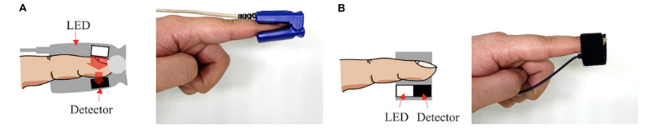
Figure 4 Configuration for photoplethysmography measurement: (A) transmissive type and (B) reflective type (Park et al. 2022a).

The raw detector output is often described as comprising a slowly varying component and a pulsatile component. The slowly varying component reflects average absorption, tissue contact, venous volume, ambient light contributions, and instrument gain. In contrast, the pulsatile component reflects cardiac-related variations superimposed on that level. The ratio between these components is not a universal physiological constant because both are influenced by sensor placement and electronics. Centering or per-window scaling may facilitate numerical analysis but removes information about the absolute level and amplitude. Any amplitude-dependent interpretation therefore requires access to unnormalized signal values, known gain, and a stable acquisition geometry (Charlton et al. 2023).
Wavelength influences optical penetration depth, absorption contrast, and sensitivity to tissue composition. Green light is strongly absorbed by haemoglobin and is commonly used in wrist-worn devices; whereas red and near-infrared light penetrate more deeply and form the basis of pulse oximetry. Multiple wavelengths can provide complementary optical information, but the use of multiple wavelengths alone does not constitute a calibrated measurement of arterial oxygen saturation. Pulse oximetry requires a ratio-of-ratios approach, device calibration, adequate pulsatility, and assumptions regarding dyshemoglobins and measurement conditions. (Nitzan et al. 2014).
    - Hardware and Acquisition
A PPG sensor chain includes light emitters, current drivers, tissue coupling, a photodiode, transimpedance amplification, analogue filtering, ambient-light cancellation, analogue-to-digital conversion, timing control, and digital processing. LED current and detector gain determine the available dynamic range but can also contribute to signal clipping or amplify noise when improperly configured. Nominal analogue-to-digital converter resolution in bits does not equal effective physiological resolution when noise, saturation, or optical coupling are limiting factors. Internal averaging improves random-noise suppression at the cost of temporal bandwidth. To reproduce the acquisition conditions of a recording, hardware identity, firmware, wavelengths, LED current and gain settings, sampling rate, averaging, filter configuration, and channel units must be known (Charlton et al. 2022).
Sampling converts a continuous, band-limited analogue signal into a sequence of discrete values. Frequencies above half the sampling rate can alias into lower frequencies unless analogue anti-alias filtering sufficiently attenuates them before conversion. A high nominal sampling rate does not compensate for inadequate analogue bandwidth, clock instability, packet loss, or undocumented downsampling. Conversely, a sampling rate far above the physiological bandwidth increases storage and computation without guaranteeing more information. The appropriate sampling rate is determined by the fastest signal feature or timing precision required, the anti-alias filter, synchronisation requirements, and computational constraints. Resampling after acquisition cannot recover information that was not captured during acquisition (Charlton et al. 2022).
Sensor site is an important part of the measurement configuration. Finger, wrist, earlobe, forehead, arm, and other sites differ in vascular anatomy, tissue thickness, temperature, perfusion, attachment, motion, and pulse transit time. These differences alter signal amplitude, landmark visibility, and timing even when similar sensor electronics are used. Quantitative comparisons show that waveform characteristics vary substantially across measurement sites (Hartmann et al. 2019). Consequently, transferring signal-processing methods or models between measurement sites represents a form of domain-shift: a detector, feature threshold, or classifier may require re-evaluation rather than a simple adjustment of signal scale.
Contact pressure affects both optical coupling and local haemodynamics. Too little pressure can increase susceptibility to motion and ambient-light leakage, whereas excessive pressure can compress vessels, alter perfusion, change waveform morphology, or reduce pulsatility. The relation is nonlinear and depends on factors including tissue properties and sensor area. Controlled phantom studies have demonstrated that reflectance PPG amplitude and waveform characteristics vary with pressure (May et al. 2021). A wearable sensor and its attachment mechanism should therefore be described in terms of its geometry and method of fixation, and pressure variability should be considered when apparent between-group differences could instead reflect sensor fit or application technique.
Skin and tissue optical properties influence the propagation of light between the emitter and detector. Melanin, tissue thickness, blood content, adipose tissue, tattoos, hair, scars, moisture, and nail products can affect detected light intensity and signal-to-noise ratio. Simulation work indicates that skin tone and adipose thickness can change optical sensor response in ways that depend on wavelength and geometry (Ajmal et al. 2021). Such effects cannot be assumed to be fully corrected through signal normalisation alone. Robust evaluation therefore requires appropriate representation of relevant skin and tissue characteristics, transparent reporting of the study population, and consideration of subgroup-specific uncertainty.

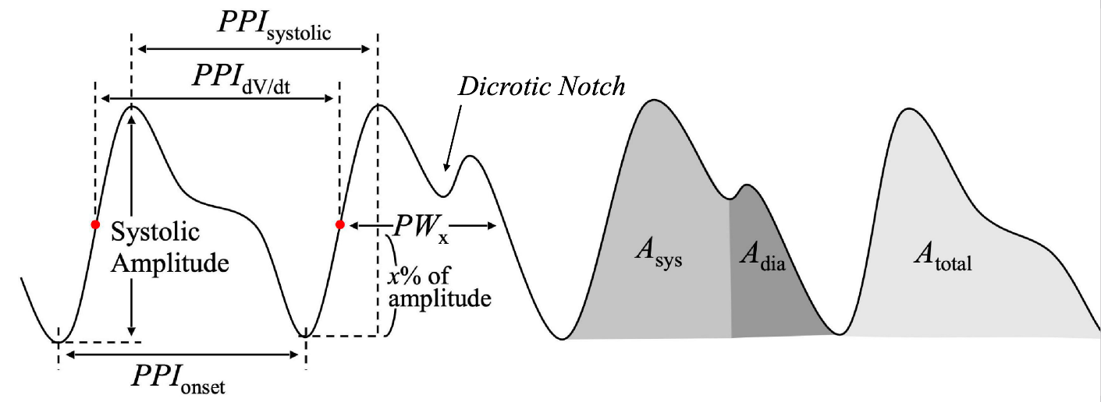
Figure 5 The PPG Waveform and Information (Park et al. 2022a)

    - Waveform Information
A peripheral PPG pulse typically contains a foot, an upstroke, a systolic peak, a descending limb, and sometimes a dicrotic notch or secondary wave (see Figure 5). The first and second derivatives of the PPG waveform can be used to make changes in slope and inflection points more apparent. Although landmark names are often associated with particular physiological events or characteristics, their visibility and location are also affected by site, age, contact pressure, bandwidth, filter phase, and noise. Landmarks therefore require explicit algorithmic definitions, for example, whether pulse onset is defined as a minimum, tangent intersection, derivative extremum, or threshold crossing. Without such an operational definition, two studies may use the same feature name while referring to different measurements (Elgendi 2012). Figure 6 illustrates how markedly these landmarks can differ between participants: the pulse of an older participant (left) shows a slower upstroke and an attenuated, often absent dicrotic notch, whereas the younger participant (right) exhibits a steeper systolic upstroke and a clearly separated secondary wave.
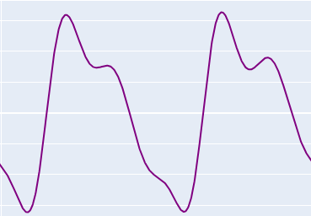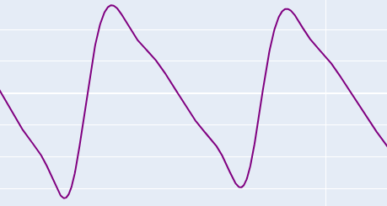
Figure 6 PPF waveform from elder participant (left) and from a young participant (right)

Pulse timing can be measured relative to another cardiac event or between measurement sites. Pulse arrival time (PAT) is measured from a electrical or mechanical cardiac reference to the arrival of the peripheral pulse and therefore includes both the pre-ejection period as well as vascular propagation time. Pulse transit time (PPT), in contrast, aims to characterize pulse propagation between two arterial measurement sites. These quantities are related to vascular properties, including arterial pressure and stiffness, but are not interchangeable, and their absolute interpretation requires synchronised measurements and clearly defined fiducial points. Filter-induced timing shifts can be comparable to the physiological differences under study, especially when different landmarks contain different frequency components (Liao et al. 2023).
Respiration modulates PPG through several mechanisms. Changes in venous return, stroke volume, respiratory sinus arrhythmia, intrathoracic pressure, and movement can alter waveform amplitude, baseline, and beat timing. Very-low-frequency baseline changes can also arise from vasomotor regulation, temperature, or sensor contact. Separating these influences is therefore not simply a matter of identifying a particular frequency component, because multiple physiological and measurement-related processes can contribute to the observed signal. The same spectral peak may have different origins during rest and physical activity. When respiratory rate is inferred from PPG, agreement should therefore be evaluated against a respiratory reference across the intended population and motion conditions (Charlton et al. 2023).
    - PPG and ECG
ECG records electrical potential differences generated by cardiac depolarization and repolarization, whereas PPG records a peripheral optical pulse. An ECG R peak precedes the arrival of the corresponding peripheral pulse by a variable delay. ECG is therefore commonly used as a reference for cardiac rhythm and R–R interval measurement, whereas PPG can provide convenient measurement of peripheral pulse timing and waveform morphology. Agreement in average heart rate does not establish the interchangeability of the two modalities for measures of beat-to-beat variability, arrhythmia detection, or waveform morphology. The two modalities therefore provide related but distinct physiological information (Mejía-Mejía et al. 2020). (see Figure 7)

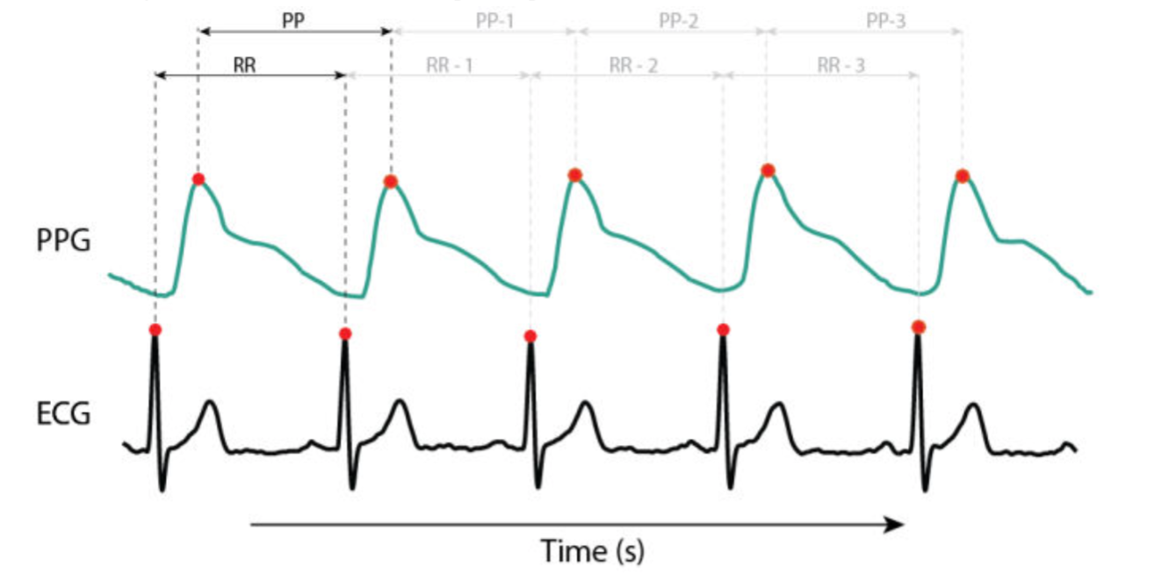
Figure 7 The overlay of PPG and ECG signals. Due to the pulse arrival time, the PPG waveform exhibits a lag relative to the ECG signal (Chapter 4: The differences and similarities between ECG and PPG 2025)

Pulse-rate variability (PRV) is derived from successive peripheral pulse events. It incorporates cardiac interval variation together with variability in pulse propagation and pulse-event detection. At rest and under stable physiological conditions, PRV may approximate selected HRV metrics; disagreement can increase with changes in posture, respiration, vascular state, ectopy, low perfusion, and motion. Terminology should preserve this distinction: PPG yields pulse-to-pulse intervals and PRV unless concurrent ECG or appropriate validation demonstrates sufficient agreement for the intended metric and condition. Treating all PPG pulse-to-pulse intervals as NN intervals can conceal vascular and measurement contributions (Mejía-Mejía et al. 2020).
Wearable PPG offers a low measurement burden, compact hardware, and compatibility with repeated measurements. ECG provides a more direct measure of cardiac electrical activity and rhythm but usually requires electrode contact, stable placement, and a different acquisition chain. Neither is artefact-free: motion can disturb electrodes and optical coupling through different mechanisms. Modality selection should therefore depend on the intended measurement endpoint. PPG may be sufficient for pulse rate and peripheral waveform morphology under validated conditions; rhythm diagnosis or precise characterization of HRV generally favours ECG. Multimodal recording can provide complementary information about electrical timing, pulse propagation, and motion, at the cost of additional synchronisation requirements and measurement burden (Charlton et al. 2023).
    - Motion Artifacts and Cancellation
Motion artefacts in PPG arise through several mechanisms: sensor displacement changes optical geometry; pressure changes compress tissue and vessels; skin deformation changes scattering; venous blood volume may change; ambient light may enter the detector; cable or electronic movement may introduce additional disturbance; and severe transients can saturate the analogue signal chain. The resulting artefact can be impulsive, periodic, broadband, or slowly varying. During walking or repetitive exercise, its frequency content may overlap with the cardiac frequency and its harmonics. Consequently, a fixed frequency filter cannot reliably separate the pulsatile PPG component from motion artefacts under all conditions (Lee et al. 2020).
An IMU commonly combines three-axis accelerometers and three-axis gyroscopes. Accelerometers measure specific force, which includes the contribution of gravity expressed in the sensor frame, together with motion-related translational acceleration and measurement noise. Gyroscopes measure angular velocity but are subject to biases that can accumulate when angular velocity is integrated to estimate orientation. Coordinate frames rotate with the device; vector magnitudes provide orientation-independent summaries but discard directional information. Calibration, scale factors, bias, measurement range, sampling, and synchronisation determine how effectively IMU signals can describe posture, activity, vibration, or motion associated with optical artefacts (Woodman 2007).
Adaptive noise cancellation estimates an unwanted signal component using one or more reference inputs. In the least-mean-squares (LMS) family, filter coefficients are updated to minimise output error, while normalized LMS scales the adaptation step by reference signal energy. Convergence depends on step size, filter length, reference statistics, and the degree to which the reference is correlated with the artefact while remaining sufficiently independent of the desired physiological signal. When the desired pulse signal and the motion reference are correlated, or when the relationship between motion and optical artefact is nonlinear, the algorithm can subtract physiological content or fail to converge. Reference delay and coefficient behavior should therefore be inspected alongside the resulting signal, rather than relying only on the apparent smoothness of the output (Widrow et al. 1975).
Wavelet denoising represents a signal at multiple scales and attenuates coefficients assumed to contain noise. Performance depends on wavelet family, decomposition depth, boundary rule, threshold type, and threshold level. A coefficient cannot be assumed to represent noise merely because it is small or belongs to a high-frequency band; sharp physiological upstrokes also create high-frequency coefficients. Soft thresholding provides a principled shrinkage framework but does not eliminate the need for validation of the processed signal (Donoho 1995). Morphology, pulse count, timing, and amplitude should be checked after denoising.
Empirical mode decomposition (EMD) separates a signal into data-adaptive intrinsic mode functions (IMFs) and a residual. It is attractive for nonlinear and nonstationary data because its basis functions are not fixed in advance. Practical results depend on the shifting procedure, stopping criteria, boundary handling, mode mixing, and the rule used to classify modes as physiological signal or artefact. Removing complete modes can discard physiological content when their frequency content overlaps with that of motion artefacts. Ensemble variants reduce some instability but add parameters and computation. A decomposition plot provides descriptive evidence but does not demonstrate that recovered modes correspond to unique physiological generators (Huang et al. 1998).
Spectral-motion methods aim to identify cardiac-frequency components while suppressing spectral components associated with acceleration. TROIKA combines signal decomposition, sparse spectral reconstruction, spectral peak selection, and tracking for heart-rate estimation from PPG during intensive exercise PPG (Zhang et al. 2015). Its primary endpoint is heart-rate estimation, not reconstruction of a clinically faithful waveform. This endpoint distinction is important more generally: a method optimized for average heart rate may alter beat timing or morphology, while a morphology-preserving method may retain too much disturbance for reliable downstream analysis. Evaluation should therefore reflect the intended downstream measurement or task.
Learned artefact-reduction methods can map contaminated signals and motion context to a clean target, event sequence, or downstream physiological estimate. Convolutional and recurrent models can represent nonlinear, time-varying relationships, but they require representative training targets. Paired clean targets are difficult to obtain during natural motion; synthetic mixtures may not reproduce realistic contact-related artefacts; and a reference device may measure a different modality. A network can minimize waveform error by smoothing peaks or exploiting dataset-specific shortcuts. Learned outputs therefore require evaluation of event timing, morphology, spectral content, coverage, generalisation to unseen participants and motions, and comparison with a no-denoising baseline (Reiss et al. 2019).
Red and infrared PPG provide an additional source of information for artefact handling. Shared optical fluctuations can be characterized using cross-wavelength correlation, lag, coherence, and ratio-based measures, while principal component analysis (PCA) and independent component analysis (ICA) can be used to seek latent components from multiple observed channels. Ratio-based processing can reduce approximately multiplicative common disturbances (Patterson and Yang 2011), but neither correlation nor blind source separation demonstrates by itself that a recovered component is physiologically clean.
Artefact management does not necessarily require reconstruction of the affected waveform. An alternative is to detect motion, assess signal quality, select usable intervals, and report the resulting coverage. This may be preferable when the physiological and artefactual components cannot be separated with sufficient confidence.
These principles support an endpoint-specific processing strategy. A low-motion segment can proceed directly to pulse detection and feature extraction. When a validated artefact-reduction method is applied to a motion-contaminated segment, the processed PPG can enter the same pulse detector and HR/PPI/PRV feature extractor. Morphology features require the stricter condition that individual pulse shapes remain sufficiently reliable for the identification and measurement of waveform landmarks.

  - Machine Learning and Deep Learning
    - Concept of AI and ML
Artificial intelligence (AI) is transforming scientific research across various disciplines by introducing new approaches to data analysis, modelling, and scientific discovery (Frazier and Song 2024). AI broadly refers to the development of systems capable of performing tasks commonly associated with human intelligence. Machine learning (ML) is a subfield in which models learn patterns or relationships from data rather than relying solely on explicitly programmed decision rules in advance, and deep learning (DL) is a subfield of ML based on multilayer neural networks that learn hierarchical representations (Hinton et al. 2006; McCarthy et al. 1955; Samuel 1959). The relationship between AI, ML, and DL is illustrated in Figure 8.
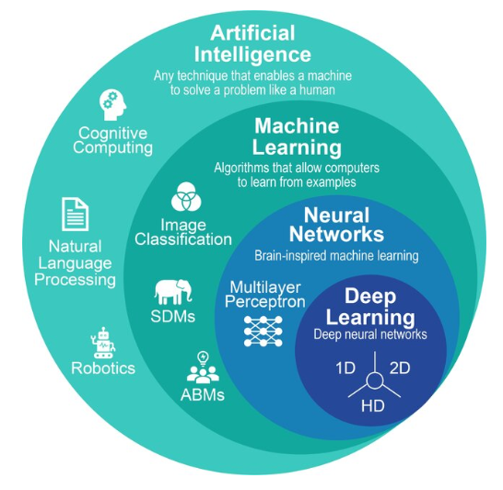
Figure 8 The nested hierarchy of artificial intelligence (AI), machine learning (ML), neural networks, and deep learning (DL) (Frazier and Song 2024)

ML is commonly divided into supervised, unsupervised, and reinforcement learning (see Figure 9). Supervised learning estimates a mapping from inputs to known labels or continuous targets; unsupervised learning identifies structure in unlabeled data, such as clusters or lower-dimensional representations; reinforcement learning learns sequential decision-making strategies based on rewards obtained through interaction with an environment (Cortes and Vapnik 1995; Lee and Seung 1999; Watkins and Dayan 1992). The ML component of the present thesis follows a supervised learning approach, in which synchronized physiological and motion signals are used for three-class time series classification study.
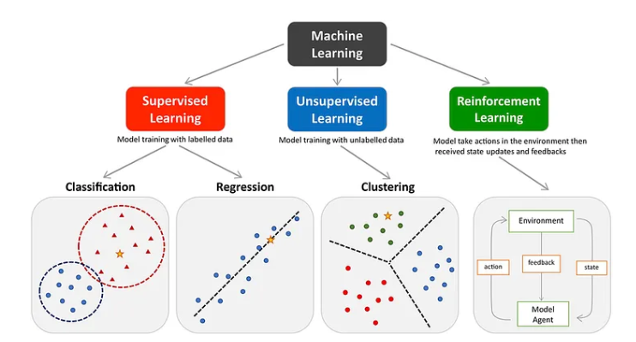
Figure 9 The main types of machine learning (Peng et al. 2021)
    - Supervised Time Series Classification Models
Time series dataset consists of sequences of observations recorded over time; with individual data points indexed according to their time of acquisition (Wilson 2016). Physiological and motion signals such as PPG, ECG, and IMU recordings are therefore naturally represented as time series. The information contained in time-series data is determined not only by individual observations but also by their temporal evolution and relationships across time (Wu et al. 2023). This presents challenges for data analysis, particularly when relevant information depends on sequential dependencies, trends, seasonal patterns, and complex temporal dynamics. Consequently, time-series analysis requires sophisticated methods capable of extraction representations that preserve and exploit these temporal characteristics (Wang et al. 2024).
Time Series Classification (TSC) is a supervised-learning task in which a time series is assigned to one of a predefined set of classes and has been applied in many fields (Ismail Fawaz et al. 2020). TSC differs from classification based on conventional tabular data because the ordering and temporal relationships among observations may themselves contain discriminative information (Bagnall et al. 2017). Traditional statistical methods provide important theoretical and analytical foundations, but methods based on assumptions such as linearity and stationarity may not capture all relevant structure in complex, non-linear, and nonstationary signals. DL approaches provide an alternative by learning representations directly from time-series data and can model complex temporal patterns across multiple input channels (Wang et al. 2024).
Given the multichannel and temporally structured nature of synchronised PPG and IMU recordings, deep-learning-based TSC provides a suitable framework for investigating whether discriminative patterns can be learned directly from the recorded signals. In this thesis, 1-D CNN, InceptionTime, and ShapeFormer are considered candidate architectures because they provide different approaches to learning temporal representations from multivariate time-series data.

2.4.3 One-Dimensional Convolutional Networks
Convolutional neural networks (CNNs) have increasing applied to end-to-end TSC because they can learn discriminative representations directly from sequential data without requiring a separate hand-crafted feature-extraction state (Wang et al. 2017). Originally established in areas such as image classification, convolutional architectures use learned filters to identify local patterns that are informative for a given task (Taherkhani et al. 2023). For time-series data, this principle can be extended to one-dimensional convolutions operating along the temporal axis.
A one-dimensional convolution applies a learned kernel along the temporal axis (Wang et al. 2017). For input channel $c$, filter $k$, kernel coefficient $w_{k,c,j}$, bias $b_{k}$ and time index $t$, a basic cross-correlation form is
$$z_{k,t}=b_{k}+\sum_{c=1}^{C}{\sum_{j=0}^{K-1}{w_{k,c,j}x_{c,t+j}}}.$$
The same kernel coefficients are reused at every valid temporal position, allowing the filter to respond to a learned local pattern at different positions within the input window (Wang et al., 2017). Multiple filters produce multiple feature channels, and multivariate kernels can combine information across input channels (Wang et al. 2017). Nonlinear activation functions and stacked layers allow later representations to combine simpler local patterns over a wider effective receptive field (Wang et al., 2017).
Kernel length, stride, dilation, and network depth determine the temporal context represented by the network. Short kernels capture local temporal structure, while stacked layers or dilated convolutions expand the effective receptive field (Wang et al., 2017). Pooling reduces temporal resolution and can increase tolerance to small temporal shifts (Wang et al., 2017). Global average pooling summarises each learned feature channel across the temporal dimension, avoiding the large parameter count associated with a fully connected layer connected to every time position (Wang et al., 2017). This can reduce model complexity, although it does not guarantee resistance to overfitting.

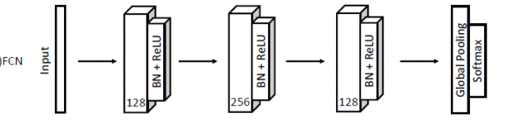
Figure 10 Architecture of Fully convolutional network by Wang et al. (2017)

The fully convolutional network proposed by Wang et al. (2017) as a TSC baseline consists of a three Conv1D–batch-normalisation–ReLU blocks with kernel lengths 8, 5, and 3 without striding, and counts 128, 256, and 128, respectively (see Figure 10). The network concludes with global average pooling and a softmax classifier. This architecture provides a useful reference for evaluating whether a relatively simple hierarchy of learned local temporal filters is sufficient for a multi-class classification task. More specialised architectures can subsequently extend this principle by explicitly incorporating features such as multiple temporal scales or alternative representations of characteristic signal patterns.

2.4.4 InceptionTime
InceptionTime was developed as a convolutional architecture for TSC designed to learn patterns across multiple temporal scales (Ismail Fawaz et al. 2020). The complete InceptionTime model is an ensemble of five classifiers with identical architectures but independently initialized weights. Each classifier consists of a sequence of Inception modules, adapted from the Inception concept originally introduced for image classification (Ioffe and Szegedy 2015; Ismail Fawaz et al. 2020). The core idea of ​​the Inception module is to apply parallel convolutional filters with different kernel lengths, enabling the network to learn both shorter- and longer-range temporal patterns from the same input sequence. Inception network for time series classification

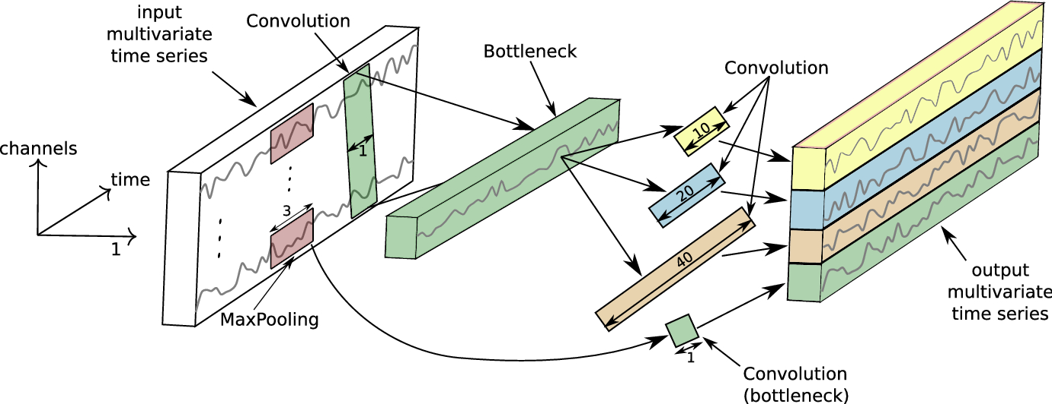
Figure 11 Inside details of one inception module with a 1×1 bottleneck layer (Ismail Fawaz et al. 2020)

The core Inception module first applies an optional 1×1 bottleneck convolution to reduce channel dimensionality (see Figure 11). The resulting sequence is then processed by parallel temporal convolutions with different kernel lengths and through a separate max-pooling branch followed by a 1×1 convolution. The branch outputs are concatenated, batch-normalised, and passed through a rectified linear unit (ReLU) activation. In the original configuration, the three temporal kernel lengths are 10, 20, and 40, each convolutional branch has 32 filters, and the bottleneck contains 32 filters. Longer kernels capture information over wider temporal intervals, while shorter kernels preserve finer local structure. The parallel branches therefore create learned representations at multiple temporal scales within the same module.
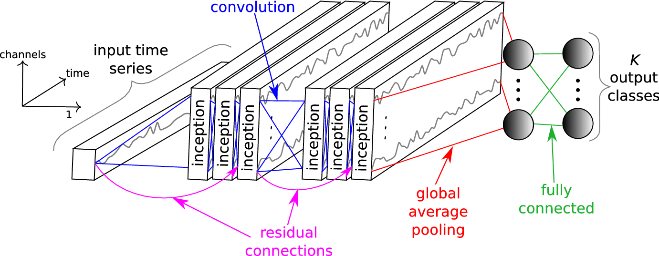
Figure 12 Architecture of an Inception network with 6 different Inception modules (Ismail Fawaz et al. 2020)

The published Inception network contains two residual blocks, with three Inception modules in each block, followed by global average pooling and a softmax output (see Figure 12). Residual connections provide shortcut paths across groups of Inception modules, facilitating the optimisation of the deeper network. The bottleneck reduces channel dimensionality before the longer convolutions, thereby limiting parameter growth. Ablation experiments reported by Ismail Fawaz et al. (2020) primarily support the bottleneck as of reducing model complexity rather than demonstrating a consistent improvement in classification accuracy.
InceptionTime is particularly relevant to physiological TSC because an input window may simultaneously contain fine waveform morphology, patterns spanning multiple cardiac cycles, and slower temporal variations. Its parallel convolutional kernels provide a mechanism for learning representations across these different temporal scales without requiring them to be defined explicitly through handcrafted features.

2.4.5 ShapeFormer
ShapeFormer builds on the concept of a shapelet: a discriminative subsequence whose similarity to regions of a time series can provide information for classification (Le et al. 2024). Ye and Keogh (2009) introduced time-series shapelets as subsequences selected according to their ability to separate classes. ShapeFormer extends this concept by incorporating class-specific shapelets into one of two complementary representation branches. Because the discovery of class-specific shapelets uses class labels, the discovery process must be restricted to the training data available at each stage of model validation to avoid information leakage (Cawley and Talbot 2010).
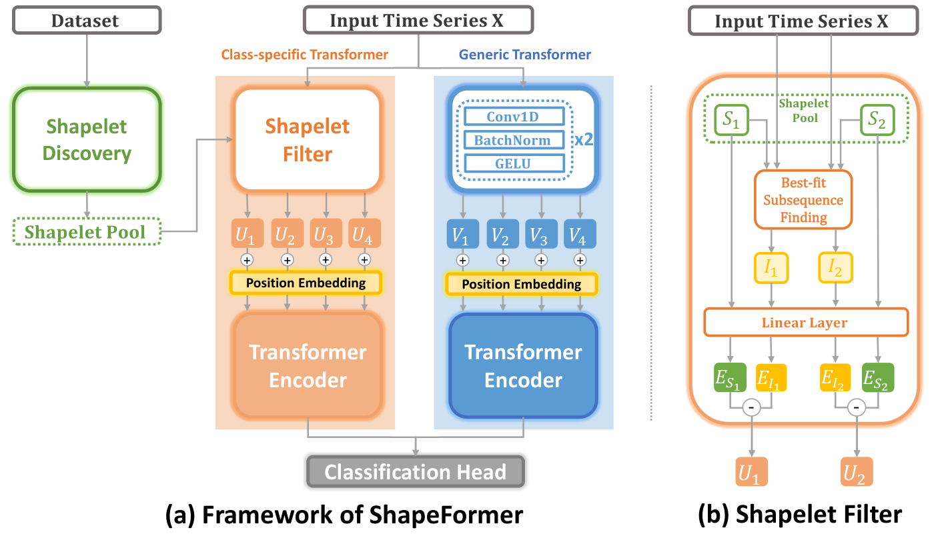
Figure 13 The general architecture of ShapeFormer. (a) Framework of ShapeFormer and (b) Shapelet Filter (Le et al. 2024)
The ShapeFormer architecture (see Figure 13) combines a class-specific shapelet-transformer branch and a generic convolution-transformer branch (Le et al. 2024). The class-specific branch learns representations based on differences between selected shapelets and subsequences of the input, whereas the generic branch learns a complementary representation directly from the multivariate input. The outputs of the two branches are concatenated before classification using a linear layer and softmax output. ShapeFormer therefore combines explicitly shapelet-informed information with a more general learned representation rather than treating the selected shapelets as a complete representation of the input series.
Offline Shapelet Discovery generates candidate subsequences from the training series using perceptually important points and ranks candidates within each class according to information gain. Because this procedure is label-informed, performing shapelet discovery on the complete dataset before separating training and validation data would allow information from the validation set to influence model development and would therefore constitute data leakage (Cawley and Talbot 2010). Shapelet discovery must consequently be performed using only the training portion within each evaluation fold or split. The selected shapelets initialise trainable Shapelet-filter parameters, which can subsequently be updated during network training (Le et al. 2024).
For each shapelet, the Shapelet Filter searches a local region of the input for the best-matching subsequence according to complexity-invariant distance. The filter embeds both the selected input subsequence and the shapelet and uses their difference to construct a class-specific token. A transformer encoder then models relationships between the resulting shapelet-informed tokens. ShapeFormer incorporates positional information before the transformer encoding, allowing the representation to retain information about the ordering of the token sequence.

- Pipeline Design and Implementation
This chapter describes the design and implementation of the analysis pipeline for three-class frailty-related group classification, providing an overview of the dataset, preprocessing, static and dynamic signal processing, feature construction, classification, validation, and considerations for future mobile deployment.
The workflow comprises three coordinated representations: an eight-channel time-series branch, a handcrafted-feature branch, and an optional signal–feature fusion branch. Motion-contaminated PPG can additionally pass through the artefact-reduction branch before pulse and feature extraction. All branches use the same participant identifiers, recording-role definitions, and participant-grouped validation folds, ensuring that the signal-processing and classification stages remain aligned.
  - Overall workflow
Figure 14 presents the workflow for three-class frailty classification using synchronised PPG and IMU signals. The dataset comprises 29 participants and 261 raw recordings, with the target groups defined as Pre-Frail, Robust/Non-Frail, and Young. Initial data preparation includes mapping the available clinical frailty information to the three target classes, matching participant identifiers to the corresponding signal files, retaining the predefined recording stages, and extracting the required signal channels. Each recording contains red and infrared PPG signals together with six IMU channels comprising three-axis acceleration and three-axis angular velocity. File-level quality control is performed to identify recordings with corrupted files, missing channels, insufficient signal duration, or other conditions that make them unsuitable for analysis.
Following data preparation, the dataset is partitioned using participant-level five-fold stratified group cross-validation, implemented with StratifiedGroupKFold (Pedregosa et al. 2018). Participant identity is used as the grouping variable so that all recordings and signal windows from the same participant remain within a single fold. This prevents information from the same participant from appearing in both the training and validation data. In each cross-validation iteration, four folds are used for model training and the remaining fold for validation. The procedure is repeated across the five folds so that each participant contributes to an out-of-fold validation prediction. Stratification is used to preserve the distribution of the three groups across folds as far as possible.
Within each cross-validation iteration, the signals undergo a standardised preprocessing procedure. Missing PPG samples are first handled by interpolation to construct a baseline-preserving optical signal representation. A separate PPG representation used for filtered analysis is linearly detrended and subsequently band-pass filtered between 0.2 and 8 Hz to suppress baseline drift and high-frequency noise. For the IMU signals, acceleration channels are low-pass filtered using a third-order Butterworth filter with a 20 Hz cut-off, and each gyroscope channel at 40 Hz. The gravitational component is estimated and removed from the acceleration signal to obtain dynamic acceleration associated primarily with body movement. The processed multichannel recordings are subsequently divided into fixed-length temporal windows with 50% overlap. Each window is normalised using robust median and interquartile-range scaling, after which extreme values are clipped to the range [−8, 8] to reduce the influence of outliers.
In addition to the raw multichannel time-series signals, the pipeline supports signal-quality assessment and motion characterisation. PPG segments with acceptable signal quality and low motion can proceed directly to subsequent analysis, whereas motion-contaminated segments can either be processed using a configured artefact-reduction method or excluded when sufficient signal quality cannot be recovered.
The pipeline also supports the extraction of physiologically interpretable handcrafted features. PPG pulse peaks are identified using an Aboy++-based peak-detection procedure. The detected peaks are used to derive pulse-to-pulse intervals (PPIs) and HRV measures. Individual pulse segments defined from the detected pulse sequence are additionally used to derive pulse-wave morphology features, including pulse amplitude, rise time, decay time, pulse width, systolic slope, and pulse area. Additional time- and frequency-domain features are described in Section 3.4. Any feature scaler or other transformation whose parameters must be estimated from the data is fitted exclusively using the corresponding training fold.
The validation fold is processed using the same signal-processing, signal-quality assessment, motion artifact cancellation, window-generation, and feature-extraction procedures as the training folds. Parameters learned from data, however, are estimated using the training fold only. Validation samples are subsequently transformed using the feature schema, channel order, and training-derived transformation parameters. This separation reduces the risk of information leakage through preprocessing, feature scaling, feature selection, or other data-dependent transformations.
After preprocessing and feature extraction, several candidate classification architectures are trained and compared. The DL models comprise a baseline 1D-CNN, InceptionTime, a computationally reduced Small InceptionTime variant, and ShapeFormer. The DL models operate on the eight-channel time-series representation, with selected experiments additionally incorporating handcrafted features alone. In the fusion experiments, the multichannel time series is encoded by the deep neural network, while the handcrafted physiological features are processed through a separate multilayer perception (MLP). The resulting time-series and tabular representations are then fused before the final three-class prediction.
Model comparison and configuration optimisation consider not only the network architecture but also the window length and overlap, loss function, sampling method, degree of regularisation, and participant-level aggregation strategy. Each candidate configuration is trained and evaluated using the same participant-level fold assignments. Predictions from the five validation folds are combined to form out-of-fold predictions, ensuring that each out-of-fold prediction is produced by a model that was not trained on data from the corresponding participant. Due to the small sample size, each model comparison used participant-level five-fold stratified group cross-validation and repeated 5 times, as the resampling method on the training set (Hellqvist et al. 2024).
Because each participant generally contributes multiple recording files and temporal windows, window-level predictions are aggregated to obtain a participant-level prediction. The pipeline supports quality-weighted probability aggregating, in which windows with higher estimated signal quality receive greater weight. The participant-level class prediction is then determined from the aggregated probabilities across the three target classes.
Model performance is evaluated primarily at the participant level using balanced accuracy, macro-averaged F1 score, class-specific recall, class-specific F1 score, and the confusion matrix. Because the groups are unequal in size, balanced accuracy and macro-averaged F1 provide a more informative assessment of performance across all three classes than conventional accuracy alone. Fold-wise performance and its variability are also examined, together with learning curves and the difference between training and validation performance, to assess model stability, overfitting, and generalisation.
Finally, the cross-validation results are used for model interpretation and configuration selection. This includes class-level error analysis, examination of confusion patterns, ablation experiments on input signals and handcrafted features, and comparisons among model hyperparameters, signal-quality-control procedures, and regularisation strategies. The final configuration is therefore selected by considering overall cross-validation performance, between-fold variability, weakest-class performance, and the training-validation gap, rather than the highest result obtained from an individual run. The cross-validation folds are used to generate out-of-fold predictions and compare candidate configurations; under the current experimental protocol, they do not constitute an additional independent test set.

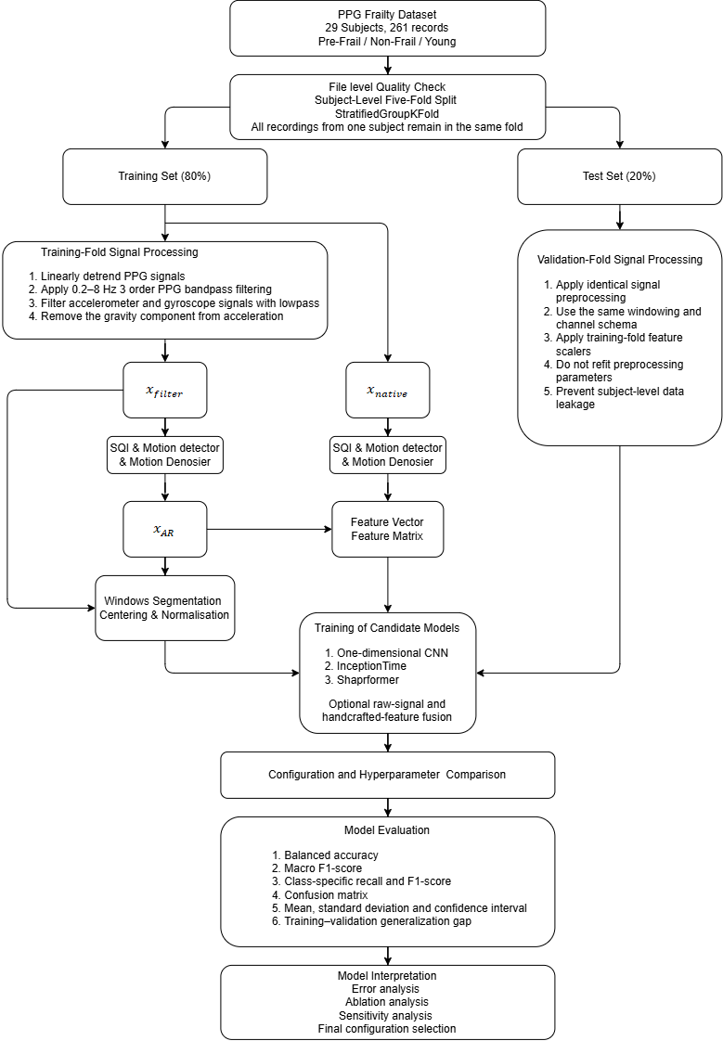
Figure 14 Classification Workflow
  - Datasets
    - Internal Main Datasets
The primary data originate from the cross-sectional laboratory study Cardiovascular Parameters as Potential Biomarkers for Frailty: A Dynamic Assessment Using Photoplethysmography reported by Eifert (2026). Participants were measured between 08:00 and 15:30 under standardised laboratory conditions at approximately 21–25 °C. The protocol comprised a five-minute seated baseline, two usual-pace 4.57 m walking trials, two five-times-sit-to-stand trials, and a five-minute seated recovery after each task. Task order was randomised. Each segment was started, stopped, and saved separately, producing nine recordings per participant. The nine recording roles in the repository are B (baseline), W1 and W2 (walking), S1 and S2 (sit-to-stand), and R1–R4 (post-task recovery).
Participants were recruited through university, community, gym, residential-care, and personal networks. Cognitive pre-screening used the Six-Item Screener. Principal eligibility requirements included the ability to walk 4.57 m independently or with an aid, and the ability to communicate in English or German. The source study excluded several conditions that could compromise safety or the interpretation of cardiovascular and motor measurements, including serious neurological or musculoskeletal disease, arrhythmia or atrial fibrillation, hypertension, coronary artery disease, heart failure, pacemaker or beta-blocker use, and relevant disease, scarring, or tattooing at the non-dominant fingertip. Participants with diabetes were retained to preserve the available sample size).
Frailty was assessed only in participants aged 60 years or older using the Fried physical frailty phenotype. Its operational components were unintentional weight loss greater than 4.5 kg in the preceding year; exhaustion based on the specified CES-D items; low weekly activity below 383 kcal for men or 270 kcal for women; grip-strength weakness assessed against sex- and BMI-stratified thresholds; and slowness assessed from the 4.57 m walk against sex- and height-stratified time thresholds (Fried et al. 2001). A total score of 0 correspond to Robust/Non-Frail, scores of 1-2 correspond to pre-frail, and scores of 3 or more correspond to Frail. No older participant in the operational dataset met three or more criteria. The Young participants, for whom the Fried phenotype was not applied, are retained as an age-reference group and form the third classification class.
As such, the operational dataset used in this thesis contains 29 participants: 9 pre-frail, 12 Robust/Non-Frail, and 8 Young participants. With nine recordings per participant, the complete repository contains 261 recordings. The five motion-minimised conditions (B and R1–R4) provide 145 recordings for the static/reference branch.
Ethical approval was granted by the Ethics Committee of the Department of Psychology and Ergonomics at Technische Universität Berlin (tracking number 2712888; approval letter 30 June 2025). Participants provided written informed consent and were compensated.

Table 3 Operational cohort used by in this thesis. Participant characteristics are from Eifert (2026); recording counts are derived from the audited repository structure.
Group | N | Age, years  (mean ± SD) | Female  (n) | All files | Static roles  (B + R1–R4)
Pre-Frail | 9 | 67.7 ± 5.9 | 8 | 81 | 45
Robust/non-frail | 12 | 69.8 ± 5.9 | 6 | 108 | 60
Young | 8 | 25.5 ± 1.8 | 7 | 72 | 40
Total | 29 | — | 21 | 261 | 145

Eifert used a custom reflectance finger-clip device attached to the non-dominant index fingertip. The optical module was a MAX30102 with nominal red and infrared wavelengths of 660 and 880 nm, respectively. The IMU was an LSM6DS3 (accelerometer range of ±4 g, gyroscope range of ±500°/s). The signals were acquired at 400 Hz and software synchronized. Repository files contain the ordered columns RED, IR, AX, AY, AZ, GX, GY, and GZ, corresponding to two optical channels, three acceleration axes, and three angular-velocity axes .
The CSV files contain no explicit timestamp column; time is therefore reconstructed from the sample index and sampling frequency as $t_{n}=\frac{n}{f_{s}}$ , where $n$ is the sample index and $f_{s}=400 Hz$ is the configured sampling frequency. The main pipeline preserves the stored IMU numerical scale, with acceleration expressed in g and gyroscope in degrees per second (°/s) and uses the recorded AX–AZ and GX–GZ channels consistently throughout preprocessing, feature extraction, and classification. The calibrated EKF profile performs the required unit conversions internally.
The motion-minimised static/reference branch uses B and R1–R4 (145 recordings). The W1/W2 and S1/S2 task recordings comprise 116 recordings and form the dynamic branch, providing the principal motion-contaminated inputs for the artefact-reduction and motion-aware feature workflow described in Section 3.3.5.
    - Open-source motion-artifact development dataset
The open dataset used for motion-artefact development is the Pulse Transit Time PPG Dataset, version 1.0.0, published on PhysioNet (Mehrgardt et al. 2022). It contains 66 records from 22 healthy adults aged 20–53 years. Each participant completed sitting, stationary walking, and running conditions in randomised order. The dataset contains more than 40,000 heartbeats and synchronised multimodal recordings. (see Table 4)

Table 4 PhysioNet PTT-PPG v1.0.0 content and its project role (Mehrgardt et al. 2022).
Signal family | Published channels | Sampling information | Use in this project
ECG waveform | ecg | 500 Hz | Cardiac waveform context
ECG annotation | WFDB .atr; CSV peaks | R-peak events | Heartbeat-timing reference
Multi-site PPG | pleth_1–pleth_6 | Public 500 Hz grid | Optical input and cross-channel context
IMU | a_x–a_z, g_x–g_z | 500 Hz | Motion reference/context
Contact pressure | lc_1, lc_2 | Exported on public grid | Auxiliary acquisition context
Temperature | temp_1–temp_3 | Exported on public grid | Auxiliary acquisition context
Metadata | activity, anthropometrics, BP, HR, SpO₂ | Per record/participant | Activity labels and reference metadata

The WFDB files contain 18 waveform channels. The distributed CSV representation contains 20 columns: time, 18 waveform channels, and a peak-annotation column. The open dataset is used to develop and evaluate the motion-processing branch independently of the frailty-related group labels in the main dataset. ECG R-peak annotations provide a reference for HR and PPI evaluation, while the sitting/walking/running labels and synchronised IMU channels provide motion context. The relevant PPG and IMU channels are processed through the same motion-processing module interfaces described in Section 3.3.5. The resulting PPG is then evaluated using the common pulse-detection and HR/PPI/PRV feature-extraction procedures.
For this development dataset, the waveform channels are processed at their public 500 Hz sampling rate. Each artefact-reduction run records the selected PPG channel or channels, IMU references, preprocessing profile, and module parameters to ensure that the processed signal and subsequent pulse-feature evaluation can be reproduced.
  - Signal Preparation
Each internal recording is associated with a participant ID, class label, recording role, and configured sampling rate. The pipeline requires eight signal channels: RED, IR, AX, AY, AZ, GX, GY, and GZ. Signal columns are converted to numeric values, and isolated non-finite samples are replaced using linear interpolation between neighbouring finite samples. Time is represented by $t=n/f_{s}$. The internal dataset uses $f_{s}=400\text{ Hz}$, while the open motion-development dataset uses its public 500 Hz sampling grid.
Participant grouping is established before any training-dependent transformation. Each participant is assigned to a single fold using StratifiedGroupKFold (Pedregosa et al. 2018), and every file, signal window, feature vector, and feature matrix derived from that participant retains the same fold assignment. Deterministic record-local filtering and feature computation use only the current record; imputation, feature standardisation, feature selection, learned quality thresholds, and model parameters that require estimation from the dataset are fitted using the training participants only and subsequently applied unchanged to the held-out participants.
The preprocessing stage creates distinct signal views for different downstream purposes. Absolute optical level is retained where required for DC-dependent optical ratios; pulse detection, morphology, and generic signal features use a filtered PPG representation that preserves relative waveform amplitude; and the deep-learning branch applies an additional robust normalisation only after temporal segmentation. Motion-artifact reduction, when enabled, modifies the analysis PPG before pulse and feature extraction rather than creating a separate feature pipeline. Table 5 summarises these signal representations, stating for each view how it is produced and which downstream stage consumes it.

Table 5 Signal representations created by preprocessing and their downstream use.
Signal view | Construction | Used by
Baseline-preserving optical view ($x_{native}$) | Interpolated RED/IR on the acquisition scale before detrending/band-pass | DC, PI and RED/IR DC-dependent optical ratios
Analysis PPG ($x_{filter}$) | Linear detrend + zero-phase 0.2–8 Hz Butterworth band-pass | Pulse detection, HR/PPI/PRV, morphology, generic optical features
Artifact-reduced PPG ($x_{AR}$) | Output of the configured Section 3.3.5 module, aligned to the original sample grid | Motion-segment HR/PPI/PRV and morphology; replaces $x_{filt}$ for that segment
Deep-learning window (windowed $x_{filter}$) | Per-window median centering + IQR scaling + clipping | 1-D CNN, InceptionTime, ShapeFormer and raw-signal fusion branch
Processed IMU | LP-filtered acceleration/gyroscope, gravity-reduced acceleration, magnitudes and jerk | Motion routing, artifact-reduction references and IMU features

    - PPG preprocessing
After missing-sample repair, the interpolated RED and IR signals are copied as the baseline-preserving optical view ($x_{native}$). This view retains the acquisition-scale optical level and is used only for quantities whose definition requires a non-pulsatile baseline, such as DC components and AC/DC-based wavelength ratios.
The pulse-analysis view is produced independently for each wavelength. A least-squares linear trend ($an+b$) is removed from each PPG channel ($x[n]$), $x_{d}\left[n\right]=x\left[n\right]-\left(an+b\right).$ and the detrended signal is filtered using a third-order Butterworth band-pass with cut-off frequencies of 0.2 and 8.0 Hz. The filter is implemented as second-order sections and applied forward and backward using sosfiltfilt, thereby avoiding phase displacement in the offline filtered output. The resulting $x_{filt}$ retains relative waveform-amplitude information and is supplied to pulse detection and engineered-feature extraction. The signals are not median/IQR-normalised before feature extraction (Butterworth 1930; May et al. 2021; Park et al. 2022a).
For a motion-labelled segment, $x_{filt}$ is either passed directly to the shared analysis interface or replaced by the aligned artefact-reduced output $x_{AR}$ described in Section 3.3.5. All downstream pulse features use the selected analysis signal for that segment, allowing static and artefact-reduced dynamic PPG to follow the same feature-extraction pathway.
Figure 15 compares an example raw PPG signal with its corresponding preprocessed signal in the time domain. Following preprocessing, baseline variation and high-frequency fluctuations are reduced while the pulsative waveform remain visible. The figure was generated using the same preprocessing procedure implemented in the pipeline.

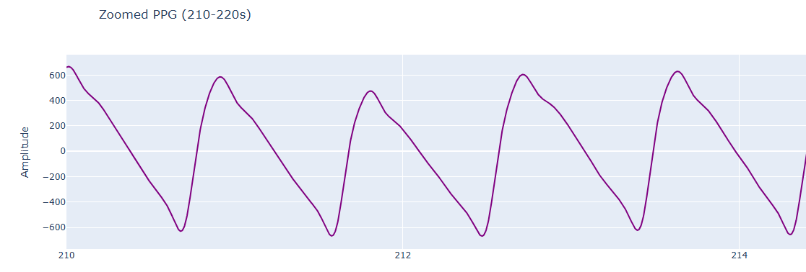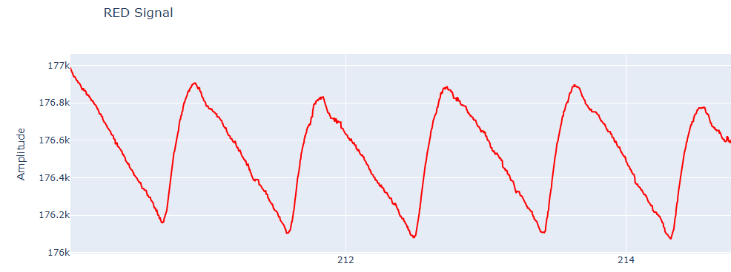
Figure 15 Example raw PPG signal (below) and corresponding preprocessed PPG signal (above) in the time domain

    - IMU preprocessing, attitude estimation, and gravity removal
Each acceleration axis is low-pass filtered using a third-order Butterworth filter with a 20 Hz cut-off, and each gyroscope axis at 40 Hz. Acceleration measures specific force; during slow movement, a substantial component of the measured acceleration can arise from gravity projected into the sensor coordinate frame. Separating this component from dynamic acceleration therefore requires an explicit estimation model. The pipeline provides two IMU preprocessing profiles.
Profile A: low-pass gravity separation. Gravity is estimated from the filtered acceleration by a second-order 0.3 Hz low-pass:
$$\hat{g}[n]={LPF}_{0.3 Hz}\left\{a_{f}[n]\right\}, a_{dyn}[n]=a_{f}[n]-\hat{g}[n].$$
The classifier input is $\left[RED, IR, a_{dyn,x}, a_{dyn,y}, a_{dyn,z}, ω_{f,x}, ω_{f,y}, ω_{f,z}\right]$. This method is computationally light and does not require sensor-axis calibration. Its limitation is that rapid orientation changes can place gravity energy above 0.3 Hz and therefore allow it to leak into $a_{dyn}$, while slow translational acceleration may be absorbed into $\hat{g}$. It is therefore described as low-pass gravity separation rather than full attitude compensation (Woodman 2007).
Profile B: Calibrated roll–pitch extended Kalman filter (EKF). The implementation assumes that raw acceleration is expressed in g and converts it to SI units using $9.81 m s^{-2}$. Angular velocity is assumed to be expressed in degrees per second and is converted to radians per second. Initial tilt is estimated by
$$ϕ_{0}=atan2\left(a_{y}, \sqrt{a_{x}^{2}+a_{z}^{2}}\right), θ_{0}=atan2\left(-a_{x}, \sqrt{a_{y}^{2}+a_{z}^{2}}\right).$$
The state is $x={\left[ϕ, θ, b_{gx}, b_{gy}, b_{gz}\right]}^{T}$. Using bias-corrected angular rates, the Euler-angle process model is
$$\dot{ϕ}=ω_{x}+ω_{y}sinϕtanθ+ω_{z}cosϕtanθ, \dot{θ}=ω_{y}cosϕ-ω_{z}sinϕ.$$
The state is propagated using forward Euler integration with $Δt=1/f_{s}$. Accelerometer-derived roll and pitch form the observation. The observation covariance is multiplied by
$$s_{R}=1+α_{R}max\left(0, \frac{\left|‖a‖-g\right|}{g}\right), α_{R}=3,$$
so that the filter assigns less weight to accelerometer-derived tilt when the measured acceleration magnitude deviates from the expected gravitational magnitude. The project defaults are $\left[5, 5, 0.05, 0.05, 0.05\right]Δt$ for process-noise $\left[0.5, 0.5\right]$ for the base observation-noise. EKF prediction and correction follow the standard covariance equations (Sabatini 2011). Because this configuration does not use magnetometer correction, yaw cannot be independently corrected from an absolute heading reference. Consequently, only roll and pitch are used for gravity compensation.
For each sample, $R\left(ϕ, θ\right)=R_{x}\left(ϕ\right)R_{y}\left(θ\right)$, and gravity expressed in the body frame is
$$g_{b}={R\left(ϕ, θ\right)}^{T}{\left[0, 0, g\right]}^{T}, a_{dyn}=a_{f}-g_{b}.$$
Both profiles calculate acceleration magnitude, angular-rate magnitude, and jerk magnitude:
$$A[n]={\left\|a_{dyn}[n]\right\|}_{2}, Ω[n]={\left\|ω_{f}[n]\right\|}_{2}, J[n]={\left\|f_{s}\left(a_{dyn}[n]-a_{dyn}[n-1]\right)\right\|}_{2}.$$
Within a single run, the selected IMU profile remains fixed and is used consistently for artefact reduction, IMU feature extraction, and time-series model input.

    - Windows segmentation
After signal preprocessing, the eight input channel signals are segmented into windows using a configured window length and an overlap fraction. For a window length of $T_{w}$ seconds and overlap $o$, the nominal window size and hop size are
$$N_{w}=round\left(f_{s}T_{w}\right), N_{h}=max\left\{1, round\left[f_{s}T_{w}\left(1-o\right)\right]\right\}.$$
The iterator uses regularly spaced starting positions and appends a final end-aligned window if the last regular window does not reach the end of the recording. Short records are zero-padded, while long records may be uniformly capped to a configured maximum number of windows. The selected classification configuration uses five-second windows and 50% overlap. All windows retain their file and participant identifiers, and the participant-level partitioning is established before model fitting to ensure that windows from the same participant cannot appear in both training and validation data.

    - Centering, normalization and standardization
Different representations use different scaling rules because signal amplitude has different interpretations in waveform-feature extraction and direct time-series modelling. For DL windows, each channel in each window is centred using its median ($m$) and scaled using a robust estimate of the standard-deviation based on the interquartile range:
$$s_{IQR}=\frac{Q_{0.75}-Q_{0.25}}{1.349}, z\left[n\right]=clip\left(\frac{x\left[n\right]-m}{s}, -8, 8\right).$$
If $s_{IQR}≤{10}^{-6}$, the ordinary window standard deviation is used; if this also degenerates, $s=1$. The factor 1.349 makes the IQR estimate consistent with the standard deviation under a Gaussian distribution. Median/IQR scaling reduces the influence of pulse spikes and motion outliers (Rousseeuw and Croux 1993). Because this operation removes absolute optical level and rescales amplitude within each window, amplitude-dependent information required by engineered features is obtained from the separate analysis representations rather than from the normalised deep-learning windows.
For handcrafted recording-level features, feature extraction is performed before window-level normalisation. Optical amplitudes, RMS values, pulse areas, and spectral powers therefore remain tied to the filtered analysis representation $x_{filter}$, while DC-dependent features are calculated from $x_{native}$. After the complete feature vector is assembled, missing feature values are median-imputed and the feature columns are standardised using the training-fold mean $μ_{j}$ and population standard deviation $σ_{j}$: $z_{ij}=\frac{x_{ij}-μ_{j}}{σ_{j}}$ before they enter a classifier or feature MLP.

    - Motion artifact-reduction modules
Motion artifacts (MA) are a major challenge in PPG signal processing and can substantially distort, or in severe cases, obscure the pulsatile component of the signal. Although numerous methods have been proposed for motion-artefact reduction, no single approach is effective under all acquisition conditions. An alternative to attempting reconstruction of every contaminated segment is selective processing, in which signal quality is first assessed and segments are either analysed directly, subjected to artefact reduction, or excluded when adequate signal quality cannot be recovered (Park et al. 2022)
Building on this principle, each analysis segment in the present pipeline is first evaluated using a signal-quality and motion gate (SQI). Segments with sufficiently low MA contamination and acceptable signal quality proceed directly to pulse and feature analysis. Segments identified as MA contaminated are routed to a configured artefact-reduction module, after which signal quality is reassessed. Segments that remain unsuitable for the intended endpoint are excluded. The MA-reduction and coarse-denoising algorithms examined in this work are described in the following subsections.
Because the internal main datasets (Section 3.2.1) provide no reference annotations for pulse timing during dynamic recordings or corresponding clean PPG waveforms, the following motion-artefact denoising methods are quantitatively evaluated using the external open-source dataset, Pulse Transit Time PPG Dataset, version 1.0.0 (Mehrgardt et al. 2022) (Section 3.2.2), which provides ECG-derived cardiac timing references. For each method, pulse detection is applied to the processed PPG, from which HR, IBIs, and HRV measures are derived and compared with the corresponding ECG-derived reference measures (Esgalhado et al. 2022). because the external dataset differs from the internal dataset in participant population, acquisition environment, and hardware, performance on the external dataset is interpreted as development evidence for the motion-processing methods rather than as evidence of generalisation to the internal frailty-related dataset. On the internal dynamic recordings, the effect of artefact reduction is therefore additionally inspected through waveform comparisons and downstream signal-quality measures.
Artefact processing is an optional branch controlled by the run configuration. Each analysis segment receives synchronised PPG and processed IMU signals. The quality/motion gate determines whether the segment is analysed directly, routed through the configured artefact-reduction module, or excluded. When artefact reduction is applied, the resulting PPG is returned on the original temporal grid and passed to the same pulse-detection and feature-extraction procedures used for the motion-minimised recordings. This common interface ensures that differences in downstream features arise from the selected signal representation rather than from separate extraction procedures.

      - Endpoint specific Signal-quality indices
The quality gate distinguishes between the requirements of pulse timing and pulse morphology. $Q_{rate}$ is used to determine whether a segment is suitable for pulse detection, HR, PPI, and PRV. In contrast, $Q_{morph}$ applies stricter waveform-repeatability and morphology requirements before morphology-derived features are accepted. Component measures include cardiac-band power concentration, periodicity, plausible peak density, PPI stability, RED–IR agreement, and IMU motion energy. Flatline, clipping, and long-gap checks act as hard exclusion criteria (Charlton et al. 2025a; Moscato et al. 2022; Orphanidou et al. 2015).
$$q_{spec}=\frac{\int_{0.5}^{3}{S_{x}\left(f\right)df}}{\int_{0.2}^{8}{S_{x}\left(f\right)df}+ε}$$
$$q_{ppi}=exp\left[-\frac{MAD\left(PPI\right)}{median\left(PPI\right)}\right]$$
$$q_{motion}=exp\left[-λ_{A}RMS\left(A\right)-λ_{Ω}RMS\left(Ω\right)-λ_{J}RMS\left(J\right)\right]$$
Segments that satisfy the endpoint quality threshold output are passed directly to downstream analysis using $x_{filter}$. Motion-contaminated segments are routed to the configured artefact-reduction module when enabled. Following processing, $Q_{rate}$ and $Q_{morph}$ are recomputed on the resulting signal to determine which downstream pulse-derived features can be retained. If artefact reduction is disabled, or if the processed segment still fails the required quality threshold, the segment is excluded from the corresponding analysis. (Haidamous and Antink 2026; Moscato et al. 2022).

      - Motion detector
As a complement to the SQI module, a motion-detector module was inserted between the SQI and the motion-denoising stage to distinguish authentically low-quality segments from dynamic segments that are strongly affected by motion artefacts. Each segment that passes through the combined SQI–motion-detector stage is therefore assigned to one of three quality classes: (1) Excellent, passed directly to pulse and feature analysis; (2) Acceptable, used for pulse detection only; or (3) Unfit, either routed to the motion-artefact denoising module or discarded. The decision rules combine the motion-detector output with the two SQI sub-scores $Q_{rate}$ and $Q_{morph}$, as summarised in Table 6.

Table 6 Rules used to assign each segment to the Excellent, Acceptable, or Unfit quality class.
SQI | Q_{rate} | Q_{morph} | Motion | Assigned class
off | — | — | off | Excellent for static recording roles (B/R); Unfit otherwise
off | — | — | low | Excellent
off | — | — | high | Unfit
on | fail / unavailable | any | any | Unfit
on | pass | pass | off / low | Excellent
on | pass | pass | high | Unfit
on | pass | fail / unavailable | off / low | Acceptable
on | pass | fail / unavailable | high | Unfit

The module is implemented as a lightweight CNN binary classifier. It operates on the preprocessed eight-channel PPG and IMU signal at a fixed sampling rate of 400 Hz, segmented into 8-s windows with a 2-s stride (75% overlap). The model is trained and cross-validated on the internal dataset (Section 3.2.1) and additionally subjected to an independent external test on the open-source Pulse Transit Time PPG Dataset (Section 3.2.2). Its classification performance is reported through the cross-validation results, the external generalisation scores, and the ablation study of the final three-class frailty classification pipeline.

      - IMU-referenced adaptive cancellation
Normalised least-mean squares (NLMS) uses the processed IMU axes, their vector magnitudes, and, where configured, short temporal lags as reference inputs $u[n]$ for estimating an additive artefact component in the PPG signal $d[n]$. The estimated artefact $\hat{v}[n]$, residual $e[n]$, and coefficient update are defined as (Widrow et al. 1975):
$$\hat{v}\left[n\right]=w{\left[n\right]}^{T}u\left[n\right],$$
$$e\left[n\right]=d\left[n\right]-\hat{v}\left[n\right],$$
$$w\left[n+1\right]=w\left[n\right]+\frac{μe\left[n\right]u\left[n\right]}{ε+{\left\|u\left[n\right]\right\|}_{2}^{2}}.$$
The artefact is estimated as the inner product of the weights and the IMU reference vector; the residual is obtained by subtracting this estimate from the PPG. The filter coefficients are then updated according to the normalised error gradient.
NLMS is considered because it is computationally efficient, can operate causally, and directly exploits the synchronised IMU reference signals available in both datasets. The residual $e[n]$ is returned as $x_{AR}$ after the output-band and temporal-alignment checks defined by the common artefact-processing interface. The method assumes that the reference inputs contain information correlated with the optical artefact while remaining sufficiently independent of the desired physiological component. This assumption may not hold completely during physical activity: movement can coincide with genuine cardiovascular changes, while the IMU does not measure all sources of optical disturbance, such as changes in sensor-skin observe contact pressure. NLMS may therefore attenuate physiological information when reference and physiological components are correlated or leave residual artefact when the IMU does not adequately represent the optical disturbance.

      - Non-stationary decomposition
The decomposition module represents motion-corrupted PPG as a set of time-localised or data-adaptive components that can be selectively attenuated before signal reconstruction. The configured methods include discrete wavelets or wavelet packets, empirical-mode decomposition (EMD) and its noise-assisted variants, variational mode decomposition (VMD), or singular-spectrum decomposition. Components identified as predominantly motion- or noise-related are attenuated, and the retained components are reconstructed on the original sample grid. For wavelet shrinkage, wavelet coefficients $d_{j,k}$ are soft-thresholded according to:
$${\tilde{d}}_{j,k}=sign\left(d_{j,k}\right)max\left(\left|d_{j,k}\right|-λ_{j}, 0\right).$$
where $λ_{j}$ is the threshold applied at decomposition level $j$. The reconstructed waveform is subsequently restricted to the defined PPG analysis band and returned as $x_{AR}$(Dragomiretskiy and Zosso 2014; Huang et al. 1998). Decomposition methods are evaluated because both the physiological PPG component and motion artefacts can vary over time, such that their spectral content may overlap intermittently rather than remaining separable by a fixed frequency filter.

      - Spectral suppression and temporal tracking
The third optional MA-reduction and coarse-denoising algorithm computes a short-time Fourier transform (STFT) of the PPG and synchronised IMU signals. A motion spectrum $S_{u}(k,t)$ is constructed from the IMU magnitudes, and a bounded soft mask attenuates PPG spectral components associated with strong motion energy. The mask $M$ is determined from the ratio between the motion and PPG spectra while maintaining a minimum pass-through value $M_{min}$. The processed complex PPG spectrum is obtained by applying the mask to the original spectrum:
$$M\left(k,t\right)=max\left[M_{min}, 1-α\frac{S_{u}\left(k,t\right)}{S_{x}\left(k,t\right)+ε}\right],$$
$$\tilde{X}\left(k,t\right)=M\left(k,t\right)X\left(k,t\right).$$
The processed time-domain signal is reconstructed from $\tilde{X}(k,t)$ using the inverse STFT and returned through the common artefact-processing interface.
When rate tracking is enabled, the cardiac spectral trajectory is selected across successive frames using the configured dynamic-programming or probabilistic tracker to obtain a temporally consistent estimate of HR/PPI. TROIKA- and JOSS-type spectral separation approaches motivate this processing family (Zhang et al. 2015). TROIKA combines singular-spectrum preprocessing, sparse spectral estimation, and peak tracking, whereas JOSS jointly reconstructs sparse PPG and acceleration spectra to exploit differences and similarities in their spectral support (Zhang et al. 2015). This processing family is particularly relevant when the primary endpoint is a stable rate or PPI trajectory rather than preservation of detailed pulse-waveform morphology.

      - Dual-wavelength blind source separation
The fourth optional MA-reduction and coarse-denoising algorithm treats the red and infrared PPG, with optionally delayed copies, as observed mixtures of the underlying signal components, X(t) = A S(t), where X(t) contains the observed signals, S(t) represents latent source components, and A is the mixing matrix.
PCA decomposes the observations into orthogonal components ordered by explained variance, ICA seeks statistically independent non-Gaussian components, and nonnegative matrix factorization (NMF) decomposes a nonnegative representation into nonnegative factors when the signal representation permits it. The cardiac component is selected using criteria including plausible periodicity, dual-wavelength consistency, beat-template stability, and low coherence with the IMU signals (Kim and Yoo 2006; Lee et al. 2020). The selected component is mapped back to the original sampling grid and returned as $x_{AR}$. Blind source separation is evaluated because the two PPG wavelengths may contain shared motion- and contact-related disturbances while exhibiting different optical responses to the underlying pulsatile signals.

      - Integration with Feature Engineering
Regardless of the selected artefact-reduction module, Section 3.4 receives the same signal interface: baseline-preserving RED/IR $x_{native}$, analysis RED/IR $x_{analysis}$ ($x_{filter}$ for direct segments or $x_{AR}$ for artefact-reduced segments), and the processed IMU signals. HR, PPI, PRV, morphology, and other PPG-derived features are therefore calculated using a common feature-extraction workflow irrespective of the preceding artefact-processing route.
  - Feature Engineering
Feature engineering operates on the signal views produced by Section 3.3 and generates physiological and engineering descriptors at the pulse, window, and recording levels. The same feature-extractor procedure is applied to low-motion and artefact-reduced PPG; the only difference is whether $x_{analysis}$ corresponds to the ordinary filtered signal $x_{filter}$ or the processed signal $x_{AR}$. Features are not extracted from the robustly normalised DL windows unless their definition explicitly requires scale-independent or standardized inputs, such as correlation-based measures.
Feature engineering provides a transparent representation of pulse timing, waveform morphology, optical-channel agreement, and motion context. The pipeline maintains two complementary input representations for classification. DL models receive normalised eight-channel time-series windows directly (Kwon et al. 2019a), whereas the handcrafted-feature branch converts physiologically motivated or statistically interpretable measurements into a single feature vector and a chronological window-level feature matrix for each recording. This separation allows the models to use either learned representations of the multichannel time series or explicitly defined summary characteristics of the physiological and motion signals. Table 7 summarises the resulting feature hierarchy: for each branch it lists the signal input, the level at which the features are natively computed, and the level at which they are emitted to the classifier.

Table 7 Feature extraction hierarchy and aggregation level.
Feature branch | Signal input | Native level | Output level
Pulse timing / PRV | $$x_{analysis}$$ | Pulse events and PPI sequence | Recording/file features
Pulse morphology | $x_{analysis}$ + $x_{native}$ for DC | Accepted valley-to-valley beats | Recording/file features
Dual wavelength | RED/IR $x_{analysis}$; $x_{native}$ for DC terms | Beat or recording relation | Recording/file features
Generic optical statistics/spectrum | 10 s $x_{analysis}$ windows | Engineering window | Window features → file mean/SD
IMU statistics/spectrum | 10 s processed IMU windows | Engineering window | Window features → file mean/SD
Complete feature matrix | Ordered engineering windows + file context | One recording | Feature-only classifier input

    - Pulse detection
      - Project Aboy++-inspired algorithm
Pulse peaks are detected separately for both polarities of the PPG signal to accommodate possible waveform inversion arising from sensor configuration or preceding signal processing. The implementation is inspired by Aboy++ (Goda, Charlton, and Behar 2023, 2024) but is not an exact reproduction of the published algorithm. Aboy++ was designed as a computationally efficient adaptive PPG beat detector and extends the original Aboy approach (Aboy et al. 2005) for robust detection in long PPG recordings.
The project algorithm proceeds as follows.
- Initial preprocessing and segmentation. Low-frequency drift is removed using a 0.2 Hz high-pass filter, and the resulting signal is divided into non-overlapping 10 s blocks.
- Adaptive band-pass filtering. Within each block, a second-order band-pass filter is applied from 0.5 Hz to $f_{H}=min\left\{8, max\left[1.5, 3\left(1+HRI\right)\right]\right\} Hz,$
- where $HRI$ denotes the heart-rate index propagated from the preceding block.
- Preliminary peak detection. A permissive preliminary peak search is performed using a minimum peak distance corresponding to a maximum pulse rate of 210 beats/min. The amplitudes of the preliminary systolic peaks are then used to establish an adaptive reference for the final prominence threshold.
- Heart-rate-index update. Preliminary pulse-to-pulse intervals, $P_{d}$, above their 30th percentile are identified. If their mean lies between 0.5–1.5 times their median, the heart-rate index is updated as $HRI=10\frac{SD\left(P_{d}\right)}{mean\left(P_{d}\right)}.$
- Final peak detection. ${HR}_{win}=f_{s}/\left[3\left(1+HRI\right)\right]$ is defined, and the final peak search enforces a minimum separation of $2{HR}_{win}$ samples, subject also to the minimum distance corresponding to 210 beats/min distance. The final prominence threshold is set to 25% of the larger of (i) the mean of the upper 30% of preliminary peak amplitudes and (ii) the standard deviation of the current block.
- Polarity selection. Steps 1-5 are repeated for the opposite PPG polarity. The polarity producing the larger score $S=N_{clean PPI}+0.5coverage-min\left(CV, 2\right).$ is selected for the block.
- Peak merging and interval cleaning. Peaks from successive blocks are combined, after which physiologically implausible or abrupt intervals are rejected.
An interval shorter than $0.5\tilde{PPI}$ or longer than $1.8\tilde{PPI}$ causes the following detected peak to be removed. The subsequent interval-cleaning stage accepts pulse rates between 35 to 210 beats/min, corresponding to PPI bounds of $60/210≤PPI≤60/35$ s. When at least five intervals are available, a robust deviation criteria. The median absolute deviation (MAD) is scaled by 1.4826 to estimate a robust standard deviation, and intervals differing from the median by more than four robust standard deviations are rejected.

3.4.1.2 MSPTDfast PPG beat detection algorithm
The multi-scale peak & trough detection (MSPTD) algorithm has been found to be one of the most accurate PPG beat detection algorithms (Charlton et al. 2025). The implementation is inspired by MSPTDfast (v.2) (Charlton et al. 2025a) but is not an exact reproduction of the published algorithm. Charlton et al. (2025) reported that MSPTDfast (v.2) was found to have the highest F₁-score alongside MSPTD, and amongst one of the lowest execution times. In the present project, MSPTDfast v.2 is evaluated as a named alternative to the project Aboy++-inspired detector.This project implements an equation-level Python port of the peak branch of the MSPTDfast (v.2) beat detector, registered under the identifier msptdfast_v2_3_python_port. The port follows the reviewed ppg-beats v2.3 MATLAB source, but it does not claim bitwise parity with the MATLAB implementation, and it does not reproduce the complete peak-and-onset algorithm. The individual processing steps are described below.
- Route-specific input selection. On the identity and direct route the detector receives the repaired native PPG signal, because the MSPTDfast core performs its own window-wise linear detrending. On a non-identity artefact-reduction route it receives the aligned rate-only analysis signal and operates on the longest contiguous valid segment. The red and infrared wavelengths are processed separately, and the common pipeline time grid remains fixed at 400 Hz.
- Construction of overlapping analysis windows. Let the source sampling frequency be $f_{s}$. With a nominal window duration of 6 s and an overlap fraction of 0.20, the window length and the stride size are
$$N_{nom}=\text{round}\left(6f_{s}\right), H=\text{round}\left[N_{nom}\left(1-0.20\right)\right]$$To reproduce the inclusive end-index convention of the reviewed MATLAB source, the port uses $N_{nom}+1$ samples per full window. If the last regular window start does not reach the end of the record, one additional right-aligned window is appended.
- Reduction of the internal sampling frequency. The decimation factor and the effective detector frequency are
$$d=\text{max}\left(1,\left\lfloor \frac{f_{s}}{20}\right\rfloor \right), f_{r}=\frac{f_{s}}{d}$$On the 400 Hz project grid this yields $d=20$ and $f_{r}=20\text{ Hz}$. Following the reviewed reference implementation, every $d$-th sample is passed to the detector core; this operation is not relabelled as a separately designed anti-aliasing filter.
- Window-wise detrending. A best-fit straight line is removed from each downsampled window, yielding the detrended signal $x[n]$. Because this detrending is part of MSPTDfast itself, it is not duplicated by an additional project-specific preprocessing stage on the direct route.
- Restriction of the scale range. For a reduced window of $N$ samples, the maximum scale and the window duration are
$$L=\left\lceil \frac{N}{2}\right\rceil -1, T=\frac{N}{f_{r}}$$and each scale $k∈\left\{1,…,L\right\}$ is associated with the frequency
$$f_{k}=\frac{\frac{L}{k}}{T}$$Only scales satisfying $f_{k}≥\frac{30}{60}=0.5\text{ Hz}$ are retained, which corresponds to a lower pulse-rate bound of 30 bpm. The largest retained scale is denoted $k_{max}$.
- Construction of the local-maxima scalogram. For every valid sample index $n$ and every scale $k≤k_{max}$,
$$M\left(k,n\right)=\left\{\begin{aligned}1, x[n]>x[n-k]\text{ and }x[n]>x[n+k] \\ 0,\text{ otherwise}\end{aligned}\right.$$In contrast to the original formulation, the implementation stores a Boolean matrix instead of randomised scalogram values.
- Selection of the characteristic scale. The number of local maxima at each scale is
$$γ\left(k\right)=\sum_{n}{M\left(k,n\right)}$$and the characteristic scale is taken as
$$λ=\text{arg max}{}_{k}γ\left(k\right)$$
- Identification of candidate pulse peaks. A sample is retained as a candidate peak when it remains a local maximum at every scale from 1 to $λ$:
$$P=\left\{n:\prod_{k=1}^{λ}{M\left(k,n\right)=1}\right\}$$The published algorithm applies an analogous local-minima branch to detect pulse onsets. The present port does not implement this onset branch and therefore returns peak indices only.
- Mapping back to the 400 Hz grid and local refinement. Each peak found on the reduced grid is mapped back by the decimation factor, and its final position is set to the maximum of the original source segment within a local search window. The tolerance is 0.05 s for $f_{r}≥20\text{ Hz}$, 0.10 s for $10≤f_{r}<20\text{ Hz}$, and 0.20 s below 10 Hz. With the default project settings, refinement therefore searches $±0.05\text{ s}$, corresponding to $±20$ samples at 400 Hz.
- Merging of overlapping windows. Peaks from all windows are converted to absolute record indices, sorted, and deduplicated. A detector failure does not trigger a fallback to the Aboy++-inspired detector or to any other peak detector.
- Application of the common HR/PPI eligibility contract. The wrapper requires at least 8 s of usable observation and at least five detected peaks per wavelength. Peak times and pulse-to-pulse intervals are given by
$$t_{i}=\frac{p_{i}}{400}, {\text{PPI}}_{i}=t_{i+1}-t_{i}$$and an interval is accepted when
$$\frac{60}{210}≤{\text{PPI}}_{i}≤\frac{60}{35}$$The detector output is stored in the shared PulseResult contract, together with the wavelength, the source route, the valid-interval mask, the coverage, the parameter mapping, the implementation identifier, and the provenance hash.
The ported detector is used for pulse-rate and PPI evaluation rather than for direct morphology extraction. Because it returns peaks but not onsets, it must be described as an equation-level, peak-only port of MSPTDfast (v.2) rather than as a complete bitwise reproduction of the published MATLAB detector. This limitation does not preclude a paired heartbeat benchmark, provided that the same ECG reference, channel policy, temporal tolerance, and evaluation records are used for both MSPTDfast and the Aboy++-inspired detector of this project.
The statements concerning the original MSPTD scalogram, the complete peak-and-onset algorithm, the 20 Hz internal rate, the 30 bpm lower scale bound, the six-second window, and the published efficiency comparison are taken from Charlton et al. (2025) and the official ppg-beats v2.3 source. The statements concerning the native/direct input, the 400 Hz route, the peak-only implementation, the inclusive window length, the local refinement, the minimum observation requirement, the PPI bounds, the absence of a detector fallback, and the PulseResult provenance describe the present Python implementation.

3.4.2 HR, PPI and PRV features
For detected peaks at sample indices $p_{i}$, the PPI and instantaneous pulse rate are calculated as
${PPI}_{i}=\frac{p_{i+1}-p_{i}}{f_{s}}$ ${PR}_{i}=\frac{60}{{PPI}_{i}}$
where (f_{s}) is the sampling frequency. The feature set is computed separately for the RED and IR channels, after which cross-channel consistency measures can be derived. Time-domain pulse-timing features are calculated for recordings containing a sufficient number of accepted intervals, whereas spectral and entropy measures are calculated only when their respective data-length requirements are satisfied. The implementation calculates the PPI and PRV features summarised in Table 8.

Table 8 HR/PPI/PRV feature definitions, modeled after the systematic domain organization used by Eifert (2026) and the Task Force (1996).
Domain | Features | Computation / eligibility
Availability and central rate | Peak count, PPI count, accepted duration/coverage, mean/median PPI, mean/median pulse rate | All recordings with accepted pulses
Dispersion | SD(PPI), IQR, MAD, $CV=\text{SD}/\text{mean}$, pulse-rate SD | Accepted PPI sequence
Successive change | RMSSD, SDSD, NN50, pNN50 | Successive accepted PPI pairs
Poincaré | SD1, SD2, SD1/SD2 | Accepted PPI pairs
Frequency domain | VLF 0.003–0.04 Hz, LF 0.04–0.15 Hz, HF 0.15–0.40 Hz, LF/HF, normalized LF/HF | Five-minute baseline/recovery recordings; 4 Hz interpolated detrended tachogram + Welch PSD
Entropy | $$\text{SampEn}(m=2,r=0.2·\text{SD})$$ | At least 200 accepted intervals

The PPI and PRV features:
$$SDNN=SD\left({PPI}_{i}\right), RMSSD=\sqrt{\frac{1}{N-1}\sum_{i=1}^{N-1}{{\left({PPI}_{i+1}-{PPI}_{i}\right)}^{2}}},$$
the standard deviation of successive differences (SDSD), NN50, and $pNN50=\frac{NN50}{N-1}$. The Poincaré measures are defined as
$$SD1=\sqrt{\frac{1}{2}}SD\left(ΔPPI\right), SD2=\sqrt{max\left(0,2{SDNN}^{2}-\frac{1}{2}SD{\left(ΔPPI\right)}^{2}\right)}.$$
Spectral PRV is calculated only when at least ten accepted intervals are available and the analysed interval sequence spans at least 60 s. Accepted PPIs are interpolated linearly onto a uniformly sampled 4 Hz tachogram, detrended, and analysed using Welch’s averaged periodogram with a Hann window (Welch, 1967). Spectral power is integrated within the very-low-frequency (VLF: 0.003–0.04 Hz), low-frequency (LF: 0.04–0.15 Hz), and high-frequency (HF: 0.15–0.4 Hz), and the LF/HF ratio is subsequently calculated (Billman 2013; Electrophysiology 1996; Laborde et al. 2017).
Sample entropy is used to characterize the regularity of the PPI sequence. It compares the occurrence of similar patterns of length $m$ with those that remain similar when extended to length $m+1$ and is calculated as $-\text{ln}(A/B)$ with $m=2$ and tolerance $r=0.2$ times the standard deviation of the PPI sequence (Richman and Moorman 2000).
Static baseline and recovery recordings can therefore contribute to the complete PRV feature set when the required duration and interval criteria are met. Shorter walking and sit-to-stand recordings, including those processed by artefact reduction, provide HR, PPI, and the eligible time-domain PRV descriptors. Frequency-domain PRV is calculated only when the specified duration criterion is satisfied. The term PRV is used throughout this thesis for variability derived from PPG pulse intervals because PPI reflects both cardiac timing and variability associated with peripheral pulse propagation and detection (Mejía-Mejía et al. 2020).

3.4.3 Pulse morphology and dual-wavelength features
For each accepted systolic peak $p$ at time $t_{p}$, the preceding and following valleys (minima in the segments) $v_{L}$ and $v_{R}$, occurring at times $t_{p}$, $t_{L}$, and $t_{R}$, respectively, define a valley-to-valley beat. A local linear baseline $l(t)$ is formed between the two valleys. Beat morphology is calculated from $x_{analysis}$, while the corresponding acquisition-scale RED/IR baseline values required for DC-dependent ratios are taken from $x_{native}$ at the same beat locations. Only beats accepted by $Q_{morph}$ and satisfying the required boundary and physiological plausibility criteria are retained. The exact operational definitions used in the final pipeline are given in Table 9.
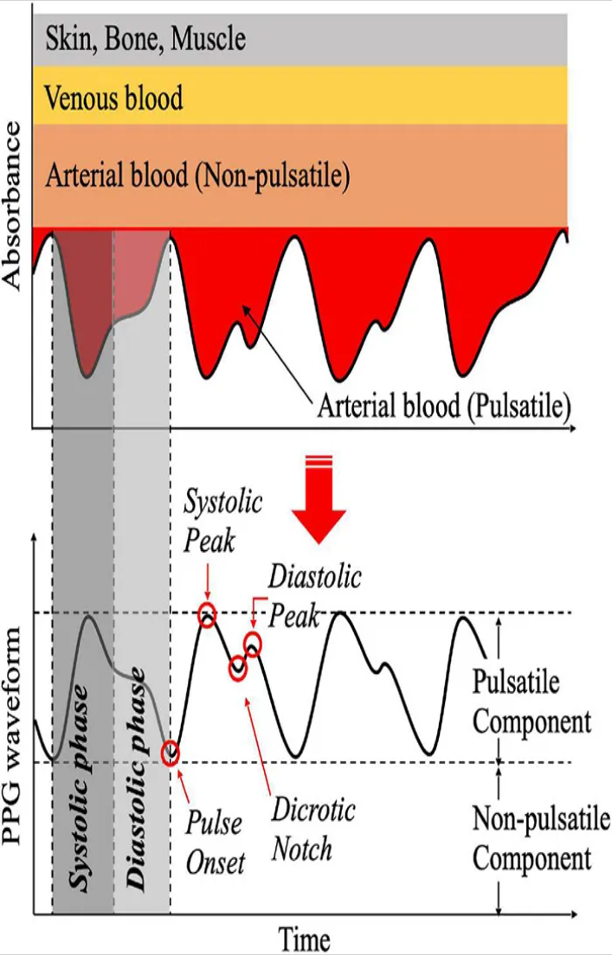
Figure 16 Principle of photoplethysmogram generation and waveform (Park et al. 2022a).

For each retained beat and wavelength, AC is defined by the baseline-corrected pulse amplitude (see Pulsatile in Figure 16) and DC by the corresponding local baseline level (see non-pulsatile in Figure 16) in the baseline-preserving optical view. Beat-level morphology and optical quantities are aggregated to the window-level and recording-level using the median and MAD under the robust aggregation setting, while the mean and standard deviation are used under the alternative non-robust setting. Ratio features are calculated only when their denominators satisfy the corresponding validity checks. Amplitude-based morphology features are reported in the units of the processed PPG representation, whereas timing features are reported in milliseconds. Table 9 pulse-morphology and dual-wavelength features lists the resulting pulse-morphology and dual-wavelength features, together with the beat-level quantities from which each is derived and the aggregation level at which it is emitted.

Table 9 pulse-morphology and dual-wavelength features
Feature | Operational definition | Level
Baseline-corrected amplitude $A_{p}$ | $$x_{analysis}(t_{p})-l(t_{p})$$ | Beat
Rise time $T_{r}$ | $$t_{p}-t_{L}$$ | Beat
Decay time $T_{d}$ | $$t_{R}-t_{p}$$ | Beat
Half-prominence width $W_{50,prom}$ | Width at 50% peak prominence | Beat
Mean systolic upslope $S_{sys}$ | $$A_{p}/(T_{r}+ε)$$ | Beat
Baseline-corrected pulse area | $$\int_{t_{L}}^{t_{R}}{\text{max}[x_{analysis}(t)-l(t),0]dt}$$ | Beat
AC | Median accepted beat amplitude $A_{p}$ for the wavelength | Recording
DC | Median baseline-preserving optical level at accepted beat baselines | Recording
Perfusion-style ratio PI | $$AC/(|DC|+ε)$$ | Recording
RED/IR AC ratio $r_{AC}$ | $${AC}_{RED}/({AC}_{IR}+ε)$$ | Recording
RED/IR DC ratio $r_{DC}$ | $$|{DC}_{RED}|/(|{DC}_{IR}|+ε)$$ | Recording
Ratio-of-ratios $R$ | $$[{AC}_{RED}/(|{DC}_{RED}|+ε)]/[{AC}_{IR}/(|{DC}_{IR}|+ε)]$$ | Recording
Zero-lag Pearson correlation $ρ_{0}$ | $$\text{corr}(z_{RED},z_{IR})$$ | Recording/window
Maximum normalized cross-correlation $ρ_{max}$ | $\text{max} \text{corr}[z_{RED}(t),z_{IR}(t+τ)]$, $τ∈[-0.5,0.5]$ s | Recording/window

The RED and IR signals are standardised only when calculating correlation and cross-correlation measures, preventing differences in channel scale from dominating these similarity measures. The zero-lag coefficient $ρ_{0}$ characterizes direct waveform agreement, whereas $ρ_{max}$ and $τ^{*}$ characterize the maximum agreement and corresponding relative lag between the two channels. The lag search was empirically restricted to ±0.5 s to avoid selection of distant periodic maxima.
The final feature set therefore provides three complementary descriptions of the optical pulse. Rise time, decay time, and width describe temporal morphology; amplitude, mean upslope, and area describe pulse shape and excursion within the processed signal representations; and the perfusion-style and dual-wavelength descriptors characterize relative optical modulation and agreement between wavelengths.

3.4.4 Statistical, spectral, and IMU window features
The second feature path describes local signal distribution, spectral content, and motion context on the 10 s engineering windows defined in Section 3.3.3. These engineering windows are used for handcrafted feature extraction and are distinct from the configurable windows used as direct inputs to the DL models. The descriptors are calculated from $x_{analysis}$ for RED and IR and from the processed IMU signals. The DL median/IQR normalisation is not applied before descriptor calculation. The same per-window feature extractor can therefore be applied to both filtered low-motion PPG and artefact-reduced motion PPG.
For RED, IR, acceleration magnitude $A$, angular-rate magnitude $Ω$, and jerk magnitude $J$, the time-domain descriptors comprise the mean, population standard deviation, RMS, IQR, MAD, bias-corrected skewness, and Pearson kurtosis. The six individual IMU axes (AX–AZ and GX–GZ) are characterized by the same time-domain descriptors, retaining directional motion information in addition to the vector magnitudes.
$$RMS=\sqrt{\frac{1}{N}\sum{x_{n}^{2}}},$$
$$MAD=median\left(\left|x_{n}-median\left(x\right)\right|\right)$$
Welch power spectral density uses a Hann window, with
$$nperseg=min\left(N,max\left(64,min\left(2048, 4f_{s}\right)\right)\right),$$
and 50% segment overlap. From the nonnegative PSD, the pipeline calculates total power, normalised spectral entropy, dominant frequency, spectral centroid, and frequency-band powers. For optical PPG, the defined bands are 0.2–0.5, 0.5–3.0, and 3.0–8.0 Hz. For IMU magnitude signals, the bands are 0.1–0.5, 0.5–3.0, 3.0–8.0, and 8.0–20.0 Hz. These bands are engineering descriptors of signal content and are distinct from the conventional VLF, LF, HF bands used for PRV analysis (Welch 1967).
For spectral bins
$$p_{k}=\frac{S_{k}}{\sum{S_{k}}},$$
$$H_{spec}=-\frac{\sum{p_{k}log\left(p_{k}\right)}}{logK}$$
And the spectral centroid is
$$f_{centroid}=\frac{\sum{f_{k}S_{k}}}{\sum{S_{k}}+ε}$$
For each descriptor $q_{w}$ calculated over engineering windows $w=1,…,W$, the recording-level vector stores the mean and SD of $q_{w}$. Table 10 lists the statistical, spectral, and inertial descriptors computed in this way, with their signal source and window basis. The resulting representation therefore captures both the average local signal characteristic within a recording and its variation over time. Full-record pulse, PRV, morphology features from Sections 3.4.2–3.4.3 are then concatenated with these window-level aggregates and are not independently recalculated within each engineering window.

Table 10 Statistical, spectral, and inertial features
Signal family | Per-window descriptors | File aggregation
RED, IR analysis PPG | Mean, SD, RMS, IQR, MAD, skewness, Pearson kurtosis; total power, spectral entropy, dominant frequency, centroid; 0.2–0.5, 0.5–3, 3–8 Hz powers | Mean and SD across engineering windows
AX–AZ, GX–GZ | Mean, SD, RMS, IQR, MAD, skewness, Pearson kurtosis | Mean and SD across engineering windows
A, Ω, J | Same time descriptors; total power, entropy, dominant frequency, centroid; 0.1–0.5, 0.5–3, 3–8, 8–20 Hz powers | Mean and SD across engineering windows
Local RED–IR relations | Window Pearson correlation, RED/IR SD ratio, RED/IR IQR ratio | Mean and SD across engineering windows

3.4.5 Signal–feature fusion
In current PPG research, two mainstream input strategies are commonly used: (1) segmenting the preprocessed raw signal into fixed-length windows with a fixed stride and feeding the segments directly into machine-learning models (Kwon et al. 2019b), and (2) first detecting peaks or valleys to segment individual pulses, which are then either resampled to a fixed length or converted into beat-by-beat features before being fed into the model (Alastruey et al. 2023; Hellqvist et al. 2024).
This thesis adopts strategy (1) as the primary input method, using the preprocessed, fixed-window-segmented eight-channel raw signals as the main model input. Compared with raw signal segments, however, purely feature-based inputs substantially improve the interpretability of the classification models, and beat-by-beat segmentation facilitates the extraction of inter-beat intervals and PPG pulse-waveform features. This thesis therefore also draws on strategy (2): recordings are segmented beat by beat to extract inter-beat-interval and pulse-waveform features, which are aggregated at the recording level and the window level to preserve beat-to-beat variability and long-sequence characteristics.
Building on this, the feature extractor produces two engineered representations: a fixed recording-level feature vector and a chronologically ordered window-level feature matrix. These representations can be used independently or, where configured, combined with the learned time-series representation in a signal–feature fusion model. All representations are derived from the same feature registry, so enabling or disabling handcrafted features changes the model input rather than the upstream signal-processing definitions.
The chronologically ordered feature-matrix representation uses 10-s windows with an 80% overlap (2-s hop). For recording $i$ with duration $L_{i}$ in seconds, the sequence length is $K_{i}=1+\left\lfloor \frac{L_{i}-W}{H}\right\rfloor$, where $W$ = 10 s is the window length and $H$ = 2 s is the hop/stride. $K_{i}$ is not forced to one fixed value: within each batch, shorter sequences are zero-padded to the length of the longest sequence in that batch, and a row mask prevents padded positions from entering the final temporal average. Each feature matrix consists of 146 purely window-level features, covering time- and frequency-domain descriptors and variability measures derived from the IMU signals, pulse morphology, PRV, and peak-to-peak intervals (PPI). The peak, PPI, and morphology features are first extracted through beat-by-beat segmentation of the recording and then assigned to the corresponding windows along the time axis. Within each window, the beat-level values are aggregated using the median and the MAD into a single 146-dimensional feature vector, so each recording yields a feature matrix of size $146×K_{i}$.
The recording-level feature vector can optionally be fused with the eight-channel raw windows. With handcrafted features disabled, the raw time-series classifiers receive only the eight normalized signal channels. With feature-only configurations, either the fixed recording-level feature vector or the chronological ordered feature matrix is classified without raw waveform input. With fusion enabled, the complete recording-level feature vector is combined with the pooled representation learned from the multichannel time series before the three-class classification layer. Table 11 summarises the 3 feature representation categories together with the 8 channels (raw signal) used in this pipeline.

Table 11 The four data representations used for classification.
Mode | Input unit | Input representation
Raw-signal | Window → pooled/file prediction | Robust-normalized [RED, IR, AX, AY, AZ, GX, GY, GZ]
Feature-vector | One file/recording | Standardized complete fixed feature vector
Feature-matrix | Window → One file/recording | Chronological sampled-feature matrix

  - Time-series classifiers and model optimization
    - Imbalance and calibration
Section 3.5 uses the representations defined in Section 3.4.5 for raw eight-channel time-series classification, feature-only classification, and optional signal–feature fusion. All experiment modes use the same participant-level fold assignments and the same three target classes. To address unequal class sizes and differences in the number of training samples contributed by individual participants, the pipeline supports participant-balanced and class-participant-balanced sampling. The loss function is configurable and can incorporate imbalance-aware strategies including weighted cross-entropy, Balanced Softmax, focal loss, effective-number weighting, with label smoothing available as an additional regularization option. The specific sampling and loss configuration is treated as an experimental parameter rather than applying all imbalance-handling methods simultaneously. If probability calibration is assessed, the calibrator is fitted using predictions generated without training on the corresponding calibration participants and is evaluated only after its parameters have been fixed.
    - Model architecture
      - Baseline: 1D-CNN
The 1-D CNN serves as the baseline raw-signal encoder. One-dimensional convolutions learn local temporal filters that are shared across the input window, while max pooling reduces temporal resolution and increases the effective temporal context represented by the subsequent layers. Global average pooling then converts the final feature maps into a fixed-dimensional representation (Wang et al. 2017). The architecture implemented in this thesis consists of three convolutional stages with 32, 64, and 128 output channels and kernel sizes 9, 9, and 7, followed by global average pooling and a three-class linear classification head.
Table 12 summarises the default configurations and parameters of the 1D-CNN used as the baseline in this project. A single explicitly supplied dropout value overrides the default dropout values of the three convolutional stages. With eight input channels and three classes, the architecture has 79,139 trainable parameters.

Table 12 Default 1-D CNN baseline.
Stage | Operation | Default project parameters | Output channels
Input | Robustly normalized window | 8 channels, shape [8,T] | 8
Block 1 | Conv1d → BatchNorm → ReLU → MaxPool → Dropout | kernel 9, padding 4, pool 4, dropout 0.10 | 32
Block 2 | Conv1d → BatchNorm → ReLU → MaxPool → Dropout | kernel 9, padding 4, pool 4, dropout 0.15 | 64
Block 3 | Conv1d → BatchNorm → ReLU | kernel 7, padding 3 | 128
Pool/head | Adaptive global average pool → Dropout → Linear | dropout 0.20; three logits | 3

      - InceptionTime
InceptionTime uses parallel convolutional filters of different temporal widths, allowing each module to detect patterns at multiple temporal scales (Ismail Fawaz et al. 2020). For multichannel input, the implementation first applies a 1×1 bottleneck convolution to 32 channels. Three parallel convolutional branches then apply 32 filters with kernels 39, 19, and 9. A fourth branch applies max pooling with a width of 3 and stride of 1, followed by a 1×1 convolution with 32 filters. The four branch outputs are concatenated to produce 128 channels, followed by batch normalisation and ReLU activation.
The InceptionTime model used in this thesis stacks six Inception modules, with a residual connection applied after every third module (see Table 13). When the number of channels differ, the shortcut uses a 1×1 projection followed by batch normalisation. When the number of channels already match, the local implementation applies batch normalization without the 1x1 projection, whereas the upstream implementation retains the projection. Global average pooling, optional dropout, and a linear three-class head produce the output logits. If dropout is configured as −1, the effective InceptionTime dropout is zero; when a dropout value such as 0.5 is specified, it is applied at the classification head rather than within the individual Inception modules.
Because of the small size of the dataset used for classifier training, overfitting was observed during model development. To reduce model complexity and improve generalisation, a simpler InceptionTime variant was therefore implemented as an additional reference configuration. The reduced-capacity variant uses a depth of three modules, 16 filters per branch, and a 16-channel bottleneck (see Table 13). This variant was included to examine whether reducing model capacity provides a more suitable configuration for the limited number of independent participants available for model development.
The original InceptionTime method uses an ensemble of five independently initialised networks. In contrast, the implementation evaluated in this thesis trains a single Inception network for each fold and repeat. It is therefore treated as an InceptionTime-derived single-network implementation rather than a reproduction of the complete original InceptionTime ensemble. Table 13 shows the parameters of both InceptionTime models.

Table 13 InceptionTime-modules used in the pipeline and their parameters.
Parameter | Full port | Small port
Module depth | 6 | 3
Filters per branch | 32 | 16
Bottleneck channels | 32 | 16
Temporal kernels | 39 / 19 / 9 | same
Pool branch | max-pool width 3 + 1×1 Conv | same
Module output | 128 channels | 64 channels
Residual shortcut | every 3 modules | every 3 modules
Output | GAP → optional dropout → 3 logits | GAP → optional dropout → 3 logits
Default head dropout | 0 | 0

      - ShapeFormer
ShapeFormer combines class-specific shapelets with generic convolutional features and applies attention to both representations (Le et al. 2024). Shapelets are discriminative subsequences whose distance to a time series provides interpretable class information (Lines et al. 2012). In the project implementation, shapelet discovery is performed separately within each training fold so that information from held-out participants does not enter the shapelet-selection procedure.
The default project discovery uses at most 180 class-balanced training windows. For each class and channel, it scans length-128 candidate subsequences with a stride of 64, scores candidates using the mean standardised class-versus-other effect, retains up to eight candidates per class and channel, limits overlap between retained candidates to 50%, and selects three shapelets per class. The current main implementation also limits the optional upstream perceptual-position-aware discovery (PISD) procedure to 180 windows and uses num_pip = 0.2.
For shapelet $s_{m}$ and candidate segment $u$, the ShapeBlock calculates the mean squared distance multiplied by a clipped complexity-invariance factor. In the implemented distance calculation, the complexity terms for the shapelet and candidate segment are defined asymmetrically:
$${CI}_{s}\left(s_{m}\right)=\sqrt{\sum_{t}{{\left(s_{m,t}-s_{m,t-1}\right)}^{2}}+{10}^{-3}}, {CI}_{u}\left(u\right)=\sum_{t}{{\left(u_{t}-u_{t-1}\right)}^{2}}+{10}^{-3},$$
$$d_{m}\left(u\right)=\frac{1}{L}{\left\|u-s_{m}\right\|}_{2}^{2}×min\left(3,\frac{max\left({CI}_{u}\left(u\right),{CI}_{s}\left(s_{m}\right)\right)}{min\left({CI}_{u}\left(u\right),{CI}_{s}\left(s_{m}\right)\right)}\right).$$
The candidate-window term omits the square root used in the shapelet term. This asymmetry reflects the implemented local/upstream code path and differs from the conventional symmetric formulation of complexity-invariant distance. It is therefore treated as an implementation-specific characteristic of the evaluated port. The minimum-distance segment is embedded, the trainable shapelet embedding is subtracted, and channel and temporal (i.e., start and end) position embeddings are added. Multi-head self-attention then models dependencies among the resulting shapelet tokens.
The generic branch applies a temporal 2-D convolution with a kernel width of 8, followed by batch normalisation and Gaussian Error Linear Unit (GELU) activation. A subsequent convolution operates across all eight input channels. Learnable positional encodings and a second attention/feed-forward block are then used to model generic temporal patterns. The shapelet and generic representations (128 and 48 dimensions by default) are concatenated before classification.
Table 14 summarizes the default parameters of the ShapeFormer port. The implementation retains the two-branch concept proposed by Le et al. (2024) but does not constitute an exact reproduction of the published or upstream repository. In particular, several inherited layers are instantiated but do not contribute to the forward pass (local_layer, the local-position projection, out2, and local_merge), and the global branch uses the first output token rather than pooling across all shapelet tokens.

Table 14 Default ShapeFormer-port parameters.
Parameter | Project default | Upstream relationship
Shapelets per class | 3 | Tunable project choice
Shapelet length / stride | 128 / 64 samples | Project adaptation to 400 Hz windows
Declared local_window | 64 samples | Retained port parameter; it does not control the active width-8 local convolution
Local / shapelet embedding | 48 / 128 | Port default
Feed-forward dimension | 256 | Port default
Attention heads | 4 | Both embedding sizes divisible by 4
Dropout | 0.30 | Port default
Discovery windows | 180 in the current effect-size and PISD main calls; PISD wrapper default 60 | Training-fold cap
Gradient clipping | norm 4 | Project training safeguard

The optional PISD wrapper depends on a hard-coded path to the external upstream ShapeFormer repository and is therefore not implemented as a self-contained package dependency. Moreover, the local ShapeFormer training procedure selects the epoch with the highest validation-window balanced accuracy. In the historical evaluation workflow, the outer held-out fold was used for this validation-based model selection. Consequently, the historical ShapeFormer results were obtained under an exploratory validation-guided early-stopping protocol and are not directly comparable with the fixed-epoch InceptionTime reference results.
      - Feature-vector classifiers and optional fusion
The standardised recording-level feature vector is also classified directly using conventional tabular models. The reference models comprises L2-regularised logistic regression, a radial basis function (RBF) support-vector classifier, and Extra Trees. These models use one feature vector per recording and therefore provide a direct feature-only baseline without operating on the temporal sequence of engineered features.
For signal-feature fusion, the selected raw-signal encoder first produces window embeddings, which are pooled to obtain a single recording-level representation. The complete fixed feature vector is encoded using Linear(n,64)–LayerNorm–ReLU–Dropout–Linear(64,32)–LayerNorm–ReLU. The signal and feature embeddings are concatenated before being passed to the final three-class classification head. Setting the feature input to None reduces the same architecture to the raw-signal model.
    - Optimization and grid search
To enable a fair comparison and optimize the performance of all models, the pipeline’s sweep script programmatically enumerates configuration grids, executes participant-grouped folds for each configuration, repeats configurations across random seeds, writes one result artefact per run, and ranks configuration-level aggregates. This procedure constitutes a custom grid-search framework in which model architecture and associated training and preprocessing parameters can be evaluated under consistent participant-level fold assignments.
Configuration selection is based on aggregated performance across the grouped cross-validation evaluations rather than on the result of a single fold or run. For each model, the highest-ranked configuration according to the predefined selection criteria is retained for subsequent analysis and comparison. Because multiple configurations are evaluated repeatedly on the same small cohort, an unbiased assessment of the selected configuration therefore requires evaluation using a locked configuration on an untouched participant holdout or external cohort (Bergstra and Bengio 2012).

Table 15 Audited grid dimensions. Not every Cartesian combination was run in every sweep; each result is tied to its recorded configuration.
Search family | Values represented in project sweeps | Selection role
Architecture | CNN, InceptionTime, small InceptionTime, ShapeFormer; optional feature fusion | Model comparison
Windowing | CLI lengths 15, 10, 5, 2 s; overlap 80, 50, 30, 0%; later training-overlap ablation 0/30% with validation overlap held fixed | Temporal context/redundancy
Optimization | learning rates 0.001, 0.0005, 0.0002; epochs 9, 10, 15, 20, or 50 across routes; optional patience in historical routes | Convergence and overfit control
Regularization | weight decay 0.001–0.02; dropout 0.3–0.7; label smoothing 0.05–0.30 | Capacity control
Loss/balance | weighted CE, focal, Balanced Softmax; inverse-count/effective-number weights | Class imbalance
Sampling budget | all, 50%, 32, or 16 windows per subject per epoch | Correlation/exposure ablation
Signal quality | none, top 70%, top 50% | Artifact robustness
Aggregation | mean probability, quality-weighted mean | Participant decision
All neural models output logits $z_{c}$ and corresponding class probabilities $p_{c}=\frac{exp\left(z_{c}\right)}{\sum_{j}{exp\left(z_{j}\right)}}$. The default optimiser is AdamW, which combines Adam’s adaptive first- and second-moment estimates with decoupled weight decay (Kingma and Ba 2017; Loshchilov and Hutter 2019).
In addition to the model-specific hyperparameters, several training-objective and regularization algorithms were incorporated to investigate whether they improve classification performance and generalisability. During the grid search, these options were evaluated in configured enabled and disabled states, allowing their effects to be compared across model configurations. The implemented objective options include:
- Weighted cross-entropy: $L=-w_{y}logp_{y}$, with weights derived from inverse participant count or effective sample number.
- Balanced Softmax: adds $logn_{c}$ to the class logit before cross-entropy, accounting for class-frequency shift (Ren et al. 2020).
- Focal loss: $L=-w_{y}{\left(1-p_{y}\right)}^{γ}logp_{y}$, default $γ=2$, which down-weights easy examples (Lin et al. 2017).
- Effective-number weighting: $w_{c}∝\frac{1-β}{1-β^{n_{c}}}$ with project default $β=0.999$, then normalized to mean one (Cui et al. 2019).
- Label smoothing: replaces a one-hot target by a mixture with a uniform class distribution to reduce extreme confidence (Szegedy et al. 2016).

  - Evaluation Design

3.6.1 Participant-grouped data splitting
The pipeline uses StratifiedGroupKFold with participant identity as the grouping variable. All recordings and all derived windows or feature matrices belonging to the same participant are therefore assigned to the same fold. Five folds are used because the smallest class contains eight participants. In each iteration, four folds form the training set and the remaining fold serves as the validation fold; repeated seeds provide repeated grouped evaluations (Pedregosa et al. 2018). Due to the small sample size, participant-level five-fold stratified group cross-validation repeated 5 times, as the resampling method on the training set (Hellqvist et al. 2024).
Every transformation that estimates parameters from the data is fitted using the active training participants only. This includes feature imputation, feature standardisation, learned feature selection, quality-reference parameters, shapelet discovery, model weights, probability calibration, and any other fitted preprocessing object. Record-local deterministic filtering and feature extraction are applied independently to each recording using the same predefiend procedures for both training and validation data.

3.6.2 Benchmark hierarchy, aggregation, and metrics
The raw-signal and fusion models can produce multiple predictions for each recording because a recording contains several time-series windows. The classifier produces one probability vector for each normalised window. Window probabilities are aggregated using an unweighted mean or the configured SQI-weighted mean. Feature-vector and feature-matrix classifiers, by contrast, produce one prediction per recording. Predictions are ultimately aggregated to obtain a three-class probability vector for each participant.
For class $c$, the unweighted participant probability is
$$p_{s,c}=\frac{1}{\left|W_{s}\right|}\sum_{w∈W_{s}}{p_{w,c}}.$$
For quality-weighting aggregation,
$$p_{s,c}^{\left(q\right)}=\frac{\sum_{w∈W_{s}}{q_{w}p_{w,c}}}{\sum_{w∈W_{s}}{q_{w}}+ε}.$$
In the implemented participant-level aggregation, probabilities are calculated directly from all retained windows belonging to a participant rather than first assigning equal weight to each recording. Consequently, recordings that contribute more retained windows therefore have greater influence on the participant-level probability. Recording-level aggregation is reported separately as a diagnostic. The project benchmark and selection priority is outlined in Table 16.

Table 16 Metric priority for frailty-related classification.
Priority | Benchmark/metric | Purpose
1 | Participant-level balanced accuracy | Primary discrimination endpoint, robust to unequal class counts
2 | Participant-level macro-F1 | Co-primary/tie-break measure of balanced precision–recall performance
3 | Lower uncertainty bound across repeats | Preference for configurations whose performance is not driven by one split
4 | Worst-class recall and worst-class F1 | Prevents a high average from hiding collapse of one group
5 | Per-class precision, recall, F1 and participant confusion matrix | Reveals Pre-Frail/Robust/Young error structure
6 | Between-repeat SD; paired split differences | Implemented repeat uncertainty plus a planned matched-split diagnostic
7 | Training–validation gap and loss curves | Overfitting diagnostics, not selection endpoints alone
8 | File- and window-level BA/macro-F1 | Engineering diagnostics only; not independent clinical samples

The primary comparison is based not on the configuration producing the highest individual run, but on configuration-level performance aggregated across matched participant splits and random seeds. The audited ranking order is: (1) mean participant-level balanced accuracy, descending; (2) mean participant-level macro-F1, descending; (3) the 95% lower bound for participant-level balanced accuracy, descending; (4) the 95% lower bound for participant-level macro-F1, descending; (5) mean worst-class recall, descending; (6) mean worst-class F1, descending; and (7) the standard deviation of participant-level balanced accuracy, ascending. Only complete configurations are included in the ranking, and runtime is descriptive rather than a performance tiebreaker.
For the leaderboard field worst_class_f1_mean, F1 is first calculated separately for each class within each repetition. The resulting values are then averaged across repetitions for each class, and the minimum of these three-class means is reported. This measure therefore reflects the performance of the class with the lowest average F1 across repeated evaluations.
Ablation comparisons use the same participant folds to compare raw-signal input, feature-only input, signal–feature fusion, artefact-reduction methods, SQI modes, model architectures, and optimisation configurations.
  - Implementation details
The entire Pipeline was executed on a machine with hardware and software environment shown in Table 17.
Table 17 Detail list of Hardware and software environments
Specifications | Details
Processor | 13th Gen Intel(R) Core(TM) i7-13700K 3.40 GHz
RAM | 64.0 GB
System | Windows 10 Education
GPU | RTX 4080 16GB *1
Python env | Version 3.11.14

- Results
This chapter reports the classification performance of the complete pipeline on the three frailty-related groups under systematic variation of its modules, model architectures, hyper-parameters, and input representations. It is organised in two parts. Section 4.1 evaluates the dynamic-processing branch (i.e., beat detection, motion detection, and motion-artefact reduction) using an external, ECG-annotated dataset wherever ground truth is required. Section 4.2 evaluates the time-series classification branch on the internal cohort, progressing from a coarse screening of input representations to a single-factor ablation, a hyper-parameter search, and the selection of a final configuration.
The only labelled cohort available for this project is the internal main dataset of 29 participants. No independent external cohort with frailty labels exists, and no participant can therefore be reserved as a true held-out test set without reducing the smallest class below a usable size. In the absence of external validation, the analysis unit throughout this chapter is the participant-level out-of-fold (OOF) cluster prediction. Specifically, each of the 29 participants is treated as an independent exchangeable resampling unit that carries all of its repeats, and every prediction attributed to a participant is produced by a model that never saw any recording from that participant during training.
Each experiment uses stratified group five-fold cross-validation with participant identity as the grouping variable, repeated five times. Every repeat re-initialises the model and re-draws the fold assignment from a fixed seed (42, 10042, 20042, 30042, 40042), so that the repeats satisfy the resampling requirement while the seed sequence remains identical across configurations. Because the seed list is shared, two configurations are always compared on matched participant splits, and the stochastic component of the comparison is removed rather than merely averaged out.
Balanced accuracy (BA) and macro-F1 are the primary and co-primary endpoints, in accordance with the metric priority defined in Table 17. Uncertainty is quantified in two ways: a between-repeat standard deviation, which describes the stability of a configuration under re-seeding, and a participant-cluster bootstrap 95% confidence interval (Field and Welsh 2007), which describes the uncertainty that arises from the identity of the 29 participants themselves. Hypothesis tests use 10,000 participant-cluster permutations (Good, P.I. 2005); both raw and Holm-adjusted p-values are reported (Holm 1979). All tests are two-sided and α = 0.05.
  - Dynamic processing
This project designed and implemented an exploratory processing branch dedicated to identifying motion-contaminated segments of the synchronised PPG and IMU signals and to performing a first-pass reduction of motion artefacts. For several nodes of this branch, multiple established methods were implemented in parallel, and a two-stage evaluation was used to select a single route into the classifier.
The two stages differ in the ground truth available to them. In the first stage, each module is evaluated in isolation on an open-source dataset that provides synchronised ECG beat annotations, so that beat-level and interval-level accuracy can be measured against an external reference. In the second stage, the surviving candidates are evaluated by ablation inside the three-class frailty task, where the endpoint is the effect on final classification performance rather than on signal fidelity. All tests that use the PTT PPG dataset resample the signals to 400 Hz to match the system’s internal acquisition rate.
    - Peak detector
Because the SQI–motion-detector stage of the pipeline already removes low-quality and heavily motion-contaminated segments before pulse detection, the beat detector must only to be accurate and robust on clean, stationary PPG. Its evaluation was therefore restricted to the static recordings of the Pulse Transit Time PPG dataset, for which synchronised ECG beat annotations are available.
Five endpoints were evaluated. The primary endpoint is the root-mean-square error between the detected PPI sequence and the annotated ECG IBI sequence, denoted IBI–PPI RMSE. Because it is computed on intervals rather than on absolute beat positions, it is insensitive to the constant pulse-arrival delay between the ECG R-peak and the corresponding PPG upstroke. Beat-level detection quality is characterised by sensitivity, positive predictive value (PPV), and their harmonic mean, the F1 score, computed as described by Charlton et al. (2025b). Computational cost is characterised by execution time. The two detectors compared are the Aboy++-inspired detector of this project (Section 3.4.1.1) and the MSPTDfast (v.2) Python port (Section 3.4.1.2), each evaluated separately on the infrared (IR) and the red channel.
Because the PPG and ECG clocks are not perfectly synchronised, the two beat series were temporally aligned before matching. The time lag that maximised the number of ECG and PPG beats agreeing to within 150 ms was searched from −10 s to +10 s in steps of 0.02 s. Following the ppg-beats assessment framework and the approach of Kotzen (2021), the lag was allowed to vary within a recording in order to absorb clock drift and was re-estimated every 300 s.
Beat-level metrics were computed for each subject recording following (Charlton et al 2022). A reference beat was counted as correctly identified when the closest PPG-derived beat fell within ±150 ms of it and was matched one-to-one, without reuse. From the numbers of reference beats ($n_{ref}$), detected PPG beats ($n_{PPG}$), and correctly identified beats ($n_{correct}$) were used to calculate the following:
$$\begin{matrix}\text{(1)} & \begin{matrix}\text{sensitivity }\left(\%\right), Se=\frac{n_{correct}}{n_{ref}}×100\end{matrix}\end{matrix}$$
$$\begin{matrix}\text{(2)} & \begin{matrix}\text{positive predictive value }\left(\%\right), PPV=\frac{n_{correct}}{n_{PPG}}×100\end{matrix}\end{matrix}$$
$$\begin{matrix}\text{(3)} & \begin{matrix}F_{1}-\text{score }\left(\%\right), F_{1}=\frac{2×PPV×Se}{PPV+Se}×100.\end{matrix}\end{matrix}$$
Execution time was measured as the wall-clock time required to run the detector without parallelisation, expressed as a percentage of the PPG signal duration; the hardware used is listed in Table 18. All endpoints are reported as the median and interquartile range, and the whiskers of the corresponding boxplots denote the 10th and 90th percentiles. The two detectors were compared with two-sided Wilcoxon rank-sum tests, applied separately to each channel. The resulting ten comparisons, comprising five endpoints on two channels, were treated as a single family and corrected with the Holm–Šidák step-down procedure (Holm 1979; Šidák 1967) at a significance level of α = 0.05.
All comparisons are based on the same 22 subject recordings per channel. Raw p-values were obtained from two-sided rank-sum tests and adjusted with the Holm–Šidák step-down formula $p_{adj(i)}=\underset{j≤i}{\text{max}}\left[1-{\left(1-p_{\left(j\right)}\right)}^{m-j+1}\right],$ where m = 10 is the family size and p(j) denote the j-th smallest raw p-value.
Table 18 summarises the descriptive performance of both detectors. On the infrared channel the MSPTDfast port reached a median sensitivity of 99.8% [99.6, 99.9] and a median F1 of 99.7% [99.4, 99.8], compared with 97.0% [91.2, 97.9] and 97.8% [90.8, 98.8] for the Aboy++-inspired detector; the ordering is the same on the red channel. The margin is considerably larger for interval accuracy: the median IBI–PPI RMSE falls from 35.2 ms [31.0, 38.4] to 19.2 ms [15.8, 27.7] on the infrared channel and from 39.4 ms [33.9, 41.7] to 23.5 ms [18.7, 34.1] on the red channel. Positive predictive value is comparably high for both detectors, which indicates that the Aboy++-inspired detector misses beats rather than inserting spurious ones. Execution time differs by approximately a factor of five, 0.006% against 0.031 % of the signal duration.The Box plots posted in Appendix A describe performance of both detectors in RMSE, F1, Sensitivity, positive predictive value and Execution time.

Table 18 Beat-detector performance on the static recordings of the Pulse Transit Time PPG dataset, reported as median [Q1, Q3] over 22 subject recordings per channel. Execution time is expressed as a percentage of the PPG signal duration.
Metric | Aboy++ IR | Aboy++ Red | MSPTDfast IR | MSPTDfast Red
Sensitivity (%) | 97.0 [91.2, 97.9] | 94.5 [85.9, 97.8] | 99.8 [99.6, 99.9] | 99.7 [99.1, 99.8]
PPV (%) | 99.6 [93.3, 100.0] | 99.1 [86.1, 99.8] | 99.5 [99.1, 99.7] | 99.3 [86.4, 99.8]
F1 (%) | 97.8 [90.8, 98.8] | 96.4 [74.8, 98.7] | 99.7 [99.4, 99.8] | 99.6 [89.9, 99.8]
IBI–PPI RMSE (ms) | 35.2 [31.0, 38.4] | 39.4 [33.9, 41.7] | 19.2 [15.8, 27.7] | 23.5 [18.7, 34.1]
Execution time (%) | 0.031[0.031, 0.031] | 0.031 [0.030, 0.032] | 0.006 [0.006, 0.006] | 0.006 [0.006, 0.006]

Consistent with this description, eight of the ten corrected comparisons reject the null hypothesis (see Table 19). Sensitivity, F1, IBI–PPI RMSE, and execution time favour the MSPTDfast port on both channels, whereas positive predictive value shows no significant difference (adjusted p = 0.997 on both channels), confirming that the two detectors differ in recall rather than in precision.

Table 19 Holm–Šidák-adjusted p-values for the comparison between the MSPTDfast (v.2) Python port and the Aboy++-inspired detector. Ten comparisons (five endpoints × two channels) form one correction family; α = 0.05.
Endpoint | Adjusted p, IR | Adjusted p, Red | Outcome
Sensitivity (%) | 1.93 × 10⁻⁶ | 1.43 × 10⁻⁴ | MSPTDfast higher
PPV (%) | 0.9968 | 0.9968 | No significant difference
F1 (%) | 4.12 × 10⁻⁵ | 0.0100 | MSPTDfast higher
IBI–PPI RMSE (ms) | 7.16 × 10⁻⁴ | 6.11 × 10⁻³ | MSPTDfast lower
Execution time (%) | 1.34 × 10⁻⁷ | 1.34 × 10⁻⁷ | MSPTDfast lower

Taken together, the MSPTDfast (v.2) Python port dominates the Aboy++-inspired detector on every endpoint on which the two differ, and it is approximately five times cheaper to run. Because the interval-level endpoint is the one that propagates into the PPI and PRV features of the classifier, the MSPTDfast port was selected as the default beat detector for all subsequent experiments, and the Aboy++-inspired detector was retained only as a configurable alternative.

    - Motion detection
The motion detector is a compact 1-D CNN (“LightCNN”) that performs binary window-level classification of motion versus non-motion from the red and infrared PPG channels together with the six processed IMU channels. Its architecture is summarised in Table 20. The network is deliberately small (three convolutional blocks with 12, 24 and 24 channels, GroupNorm and GELU activations, average pooling, and a single-logit linear head) so that it can be trained repeatedly inside the cross-validation loop without dominating the computational budget of the pipeline.

Table 20 Architecture of the LightCNN binary motion detector
Layer | Input → output | Kernel / operation | Output length
Input | 8 channels | 8 s × 400 Hz | 3200
Conv block 1 | 8 → 12 | Conv1d, kernel 9, padding 4 | 3200
 | 12 → 12 | GroupNorm (1 group) + GELU | 3200
 |  | AvgPool1d(2) | 1600
Conv block 2 | 12 → 24 | Conv1d, kernel 7, padding 3 | 1600
 | 24 → 24 | GroupNorm (1 group) + GELU | 1600
 |  | AvgPool1d(2) | 800
Conv block 3 | 24 → 24 | Conv1d, kernel 5, padding 2 | 800
 | 24 → 24 | GroupNorm (1 group) + GELU | 800
Global pooling | 24 → 24 | AdaptiveAvgPool1d(1) | 1
Classifier | 24 → 1 | Linear | one logit

Two symmetric transfer experiments were performed as a pair of comparison. In configuration Frailty29, the detector is trained with five-fold cross-validation on the internal cohort, validated out-of-fold, and then applied without adaptation to the external PTT dataset. In configuration PTT22, the roles are exchanged: the detector is trained and validated on PTT and then applied to the internal cohort. Results are reported both at window level and after file-level aggregation.

Table 21 Motion-detector performance in the two transfer directions. Values are balanced accuracy / F1.
Model / test | Window BA / F1 | File BA / F1 | Window ROC-AUC | File ROC-AUC
Frailty29 OOF | 0.9489 / 0.7286 | 0.9682 / 0.9682 | 97.1 ± 12.6 | 97.2 ± 12.1
Frailty29 → PTT22 | 0.7889 / 0.7178 | 0.7841 / 0.7115 | 100.0 ± 0.0 | 100.0 ± 0.0
PTT22 OOF | 1.0000 / 1.0000 | 1.0000 / 1.0000 | 100.0 ± 0.0 | 100.0 ± 0.0
PTT22 → Frailty29 | 0.5000 / 0.0232 | 0.5000 / 0.3025 | 56.6 ± 10.0 | 56.7 ± 12.3

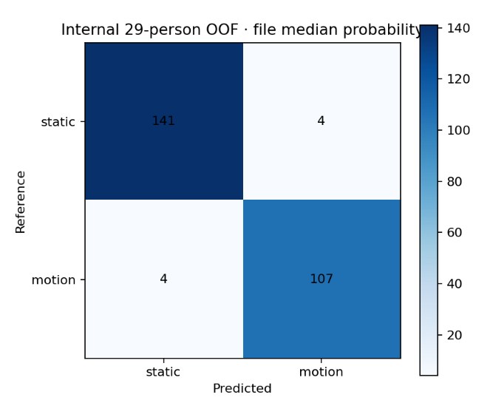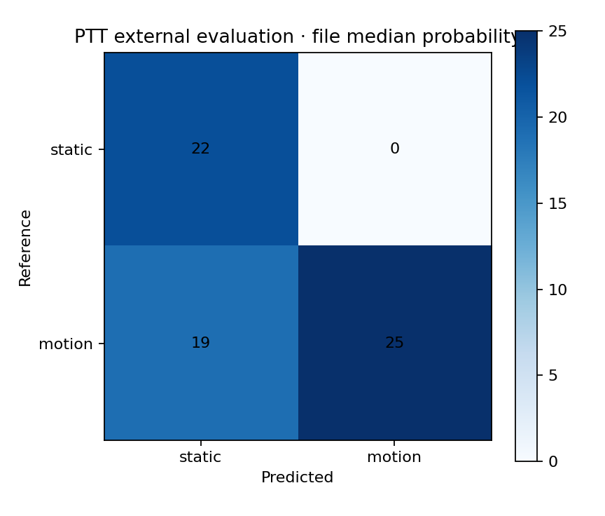
Figure 17 Confusion Matrix of file-level aggression prediction by Frailty_29 model (left) and PTT_22 model (right)

Table 21 summarize the performance of two motion detectors.
The PTT22 model showed perfect class separation during internal validation at both window and file level. At the operating threshold of 0.500, the median score is 1.000 for both static and motion windows. Consequently, the participant-balanced class centres were numerically indistinguishable, with ROC AUCs of 0.5635 and 0.5674 at the window and file levels, respectively. Even if the threshold were selected post hoc by maximising balanced accuracy across all 29 internal participants, the maximum achievable balanced accuracy would be only approximately 0.538 at window level and 0.550 at file level. The PTT22 model was therefore discarded, and the Frailty29 parameters were adopted as the default for the motion-detector module in all subsequent experiments. Appendix B reports the corresponding confusion matrices, score distributions, and ROC/PR curves, while Figure 17 compares the file-level confusion matrices of the two models.
    - Motion artifact denoiser
Six candidate reducers were implemented and compared against an identity control: an IMU-referenced NLMS adaptive noise canceller (nlms_imu_anc), singular spectrum analysis (ssa_decomposition), an IMU-informed spectral mask (spectral_mask), PCA blind-source separation (pca_bss), FastICA blind-source separation (fastica_bss), and spectral NMF blind-source separation (nmf_bss). Their algorithmic definitions, governing equations, and frozen parameters are given in Section 3.3.5. The identity reducer copies the red and infrared channels sample-for-sample and exists to answer the question of whether any of the methods is genuinely better than doing nothing.
Each reducer was evaluated on the dynamic (see Table 22) and the static portions (see Table 23) of the PTT dataset separately. The evaluation is indirect but end-to-end relevant. The denoised PPG is passed to the same beat detector, and the resulting beat series is compared with the ECG annotations. The primary endpoint is the subject-macro PPI–RR RMSE; beat-matching F1 after constant-lag alignment is reported as a guard against a deceptively low interval error obtained from a small and easy subset of matched beats. All standard deviations are between-subject sample standard deviations (ddof = 1) and not repeat-training uncertainty. Rows are sorted primarily by ascending RMSE, with descending F1 as tie-breaker.

Table 22 Denoiser results on the dynamic recordings. An asterisk marks the best value of a metric.
Denoiser | IR/RED | RMSE ± SD (ms) | F1 ± SD (%) | RMSE p vs identity
spectral_mask* | IR | 70.0 ± 45.5 * | 91.4 ± 8.1 | 0.0656
ssa_decomposition | IR | 70.4 ± 48.7 | 91.7 ± 8.0 | 0.0154
pca_bss | IR | 71.4 ± 43.4 | 93.7 ± 5.3 | 0.1547
pca_bss | RED | 71.4 ± 43.4 | 93.7 ± 5.3 | 1.00 × 10⁻⁴
fastica_bss* | IR | 71.7 ± 39.9 | 93.8 ± 5.0 * | 0.3947
fastica_bss* | RED | 71.7 ± 39.9 | 93.8 ± 5.0 * | 0.0530
identity | IR | 74.3 ± 48.7 | 91.3 ± 8.0 | Reference
spectral_mask | RED | 76.8 ± 43.9 | 91.1 ± 7.8 | 0.0028
ssa_decomposition | RED | 79.5 ± 47.6 | 91.4 ± 7.8 | 0.0530
identity | RED | 83.9 ± 46.0 | 90.6 ± 7.7 | Reference
nmf_bss | IR | 84.2 ± 37.6 | 87.6 ± 9.2 | 0.0656
nmf_bss | RED | 87.8 ± 38.7 | 87.0 ± 8.6 | 0.2525
nlms_imu_anc | IR | 146.9 ± 19.4 | 80.4 ± 5.5 | 6.00 × 10⁻⁵
nlms_imu_anc | RED | 147.5 ± 18.3 | 80.2 ± 5.4 | 6.00 × 10⁻⁵

Table 23 Denoiser results on the static recordings.
Denoiser | IR/RED | RMSE ± SD (ms) | F1 ± SD (%) | RMSE p vs identity
spectral_mask* | IR | 21.1 ± 11.0 * | 97.7 ± 6.9 | 0.0092
ssa_decomposition* | IR | 22.3 ± 14.0 | 97.7 ± 6.8 * | 0.0032
identity | IR | 28.6 ± 21.4 | 97.3 ± 7.1 | Reference
spectral_mask | RED | 31.5 ± 30.8 | 96.8 ± 7.0 | 0.0005
ssa_decomposition | RED | 33.9 ± 34.1 | 96.6 ± 7.2 | 0.0143
pca_bss | IR | 34.4 ± 26.9 | 97.1 ± 7.1 | 0.0312
pca_bss | RED | 34.4 ± 26.9 | 97.1 ± 7.1 | 0.4628
fastica_bss | IR | 34.8 ± 20.5 | 96.7 ± 6.9 | 0.2271
fastica_bss | RED | 34.8 ± 20.5 | 96.7 ± 6.9 | 0.5337
identity | RED | 40.0 ± 37.0 | 96.3 ± 7.1 | Reference
nmf_bss | IR | 51.7 ± 22.5 | 96.9 ± 5.3 | 0.0006
nmf_bss | RED | 58.8 ± 30.4 | 95.8 ± 6.4 | 0.0014
nlms_imu_anc | IR | 119.1 ± 17.7 | 82.1 ± 6.7 | 6.00 × 10⁻⁵
nlms_imu_anc | RED | 121.6 ± 19.9 | 81.3 ± 6.5 | 6.00 × 10⁻⁵

On the dynamic set the best reducer improves the IR RMSE from 74.3 ms to 70.0 ms, a reduction of 5.8% (4.3 ms), while the between-subject standard deviation of that same quantity is approximately 45 ms. The between-subject term exceeds the between-method term by an order of magnitude, which means that the identity of the participant determines interval accuracy far more strongly than the choice of reducer does.
The metric nlms_imu_anc roughly doubles the dynamic interval error relative to identity (146.9 ms versus 74.3 ms) and reduces beat F1 by about 11 pp. Decisive, however, is its behaviour on the static set, where it still produces an RMSE of 119.1 ms against an identity baseline of 28.6 ms. On static recordings there is by definition almost no motion to cancel, so a well-behaved canceller should converge to a near-unity transfer function and leave the signal intact. That it instead quadruples the error demonstrates that the filter is not removing motion but injecting distortion.
pca_bss and fastica_bss produce identical values on the IR and RED rows of both tables. This is expected from the algorithm rather than an error: both operate jointly on the two synchronised wavelengths, select a single cardiac component, and project it back onto both channels, so the two outputs share a common source and yield the same beat series. The consequence for interpretation is that these two methods cannot improve the channels independently, and their apparent large gain on the red channel (83.9 → 71.4 ms) is obtained by importing infrared information into the red channel rather than by cleaning the red channel as such. Any dual-wavelength feature computed downstream (including the R/IR amplitude ratio used for the perfusion-related features of Section 3.4.3) is therefore partly invalidated by these reducers, because the two wavelengths are no longer independent measurements. This constitutes a substantive argument for preferring spectral_mask, which processes each channel separately, over the blind-source-separation methods, independently of the RMSE ranking.
Because the reducer only ever receives segments that the upstream stages have already flagged as low-quality, the static endpoints are of lower operational importance than the dynamic endpoints. Selection was therefore driven by dynamic RMSE, and spectral_mask is carried forward as denoiser for the three-class classification experiments. Appendix C reports the remaining endpoints and the per-metric histograms.

  - Time series Classification
This section evaluates the classification of the three frailty-related groups with the 1-D CNN, InceptionTime, and ShapeFormer architectures on the single available internal dataset. The selection procedure is structured and sequential: input representations are screened first, architectures are compared next under a matched protocol, the effect of the dynamic-branch modules is measured by ablation, the data subset used for tuning is fixed, and only then are hyper-parameters searched. Each stage removes candidates and thereby limits the number of comparisons performed on the same 29 participants.

Table 24 Input-representation screening. Participant-level metrics, five repeats × five folds.
Case | BA mean ± SD (%) | BA cluster 95% CI (%) | Macro-F1 mean ± SD (%) | Macro-F1 cluster 95% CI (%) | Macro ROC-AUC mean ± SD (%) | F1 Holm P
raw__cnn | 51.5 ± 3.9 | [38.7, 64.6] | 50.4 ± 3.9 | [35.9, 63.9] | 66.9 ± 1.7 | N/A
feature_vector__logistic | 48.4 ± 3.2 | [35.3, 62.2] | 49.7 ± 3.3 | [37.0, 61.7] | 67.6 ± 2.9 | 0.9418
feature_matrix__inception_small | 44.7 ± 4.3 | [32.8, 55.6] | 35.8 ± 3.7 | [26.7, 43.5] | 61.4 ± 4.9 | 0.5635

    - Data representation screening and evaluation
This experiment establishes the approximate performance level of the three input representations. Because each representation requires a different model family, the comparison necessarily confounds the information content of the representation with the inductive bias of the architecture that consumes it, and it is therefore reported as an orientation experiment rather than as evidence about representations as such. Three routes were tested with five repeats × five folds each: a recording-level feature matrix consumed by Small InceptionTime with registry defaults and Fixed-10 windowing; the eight-channel raw signal at 400 Hz consumed by the 1-D CNN with 5 s windows, 2.5 s hop and Fixed-10 windowing; and a recording-level feature vector consumed by multinomial logistic regression with LBFGS and max_iter = 5000.

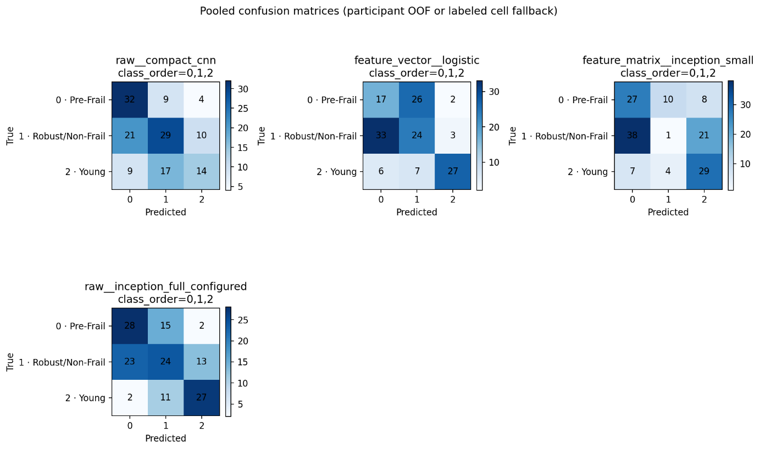
Figure 18 Pooled confusion matrices of the input-representation screening routes (participant out-of-fold predictions, five repeats × 29 participants).

Figure 18 indicates that the classification confusion is concentrated in the Robust/Non-Frail → Pre-Frail direction. For the feature_matrix_inception_small route the Robust/Non-Frail class collapses almost entirely: only one of its 60 participant-repeats is recovered, with 38 assigned to Pre-Frail and 21 to Young. As such, there is evidence that this route behaves effectively as partial class collapse.
Table 24 illustrates performance of four data and feature representations together with their models. No route is statistically distinguishable from any other: the Holm-adjusted p-values are 0.9418 and 0.5635, and all three participant-cluster confidence intervals include the chance level of 33.3% as well as one another. The descriptive ordering places the raw eight-channel route first, but the margin over the feature-vector route is 3.1 pp against a cluster interval half-width of approximately 13 pp. The only interpretable statement that can be made at this stage is that all three routes are viable enough to justify further investigation and that none can be eliminated on evidence.
Since the three routes could not all be explored in equal depth within the scope of this thesis, the raw eight-channel route was selected as the primary input representation for the subsequent classifier experiments.

    - End-to-end deep learning models comparison
ShapeFormer has a substantially longer training time than the other candidates, and it was therefore necessary to establish whether it offers classification performance at least comparable to theirs before admitting it to the large-scale grid search and ablation programme. All three models were compared under strictly matched conditions: eight-channel raw input, 5 s windows with 50% overlap, patience 20, no additional PPI/HRV input, and identical default learning rate and regularisation. The data were split by first reserving 20% as a held-out fold and then partitioning the remaining 80% with StratifiedGroupKFold into five folds. To expose the maximum potential of each architecture, early stopping was performed on validation accuracy with a patience of 20, and in each outer fold the held-out fold served both for early stopping and for final performance assessment, following Wang et al. (2017). This protocol makes the absolute values optimistic, and it is used here only for a one-off matched horizontal comparison; the resulting absolute values are not used to select the final configuration or pipeline route. Repeat-level BA, F1, ROC-AUC and PR-AUC are reported as mean ± SD with Student-t 95% confidence intervals, and the three candidate routes were compared against CompactCNN with 100,000 participant-cluster permutations.

Table 25 End-to-end model comparison under matched conditions (5 s windows, 50 % overlap, patience 20, no extra PPI/HRV input).
Model | Subject BA (%) | BA 95 % repeat t-CI | Macro-F1 (%) | Mean runtime
InceptionTime | 72.7 ± 6.0 | 65.2–80.2 | 72.3 ± 5.9 | 397 s
CNN1D | 70.3 ± 4.5 | 64.7–75.9 | 70.8 ± 4.8 | 173 s
ShapeFormer-PISD | 61.6 ± 4.5 | 55.9–67.2 | 60.5 ± 5.1 | 4864 s

The comparison is shown in Table 25 and findings are as follows. InceptionTime is the descriptive point leader (see Figure 19), but neither its BA nor its F1 advantage over the 1-D CNN is significant (p = .500 and p = .625 respectively). The comparison between InceptionTime and the 1-D CNN is genuinely inconclusive. ShapeFormer is lower than both alternatives on BA and F1 in five of five matched repeats. It trails InceptionTime by 11.1 pp of BA and 11.8 pp of F1 while requiring approximately 12.3 times the runtime, and approximately 28.1 times the runtime of the CNN. ShapeFormer was consequently excluded from the large-scale fixed-epoch sweep and from the intermediate V2 stage on two grounds. First, it demonstrated no average performance advantage capable of offsetting its computational cost under the matched historical configuration. Second, its single-run training cost was markedly higher than that of InceptionTime and the CNN. This exclusion is a resource-allocation decision and not a statistical one. Indeed, the evidence does not establish that ShapeFormer is significantly unsuited to this classification task or to this dataset.
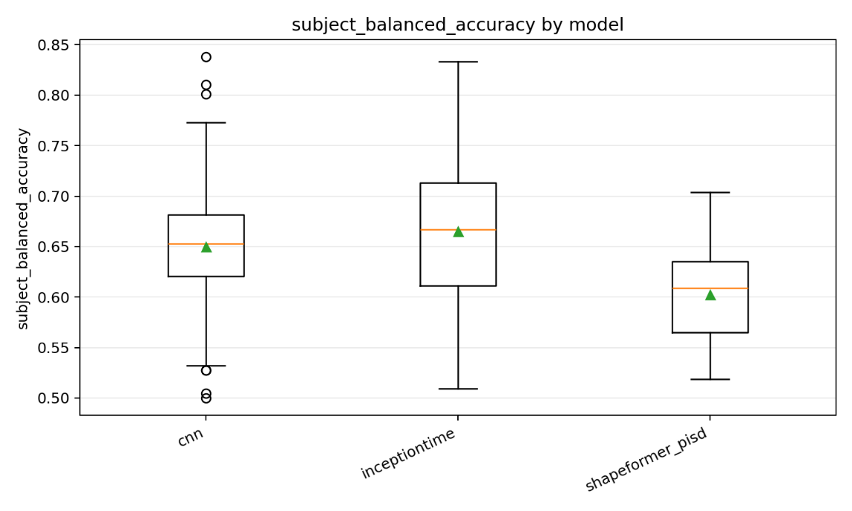
Figure 19 Distribution of participant-level balanced accuracy by 1-D CNN, InceptionTime and ShapeFormer-PISD. InceptionTime shows the widest dispersion (whiskers 0.509–0.833); the 1-D CNN and ShapeFormer-PISD show a comparably narrower spread, with the ShapeFormer-PISD distribution shifted towards lower values.

    - SQI-Gating and Motion Detector routing
The SQI and motion detector together form the dynamic routing branch of the pipeline. This experiment measures their effect on final classification performance rather than on signal fidelity, and it is the second of the two evaluation stages described at the beginning of Section 4.1. Four routes were compared as shown in Table 26.

Table 26 Four tested routes in SQI-Motion module
Route | Input roles | SQI | All-29 motion detector | Denoiser
off_off_all_roles | B/R/S/W | off | off | off
static_only | B/R | off | off | off
sqi_only | B/R/S/W | on | off | off
sqi_motion | B/R/S/W | on | on | off

Because segments emerging from the denoiser are used only for beat-level feature extraction and do not enter the eight-channel representation, the denoiser setting has no effect on this experiment. As such, it was disabled throughout the experiment in order to avoid unnecessary training time and memory pressure. The experiment therefore isolates the effect of the SQI module and of the motion-detector module on the default 1-D CNN configuration. In the absence of annotated data for this cohort, the SQI thresholds were not obtained by supervised training but were set to fixed values, with $Q_{rate}>0.50$ and $Q_{morph}>0.65$ treated as positive. The module acts on the model input only and does not affect the post-classification aggregation.
Table 27 presents the ablation test of 4 routes in SQI gating and motion-detector routing.

Table 27 Effect of SQI gating and motion-detector routing on the default 1-D CNN.
Case | BA mean ± SD (%) | BA cluster 95% CI (%) | Macro-F1 mean ± SD (%) | Macro-F1 cluster 95% CI (%) | Macro ROC-AUC mean ± SD (%) | ROC-AUC cluster 95% CI (%) | BA Holm P | F1 Holm P
cnn__off_off_all | 61.9 ± 5.8 | [49.3, 73.7] | 61.9 ± 4.7 | [49.2, 73.0] | 78.1 ± 1.2 | [67.1, 87.7] | N/A | N/A
cnn__sqi_only | 59.2 ± 9.3 | [44.7, 72.8] | 60.6 ± 8.4 | [45.5, 73.4] | 75.8 ± 3.7 | [63.9, 87.1] | 0.5615 | 0.7550
cnn__sqi_motion | 52.5 ± 10.3 | [40.1, 65.2] | 51.6 ± 11.2 | [37.7, 64.0] | 69.8 ± 3.8 | [56.8, 81.6] | 0.2861 | 0.1419
cnn__off_motion | 50.9 ± 4.4 | [37.7, 64.0] | 51.0 ± 5.2 | [36.7, 63.7] | 68.0 ± 4.5 | [54.7, 80.5] | 0.0643 | 0.0377

The result show a progressive reduction in performance as additional gating stages are introduced, with the reference configuration (in which all signal roles are retained and all gating is disabled), achieving the best overall performance. Balanced accuracy decreases monotonically from 61.9% to 59.2%, 52.5% and 50.9% across the four configurations, while macro-F1 decreases from 61.9% to 51.0%. Macro ROC-AUC similarly declines monotonically, from 78.1% to 68.0%.
Comparing off_off_all with off_motion isolates the effect of motion gating and shows reductions of 11.0 pp in balanced accuracy and 10.1 pp in ROC AUC. Comparing off_off_all with sqi_only isolates the effect of SQI-based gating, resulting in smaller reductions of 2.7 pp and 2.3 pp, respectively. Thus, although the motion detector achieved the strongest performance when evaluated independently in Section 4.1.2, its integration into the complete classification pipeline produced the largest deterioration in downstream performance. Appendix C presents additional performance metrics for the denoiser comparison, together with comparative distributions for each metric.
Two factors may explain this result. First, motion-related information may itself be discriminative for the target class. The Fried Frailty Phenotype is defined partially by physical performance characteristics, including gait speed, weakness, and exhaustion, while the S and W recordings capture sit-to-stand and walking dynamics that may reflect these characteristics. Excluding motion-affected windows may therefore remove not only signal artefacts but also physiologically relevant information associated with the construct being classified. The progressive decline in ROC AUC as gating is introduced is consistent with this interpretation.
Second, the SQI is unsupervised, rank-based, and applied independently within each file. Because no annotated signal-quality labels are available for this cohort, its thresholds are heuristic and retention is defined as a fixed proportion of beats within each file. Consequently, a recording containing uniformly poor pulse waveforms is not necessarily rejected. Instead, the SQI retains the highest-ranked fraction of beats within that recording, even when their absolute quality remains poor. Quality control is therefore performed relative to the signal-quality distribution of each individual file rather than against an absolute quality criterion.
Based on these findings, the configuration retaining all signal roles, including both static and motion recordings, was carried forward for subsequent deep-learning experiments. This configuration was evaluated using architectures such as CNN and Inception Time to determine whether models capable of learning directly from the time-series data can exploit information contained in both static and motion-related signals.

    - Grid search and ablation tests
To further explore the classification potential of this pipeline on the current dataset, several aspects of the modelling framework were systematically evaluated, including candidate model architectures and parameters, input lengths and resampling rates, and strategies for addressing class imbalance. Complete results, including additional tables and figures are provided in Appendix D.

      - Single-factor ablation for CNN and InceptionTime
This experiment varies one design decision at a time relative to a common baseline B0, holding all other settings fixed. The factors examined are the input sampling rate, the window plan, the IMU preprocessing and gravity-removal method, the normalisation scope, the sampler, the optimiser and batch size, and the aggregation level (see Table 28).

Table 28 Details of B0-B7
Case | Single change relative to B0
B0 | reference
B1 | 64 Hz → 400 Hz
B2 | 15 s / 3 s → 5 s / 2.5 s
B3 | IMU low-pass gravity separation → calibrated EKF dynamic acceleration
B4 | all-channel window scaling → PPG-window + IMU-fold scaling
B5 | file-weighted → role-equally-weighted sampler
B6 | AdamW / batch 32 → Adam / batch 64
B7 | direct-window aggregation → file/role aggregation

Table 29 InceptionTime B0–B7 comparison
Case | Factor | BA mean ± SD (%) | Δ BA vs B0 mean ± SD (pp) | Macro-F1 mean ± SD (%) | Δ Macro-F1 vs B0 mean ± SD (pp)
B0 | baseline | 56.8 ± 2.1 | 0.0 ± 0.0 | 57.2 ± 2.2 | 0.0 ± 0.0
B1 | sampling_rate 64 Hz → 400 Hz | 50.3 ± 2.0 | -6.5 ± 3.5 | 50.4 ± 2.0 | -6.8 ± 3.1
B2 | window_plan 15 s / 3 s → 5 s / 2.5 s | 50.9 ± 4.3 | -5.8 ± 4.7 | 51.8 ± 3.7 | -5.4 ± 3.9
B3 | imu_preprocessing  IMU low-pass gravity separation  → calibrated EKF dynamic acceleration | 49.7 ± 5.3 | -7.0 ± 5.9 | 50.3 ± 6.6 | -6.9 ± 7.1
B4 | Normalization  all-channel window scaling →  PPG-window + IMU-fold scaling | 43.0 ± 6.6 | -13.8 ± 6.3 | 43.1 ± 6.5 | -14.2 ± 5.9
B5 | Sampler  file-weighted → role-equally-weighted sampler | 52.3 ± 3.3 | -4.4 ± 2.8 | 52.1 ± 3.4 | -5.2 ± 2.3
B6 | optimizer_and_batch_size  AdamW/batch32 → Adam/batch64 | 56.0 ± 3.4 | -0.7 ± 5.0 | 56.2 ± 4.2 | -1.0 ± 5.7
B7 | direct-window aggregation → file/role aggregation | 57.3 ± 3.3 | 0.6 ± 1.9 | 57.9 ± 4.0 | 0.7 ± 2.4

Table 30 CNN B0–B7 comparison
Profile | Factor | BA mean ± SD (%) | Δ BA vs B0 mean ± SD (pp) | Macro-F1 mean ± SD (%) | Δ Macro-F1 vs B0 mean ± SD (pp)
B0 | baseline | 53.8 ± 6.1 | 0.0 ± 0.0 | 52.9 ± 5.9 | 0.0 ± 0.0
B1 | sampling_rate 64 Hz → 400 Hz | 44.9 ± 8.3 | -8.9 ± 13.2 | 43.8 ± 9.8 | -9.1 ± 14.5
B2 | window_plan 15 s / 3 s → 5 s / 2.5 s | 56.9 ± 5.3 | 3.1 ± 11.2 | 57.2 ± 6.2 | 4.2 ± 11.8
B3 | imu_preprocessing  IMU low-pass gravity separation  → calibrated EKF dynamic acceleration | 47.2 ± 8.4 | -6.6 ± 9.8 | 47.6 ± 8.5 | -5.3 ± 9.2
B4 | Normalization  all-channel window scaling →  PPG-window + IMU-fold scaling | 43.3 ± 3.3 | -10.5 ± 4.4 | 42.8 ± 3.1 | -10.1 ± 4.4
B5 | Sampler:  file-weighted → role-equally-weighted sampler | 52.3 ± 3.2 | -1.5 ± 6.0 | 53.4 ± 4.1 | 0.4 ± 6.0
B6 | optimizer_and_batch_size  AdamW/batch32 → Adam/batch64 | 49.2 ± 6.1 | -4.6 ± 6.0 | 48.7 ± 6.0 | -4.2 ± 6.0
B7 | direct-window aggregation → file/role aggregation | 54.7 ± 6.4 | 0.9 ± 3.7 | 54.0 ± 6.5 | 1.1 ± 3.4

Table 29 and Table 30 show the effects of each individual factor on CNN and InceptionTime models while all factors are held constant. An effect is considered reliable only when its magnitude exceeds its standard deviation and, preferably, when its direction is consistent across the two architectures. Based on these criteria, only one factor produces an unambiguous effect.
Normalisation scope (B4) is the most influential design decision in the entire pipeline. It produces the largest effect for both models (−13.8 pp for InceptionTime, −10.5 pp for the CNN), with the two architectures agreeing in both direction and approximate magnitude. It is also the only factor for which |Δ| exceeds the Δ standard deviation for both models (13.8 > 6.3 and 10.5 > 4.4). The effect on worst-class F1 is proportionally even larger (46.6 → 34.7 %), indicating that the degradation also affects performance on the most difficult class. These findings show that window-level scaling improves the classification performance of both deep learning models.
Two additional factors produce effects in the same direction across both architectures and therefore warrant interpretation, despite not meeting the strict magnitude criterion. Increasing the input sampling rate from 64 Hz to 400 Hz (B1) reduces performance for both models (−6.5 and −8.9 pp). Because the physiologically informative frequency range of the PPG signal lies below approximately 8 Hz, and the pipeline already band-pass filters the signal between 0.2–8 Hz, a sampling rate of 64 Hz comfortably satisfies the Nyquist criterion. Increasing the sampling rate to 400 Hz therefore adds substantially more samples (i.e., 6.25×) without providing additional information. For fixed kernel sizes, however, it reduces the receptive field in temporal terms by the same factor. At 400 Hz, for example, a kernel of length 9 spans only 22.5 ms, compared with approximately 141 ms at 64 Hz. Consequently, the network’s early layers can no longer capture a complete pulse within a single receptive field. This was the motivation for including sampling-rate scaling in the ablation study. The results support the position that a local receptive field spanning a greater proportion of the cardiac cycle benefits classification performance.
The IMU preprocessing result (B3) is the most counter-intuitive in this chapter and warrants explicit discussion. Replacing the legacy IMU processing with a calibrated EKF-based attitude estimate and physically correct gravity removal reduces performance for both models (−7.0 and −6.6 pp). Thus, a physically more accurate representation produces a less effective classifier. One possible explanation is that gravity removal eliminates orientation- or posture-related information that is genuinely predictive of the class label. This is the second instance in this chapter (following the motion-detector routing of Section 4.2.3) in which a “cleaner” signal appears to be less informative for classification. Together, these findings suggest that components of uncorrected motion signal contain information that contributes positively to model performance.
The effects of the remaining factors are weaker. The window plan (B2) is the only factor for which the two architectures produce effects in opposite directions (InceptionTime −5.8, CNN +3.1). However, the standard deviation of the CNN effect (11.2 pp) substantially exceeds the estimated effect itself, meaning that this apparent disagreement is not itself reliable. Finally, the structural limitations of the ablation design should be acknowledged. Because each factor is varied individually from a single baseline configuration, the analysis estimates only main effects and cannot identify interactions between factors.

      - Batch size and Learning rate
The full hyper-parameter search was conducted using InceptionTime only. This choice was not based on evidence of statistical superiority over the CNN, as Section 4.2.2 demonstrated no significance difference between the two architectures. Rather, given their comparable performance, InceptionTime was selected for further optimization because it achieved descriptively better results, allowing the available computational budget to be concentrated on a single architecture.

Table 31 Batch size and learning rate.
case_id | balanced_accuracy_mean_sd_percent | macro_f1_percent_mean_sd
b16_lr3e-4 | 59.5 ± 6.2 | 59.4 ± 6.3
b32_lr1e-3 | 56.1 ± 6.4 | 55.4 ± 8.1
b16_lr1e-3 | 55.2 ± 5.1 | 55.4 ± 6.3
b16_lr1e-4 | 54.9 ± 4.1 | 54.6 ± 4.5
b32_lr3e-4 | 54.3 ± 3.0 | 53.4 ± 3.6
b32_lr1e-4 | 51.9 ± 7.2 | 51.3 ± 6.8

Table 31 presents the results of the grid search across batch size and learning rate, conducted to identify the best-performing combination and examine the interaction between the two hyperparameters. Mean performance spans 7.6 pp from the best to the worst configuration. This range is comparable to the effect sizes of the strongest ablation factors and is therefore not negligible. However, the standard deviations range from 3.0–7.2 pp, meaning that none of the neighbouring configurations can be clearly distinguished. The best-ranked configuration, b16_lr3e-4, exceeds the second-ranked configuration by 3.4 pp, but their standard deviations are 6.2 and 6.4 pp, respectively. It should therefore be regarded as the highest-ranked configuration rather than as demonstrably superior.
Nevertheless, two tendencies in the grid are consistent with established optimisation behaviour. A batch size of 16 outperforms a batch size of 32 at two of the three learning rates: by 5.2 pp at 3 × 10⁻⁴ and by 3.0 pp at 1 × 10⁻⁴. It performs marginally worse at 1 × 10⁻³ (−0.9 pp). Smaller batches introduce greater stochasticity into the gradient estimates, which can act as a form of implicit regularisation and may be beneficial in the small-data setting considered in this thesis. With no more than 21 training participants per fold, the model is highly over-parameterised relative to the number of independent participants. Additional gradient noise may therefore help to reduce overfitting, although the variability across runs prevents a definitive conclusion. The second tendency concerns the interaction between batch size and learning rate. The highest-ranked learning rate shifts from 3 × 10⁻⁴ with a batch size of 16 to 1 × 10⁻³ with a batch size of 32. This shift is directionally consistent with linear or square-root learning-rate scaling principles, according to which increasing the batch size is generally accompanied by an increase in the learning rate. However, the coarse grid and substantial variability, the results should be interpreted as evidence of a possible interaction rather than confirmation of a particular scaling rule.

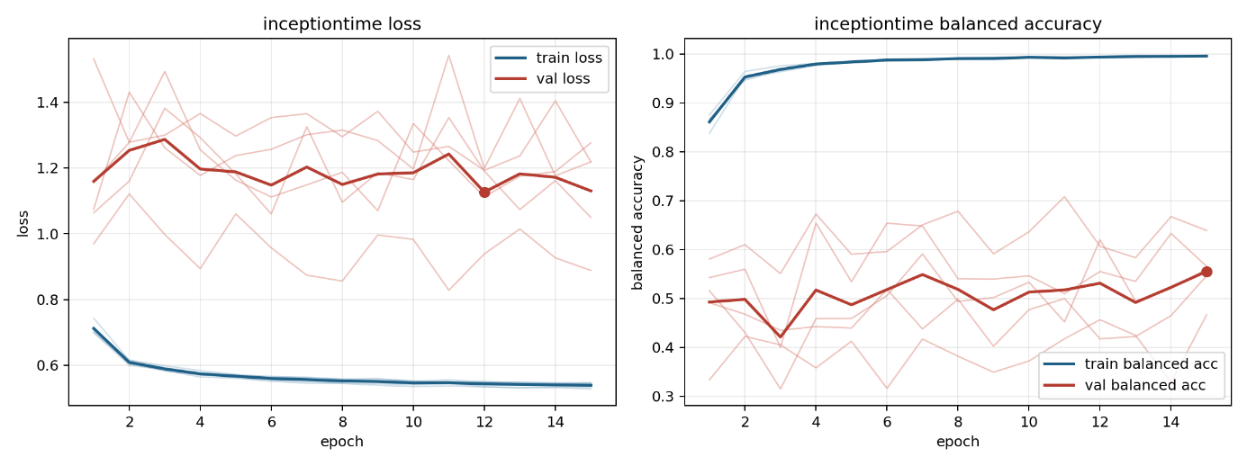
Figure 20 A Learning Curve plot from InceptionTime with loss curve on left and BA curve on right

      - Regularization
Figure 20 presents the loss and balanced-accuracy learning curves for an InceptionTime model. Training balanced accuracy reaches almost 1.00 by epoch 6, whereas validation balanced accuracy remains below 0.6 and shows no sustained improvement. The pronounced divergence between training and validation performance provides clear evidence of overfitting, which is a major concern when training a complex deep learning model on a small dataset. Consequently, systematically evaluating different regularisation settings represents an approximately next step.

Table 32 Regularisation grid over weight decay (wd), dropout (do) and label smoothing (ls).
case_id | balanced_accuracy_mean_sd_percent | macro_f1_percent_mean_sd
r9_wd01_do07_ls01 | 58.9 ± 4.0 | 59.4 ± 4.6
r2_wd001_do05_ls02 | 58.1 ± 3.3 | 57.5 ± 4.1
r6_wd005_do07_ls03 | 58.1 ± 2.6 | 58.0 ± 2.1
r7_wd01_do03_ls03 | 57.8 ± 1.5 | 56.4 ± 3.5
r8_wd01_do05_ls02 | 56.8 ± 3.0 | 56.3 ± 3.3
r4_wd005_do03_ls02 | 56.4 ± 4.1 | 55.8 ± 3.1
r5_wd005_do05_ls02 | 56.3 ± 2.5 | 55.4 ± 3.0
r1_wd001_do03_ls01 | 55.6 ± 4.7 | 55.6 ± 5.4
r3_wd001_do07_ls03 | 55.0 ± 6.4 | 54.8 ± 6.4

The regularisation grid produces the smallest variation among the searches performed (see Table 32). Across the nine configurations, mean performance spans only 3.9 pp, ranging from 55.0% to 58.9%, and the ±1 SD intervals of all configurations overlap. Within the tested ranges (weight decay 0.001 to 0.1, dropout 0.3 to 0.7, label smoothing 0.1 to 0.3), participant-level performance appears largely insensitive to the regularisation settings. Consequently, none of the configurations can be considered superior based on its mean performance.

      - Further exploratory searches
In addition to the single-factor ablation tests and the hyperparameter searches reported above, a number of further factors were examined during development. These comprised alternative fixed stopping epochs within a narrow range around the default value of ten epochs, the length of the input window, the overlap between consecutive windows, the proportion of windows retained per recording (a regularisation strategy based on downsampling the total number of windows), and a regularisation parameter search for the 1D-CNN architecture. Consistent with the InceptionTime regularisation search, none of these factors emerged as a subject-level determinant of performance. The configuration of the final case was therefore not adjusted on the basis of these results, and they are not discussed further in the main text. The complete tables and figures are provided in Appendix D.

      - Final test for final configuration
Five candidate Inception Time configurations were carried forward to the final evaluation. All five use the same data definition: participant-grouped 5 × 5 splitting procedure with seeds 42, 10042, 20042, 30042 and 40042; raw eight-channel representation; signal-preparation pipeline; beat detector; per-window robust scaling; disabled SQI, motion and denoiser modules; AdamW optimiser; inverse-frequency class weighting; and Line B aggregation pathway (window → file → role → participant). The complete shared specification is provided in Table 35 (see Appendix E), while the differences among the five configurations are summarized in Table 33.
The five configurations were not selected as part of an unconstrained search. Three comparisons constitute controlled single-factor contrasts because of the two configurations in each comparison differ in exactly one setting: recording roles (Rank 3 versus Rank 5), network capacity (Rank 1 versus Rank 3), and gravity handling (Rank 1 versus Rank 2). In contrast, the comparison between Rank 3 and Rank 4 combines six changes and can therefore be interpreted only descriptively. The final evaluation results are presented in Table 34.

Table 33 Differences between the Top5 configurations
Configuration | Rank 1 | Rank 2 | Rank 3 | Rank 4 | Rank 5
Architecture | Small | Small | Full | Full | Full
Bottleneck / filters per branch / depth | 16 / 16 / 3 | 16 / 16 / 3 | 32 / 32 / 6 | 32 / 32 / 6 | 32 / 32 / 6
Module output | 64 | 64 | 128 | 128 | 128
Roles | B/R/S/W | B/R/S/W | B/R/S/W | B/R/S/W | B/R
Gravity | Profile-A, low-pass 0.3Hz, fourth order | not estimated, not removed | Profile-A | Profile-A | Profile-A
Raw-window cap | 128 / file | 128 / file | 128 / file | 90% /recording, no fixed cap | 128 / file
Epochs | 10 | 10 | 10 | 15 | 10
Batch | 16 | 16 | 16 | 32 | 16
LR | 3e-4 | 3e-4 | 3e-4 | 1e-3 | 3e-4
Weight decay | 0.001 | 0.001 | 0.001 | 5e-4 | 0.001
Label smoothing | 0.20 | 0.20 | 0.20 | 0.10 | 0.20
Class-count basis | row | row | row | participant | row
Table 34 Final configuration results. Participant-level metrics over five repeats of participant-grouped five-fold cross-validation.
Case | tuned_all_roles__small | tuned_all_roles_  small_no_gravity | tuned_all_roles__  full | s1_163_v2_port_  all_roles | tuned_static_  full
BA mean ± SD (%) | 71.9 ± 4.7* | 71.4 ± 4.9 | 70.6 ± 5.4 | 66.3 ± 4.9 | 58.1 ± 3.3
Macro-F1 mean ± SD (%) | 70.4 ± 4.4* | 69.3 ± 3.9 | 69.6 ± 5.2 | 67.6 ± 4.4 | 57.5 ± 4.1
Macro ROC-AUC mean ± SD (%) | 84.4 ± 3.1 | 86.6 ± 2.5* | 84.3 ± 2.4 | 83.1 ± 3.0 | 74.0 ± 1.8
Macro PR-AUC mean ± SD (%) | 77.6 ± 4.2 | 80.9 ± 2.3* | 77.5 ± 2.5 | 76.0 ± 5.1 | 66.2 ± 1.9
Worst-fold BA (%) | 33.3 | 50.0* | 50.0 | 33.3 | 27.8
Worst-class F1 (%) | 62.1* | 56.0 | 59.8 | 56.2 | 50.0

The three highest-ranking configurations achieved relatively similar performance, and the final configuration was therefore selected from among these candidates. Inspection of the class-specific recalls in the confusion matrices showed that recall from the robust class remained substantially lower than recall for the young and prefrail classes.
Rank 1 and Rank 3 differ only in the capacity of the InceptionTime encoder. Rank 1 uses a bottleneck size and 16 filters per branch, a depth of 3, and a module output size of 64, whereas Rank 3 uses a bottleneck size and 32 filters per branch, a depth of 6, and module output size of 128. The smaller network achieved a balanced accuracy off 71.9 ± 4.7%, compared with 70.6 ± 5.4% for the larger network. This difference of 1.3 pp is small relative to the variability across repeats. Macro ROC-AUC and macro PR-AUC were also nearly identical (84.4% versus 84.3%, and 77.6% versus 77.5%, respectively). Thus, there is no evidence that the additional network capacity improves participant-level performance in this cohort.
Rank 1 and Rank 2 differ only in whether a gravity component is estimated and removed from the accelerometer channels. Rank 1 applies the Profile-A low-pass estimate at 0.3 Hz using a fourth-order filter, whereas Rank 2 performs no gravity estimation or removal. Their balanced accuracies were 71.9 ± 4.7% and 71.4 ± 4.9%, respectively. The difference of 0.5 pp is negligible relative to the variability across repeats. The ranking metrics favoured the configuration without gravity removal by larger margins: macro PR-AUC was 80.9 ± 2.3% for Rank 2 and 77.6 ± 4.2% for Rank 1, while macro ROC-AUC was 86.6 ± 2.5% and 84.4 ± 3.1%, respectively. Rank 2 also achieved a higher worst-fold balanced accuracy (50.0% versus 33.3%). Conversely, worst-class F1 favoured Rank 1, which included gravity removal (62.1% versus 56.0%).
According to the audited ranking procedure specified in Section 3.6.2, Rank 1 is favoured by the first criterion (mean participant-level balanced accuracy), the second criterion (mean macro-F1), and the fourth criterion (worst-class F1). Rank 2 is favoured by the third criterion, which prioritises configurations whose performance is not driven by a single split. Its worst-fold balanced accuracy of 50.0%, compared with 33.3% for Rank 1, and its ranking metrics showed the lowest variability. Rank 1 was therefore selected as the final configuration under the pre-specified ranking procedure. Nevertheless, its advantage over Rank 2 on the primary endpoint is only 0.5 pp, and the two configurations should be regarded as indistinguishable based on the available evidence. Rank 2 also has the practical advantage of being simpler because it does not require a gravity estimation stage.
- Discussion
The aim of this thesis was to develop a transparent Python-based signal-processing pipeline integrating synchronised PPG and IMU signals and to investigate their potential for reproducible participant-level classification of frailty-related groups and, subject to independent validation, for future remote-monitoring applications. This aim was addressed through three objectives. First, a transparent and reproducible pipeline was developed for processing synchronised PPG and IMU recordings, including preprocessing, peak detection, motion detection, and motion-artefact reduction. Second, the physiological and movement-related information contained in these recordings was investigated through PPG-derived features and participant-level classification of prefrail older adults, non-frail older adults, and young reference participants. Third, the reliability of the workflow was evaluated using participant-independent data partitioning, comparisons with established reference implementations, and systematic assessments across different modelling and signal-processing configurations. These components were integrated into a maintainable Python pipeline, and the current limitations of the approach and requirements for its future application in wearable monitoring were documented.
The following discussion focuses primarily on the robustness and sensitivity analyses, as these provide the most important evidence regarding the reliability of the classification results and the extent to which performance depends on specific data-processing, modelling, and evaluation decisions.
  - Robustness analysis and Sensitivity analysis
Recording role composition produced the largest single-factor effect observed in the thesis. The contrast between Rank 3 and Rank 5 isolates input scope because the two configurations are identical in every other entry in Tables 33 and 34. Including the dynamic S and W recordings alongside the static B and R recordings increased balanced accuracy from 58.1% to 70.6%, a difference of 12.5 pp. All six reported endpoints changed in the same direction: macro-F1 increased by 12.1 pp, macro ROC-AUC by 10.3 pp, macro PR-AUC by 11.3 pp, worst-fold balanced accuracy by 22.2 pp, and worst-class F1 by 9.8 pp. This is the only contrast for which a threshold-based metric, two ranking-based metrics, and both worst-case endpoints agreed. Nevertheless, the effect did not survive multiplicity correction: the unadjusted p-value of 0.0418 increased to 0.1255 after Holm adjustment, while the participant-clustered interval remained wide at [1.39, 22.87].
The influence of the dynamic recordings must also be interpreted in relation to the aggregation procedure. During training, the sampler visits every retained window once per epoch. The dynamic recordings therefore constitute only a small proportion of the training signal: they account for 4.073% of the total recording duration and, at the 5 s window and 2.5 s hop used here, contribute several hundred windows compared with the tens of thousands from the static recordings. At inference, however, the Line B path aggregates predictions using an unweighted mean at each role-task level. Consequently, B, R, S, and W each contribute one quarter of the participant-level decision, with the two dynamic tasks together contribute one half. Because the static recordings are collectively 23.55 times longer than the dynamic recordings, each second of dynamic data receives, on average, approximately 23.55 times the participant-level weight of a second of static data. The observed improvement therefore reflects both the information provided by the dynamic tasks and their weighting within the aggregation scheme.
IMU and gravity handling produced the clearest consistent negative result. In the single-factor ablation, replacing the legacy handling with a calibrated EKF attitude estimate and physically correct gravity removal degraded both architectures. In the final-configuration contrast, removing the Profile-A gravity estimate left balanced accuracy within the repeat dispersion while improving both ranking metrics and the worst-fold value. No experiment found gravity-removal to improve participant-level classification. The empirical conclusion is therefore that the simplest handling performed at least as well as the physically faithful alternatives on this cohort. The reason remains unresolved. Retained gravity components may contain posture or orientation information associated with the target groups, but estimation transients in the short recordings provide an equally plausible explanation. Section 5.5 proposes an experiment that would distinguish between these possibilities.
A structural pattern was the consistently stronger performance of ranking-based than threshold-based metrics. Their raw values cannot be compared directly because their chance levels differ: 0.500 for a one-versus-rest ROC-AUC and 0.333 for three-class balanced accuracy. After normalising each metric relative to its distance from chance, the five final configurations show gaps of 10.8, 16.1, 12.7, 16.7 and 10.8 points, all favouring the ranking-based metric. The margin analysis supports the same interpretation: a label-informed change to the decision rule increased balanced accuracy by 7.87 and 11.57 pp for the three highest-ranked configurations. Because this rule was fitted with knowledge of the labels, these values should be interpreted as a diagnostic estimate of decision-rule sensitivity rather than as unbiased performance improvements. Nevertheless, the result indicates that part of the discrepancy between ranking- and threshold-based metrics arises from the decision rule rather than the learned representation alone.
Finally, the sensitivity-analysis design imposes important limitations. One-factor-at-a-time ablation from a single baseline estimates main effects only and cannot identify interactions. The window-plan factor, which improved the 1-D CNN and degraded InceptionTime, demonstrates that at least one architecture-dependent interaction exists. Individually beneficial settings therefore cannot be assumed to form an optimal configuration when combined, and each estimated effect remains conditional on the baseline from which it was measured. Because most effect standard deviations exceeded the corresponding mean effects, the ablation is better suited to identifying clearly harmful settings than to constructing an optimum through the additive combination of apparently beneficial choices.
  - Limitations
The first limitation concerns the scope of the modelling investigation. During development, the established signal-processing chain and the candidate input representations were surveyed and adopted comparatively broadly: three data representations and their corresponding classification branches were implemented and evaluated under the same participant-grouped protocol. Because none of the three representations differed significantly from the others in participant-level performance, only one of them — the raw-signal input path combined with the single-model InceptionTime architecture — was pursued in depth, while the feature-vector and feature-matrix branches were retained only as exploratory comparisons. All subsequent experiments, including the routing ablation, the two hyper-parameter grids and the final five-way comparison, are therefore conditional on this single architectural choice, and the present work provides no evidence that an alternative representation, a hybrid feature-fusion design or a model ensemble would not have performed comparably or better. This restriction of scope constitutes the most substantial limitation of the thesis.
At the dataset level, no external cohort with frailty labels was available, and no subset of participants could be reserved as a held-out test set without reducing the smallest class below a usable size. All reported classification results therefore represent internal out-of-fold performance. Participant-grouped splitting prevents subject-level leakage and was applied without exception. However, the motion-detector transfer experiment reported in Section 4.1.2 demonstrated that participant-grouped validation does not necessarily reveal a shortcut operating at the level of the acquisition block. The same type of failure cannot be excluded for the frailty classifier because no corresponding transfer test was available. This is the principal reason why the present thesis is framed as a feasibility investigation.
Then, the size and composition of the cohort represent the central limitation from which many of the other limitations follow. The entire labelled evidence based comprised 29 participants: nine Pre-Frail, 12 Robust/Non-Frail, and 8 Young participants. In the experiments for which they were computed, participant-cluster bootstrap intervals spanned approximately ±13 pp, placing the effective resolution for participant-level comparisons between configurations at approximately 10 pp. Smaller differences were reported descriptively and used for ranking within the selection procedure, but they do not constitute evidence of superiority that can be expected to generalise beyond this cohort. A single participant accounts for 3.70, 2.78 and 4.17 pp of balanced accuracy in the three classes, respectively. Class-level recall therefore changes in coarse increments, and small differences should not be overinterpreted.
Model selection was performed on the same 29 participants throughout. Representation screening, architecture comparison, routing ablation, single-factor ablation, two hyper-parameter grids, and the final five-way comparison were all evaluated using this cohort. Selecting the best configuration through such a sequence introduces optimistic bias into the reported performance of the selected model, even when each individual comparison is internally unbiased. The sequential structure of the search does not eliminate this bias. The balanced accuracy of 71.9% should therefore be interpreted as the upper end of a plausible range for this pipeline on the present cohort rather than as an unbiased estimate of its performance on new participants.
With regard to data processing, the window-level input representation constrains the feature branch. Because the model processes fixed-length windows, beat-resolved quantities such as pulse-rate variability and pulse-wave morphology can enter the fusion pathway only as values aggregated within each window. Consequently, the ordering of intervals within a window and the trajectory of morphological change across successive beats are reduced to summary statistics. Whether this reduction removes information relevant to the classification target was not investigated.
The dynamic recordings are also short. They account for only 4.073% of the recorded duration and have an average duration of 15.93 s per recording. Of the 116 dynamic recordings, 113 are shorter than 30 s and five are shorter than 8 s; the latter cannot provide a complete window for the 8 s motion detector. Nevertheless, the largest effect observed in the thesis resulted from including these recordings, meaning that this effect is based on a small number of short recordings per participant.
Participant-level aggregation also gives individual short recordings considerable influence over the final decision. Under the Line B pathway, the four role tasks (i.e., B, R, S, and W) each contribute 25% of the participant-level prediction, regardless of their duration. Consequently, the single baseline recording contributes 25% on its own, each of the four recovery recordings contributes 6.25%, and each of the two sit-to-stand and two walking recordings contributes 12.5%. With the 5 s window and 2.5 s hop used in the final configuration, a recording lasting approximately 300 s produces 119 windows, whereas the shortest dynamic recording in the dataset, lasting 6.88 s, produces only one. In the latter case, a single 5 s window determines 12.5% of the participant-level prediction. The 20 recordings shorter than 10 s produce no more than two windows each and are subject to the same issue, although to varying degrees. A transient artefact, a momentary loss of contact, or an atypical beat within one such window is therefore not averaged out. The robustness of participant-level predictions to single-window disturbances was not assessed. This limitation is particularly relevant to the decomposition presented in Section 4.2.4.5 because aggregation accounts for the larger part of the strongest effect observed in this thesis, and the recordings with the greatest per-window influence are precisely those assigned this weight.
In addition, for SQI-based dynamic signal filtering were established within the pipeline, the absence of high-quality, manually annotated data precluded supervised threshold training. Consequently, this study employed custom, unsupervised thresholds, resulting in SQI-based ranking performed within the dataset itself. As a result, if the heartbeat waveforms across an entire file are generally of poor quality, the SQI mechanism selects the best fixed percentage of heartbeats for model input rather than discarding the file entirely. Thus, the current SQI approach relies heavily on the inherent quality of the data and the preceding dynamic monitoring module.
Finally, the mean participant-level balanced accuracy of 71.9 ± 4.7 % achieved by the transparent Python-based signal-processing pipeline developed here remains far below the level that would constitute diagnostically informative performance, and it was obtained under internal out-of-fold evaluation on 29 participants rather than on an independent cohort. In addition, the pipeline was not assessed with respect to mobile deployment on portable wearable monitoring and analysis devices: neither the reproducibility of the processing chain on embedded hardware nor its implementation boundaries — computational cost, memory footprint, latency and energy consumption — were evaluated. The results reported here therefore support a feasibility statement about the information contained in synchronised PPG and IMU recordings.

  - Future directions
Although this study ultimately achieved a significant improvement in classification performance by leveraging dynamic data, such data for frail and pre-frail populations is extremely scarce in real-world applications—difficult to obtain for training sets and even harder to acquire in clinical settings. Moreover, the dynamic data primarily enhanced classification accuracy for the "young" cohort, which is not directly relevant to frailty classification. The beat-indexed representation not implemented here remains the most substantial methodological extension available. Representing each valid inter-beat interval as one row of a pulse-event feature matrix would preserve the ordering of intervals and the trajectory of morphological change across successive beats, which are reduced to summary statistics under the present window-level aggregation. Such a representation would sacrifice some frequency-domain resolution and is appreciably more complex to implement, particularly with respect to variable sequence lengths, missing beats and cross-channel alignment. Whether it would improve classification for this target is not known and would have to be tested; the argument for attempting it is that autonomic regulation is expressed through the temporal organisation of beat-to-beat variation, which the current representation does not retain.
Given that the "Robust/Non-Frail" group consistently ranks as the weakest category across all configurations—and that the difficulty associated with it cannot be attributed to class size—it is worth exploring alternative task decomposition strategies. A two-stage binary classification approach—first distinguishing between younger and older individuals, followed by a binary classification within the older cohort to separate "Pre-Frail" from "Robust/Non-Frail" subjects—could simplify the second stage to a clinically meaningful distinction; however, this comes at the cost of error propagation from the first stage and a reduced effective sample size. Sigmund (2026) reported exploring a similar hierarchical decomposition for predicting care levels but found it failed to resolve the fundamental limitation of minority class data scarcity; consequently, this approach should be pursued with caution. If the ordinal relationship "Young–Robust–Pre-Frail" can be substantiated, an ordinal model employing a single latent variable with two cut-points offers another viable option.
Finally, the deployment envelope of the pipeline on portable wearable monitoring and analysis hardware remains to be characterised. The present implementation was developed and evaluated on desktop hardware and deliberately prioritises transparency and auditability over computational economy, so the results reported here establish neither the reproducibility of the processing chain on embedded devices nor the upper bound of what such devices can support. Profiling the individual modules — channel-specific filtering, attitude estimation, beat detection, signal-quality assessment, motion detection, motion-artefact reduction and inference — with respect to computational cost, memory footprint, latency and energy consumption would establish which parts of the chain can be executed on-device in a streaming manner, which require batched processing, and which must be deferred to an external processor. Comparing full-precision inference with quantised or pruned variants of the selected InceptionTime configuration would additionally quantify how much participant-level accuracy is traded for a reduced computational budget. An assessment of this kind would allow the feasibility of the pipeline to be verified under the constraints of the wearable devices on which it is ultimately intended to operate.

- Conclusion
This thesis aims to develop a transparent Python-based signal-processing pipeline that integrates synchronised PPG and IMU signals to investigate their potential for reproducible participant-level classification of frailty-related groups and, subject to independent validation, their suitability for remote monitoring applications. The thesis has three main objectives. First, it develops a transparent and reproducible signal-processing pipeline for synchronised PPG and IMU recordings, including preprocessing, peak detection, motion detection, and motion-artefact reduction. Second, it investigates physiological and movement-related information in the recordings through PPG-derived features and participant-level classification of the pre-frail older, non-frail older, and young reference groups. Third, it evaluates the reliability of the resulting workflow through participant-independent data partitioning, comparison with established reference implementations, and assessment across different modelling and signal-processing configurations. These components are integrated into a maintainable Python pipeline, with its current limitations and requirements for future wearable applications explicitly documented.
The first objective was met. A modular Python pipeline was implemented in which every core signal-processing operation — channel-specific preprocessing, IMU handling, window segmentation, robust window-wise normalisation, beat detection, signal-quality assessment, motion detection, motion-artefact reduction, feature extraction, participant-grouped partitioning, classification, probability aggregation and participant-level evaluation — is expressed explicitly using standard scientific-computing libraries rather than delegated to an end-to-end toolkit. Every parameter estimated from data is fitted on the active training participants only, and participant identity is the grouping variable throughout. This transparency did not come at the cost of accuracy: MSPTDfast (v.2) Python port reproduced reference behaviour on external ECG-annotated recordings, with a median beat-detection F1 of 99.7 % and a median IBI–PPI RMSE of 19.2 ms on the infrared channel. Simultaneously, both the motion detector and motion denoiser underwent reliability testing on external supervised public training sets.
The second objective developed three data presentations. Two of them explored and implemented the extraction of time-domain and frequency-domain features, pulse wave morphology features, and heart rate variability features from PPG and iMU signals, respectively focusing on macroscopic frequency-domain features and temporal variability features. They were also successfully implemented as transparent feasibility weakened classification branches in the complete pipeline. In exploratory subject-level classification, these two lines achieved slight classification capabilities of 48.4 ± 3.2% and 44.7 ± 4.3%, respectively. However, due to the selection of a third deep neural network branch as the main classifier for the pipeline, neither of these lines made significant progress. Nevertheless, the exploration of the deep neural network classifier branch revealed potential unknown features in the original signal that are easily filtered out, greatly improving the frailty classification performance and serving as a potential direction for future research.
The last objective produced a qualified positive result. Under participant-independent evaluation, the selected configuration reached a mean participant-level balanced accuracy of 71.9 ± 4.7 %, a macro-F1 of 70.4 ± 4.4 % and a macro ROC-AUC of 84.4 ± 3.1 %, against a three-class chance level of 33.3 %. The recordings therefore contain group-related information that was reproducibly detectable under leakage-safe internal evaluation. The class-level results qualify this substantially: the Young group was close to separable, with recalls between 0.875 and 1.000, whereas Robust/Non-Frail reached only 0.417 to 0.500 despite being the largest class. Since the Young group is an age-reference group rather than a frailty grade, the aggregate figures are raised by a contrast that a frailty-grading task would not contain, and the distinction that corresponds to frailty grading — Pre-Frail against Robust/Non-Frail among older participants — is the part of the task that performed worst. This pattern is consistent with the source study of the same cohort, in which age-related differences were detected reliably while distinctions within the older cohort were detected only under specific conditions.
At its current stage, the resulting pipeline is intended to support transparent and reproducible engineering analysis, comparison of signal-processing methods, and exploratory classification of frailty-related groups within the available dataset. The results provide preliminary evidence that synchronised PPG and IMU signals contain information associated with the frailty-related groups investigated here. They do not establish a frailty-specific physiological biomarker, and they do not establish clinical diagnostic validity.
Subject to larger and longitudinal cohorts, external participant-level validation, annotated quality labels and prospective clinical evaluation, the framework developed here may provide a basis for further investigation of wearable PPG and IMU sensing in repeated frailty assessment.
- Resource Availability
The Python based PPG & IMU signal processing Pipeline and Frailty classifier are opensource. https://github.com/KaifengXuuu/PPG-Frailty-pipeline/tree/main
- Software reference
The following artificial intelligence tools were used. These tools were employed for text and language review, wording optimization, and formatting adjustments, as well as for code review, scripting assistance, and code execution testing.
Anthropic. (2026). Claude (Opus 5) [Large language model]. https://claude.ai
OpenAI. (2026). ChatGPT (GPT-5.6 ) [Large language model]. https://chatgpt.com/

References
Aboy, M., J. McNames, Tran Thong, D. Tsunami, M. S. Ellenby, and B. Goldstein. 2005. “An Automatic Beat Detection Algorithm for Pressure Signals.” IEEE Transactions on Biomedical Engineering 52(10):1662–70. doi:10.1109/TBME.2005.855725.
Ajmal, Tananant Boonya-ananta, Andres Rodriguez, V. N. Du Le, and Jessica Ramella-Roman. 2021. “Monte Carlo Analysis of Optical Heart Rate Sensors in Commercial Wearables: The Effect of Skin Tone and Obesity on the Photoplethysmography (PPG) Signal.” Biomedical Optics Express 12:7445–57. doi:10.1364/BOE.439893.
Alastruey, Jordi, Peter H. Charlton, Vasiliki Bikia, Birute Paliakaite, Bernhard Hametner, Rosa Maria Bruno, Marijn P. Mulder, Samuel Vennin, Senol Piskin, Ashraf W. Khir, Andrea Guala, Christopher C. Mayer, Jonathan Mynard, Alun D. Hughes, Patrick Segers, and Berend E. Westerhof. 2023. “Arterial Pulse Wave Modeling and Analysis for Vascular-Age Studies: A Review from VascAgeNet.” American Journal of Physiology-Heart and Circulatory Physiology 325(1):H1–29. doi:10.1152/ajpheart.00705.2022.
Álvarez-Millán, Lesli, Claudia Lerma, Daniel Castillo-Castillo, Rosa M. Quispe-Siccha, Argelia Pérez-Pacheco, Jesús Rivera-Sánchez, and Ruben Fossion. 2022. “Chronotropic Response and Heart Rate Variability before and after a 160 m Walking Test in Young, Middle-Aged, Frail, and Non-Frail Older Adults.” International Journal of Environmental Research and Public Health 19(14):8413. doi:10.3390/ijerph19148413.
Bagnall, Anthony, Jason Lines, Aaron Bostrom, James Large, and Eamonn Keogh. 2017. “The Great Time Series Classification Bake off: A Review and Experimental Evaluation of Recent Algorithmic Advances.” Data Mining and Knowledge Discovery 31(3):606–60. doi:10.1007/s10618-016-0483-9.
Bent, Brinnae, Benjamin A. Goldstein, Warren A. Kibbe, and Jessilyn P. Dunn. 2020. “Investigating Sources of Inaccuracy in Wearable Optical Heart Rate Sensors.” Npj Digital Medicine 3(1):18. doi:10.1038/s41746-020-0226-6.
Benzinger, Petra, Annette Eidam, and Jürgen M. Bauer. 2021. “Klinische Bedeutung Der Erfassung von Frailty.” Zeitschrift Fur Gerontologie Und Geriatrie 54(3):285–96. doi:10.1007/s00391-021-01873-z.
Bergstra, James, and Yoshua Bengio. 2012. “Random Search for Hyper-Parameter Optimization.” Journal of Machine Learning Research 13(10):281–305. http://jmlr.org/papers/v13/bergstra12a.html.
Billman, George E. 2013. “The LF/HF Ratio Does Not Accurately Measure Cardiac Sympatho-Vagal Balance.” Frontiers in Physiology 4. doi:10.3389/fphys.2013.00026.
Buta, Brian J., Jeremy D. Walston, Job G. Godino, Minsun Park, Rita R. Kalyani, Qian-Li Xue, Karen Bandeen-Roche, and Ravi Varadhan. 2016. “Frailty Assessment Instruments: Systematic Characterization of the Uses and Contexts of Highly-Cited Instruments.” Ageing Research Reviews 26:53–61. doi:10.1016/j.arr.2015.12.003.
Butterworth, S. 1930. “On the Theory of Filter Amplifiers.” https://bibbase.org/network/publication/butterworth-onthetheoryoffilteramplifiers-1930.
Cawley, Gavin C., and Nicola L. C. Talbot. 2010. “On Over-Fitting in Model Selection and Subsequent Selection Bias in Performance Evaluation.” Journal of Machine Learning Research 11(70):2079–2107. http://jmlr.org/papers/v11/cawley10a.html.
Challoner, A. V., and C. A. Ramsay. 1974. “A Photoelectric Plethysmograph for the Measurement of Cutaneous Blood Flow.” Physics in Medicine and Biology 19(3):317–28. doi:10.1088/0031-9155/19/3/003.
Chapter 4: The differences and similarities between ECG and PPG. 2025. https://academy.fibricheck.com/hc/en-be/articles/6383416554396-Chapter-4-The-differences-and-similarities-between-ECG-and-PPG.
Charlton, Peter H., John Allen, Raquel Bailón, Stephanie Baker, Joachim A. Behar, Fei Chen, Gari D. Clifford, David A. Clifton, Harry J. Davies, Cheng Ding, Xiaorong Ding, Jessilyn Dunn, Mohamed Elgendi, Munia Ferdoushi, Daniel Franklin, Eduardo Gil, Md Farhad Hassan, Jussi Hernesniemi, Xiao Hu, Nan Ji, Yasser Khan, Spyridon Kontaxis, Ilkka Korhonen, Panicos A. Kyriacou, Pablo Laguna, Jesús Lázaro, Chungkeun Lee, Jeremy Levy, Yumin Li, Chengyu Liu, Jing Liu, Lei Lu, Danilo P. Mandic, Vaidotas Marozas, Elisa Mejía-Mejía, Ramakrishna Mukkamala, Meir Nitzan, Tania Pereira, Carmen C. Y. Poon, Jessica C. Ramella-Roman, Harri Saarinen, Md Mobashir Hasan Shandhi, Hangsik Shin, Gerard Stansby, Toshiyo Tamura, Antti Vehkaoja, Will Ke Wang, Yuan-Ting Zhang, Ni Zhao, Dingchang Zheng, and Tingting Zhu. 2023. “The 2023 Wearable Photoplethysmography Roadmap.” Physiological Measurement 44(11):111001. doi:10.1088/1361-6579/acead2.
Charlton, Peter H., Erick Javier Argüello-Prada, Jonathan Mant, and Panicos A. Kyriacou. 2025a. “The MSPTDfast Photoplethysmography Beat Detection Algorithm: Design, Benchmarking, and Open-Source Distribution.” Physiological Measurement 46(3):035002. doi:10.1088/1361-6579/adb89e.
Charlton, Peter H., Erick Javier Argüello-Prada, Jonathan Mant, and Panicos A. Kyriacou. 2025b. “The MSPTDfast Photoplethysmography Beat Detection Algorithm: Design, Benchmarking, and Open-Source Distribution.” Physiological Measurement 46(3):035002. doi:10.1088/1361-6579/adb89e.
Charlton, Peter H., Kristjan Pilt, and Panicos A. Kyriacou. 2022. “Establishing Best Practices in Photoplethysmography Signal Acquisition and Processing.” Physiological Measurement 43(5):050301. doi:10.1088/1361-6579/ac6cc4.
Chaves, Paulo H. M., Ravi Varadhan, Lewis A. Lipsitz, Phyllis K. Stein, B. Gwen Windham, Jing Tian, Lee A. Fleisher, Jack M. Guralnik, and Linda P. Fried. 2008. “Physiological Complexity Underlying Heart Rate Dynamics and Frailty Status in Community-Dwelling Older Women.” Journal of the American Geriatrics Society 56(9):1698–1703. doi:10.1111/j.1532-5415.2008.01858.x.
Clegg, Andrew, John Young, Steve Iliffe, Marcel Olde Rikkert, and Kenneth Rockwood. 2013. “Frailty in Elderly People.” Lancet 381(9868):752–62. doi:10.1016/S0140-6736(12)62167-9.
Collard, Rose M., Han Boter, Robert A. Schoevers, and Richard C. Oude Voshaar. 2012. “Prevalence of Frailty in Community-Dwelling Older Persons: A Systematic Review.” Journal of the American Geriatrics Society 60(8):1487–92. doi:10.1111/j.1532-5415.2012.04054.x.
Cortes, Corinna, and Vladimir Vapnik. 1995. “Support-Vector Networks.” Machine Learning 20(3):273–97. doi:10.1007/BF00994018.
Cui, Yin, Menglin Jia, Tsung-Yi Lin, Yang Song, and Serge Belongie. 2019. “Class-Balanced Loss Based on Effective Number of Samples.” Pp. 9260–69 in 2019 IEEE/CVF Conference on Computer Vision and Pattern Recognition (CVPR).
Dent, E., J. E. Morley, A. J. Cruz-Jentoft, L. Woodhouse, L. Rodríguez-Mañas, L. P. Fried, J. Woo, I. Aprahamian, A. Sanford, J. Lundy, F. Landi, J. Beilby, F. C. Martin, J. M. Bauer, L. Ferrucci, R. A. Merchant, B. Dong, H. Arai, E. O. Hoogendijk, C. W. Won, A. Abbatecola, T. Cederholm, T. Strandberg, L. M. Gutiérrez Robledo, L. Flicker, S. Bhasin, M. Aubertin-Leheudre, H. A. Bischoff-Ferrari, J. M. Guralnik, J. Muscedere, M. Pahor, J. Ruiz, A. M. Negm, J. Y. Reginster, D. L. Waters, and B. Vellas. 2019. “Physical Frailty: ICFSR International Clinical Practice Guidelines for Identification and Management.” The Journal of Nutrition, Health & Aging 23(9):771–87. doi:10.1007/s12603-019-1273-z.
Dent, Elsa, Jack Dalla Via, Trent Bozanich, Emiel O. Hoogendijk, Abadi K. Gebre, Cassandra Smith, Kun Zhu, Richard L. Prince, Joshua R. Lewis, and Marc Sim. 2024. “Frailty Increases the Long-Term Risk for Fall and Fracture-Related Hospitalizations and All-Cause Mortality in Community-Dwelling Older Women.” Journal of Bone and Mineral Research: The Official Journal of the American Society for Bone and Mineral Research 39(3):222–30. doi:10.1093/jbmr/zjad019.
Donoho, D. L. 1995. “De-Noising by Soft-Thresholding.” IEEE Transactions on Information Theory 41(3):613–27. doi:10.1109/18.382009.
Dragomiretskiy, Konstantin, and Dominique Zosso. 2014. “Variational Mode Decomposition.” IEEE Transactions on Signal Processing 62(3):531–44. doi:10.1109/TSP.2013.2288675.
Electrophysiology, Task Force of the European Society of Cardiology the North American Society of Pacing. 1996. “Heart Rate Variability.” Circulation 93(5):1043–65. doi:10.1161/01.CIR.93.5.1043.
Elgendi, Mohamed. 2012. “On the Analysis of Fingertip Photoplethysmogram Signals.” Current Cardiology Reviews 8(1):14–25. doi:10.2174/157340312801215782.
Esgalhado, Filipa, Arnaldo Batista, Valentina Vassilenko, Sara Russo, and Manuel Ortigueira. 2022. “Peak Detection and HRV Feature Evaluation on ECG and PPG Signals.” Symmetry 14(6):1139. doi:10.3390/sym14061139.
Esther Eifert. 2026. “Cardiovascular Parameters as Potential Biomarkers for Frailty: A Dynamic Assessment Using Photoplethysmography.”
Frazier, Amy, and Lei Song. 2024. “Artificial Intelligence in Landscape Ecology: Recent Advances, Perspectives, and Opportunities.” Current Landscape Ecology Reports 10. doi:10.1007/s40823-024-00103-7.
Fried, L. P., C. M. Tangen, J. Walston, A. B. Newman, C. Hirsch, J. Gottdiener, T. Seeman, R. Tracy, W. J. Kop, G. Burke, M. A. McBurnie, and Cardiovascular Health Study Collaborative Research Group. 2001. “Frailty in Older Adults: Evidence for a Phenotype.” The Journals of Gerontology. Series A, Biological Sciences and Medical Sciences 56(3):M146-156. doi:10.1093/gerona/56.3.m146.
Fried, Linda P., Alan A. Cohen, Qian-Li Xue, Jeremy Walston, Karen Bandeen-Roche, and Ravi Varadhan. 2021. “The Physical Frailty Syndrome as a Transition from Homeostatic Symphony to Cacophony.” Nature Aging 1(1):36–46. doi:10.1038/s43587-020-00017-z.
Fried, Linda P., Qian-Li Xue, Anne R. Cappola, Luigi Ferrucci, Paulo Chaves, Ravi Varadhan, Jack M. Guralnik, Sean X. Leng, Richard D. Semba, Jeremy D. Walston, Caroline S. Blaum, and Karen Bandeen-Roche. 2009. “Nonlinear Multisystem Physiological Dysregulation Associated With Frailty in Older Women: Implications for Etiology and Treatment.” The Journals of Gerontology: Series A 64A(10):1049–57. doi:10.1093/gerona/glp076.
Gill, Thomas M., Evelyne A. Gahbauer, Heather G. Allore, and Ling Han. 2006. “Transitions Between Frailty States Among Community-Living Older Persons.” Archives of Internal Medicine 166(4):418–23. doi:10.1001/archinte.166.4.418.
Goda, Márton Á., Peter H. Charlton, and Joachim A. Behar. 2023. “Robust Peak Detection for Photoplethysmography Signal Analysis.”
Goda, Márton Á., Peter H. Charlton, and Joachim A. Behar. 2024. “pyPPG: A Python Toolbox for Comprehensive Photoplethysmography Signal Analysis.” Physiological Measurement 45(4):045001. doi:10.1088/1361-6579/ad33a2.
Haidamous, Jad, and Christoph Hoog Antink. 2026. “Task- and Metric-Specific Signal Quality Indices for Medical Time Series.”
Hartmann, Vera, Haipeng Liu, Fei Chen, Qian Qiu, Stephen Hughes, and Dingchang Zheng. 2019. “Quantitative Comparison of Photoplethysmographic Waveform Characteristics: Effect of Measurement Site.” Frontiers in Physiology 10. doi:10.3389/fphys.2019.00198.
Health, Ministry of. 2017. “Frailty in Older Adults - Early Identification and Management - Province of British Columbia.” Province of British Columbia. https://www2.gov.bc.ca/gov/content/health/practitioner-professional-resources/bc-guidelines/frailty.
Hellqvist, Henrik, Mikael Karlsson, Johan Hoffman, Thomas Kahan, and Jonas Spaak. 2024. “Estimation of Aortic Stiffness by Finger Photoplethysmography Using Enhanced Pulse Wave Analysis and Machine Learning.” Frontiers in Cardiovascular Medicine 11:1350726. doi:10.3389/fcvm.2024.1350726.
Hinton, Geoffrey E., Simon Osindero, and Yee-Whye Teh. 2006. “A Fast Learning Algorithm for Deep Belief Nets.” Neural Computation 18(7):1527–54. doi:10.1162/neco.2006.18.7.1527.
Holm, Sture. 1979. “A Simple Sequentially Rejective Multiple Test Procedure.” Scandinavian Journal of Statistics 6(2):65–70. https://www.jstor.org/stable/4615733.
Hoogendijk, Emiel O., Jonathan Afilalo, Kristine E. Ensrud, Paul Kowal, Graziano Onder, and Linda P. Fried. 2019. “Frailty: Implications for Clinical Practice and Public Health.” The Lancet 394(10206):1365–75. doi:10.1016/S0140-6736(19)31786-6.
Huang, Norden, Zheng Shen, Steven Long, Manli Wu, Hsing Shih, Quanan Zheng, Nai-Chyuan Yen, Chi-Chao Tung, and Henry Liu. 1998. “The Empirical Mode Decomposition and the Hilbert Spectrum for Nonlinear and Non-Stationary Time Series Analysis.” Proceedings of the Royal Society of London. Series A: Mathematical, Physical and Engineering Sciences 454:903–95. doi:10.1098/rspa.1998.0193.
Ioffe, Sergey, and Christian Szegedy. 2015. “Batch Normalization: Accelerating Deep Network Training by Reducing Internal Covariate Shift.”
Ismail Fawaz, Hassan, Benjamin Lucas, Germain Forestier, Charlotte Pelletier, Daniel F. Schmidt, Jonathan Weber, Geoffrey I. Webb, Lhassane Idoumghar, Pierre-Alain Muller, and François Petitjean. 2020. “InceptionTime: Finding AlexNet for Time Series Classification.” Data Mining and Knowledge Discovery 34(6):1936–62. doi:10.1007/s10618-020-00710-y.
Kaplan Berkaya, Selcan, Alper Kursat Uysal, Efnan Sora Gunal, Semih Ergin, Serkan Gunal, and M. Bilginer Gulmezoglu. 2018. “A Survey on ECG Analysis.” Biomedical Signal Processing and Control 43:216–35. doi:10.1016/j.bspc.2018.03.003.
Kim, B. S., and Sun kyung Yoo. 2006. “Motion Artifact Reduction in Photoplethysmography Using Independent Component Analysis.” IEEE Transactions on Biomedical Engineering 53:566–68. doi:10.1109/TBME.2005.869784.
Kingma, Diederik P., and Jimmy Ba. 2017. “Adam: A Method for Stochastic Optimization.”
Kligfield, Paul, Leonard S. Gettes, James J. Bailey, Rory Childers, Barbara J. Deal, E. William Hancock, Gerard van Herpen, Jan A. Kors, Peter Macfarlane, David M. Mirvis, Olle Pahlm, Pentti Rautaharju, and Galen S. Wagner. 2007. “Recommendations for the Standardization and Interpretation of the Electrocardiogram.” Circulation 115(10):1306–24. doi:10.1161/CIRCULATIONAHA.106.180200.
Kołodziej, Marcin, Andrzej Majkowski, Remigiusz J. Rak, Bartosz Świderski, and Andrzej Rysz. 2017. “System for Automatic Heart Rate Calculation in Epileptic Seizures.” Australasian Physical & Engineering Sciences in Medicine 40(3):555–64. doi:10.1007/s13246-017-0557-z.
Kwon, Patrick M., Steven Lawrence, Bridget R. Mueller, Julian F. Thayer, Emma K. T. Benn, and Jessica Robinson-Papp. 2022. “Interpreting Resting Heart Rate Variability in Complex Populations: The Role of Autonomic Reflexes and Comorbidities.” Clinical Autonomic Research 32(3):175–84. doi:10.1007/s10286-022-00865-2.
Kwon, Soonil, Joonki Hong, Eue-Keun Choi, Euijae Lee, David Earl Hostallero, Wan Ju Kang, Byunghwan Lee, Eui-Rim Jeong, Bon-Kwon Koo, Seil Oh, and Yung Yi. 2019a. “Deep Learning Approaches to Detect Atrial Fibrillation Using Photoplethysmographic Signals: Algorithms Development Study.” JMIR mHealth and uHealth 7(6):e12770. doi:10.2196/12770.
Kwon, Soonil, Joonki Hong, Eue-Keun Choi, Euijae Lee, David Earl Hostallero, Wan Ju Kang, Byunghwan Lee, Eui-Rim Jeong, Bon-Kwon Koo, Seil Oh, and Yung Yi. 2019b. “Deep Learning Approaches to Detect Atrial Fibrillation Using Photoplethysmographic Signals: Algorithms Development Study.” JMIR mHealth and uHealth 7(6):e12770. doi:10.2196/12770.
Laborde, Sylvain, Emma Mosley, and Julian F. Thayer. 2017. “Heart Rate Variability and Cardiac Vagal Tone in Psychophysiological Research – Recommendations for Experiment Planning, Data Analysis, and Data Reporting.” Frontiers in Psychology 8. doi:10.3389/fpsyg.2017.00213.
Le, Xuan-May, Ling Luo, Uwe Aickelin, and Minh-Tuan Tran. 2024. “ShapeFormer: Shapelet Transformer for Multivariate Time Series Classification.” Pp. 1484–94 in Proceedings of the 30th ACM SIGKDD Conference on Knowledge Discovery and Data Mining, KDD ’24. New York, NY, USA: Association for Computing Machinery.
Lee, D. D., and H. S. Seung. 1999. “Learning the Parts of Objects by Non-Negative Matrix Factorization.” Nature 401(6755):788–91. doi:10.1038/44565.
Lee, Jongshill, Minseong Kim, Hoon-Ki Park, and In Young Kim. 2020. “Motion Artifact Reduction in Wearable Photoplethysmography Based on Multi-Channel Sensors with Multiple Wavelengths.” Sensors 20(5):1493. doi:10.3390/s20051493.
Li, Suyi, Lijia Liu, Jiang Wu, Bingyi Tang, and Dongsheng Li. 2018. “Comparison and Noise Suppression of the Transmitted and Reflected Photoplethysmography Signals.” BioMed Research International 2018:4523593. doi:10.1155/2018/4523593.
Liao, Shangdi, Haipeng Liu, Wan-Hua Lin, Dingchang Zheng, and Fei Chen. 2023. “Filtering-Induced Changes of Pulse Transmit Time across Different Ages: A Neglected Concern in Photoplethysmography-Based Cuffless Blood Pressure Measurement.” Frontiers in Physiology 14. doi:10.3389/fphys.2023.1172150.
Lin, Tsung-Yi, Priya Goyal, Ross Girshick, Kaiming He, and Piotr Dollár. 2017. “Focal Loss for Dense Object Detection.” Pp. 2999–3007 in 2017 IEEE International Conference on Computer Vision (ICCV).
Lines, Jason, Luke M. Davis, Jon Hills, and Anthony Bagnall. 2012. “A Shapelet Transform for Time Series Classification.” Pp. 289–97 in Proceedings of the 18th ACM SIGKDD international conference on Knowledge discovery and data mining, KDD ’12. New York, NY, USA: Association for Computing Machinery.
LLC MedicTests. 2019. “Cardiology Guide for EMT Students.” https://medictests.com/units/the-quick-and-dirty-guide-to-cardiology-part-i.
Loshchilov, Ilya, and Frank Hutter. 2019. “Decoupled Weight Decay Regularization.”
May, James M., Elisa Mejía-Mejía, Michelle Nomoni, Karthik Budidha, Changmok Choi, and Panicos A. Kyriacou. 2021. “Effects of Contact Pressure in Reflectance Photoplethysmography in an In Vitro Tissue-Vessel Phantom.” Sensors 21(24):8421. doi:10.3390/s21248421.
McCarthy, John, Marvin Minsky, Nathaniel Rochester, and Claude Shannon. 1955. “A Proposal for the Dartmouth Summer Research Project on Artificial Intelligence, August 31, 1955.” AI Magazine 27:12–14.
Mehrgardt, Philip and Khushi, Matloob and Poon, Simon and Withana, Anusha. 2022. Pulse Transit Time PPG Dataset: Version Version 1.0.0. PhysioNet. doi:https://doi.org/10.13026/g3me-rt62.
Mejía-Mejía, Elisa, Karthik Budidha, Tomas Ysehak Abay, James M. May, and Panayiotis A. Kyriacou. 2020. “Heart Rate Variability (HRV) and Pulse Rate Variability (PRV) for the Assessment of Autonomic Responses.” Frontiers in Physiology 11. doi:10.3389/fphys.2020.00779.
Michael Gekle, Erhard Wischmeyer, Stefan Gründer, Marlen Petersen, Albrecht Schwab, Nikolaj Klöcker, Fritz Markwardt, Hugo Marti, and Hans-Christian Pape. 2010. Taschenlehrbuch Physiologie. 2., überarbeitete Auflage 2015.
Mitnitski, Arnold B., Alexander J. Mogilner, and Kenneth Rockwood. 2001. “Accumulation of Deficits as a Proxy Measure of Aging.” The Scientific World Journal 1(2):321027. doi:10.1100/tsw.2001.58.
Moqri, Mahdi, Chiara Herzog, Jesse R. Poganik, Jamie Justice, Daniel W. Belsky, Albert Higgins-Chen, Alexey Moskalev, Georg Fuellen, Alan A. Cohen, Ivan Bautmans, Martin Widschwendter, Jingzhong Ding, Alexander Fleming, Joan Mannick, Jing-Dong Jackie Han, Alex Zhavoronkov, Nir Barzilai, Matt Kaeberlein, Steven Cummings, Brian K. Kennedy, Luigi Ferrucci, Steve Horvath, Eric Verdin, Andrea B. Maier, Michael P. Snyder, Vittorio Sebastiano, and Vadim N. Gladyshev. 2023. “Biomarkers of Aging for the Identification and Evaluation of Longevity Interventions.” Cell 186(18):3758–75. doi:10.1016/j.cell.2023.08.003.
Moscato, Serena, Stella Lo Giudice, Giulia Massaro, and Lorenzo Chiari. 2022. “Wrist Photoplethysmography Signal Quality Assessment for Reliable Heart Rate Estimate and Morphological Analysis.” Sensors 22(15):5831. doi:10.3390/s22155831.
Nitzan, Meir, Ayal Romem, and Robert Koppel. 2014. “Pulse Oximetry: Fundamentals and Technology Update.” Medical Devices: Evidence and Research 231. doi:10.2147/MDER.S47319.
Orphanidou, Christina, Timothy Bonnici, Peter Charlton, David Clifton, David Vallance, and Lionel Tarassenko. 2015. “Signal-Quality Indices for the Electrocardiogram and Photoplethysmogram: Derivation and Applications to Wireless Monitoring.” IEEE Journal of Biomedical and Health Informatics 19(3):832–38. doi:10.1109/JBHI.2014.2338351.
Park, Junyung, Hyeon Seok Seok, Sang-Su Kim, and Hangsik Shin. 2022a. “Photoplethysmogram Analysis and Applications: An Integrative Review.” Frontiers in Physiology 12:808451. doi:10.3389/fphys.2021.808451.
Park, Junyung, Hyeon Seok Seok, Sang-Su Kim, and Hangsik Shin. 2022b. “Photoplethysmogram Analysis and Applications: An Integrative Review.” Frontiers in Physiology 12. doi:10.3389/fphys.2021.808451.
Patterson, James A. C., and Guang-Zhong Yang. 2011. “Ratiometric Artifact Reduction in Low Power Reflective Photoplethysmography.” IEEE Transactions on Biomedical Circuits and Systems 5(4):330–38. doi:10.1109/TBCAS.2011.2161304.
Pedregosa, Fabian, Gaël Varoquaux, Alexandre Gramfort, Vincent Michel, Bertrand Thirion, Olivier Grisel, Mathieu Blondel, Andreas Müller, Joel Nothman, Gilles Louppe, Peter Prettenhofer, Ron Weiss, Vincent Dubourg, Jake Vanderplas, Alexandre Passos, David Cournapeau, Matthieu Brucher, Matthieu Perrot, and Édouard Duchesnay. 2018. “Scikit-Learn: Machine Learning in Python.”
Peng, Junjie, Elizabeth C. Jury, Pierre Dönnes, and Coziana Ciurtin. 2021. “Machine Learning Techniques for Personalised Medicine Approaches in Immune-Mediated Chronic Inflammatory Diseases: Applications and Challenges.” Frontiers in Pharmacology 12. doi:10.3389/fphar.2021.720694.
Reiss, Attila, Ina Indlekofer, Philip Schmidt, and Kristof Van Laerhoven. 2019. “Deep PPG: Large-Scale Heart Rate Estimation with Convolutional Neural Networks.” Sensors 19(14):3079. doi:10.3390/s19143079.
Ren, Jiawei, Cunjun Yu, Shunan Sheng, Xiao Ma, Haiyu Zhao, Shuai Yi, and Hongsheng Li. 2020. “Balanced Meta-Softmax for Long-Tailed Visual Recognition.”
Richman, J. S., and J. R. Moorman. 2000. “Physiological Time-Series Analysis Using Approximate Entropy and Sample Entropy.” American Journal of Physiology. Heart and Circulatory Physiology 278(6):H2039-2049. doi:10.1152/ajpheart.2000.278.6.H2039.
Rockwood, Kenneth, Xiaowei Song, Chris MacKnight, Howard Bergman, David B. Hogan, Ian McDowell, and Arnold Mitnitski. 2005. “A Global Clinical Measure of Fitness and Frailty in Elderly People.” CMAJ: Canadian Medical Association Journal = Journal de l’Association Medicale Canadienne 173(5):489–95. doi:10.1503/cmaj.050051.
Rousseeuw, Peter J., and Christophe Croux. 1993. “Alternatives to the Median Absolute Deviation.” Journal of the American Statistical Association 88(424):1273–83. doi:10.1080/01621459.1993.10476408.
Sabatini, Angelo Maria. 2011. “Estimating Three-Dimensional Orientation of Human Body Parts by Inertial/Magnetic Sensing.” Sensors 11(2):1489–1525. doi:10.3390/s110201489.
Samuel, A. L. 1959. “Some Studies in Machine Learning Using the Game of Checkers.” IBM Journal of Research and Development 3(3):210–29. doi:10.1147/rd.33.0210.
Shaffer, Fred, and J. P. Ginsberg. 2017. “An Overview of Heart Rate Variability Metrics and Norms.” Frontiers in Public Health 5. doi:10.3389/fpubh.2017.00258.
Šidák, Zbyněk. 1967. “Rectangular Confidence Regions for the Means of Multivariate Normal Distributions.” Journal of the American Statistical Association 62(318):626–33. doi:10.2307/2283989.
Sokolova, Marina, and Guy Lapalme. 2009. “A Systematic Analysis of Performance Measures for Classification Tasks.” Information Processing & Management 45(4):427–37. doi:10.1016/j.ipm.2009.03.002.
Stone, Kieran, Arvind Mistry, Daniel Cyrus, John Cannon, Ignacy Mokrzecki, and Faisal I. Rezwan. 2024. “Deciphering T-Wave Morphologies on ECGs: The Simplified Egg and Changing Yolk Model and the Importance of the QTp Interval.” 2024.12.17.24318926.
Szegedy, Christian, Vincent Vanhoucke, Sergey Ioffe, Jon Shlens, and Zbigniew Wojna. 2016. “Rethinking the Inception Architecture for Computer Vision.” Pp. 2818–26 in 2016 IEEE Conference on Computer Vision and Pattern Recognition (CVPR).
Tagliafico, Luca, Silvia Ottaviani, Riccardo Balzano, Stefania Peruzzo, Alessio Nencioni, and Fiammetta Monacelli. 2026. “Exploring Heart Rate Variability as a Biomarker for Frailty: A Narrative Review.” European Journal of Clinical Investigation 56(4):e70194. doi:10.1111/eci.70194.
Taherkhani, Aboozar, Georgina Cosma, and T. M. McGinnity. 2023. “A Deep Convolutional Neural Network for Time Series Classification with Intermediate Targets.” SN Computer Science 4(6):832. doi:10.1007/s42979-023-02159-4.
Varadhan, R., C. L. Seplaki, Q. L. Xue, K. Bandeen-Roche, and L. P. Fried. 2008. “Stimulus-Response Paradigm for Characterizing the Loss of Resilience in Homeostatic Regulation Associated with Frailty.” Mechanisms of Ageing and Development 129(11):666–70. doi:10.1016/j.mad.2008.09.013.
Varadhan, Ravi, Paulo H. M. Chaves, Lewis A. Lipsitz, Phyllis K. Stein, Jing Tian, B. Gwen Windham, Ronald D. Berger, and Linda P. Fried. 2009. “Frailty and Impaired Cardiac Autonomic Control: New Insights From Principal Components Aggregation of Traditional Heart Rate Variability Indices.” The Journals of Gerontology: Series A 64A(6):682–87. doi:10.1093/gerona/glp013.
Varela, Aimilia, and Constantinos H. Davos. 2019. “Cardiovascular Anatomy and Physiology: Basic Principles and Challenges.” Pp. 3–11 in Cardiovascular Computing—Methodologies and Clinical Applications, edited by S. Golemati and K. S. Nikita. Singapore: Springer.
Wang, Yuxuan, Haixu Wu, Jiaxiang Dong, Yong Liu, Mingsheng Long, and Jianmin Wang. 2024. Deep Time Series Models: A Comprehensive Survey and Benchmark.
Wang, Zhiguang, Weizhong Yan, and Tim Oates. 2017. “Time Series Classification from Scratch with Deep Neural Networks: A Strong Baseline.” Pp. 1578–85 in 2017 International Joint Conference on Neural Networks (IJCNN).
Watkins, Christopher J. C. H., and Peter Dayan. 1992. “Q-Learning.” Machine Learning 8(3):279–92. doi:10.1007/BF00992698.
Welch, P. 1967. “The Use of Fast Fourier Transform for the Estimation of Power Spectra: A Method Based on Time Averaging over Short, Modified Periodograms.” IEEE Transactions on Audio and Electroacoustics 15(2):70–73. doi:10.1109/TAU.1967.1161901.
Widrow, B., J. R. Glover, J. M. McCool, J. Kaunitz, C. S. Williams, R. H. Hearn, J. R. Zeidler, Jr. Eugene Dong, and R. C. Goodlin. 1975. “Adaptive Noise Cancelling: Principles and Applications.” Proceedings of the IEEE 63(12):1692–1716. doi:10.1109/PROC.1975.10036.
Wilson, Granville Tunnicliffe. 2016. “Time Series Analysis: Forecasting and Control, 5th Edition, by George E. P. Box, Gwilym M. Jenkins, Gregory C. Reinsel and Greta M. Ljung, 2015. Published by John Wiley and Sons Inc., Hoboken, New Jersey, Pp. 712. ISBN: 978-1-118-67502-1.” Journal of Time Series Analysis 37(5):709–11. doi:10.1111/jtsa.12194.
Woodman, O. 2007. “An Introduction to Inertial Navigation.”
World Health Organization. 2025. “Ageing and Health.” https://www.who.int/news-room/fact-sheets/detail/ageing-and-health.
Wu, Haixu, Tengge Hu, Yong Liu, Hang Zhou, Jianmin Wang, and Mingsheng Long. 2023. “TimesNet: Temporal 2D-Variation Modeling for General Time Series Analysis.”
Ye, Lexiang, and Eamonn Keogh. 2009. “Time Series Shapelets: A New Primitive for Data Mining.” Pp. 947–56 in Proceedings of the 15th ACM SIGKDD international conference on Knowledge discovery and data mining. Paris France: ACM.
Zhang, Zhilin, Zhouyue Pi, and Benyuan Liu. 2015. “TROIKA: A General Framework for Heart Rate Monitoring Using Wrist-Type Photoplethysmographic Signals during Intensive Physical Exercise.” IEEE Transactions on Bio-Medical Engineering 62(2):522–31. doi:10.1109/TBME.2014.2359372.

Appendix A: Comparison of Peak Detectors
This appendix documents the beat-detector comparison summarised in Section 4.1.1. It reports the per-test statistics behind the corrected p-values of Table 20 and shows the distribution of each endpoint across the 22 subject recordings. The evaluation protocol, the metric definitions, and the multiple-comparison correction are described in Section 4.1.1 and are not repeated here.

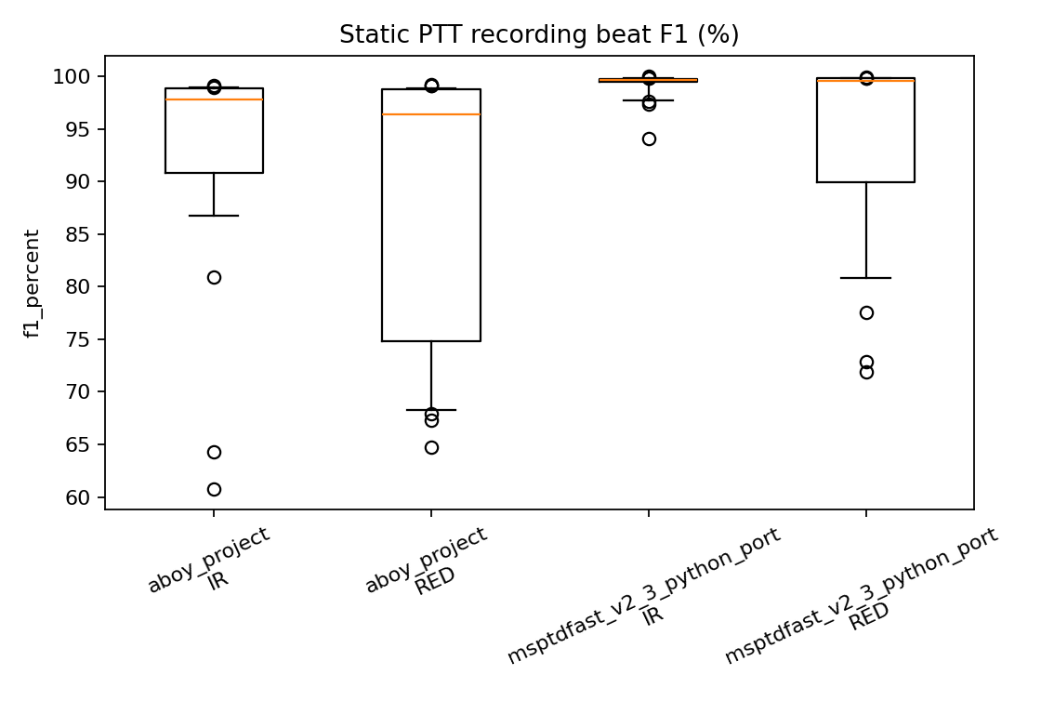
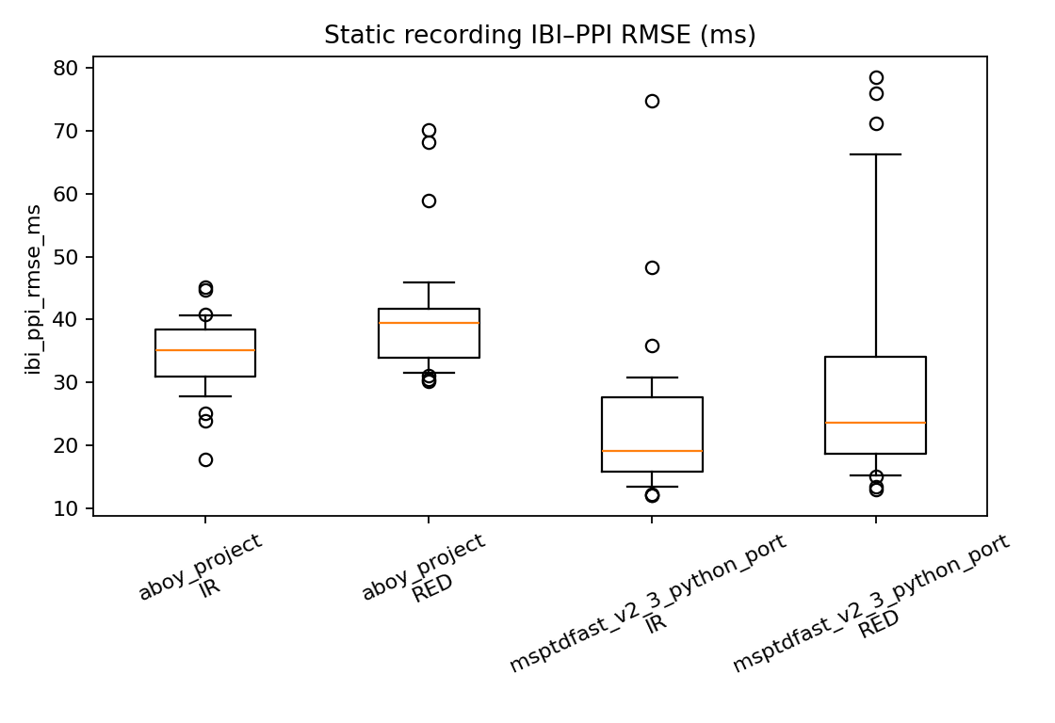
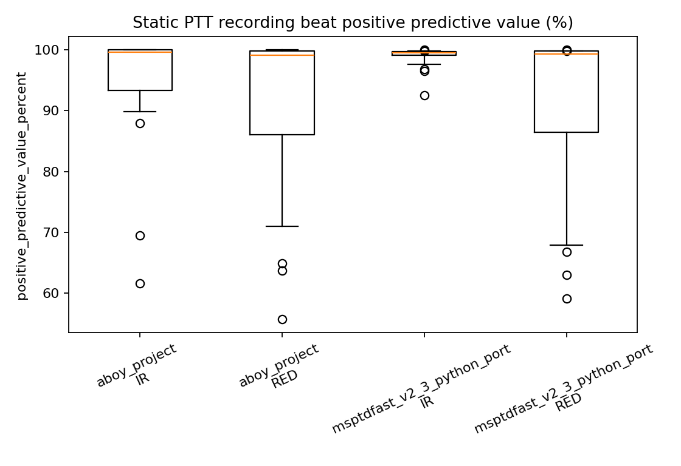
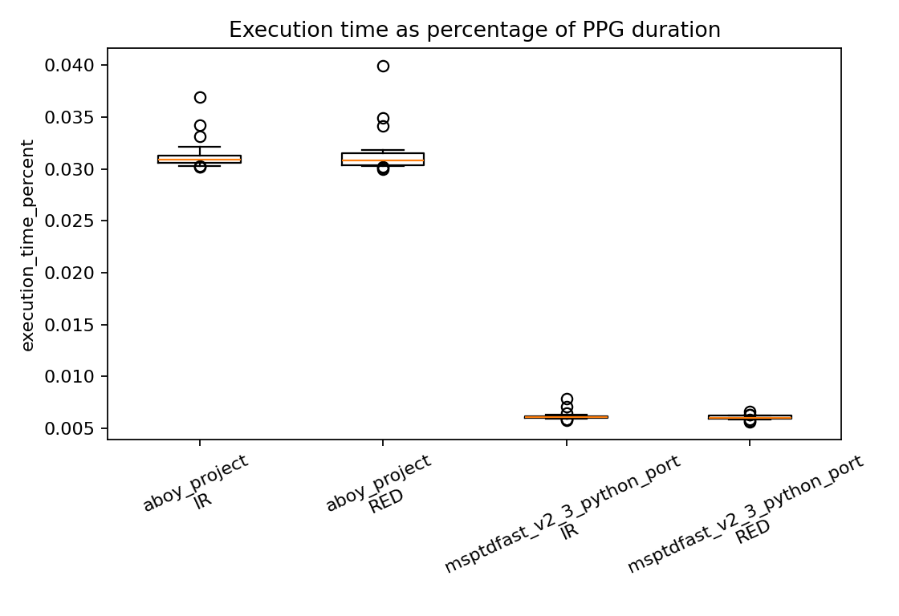
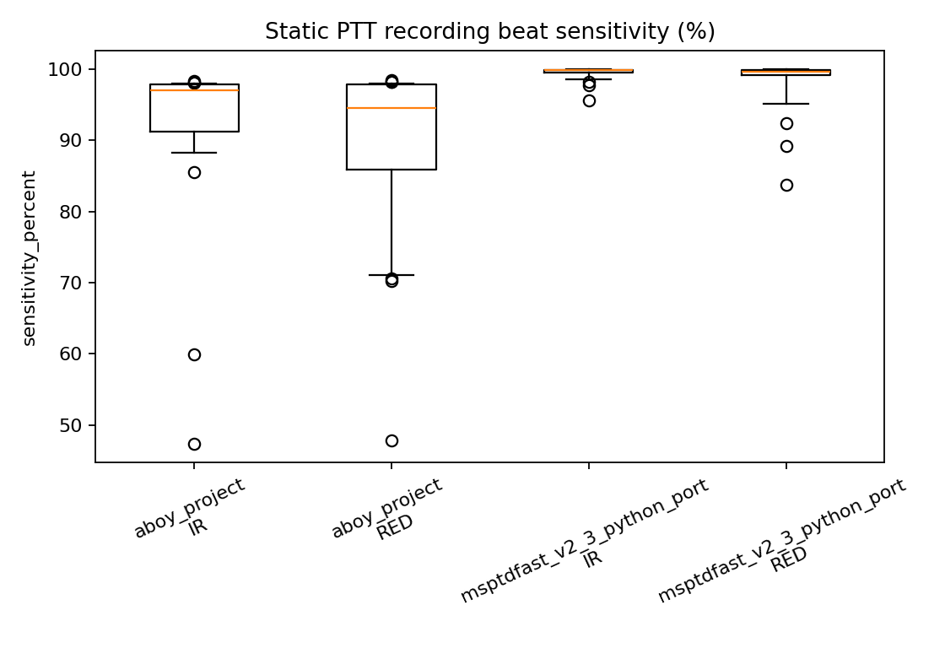

Appendix B: Motion Detector Evaluation
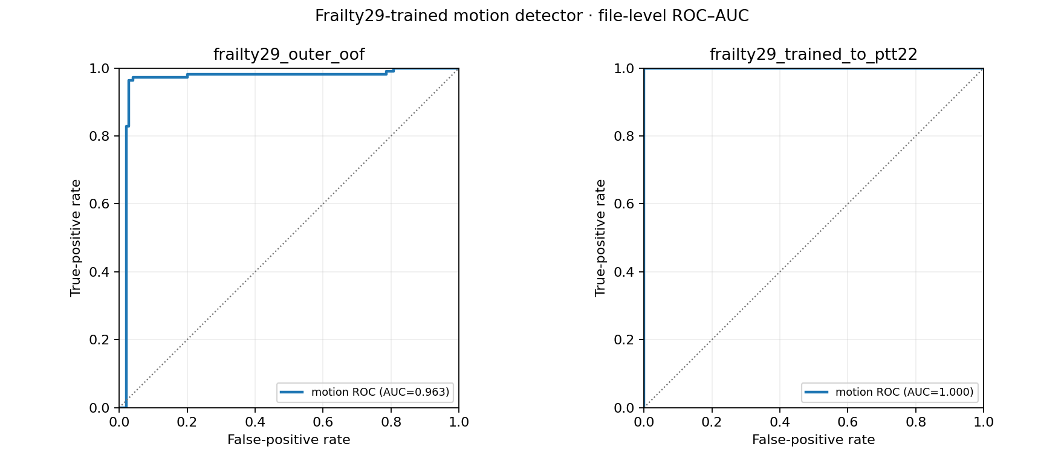
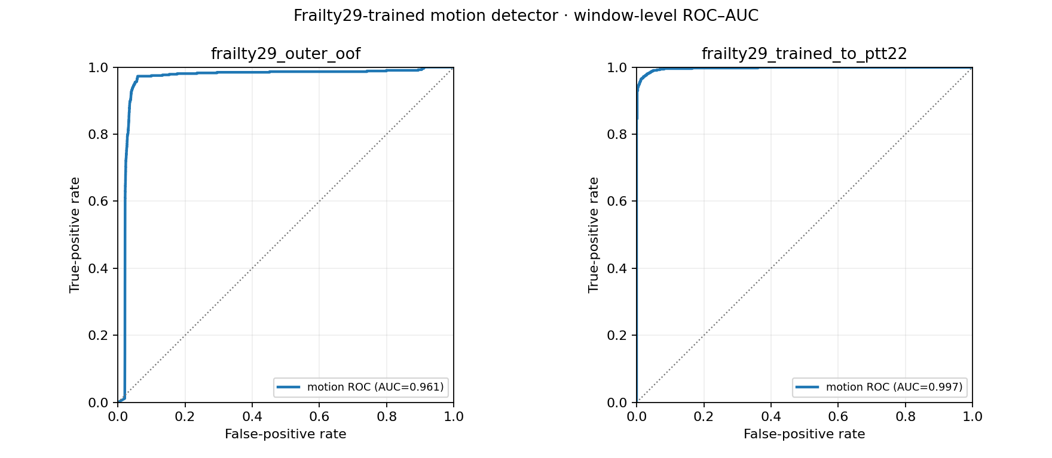
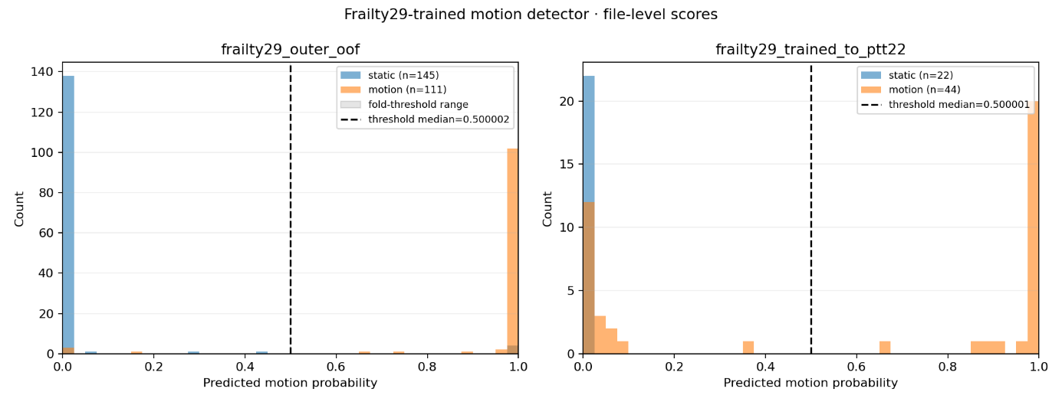
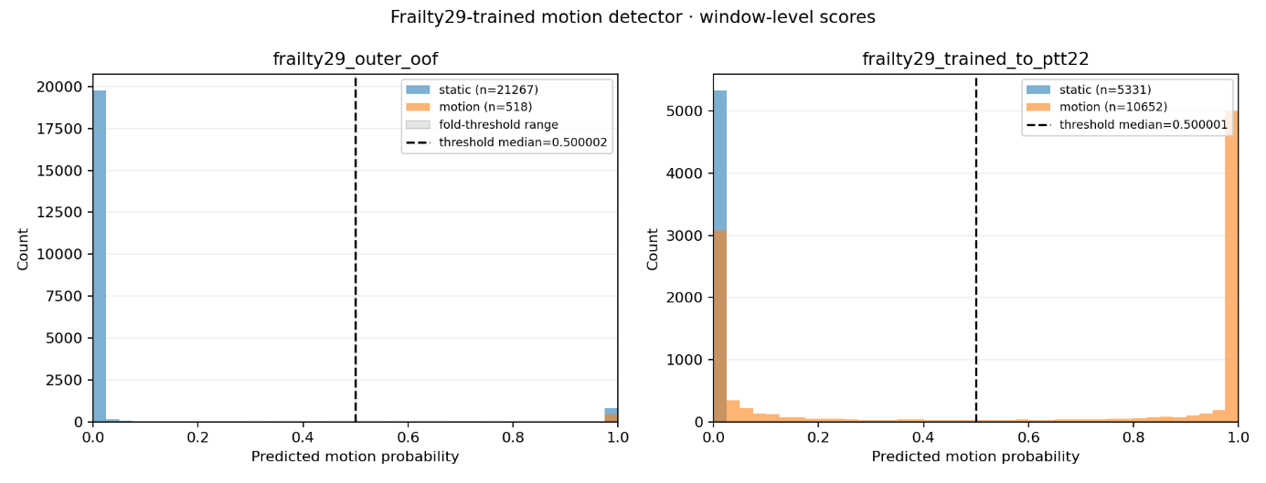
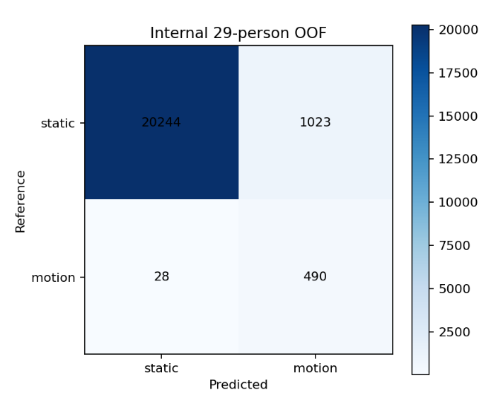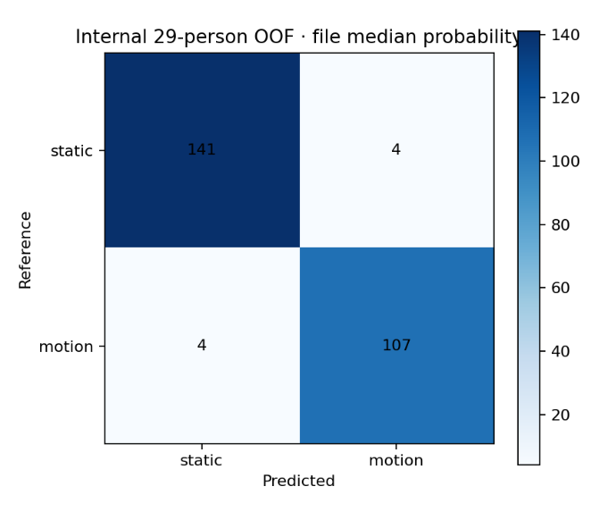
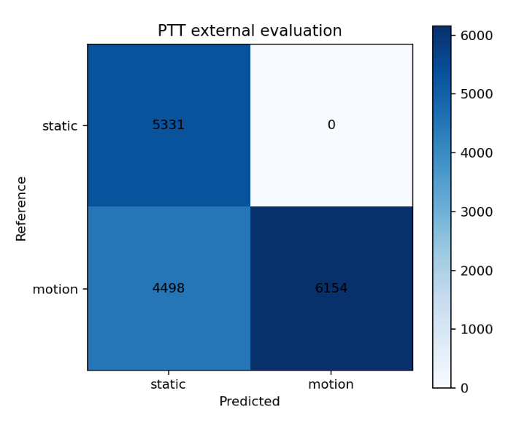

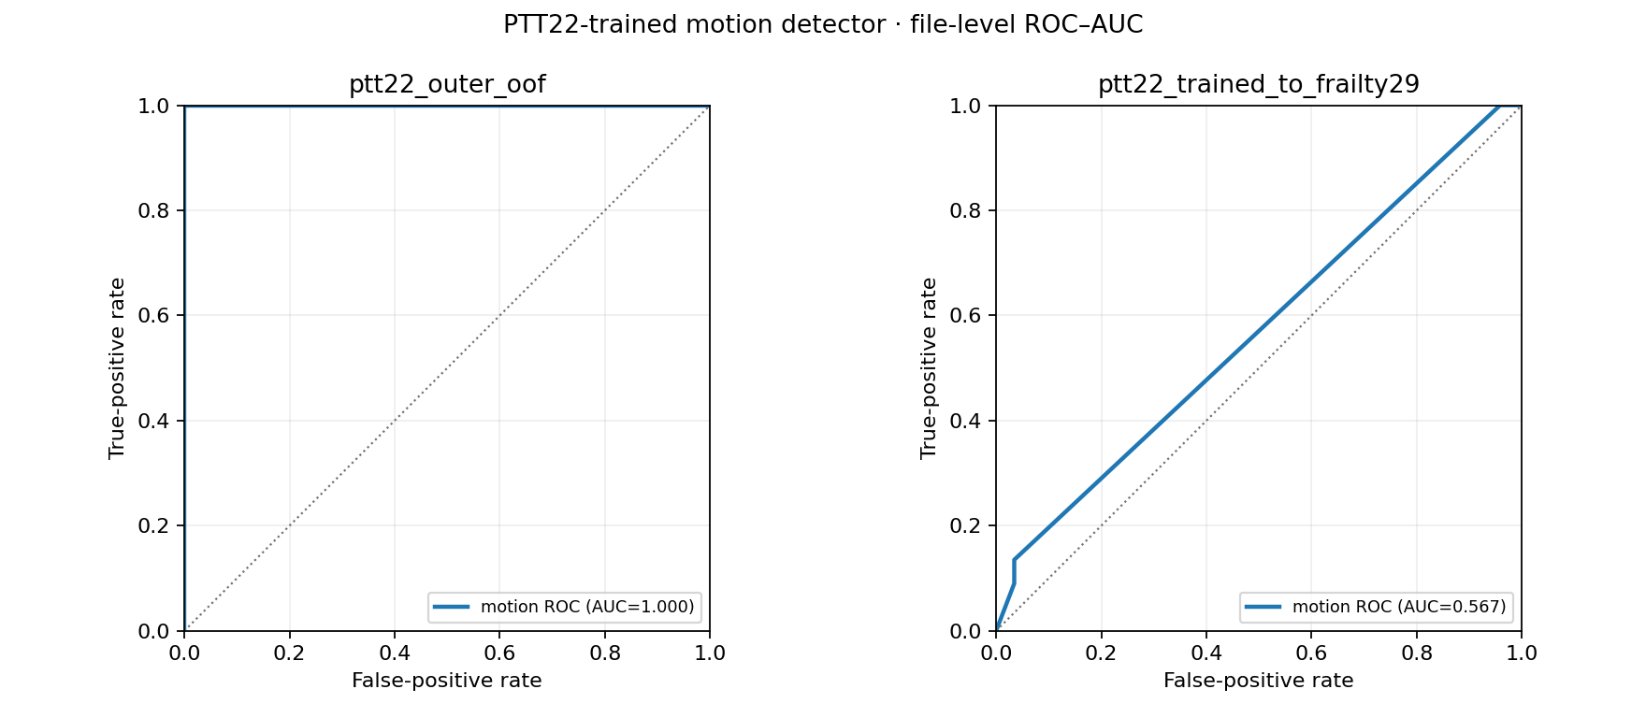
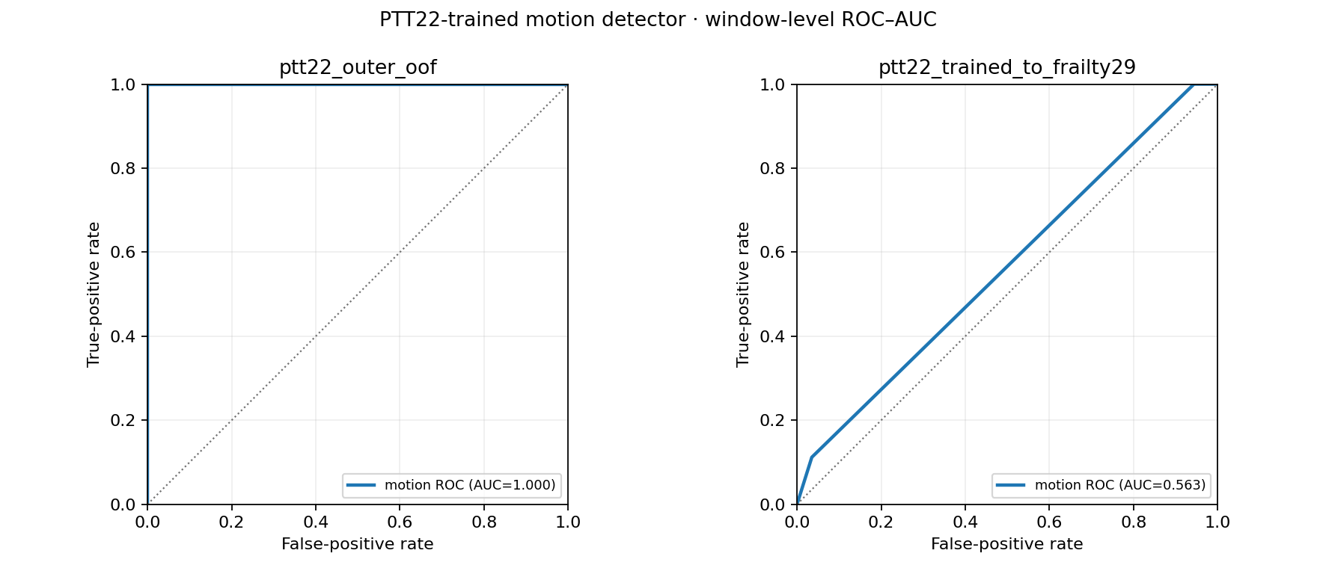
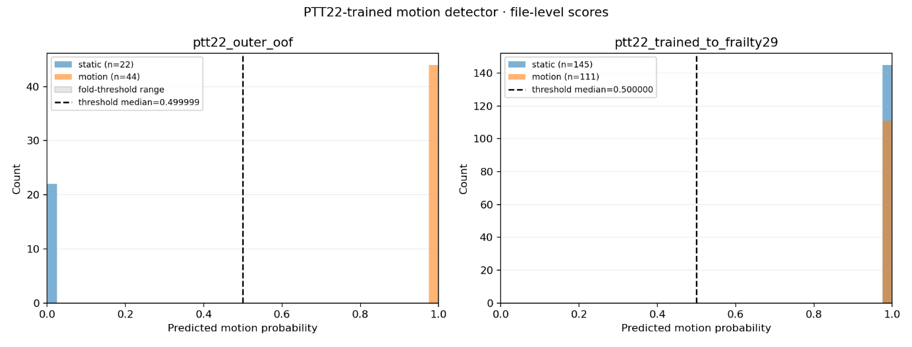
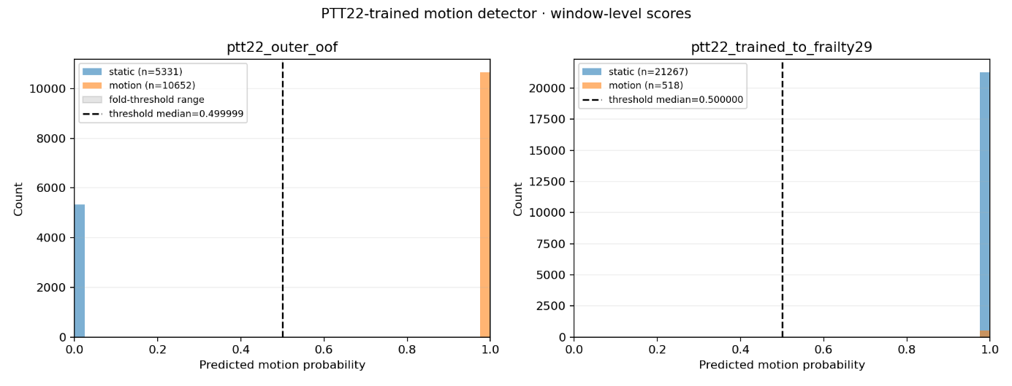
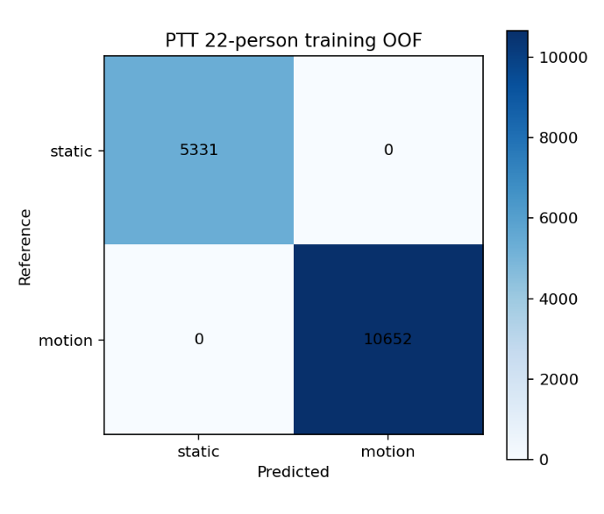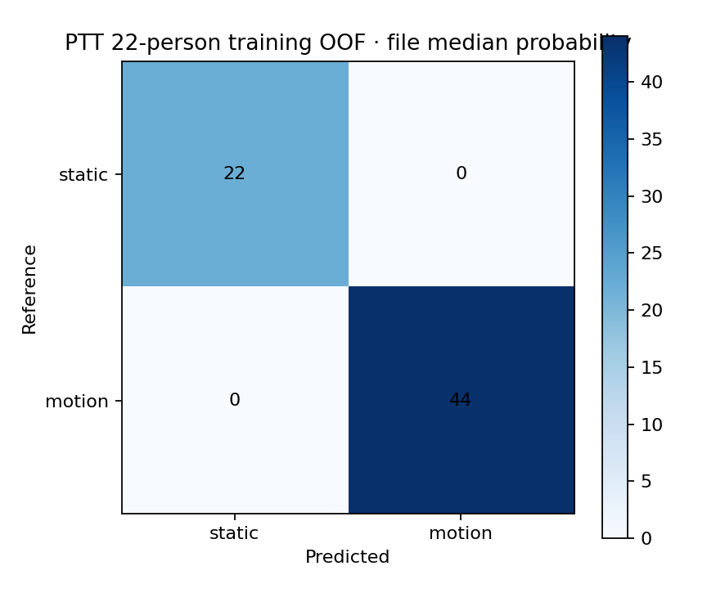

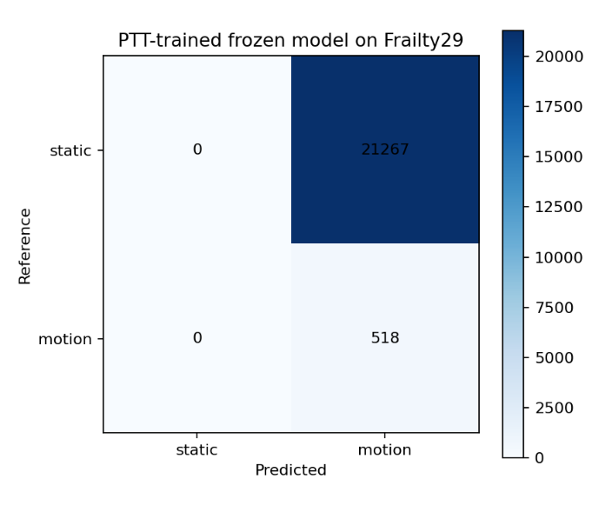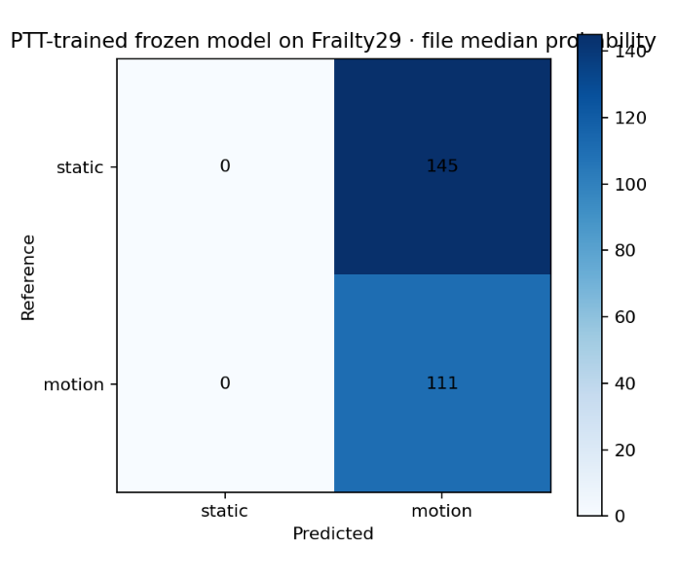

Appendix C: Motion artifact Denoiser Evaluation

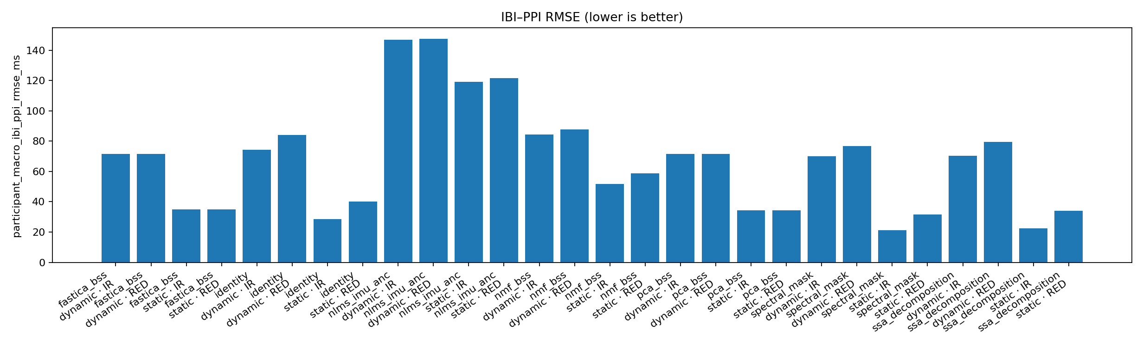

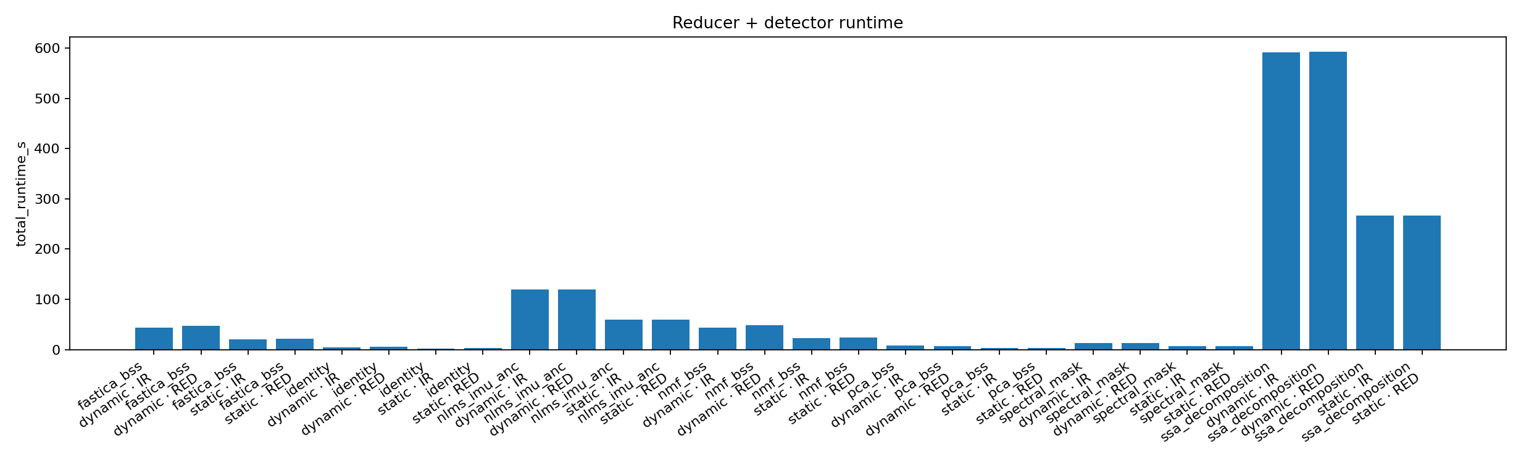
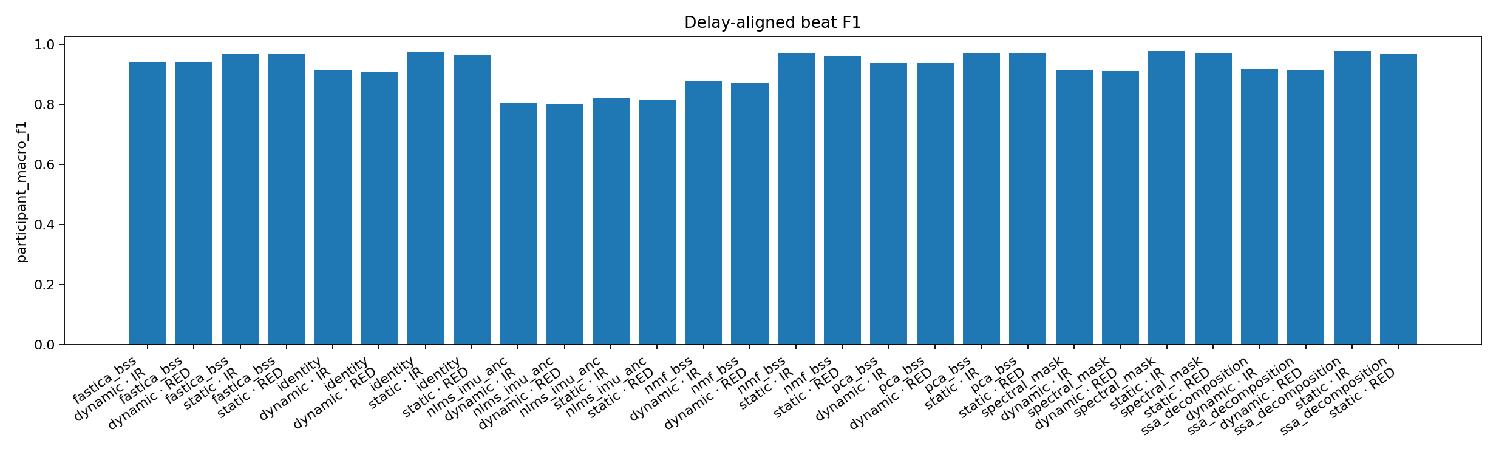
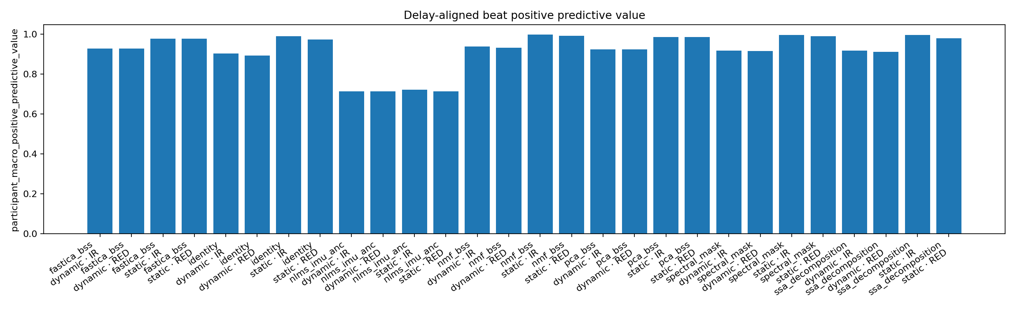

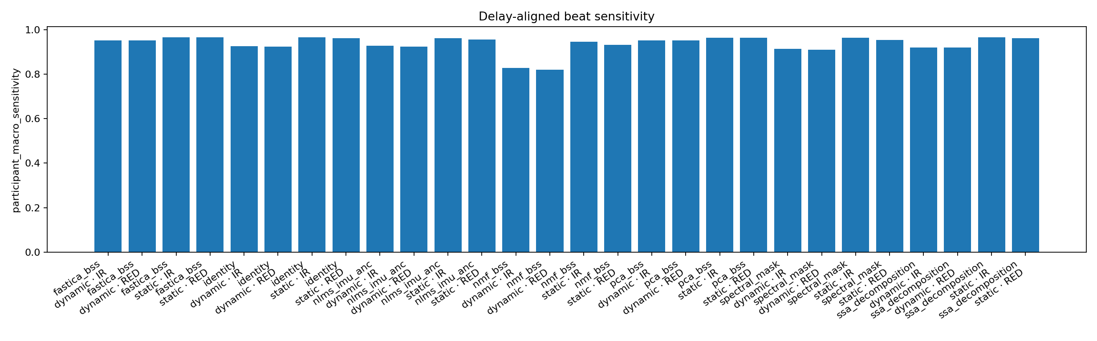

Appendix D: Grid search results

A: Batch Size + Learning Rate:
case_id | balanced_accuracy_mean_sd_percent | macro_f1_percent_mean_sd
b16_lr3e-4 | 59.5 ± 6.2 | 59.4 ± 6.3
b32_lr1e-3 | 56.1 ± 6.4 | 55.4 ± 8.1
b16_lr1e-3 | 55.2 ± 5.1 | 55.4 ± 6.3
b16_lr1e-4 | 54.9 ± 4.1 | 54.6 ± 4.5
b32_lr3e-4 | 54.3 ± 3.0 | 53.4 ± 3.6
b32_lr1e-4 | 51.9 ± 7.2 | 51.3 ± 6.8

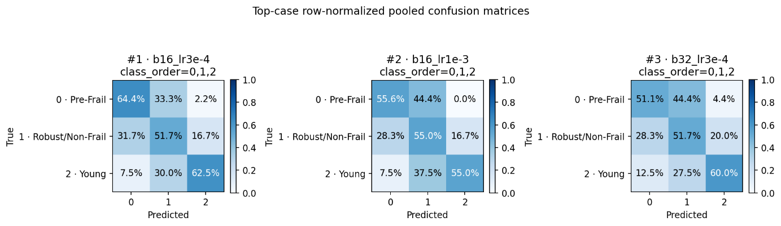
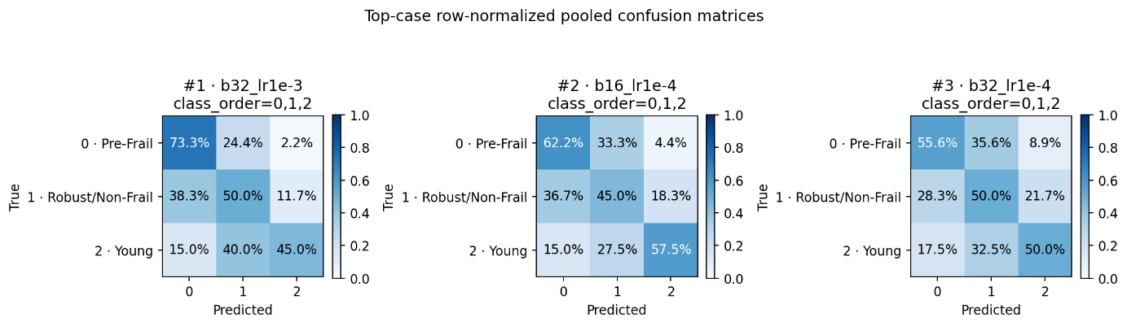

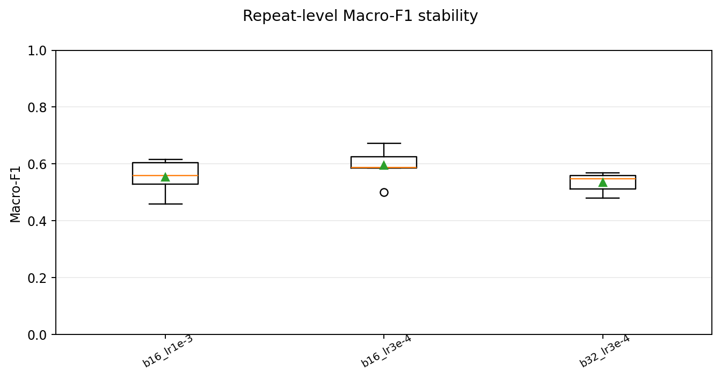

B: Regularization
case_id | balanced_accuracy_mean_sd_percent | macro_f1_percent_mean_sd
r9_wd01_do07_ls01 | 58.9 ± 4.0 | 59.4 ± 4.6
r2_wd001_do05_ls02 | 58.1 ± 3.3 | 57.5 ± 4.1
r6_wd005_do07_ls03 | 58.1 ± 2.6 | 58.0 ± 2.1
r7_wd01_do03_ls03 | 57.8 ± 1.5 | 56.4 ± 3.5
r8_wd01_do05_ls02 | 56.8 ± 3.0 | 56.3 ± 3.3
r4_wd005_do03_ls02 | 56.4 ± 4.1 | 55.8 ± 3.1
r5_wd005_do05_ls02 | 56.3 ± 2.5 | 55.4 ± 3.0
r1_wd001_do03_ls01 | 55.6 ± 4.7 | 55.6 ± 5.4
r3_wd001_do07_ls03 | 55.0 ± 6.4 | 54.8 ± 6.4

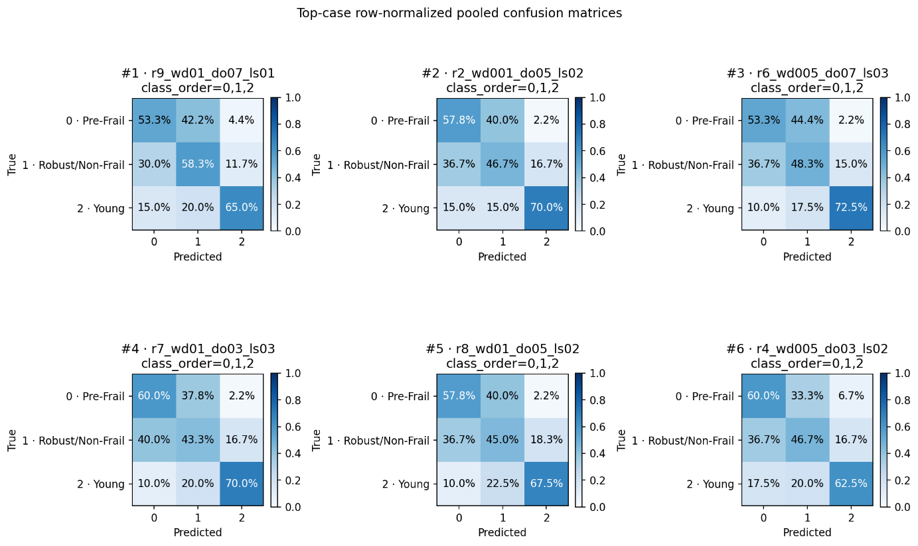
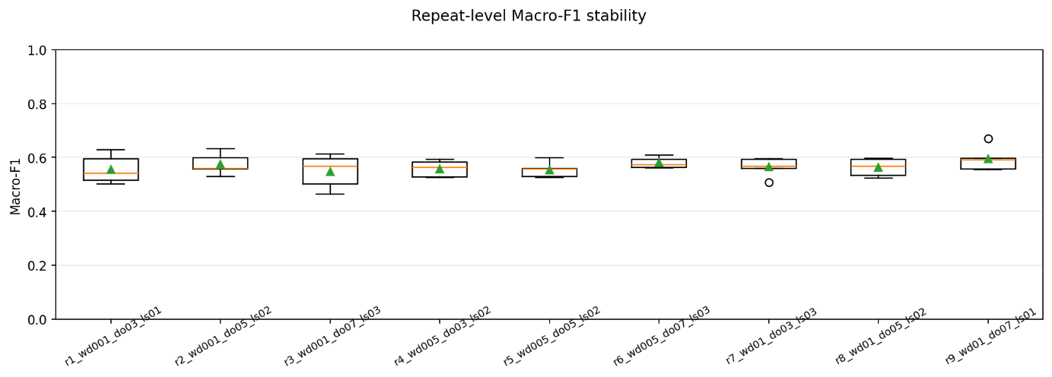
C: Others
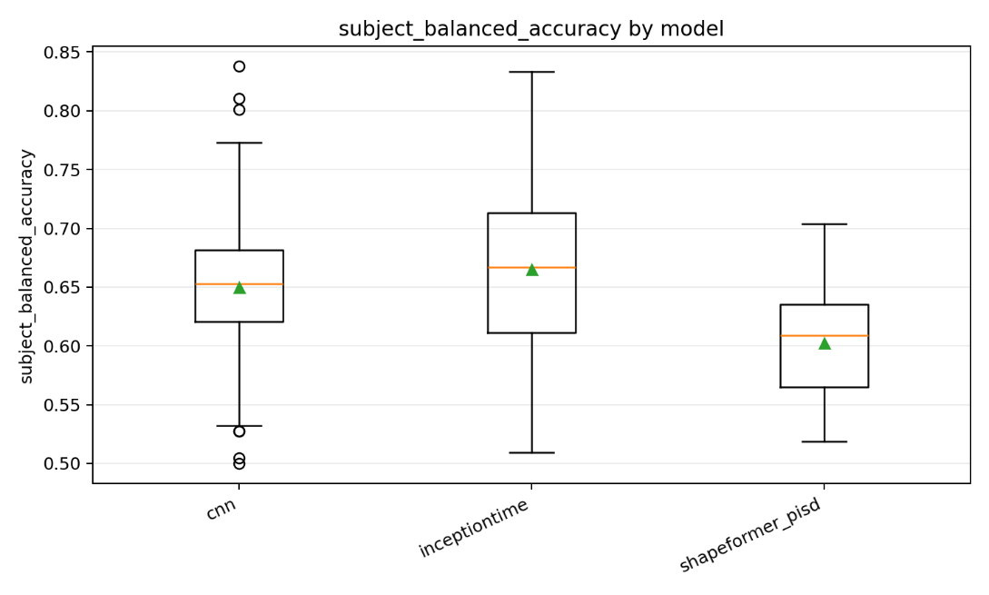
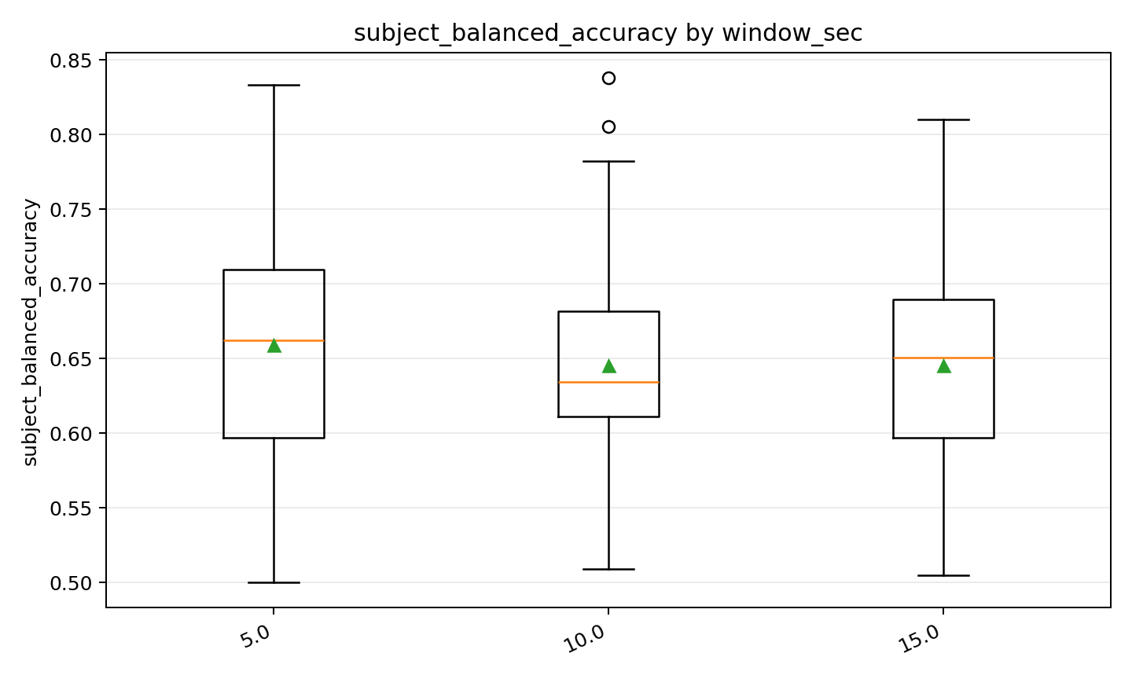

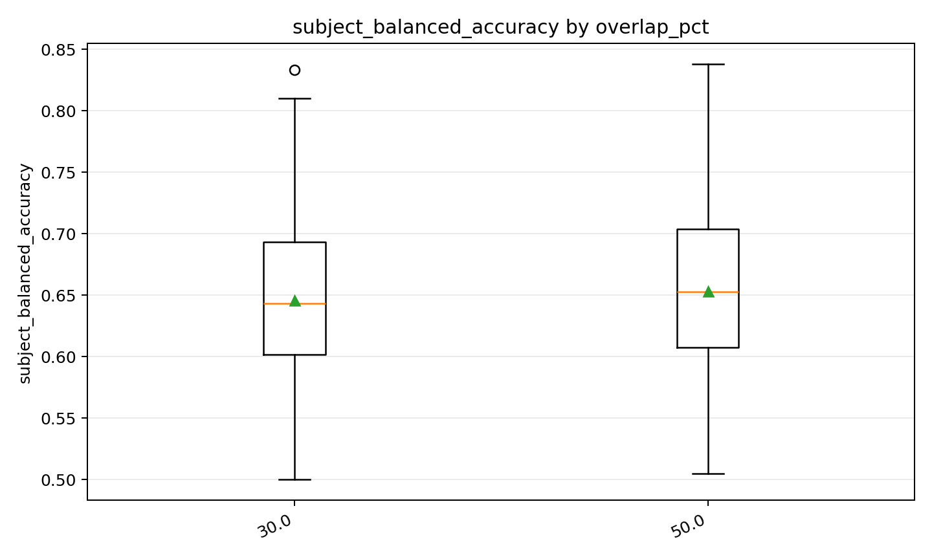

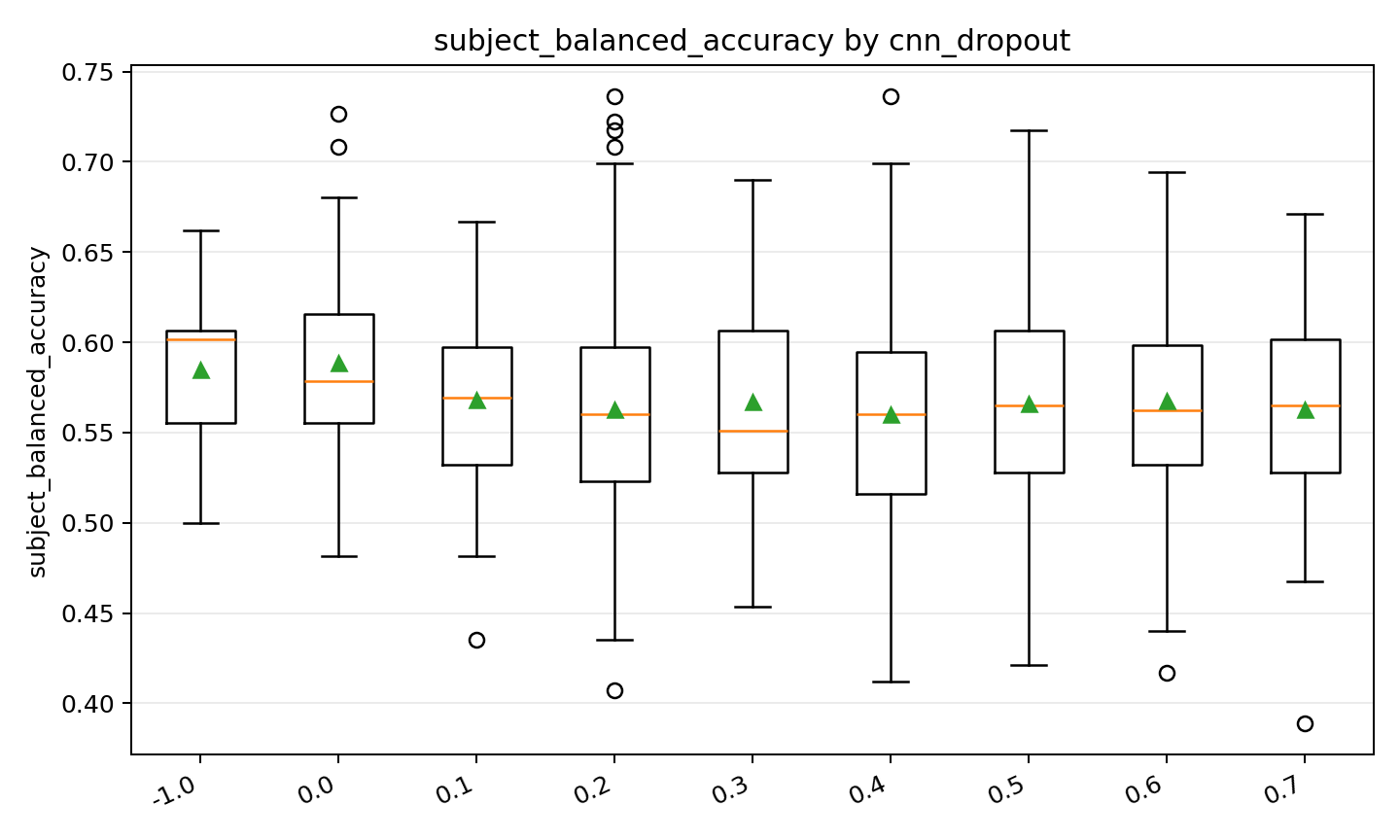

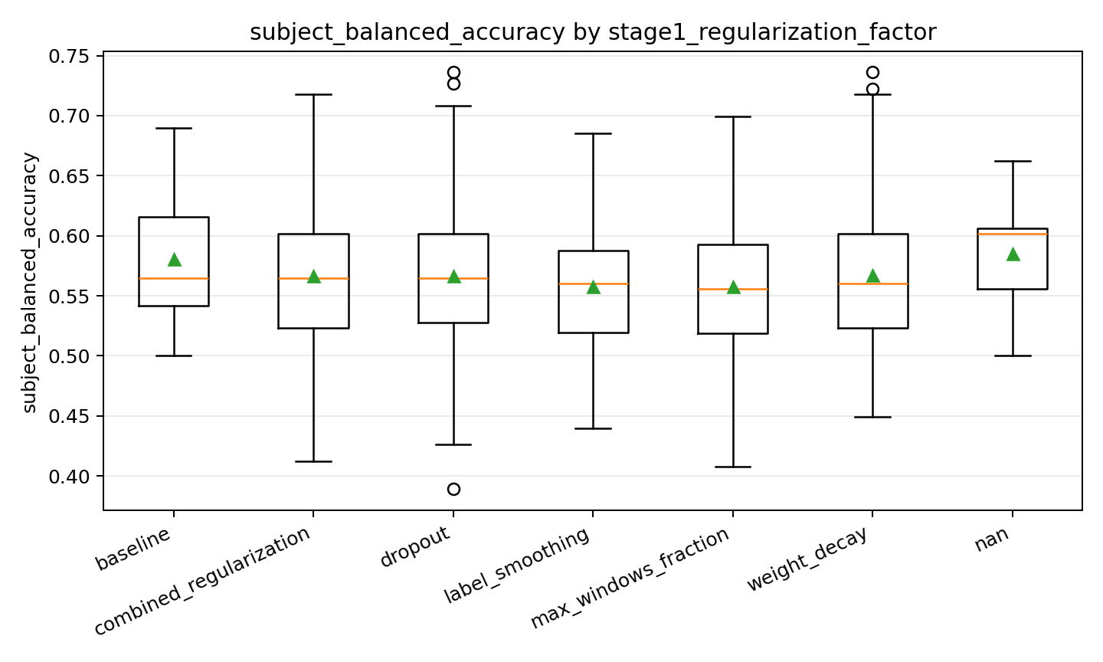
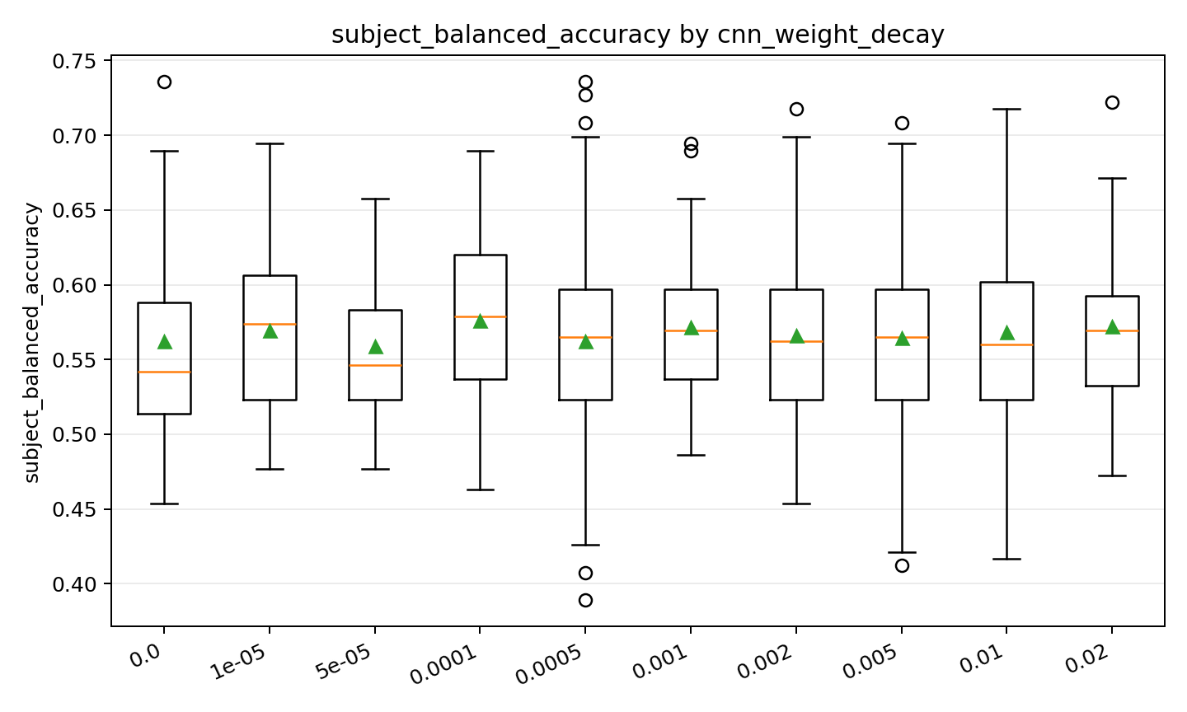

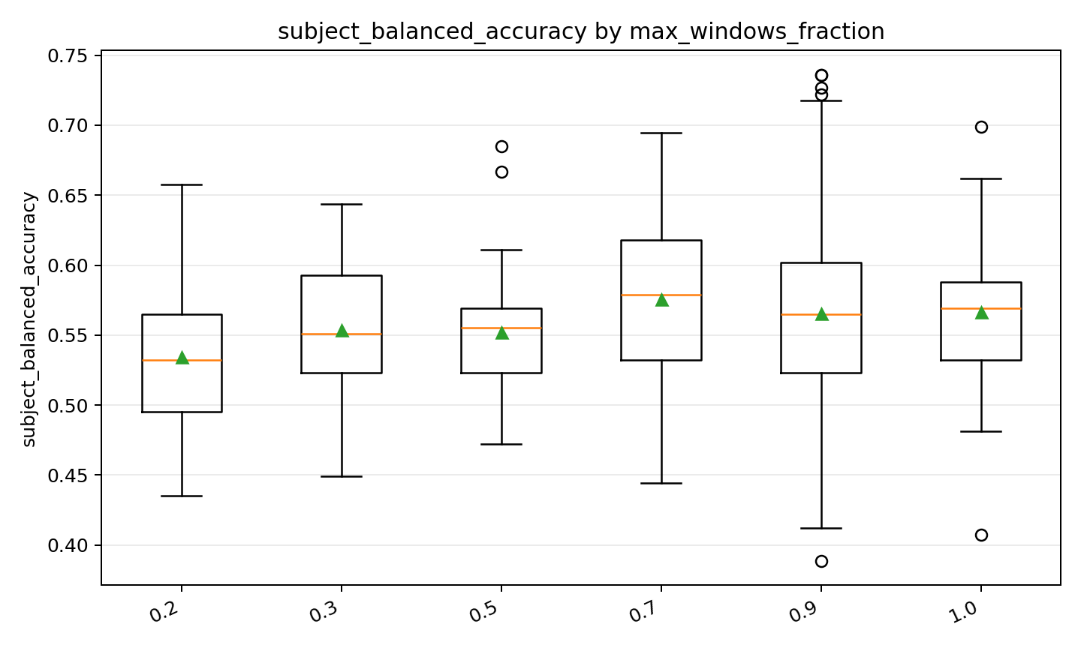
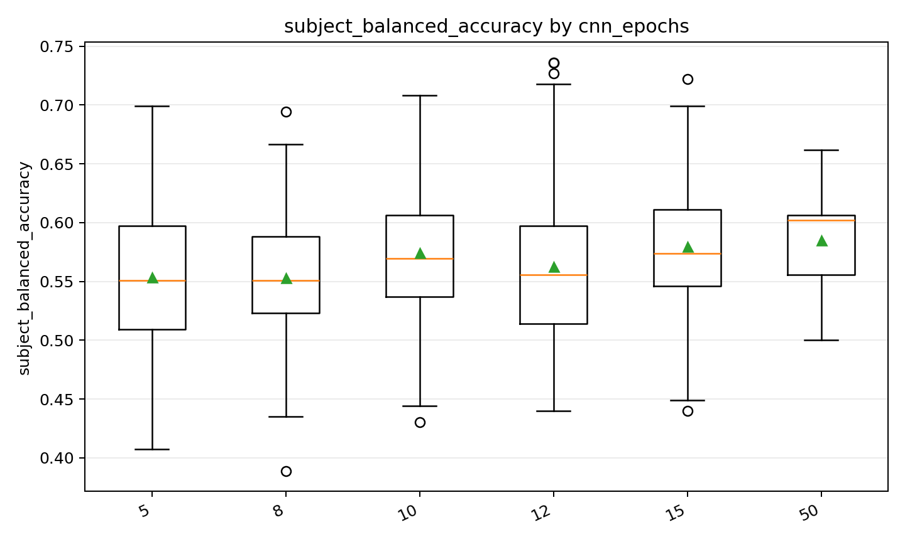

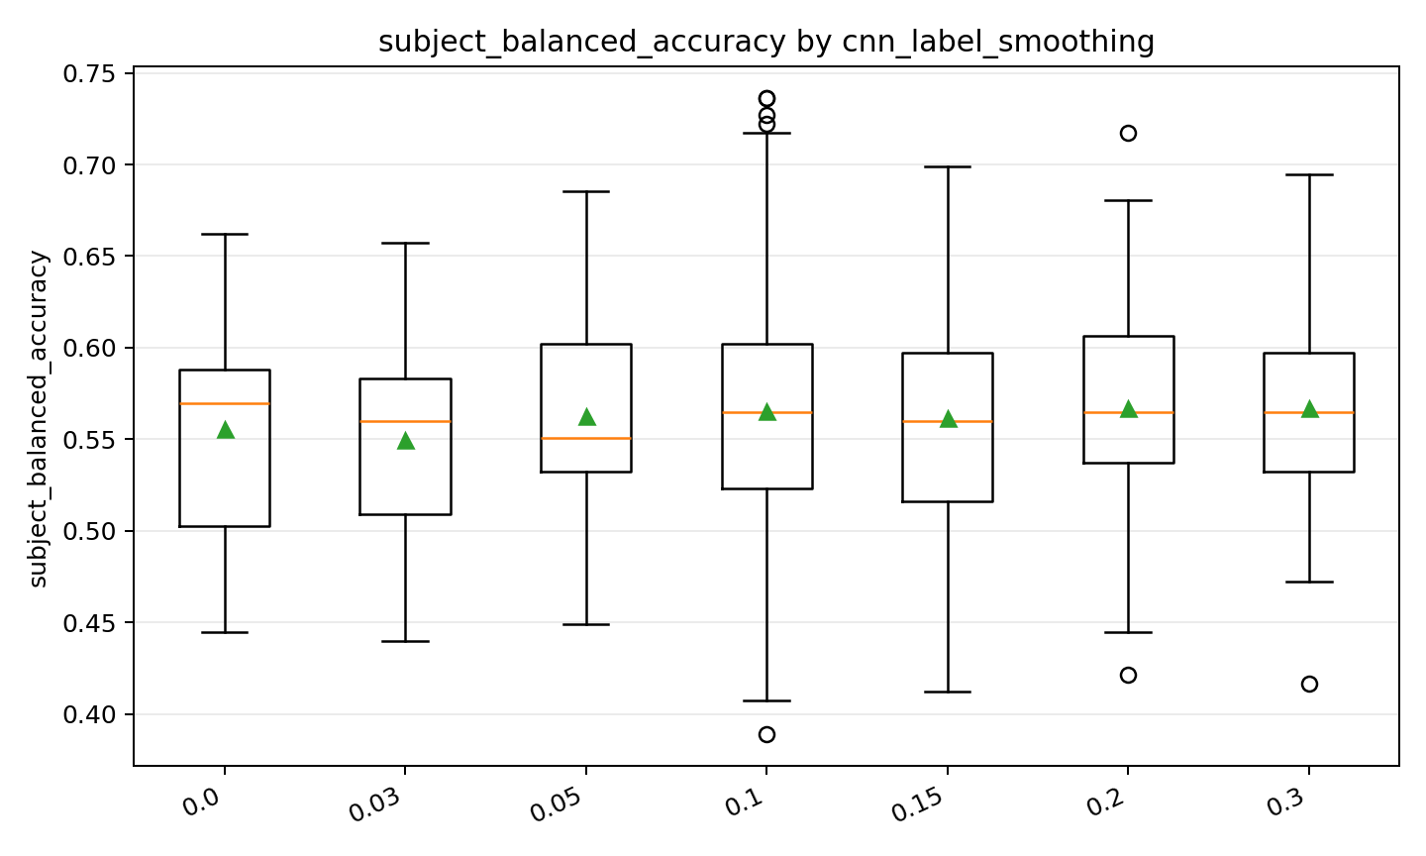

Appendix E: Configurations of Final Top 5 Cases
Table 35 Public shared Configuration in Top5 models
Setting | Value shared by all five models
Data | 261 records; 29 participants; three classes: Pre-Frail / Robust / Young
Split | participant-grouped 5×5; seeds 42, 10042, 20042, 30042, 40042
Representation | raw; 8 channels: RED, IR, A_dyn_x/y/z, GX/GY/GZ
Sampling rate | canonical processing 400 Hz; DL polyphase resampling 64 Hz
Raw DL window | 5 s, hop 2.5 s; complete windows only; no padding; valid fraction 1.0
PPG filtering | third-order Butterworth SOS; 0.2–8 Hz; zero phase; notch off
Gap repair | inside-only linear interpolation; maximum 100 samples; no edge extrapolation
Peak detector | MSPTDfast v2.3 Python port; min 8 s; min 5 peaks; 20 Hz detector grid; 6 s detector window; overlap 0.2
DL scaling | per-window robust scaling over all eight channels; median / (IQR / 1.349), SD fallback, clip [-8, 8]; no additional fold-level IMU transform
IMU calibration | ACC low-pass 20 Hz, gyroscope low-pass 40 Hz, third-order
SQI / motion / denoiser | all disabled
Shared model architecture | single network; ensemble 1; 4 branches; kernels [39, 19, 9]; pool 3; residual interval 3; mask-aware GAP; dropout 0.50
Optimizer | AdamW; betas [0.9, 0.999]; eps 1e-8; AMSGrad off
Sampling / loss | exhaustive shuffle without replacement; inverse-frequency class weights; cross entropy; deterministic algorithms
Aggregation | Line B: window to file to role to participant; ordinary mean at each level; missing roles use the available-role mean
Evaluation | participant-level BA primary; macro-F1, per-class, worst-class, confusion, coverage; participant-cluster bootstrap 10,000
Output | window-, file- and participant-level OOF predictions saved as parquet
