When Does Evidence Expansion Help? A Cross-Domain Study of Retrieval Paths and Lightweight Routing for Regulatory Evidence
Kaifeng Sun
China Jiliang University, China
Sole author and corresponding author
Editable pre-submission manuscript

Abstract
Regulatory question answering often fails because the decisive evidence is not contained in the retrieved leaf passage but in its heading, parent clause, table, or cited provision. We study whether common evidence-expansion stages improve retrieval before generation under a risk-sensitive criterion that requires complete supporting evidence and rejects materially misleading additions. In a prespecified pilot of 120 questions drawn from Chinese chemical-safety standards and English pharmaceutical-regulatory documents, we compare six retrieval paths built on a shared BM25 first stage, including reranking, structural-context expansion, relation expansion, and their combinations. Human annotators labeled 10,385 evidence occurrences for completeness and harmfulness. Structural context provided the clearest benefit: adding heading, parent, and table context improved combined success by 15.83 percentage points over BM25, whereas reranking and one-hop relation expansion yielded limited independent rescue. The most complete path did not outperform the cheaper context-only path because additional evidence often introduced harmful material. Lightweight learned routers outperformed a prespecified heuristic in grouped out-of-fold evaluation, but calibration-based abstention failed to achieve usable risk and coverage. These results support selective use of structural context and separate evaluation of completeness and harm, while indicating that reliable evidence-sufficiency abstention requires substantially more calibration data.
Keywords: regulatory retrieval; risk-sensitive evaluation; structural context expansion; selective routing; evidence sufficiency; retrieval-augmented generation

1. Introduction
Regulatory questions often require more than a topically related passage. A valid answer may depend on a heading that fixes the applicable scope, a parent clause that identifies the responsible party, a table that supplies a numeric threshold, or a cited provision that defines a term. Retrieval-augmented systems provide external evidence and provenance for knowledge-intensive tasks [2], but a fixed retrieval strategy cannot assume that every question needs the same amount or type of expansion.
Modern pipelines commonly combine a lexical first stage with dense retrieval or neural reranking [3-5]. Adaptive retrieval methods instead decide when to retrieve or which reasoning strategy to use [6-8]. Hierarchical methods also recover context at several levels of a document [9]. These approaches motivate more flexible regulatory retrieval, but they do not remove a basic risk: additional evidence can be irrelevant, conflicting, or deceptively close to the correct rule. Prior work has shown that excessive or counterfactual context can reduce downstream accuracy [10,11]. In a regulatory setting, a passage about the wrong standard version, product, jurisdiction, threshold, or exception can do more harm than ordinary topical noise.
This study asks when evidence expansion helps before generation. We separate three outcomes: evidence completeness, harmful expansion, and combined path success. A path succeeds only when it contains all required evidence (or a single sufficient unit) and contains no evidence judged materially misleading. This strict definition reflects a risk-averse retrieval setting. It also exposes why reporting recall alone can overstate practical utility.
We constructed a frozen two-domain Pilot with 120 questions and ran six predefined paths for every question. The paths isolate reranking, structural context, and one-hop relation traversal while keeping BM25 as a common first stage. We then evaluated two lightweight routers using only information available after BM25 and a bounded metadata lookup. Document-grouped out-of-fold evaluation, separate calibration folds, paired question-level bootstrap intervals, and an explicit Go/No-Go rule limited post hoc interpretation.
The study makes four contributions. First, it provides a risk-sensitive evaluation of 720 regulatory question-path outputs with evidence-unit labels, duplicate annotation, and adjudication. Second, it compares six paths while separating completeness, harmful expansion, combined success, and execution cost. Third, matched comparisons show that parent, heading, and table context account for most independent rescue in this Pilot. Fourth, leakage-safe evaluation shows that simple learned routing can outperform a frozen cue-based heuristic, but calibrated abstention does not reach usable risk and coverage. The last result caused the prespecified expansion decision to fail; we report it as a boundary of the approach rather than tune it away.
Figure 1. Prespecified study workflow from question construction to diagnostic evaluation.
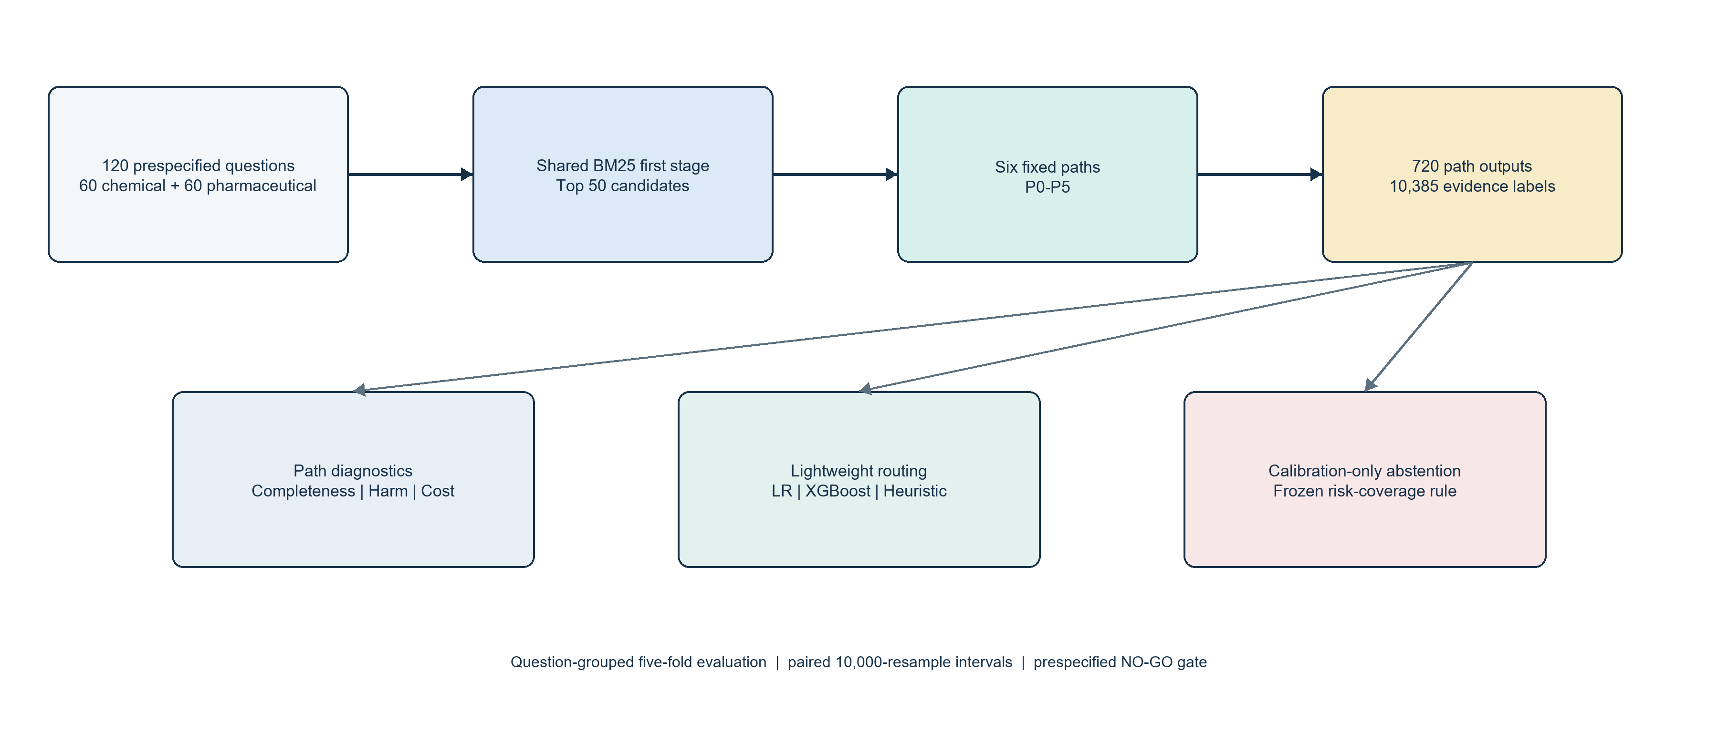

2. Related Work

2.1 Sparse retrieval and neural reranking
BM25 remains a strong and interpretable lexical baseline derived from the probabilistic relevance framework [1]. Dense Passage Retrieval demonstrated that learned dual encoders can outperform lexical retrieval on several open-domain question-answering benchmarks [3]. The BEIR benchmark later found that BM25 remained robust across heterogeneous zero-shot tasks, while reranking and late-interaction methods improved average effectiveness at higher computational cost [5]. Sequence-to-sequence rerankers provide another strong second stage over a bounded candidate set [4]. Our design follows this multi-stage pattern but fixes BM25 as the first stage so that later path differences remain attributable.

2.2 Adaptive and structured evidence retrieval
Active Retrieval Augmented Generation retrieves during long-form generation when predicted content appears uncertain [6]. Self-RAG learns retrieval and critique decisions through reflection tokens [7], and Adaptive-RAG selects among no-retrieval, single-step, and multi-step strategies using predicted question complexity [8]. RAPTOR organizes document evidence hierarchically to retrieve at different levels of abstraction [9]. Our task differs in two ways. It routes among fixed evidence-assembly paths before generation, and it uses lightweight tabular models rather than training a language-model controller. This narrower setting suits a small labeled Pilot and permits explicit path-stage comparisons.

2.3 Evidence quality, noise, and abstention
RAG evaluation frameworks distinguish context relevance from answer faithfulness and answer relevance [13,14]. We stop before answer generation and label the retrieved package directly. This avoids using one language model to judge another and allows annotators to identify evidence that changes the regulatory interpretation. Studies of detrimental and counterfactual contexts show why this distinction matters: more retrieved text can lower answering performance, and relevant-looking conflict can mislead a model [10,11]. Multilingual relevance assessment also shows that systems struggle to recognize when supplied passages do not support an answer [12].
Confidence calibration asks whether a predicted probability matches empirical correctness [15]. Selective prediction extends this problem by allowing a model to reject decisions and evaluating the resulting risk-coverage trade-off [16]. We use Brier score and expected calibration error for probability quality, then test a prespecified calibration-only threshold for abstention. The threshold is selected without access to the corresponding outer test fold.

2.4 Legal and regulatory language processing
Legal NLP benchmarks show strong domain effects and persistent generalization challenges [17,18]. COLIEE evaluates case-law and statute-law retrieval and entailment, and participating systems combine lexical retrieval, transformers, structural information, filtering, and thresholds [19]. Our corpora concern technical standards and pharmaceutical regulation rather than case law. The same retrieval problem remains: a system must locate an attributable provision under long, structured, and cross-referenced documents.

3. Study Design and Regulatory Corpora

3.1 Prespecified Pilot and research questions
The protocol, path definitions, model settings, evidence labels, grouped splits, calibration rule, and continuation thresholds were frozen before path labels were inspected. The original research question asked whether a calibrated router could select the least costly successful path and abstain when no path was likely to provide complete evidence. The final manuscript retains all frozen decisions but centers the diagnostic questions supported by the Pilot: how the paths differ, which stages rescue failures, whether simple routers improve path selection, and where calibration and transfer fail.
The Pilot contains 120 newly written questions. Sixty Chinese questions cover chemical-safety standards, and 60 English questions cover pharmaceutical regulatory documents. Chemical questions were evenly divided among direct clauses, parent or heading context, table-related evidence, citation dependency, and evidence insufficiency (12 per category). The pharmaceutical corpus contained no relation that resolved uniquely to an attributable target chunk under the frozen graph rule. Its questions therefore comprised 15 each for direct clauses, parent or heading context, tables, and evidence insufficiency. Construction categories controlled coverage during authoring but were never supplied to the routers.
Question authors inspected source evidence to express realistic information needs but did not inspect P0-P5 rankings before freezing a question and its evidence specification. A pre-freeze reviewer checked naturalness, specificity, source validity, category fit, and overlap with two pre-existing evaluation sets. All 120 questions were accepted after review. For evidence-insufficient questions, a reviewer documented a manual search of the frozen corpus; six failed paths alone could not establish corpus insufficiency.

3.2 Chemical-safety corpus
The chemical corpus was a read-only Neo4j snapshot containing 9,206 standards, 991,453 sections, 68,422 tables, 743,055 hierarchy edges, and 33,818 logical relation edges. The retrieval index used a CJK analyzer over section title, summary, and content. A reproducible title screen produced 532 candidate standards for human scope review; the final allowlist retained 399 standards as question sources and excluded 133. Retrieved distractors could still come from the wider frozen corpus. Globally unique section identifiers supported evidence provenance, while standard identifiers defined grouping for evaluation.

3.3 Pharmaceutical-regulatory corpus
The pharmaceutical snapshot contained 2,478 unique chunks drawn from 99 enriched files. Each record supplied a stable chunk identifier, document identifier, heading, content, and parent context. A frozen graph snapshot contained 7,578 nodes and 15,237 edges, including explicit document-level references. None of these references resolved deterministically to one target text chunk under the conservative protocol, so graph expansion returned no eligible target in this domain. The study reports this structural absence rather than introducing a heuristic target mapping after inspection.
Table 1. Characteristics of the two regulatory retrieval domains.
Characteristic | Chemical-safety domain | Pharmaceutical-regulatory domain
Language | Chinese | English
Frozen source corpus | 9,206 standards and 991,453 sections | 99 enriched files and 2,478 unique chunks
First-stage retrieval | CJK BM25 index over section title, summary, and content | BM25 over stable document chunks
Structural context | Heading hierarchy, immediate parent, and tables | Heading, parent context, and tables
Eligible graph expansion | One-hop CITES or DEPENDS_ON targets when uniquely attributable | No reference resolved uniquely to an attributable target chunk
Pilot questions | 60 across five construction categories | 60 across four construction categories

3.4 Annotation
Every ranked item and context sidecar received one label: REQUIRED, SUFFICIENT, CONTEXT, IRRELEVANT, or HARMFUL. REQUIRED items collectively formed a complete evidence specification; one SUFFICIENT item could satisfy a single-item specification. CONTEXT clarified correct evidence without being independently sufficient. IRRELEVANT covered background noise, duplication, or weak topical overlap. HARMFUL identified evidence that could materially change the regulatory interpretation, including the wrong standard version, regulatory object, jurisdiction, responsibility, condition, threshold, or exception, or evidence that directly conflicted with the correct rule.
Evidence completeness ignored harmful status and recorded whether the evidence specification was met. Harmful expansion recorded whether any evaluated ranked item or eligible sidecar was HARMFUL. Combined path success required complete evidence and no harmful item. This is a deliberately strict, risk-averse endpoint. Reporting all three outcomes shows whether a path failed because it missed evidence or because it added misleading material.
Figure 2. Risk-sensitive definition of combined path success.
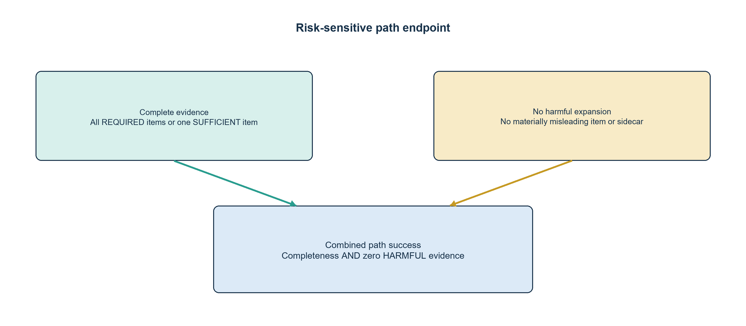
Primary annotation was blinded to path method names. The final freeze covered 10,385 evidence-label occurrences across 720 path outputs. A seeded, category-stratified sample of 30 complete questions received independent duplicate annotation across all six outputs and every associated evidence unit. Across 901 visible duplicate rows, exact agreement was 71.48% (95% question-cluster bootstrap interval, 66.11% to 76.85%), and Cohen's kappa was 0.556 (95% interval, 0.470 to 0.637) [21]. The adjudication queue contained 279 disagreements or harmful-reason differences, corresponding to 837 final path-level occurrences. Both original labels and the adjudication record were preserved.

4. Evidence Paths and Lightweight Routing

4.1 Six frozen paths
BM25 ran once to depth 50, and ranked evaluation was truncated at 10. P0 returned BM25 top 10. P1 reranked the BM25 top 50 with Qwen3-Reranker-0.6B and returned the top 10. P2 added structural context to the first five BM25 seeds. P3 expanded one outgoing CITES or DEPENDS_ON relation from the first five BM25 seeds. P4 combined reranking and context. P5 combined reranking, context, and relation expansion.
Context sidecars were ordered as heading path, immediate parent, and table, with at most three sidecars per seed. Sidecars retained separate identifiers and did not consume ranked positions. Relation expansion preserved the five seeds, inserted at most five unique targets, followed one outgoing normalized relation at confidence at least 0.85, and used deterministic tie-breaking. This bounded construction prevents a general graph walk from entering the study.
The reranker used normalized yes-versus-no relevance probability, a maximum length of 1,024 tokens, bfloat16 inference, and deterministic ordering by reranker score, BM25 rank, and source identifier. The model snapshot was identified by a frozen file-manifest hash. No reranker training or hyperparameter search was performed.

4.2 Fixed policies and Oracle
We compared BM25-only (P0), all modules (P5), a frozen heuristic, two learned routers, and a diagnostic Oracle. The heuristic selected P2 for table or context cues, P3 for citation cues, P5 when both cue types appeared, P1 when the BM25 ambiguity gap was below 0.15, and P0 otherwise. The Oracle selected the lowest-cost successful path for each routable question. When no path succeeded, it abstained and received zero combined success. Such questions remained in all-question quality results but were excluded from routable-only Oracle cost comparisons.
Cost was a lexicographic tuple of neural calls, graph targets, context items, median runtime, and path identifier. This definition makes the Oracle a diagnostic upper bound over the evaluated paths, not a deployable system.

4.3 Router features and models
Each question-path pair formed one supervised record. The label was combined path success. Features were available immediately after BM25 plus a bounded metadata-only lookup: domain, normalized query length, top BM25 score, score gaps from rank 1 to ranks 2 and 5, entropy of the top-10 BM25 scores, table and citation cue indicators, eligible outgoing-edge count, maximum stored edge confidence, path identifier, and frozen path-cost attributes. Router features excluded construction category, evidence labels, reranker outputs, fetched graph targets, retrieved text overlap, and any post-execution measurement.
The learned models were L2 Logistic Regression with C = 1 and XGBoost with 100 depth-3 trees, learning rate 0.05, subsample 0.8, column subsample 0.8, and L2 regularization 1 [20]. We conducted no model or hyperparameter search.

4.4 Splits, calibration, and abstention
Questions sharing a source document, standard, clause family, table, or relation family shared one group identifier. A stable seeded hash assigned groups to five folds. For outer fold i, fold i was the test set, fold (i + 1) mod 5 was the calibration set, and the remaining three folds trained the model. The feature vectorizer and scaler were fit on training records only.
Logistic Regression used its native probabilities. XGBoost probabilities received Platt calibration on the calibration fold. The abstention threshold was the smallest distinct calibrated probability on that fold for which at least 10 question decisions were accepted and empirical accepted failure was at most 10%. If no threshold qualified, the fold forced full abstention. The threshold then remained unchanged on the outer test fold. The no-abstention variant selected the lowest-cost path above the same threshold; when no path qualified, it selected the maximum-probability path.

4.5 Statistical analysis
Path rates used all 120 questions or the stated 60-question domain subset. Matched path and policy differences used 10,000 paired bootstrap resamples at the complete-question level with seed 20260723. We report percentile 95% intervals. Exact McNemar tests assessed paired discordant outcomes [22], and Holm correction controlled family-wise error across the five stage comparisons [23]. Router comparisons against the heuristic used the same paired question-level procedure. Probability quality used Brier score and a fixed 10-bin expected calibration error. Selective results report coverage, accepted failure, and abstention separately.
Cross-domain transfer trained and calibrated on one complete source domain and evaluated the untouched target domain. Because chemical questions were Chinese and pharmaceutical questions were English, domain and language shift were confounded. We therefore treat transfer as descriptive.

5. Results

5.1 Path outcomes
Table 2 reports pooled outcomes. BM25-only reached 26.67% completeness and 17.50% combined success. Adding context without a neural call (P2) raised completeness to 55.00% and combined success to 33.33%. The full P5 path reached the highest completeness, 63.33%, but also produced harmful evidence on 51.67% of questions. Its combined success remained 33.33%, equal to P2. More complete retrieval did not produce a better risk-sensitive endpoint.
Table 2. Pooled outcomes for the six prespecified evidence paths (n = 120).
Path | Evidence completeness (%) | Harmful expansion (%) | Combined success (%) | Mean neural calls
P0 | 26.67 | 40.83 | 17.50 | 0.00
P1 | 34.17 | 50.00 | 19.17 | 1.00
P2 | 55.00 | 42.50 | 33.33 | 0.00
P3 | 28.33 | 40.83 | 18.33 | 0.00
P4 | 61.67 | 51.67 | 32.50 | 1.00
P5 | 63.33 | 51.67 | 33.33 | 1.00

Domain results differed. In chemical safety, P2 and P5 each reached 21.67% combined success, compared with 16.67% for P0. Harmful expansion reached 66.67% for reranked paths P1, P4, and P5. In pharmaceutical regulation, P2, P4, and P5 each reached 45.00% combined success, compared with 18.33% for P0. The pharmaceutical graph stage inserted no eligible target, so P3 matched P0 and P5 matched P4 except for negligible execution overhead.
Figure 3. Pooled evidence completeness, harmful expansion, and combined success across P0-P5.
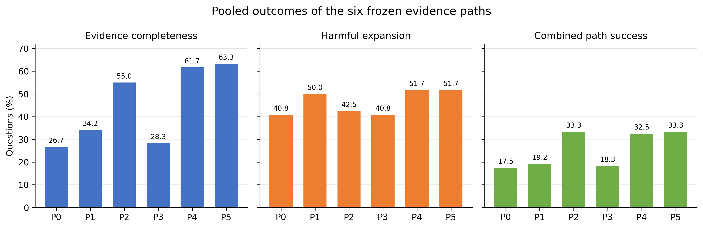

5.2 Matched stage effects
Matched comparisons identified context as the only stage with a substantial and repeatable effect (Table 3). P2 improved combined success over P0 by 15.83 percentage points (95% paired bootstrap interval, 9.17 to 22.50; exact McNemar p = 0.0000038; Holm-adjusted p = 0.000019). P4 improved over P1 by 13.33 points (95% interval, 7.50 to 20.00; Holm-adjusted p = 0.000122). Neither context comparison lost a previously successful question.
Reranking improved combined success by 1.67 points (95% interval, -1.67 to 5.00), rescuing three questions and losing one. Each graph comparison improved success by 0.83 points (95% interval, 0 to 2.50) and rescued one question. Under the prespecified rescue definition, context rescued 19 unique questions, reranking three, and graph traversal one.
Table 3. Matched path-stage effects on combined success.
Added stage | Comparison | Difference (pp) | 95% CI (pp) | Rescued | Lost | Holm-adjusted p
Context | P2 - P0 | 15.83 | 9.17 to 22.50 | 19 | 0 | <0.001
Context after reranking | P4 - P1 | 13.33 | 7.50 to 20.00 | 16 | 0 | <0.001
Reranking | P1 - P0 | 1.67 | -1.67 to 5.00 | 3 | 1 | 1.000
Graph | P3 - P0 | 0.83 | 0.00 to 2.50 | 1 | 0 | 1.000
Graph after reranking/context | P5 - P4 | 0.83 | 0.00 to 2.50 | 1 | 0 | 1.000

Construction diagnostics explain part of the context effect. Among 15 pharmaceutical parent or heading questions, P2 rescued 11 relative to P0 and P4 rescued 10 relative to P1. Each context comparison rescued five of 15 pharmaceutical table questions. Chemical context gains were smaller: P2 rescued two of 12 table questions and one of 12 parent or heading questions. The single graph rescue occurred among chemical citation-dependency questions. These categories were authored to represent distinct evidence structures, so the concentration supports mechanism interpretation but limits claims of uniform domain-independent benefit.
Figure 4. Paired effects of added path stages and learned routers. Error bars show 95% paired question-level bootstrap intervals.
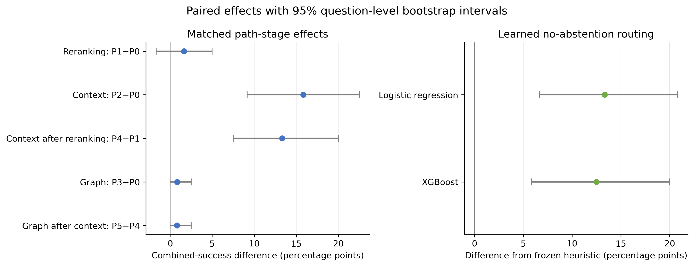

5.3 Lightweight routing
The frozen heuristic achieved 19.17% combined success. Logistic Regression reached 32.50%, a gain of 13.33 points (95% interval, 6.67 to 20.83; Holm-adjusted exact McNemar p = 0.0017). XGBoost reached 31.67%, a gain of 12.50 points (95% interval, 5.83 to 20.00; adjusted p = 0.0017). Both improvements had the favorable direction in four of five outer folds.
Logistic Regression used 0.533 mean neural calls per question, slightly more than the heuristic's 0.500. XGBoost used 0.392, a 21.7% reduction. The all-modules policy achieved 33.33% success with one neural call, while the Oracle achieved 36.67% over all questions. Only 44 questions had any successful path. Among these routable questions, the Oracle used 0.068 mean neural calls because the lexicographic cost rule favored successful non-neural paths.
Table 4. Fixed and learned policy outcomes.
Policy | Combined success (%) | Mean neural calls | Selective coverage (%) | Accepted failure (%)
BM25-only | 17.50 | 0.000 | 100.00 | Not applicable
All modules | 33.33 | 1.000 | 100.00 | Not applicable
Frozen heuristic | 19.17 | 0.500 | 100.00 | Not applicable
Logistic Regression | 32.50 | 0.533 | 9.17 | 63.64
XGBoost | 31.67 | 0.392 | 0.00 | Not defined
Oracle (diagnostic) | 36.67 | 0.068* | 36.67 | 0.00

*Oracle neural calls are calculated over the 44 routable questions only.

5.4 Calibration and abstention
The Logistic Regression no-abstention predictions had a Brier score of 0.200 and a 10-bin expected calibration error of 0.098. XGBoost produced 0.289 and 0.264. These global scores did not yield a useful selective policy. Logistic Regression accepted 11 of 120 outer-test decisions, for 9.17% coverage, and seven accepted decisions failed, for 63.64% accepted failure. Four of five folds forced full abstention because their calibration partitions contained no threshold meeting the frozen risk and minimum-count constraints. XGBoost forced full abstention in all five folds.
The protocol required at least 20% coverage, accepted failure at most 10%, and a failure reduction of at least five points relative to no-abstention routing. Neither model met these conditions. We did not scan outer-test predictions, lower the minimum accepted count, or relax the risk threshold.

5.5 Descriptive transfer
Training on chemical questions and testing on pharmaceutical questions yielded 45.00% no-abstention success for Logistic Regression and 30.00% for XGBoost. The reverse direction yielded 21.67% and 23.33%. All four source-domain calibration procedures forced full abstention on the target domain. Since domain and language changed together, these values cannot isolate either factor. They provide no evidence that evidence-sufficiency calibration transfers.

5.6 Prespecified continuation decision
The prespecified continuation rule was not satisfied. Two of five quantitative signals passed: Oracle routing met the practical improvement criterion, and both learned no-abstention routers beat the heuristic. The path-heterogeneity, independent-module-rescue, and calibrated-abstention signals failed, as did one qualitative gate. The resulting decision was NO-GO for expansion of the original calibrated-routing study. Appendix A reports the fixed decision criteria and their outcomes.

6. Discussion

6.1 Context expansion supplied most of the useful evidence
Adding heading, parent, and table sidecars to BM25 nearly doubled pooled combined success, from 17.50% to 33.33%, without a neural call. The gain came mainly from questions whose answer scope was structurally separated from the retrieved leaf text. This pattern aligns with hierarchical retrieval research [9], but the present result concerns attributable source context rather than generated summaries.
Pharmaceutical parent and table questions benefited much more than their chemical counterparts. Differences in document preparation, chunking, and table representation may explain part of this gap. A larger study should stratify results by naturally occurring document structures rather than fixed authoring quotas and should test whether the same mechanism persists under independently sampled user questions.

6.2 More modules did not produce a better risk-sensitive path
P5 retrieved the most complete evidence but did not improve combined success over P2. Reranking raised completeness while also raising the rate of harmful evidence, especially in the chemical domain. These findings resemble prior reports that detrimental or conflicting context can reduce downstream performance [10,11]. Our endpoint is stricter because one harmful unit causes path failure. The strict rule suits high-risk evidence delivery, but readers should examine completeness and harm separately when applying the findings to lower-risk tasks.
Graph traversal had little opportunity to help. The chemical corpus produced one independent graph rescue, and the pharmaceutical corpus produced no eligible target under the frozen attribution rule. These data cannot establish that regulatory relations lack value. They show that conservative, one-hop, uniquely attributable relations were sparse in these snapshots. A future graph study would need better relation coverage and independent evidence specifications, not a more permissive traversal added after seeing the Pilot.

6.3 Lightweight routing learned useful path preferences
Both learned routers recovered most of the all-modules success while selecting paths per query. XGBoost also reduced neural calls relative to the heuristic. The gain over a fixed cue policy suggests that BM25 score shape, query length, domain, bounded relation metadata, and path identity contain predictive signal. The Oracle gap was modest in absolute success, but only 44 questions were routable, which limits the amount of positive supervision.
Simple models were adequate for this small route-selection study. The experiment does not establish a generally deployable router. The same question structures that created path differences also shaped the training distribution, and domain was an explicit feature. The transfer results cannot separate domain from language. An external test with naturally sampled questions would be needed before deployment.

6.4 Abstention failed despite acceptable-looking global calibration metrics
Selective prediction failed despite favorable global metrics for Logistic Regression. Its Brier score and ECE appeared better than XGBoost's, yet its 11 accepted decisions failed 63.64% of the time. XGBoost found no valid operating threshold. Average calibration summaries therefore did not guarantee a safe low-risk acceptance region.
Small calibration folds, few successful question-path pairs, dependence among the six paths for each question, and cross-domain heterogeneity all reduce threshold stability. The protocol's minimum of 10 accepted calibration questions prevented a threshold from being justified by a handful of easy cases. That safeguard produced degenerate coverage, which is preferable to reporting a threshold selected on test outcomes. A future abstention study would require a larger calibration population and an independently frozen test set.

6.5 Limitations
The Pilot is small and deliberately balanced by evidence structure. Its rates do not estimate the natural frequency of direct, contextual, tabular, relational, or unanswerable regulatory questions. Chemical and pharmaceutical data also differ in language, corpus size, document structure, retrieval implementation, and relation availability. Cross-domain comparisons remain descriptive.
Annotation agreement was moderate. The HARMFUL category requires judgment about whether evidence can change a regulatory interpretation. Ordered rules, complete-question duplicate annotation, retained raw decisions, and adjudication improve transparency, but they do not eliminate subjectivity. The strict combined-success rule may understate performance for applications that can safely ignore irrelevant or conflicting items.
The study evaluates evidence retrieval, not generated answers. It cannot show that a language model would use complete evidence faithfully or that an end user would interpret the package correctly. Runtime values came from two different local source systems and should not be treated as a hardware-neutral benchmark. The Oracle only selects among six evaluated paths and does not bound the performance of other retrieval strategies.

7. Conclusion
Evidence expansion was most useful when decisive scope information was structurally adjacent to the retrieved passage rather than lexically distant from it. Across both regulatory domains, adding heading, parent, and table context produced the clearest independent gain and matched the full path's risk-sensitive success without a neural call. Reranking and conservative graph traversal yielded little independent rescue, while indiscriminate expansion often added harmful evidence. The practical implication is narrow but clear: structural context should be added selectively, and retrieval quality should report completeness and harm separately rather than treating more evidence as automatically better.
Lightweight learned routers outperformed the prespecified heuristic under grouped out-of-fold evaluation, but the present sample did not support a reliable abstention policy. This is a data-limited negative finding rather than evidence that evidence-sufficiency abstention is impossible. Larger independent calibration sets, naturally sampled questions, and less confounded cross-domain evaluation are required before the routing and abstention components can support deployment.

Author Contributions
Kaifeng Sun is the sole author and was responsible for conceptualization, methodology, software, validation, formal analysis, investigation, data curation, visualization, writing the original draft, reviewing and editing the manuscript, and project administration.

Data and Code Availability
The public repository contains the frozen protocol, schemas, code, aggregate manifests, tables, figures, and hashes needed to reproduce the reported statistics. Copyrighted source corpora, database snapshots, source passages, credentials, question-level predictions, and completed annotation workbooks are excluded. The repository is available at https://github.com/Kaifengsun/calibrated-regulatory-evidence-routing.

Ethics Statement
The study used regulatory documents and technical standards and did not collect personal or sensitive information. Annotation was performed to construct and evaluate the retrieval dataset; annotators were not treated as research participants. The system is a research prototype and should not replace professional regulatory interpretation. A retrieved evidence package can remain incomplete or misleading even when a path receives a high predicted score.

Appendix A. Continuation Criteria and HARMFUL Evidence Examples

A.1 Prespecified continuation decision
The study could continue only if all three qualitative gates and at least four of five quantitative signals passed. Two quantitative signals passed. Oracle routing met the practical improvement criterion, and both learned no-abstention routers beat the heuristic. Three signals failed: 23 questions (19.17%) needed a successful path beyond P0, just below the required 24 questions (20%); only context met the minimum five-question module-rescue threshold, whereas two module types were required; and calibrated abstention did not achieve the prespecified risk and coverage. One qualitative gate also failed conservatively because the strongest context gains were concentrated in authoring strata designed to need parent or table context. No threshold, question, path, or model was changed after this decision.

A.2 Illustrative HARMFUL evidence categories
The examples below are schematic paraphrases of the annotation rules rather than quotations from the source corpora.
Category | Illustrative case | Why it is HARMFUL rather than IRRELEVANT
Wrong version | A superseded standard is retrieved for a requirement governed by the current edition. | The obsolete rule can change the applicable obligation.
Wrong regulatory object | A provision for a different product, substance, or responsible party appears topically relevant. | The evidence can transfer a duty or restriction to the wrong object.
Wrong condition or threshold | A nearby clause supplies a different concentration, duration, or triggering condition. | The value can directly alter the regulatory decision.
Conflicting exception | An exception from another scope is added without the clause that limits its use. | The package can incorrectly imply that the main requirement does not apply.

References
1. Robertson S, Zaragoza H. The probabilistic relevance framework: BM25 and beyond. Foundations and Trends in Information Retrieval. 2009;3(4):333-389. doi:10.1561/1500000019.
2. Lewis P, Perez E, Piktus A, et al. Retrieval-augmented generation for knowledge-intensive NLP tasks. In: Advances in Neural Information Processing Systems 33. 2020.
3. Karpukhin V, Oguz B, Min S, et al. Dense passage retrieval for open-domain question answering. In: Proceedings of EMNLP 2020. 2020:6769-6781. doi:10.18653/v1/2020.emnlp-main.550.
4. Nogueira R, Jiang Z, Pradeep R, Lin J. Document ranking with a pretrained sequence-to-sequence model. In: Findings of EMNLP 2020. 2020:708-718. doi:10.18653/v1/2020.findings-emnlp.63.
5. Thakur N, Reimers N, Rucklé A, Srivastava A, Gurevych I. BEIR: A heterogeneous benchmark for zero-shot evaluation of information retrieval models. In: Advances in Neural Information Processing Systems 34. 2021.
6. Jiang Z, Xu F, Gao L, et al. Active retrieval augmented generation. In: Proceedings of EMNLP 2023. 2023:7969-7992. doi:10.18653/v1/2023.emnlp-main.495.
7. Asai A, Wu Z, Wang Y, Sil A, Hajishirzi H. Self-RAG: Learning to retrieve, generate, and critique through self-reflection. In: International Conference on Learning Representations. 2024.
8. Jeong S, Baek J, Cho S, Hwang SJ, Park J. Adaptive-RAG: Learning to adapt retrieval-augmented large language models through question complexity. In: Proceedings of NAACL 2024. 2024:7036-7050. doi:10.18653/v1/2024.naacl-long.389.
9. Sarthi P, Abdullah S, Tuli A, Khanna S, Goldie A, Manning CD. RAPTOR: Recursive abstractive processing for tree-organized retrieval. In: International Conference on Learning Representations. 2024.
10. Oh P, Thorne J. Detrimental contexts in open-domain question answering. In: Findings of EMNLP 2023. 2023:11589-11605. doi:10.18653/v1/2023.findings-emnlp.776.
11. Hong G, Kim J, Kang J, Myaeng SH, Whang JJ. Why so gullible? Enhancing the robustness of retrieval-augmented models against counterfactual noise. In: Findings of NAACL 2024. 2024:2474-2495. doi:10.18653/v1/2024.findings-naacl.159.
12. Thakur N, Bonifacio L, Zhang C, et al. "Knowing when you don't know": A multilingual relevance assessment dataset for robust retrieval-augmented generation. In: Findings of EMNLP 2024. 2024.
13. Es S, James J, Espinosa Anke L, Schockaert S. RAGAs: Automated evaluation of retrieval augmented generation. In: Proceedings of EACL 2024: System Demonstrations. 2024:150-158. doi:10.18653/v1/2024.eacl-demo.16.
14. Saad-Falcon J, Khattab O, Potts C, Zaharia M. ARES: An automated evaluation framework for retrieval-augmented generation systems. In: Proceedings of NAACL 2024. 2024:338-354. doi:10.18653/v1/2024.naacl-long.20.
15. Guo C, Pleiss G, Sun Y, Weinberger KQ. On calibration of modern neural networks. In: Proceedings of the 34th International Conference on Machine Learning. PMLR. 2017;70:1321-1330.
16. Geifman Y, El-Yaniv R. SelectiveNet: A deep neural network with an integrated reject option. In: Proceedings of the 36th International Conference on Machine Learning. PMLR. 2019;97:2151-2159.
17. Chalkidis I, Fergadiotis M, Androutsopoulos I. MultiEURLEX: A multilingual and multi-label legal document classification dataset for zero-shot cross-lingual transfer. In: Proceedings of EMNLP 2021. 2021:6974-6996. doi:10.18653/v1/2021.emnlp-main.559.
18. Chalkidis I, Jana A, Hartung D, et al. LexGLUE: A benchmark dataset for legal language understanding in English. In: Proceedings of ACL 2022. 2022:4310-4330. doi:10.18653/v1/2022.acl-long.297.
19. Goebel R, Kano Y, Kim MY, Rabelo J, Satoh K, Yoshioka M. Overview and discussion of the Competition on Legal Information, Extraction/Entailment (COLIEE) 2023. Review of Socionetwork Strategies. 2024;18:27-47. doi:10.1007/s12626-023-00152-0.
20. Chen T, Guestrin C. XGBoost: A scalable tree boosting system. In: Proceedings of the 22nd ACM SIGKDD International Conference on Knowledge Discovery and Data Mining. 2016:785-794. doi:10.1145/2939672.2939785.
21. Cohen J. A coefficient of agreement for nominal scales. Educational and Psychological Measurement. 1960;20(1):37-46. doi:10.1177/001316446002000104.
22. McNemar Q. Note on the sampling error of the difference between correlated proportions or percentages. Psychometrika. 1947;12(2):153-157. doi:10.1007/BF02295996.
23. Holm S. A simple sequentially rejective multiple test procedure. Scandinavian Journal of Statistics. 1979;6(2):65-70.

