RAJALAKSHMI ENGINEERING COLLEGE RAJALAKSHMI NAGAR, THANDALAM 602 105





CS23531 – WEB PROGRAMMING

Laboratory Record Note Book

Name : KAIF REHMAN S.T
Year / Branch / Section : III Year – CSE - C
University Register No. : 2116230701134
College Roll No. : 230701134
Semester : V
Academic Year : 2025 - 2026

.

DEPARTMENT OF COMPUTER SCIENCE AND ENGINEERING

CS23531 – WEB PROGRAMMING

REG NO 2116230701134

NAME KAIF REHMAN S.T

YEAR III - CSE

SEC C


RAJALAKSHMI ENGINEERING COLLEGE
An Autonomous Institution

BONAFIDE CERTIFICATE

KAIF REHMAN S.T

Name: ……………………………………………………………………………

III YEAR
V
B.E. CSE

Academic Year: ………………… Semester: ……… Branch: ………………

2116230701134
Register No.

Certified that this is the bona fide record of work done by the above student in
CS23531 – WEB PROGRAMMING
the ................................................................................................. Laboratory

during the academic year 2025- 2026.

Signature of Faculty in-charge

06/11/2025

Submitted for the Practical Examination held on …………………………

Internal Examiner External Examiner

INDEX
EX. NO. | DATE | NAME OF THE EXPERIMENT | GITHUB QR CODE
1 | 23/07/25 | HTML Basics | 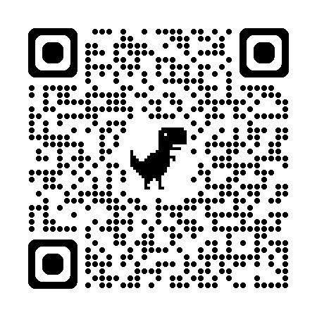
2 | 27/07/25 | HTML – Elements
3 | 01/08/25 | Design With HTML & CSS
4 | 16/08/25 | Webpages With JavaScript
5 | 05/09/25 | Advanced Web Components
6 | 14/09/25 | NodeJS & Mongo DB
7 | 28/09/25 | React Setup & Components
8 | 30/09/25 | React Lifecycle & Tools
9 | 11/10/25 | React Dataflow & Deployment
10 | 27/10/25 | Full Stack Project

