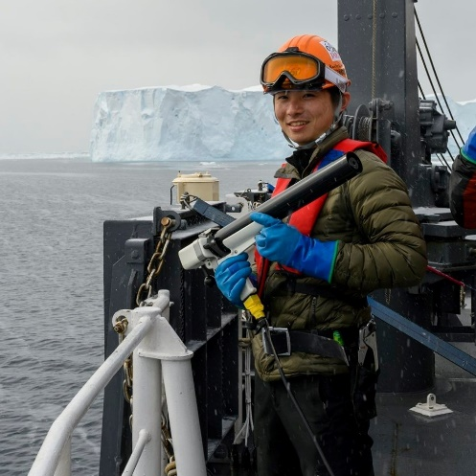Curriculum Vitae of **Kaihe Yamazaki**

>> PhD student in physical oceanography and climate dynamics

## EDUCATION

Hokkaido University, Japan, Apr 2019 - Preseant  
  PhD course in Graduate School of Environmental Science, Earth System Science  
  Supervisor: Shigeru Aoki (associate professor), Institute of Low Temperature Science  
Hokkaido University, Japan, Apr 2017 - Mar 2019  
  Master of Environmental Science, Physical Oceanography  
Tohoku University, Japan, Apr 2013 - Mar 2017  
  Bachelor of Science, Geophysics

## PUBLICATION

Aoki, S., **Yamazaki, K.**, Hirano, D., Katsumata, K., Shimada, K., Kitade, Y., & Sasaki, H. (2020).  
  Reversal of freshening trend of Antarctic Bottom Water in the Australian-Antarctic Basin during 2010s.  
  Scientific Reports, 10, 14415. [10.1038/s41598-020-71290-6](https://doi.org/10.1038/s41598-020-71290-6)  
**Yamazaki, K.**, Aoki, S., Shimada, K., Kobayashi, T., & Kitade, Y. (2020).   
  Structure of the subpolar gyre in the Australian‐Antarctic Basin derived from Argo floats.   
  Journal of Geophysical Research: Oceans, 125, e2019JC015406. [10.1029/2019JC015406](https://doi.org/10.1029/2019JC015406)

## FIELD WORK

2019, Nov 27 - 2020, Mar 22, off Sabrina coast/Lützow-Holm bay (off Syowa Antarctic Station), [the 61st Japanese Antarctic Research Expedition](https://www.nipr.ac.jp/jare/activity/?fbclid=IwAR1Mifw7IKES5kr5PIMq9_uBh1gYLGiVuuelRUq-sP-xay5PFkdKm_LRJWA) on Icebreaker Shirase  
2019, Jan 19 - Mar 5, Off East Antarctica on R/V Kaiyo-maru "BROKE-revisit" (Japan Fisheries Agency)   
2018, October 10-19, Trial cruise for the Antarctic survey on R/V Kaiyo-maru (Japan Fisheries Agency)  
2018, March 9, Sea ice observation field course in Lake Saroma (International Antarctic Institute)  
2018, February 9-14, Sea of Okhotsk on VSL Soya (Japan Coast Guard)  
2016, June 14-26, The Oyashio Current on R/V Wakataka-maru (Tohoku National Fisheries Research Institute)

## EXPOSURE

2020, July 12-16, JpGU - AGU Joint Meeting 2020 (virtual meeting)  
  Poleward shift of the southern boundary of the Antarctic Circumpolar Current off East Antarctica  
2018, December 5, Oral presentation, at the 1st GRAntarctic International Symposium (Tokyo)  
  Subsurface cross-slope exchange in the Australian-Antarctic Basin  
2018, October 22, Poster presentation, at Argo Science Workshop 6th Meeting (Tokyo)  
  Utilize a legacy of under-ice Argo with the positional interpolation along isobath  
2018, June 7, Poster presentation, at Asia Oceania Geosciences Society 15th Meeting (Hawaii)  
  Structure of the subpolar gyre in the Australian-Antarctic Basin  
2018, May 21, Poster presentation, at Japan Geophysical Union Meeting 2018 (Tokyo)  
  Structure of the subpolar gyre in the Australian-Antarctic Basin  
2017, December 5, Oral presentation, at the 8th Symposium on Polar Science (Tokyo)  
  Absolute velocity field of Antarctic Slope Current and topographically constrained gyre-like structures, in East Antarctica

## FEATURE

・Skills: CTD/XCTD/AXCTD measurement, sea ice observation, Data analysis (including ADCP, numerical simulation), geophysical fluid dynamics, thermodynamics, statistics, climatology, chemical oceanography

・Tools: Windows10, Linux, Python3, Fortran, MATLAB (a little), VS Code, Ocean Data View

・Favorites: sweets, beer, something spicy

・Breath: backcountry ski (telemarker), mountaineering, cycling, karaoke

## CONTACT

[Atmosphere-Ocean Interaction Research Group](http://climbsd.lowtem.hokudai.ac.jp/index_e.html)  
[Institute of Low Temperature Science](http://www.lowtem.hokudai.ac.jp/en/index.html), Hokkaido University  
060-0819, N106, N19, W8, Kita-ward, Sapporo City, Hokkaido, Japan  
Phone Number: +81-11-706-5479

Email: [kaiheyamazaki@gmail.com](mailto:kaiheyamazaki@gmail.com), [kaihe@ees.hokudai.ac.jp](mailto:kaihe@ees.hokudai.ac.jp)

Twitter: @KaiheZak

Website: <https://kaiheyamazaki.github.io/>