Starting Project in Python

Creating Virtual Environments in Python

What are they?
An isolated environment on your computer, where you can run and test your Python Projects. Allows management of project-specific dependencies without interfering with other projects or the original python installation. It is basically a container (isolated within the folder), in which each virtual environment will contain the following:
- Own Python Interpreter
- Own Python installed packages
- Isolated from other virtual environments.
- Can have different versions of same packages (e.g. Numpy could be a different version on this environment)
Once a Virtual environment is created in python it will contain the following packages
- Bin (Linux/Mac) and Scripts (Windows): Contains the python interpreter executable and binaries for tools like pip.
  - Activation Scripts: files used to activate the environment (.csh, .fish or .ps1 for powershell)
  - Python Executable: a link or copy of the python interpreter used to create the environment
- Lib/ (All Platforms): supporting libraries for python
  - Site-packages/: all third party libraries installed via pip package manager are stored.
- Include/: contains header files that c-based python packages might need.
- Pyvenv.cfg: a configuration file at the root of the .venv directory. Settings for the venv including home (the base python installation path), include-system-packages (whether to use global packages) and the versions.

When to use them?
- Prevents package version conflicts between projects
- More portable and reproducible
- Allows testing with different python versions.

How to use?

Windows
- In your folder directory you can create one using:
py -<version> -m venv <ve_name>
- You can activate it using:
<ve_name>\Scripts\activate
- You can install packages using the command (make sure venv is selected):
pip install <package_name>

Mac/Linux
- In your folder directory you can create one using:
python<version> -m venv <ve_name>
- You can activate it using:
source <ve_name>/bin/activate
- You can install packages using the command (make sure venv is selected):
pip install <package_name>
To Deactivate just type “deactivate” in the terminal.
If you would like to delete the venv u can use:
- (windows) rmdir <ve_name>
- (unix) rm -rf <ve_name>

How to reproduce environment
If you have already created a virtual environment and would like to use the:
- Activate the venv
- pip3 freeze > requirements.txt
  - This creates a requirements.txt containing all the packages which were installed in the current directory of the venv.
- If you want to use requirement.txt for another venv you can use the following command to run pip install on all libraries in the .txt file (given you already created the virtual environment for the folder):
  - pip install -r requirements.txt

Using Conda
Using Conda (venv is more lightweight including less clutter, however has more package control and better for more robust projects, especially for data science and machine learning).
- conda create -n <name> python=<python_version>
  - created python virtual environment using specified python version
- conda activate <name>
  - activates python virtual environment
- conda install <package_name> or pip install <package_name>
  - installing certain packages for the environment
- To reproduce
  - conda env export –no-builds > environment.yml
    - created a .yml file consisting of all configurations for the dedicated python environment.
  - conda env create -f environment.yml
    - using the .yml file (you can copy from the original project and put into new project), setup the environment for reproducibility.
  - conda activate <name>
To delete virtual environment
conda env remove -n <name>

Installing PyTorch
Using the link, setup certain criteria for installation
- Get Started
For mine it was:
pip3 install torch --index-url https://download.pytorch.org/whl/cu126

Fun Facts of Python

Enumeration
allows you to not only iterate through the list of values but also create a respective index number for the respective value in the list.
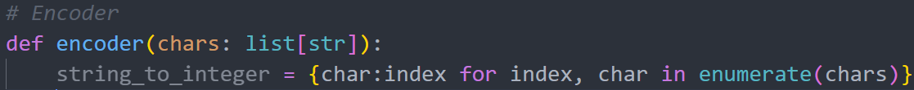
In this example, we are return a list of values in dictionary form. Index which is pointing to each char in the chars. Meaning char is the key and index is the value assigned to the respective key.

Lambda Functions
Lambda functions are single line functions, which are readable and faster to construct then. Furthermore the parameters for a lambda function look like this:
inputs: operations

LLM from Scratch

LLM Introduction

What Are They?
Neural network designed to understand, generate and respond to human-like text. LLMs will generally have large number of parameters and immense dataset on which it’s traine don. This will include adjustable weights in the network that are optimised during training to predict the next word in a sequence.
They utilise an architecture called the transformer. Allowing them to pay selective attention to different parts of the input when making predictions, making them especially adept at handling the nuances and complexities of human language. Unlike the tradition machine learning models, the model will use a more unsupervised learning approach in which the feature extraction is not required.
Local implementation of the model can significantly decrease latency and reduce server-related costs.
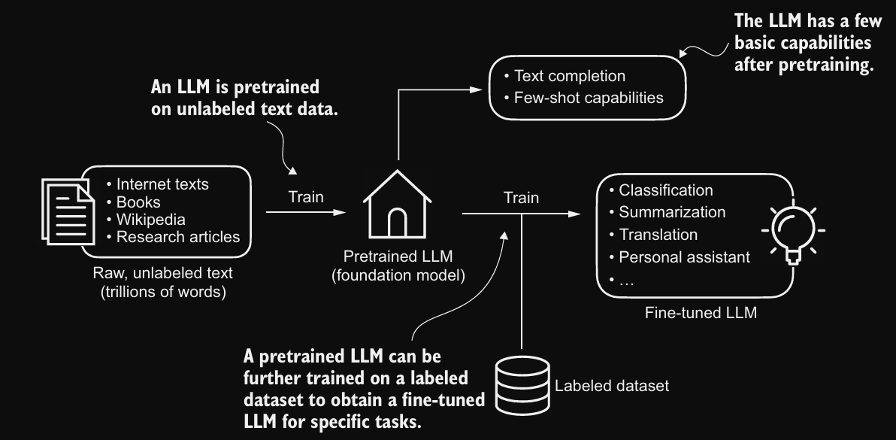
After obtaining a pretrained llm from training on large text dataset, LLM is trained to predict the next word in the text. Further training the model using labelled data. Instructions fine-tuning and classification fine-tuning. Instructions fine-tuning; the labelled dataset consists of instructions and answer pairs such as a query to translate a text accomplished by the correctly translated text. In classification fine-tuning, the labelled dataset consists of texts and associated class labels. For example, given an email, verify whether it was spam or not using a supervised learning approach where the it is either “spam” or “not spam”.

Transformer Model
From the paper called “Attention is all you need”. Consists of 2 submodules: an encoder and a decoder. The encoder processes the input text and turns it into a series of numerical representations. The decoder takes encoded vectors and generates the output text (into English for example of the model is trained on English text). Encoder and decoder consist of many layers connect by a self-attention mechanism. This mechanism allows model to weight the importance of different words or tokens in a sequence relative to each other. Allows it to extract relationships with other input data.
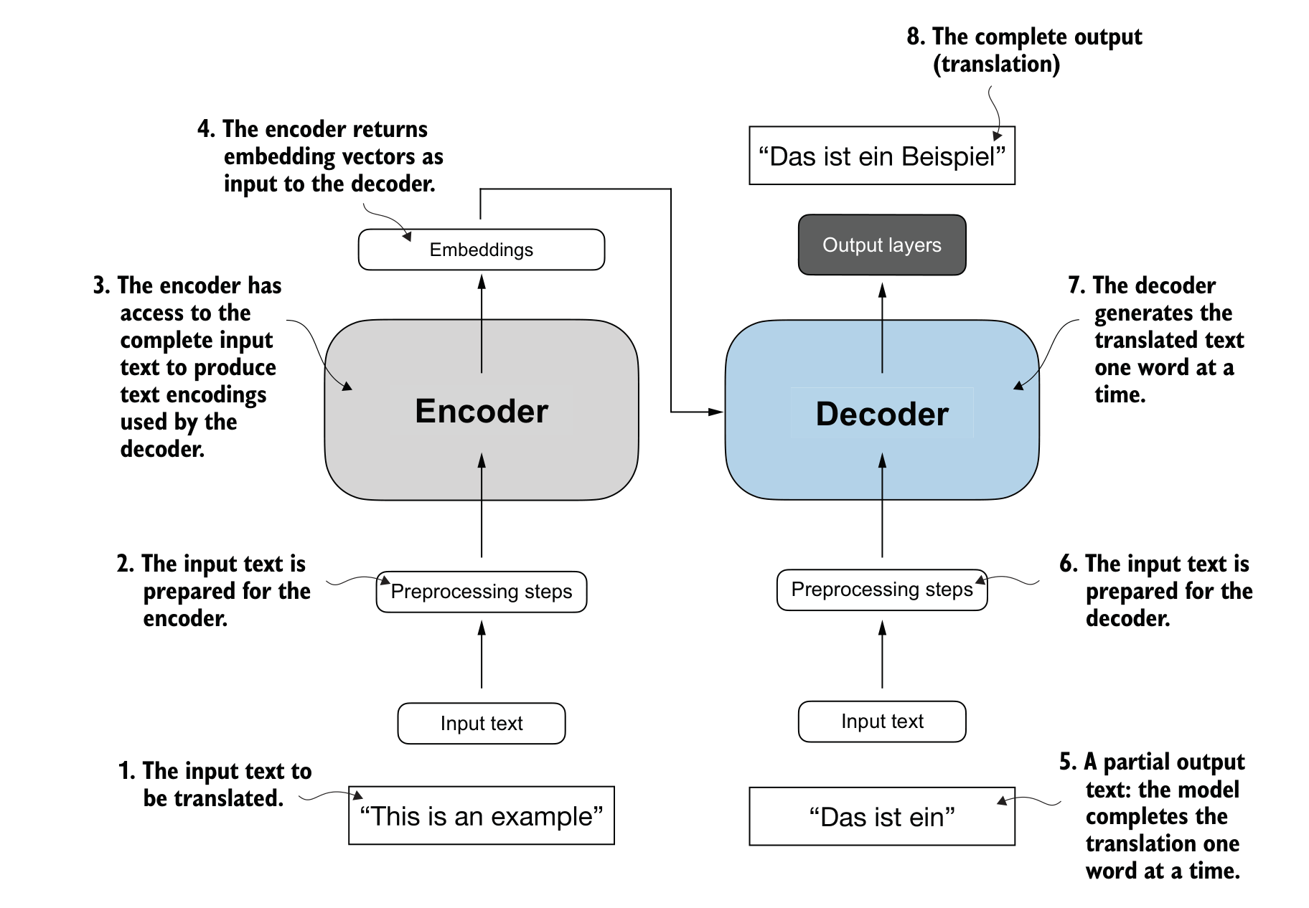
BERT Bidirectional encoder representations from transformers
- Has a different approach to GPT’s training methods. GPT is designed for generative tasks, whilst BERT and variants specialise in masked word prediction, where the model predicts masked or hidden words in a given sentence.
- This allows BERT strengths in text classification tasks, including sentiment prediction and document categorisation.
- X uses BERT as a way of detecting toxic content.
GPT Generative Pretrained Transformer.
- Focuses on the decoder portion of the original transformer architecture and designed for tasks that require generating texts.
- GPT model which are trained to perform text completion tasks, show remarkable versatility in their capabilities due to executing both zero-shot and few shot-learning tasks.
  - Zero-shot learning refers to the ability to generalise to completely unseen tasks without any prior specific examples (higher creative thinking compared to BERT).
  - Few shot learning; involves learning from a minimal number of examples the user provides as input.

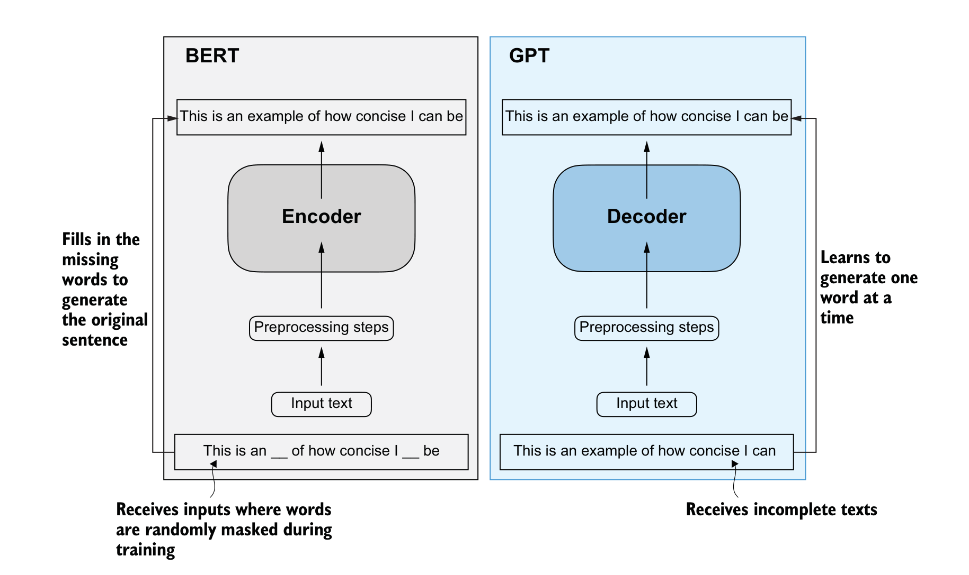
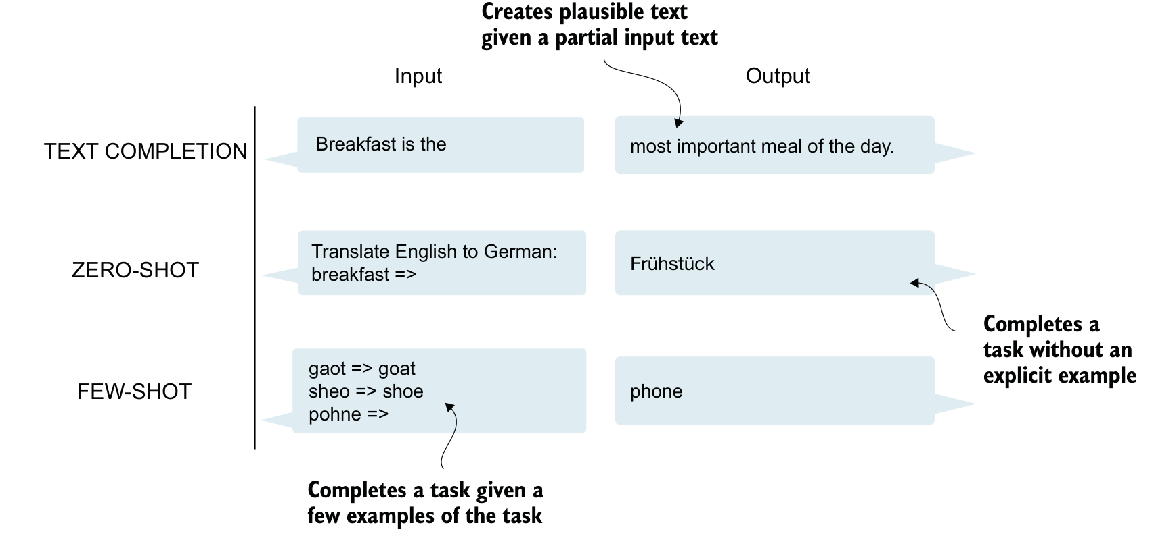
The more token, the vocabulary the model will understand. It doesn’t necessarily make the model smarter (most cause it should), however it is good to have higher token amounts, to increase diversity.
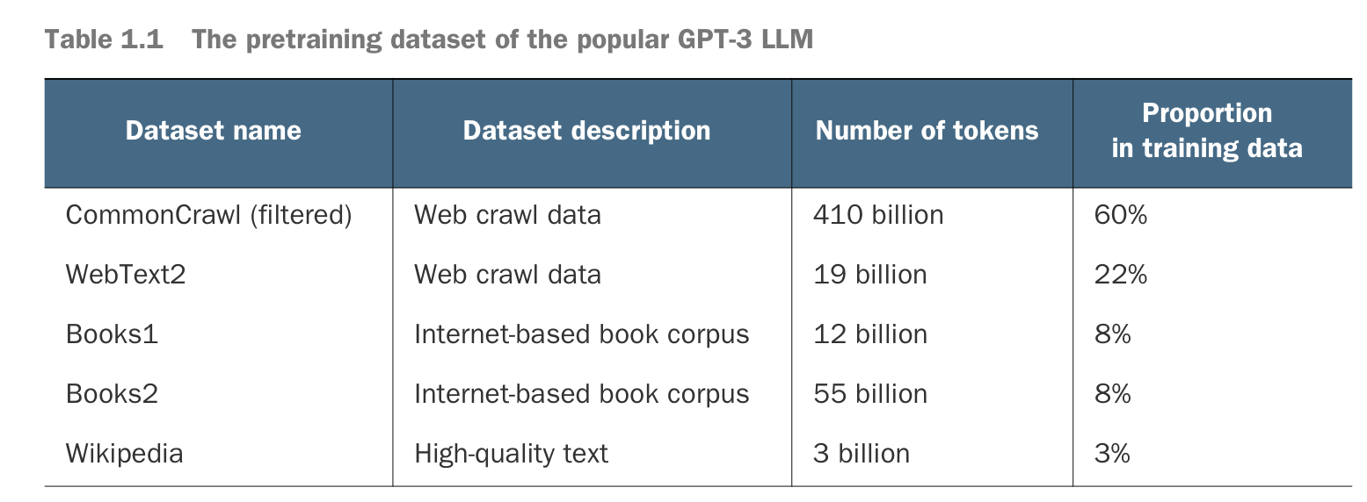
LLMs can be fine-tuned on specific tasks with relatively smaller datasets, reducing the computational recourses needs and improving performance. The term next word prediction pretraining refers to a system which learns to predict the upcoming word in a generated sentence by looking at the words that have come before it.
Furthermore, since decoder style models like GPT generate text by predicting text one word at a time, they are considered a type of autoregressive model. This means incorporate previous outputs as inputs for future predictions. Furthermore, GPT-3 has 96e transformer layers and 175 billion parameters in total.
Emergent behaviour: the ability to perform tasks that the model wasn’t explicitly trained on to perform. For example, GPT was solely trained for the purpose of next word prediction, however it was also able to perform translations (this could be due to its exposure to multilingual data in diverse context). It indicates it’s generative language model’s versatility, however my own note here; could be very scary it has other capabilities such as lying (hidden).

Building a Large Language Model
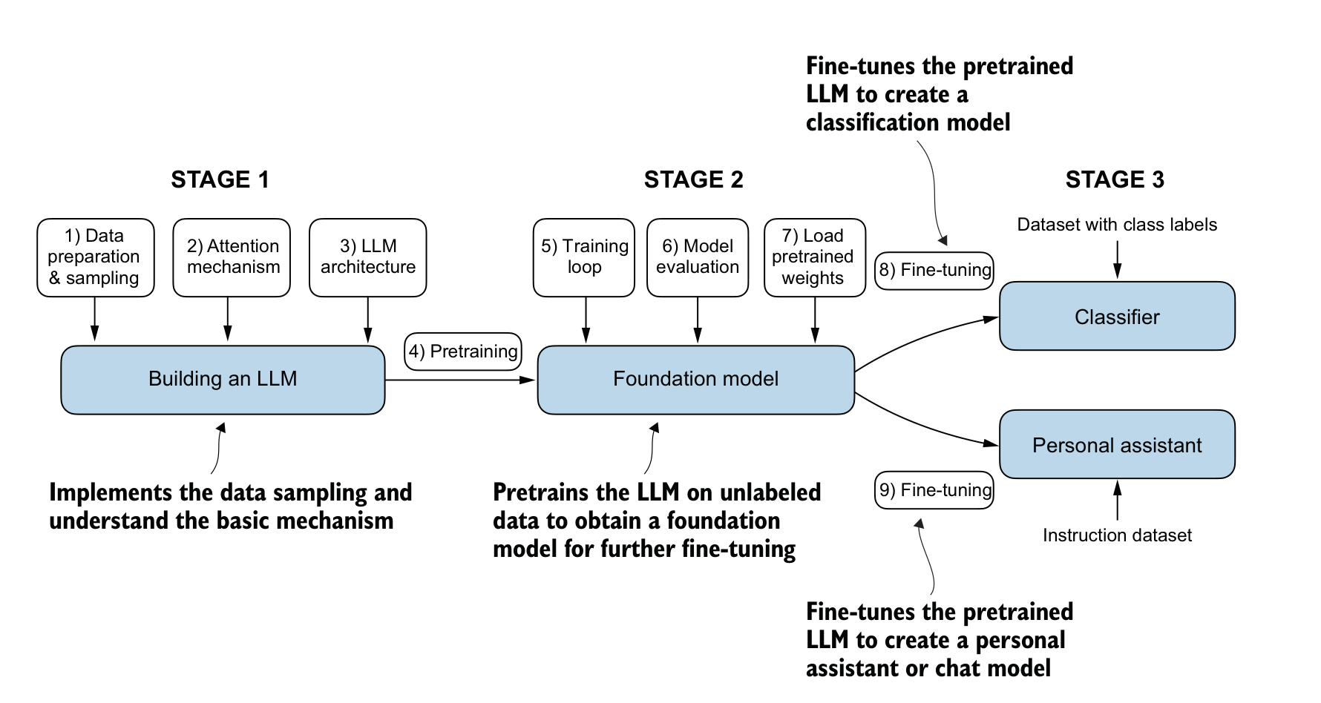
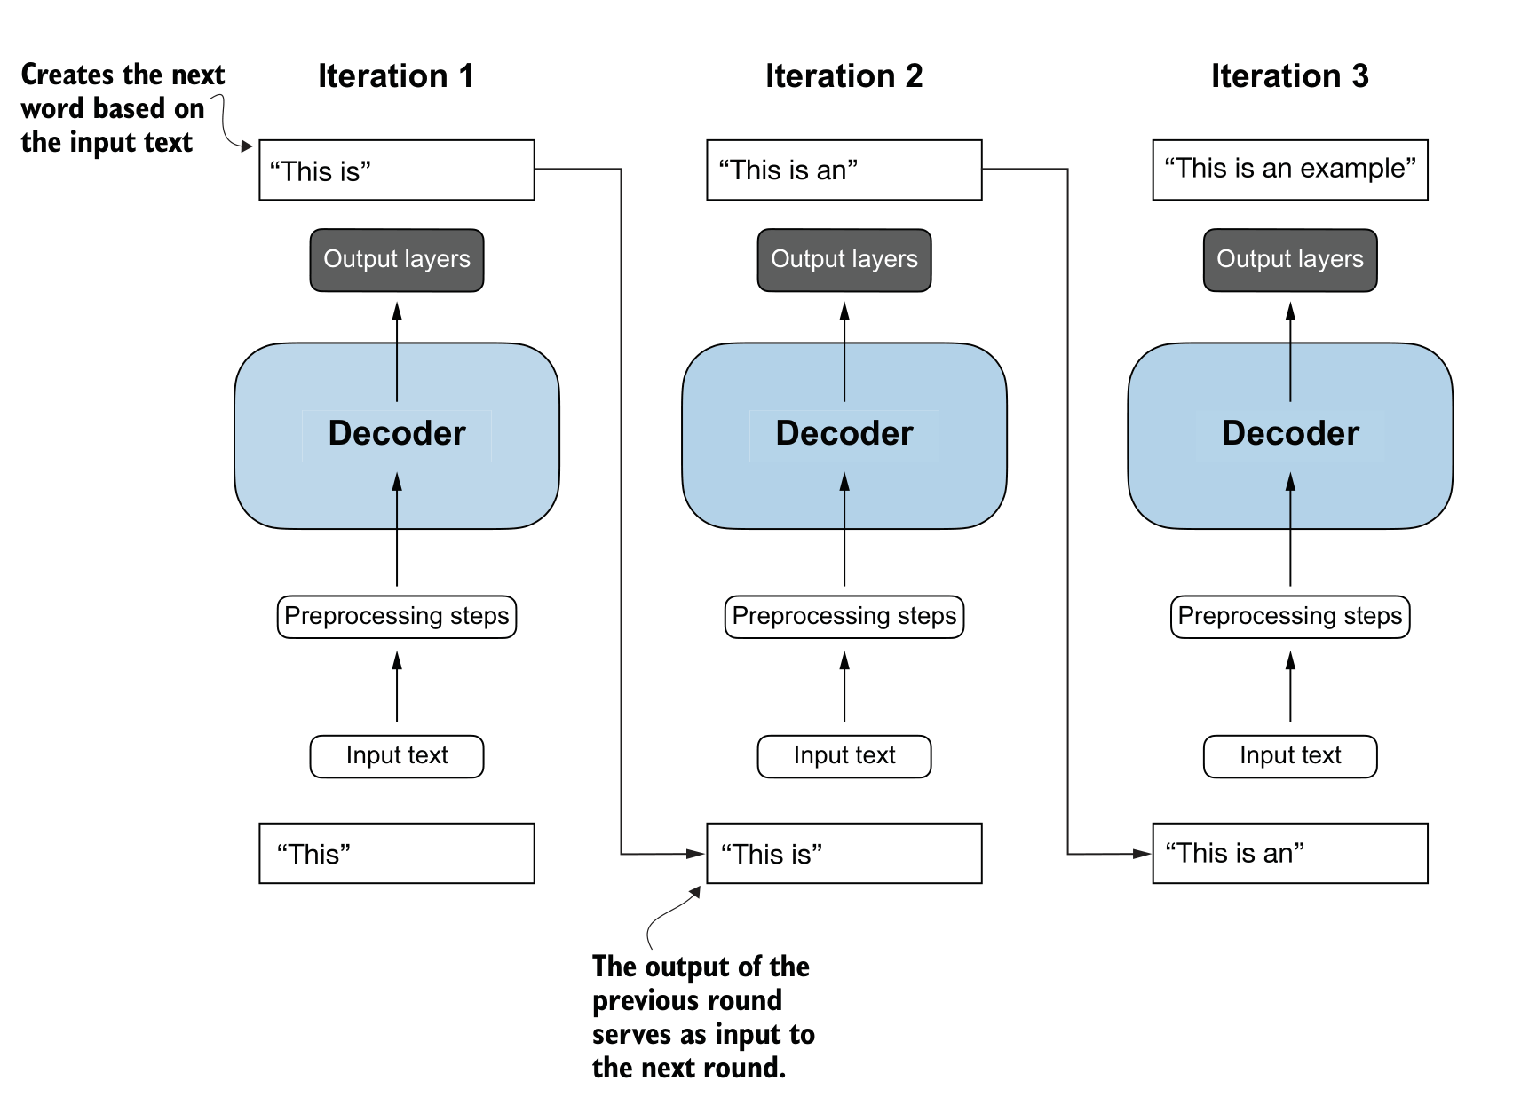

Working with text data

Converting tokens in token IDs
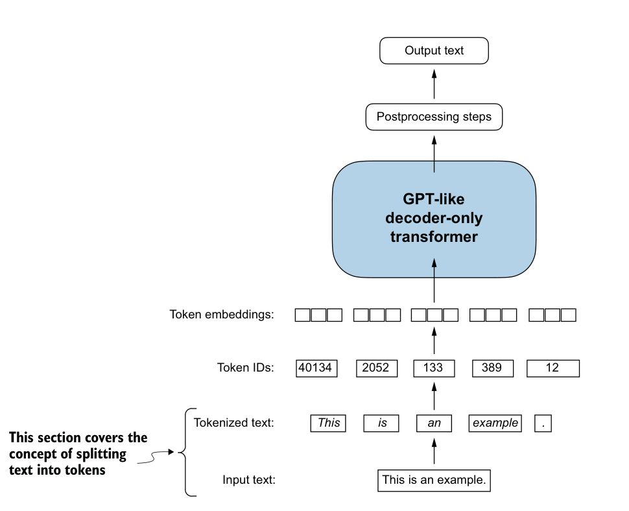
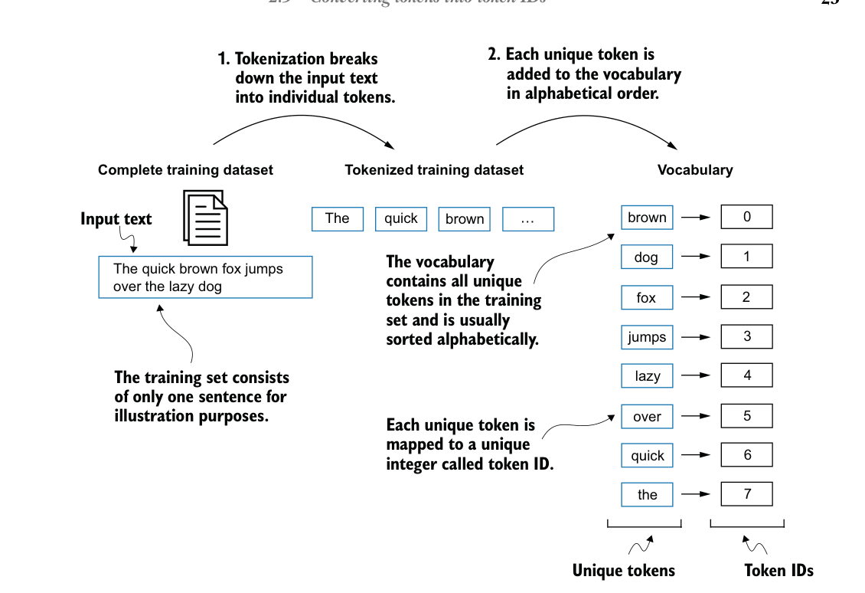
Only problem with our implementation is that our LLM is only entitled to vocabulary in the text document or input text. For example, in the Romeo and Juliet script, there is no word ‘Hello’, therefore this will naturally lead to a misunderstanding or errors in encoding if “hello” was expected in the text. Therefore, this is why large language models and foundations models exists.
Current Tokeniser: SimpleTokeniserV1

Adding Special context tokens
Allows Tokeniser to handle unknown words.
- <|unk|> token represents new and unknown words that were not part of the training data (not part of the vocabulary)
- <|endoftext|> token that we can use to separate two unrelated text sources.
In the current gpt model, the Tokeniser doesn’t use an <|unk|> token for vocabulary which doesn’t exist. Instead, it uses byte pair encoding tokenizer, which breaks words down into sub word units.

Byte Pair Encoding
Due to the complexity of BPE (byte pair encoding), tiktoken can be used to implement this.
BPE works like this
- It breaks down words that aren’t in its predefined vocabulary into smaller sub-word units or even individual characters, enabling it to handle out-of-vocabulary words.
- Therefore, the GPT model wouldn’t have to use <|unk|> token, giving it more versatility.
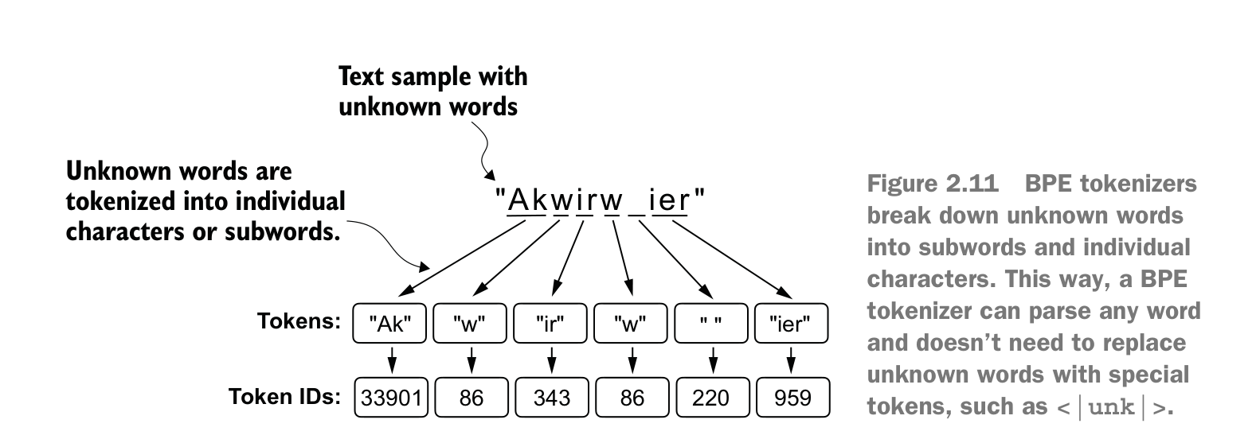

Data sampling with sliding window
Embeddings for the LLM to generate input-target pairs required for training an LLM. These embeddings are used to predict the next word in the text.
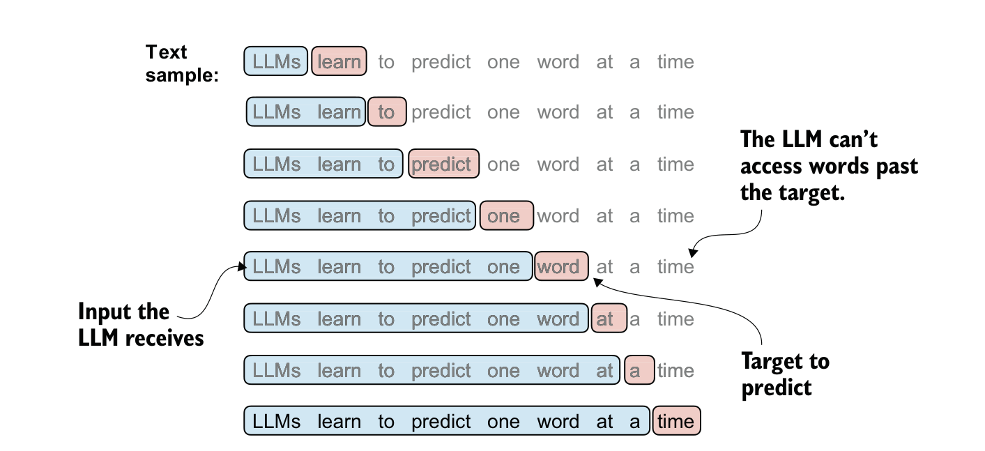

PyTorch
Concepts of tensors and their usage, automatic differentiations engine (allows conveniently and efficiently use backpropagation)
It is a tensor library which is an automatic differentiation engine (auto grad), allowing automatic computation of gradients for tensor operations, simplifying backpropagation and model optimisation. PyTorch is heavily a deep learning library.
Check PyTorch version control and GPU compatibility use the following function
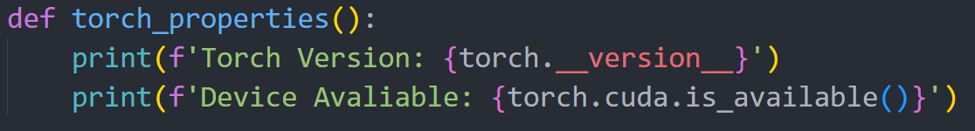

Understanding of Tensors
Scalars are single digit numbers or rank 0. Vectors are 1D which consists of a series and is rank 1. Matrices are rank 2 with 3D dimensions. However, visualising anything more than 3D is nearly impossible, therefore tensors are used for this. PyTorch is very similar to NumPy in terms of structure, however, have a strong important feature for deep learning called differentiation engine allowing it simplify computing gradients.
Float32 is the primary choice for float / int values as it provides precision and computational efficiency. It consumes less memory. Moreover, GPU architectures are optimised for 32-bit computations (that’s why we wouldn’t use 16-bit ones).

Seeing Models as Computation Graphs
Using the autograd system in pytorch, it will be able to compute gradients in dynamic computational graphs automatically. It will display a directed graph.
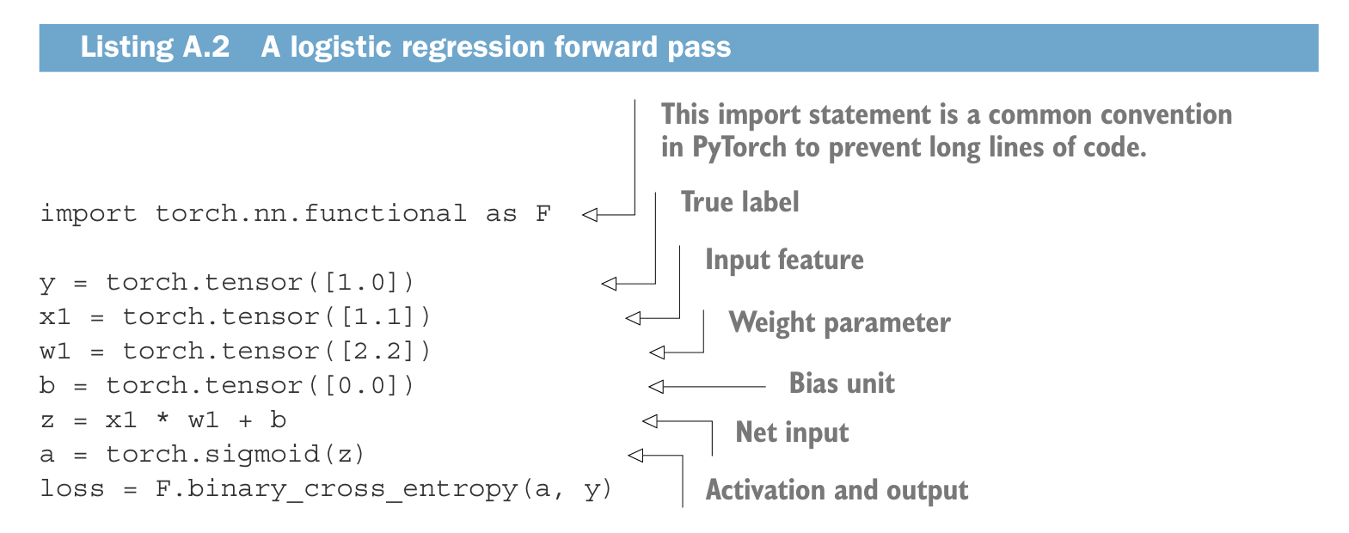
This is a simple logistic regression (classification of 0 or 1, e.g. spam or not spam). In the terms of code and general concept this is how the neural network would normally be:
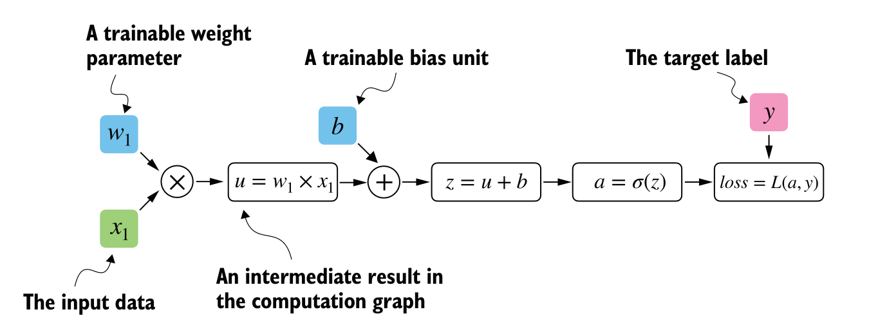

Automatic Differentiation
PyTorch by default will create computational graph (in the background) if one of the terminal nodes has the requires_grad attribute set to True. This attribute allows the easier computation of gradients. Gradients are required during training neural network as it will be necessary for backpropagation (has the chain rule).
Backpropagation will use the error produced from the output function and propagate backwards in the neural network. Updating the respective weights (edge) for each node connection. Then after it would run a forward pass (after backpropagation finished and restarted at the input to first hidden layer nodes) and output another result (should be slightly better). Furthermore, this process it looped based on how many epochs you are running. Also, another thing would be to do. Really good link on back propagation. #2. Solved Example Back Propagation Algorithm Multi-Layer Perceptron Network by Dr. Mahesh Huddar.
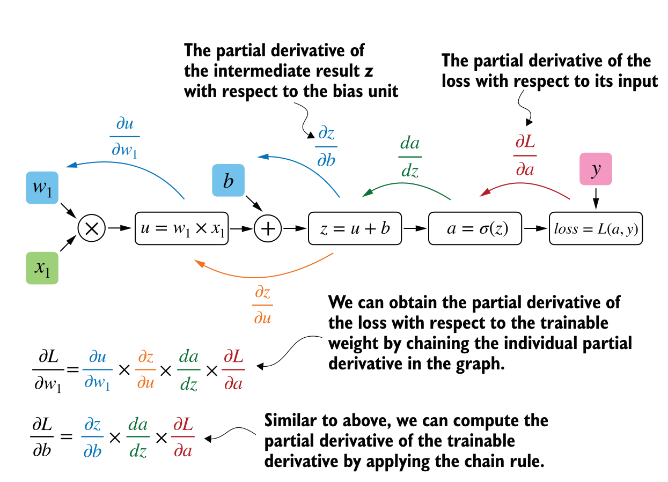
- Partial derivates measure the rate at which a function changes with respect to one of its variables (basically 2nd derivative).
- A gradient is a vector containing all the partial derivatives of a multivariate function, a function with more than one variable (basically f(x,y) like function).
Python’s autograd engine constructs a computational graph in the background by tracking every operation performed on tensors. Then, calling the grad function, we can compute the gradient of the loss concerning the model parameter (e.g. w1).

Implementing multiplayer neural networks
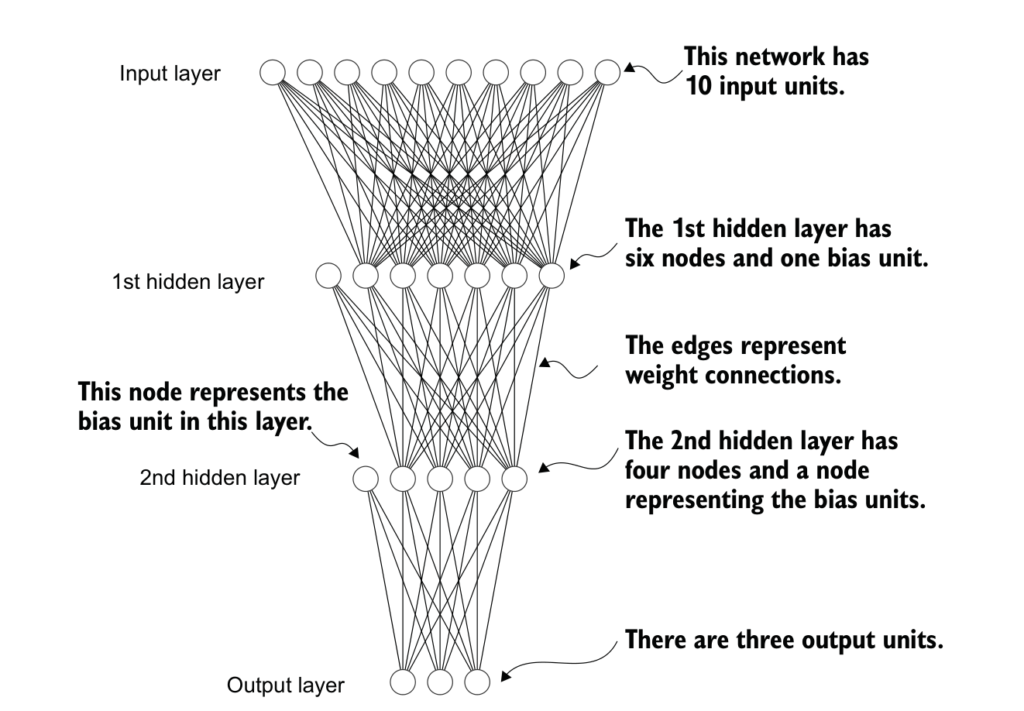
- Input layer (the starting layer for x values)
- Hidden layers will consist of z + 1 layers (more layers the better in some cases, however, could use up more resources and compute power). Furthermore, the +1 represents the bias layer.
- Weights are denoted by edges. These edges hold weights for the connecting nodes (node relationship). Weights are updated through the looped backpropagation process.
- Output layer will produce a logit values, in which an algorithm such as SoftMax will output the result based on the normal distribution.
The forward pass in the network refers to calculating output tensors from input tensors. Input data hidden layer/s Output layer.
P.S. note for coding practice
* If we just want to use a network without training or backpropagation – for example, if we use it for prediction after training – constructing this computational graph for backpropagation can be wasterful as it performs unnecessary computations and consumes additional memory. So, when we use a model for inference (for instances, making predictions) rather than training, the best practice is to use the torch.no_grad() context manager. It lets PyTorch know that it doesn’t need to keep track of the gradients, which can result in significant savings in memory and computations.

Setting up efficient data loaders
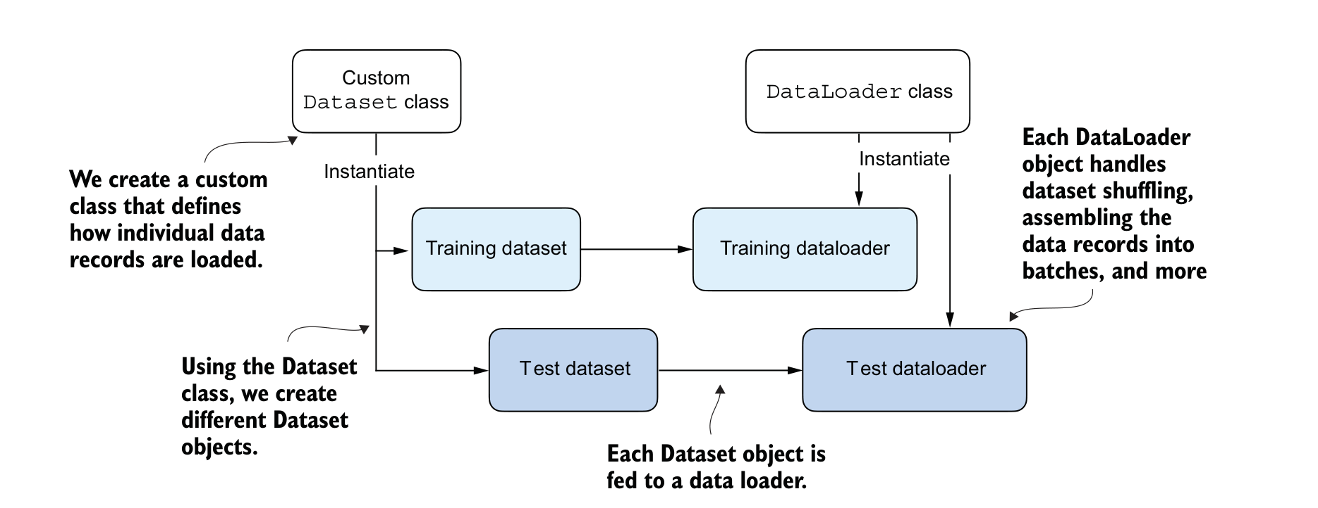
PyTorch already has implements Dataset and Data loader classes (we can inherit them into our own class).
- Dataset is used to instantiate objects that define how each data record is loaded.
- Data Loader handles how the data is shuffled and assembled into batches.
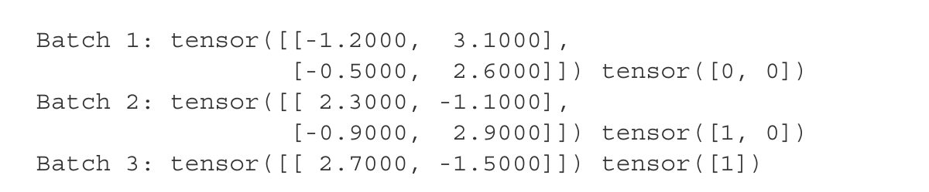
A training epoch when the train loader iterates over the training dataset, visiting each training example once.
As you can see the last batch has only 1 entry (due to 5 / 2 leading to 1 extra). This could lead to convergence during training therefore dropping the odd number would be the best solution.
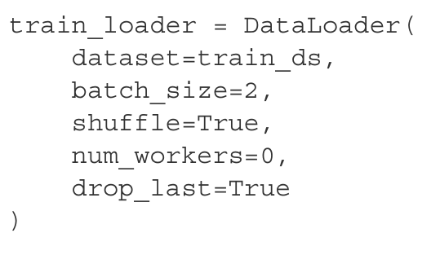

Num workers crucial for parallelising data loading and preprocessing. If set to 0; data loading will be done in the main process and in separate worker processes. If the dataset was much larger, this could lead to bottlenecking issues (slower loading times).
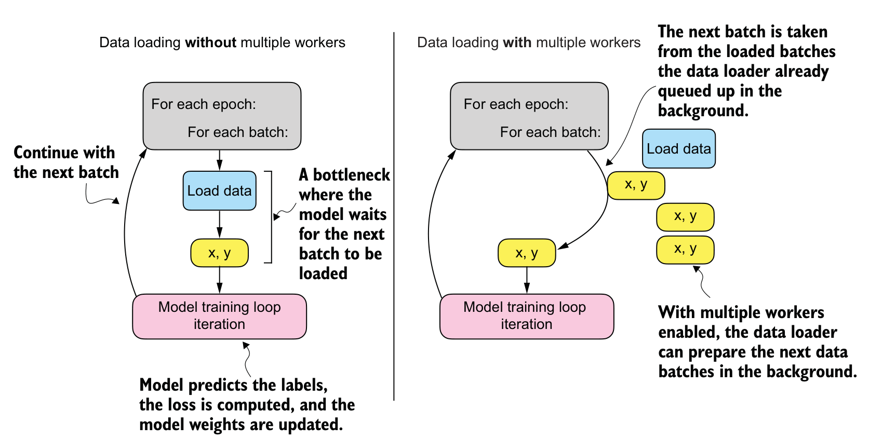
Similar to single processing (CPU) vs parallel processing (GPU).

Disadvantages of using the multiple workers
For smaller dataset (such as the example one), only one is necessary due to the significantly less computations. It could lead to some problems, which might include the overhead (setting up workers for certain batch loading) of spinning multiple worker processes, which could take longer than the actual data loading when your dataset is small.

Training Loop
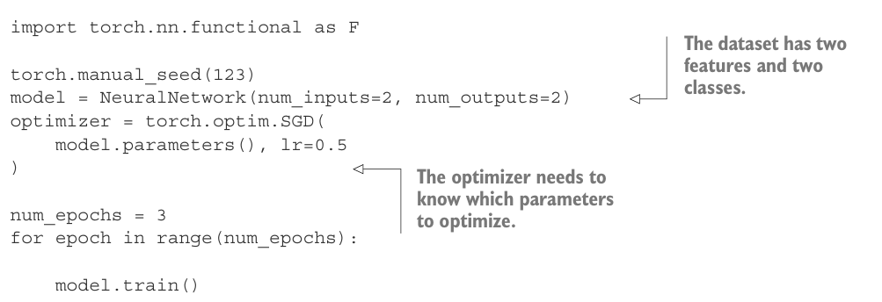
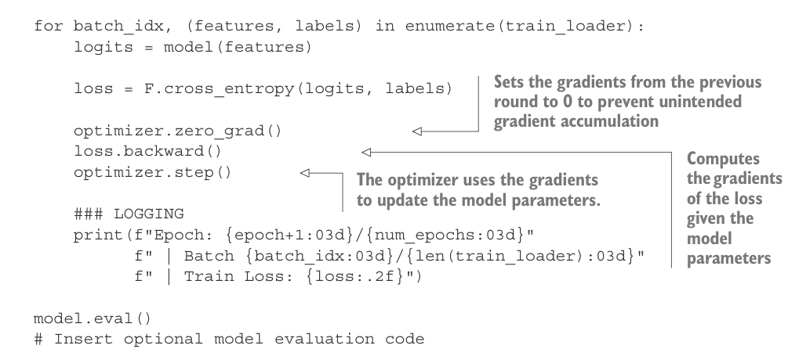
And output
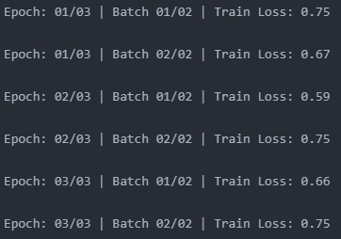
We can see that in each epoch (it will train on each batch)
- It will produce the loss output
- Before backpropagation starts again, you need to reset the gradient to zero (due to previous round unintentional gradient accumulation)
- Computes the gradients of the loss given the model parameters
- The optimiser uses the gradients (produced from the backpropagation to update the bias and weights).
- Finally output the result of the training for that epoch’s batch instance.
- Repeat the process and you see lower training loss
In this case, we don’t have enough data to derive solution (most likely due to data being randomised meaning it would not generalise well).

