WALMART
Customer Retention Analytics
Power BI Dashboard Report

Prepared by: Kailash Choudhary
Power BI Analytics — Internshala Trainings
May 2026

1. Project Overview

This project was done as part of the Power BI Analytics course on Internshala. The goal was to build a Customer Retention Dashboard for Walmart using five datasets covering customer demographics, transactions, store locations, loyalty program data, and churn labels.
The main idea was to understand why customers are churning, identify high-value and at-risk segments, and figure out what role loyalty programs and promotions play in retention. The dashboard was built in Power BI with proper data modeling, DAX measures, and interactive visuals.

Datasets Used
- Customer_Demographics.csv — age, gender, region, income level, membership date, preferred channel
- Customer_Transactions.csv — transaction ID, store, product category, amount, promotion applied
- Store_Locations.csv — store type, region, opening year
- Loyalty_Program.csv — loyalty tier, points earned and redeemed
- Churn_Labelled_Customers.csv — churn flag, last purchase date, churn reason

Data Model
The data model follows a star schema with Customer_Demographics at the center. Relationships set up:
- Customer_Demographics (1) to (*) Customer_Transactions via Customer_ID
- Customer_Demographics (1) to (*) Loyalty_Program via Customer_ID
- Customer_Demographics (1) to (*) Churn_Labelled_Customers via Customer_ID
- Customer_Transactions (*) to (1) Store_Locations via Store_ID

Key Calculated Columns and Measures
- Membership_Duration — DATEDIFF from Membership_Since to TODAY()
- Transaction_Year and Transaction_Month — extracted from Transaction_Date
- Age_Group — segmented into 18-25, 26-35, 36-45, 46-55, 55+
- Purchase_Segment — Low-Tier (0-3), Mid-Tier (4-8), High-Tier (9+)
- Total_Amount_Spent — SUMX with RELATEDTABLE to get per-customer totals
- CLV = Total_Amount_Spent / Membership_Duration_Years
- CLV_Segment — High CLV (above average), Low CLV (below average)
- Churn Rate % = (Churned Customers / Total Customers) x 100

2. Churn and Retention Metrics

This page looks at how churn is spread across different customer segments. The churn rate KPI is calculated as churned customers divided by total customers, multiplied by 100.
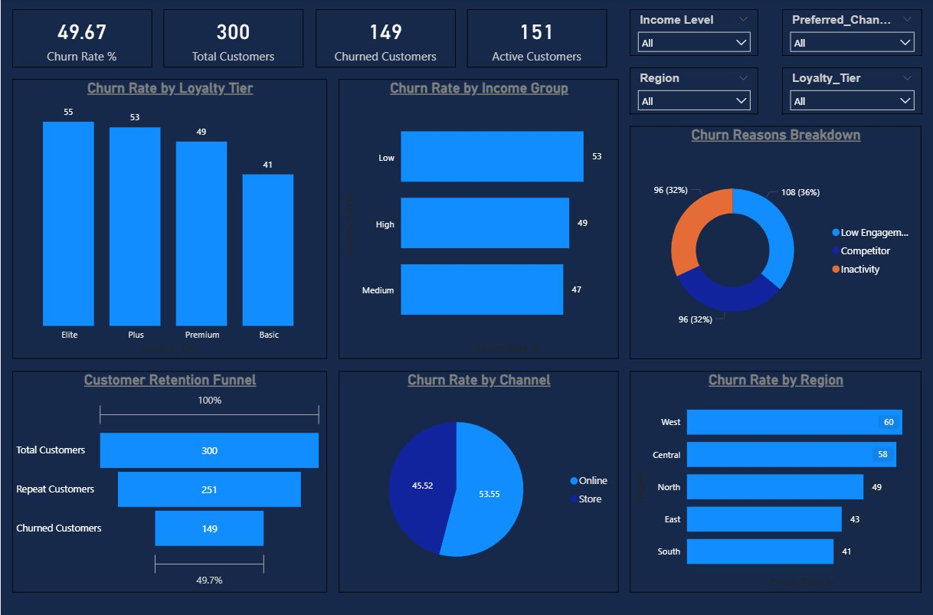

KPI Overview
Out of 300 total customers, 149 have churned — giving a churn rate of 49.67%. That is almost half the customer base, which clearly shows retention is a major issue. Only 151 customers are currently active.

Churn Rate by Region
West has the highest churn at 60%, followed by Central at 58%. South has the lowest at 41%. The western and central markets are where retention efforts need to be focused most urgently.

Churn Rate by Income Group
Low income customers churn the most at 53%. This is not too surprising — they tend to be more price-sensitive and more likely to switch if a competitor offers a better deal. Medium income customers churn the least at 47%.

Churn Rate by Channel
Store customers churn more (53.55%) compared to Online customers (45.52%). Online customers seem slightly better retained, possibly because of convenience and delivery habits forming over time.

Churn Rate by Loyalty Tier
Elite tier has the highest churn at 55%, which honestly was unexpected. You would think the most loyal customers stay longest. One possible explanation is that Elite customers have higher expectations and are more likely to leave when those are not met. Basic tier has the lowest churn at 41%.

Customer Retention Funnel
The funnel goes from 300 total customers down to 251 repeat customers and then 149 churned. So while most customers did make more than one purchase, a large portion eventually stopped coming back.

Churn Reasons Breakdown
Competitor switching is the top reason at 36% (108 customers). Low Engagement and Inactivity are tied at 32% each with 96 customers each. Competitive pricing and engagement strategies are the two main things to address here.

3. Repeat Purchase Analysis

This section segments customers by purchase frequency and looks at buying patterns across age groups, regions, loyalty tiers and product categories.
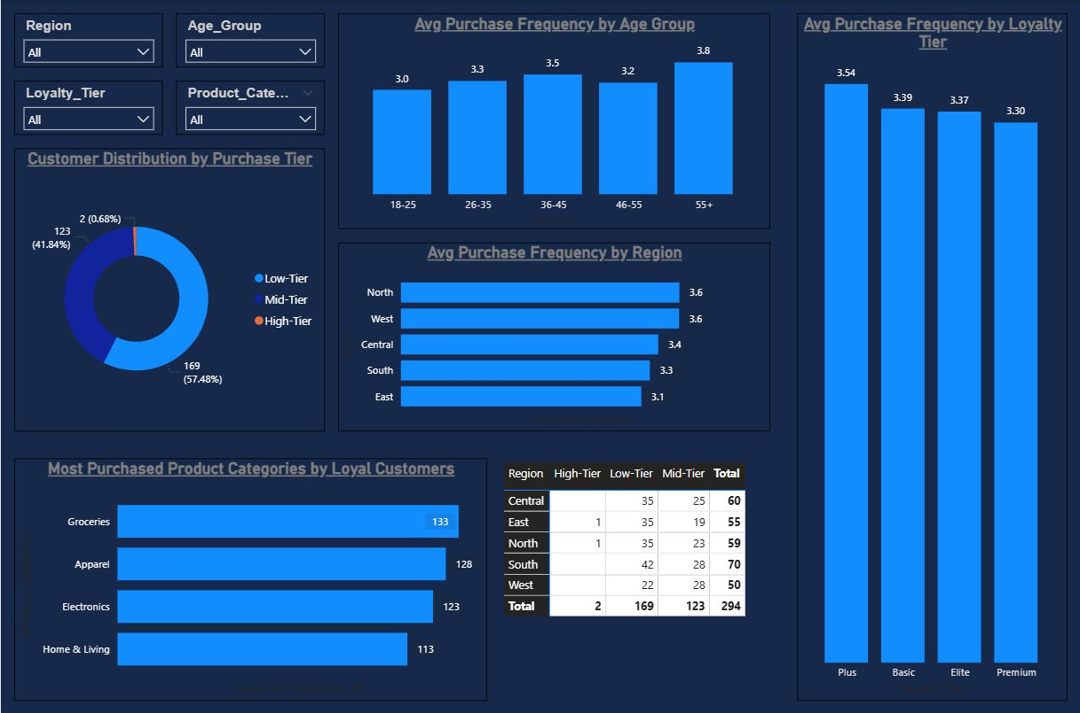

Customer Distribution by Purchase Tier
Most customers sit in Mid-Tier at 169 customers (57.48%), followed by Low-Tier at 123 (41.84%). Only 2 customers hit High-Tier with 9+ purchases — that is just 0.68% of the base. Very few customers are truly highly engaged shoppers.

Avg Purchase Frequency by Age Group
Older customers (55+) shop most frequently at an average of 3.8 purchases. The 18-25 group has the lowest at 3.0. Older customers tend to be more habitual shoppers with established routines, which probably explains this pattern.

Avg Purchase Frequency by Region
North and West lead at 3.6 purchases on average, while East is lowest at 3.1. The differences are not huge but East and South could benefit from campaigns aimed at increasing visit frequency.

Avg Purchase Frequency by Loyalty Tier
Plus tier leads slightly at 3.54 but the range across all tiers is only 3.30 to 3.54. That is a pretty small difference, suggesting loyalty tier alone does not drive significantly more purchase frequency.

Most Purchased Product Categories
Groceries top the list at 133 transactions, followed by Apparel (128), Electronics (123), and Home & Living (113). Groceries being number one makes sense since people need them regularly — it naturally drives repeat visits more than other categories.

Purchase Segments by Region
South has the most customers at 70, followed by Central and North. One thing to note — the matrix shows 294 total customers instead of 300, because 6 customers have no transactions recorded. They exist in the demographics data but have never actually purchased anything.

4. Promotion and Loyalty Impact

This page looks at whether promotions actually change spending behavior, and how engaged customers are with the loyalty program across different tiers.
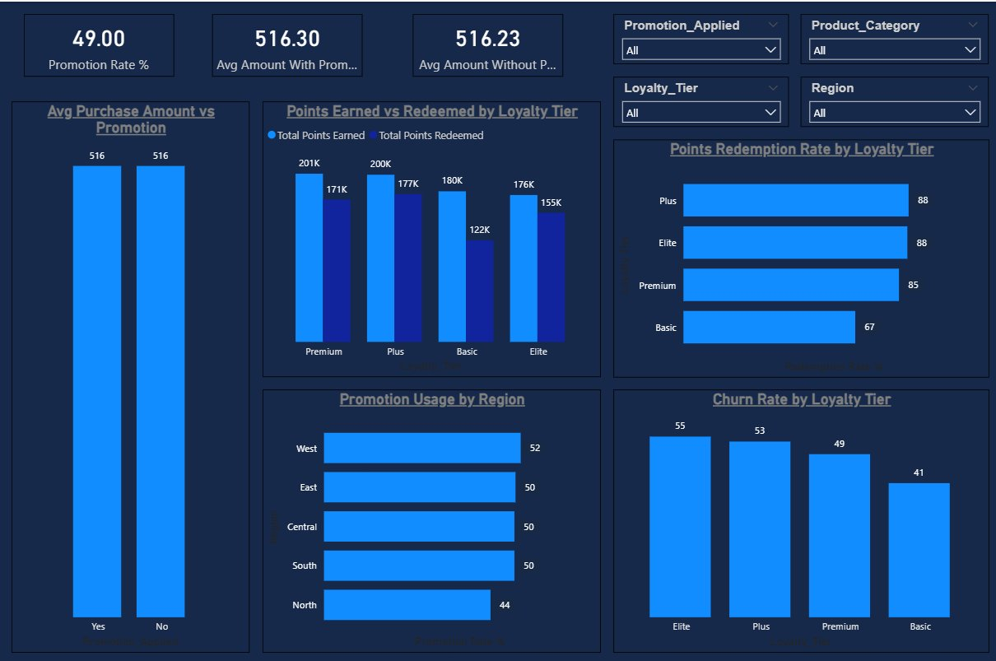

Promotion Rate
49% of all transactions had a promotion applied. So roughly every other transaction involves some kind of discount or offer — that is quite a high frequency of promotions.

Avg Purchase Amount — With vs Without Promotion
This is probably the most interesting finding on this page. The average purchase with a promotion is Rs.516.30 and without is Rs.516.23. A difference of just Rs.0.07. Promotions are basically having no impact on how much customers spend. It looks like customers are spending the same amount whether or not they get a discount.

Points Earned vs Redeemed by Tier
Every tier shows a gap between points earned and redeemed. Premium earns 201K but redeems 171K. Basic earns 180K but redeems only 122K — that is the biggest gap. If customers are earning points but not using them, they are not really engaging with the loyalty program in a meaningful way.

Churn Rate by Loyalty Tier
Elite tier again has the highest churn at 55%, while Basic is lowest at 41%. One possible explanation — Basic customers may just be less aware of alternatives, while Elite customers actively compare options and switch when something better comes along.

Points Redemption Rate by Loyalty Tier
Plus and Elite redeem 88% of their points, Premium 85%, and Basic only 67%. Basic tier members are clearly the least engaged with the redemption side of the program, which makes it feel less valuable to them.

Recommendations
- Send point expiry reminders to Basic tier members — nudge them to redeem and re-engage with the program
- Shift budget away from blanket promotions since they show near zero impact on spending — use personalized offers instead
- Run double-point events for Basic members to give them a reason to move toward Plus tier

5. Store Performance and Customer Lifetime Value

This section covers how different store types compare on transactions and retention, and then looks at CLV which measures value generated per year of membership.
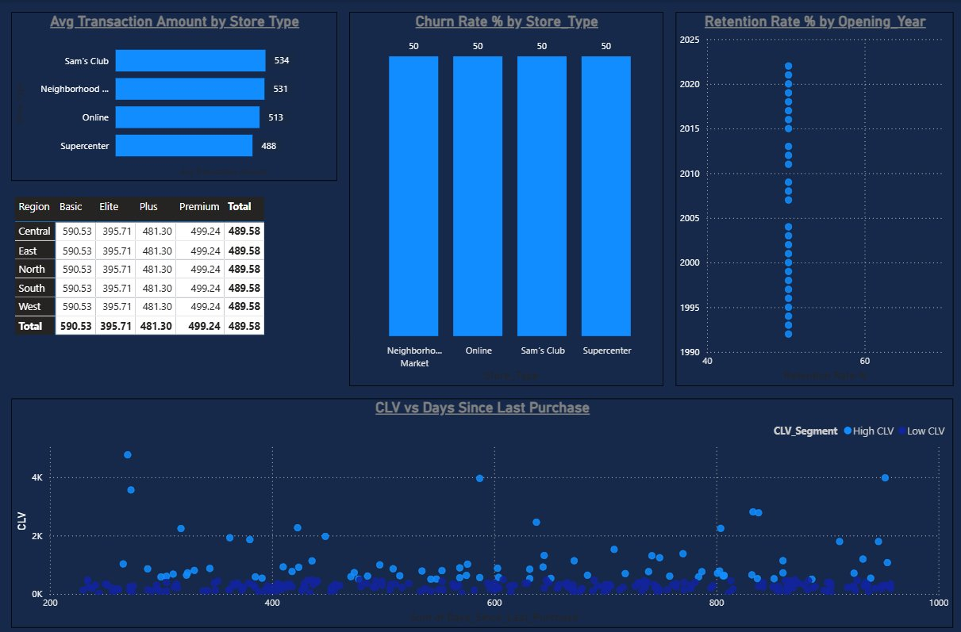

Avg Transaction Amount by Store Type
Sam's Club has the highest average transaction at Rs.534, followed by Neighborhood Market (Rs.531), Online (Rs.513), and Supercenter (Rs.488). Sam's Club being highest makes sense — it serves bulk buyers who naturally spend more per visit.

Churn Rate by Store Type
All four store types show exactly 50% churn — every single one. This tells us the churn problem is not tied to any particular store format. It is a company-wide issue that needs a company-wide fix rather than a store-specific one.

Retention Rate by Opening Year
The scatter chart shows retention hovering around 50-60% across all store opening years from 1990 to 2025. It does not seem to matter when a store opened — the retention rate is roughly the same. Store age is not really a factor here.

CLV by Loyalty Tier and Region
Basic tier customers have the highest average CLV at Rs.590.53, followed by Premium (Rs.499.24), Plus (Rs.481.30), and Elite (Rs.395.71). This is a bit surprising since you would expect higher tier customers to spend more. One possible reason is that Basic customers have been members longer and have more consistent spending habits over time.
Also notable — CLV is identical across all five regions within each tier. So region has no effect on CLV at all. The loyalty tier is what really determines customer value.

CLV vs Days Since Last Purchase
This scatter chart is probably the most useful visual in the whole project. It clearly shows two groups of High CLV customers — those still actively shopping and those who have gone quiet. That second group — high value but recently inactive — is the most important segment to focus on for retention efforts.

6. Summary and Recommendations

Key Findings
- Churn rate is 49.67% — nearly 1 in 2 customers has churned
- Competitor switching (36%) is the top churn reason
- West and Central regions have the highest churn at 60% and 58%
- Store channel churns more than Online — 53.55% vs 45.52%
- Promotions have almost zero impact on basket size — only Rs.0.07 difference
- Basic tier customers have the highest CLV at Rs.590 despite being lowest tier
- Churn rate is exactly 50% across all store types — systemic problem
- Only 2 out of 300 customers reach High-Tier purchase frequency
- Basic tier has the lowest redemption rate at 67%

Recommendation 1 — Win back high-value inactive customers
The CLV vs Days Since Last Purchase scatter chart makes it easy to spot customers who used to spend well but have recently gone quiet. These should be the first priority for any retention campaign. A personalized win-back offer — a targeted discount, bonus points, or a direct outreach email — could bring them back before they are lost completely. This is a much better use of budget than broad promotions.

Recommendation 2 — Improve the online channel
Online customers churn less than store customers but the gap is not big enough. Since competitor switching is the top churn reason and Amazon is the obvious competitor, improving the Walmart.com experience is important. Better product recommendations, faster delivery, and exclusive online deals could help close the gap and make the online channel a stronger retention tool.

Recommendation 3 — Make the loyalty program feel rewarding
A lot of customers are collecting points but not using them — especially in Basic tier where redemption is only 67%. The program does not feel rewarding enough for lower tier members. Simple improvements like point expiry alerts, a visible progress bar showing how close someone is to the next tier, and small milestone bonuses after every few purchases could meaningfully improve engagement without a major overhaul.

Walmart Customer Retention Analytics — Power BI Project
Kailash Choudhary | Internshala Trainings | May 2026

