**PRODUCT PRICE DISPLAY**

MUKESHKANNA.B

MANIKANDAN.S

NIVETHITHA.M

DURAIRAJ.M

SARADA.RC

KAILASA ESWARAN.I

RAHUL KANNA.R

**INTRODUCTION:**

**The idea of our project is to display the product and also its price so that it can be used for shopping purposes. We are using UTLP kit in order to execute our idea. The main key components involved in the project are five ULK interfaces which helps in displaying the result in character , number , led format.**

**FIVE INTERFACES ARE:**

**1)Graphical LCD**

**2)Character LCD**

**3)7Segment display**

**4)LED**

**5)Graphical LCD touch**

**EXPERIMENT SECTION:**

**The graphical LCD displays four different colours . When a particular colour is pressed the touch is sensed and the respective product is displayed on the character LCD which is already interfaced with the kit. It displays four products namely**

**Back case, pendrive, flip cover, temper glass. And the respective prices of the products will be displayed in 7segment display.**

**THE CODE TO RUN OUR PROJECT IS GIVEN BELOW**

#include "macros.h"#include<ulk.h>

int main(void) PROGRAM_ENTRY;

struct PIXEL

{

unsigned int x;

unsigned int y;

};

extern struct PIXEL pixel;

extern struct PIXEL ulk_proc_touch_spi_enable(void);

extern struct PIXEL ulk_proc_touch_spi_poll(void);

extern void ulk_proc_touch_spi_disable(void);

int main()

{

ulk_cpanel_printf("Select the PRODUCTS \n GREEN -PENDRIVE \n RED - BACKCASE\n BLUE -FLIPCOVER \n BLACK - TEMPER GLASS");

ulk_fpga_7seg_led_enable();

ulk_fpga_clcd_init();

ulk_fpga_clcd_display_on();

ulk_fpga_clcd_display_clear();

ulk_fpga_clcd_cursor_home();

int cg=0,cd=0,cn=0,cb=0,count=0,ig=0;

int i=0,j=0,k,l=0, *address = 0x80500000;

for(i=0;i<120;i++)

{

for(j=0; j<160; j++)

{

*(address+(i*320+j)) = 0xff0000;

}

}

for(i=120;i<240;i++)

{

for(j=0; j<160; j++)

{

*(address+(i*320+j)) = 0x00ff00;

}

}

for(i=0;i<120;i++)

{

for(j=160; j<320; j++)

{

*(address+(i*320+j)) = 0x0000ff;

}

}

for(i=120;i<240;i++)

{

for(j=160; j<320; j++)

{

*(address+(i*320+j)) = 0x000000;

}

}

ulk_proc_touch_spi_enable();

while(ig<5)

{

ulk_fpga_clcd_display_string("*****CHOOSE PRODUCTS");

ulk_proc_delay(ULK_SEC(6));

pixel=ulk_proc_touch_spi_poll();

if (pixel.x<160 && pixel.y<120)

{

cg++;

ulk_fpga_clcd_init();

ulk_fpga_clcd_display_on();

ulk_fpga_clcd_display_clear();

ulk_fpga_clcd_cursor_home();

ulk_fpga_clcd_display_string("PENDRIVE");

int count=500;

ulk_fpga_7seg_led_write(count);

}

if (pixel.x<160 && pixel.y>120)

{

cd++;

ulk_fpga_clcd_init();

ulk_fpga_clcd_display_on();

ulk_fpga_clcd_display_clear();

ulk_fpga_clcd_cursor_home();

ulk_fpga_clcd_display_string("BACKCASE");

ulk_fpga_clcd_shift_left(4);

ulk_fpga_clcd_shift_right(7);

int count=600;

ulk_fpga_7seg_led_write(count);

}

if (pixel.x>160 && pixel.y>120)

{

cb++;

ulk_fpga_clcd_init();

ulk_fpga_clcd_display_on();

ulk_fpga_clcd_display_clear();

ulk_fpga_clcd_cursor_home();

ulk_fpga_clcd_display_string("FLIPCOVER");

ulk_fpga_clcd_shift_left(4);

ulk_fpga_clcd_shift_right(7);

int count=400;

ulk_fpga_7seg_led_write(count);

}

if (pixel.x>160 && pixel.y<120)

{

cn++;

ulk_fpga_clcd_init();

ulk_fpga_clcd_display_on();

ulk_fpga_clcd_display_clear();

ulk_fpga_clcd_cursor_home();

ulk_fpga_clcd_display_string("TEMPER GLASS");

ulk_fpga_clcd_shift_left(4);

ulk_fpga_clcd_shift_right(7);

int count=550;

ulk_fpga_7seg_led_write(count);

}

ig++;

}

if(cg>cd && cg>cn && cg>cb)

{

ulk_fpga_clcd_display_on();

ulk_fpga_clcd_display_clear();

ulk_fpga_clcd_cursor_home();

ulk_fpga_clcd_display_string("PENDRIVE ORDERED");

ulk_fpga_clcd_shift_left(4);

ulk_fpga_clcd_shift_right(7);

}

if(cd>cg && cd>cn && cd>cb)

{

ulk_fpga_clcd_display_on();

ulk_fpga_clcd_display_clear();

ulk_fpga_clcd_cursor_home();

ulk_fpga_clcd_display_string("BACKCASE ORDERED");

ulk_fpga_clcd_shift_left(4);

ulk_fpga_clcd_shift_right(7);

}

if(cb>cg && cb>cn && cb>cd)

{

ulk_fpga_clcd_display_on();

ulk_fpga_clcd_display_clear();

ulk_fpga_clcd_cursor_home();

ulk_fpga_clcd_display_string("FLIPCOVER ORDERED");

ulk_fpga_clcd_shift_left(4);

ulk_fpga_clcd_shift_right(7);

}

if(cn>cb && cn>cd && cn>cg)

{

ulk_fpga_clcd_display_on();

ulk_fpga_clcd_display_clear();

ulk_fpga_clcd_cursor_home();

ulk_fpga_clcd_display_string("TEMPER GLASS ORDERED");

ulk_fpga_clcd_shift_left(4);

ulk_fpga_clcd_shift_right(7);

}

return 0;

}

The above code is used to produce the desired output.

**OUTPUT**

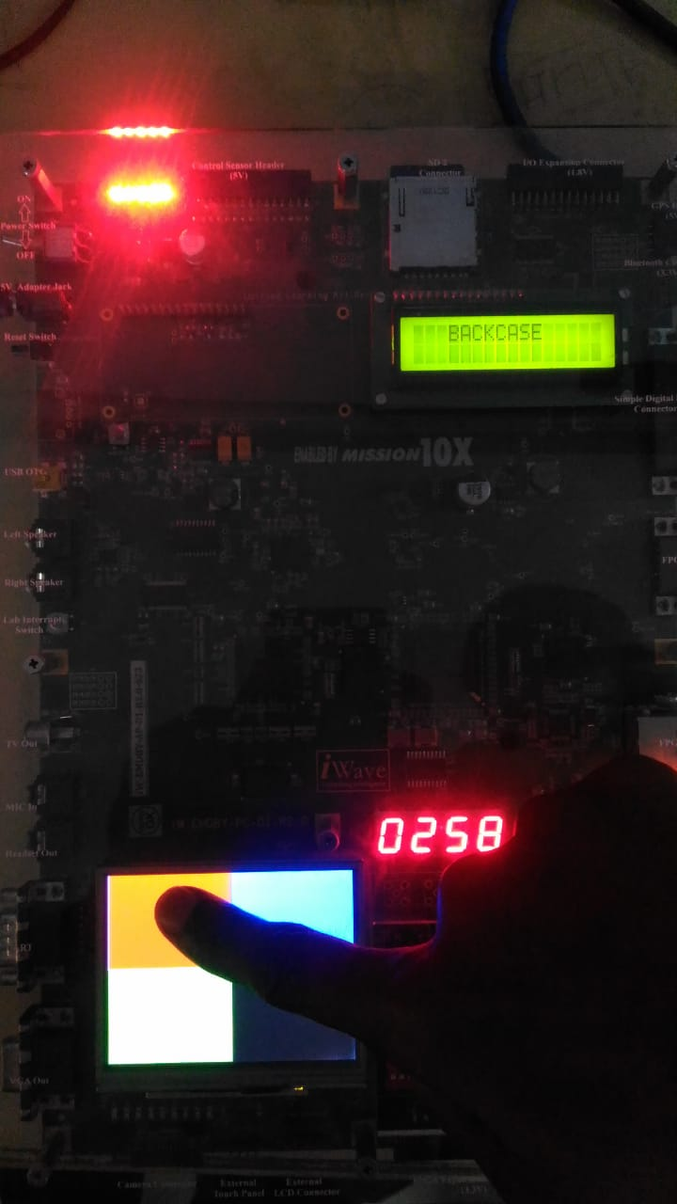

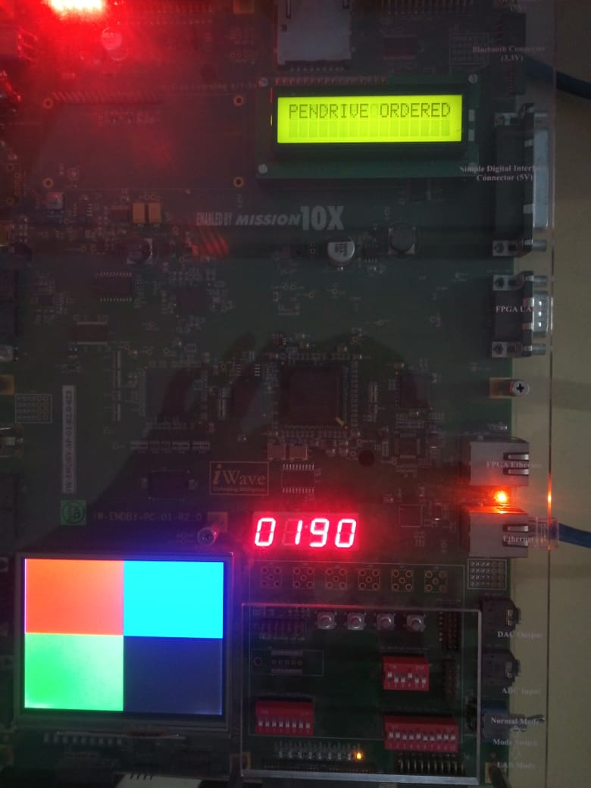

**ULK GRAPHICAL LCD INTERFACING**

•This interface is used to display a set of 4 different colors.

•Each color represents a particular product.

On touching a particular colour the respective product will be displayed on the character LCD.

**ULK 7 SEGMENT DISPLAY INTERFACING**

•The 7 segment display is used to display the price of the product.

Whenever a product is selected the price will be displayed . This will be helpful for the users.

**ULK LED INTERFACING**

LED is used to indicate if the product is selected or not..

•If the LED glows, it means that the user has seelcted the product.

**CONCLUSION**

The project is thus helpful implementing a product display system in shops so that user can know the prices.It can be further implemented to many products.