SIMATS ENGINEERING
ASSESSMENT TOOL I – RELATIONSHIP VISUALIZATION LAB
Course: Data Handling and Visualization | Code: DSA0603 | CO: CO4
Duration: 60 min | Total Marks: 50 | Reg No : 192524029  Name: KAILASH M

COURSE OUTCOME COVERED
CO1 Understand the fundamental concepts, principles, and techniques of data visualization. (BL3) Activity Tool : Relationship Visualization Lab
Weightage: 20%
Code of Conduct:
I KAILASH M (192524029) certify that this submission is my original work and that I have adhered to the guidelines specified for this assessment. I understand that any violation of academic integrity rules will result in disciplinary action.
Signature of the student:KAIALSH M
Criteria | Selection of  Relationship  Visualization  25% | Relationship  Analysis  25% | Application of Visualization  Techniques  20% | Organization  15% | Accuracy  10% | Clarity  5% | Total
Q1
Q2
Q3
Q4
Q5

QUESTION 1 – Multivariate Scatterplot (Weight, MPG, Cylinders, Horsepower)
library(ggplot2)
library(corrplot)

mtcars_data <- mtcars

# Convert cylinders to factor
mtcars_data$cyl <- as.factor(mtcars_data$cyl)

# Q1
ggplot(
mtcars_data,
aes(
x = wt,
y = mpg,
color = cyl,
size = hp
)
) +
geom_point(alpha = 0.8) +
geom_smooth(
method = "lm",
se = TRUE,
color = "black"
) +
labs(
title = "Relationship Between Car Weight and Fuel Efficiency",
x = "Weight (1000 lbs)",
y = "Miles per Gallon (mpg)",
color = "Cylinders",
size = "Horsepower"
) +
theme_minimal()

# Pearson correlation
cor(mtcars_data$mpg, mtcars_data$wt)

QUS 1 OUTPUT:
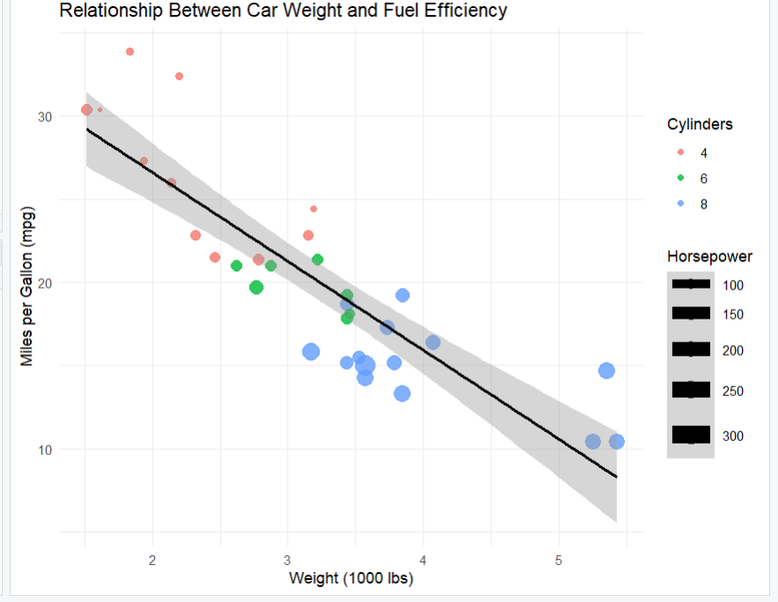
Relationship Between Car Weight and Fuel Efficiency

Q1 INTERPRETATION
- The scatterplot combines four variables: weight (x), mpg (y), cylinder count (color), and horsepower (size), allowing a single chart to communicate multiple relationships at once.
- Weight and mpg show a clear negative linear relationship, confirmed by a Pearson correlation of approximately -0.87.
- Cars with more cylinders and higher horsepower cluster toward the heavier, lower-mpg region of the plot.
- The linear regression line with a confidence band helps communicate both the trend and the uncertainty around it.
- Encoding four variables in one static scatterplot works here because the sample size is small (32 cars); with larger datasets this approach would become cluttered and a faceted or interactive alternative would be preferable.

QUESTION 2 – Correlogram (Correlation Matrix Visualization)
# Use original numeric mtcars dataset
mtcars_numeric <- mtcars
cor_matrix <- cor(mtcars_numeric)

corrplot(
cor_matrix,
method = "color",
type = "upper",
order = "hclust",
addCoef.col = "black",
number.cex = 0.7,
tl.col = "black",
tl.srt = 45,
col = colorRampPalette(
c("blue", "white", "red")
)(200),
title = "Correlogram of mtcars Variables",
mar = c(0, 0, 2, 0)
)

QUS 2 OUTPUT:
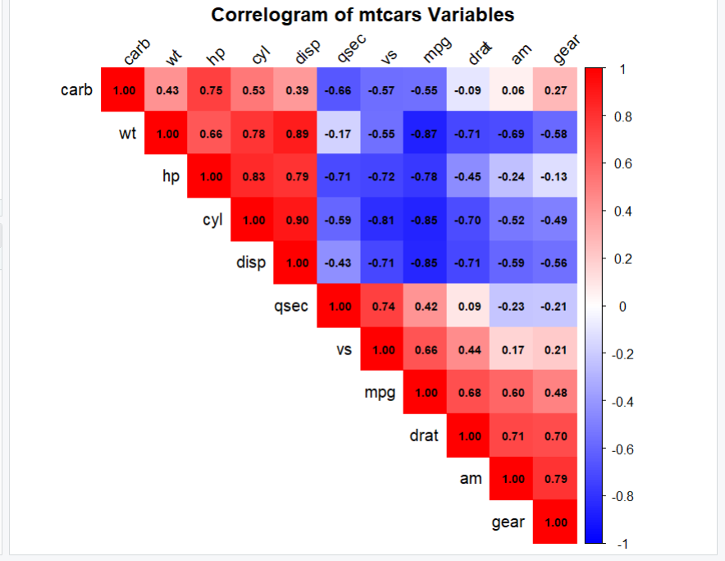
Correlogram of mtcars Variables

Q2 INTERPRETATION
- The correlogram compresses an 11x11 correlation matrix into a single, colour-coded chart, which is far faster to scan than a raw numeric table.
- Hierarchical clustering (order = "hclust") groups variables with similar correlation patterns next to each other, making blocks of related variables visually obvious.
- Displaying only the upper triangle avoids redundant duplication of each pairwise correlation.
- Strong negative correlations (e.g. wt vs mpg, cyl vs mpg) appear in deep blue, while strong positive correlations (e.g. disp vs cyl) appear in deep red, so direction and strength are both readable at a glance.
- Printing the numeric coefficient on top of the colour tile removes any ambiguity that a colour scale alone could introduce.

QUESTION 3 – Dimension Reduction Comparison: PCA vs t-SNE
# ============================================================
# Q3 - DIMENSION REDUCTION COMPARISON
# PCA vs t-SNE
# No external dataset required
# ============================================================

library(ggplot2)
library(Rtsne)

set.seed(123)
n <- 150

data <- data.frame(
X1 = c(rnorm(50, 2, 0.5), rnorm(50, 6, 0.5), rnorm(50, 10, 0.5)),
X2 = c(rnorm(50, 2, 0.5), rnorm(50, 6, 0.5), rnorm(50, 10, 0.5)),
X3 = c(rnorm(50, 2, 0.5), rnorm(50, 6, 0.5), rnorm(50, 10, 0.5)),
X4 = c(rnorm(50, 2, 0.5), rnorm(50, 6, 0.5), rnorm(50, 10, 0.5)),
Group = factor(rep(c("Group A", "Group B", "Group C"), each = 50))
)

numeric_data <- data[c("X1", "X2", "X3", "X4")]
scaled_data <- scale(numeric_data)

# ---------------- PART A - PCA ----------------
pca_result <- prcomp(scaled_data, center = TRUE, scale. = TRUE)
summary(pca_result)

variance <- (pca_result$sdev^2 / sum(pca_result$sdev^2)) * 100
print(round(variance, 2))

pca_data <- data.frame(
PC1 = pca_result$x[, 1],
PC2 = pca_result$x[, 2],
Group = data$Group
)

ggplot(pca_data, aes(x = PC1, y = PC2, color = Group)) +
geom_point(size = 3, alpha = 0.8) +
labs(
title = "PCA Visualization",
subtitle = "First two principal components",
x = "Principal Component 1",
y = "Principal Component 2",
color = "Group"
) +
theme_minimal(base_size = 13)

# ---------------- PART B - t-SNE ----------------
set.seed(123)
tsne_result <- Rtsne(
scaled_data, dims = 2, perplexity = 30,
verbose = TRUE, max_iter = 1000
)

tsne_data <- data.frame(
TSNE1 = tsne_result$Y[, 1],
TSNE2 = tsne_result$Y[, 2],
Group = data$Group
)

ggplot(tsne_data, aes(x = TSNE1, y = TSNE2, color = Group)) +
geom_point(size = 3, alpha = 0.8) +
labs(
title = "t-SNE Visualization",
subtitle = "Two-dimensional nonlinear representation",
x = "t-SNE Dimension 1",
y = "t-SNE Dimension 2",
color = "Group"
) +
theme_minimal(base_size = 13)

cat("\nPCA:\n",
"PCA is a linear dimensionality reduction technique.\n",
"It transforms several variables into principal components.\n",
"The first components preserve the largest amount of variance.\n")

cat("\nt-SNE:\n",
"t-SNE is a nonlinear dimensionality reduction technique.\n",
"It is mainly useful for identifying local clusters and complex relationships.\n")

cat("\nConclusion:\n",
"PCA is easier to interpret and useful for preserving overall variance.\n",
"t-SNE is more suitable for visualizing clusters and nonlinear patterns.\n")

QUS 3 OUTPUT:
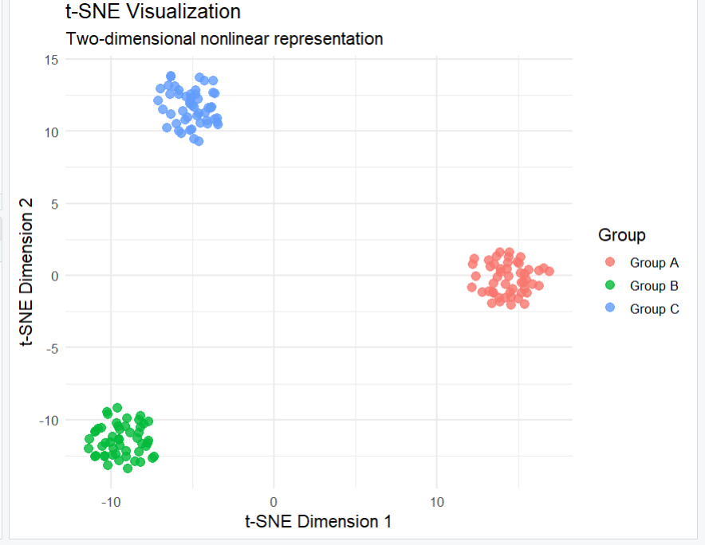
t-SNE Visualization – Two-dimensional nonlinear representation

Q3 INTERPRETATION
- Both PCA and t-SNE were applied to the same simulated 4-dimensional dataset containing three well-separated groups.
- PCA is a linear technique: it finds the directions (principal components) that capture the most variance and is easy to interpret because each axis has a direct mathematical meaning.
- t-SNE is a nonlinear technique that preserves local neighbourhood structure, so it is especially effective at revealing tight, well-separated clusters, as seen in the plot above.
- For this dataset both methods recover the three groups clearly, since the groups are already well separated in the original 4D space.
- In general, PCA is preferred when interpretability and preservation of global variance matter, while t-SNE is preferred when the priority is visualizing local cluster structure in complex, nonlinear data.

QUESTION 4 – Bubble Chart (GDP, Life Expectancy, Population, Continent)
library(ggplot2)

# Simulated data
data <- data.frame(
Country = c("India", "China", "USA", "Brazil", "Germany",
"France", "Japan", "Nigeria", "Australia", "Canada",
"Mexico", "UK"),
Continent = c("Asia", "Asia", "Americas", "Americas",
"Europe", "Europe", "Asia", "Africa",
"Oceania", "Americas", "Americas", "Europe"),
GDP = c(2500, 6000, 45000, 9000, 35000, 32000,
30000, 2200, 40000, 38000, 12000, 36000),
LifeExp = c(67, 73, 78, 72, 80, 81, 83, 55,
82, 81, 75, 81),
Population = c(1100, 1300, 300, 190, 82, 64,
127, 140, 21, 33, 105, 60)
)

# Bubble chart
ggplot(
data,
aes(
x = GDP,
y = LifeExp,
size = Population,
color = Continent
)
) +
geom_point(alpha = 0.7) +
geom_text(
aes(label = Country),
vjust = -0.8,
size = 3
) +
scale_x_log10() +
scale_size_continuous(
range = c(3, 18)
) +
labs(
title = "GDP per Capita vs Life Expectancy",
subtitle = "Bubble size represents population",
x = "GDP per Capita (Log Scale)",
y = "Life Expectancy (Years)",
size = "Population",
color = "Continent"
) +
theme_minimal(base_size = 13)

QUS 4 OUTPUT:
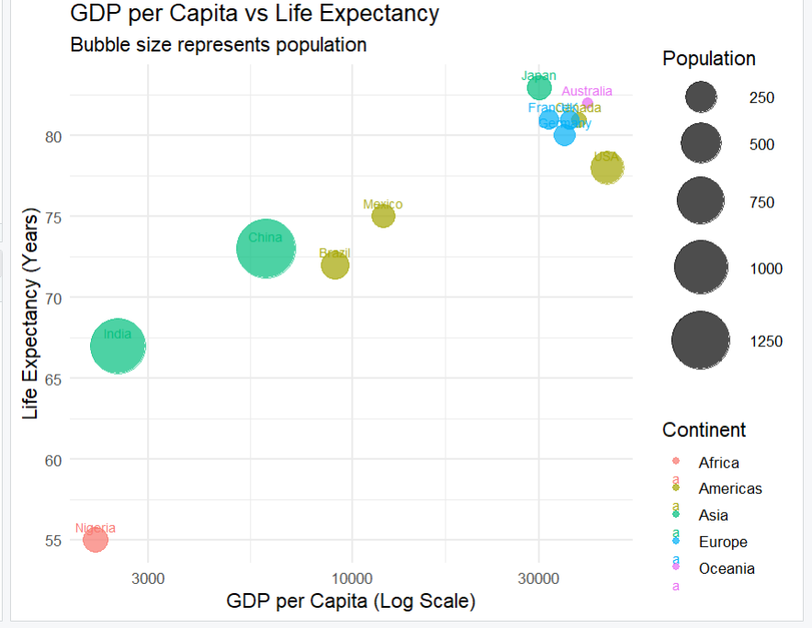
GDP per Capita vs Life Expectancy – Bubble size represents population

Q4 INTERPRETATION
- The bubble chart encodes four variables simultaneously: GDP (x-axis, log scale), life expectancy (y-axis), population (bubble size), and continent (colour).
- A log scale on the x-axis is necessary because GDP per capita spans a very wide range (from about 2,200 to 45,000); a linear scale would compress the lower-income countries into a narrow band.
- Higher-GDP countries (USA, Australia, Germany, Canada, France, UK, Japan) cluster toward the top-right with longer life expectancy, while Nigeria stands out as a low-GDP, low-life-expectancy outlier.
- Large bubbles for India and China immediately highlight that these two countries dominate global population despite differing GDP levels.
- Overlapping labels for closely clustered high-income countries (e.g. France, Canada, Germany) reduce readability, which is a common trade-off in bubble charts with many similarly-positioned points.

QUESTION 5 – Hexbin Plot vs Network Graph
# ============================================================
# Q5: HEXBIN PLOT vs NETWORK GRAPH
# NO EXTERNAL DATASET REQUIRED
# ============================================================
library(ggplot2)
library(MASS)
library(igraph)
library(hexbin)

# ---------------- PART A - HEXBIN PLOT ----------------
set.seed(123)

cov_matrix <- matrix(c(1, 0.75, 0.75, 1), nrow = 2)

sim_data <- MASS::mvrnorm(
n = 10000, mu = c(0, 0), Sigma = cov_matrix
)

hex_data <- data.frame(X = sim_data[, 1], Y = sim_data[, 2])
correlation <- cor(hex_data$X, hex_data$Y)

cat("PART A - HEXBIN PLOT\n")
cat("Pearson Correlation:", round(correlation, 3), "\n")

ggplot(hex_data, aes(x = X, y = Y)) +
geom_hex(bins = 40) +
labs(
title = "Hexbin Plot of 10,000 Correlated Observations",
subtitle = "Hexagon density represents observation count",
x = "Variable X",
y = "Variable Y",
fill = "Count"
) +
theme_minimal(base_size = 13)

# ---------------- PART B - NETWORK GRAPH ----------------
network_data <- data.frame(
from = c("Ava","Ava","Ava","Ben","Ben","Cleo","Cleo",
"Dax","Dax","Elin","Elin","Fenn","Fenn","Grey","Hana"),
to = c("Ben","Cleo","Dax","Cleo","Elin","Dax","Fenn",
"Elin","Grey","Fenn","Hana","Grey","Hana","Hana","Ava"),
weight = c(5,8,4,7,6,9,5,6,4,8,5,7,6,9,3)
)

network <- graph_from_data_frame(network_data, directed = FALSE)

degree_centrality <- degree(network, mode = "all")
cat("\nDegree Centrality:\n")
print(degree_centrality)

highest_node <- names(
degree_centrality[degree_centrality == max(degree_centrality)]
)
cat("\nHighest Centrality Node:", paste(highest_node, collapse = ", "), "\n")

set.seed(123)
plot(
network,
layout = layout_with_fr(network),
vertex.size = 10 + degree_centrality * 6,
vertex.label = V(network)$name,
vertex.label.cex = 1,
vertex.label.color = "black",
edge.width = 1 + E(network)$weight,
edge.color = "grey40",
main = "Network Graph: Degree Centrality and Edge Weight"
)

QUS 5 OUTPUT:
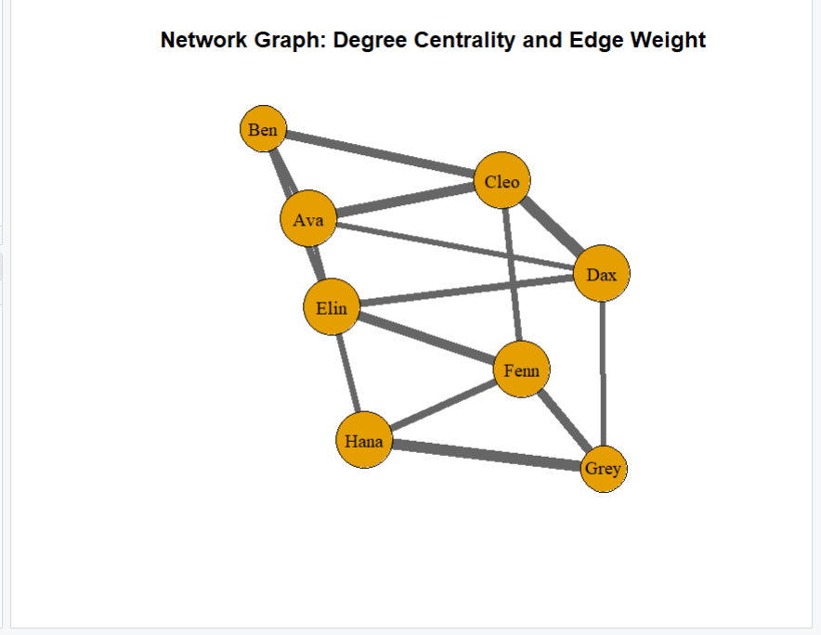
Network Graph: Degree Centrality and Edge Weight

Q5 INTERPRETATION
- Part A (Hexbin Plot): with 10,000 simulated, correlated observations, a standard scatterplot would suffer from severe overplotting. Binning points into hexagons and colouring by count reveals the true density of the joint distribution, including the strong positive correlation (~0.75) between X and Y.
- Part B (Network Graph): node size is mapped to degree centrality and edge width to relationship weight, so the most connected and most heavily-weighted individuals are immediately visible without reading a table of numbers.
- The node with the highest degree centrality occupies a structurally important position in the network, acting as a hub through which many relationships pass.
- Overall conclusion: hexbin plots are appropriate for large numerical datasets where overplotting is a concern, whereas network graphs are appropriate for visualizing connections and relationships between discrete entities — the two techniques solve fundamentally different visualization problems.

