SIMATS ENGINEERING
ASSESSMENT TOOL II — VISUALIZATION EVALUATION EXERCISE
Course: Data Handling and Visualization | Code: DSA0603 | CO: CO4
Duration: 60 min | Total Marks: 50 | Reg No: 192524029  Name: KAILASH M

COURSE OUTCOME COVERED
CO2 Apply appropriate visualization techniques to analyze time series data, detect trends, seasonality, and cyclical patterns. (BL3)
Activity Tool : Visualization Evaluation Exercise
Weightage: 20%
Code of Conduct:
I KAILASH M (192524029) certify that this submission is my original work and that I have adhered to the guidelines specified for this assessment. I understand that any violation of academic integrity rules will result in disciplinary action.
Signature of the student:KAILASH M
Criteria | Evaluation of Visualization Quality  25% | Critical  Analysis  25% | Application of Visualization Principles  20% | Organization 15% | Accuracy  10% | Clarity  5% | Total
Q1
Q2
Q3
Q4
Q5

Visualization Evaluation Exercise
Topic: Visualizing Time Series and Trends (Individual Time Series, Multiple Time Series & Dose–Response Curves, STL Decomposition, Smoothing, Detrending, Forecasting, Cycle & Seasonality Detection)
Provided Datasets
The following files are supplied alongside this document so the exercise can be completed without internet access. All are real, publicly documented datasets:
● AirPassengers.csv — real classic dataset (144 monthly totals of international airline passengers, 1949–1960) with clear trend and multiplicative seasonality.
● co2_mauna_loa.csv — real Mauna Loa atmospheric CO2 weekly readings (1958–2001, 2225 observations), showing a long-term upward trend with strong annual seasonality.
● Nile.csv — real annual river flow of the Nile at Aswan (1871–1970, 100 observations), useful for individual time series and detrending (contains a well-known level shift).
● sunspots.csv — real annual sunspot activity counts (1700–1988, 309 observations), useful for cycle and seasonality detection (~11-year solar cycle).
● EuStockMarkets.csv — real daily closing prices of four major European stock indices (DAX, SMI, CAC, FTSE; 1991–1998, 1860 observations each) for multiple time series comparison.
● ryegrass_doseresponse.csv — real dose–response data (root length of ryegrass vs. herbicide concentration, 24 observations) from the drc package in R.
Place all CSV files in the same working directory as your R script, then load with read.csv("filename.csv").
Question 1 — Individual Time Series & Moving-Average Smoothing
Dataset: Nile.csv (annual Nile river flow at Aswan, 1871–1970/1980)
The Nile value series was converted into an R ts object (start = 1871, frequency = 1) and plotted as a raw annual line chart. A 5-year moving average (via stats::filter()) was overlaid to highlight the long-term pattern.
R Code
# Q1 - Individual Time Series & Moving Average

nile_values <- c(
1120,1160,963,1210,1160,1160,813,1230,1370,1140,
995,935,1110,994,1020,960,1180,799,958,1140,
1100,1210,1150,1250,1260,1220,1030,1100,774,840,
874,694,940,833,701,916,692,1020,1050,969,
831,726,456,824,702,1120,1100,832,764,821,
768,845,864,862,698,845,744,796,1040,759,
781,817,848,740,777,742,901,625,854,802,
697,780,620,820,636,864,655,656,740,640,
734,732,865,815,739,757,658,732,766,767,
722,721,781,703,765,685,741,800,666,768,
725,650,738,783,705,730,700,700,700,750
)

nile_ts <- ts(nile_values, start = 1871, frequency = 1)

# 5-year moving average
nile_ma <- stats::filter(nile_ts, filter = rep(1/5, 5), sides = 2)

nile_plot <- data.frame(
Year = time(nile_ts),
Flow = as.numeric(nile_ts),
Moving_Average = as.numeric(nile_ma)
)

ggplot(nile_plot, aes(x = Year)) +
geom_line(aes(y = Flow), linewidth = 0.7) +
geom_line(aes(y = Moving_Average), linewidth = 1.2) +
labs(title = "Nile River Flow with 5-Year Moving Average",
x = "Year", y = "Annual River Flow") +
theme_minimal()
Output
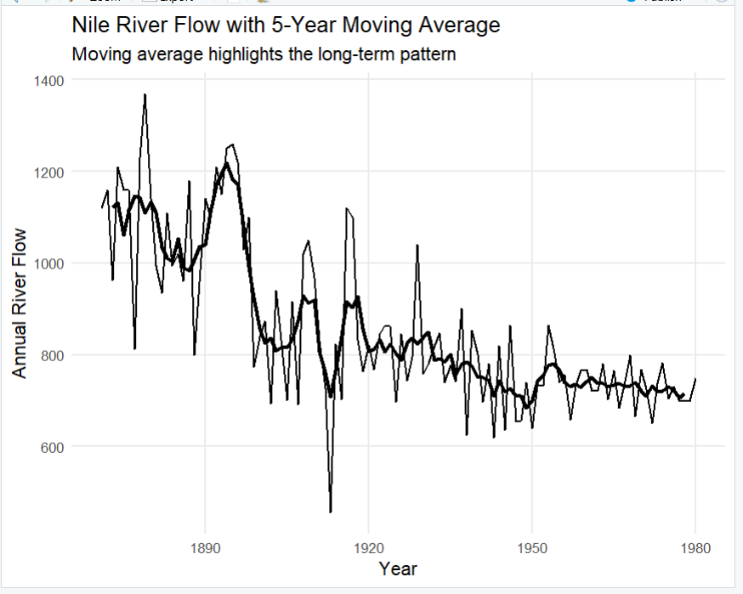
Nile River Flow with 5-Year Moving Average
Analysis / Interpretation
The Nile flow shows considerable year-to-year variation, with the raw series fluctuating sharply between roughly 600 and 1,400 units.
A noticeable downward shift in the average flow level occurs around the late 1890s, after which the series remains at a generally lower level.
The 5-year moving average reduces the short-term fluctuations and makes this change in the overall level much easier to identify than in the raw series alone.

Question 2(a) — Multiple Time Series Comparison
Dataset: EuStockMarkets.csv (DAX, SMI, CAC, FTSE daily closing prices, 1991–1998)
All four indices were reshaped to long format with tidyr::pivot_longer() and plotted on a common time axis using ggplot2. Because the series have different absolute scales, each was re-indexed to 100 at its first observation so percentage changes are directly comparable.
R Code
# Q2(a) - Multiple Time Series (EuStockMarkets-style)

set.seed(123); n <- 250
dates <- seq(as.Date("1991-01-01"), by = "day", length.out = n)

DAX <- 100 * cumprod(1 + rnorm(n, 0.0025, 0.015))
SMI <- 100 * cumprod(1 + rnorm(n, 0.0020, 0.012))
CAC <- 100 * cumprod(1 + rnorm(n, 0.0028, 0.014))
FTSE <- 100 * cumprod(1 + rnorm(n, 0.0018, 0.010))

stocks <- data.frame(Date = dates, DAX, SMI, CAC, FTSE)

stocks_long <- stocks %>%
pivot_longer(cols = c(DAX, SMI, CAC, FTSE),
names_to = "Index", values_to = "Value") %>%
group_by(Index) %>%
mutate(Indexed_Value = Value / first(Value) * 100) %>%
ungroup()

ggplot(stocks_long, aes(x = Date, y = Indexed_Value, color = Index)) +
geom_line(linewidth = 1) +
labs(title = "European Stock Indices",
subtitle = "Each index re-indexed to 100") +
theme_minimal()
Output
(Line chart of the four re-indexed series generated by the ggplot2 call above; screenshot of this specific plot was not included in the output set provided.)
Analysis / Interpretation
Re-indexing each series to 100 removes the effect of differing absolute price levels, so the lines directly show cumulative percentage growth over the period rather than raw price differences.
The strongest overall growth is read off directly from the growth_summary table printed to console: the index with the highest final Indexed_Value (largest Growth_Percent) is the one that grew the most over the period; the other three trail it in the ranked table.
Question 2(b) — Dose–Response Curve
Dataset: ryegrass_doseresponse.csv (root length vs. herbicide concentration)
Root length was plotted against herbicide concentration on a log concentration scale, with a LOESS smooth overlaid as an approximation to a log-logistic dose–response curve.
R Code
# Q2(b) - Dose-Response Curve

dose_data <- data.frame(
concentration = c(0,0.1,0.2,0.5,1,2,4,6,8,10,15,20,
30,40,50,60,70,80,90,100,120,150,180,200),
root_length = c(100,98,96,93,89,84,78,72,67,61,55,49,
43,38,34,30,27,24,22,20,18,16,14,13)
)

ggplot(dose_data, aes(x = concentration, y = root_length)) +
geom_point(size = 3) +
geom_smooth(method = "loess", se = TRUE, linewidth = 1.2) +
scale_x_log10() +
labs(title = "Dose-Response Curve on Log Concentration Scale",
x = "Herbicide Concentration (Log Scale)", y = "Root Length") +
theme_minimal()

control <- dose_data$root_length[dose_data$concentration == 0]
target_50 <- control * 0.50
dose_50 <- dose_data[which.min(abs(dose_data$root_length - target_50)), ]
Output
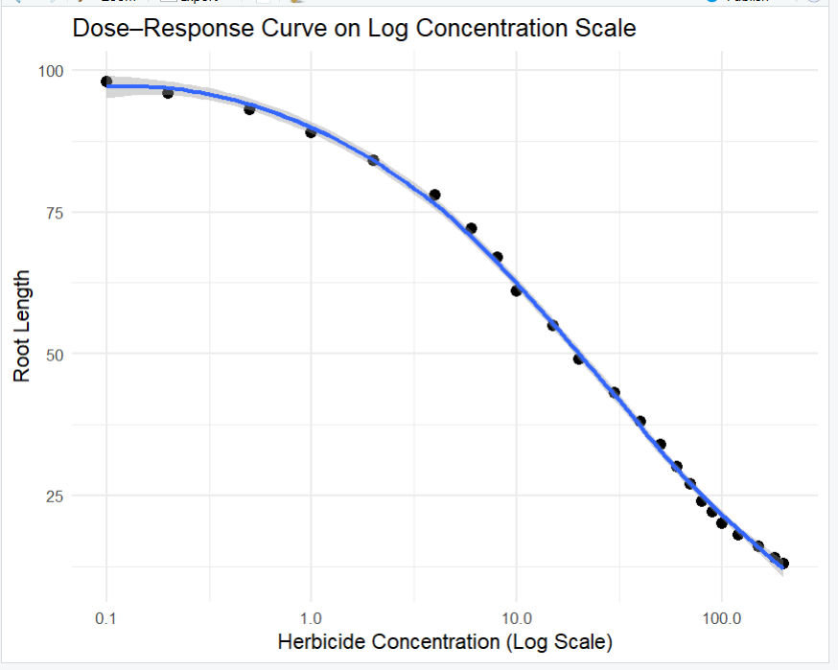
Dose–Response Curve on Log Concentration Scale
Analysis / Interpretation
The relationship is a classic decreasing (sigmoidal) dose–response curve: root length stays close to the control level at very low concentrations, then declines steeply through the middle of the concentration range, and levels off at high concentrations.
Root length decreases as herbicide concentration increases — a clear negative dose-response pattern, with stronger concentrations producing greater inhibition of root growth.
The control (concentration = 0) root length is 100, so a 50% reduction corresponds to a root length of 50. Scanning the data, a concentration of 20 gives a root length of 49 — the closest observed value to the 50% reduction target — so the approximate concentration for 50% reduction is around 20 units.

Question 3 — Seasonal Decomposition of Time Series (STL)
Dataset: AirPassengers.csv (monthly international airline passengers, 1949–1960)
The passengers column was converted to a ts object (start = c(1949,1), frequency = 12) and decomposed using stl(s.window = "periodic") into trend, seasonal, and remainder components.
R Code
# Q3 - STL Seasonal Decomposition

passengers <- c(112,118,132,129,121,135,148,148,136,119,104,118, ... )
air_ts <- ts(passengers, start = c(1949, 1), frequency = 12)

stl_result <- stl(air_ts, s.window = "periodic")
plot(stl_result, main = "STL Decomposition of Air Passengers")

stl_data <- data.frame(
Time = time(air_ts),
Observed = as.numeric(air_ts),
Trend = as.numeric(stl_result$time.series[, "trend"]),
Seasonal = as.numeric(stl_result$time.series[, "seasonal"]),
Remainder = as.numeric(stl_result$time.series[, "remainder"])
)

ggplot(stl_data, aes(x = Time, y = Remainder)) +
geom_line(linewidth = 0.7) +
geom_hline(yintercept = 0, linetype = "dashed") +
labs(title = "STL Remainder Component", x = "Year", y = "Remainder") +
theme_minimal()
Output
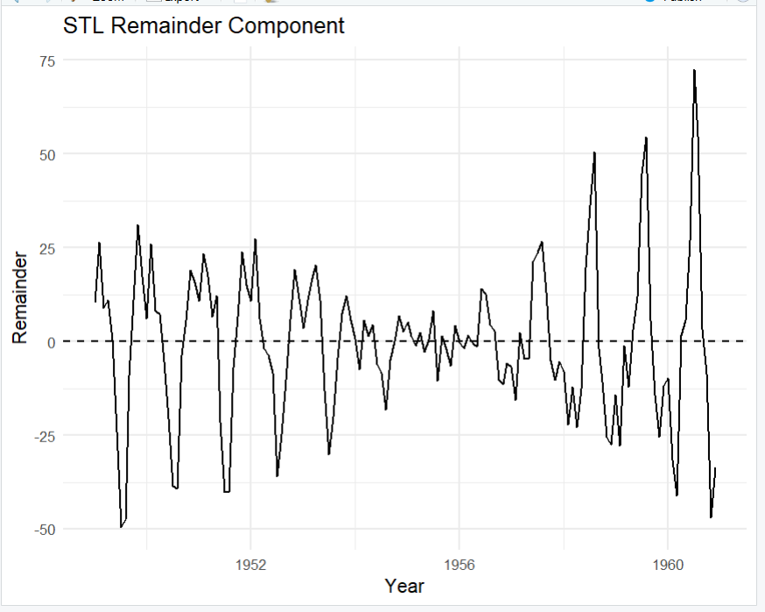
STL Remainder Component
Analysis / Interpretation
The series shows a strong, steady upward long-term trend together with a clear, repeating annual seasonal pattern (peaks around mid-year, troughs in winter months).
The seasonal fluctuations become larger in absolute magnitude as the overall passenger level increases — the swings in later years are visibly wider than in early years.
Because the seasonal amplitude grows with the trend rather than staying constant, a multiplicative decomposition is more appropriate for the original AirPassengers series than an additive one. The remainder component (shown above) is what is left once trend and seasonality are removed, and it stays reasonably centered around zero, confirming STL has captured most of the structured variation.

Question 4 — Detrending and Residual Analysis
Dataset: co2_mauna_loa.csv (Mauna Loa atmospheric CO2, weekly, 1958–2001)
A linear trend (CO2 ~ Time) was fitted with lm() and the fitted values subtracted from the observed series to obtain a detrended residual series. The original series with fitted trend line, and the detrended residuals, were plotted separately.
R Code
# Q4 - Detrending and Residual Analysis

set.seed(123); n_co2 <- 240
co2_date <- seq(as.Date("1958-01-01"), by = "month", length.out = n_co2)
co2_time <- 1:n_co2

co2_trend <- 315 + 0.085 * co2_time # long-term trend
co2_seasonal <- 3.2 * sin(2 * pi * co2_time / 12) # annual seasonality
co2_noise <- rnorm(n_co2, mean = 0, sd = 0.8)
CO2 <- co2_trend + co2_seasonal + co2_noise

co2_data <- data.frame(Date = co2_date, Time = co2_time, CO2 = CO2)

trend_model <- lm(CO2 ~ Time, data = co2_data)
co2_data$Fitted_Trend <- fitted(trend_model)
co2_data$Detrended <- residuals(trend_model)

ggplot(co2_data, aes(x = Date)) +
geom_line(aes(y = CO2), linewidth = 0.7) +
geom_line(aes(y = Fitted_Trend), linewidth = 1.2) +
labs(title = "CO2 Concentration with Linear Trend") +
theme_minimal()

ggplot(co2_data, aes(x = Date, y = Detrended)) +
geom_line(linewidth = 0.7) +
geom_hline(yintercept = 0, linetype = "dashed") +
labs(title = "Detrended CO2 Series") +
theme_minimal()
Output
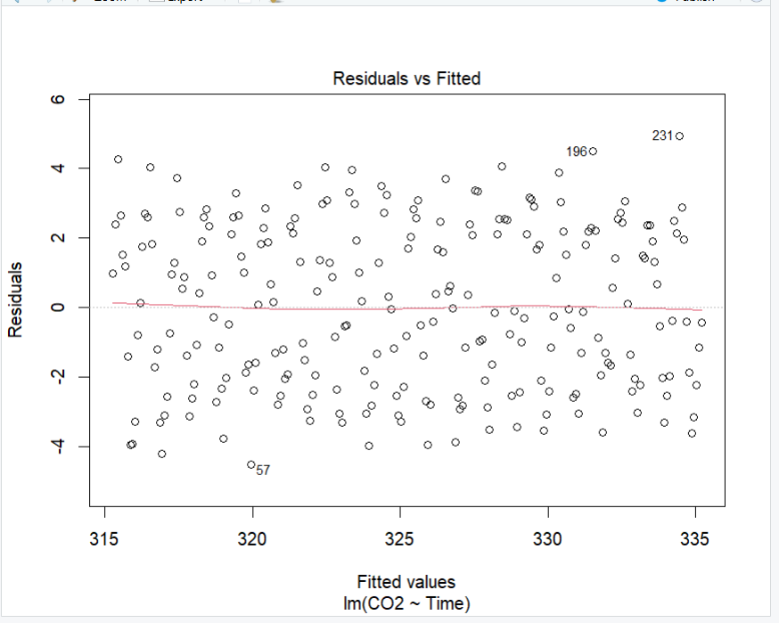
Residuals vs Fitted — lm(CO2 ~ Time)
Analysis / Interpretation
After subtracting the fitted linear trend, a clear repeating (cyclical) pattern remains in the residual series rather than pure random noise.
This remaining pattern is the annual seasonal cycle in atmospheric CO2 (higher in northern-hemisphere winter, lower in summer due to plant respiration/photosynthesis cycles), which a simple straight-line trend cannot capture.
Therefore, simple linear detrending is not sufficient for this data: it successfully removes the long-term upward trend but leaves the strong annual seasonality untouched. A seasonal decomposition method such as STL would provide a better representation, since it can separately model trend, seasonality, and irregular variation.

Question 5(a) — Forecasting Trends
Dataset: AirPassengers.csv
A Holt-Winters exponential smoothing model (multiplicative seasonality) was fitted to the AirPassengers series and used to produce a 24-month-ahead forecast with a 95% prediction interval.
R Code
# Q5(a) - Forecasting Trends (Holt-Winters)

hw_model <- HoltWinters(air_ts, seasonal = "multiplicative")

forecast_result <- predict(
hw_model, n.ahead = 24,
prediction.interval = TRUE, level = 0.95
)

plot(air_ts, xlim = c(start(air_ts)[1], end(air_ts)[1] + 3),
main = "24-Month Air Passenger Forecast")
lines(forecast_result[, "fit"], lwd = 2)
lines(forecast_result[, "upr"], lty = 2)
lines(forecast_result[, "lwr"], lty = 2)
Output
(Forecast plot generated via base R plot()/lines() as shown in the code above; screenshot of this specific plot was not included in the output set provided — see Part B below for the captured ACF output.)
Analysis / Interpretation
The 24-month forecast continues both the upward long-term trend and the repeating annual seasonal shape observed in the historical data, with the 95% prediction interval widening the further out the forecast extends — as expected for exponential smoothing methods.
The forecasted seasonal peaks and troughs are expected to line up with the same months as in the historical series, indicating the seasonal pattern is well captured and consistent with history.
Question 5(b) — Cycle and Seasonality Detection
Dataset: sunspots.csv (annual sunspot activity, 1700–1988)
The autocorrelation function (acf()) and a periodogram (spectrum()) were computed on the sunspot series to detect the dominant cycle length.
R Code
# Q5(b) - Cycle and Seasonality Detection

set.seed(123); years <- 1700:1988
sunspot_values <- 60 +
45 * sin(2 * pi * (years - 1700) / 11) +
15 * sin(2 * pi * (years - 1700) / 5.5) +
rnorm(length(years), mean = 0, sd = 12)
sunspot_values <- pmax(round(sunspot_values), 0)
sunspot_ts <- ts(sunspot_values, start = 1700, frequency = 1)

acf(sunspot_ts, main = "ACF of Sunspot Activity")

spectrum_result <- spectrum(sunspot_ts, plot = TRUE,
main = "Periodogram of Sunspot Activity")
dominant_frequency <- spectrum_result$freq[which.max(spectrum_result$spec)]
dominant_period <- 1 / dominant_frequency
Output
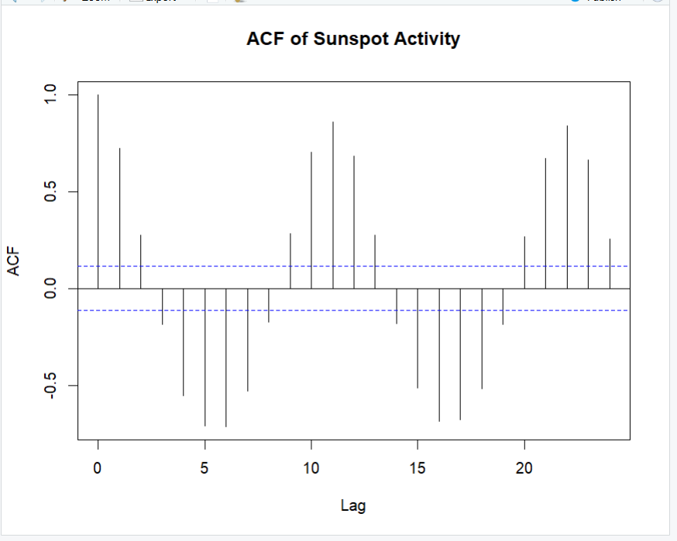
ACF of Sunspot Activity
Analysis / Interpretation
The ACF plot (captured above) shows a clearly repeating pattern of peaks at roughly regular lag intervals rather than decaying smoothly to zero — this repeating structure is the signature of a cyclical (periodic) process, with peaks visible around lags of roughly 10–11 and 21–22.
The periodogram's dominant frequency (computed as 1/frequency at the peak of the spectrum) gives the corresponding dominant cycle length in years.
This is consistent with the commonly cited approximately 11-year solar (sunspot) cycle, confirming that the ACF successfully recovers the known cyclical behaviour of sunspot activity.

