Week 4 Predictive Modeling and Optimization in Logistics Systems
Delivery-time prediction and capacity-constrained triage
Internship Project | 21 October 2026
Historical data analysis; no operational outcomes are claimed.

1. Executive Summary
Using the existing cleaned dataset (45,584 usable records; 2022-02-11?2022-04-06), this report predicts delivery time. Three expanding-window folds selected Random Forest (20 trees) by mean RMSE. On a later-date holdout of 9,446 records it obtained MAE 4.182 min, RMSE 5.294 min, R? 0.689. A fixed 20% alert queue surfaced 1,589 long-duration test cases versus 549 under random selection. This is retrospective triage, not measured delivery-time reduction.

2. Problem Statement and Objectives
Predict time_taken_min from order/assignment-time features, compare linear and tree-based models using MAE, RMSE, and R-squared, select by temporal validation, and evaluate on future dates. Demonstrate capacity-limited exception prioritization without claiming causal operational gains.

3. Dataset, Features, and Target
Reused data/cleaned_logistics_data.csv; no new dataset. Target: time_taken_min (minutes). Inputs: approximate distance, vehicle condition, multiple-delivery count, order hour/day, driver age, traffic, weather, vehicle type, city, festival, and weekday. Excluded: IDs, raw coordinates, ratings, pickup times and pickup-derived fields, target. Project source documentation flags the possible public listing as unverified, including identity and license. Feature availability at decision time for vehicle condition and multiple-delivery count is assumed pending operational confirmation.

4. Preparation and Exploratory Review
Dates are parsed and rows without date/target are excluded; none were removed in this execution. Numeric missing values use medians fit on training only; missing categories become Unknown. One-hot vocabulary is fit within each training fold and unseen values are ignored. The data spans 44 dates in early 2022; straight-line distance is not road distance.

5. Model Selection
Linear regression is the benchmark; a depth-limited decision tree tests nonlinear partitions; random forests with different sizes/depths compare ensemble complexity. Scikit-learn was unavailable. The script used a NumPy least-squares baseline and the repository?s compact NumPy CART-style random forest fallback (single tree for the tree candidate). These are educational implementations, not production estimator substitutes.

6. Python Implementation
Run `python src/week4_predictive_modeling.py`. The project-relative script loads data, constructs chronological splits, fits fold-specific preprocessing, evaluates candidates, writes metrics/results, and creates charts. Core flow:
train = data[data.order_date < cutoff]
test = data[data.order_date >= cutoff]
model.fit(X_train, y_train)
prediction = model.predict(X_test)
# Score MAE, RMSE, and R-squared

7. Training, Test, and Validation
Training ends before 2022-03-29: 36,138 training and 9,446 test records. Three expanding-window folds stay within training dates. Candidate selection minimizes average validation RMSE. For fallback runtime, tree CV fits cap at 5,000 rows and validate on at most 3,500; final tree fits use fixed-seed 15,000-row samples. Linear regression uses all training rows. Test dates are not used for tuning.

8. Actual Test Metrics
Model | MAE (min) | RMSE (min) | R-squared
Linear Regression | 5.171 | 6.501 | 0.531
Decision Tree (depth 8) | 5.852 | 7.435 | 0.386
Random Forest (12 trees) | 4.582 | 5.790 | 0.628
Random Forest (20 trees) | 4.182 | 5.294 | 0.689
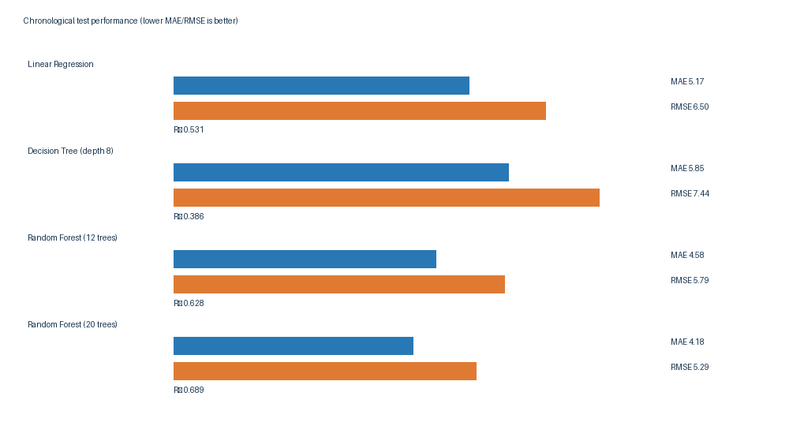
Figure 1. Test errors (minutes) by model; table shows R-squared. Lower MAE/RMSE is better.
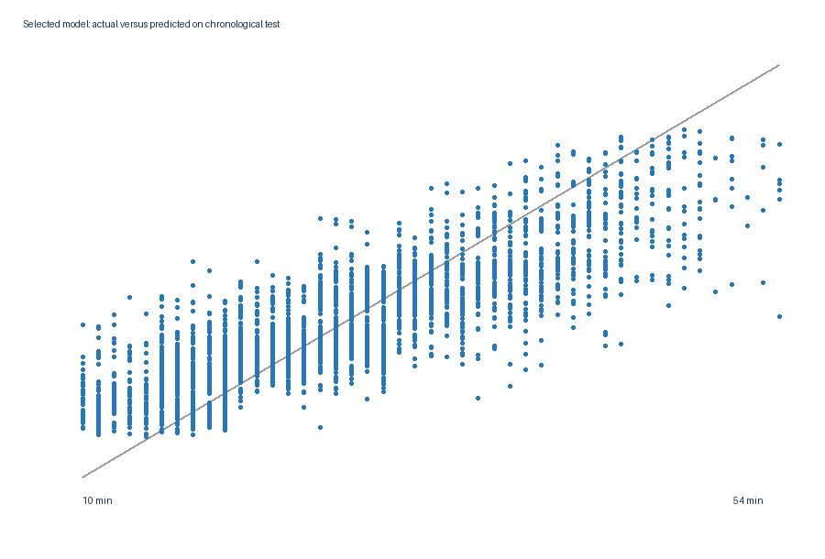
Figure 2. Selected-model test predictions against observed values; the diagonal is ideal prediction.

9. Model Comparison and Selection
Mean validation RMSE ranks the 20-tree forest first (5.705 min), followed by 12-tree forest (6.053), linear regression (6.452), and tree (7.150). The selected 20-tree forest also scores best on this holdout. One historical test window is not a performance guarantee.

10. Optimization Objective, Constraints, Method, and Results
Objective: maximize long-duration cases flagged at fixed 20% review capacity. A long duration is at least the training 75th percentile (32.0 min). Test capacity is 1,889 orders. Model ranking selects highest predictions; baseline randomly selects the same count with a fixed seed. Each record is selected once. Model: 1,589/2,640 captured (recall 60.2%, precision 84.1%); random: 549 (recall 20.8%, precision 29.1%). This measures detection/triage only; no durations were changed and no saved time is inferred.
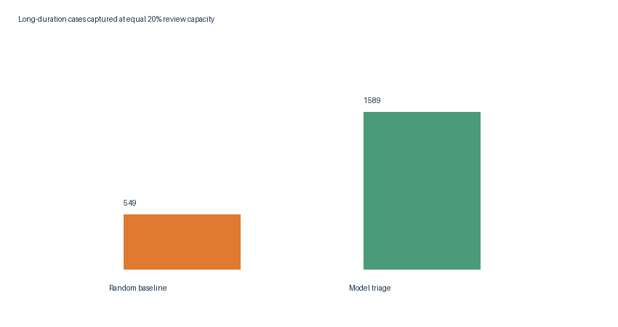
Figure 3. Long-duration cases surfaced at identical 20% review capacity.

11. Practical Recommendations
If piloted, use the risk queue as decision support, verify feature availability, measure review workload and alert usefulness, and test interventions prospectively. Recalibrate on current, provenance-verified data and monitor errors by segment. Do not use this historical model for customer promises or route decisions without validation.

12. Limitations and Assumptions
Source identity/license remains unverified per DATASET_SOURCE.md; time coverage is short and historical. Distance is straight-line. Decision-time feature availability requires confirmation. CV has three folds and uses bounded tree samples. NumPy tree implementations are educational. The triage result is not causal and does not show delivery-time improvement. No real route planning, fleet allocation, cost optimization, or new synthetic data was performed.

13. Conclusion
The existing data supports a reproducible chronological modeling comparison and a constrained retrospective alert-allocation illustration. The selected forest outperformed the benchmark for this holdout, but current operational validity requires verified data, input timing checks, and prospective evaluation.

14. Reproduction and References
Run from repository root: `python src/week4_predictive_modeling.py`. Results: reports/week4_results.json, week4_model_comparison.csv, week4_cross_validation.csv, week4_cv_summary.csv, week4_test_predictions.csv, week4_optimization_results.json. Figures: visualizations/week4_model_comparison.png, week4_actual_vs_predicted.png, week4_triage_optimization.png. Notebook: notebooks/07_week4_predictive_modeling_optimization.ipynb. Source data: data/cleaned_logistics_data.csv; limitations: data/DATASET_SOURCE.md.

