Week 3 Internship Report
Advanced Data Analysis and Visualization in Logistics
Hypothetical synthetic shipment dataset | 1,000 records | Generated with seed 20261021
Prepared 21 October 2026
All records and findings are simulated for educational analysis. No organization or real dataset provenance is asserted.

Executive Summary
This report examines a reproducible synthetic dataset of 1,000 shipments over calendar year 2025. Mean delivery time is 44.91 minutes (median 43.05; SD 19.09); mean cost is 315.97 simulated currency units (median 270.17; SD 194.38). Distance correlates with duration (Pearson r=0.757) and cost (r=0.847). Severe-traffic records average 62.98 minutes versus 37.26 under low traffic. These results describe the stipulated generator only and do not demonstrate real-world causal effects.

Objectives and Methodology
The analysis checks data quality, computes descriptive statistics and Pearson correlations, compares delivery duration and cost across traffic, vehicle, and status groups, and summarizes monthly movement. Python, pandas, NumPy, and matplotlib when available are used; in the restricted environment Pillow generated charts. The fixed pseudorandom seed makes dataset generation reproducible.

Synthetic Dataset Schema and Assumptions
Fields: shipment_id, order_date, origin_zone, destination_zone, distance_km, weight_kg, traffic_condition, vehicle_type, delivery_time_min, transportation_cost, shipment_status, delayed. Dates are sampled across 2025. Distance is clipped to 1?55 km, weight to 0.3?180 kg. Duration is based on assumed vehicle speeds, a traffic increment, a small weight term, and random noise. Cost uses vehicle-specific assumed rates per kilometre, weight, and noise. Delay is sampled probabilistically from traffic and simulated duration. Currency is intentionally unspecified. This is not observed company data.

Data Quality and Summary Statistics
The CSV contains 1,000 rows and 12 columns, with zero missing cells, duplicate rows, or duplicate shipment identifiers. Distance mean 11.95 km (SD 7.43; median 10.17; range 1.13?55.00); weight mean 12.02 kg (SD 9.68; median 9.54; range 0.75?96.47). Delivery time mean 44.91 minutes (SD 19.09; median 43.05; range 8.0?129.1). Cost mean 315.97 (SD 194.38; median 270.17; range 45.00?1513.33) simulated units.
Histogram views show the observed sample spread and tails. They help identify where simulated observations concentrate, but outliers are not operational incidents.
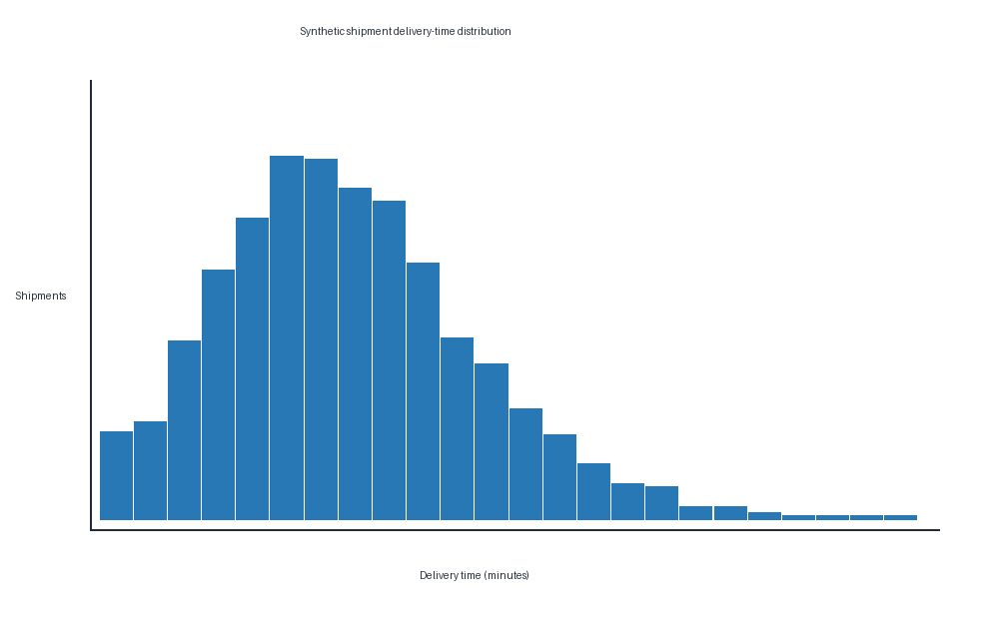
Figure 1: week3 delivery time distribution. Synthetic data visualization.
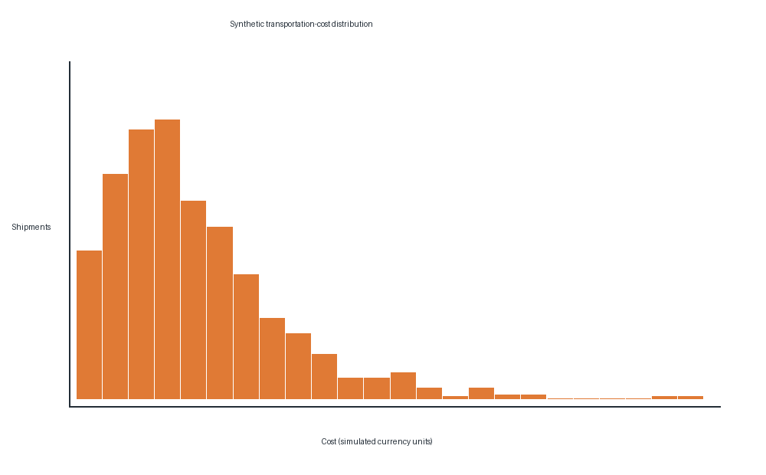
Figure 2: week3 transportation cost distribution. Synthetic data visualization.

Correlation Analysis
Pearson correlations: distance?delivery time 0.757; distance?cost 0.847; delivery time?cost 0.713; weight?delivery time 0.055; weight?cost 0.066. The heatmap provides a compact comparison of linear associations. Because formulas explicitly include distance and vehicle rate, these correlations partly reflect generator construction. Correlation does not establish causation.
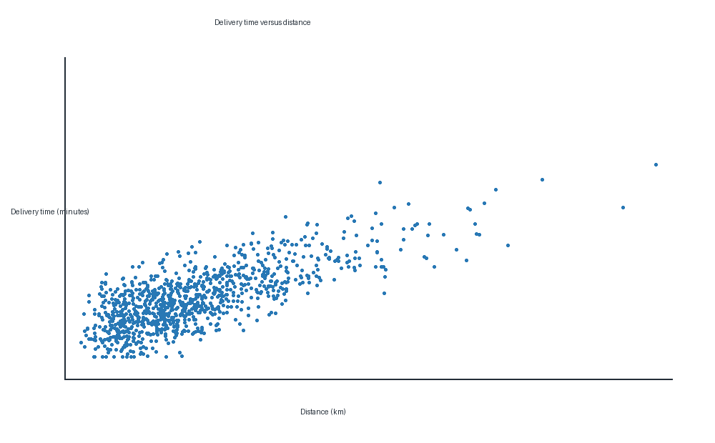
Figure 3: week3 correlation heatmap. Synthetic data visualization.

Group Comparisons and Visualizations
Mean delivery times by traffic are Low 37.26, Moderate 41.20, High 50.45, Severe 62.98 minutes. Mean costs by vehicle are Motorcycle 265.91, Van 336.61, Truck 444.47 simulated units. Delayed records average 52.06 minutes and on-time records 42.72 minutes; status is generated partly from duration, so this difference is structurally expected. Bar charts compare group averages; unequal group sizes and within-group variation should be considered. Group differences are descriptive associations, not causal estimates.
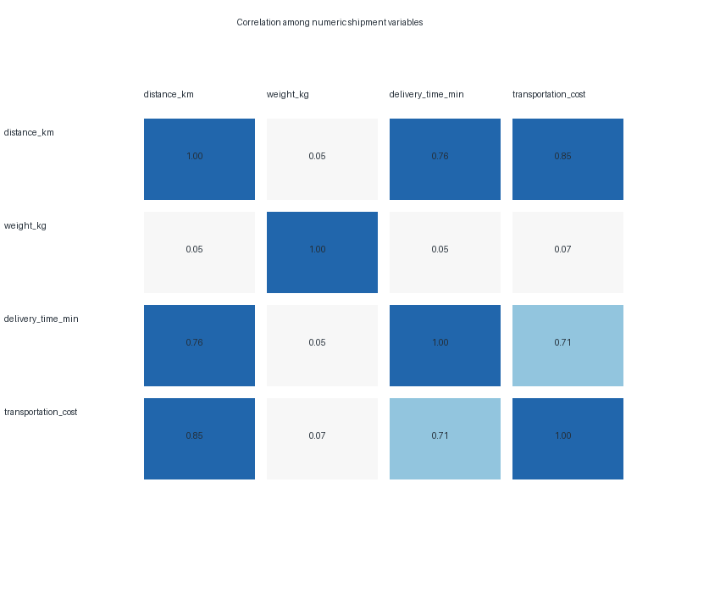
Figure 4: week3 delivery time by traffic. Synthetic data visualization.
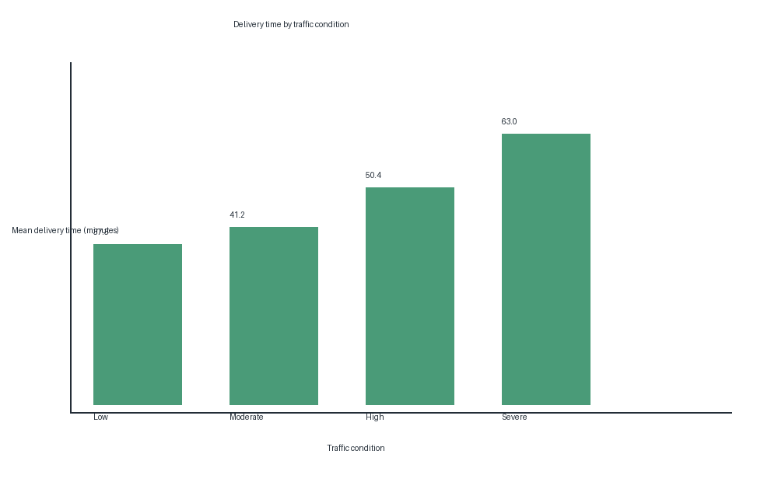
Figure 5: week3 cost by vehicle. Synthetic data visualization.
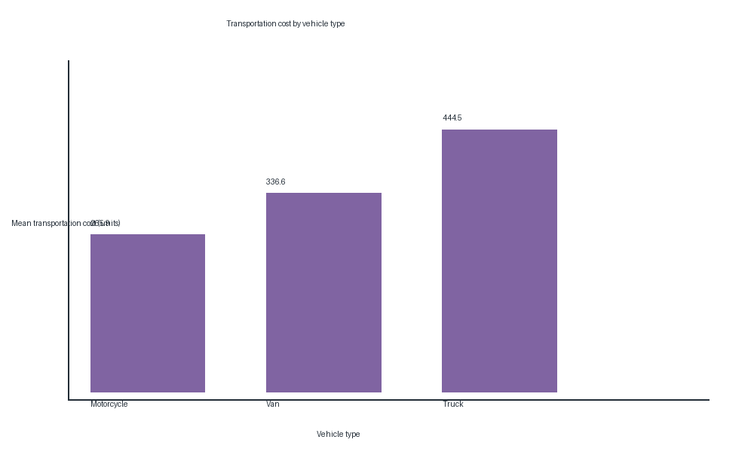
Figure 6: week3 delivery time by status. Synthetic data visualization.

Time Trend
Monthly mean duration ranges from 42.28 minutes in June to 48.15 in February. Since the simulation does not impose seasonality, this movement is best interpreted as sample variation. A monthly line chart shows temporal ordering without claiming a persistent seasonal effect.
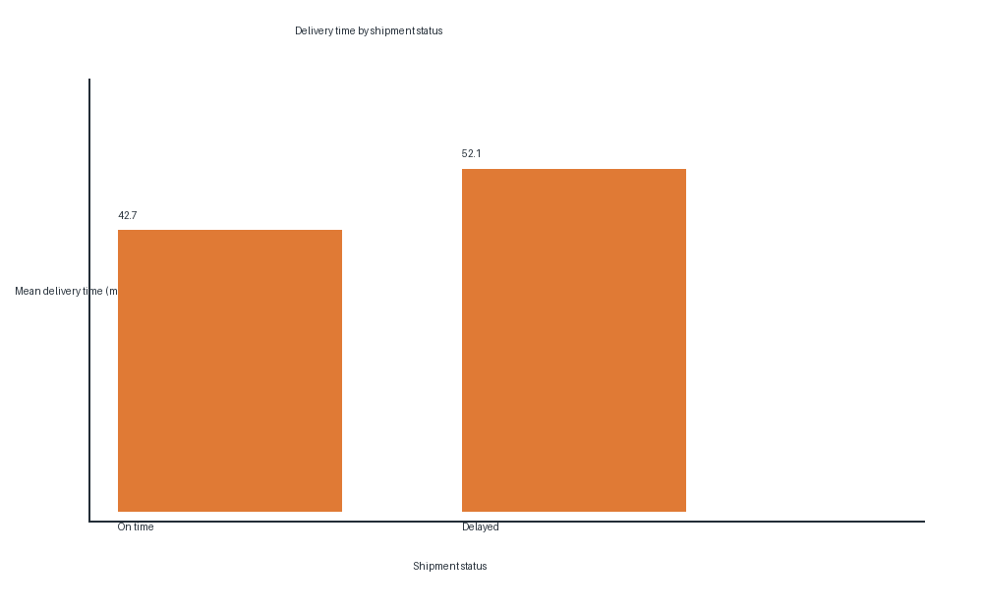
Figure 7: week3 monthly delivery time. Synthetic data visualization.

Logistics Insights and Recommendations
For actual operations, segment service monitoring by distance, traffic exposure, vehicle, and promised service level. Review long-duration and high-cost segments, and evaluate cost per completed shipment. Capacity or fleet decisions should use real event timestamps, route conditions, payload capacity, and validated service targets. Test changes prospectively or through an appropriate design; the synthetic group differences do not predict benefits.

Python Implementation
The analysis script is src/week3_logistics_eda.py. It generates the CSV with a fixed NumPy random seed when absent, checks shape/types/missingness/duplicates, writes summary statistics and correlation matrices as CSV, saves group comparisons and diagnostics as JSON, and produces eight figures. Outputs are under reports/ and visualizations/.

Limitations and Conclusion
The records are hypothetical, generated from simplified assumptions, and do not encode road-network distance, promised times, actual dispatch decisions, vehicle capacity, operating currency, or an identifiable logistics company. Results are not representative estimates and cannot justify operational decisions. The exercise demonstrates an EDA workflow and the need to validate patterns using real, appropriately governed operational data.

Project File References
data/week3_hypothetical_logistics.csv
src/week3_logistics_eda.py
notebooks/06_week3_advanced_logistics_eda.ipynb
reports/week3_summary_statistics.csv
reports/week3_correlations.csv
reports/week3_results.json
visualizations/week3_*.png

