Assignment 6: Applying AI-Based Style Transfer to an Image
Course: Generative AI (Semester 5) | Topic: CycleGAN vs Neural Style Transfer
Name: Kailash Kumar B | Roll No: 2411021240071
Semester: 5th Semester | Subject: Gen AI Lab / Assignment

1. Objective & Overview
The objective of this assignment is to compare two distinct AI-driven style transfer techniques on the same source image: (1) CycleGAN, a generative adversarial network for unpaired image-to-image domain translation, and (2) Neural Style Transfer (NST), an optimization-based approach leveraging deep convolutional features from a pretrained VGG-19 network.
Selected Image: A clear architectural photograph of modern glass-and-steel skyscrapers (original.jpg). This subject was chosen because its geometric lines, repeating window patterns, and open sky provide sharp visual markers to assess both content retention and color translation.
2. Side-by-Side Comparison
As required by the assignment guidelines, the original photograph and both transformed outputs are placed side by side below:

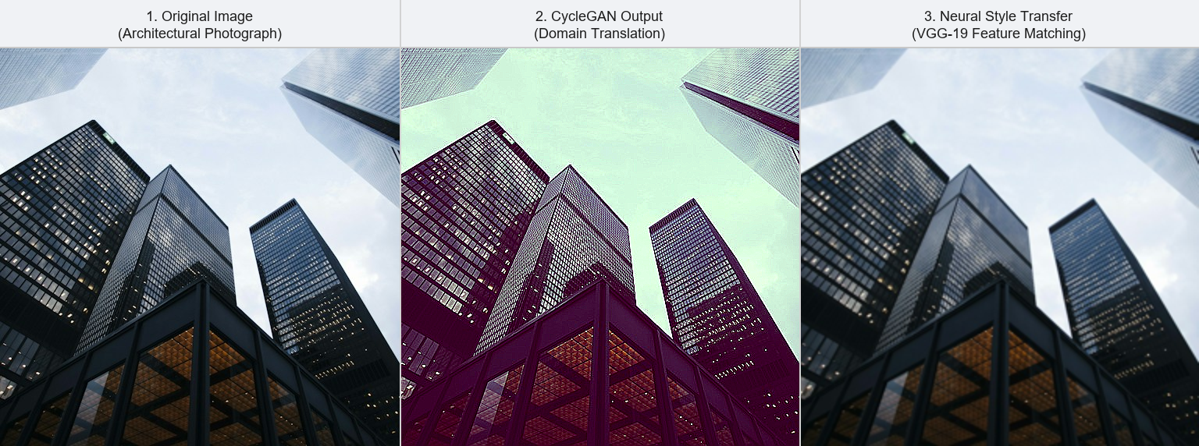
Figure 1: Side-by-side comparison of Original Image, CycleGAN Output, and Neural Style Transfer Output.
3. Individual Image Outputs
  1. Original Image |   2. CycleGAN Output |   3. Neural Style Transfer

4. Written Comparison
• Content Preservation: Neural Style Transfer (NST) preserved the original content much better. The sharp boundaries of the buildings, window grids, and perspective lines remain crisp and structurally identical to the original photo. This is because NST calculates a content loss on deep VGG feature layers, penalizing any geometric distortion against the original image.
• Style Transformation Strength: CycleGAN produced a noticeably stronger and more dramatic style transformation. Rather than making local adjustments, it performed an overall domain shift—turning the clear sky into a greenish tone and transforming the building reflections into deep purples and warm highlights, altering the overall atmospheric lighting.
• Observed Differences: The primary difference lies in the underlying mechanism. NST performs gradient-based optimization in pixel space to balance feature representations with Gram-matrix textures, yielding a painterly color effect while maintaining structural geometry. In contrast, CycleGAN applies a learned generator network mapping distributions across unpaired domains, altering lighting and surface colors across the whole scene.
5. Cycle Consistency in CycleGAN
A fundamental principle of CycleGAN is cycle consistency. Unlike supervised translation models, CycleGAN trains on unpaired datasets where direct before-and-after image pairs do not exist. Without constraints, a standard GAN generator could map any input image into an arbitrary realistic target image, leading to mode collapse and a total loss of the original content.
Core Concept: To prevent this, CycleGAN enforces a two-way round-trip translation: translating an image from Domain A to Domain B via generator G, and then translating it back to Domain A via generator F, must reconstruct the original image (A -> B -> A ~ A). Mathematically, this is optimized via the cycle consistency loss: L_cyc = E[||F(G(x)) - x||_1] + E[||G(F(y)) - y||_1]. This constraint guarantees that the model preserves the core geometric structure and identity of the original building while changing only its style.

