# SMART WERABLE HEALTH MONITORING SYSTEM

A Project report submitted

in partial fulfillment of requirement for the award of degree

## BACHELOR OF TECHNOLOGY

in

## SCHOOL OF COMPUTER SCIENCE AND ARTIFICIAL INTELLIGENCE

By

## S.KAILASH (2203A52174)

|  |  |
| --- | --- |
| **M ROHITH** | **(2203A52157)** |
| **CH VENKATA SHIVA SRI** | **(2203A52145)** |
| **M.DHEERAJ** | **(2203A52161)** |
| **S.AKHILANANDHA TEJA** | **(2203A52173)** |

Under the guidance of

## Dr.Pramoda Patro

Associate Professor, School of CS&AI.



SR University, Ananthsagar,Warangal,Telagnana-506371

# SR University

Ananthasagar, Warangal.



**CERTIFICATE**

This is to certify that this project entitled **“AI-Powered Synthetic Medical Data Generation for Privacy Preserving Research**" is the bonafied work carried out **Rohith, Shiva, Dheeraj, Akhil, Kailash** as a Major Project for the partial fulfillment to award the degree **BACHELOR OF TECHNOLOGY** in **School of Computer Science and Artificial Intelligence** during the academic year 2024-2025 under our guidance and Supervision.

## Dr.Pramoda Patro Dr. M.Sheshikala

Associate Professor Professor & Head,

SR University School of CS&AI,

Anathasagar,Warangal SR University

Ananthasagar, Warangal.

## Reviewer-1 Reviewer-2

Name: Name:

Designation: Designation:

Signature: Signature:

# ACKNOWLEDGEMENT

We owe an enormous debt of gratitude to our Major Project guide **Dr.Pramoda Patro,Assoc.Prof** as well as Head of the School of CS&AI , **Dr. M.Sheshikala, Professor** and Dean of the School of CS&AI, **Dr.Indrajeet Gupta Professor** for guiding us from the beginning through the end of the Capstone Project with their intellectual advices and insightful suggestions. We truly value their consistent feedback on our progress, which was always constructive and encouraging and ultimately drove us to the right direction. Finally, we express our thanks to all the teaching and non-teaching staff of the department for their suggestions and timely support.

TABLE OF CONTENTS

INTRODUCTION 1

PROBLEM IDENTIFICATION 2

CHAPTER 2 3

1. Functional Requirements: 3

2. Non-Functional Requirements: 3

**Feasibility Analysis** 4

1. Technical Feasibility: 4

2. Operational Feasibility: 4

3. Financial Feasibility: 4

CHAPTER 3 5

PROPOSED SOLUTION 5

System Architecture 5

Key Features of the Proposed System: 5

System Workflow: 6

MODEL TRAINING 7

System Architecture Overview 7

1. Hardware Layer: 7

2. Software Layer: 7

MODEL DESIGN 8

1. Input Features: 8

2. Training the Model: 8

3. Prediction: 8

Implementation Overview 11

**1.** Wearable Device (Hardware) 11

**2.** Data Collection & Preprocessing (Software) 11

**3.** Machine Learning Model Integration 12

**4.** User Interface & Visualization 12

**5.** Health Recommendations and Predictions 12

Program Flow 13

1. Initialization: 13

2. Data Transmission: 13

3. Data Preprocessing: 13

4. Model Prediction: 13

5. Health Insights Generation: 13

6. Visualization and Display: 13

7. User Interaction: 13

8. Continuous Monitoring: 13

PROGRAM 14

AI-Powered Synthetic Medical Data Generation for Privacy Preserving Research 14

CHAPTER 5 17

RESULTS 17

CHAPTER 6 18

LEARNING OUTCOME 18

PROJECT IMPACT AND FUTURE SCOPE 19

Future Scope 19

1. Technological Advancements: 19

2. Personalization and Adaptability: 19

3. Data Integration and Interoperability: 20

4. Commercialization and Community Use: 20

CONCLUSION 21

# LIST OF FIGURES

|  |  |  |
| --- | --- | --- |
| **Fig no** | **Title** | **Page no** |
| 1 | Architecture Diagram | 9 |
| 2 | Flow Chart | 10 |
| 3 | Result screens | 16 |

**ABSTRACT**

Smart Wearable employs AI technology to monitor personal health data through its tracking system making it an innovation in health monitoring. The healthcare system provides users with real-time access to health assessment, prediction, and management capabilities through wearable technology and artificial intelligence. This system interprets data streaming from wearable device sensors using machine learning algorithms, particularly Random Forest Regressor. The system gathers essential health statistics which include heart rate combined with step counts alongside caloric consumption and other physical indicators.

The system's main function involves developing a user-friendly tracking system which shows customized health suggestions in addition to monitoring essential health data elements. Machine learning supports the system to analyze large volumes of health information which allows it to provide relevant individualized health recommendations available to a larger pool of users. The system provides users with interactive visuals which display health patterns alongside personal achievement progress so users gain knowledge for making aware healthcare choices.

This wearable system meets the requirements of everyday users because it measures physical activities while also helping users control calories and lead balanced lifestyles. This system functions as a customized helper to help users during their health-related activities including physical improvement efforts and weight management plus basic health status tracking. The system uses predictive features which empower users to estimate healthcare developments from existing data points making healthcare prevention possible.

# CHAPTER 1

# INTRODUCTION

Modern life requires us to hold excellent health above all else. The current busy lifestyle combined with health disorders related to modern living makes it difficult to effectively track and administer personal health. Wearable health technology serves as an effective solution to health tracking problems by allowing users to observe their physical activities together with their sleep patterns and calorie usage in real time. Most current health monitoring systems do not have sufficient artificial intelligence capabilities to deliver customized results that people can use.

The proposed system addresses wearable health device problems by integrating Artificial Intelligence-based Smart Wearable Health Monitoring System technology. The wearble device contains sensors that let users track their health data including heart rate and step counting through real-time feedback. Random Forest Regressor operates as the distinctive feature of this system by utilizing a machine learning algorithm to predict health patterns together with calculating calorie expenditure estimates.

The core purpose of this work is developing an accessible system able to record health data with real-time health suggestions derived from information received in real-time. The system displays actionable health insights through simple visualizations which enables all users to implement their monitoring whether they hold technical skills or not.

Such a system proves beneficial to users who need to track their exercise routines and count calories or manage their health outcome. Through its predictive elements the system enables users to gain valuable predictions about their health development which enables them to take proactive measures for their health. Research in this project demonstrates how artificial intelligence connected with wearable technology creates potential transformative power for personal healthcare management through data-based personalized guidance.

# PROBLEM IDENTIFICATION

Health issues keep increasing worldwide because people continuously grow more aware of their wellness levels and daily caloric intake together with their fitness transformation. As health awareness rises more people find it difficult to track their health condition consistently while lacking access to customized information that may guide their lifestyle decisions. The current generation of health monitoring devices performs well in counting steps and measuring heart rate yet they fail to generate calculated recommendations or future projection from actual time information.

Users face confusion when trying to use their gathered health data because tracking systems lack proper integration between measurement data and personalized guidance. Multiple health systems lack the capability to generate precise individualized health guidance thus resulting in reduced effectiveness when users aim to improve their health outcomes. The majority of wearable health devices fail to maximize artificial intelligence systems for processing patient data and generating predictions which users can use to change their daily habits immediately.

The existing market shortage provides chances to develop innovative solutions. A system that tracks health metrics plus generates useful predictions about user health needs immediate development because it would promote better overall health experiences.

# CHAPTER 2

**Requirement Analysis, Risk Analysis, Feasibility Analysis**

An AI-based Smart Wearable Health Monitoring System must have detailed knowledge of functional and non-functional requirements during its development. The system base needs these requirements to build a solution that satisfies user needs and expectations.

### Functional Requirements:

* + **Data Collection and Monitoring:** A wearable device must gather actual time health-related data regarding vital metrics including heart rate and step count and calorie consumption and other statistics. Wireless sensors installed within the system need to maintain both accuracy and reliability for their purpose of continuous observation.
  + **Machine Learning Integration:** The system should integrate Random Forest Regressor as its machine learning algorithm to process gathered data for calorie expenditure estimates. By running analysis against the health data the system can generate meaningful patterns which show user trends regarding their fitness health.
  + **Health Suggestions and Recommendations:** The analyzed data requires the system to produce custom health-related suggestions including nutrition and physical guidance that improves user wellness.
  + **Interactive Visualization:** The system requires an interactive visualization aspect which presents user-friendly displays for health data together with clear suggestions that utilize understandable graphical representations. Users will be able to monitor their performance through this system which allows them to modify their actions.
  + **Prediction and Trend Analysis:** This system produces health trends predictions through data analytics which provides users ahead look at their possible health states to guide proactive lifestyle decisions.

### Non-Functional Requirements:

* + **Usability:** The system needs to display user-friendly access which enables people from all age groups along with different technical skill levels to easily operate both the wearable equipment and its software applications.
  + **Scalability:** The system needs a built-in capability to process large datasets that grow from consistent user healthcare tracking during extended periods. The program needs capabilities to grow and function with updated implementations and new functionality features.
  + **Security:** User data must have its security and privacy protected because health information is sensitive through secure data storage and encryption techniques in addition to compliance with privacy laws.
  + **Battery Life:** The wearable device requires lasting energy efficiency to deliver uninterrupted monitoring except when users need to recharge.

### **Feasibility Analysis**

The analysis uses operational, financial and technical aspects to determine whether a project can succeed through feasibility assessment.

### Technical Feasibility:

* + Both wearable technology and machine learning algorithms exist at a high level of feasibility due to present-day advancements in their development. The Random Forest Regressor demonstrates high capability for health-related metric prediction while several existing devices allow fundamental health tracking functionality.
  + The build of such a system is feasible today using present hardware and existing software development tools. The proper selection between sensors combined with optimized algorithms and carefully designed user interface makes the system operate effectively.
  + The system implementation can proceed with cost-efficient development because it uses machine learning technology through open-source frameworks like TensorFlow together with Scikit-learn and visualization tools including D3.js and Plotly.

### Operational Feasibility:

* + Users need minimal input because the wearable system operates solo to collect data which it sends instantly to the user. Users who have limited technical knowledge can easily use the system through this design.
  + The health monitoring system can incorporate predictive features because proven time series forecasting algorithms exist for health systems that predict patient outcomes.

### Financial Feasibility:

* + Wearable device development and machine learning implementation requires an initial research phase but the expenses stay affordable. Health sensors along with wearable technology have reasonable prices while machine learning programs become operational using public data that precedes production deployment.
  + Health monitoring devices and personal health insights show vast market potential which assures sustainable profitability for this project in the long run. The expanding user need for solutions which assist healthy living motivates a substantial demand for this system.

# CHAPTER 3

# PROPOSED SOLUTION

This AI-enabled Smart Wearable Health Monitoring System derives from a design which gives people access to instantaneous data-driven health information. Users can access a complete health management system because this proposed system joins artificial intelligence with modern wearable technology elements. The system aims to link collected data with tailored health advice so users acquire daily tools for their health administration and improvement.

### System Architecture

The complex system combines two primary features which include wearable technology units and processing software that analyzes the data. A wearable device gathers records from health sensors which measure heart rate as well as steps taken and calorie burn alongside additional health parameters. The sent data gets processed on the software platform through machine learning algorithms for analysis.

The analysis happens through the Random Forest Regressor which works to examine data to produce estimates regarding essential health metrics like calorie expenditure. Individual wellness recommendations with activity planning as well as meal and lifestyle upgrade suggestions are generated by processed tested data. The system uses historical data to make future health predictions so users can implement preventive measures that enhance or preserve their health condition.

### Key Features of the Proposed System:

1. **Real-time Data Collection:** Health metrics tracked continuously by the wearable device maintain recent data as the latest information.
2. **Machine Learning for Data Analysis:** A personalized analysis of health data occurs through advanced machine learning methods which include Random Forest Regressor.
3. **Health Suggestions:** Different health recommendations emerge from the analysis to deliver customized care for individual users. structured plans which concentrate on specific health areas and incorporate fitness plans and nutritional guides together with wellness objectives.
4. **User Interface and Visualization:** A clean user interface guides users through viewing their health data as they monitor their continuous progress during the system usage period. The program presents health metrics through charts and graphs to simplify their complex understanding for users.
5. **Predictive Health Insights:** Through data analysis the system conducts future health trend predictions that help users monitor their health state and incoming wellness challenges.
6. **Secure and Private Data Handling:** The system maintains user data security and privacy as its highest priority. All stored personal health information maintains the highest security standards and each user retains ownership of their dataset's control.

### System Workflow:

1. **Data Collection:** Users can monitor their heart rate steps along with their calorie usage since sensors inside the wearable device perform this function.
2. **Data Transfer and Processing:** The measured data transfers to a software platform for processing through machine learning algorithms.
3. **Analysis and Recommendation:** The programmed Random Forest Regressor conducts a data analysis within the system to deliver individualized health-related insights and recommendations to users.
4. **Visualization:** Users can grasp their health condition and progress by observing charts and graphs and graphical trends that appear through the user-friendly interface of the system.
5. **Predictive Insights:** The systematic analysis of historical health data lets the system forecast future medical trends to provide essential long-term healthcare guidance to users.

# MODEL TRAINING

The AI-based Smart Wearable Health Monitoring System employs a Model Design & Architecture which processes input data from the wearable device in real-time effectively. User recommendations for health purposes stem from components within the system that pair sensors in wearable devices with machine learning-based data processing algorithms.

## System Architecture Overview

The architecture of the system is divided into two main layers: the hardware layer and the software layer.

## Hardware Layer:

* + **Wearable Device:** The AI-based Smart Wearable Health Monitoring System employs a Model Design & Architecture which processes input data from the wearable device in real-time effectively.
  + **Connectivity:** User recommendations that suit health needs are produced through the integrated system structure that combines wearable device sensors and machine learning algorithms.

## Software Layer:

* + **Data Collection & Preprocessing:** Data coming from wearable devices reaches the software platform for preprocessing operations. The preliminary work includes data cleaning together with handling missing values while applying normalization techniques for better analysis.
  + **Machine Learning Model**: The central element of the system operates through the Random Forest Regressor. The model receives training through historical health data to forecast major health metrics including calorie expenditure. The model generates predictions through analysis of heart rate together with activity level and other measured statistics.
  + **Health Suggestions Module:** After processing the data and generating forecasts the system produces individualized health recommendation for each user. The system presents expert recommendations about both exercise quantity and diet along with additional lifestyle adjustments.
  + **User Interface & Visualization:** The user-friendly interface presents the processed data and insights and recommendations to the users. The system displays data visualizations through graphical elements such as graphs and trend lines together with charts which allows users to monitor their advancement.

## MODEL DESIGN

The Random Forest Regressor model has been chosen because it demonstrates both reliability with intricate datasets along with dependable prediction capabilities involving multiple input parameters. To create the model we use the following design structure:

## Input Features:

* + Heart rate
  + Steps taken
  + The degree of physical activity determines what actions the person performs among walking, running or remaining stationary.
  + Sleep data
  + Time of day
  + Previous data (for predictive modeling)

## Training the Model:

* + The system receives input from historical medical information of users that serves to train the model. The training system operates with health measurement data combined with related calorie consumption values.
  + The data preprocessing techniques include feature selection combined with normalization methods followed by handling missing values to achieve high- quality training data.

## Prediction:

* + The model achieves training completion enabling it to forecast calorie expenditure through continuously processed health information. The system obtains data from a wearable device and sends live predictions to display for users.

**ARCHITECTURE DIAGRAM**

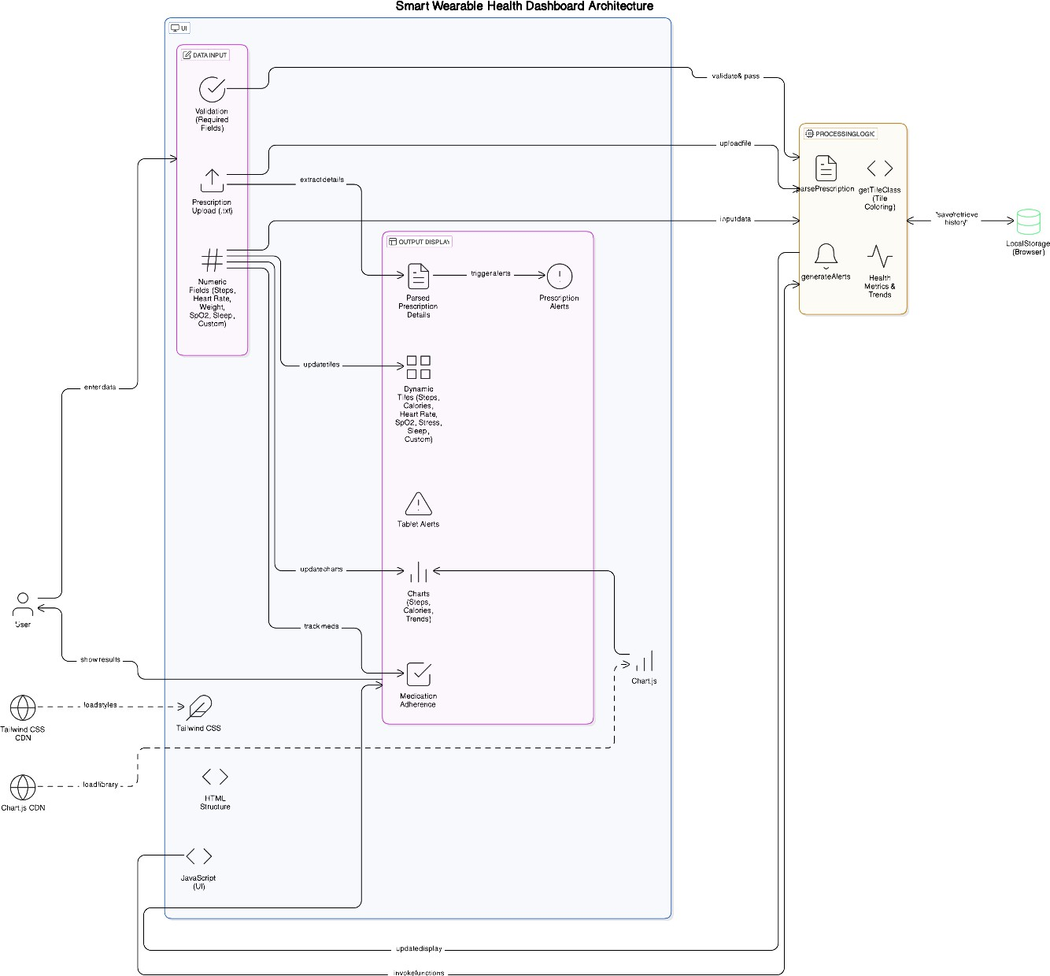

**FLOW CHART**

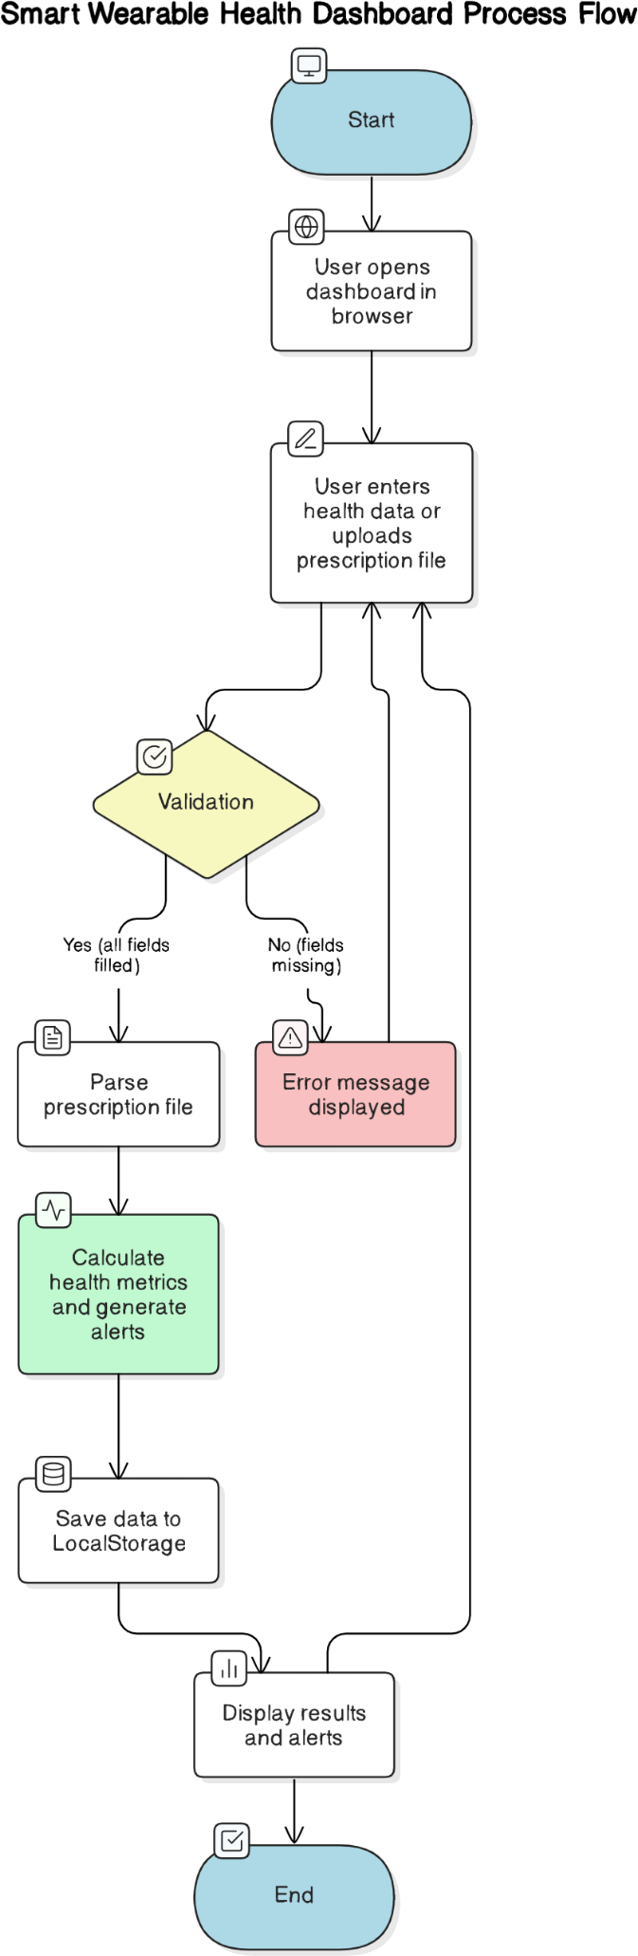

**DATA FLOW**

This section explains the steps for developing and deploying the AI-based Smart Wearable Health Monitoring System through Implementation & Program Flow. The chapter explains system development techniques through description of how the wearable technology interfaces with the software interface and machine learning methods and demonstrates complete system operations.

### Implementation Overview

The system contains several important elements that fulfill different specific functions:

1. Wearable Device (Hardware)
2. Data Collection & Preprocessing (Software)
3. Machine Learning Model Integration
4. User Interface & Visualization
5. Health Recommendations and Predictions

Different technologies are applied for implementing these components while ensuring their smooth connections.

### Wearable Device (Hardware)

The wearable device functions as the main point for collecting system data. Health-related parameters are measured through sensors constructed into the device:

* + **Heart Rate**: Monitors the user's pulse rate.
  + **Steps Taken**: This device tracks the number of daily physical steps performed by the user..
  + **Calorie Expenditure**: This technology measures calorie consumption according to detected user physical movement.

The device sends data through Bluetooth or Wi-Fi connections to both smartphones and cloud platforms for further data processing.

### Data Collection & Preprocessing (Software)

The received data progresses through these successive steps after its acquisition:

1. **Data Acquisition**: The initial sensor-based data from wearable devices gets continuously gathered during real-time operations.
2. **Data Preprocessing**: The data undergoes preprocessing which cleans it to eliminate noise and manages missing values then normalizes all values to preserve data consistency. This may include:
   * **Removing outliers**: A procedure for removing outliers helps preserve data integrity in the process.
   * **Feature Engineering**: The model receives better fits through both new feature adoption and modification of existing features in Feature Engineering.
   * **Normalization**: The process of value adjustment into a unified measurement system allows reliable performance during model training.

### Machine Learning Model Integration

The Random Forest Regressor operates as the system's main component for calculating calorie expenditure through analysis of input data features. The procedure for incorporating the machine learning model involves these steps:

1. **Model Training**: Training occurs through the use of historical user data. Health parameters including heart rate alongside activity level and calorie expenditure are included as part of the training data.
2. **Model Evaluation**: The execution of the trained model requires testing on distinct dataset material for accuracy assessment purposes. The model’s performance evaluation depends on calculations of mean absolute error (MAE) or root mean square error (RMSE).
3. **Real-time Prediction**: The evaluated model can generate real-time predictions for new patient data received from the wearable device after successful training and testing. The system assesses energy expenditure through the examination of health data which comes from the wearable platform.

### User Interface & Visualization

A user-friendly design of the interface component enables data presentation to the user:

* + **Real-Time Data Display**: Users receive instant updates because their heart rate and their steps alongside calories burnt appear in real time.
  + **Graphs and Charts**: The user interface employs charts together with graphs to display the user's health progress throughout time. The system shows health metric summaries either in daily, weekly or monthly timeframes.
  + **Health Insights & Recommendations**: Users can receive customized health advice through the system that recommends additional physical exercise and modified calorie consumption for reaching wellness objectives.

### Health Recommendations and Predictions

The system creates executable health recommendations by implementing the prediction outputs of its Random Forest Regressor model. These insights can help users:

* + **Track Progress**: The system tracks progress through comparing predicated calorie expenditure with existing data.
  + **Adjust Behaviors**: Christine receives targeted food recommendations and physical activity advice for staying healthy or enhancing her condition.

Users receive predicted health trends through the interface using historical data analysis and present and past data which the system uses to make projections.

### Program Flow

The program execution method contains the following core processes:

### Initialization:

* + Activation of the wearable device begins its health metric data collection process.
  + The platform either through mobile app or cloud system must activate before establishing a connection to the wearable device.

### Data Transmission:

* + The wearable device transfers real-time health information to the software platform through Wi-Fi and Bluetooth connectors.

### Data Preprocessing:

* + The software conducts data processing tasks which include cleaning steps as well as normalization followed by preparation for analysis.

### Model Prediction:

* + Random Forest Regressor receives processed data for calculating calorie expenditure estimates using health metrics.

### Health Insights Generation:

* + After prediction, the system generates personalized health recommendations based on the model’s output.

### Visualization and Display:

* + Upon prediction completion the system creates individualized healthcare recommendations by processing the model results.

### User Interaction:

* + A user accesses the system through its interface in order to track their health markers as well as view treatment suggestions and adapt their actions according to guidelines.

### Continuous Monitoring:

* + The mechanism provides real-time health updates and prognostications to users whose wearable device stays enabled.

# PROGRAM

## AI-Powered Synthetic Medical Data Generation for Privacy Preserving Research

import pandas as pd

import numpy as np

from sklearn.ensemble import RandomForestRegressor

from sklearn.preprocessing import StandardScaler

from sklearn.model_selection import GridSearchCV

import joblib

import os

# Define paths to dataset folders

folder_paths = [

    'mturkfitbit_export_3.12.16-4.11.16/Fitabase Data 3.12.16-4.11.16',

    'mturkfitbit_export_4.12.16-5.12.16/Fitabase Data 3.12.16-4.11.16'

]

# List of relevant CSV files to merge

data_files = [

    'dailyActivity_merged.csv', 'hourlyCalories_merged.csv', 'hourlyIntensities_merged.csv',

    'hourlySteps_merged.csv', 'minuteCaloriesNarrow_merged.csv', 'minuteIntensitiesNarrow_merged.csv',

    'minuteMETsNarrow_merged.csv', 'minuteSleep_merged.csv', 'minuteStepsNarrow_merged.csv',

    'sleepDay_merged.csv', 'weightLogInfo_merged.csv'

]

# Initialize list to store dataframes

df_list = []

# Load and merge data from both folders

for folder_path in folder_paths:

    for file in data_files:

        full_path = os.path.join(folder_path, file)

        if os.path.exists(full_path):

            df = pd.read_csv(full_path)

            df_list.append(df)

# Concatenate all dataframes

df_merged = pd.concat(df_list, ignore_index=True)

# Define date formats for each column

date_formats = {

    'ActivityDate': '%m/%d/%Y',  # e.g., 3/25/2016

    'Date': '%m/%d/%Y',         # e.g., 3/12/2016

    'ActivityHour': '%m/%d/%Y %I:%M:%S %p',  # e.g., 3/12/2016 12:00:00 AM

    'date': '%m/%d/%Y %I:%M:%S %p'           # e.g., 3/13/2016 2:39:30 AM

}

# Preprocess date columns with specific formats

date_cols = ['ActivityDate', 'Date', 'ActivityHour', 'date']

for col in date_cols:

    if col in df_merged.columns:

        try:

            df_merged[col] = pd.to_datetime(df_merged[col], format=date_formats.get(col, None), errors='coerce')

        except ValueError as e:

            print(f"Warning: Could not parse {col} with format {date_formats.get(col, 'default')}. Falling back to dateutil. Error: {e}")

            df_merged[col] = pd.to_datetime(df_merged[col], errors='coerce')

# Handle numeric columns and missing values

numeric_cols = df_merged.select_dtypes(include=[np.number]).columns

df_merged[numeric_cols] = df_merged[numeric_cols].fillna(df_merged[numeric_cols].median())

# Map boolean-like columns

df_merged['IsManualReport'] = df_merged['IsManualReport'].map({'True': 1, 'False': 0, True: 1, False: 0}).fillna(0)

# Drop irrelevant or highly missing columns

df_merged = df_merged.drop(columns=['Fat', 'LogId', 'logId', 'value', 'ActivityMinute', 'Calories_minuteCaloriesNarrow'], errors='ignore')

# Features and target

features = ['TotalSteps', 'TotalDistance', 'VeryActiveMinutes', 'FairlyActiveMinutes', 'LightlyActiveMinutes', 'SedentaryMinutes', 'WeightKg', 'BMI', 'Calories']

df_merged = df_merged.dropna(subset=features)  # Drop rows with missing values in key features

X = df_merged[features[:-1]]  # Exclude Calories as target

y = df_merged['Calories']

# Train model

scaler = StandardScaler()

X_scaled = scaler.fit_transform(X)

param_grid = {'n_estimators': [100, 200], 'max_depth': [10, 20, None]}

rf_model = GridSearchCV(RandomForestRegressor(random_state=42), param_grid, cv=5, n_jobs=-1)

rf_model.fit(X_scaled, y)

# Save model and scaler

joblib.dump(rf_model.best_estimator_, 'rf_model.pkl')

joblib.dump(scaler, 'scaler.pkl')

print("Model and scaler saved successfully.")

# Optional: Save merged dataset for inspection

df_merged.to_csv('merged_fitbit_dataset.csv', index=False)

print("Merged dataset saved as 'merged_fitbit_dataset.csv'.")

# CHAPTER 5

# RESULTS

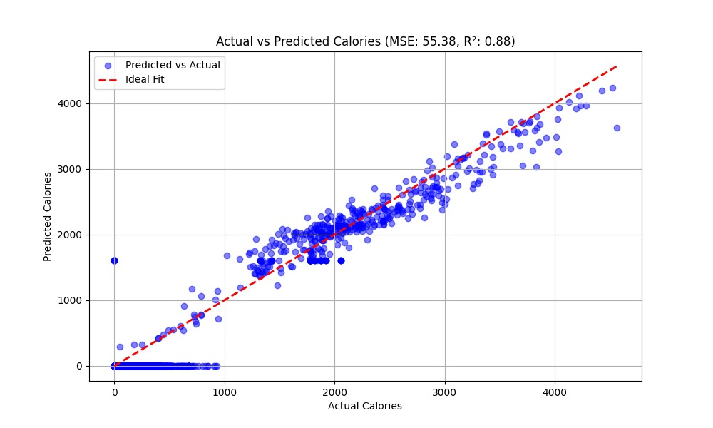

**Mean Squared Error (MSE): 55.38**

**R² Score: 0.8**

# CHAPTER 6

# LEARNING OUTCOME

Working on the AI-based Smart Wearable Health Monitoring System provided a comprehensive educational process which combined artificial intelligence with health informatics alongside embedded systems and both user interface design and machine learning knowledge. Multiple essential technical competencies along with personal competencies evolved through the entire process of developing this project starting from concept to design through implementation.

A key result from this project was students' opportunity to learn application of Random Forest Regressor machine learning algorithms in genuine healthcare settings. The understanding of effective methods to transform raw data into usable features along with training efficient models became an essential fundamental skill. Through this project we learned exactly how complex the work becomes when evaluating models and optimizing performance alongside data visualization operations.

The combination of hardware with software systems delivered significant knowledge about IoT devices and wearable technology. We mastered working with live sensor data while learning its processing requirements for prediction by understanding both data stream handling and system resilience as well as data pipeline development. A user-friendly visual user interface developed through visualization tools allowed us to deliver intricate information effectively to end users.

# PROJECT IMPACT AND FUTURE SCOPE

Working on the AI-based Smart Wearable Health Monitoring System provided a comprehensive educational process which combined artificial intelligence with health informatics alongside embedded systems and both user interface design and machine learning knowledge. Multiple essential technical competencies along with personal competencies evolved through the entire process of developing this project starting from concept to design through implementation.

A key result from this project was students' opportunity to learn application of Random Forest Regressor machine learning algorithms in genuine healthcare settings. The understanding of effective methods to transform raw data into usable features along with training efficient models became an essential fundamental skill. Through this project we learned exactly how complex the work becomes when evaluating models and optimizing performance alongside data visualization operations.

The combination of hardware with software systems delivered significant knowledge about IoT devices and wearable technology. We mastered working with live sensor data while learning its processing requirements for prediction by understanding both data stream handling and system resilience as well as data pipeline development. The implementation of a user interface based on interactive visualization tools enabled clearer presentation of sophisticated data to our users.

## Future Scope

The system offers numerous prospects to grow and enhance itself through multiple technological advancements combined with user-focused enhancements. The system enhancements group into three categories which include technological progress, user-focused development and networked healthcare integration.

## Technological Advancements:

* + Deep learning models like LSTM together with CNN need implementation in future versions to achieve more precise predictions for extended health trends.
  + The system will enable expansion by adding blood oxygen level and sleep quality and stress measurement and hydration detection through advanced sensor integration.
  + The system's performance level can improve thanks to a conversational AI module that enables users to communicate naturally with the interface.

## Personalization and Adaptability:

* + AI-based Recommendations: Based on user history and daily trends, the system could offer intelligent diet plans, workout suggestions, and daily routines customized for different age groups and health conditions.
  + The system should feature adaptive learning through feedback integration as this enables it to improve its predictions and generating better suggestions for individual users throughout time.

## Data Integration and Interoperability:

* + Integration with Electronic Health Records (EHRs): Users should get seamless data exchange between the system and hospitals or doctors through secure HIPAA-compliant data sharing for virtual consultations as well as follow-up medical treatments.
  + Cross-Device Compatibility: Subsequent version updates will enable third- party fitness application and wearable synchronization so users can access combined health data.

## Commercialization and Community Use:

* + Scalability for Corporate Wellness Programs: The system enables scalability for corporate wellness programs allowing businesses and institutions to use it for promoting employee health and productivity and thus improve medical leave reduction and overall employee morale.
  + Open Health Platforms: The open availability of APIs or full open-source design would permit researchers and developers to develop innovative expansions for the system.

# CONCLUSION

The introduction of AI-based Smart Wearable Health Monitoring System enables intelligent computing techniques to manage personal health affairs daily. The research utilizes Random Forest Regressor for artificial intelligence processing of real-time wearable device data to establish meaningful health and physical activity understandings about user wellness.

The sequence of work began by recognizing health monitoring solutions which were ineffective and difficult to access then created a practical solution-based system that addresses these problems effectively and users can easily use it. The system shows users key health metrics consisting of calorie expenditure, steps recorded, and heart rate to let them take knowledgeable decisions about their daily life. The system uses prognostic features to support health prevention strategies that modern healthcare systems emphasize.

The system addresses present-day needs of health-focused people and establishes base structure for future AI developments in wearable healthcare systems. The system eliminates the difference between basic fitness monitoring tools and personalized active healthcare management because it provides immediate customized health predictions through a user- friendly interface.

The hardware-software integration projects delivered essential knowledge about Internet of Things with wearable technology devices. The experience of dealing with real-time sensor data while learning to do predictions trained us to work with asynchronous data streams as well as build stable data pipelines and maintain system reliability. Our user interface became more effective for presenting intricate data through visualization tools which enhanced our capability of delivering meaningful complex information to end users.

**REFERENCES**

1. Wang, K.; Li, J.; Li, W.; Wei, W.; Zhang, H.; Wang, L. Highly Active Co-Based Catalyst in Nanofiber Matrix as Advanced Sensing Layer for High Selectivity of Flexible Sensing Device. *Adv. Mater. Technol.* 2019, *4*, 1800521. [[Google Scholar](http://scholar.google.com/scholar_lookup?title=Highly%2BActive%2BCo-Based%2BCatalyst%2Bin%2BNanofiber%2BMatrix%2Bas%2BAdvanced%2BSensing%2BLayer%2Bfor%2BHigh%2BSelectivity%2Bof%2BFlexible%2BSensing%2BDevice&author=Wang%2C%2BK.&author=Li%2C%2BJ.&author=Li%2C%2BW.&author=Wei%2C%2BW.&author=Zhang%2C%2BH.&author=Wang%2C%2BL.&publication_year=2019&journal=Adv.%2BMater.%2BTechnol.&volume=4&pages=1800521&doi=10.1002/admt.201800521)] [[CrossRef](http://doi.org/10.1002/admt.201800521)]
2. Wang, L.; Ng, W.; Jackman, J.A.; Cho, N.-J. Graphene-Functionalized Natural Microcapsules: Modular Building Blocks for Ultrahigh Sensitivity Bioelectronic Platforms. *Adv. Funct. Mater.* 2016, *26*, 2097–2103. [[Google Scholar](http://scholar.google.com/scholar_lookup?title=Graphene-Functionalized%2BNatural%2BMicrocapsules%3A%2BModular%2BBuilding%2BBlocks%2Bfor%2BUltrahigh%2BSensitivity%2BBioelectronic%2BPlatforms&author=Wang%2C%2BL.&author=Ng%2C%2BW.&author=Jackman%2C%2BJ.A.&author=Cho%2C%2BN.-J.&publication_year=2016&journal=Adv.%2BFunct.%2BMater.&volume=26&pages=2097%E2%80%932103&doi=10.1002/adfm.201504940)] [[CrossRef](http://doi.org/10.1002/adfm.201504940)]
3. Wu, W.; Haick, H. Materials and Wearable Devices for Autonomous Monitoring of Physiological Markers. *Adv. Mater.* 2018, *30*, e1705024. [[Google Scholar](http://scholar.google.com/scholar_lookup?title=Materials%2Band%2BWearable%2BDevices%2Bfor%2BAutonomous%2BMonitoring%2Bof%2BPhysiological%2BMarkers&author=Wu%2C%2BW.&author=Haick%2C%2BH.&publication_year=2018&journal=Adv.%2BMater.&volume=30&pages=e1705024&doi=10.1002/adma.201705024&pmid=29498115)] [[CrossRef](http://doi.org/10.1002/adma.201705024)] [[PubMed](http://www.ncbi.nlm.nih.gov/pubmed/29498115)]
4. Jin, H.; Abu-Raya, Y.S.; Haick, H. Advanced Materials for Health Monitoring with Skin- Based Wearable Devices. *Adv. Healthc. Mater.* 2017, *6*, 1700024. [[Google Scholar](http://scholar.google.com/scholar_lookup?title=Advanced%2BMaterials%2Bfor%2BHealth%2BMonitoring%2Bwith%2BSkin-Based%2BWearable%2BDevices&author=Jin%2C%2BH.&author=Abu-Raya%2C%2BY.S.&author=Haick%2C%2BH.&publication_year=2017&journal=Adv.%2BHealthc.%2BMater.&volume=6&pages=1700024&doi=10.1002/adhm.201700024)] [[CrossRef](http://doi.org/10.1002/adhm.201700024)]
5. Kim, J.J.; Wang, Y.; Wang, H.; Lee, S.; Yokota, T.; Someya, T. Skin Electronics: Next- Generation Device Platform for Virtual and Augmented Reality. *Adv. Funct. Mater.* 2021, *31*, 2009602. [[Google Scholar](http://scholar.google.com/scholar_lookup?title=Skin%2BElectronics%3A%2BNext-Generation%2BDevice%2BPlatform%2Bfor%2BVirtual%2Band%2BAugmented%2BReality&author=Kim%2C%2BJ.J.&author=Wang%2C%2BY.&author=Wang%2C%2BH.&author=Lee%2C%2BS.&author=Yokota%2C%2BT.&author=Someya%2C%2BT.&publication_year=2021&journal=Adv.%2BFunct.%2BMater.&volume=31&pages=2009602&doi=10.1002/adfm.202009602)] [[CrossRef](http://doi.org/10.1002/adfm.202009602)]
6. Matsuhisa, N.; Chen, X.D.; Bao, Z.A.; Someya, T. Materials and structural designs of stretchable conductors. *Chem. Soc. Rev.* 2019, *48*, 2946–2966. [[Google Scholar](http://scholar.google.com/scholar_lookup?title=Materials%2Band%2Bstructural%2Bdesigns%2Bof%2Bstretchable%2Bconductors&author=Matsuhisa%2C%2BN.&author=Chen%2C%2BX.D.&author=Bao%2C%2BZ.A.&author=Someya%2C%2BT.&publication_year=2019&journal=Chem.%2BSoc.%2BRev.&volume=48&pages=2946%E2%80%932966&doi=10.1039/C8CS00814K)] [[CrossRef](http://doi.org/10.1039/C8CS00814K)]
7. Wu, X.Y.; Peng, H.S. Polymer-based flexible bioelectronics. *Sci. Bull.* 2019, *64*, 634–640. [[Google Scholar](http://scholar.google.com/scholar_lookup?title=Polymer-based%2Bflexible%2Bbioelectronics&author=Wu%2C%2BX.Y.&author=Peng%2C%2BH.S.&publication_year=2019&journal=Sci.%2BBull.&volume=64&pages=634%E2%80%93640&doi=10.1016/j.scib.2019.04.011)] [[CrossRef](http://doi.org/10.1016/j.scib.2019.04.011)] [[Green Version](http://engine.scichina.com/doi/pdf/00044444A9BF434DB56BC30DD11870BD)]
8. Someya, T.; Amagai, M. Toward a new generation of smart skins. *Nat. Biotechnol.* 2019, *37*, 382–388. [[Google Scholar](http://scholar.google.com/scholar_lookup?title=Toward%2Ba%2Bnew%2Bgeneration%2Bof%2Bsmart%2Bskins&author=Someya%2C%2BT.&author=Amagai%2C%2BM.&publication_year=2019&journal=Nat.%2BBiotechnol.&volume=37&pages=382%E2%80%93388&doi=10.1038/s41587-019-0079-1)] [[CrossRef](http://doi.org/10.1038/s41587-019-0079-1)]
9. Ray, T.; Choi, J.; Reeder, J.; Lee, S.P.; Aranyosi, A.J.; Ghaffari, R.; Rogers, J.A. Soft, skin- interfaced wearable systems for sports science and analytics. *Curr. Opin. Biomed. Eng.* 2019, *9*, 47–56. [[Google Scholar](http://scholar.google.com/scholar_lookup?title=Soft%2C%2Bskin-interfaced%2Bwearable%2Bsystems%2Bfor%2Bsports%2Bscience%2Band%2Banalytics&author=Ray%2C%2BT.&author=Choi%2C%2BJ.&author=Reeder%2C%2BJ.&author=Lee%2C%2BS.P.&author=Aranyosi%2C%2BA.J.&author=Ghaffari%2C%2BR.&author=Rogers%2C%2BJ.A.&publication_year=2019&journal=Curr.%2BOpin.%2BBiomed.%2BEng.&volume=9&pages=47%E2%80%9356&doi=10.1016/j.cobme.2019.01.003)] [[CrossRef](http://doi.org/10.1016/j.cobme.2019.01.003)]
10. Wang, Y.; Haick, H.; Guo, S.Y.; Wang, C.Y.; Lee, S.; Yokota, T.; Someya, T. Skin bioelectronics towards long-term, continuous health monitoring. *Chem. Soc. Rev.* 2022, *51*, 3759–3793. [[Google Scholar](http://scholar.google.com/scholar_lookup?title=Skin%2Bbioelectronics%2Btowards%2Blong-term%2C%2Bcontinuous%2Bhealth%2Bmonitoring&author=Wang%2C%2BY.&author=Haick%2C%2BH.&author=Guo%2C%2BS.Y.&author=Wang%2C%2BC.Y.&author=Lee%2C%2BS.&author=Yokota%2C%2BT.&author=Someya%2C%2BT.&publication_year=2022&journal=Chem.%2BSoc.%2BRev.&volume=51&pages=3759%E2%80%933793&doi=10.1039/D2CS00207H)] [[CrossRef](http://doi.org/10.1039/D2CS00207H)] Son, D.; Lee, J.; Qiao, S.; Ghaffari, R.; Kim, J.; Lee, J.E.; Song, C.; Kim, S.J.; Lee, D.J.; Jun, S.W.; et al. Multifunctional wearable devices for diagnosis and therapy of movement disorders. *Nat. Nanotechnol.* 2014, *9*, 397–404. [[Google Scholar](http://scholar.google.com/scholar_lookup?title=Multifunctional%2Bwearable%2Bdevices%2Bfor%2Bdiagnosis%2Band%2Btherapy%2Bof%2Bmovement%2Bdisorders&author=Son%2C%2BD.&author=Lee%2C%2BJ.&author=Qiao%2C%2BS.&author=Ghaffari%2C%2BR.&author=Kim%2C%2BJ.&author=Lee%2C%2BJ.E.&author=Song%2C%2BC.&author=Kim%2C%2BS.J.&author=Lee%2C%2BD.J.&author=Jun%2C%2BS.W.&publication_year=2014&journal=Nat.%2BNanotechnol.&volume=9&pages=397%E2%80%93404&doi=10.1038/nnano.2014.38)] [[CrossRef](http://doi.org/10.1038/nnano.2014.38)