**CREATE A CHATBOT IN PYTHON**

**Phase 3: Development Part 1**

**Team detail**

962821106036: KAILASH T (Team Leader)

962821106024: DHANUSH THIVAKAR P

962821106038: MAHAANT M P

962821106047: PUVIARASAN M

962821106304: JERVIN S

**Project Title: Create Chatbot in Python**

**Introduction:**

Chatbot development is a dynamic field at the intersection of artificial intelligence and human-computer interaction. Chatbots, also known as conversational agents, are computer programs designed to simulate human-like conversations. These intelligent agents have gained significant popularity in recent years due to their versatility and the ability to interact with users in a conversational manner.

Chatbots can be found in various applications, ranging from customer support to virtual assistants, making user interactions seamless and efficient. In this article, we will explore the fundamentals of chatbot development, including the essential components and how they facilitate meaningful interactions between users and machines.

**Python programming language for Chatbot:**

import nltk

from nltk.chat.util import Chat, reflections

# Define patterns and responses for the chatbot

patterns = [

# Greetings

(r'hi|hello|hey', ['Hello! How can I assist you now?', 'Hi there!', 'Hey!']),

# General information

(r'how are you?',['I am fine in AI world']),

(r'what is your name?', ['I am a chatbot.', 'You can call me Chatbot.']),

(r'who are you?', ['I am an AI chatbot designed to assist you.', 'I am Chatbot, here to help.']),

(r'what can you do?', ['I can answer questions, provide information, and have conversations with you.', 'Ask me anything, and I will do my best to assist you.']),

(r'where are you from?',['I am from the AI world']),

# Education-related questions

(r'how can I study?|how can I learn?', ['You can study by reading textbooks, attending classes, or watching online courses.']),

(r'what is education?|educational|learning', ['Education is essential for personal growth and career development.']),

# Project-related questions

(r'what is project|assignment', ['Projects are a great way to apply what you have learned.']),

# Advice and instructions

(r'give me advice|advice me|advice', ['I am just a chatbot so refer the youtube channels']),

(r'purpose of instructions|guidance', ['To complete the task, follow the given instructions from your teachers or higher officers or your head officers']),

# AI

(r'what is artificial intellegence|AI?', ['AI, or Artificial Intelligence, refers to the simulation of human intelligence in machines or computer systems.']),

#life

(r'meaning of life', ['The meaning of life is a philosophical question that people have different opinions on. Some believe it is about finding happiness, while others seek purpose through various means.']),

# weather and climate

(r'weather update|climate changes', ['I am sorry, I do not have access to real-time data. You can check the weather using a weather website or app.']),

(r'what is India?|India|Bharath', ['India is a country located in South Asia. It is bordered by Pakistan to the northwest, China and Nepal to the north, Bhutan to the northeast, and Bangladesh and Myanmar to the east.']),

# Personal questions

(r'how old are you?', ['I am just a computer program, so I do not have an age.']),

# Fun questions

(r'tell me a joke', ['Sure, here is one: Why do not scientists trust atoms? Because they make up everything!']),

# Technology-related questions

(r'what is the Internet?|internet', ['The Internet is a global network of interconnected computers that allows the sharing of information and resources.']),

(r'explain cloud computing|cloud computing', ['Cloud computing is a technology that allows users to access and store data and run applications over the internet rather than on a local device.']),

# Food-related questions

(r'favorite food|what do you eat', ['I do not eat, but I can help you find information about your favorite foods.']),

# Travel-related questions

(r'best travel destination', ['There are many great travel destinations around the world. It depends on your interests.']),

# Entertainment

(r'favorite movie', ["I don't watch movies, but I can recommend some popular ones if you'd like."]),

# Personal development

(r'how to improve myself|motivation', ['Improving oneself is a lifelong journey. It can involve learning new skills, setting goals, and self-reflection.']),

# Interactive questions

(r'what is your favorite color?', ["I'm just a chatbot, so I don't have a favorite color. What's yours?"]),

(r'tell me a riddle', ["Sure, here's one: I'm tall when I'm young, and I'm short when I'm old. What am I?"]),

# Music-related questions

(r'favorite music genre|what is your favorite music', ["I don't have personal music preferences, but I can recommend music based on your taste. What genre do you like?"]),

(r'best songs of all time|songs', ["There are many great songs in music history. What's your favorite genre, and I can recommend some songs from it."]),

# Books and reading

(r'favorite book', ["I don't read books, but I can suggest some popular books if you're interested. What genre do you like?"]),

(r'suggest a good book', ["Of course, I'd recommend 'To Kill a Mockingbird' by Harper Lee if you haven't read it already."]),

# Travel and destinations

(r'best travel destination|dream vacation', ["Dream vacations vary, but some popular destinations include the Maldives, Paris, and Japan. Where would you like to travel?"]),

(r'beach or mountains', ["Beach and mountains both have their charm. What's your ideal vacation: relaxing on the beach or hiking in the mountains?"]),

# Technology and gadgets

(r'latest tech news|news', ["I'm not up to date with current news, but you can check websites like TechCrunch for the latest tech news."]),

# Personal development

(r'how to stay motivated', ["Staying motivated can be a challenge. Setting clear goals and breaking them into smaller tasks can help. What are you trying to stay motivated for?"]),

# Default response for unmatched queries

(r'(.*)', ["I am not sure I understand. Could you please provide more details?", "I'm here to assist. Please ask me a specific question."]),

]

# Create a chatbot with the defined patterns and reflections

chatbot = Chat(patterns, reflections)

while True:

user_input = input("You: ")

if user_input.lower() == 'quit':

print("Chatbot: Goodbye!")

break

response = chatbot.respond(user_input)

print("Chatbot:",response)

**Output Representsation:**

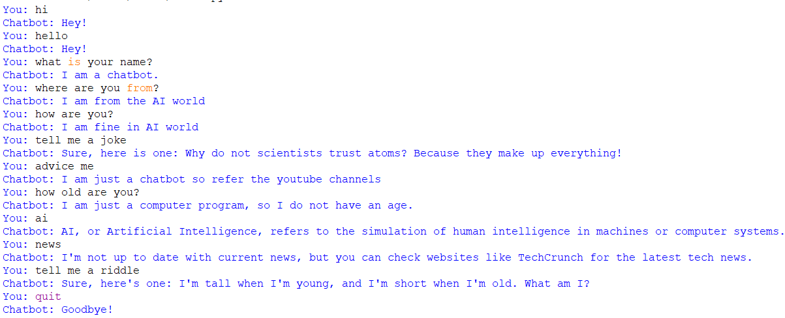

**Explanation of the program:**

**Importing Libraries:**

🡪 The program starts by importing the necessary libraries.

🡪 nltk is the Natural Language Toolkit, a library used for natural language processing.

🡪 Chat and reflections are specific components from the NLTK library that are used for creating chatbots.

**Defining Patterns and Responses:**

The code defines a list of patterns and corresponding responses for the chatbot. These patterns are used to recognize user inputs and provide predefined responses.

The patterns are structured as regular expressions and include categories like greetings, general information, education-related questions, AI-related questions, personal questions, and more.

**Creating the Chatbot:**

The code uses the defined patterns and reflections to create a chatbot instance.

The Chat class is initialized with these patterns and reflections.

**User Interaction Loop:**

The program enters a while loop, allowing the user to interact with the chatbot.

It continually prompts the user for input using input("You: ").

**User Input and Responses:**

The user's input is stored in the user_input variable.

If the user enters "quit," the chatbot prints "Goodbye!" and exits the loop.

Otherwise, the chatbot uses the respond method to find a matching pattern and respond with a predefined message based on the input.

**Displaying the Chatbot's Response:**

The chatbot's response is stored in the response variable.

The program then prints "Chatbot:" followed by the chatbot's response.

**Repeat or Exit:**

The loop continues until the user enters "quit."

When the user does so, the chatbot says "Goodbye!" and the program exits

**Implementation of User Interaction in Our Program:**

**1.**The program starts by defining a list of patterns and responses for the chatbot. These patterns are structured as regular expressions and categorized into different topics such as greetings, general information, education, AI, and many more.

**2.**A chatbot instance is created using the defined patterns and the Chat class from the NLTK library.

**3.**The program enters a while loop, allowing the user to interact with the chatbot. It prompts the user to input their message with input("You: ").

**4.**The user's input is stored in the user_input variable.

**5.**The program checks if the user's input is "quit." If it is, the chatbot prints "Goodbye!" and exits the loop.

**6.**If the user input is not "quit," the chatbot uses the respond method to find a matching pattern from the defined patterns. It then responds with a predefined message based on the input.

**7.**The chatbot's response is stored in the response variable.

**8.**The program then prints "Chatbot:" followed by the chatbot's response.

**9.**The loop continues until the user enters "quit."

**Advantage of Our Program:**

**Customizable Responses:**

It allows you to define patterns and responses, making it highly customizable. You can tailor the chatbot to provide answers and information relevant to your specific use case or area of expertise.

**Structured Interaction:**

The chatbot can engage in structured interactions with users. By categorizing patterns, it ensures that users receive appropriate responses based on the context of their input.

**User Assistance:**

The chatbot can provide assistance on a wide range of topics, from general information to specific questions. Users can seek information or guidance on various subjects.

**Easy to Extend:**

You can easily extend the chatbot's capabilities by adding more patterns and responses. This flexibility makes it adaptable to evolving user needs.

**User-Friendly:**

The chatbot operates in a conversational manner, making it user-friendly. Users can interact with it using natural language, which is familiar and comfortable for most people.

**No Internet Access Required:**

The chatbot doesn't rely on internet access for its responses. This can be advantageous in situations where users need information but may not have reliable internet connectivity.

**Educational Tool:**

It can be used as an educational tool to teach users about various topics. For example, it can explain concepts related to AI, education, technology, and more.

**Entertainment:**

The chatbot can also provide entertainment by telling jokes, riddles, and discussing music, movies, and books.

**Practice with Regular Expressions:**

If you're learning about regular expressions, this program provides a practical example of how they can be used to match and respond to user input.

**Structured Development:**

It serves as a structured foundation for building more advanced chatbots. You can use this as a starting point and expand on it to create more sophisticated conversational agents.

**No Real-Time Data Dependency:**

The chatbot doesn't rely on real-time data sources. This means it can operate in various environments without the need for constant internet connectivity or data updates.

**Support for Reflections:**

The program uses the reflections module from NLTK, which allows for further customization and variation in responses.

**Conclusion:**

This chatbot program is a useful tool for having structured conversations with users. It can answer questions, provide information, and even tell jokes or riddles. You can customize its responses and use it for various purposes, like education or entertainment. However, it has limitations, such as not handling very complex conversations. It's a good starting point for building chatbots, but it's not connected to the internet for real-time information. We will continue the development of our chatbot in phase 4.