**Phase 5: Project Documentation & Submission**

**Team detail**

962821106036: KAILASH T (Team Leader)

962821106024: DHANUSH THIVAKAR P

962821106038: MAHAANT M P

962821106047: PUVIARASAN M

962821106304: JERVIN S

**Project Title: Create Chatbot in Python**

**INTRODUCTION:**

This chatbot is like a smart computer program that talks to you through typing. It can help with things like answering questions, solving problems, or just having a friendly chat. This Chatbots are used in websites to make things easier and more convenient for people. It uses special technology to understand what you're saying and give you helpful answers.

**DESIGN THINKING:**

Design thinking is a problem-solving and innovation approach that places a strong emphasis on understanding and addressing the needs and desires of users. It is a structured methodology used to create user-centered solutions, often applied in product design, software development, and various problem-solving scenarios. Here’s how you can use design thinking principles to design chatbots:

**Empathize:**

Empathize means understanding what users want and need from the chatbot. This involves talking to users, figuring out their problems, and how the chatbot can help. It's about listening to users and their experiences to make the chatbot work better for them.

**Define:**

Identify Chatbot Goals: Define specific objectives the chatbot should achieve (e.g., customer support, information delivery, sales assistance).

Compile User Personas: Create user personas representing different user groups, their preferences, and needs.

**Ideate:**

Brainstorm Conversational Flows: Generate a variety of conversation flow ideas that address different user needs and scenarios.

Design Chatbot Features: Think of innovative features or functionalities the chatbot could offer, such as interactive elements or personalized responses.

**Prototype:**

Create Chatbot Mockups: Develop low-fidelity prototypes or wireframes of the chatbot's interface and conversation structure.

Develop Conversational Scripts: Write sample dialogues and responses for the chatbot to test its interactions.

**Test:**

User Testing: Conduct usability tests with real users to assess how well the chatbot meets their needs.

Iterate and Refine: Gather feedback on user experiences, and refine the chatbot's design, conversation flow, and features based on the test results.

**Implement:**

Develop the Chatbot: Build the chatbot using the insights and refined design from the testing phase.

Deploy and Monitor: Launch the chatbot and continuously monitor its performance, user feedback, and engagement.

**FRAMEWORK USED:**

**Flask:**

Flask is a lightweight and flexible web framework for Python that is commonly used for building web applications. Here are some key points about Flask,

**Micro Framework:**

Flask is often referred to as a "micro" framework because it provides only the essential components for building web applications. It gives developers the freedom to choose and integrate other libraries and components as needed.

**Simple and Minimalistic:**

Flask is designed to be simple and easy to understand. It doesn't impose a specific way of structuring your application, which allows for flexibility in project organization.

**Werkzeug and Jinja2:**

Flask is built on top of the Werkzeug WSGI (Web Server Gateway Interface) library, which handles HTTP request and response, and the Jinja2 templating engine for rendering HTML templates.

**Routing:**

Flask provides a straightforward way to define URL routes, allowing you to map specific URLs to view functions that handle user requests.

**Extensible:**

Flask has a wide range of extensions available that can be easily integrated to add functionalities like database support, authentication, and more.

**RESTful Support:**

Flask is well-suited for creating RESTful APIs and web services, making it a popular choice for building APIs.

**LIBRARIES USED:**

**NLTK (Natural Language Toolkit):**

The Natural Language Toolkit (NLTK) is a powerful and widely used Python library for working with human language data, particularly for natural language processing (NLP) and text analysis.

**Text Processing:**

NLTK provides tools for various text processing tasks, such as tokenization (breaking text into words or sentences), stemming (reducing words to their root form), and part-of-speech tagging (identifying the grammatical category of words).

**Corpora and Lexicons:**

NLTK includes a wide range of corpora (large collections of text) and lexicons (word lists and associated information) that are useful for linguistic analysis and research. For example, it contains the Gutenberg Corpus, WordNet, and more.

**NLP Algorithms:**

NLTK offers a collection of algorithms and tools for various NLP tasks, including text classification, language identification, named entity recognition, sentiment analysis, and parsing.

**Integration with Other Libraries:**

NLTK can be integrated with other Python libraries, such as NumPy and SciPy, for advanced data analysis and machine learning tasks.

**Natural Language Processing Pipelines:**

NLTK allows you to create NLP pipelines to process and analyze text data step by step, making it easier to build complex NLP applications.

**Machine Learning:**

While NLTK provides a foundation for many NLP tasks, it is often used in combination with machine learning libraries like scikit-learn and TensorFlow for more advanced applications.

**Extensibility:**

Users can customize and extend NLTK's functionality by adding their own corpora, algorithms, or resources.

**MODULES USED:**

**Chat:**

The chat module in the Natural Language Toolkit (NLTK) is used to create chatbots or conversational agents. It provides a way to define patterns for user input and specify appropriate responses. The chat module is a part of NLTK's chatbot capabilities and is used for building chatbot systems in a structured manner.

**Pattern-Response Pairs:**

The core functionality of the chat module involves defining patterns and associated responses. Patterns are regular expressions or strings that the chatbot uses to identify user input, and responses are the chatbot's replies when a matching pattern is detected.

**Reflections:**

The chat module includes a dictionary called reflections that helps the chatbot handle reflections. Reflections are words or phrases that users might use to refer to themselves, like changing "I am" to "you are." The reflections dictionary maps such words and phrases to their reflected versions.

**Pattern-Response Configuration:**

You can configure the chatbot with specific pattern-response pairs to enable it to respond to a wide range of user inputs. These pairs define how the chatbot should react to different queries or statements.

**Interactive Chatting:**

Once patterns and responses are defined, the chatbot can engage in interactive conversations with users. It processes user input, matches patterns, and responds accordingly.

**User Interaction:**

Users can type or input sentences to the chatbot, and the chat module processes these inputs, attempting to match them with the defined patterns.

**Our Chatbot in Web screen:**

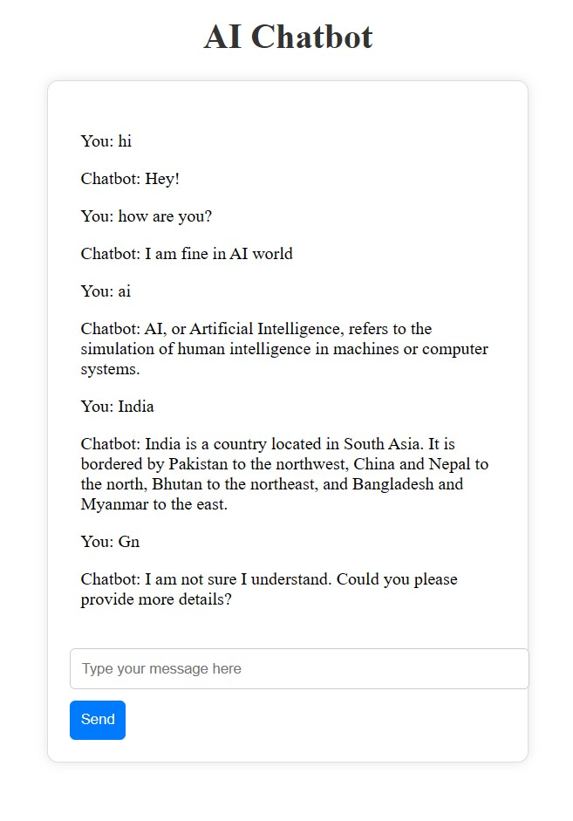

**Reflections:**

The reflection module in the Natural Language Toolkit (NLTK) is used to handle reflections in chatbots or conversational agents. Reflections are words or phrases that users might use to refer to themselves. For example, when a user says, "I am happy," a chatbot should be able to respond, "You are happy." The reflection module helps chatbots transform words and phrases to maintain a natural and coherent conversation.

**Mapping:**

The reflection module provides a dictionary called reflections that maps common words or phrases to their reflected versions. For example, it maps "I" to "you" and "my" to "your."

**Customization:**

While the reflection module comes with a set of default reflections, you can customize this dictionary to add or modify entries to suit your specific chatbot's needs.

**Case Insensitivity:**

The reflection module is usually case-insensitive, meaning it can handle words in both uppercase and lowercase letters. For instance, it can handle "I" or "i" as equivalent.

**Regular Expressions:**

The reflection module works in conjunction with regular expressions or patterns defined for chatbot responses. It transforms user inputs based on these patterns, making the chatbot's responses more natural and human-like.

**INNOVATIONS:**

Innovation in chatbots is a dynamic field, with continuous advancements and creative applications.

**Conversational AI:**

Advancements in natural language processing (NLP) and machine learning have led to chatbots that can engage in more natural and context-aware conversations. They can understand user intent, sentiment, and tone, providing more personalized and human-like interactions.

**Personalization:**

Innovations in data analytics and user profiling enable chatbots to offer highly personalized recommendations, content, and responses. They can adapt to individual preferences and behaviours.

**Emotional Intelligence:**

Some chatbots are being designed to recognize and respond to user emotions. They can provide empathetic responses, offering support and assistance in emotionally sensitive situations.

**AI-Powered Decision-Making:**

Chatbots are becoming more capable of assisting users in making decisions, whether it's recommending products, suggesting travel destinations, or providing financial advice.

**Industry-Specific Applications:**

Chatbots are finding innovative uses in various industries, such as healthcare (medical diagnosis and virtual health assistants), e-commerce (personal shopping assistants), and finance (customer support and financial advice).

**Chatbots for Content Creation:**

Some chatbots are designed to generate content, such as writing articles, product descriptions, or code snippets. They use natural language generation (NLG) techniques.

**Hybrid Models:**

Combining chatbots with human agents for a seamless handover is an innovative approach. Users can start with a chatbot and transition to a human agent when needed, ensuring the best of both worlds.

**Ethical and Responsible AI:**

Innovations in chatbots include a focus on ethical considerations, fairness, transparency, and the responsible use of AI to avoid biases and discrimination.

**Collaboration and Team Chatbots:**

Chatbots designed for team communication and collaboration are becoming popular. They help streamline workflows, manage tasks, and facilitate teamwork.

**Augmented Reality (AR) and Virtual Reality (VR):**

Chatbots are being integrated into AR and VR applications, providing virtual assistant experiences in immersive environments.

**Security and Authentication:**

Chatbots are innovatively used for security purposes, such as multi-factor authentication, identity verification, and fraud detection.

**Education and Training:**

Chatbots are employed in education and training settings to provide personalized learning experiences, answer student questions, and offer instant feedback.

**Embracing New Technologies:**

Chatbots are exploring new technologies like blockchain for secure and transparent transactions, as well as edge computing for faster response times