INDIRA GANDHI NATIONAL OPEN UNIVERSITY
School of Computer and Information Sciences
Maidan Garhi, New Delhi — 110 068

PROJECT REPORT
BCSP-064
DEVELOPMENT OF AN E-COMMERCE
WEB APPLICATION FOR
ONLINE SHOPPING

A project report submitted in partial fulfilment of the requirements
for the award of the degree of
BACHELOR OF COMPUTER APPLICATIONS (BCA)
Particulars | Details
Submitted by | Kailash Kumar Jha
Enrolment Number | 2400767095
Programme | Bachelor of Computer Applications (BCA)
Course Code | BCSP-064
Study Centre Code | 07162P
Regional Centre | RCD1 — 07: Delhi 1 (Mohan Estate, South Delhi)
E-mail | Provided in the submitted copy
Mobile Number | Provided in the submitted copy
Project Guide | Shankar Jha — Backend Lead (Software Engineer)
Session | January 2026

Under the supervision of
Shankar Jha
Backend Lead (Software Engineer), Wizcart Technologies LLC

CERTIFICATE OF ORIGINALITY

This is to certify that the project report entitled "DEVELOPMENT OF AN E-COMMERCE WEB APPLICATION FOR ONLINE SHOPPING" submitted to Indira Gandhi National Open University in partial fulfilment of the requirements for the award of the degree of BACHELOR OF COMPUTER APPLICATIONS (BCA), is an original work carried out by Mr. Kailash Kumar Jha, Enrolment No.: 2400767095, under the guidance of Mr. Shankar Jha.

The matter embodied in this project is a genuine work done by the student and has not been submitted whether to this University or to any other University / Institute for the fulfilment of the requirement of any course of study.

Signature of the Student | Signature of the Guide
Name: Kailash Kumar Jha | Name: Shankar Jha
Enrolment No.: 2400767095 | Designation: Backend Lead (Software Engineer)
Address: Provided in the submitted copy | Address: Provided in the submitted copy
Date: .............................. | Date: ..............................

SCHOOL OF COMPUTER AND INFORMATION SCIENCES
IGNOU, MAIDAN GARHI, NEW DELHI — 110 068
PROFORMA OF BCA PROJECT PROPOSAL (BCSP-064)
(Project Title and Guide’s Details)

# | Item | Details
 | Enrolment No. | 2400767095
 | Regional Centre Code | RCD1
 | Study Centre Code | 07162P
1 | Name of Student | Kailash Kumar Jha
2 | Address of the Student | Provided in the submitted copy
3 (a) | E-mail | Provided in the submitted copy
3 (b) | Telephone / Mobile No. | Provided in the submitted copy
4 | Title of the Project | DEVELOPMENT OF AN E-COMMERCE WEB APPLICATION FOR ONLINE SHOPPING
5 (a) | Name of the Project Guide | Shankar Jha
5 (b) | Designation of the Project Guide | Backend Lead (Software Engineer)
6 | Address of Project Guide | Provided in the submitted copy
7 | Qualification of the Guide | B.Tech (Information Technology) — bio-data attached
8 | Industrial / Teaching experience of the Guide | 5+ years (Industry)
9 | Software used for this Project | MongoDB 7 (Community Server), Express.js 4, React 18, Node.js 22, Mongoose 8, JSON Web Token, bcrypt, Jest, Supertest, Vite, Git, VS Code, Postman

Signature of the Student | Signature of the Guide
Date: .............................. | Date: ..............................

Note — as required by the BCSP-064 guidelines: the use of Visual Basic with MS-Access as front end and back end respectively is forbidden, and the use of C or C++ is prohibited for projects associated with database management. This project uses none of those. MongoDB is listed among the permitted database engines and React among the permitted languages and frameworks in Section VII of the guidelines.

For Office Use Only
Approved ☐ Not approved ☐ | Signature, Designation and Stamp of the  Project Proposal Evaluator  Date: ..........................
Suggestions for reformulating the project:

BIO-DATA OF THE PROJECT GUIDE

Particulars | Details
Name | Shankar Jha
Qualification | B.Tech (Information Technology), Bharati Vidyapeeth College of Engineering
Current Designation | Backend Lead (Software Engineer)
Organisation | Wizcart Technologies LLC
Total Experience | 5+ years (Industry)
Area of Specialisation | Backend development, product engineering, SaaS platforms
Address | Provided in the submitted copy
E-mail | Provided in the submitted copy

Professional Summary
Shankar Jha is a software engineer with more than five years of industry experience in backend engineering, full-stack application development and SaaS platform architecture. He currently serves as Backend Lead at Wizcart Technologies LLC, where he is responsible for the design of scalable service infrastructure, data synchronisation pipelines and transactional API design.

Professional Experience
- Backend Lead — Wizcart Technologies LLC (current role)
- Senior Development Engineer — AVIZVA
- Full Stack Engineer — Surepass Technologies
- Full Stack Software Developer — Flowboard Technologies

Key Projects and Achievements
- Designed and engineered core systems for high-throughput, enterprise-grade SaaS platforms.
- Architected security-compliance protocols and transactional APIs for financial technology platforms.
- Integrated distributed analytical engines within real-time health-technology systems.

Educational Credentials
- B.Tech in Information Technology — Bharati Vidyapeeth College of Engineering

Signature of the Guide | Date: ..............................

ACKNOWLEDGEMENT

The completion of this project has depended on the guidance, encouragement and patience of a number of people, and it is a pleasure to record my thanks to them here.
I am deeply grateful to my project guide, Mr. Shankar Jha, Backend Lead at Wizcart Technologies LLC, for agreeing to supervise this work. His insistence that I justify every design decision — rather than simply make it work — shaped the project more than any other single influence. The concurrency handling in the checkout engine and the decision to recompute every price on the server are both the direct result of his review comments.
I thank the School of Computer and Information Sciences, IGNOU, for framing a project course that requires the student to work through the whole software development life cycle rather than only the coding phase. I am also grateful to the Coordinator and the academic counsellors at Study Centre 07162P for their guidance on the procedural requirements of the submission.
Finally, I thank my family for their steady support over the months this project took, and for tolerating the long evenings it consumed.

Kailash Kumar Jha
Enrolment No.: 2400767095

PROJECT RESOURCES

The complete source code of this project, and a running instance of the application, are available online. Scan the code below with any phone camera, or type the address into a browser.


None: Source code repository
Resource | Address | What you will find there
Source code | https://github.com/Kailashkush/ignou-bca-ecommerce | Complete source code, tests and build scripts

PROJECT SYNOPSIS
(as approved — reproduced here per Section V of the BCSP-064 guidelines)

1. Title of the Project
DEVELOPMENT OF AN E-COMMERCE WEB APPLICATION FOR ONLINE SHOPPING
The project is referred to throughout by the working name **ShopSphere**.

2. Introduction and Objectives of the Project
Small and medium-sized retailers wishing to sell online must choose between a hosted platform that charges a subscription and a share of every transaction, and a self-hosted system that must be built and maintained. This project takes the second route and delivers a complete, tested e-commerce web application on the MERN stack — MongoDB, Express.js, React and Node.js — with a public storefront for customers and a back-office dashboard for the store administrator.
The objectives of the project are as follows.
- To build a responsive customer interface that works on desktop, tablet and mobile without a separate mobile site.
- To implement stateless authentication with JSON Web Tokens, storing passwords only as bcrypt hashes.
- To provide catalogue search, category and price filtering, sorting and pagination, served by database indexes rather than collection scans.
- To guarantee that concurrent checkouts cannot oversell stock, by making the stock check and the stock decrement a single atomic database operation.
- To recompute every monetary amount on the server, so that a tampered client cannot alter what it pays.
- To enforce role-based access control, so that a customer account cannot reach administrative functions or another customer's orders.
- To provide an administrative dashboard with sales analytics, catalogue maintenance, order fulfilment and customer account administration.
- To document every phase of the software development life cycle in accordance with the BCSP-064 guidelines.

3. Project Category
**Category: RDBMS / Database Management System — implemented with a NoSQL (document-oriented) database, delivered as an Internet / Web Technologies application.**
The project is data-centric: its core concern is the definition, indexing, querying and integrity of persistent data across four collections, together with the concurrency control needed to keep that data correct. It is implemented on MongoDB, which appears in the list of permitted database engines in Section VII of the BCSP-064 guidelines, and is delivered over web technologies (React, Express, REST), which appear in the same list. The project uses neither Visual Basic with MS-Access nor C or C++, both of which the guidelines prohibit for database projects.

4. Analysis

4.1 Context Diagram (DFD Level 0)
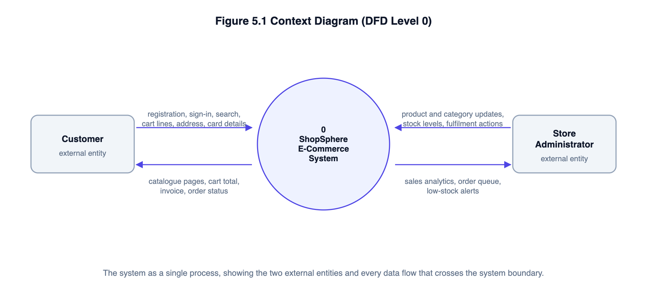
Figure S1: Context diagram — the system boundary and its two external entities

4.2 Data Flow Diagram — Level 1
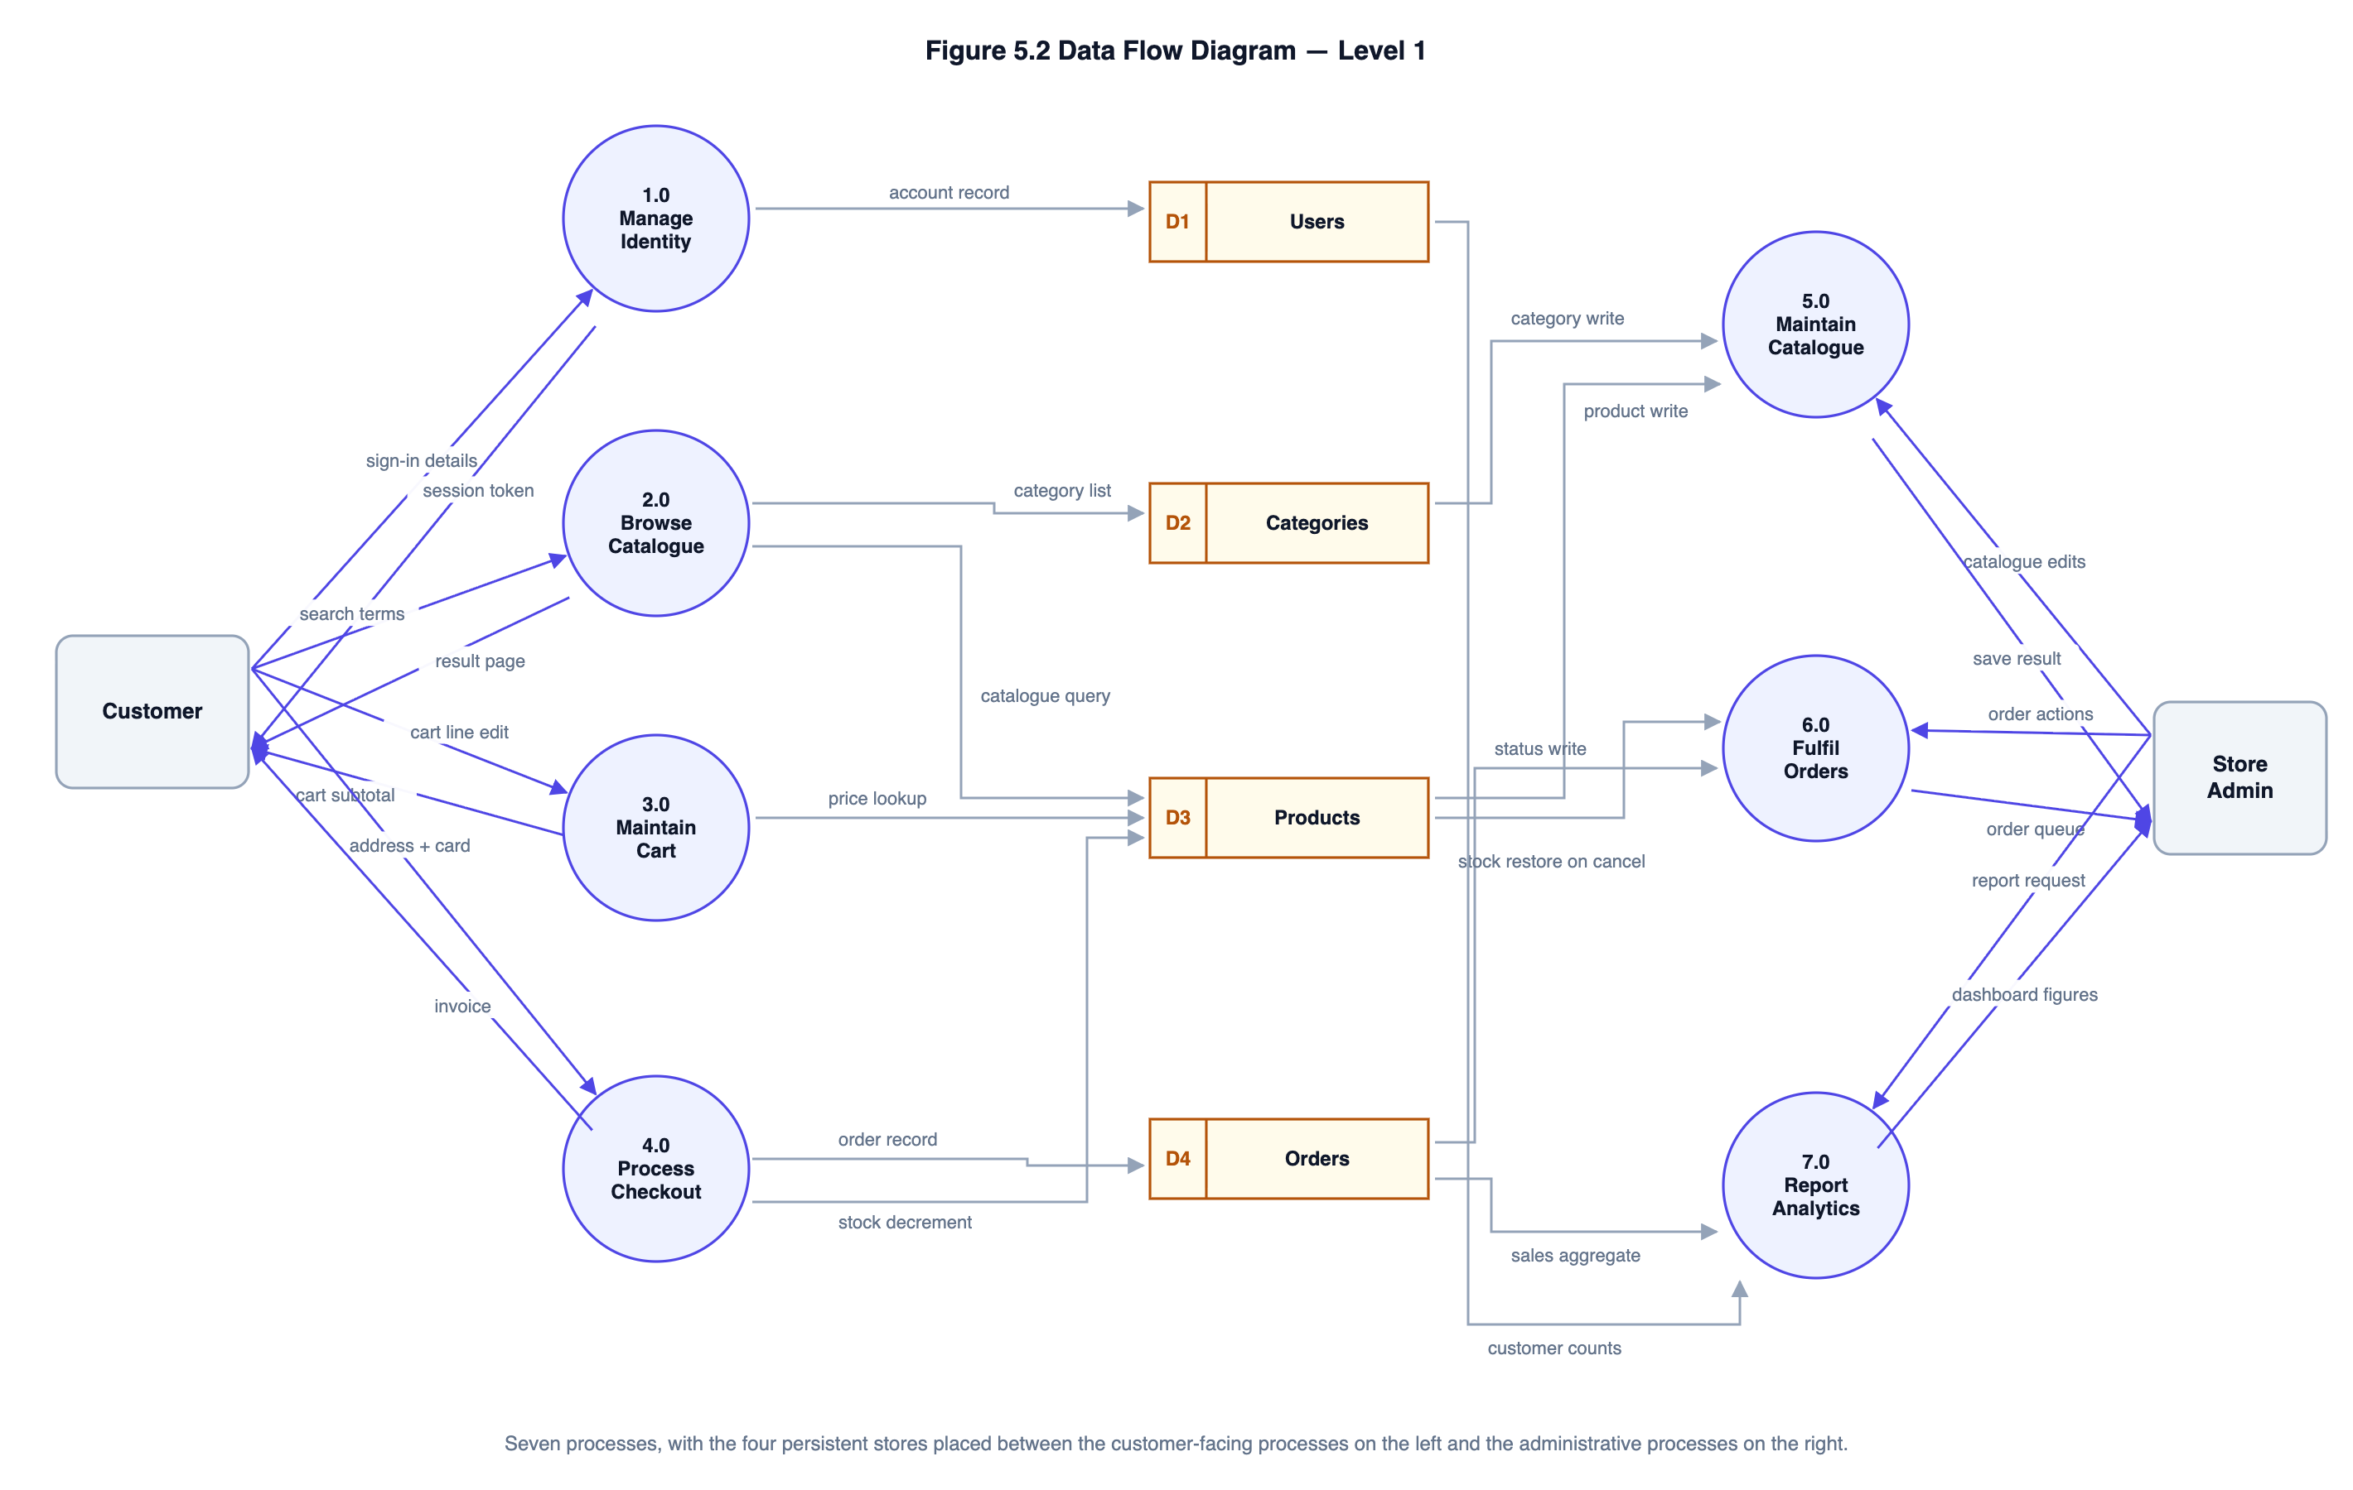
Figure S2: Level 1 DFD — seven processes and four data stores

4.3 Data Flow Diagrams — Level 2
Two processes are decomposed to the second level: the checkout engine, because it carries the system’s most important correctness requirements, and catalogue browsing, because it is where untrusted input meets the database.
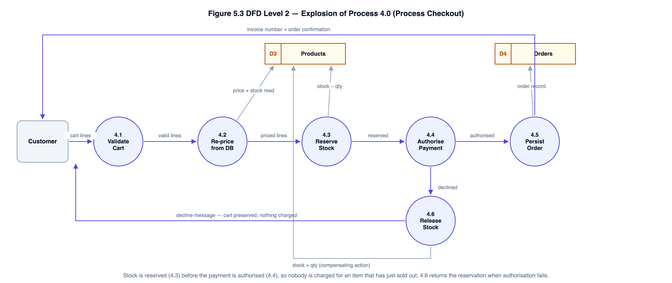
Figure S3: Level 2 DFD — explosion of process 4.0, Process Checkout
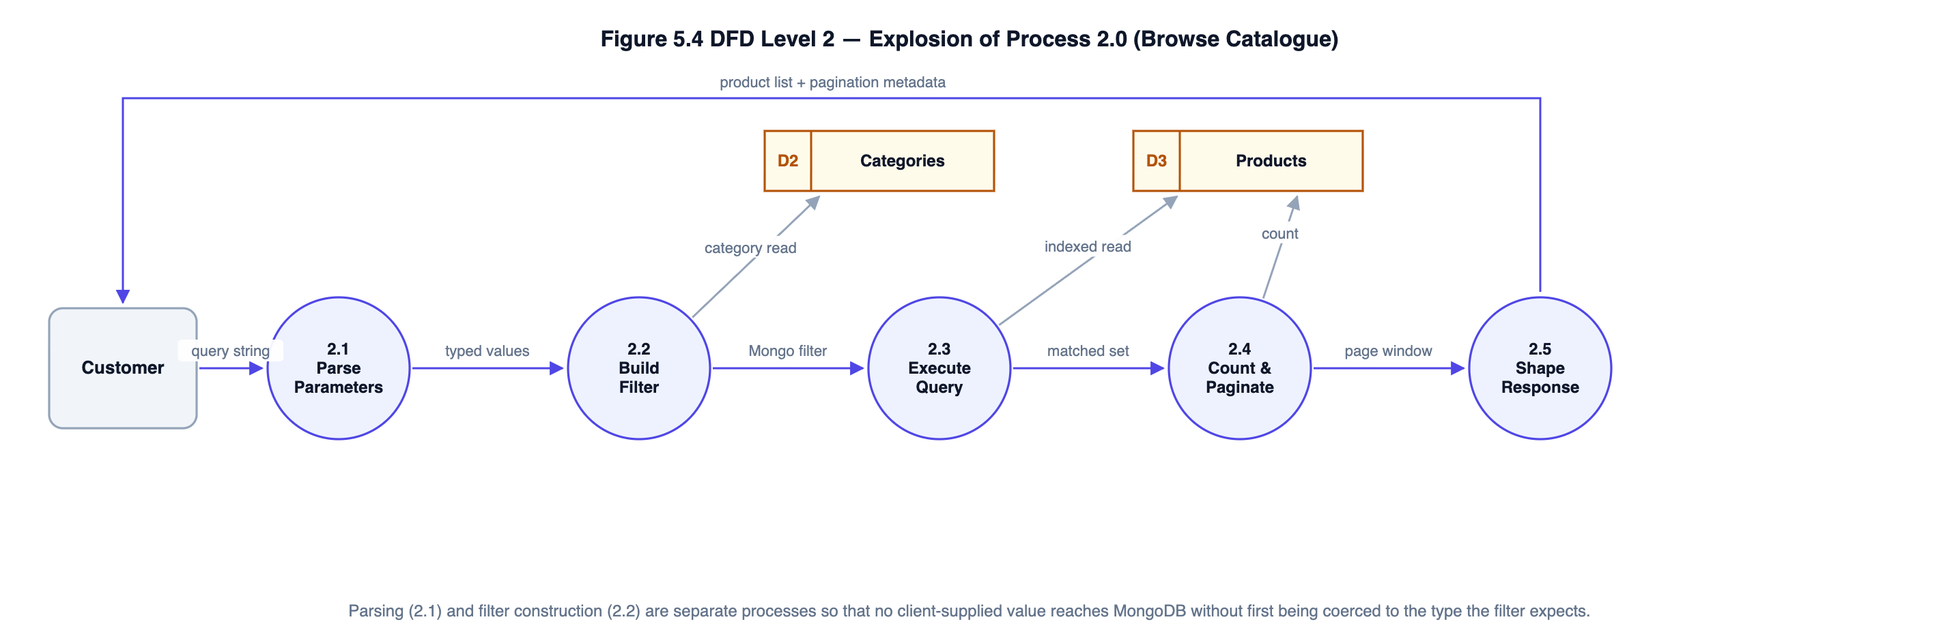
Figure S4: Level 2 DFD — explosion of process 2.0, Browse Catalogue

4.4 Entity–Relationship Diagram
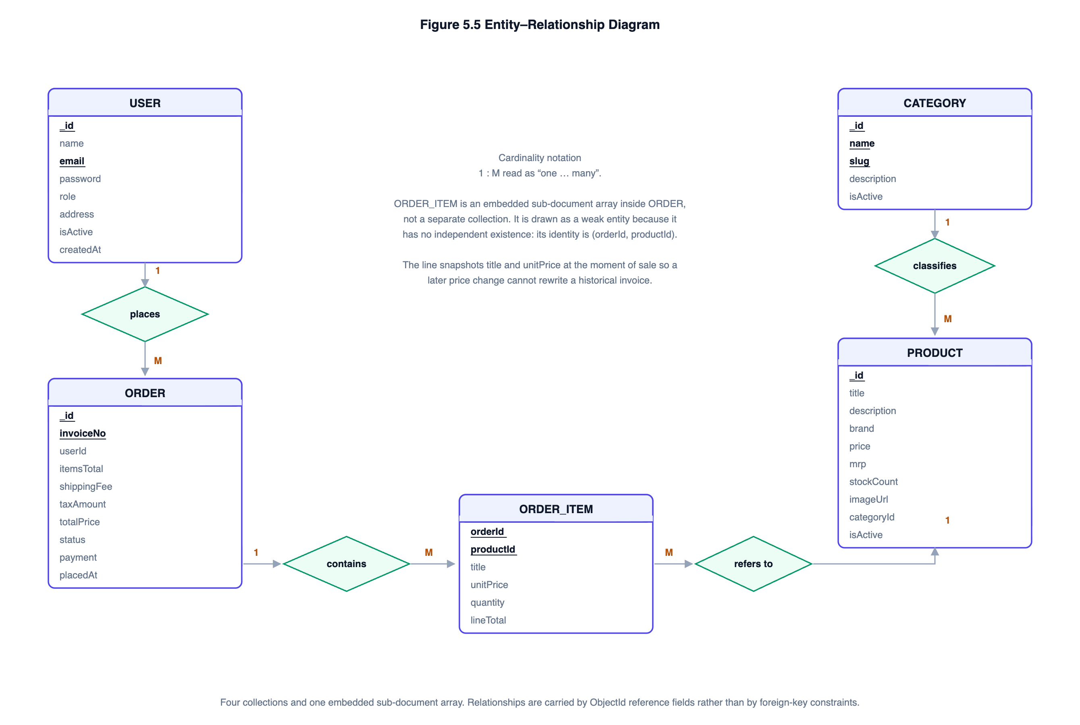
Figure S5: Entity–relationship diagram. ORDER_ITEM is a weak entity embedded within ORDER.

4.5 Use Case Diagram
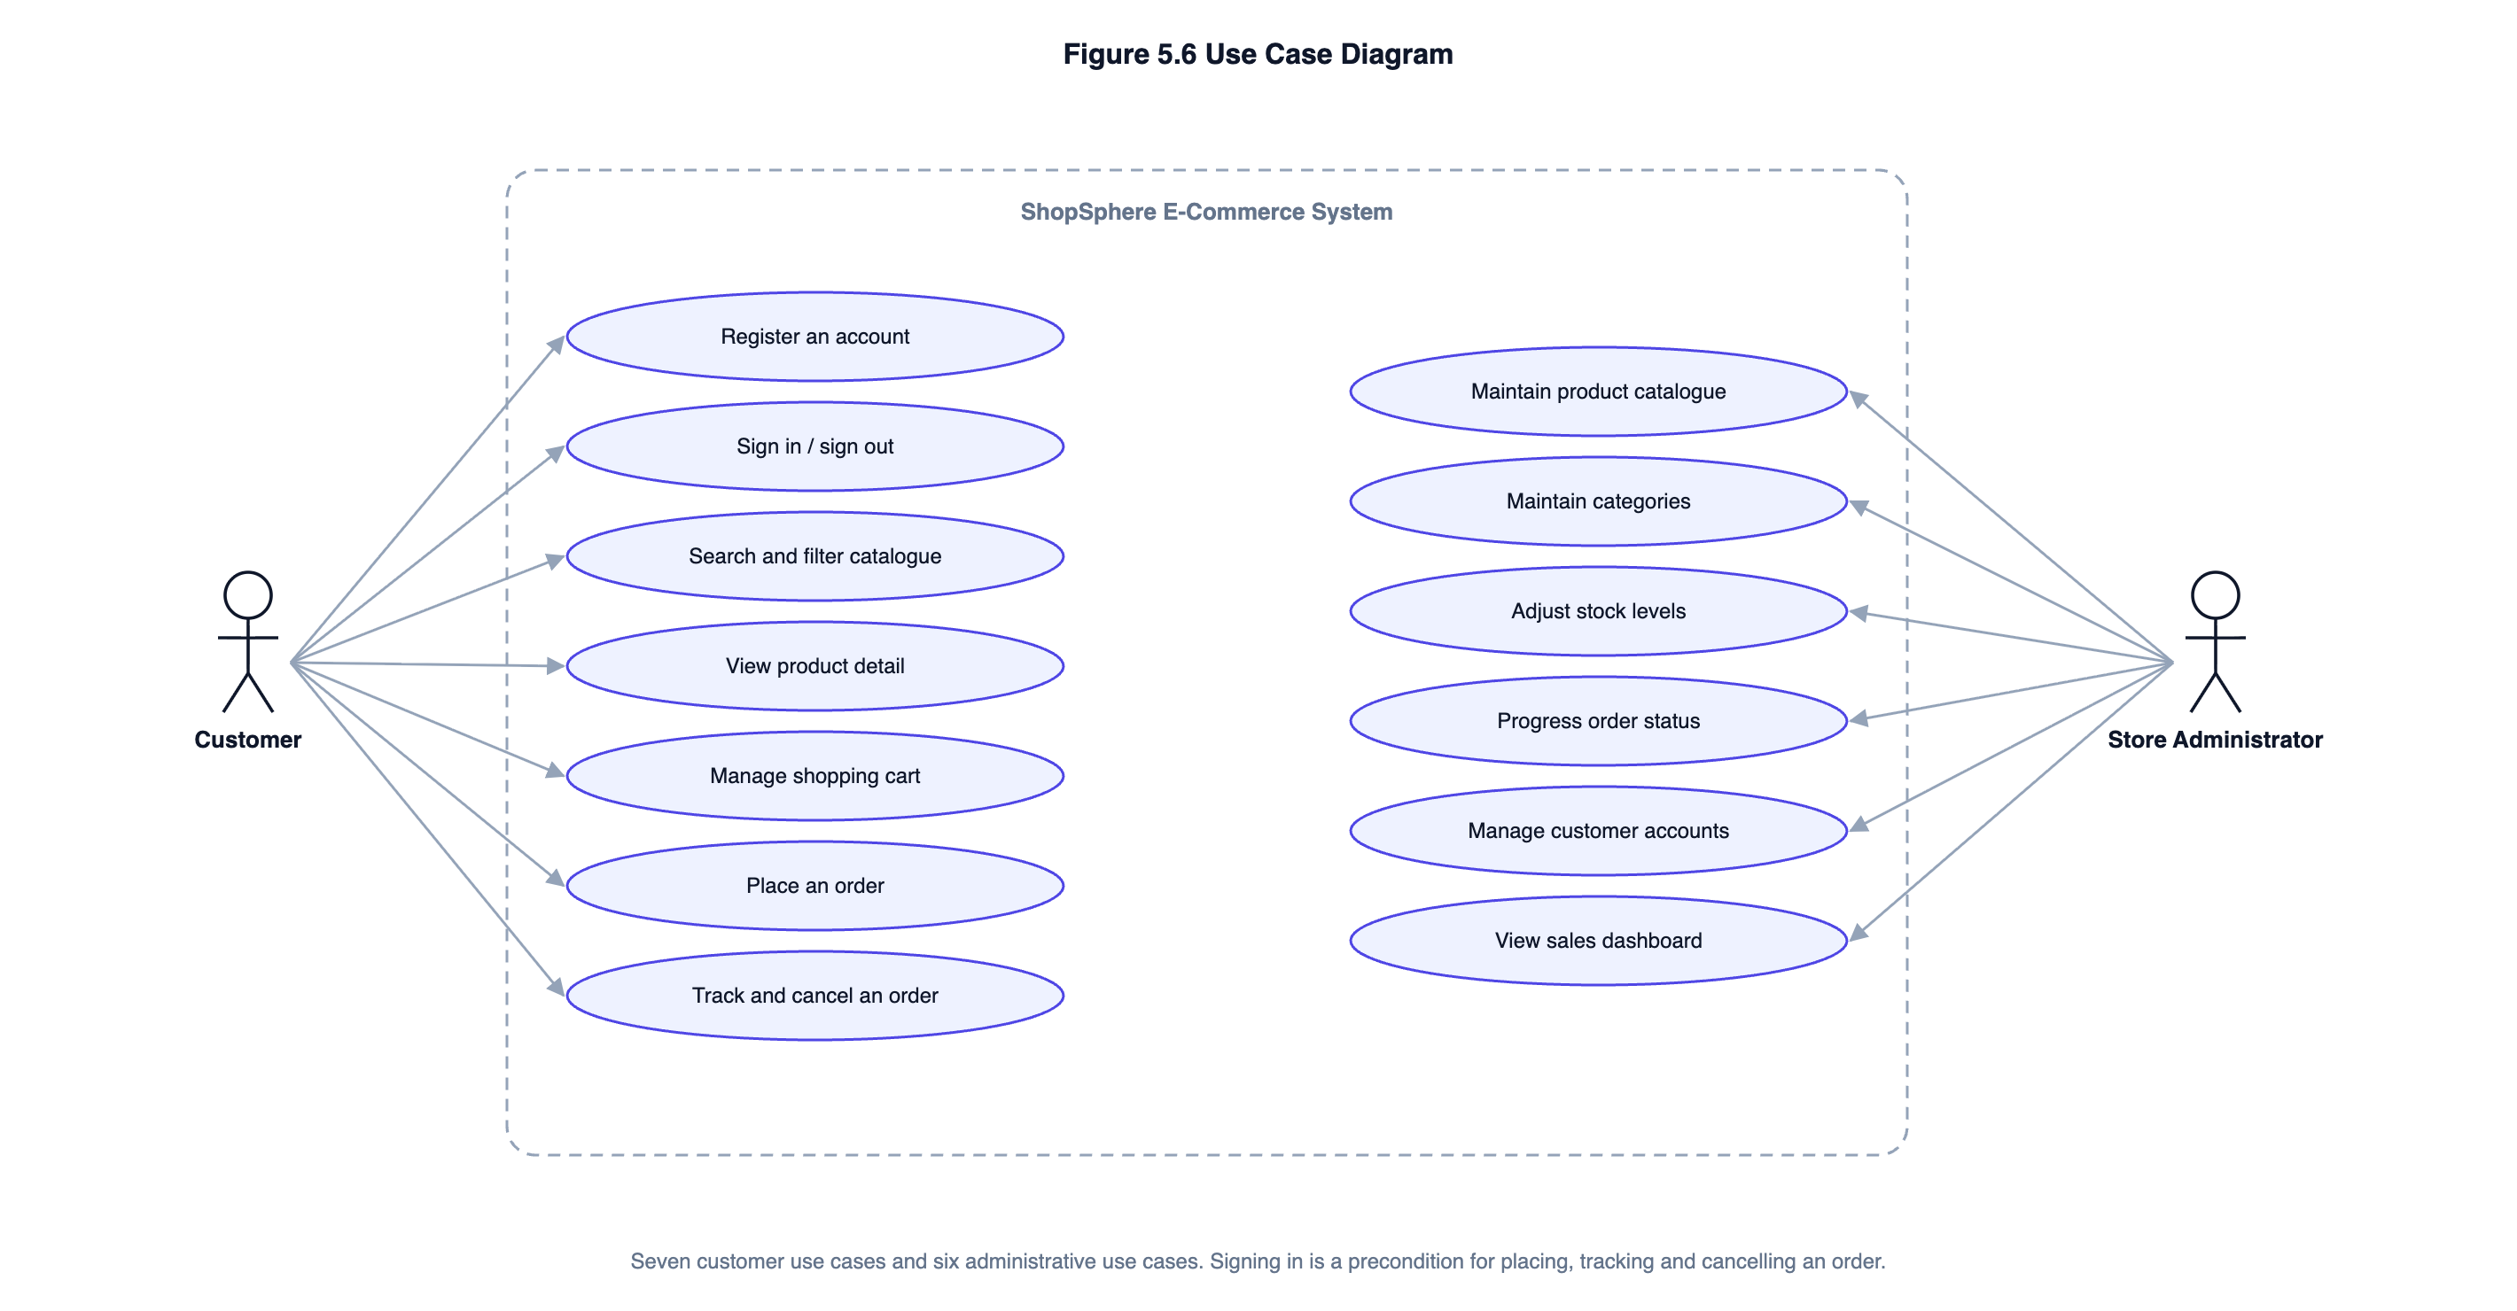
Figure S6: Use case diagram — seven customer and six administrative use cases

4.6 Database Design
The database comprises four collections. Relationships are carried by ObjectId reference fields; MongoDB enforces no foreign-key constraints, so referential integrity is maintained in application code.
Table S1: Collections, fields and indexes
Collection | Principal fields | Indexes
users | _id, name, email (unique), password (bcrypt hash), role {customer | admin}, address, isActive, lastLoginAt | Unique on email
categories | _id, name (unique), slug (unique), description, isActive | Unique on name; unique on slug
products | _id, title, description, brand, price, mrp, category (ref), stockCount, imageUrl, rating, isActive | Weighted text index on (title 10, brand 5, description 1); compound (category, price); createdAt descending; isActive
orders | _id, invoiceNo (unique), user (ref), items[] {product, title, unitPrice, quantity, lineTotal}, itemsTotal, shippingFee, taxAmount, totalPrice, shippingAddress, payment, status, statusHistory[] | Unique on invoiceNo; compound (user, placedAt desc); compound (status, placedAt desc)

5. Complete Structure of the Project

5.1 Number of Modules and Their Description
The system comprises five functional modules beneath a single application shell.
Table S2: Modules and their scope
# | Module | Description | Endpoints
M1 | Identity Management | Registration with a password policy, credential verification, JWT issue and verification, role-based route protection, profile and default-address maintenance, password change. | 6
M2 | Catalogue Management | Product and category storage; keyword search over a weighted text index; filtering by category, price band and availability; five sort orders; pagination; administrator create, amend and soft-delete. | 7
M3 | Shopping Cart | Browser-resident cart mirrored to local storage; add, change quantity and remove; per-item and per-order quantity caps; survives a page reload. | Client-side
M4 | Checkout and Order Processing | Server-side re-pricing from stored prices; atomic stock reservation; simulated card gateway with Luhn and expiry validation, plus cash on delivery; invoice generation; order history; cancellation with stock restoration. | 5
M5 | Store Administration | Analytics dashboard with a fourteen-day revenue series, order status breakdown, best sellers and low-stock alerts; order fulfilment governed by a state machine; customer account activation. | 9

5.2 Data Structures
Table S3: Principal data structures and the reason for each
Data structure | Where used | Why it is the right choice
Hash map (JavaScript Map) | Cart normalisation, merging duplicate lines for the same product; joining aggregation results to the day series in the dashboard. | Constant-time lookup by key, which turns what would be a nested scan into a single pass.
Array of sub-documents | order.items — the order lines embedded in each order document. | Order lines are written once and always read with their order, so embedding avoids a join on the most frequent order read.
B-tree index | Every _id, the unique indexes on email, slug and invoice number, and the compound (category, price) and (user, placedAt) indexes. | Logarithmic lookup; supports both equality and range predicates, and can satisfy a sort without a separate sort stage.
Inverted index (MongoDB text index) | Keyword search over product title, brand and description. | Maps each term to the documents containing it, giving relevance-ranked search without scanning the collection.
Finite state machine (transition table) | Order status, declared once as a frozen object on the Order model. | Makes every legal transition explicit in one place, so no code path can produce an invalid state.
Reducer over an immutable state array | Client-side cart state. | Every mutation is followed by the same persistence step; a single switch keeps the transitions in one readable place.
Frozen configuration object | PRICING_RULES, sort-key whitelist, environment configuration. | Business constants are defined once and cannot be mutated at run time.

5.3 Process Logic for Each Module
**M1 — Identity Management.** Registration validates the name, email and password against the stated policy, checks that the email is unused, and creates the account with the role forced to `customer` — the role is never read from the request body, which is what prevents privilege escalation at registration. A pre-save hook hashes the password with bcrypt at a work factor of twelve. Sign-in looks the account up by a normalised email address, compares the supplied password in constant time, and returns one generic message for both an unknown address and a wrong password so that registered addresses cannot be enumerated. Every protected request extracts the bearer token, verifies its signature and expiry, and then re-reads the account from the database rather than trusting the token payload, so that deactivating an account takes effect on its very next request.
**M2 — Catalogue Management.** The listing endpoint passes the query string to a filter builder that coerces every value to the type the filter expects: an identifier only if it parses as an ObjectId, a price bound only if it parses as an integer, a sort key only if it appears in a whitelist, and a page size capped at forty-eight. A raw string is never handed to MongoDB, which is what prevents operator injection through a query parameter. A keyword search uses the weighted text index and, unless an explicit order is requested, is returned ranked by relevance. An inverted price band — minimum above maximum — is discarded rather than applied, because applying it would return an empty page with no explanation. Deletion is a soft delete that clears `isActive`, so historical orders retain a resolvable product reference.
**M3 — Shopping Cart.** The cart is held in browser memory and mirrored to local storage so it survives a page reload. Quantities are capped per product and the number of distinct products is capped per cart. Both caps are re-applied on the server, because the client is not a security boundary. The totals displayed are explicitly labelled an estimate: the binding figure is the one the server returns at checkout.
**M4 — Checkout and Order Processing.** The submitted cart is treated as nothing more than a list of product identifiers and quantities. Duplicate lines for the same product are merged before the quantity cap is applied, so splitting a line cannot bypass it. Every price is then re-read from the database and every total recomputed. Stock is reserved by a conditional atomic update — `findOneAndUpdate` with a filter requiring sufficient stock and an `$inc` that decrements it — which makes the check and the decrement a single indivisible operation and therefore closes the race window in which two concurrent checkouts could both succeed. Reservation happens **before** payment authorisation, so a customer is never charged for an item that has just sold out; if authorisation then fails, every reservation already taken is released as a compensating action. Where the deployment is a replica set the whole sequence runs inside a real multi-document transaction; on a standalone server it falls back to compensation. Finally the order is written with a cryptographically random invoice number and a snapshot of the title and unit price of every line, so that a later catalogue price change cannot rewrite a historical invoice.
**M5 — Store Administration.** Dashboard figures are computed by MongoDB aggregation pipelines rather than by loading orders into the application, so the work scales with the database rather than with application memory. Calendar-day buckets are resolved in the store’s configured timezone, not in UTC. Order status changes are validated against the transition table declared on the Order model; a cancellation returns stock to the catalogue and marks a paid order as refunded, and a cash-on-delivery order is marked paid when it reaches DELIVERED. An administrator cannot deactivate their own account, because the screen needed to undo it would become unreachable.

5.4 Testing Details
Testing is planned at three levels, with test cases designed and reported separately for each as the guidelines require.
Table S4: Planned testing at three levels
Level | Scope | Approach | Planned cases
Unit testing | Individual functions and schemas in isolation — Luhn validation, expiry checking, query-string parsing, cart normalisation, pricing arithmetic, calendar helpers, schema validation and hooks. | Jest. Database-touching cases run against an in-memory MongoDB instance so that real index and constraint behaviour is exercised rather than mocked. | ≈ 55
Integration testing | Complete request paths — router, validation chain, middleware, controller, service, model and database — for all twenty-seven endpoints. | Jest with Supertest driving the Express application over real HTTP in-process. Nothing is stubbed. | ≈ 65
System testing | Whole user journeys in the order a real visitor performs them: registration → search → add to cart → checkout → fulfilment; catalogue narrowing; cancel and rebuy; administrator catalogue lifecycle; session lifecycle across a password change. | Jest. Each step uses only data returned by the previous step, so a break anywhere fails the case. | 5

Specific properties that will be asserted rather than assumed include: that concurrent checkouts cannot oversell the last unit; that a client-supplied price is ignored; that a declined payment leaves stock unchanged and writes no order; that no card number or CVV is persisted; that a customer cannot read another customer's order; and that deactivating an account takes effect immediately.

5.5 Reports Generation
The system generates the following reports and outputs. Each is produced from live data at the moment it is requested; none is pre-computed or cached.
Table S5: Reports generated by the system
Report / output | Audience | Tentative contents
Sales summary | Administrator | Total revenue, order count, units sold and average order value across all realised orders (confirmed, shipped and delivered).
Fourteen-day revenue trend | Administrator | Revenue and order count per calendar day for the last fourteen days, plotted as an area chart, with days of no trading shown as zero rather than omitted.
Order status breakdown | Administrator | Count of orders in each of the five states, plotted as a horizontal bar chart.
Best-selling products | Administrator | Top five products by units sold, with the revenue each generated.
Low-stock alert | Administrator | Every active product at or below five units, ordered by stock ascending, with an out-of-stock flag.
Order queue | Administrator | All orders with invoice number, customer, date, item count, total, payment method and status; filterable by status and paginated.
Customer register | Administrator | All accounts with name, email, role, registration date and activation status; searchable by name or email.
Customer order history | Customer | Own orders, newest first, with invoice number, date, total, status and item summary.
Order detail / invoice | Customer and administrator | Invoice number, order date, itemised lines with unit price and line total, subtotal, delivery charge, tax, payable total, delivery address, payment method with the last four digits of the card, and the full status timeline.

6. Tools, Platform and Hardware / Software Requirements

6.1 Tools and Platform
Table S6: Tools and platform
Layer | Technology
Front end | React 18, react-router-dom 6, React Context API, Axios, Recharts, Vite 5, CSS3 (Grid, custom properties)
Back end | Node.js 22, Express 4, Mongoose 8, jsonwebtoken, bcryptjs, express-validator, helmet, express-mongo-sanitize, express-rate-limit, cors, morgan
Database | MongoDB 7 Community Server, with text and compound indexes and the aggregation framework
Testing | Jest 29, Supertest 7, mongodb-memory-server 10
Development tools | Visual Studio Code, Git, Postman, MongoDB Compass, Chrome DevTools
Architecture | Decoupled three-tier: React SPA → stateless REST API → document database

6.2 Hardware Requirements
Table S7: Hardware requirements
Component | Development machine | Deployment server | Client device
Processor | Dual-core 2.0 GHz or better | One virtual CPU | Any
Memory | 8 GB (4 GB minimum) | 1–2 GB | 2 GB
Disk | 10 GB free | 10 GB, growing with order history | Negligible
Network | Broadband | Public IP address or reverse proxy | Any internet connection
Display | 1366 × 768 or better | Not applicable | 360 px width or wider

6.3 Software Requirements
Table S8: Software requirements
Component | Development | Deployment | Client
Operating system | Windows 10+, macOS 12+ or Ubuntu 20.04+ | Any Linux with a supported Node.js build | Any
Runtime | Node.js 18 LTS or later, npm 9+ | Node.js 18 LTS or later | Not applicable
Database | MongoDB 6+ Community Server | MongoDB 6+; a replica set is recommended so that real multi-document transactions are available | Not applicable
Browser | Chrome or Firefox with developer tools | Not applicable | Chrome 90+, Firefox 88+, Safari 14+ or Edge 90+
Other | Git, Visual Studio Code, Postman | A process supervisor (pm2 or systemd); TLS termination at the proxy | JavaScript and local storage enabled

7. Is This Project Being Done for Any Industry or Client?
**No.**
This project is not being carried out for any industry, client or organisation. It is an independent academic project, formulated by the student in consultation with the project guide as permitted by Section III of the BCSP-064 guidelines, which state that it is not mandatory for a student to work on a real-life project and that the student may formulate a project problem with the help of the guide. The problem domain is modelled on the needs of a small retailer, but no particular retailer is involved, no client data is used, and no confidentiality restriction applies to the source code, which is reproduced in full in the project report.

8. Future Scope and Further Enhancement
The architecture is deliberately decoupled so that the enhancements below can be made without rebuilding the system.
- Product variants. A variants array on the product document, each variant carrying its own SKU, attributes and stock count, with the atomic reservation operating on a positional array element. Required before apparel or footwear can be sold properly.
- Live payment gateway. Replacing the simulated gateway with a certified integration, in which the browser posts card details directly to the gateway and the application only ever sees a token. The module boundary is drawn so this touches one file.
- Server-side cart. Persisting the cart against the account so it follows the customer between devices.
- Email and SMS notification. Transactional despatch on order placement and each status change, queued so that a provider outage cannot fail a checkout.
- Customer reviews. A reviews collection with a verified-purchase check and incremental update of the product rating.
- Discount codes and promotions. Validity rules applied during the server-side re-pricing step, so a discount cannot be forged by the client.
- Image upload pipeline. Multipart upload, server-side resizing and delivery through a content delivery network.
- Native mobile application. Because the server is a headless REST API, a React Native client can consume the same endpoints with no server change.
- Recommendation engine. Collaborative filtering over the co-purchase information already present in the order history, replacing the current same-category query.
- Dedicated search engine. Elasticsearch or MeiliSearch for typo tolerance, synonyms and faceted counts, none of which a MongoDB text index provides.
- Multi-vendor marketplace. Seller accounts, per-seller catalogues, commission calculation and split settlement.
- Progressive web application. A service worker for offline catalogue browsing and installability on mobile.

TABLE OF CONTENTS

This contents page is generated by Word from the document headings. To populate or refresh it, open the document in Microsoft Word, click anywhere in the table below and press F9 (on macOS, Command-Option-Shift-U), then choose "Update entire table". In LibreOffice Writer, use Tools → Update → Indexes and Tables.

…

LIST OF FIGURES

Figure | Caption
Figure 1 | Project schedule showing the nineteen-week plan, with testing overlapping implementation
Figure 2 | Three-tier architecture. The browser never reaches the database directly; every request passes through the Express middleware chain.
Figure 3 | Context diagram showing the system boundary and the two external entities
Figure 4 | Level 1 data flow diagram — seven processes and four data stores
Figure 5 | Level 2 explosion of the checkout process
Figure 6 | Level 2 explosion of the catalogue browsing process
Figure 7 | Entity–relationship diagram. ORDER_ITEM is a weak entity embedded within ORDER.
Figure 8 | Use case diagram showing seven customer use cases and six administrative use cases
Figure 9 | Module hierarchy. Each module owns its controller, service logic and data model.
Figure 10 | Order status state machine. DELIVERED and CANCELLED are terminal states.
Figure 11 | Catalogue listing — fluid product grid with the filter sidebar and sort control
Figure 12 | Home page — hero, category shortcuts with live counts, new arrivals
Figure 13 | Keyword search for "earphones", ranked by relevance
Figure 14 | Combined filters: ₹500–₹2,000, in stock, price ascending
Figure 15 | Page not found — shown for any unmatched route
Figure 16 | Product detail — description, live stock position, quantity stepper and related items
Figure 17 | Sign in, with the demonstration credentials shown
Figure 18 | Sign-in failure — one generic message for both cases
Figure 19 | Registration — the password policy as a live checklist
Figure 20 | Profile — details, default address and password change
Figure 21 | Adding to the cart — transient confirmation and badge
Figure 22 | Shopping cart with the free-delivery threshold prompt
Figure 23 | Checkout — delivery address, payment selection, card entry and the server-priced order summary
Figure 24 | Declined payment — stock already returned, no order written
Figure 25 | Order confirmation with the invoice number
Figure 26 | Order history, most recent first
Figure 27 | Order detail with the status timeline
Figure 28 | Administrator dashboard — headline figures, fourteen-day revenue series, status breakdown, best sellers and low-stock alerts
Figure 29 | Order queue — filterable by status, offering only the transitions the state machine permits from each order’s current state
Figure 30 | Product maintenance with colour-coded stock levels
Figure 31 | Product form with per-field validation
Figure 32 | Category maintenance — deletion blocked while in use
Figure 33 | Customer administration — search, filter, activation
Figure 34 | Home page at 390 px
Figure 35 | Catalogue at 390 px — two columns
Figure 36 | Product detail at 390 px
Figure 37 | Catalogue at 834 px (tablet) — three columns

LIST OF TABLES

Table | Caption
Table 1 | Project objectives and the evidence for each
Table 2 | Difficulties with the manual process and the corresponding system response
Table 3 | Comparison of implementation options
Table 4 | Indicative cost comparison for the first year of operation
Table 5 | Increments delivered, in order
Table 6 | Basic COCOMO estimate compared with the effort actually expended
Table 7 | User classes and their privileges
Table 8 | Functional requirements
Table 9 | Non-functional requirements
Table 10 | Development environment
Table 11 | Server-side deployment requirements
Table 12 | Client-side requirements
Table 13 | Presentation-tier technologies
Table 14 | Application-tier technologies
Table 15 | Data-tier technologies
Table 16 | Development and testing tools
Table 17 | Level 1 processes and the stores they access
Table 18 | Sub-processes of the checkout engine
Table 19 | Relationships and how each is implemented
Table 20 | Use case description — Place an Order
Table 21 | Use case description — Progress Order Status
Table 22 | Data dictionary — users collection
Table 23 | Data dictionary — categories collection
Table 24 | Data dictionary — products collection
Table 25 | Data dictionary — orders collection
Table 26 | Modules, responsibilities and coupling
Table 27 | Collection characteristics
Table 28 | The design assessed against the first three normal forms
Table 29 | Indexes and the queries they serve
Table 30 | Integrity constraints, their enforcement and their tests
Table 31 | Screen inventory
Table 32 | Responsive behaviour by viewport width
Table 33 | Complete API endpoint specification
Table 34 | Coding conventions applied
Table 35 | Validation applied at each layer
Table 36 | Error conditions and the system’s response
Table 37 | The three levels of testing
Table 38 | Unit test cases (all 55 cases pass — see Section 8.5 for the run summary)
Table 39 | Integration test cases (all 67 cases pass — see Section 8.5 for the run summary)
Table 40 | System test cases and results (5 journeys, all passing)
Table 41 | Test execution summary
Table 42 | Code coverage by area (server source)
Table 43 | Defect D-01 — timezone-dependent date bucketing
Table 44 | Defect D-02 — an invalid test fixture
Table 45 | Defect D-03 — over-strict image validation
Table 46 | Access controls and the evidence for each
Table 47 | Additional security measures
Table 48 | Security tests and their outcomes
Table 49 | Near-term enhancements

1. INTRODUCTION

1.1 Background
Retail in India has moved decisively online over the past decade. For a small or medium-sized retailer, however, the move is not simply a matter of deciding to sell on the internet. The retailer must choose between a hosted platform that charges a recurring fee and a share of every transaction, and a self-hosted system that must be built and maintained. The first option is quick but expensive over time and restrictive in what can be customised; the second demands engineering effort that a small business rarely has in-house.
This project takes the second route and asks what it actually costs, in engineering terms, to build a competent online store. The answer turns out to be less about the volume of code and more about getting a handful of things right: knowing who the user is, never trusting a price that arrives from a browser, and making sure two customers cannot buy the same last unit.
The result is ShopSphere, a working e-commerce web application built on the MERN stack — MongoDB, Express.js, React and Node.js. It supports a public catalogue with search and filtering, registered customer accounts, a persistent shopping cart, a checkout with a simulated payment gateway, order tracking, and a back-office dashboard through which a store administrator maintains the catalogue and fulfils orders.

1.2 The Problem in Concrete Terms
Three specific technical problems recur in small-scale e-commerce systems, and this project treats each of them as a first-class design concern rather than an afterthought.

1.2.1 The client cannot be trusted
A shopping cart normally lives in the browser so that adding an item feels instant. But whatever lives in the browser can be edited by the person using it. A system that accepts the cart total sent by the client will, sooner or later, sell a television for one rupee. The design adopted here keeps the cart in the browser for responsiveness but treats the submitted cart as nothing more than a list of product identifiers and quantities; every price, every subtotal, the shipping charge, the tax and the final payable amount are recomputed on the server from the database before an order is accepted.

1.2.2 Two customers, one last unit
If the last unit of a product is in stock and two customers check out at the same instant, the obvious implementation — read the stock, compare it with the quantity wanted, then write the reduced figure back — contains a window between the read and the write in which both requests see stock available. Both succeed, and the store has sold something it does not have. This is a classic race condition, and it does not appear during manual testing because it needs two requests to arrive within milliseconds of each other. The system resolves it by making the check and the decrement a single atomic database operation, described in detail in Section 6.4.2 and demonstrated by test case TC-U-36.

1.2.3 Credentials and card data
Amateur implementations frequently store passwords in a form from which the original can be recovered, and some store card numbers "for convenience". Both are serious failures. In this system passwords are stored only as bcrypt hashes with a work factor of twelve, and the card number supplied at checkout is validated in memory, reduced to its last four digits for the invoice, and then discarded. Test cases TC-U-09 and TC-I-39 assert that neither the card number nor the CVV appears anywhere in the stored order document.

1.3 Structure of This Report
The report follows the software development life cycle. Chapter 2 states the objectives and fixes the scope. Chapter 3 covers system analysis: the identification of need, the feasibility study, the process model adopted, the schedule, the software requirements specification and the hardware and software requirements. Chapter 4 describes the tools and environment. Chapters 5 and 6 present the analysis and design documents respectively — data flow diagrams to the second level, the entity-relationship model, the data dictionary, modularisation, database design, procedural design and interface design. Chapter 7 covers the implementation and the coding standards applied. Chapter 8 presents the test case designs and results for unit, integration and system testing, together with an account of the defects found and corrected. Chapter 9 reproduces the input and output screens. Chapter 10 sets out the security measures implemented. Chapters 11 to 13 state the limitations, the scope for future work, and the conclusion. The complete source code is reproduced in Appendix A.

2. OBJECTIVES OF THE PROJECT

2.1 Primary Objectives
The project sets out to deliver a working, tested e-commerce application that meets the following objectives. Each is stated so that it can be verified rather than merely asserted, and the final column of Table 1 names the evidence in this report that establishes it.
Table 1: Project objectives and the evidence for each
# | Objective | How it is verified
O1 | Build a responsive customer interface that remains usable on a desktop monitor, a tablet and a mobile phone without a separate mobile site. | Screens in Chapter 9 captured at 1440 px, 834 px and 390 px widths (Figures 34–37).
O2 | Implement stateless authentication using JSON Web Tokens, with passwords stored only as one-way hashes. | Section 10.2; test cases TC-U-37 to TC-U-42, TC-I-01 to TC-I-16.
O3 | Provide catalogue search, category filtering, price-band filtering, sorting and pagination backed by database indexes rather than collection scans. | Section 6.2.3; test cases TC-U-14 to TC-U-24, TC-I-17 to TC-I-24.
O4 | Guarantee that concurrent checkouts cannot oversell stock. | Section 6.4.2; test cases TC-U-36 and TC-I-45.
O5 | Recompute every monetary amount on the server so that a tampered client cannot alter what it pays. | Section 6.4.1; test case TC-I-38.
O6 | Enforce role-based access control so that customer accounts cannot reach administrative functions or other customers’ orders. | Section 10.3; test cases TC-I-29, TC-I-30, TC-I-47, TC-I-50, TC-I-59.
O7 | Provide a back-office dashboard with sales analytics, catalogue maintenance, order fulfilment and customer administration. | Chapter 9, Figures 28–33; test cases TC-I-56 to TC-I-65.
O8 | Document every phase of the development life cycle in accordance with the BCSP-064 guidelines. | This report in its entirety.

2.2 Scope — What the System Does
The scope was fixed deliberately narrow so that the features chosen could be implemented properly and tested, rather than a longer list implemented superficially. The system provides:
- Account management — registration with a password policy, sign-in, sign-out, profile and default-address maintenance, and password change.
- Catalogue browsing — a paginated product listing with full-text keyword search, filtering by category, price band and stock availability, and five sort orders.
- Product detail — full description, live stock position, discount calculation against the maximum retail price, and related items from the same category.
- Shopping cart — add, change quantity and remove, with the cart surviving a page reload, and per-item and per-order quantity caps enforced on both client and server.
- Checkout — server-side re-pricing, delivery address capture with validation, a simulated card gateway and a cash-on-delivery option, and invoice generation.
- Order tracking — order history, full order detail with a status timeline, and customer-initiated cancellation while the order has not yet shipped.
- Store administration — a sales dashboard with a fourteen-day revenue series, best-selling products and low-stock alerts; product and category maintenance; stock adjustment; order status progression; and customer account activation.

2.3 Scope — What the System Deliberately Does Not Do
Stating the exclusions explicitly is as important as stating the inclusions, because it prevents the report from implying capabilities the software does not have.
- No live payment processing. The gateway is simulated. It reproduces the contract of a real gateway — validate, authorise, return a reference — but no money moves and no acquirer is contacted. This is a requirement of the academic brief, not an oversight, and the reasoning is set out in Section 6.4.3.
- No multi-vendor marketplace. There is a single store with a single administrative role. Seller onboarding, commission handling and per-vendor payouts are out of scope.
- No shipping-carrier integration. Order status is advanced manually by the administrator; there is no pickup booking or live consignment tracking.
- No product reviews or ratings submission. Ratings are displayed from seeded data but customers cannot submit them.
- No email or SMS notification. Order confirmation is shown on screen and in the order history; nothing is despatched.
- No recommendation engine. "Related products" is a same-category query, not a learned recommendation.

3. SYSTEM ANALYSIS

3.1 Identification of Need and Preliminary Investigation
The investigation began by examining how a small retailer currently operates without a web presence, and where the manual process breaks down.
Table 2: Difficulties with the manual process and the corresponding system response
Aspect of the manual process | Observed difficulty | How the proposed system addresses it
Trading hours | Sales are possible only while the shop is open; enquiries outside those hours are lost. | The catalogue and checkout are available continuously.
Stock records | Stock is tracked in a register or a spreadsheet and is updated after the fact, so the figure is frequently wrong. | Stock is decremented atomically at the moment an order is accepted, so the catalogue figure and the physical figure stay in step.
Price changes | A price change must be applied to every label and price list by hand. | A single update in the administration screen changes the price everywhere at once, while orders already placed keep the price they were sold at.
Order records | Orders are recorded on paper; finding a past order means searching through a file. | Every order carries a unique invoice number and is retrievable by the customer and by the administrator.
Sales visibility | The owner knows the day’s takings but not which products are selling or which are about to run out. | The dashboard reports revenue over fourteen days, best-selling products by units and revenue, and products at or below a low-stock threshold.
Geographic reach | Customers must be physically present. | Any customer with a browser can order; delivery is to a validated Indian address.

The investigation also considered the alternative of adopting an existing hosted platform. Table 3 sets out that comparison.
Table 3: Comparison of implementation options
Option | Strengths | Weaknesses for this class of user
Hosted SaaS platform (Shopify, BigCommerce and similar) | Operational within days; hosting, updates and security patching handled by the vendor; a large ecosystem of add-ons. | A recurring subscription plus a percentage of each transaction; limited control over the source; the store is difficult to migrate away from later.
Open-source monolith (Magento, PrestaShop and similar) | No licence fee; a large feature set available immediately. | Heavy resource requirements; customisation usually means working against the framework; each third-party plugin widens the attack surface.
Purpose-built decoupled application (this project) | No licence or transaction fee; complete control over behaviour and data; a small surface area that one developer can reason about; modest hosting requirements. | Requires engineering effort up front; the operator is responsible for hosting, backups and security updates.

The conclusion of the preliminary investigation was that a purpose-built decoupled application is justified where the retailer has access to development effort — which is the situation of an academic project — and where long-run transaction fees would otherwise accumulate. That conclusion sets the direction for the rest of this report.

3.2 Feasibility Study
Feasibility was assessed along four dimensions before implementation began.

3.2.1 Technical feasibility
The stack chosen is JavaScript end to end. The same language runs in the browser, on the server and in the test suite, and the data representation — JSON objects on the wire, BSON documents in the database — needs no translation layer between tiers. For a single developer this materially reduces the cognitive load of moving between tiers, which is the largest practical risk in a solo full-stack project.
Node.js handles concurrent requests on a single-threaded event loop with non-blocking input and output, which suits an application whose work is dominated by waiting for the database rather than by computation. React’s component model and virtual DOM keep interface updates localised. MongoDB’s document model accommodates products whose attributes differ by category without the sparse columns or entity-attribute-value tables that the same requirement forces on a strictly relational schema. Every component is mature, documented and widely deployed; none of them is experimental.
The one genuine technical risk identified in advance was concurrency control during checkout, because MongoDB guarantees atomicity at the level of a single document but multi-document transactions require a replica set, which a standalone development installation is not. The resolution — a conditional atomic update with a compensating action, upgrading to a real transaction when the deployment supports one — is set out in Section 6.4.2. The risk was therefore assessed as manageable, and the project was judged technically feasible.

3.2.2 Economic feasibility
Every component of the development environment is free and open source: Node.js, React, Express, MongoDB Community Server, Mongoose, Jest, Vite, Git and Visual Studio Code. The only development cost is the student’s time. Table 4 sets out the position for a hypothetical first year of live operation, which is the relevant comparison for a retailer weighing this against a subscription platform.
Table 4: Indicative cost comparison for the first year of operation
Item | Self-hosted (this project) | Hosted SaaS platform
Software licences | Nil — all components are open source | Nil, but bundled into the subscription
Subscription | Nil | Approximately ₹2,000 – ₹8,000 per month
Transaction commission | Nil (payment-gateway charges apply in both cases) | 0.5% – 2% of each order in addition to gateway charges
Application hosting | Approximately ₹500 – ₹900 per month on an entry-level cloud instance | Included
Database hosting | Nil on the same instance, or approximately ₹0 on a free-tier managed cluster at this scale | Included
Domain and TLS certificate | Approximately ₹900 per year; TLS free via Let’s Encrypt | Domain billed separately
Development effort | Borne once, up front | Minimal
Indicative first-year cash cost | ≈ ₹8,000 – ₹12,000 | ≈ ₹24,000 – ₹96,000 plus commission

The figures above are indicative rather than quoted, and are included to show the shape of the trade-off rather than to give a precise budget. The conclusion is that the self-hosted route trades a one-off engineering cost for a materially lower recurring cost, and is economically feasible for the intended user.

3.2.3 Operational feasibility
The people who must operate the system are the store administrator and the customers. The administrator needs no database knowledge: products, categories, stock and order status are all maintained through forms and buttons, and the state machine governing order status means the interface only ever offers a transition the server will accept, so an administrator cannot reach an invalid state by clicking the wrong thing. Customers need no training; the catalogue, cart and checkout follow the conventions already established by the large retail sites they use.
Operationally the decoupled design also helps maintenance: because the browser application communicates with the server only over a documented set of REST endpoints, the interface can be restyled or rebuilt without touching the server, and the server can be refactored without breaking the interface so long as the endpoint contract holds.

3.2.4 Behavioural feasibility
Behavioural feasibility asks whether the people affected will actually adopt the system. The principal resistance expected from a small retailer is a reluctance to trust an unfamiliar process with money and stock. Three design decisions address that directly: the stock figure shown in the catalogue is the real figure, because it is decremented at the moment of sale rather than in a later reconciliation; every order carries an invoice number and a full status history, so any query can be answered from the record; and the dashboard presents the day-to-day numbers the owner already tracks, in a form they already recognise. For customers, the familiar interaction pattern and the visible stock position lower the barrier to a first purchase.

3.3 Software Engineering Paradigm Applied
The **incremental process model** was adopted. The requirements were understood well enough at the outset to be specified, which rules out a purely exploratory approach, but a single waterfall pass would have deferred all testing to the end — a poor fit for a solo project with a fixed submission date, because any serious defect found late would leave no time to correct it.
Under the incremental model the system was delivered as a sequence of working increments, each one analysed, designed, coded and tested before the next began:
Table 5: Increments delivered, in order
Increment | Scope delivered | Verified by
I — Foundation | Project skeleton, environment configuration, database connection, central error handling, User model. | Application starts; TC-U-37 to TC-U-42.
II — Identity | Registration, sign-in, JWT issue and verification, role-based route protection, profile and password change. | TC-I-01 to TC-I-16.
III — Catalogue | Category and Product models with indexes, listing with search, filter, sort and pagination, product detail, administrator CRUD. | TC-U-14 to TC-U-24; TC-I-17 to TC-I-35.
IV — Cart and checkout | Cart context, server-side re-pricing, atomic stock reservation, simulated payment, order persistence, invoice generation. | TC-U-25 to TC-U-36; TC-I-36 to TC-I-45.
V — Fulfilment | Order history, order detail, cancellation, administrator status progression governed by the state machine. | TC-I-46 to TC-I-55.
VI — Administration | Dashboard aggregations, customer administration, low-stock alerts. | TC-I-56 to TC-I-65.
VII — Hardening | System testing of complete journeys, defect correction, documentation. | TC-S-01 to TC-S-05.

The choice paid for itself in Increment VI. The defect described in Section 8.6.1 — the dashboard reporting its fourteen-day sales window one day out and silently excluding the current day — was found because the increment was tested as soon as it was built, while the reasoning behind the date arithmetic was still fresh. Under a waterfall schedule the same defect would have surfaced during final testing, if at all, since the symptom is a subtly wrong chart rather than a visible failure.

3.4 Project Planning and Scheduling
The work was planned over nineteen weeks, undertaken part-time alongside the remaining coursework of the semester. Figure 1 shows the schedule. Testing overlaps implementation deliberately, in keeping with the incremental model: each increment was tested as it was completed rather than at the end of the project.
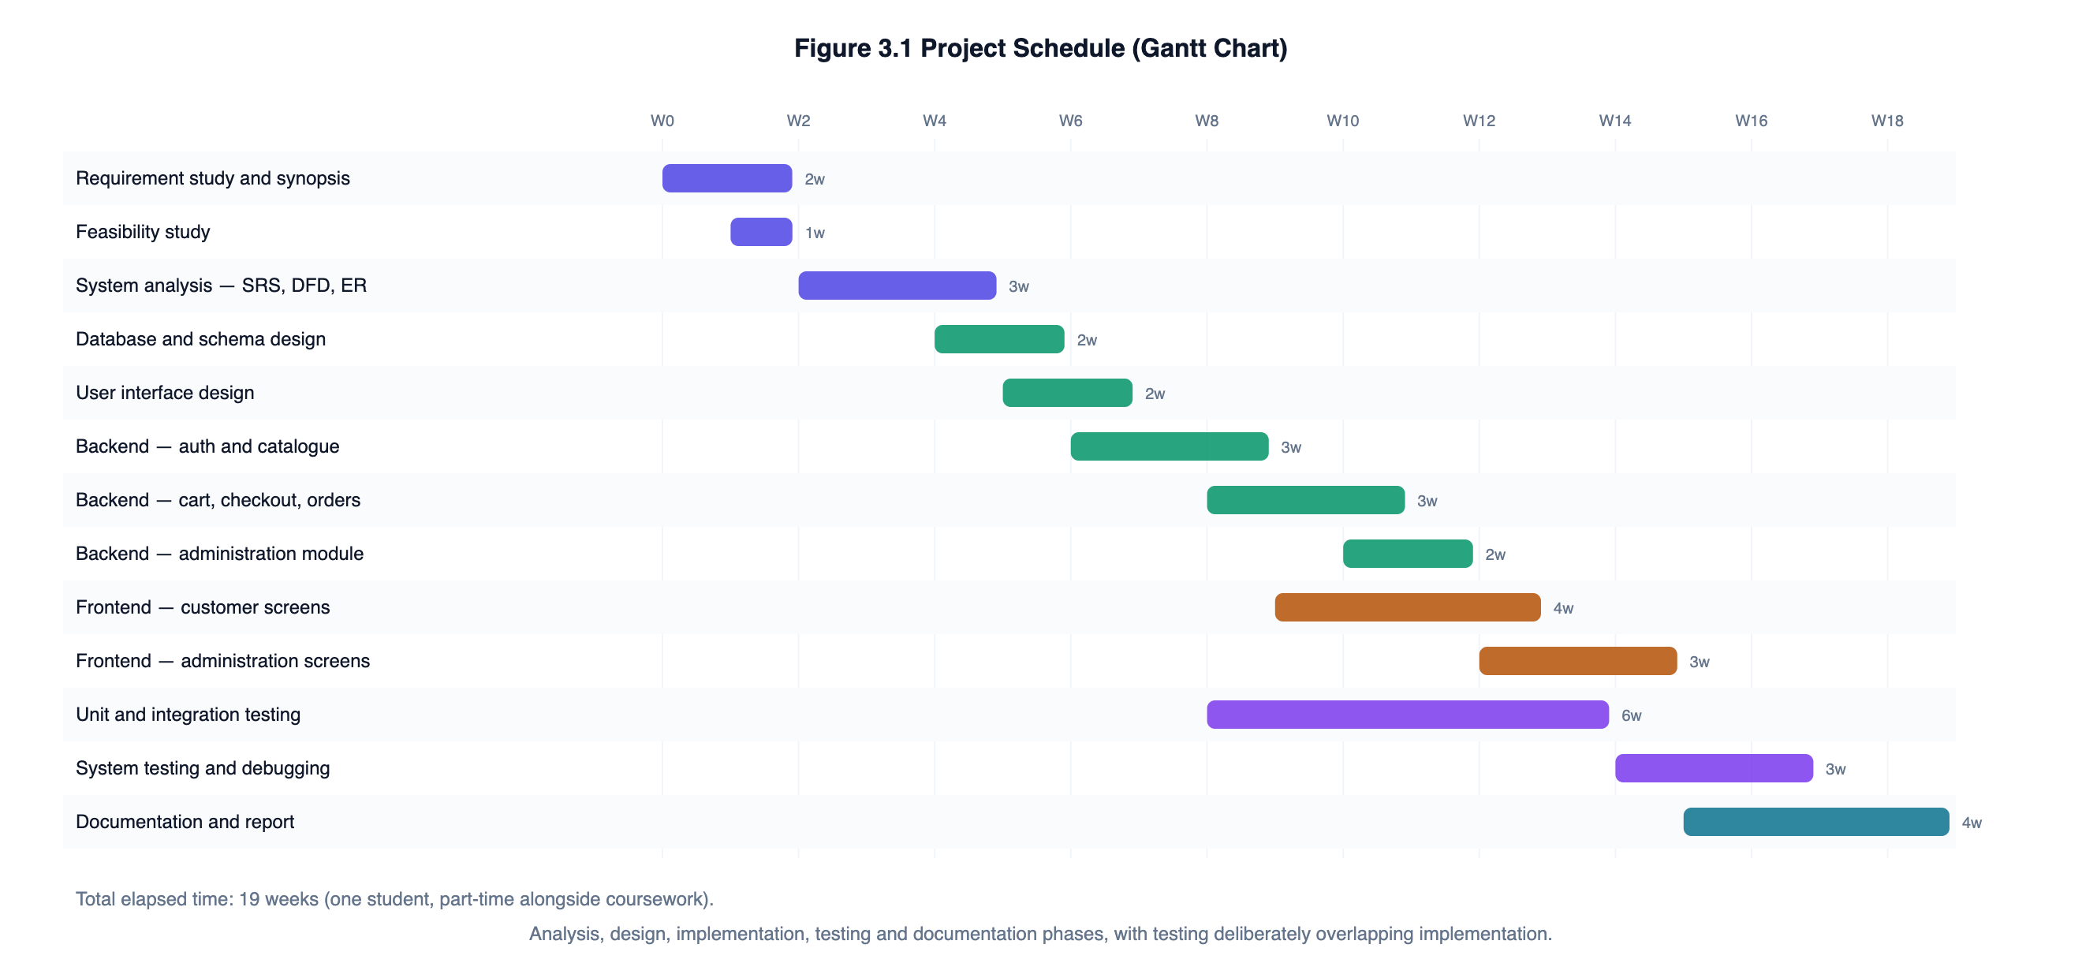
Figure 1: Project schedule showing the nineteen-week plan, with testing overlapping implementation

3.4.1 Effort estimation
An estimate was prepared using the Basic COCOMO model for an organic project, which is the appropriate mode for a small team working on a familiar problem in a stable environment. The model gives effort as E = a × (KLOC)^b person-months, with a = 2.4 and b = 1.05 for organic projects, and duration as D = c × E^d months with c = 2.5 and d = 0.38.
Table 6: Basic COCOMO estimate compared with the effort actually expended
Quantity | Value | Basis
Delivered source lines (server/src and client/src, excluding blank and comment-only lines) | 5,530 | Measured from the final code base
KLOC | 5.53
Effort, E = 2.4 × 5.53^1.05 | ≈ 14.5 person-months | Basic COCOMO, organic mode
Duration, D = 2.5 × 14.5^0.38 | ≈ 6.9 months | Basic COCOMO, organic mode
Implied average staffing, E ÷ D | ≈ 2.1 persons
Actual effort expended | Approximately 4.5 person-months | One student, part-time over nineteen weeks

The actual effort is well below the COCOMO figure, and it is worth being honest about why rather than presenting the gap as an achievement. COCOMO was calibrated against industrial projects that carry costs this one does not: requirements negotiation with a real client, formal review gates, integration with existing systems, user acceptance testing, deployment and handover documentation. It also assumes a team, and therefore the communication overhead a team incurs. A single developer working to a specification they wrote themselves avoids nearly all of that. The estimate is included because the BCSP-064 guidelines call for cost estimation, and because the gap is itself instructive: it shows how much of the cost of industrial software lies outside the act of writing code.

3.5 Software Requirements Specification

3.5.1 User classes
Table 7: User classes and their privileges
User class | Characteristics | Privileges
Visitor (unauthenticated) | Any person with a browser; no account; may be evaluating the store before registering. | Browse and search the catalogue, view product detail, build a cart. Cannot check out, and cannot see any order.
Customer (authenticated) | Registered account holder; general computer literacy assumed, no technical knowledge required. | Everything a visitor may do, plus checkout, order history, order detail for their own orders only, order cancellation before despatch, and profile maintenance.
Store administrator | Store owner or an employee acting for them; comfortable with forms and tables but not with databases. | Catalogue and category maintenance, stock adjustment, view and progress any order, customer account activation, and the analytics dashboard.

3.5.2 Functional requirements
Each requirement below is identified so that it can be traced to the test cases in Chapter 8.
Table 8: Functional requirements
ID | Requirement | Priority
FR-01 | The system shall allow a visitor to register with a name, a unique email address and a password meeting the stated policy. | High
FR-02 | The system shall reject a registration whose email address is already in use, irrespective of letter case. | High
FR-03 | The system shall authenticate a registered user and issue a signed access token valid for seven days. | High
FR-04 | The system shall return an identical response for an unknown email address and an incorrect password, so that registered addresses cannot be enumerated. | High
FR-05 | The system shall allow a signed-in user to change their own password after confirming the current one. | Medium
FR-06 | The system shall allow a signed-in user to maintain their name and a default delivery address. | Medium
FR-07 | The system shall present a paginated catalogue of active products. | High
FR-08 | The system shall support full-text keyword search over product title, brand and description, ranked by relevance. | High
FR-09 | The system shall support filtering by category, by price band and by stock availability, in any combination. | High
FR-10 | The system shall support ordering results by recency, price ascending, price descending, customer rating and name. | Medium
FR-11 | The system shall present full product detail including live stock position and any discount against the maximum retail price. | High
FR-12 | The system shall suggest up to four related in-stock products from the same category. | Low
FR-13 | The system shall maintain a shopping cart that survives a page reload. | High
FR-14 | The system shall cap the quantity per product and the number of distinct products in a cart, and shall enforce both caps on the server. | Medium
FR-15 | The system shall recompute the item subtotal, delivery charge, tax and payable total on the server from stored prices before accepting an order. | High
FR-16 | The system shall decrement stock atomically and shall not permit an order that would take stock below zero. | High
FR-17 | The system shall validate card details, simulate an authorisation, and persist no card number or CVV. | High
FR-18 | The system shall return reserved stock to the catalogue if payment authorisation fails. | High
FR-19 | The system shall offer cash on delivery as an alternative to card payment. | Medium
FR-20 | The system shall generate a unique, non-sequential invoice number for every order. | High
FR-21 | The system shall present a customer with their own order history and order detail, and shall deny access to any other customer’s order. | High
FR-22 | The system shall permit a customer to cancel an order that has not yet been despatched, returning the stock to the catalogue. | Medium
FR-23 | The system shall restrict order status changes to the transitions defined by the order state machine. | High
FR-24 | The system shall allow an administrator to create, amend and withdraw products and categories. | High
FR-25 | The system shall prevent deletion of a category that still contains active products. | Medium
FR-26 | The system shall present an administrator with total revenue, order count, units sold, average order value, a fourteen-day revenue series, best-selling products and low-stock alerts. | High
FR-27 | The system shall allow an administrator to activate or deactivate a customer account, with immediate effect on that account’s existing sessions. | Medium
FR-28 | The system shall prevent an administrator from deactivating their own account. | Low

3.5.3 Non-functional requirements
Table 9: Non-functional requirements
ID | Category | Requirement
NFR-01 | Performance | A catalogue listing request shall be served in under 200 ms on the reference hardware for a catalogue of up to 10,000 products, achieved by serving every filter from an index rather than a collection scan.
NFR-02 | Performance | The page size returned by the catalogue endpoint shall be capped server-side, so that a request for an unbounded page cannot be used to exhaust server memory.
NFR-03 | Security | Passwords shall be stored only as bcrypt hashes with a work factor of not less than 12, and shall never appear in an API response or a log.
NFR-04 | Security | All protected endpoints shall verify the caller’s token and re-read the account from the database on every request.
NFR-05 | Security | The system shall neutralise MongoDB operator injection in the request body, query string and route parameters.
NFR-06 | Security | Authentication endpoints shall be rate limited to ten failed attempts per address per fifteen minutes.
NFR-07 | Security | Card numbers and CVVs shall not be written to the database or to any log; only the last four digits shall be retained.
NFR-08 | Reliability | A failed checkout shall leave stock exactly as it was before the attempt.
NFR-09 | Reliability | Order records shall retain the price at which each item was sold, so that a later catalogue price change cannot alter a historical invoice.
NFR-10 | Usability | The interface shall be usable without horizontal scrolling at viewport widths from 360 px upwards.
NFR-11 | Usability | Every validation failure shall be reported with a message naming the field concerned, and all failures in one submission shall be reported together.
NFR-12 | Accessibility | Interactive controls shall be reachable and operable by keyboard, with a visible focus indicator, and the interface shall honour a reduced-motion preference.
NFR-13 | Maintainability | Business logic shall reside in service modules that can be unit tested without an HTTP layer.
NFR-14 | Maintainability | Automated test coverage of the server source shall not fall below 80% of statements.
NFR-15 | Portability | The system shall run unchanged on Windows, macOS and Linux with Node.js 18 or later and MongoDB 6 or later.

3.5.4 Assumptions and dependencies
- A single store with a single administrative role; the system is not a marketplace.
- Delivery addresses are Indian: pincodes are validated as exactly six digits and mobile numbers as ten digits beginning 6 to 9.
- Monetary amounts are whole rupees. Storing money in whole units avoids the accumulation of binary floating-point error across order arithmetic; the consequence is that prices cannot carry paise.
- A single flat rate of 18% is applied as tax. A production deployment would hold an HSN-wise rate against each product; the rate is isolated in one constant so that change is contained.
- The deployment is behind TLS. The application sets transport security headers but terminates TLS at the hosting layer, not in application code.
- The browser supports ES2020, CSS Grid and the Fetch API — met by all current versions of Chrome, Firefox, Safari and Edge.

3.6 Hardware and Software Requirements

3.6.1 Development environment
Table 10: Development environment
Component | Specification used | Minimum recommended
Processor | Apple M-series / Intel Core i5 equivalent | Dual-core, 2.0 GHz
Memory | 8 GB | 4 GB
Disk | 10 GB free (source, dependencies, database files) | 5 GB free
Operating system | macOS 15 (Darwin 25.6) | Windows 10, macOS 12 or Ubuntu 20.04
Runtime | Node.js 22.23.1, npm 10.9.8 | Node.js 18 LTS
Database | MongoDB Community Server 7 (standalone) | MongoDB 6
Editor | Visual Studio Code | Any editor with JavaScript support
API testing | Postman, curl | Either
Version control | Git | Git
Browser | Chrome / Safari with developer tools | Any modern browser

3.6.2 Deployment environment (server side)
Table 11: Server-side deployment requirements
Component | Requirement
Processor | One virtual CPU is sufficient at the scale addressed
Memory | 1 GB for the Node.js process; 2 GB if MongoDB runs on the same host
Disk | 10 GB, growing with catalogue images and order history
Operating system | Any Linux distribution with a supported Node.js build
Runtime | Node.js 18 LTS or later
Database | MongoDB 6 or later; a replica set is recommended so that the checkout engine can use real multi-document transactions
Network | A public IP address or a reverse proxy, with TLS terminated at the proxy
Process management | A supervisor such as pm2 or a systemd unit, so the service restarts after a failure

3.6.3 Client environment
Table 12: Client-side requirements
Component | Requirement
Device | Desktop, laptop, tablet or smartphone
Browser | Chrome 90+, Firefox 88+, Safari 14+ or Edge 90+
JavaScript | Required — the application is a client-rendered single-page application
Local storage | Required for the access token and the cart to survive a page reload; the application degrades to a per-session cart if storage is unavailable
Screen width | 360 px or wider
Connection | Any; the initial bundle is approximately 200 KB compressed

4. TOOLS AND ENVIRONMENT USED

4.1 Architectural Overview
The system is organised as three tiers that communicate only through defined interfaces. Figure 2 shows the arrangement and what occupies each tier.
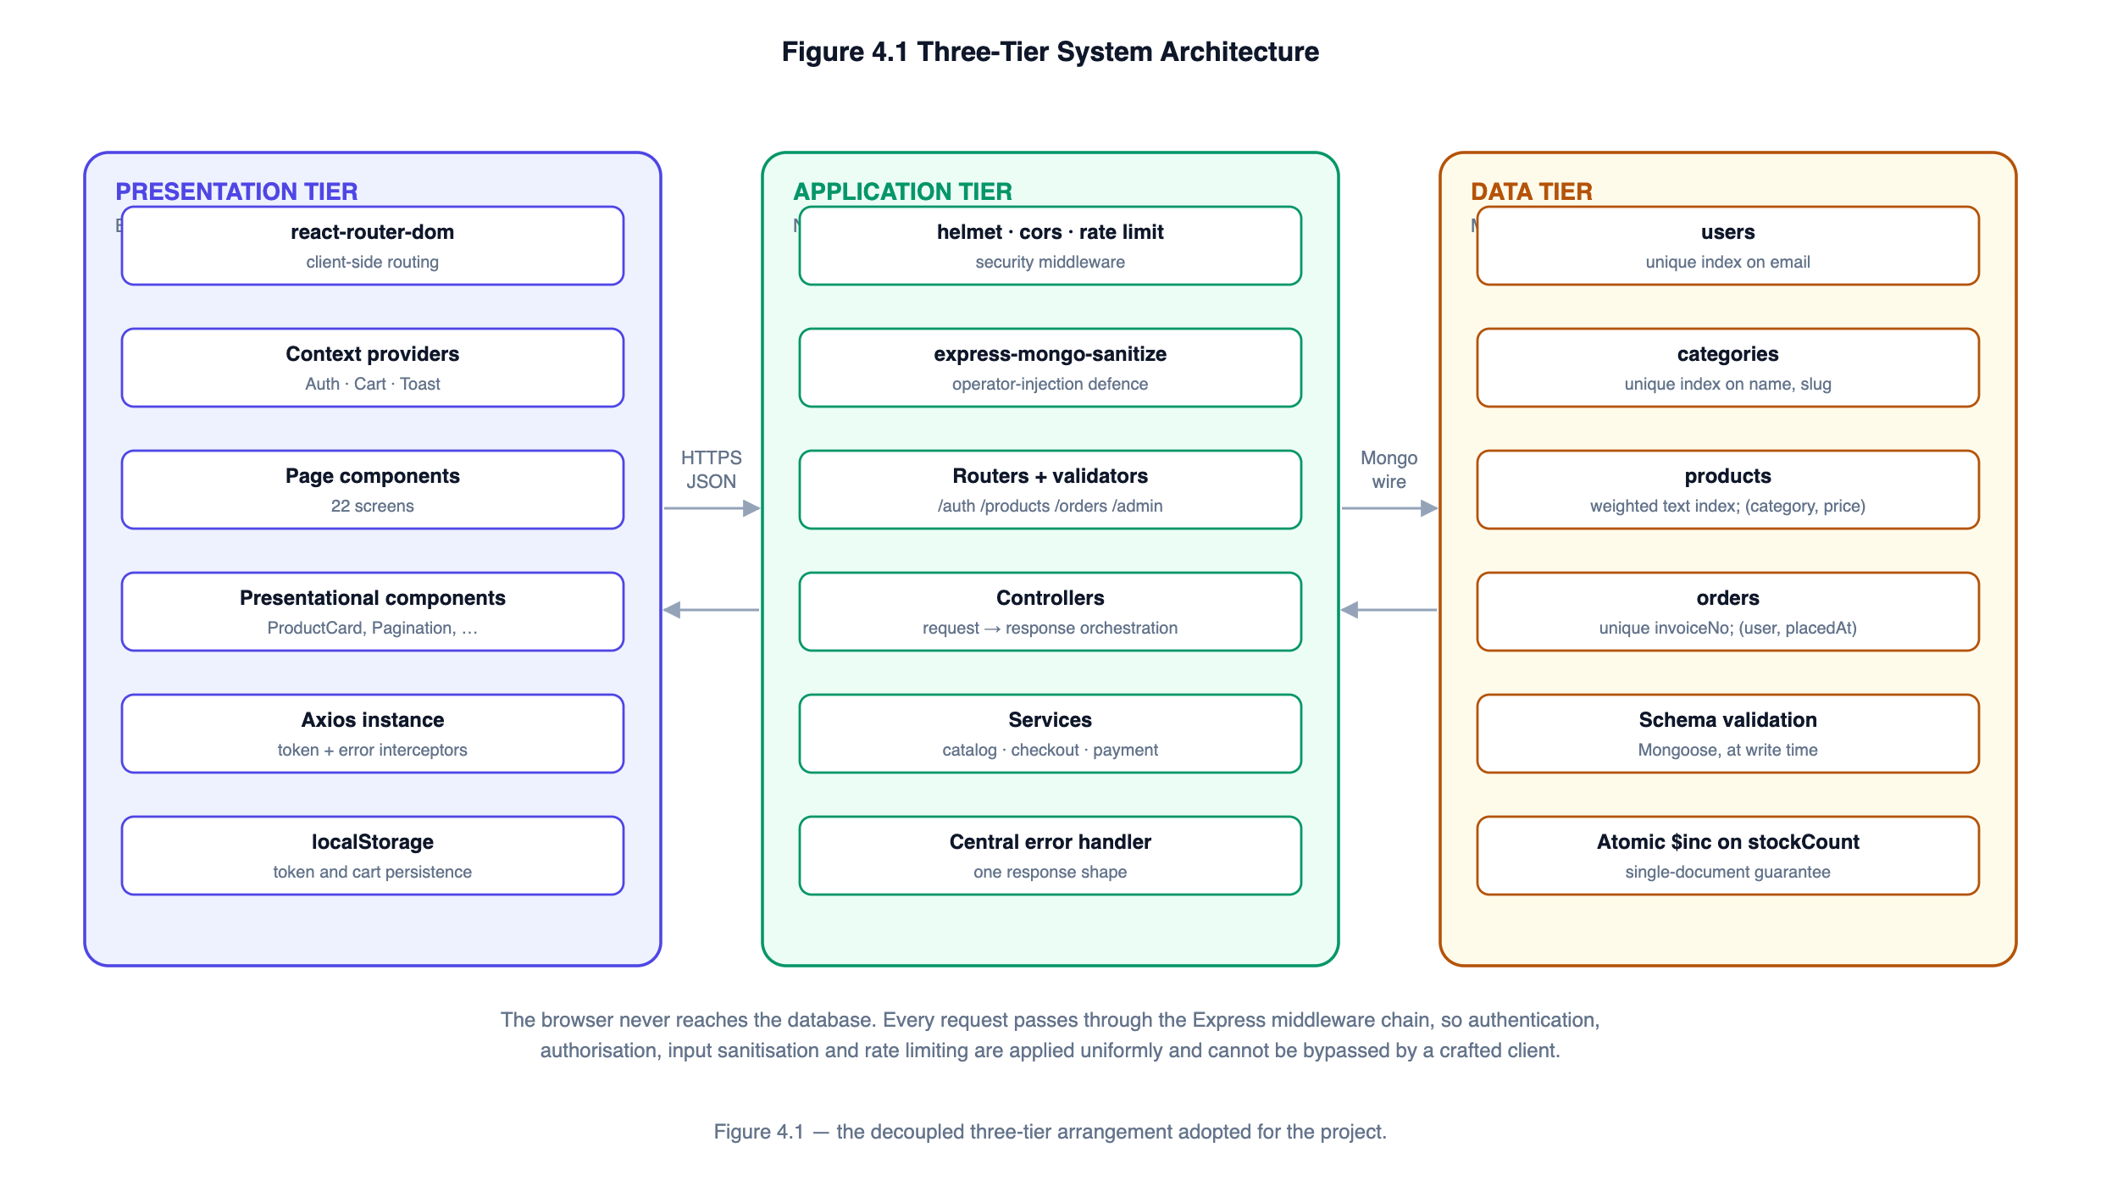
Figure 2: Three-tier architecture. The browser never reaches the database directly; every request passes through the Express middleware chain.
The property that matters most in this arrangement is that the presentation tier has no path to the data tier. A browser cannot open a database connection, so every read and every write must pass through the application tier, where authentication, authorisation, input sanitisation and rate limiting are applied. A security control placed in that chain therefore cannot be bypassed by a crafted client, which is not true of a design where the browser talks to the database directly.

4.2 Presentation Tier
Table 13: Presentation-tier technologies
Technology | Version | Role in this project
React | 18.3 | Component model and rendering. The virtual DOM reconciles only the parts of the tree that changed, so updating a cart quantity does not re-render the catalogue.
react-router-dom | 6.26 | Client-side routing for 22 screens, including nested routes for the administration section and route guards for protected pages.
React Context API | built in | Application-wide state: the signed-in user, the cart and the notification queue. Chosen over Redux because the state is small and the reducer pattern alone is sufficient — see Section 4.6.
Axios | 1.7 | HTTP client, configured with request and response interceptors that attach the access token and normalise every API error into one shape.
Recharts | 2.12 | Declarative charting for the administrator dashboard, built on SVG so charts scale with the container.
Vite | 5.4 | Development server with hot module replacement, and the production bundler. The development proxy forwards /api to the Node server so that the browser sees one origin.
CSS custom properties | — | A single design-token block defines the palette, radii and shadows; the fluid grid uses CSS Grid with auto-fill and minmax so the column count adapts without media queries.

4.3 Application Tier
Table 14: Application-tier technologies
Technology | Version | Role in this project
Node.js | 22.23 | JavaScript runtime. Its non-blocking event loop suits a workload dominated by waiting on the database.
Express | 4.19 | HTTP framework. Routers divide the API into five namespaces; the middleware chain provides a single place to apply cross-cutting concerns.
Mongoose | 8.6 | Object document mapper. Provides schema definition, validation at write time, index declaration and population of referenced documents.
jsonwebtoken | 9.0 | Issues and verifies the signed access tokens described in Section 10.1.
bcryptjs | 2.4 | Adaptive password hashing at a work factor of 12.
express-validator | 7.2 | Declarative request validation beside each route, collecting all failures in one pass.
helmet | 7.1 | Sets security response headers, including content-type sniffing protection, frame denial and a restrictive referrer policy.
express-mongo-sanitize | 2.2 | Strips keys beginning with $ or containing a dot from the body, query and parameters — the defence against NoSQL operator injection.
express-rate-limit | 7.4 | Request budgets: 300 per fifteen minutes for the API generally, 10 failed attempts for authentication.
cors | 2.8 | Restricts browser access to the configured client origin.
morgan | 1.10 | Request logging in development and production formats.

4.4 Data Tier
Table 15: Data-tier technologies
Technology | Version | Role in this project
MongoDB Community Server | 7.0 | Document database holding four collections. Chosen for the schema flexibility discussed in Section 4.6 and for its single-document atomicity guarantee, on which the stock reservation depends.
MongoDB text index | — | A weighted compound text index over product title, brand and description, giving relevance-ranked keyword search without a collection scan.
MongoDB aggregation pipeline | — | Computes the dashboard figures — revenue totals, the daily series, the status breakdown and best sellers — inside the database rather than by loading every order into the application.

4.5 Development, Testing and Tooling
Table 16: Development and testing tools
Tool | Purpose
Jest 29 | Test runner and assertion library for all 129 automated tests.
Supertest 7 | Drives the Express application over HTTP inside the test process, without binding a port.
mongodb-memory-server 10 | Starts a real MongoDB binary on a random port with data files in a temporary directory. Using a genuine server rather than a mock means the tests exercise real index behaviour, real unique-constraint violations and real atomic updates.
Visual Studio Code | Editor.
Postman and curl | Manual API exploration during development.
Git | Version control.
MongoDB Compass / mongosh | Inspecting collections and explaining query plans.
Chrome DevTools | Layout debugging, network inspection and responsive testing.

4.6 Justification of the Principal Choices
Three choices deserve an explicit defence, because in each case a reasonable alternative exists.

4.6.1 Why a document database rather than a relational one
The decisive consideration is the shape of product data. A pair of running shoes has a size and a colour; a laptop has a processor, a memory capacity and a warranty period; a paperback has an author, a publisher and a page count. Representing all three in one relational table requires either a wide table in which most columns are null for most rows, or an entity-attribute-value arrangement in which every attribute read becomes a join. The first wastes space and makes constraints meaningless; the second turns a simple product listing into a multi-way join whose cost grows with traffic.
A document model stores each product as one self-contained record, so products with different attributes coexist in one collection and a product read is a single document fetch. This is not an argument that document databases are generally superior — for a system dominated by many-to-many relationships and multi-table transactions, a relational engine would be the better choice. It is an argument that the dominant access pattern here, which is reading one product or a page of products by an indexed filter, is exactly what a document store is good at.

4.6.2 Why the Context API rather than Redux
The application-wide state consists of three things: the signed-in user, the cart and the notification queue. Redux would add a store, action creators, reducers, selectors and middleware to manage state that fits comfortably in three context providers, one of which already uses a reducer where a reducer earns its place — the cart, whose every mutation must be followed by the same persistence step. Adding a dependency to solve a problem the project does not have would make the code harder to follow, not easier. Were the state to grow to the point where prop drilling or unnecessary re-renders became a real cost, the reducer in `CartContext` would migrate to a store with little disruption, because the component interface is already the same shape.

4.6.3 Why JSON Web Tokens rather than server sessions
Server-side sessions require the server to hold state for every signed-in user, which ties a user to a particular server instance unless a shared session store is introduced. A signed token moves that state to the client and lets any instance verify a request with nothing but the signing key.
The standard objection to tokens is that they cannot be revoked before they expire. That objection is answered here by re-reading the user record from the database on every protected request rather than trusting the token payload. The cost is one indexed lookup per request; the benefit is that deactivating an account takes effect on that account’s very next request, which test case TC-I-62 demonstrates. The token therefore establishes identity, but authority is always checked against live data.

5. SYSTEM DESIGN — ANALYSIS DOCUMENTS
This chapter presents the analysis models: the data flow diagrams from context level down to the second level, the entity-relationship model, the use case model and the data dictionary. Chapter 6 then moves from what the system does to how it is built.

5.1 Context Diagram (DFD Level 0)
The context diagram fixes the system boundary. It shows the whole application as a single process and identifies the two external entities that interact with it, together with the data that crosses the boundary in each direction.
Figure 3: Context diagram showing the system boundary and the two external entities
There are exactly two external entities. The **Customer** supplies registration and sign-in details, search terms, cart changes, a delivery address and payment details, and receives catalogue pages, cart totals, an invoice and order status. The **Store Administrator** supplies catalogue and stock updates and fulfilment decisions, and receives sales analytics, the order queue and low-stock alerts. No other party interacts with the system: because the payment gateway is simulated inside the application, there is no external payment processor on the diagram. A production deployment would add one, and Section 12.2 describes what that would change.

5.2 Data Flow Diagram — Level 1
The single process of the context diagram decomposes into seven processes. Figure 4 places the four data stores between the customer-facing processes on the left and the administrative processes on the right, which keeps the flow lines short and makes the separation of the two access paths visible.
Figure 4: Level 1 data flow diagram — seven processes and four data stores
Table 17: Level 1 processes and the stores they access
Process | Responsibility | Stores accessed
1.0 Manage Identity | Registration, credential verification, token issue, profile and password maintenance. | D1 Users (read / write)
2.0 Browse Catalogue | Parses search and filter parameters, executes the catalogue query, paginates the result. | D2 Categories (read), D3 Products (read)
3.0 Maintain Cart | Holds the cart in the browser, validates quantities against live stock and price. | D3 Products (read)
4.0 Process Checkout | Re-prices the cart, reserves stock, authorises payment, persists the order. | D3 Products (read / write), D4 Orders (write)
5.0 Maintain Catalogue | Administrator creation and amendment of products and categories, and stock adjustment. | D2 Categories (write), D3 Products (write)
6.0 Fulfil Orders | Advances order status within the state machine; restores stock on cancellation. | D4 Orders (read / write), D3 Products (write)
7.0 Report Analytics | Aggregates revenue, order counts, best sellers and low stock. | D1 Users (read), D3 Products (read), D4 Orders (read)

5.3 Data Flow Diagrams — Level 2
Two processes are decomposed further: process 4.0, because it carries the system’s most important correctness requirements, and process 2.0, because it is where untrusted input meets the database.

5.3.1 Explosion of process 4.0 — Process Checkout
Figure 5: Level 2 explosion of the checkout process
The ordering of these six sub-processes is the design, not an implementation detail. Process 4.2 re-prices the cart from the database, so the figure the customer is asked to authorise is the store’s figure and not the browser’s. Process 4.3 reserves stock **before** 4.4 authorises payment, so a customer is never charged for an item that sold out in the interval. If 4.4 declines, process 4.6 returns the reserved units to the catalogue as a compensating action, leaving stock exactly as it was. Test case TC-I-40 asserts precisely this: after a declined payment, the stock count is unchanged and no order document exists.
Table 18: Sub-processes of the checkout engine
Sub-process | Input | Processing | Output
4.1 Validate Cart | Raw cart lines from the client | Checks each product reference is a valid identifier and each quantity a whole number within the cap; merges duplicate lines for the same product so that splitting a line cannot bypass the cap. | Normalised line list, or a 422 error
4.2 Re-price from DB | Normalised lines | Reads the current price and stock of every referenced product; rejects any product that is withdrawn or short of stock; computes subtotal, delivery charge, tax and total. | Priced lines and authoritative totals
4.3 Reserve Stock | Priced lines | For each line, performs a conditional atomic decrement. On failure, releases every reservation already taken in this request. | Confirmation, or a 409 naming the item
4.4 Authorise Payment | Card details and payable amount | Validates the card structurally (Luhn checksum, expiry, CVV) and simulates an authorisation; retains only the last four digits. | Transaction reference, or a decline
4.5 Persist Order | Priced lines, address, payment result | Generates a unique invoice number and writes the order document with a snapshot of every line. | Order record and invoice number
4.6 Release Stock | Priced lines | Compensating action: increments stock back by the reserved quantity. | Stock restored to its prior value

5.3.2 Explosion of process 2.0 — Browse Catalogue
Figure 6: Level 2 explosion of the catalogue browsing process
Parsing (2.1) and filter construction (2.2) are separate sub-processes because that is where the security boundary lies. Every value arriving in the query string is coerced to the type the filter expects — an identifier is accepted only if it parses as a valid ObjectId, a price bound only if it parses as an integer, a sort key only if it appears in a whitelist. A string is never handed to MongoDB unchanged, which is what prevents an attacker from smuggling an operator object such as `{"$ne": null}` through a query parameter. Test case TC-U-24 exercises exactly that attempt and asserts that the resulting filter contains neither value.

5.4 Entity–Relationship Model
Figure 7 presents the conceptual data model. MongoDB has no foreign-key constraints, so the relationships shown are maintained by application code rather than by the engine; the model is nonetheless a faithful description of how the data is related.
Figure 7: Entity–relationship diagram. ORDER_ITEM is a weak entity embedded within ORDER.
Table 19: Relationships and how each is implemented
Relationship | Cardinality | Implementation | Rationale
USER places ORDER | 1 : M | order.user holds the user’s ObjectId. | A customer may place many orders; every order belongs to exactly one customer.
ORDER contains ORDER_ITEM | 1 : M | Embedded array order.items inside the order document. | Order lines are never queried independently of their order and are written once, so embedding avoids a join on the most frequent order read.
ORDER_ITEM refers to PRODUCT | M : 1 | items[].product holds the product’s ObjectId, alongside a snapshot of the title and unit price. | The reference allows navigation back to the catalogue entry; the snapshot means a later price change cannot rewrite a historical invoice.
CATEGORY classifies PRODUCT | 1 : M | product.category holds the category’s ObjectId. | Referencing rather than embedding means renaming a category updates every listing at once.

5.4.1 Why order lines are embedded but categories are referenced
The two decisions look inconsistent and are worth justifying together, because they follow from the same rule applied to different access patterns.
Order lines are **embedded**. They are written once, at checkout, and are afterwards read only as part of their order — nobody asks "show me every order line for product X" outside the analytics pipeline, which handles it with an unwind stage. Embedding makes the common read a single document fetch and makes the order record self-contained, which matters for a financial document.
Categories are **referenced**. A category is read on nearly every catalogue request and is displayed by name, but it changes rarely and is shared by many products. Embedding the category into each product would mean that renaming one category required rewriting every product document that used it. Referencing makes the rename a single write.
The rule behind both is the same: embed data that is written with its parent and read with its parent; reference data that is shared and changes independently.

5.5 Use Case Model
Figure 8: Use case diagram showing seven customer use cases and six administrative use cases
Table 20 gives the detailed description of the two use cases that carry the most logic. The remainder follow the same pattern and are not reproduced individually.
Table 20: Use case description — Place an Order
Field | UC-06 Place an Order
Actor | Customer (authenticated)
Precondition | The customer is signed in and the cart contains at least one item.
Main flow | 1. The customer opens the checkout page.  2. The system re-prices the cart from the database and displays the authoritative total.  3. The customer enters or confirms the delivery address.  4. The customer selects card payment or cash on delivery.  5. For a card payment, the customer enters the card details.  6. The customer submits the order.  7. The system validates the address and the card structurally.  8. The system re-prices the cart again and reserves stock atomically for every line.  9. The system authorises the payment.  10. The system writes the order with a unique invoice number.  11. The system empties the cart and shows the confirmation.
Alternative — out of stock | At step 8, if any line cannot be reserved, every reservation already taken is released, a 409 response names the item concerned, and the cart is left intact.
Alternative — payment declined | At step 9, if authorisation fails, the reserved stock is released, a 422 response explains the decline, and no order is written.
Alternative — cash on delivery | Steps 5 and 9 are skipped. The order is created with status PENDING and payment status PENDING, and is marked paid when it reaches DELIVERED.
Postcondition | An order exists with a unique invoice number; stock is reduced by exactly the quantities ordered; the cart is empty.
Requirements covered | FR-13 to FR-20
Test cases | TC-I-36 to TC-I-45, TC-S-01, TC-S-03

Table 21: Use case description — Progress Order Status
Field | UC-11 Progress Order Status
Actor | Store administrator
Precondition | The administrator is signed in and an order exists.
Main flow | 1. The administrator opens the order queue, optionally filtered by status.  2. The system displays each order with only the status transitions that are legal from its current state.  3. The administrator selects a transition.  4. The system validates the transition against the order state machine.  5. The system records the new status and appends an entry to the status history.
Alternative — cancellation | If the chosen transition is CANCELLED, the system first returns every reserved unit to the catalogue and marks a paid order as refunded.
Alternative — cash on delivery reaching DELIVERED | The payment status is set to PAID and the settlement time recorded.
Exception — illegal transition | If a transition that is not permitted from the current state is requested — for example moving a DELIVERED order back to SHIPPED — the system rejects it with a 409 response naming the permitted next states.
Postcondition | The order carries the new status and an audit trail entry.
Requirements covered | FR-22, FR-23
Test cases | TC-I-51 to TC-I-55, TC-S-01

5.6 Data Dictionary
The data dictionary records every field of every collection: its type, its constraints and its purpose. The types given are the Mongoose schema types, which map onto BSON types in storage.

5.6.1 Collection: users
Table 22: Data dictionary — users collection
Field | Type | Constraints | Description
_id | ObjectId | Primary key, auto-generated | Unique account identifier.
name | String | Required, 2–80 characters, trimmed | Display name.
email | String | Required, unique index, lower-cased, pattern-checked | Sign-in identifier. Normalising to lower case at write time is what makes the unique index genuinely case-insensitive.
password | String | Required, minimum 8 characters, select: false | bcrypt hash at work factor 12. Never selected by a query unless explicitly requested, and stripped again during JSON serialisation.
role | String | Enumeration {customer, admin}, default customer | Authorisation discriminator. Never writable through the registration endpoint.
address | Sub-document | Optional | Default delivery address: line1, line2, city, state, pincode (6 digits), phone (10 digits beginning 6–9).
isActive | Boolean | Default true | Cleared to deactivate an account; checked on every authenticated request.
lastLoginAt | Date | Nullable | Time of the most recent successful sign-in.
createdAt / updatedAt | Date | Maintained automatically | Audit timestamps.

5.6.2 Collection: categories
Table 23: Data dictionary — categories collection
Field | Type | Constraints | Description
_id | ObjectId | Primary key | Unique category identifier.
name | String | Required, unique index, 2–60 characters | Display name.
slug | String | Unique index, derived from name | URL-safe form used in links; regenerated whenever the name changes.
description | String | Optional, maximum 300 characters | Short description.
isActive | Boolean | Default true | Withdraws a category from the navigation.
createdAt / updatedAt | Date | Maintained automatically | Audit timestamps.

5.6.3 Collection: products
Table 24: Data dictionary — products collection
Field | Type | Constraints | Description
_id | ObjectId | Primary key | Unique product identifier.
title | String | Required, 3–140 characters, text-indexed (weight 10) | Product name; the highest-weighted field in keyword search.
description | String | Required, 10–4000 characters, text-indexed (weight 1) | Full description.
brand | String | Optional, maximum 60 characters, text-indexed (weight 5) | Manufacturer or brand.
price | Number | Required, 1–10,000,000, rounded to a whole number | Selling price in whole rupees. Rounding at write time prevents binary floating-point drift accumulating across order arithmetic.
mrp | Number | Optional, ≥ 1 | Maximum retail price; used to derive the displayed discount.
category | ObjectId | Required, references categories, indexed | Owning category.
stockCount | Number | Required, ≥ 0, whole number, default 0 | Units available. The field on which the atomic conditional decrement operates.
imageUrl | String | Optional, http(s) URL or root-relative path | Product illustration.
rating / ratingCount | Number | 0–5 / ≥ 0 | Displayed customer rating. Not writable through the API.
isActive | Boolean | Default true, indexed | Cleared by a soft delete so historical orders keep a valid reference.
createdAt / updatedAt | Date | Maintained automatically | Audit timestamps.

5.6.4 Collection: orders
Table 25: Data dictionary — orders collection
Field | Type | Constraints | Description
_id | ObjectId | Primary key | Unique order identifier.
invoiceNo | String | Required, unique index, upper-cased | Format INV-YYYYMMDD-XXXXXX, where the suffix is six cryptographically random hex characters so invoice numbers cannot be enumerated.
user | ObjectId | Required, references users | Purchasing customer.
items | Array of sub-documents | At least one element | Order lines: product reference, title snapshot, unitPrice snapshot, quantity (1–10) and lineTotal.
itemsTotal | Number | Required, ≥ 0 | Sum of the line totals, in rupees.
shippingFee | Number | Required, ≥ 0 | Nil at or above ₹500, otherwise ₹49.
taxAmount | Number | Required, ≥ 0 | Tax at 18%, rounded to whole rupees so the invoice balances.
totalPrice | Number | Required, ≥ 0 | Amount payable.
shippingAddress | Sub-document | Required | Delivery address snapshot taken at the time of the order.
payment | Sub-document | Required | method {CARD, COD}; status {PENDING, PAID, FAILED, REFUNDED}; transactionId; cardLast4; paidAt. No card number or CVV is present.
status | String | Enumeration of five states, indexed | PENDING, CONFIRMED, SHIPPED, DELIVERED or CANCELLED.
statusHistory | Array | — | Audit trail of every status change with its time and an optional note.
placedAt / cancelledAt | Date | — | Order and cancellation times.

6. SYSTEM DESIGN — DESIGN DOCUMENTS

6.1 Modularisation
The system divides into five functional modules beneath a single application shell. Each module owns its routes, its controller, its service logic and its data model, so a change confined to one module does not ripple into the others.
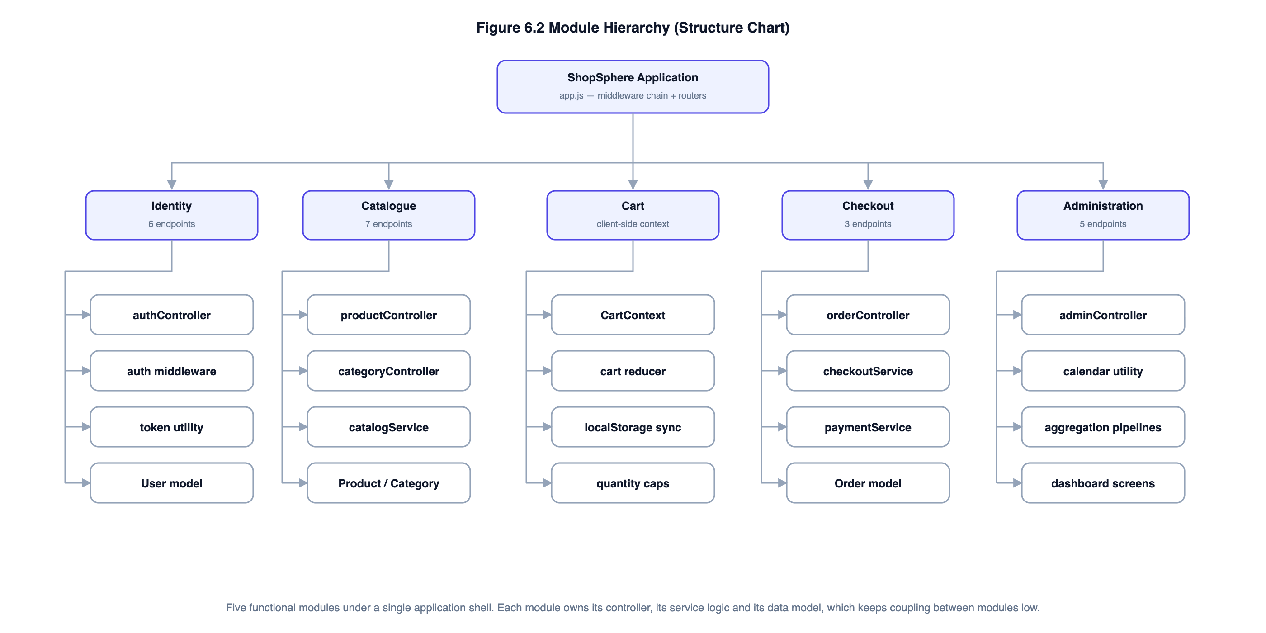
Figure 9: Module hierarchy. Each module owns its controller, service logic and data model.
Table 26: Modules, responsibilities and coupling
Module | Responsibility | Principal components | Coupling
Identity | Registration, authentication, session establishment, profile and password maintenance. | authController, auth middleware, token utility, User model | Depended on by every other module through the protect middleware; depends on none of them.
Catalogue | Product and category storage, search, filtering, sorting, pagination and administrator maintenance. | productController, categoryController, catalogService, Product and Category models | Depends on Identity for administrator route protection only.
Cart | Holds the cart in the browser and mirrors it to local storage. | CartContext, cart reducer | Client-side only; communicates with the server solely by submitting product identifiers and quantities.
Checkout | Re-pricing, stock reservation, payment authorisation, order persistence, cancellation. | orderController, checkoutService, paymentService, Order model | Depends on Catalogue for prices and stock, and on Identity for the purchaser.
Administration | Analytics aggregation, customer account administration, order fulfilment. | adminController, calendar utility, aggregation pipelines | Reads from all three data-owning modules; is depended on by none.

The dependency direction is deliberate and one-way. Identity is depended upon but depends on nothing; Administration depends on the others but nothing depends on it. There are no cycles, which is what allows any single module to be unit tested without starting the others.

6.2 Database Design

6.2.1 Collections
The database holds four collections. Their fields are catalogued in Section 5.6; this section covers the design decisions behind them.
Table 27: Collection characteristics
Collection | Approximate document size | Growth | Write frequency
users | 350 bytes | One per registered customer | Low — on registration and profile change
categories | 200 bytes | Fixed and small (six in the seeded data) | Very low
products | 900 bytes | One per catalogue item | Low for content; high for stockCount, which changes on every sale
orders | 1.2 KB | One per order — the fastest-growing collection | Write once, then a small number of status updates

6.2.2 Normalisation
Normalisation is a relational concept, and applying it to a document store requires some care. The underlying goal — eliminating update anomalies caused by storing the same fact in more than one place — still applies, so the design is examined against the first three normal forms, with the places where it deliberately departs from them identified and justified.
Table 28: The design assessed against the first three normal forms
Form | Requirement | Position in this design
1NF | Atomic attribute values; no repeating groups. | Scalar fields are atomic. The items array in an order is a repeating group in relational terms and would be a separate table in a relational schema. It is retained here because a document store supports arrays natively and because order lines are always read with their order.
2NF | No partial dependency on part of a composite key. | Satisfied. Every collection has a single-attribute key (_id), so partial dependency cannot arise.
3NF | No transitive dependency of a non-key attribute on another non-key attribute. | Satisfied for users, categories and products. Orders deliberately depart from it: items[].title and items[].unitPrice are duplicated from the product document and therefore depend transitively on items[].product.

The departure in the orders collection is the interesting one, and it is worth being explicit that it is a departure rather than presenting the schema as fully normalised.
An order is a financial record. If an order line held only a reference to the product, then an administrator correcting a typographical error in a product title — or, more seriously, changing its price — would silently rewrite every historical invoice that referenced it. A customer printing a six-month-old invoice would see a price they had never paid. Denormalising the title and unit price into the line makes the order document a faithful snapshot of the transaction as it occurred. The product reference is retained alongside the snapshot so the catalogue entry can still be reached.
The update anomaly that normalisation exists to prevent does not arise here, because the duplicated values are immutable once written. They are never updated, only read. This is the standard justification for denormalising a historical record, and it is a considered trade-off rather than an oversight.

6.2.3 Index design
Every index in the system exists to serve a specific query, and each is justified below. Indexes are not free: each one consumes storage and slows writes, so an index that serves no actual query is a cost with no benefit.
Table 29: Indexes and the queries they serve
Collection | Index | Type | Query it serves
users | { email: 1 } | Unique | Sign-in lookup by email, and enforcement of one account per address. The uniqueness constraint is the real guarantee against a duplicate registration created by two concurrent requests.
categories | { name: 1 }, { slug: 1 } | Unique | Category lookup and prevention of duplicates.
products | { title: text, brand: text, description: text } with weights 10, 5, 1 | Weighted text | Keyword search. The weighting makes a match in the title rank above the same word appearing only in the body text.
products | { category: 1, price: 1 } | Compound | "Browse a category, ordered by price" — the most common catalogue access path. The compound order matters: the equality field comes first, the range field second.
products | { createdAt: -1 } | Single field | The default "newest first" listing, served as an index scan rather than an in-memory sort.
products | { isActive: 1 } | Single field | Excluding soft-deleted products, which every public catalogue query does.
orders | { invoiceNo: 1 } | Unique | Invoice lookup, and a database-level guarantee that two orders cannot share a number even if the random generator were to collide.
orders | { user: 1, placedAt: -1 } | Compound | "My orders, newest first" — the single most frequent order query. Serving both the filter and the sort from one index avoids a sort stage entirely.
orders | { status: 1, placedAt: -1 } | Compound | The administrator’s order queue filtered by status.

6.2.4 Data integrity and constraints
MongoDB enforces no foreign keys, so referential integrity is the application’s responsibility. Rather than leaving that implicit, every constraint is listed below with the mechanism that enforces it and the test that proves it.
Table 30: Integrity constraints, their enforcement and their tests
Constraint | Enforcement mechanism | Test case
Email addresses are unique across accounts | Unique index on users.email, with the value lower-cased at write time | TC-U-40, TC-I-03
Passwords are never stored in recoverable form | A pre-save hook hashes the field whenever it changes; select: false keeps it out of query results | TC-U-37, TC-U-38, TC-I-02
A product must belong to an existing, active category | Checked in the controller before create and before update | TC-I-31
A category holding active products cannot be deleted | Referencing products are counted and the delete refused if any exist | TC-I-35
Stock can never fall below zero | Schema minimum of 0, plus the conditional atomic decrement which matches no document when stock is insufficient | TC-U-36, TC-I-41, TC-I-45
Prices and stock counts are whole numbers | A schema setter rounds price on write; an integer validator rejects fractional stock | TC-U-43, TC-U-44
An order must contain at least one line | Array validator on orders.items | TC-U-25
Quantity per product is capped at 10 | Schema maximum, plus cart normalisation that merges duplicate lines before applying the cap | TC-U-29
Invoice numbers are unique | Unique index on orders.invoiceNo, with 24 bits of cryptographic randomness in the suffix | TC-U-48
Order status follows the defined state machine | The transition table is declared on the Order model and checked before every change | TC-U-47, TC-I-52
A withdrawn product remains resolvable from historical orders | Deletion is a soft delete that clears isActive rather than removing the document | TC-I-32
Order totals equal the sum of their parts | Tax is rounded to whole rupees at computation time, so the printed figures balance exactly | TC-U-30, TC-I-37

6.3 Procedural Design
This section sets out the algorithms behind the three operations that carry the most logic. Each is given first as pseudocode and then as the actual implementation, so the design and the code can be compared directly.

6.3.1 Authentication and request authorisation
Algorithm 1 — request authentication and role restriction
ALGORITHM AuthenticateRequest
INPUT HTTP request
OUTPUT req.user, or an error response

1. token <- extract bearer token from the Authorization header
2. IF token is absent THEN
3. RETURN 401 "Authentication is required"
4. TRY
5. payload <- verify signature and expiry of token using JWT_SECRET
6. CATCH expired -> RETURN 401 "Your session has expired"
7. CATCH invalid -> RETURN 401 "Invalid authentication token"
8. user <- read users collection by payload.sub // live read, not the token
9. IF user does not exist THEN RETURN 401
10. IF user.isActive is false THEN RETURN 403 "Account deactivated"
11. req.user <- user
12. CONTINUE to the next middleware

ALGORITHM RestrictTo(allowedRoles)
1. IF req.user is absent THEN RETURN 401
2. IF req.user.role NOT IN allowedRoles THEN RETURN 403
3. CONTINUE

Step 8 is the design decision worth noting. The token already carries the user identifier and role, so the database read could be skipped. It is performed anyway because trusting the token payload alone would mean a deactivated account continued to work until its token expired — up to seven days. Re-reading costs one indexed lookup and makes deactivation effective on the very next request, which test case TC-I-62 demonstrates.

6.3.2 Checkout: pricing and atomic stock reservation
This is the most important algorithm in the system, and the one where a naive implementation fails in ways that manual testing does not reveal.
Algorithm 2 — order placement with atomic stock reservation
ALGORITHM PlaceOrder
INPUT rawItems, shippingAddress, paymentMethod, card
OUTPUT order document, or an error

1. items <- NormaliseCart(rawItems) // validate, merge duplicates, cap qty
2. quote <- PriceCart(items) // authoritative prices from the DB
3. reserved <- empty list
4. FOR EACH line IN quote.lines DO
5. ok <- AtomicReserve(line.product, line.quantity)
6. IF NOT ok THEN
7. FOR EACH r IN reserved DO AtomicRelease(r.product, r.quantity)
8. RETURN 409 "<title> went out of stock"
9. append line to reserved
10. TRY
11. payment <- AuthorisePayment(card, quote.totalPrice)
12. CATCH declined
13. FOR EACH r IN reserved DO AtomicRelease(r.product, r.quantity)
14. RETURN 422 "payment declined"
15. invoiceNo <- "INV-" + yyyymmdd + "-" + 6 random hex characters
16. status <- CONFIRMED IF payment.status = PAID ELSE PENDING
17. WRITE order { invoiceNo, user, quote.lines, totals, address, payment, status }
18. RETURN 201 with the order

SUBROUTINE AtomicReserve(productId, qty)
1. result <- findOneAndUpdate(
filter: { _id: productId, isActive: true, stockCount: { $gte: qty } },
update: { $inc: { stockCount: -qty } } )
2. RETURN (result IS NOT NULL)

SUBROUTINE PriceCart(items)
1. products <- find products by the identifiers in items, where isActive
2. FOR EACH item DO
3. IF product not found THEN RETURN 404 "no longer available"
4. IF stockCount < quantity THEN RETURN 409 "only N remain"
5. lineTotal <- product.price * quantity // price from the DB, not the client
6. itemsTotal <- sum of lineTotal
7. shippingFee <- 0 IF itemsTotal >= 500 ELSE 49
8. taxAmount <- round(itemsTotal * 0.18)
9. RETURN lines, itemsTotal, shippingFee, taxAmount, itemsTotal+shippingFee+taxAmount

Two properties of this algorithm are worth drawing out.
**The predicate and the update are one operation.** The obvious implementation of a stock decrement is to read the current count, compare it with the quantity wanted, and write the reduced figure back. Between the read and the write there is a window in which a second request can perform its own read and see the same stock. Both requests then believe the stock is available and both write, and the store has sold one more unit than it has. The window is small — a few milliseconds — which is precisely why manual testing never finds the defect.
Expressing the check as part of the update closes the window. MongoDB guarantees that an update to a single document is atomic, so no other writer can interleave between the filter being evaluated and the increment being applied. The request that loses the race matches no document, receives `null`, and is told the item is out of stock. Test case TC-U-36 fires ten simultaneous reservations against a product with one unit in stock and asserts that exactly one succeeds and nine are rejected; TC-I-45 does the same through the HTTP layer with two concurrent customers.
**Failure leaves no trace.** An order spans several documents, so all-or-nothing behaviour must be arranged explicitly. Where the deployment is a replica set, a real multi-document transaction is used and the abort undoes the writes. On a standalone `mongod`, which does not support transactions and is the usual development configuration, the service falls back to a compensating-action pattern: every reservation already taken is released before the error is returned. The caller does not need to know which mode is in force, because both are hidden behind one helper. Test case TC-U-35 asserts the rollback directly, and TC-I-40 asserts that a declined payment leaves stock unchanged and writes no order.
The implementation of the reservation subroutine is reproduced below exactly as it appears in the source.
Listing 1 — services/checkoutService.js, the atomic reservation
/**
* Atomically decrements stock for one line.
*
* @returns {Promise<boolean>} true if the units were reserved, false if the
* product no longer had enough stock.
*/
async function reserveOne(productId, quantity, session) {
const options = session ? { session } : {};
const updated = await Product.findOneAndUpdate(
// The predicate is part of the same atomic operation as the update, which
// is precisely what closes the check-then-act race window.
{ _id: productId, isActive: true, stockCount: { $gte: quantity } },
{ $inc: { stockCount: -quantity } },
{ new: true, ...options }
);
return updated !== null;
}

6.3.3 Catalogue search and filter construction
Algorithm 3 — construction of the catalogue query
ALGORITHM BuildProductQuery(queryString)
OUTPUT filter, sort, page, limit, skip

1. filter <- { isActive: true }
2. keyword <- trim(queryString.q) IF it is a string ELSE ""
3. IF keyword is not empty THEN
4. filter.$text <- { $search: first 100 characters of keyword }
5. usedTextSearch <- true
6. IF queryString.category parses as a valid ObjectId THEN
7. filter.category <- ObjectId(queryString.category)
// anything else is ignored, never passed through
8. min <- parseInt(queryString.minPrice); max <- parseInt(queryString.maxPrice)
9. IF min is finite and >= 0 THEN priceFilter.$gte <- min
10. IF max is finite and >= 0 THEN priceFilter.$lte <- max
11. IF both present AND min > max THEN discard both // an inverted band would
// silently return nothing
12. IF queryString.inStock = "true" THEN filter.stockCount <- { $gt: 0 }
13. IF queryString.sort is a key of the SORT_OPTIONS whitelist THEN
14. sort <- SORT_OPTIONS[queryString.sort]
15. ELSE IF usedTextSearch THEN sort <- { score: { $meta: "textScore" } }
16. ELSE sort <- { createdAt: -1 }
17. page <- parseInt(queryString.page) IF valid and > 0 ELSE 1
18. limit <- min(parseInt(queryString.limit), 48) IF valid and > 0 ELSE 12
19. RETURN filter, sort, page, limit, (page-1) * limit

Every line that consumes user input coerces it to an expected type before use. An identifier is accepted only if it parses as an ObjectId; a price bound only if it parses as an integer; a sort key only if it appears in a whitelist; a page size only after being capped at 48. A raw string is never handed to MongoDB, which is what prevents a query parameter carrying an operator object from reaching the engine. The cap at step 18 is equally deliberate: without it, a request for a page of one million items would be honoured and would exhaust server memory.
Step 11 addresses a usability failure rather than a security one. A price band whose minimum exceeds its maximum matches nothing, and a user who types the two figures the wrong way round would see an empty catalogue with no explanation. Discarding the inverted band shows the unfiltered catalogue instead, which is the more useful behaviour. Test case TC-U-19 covers it.

6.3.4 Order status transitions
Order status is governed by an explicit state machine rather than by scattered `if` statements. The transition table is declared once on the Order model, so every code path that changes a status is bound by the same rules.
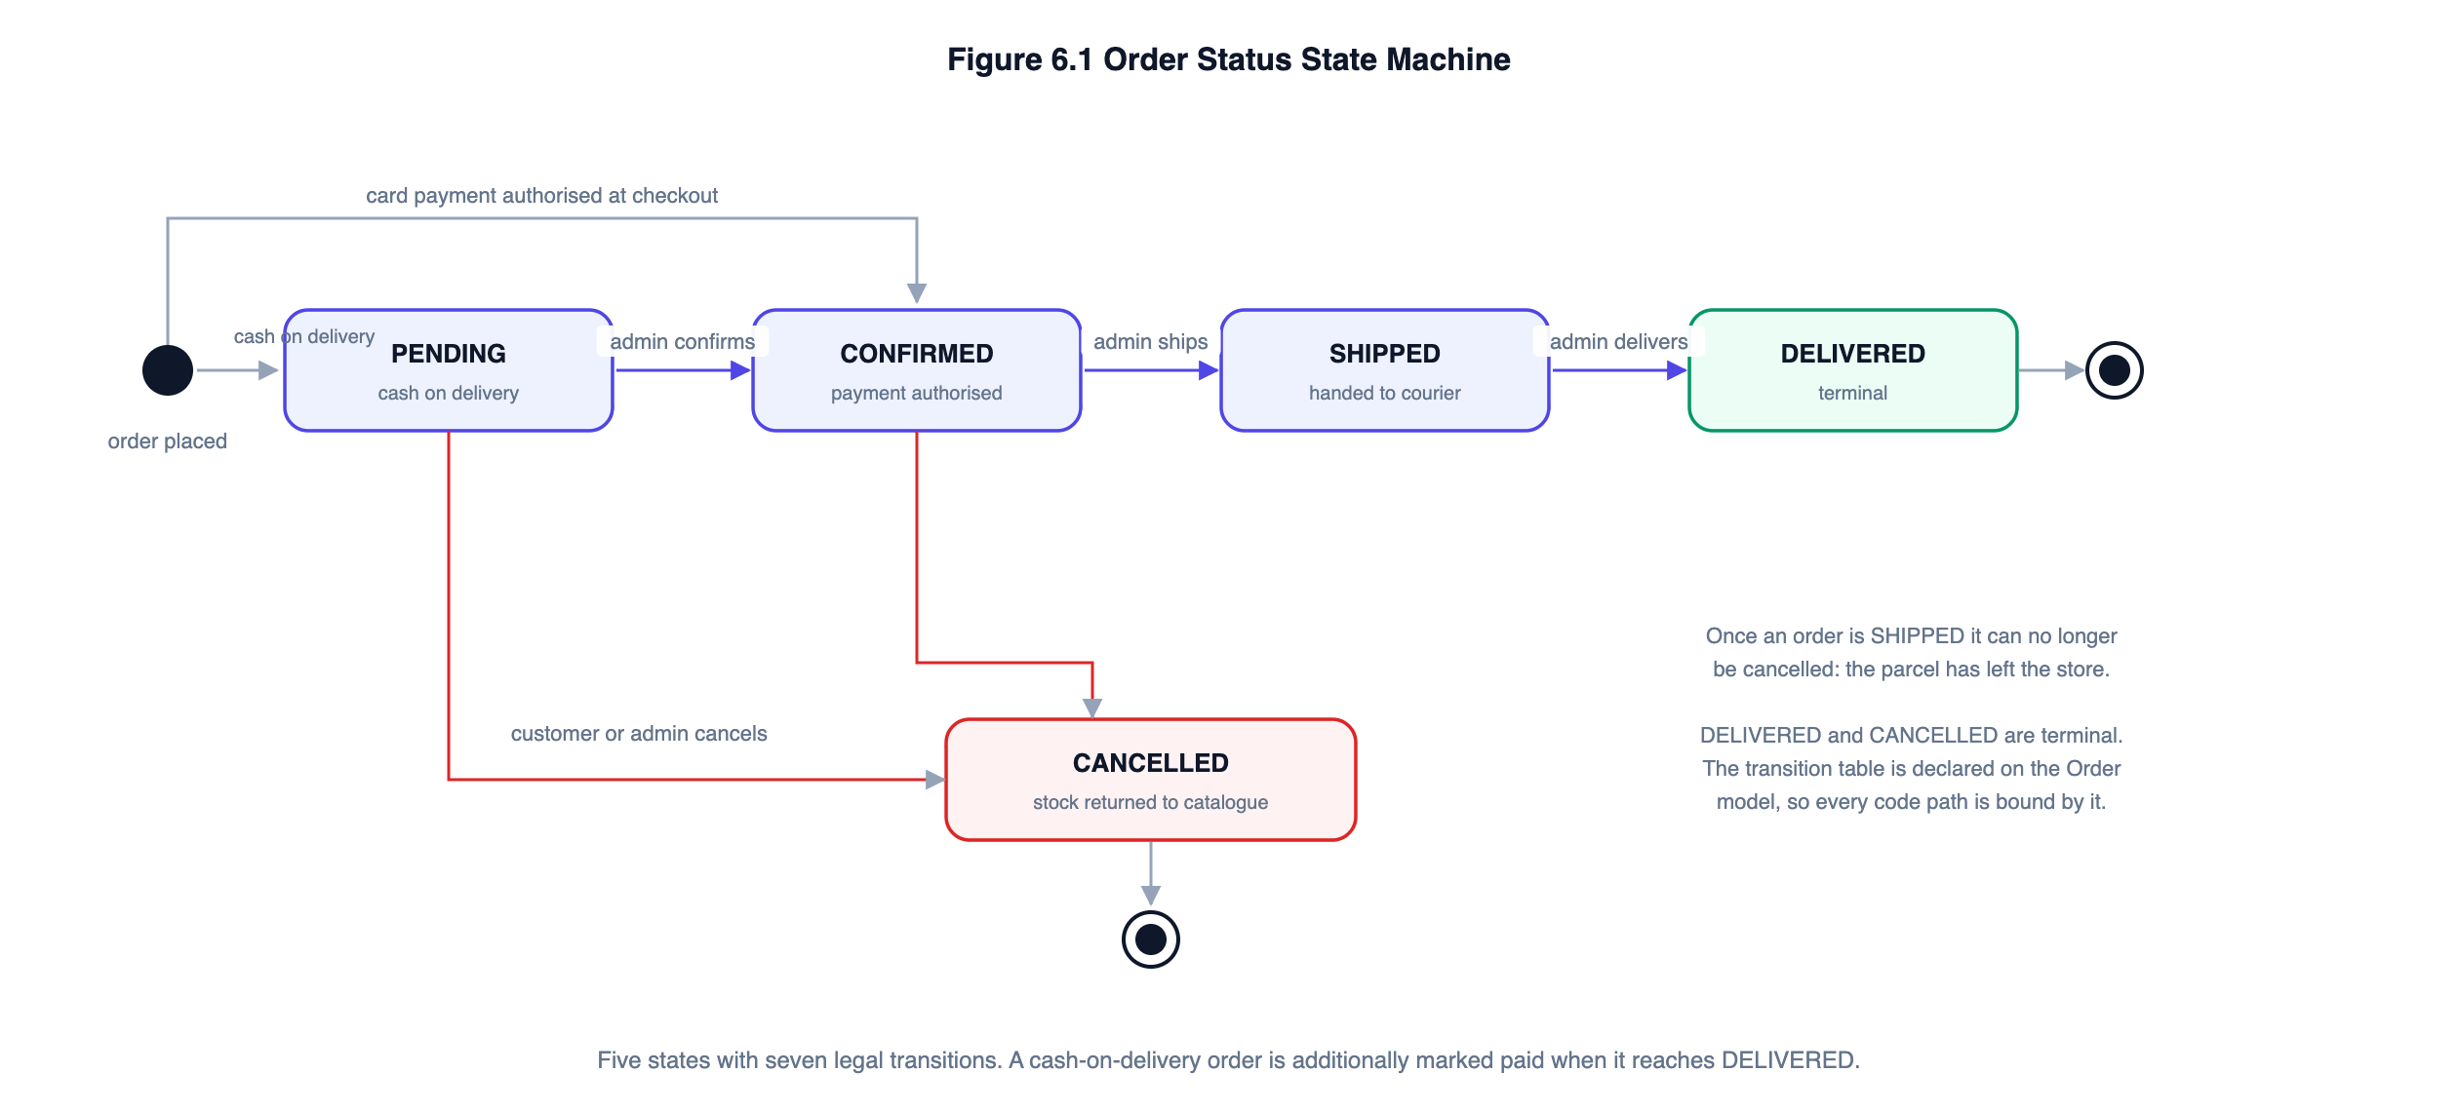
Figure 10: Order status state machine. DELIVERED and CANCELLED are terminal states.
Listing 2 — models/Order.js, the transition table
/**
* Legal status transitions. Encoding them here, rather than in the controller,
* guarantees that no code path can move a DELIVERED order back to SHIPPED.
*/
orderSchema.statics.ALLOWED_TRANSITIONS = Object.freeze({
PENDING: ['CONFIRMED', 'CANCELLED'],
CONFIRMED: ['SHIPPED', 'CANCELLED'],
SHIPPED: ['DELIVERED'],
DELIVERED: [],
CANCELLED: [],
});

Declaring the table in one place has a practical consequence in the interface: the administrator’s order queue renders a button only for a transition the server will accept, so an invalid state cannot be reached by clicking the wrong control. The server still validates, because the interface is not a security boundary, but the two never disagree.

6.4 User Interface Design

6.4.1 Principles applied
- A fluid grid rather than breakpoint-driven layouts. The catalogue uses CSS Grid with repeat(auto-fill, minmax(220px, 1fr)), so the column count adapts to the viewport without a media query deciding it. Media queries are reserved for the few places where the structure itself has to change — the filter sidebar, the navigation bar and the administration tables.
- State in the URL, not only in memory. Every catalogue filter, sort order and page number lives in the query string. A search result can therefore be bookmarked and shared, the browser back button behaves as the user expects, and a page refresh returns the same results.
- Report every validation failure at once. The API collects all validation failures in one pass and returns them together with the field each concerns, so a user correcting a form is not sent round the loop once per mistake.
- Distinguish empty from loading. A screen fetching data shows skeleton placeholders shaped like the content that is coming; a screen with genuinely nothing to show says so and offers the next action.
- Keyboard access and a visible focus ring. The default focus outline is replaced with a higher-contrast one rather than removed, so keyboard users can see where they are.
- Honour a reduced-motion preference. Decorative transitions are disabled under prefers-reduced-motion.
- Never offer an action that will be refused. Out-of-stock products show a disabled control rather than one that fails on click; an order past despatch shows no cancel button; the order queue offers only legal status transitions.

6.4.2 Screen inventory
Table 31: Screen inventory
Area | Screens
Public | Home, catalogue listing, product detail, shopping cart, sign in, register, page not found
Customer | Checkout, order confirmation, order history, order detail, profile
Administration | Dashboard, products, product form, categories, orders, customers
Shared components | Navigation bar with search and cart badge, footer, pagination, alert, toast notification, loading skeleton, empty state, quantity stepper, product card, route guard

6.4.3 Responsive behaviour
Table 32: Responsive behaviour by viewport width
Viewport | Catalogue grid | Structural change
1200 px and above | 4–5 columns | Filter sidebar fixed at 250 px; dashboard in two columns
1000–1199 px | 3–4 columns | Unchanged
720–999 px | 2–3 columns | Filter sidebar moves above the results; dashboard becomes one column; administration navigation becomes a horizontal scroller
Below 720 px | 2 columns at a 150 px minimum | Navigation labels collapse to icons; the brand word mark is hidden; forms become single column; cart lines reflow to two rows

6.5 API Design
The server exposes a REST API over five namespaces. Table 33 is the complete endpoint specification.
Table 33: Complete API endpoint specification
Method and path | Access | Purpose
POST /api/auth/register | Public | Create a customer account; returns a token
POST /api/auth/login | Public | Authenticate; returns a token
GET /api/auth/me | Authenticated | Current user — used to restore a session
PATCH /api/auth/me | Authenticated | Update own name and default address
PATCH /api/auth/me/password | Authenticated | Change own password
GET /api/categories | Public | Active categories with live product counts
POST /api/categories | Admin | Create a category
PATCH /api/categories/:id | Admin | Amend a category
DELETE /api/categories/:id | Admin | Delete a category, if empty
GET /api/products | Public | Catalogue listing with search, filter, sort, page
GET /api/products/:id | Public | Product detail
GET /api/products/:id/related | Public | Up to four related in-stock products
POST /api/products | Admin | Create a product
PATCH /api/products/:id | Admin | Amend a product
DELETE /api/products/:id | Admin | Withdraw a product (soft delete)
PATCH /api/products/:id/stock | Admin | Set stock to an absolute figure
POST /api/orders/quote | Authenticated | Re-price a cart without placing an order
POST /api/orders | Authenticated | Place an order
GET /api/orders/my | Authenticated | Own order history, paginated
GET /api/orders/:id | Owner or admin | Order detail
PATCH /api/orders/:id/cancel | Owner or admin | Cancel before despatch
GET /api/orders | Admin | All orders, optionally filtered by status
PATCH /api/orders/:id/status | Admin | Advance status within the state machine
GET /api/admin/dashboard | Admin | Aggregated analytics
GET /api/admin/users | Admin | Customer accounts, searchable and paginated
PATCH /api/admin/users/:id/status | Admin | Activate or deactivate an account
GET /api/health | Public | Liveness check

Every response shares one envelope, so a client never has to guess the shape of what it received:
Listing 3 — the uniform response envelope
// success
{ "success": true, "message": "…", "data": { … } }

// failure
{ "success": false, "message": "…", "details": [ { "field": "…", "message": "…" } ] }

7. CODING

7.1 Coding Standards Adopted
A consistent set of conventions was applied throughout, both because the BCSP-064 guidelines call for standardisation of coding and because consistency is what makes a 9,000-line code base navigable by one person over several months.
Table 34: Coding conventions applied
Area | Convention adopted
Indentation | Two spaces, no tabs, throughout both server and client.
Naming — variables and functions | camelCase, with names that state intent: reserveStock, normaliseCartItems, toLocalDateKey.
Naming — classes and models | PascalCase: ApiError, User, Product, Order.
Naming — constants | UPPER_SNAKE_CASE for module-level constants: SALT_ROUNDS, PRICING_RULES, MAX_LIMIT.
Naming — React components | PascalCase file and component names; one component per file.
File organisation (server) | Strict separation into config, models, middleware, services, controllers, routes, utils.
File organisation (client) | Separation into api, context, components, pages, utils, styles.
Asynchronous code | async / await throughout; no raw promise chains and no callbacks.
Error handling | Controllers throw ApiError; a single middleware converts every error into the response envelope. No controller formats an error itself.
Comments | Every module opens with a block comment stating its purpose. Inline comments explain why, not what — the code already states what.
Line length | Approximately 100 characters.
Magic numbers | Avoided. Business rules live in named constants: FREE_SHIPPING_THRESHOLD, TAX_RATE, MAX_QTY_PER_ITEM.
Imports | Grouped: Node built-ins, then third-party packages, then local modules.

7.2 Project Directory Structure
Listing 4 — project directory structure
ecommerce-app/
├── server/ Node.js + Express REST API
│ ├── src/
│ │ ├── config/
│ │ │ ├── env.js Validated environment configuration
│ │ │ └── db.js Connection management; transaction capability probe
│ │ ├── models/
│ │ │ ├── User.js Schema, password hashing hook, comparison method
│ │ │ ├── Category.js Schema with slug derivation
│ │ │ ├── Product.js Schema, text and compound indexes, virtuals
│ │ │ └── Order.js Schema, embedded lines, state-transition table
│ │ ├── middleware/
│ │ │ ├── auth.js protect, restrictTo, optionalAuth
│ │ │ ├── validate.js express-validator bridge
│ │ │ ├── rateLimiter.js API and authentication request budgets
│ │ │ └── errorHandler.js Central error normalisation and 404 handler
│ │ ├── services/
│ │ │ ├── catalogService.js Query-string to Mongo filter construction
│ │ │ ├── checkoutService.js Pricing, atomic reservation, compensation
│ │ │ └── paymentService.js Simulated gateway; Luhn and expiry validation
│ │ ├── controllers/ One per module
│ │ ├── routes/ Validation rules beside each route
│ │ ├── utils/
│ │ │ ├── ApiError.js Error type carrying an HTTP status
│ │ │ ├── asyncHandler.js Forwards rejected promises to next()
│ │ │ ├── token.js JWT sign and verify
│ │ │ ├── invoice.js Cryptographically random invoice numbers
│ │ │ ├── calendar.js Timezone-correct calendar-day helpers
│ │ │ └── slugify.js URL-safe slug derivation
│ │ ├── seed/ Demonstration data
│ │ ├── app.js Middleware assembly; exported unstarted
│ │ └── server.js Port binding and graceful shutdown
│ └── tests/
│ ├── setup.js In-memory MongoDB lifecycle
│ ├── helpers.js Shared fixtures
│ ├── unit/ 5 suites, 55 cases
│ ├── integration/ 4 suites, 69 cases
│ └── system/ 1 suite, 5 cases
└── client/ React 18 single-page application
├── public/ Favicon and bundled product illustrations
└── src/
├── api/ Axios instance and endpoint wrappers
├── context/ Auth, Cart and Toast providers
├── components/ Reusable presentational components
├── pages/ 22 screens, including pages/admin/
├── utils/ Currency, date and status formatting
├── styles/global.css Design tokens, fluid grid, responsive rules
├── App.jsx Route table
└── main.jsx Entry point and provider composition

7.3 Selected Implementation Listings
The complete source is reproduced in Appendix A. This section presents the listings that carry the design decisions discussed in Chapter 6, each with an explanation of what it does and why it is written that way.

7.3.1 Password storage
Listing 5 — models/User.js, password hashing and verification
/**
* Hash the password before every save in which it changed.
* Guarding on `isModified` prevents re-hashing an already-hashed value when an
* unrelated field (for example `lastLoginAt`) is updated.
*/
userSchema.pre('save', async function hashPassword(next) {
if (!this.isModified('password')) return next();
try {
this.password = await bcrypt.hash(this.password, SALT_ROUNDS);
return next();
} catch (error) {
return next(error);
}
});

/**
* Constant-time comparison of a candidate password against the stored hash.
* @param {string} candidate plain-text password supplied at login
* @returns {Promise<boolean>}
*/
userSchema.methods.comparePassword = function comparePassword(candidate) {
return bcrypt.compare(candidate, this.password);
};

Three points. The guard on `isModified` prevents an already-hashed value being hashed a second time when an unrelated field such as `lastLoginAt` is saved — without it, the stored hash would be destroyed on the user’s next sign-in. A work factor of twelve costs roughly a quarter of a second per hash, which is negligible on a login but makes an offline brute-force attempt expensive. And `bcrypt.compare` performs a constant-time comparison, so the time taken to reject a wrong password reveals nothing about how much of it was correct.

7.3.2 Central error handling
Listing 6 — middleware/errorHandler.js, error normalisation
/**
* Translates driver- and Mongoose-specific errors into ApiError instances so
* that the responder below only ever deals with one error shape.
*/
function normaliseError(error) {
if (error instanceof ApiError) return error;

// Schema validation failed (required field missing, min/max violated, ...)
if (error instanceof mongoose.Error.ValidationError) {
const details = Object.values(error.errors).map((e) => ({
field: e.path,
message: e.message,
}));
return ApiError.unprocessable('Some of the submitted values are invalid.', details);
}

// A path parameter was not a valid ObjectId.
if (error instanceof mongoose.Error.CastError) {
return ApiError.badRequest(`'${error.value}' is not a valid ${error.path}.`);
}

// Unique index violation.
if (error.code === 11000) {
const field = Object.keys(error.keyValue || {})[0] || 'value';
const friendly = field === 'email'
? 'An account with this email address already exists.'
: `A record with this ${field} already exists.`;
return ApiError.conflict(friendly);
}

// Body parser rejected a malformed JSON payload.
if (error.type === 'entity.parse.failed') {
return ApiError.badRequest('The request body is not valid JSON.');
}

return error;
}

Converging every failure on one handler gives a single place to decide what the client is allowed to see. Driver messages, stack traces and the shape of a failing query are logged on the server but never returned in production, because each of them helps an attacker map the system. The same function also translates Mongoose validation failures and duplicate-key violations into the field-level detail list the interface renders, so a 409 on a duplicate email arrives as a sentence the user can act on rather than as `E11000 duplicate key error collection`.

7.3.3 Client-side cart state
Listing 7 — context/CartContext.jsx, cart loading and reduction
/** Reads the persisted cart, discarding anything that is not well formed. */
function loadCart() {
try {
const raw = localStorage.getItem(CART_KEY);
if (!raw) return [];
const parsed = JSON.parse(raw);
if (!Array.isArray(parsed)) return [];

return parsed
.filter((line) => line && typeof line.productId === 'string'
&& Number.isInteger(line.quantity) && line.quantity > 0)
.slice(0, MAX_DISTINCT_ITEMS)
.map((line) => ({ ...line, quantity: Math.min(line.quantity, MAX_QTY_PER_ITEM) }));
} catch {
// Corrupt or unavailable storage must not stop the app from loading.
return [];
}
}

function cartReducer(state, action) {
switch (action.type) {
case 'ADD': {
const { product, quantity } = action;
const existing = state.find((line) => line.productId === product._id);

if (existing) {
const capped = Math.min(existing.quantity + quantity, MAX_QTY_PER_ITEM, product.stockCount);
return state.map((line) =>
line.productId === product._id ? { ...line, quantity: capped } : line);
}
if (state.length >= MAX_DISTINCT_ITEMS) return state;

return [...state, {
productId: product._id,
title: product.title,
price: product.price,
imageUrl: product.imageUrl,
stockCount: product.stockCount,
quantity: Math.min(quantity, MAX_QTY_PER_ITEM, product.stockCount),
}];
}

case 'SET_QUANTITY': {
const quantity = Math.max(1, Math.min(action.quantity, MAX_QTY_PER_ITEM));
return state.map((line) =>
line.productId === action.productId ? { ...line, quantity } : line);
}

case 'REMOVE':
return state.filter((line) => line.productId !== action.productId);

case 'CLEAR':
return [];

default:
return state;
}
}

The reducer exists because every cart mutation must be followed by the same persistence step, and a single switch keeps those transitions in one readable place. The loader is defensive: local storage can contain anything a user has put there, so every entry is checked for shape and every quantity re-capped before it is trusted. None of this is a security control — the server re-validates and re-prices everything — but it prevents a corrupted storage entry from crashing the application on load.

7.4 Validation Checks Implemented
Validation is applied in three layers, and the layering is deliberate. The client validates for immediate feedback; the route validates the shape of the request; the schema validates at the point of writing. Only the last two are security controls — the first can be bypassed by anyone with developer tools open.
Table 35: Validation applied at each layer
Field | Client check | Route check (express-validator) | Schema check (Mongoose)
Name | Required, 2–80 characters | isLength({min:2, max:80}), trimmed | Required, minlength 2, maxlength 80
Email | HTML5 email type | isEmail, normalised | Pattern match, unique index, lower-cased
Password | Live checklist of the four rules | Length 8–72, plus lower case, upper case and digit | Required, minlength 8, select:false
Product price | type="number", minimum 1, step 1 | isInt({min:1, max:10000000}) | Required, min 1, rounded by a setter
Stock count | type="number", minimum 0, step 1 | isInt({min:0}) | Required, min 0, integer validator
Pincode | 6-digit input mask | matches(/^\d{6}$/) | Pattern /^\d{6}$/
Mobile number | 10-digit input mask | matches(/^[6-9]\d{9}$/) | Pattern /^[6-9]\d{9}$/
Cart quantity | Stepper capped at min(10, stock) | isInt({min:1, max:10}) | Order line min 1, max 10, integer
Card number | 13–19 digits | Present and a string | Not persisted — validated in the service by Luhn checksum
Image URL | type="url" | http(s) URL or a root-relative path | Maximum 500 characters
Category reference | Select list of existing categories | isMongoId() | ObjectId reference, plus an existence check in the controller
Order status | Only legal transitions rendered | isIn(ORDER_STATUSES) | Enumeration, plus the transition table check

7.5 Error Handling Strategy
Table 36: Error conditions and the system’s response
Condition | Status | Behaviour
Malformed request body | 400 | Body parser failure translated to a readable message
Invalid ObjectId in a path parameter | 400 / 422 | Cast error translated, naming the parameter
Missing or invalid token | 401 | Client clears the stored token and falls back to the signed-out state
Expired token | 401 | Distinct message inviting the user to sign in again
Deactivated account | 403 | Explains the account state
Insufficient role | 403 | Named as an administrator-only action
Resource not found | 404 | Generic message; an order belonging to another customer also returns 404 rather than 403, so that the existence of the record is not disclosed
Duplicate key | 409 | Field-specific message, for example "an account with this email already exists"
Out of stock during checkout | 409 | Names the item and the quantity remaining
Illegal status transition | 409 | Names the permitted next states
Validation failure | 422 | Every offending field returned together in details
Payment declined | 422 | Reserved stock released first; no order written
Rate limit exceeded | 429 | Retry guidance returned
Unexpected server fault | 500 | Generic message in production; full stack logged server-side and returned only outside production

8. TESTING

8.1 Testing Strategy
Testing was carried out at three levels, in the sequence the incremental process model implies: each increment was unit tested as it was written, integration tested once its endpoints existed, and finally exercised as part of a whole user journey in system testing. A total of **127 automated test cases** were written, all of which pass. They run in approximately 31 seconds and can be re-executed at any time with `npm test`.
Table 37: The three levels of testing
Level | What is under test | What is stubbed | Cases
Unit | A single function or schema in isolation — the Luhn validator, the query-string parser, the cart normaliser, the calendar helpers, the Mongoose schemas and their hooks. | Nothing is mocked. The tests that touch the database use a real MongoDB instance; the rest are pure functions and need nothing. | 55
Integration | A complete request path — router, validation chain, middleware, controller, service, model and database — driven over real HTTP by Supertest. | Nothing. The Express application is mounted in-process against an in-memory MongoDB server. | 67
System | Whole user journeys performed in the order a real visitor performs them, each step using only data returned by the previous step. | Nothing. | 5

8.1.1 The test environment
All three levels run against `mongodb-memory-server`, which downloads and starts a genuine MongoDB binary on a random port with its data files in a temporary directory. This choice is worth explaining, because mocking the database driver would have been faster to set up.
A mocked driver tests only that the application called the functions the author expected it to call. It cannot tell you whether a unique index actually rejects a duplicate, whether a text index actually ranks a title match above a description match, or whether a conditional atomic update actually serialises two concurrent writers. Those are precisely the behaviours this system depends on, and all three are asserted directly — by TC-U-40, TC-I-18 and TC-U-36 respectively. A mock would have passed all three while the real system failed.
Every collection is emptied between test cases, so each case starts from a known state and the order in which cases run cannot affect the outcome. Indexes are built once before the suite begins; without that step the first unique-constraint test would pass merely because the index did not yet exist. Every case in Table 38 and Table 39 passes; the run summary is given in Section 8.5.

8.2 Unit Test Case Design and Results
Unit tests concentrate on the pure logic where a defect is cheapest to find and most expensive to miss. Table 38 gives the design of every unit test case and its outcome.
Table 38: Unit test cases (all 55 cases pass — see Section 8.5 for the run summary)
Case ID | Test case design and expected behaviour
TC-U-37 | Stores the password as a bcrypt hash, never in plain text
TC-U-38 | Excludes the password from query results by default
TC-U-39 | Verifies a correct password and refuses an incorrect one
TC-U-40 | Enforces one account per email address, case-insensitively
TC-U-41 | Rejects a malformed email address and a short password
TC-U-42 | Does not re-hash the password when an unrelated field changes
TC-U-43 | Rounds a fractional price to whole rupees
TC-U-44 | Refuses negative or fractional stock
TC-U-45 | Derives inStock and discountPercent virtuals
TC-U-46 | Derives a URL-safe slug from the name
TC-U-47 | Declares a state machine that forbids illegal transitions
TC-U-48 | Generates unique, unguessable invoice numbers
TC-U-25 | Rejects an empty cart
TC-U-26 | Rejects a line whose product reference is malformed
TC-U-27 | Rejects a fractional or zero quantity
TC-U-28 | Merges duplicate lines for the same product
TC-U-29 | Enforces the per-product quantity cap after merging
TC-U-30 | Computes the total from database prices, ignoring the client
TC-U-31 | Charges shipping below the free-shipping threshold
TC-U-32 | Refuses to price more units than are in stock
TC-U-33 | Refuses to price a withdrawn product
TC-U-34 | Decrements stock atomically for every line
TC-U-35 | Rolls back earlier reservations when a later line fails
TC-U-36 | Never oversells under concurrent reservations
TC-U-49 | Resolves the calendar day in the target zone, not in UTC
TC-U-50 | Keeps a late-evening local sale on the day it was made
TC-U-51 | Pads month and day to two digits
TC-U-52 | Returns exactly N keys, oldest first, ending today
TC-U-53 | Produces a strictly increasing run with no gaps or repeats
TC-U-54 | Includes today for a store east of Greenwich (the original bug)
TC-U-55 | The query lower bound precedes the oldest bucket
TC-U-14 | Applies safe defaults when no parameters are supplied
TC-U-15 | Turns a keyword into a $text search and sorts by relevance
TC-U-16 | Accepts a valid category id and converts it to an ObjectId
TC-U-17 | Silently ignores a category that is not a valid identifier
TC-U-18 | Builds a bounded price filter
TC-U-19 | Discards an inverted price band rather than returning nothing
TC-U-20 | Caps the page size so a huge limit cannot be requested
TC-U-21 | Falls back to page 1 for a non-numeric or negative page
TC-U-22 | Computes skip from page and limit
TC-U-23 | Accepts only whitelisted sort keys
TC-U-24 | Never passes a raw object through as a filter value (injection)
TC-U-01 | Accepts a number with a correct check digit
TC-U-02 | Rejects a number with a single mistyped digit
TC-U-03 | Rejects a string containing non-digits
TC-U-04 | Accepts a date several years ahead
TC-U-05 | Rejects a month that has already passed
TC-U-06 | Rejects an out-of-range month
TC-U-07 | Treats a card as valid through the last day of its expiry month
TC-U-08 | Authorises a well-formed card and returns a transaction reference
TC-U-09 | Retains only the last four digits of the card number
TC-U-10 | Rejects an invalid card number with a 422 and field details
TC-U-11 | Reports every invalid field at once rather than one at a time
TC-U-12 | Declines a card ending in 0000 (simulated issuer decline)
TC-U-13 | Records a cash order as unpaid with no card data

8.2.1 Unit test highlights
Three unit cases deserve particular mention, because each tests a property that would be difficult to establish any other way.
**TC-U-36 — no overselling under concurrency.** The test creates a product with one unit in stock, then fires ten simultaneous reservation attempts and awaits them all. It asserts that exactly one succeeded, nine were rejected, and the final stock count is zero. This is the only practical way to demonstrate that the conditional atomic update closes the race window; no amount of sequential testing would reveal a defect here.
**TC-U-09 — no card data is retained.** The test authorises a payment and then asserts not only that the returned object carries the correct last four digits, but that the full card number and the CVV appear nowhere in the serialised result. Asserting the absence of data is unusual but is exactly the right shape of assertion for a confidentiality requirement.
**TC-U-54 — the current day is inside the reporting window.** This case was written in response to the defect described in Section 8.6.1. It fixes the clock at 23:00 Indian Standard Time — at which moment the UTC date is still the previous day — and asserts that the fourteen-day window nonetheless ends on the local date. The original implementation failed this assertion.

8.3 Integration Test Case Design and Results
Integration tests exercise complete request paths over real HTTP. Nothing is stubbed: a request passes through the same routers, validators, middleware, controllers, services and models that serve a production request, and reaches a real database.
Table 39: Integration test cases (all 67 cases pass — see Section 8.5 for the run summary)
Case ID | Test case design and expected behaviour
TC-I-36 | Returns the authoritative total without placing an order
TC-I-37 | Places a card order, decrements stock and returns an invoice
TC-I-38 | Recomputes the price and ignores client-supplied amounts
TC-I-39 | Stores no card number or CVV anywhere on the order
TC-I-40 | Releases reserved stock when the payment is declined
TC-I-41 | Refuses an order for more units than are in stock
TC-I-42 | Places a cash-on-delivery order as PENDING and unpaid
TC-I-43 | Rejects an invalid pincode in the shipping address
TC-I-44 | Refuses an anonymous checkout
TC-I-45 | Does not oversell when two customers race for the last unit
TC-I-46 | A customer can read their own order
TC-I-47 | A customer cannot read another customer’s order
TC-I-48 | An administrator can read any order
TC-I-49 | The order list is scoped to the calling customer
TC-I-50 | A customer cannot list every order in the store
TC-I-51 | An administrator advances the order through legal states
TC-I-52 | An illegal state transition is refused with 409
TC-I-53 | Cancelling an order returns the stock to the catalogue
TC-I-54 | A shipped order can no longer be cancelled by the customer
TC-I-55 | A cash order is marked paid when it is delivered
TC-I-01 | Creates an account and returns a token
TC-I-02 | Never returns the password hash in the response body
TC-I-03 | Refuses a duplicate email address with 409
TC-I-04 | Rejects a weak password and lists the reason
TC-I-05 | Rejects a malformed email address
TC-I-06 | Ignores a role supplied in the body (privilege escalation)
TC-I-07 | Signs in with correct credentials
TC-I-08 | Rejects a wrong password with 401
TC-I-09 | Gives an identical message for unknown email and wrong password
TC-I-10 | Resists a NoSQL operator injection in the credentials
TC-I-11 | Refuses a deactivated account with 403
TC-I-12 | Returns the signed-in user for a valid token
TC-I-13 | Refuses a request with no token
TC-I-14 | Refuses a tampered token
TC-I-15 | Changes the password and issues a fresh token
TC-I-16 | Refuses the change when the current password is wrong
TC-I-56 | Aggregates revenue, order count and the 14-day series
TC-I-57 | Reports zeroes rather than failing on an empty store
TC-I-58 | Flags products at or below the low-stock threshold
TC-I-59 | Refuses a customer with 403
TC-I-60 | Lists users and never exposes a password hash
TC-I-61 | Searches users by name or email
TC-I-62 | Deactivating an account takes effect on the next request
TC-I-63 | An administrator cannot deactivate their own account
TC-I-64 | The 14-day window ends on the current local day
TC-I-65 | An order placed today lands in the final bucket
TC-I-17 | Lists active products with pagination metadata
TC-I-18 | Finds products by keyword using the text index
TC-I-19 | Filters by price band
TC-I-20 | Filters out items with no stock when asked
TC-I-21 | Sorts by price ascending
TC-I-22 | Paginates correctly
TC-I-23 | Excludes withdrawn (soft-deleted) products
TC-I-24 | Rejects a non-numeric price filter with 422
TC-I-25 | Returns full detail for an existing product
TC-I-26 | Returns 422 for a malformed identifier
TC-I-27 | Returns 404 for an identifier that does not exist
TC-I-28 | An administrator can create a product
TC-I-29 | A customer is refused with 403
TC-I-30 | An anonymous caller is refused with 401
TC-I-31 | A product cannot be created in a category that does not exist
TC-I-32 | Deleting a product is a soft delete that preserves the record
TC-I-33 | An update cannot write a field outside the permitted list
TC-I-34 | Lists categories with a live product count
TC-I-35 | Refuses to delete a category that still holds products
TC-I-36a | Accepts a bundled root-relative illustration path
TC-I-36b | Rejects a value that is neither a URL nor a path

8.3.1 Integration test highlights
**TC-I-38 — client-supplied prices are ignored.** The test posts an order in which the client has set `unitPrice` to 1 and `totalPrice` to 1 for goods worth ₹2,000. The order is accepted — those fields are simply not read — and the stored order shows an item total of ₹2,000 and a payable total of ₹2,360. This is the single most important commercial assertion in the suite.
**TC-I-40 — a declined payment leaves no trace.** Stock is captured before the attempt, a card that the simulated gateway declines is submitted, and the test asserts that the response is a 422, that the stock count is exactly what it was before, and that no order document exists. This proves the compensating action in Section 6.3.2 actually runs.
**TC-I-47 — a customer cannot read another customer’s order.** A second account requests an order belonging to the first and receives 404, not 403. Returning 403 would confirm that the identifier corresponds to a real order, which is itself an information disclosure.
**TC-I-62 — deactivation takes effect immediately.** The test establishes that a customer’s token works, has an administrator deactivate the account, and then asserts that the same token — still cryptographically valid and unexpired — is refused on the very next request. This is the evidence for the design decision defended in Section 4.6.3.

8.4 System Test Case Design and Results
System tests ask a different question from integration tests. Where an integration test asks "does this endpoint behave correctly?", a system test asks "can a person actually complete this task from beginning to end?" Each step uses only data returned by the previous step, so a break anywhere in the chain fails the case.
Table 40: System test cases and results (5 journeys, all passing)
Case ID | Journey | Steps exercised | Result
TC-S-01 | Registration through to delivery | Administrator creates a category and a product → visitor registers → searches the catalogue by keyword → opens the product page → requests a price quote → checks out with a card → stock falls by exactly the quantity bought → the order appears in the customer’s history → the administrator ships and delivers it → the sale is reflected in the dashboard totals. | Pass
TC-S-02 | Browse, filter and narrow a catalogue | Category counts are correct → filter by category returns 3 of 4 → adding an in-stock filter returns 2 → adding a price floor returns exactly 1, and it is the expected product. | Pass
TC-S-03 | Cancel an order and buy again | One unit in stock → first buyer takes it → second buyer is correctly refused with 409 → first buyer cancels → second buyer now succeeds → final stock is zero → dashboard counts one sale, not two. | Pass
TC-S-04 | Administrator catalogue lifecycle | Create a category and confirm its slug → create a product with zero stock → confirm it is hidden from an in-stock listing → restock it → confirm it appears → withdraw it → delete the now-empty category. | Pass
TC-S-05 | Session lifecycle across a password change | Register → change password → old password is refused → new password works → the freshly issued token can complete a purchase. | Pass

8.5 Test Summary and Coverage
Table 41: Test execution summary
Level | Suites | Cases | Passed | Failed
Unit | 5 | 55 | 55 | 0
Integration | 4 | 67 | 67 | 0
System | 1 | 5 | 5 | 0
Total | 10 | 127 | 127 | 0

Statement coverage of the server source is **86.2%**, with 88.4% of lines and 86.0% of functions covered. The non-functional requirement NFR-14 set a floor of 80% of statements, which is met. Table 42 gives the breakdown by directory.
Table 42: Code coverage by area (server source)
Area | % Statements | % Branches | % Functions | % Lines
config | 56.25 | 44.44 | 50 | 60
controllers | 82.39 | 65.38 | 88.23 | 87.19
middleware | 68.23 | 46.42 | 75 | 69.33
models | 94.73 | 81.25 | 88.88 | 94.54
routes | 98.87 | 83.33 | 83.33 | 98.83
services | 93.71 | 88.8 | 88.88 | 93.91
utils | 97.87 | 55.55 | 100 | 97.77

The lower branch coverage figure is expected and worth explaining rather than hiding. A large share of the uncovered branches lie in the central error handler, which contains a translation arm for every class of database and driver fault the application might encounter. Several of those faults — a connection loss mid-write, for instance — cannot be provoked from a test without elaborate fault injection. The arms that can be provoked are tested; the remainder are simple, single-expression translations whose risk is low.

8.6 Debugging and Code Improvement
Four defects found during development are recorded here, with the symptom, the diagnosis, the correction and the regression test added to prevent recurrence. They are included because an honest account of what went wrong is more useful than a claim that nothing did.

8.6.1 Defect D-01 — the dashboard reported its sales window one day out
Table 43: Defect D-01 — timezone-dependent date bucketing
Aspect | Detail
Severity | Medium — silently wrong analytics, no visible failure
Symptom | The fourteen-day revenue chart was labelled 09 September to 22 September when the correct local window was 10 September to 23 September. Orders placed on the current day did not appear on the chart at all.
How it was found | By reading the rendered chart against the seeded data during Increment VI, not by a failing test. No test existed for the window boundaries.
Diagnosis | The controller built its day keys with date.toISOString().slice(0, 10). toISOString converts to UTC first. For a store in Asia/Kolkata (UTC+5:30), local midnight is 18:30 UTC on the previous day, so every key came out one day early. Separately, the MongoDB $dateToString grouping used its default UTC timezone, so the two sides of the join were computed against different notions of "day".
Correction | A new module utils/calendar.js resolves calendar days in the store’s own timezone using Intl.DateTimeFormat with the en-CA locale, whose short date format is already ISO-ordered. The same timezone is now passed to $dateToString, so the keys generated in JavaScript and the buckets produced by MongoDB always agree. The zone is configurable through STORE_TIMEZONE, defaulting to Asia/Kolkata.
Client-side correction | The dashboard was also parsing the returned YYYY-MM-DD string with new Date(), which treats it as UTC midnight and would therefore render the previous day for any viewer west of Greenwich. It now splits the parts and constructs a local date.
Regression tests added | TC-U-49 to TC-U-55 for the calendar helpers, including TC-U-54 which fixes the clock at 23:00 IST and asserts the window still ends on the local date; and TC-I-64 and TC-I-65, the latter asserting that an order placed today lands in the final bucket. TC-I-65 fails against the original implementation.

This defect is the most instructive of the four. It produced no error, no warning and no failing request; the chart simply showed slightly the wrong thing, and only a reader who knew what the data should look like would notice. It is also a defect that would never appear for a developer working in UTC, which is a reminder that a test suite passing on one machine says nothing about its behaviour on another unless the environmental assumption is itself tested. TC-U-49 to TC-U-55 now pin that assumption down explicitly.

8.6.2 Defect D-02 — a test card that could never reach the code path it tested
Table 44: Defect D-02 — an invalid test fixture
Aspect | Detail
Severity | Low — a defect in the test suite, not in the product
Symptom | TC-U-12, which asserts that a card ending in 0000 is declined by the simulated issuer, failed with the message "The card details could not be accepted" instead of "declined by the issuing bank".
Diagnosis | The test used the card number 4111111111110000, which does not satisfy the Luhn checksum. The payment service validates structure before it evaluates the decline rule, so the card was rejected as malformed and the decline path was never reached. The test would have passed against an implementation with no Luhn check at all, which is the opposite of what it was written to verify.
Correction | A Luhn-valid number ending in 0000 was computed — 4111111111090000 — and substituted in both the unit test and the shared fixtures.
Lesson recorded | A test that fails for the wrong reason is only marginally better than no test. The failure message is worth reading, not just the red mark.

8.6.3 Defect D-03 — the product form rejected the catalogue’s own images
Table 45: Defect D-03 — over-strict image validation
Aspect | Detail
Severity | Medium — an administrator could not save an edit to any seeded product
Symptom | Opening any seeded product in the administration form and saving it without changes returned 422, reporting that the image URL must be a fully qualified address.
Diagnosis | The route validated imageUrl with isURL({require_protocol: true}). When the catalogue was moved from a remote image host to locally bundled illustrations, the seeded values became root-relative paths of the form /products/kettle.svg, which that rule rejects. The seed script writes directly through the model and so bypassed the route validation, which is why the inconsistency was not visible until an administrator tried to edit a product.
Correction | The rule now accepts either a fully qualified http(s) address or a root-relative path, and continues to reject anything else — a bare string, or a javascript: URL that would otherwise end up in an <img src>.
Regression tests added | TC-I-36a asserts that a bundled path is accepted; TC-I-36b asserts that javascript:alert(1) is rejected with a field-level error.

8.6.4 Defect D-04 — a misleading test name
A test case named "returns 400 for a malformed identifier" in fact asserted a 422, and passed. Both codes are defensible for a malformed path parameter — it can be read as a malformed request or as a semantically invalid value. The route-level validator runs first and returns 422 consistently with every other validation failure in the API; only a parameter that bypasses that validator reaches the cast-error handler and produces a 400. The implementation was correct and internally consistent; the test name was not. The name was corrected and the behaviour left unchanged, because consistency with the rest of the API is worth more than a finer distinction between two acceptable codes. Severity: very low, affecting only the documentation.

8.6.5 Code improvements arising from testing
- Business rules were consolidated into named constants. Writing the pricing tests made it obvious that the free-shipping threshold, the shipping fee and the tax rate appeared as literals in more than one place. They now live in a single frozen PRICING_RULES object that the tests import, so a rule change cannot leave the tests asserting the old figure.
- The cart normaliser began merging duplicate lines. An early test posted the same product twice with a quantity of six on each line. Each line individually satisfied the cap of ten, so twelve units were accepted. The normaliser now merges lines for the same product before applying the cap, and TC-U-29 pins the behaviour down.
- Product updates moved to an explicit field whitelist. Writing TC-I-33 exposed that a partial update assigned from the request body wholesale, which would have let an administrator write rating and ratingCount directly. Only the fields intended to be client-writable are now copied.
- The transaction-capability probe was added. The first implementation of the checkout opened a MongoDB session unconditionally, which fails on a standalone mongod. Rather than dropping transactions entirely, the service now detects whether the deployment supports them and chooses its strategy accordingly, so a production replica set gets real transactions while development still works.

9. INPUT AND OUTPUT SCREENS
Every screen reproduced in this chapter was captured from the running application connected to a live MongoDB database holding the seeded demonstration catalogue of 34 products across six categories, five customer accounts and forty historical orders. None of the images is a mock-up. The screens that carry the most detail are reproduced at full width; the remainder are paired to keep the chapter compact.

9.1 Public Screens
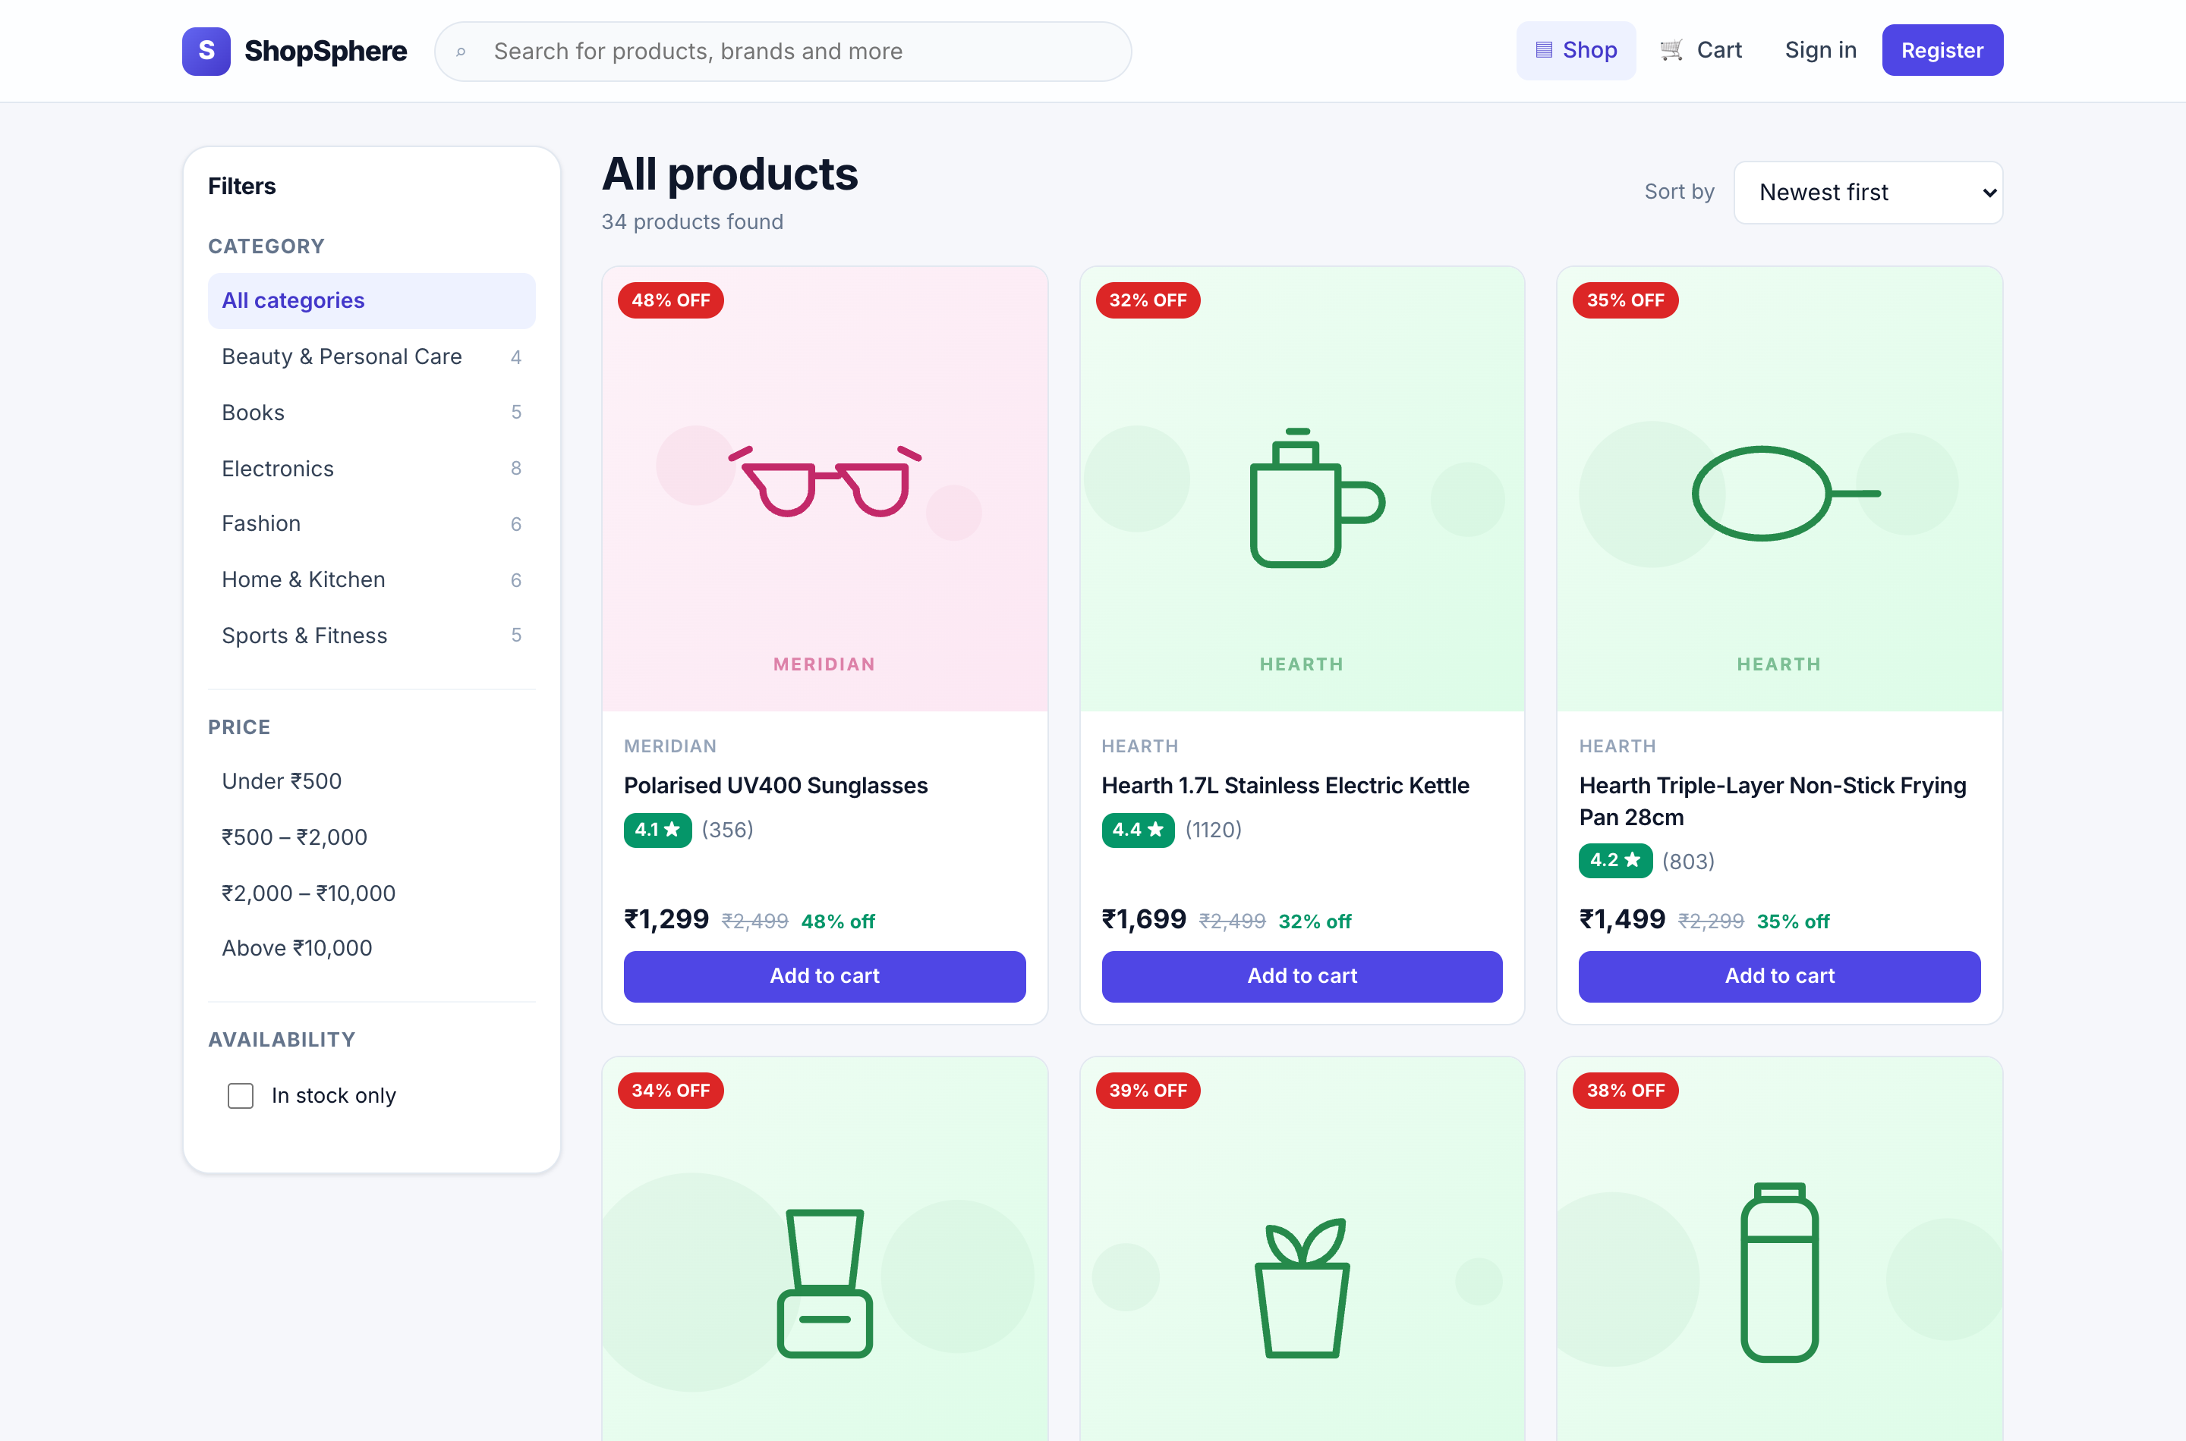
Figure 11: Catalogue listing — fluid product grid with the filter sidebar and sort control
Discount badges are derived from the difference between the selling price and the maximum retail price. Every filter shown writes to the URL query string, so this view can be bookmarked and shared, and the browser back button behaves as expected.
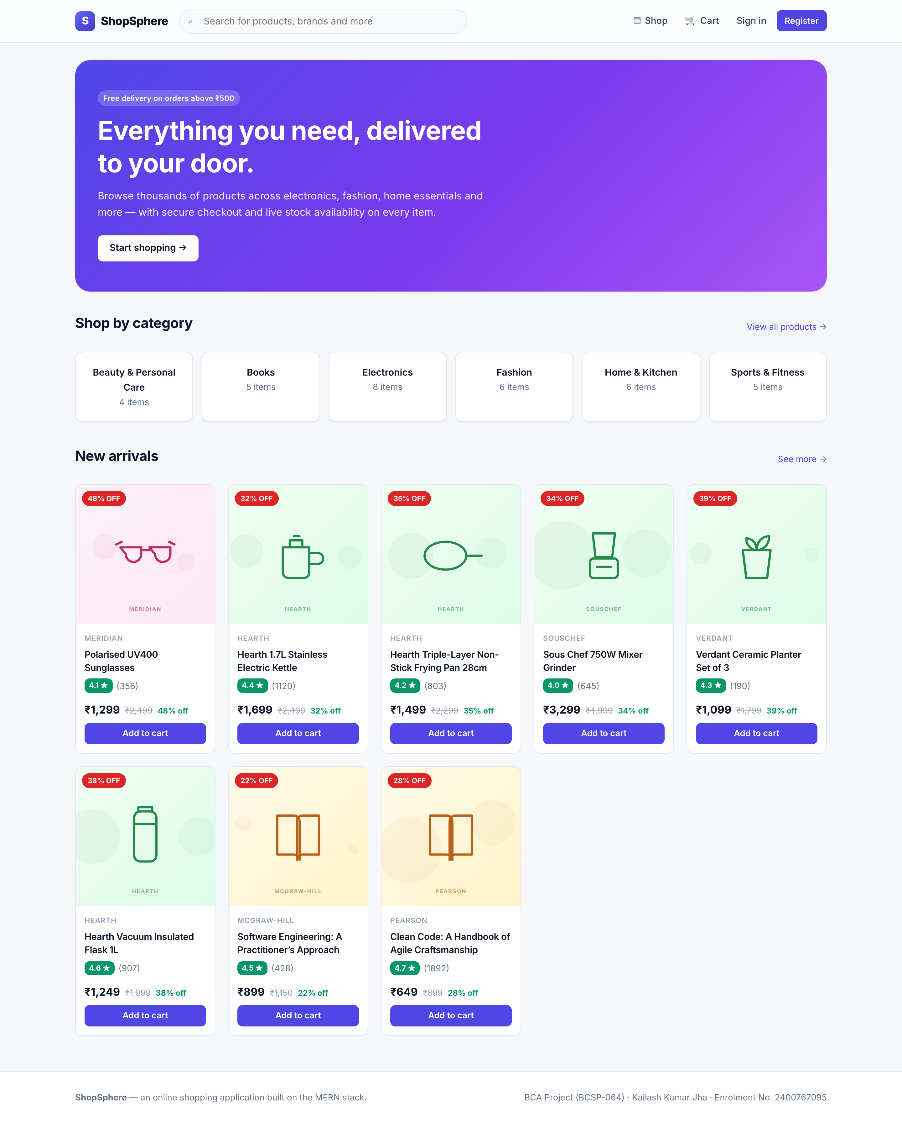 | 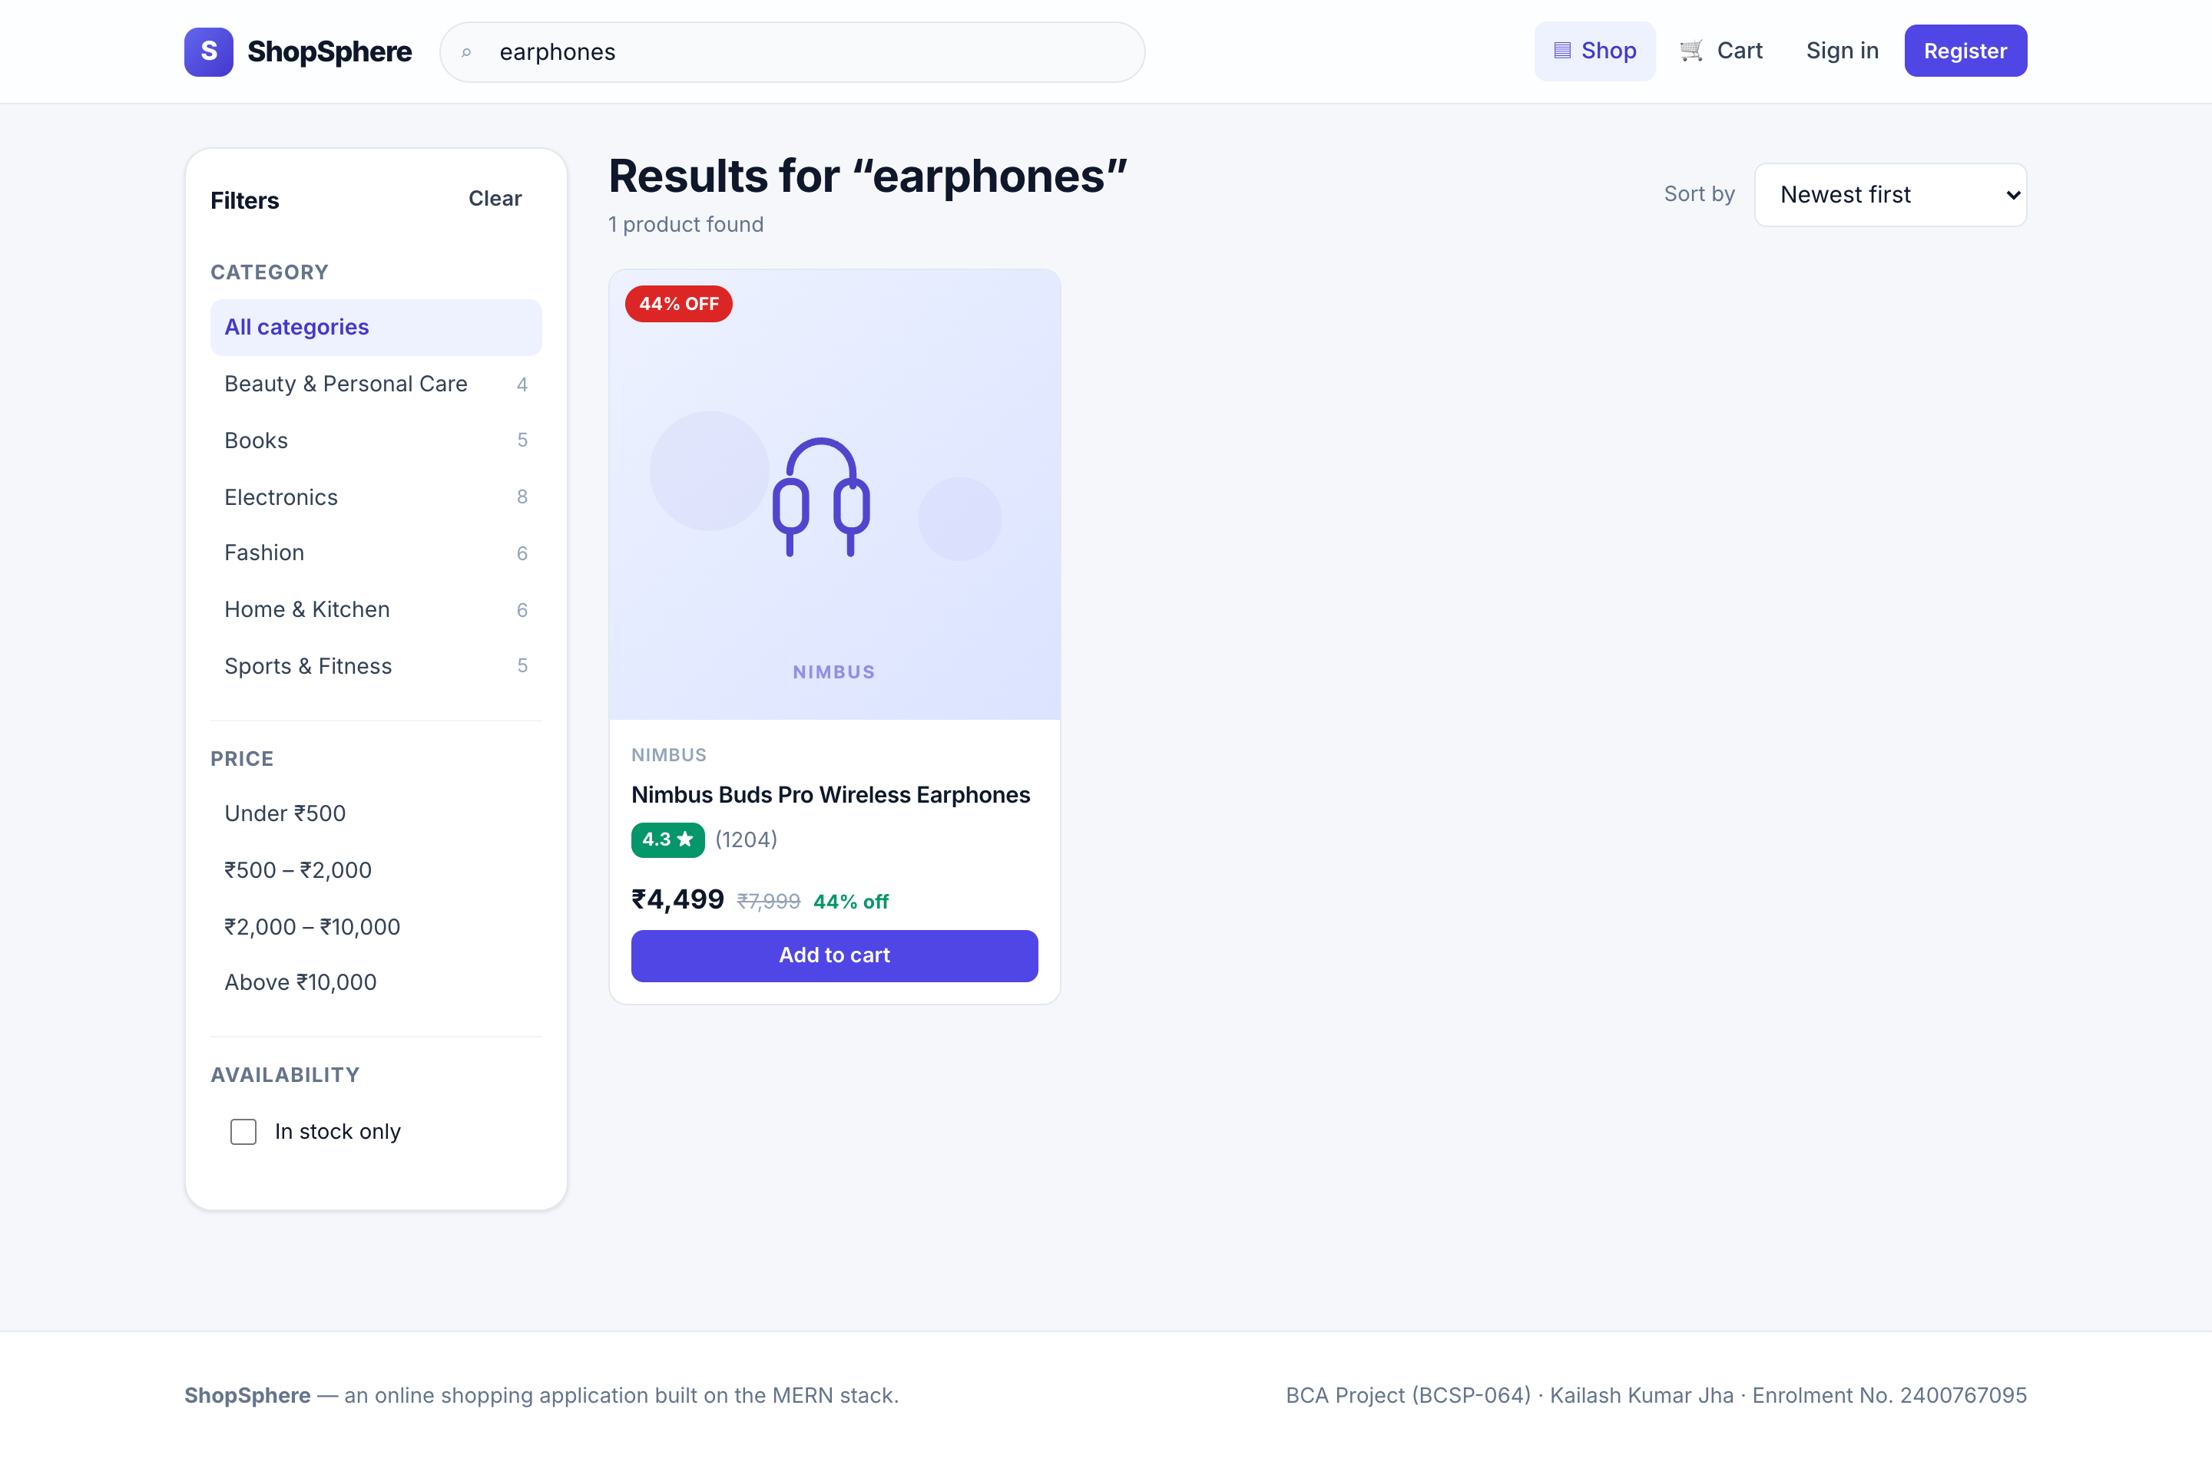
Figure 12: Home page — hero, category shortcuts with live counts, new arrivals | Figure 13: Keyword search for "earphones", ranked by relevance
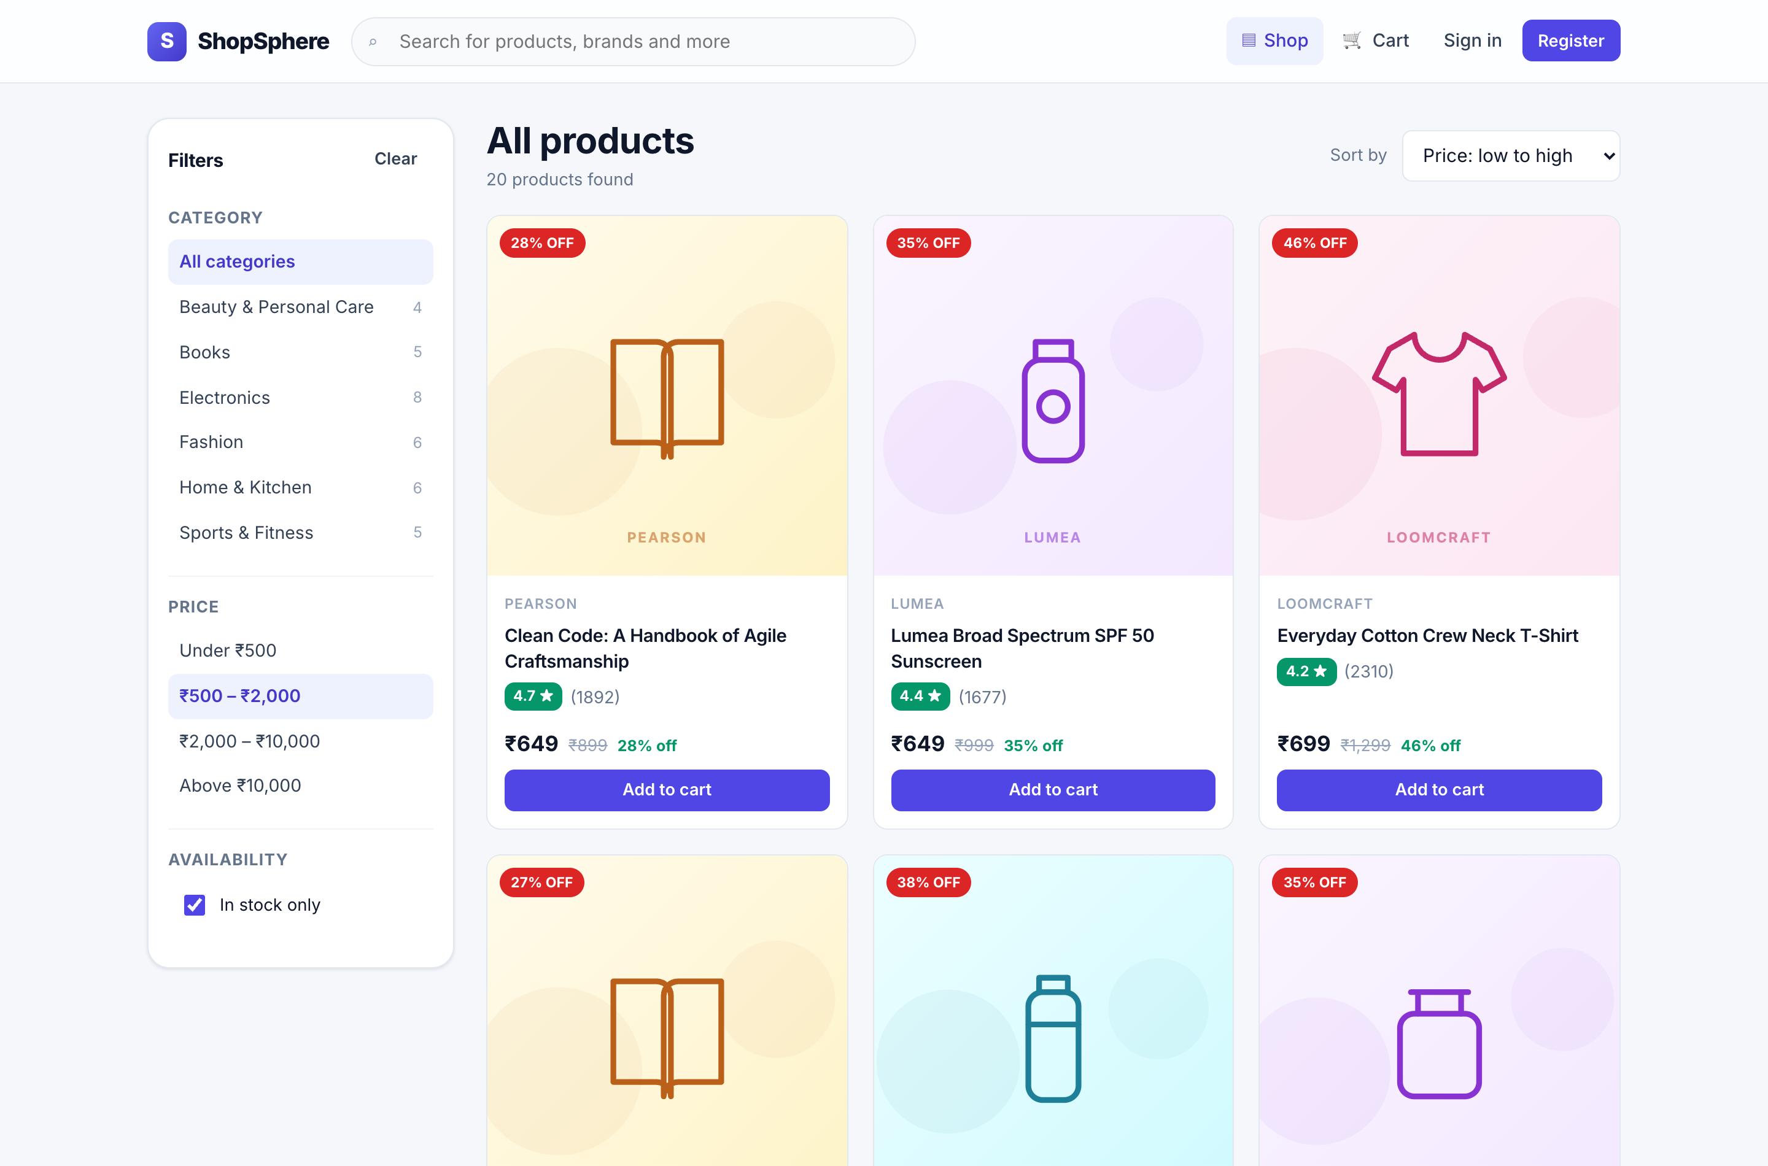 | 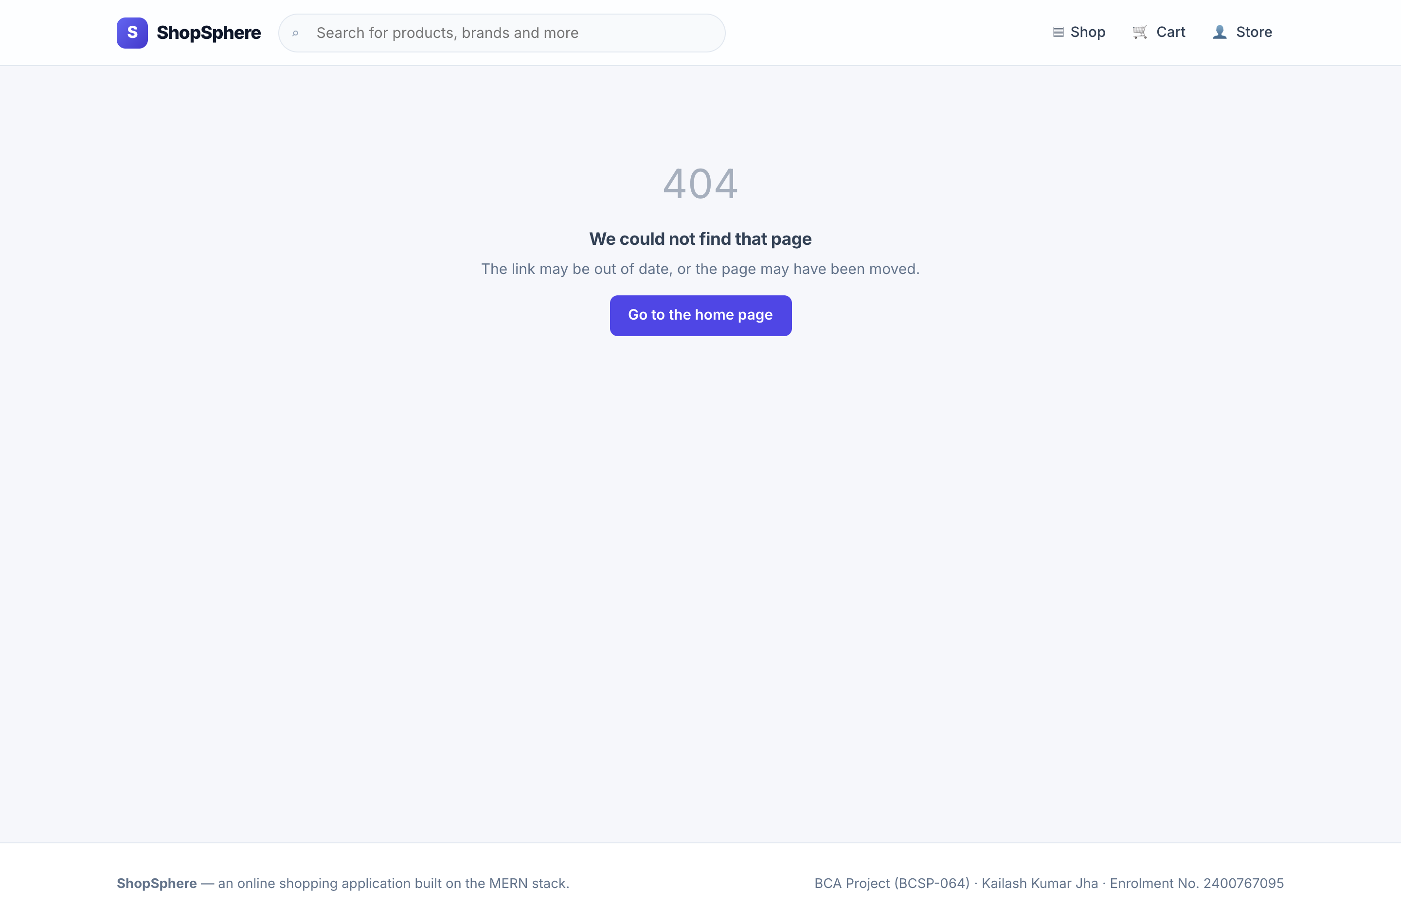
Figure 14: Combined filters: ₹500–₹2,000, in stock, price ascending | Figure 15: Page not found — shown for any unmatched route
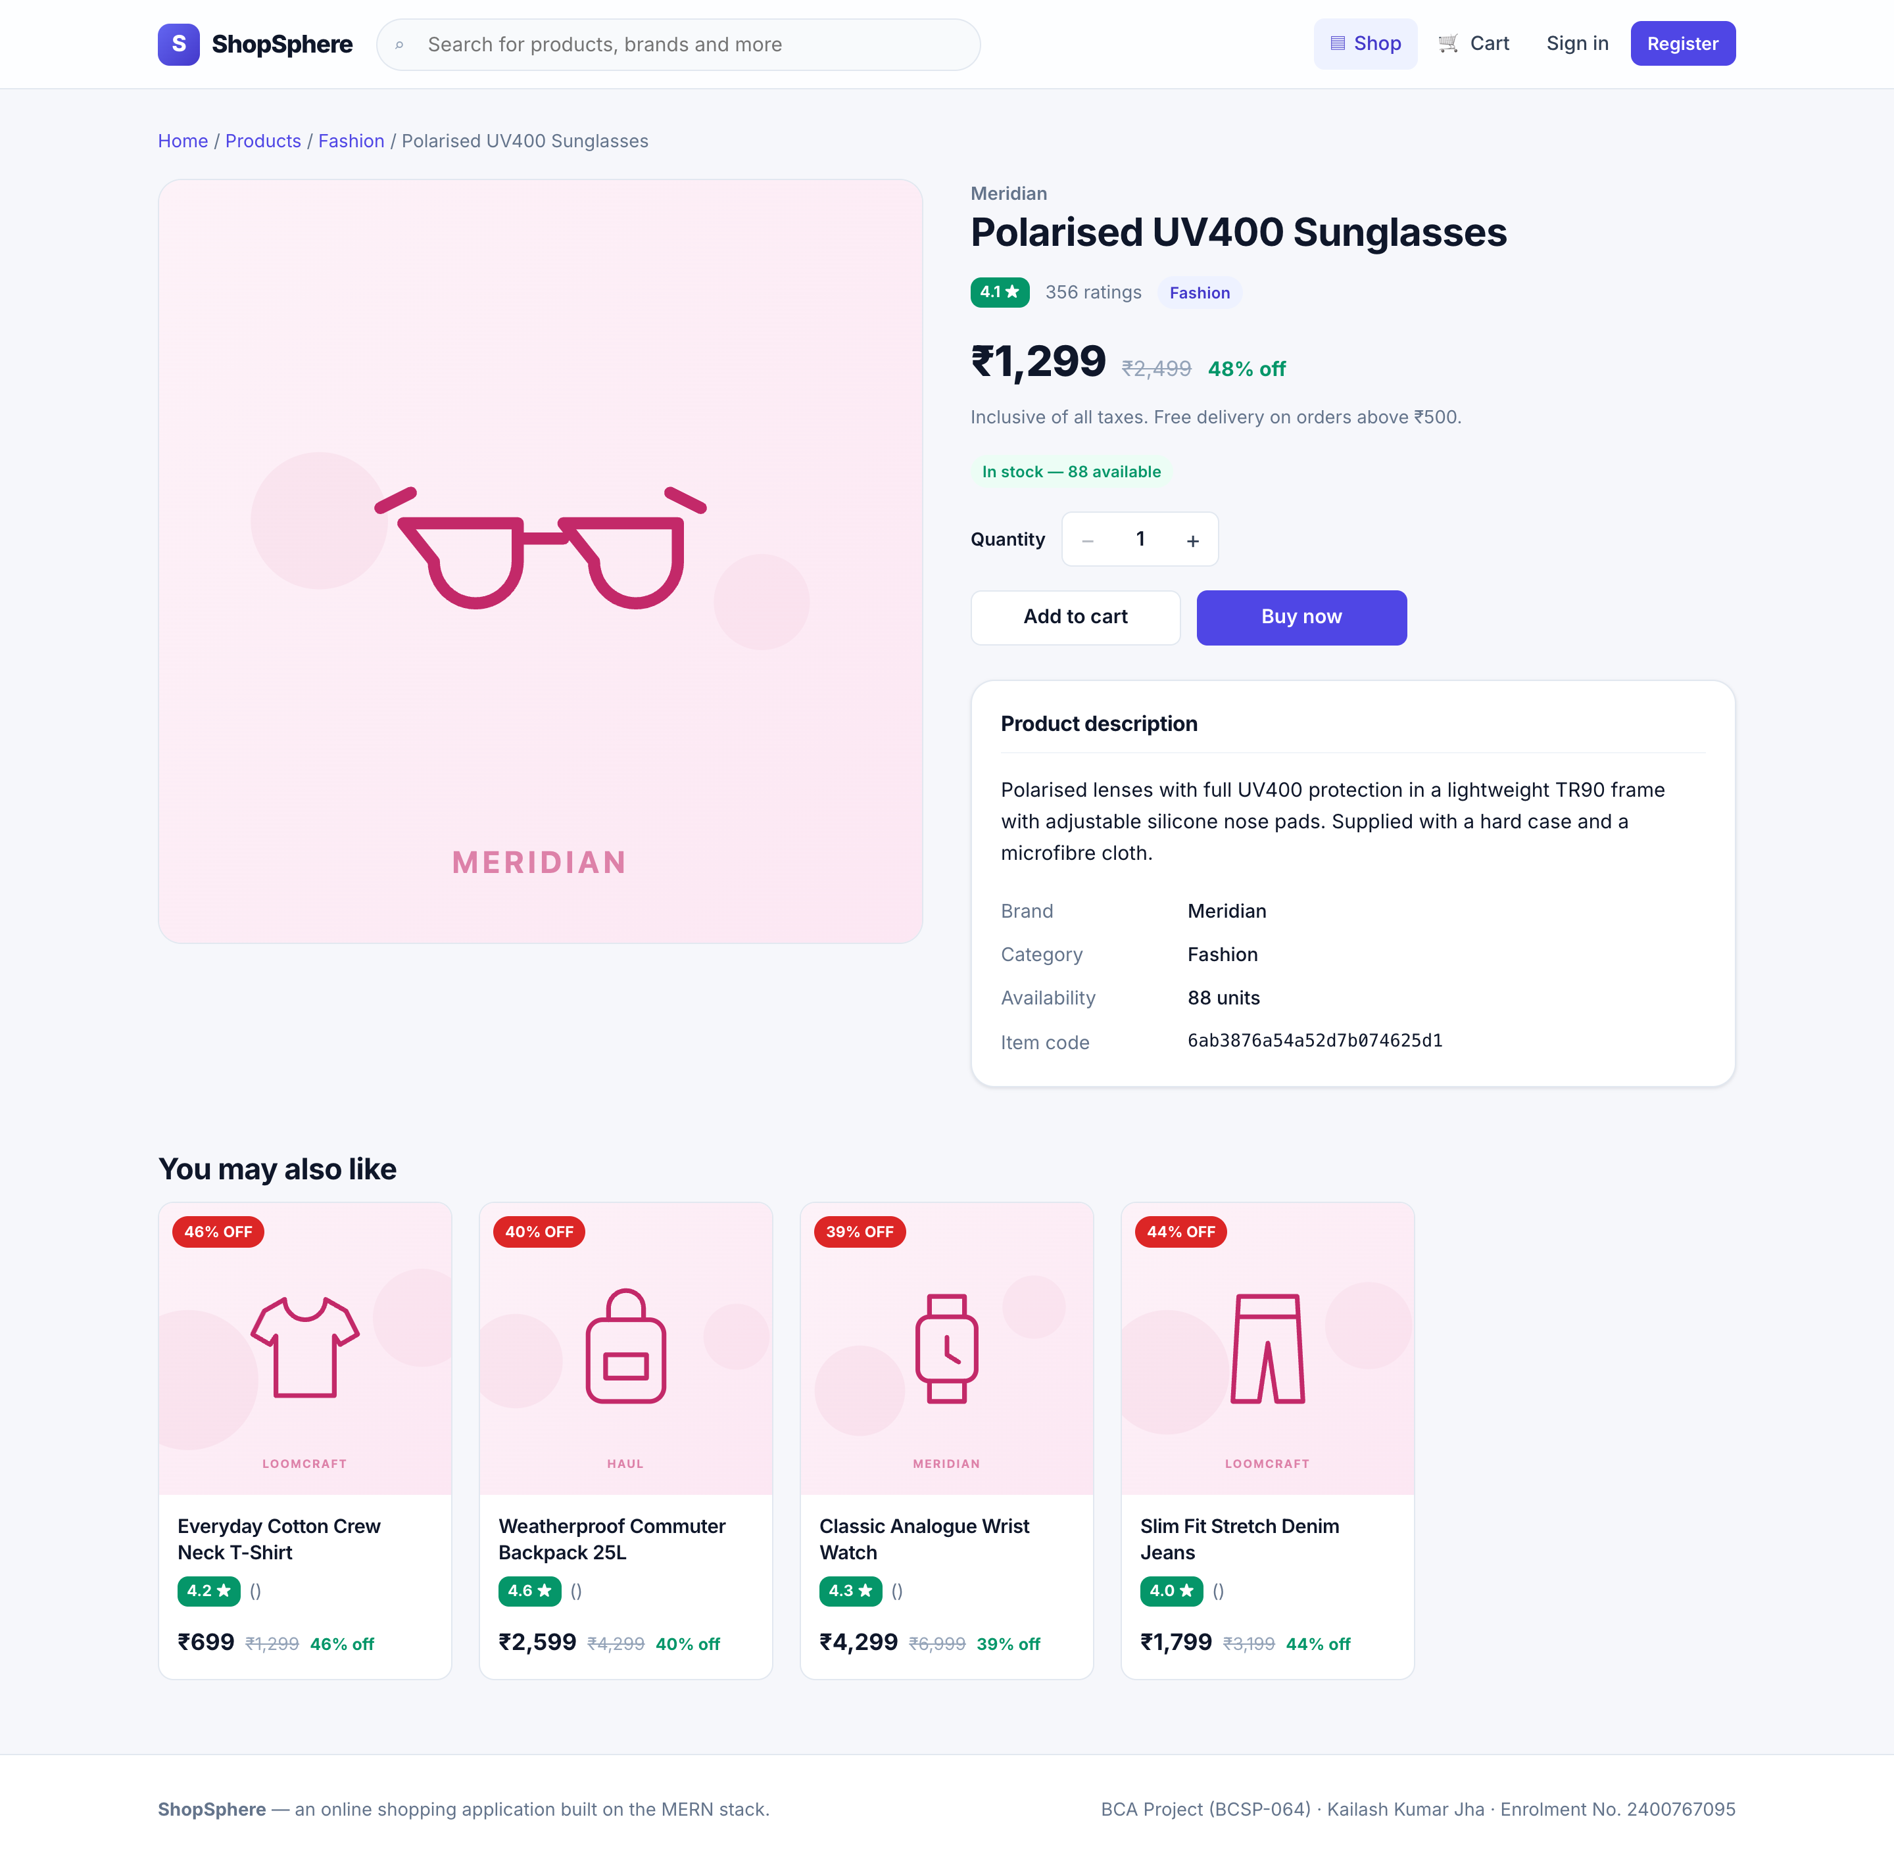
Figure 16: Product detail — description, live stock position, quantity stepper and related items
The stock badge changes colour and wording according to the live figure: green above five units, amber at five or fewer, and a disabled control with an out-of-stock veil at zero. The category tile counts on the home page are computed by a server-side aggregation rather than hard-coded, so they remain correct as the catalogue changes.

9.2 Account Screens
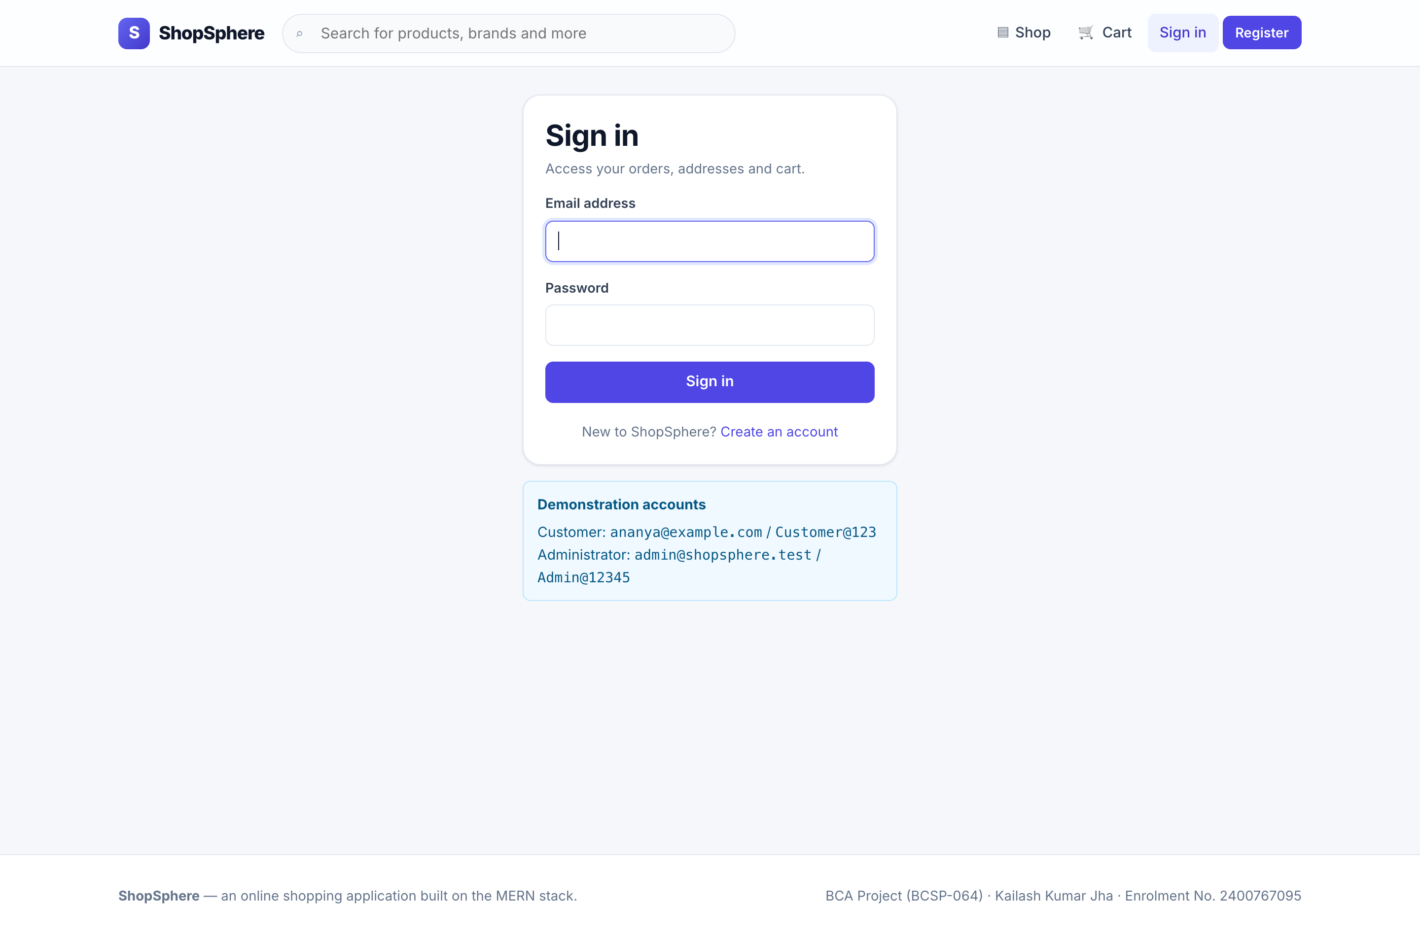 | 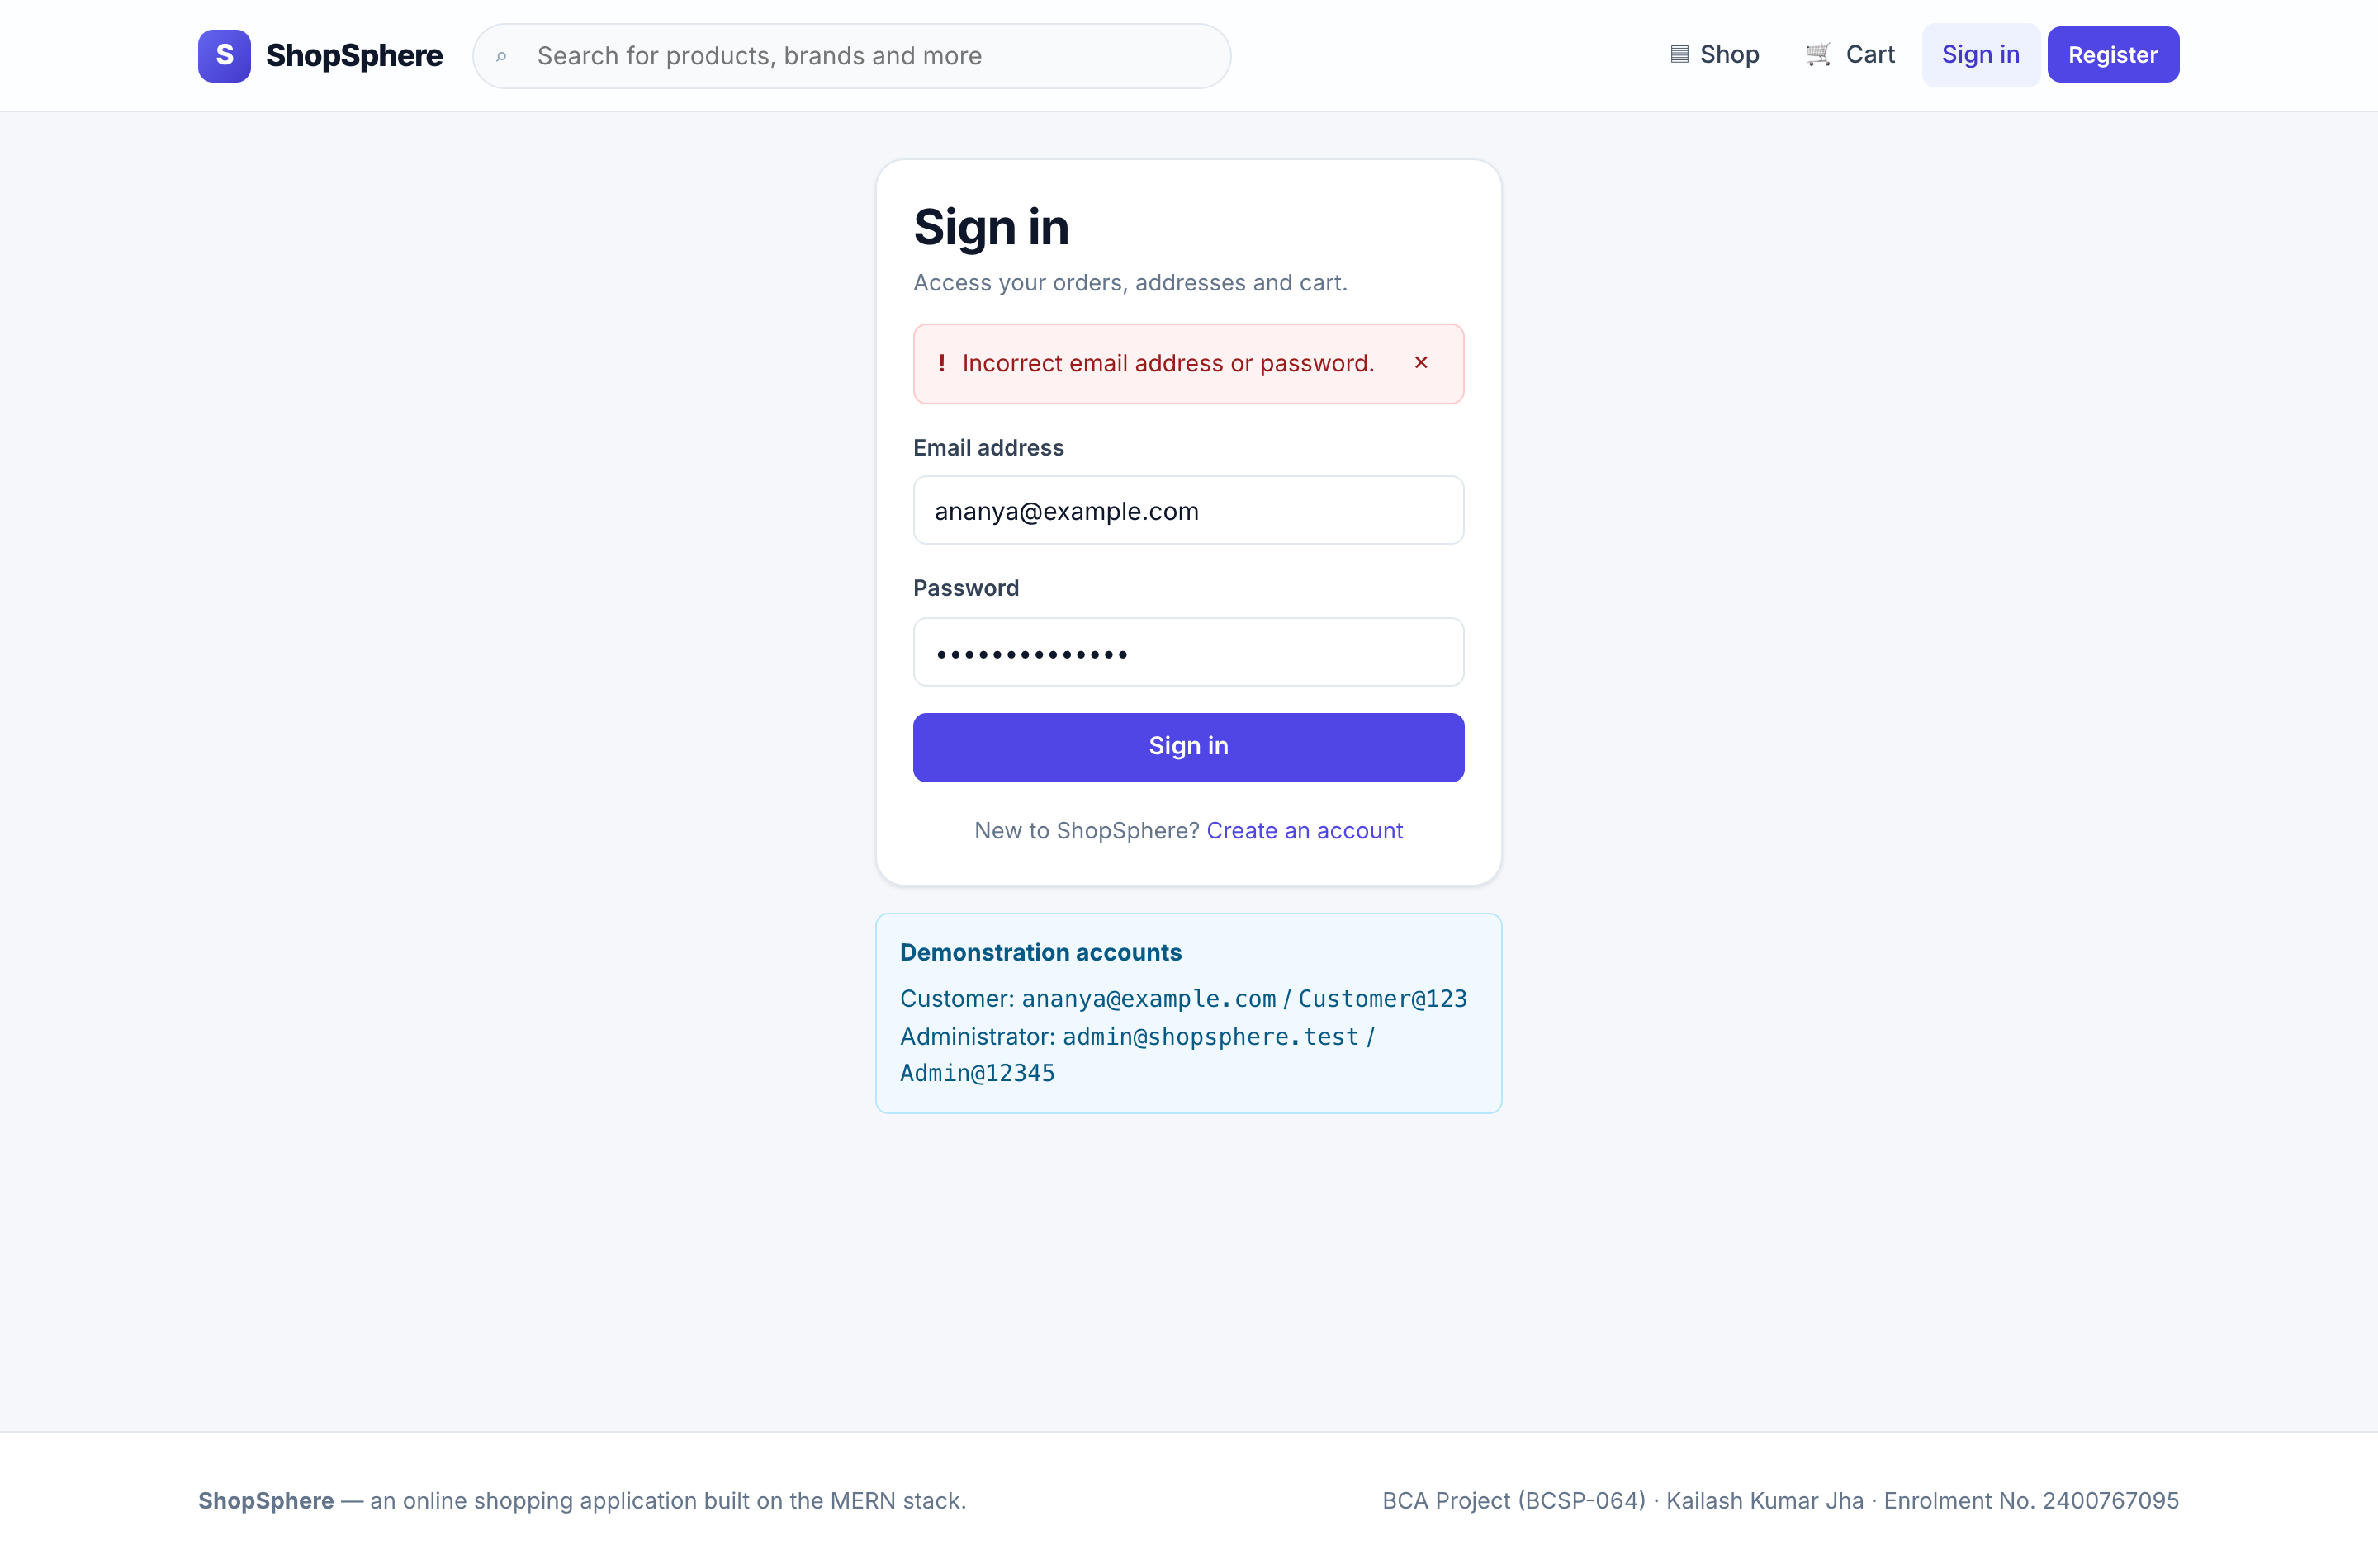
Figure 17: Sign in, with the demonstration credentials shown | Figure 18: Sign-in failure — one generic message for both cases
The identical message for an unknown address and a wrong password is deliberate: distinguishing them would let the endpoint be used to discover which addresses are registered (test case TC-I-09).
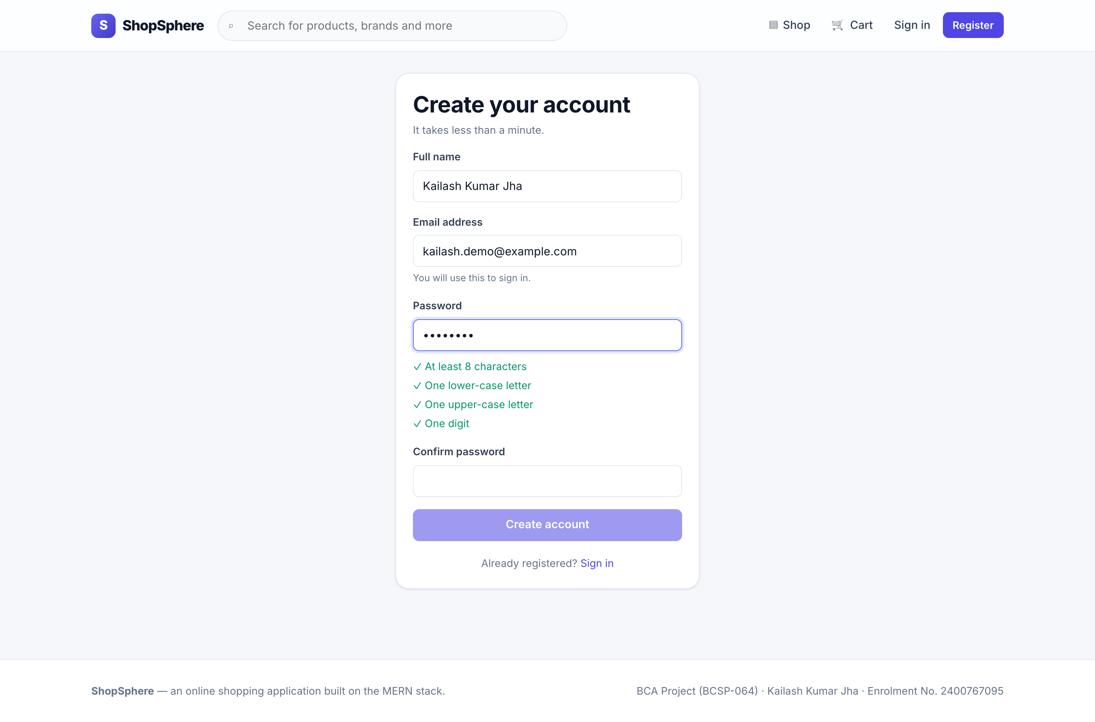 | 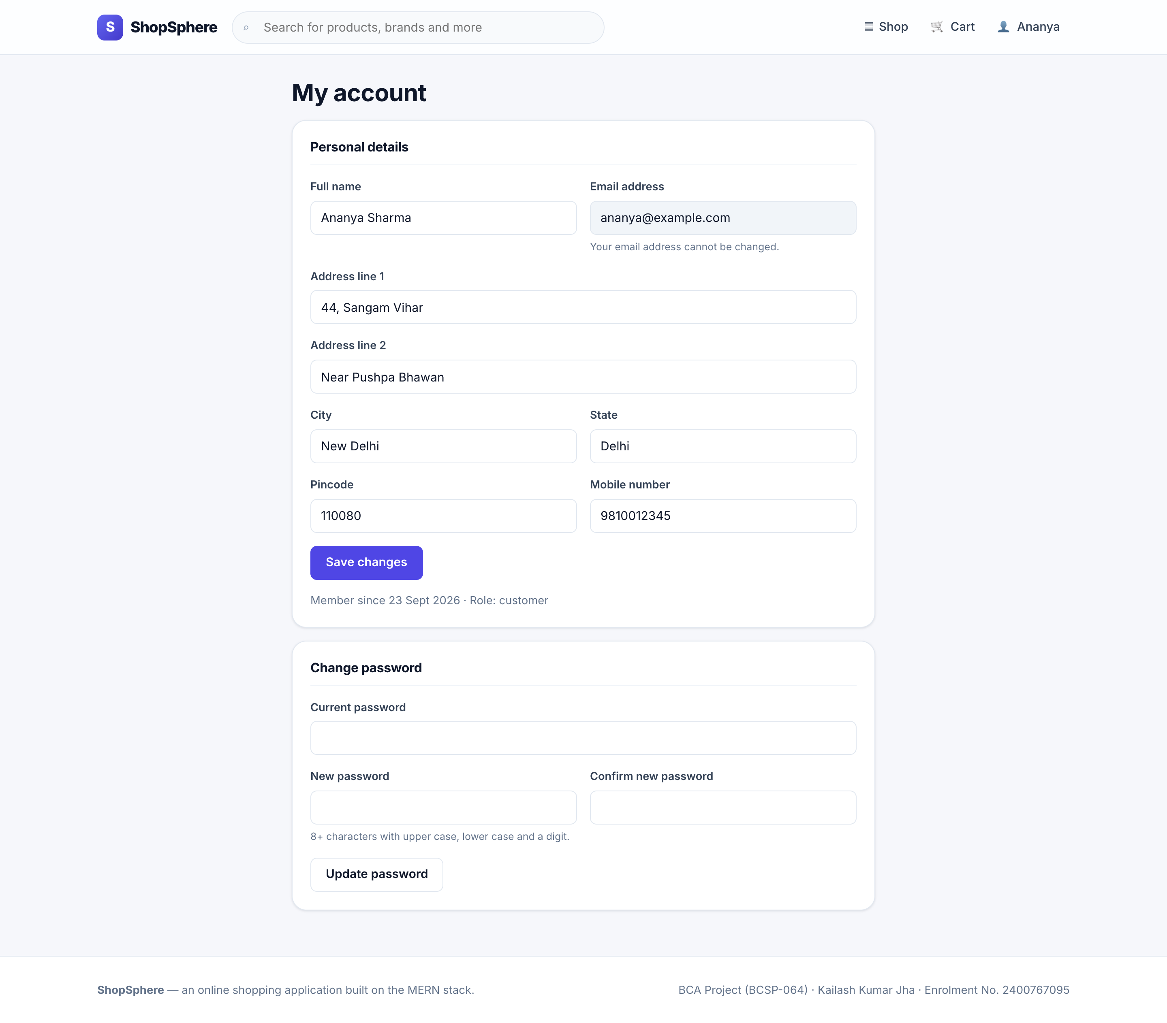
Figure 19: Registration — the password policy as a live checklist | Figure 20: Profile — details, default address and password change
The email field on the profile screen is disabled because it is the sign-in identifier; changing it would require a verification flow, which Section 2.3 places outside the scope.

9.3 Cart and Checkout
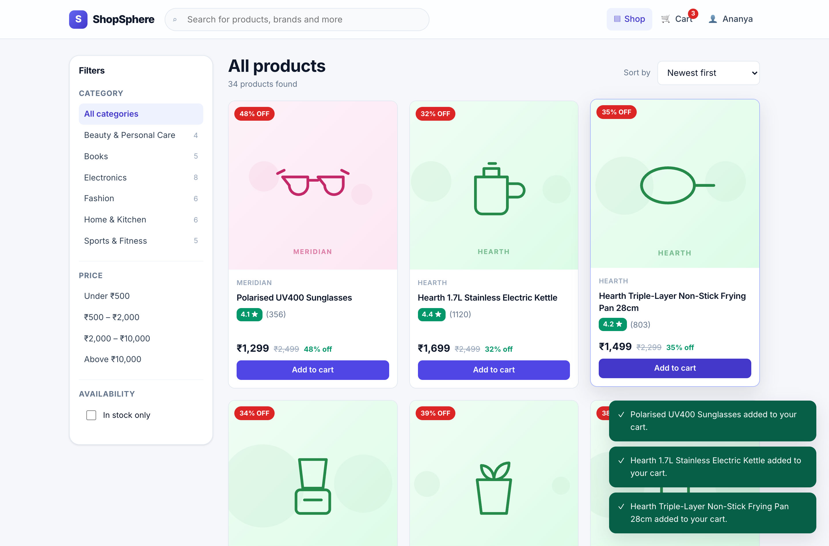 | 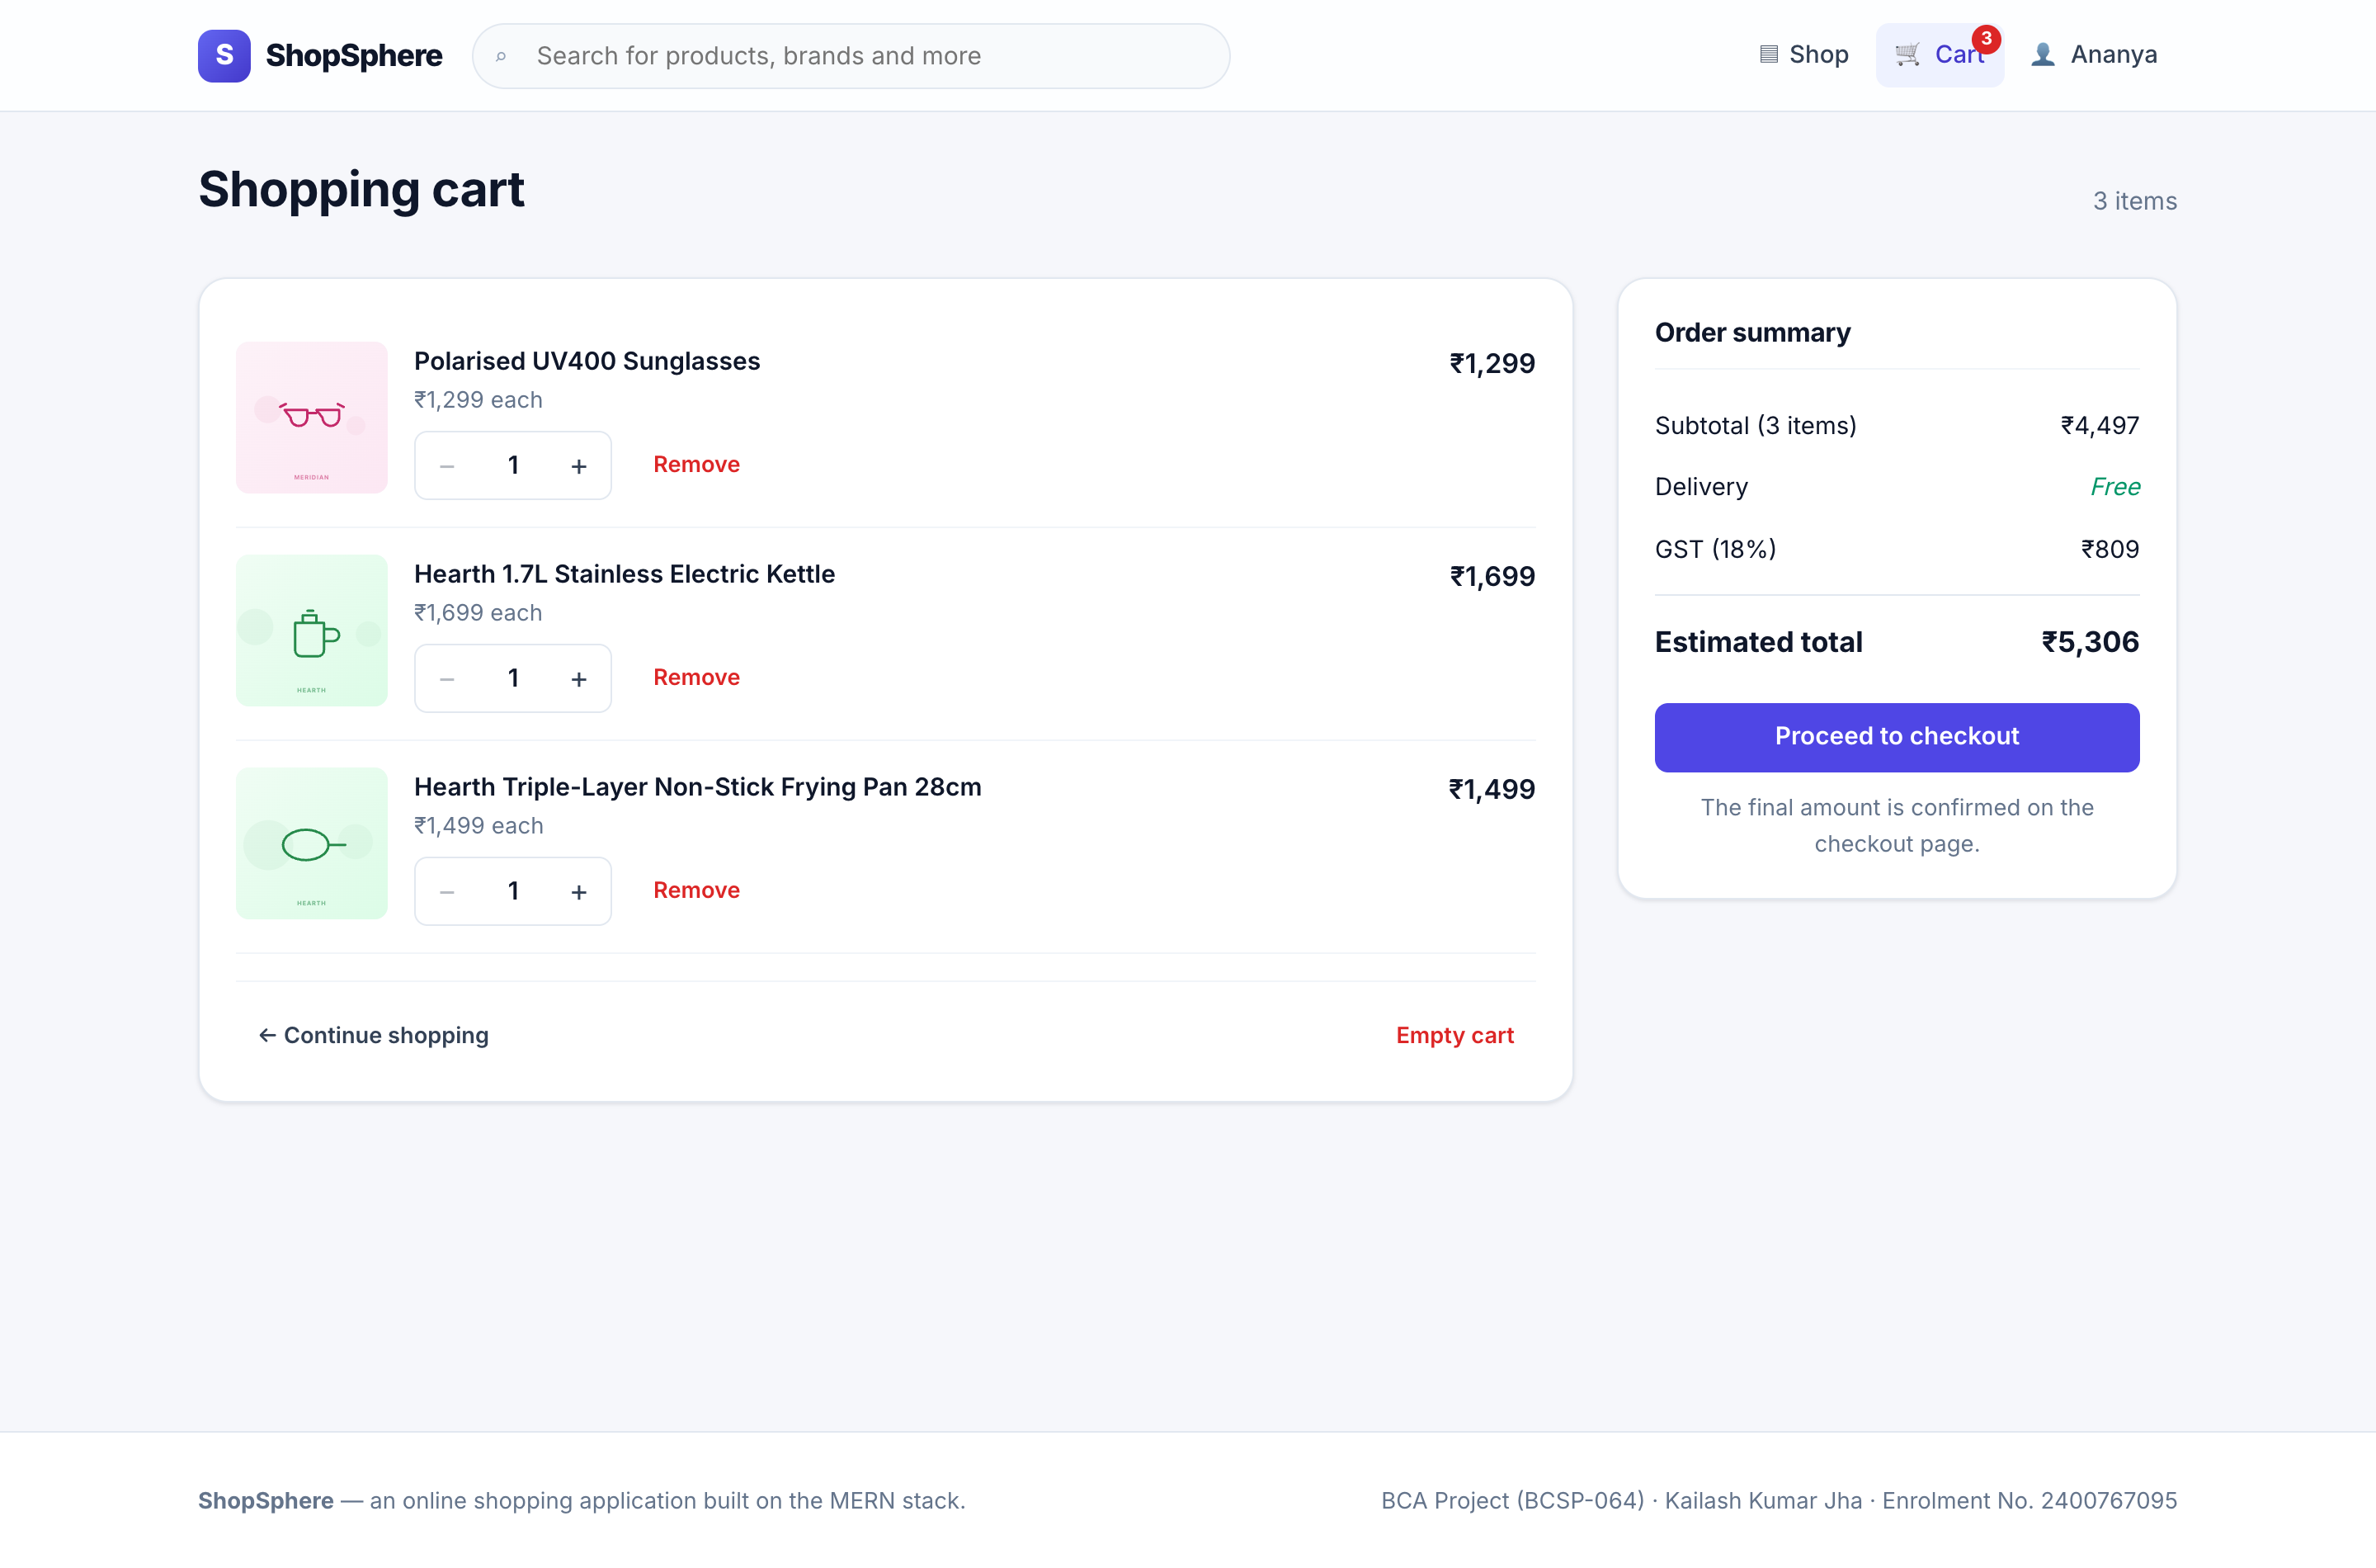
Figure 21: Adding to the cart — transient confirmation and badge | Figure 22: Shopping cart with the free-delivery threshold prompt
The cart summary is explicitly labelled an estimate. The binding figure is the one the server returns at checkout, for the reasons set out in Section 1.2.1.
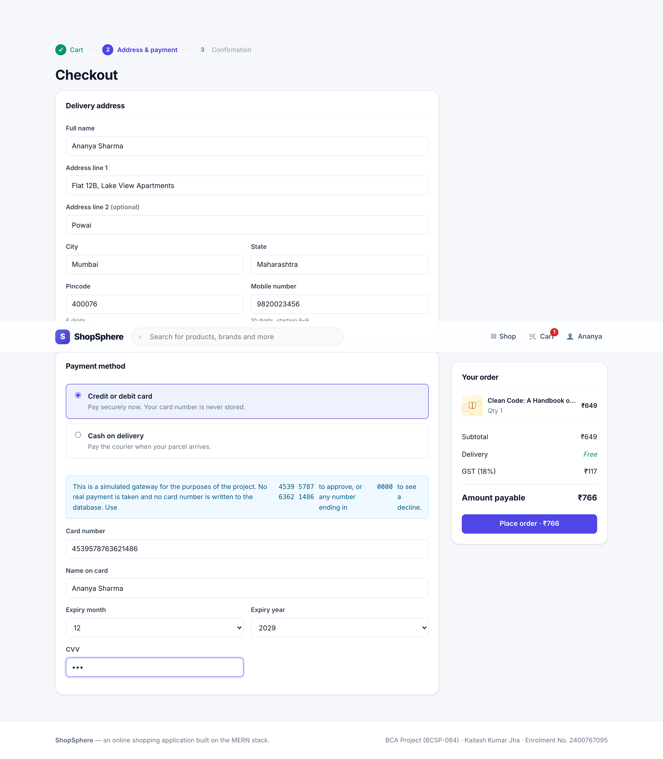
Figure 23: Checkout — delivery address, payment selection, card entry and the server-priced order summary
The payment panel states plainly that the gateway is simulated and that no card number is stored. The order summary is populated from the server’s own quote, not from figures computed in the browser.
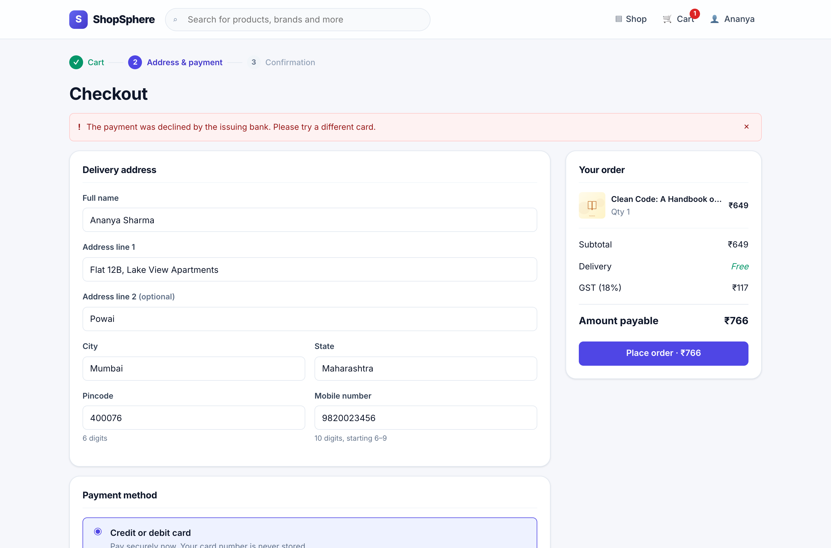 | 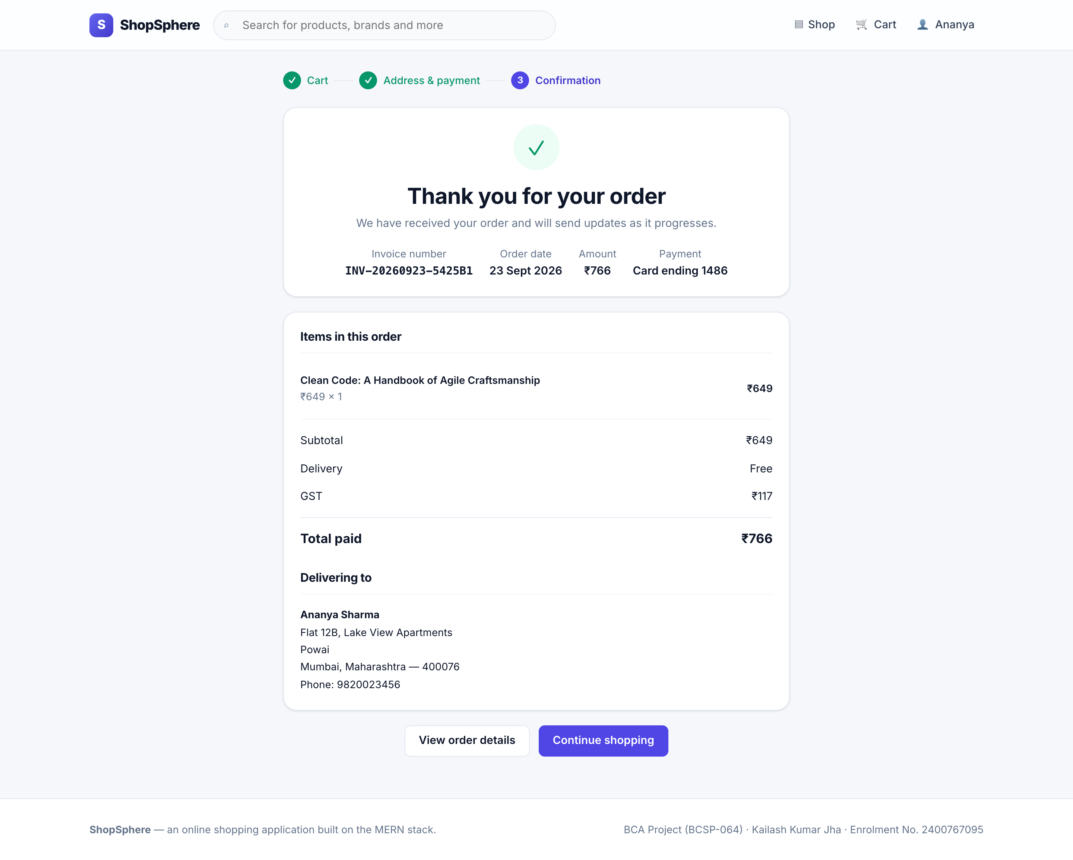
Figure 24: Declined payment — stock already returned, no order written | Figure 25: Order confirmation with the invoice number
The declined-payment screen is the visible face of test case TC-I-40: by the time the message appears, the compensating action has already returned the reserved units to the catalogue and no order document exists.

9.4 Order Tracking
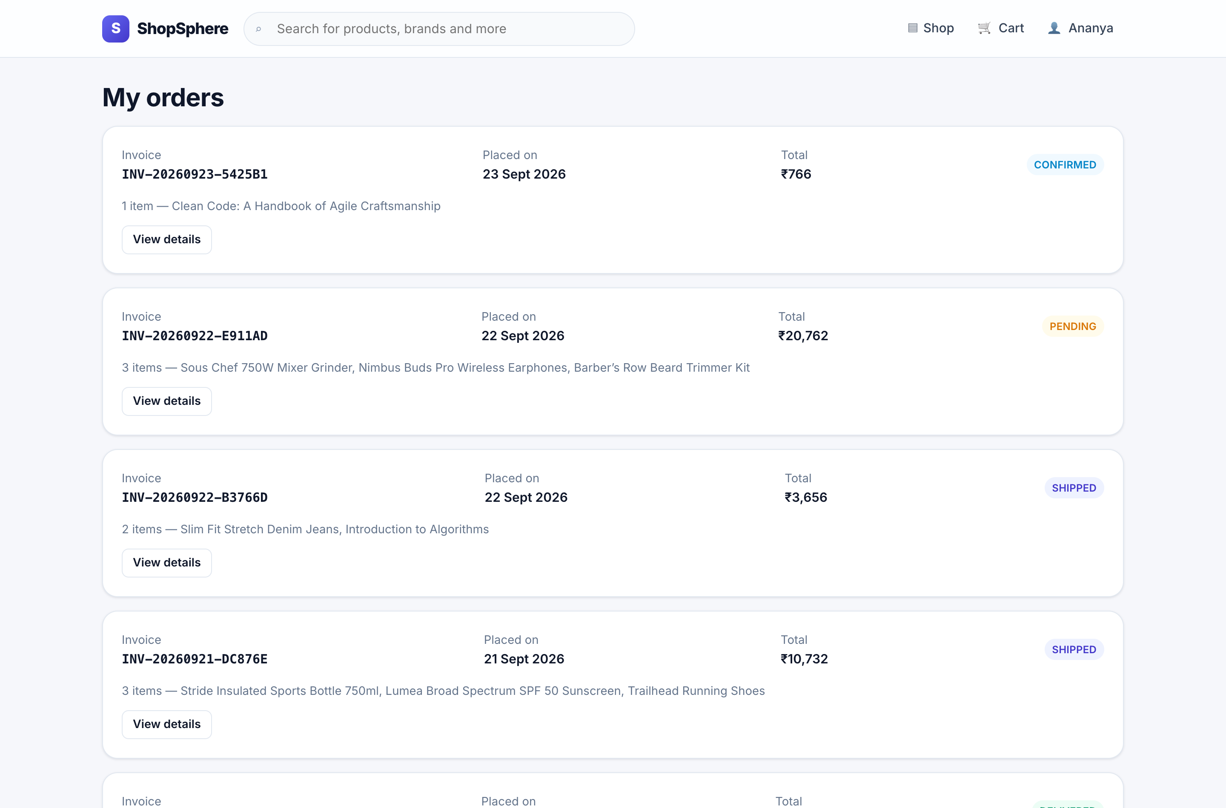 | 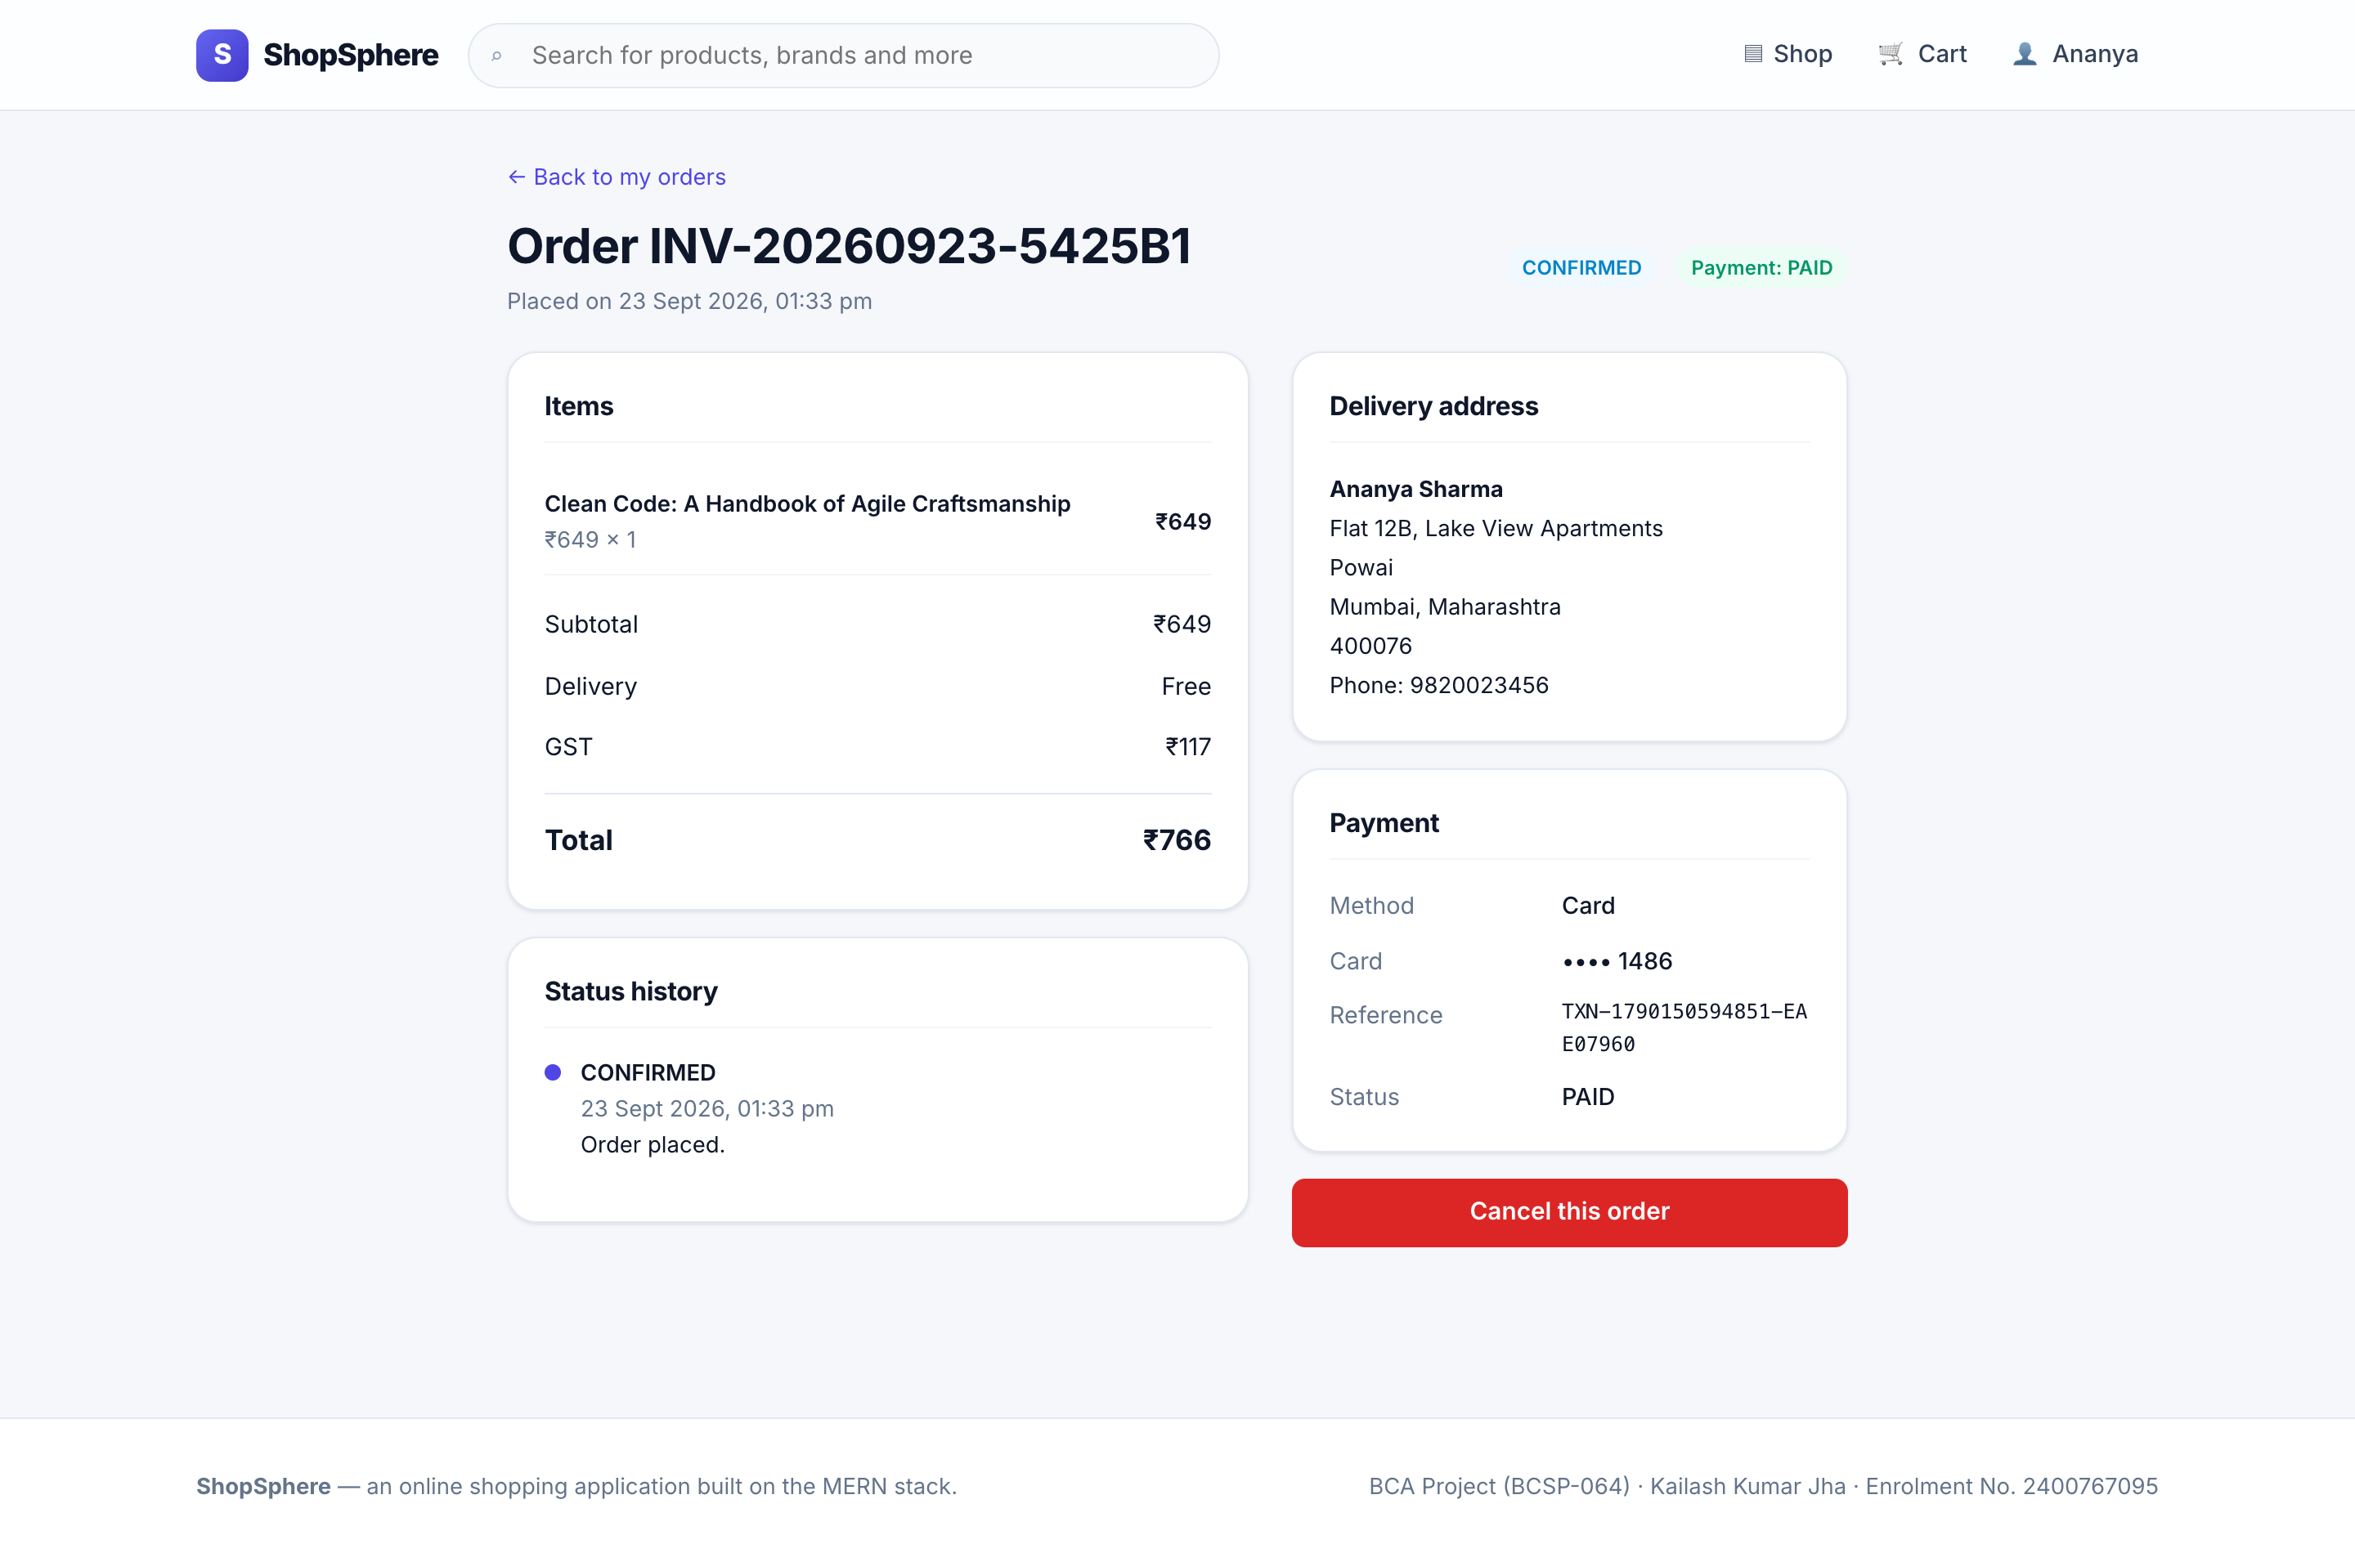
Figure 26: Order history, most recent first | Figure 27: Order detail with the status timeline
Only the last four digits of the card are shown, because only the last four digits were ever stored. The cancel control appears only while the order status permits cancellation.

9.5 Administration Screens
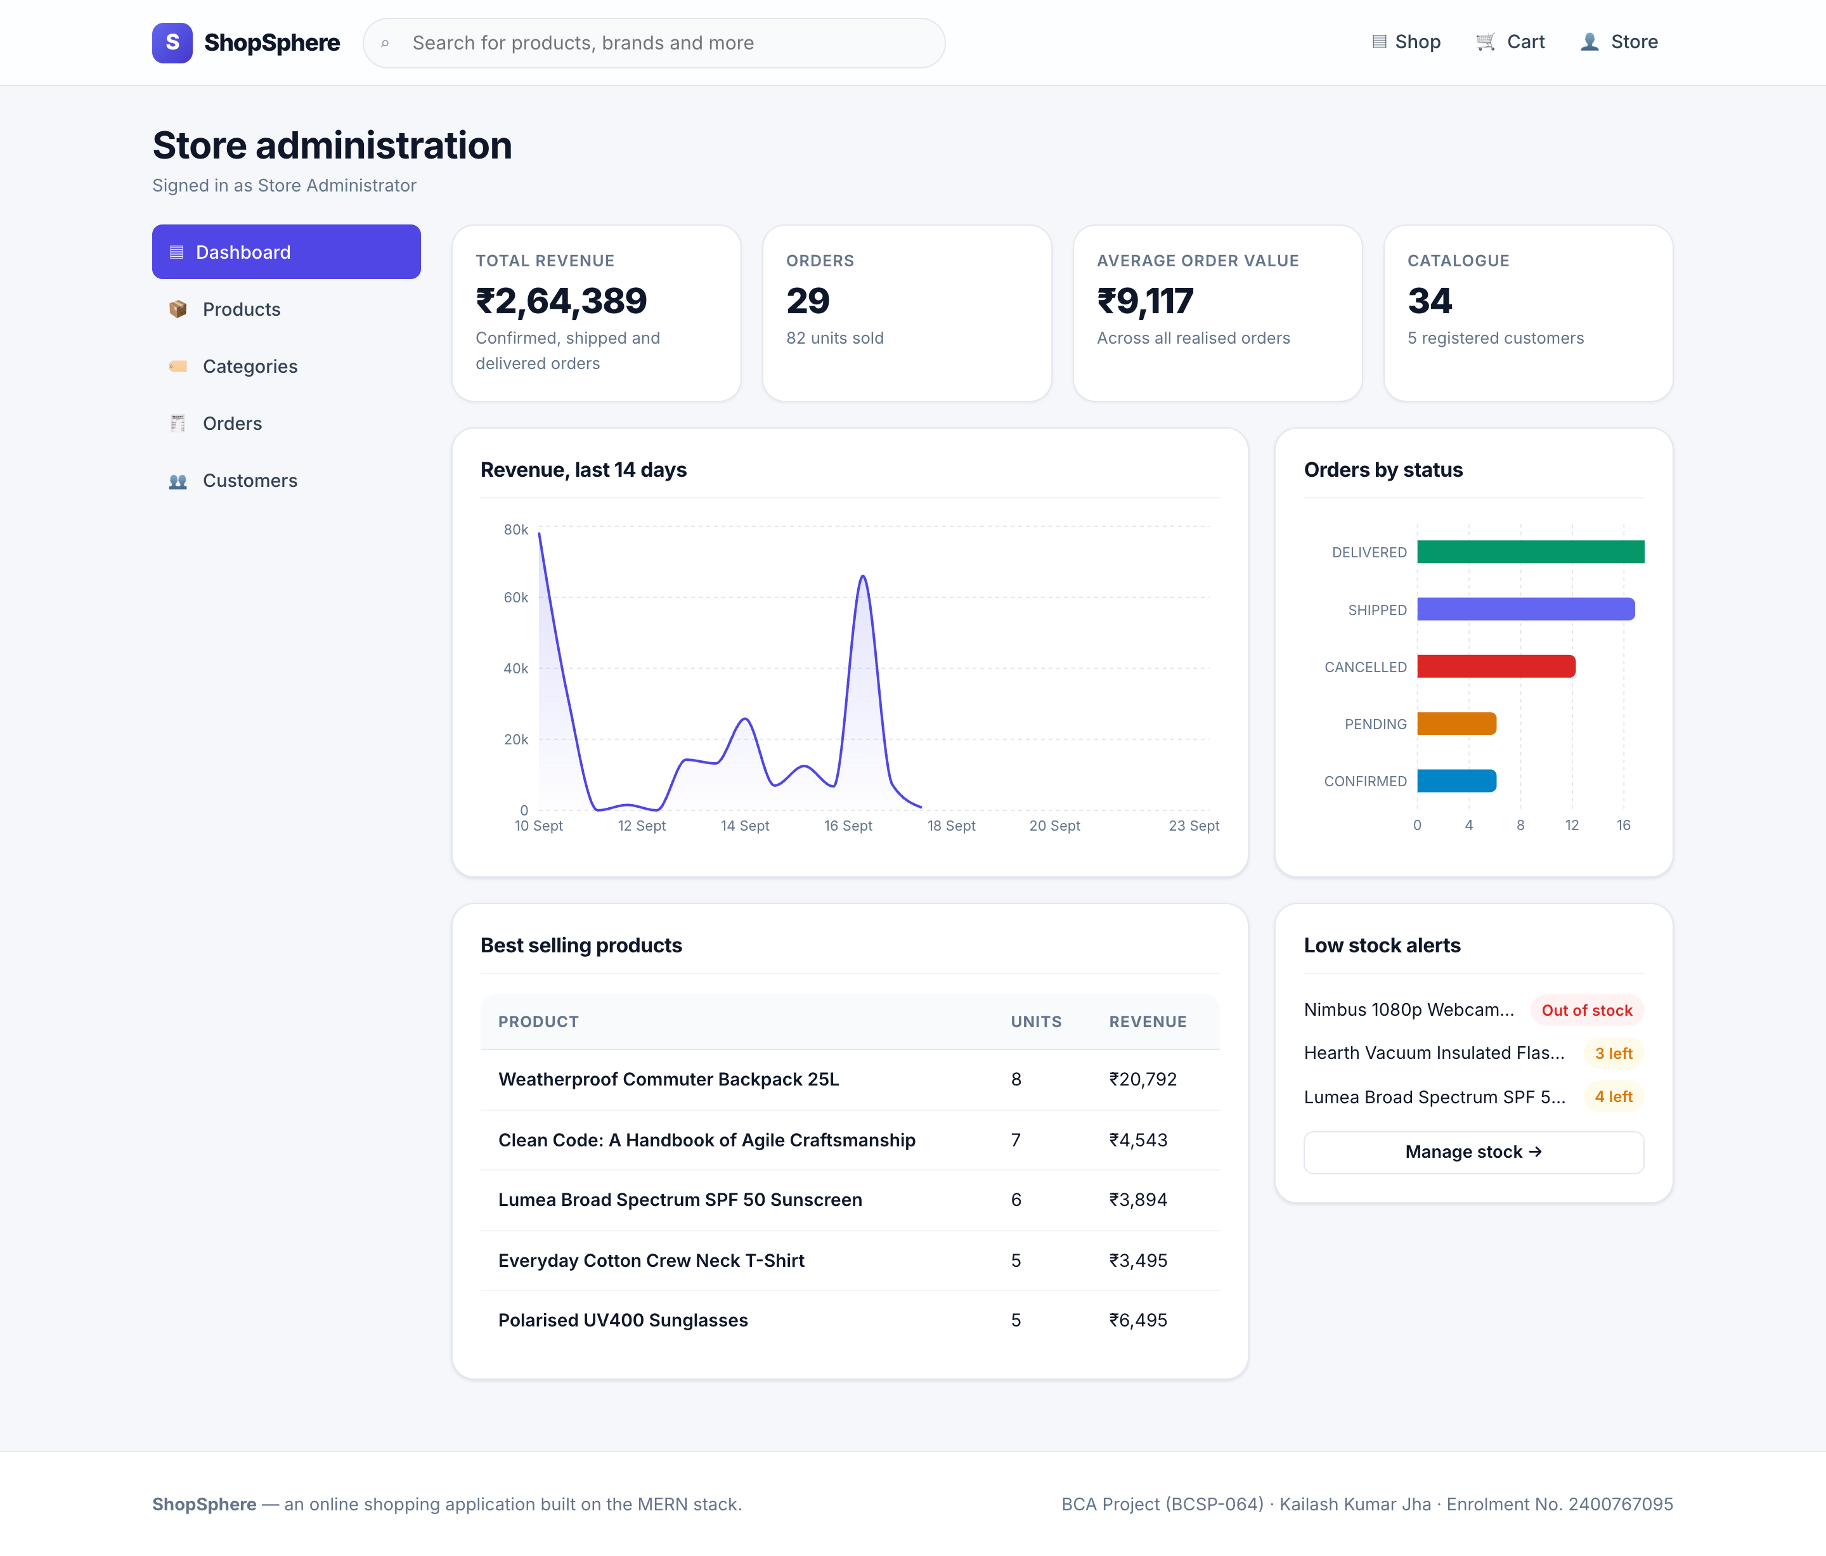
Figure 28: Administrator dashboard — headline figures, fourteen-day revenue series, status breakdown, best sellers and low-stock alerts
Every figure on this screen is computed by a MongoDB aggregation pipeline rather than by loading orders into the application and summing them in JavaScript. The date window is resolved in the store’s own timezone — see the defect recorded in Section 8.6.1.
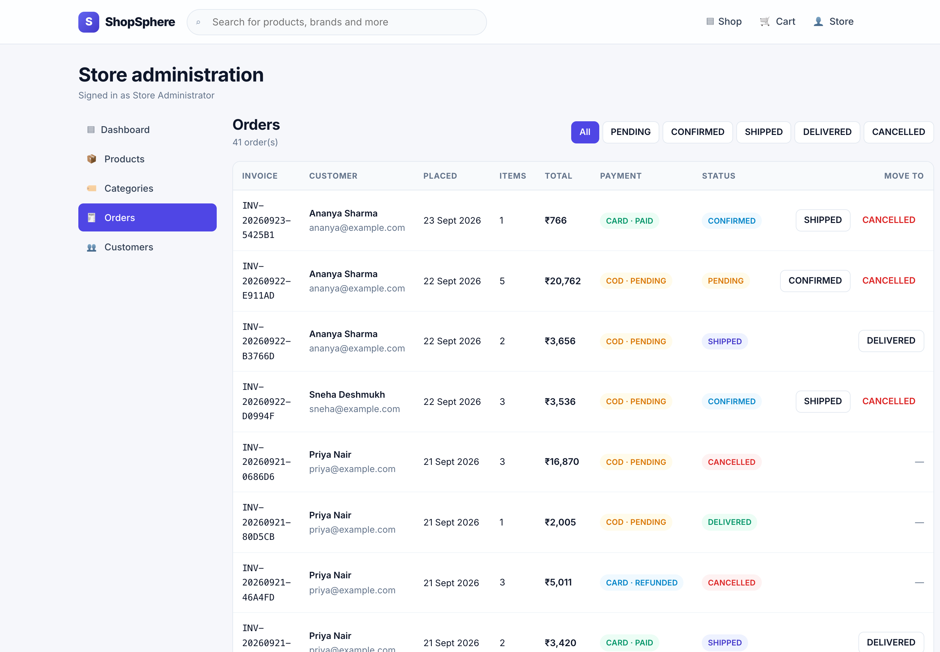
Figure 29: Order queue — filterable by status, offering only the transitions the state machine permits from each order’s current state
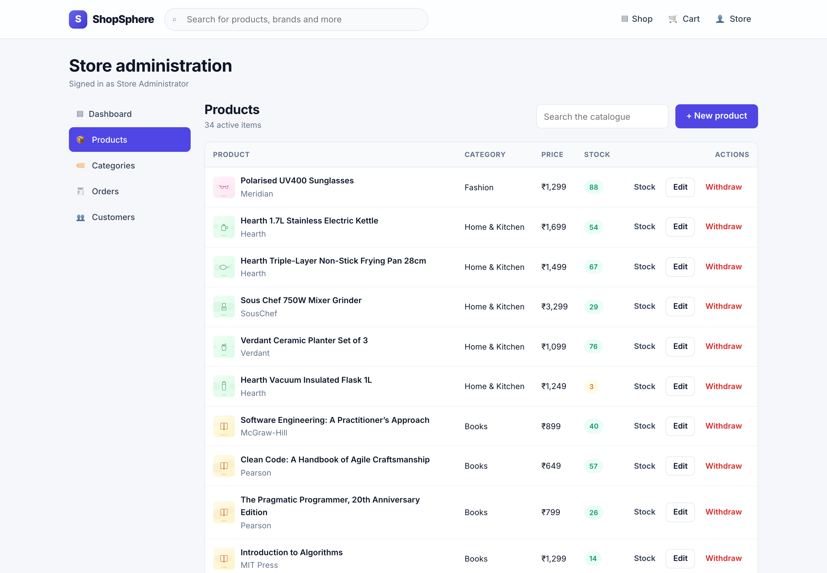 | 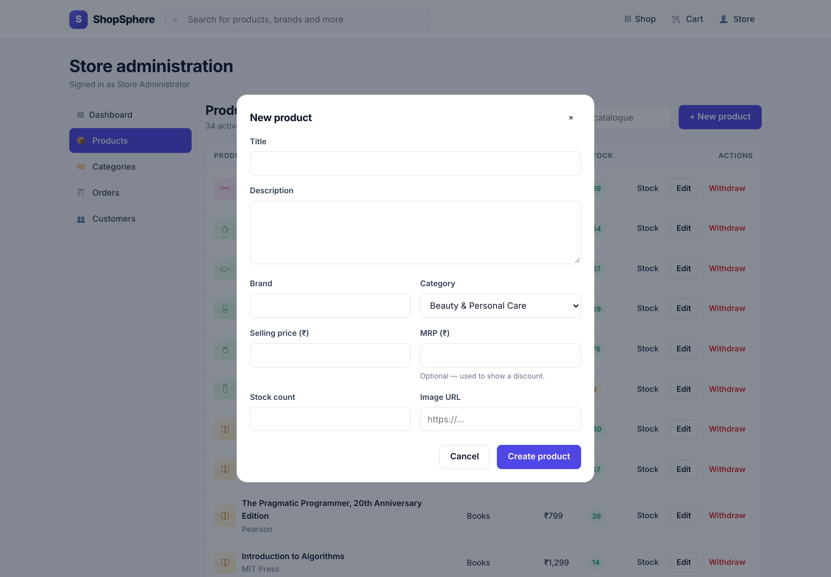
Figure 30: Product maintenance with colour-coded stock levels | Figure 31: Product form with per-field validation
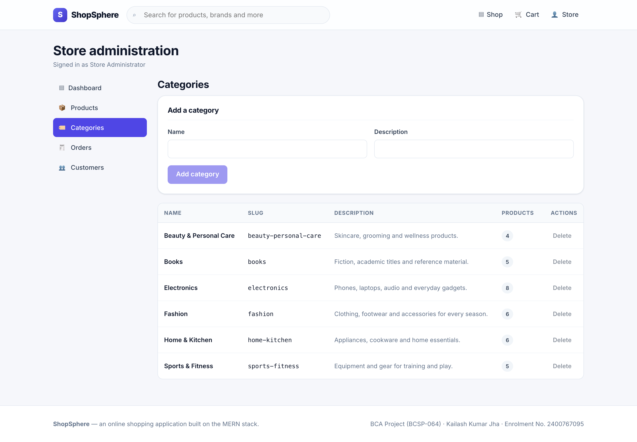 | 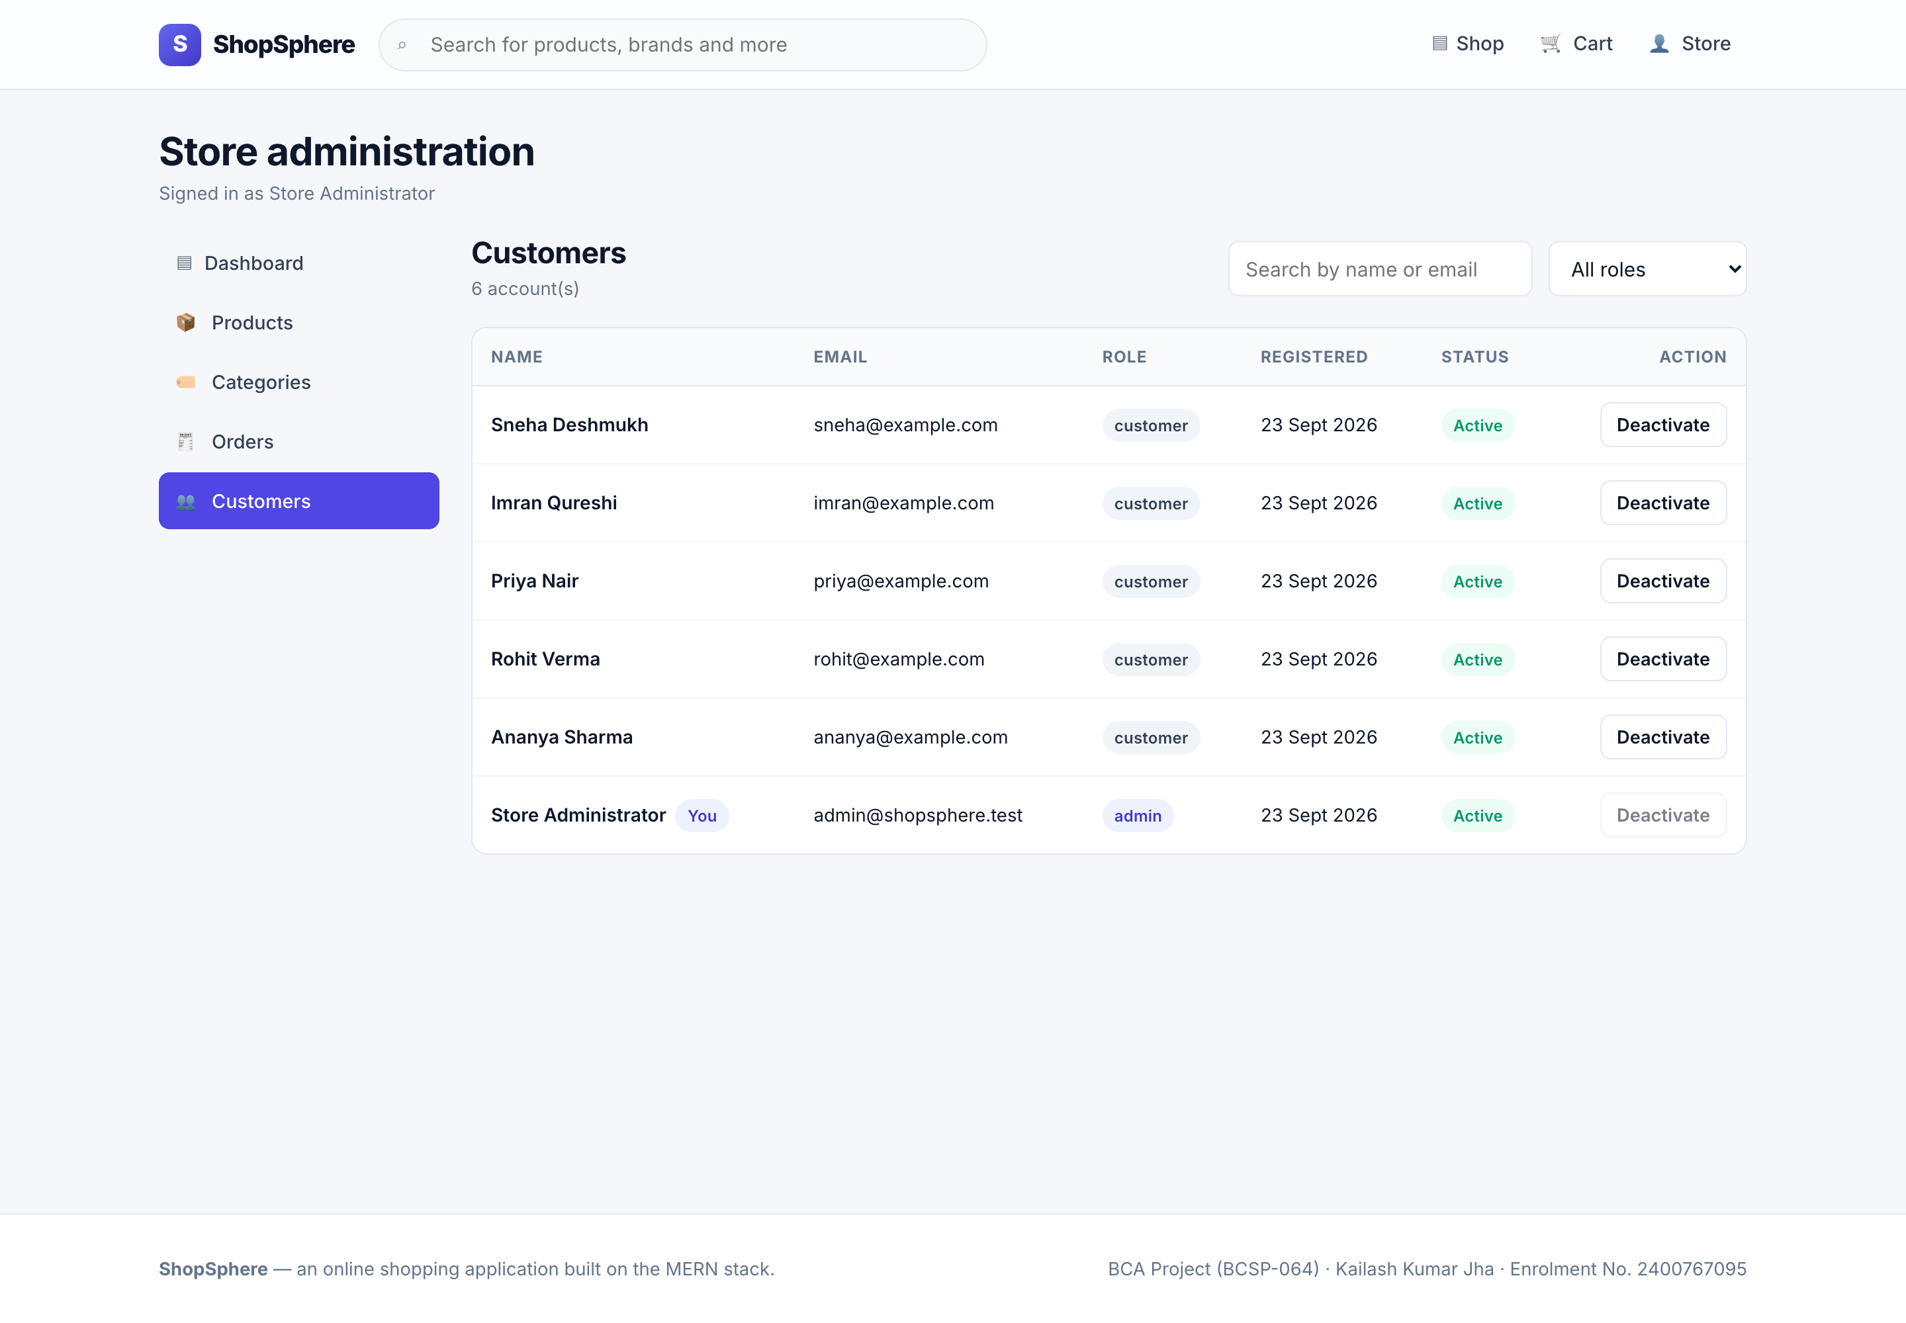
Figure 32: Category maintenance — deletion blocked while in use | Figure 33: Customer administration — search, filter, activation

9.6 Responsive Behaviour
The same application, without a separate mobile site, rendered at three viewport widths.
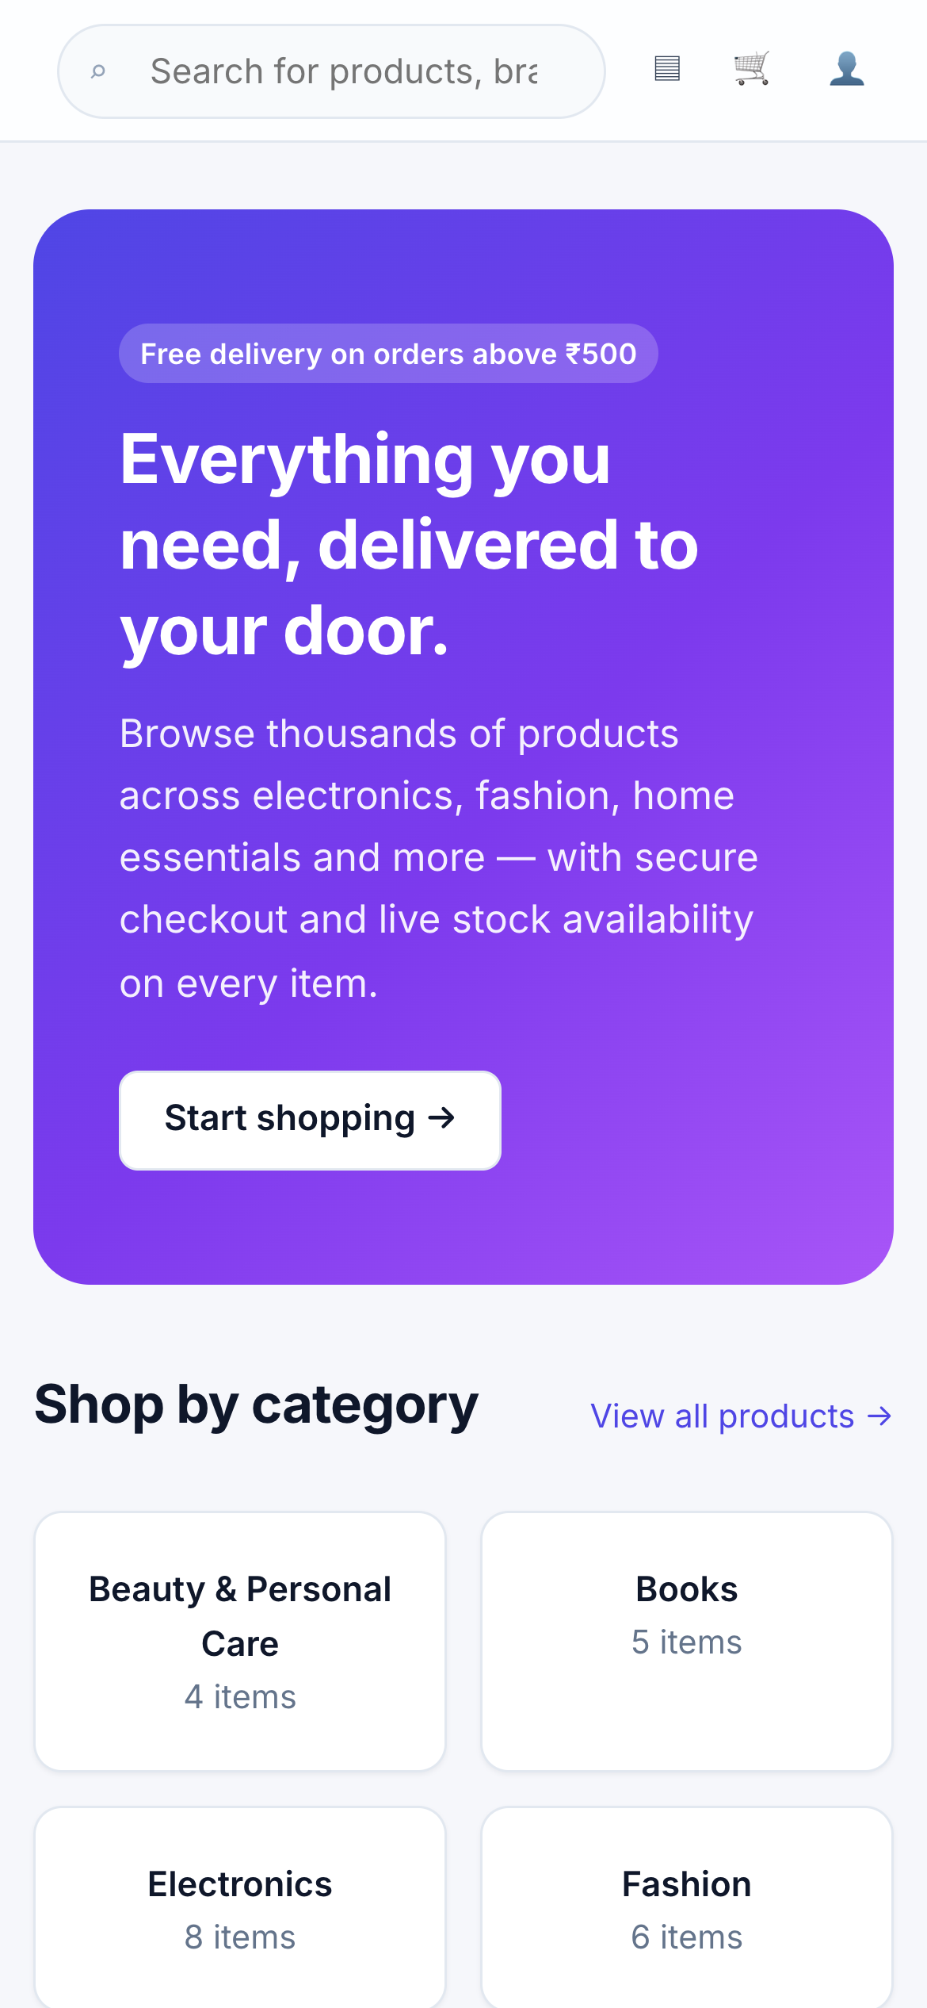 | 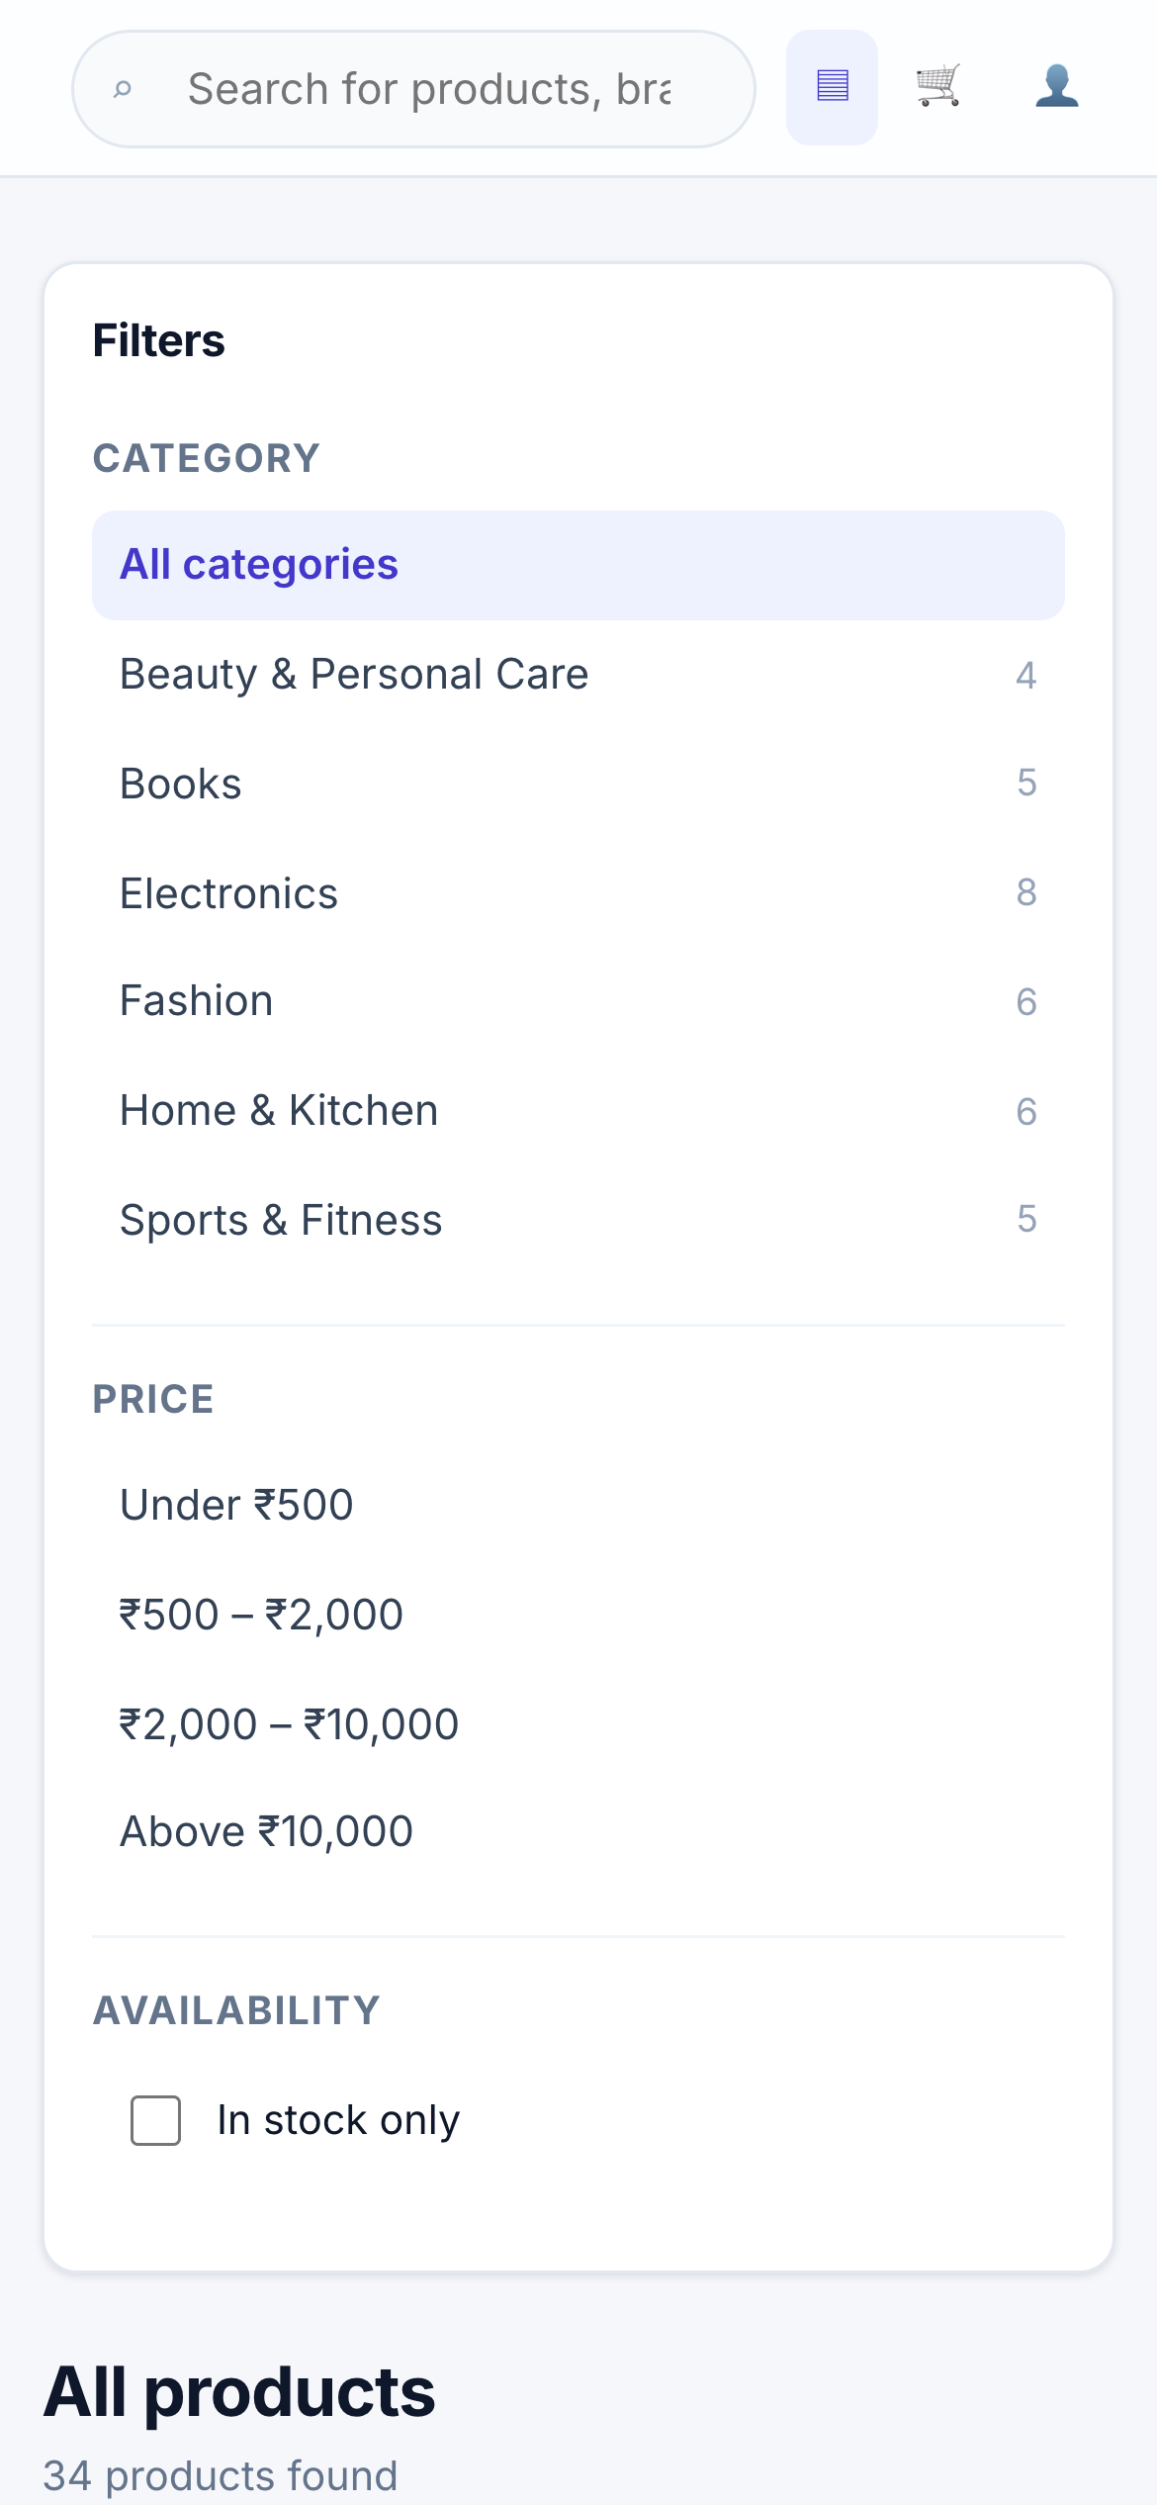 | 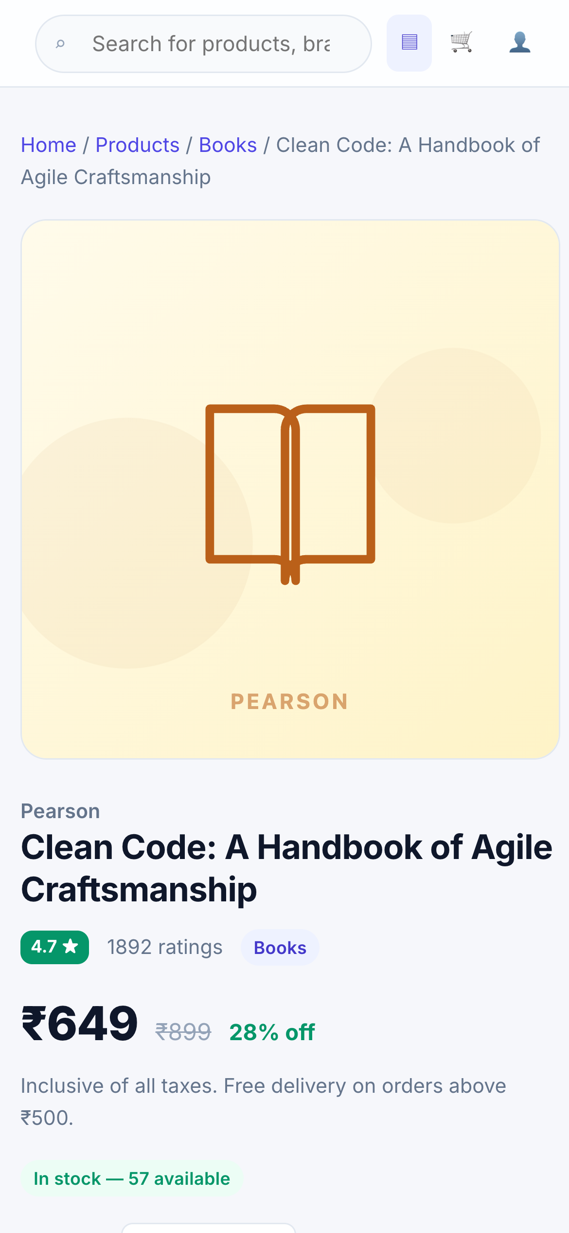
Figure 34: Home page at 390 px | Figure 35: Catalogue at 390 px — two columns | Figure 36: Product detail at 390 px
At phone width the navigation labels collapse to icons, the brand word mark is hidden to free horizontal space, the filter sidebar moves above the results and forms become single column. The catalogue grid itself needs no instruction: because it is declared with `auto-fill` and `minmax`, the column count follows the viewport on its own.
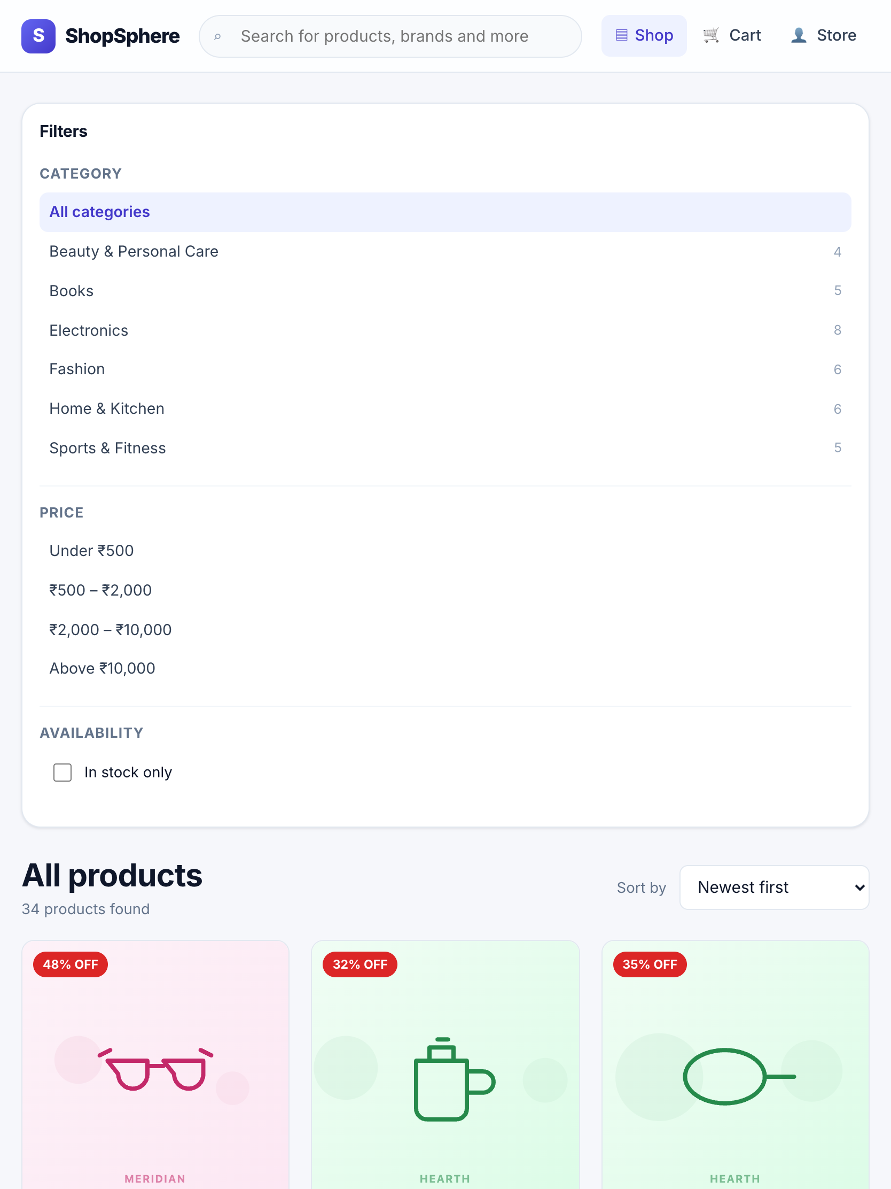
Figure 37: Catalogue at 834 px (tablet) — three columns

10. IMPLEMENTATION OF SECURITY
This chapter sets out the security measures implemented, the reasoning behind each, and the test case that demonstrates it. The BCSP-064 guidelines specifically require an account of how a user name and password are protected in transmission to the server; that is covered in Section 10.4.

10.1 Authentication
Authentication uses stateless JSON Web Tokens. On a successful sign-in the server signs a token carrying only the user identifier and role, with a seven-day expiry and an issuer claim. The token is signed, not encrypted, so nothing confidential is placed in its payload — anyone holding the token can decode and read it.
The signing secret is read from the environment and is never committed. The configuration module refuses to start a production server if the secret is still the development fallback, because a predictable signing key would let anyone forge an administrator token. That check runs at start-up, so the failure is immediate and obvious rather than latent.

10.2 Password Storage
Passwords are hashed with bcrypt at a work factor of twelve. Bcrypt is an adaptive function: the work factor can be raised as hardware improves, which a plain cryptographic hash such as SHA-256 cannot offer. Twelve rounds cost roughly a quarter of a second, which is unnoticeable on a sign-in but makes large-scale offline guessing expensive. Bcrypt also generates and stores a per-password salt, so two users choosing the same password produce different hashes and a precomputed rainbow table is useless.
The stored hash is protected by three independent mechanisms: the schema marks the field `select: false`, so it is excluded from every query result unless explicitly requested; the JSON serialiser deletes it, so even a query that did select it cannot leak it through a response; and comparison is performed by `bcrypt.compare`, which runs in constant time and therefore reveals nothing through timing.
The password policy requires at least eight characters with a lower-case letter, an upper-case letter and a digit, and is capped at seventy-two characters. The cap is not arbitrary: bcrypt silently truncates its input at seventy-two bytes, so accepting a longer password would give the user a false impression of strength. Evidence: TC-U-37, TC-U-38, TC-U-39, TC-U-41, TC-U-42, TC-I-02, TC-I-04.

10.3 Authorisation and Access Control
Authentication establishes who the caller is; authorisation decides what they may do. The two are separate middleware functions so that an endpoint can require a signed-in user without also hard-coding a role check.
Table 46: Access controls and the evidence for each
Control | Implementation | Evidence
Role escalation through registration is impossible | The registration controller sets role: customer explicitly and never reads a role from the request body. | TC-I-06
Administrative endpoints reject customers | restrictTo('admin') runs after protect on every administrative router. | TC-I-29, TC-I-50, TC-I-59
A customer can read only their own orders | The controller compares the order’s owner with the caller and returns 404 — not 403 — when they differ, so the existence of the record is not disclosed. | TC-I-47
A deactivated account loses access immediately | The user record is re-read from the database on every protected request rather than trusting the token payload. | TC-I-62
An administrator cannot lock themselves out | Self-deactivation is refused, because the screen needed to undo it is the one that would become unreachable. | TC-I-63
Mass assignment is not possible on product updates | Only an explicit whitelist of fields is copied from the request body. | TC-I-33

10.4 Protection of Credentials in Transmission
The BCSP-064 guidelines ask specifically about the security of the user name and password during transmission to the server. The position is as follows.
- Credentials are sent in the body of a POST request, never in a query string. A query string is recorded in server access logs, in browser history and in the Referer header sent to third-party resources; a request body is not.
- The deployment terminates TLS at the hosting layer, so the request body — including the password — is encrypted in transit. The application sets HTTP Strict Transport Security through helmet, instructing the browser to refuse a plain-text connection to the origin on subsequent visits.
- The password is never written to a log. The request logger records method, path, status and duration; it does not record request bodies.
- The password is never returned in a response, and never stored in the browser. Only the issued token is stored, which carries no password material.
- Authentication endpoints are rate limited to ten failed attempts per address per fifteen minutes, with successful attempts excluded from the budget. Without this, bcrypt alone would not protect a weak password against sustained guessing.
- Sign-in failures return one generic message for both an unknown address and a wrong password, so the endpoint cannot be used to discover which addresses are registered (TC-I-09).

It should be stated plainly that TLS is a deployment responsibility, not something the application code can guarantee. The application takes every measure available to it — HSTS headers, body-only credential transport, no logging — but a deployment that serves the API over plain HTTP would expose credentials regardless. The deployment requirement in Section 3.6.2 states this.

10.5 Injection Defences
MongoDB is not vulnerable to classical SQL injection, because queries are structured documents rather than concatenated strings. It is, however, vulnerable to **operator injection**. If a login handler passes the request body straight into a query, a payload of `{"email": {"$ne": null}, "password": {"$ne": null}}` matches the first user in the collection and authenticates the attacker as them.
Three layers defend against this:
- express-mongo-sanitize strips any key beginning with $ or containing a dot from the request body, query string and route parameters before any handler sees them.
- Route-level validation asserts the type of every field: an email must be a string that parses as an email address, an identifier must be a valid ObjectId, a price bound must be an integer. An object fails these checks.
- The catalogue query builder coerces every value to its expected type rather than passing it through, so even a value that survived the first two layers could not reach the engine as an operator.

Evidence: TC-I-10 attempts exactly the login payload above and asserts that no token is issued; TC-U-24 attempts operator injection through the catalogue filter and asserts the resulting filter contains neither value. Regular-expression injection is addressed separately: the only endpoint that builds a regular expression from user input is the administrative user search, which escapes every regex metacharacter first.

10.6 Handling of Payment Data
The simulated gateway is the one place where genuinely sensitive third-party data enters the system, and it is handled on the principle that the safest data is the data you do not keep.
- The card number is validated in memory using the Luhn checksum, the same check-digit algorithm every card issuer uses, which catches a mistyped number before an authorisation is attempted.
- The expiry date is checked against the current date, treating a card as valid through the final day of its expiry month.
- Only the last four digits are retained, for display on the invoice. The remaining digits and the CVV are local constants inside the authorisation function and become unreachable when it returns.
- Neither the card number nor the CVV is written to the database or to any log.
- A real deployment would replace this module with a gateway SDK, and the card number would never reach the application server at all — the browser would post it directly to the gateway, which would return a token. The module boundary is drawn so that this substitution touches one file.

Evidence: TC-U-09 asserts that the full card number and the CVV appear nowhere in the authorisation result; TC-I-39 asserts the same of the stored order document.

10.7 Other Measures
Table 47: Additional security measures
Measure | Purpose
Security response headers (helmet) | Strict Transport Security, MIME-sniffing protection, frame denial to prevent clickjacking, and a restrictive referrer policy.
Restrictive CORS policy | The browser may call the API only from the configured client origin. A wildcard would let any website on the internet issue authenticated requests on behalf of a signed-in visitor.
Request body size cap of 100 KB | Prevents a single oversized payload from exhausting server memory.
Page size cap of 48 items | Prevents a request for an unbounded page being used as a denial-of-service vector.
General API rate limit of 300 requests per fifteen minutes | Limits automated scraping and abuse.
Generic error messages in production | Stack traces and driver messages are logged server-side but never returned, because each helps an attacker map the system.
Soft deletion of products | Historical orders retain a resolvable product reference, so an audit trail cannot be broken by a catalogue change.
Cryptographically random invoice numbers | Six hex characters from crypto.randomBytes mean invoice numbers cannot be guessed or enumerated, unlike a sequential counter.
Environment secrets excluded from version control | The .env file is git-ignored; .env.example documents the required variables with placeholder values.

10.8 Security Testing Summary
Table 48: Security tests and their outcomes
Attack or misuse attempted | Test case | Outcome
Register with an elevated role in the request body | TC-I-06 | Role forced to customer
NoSQL operator injection at sign-in | TC-I-10 | Rejected; no token issued
NoSQL operator injection through catalogue filters | TC-U-24 | Values discarded; filter unaffected
Enumerate registered email addresses through sign-in | TC-I-09 | Identical response for both cases
Present a tampered token | TC-I-14 | Rejected with 401
Reach an administrative endpoint as a customer | TC-I-29, TC-I-59 | Rejected with 403
Reach an administrative endpoint anonymously | TC-I-30 | Rejected with 401
Read another customer’s order by identifier | TC-I-47 | Rejected with 404, disclosing nothing
List every order in the store as a customer | TC-I-50 | Rejected with 403
Continue using a token after deactivation | TC-I-62 | Refused on the next request
Pay a tampered price for real goods | TC-I-38 | Server price applied
Recover a password from the database or an API response | TC-U-37, TC-I-02 | Only a bcrypt hash exists; never serialised
Recover a card number or CVV from a stored order | TC-I-39 | Absent; only the last four digits retained
Exceed the per-product quantity cap by splitting cart lines | TC-U-29 | Lines merged before the cap is applied
Store a javascript: URL as a product image | TC-I-36b | Rejected with a field-level error

11. LIMITATIONS OF THE PROJECT
An honest account of what a system cannot do is more useful than an inflated account of what it can. The limitations below are grouped by whether they arise from the academic brief, from a design trade-off, or from scope.

11.1 Limitations Arising from the Academic Brief
- The payment gateway is simulated. No money moves and no acquiring bank is contacted. The module reproduces a real gateway’s contract, but a production deployment would need a certified integration, and PCI-DSS obligations would then apply to the deployment as a whole.
- The system has not been load tested. Performance claims in this report rest on the index design and on query plans, not on measurements under sustained concurrent load. The concurrency correctness of the checkout is demonstrated by test, but its throughput ceiling is unknown.
- It has not been deployed to a public server. All testing was performed locally. Behaviour behind a reverse proxy, under a content delivery network, or with TLS termination at a load balancer is therefore untested, although the application is configured for it.

11.2 Limitations Arising from Design Trade-offs
- Multi-document transactions are unavailable on a standalone database. The checkout falls back to a compensating-action pattern, which is correct but not equivalent to a transaction: if the process were killed between reserving stock and writing the order, the reservation would not be released. A replica-set deployment removes this exposure, and the code already detects and uses real transactions where they are available.
- Money is stored in whole rupees. This avoids binary floating-point error accumulating across order arithmetic, but prices cannot carry paise. A production system would store amounts as integer paise rather than integer rupees.
- A single flat tax rate is applied. Real GST varies by product category. The rate is isolated in one constant so the change is contained, but the schema would need an HSN code per product.
- Tokens cannot be revoked before expiry. The live database read on every request mitigates this for account deactivation, but a stolen token remains usable for its remaining lifetime unless the account is deactivated. A refresh-token scheme with a short-lived access token would narrow the window.
- The cart is per-browser, not per-account. A cart built on a phone does not appear on a laptop. Persisting the cart server-side against the account would fix this at the cost of a write on every cart change.

11.3 Limitations of Scope
- No product variants. Size and colour would each require a separate catalogue entry. A variant sub-document with its own stock count would be the correct model.
- No image upload. Products reference an image by URL or bundled path; there is no upload, resizing or content delivery pipeline.
- No email or SMS notification. Order confirmation is shown on screen only.
- No customer-submitted reviews. Ratings are displayed from seeded data but cannot be submitted.
- No returns or refunds workflow. Cancellation before despatch is supported; a post-delivery return is not.
- No discount codes, coupons or promotional pricing.
- No wishlist or saved-for-later list.
- Single language and single currency. The interface is English and prices are in Indian rupees, with no localisation layer.
- Administrative actions are not audit-logged. Order status changes carry a history, but a price change or a product withdrawal does not record who made it.

12. FUTURE APPLICATIONS AND ENHANCEMENTS
The limitations above suggest the work that would follow. They are grouped by the effort each would take and the value it would deliver.

12.1 Near-term Enhancements
Table 49: Near-term enhancements
Enhancement | What it involves | Value
Product variants | A variants array on the product document, each with its own SKU, attributes and stock count. The atomic reservation would operate on a positional array element rather than the top-level field. | High — without it, apparel and footwear cannot be sold properly.
Server-side cart | A cart collection keyed by user, merged with the local cart on sign-in. | Medium — the cart would follow the customer across devices.
Image upload pipeline | Multipart upload, server-side resizing to several widths, and storage in object storage behind a CDN. | Medium — removes the dependency on externally hosted images.
Email notification | A transactional email provider, triggered on order placement and each status change, dispatched through a queue so a provider outage cannot fail a checkout. | High — customers expect written confirmation.
Customer reviews | A reviews collection with a verified-purchase check, and an incremental update of the product’s rating average. | Medium — ratings are currently displayed but cannot be earned.
Discount codes | A coupons collection with validity rules, applied during the server-side re-pricing step so the discount cannot be forged by the client. | Medium — a standard commercial requirement.

12.2 Production Readiness
Three changes would be required before the system carried real money.
- A certified payment gateway. The browser would post card details directly to the gateway and receive a token, which is the only value the application would ever see. This keeps the application outside the scope of the strictest PCI-DSS requirements. The paymentService module boundary is drawn so that this substitution touches one file.
- A replica-set database. This makes real multi-document transactions available, closing the exposure described in Section 11.2, and provides automatic failover. The checkout already detects and uses transactions when the deployment supports them, so no code change is needed.
- Operational infrastructure. Structured logging with correlation identifiers, error aggregation, uptime monitoring, automated database backups with a tested restore procedure, and a continuous integration pipeline that runs the test suite on every change.

12.3 Longer-term Directions
- A native mobile application. Because the server is a headless REST API, a React Native client could consume the same endpoints with no server change. This was a consideration in choosing a decoupled architecture.
- Recommendation engine. "Related products" is currently a same-category query. Order history contains enough co-purchase information to support collaborative filtering, which is a substantially more useful signal.
- Search improvements. MongoDB’s text index does not support typo tolerance, synonyms or faceted counts. A dedicated search engine such as Elasticsearch or MeiliSearch would provide all three.
- Multi-vendor marketplace. Seller accounts, per-seller catalogues, commission calculation and split settlement. This is a substantial change to the order model rather than an addition to it.
- Internationalisation. Extracting interface strings into translation catalogues and storing prices per currency.
- Progressive web application. A service worker would allow catalogue browsing while offline and add installability, which matters on intermittent mobile connections.

13. CONCLUSION
This project set out to build a working e-commerce application on the MERN stack and to document every phase of its development in accordance with the BCSP-064 guidelines. Both objectives have been met.
The delivered system comprises 82 source files totalling approximately 9,100 lines, of which 5,530 are executable code and the remainder comments and blank lines. These are organised into five modules behind a documented REST API of twenty-seven endpoints, with a React single-page front end of twenty-two screens. The system is covered by 127 automated tests at three levels, all passing, achieving 86.2% statement coverage of the server source. Every objective stated in Section 2.1 is traceable to the evidence that establishes it.
The more valuable outcome, from the point of view of the software engineering the course is concerned with, lies in the problems that were harder than they first appeared. Three stand out.
The first is that **a cart in the browser cannot be trusted with a price**. This sounds obvious stated baldly, but the convenient implementation — accept the totals the client computed, since it already computed them to display them — is the one that fails. Recomputing every amount on the server costs an extra database read at checkout and eliminates an entire class of commercial fraud. Test case TC-I-38 makes the property explicit rather than assumed.
The second is that **correctness under concurrency has to be designed in, not tested in**. The read-compare-write sequence that oversells the last unit passes every manual test, because the failure needs two requests within milliseconds of each other. It is only avoided by recognising, at design time, that the check and the update must be a single atomic operation. The test that demonstrates it — ten simultaneous reservations against one unit of stock — had to be written deliberately; no ordinary test would have found the defect.
The third is that **the defects that matter most are often the ones that produce no error at all**. The timezone defect recorded in Section 8.6.1 threw no exception, failed no request and logged no warning. The dashboard simply reported the wrong fourteen days and silently omitted the current one. It was found by reading a chart against data that was known to be correct — which is an argument for testing against known-good data rather than only against the code’s own assumptions, and for writing down environmental assumptions as tests, which is what TC-U-49 to TC-U-55 now do.
The system as delivered is not production software: the payment gateway is simulated, it has not been load tested and it has never been deployed publicly, and Chapters 11 and 12 set out those limitations and what closing them would take. What the project does demonstrate is an end-to-end pass through the software development life cycle, applied to a problem substantial enough to raise real engineering questions and answered with reasoning that is set out rather than assumed.

14. BIBLIOGRAPHY

Books
[1] Pressman, R. S. and Maxim, B. R. (2020). *Software Engineering: A Practitioner's Approach*, 9th edition. McGraw-Hill Education.
[2] Silberschatz, A., Korth, H. F. and Sudarshan, S. (2019). *Database System Concepts*, 7th edition. McGraw-Hill Education.
[3] Martin, R. C. (2008). *Clean Code: A Handbook of Agile Software Craftsmanship*. Prentice Hall.
[4] Hunt, A. and Thomas, D. (2019). *The Pragmatic Programmer: Your Journey to Mastery*, 20th Anniversary Edition. Addison-Wesley.
[5] Sommerville, I. (2015). *Software Engineering*, 10th edition. Pearson.
[6] Chodorow, K. (2013). *MongoDB: The Definitive Guide*, 2nd edition. O'Reilly Media.
[7] Boehm, B. W. (1981). *Software Engineering Economics*. Prentice Hall. (Source of the COCOMO model applied in Section 3.4.1.)

Official Documentation
[8] React Documentation. Meta Open Source. https://react.dev
[9] Node.js Documentation. OpenJS Foundation. https://nodejs.org/docs
[10] Express.js Guide. OpenJS Foundation. https://expressjs.com
[11] MongoDB Manual. MongoDB Inc. https://www.mongodb.com/docs/manual
[12] Mongoose Documentation. https://mongoosejs.com/docs
[13] MDN Web Docs. Mozilla Foundation. https://developer.mozilla.org
[14] Jest Documentation. https://jestjs.io/docs/getting-started
[15] Vite Guide. https://vitejs.dev/guide

Standards and Specifications
[16] RFC 7519 — JSON Web Token (JWT). Internet Engineering Task Force, 2015. https://datatracker.ietf.org/doc/html/rfc7519
[17] Provos, N. and Mazières, D. (1999). "A Future-Adaptable Password Scheme." Proceedings of the USENIX Annual Technical Conference. (The bcrypt algorithm.)
[18] ISO/IEC 7812-1:2017 — Identification cards: Identification of issuers. (Source of the Luhn check-digit algorithm.)
[19] OWASP Top Ten Web Application Security Risks. Open Worldwide Application Security Project. https://owasp.org/www-project-top-ten
[20] Web Content Accessibility Guidelines (WCAG) 2.1. World Wide Web Consortium, 2018. https://www.w3.org/TR/WCAG21

University Material
[21] BCSP-064 Project Guidelines, BCA (Revised Syllabus). School of Computer and Information Sciences, Indira Gandhi National Open University, Maidan Garhi, New Delhi.
[22] MCS-011, MCS-021, MCS-023 and MCS-034 course material — Problem Solving and Programming, Data and File Structures, Database Management Systems, and Software Engineering. IGNOU.

APPENDIX A — COMPLETE SOURCE CODE
The complete source of the application is reproduced below. Listings are given in the order a reader should encounter them: configuration first, then the data models, then the layers built on top of them. Every file carries the comments present in the source; none has been abridged.
Per the BCSP-064 guidelines, the source code is excluded from the page count of the main report.

A.1 Server — Node.js, Express and MongoDB
A1. package.json — Server dependencies and scripts (44 lines)
{
"name": "ecommerce-server",
"version": "1.0.0",
"private": true,
"description": "Backend REST API for the E-Commerce Web Application (IGNOU BCA BCSP-064)",
"main": "src/server.js",
"type": "commonjs",
"scripts": {
"start": "node src/server.js",
"dev": "nodemon src/server.js",
"seed": "node src/seed/seed.js",
"test": "cross-env NODE_ENV=test jest --runInBand --detectOpenHandles",
"test:unit": "cross-env NODE_ENV=test jest tests/unit --runInBand",
"test:integration": "cross-env NODE_ENV=test jest tests/integration --runInBand",
"test:system": "cross-env NODE_ENV=test jest tests/system --runInBand",
"test:coverage": "cross-env NODE_ENV=test jest --runInBand --coverage"
},
"dependencies": {
"bcryptjs": "^2.4.3",
"cors": "^2.8.5",
"dotenv": "^16.4.5",
"express": "^4.19.2",
"express-mongo-sanitize": "^2.2.0",
"express-rate-limit": "^7.4.0",
"express-validator": "^7.2.0",
"helmet": "^7.1.0",
"jsonwebtoken": "^9.0.2",
"mongoose": "^8.6.0",
"morgan": "^1.10.0"
},
"devDependencies": {
"cross-env": "^7.0.3",
"jest": "^29.7.0",
"mongodb-memory-server": "^10.0.0",
"nodemon": "^3.1.4",
"supertest": "^7.0.0"
},
"jest": {
"testEnvironment": "node",
"setupFilesAfterEnv": ["<rootDir>/tests/setup.js"],
"testTimeout": 30000,
"collectCoverageFrom": ["src/**/*.js", "!src/seed/**", "!src/server.js"]
}
}

A2. .env.example — Environment configuration template (25 lines)
# ---------------------------------------------------------------------------
# Environment configuration template.
# Copy to ".env" and replace the placeholder values before running the server.
# The real ".env" file is git-ignored and must never be committed.
# ---------------------------------------------------------------------------

NODE_ENV=development
PORT=5000

# MongoDB connection string (MongoDB Community Server, default local instance)
MONGO_URI=mongodb://127.0.0.1:27017/ecommerce_db

# Secret used to sign JSON Web Tokens. Use a long random string in production.
JWT_SECRET=change-this-to-a-long-random-secret-string
JWT_EXPIRES_IN=7d

# Origin allowed by the CORS policy (the React development server)
CLIENT_ORIGIN=http://localhost:5173

# Credentials created by "npm run seed" for the default administrator
SEED_ADMIN_EMAIL=admin@shopsphere.test
SEED_ADMIN_PASSWORD=Admin@12345

# IANA timezone used to bucket the dashboard sales figures by calendar day
STORE_TIMEZONE=Asia/Kolkata

A3. src/config/env.js — Validated environment configuration (45 lines)
/**
* Centralised environment configuration.
*
* Every environment-dependent value used anywhere in the application is read
* here exactly once, validated, and then exported as a frozen object. Doing so
* keeps `process.env` lookups out of the business logic and makes a missing or
* malformed variable fail loudly at start-up instead of silently at run time.
*/
require('dotenv').config();

const toInt = (value, fallback) => {
const parsed = Number.parseInt(value, 10);
return Number.isNaN(parsed) ? fallback : parsed;
};

const env = {
nodeEnv: process.env.NODE_ENV || 'development',
port: toInt(process.env.PORT, 5000),
mongoUri: process.env.MONGO_URI || 'mongodb://127.0.0.1:27017/ecommerce_db',
jwtSecret: process.env.JWT_SECRET || 'insecure-development-secret',
jwtExpiresIn: process.env.JWT_EXPIRES_IN || '7d',
clientOrigin: process.env.CLIENT_ORIGIN || 'http://localhost:5173',
// IANA zone the store trades in. Every calendar-day boundary used by the
// analytics (the "sales per day" buckets) is resolved against this zone
// rather than UTC, so a sale made at 11 pm local time is reported on the day
// the customer actually made it.
storeTimezone: process.env.STORE_TIMEZONE || 'Asia/Kolkata',
seedAdminEmail: process.env.SEED_ADMIN_EMAIL || 'admin@shopsphere.test',
seedAdminPassword: process.env.SEED_ADMIN_PASSWORD || 'Admin@12345',
};

env.isProduction = env.nodeEnv === 'production';
env.isTest = env.nodeEnv === 'test';

/**
* Refuse to boot a production server with the development fallback secret.
* A predictable signing key would let anybody forge an administrator token.
*/
if (env.isProduction && env.jwtSecret === 'insecure-development-secret') {
throw new Error(
'JWT_SECRET must be set to a strong, unique value when NODE_ENV=production.'
);
}

module.exports = Object.freeze(env);

A4. src/config/db.js — Database connection and transaction-capability probe (70 lines)
/**
* MongoDB connection management.
*
* Mongoose maintains a single pooled connection for the whole process, so the
* connect helper is idempotent: calling it twice reuses the existing pool.
*/
const mongoose = require('mongoose');
const env = require('./env');

// Reject queries that reference fields not declared in the schema. Without this
// a typo such as `Product.find({ pric: 100 })` would silently return everything.
mongoose.set('strictQuery', true);

/**
* Opens the connection to MongoDB.
*
* @param {string} [uri] Optional override, used by the automated test suite to
* point at an in-memory MongoDB instance.
* @returns {Promise<mongoose.Connection>}
*/
async function connectDB(uri = env.mongoUri) {
if (mongoose.connection.readyState === 1) {
return mongoose.connection;
}

try {
await mongoose.connect(uri, {
// Fail fast instead of buffering operations for 30 s when the database
// is unreachable; this surfaces configuration mistakes immediately.
serverSelectionTimeoutMS: 10000,
});

if (!env.isTest) {
// eslint-disable-next-line no-console
console.log(`[database] connected to ${mongoose.connection.name}`);
}
return mongoose.connection;
} catch (error) {
// eslint-disable-next-line no-console
console.error('[database] connection failed:', error.message);
throw error;
}
}

/** Closes the connection. Used on graceful shutdown and after the test run. */
async function disconnectDB() {
if (mongoose.connection.readyState !== 0) {
await mongoose.connection.close();
}
}

/**
* Reports whether the connected deployment supports multi-document
* transactions. Transactions require a replica set or a sharded cluster; a
* standalone `mongod` (the usual developer set-up) does not support them.
* The checkout service uses this to choose its concurrency strategy.
*/
function supportsTransactions() {
const topology = mongoose.connection.client?.topology;
if (!topology) return false;
const description = topology.description;
if (!description) return false;
return (
description.type === 'ReplicaSetWithPrimary' ||
description.type === 'Sharded' ||
description.type === 'LoadBalanced'
);
}

module.exports = { connectDB, disconnectDB, supportsTransactions };

A5. src/models/User.js — User schema, password hashing, credential comparison (115 lines)
/**
* User collection.
*
* Stores both customers and administrators; the `role` discriminator decides
* which routes the account may reach. Passwords are never stored in plain text
* and are never returned by a query (`select: false`).
*/
const mongoose = require('mongoose');
const bcrypt = require('bcryptjs');

/** Work factor for bcrypt. 12 rounds ~ 250 ms per hash on current hardware,
* which is slow enough to make offline brute-forcing expensive but fast
* enough to keep the login endpoint responsive. */
const SALT_ROUNDS = 12;

const EMAIL_PATTERN = /^[^\s@]+@[^\s@]+\.[^\s@]{2,}$/;

const addressSchema = new mongoose.Schema(
{
line1: { type: String, required: true, trim: true, maxlength: 120 },
line2: { type: String, trim: true, maxlength: 120, default: '' },
city: { type: String, required: true, trim: true, maxlength: 60 },
state: { type: String, required: true, trim: true, maxlength: 60 },
pincode: {
type: String,
required: true,
trim: true,
match: [/^\d{6}$/, 'Pincode must be exactly 6 digits.'],
},
phone: {
type: String,
required: true,
trim: true,
match: [/^[6-9]\d{9}$/, 'Enter a valid 10-digit Indian mobile number.'],
},
},
{ _id: false }
);

const userSchema = new mongoose.Schema(
{
name: {
type: String,
required: [true, 'Name is required.'],
trim: true,
minlength: [2, 'Name must be at least 2 characters long.'],
maxlength: [80, 'Name cannot exceed 80 characters.'],
},
email: {
type: String,
required: [true, 'Email address is required.'],
// Normalising to lower case at write time is what makes the unique index
// genuinely case-insensitive; otherwise Ram@x.com and ram@x.com would
// both be accepted as distinct accounts.
lowercase: true,
trim: true,
match: [EMAIL_PATTERN, 'Enter a valid email address.'],
},
password: {
type: String,
required: [true, 'Password is required.'],
minlength: [8, 'Password must be at least 8 characters long.'],
select: false, // excluded from every query result unless explicitly asked for
},
role: {
type: String,
enum: { values: ['customer', 'admin'], message: '{VALUE} is not a valid role.' },
default: 'customer',
},
address: { type: addressSchema, default: null },
isActive: { type: Boolean, default: true },
lastLoginAt: { type: Date, default: null },
},
{
timestamps: true, // adds createdAt / updatedAt
versionKey: false,
toJSON: {
// Defence in depth: even if a query accidentally selects the password,
// serialising the document to JSON strips it.
transform(_doc, ret) {
delete ret.password;
return ret;
},
},
}
);

/** Unique index enforcing one account per email address. */
userSchema.index({ email: 1 }, { unique: true, name: 'uniq_user_email' });

/**
* Hash the password before every save in which it changed.
* Guarding on `isModified` prevents re-hashing an already-hashed value when an
* unrelated field (for example `lastLoginAt`) is updated.
*/
userSchema.pre('save', async function hashPassword(next) {
if (!this.isModified('password')) return next();
try {
this.password = await bcrypt.hash(this.password, SALT_ROUNDS);
return next();
} catch (error) {
return next(error);
}
});

/**
* Constant-time comparison of a candidate password against the stored hash.
* @param {string} candidate plain-text password supplied at login
* @returns {Promise<boolean>}
*/
userSchema.methods.comparePassword = function comparePassword(candidate) {
return bcrypt.compare(candidate, this.password);
};

module.exports = mongoose.model('User', userSchema);

A6. src/models/Category.js — Category schema with slug derivation (38 lines)
/**
* Category collection.
*
* Categories are a small, slowly changing reference collection. Products hold
* an ObjectId reference to a category rather than embedding it, so renaming a
* category updates every product listing at once.
*/
const mongoose = require('mongoose');
const { slugify } = require('../utils/slugify');

const categorySchema = new mongoose.Schema(
{
name: {
type: String,
required: [true, 'Category name is required.'],
trim: true,
minlength: 2,
maxlength: 60,
},
slug: { type: String, trim: true, lowercase: true },
description: { type: String, trim: true, maxlength: 300, default: '' },
isActive: { type: Boolean, default: true },
},
{ timestamps: true, versionKey: false }
);

categorySchema.index({ name: 1 }, { unique: true, name: 'uniq_category_name' });
categorySchema.index({ slug: 1 }, { unique: true, name: 'uniq_category_slug' });

/** Derive the slug from the name whenever the name changes. */
categorySchema.pre('validate', function deriveSlug(next) {
if (this.isModified('name') || !this.slug) {
this.slug = slugify(this.name);
}
next();
});

module.exports = mongoose.model('Category', categorySchema);

A7. src/models/Product.js — Product schema, text and compound indexes (100 lines)
/**
* Product collection — the catalogue.
*
* Indexing strategy:
* - a compound TEXT index over title/description/brand powers keyword search
* without a collection scan;
* - a compound B-tree index on (category, price) serves the common
* "browse a category, sort by price" access path;
* - `createdAt` is indexed to make the default "newest first" listing an
* index scan rather than an in-memory sort.
*/
const mongoose = require('mongoose');

const productSchema = new mongoose.Schema(
{
title: {
type: String,
required: [true, 'Product title is required.'],
trim: true,
minlength: [3, 'Title must be at least 3 characters long.'],
maxlength: [140, 'Title cannot exceed 140 characters.'],
},
description: {
type: String,
required: [true, 'Product description is required.'],
trim: true,
minlength: [10, 'Description must be at least 10 characters long.'],
maxlength: [4000, 'Description cannot exceed 4000 characters.'],
},
brand: { type: String, trim: true, maxlength: 60, default: 'Generic' },
price: {
type: Number,
required: [true, 'Price is required.'],
min: [1, 'Price must be at least 1.'],
max: [10000000, 'Price is unrealistically high.'],
// Money is stored in whole rupees to avoid binary floating-point drift
// accumulating across order-total arithmetic.
set: (value) => Math.round(Number(value)),
},
mrp: {
type: Number,
min: [1, 'MRP must be at least 1.'],
set: (value) => (value === null || value === undefined ? value : Math.round(Number(value))),
default: null,
},
category: {
type: mongoose.Schema.Types.ObjectId,
ref: 'Category',
required: [true, 'A product must belong to a category.'],
index: true,
},
stockCount: {
type: Number,
required: true,
min: [0, 'Stock count cannot be negative.'],
default: 0,
validate: {
validator: Number.isInteger,
message: 'Stock count must be a whole number.',
},
},
imageUrl: {
type: String,
trim: true,
default: '',
maxlength: 500,
},
rating: { type: Number, min: 0, max: 5, default: 0 },
ratingCount: { type: Number, min: 0, default: 0 },
isActive: { type: Boolean, default: true, index: true },
},
{ timestamps: true, versionKey: false }
);

// Weighted text index: a keyword match in the title ranks above the same
// keyword appearing only in the body text.
productSchema.index(
{ title: 'text', description: 'text', brand: 'text' },
{
name: 'product_text_search',
weights: { title: 10, brand: 5, description: 1 },
}
);

productSchema.index({ category: 1, price: 1 }, { name: 'idx_category_price' });
productSchema.index({ createdAt: -1 }, { name: 'idx_created_desc' });

/** Convenience virtual used by the UI; not persisted. */
productSchema.virtual('inStock').get(function inStock() {
return this.stockCount > 0;
});

productSchema.virtual('discountPercent').get(function discountPercent() {
if (!this.mrp || this.mrp <= this.price) return 0;
return Math.round(((this.mrp - this.price) / this.mrp) * 100);
});

productSchema.set('toJSON', { virtuals: true });

module.exports = mongoose.model('Product', productSchema);

A8. src/models/Order.js — Order schema, embedded lines, state-transition table (128 lines)
/**
* Order collection.
*
* Design note — why order lines duplicate the product title and price:
* an order is a financial record and must remain a faithful snapshot of the
* transaction. If the line only referenced the product, an administrator later
* editing the price or renaming the item would silently rewrite the customer's
* historical invoice. The `product` reference is kept as well so the catalogue
* entry can still be reached, but the printed values come from the snapshot.
*/
const mongoose = require('mongoose');

const ORDER_STATUSES = [
'PENDING',
'CONFIRMED',
'SHIPPED',
'DELIVERED',
'CANCELLED',
];

const orderItemSchema = new mongoose.Schema(
{
product: {
type: mongoose.Schema.Types.ObjectId,
ref: 'Product',
required: true,
},
title: { type: String, required: true }, // snapshot
unitPrice: { type: Number, required: true, min: 0 }, // snapshot, in rupees
quantity: {
type: Number,
required: true,
min: [1, 'Quantity must be at least 1.'],
max: [10, 'A maximum of 10 units per item is allowed in one order.'],
validate: { validator: Number.isInteger, message: 'Quantity must be a whole number.' },
},
lineTotal: { type: Number, required: true, min: 0 },
},
{ _id: false }
);

const shippingAddressSchema = new mongoose.Schema(
{
fullName: { type: String, required: true, trim: true, maxlength: 80 },
line1: { type: String, required: true, trim: true, maxlength: 120 },
line2: { type: String, trim: true, maxlength: 120, default: '' },
city: { type: String, required: true, trim: true, maxlength: 60 },
state: { type: String, required: true, trim: true, maxlength: 60 },
pincode: { type: String, required: true, match: /^\d{6}$/ },
phone: { type: String, required: true, match: /^[6-9]\d{9}$/ },
},
{ _id: false }
);

const paymentSchema = new mongoose.Schema(
{
method: { type: String, enum: ['CARD', 'COD'], required: true },
status: {
type: String,
enum: ['PENDING', 'PAID', 'FAILED', 'REFUNDED'],
default: 'PENDING',
},
// Reference returned by the simulated payment gateway. No card number,
// CVV or expiry is ever persisted — see services/paymentService.js.
transactionId: { type: String, default: null },
cardLast4: { type: String, default: null, match: /^\d{4}$/ },
paidAt: { type: Date, default: null },
},
{ _id: false }
);

const orderSchema = new mongoose.Schema(
{
invoiceNo: { type: String, required: true, trim: true, uppercase: true },
user: {
type: mongoose.Schema.Types.ObjectId,
ref: 'User',
required: true,
},
items: {
type: [orderItemSchema],
required: true,
validate: {
validator: (items) => Array.isArray(items) && items.length > 0,
message: 'An order must contain at least one item.',
},
},
itemsTotal: { type: Number, required: true, min: 0 },
shippingFee: { type: Number, required: true, min: 0, default: 0 },
taxAmount: { type: Number, required: true, min: 0, default: 0 },
totalPrice: { type: Number, required: true, min: 0 },
shippingAddress: { type: shippingAddressSchema, required: true },
payment: { type: paymentSchema, required: true },
status: { type: String, enum: ORDER_STATUSES, default: 'PENDING', index: true },
statusHistory: [
{
status: { type: String, enum: ORDER_STATUSES, required: true },
changedAt: { type: Date, default: Date.now },
note: { type: String, default: '' },
_id: false,
},
],
placedAt: { type: Date, default: Date.now },
cancelledAt: { type: Date, default: null },
},
{ timestamps: true, versionKey: false }
);

orderSchema.index({ invoiceNo: 1 }, { unique: true, name: 'uniq_invoice_no' });
// Serves "my orders, newest first" — the single most frequent order query.
orderSchema.index({ user: 1, placedAt: -1 }, { name: 'idx_user_recent_orders' });
orderSchema.index({ status: 1, placedAt: -1 }, { name: 'idx_status_recent' });

/**
* Legal status transitions. Encoding them here, rather than in the controller,
* guarantees that no code path can move a DELIVERED order back to SHIPPED.
*/
orderSchema.statics.ALLOWED_TRANSITIONS = Object.freeze({
PENDING: ['CONFIRMED', 'CANCELLED'],
CONFIRMED: ['SHIPPED', 'CANCELLED'],
SHIPPED: ['DELIVERED'],
DELIVERED: [],
CANCELLED: [],
});

orderSchema.statics.ORDER_STATUSES = ORDER_STATUSES;

module.exports = mongoose.model('Order', orderSchema);

A9. src/utils/ApiError.js — Error type carrying an HTTP status (44 lines)
/**
* Application-level error carrying an HTTP status code.
*
* Throwing `ApiError` from any controller or service lets the single central
* error-handling middleware translate the failure into a correctly shaped JSON
* response, so no controller has to format an error payload itself.
*/
class ApiError extends Error {
/**
* @param {number} statusCode HTTP status to send to the client.
* @param {string} message Human-readable, safe-to-display message.
* @param {Array} [details] Optional field-level validation details.
*/
constructor(statusCode, message, details = undefined) {
super(message);
this.name = 'ApiError';
this.statusCode = statusCode;
this.details = details;
// Marks the error as anticipated, so the handler does not treat it as a bug.
this.isOperational = true;
Error.captureStackTrace(this, this.constructor);
}

static badRequest(message, details) {
return new ApiError(400, message, details);
}
static unauthorized(message = 'Authentication is required.') {
return new ApiError(401, message);
}
static forbidden(message = 'You do not have permission to perform this action.') {
return new ApiError(403, message);
}
static notFound(message = 'The requested resource was not found.') {
return new ApiError(404, message);
}
static conflict(message) {
return new ApiError(409, message);
}
static unprocessable(message, details) {
return new ApiError(422, message, details);
}
}

module.exports = ApiError;

A10. src/utils/asyncHandler.js — Promise rejection forwarding (15 lines)
/**
* Wraps an async Express handler so that a rejected promise is forwarded to
* `next()` instead of becoming an unhandled rejection.
*
* Express 4 does not await handler return values, so without this wrapper every
* controller would need its own try/catch block purely to call `next(error)`.
*
* @param {Function} fn async (req, res, next) => any
* @returns {Function} an Express-compatible request handler
*/
const asyncHandler = (fn) => (req, res, next) => {
Promise.resolve(fn(req, res, next)).catch(next);
};

module.exports = asyncHandler;

A11. src/utils/token.js — JSON Web Token signing and verification (43 lines)
/**
* JSON Web Token helpers.
*
* The token deliberately carries only the user's id and role. Nothing secret
* is placed in the payload because a JWT is signed, not encrypted: anybody
* holding the token can decode and read its contents.
*/
const jwt = require('jsonwebtoken');
const env = require('../config/env');
const ApiError = require('./ApiError');

/**
* Signs an access token for a user document.
*
* @param {{_id: any, role: string}} user
* @returns {string} signed JWT
*/
function signToken(user) {
return jwt.sign(
{ sub: String(user._id), role: user.role },
env.jwtSecret,
{ expiresIn: env.jwtExpiresIn, issuer: 'shopsphere-api' }
);
}

/**
* Verifies a token and returns its payload.
*
* @param {string} token
* @throws {ApiError} 401 when the token is missing, malformed or expired.
*/
function verifyToken(token) {
try {
return jwt.verify(token, env.jwtSecret, { issuer: 'shopsphere-api' });
} catch (error) {
if (error.name === 'TokenExpiredError') {
throw ApiError.unauthorized('Your session has expired. Please sign in again.');
}
throw ApiError.unauthorized('Invalid authentication token.');
}
}

module.exports = { signToken, verifyToken };

A12. src/utils/invoice.js — Cryptographically random invoice numbers (23 lines)
/**
* Invoice number generation.
*
* Format: INV-YYYYMMDD-XXXXXX
* - the date segment makes an invoice human-sortable and easy to locate;
* - the random segment uses `crypto.randomBytes`, not `Math.random`, so
* invoice numbers cannot be guessed or enumerated by a customer.
*
* The `invoiceNo` field additionally carries a unique index, so on the
* astronomically unlikely event of a collision the database rejects the insert
* rather than allowing two orders to share a number.
*/
const crypto = require('crypto');

function generateInvoiceNo(date = new Date()) {
const y = date.getFullYear();
const m = String(date.getMonth() + 1).padStart(2, '0');
const d = String(date.getDate()).padStart(2, '0');
const random = crypto.randomBytes(3).toString('hex').toUpperCase(); // 6 hex chars
return `INV-${y}${m}${d}-${random}`;
}

module.exports = { generateInvoiceNo };

A13. src/utils/calendar.js — Timezone-correct calendar-day helpers (65 lines)
/**
* Calendar-day helpers for the analytics.
*
* Why this file exists: `date.toISOString().slice(0, 10)` looks like a
* reasonable way to get a "YYYY-MM-DD" key, but it converts to UTC first. For
* a store trading in Asia/Kolkata (UTC+5:30), local midnight is 18:30 UTC on
* the PREVIOUS day, so every bucket label came out one day early and the
* current day fell outside the reporting window altogether.
*
* These helpers resolve the day boundary in the store's own timezone, and the
* matching aggregation passes the same zone to `$dateToString`, so the labels
* generated here and the buckets produced by MongoDB always agree.
*/

/**
* Formats an instant as YYYY-MM-DD in the given IANA timezone.
*
* `en-CA` is used because its short date format is already ISO-ordered, which
* avoids assembling the string from parts by hand.
*
* @param {Date} date
* @param {string} timeZone IANA zone name, e.g. 'Asia/Kolkata'
* @returns {string} e.g. '2026-09-23'
*/
function toLocalDateKey(date, timeZone) {
return new Intl.DateTimeFormat('en-CA', {
timeZone,
year: 'numeric',
month: '2-digit',
day: '2-digit',
}).format(date);
}

/**
* Builds the list of day keys ending today, in the store's timezone.
*
* @param {number} days how many days the window spans, inclusive of today
* @param {string} timeZone
* @param {Date} [now] injectable for testing
* @returns {string[]} oldest first, e.g. ['2026-09-10', …, '2026-09-23']
*/
function lastNDateKeys(days, timeZone, now = new Date()) {
const keys = [];
for (let offset = days - 1; offset >= 0; offset -= 1) {
// Stepping in whole days from the current instant, then formatting in the
// target zone, is daylight-saving safe: the formatter, not the arithmetic,
// decides which calendar day an instant falls on.
const instant = new Date(now.getTime() - offset * 24 * 60 * 60 * 1000);
keys.push(toLocalDateKey(instant, timeZone));
}
return keys;
}

/**
* The earliest instant that could belong to the window. Deliberately padded by
* a day so that no order is excluded by the UTC comparison before the
* timezone-aware grouping has had a chance to place it.
*/
function windowStart(days, now = new Date()) {
const start = new Date(now.getTime() - days * 24 * 60 * 60 * 1000);
start.setUTCHours(0, 0, 0, 0);
return start;
}

module.exports = { toLocalDateKey, lastNDateKeys, windowStart };

A14. src/utils/slugify.js — URL-safe slug derivation (15 lines)
/**
* Converts a display name into a URL-safe slug.
* "Home & Kitchen" -> "home-kitchen"
*/
function slugify(text) {
return String(text)
.toLowerCase()
.trim()
.replace(/[^a-z0-9\s-]/g, '') // drop punctuation
.replace(/\s+/g, '-') // spaces become hyphens
.replace(/-+/g, '-') // collapse repeated hyphens
.replace(/^-|-$/g, ''); // trim leading/trailing hyphens
}

module.exports = { slugify };

A15. src/middleware/auth.js — Authentication and role restriction (86 lines)
/**
* Authentication and authorisation middleware.
*
* `protect` establishes *who* the caller is; `restrictTo` decides *what* that
* caller may do. Keeping the two separate means an endpoint can require a
* logged-in user without also hard-coding a role check.
*/
const User = require('../models/User');
const ApiError = require('../utils/ApiError');
const asyncHandler = require('../utils/asyncHandler');
const { verifyToken } = require('../utils/token');

/**
* Extracts a bearer token from the Authorization header.
* @returns {string|null}
*/
function extractToken(req) {
const header = req.headers.authorization;
if (header && header.startsWith('Bearer ')) {
return header.slice(7).trim();
}
return null;
}

/**
* Verifies the caller's JWT and attaches the live user document to `req.user`.
*
* The database is re-read on every request rather than trusting the token
* payload alone. This is what allows an administrator to deactivate an account
* and have that take effect immediately, instead of waiting for an
* already-issued token to expire.
*/
const protect = asyncHandler(async (req, _res, next) => {
const token = extractToken(req);
if (!token) {
throw ApiError.unauthorized('Authentication is required to access this resource.');
}

const payload = verifyToken(token); // throws 401 on tamper/expiry

const user = await User.findById(payload.sub);
if (!user) {
throw ApiError.unauthorized('The account linked to this session no longer exists.');
}
if (!user.isActive) {
throw ApiError.forbidden('This account has been deactivated.');
}

req.user = user;
return next();
});

/**
* Restricts a route to one or more roles. Must run after `protect`.
*
* @param {...string} roles allowed role names, e.g. restrictTo('admin')
*/
const restrictTo = (...roles) => (req, _res, next) => {
if (!req.user) {
return next(ApiError.unauthorized());
}
if (!roles.includes(req.user.role)) {
return next(ApiError.forbidden('This action is restricted to store administrators.'));
}
return next();
};

/**
* Attaches `req.user` when a valid token is present but does not fail when it
* is absent. Used by endpoints that behave slightly differently for signed-in
* visitors yet must stay reachable to guests.
*/
const optionalAuth = asyncHandler(async (req, _res, next) => {
const token = extractToken(req);
if (!token) return next();
try {
const payload = verifyToken(token);
const user = await User.findById(payload.sub);
if (user && user.isActive) req.user = user;
} catch {
// A bad token on an optional route is simply treated as "not signed in".
}
return next();
});

module.exports = { protect, restrictTo, optionalAuth };

A16. src/middleware/validate.js — express-validator bridge (24 lines)
/**
* Bridges express-validator's result object into the application's error type.
*
* Validation rules are declared beside each route; this middleware runs last in
* that chain and converts any collected failures into a single 422 response
* listing every offending field, so the client can highlight them all at once
* rather than one per round-trip.
*/
const { validationResult } = require('express-validator');
const ApiError = require('../utils/ApiError');

function validate(req, _res, next) {
const result = validationResult(req);
if (result.isEmpty()) return next();

const details = result.array().map((e) => ({
field: e.path || e.param,
message: e.msg,
}));

return next(ApiError.unprocessable('Some of the submitted values are invalid.', details));
}

module.exports = validate;

A17. src/middleware/rateLimiter.js — Request rate limiting (37 lines)
/**
* Request rate limiting.
*
* The authentication endpoints get a much tighter budget than the rest of the
* API: without it, an attacker could test thousands of passwords per minute
* against a known email address, and bcrypt alone would not save a weak one.
*/
const rateLimit = require('express-rate-limit');
const env = require('../config/env');

// The limiter is effectively disabled under test so that the suite's rapid-fire
// requests do not trip it and produce spurious failures.
const skipInTest = () => env.isTest;

const apiLimiter = rateLimit({
windowMs: 15 * 60 * 1000, // 15 minutes
max: 300,
standardHeaders: true,
legacyHeaders: false,
skip: skipInTest,
message: { success: false, message: 'Too many requests. Please try again later.' },
});

const authLimiter = rateLimit({
windowMs: 15 * 60 * 1000,
max: 10, // 10 login/registration attempts per IP per window
skipSuccessfulRequests: true, // only failures count towards the budget
standardHeaders: true,
legacyHeaders: false,
skip: skipInTest,
message: {
success: false,
message: 'Too many authentication attempts. Please try again after 15 minutes.',
},
});

module.exports = { apiLimiter, authLimiter };

A18. src/middleware/errorHandler.js — Central error normalisation (83 lines)
/**
* Central error handling.
*
* Every failure in the application converges here, which gives one place to
* decide what the client is allowed to see. Internal details — stack traces,
* driver messages, the shape of a failing query — are logged on the server but
* never returned in a production response, because they help an attacker map
* the system.
*/
const mongoose = require('mongoose');
const ApiError = require('../utils/ApiError');
const env = require('../config/env');

/** 404 handler for URLs that matched no route. */
function notFoundHandler(req, _res, next) {
next(ApiError.notFound(`Route ${req.method} ${req.originalUrl} does not exist.`));
}

/**
* Translates driver- and Mongoose-specific errors into ApiError instances so
* that the responder below only ever deals with one error shape.
*/
function normaliseError(error) {
if (error instanceof ApiError) return error;

// Schema validation failed (required field missing, min/max violated, ...)
if (error instanceof mongoose.Error.ValidationError) {
const details = Object.values(error.errors).map((e) => ({
field: e.path,
message: e.message,
}));
return ApiError.unprocessable('Some of the submitted values are invalid.', details);
}

// A path parameter was not a valid ObjectId.
if (error instanceof mongoose.Error.CastError) {
return ApiError.badRequest(`'${error.value}' is not a valid ${error.path}.`);
}

// Unique index violation.
if (error.code === 11000) {
const field = Object.keys(error.keyValue || {})[0] || 'value';
const friendly = field === 'email'
? 'An account with this email address already exists.'
: `A record with this ${field} already exists.`;
return ApiError.conflict(friendly);
}

// Body parser rejected a malformed JSON payload.
if (error.type === 'entity.parse.failed') {
return ApiError.badRequest('The request body is not valid JSON.');
}

return error;
}

// eslint-disable-next-line no-unused-vars -- Express identifies the error
// handler by its four-parameter signature, so `next` must stay declared.
function errorHandler(err, req, res, next) {
const error = normaliseError(err);
const statusCode = error.statusCode || 500;
const isServerFault = statusCode >= 500;

if (isServerFault && !env.isTest) {
// eslint-disable-next-line no-console
console.error('[error]', req.method, req.originalUrl, '\n', err);
}

const body = {
success: false,
message: isServerFault && env.isProduction
? 'An unexpected error occurred. Please try again later.'
: error.message,
};

if (error.details) body.details = error.details;
// The stack is exposed only outside production, purely as a debugging aid.
if (!env.isProduction && isServerFault) body.stack = err.stack;

res.status(statusCode).json(body);
}

module.exports = { errorHandler, notFoundHandler };

A19. src/services/catalogService.js — Query-string to MongoDB filter construction (96 lines)
/**
* Catalogue query construction.
*
* The listing endpoint accepts free-form query-string parameters. Turning them
* into a MongoDB filter is kept here, away from the controller, for two
* reasons: it is the part most worth unit-testing in isolation, and it is the
* part where an injection defect would be most damaging. Every value is
* explicitly coerced to the type the filter expects — an attacker cannot smuggle
* an operator object such as {"$ne": null} through, because a string is never
* passed to Mongo unchanged.
*/
const mongoose = require('mongoose');

const MAX_LIMIT = 48;
const DEFAULT_LIMIT = 12;

/** Whitelisted sort keys mapped to their Mongo sort specification. */
const SORT_OPTIONS = Object.freeze({
newest: { createdAt: -1 },
'price-asc': { price: 1 },
'price-desc': { price: -1 },
rating: { rating: -1, ratingCount: -1 },
name: { title: 1 },
});

/**
* Builds the filter, sort, skip and limit for a catalogue listing.
*
* @param {object} query raw `req.query`
* @returns {{filter: object, sort: object, page: number, limit: number, skip: number, usedTextSearch: boolean}}
*/
function buildProductQuery(query = {}) {
const filter = { isActive: true };
let usedTextSearch = false;

// --- Keyword search -------------------------------------------------------
const keyword = typeof query.q === 'string' ? query.q.trim() : '';
if (keyword.length > 0) {
// $text uses the weighted index declared on the Product schema and is
// immune to regular-expression denial of service, unlike a $regex search
// built from user input.
filter.$text = { $search: keyword.slice(0, 100) };
usedTextSearch = true;
}

// --- Category -------------------------------------------------------------
// Accepts an ObjectId; anything else is ignored rather than passed through.
if (typeof query.category === 'string' && mongoose.isValidObjectId(query.category)) {
filter.category = new mongoose.Types.ObjectId(query.category);
}

// --- Price band -----------------------------------------------------------
const min = Number.parseInt(query.minPrice, 10);
const max = Number.parseInt(query.maxPrice, 10);
const priceFilter = {};
if (Number.isFinite(min) && min >= 0) priceFilter.$gte = min;
if (Number.isFinite(max) && max >= 0) priceFilter.$lte = max;
// Guard against an inverted band (min above max), which would always return
// an empty page and look to the user like the catalogue had broken.
if (priceFilter.$gte !== undefined && priceFilter.$lte !== undefined
&& priceFilter.$gte > priceFilter.$lte) {
delete priceFilter.$gte;
delete priceFilter.$lte;
}
if (Object.keys(priceFilter).length > 0) filter.price = priceFilter;

// --- Availability ---------------------------------------------------------
if (query.inStock === 'true') {
filter.stockCount = { $gt: 0 };
}

// --- Sorting --------------------------------------------------------------
let sort;
if (typeof query.sort === 'string' && Object.hasOwn(SORT_OPTIONS, query.sort)) {
sort = { ...SORT_OPTIONS[query.sort] };
} else if (usedTextSearch) {
// With no explicit ordering, a keyword search is most useful ordered by
// relevance score rather than by date.
sort = { score: { $meta: 'textScore' } };
} else {
sort = { ...SORT_OPTIONS.newest };
}

// --- Pagination -----------------------------------------------------------
const requestedPage = Number.parseInt(query.page, 10);
const page = Number.isFinite(requestedPage) && requestedPage > 0 ? requestedPage : 1;

const requestedLimit = Number.parseInt(query.limit, 10);
const limit = Number.isFinite(requestedLimit) && requestedLimit > 0
? Math.min(requestedLimit, MAX_LIMIT) // cap protects the server from
: DEFAULT_LIMIT; // a "limit=1000000" request

return { filter, sort, page, limit, skip: (page - 1) * limit, usedTextSearch };
}

module.exports = { buildProductQuery, SORT_OPTIONS, MAX_LIMIT, DEFAULT_LIMIT };

A20. src/services/checkoutService.js — Pricing, atomic reservation, compensation (244 lines)
/**
* Checkout engine — pricing and atomic stock reservation.
*
* Two problems are solved here.
*
* 1. TRUST. The cart lives in the browser, so the quantities and prices that
* arrive at `/api/orders` are attacker-controlled. Only the product ids and
* quantities from the request are used; every price is re-read from the
* database and every total is recomputed on the server. A client that posts
* `unitPrice: 1` for a ten-thousand-rupee television is simply ignored.
*
* 2. CONCURRENCY. Two customers may check out the last unit of a product at the
* same instant. A naive "read stock, compare, then write" sequence has a
* race window between the read and the write in which both requests see
* stock available and both succeed, overselling the item.
*
* The fix is to make the check and the decrement a single atomic operation:
*
* findOneAndUpdate({ _id, stockCount: { $gte: qty } },
* { $inc: { stockCount: -qty } })
*
* MongoDB guarantees atomicity at the level of a single document, so the
* predicate and the update cannot be interleaved by another writer. The
* loser of the race matches no document, gets `null` back, and is told the
* item is out of stock.
*
* A multi-item order still needs all-or-nothing behaviour across several
* documents. Where the deployment is a replica set, a real transaction is
* used. On a standalone `mongod` — which does not support transactions — the
* service falls back to a compensating-action pattern: reservations already
* taken are released if a later line fails.
*/
const mongoose = require('mongoose');
const Product = require('../models/Product');
const ApiError = require('../utils/ApiError');
const { supportsTransactions } = require('../config/db');

/** Business rules for the charges added on top of the item subtotal. */
const PRICING_RULES = Object.freeze({
FREE_SHIPPING_THRESHOLD: 500, // rupees
SHIPPING_FEE: 49, // rupees, charged below the threshold
TAX_RATE: 0.18, // a single flat GST rate; a production system
// would hold an HSN-wise rate per product
MAX_QTY_PER_ITEM: 10,
MAX_DISTINCT_ITEMS: 20,
});

/**
* Normalises and sanity-checks the incoming cart payload.
*
* @param {Array<{productId: string, quantity: number}>} rawItems
* @returns {Array<{productId: string, quantity: number}>}
* @throws {ApiError} 422 when the cart is empty or structurally invalid.
*/
function normaliseCartItems(rawItems) {
if (!Array.isArray(rawItems) || rawItems.length === 0) {
throw ApiError.unprocessable('Your cart is empty.');
}
if (rawItems.length > PRICING_RULES.MAX_DISTINCT_ITEMS) {
throw ApiError.unprocessable(
`An order may contain at most ${PRICING_RULES.MAX_DISTINCT_ITEMS} different products.`
);
}

// Merge duplicate lines for the same product so that a client sending the
// same id twice cannot bypass the per-item quantity cap.
const merged = new Map();
for (const item of rawItems) {
const productId = String(item?.productId ?? item?.product ?? '');
const quantity = Number(item?.quantity);

if (!mongoose.isValidObjectId(productId)) {
throw ApiError.unprocessable(`'${productId}' is not a valid product reference.`);
}
if (!Number.isInteger(quantity) || quantity < 1) {
throw ApiError.unprocessable('Each cart line must have a whole-number quantity of at least 1.');
}
merged.set(productId, (merged.get(productId) || 0) + quantity);
}

const items = [];
for (const [productId, quantity] of merged) {
if (quantity > PRICING_RULES.MAX_QTY_PER_ITEM) {
throw ApiError.unprocessable(
`A maximum of ${PRICING_RULES.MAX_QTY_PER_ITEM} units per product is allowed.`
);
}
items.push({ productId, quantity });
}
return items;
}

/**
* Re-prices a cart from the database. This is the authoritative total; the
* figure shown in the browser is only ever an estimate.
*
* @param {Array<{productId: string, quantity: number}>} items normalised items
* @returns {Promise<{lines: Array, itemsTotal: number, shippingFee: number, taxAmount: number, totalPrice: number}>}
* @throws {ApiError} 404 if a product has disappeared, 409 if it is out of stock.
*/
async function priceCart(items) {
const ids = items.map((i) => new mongoose.Types.ObjectId(i.productId));
const products = await Product.find({ _id: { $in: ids }, isActive: true })
.select('title price stockCount isActive')
.lean();

const byId = new Map(products.map((p) => [String(p._id), p]));

const lines = [];
let itemsTotal = 0;

for (const item of items) {
const product = byId.get(item.productId);
if (!product) {
throw ApiError.notFound(
'One of the products in your cart is no longer available. Please review your cart.'
);
}
if (product.stockCount < item.quantity) {
throw ApiError.conflict(
`Only ${product.stockCount} unit(s) of "${product.title}" remain in stock.`
);
}

const lineTotal = product.price * item.quantity;
itemsTotal += lineTotal;

lines.push({
product: product._id,
title: product.title, // snapshot — see models/Order.js
unitPrice: product.price, // snapshot
quantity: item.quantity,
lineTotal,
});
}

const shippingFee = itemsTotal >= PRICING_RULES.FREE_SHIPPING_THRESHOLD
? 0
: PRICING_RULES.SHIPPING_FEE;

// Rounded to whole rupees so the stored total always equals the sum of its
// printed parts; a fractional paisa would make the invoice fail to balance.
const taxAmount = Math.round(itemsTotal * PRICING_RULES.TAX_RATE);
const totalPrice = itemsTotal + shippingFee + taxAmount;

return { lines, itemsTotal, shippingFee, taxAmount, totalPrice };
}

/**
* Atomically decrements stock for one line.
*
* @returns {Promise<boolean>} true if the units were reserved, false if the
* product no longer had enough stock.
*/
async function reserveOne(productId, quantity, session) {
const options = session ? { session } : {};
const updated = await Product.findOneAndUpdate(
// The predicate is part of the same atomic operation as the update, which
// is precisely what closes the check-then-act race window.
{ _id: productId, isActive: true, stockCount: { $gte: quantity } },
{ $inc: { stockCount: -quantity } },
{ new: true, ...options }
);
return updated !== null;
}

/** Returns previously reserved units to the catalogue (compensating action). */
async function releaseOne(productId, quantity, session) {
const options = session ? { session } : {};
await Product.updateOne(
{ _id: productId },
{ $inc: { stockCount: quantity } },
options
);
}

/**
* Reserves stock for every line of an order, all-or-nothing.
*
* @param {Array<{product: any, quantity: number, title: string}>} lines
* @param {mongoose.ClientSession|null} session
* @throws {ApiError} 409 naming the first item that could not be reserved.
*/
async function reserveStock(lines, session = null) {
const reserved = [];
try {
for (const line of lines) {
// eslint-disable-next-line no-await-in-loop -- reservations must be
// sequential so that a failure knows exactly what to compensate for.
const ok = await reserveOne(line.product, line.quantity, session);
if (!ok) {
throw ApiError.conflict(
`"${line.title}" went out of stock while you were checking out. Please review your cart.`
);
}
reserved.push(line);
}
} catch (error) {
// Inside a transaction the abort undoes the writes for us. Without one, we
// must put back by hand everything this request had already taken.
if (!session) {
await Promise.all(
reserved.map((line) => releaseOne(line.product, line.quantity, null).catch(() => {}))
);
}
throw error;
}
}

/** Puts stock back, used when an order is cancelled. */
async function restoreStock(lines, session = null) {
await Promise.all(lines.map((line) => releaseOne(line.product, line.quantity, session)));
}

/**
* Runs `work` inside a transaction when the deployment supports one, and
* directly otherwise. Callers do not need to know which mode is in force.
*
* @param {(session: mongoose.ClientSession|null) => Promise<any>} work
*/
async function withOptionalTransaction(work) {
if (!supportsTransactions()) {
return work(null);
}
const session = await mongoose.startSession();
try {
let result;
await session.withTransaction(async () => {
result = await work(session);
});
return result;
} finally {
await session.endSession();
}
}

module.exports = {
PRICING_RULES,
normaliseCartItems,
priceCart,
reserveStock,
restoreStock,
withOptionalTransaction,
};

A21. src/services/paymentService.js — Simulated payment gateway (137 lines)
/**
* Simulated payment gateway.
*
* The project brief requires a working checkout without a live banking
* integration, so this module reproduces the *contract* of a real gateway —
* validate, authorise, return a reference — while deliberately keeping the
* riskiest part out of the system entirely.
*
* SECURITY: no card number, CVV or expiry date is ever written to the database
* or to a log line. The card number is validated in memory, its last four
* digits are retained for display on the invoice, and every other digit is
* discarded when the function returns. A real deployment would replace this
* module with a gateway SDK and would never let the card number reach the
* application server at all.
*/
const crypto = require('crypto');
const ApiError = require('../utils/ApiError');

/**
* Luhn checksum — the check-digit algorithm every issuer uses.
* Catches mistyped card numbers before an authorisation is attempted.
*
* @param {string} digits card number with separators already removed
* @returns {boolean}
*/
function passesLuhnCheck(digits) {
let sum = 0;
let double = false;
for (let i = digits.length - 1; i >= 0; i -= 1) {
let value = digits.charCodeAt(i) - 48; // '0' is 48
if (value < 0 || value > 9) return false;
if (double) {
value *= 2;
if (value > 9) value -= 9;
}
sum += value;
double = !double;
}
return sum % 10 === 0;
}

/**
* Checks that an expiry date is a real month that has not already passed.
* @param {number} month 1-12
* @param {number} year four-digit year
*/
function isExpiryValid(month, year) {
if (!Number.isInteger(month) || month < 1 || month > 12) return false;
if (!Number.isInteger(year) || year < 2000 || year > 2100) return false;
const now = new Date();
// A card is valid through the final day of its expiry month.
const lastDayOfExpiry = new Date(year, month, 0, 23, 59, 59, 999);
return lastDayOfExpiry >= now;
}

/**
* Validates card details and simulates an authorisation call.
*
* @param {object} card
* @param {string} card.number 13-19 digits, separators permitted
* @param {string} card.holderName
* @param {number} card.expiryMonth
* @param {number} card.expiryYear
* @param {string} card.cvv 3 or 4 digits
* @param {number} amount amount in whole rupees
* @returns {{transactionId: string, cardLast4: string, status: 'PAID', paidAt: Date}}
* @throws {ApiError} 422 when the card details are structurally invalid,
* 402-style 422 when the simulated authorisation declines.
*/
function authoriseCardPayment(card, amount) {
if (!card || typeof card !== 'object') {
throw ApiError.unprocessable('Card details are required for a card payment.');
}

const number = String(card.number || '').replace(/[\s-]/g, '');
const cvv = String(card.cvv || '');
const holderName = String(card.holderName || '').trim();
const month = Number(card.expiryMonth);
const year = Number(card.expiryYear);

const problems = [];

if (!/^\d{13,19}$/.test(number)) {
problems.push({ field: 'number', message: 'Card number must be 13 to 19 digits.' });
} else if (!passesLuhnCheck(number)) {
problems.push({ field: 'number', message: 'Card number failed the checksum test.' });
}
if (!/^\d{3,4}$/.test(cvv)) {
problems.push({ field: 'cvv', message: 'CVV must be 3 or 4 digits.' });
}
if (holderName.length < 2 || holderName.length > 60) {
problems.push({ field: 'holderName', message: 'Enter the name printed on the card.' });
}
if (!isExpiryValid(month, year)) {
problems.push({ field: 'expiry', message: 'The card has expired or the expiry date is invalid.' });
}
if (!Number.isFinite(amount) || amount <= 0) {
problems.push({ field: 'amount', message: 'The payable amount is invalid.' });
}

if (problems.length > 0) {
throw ApiError.unprocessable('The card details could not be accepted.', problems);
}

// Deterministic decline rule so the failure path is reproducible in testing
// and can be demonstrated during the viva: any card ending in 0000 declines.
if (number.endsWith('0000')) {
throw ApiError.unprocessable(
'The payment was declined by the issuing bank. Please try a different card.'
);
}

const transactionId = `TXN-${Date.now()}-${crypto.randomBytes(4).toString('hex').toUpperCase()}`;

return {
transactionId,
cardLast4: number.slice(-4), // the only fragment of the card we keep
status: 'PAID',
paidAt: new Date(),
};
// `number` and `cvv` are local constants and become unreachable here.
}

/**
* Cash on delivery needs no authorisation; the order is recorded as unpaid and
* settles when the courier collects payment.
*/
function registerCashOnDelivery() {
return {
transactionId: null,
cardLast4: null,
status: 'PENDING',
paidAt: null,
};
}

module.exports = { authoriseCardPayment, registerCashOnDelivery, passesLuhnCheck, isExpiryValid };

A22. src/controllers/authController.js — Identity endpoints (120 lines)
/**
* Identity Verification Module — registration, login and profile endpoints.
*/
const User = require('../models/User');
const ApiError = require('../utils/ApiError');
const asyncHandler = require('../utils/asyncHandler');
const { signToken } = require('../utils/token');

/** Shapes the public view of a user document sent back to the client. */
const toPublicUser = (user) => ({
id: user._id,
name: user.name,
email: user.email,
role: user.role,
address: user.address,
createdAt: user.createdAt,
});

/**
* POST /api/auth/register
* Creates a customer account and returns an access token.
*
* The `role` field is deliberately NOT read from the request body: accepting it
* would let anyone register themselves as an administrator. Administrators are
* created only by the seed script or promoted by an existing administrator.
*/
const register = asyncHandler(async (req, res) => {
const { name, email, password } = req.body;

const existing = await User.findOne({ email: String(email).toLowerCase() }).lean();
if (existing) {
// Checked explicitly so the client gets a clear message; the unique index
// remains the real guarantee against a concurrent duplicate registration.
throw ApiError.conflict('An account with this email address already exists.');
}

const user = await User.create({ name, email, password, role: 'customer' });

res.status(201).json({
success: true,
message: 'Your account has been created.',
data: { user: toPublicUser(user), token: signToken(user) },
});
});

/**
* POST /api/auth/login
* Verifies credentials and issues an access token.
*/
const login = asyncHandler(async (req, res) => {
const { email, password } = req.body;

// `+password` overrides the schema's `select: false`.
const user = await User.findOne({ email: String(email).toLowerCase() }).select('+password');

// One generic message for both "no such account" and "wrong password".
// Distinguishing them would let an attacker enumerate registered addresses.
if (!user || !(await user.comparePassword(password))) {
throw ApiError.unauthorized('Incorrect email address or password.');
}
if (!user.isActive) {
throw ApiError.forbidden('This account has been deactivated. Contact the store administrator.');
}

user.lastLoginAt = new Date();
await user.save({ validateBeforeSave: false });

res.json({
success: true,
message: 'Signed in successfully.',
data: { user: toPublicUser(user), token: signToken(user) },
});
});

/** GET /api/auth/me — returns the signed-in user, used to restore a session. */
const getProfile = asyncHandler(async (req, res) => {
res.json({ success: true, data: { user: toPublicUser(req.user) } });
});

/** PATCH /api/auth/me — updates the caller's own name and default address. */
const updateProfile = asyncHandler(async (req, res) => {
const { name, address } = req.body;
const user = req.user;

if (name !== undefined) user.name = name;
if (address !== undefined) user.address = address;

await user.save();
res.json({
success: true,
message: 'Your profile has been updated.',
data: { user: toPublicUser(user) },
});
});

/** PATCH /api/auth/me/password — changes the caller's password. */
const changePassword = asyncHandler(async (req, res) => {
const { currentPassword, newPassword } = req.body;

const user = await User.findById(req.user._id).select('+password');
if (!(await user.comparePassword(currentPassword))) {
throw ApiError.unauthorized('Your current password is incorrect.');
}
if (currentPassword === newPassword) {
throw ApiError.badRequest('The new password must be different from the current one.');
}

user.password = newPassword; // the pre-save hook re-hashes it
await user.save();

// A fresh token is returned so the client is not left holding one that was
// issued before the credential change.
res.json({
success: true,
message: 'Your password has been changed.',
data: { token: signToken(user) },
});
});

module.exports = { register, login, getProfile, updateProfile, changePassword, toPublicUser };

A23. src/controllers/productController.js — Catalogue endpoints (175 lines)
/**
* Catalog Search Module — public catalogue browsing plus administrator CRUD.
*/
const Product = require('../models/Product');
const Category = require('../models/Category');
const ApiError = require('../utils/ApiError');
const asyncHandler = require('../utils/asyncHandler');
const { buildProductQuery } = require('../services/catalogService');

/**
* GET /api/products
* Paginated, filterable, sortable catalogue listing.
*
* Query parameters: q, category, minPrice, maxPrice, inStock, sort, page, limit
*/
const listProducts = asyncHandler(async (req, res) => {
const { filter, sort, page, limit, skip, usedTextSearch } = buildProductQuery(req.query);

let selection = 'title price mrp brand category stockCount imageUrl rating ratingCount createdAt';
let query = Product.find(filter);

if (usedTextSearch) {
// The relevance score is a projection, so it has to be selected before it
// can be sorted on.
selection += ' score';
query = query.select({ score: { $meta: 'textScore' } });
}

// The count runs against the same filter but without skip/limit, so the UI
// can render a correct page count.
const [items, total] = await Promise.all([
query.select(selection).sort(sort).skip(skip).limit(limit)
.populate('category', 'name slug')
.lean(),
Product.countDocuments(filter),
]);

res.json({
success: true,
data: {
items,
pagination: {
page,
limit,
total,
totalPages: Math.max(1, Math.ceil(total / limit)),
hasNextPage: skip + items.length < total,
hasPrevPage: page > 1,
},
},
});
});

/** GET /api/products/:id — full detail for one catalogue entry. */
const getProduct = asyncHandler(async (req, res) => {
const product = await Product.findOne({ _id: req.params.id, isActive: true })
.populate('category', 'name slug')
.lean({ virtuals: true });

if (!product) throw ApiError.notFound('This product is no longer available.');

res.json({ success: true, data: { product } });
});

/**
* GET /api/products/:id/related
* Up to four other in-stock products from the same category.
*/
const getRelatedProducts = asyncHandler(async (req, res) => {
const product = await Product.findById(req.params.id).select('category').lean();
if (!product) throw ApiError.notFound('This product is no longer available.');

const related = await Product.find({
_id: { $ne: product._id },
category: product.category,
isActive: true,
stockCount: { $gt: 0 },
})
.select('title price mrp imageUrl rating')
.limit(4)
.lean();

res.json({ success: true, data: { items: related } });
});

/** Rejects a category id that does not exist, so a product cannot be orphaned. */
async function assertCategoryExists(categoryId) {
const exists = await Category.exists({ _id: categoryId, isActive: true });
if (!exists) throw ApiError.unprocessable('The selected category does not exist.');
}

/** POST /api/products — administrator only. */
const createProduct = asyncHandler(async (req, res) => {
const { title, description, brand, price, mrp, category, stockCount, imageUrl } = req.body;

await assertCategoryExists(category);

const product = await Product.create({
title, description, brand, price, mrp, category, stockCount, imageUrl,
});

res.status(201).json({
success: true,
message: 'Product created.',
data: { product },
});
});

/** PATCH /api/products/:id — administrator only, partial update. */
const updateProduct = asyncHandler(async (req, res) => {
const product = await Product.findById(req.params.id);
if (!product) throw ApiError.notFound('Product not found.');

// Only these fields may be written through the API. Assigning `req.body`
// wholesale would let a caller set arbitrary schema paths.
const updatable = ['title', 'description', 'brand', 'price', 'mrp',
'category', 'stockCount', 'imageUrl', 'isActive'];

if (req.body.category !== undefined) {
await assertCategoryExists(req.body.category);
}

for (const field of updatable) {
if (Object.hasOwn(req.body, field)) product[field] = req.body[field];
}

await product.save();
res.json({ success: true, message: 'Product updated.', data: { product } });
});

/**
* DELETE /api/products/:id — administrator only.
*
* This is a soft delete. Orders reference products by id, so physically
* removing the document would leave historical invoices pointing at nothing.
* Clearing `isActive` withdraws the item from the catalogue while keeping the
* record intact.
*/
const deleteProduct = asyncHandler(async (req, res) => {
const product = await Product.findById(req.params.id);
if (!product) throw ApiError.notFound('Product not found.');

product.isActive = false;
await product.save();

res.json({ success: true, message: 'Product withdrawn from the catalogue.' });
});

/** PATCH /api/products/:id/stock — administrator only, absolute stock set. */
const adjustStock = asyncHandler(async (req, res) => {
const { stockCount } = req.body;

const product = await Product.findByIdAndUpdate(
req.params.id,
{ $set: { stockCount } },
{ new: true, runValidators: true }
);
if (!product) throw ApiError.notFound('Product not found.');

res.json({
success: true,
message: `Stock for "${product.title}" set to ${product.stockCount}.`,
data: { product },
});
});

module.exports = {
listProducts,
getProduct,
getRelatedProducts,
createProduct,
updateProduct,
deleteProduct,
adjustStock,
};

A24. src/controllers/categoryController.js — Category endpoints (73 lines)
/**
* Category endpoints: public read, administrator write.
*/
const Category = require('../models/Category');
const Product = require('../models/Product');
const ApiError = require('../utils/ApiError');
const asyncHandler = require('../utils/asyncHandler');

/**
* GET /api/categories
* Returns active categories with a live product count, used to render the
* navigation sidebar. The count comes from an aggregation rather than one
* query per category, which keeps the call at two round-trips regardless of
* how many categories exist.
*/
const listCategories = asyncHandler(async (_req, res) => {
const [categories, counts] = await Promise.all([
Category.find({ isActive: true }).sort({ name: 1 }).lean(),
Product.aggregate([
{ $match: { isActive: true } },
{ $group: { _id: '$category', count: { $sum: 1 } } },
]),
]);

const countById = new Map(counts.map((c) => [String(c._id), c.count]));
const items = categories.map((c) => ({
...c,
productCount: countById.get(String(c._id)) || 0,
}));

res.json({ success: true, data: { items } });
});

/** POST /api/categories — administrator only. */
const createCategory = asyncHandler(async (req, res) => {
const { name, description } = req.body;
const category = await Category.create({ name, description });
res.status(201).json({ success: true, message: 'Category created.', data: { category } });
});

/** PATCH /api/categories/:id — administrator only. */
const updateCategory = asyncHandler(async (req, res) => {
const category = await Category.findById(req.params.id);
if (!category) throw ApiError.notFound('Category not found.');

if (req.body.name !== undefined) category.name = req.body.name;
if (req.body.description !== undefined) category.description = req.body.description;
if (req.body.isActive !== undefined) category.isActive = req.body.isActive;

await category.save();
res.json({ success: true, message: 'Category updated.', data: { category } });
});

/**
* DELETE /api/categories/:id — administrator only.
* Refused while products still reference the category, because a product
* without a valid category could not be listed or filtered.
*/
const deleteCategory = asyncHandler(async (req, res) => {
const inUse = await Product.countDocuments({ category: req.params.id, isActive: true });
if (inUse > 0) {
throw ApiError.conflict(
`This category still contains ${inUse} active product(s). Move or withdraw them first.`
);
}

const category = await Category.findByIdAndDelete(req.params.id);
if (!category) throw ApiError.notFound('Category not found.');

res.json({ success: true, message: 'Category deleted.' });
});

module.exports = { listCategories, createCategory, updateCategory, deleteCategory };

A25. src/controllers/orderController.js — Checkout and fulfilment endpoints (249 lines)
/**
* Checkout Engine Module — order placement, history and status management.
*/
const Order = require('../models/Order');
const ApiError = require('../utils/ApiError');
const asyncHandler = require('../utils/asyncHandler');
const { generateInvoiceNo } = require('../utils/invoice');
const paymentService = require('../services/paymentService');
const {
normaliseCartItems,
priceCart,
reserveStock,
restoreStock,
withOptionalTransaction,
} = require('../services/checkoutService');

/**
* POST /api/orders/quote
* Re-prices a cart without placing an order, so the checkout page can show the
* authoritative total (including shipping and tax) before the customer commits.
*/
const quoteOrder = asyncHandler(async (req, res) => {
const items = normaliseCartItems(req.body.items);
const quote = await priceCart(items);

res.json({
success: true,
data: {
lines: quote.lines,
itemsTotal: quote.itemsTotal,
shippingFee: quote.shippingFee,
taxAmount: quote.taxAmount,
totalPrice: quote.totalPrice,
},
});
});

/**
* POST /api/orders
* Places an order.
*
* Order of operations matters. Stock is reserved *before* the payment is
* authorised, so a customer is never charged for an item that has just sold
* out; if authorisation then fails, the reserved units are returned to the
* catalogue before the error is surfaced.
*/
const createOrder = asyncHandler(async (req, res) => {
const { shippingAddress, paymentMethod, card } = req.body;

const items = normaliseCartItems(req.body.items);

const order = await withOptionalTransaction(async (session) => {
// 1. Authoritative pricing, recomputed from the database.
const quote = await priceCart(items);

// 2. Atomically reserve stock for every line (all or nothing).
await reserveStock(quote.lines, session);

// 3. Authorise payment. On failure, hand the stock back before rethrowing.
let payment;
try {
payment = paymentMethod === 'CARD'
? paymentService.authoriseCardPayment(card, quote.totalPrice)
: paymentService.registerCashOnDelivery();
} catch (paymentError) {
if (!session) await restoreStock(quote.lines, null);
throw paymentError;
}

// 4. Persist the order record.
const initialStatus = payment.status === 'PAID' ? 'CONFIRMED' : 'PENDING';
const [created] = await Order.create([{
invoiceNo: generateInvoiceNo(),
user: req.user._id,
items: quote.lines,
itemsTotal: quote.itemsTotal,
shippingFee: quote.shippingFee,
taxAmount: quote.taxAmount,
totalPrice: quote.totalPrice,
shippingAddress,
payment: { method: paymentMethod, ...payment },
status: initialStatus,
statusHistory: [{ status: initialStatus, note: 'Order placed.' }],
placedAt: new Date(),
}], session ? { session } : {});

return created;
});

res.status(201).json({
success: true,
message: `Order ${order.invoiceNo} placed successfully.`,
data: { order },
});
});

/** GET /api/orders/my — the caller's own order history, newest first. */
const listMyOrders = asyncHandler(async (req, res) => {
const page = Math.max(1, Number.parseInt(req.query.page, 10) || 1);
const limit = Math.min(20, Math.max(1, Number.parseInt(req.query.limit, 10) || 10));

const filter = { user: req.user._id };
const [items, total] = await Promise.all([
Order.find(filter).sort({ placedAt: -1 }).skip((page - 1) * limit).limit(limit).lean(),
Order.countDocuments(filter),
]);

res.json({
success: true,
data: {
items,
pagination: { page, limit, total, totalPages: Math.max(1, Math.ceil(total / limit)) },
},
});
});

/**
* GET /api/orders/:id
* A customer may read only their own orders; an administrator may read any.
* The ownership check is what stops a customer from reading another
* customer's invoice by guessing an id (an insecure-direct-object-reference).
*/
const getOrder = asyncHandler(async (req, res) => {
const order = await Order.findById(req.params.id)
.populate('user', 'name email')
.lean();

if (!order) throw ApiError.notFound('Order not found.');

const isOwner = String(order.user._id || order.user) === String(req.user._id);
if (!isOwner && req.user.role !== 'admin') {
// 404 rather than 403: confirming that the id exists would itself leak
// information about other customers' orders.
throw ApiError.notFound('Order not found.');
}

res.json({ success: true, data: { order } });
});

/**
* PATCH /api/orders/:id/cancel
* A customer may cancel their own order while it has not yet shipped.
* Cancelling returns the reserved units to the catalogue.
*/
const cancelOrder = asyncHandler(async (req, res) => {
const order = await Order.findById(req.params.id);
if (!order) throw ApiError.notFound('Order not found.');

const isOwner = String(order.user) === String(req.user._id);
if (!isOwner && req.user.role !== 'admin') {
throw ApiError.notFound('Order not found.');
}

if (!Order.ALLOWED_TRANSITIONS[order.status].includes('CANCELLED')) {
throw ApiError.conflict(
`An order that is already ${order.status.toLowerCase()} cannot be cancelled.`
);
}

await restoreStock(order.items, null);

order.status = 'CANCELLED';
order.cancelledAt = new Date();
if (order.payment.status === 'PAID') order.payment.status = 'REFUNDED';
order.statusHistory.push({
status: 'CANCELLED',
note: req.body.reason ? String(req.body.reason).slice(0, 200) : 'Cancelled by customer.',
});
await order.save();

res.json({ success: true, message: 'Your order has been cancelled.', data: { order } });
});

/** GET /api/orders — administrator only; every order, optionally by status. */
const listAllOrders = asyncHandler(async (req, res) => {
const page = Math.max(1, Number.parseInt(req.query.page, 10) || 1);
const limit = Math.min(50, Math.max(1, Number.parseInt(req.query.limit, 10) || 15));

const filter = {};
if (Order.ORDER_STATUSES.includes(req.query.status)) {
filter.status = req.query.status;
}

const [items, total] = await Promise.all([
Order.find(filter)
.populate('user', 'name email')
.sort({ placedAt: -1 })
.skip((page - 1) * limit)
.limit(limit)
.lean(),
Order.countDocuments(filter),
]);

res.json({
success: true,
data: {
items,
pagination: { page, limit, total, totalPages: Math.max(1, Math.ceil(total / limit)) },
},
});
});

/**
* PATCH /api/orders/:id/status — administrator only.
* The move is validated against the state machine declared on the Order model,
* so an illegal jump (for example DELIVERED back to SHIPPED) is rejected.
*/
const updateOrderStatus = asyncHandler(async (req, res) => {
const { status, note } = req.body;

const order = await Order.findById(req.params.id);
if (!order) throw ApiError.notFound('Order not found.');

const allowed = Order.ALLOWED_TRANSITIONS[order.status] || [];
if (!allowed.includes(status)) {
throw ApiError.conflict(
`An order with status ${order.status} cannot move to ${status}. ` +
`Permitted next states: ${allowed.length ? allowed.join(', ') : 'none'}.`
);
}

if (status === 'CANCELLED') {
await restoreStock(order.items, null);
order.cancelledAt = new Date();
if (order.payment.status === 'PAID') order.payment.status = 'REFUNDED';
}

// Cash on delivery settles when the parcel is handed over.
if (status === 'DELIVERED' && order.payment.method === 'COD') {
order.payment.status = 'PAID';
order.payment.paidAt = new Date();
}

order.status = status;
order.statusHistory.push({ status, note: note ? String(note).slice(0, 200) : '' });
await order.save();

res.json({ success: true, message: `Order marked as ${status}.`, data: { order } });
});

module.exports = {
quoteOrder,
createOrder,
listMyOrders,
getOrder,
cancelOrder,
listAllOrders,
updateOrderStatus,
};

A26. src/controllers/adminController.js — Analytics and user administration (186 lines)
/**
* Administrative Analytics Module — dashboard figures and user management.
*/
const Order = require('../models/Order');
const Product = require('../models/Product');
const User = require('../models/User');
const ApiError = require('../utils/ApiError');
const asyncHandler = require('../utils/asyncHandler');
const env = require('../config/env');
const { lastNDateKeys, windowStart } = require('../utils/calendar');
const { toPublicUser } = require('./authController');

/** Orders in these states represent realised revenue. */
const REVENUE_STATES = ['CONFIRMED', 'SHIPPED', 'DELIVERED'];

/** Length of the sales trend window, in calendar days inclusive of today. */
const TREND_DAYS = 14;

/**
* GET /api/admin/dashboard
*
* Returns the headline figures plus a 14-day sales series for the chart.
* Everything is computed with aggregation pipelines so the work happens in the
* database rather than by pulling every order into Node and summing in
* JavaScript, which would not survive a realistic order volume.
*/
const getDashboard = asyncHandler(async (_req, res) => {
// The day keys the chart will plot, resolved in the store's own timezone,
// and a generously padded lower bound for the query itself.
const dateKeys = lastNDateKeys(TREND_DAYS, env.storeTimezone);
const since = windowStart(TREND_DAYS);

const [totals, statusBreakdown, dailySales, topProducts, lowStock, counts] =
await Promise.all([
Order.aggregate([
{ $match: { status: { $in: REVENUE_STATES } } },
{
$group: {
_id: null,
revenue: { $sum: '$totalPrice' },
orders: { $sum: 1 },
units: { $sum: { $sum: '$items.quantity' } },
},
},
]),

Order.aggregate([
{ $group: { _id: '$status', count: { $sum: 1 } } },
{ $sort: { count: -1 } },
]),

Order.aggregate([
{ $match: { placedAt: { $gte: since }, status: { $in: REVENUE_STATES } } },
{
$group: {
_id: {
$dateToString: {
format: '%Y-%m-%d',
date: '$placedAt',
// Same zone as `lastNDateKeys` above, so the keys line up.
timezone: env.storeTimezone,
},
},
revenue: { $sum: '$totalPrice' },
orders: { $sum: 1 },
},
},
{ $sort: { _id: 1 } },
]),

Order.aggregate([
{ $match: { status: { $in: REVENUE_STATES } } },
{ $unwind: '$items' },
{
$group: {
_id: '$items.product',
title: { $first: '$items.title' },
unitsSold: { $sum: '$items.quantity' },
revenue: { $sum: '$items.lineTotal' },
},
},
{ $sort: { unitsSold: -1 } },
{ $limit: 5 },
]),

Product.find({ isActive: true, stockCount: { $lte: 5 } })
.select('title stockCount price')
.sort({ stockCount: 1 })
.limit(8)
.lean(),

Promise.all([
Product.countDocuments({ isActive: true }),
User.countDocuments({ role: 'customer' }),
]),
]);

const summary = totals[0] || { revenue: 0, orders: 0, units: 0 };

// Fill gaps so the chart draws a continuous axis even on days with no sales.
const salesByDate = new Map(dailySales.map((d) => [d._id, d]));
const series = dateKeys.map((key) => {
const found = salesByDate.get(key);
return { date: key, revenue: found?.revenue || 0, orders: found?.orders || 0 };
});

res.json({
success: true,
data: {
totalRevenue: summary.revenue,
totalOrders: summary.orders,
totalUnitsSold: summary.units,
averageOrderValue: summary.orders > 0 ? Math.round(summary.revenue / summary.orders) : 0,
activeProducts: counts[0],
registeredCustomers: counts[1],
statusBreakdown,
salesSeries: series,
timezone: env.storeTimezone,
topProducts,
lowStock,
},
});
});

/** GET /api/admin/users — administrator only, paginated with a name/email search. */
const listUsers = asyncHandler(async (req, res) => {
const page = Math.max(1, Number.parseInt(req.query.page, 10) || 1);
const limit = Math.min(50, Math.max(1, Number.parseInt(req.query.limit, 10) || 15));

const filter = {};
if (typeof req.query.q === 'string' && req.query.q.trim()) {
// The search text is escaped before it becomes a regular expression, so a
// value such as "a(" cannot crash the query or be used to craft a
// pathological pattern.
const safe = req.query.q.trim().slice(0, 60).replace(/[.*+?^${}()|[\]\\]/g, '\\$&');
filter.$or = [
{ name: { $regex: safe, $options: 'i' } },
{ email: { $regex: safe, $options: 'i' } },
];
}
if (req.query.role === 'admin' || req.query.role === 'customer') {
filter.role = req.query.role;
}

const [items, total] = await Promise.all([
User.find(filter).sort({ createdAt: -1 }).skip((page - 1) * limit).limit(limit).lean(),
User.countDocuments(filter),
]);

res.json({
success: true,
data: {
items: items.map(toPublicUser).map((u, i) => ({ ...u, isActive: items[i].isActive })),
pagination: { page, limit, total, totalPages: Math.max(1, Math.ceil(total / limit)) },
},
});
});

/**
* PATCH /api/admin/users/:id/status — activate or deactivate an account.
*
* An administrator cannot deactivate their own account; doing so would lock
* them out of the very screen needed to undo it.
*/
const setUserStatus = asyncHandler(async (req, res) => {
const { isActive } = req.body;

if (String(req.params.id) === String(req.user._id)) {
throw ApiError.badRequest('You cannot change the status of your own account.');
}

const user = await User.findByIdAndUpdate(
req.params.id,
{ $set: { isActive: Boolean(isActive) } },
{ new: true }
);
if (!user) throw ApiError.notFound('User not found.');

res.json({
success: true,
message: `Account ${user.isActive ? 'activated' : 'deactivated'}.`,
data: { user: { ...toPublicUser(user), isActive: user.isActive } },
});
});

module.exports = { getDashboard, listUsers, setUserStatus };

A27. src/routes/index.js — Router composition (16 lines)
/** Mounts every feature router under a single /api namespace. */
const express = require('express');

const router = express.Router();

router.get('/health', (_req, res) => {
res.json({ success: true, status: 'ok', timestamp: new Date().toISOString() });
});

router.use('/auth', require('./authRoutes'));
router.use('/categories', require('./categoryRoutes'));
router.use('/products', require('./productRoutes'));
router.use('/orders', require('./orderRoutes'));
router.use('/admin', require('./adminRoutes'));

module.exports = router;

A28. src/routes/authRoutes.js — /api/auth routes and validation (91 lines)
/**
* /api/auth — identity endpoints.
*
* Validation rules sit beside the route they guard so that the contract of an
* endpoint can be read in one place.
*/
const express = require('express');
const { body } = require('express-validator');
const validate = require('../middleware/validate');
const { protect } = require('../middleware/auth');
const { authLimiter } = require('../middleware/rateLimiter');
const controller = require('../controllers/authController');

const router = express.Router();

/** Shared password policy, applied at registration and at password change. */
const passwordRules = (field) => body(field)
.isString().withMessage('Password must be text.')
.isLength({ min: 8, max: 72 })
.withMessage('Password must be between 8 and 72 characters.')
.matches(/[a-z]/).withMessage('Password must contain a lower-case letter.')
.matches(/[A-Z]/).withMessage('Password must contain an upper-case letter.')
.matches(/\d/).withMessage('Password must contain a digit.');
// 72 characters is bcrypt's input limit; anything beyond it is silently
// truncated by the algorithm, so it is rejected rather than accepted with a
// false sense of strength.

const addressRules = [
body('address.line1').optional().trim().notEmpty().isLength({ max: 120 })
.withMessage('Address line 1 is required.'),
body('address.city').optional().trim().notEmpty().isLength({ max: 60 }),
body('address.state').optional().trim().notEmpty().isLength({ max: 60 }),
body('address.pincode').optional().matches(/^\d{6}$/)
.withMessage('Pincode must be exactly 6 digits.'),
body('address.phone').optional().matches(/^[6-9]\d{9}$/)
.withMessage('Enter a valid 10-digit Indian mobile number.'),
];

router.post(
'/register',
authLimiter,
[
body('name').trim().isLength({ min: 2, max: 80 })
.withMessage('Name must be between 2 and 80 characters.'),
body('email').trim().isEmail().withMessage('Enter a valid email address.')
.normalizeEmail({ gmail_remove_dots: false }),
passwordRules('password'),
],
validate,
controller.register
);

router.post(
'/login',
authLimiter,
[
body('email').trim().isEmail().withMessage('Enter a valid email address.')
.normalizeEmail({ gmail_remove_dots: false }),
body('password').isString().notEmpty().withMessage('Password is required.'),
],
validate,
controller.login
);

router.get('/me', protect, controller.getProfile);

router.patch(
'/me',
protect,
[
body('name').optional().trim().isLength({ min: 2, max: 80 }),
...addressRules,
],
validate,
controller.updateProfile
);

router.patch(
'/me/password',
protect,
authLimiter,
[
body('currentPassword').isString().notEmpty()
.withMessage('Your current password is required.'),
passwordRules('newPassword'),
],
validate,
controller.changePassword
);

module.exports = router;

A29. src/routes/categoryRoutes.js — /api/categories routes and validation (39 lines)
/** /api/categories — public read, administrator write. */
const express = require('express');
const { body, param } = require('express-validator');
const validate = require('../middleware/validate');
const { protect, restrictTo } = require('../middleware/auth');
const controller = require('../controllers/categoryController');

const router = express.Router();

router.get('/', controller.listCategories);

router.use(protect, restrictTo('admin'));

router.post(
'/',
[
body('name').trim().isLength({ min: 2, max: 60 })
.withMessage('Category name must be between 2 and 60 characters.'),
body('description').optional().trim().isLength({ max: 300 }),
],
validate,
controller.createCategory
);

router.patch(
'/:id',
[
param('id').isMongoId(),
body('name').optional().trim().isLength({ min: 2, max: 60 }),
body('description').optional().trim().isLength({ max: 300 }),
body('isActive').optional().isBoolean(),
],
validate,
controller.updateCategory
);

router.delete('/:id', param('id').isMongoId(), validate, controller.deleteCategory);

module.exports = router;

A30. src/routes/productRoutes.js — /api/products routes and validation (72 lines)
/** /api/products — catalogue browsing (public) and maintenance (admin). */
const express = require('express');
const { body, param, query } = require('express-validator');
const validate = require('../middleware/validate');
const { protect, restrictTo } = require('../middleware/auth');
const controller = require('../controllers/productController');

const router = express.Router();

const objectId = (name, location = param) => location(name)
.isMongoId().withMessage(`'${name}' must be a valid identifier.`);

router.get(
'/',
[
query('q').optional().isString().isLength({ max: 100 }),
query('category').optional().isMongoId().withMessage('Invalid category filter.'),
query('minPrice').optional().isInt({ min: 0 }).withMessage('minPrice must be a positive whole number.'),
query('maxPrice').optional().isInt({ min: 0 }).withMessage('maxPrice must be a positive whole number.'),
query('page').optional().isInt({ min: 1 }),
query('limit').optional().isInt({ min: 1, max: 48 }),
],
validate,
controller.listProducts
);

router.get('/:id', objectId('id'), validate, controller.getProduct);
router.get('/:id/related', objectId('id'), validate, controller.getRelatedProducts);

// ---------------------------------------------------------------------------
// Everything below requires an authenticated administrator.
// ---------------------------------------------------------------------------
router.use(protect, restrictTo('admin'));

const productWriteRules = (optional = false) => {
const opt = (chain) => (optional ? chain.optional() : chain);
return [
opt(body('title').trim().isLength({ min: 3, max: 140 }))
.withMessage('Title must be between 3 and 140 characters.'),
opt(body('description').trim().isLength({ min: 10, max: 4000 }))
.withMessage('Description must be between 10 and 4000 characters.'),
opt(body('price').isInt({ min: 1, max: 10000000 }))
.withMessage('Price must be a whole number of rupees.'),
opt(body('category').isMongoId()).withMessage('Select a valid category.'),
opt(body('stockCount').isInt({ min: 0 }))
.withMessage('Stock count must be zero or a positive whole number.'),
body('brand').optional().trim().isLength({ max: 60 }),
body('mrp').optional({ nullable: true }).isInt({ min: 1 })
.withMessage('MRP must be a whole number of rupees.'),
// Accepts either a fully qualified http(s) address or a root-relative path
// such as "/products/kettle.svg", which is how the bundled illustrations
// are referenced. A bare string is rejected so a malformed value cannot
// end up in an <img src>.
body('imageUrl').optional({ checkFalsy: true })
.custom((value) => /^https?:\/\/\S+$/i.test(value) || /^\/[\w\-./]+$/.test(value))
.withMessage('Image must be an http(s) address or a path such as /products/item.svg.'),
];
};

router.post('/', productWriteRules(false), validate, controller.createProduct);
router.patch('/:id', objectId('id'), productWriteRules(true), validate, controller.updateProduct);
router.delete('/:id', objectId('id'), validate, controller.deleteProduct);

router.patch(
'/:id/stock',
objectId('id'),
body('stockCount').isInt({ min: 0 }).withMessage('Stock count must be zero or more.'),
validate,
controller.adjustStock
);

module.exports = router;

A31. src/routes/orderRoutes.js — /api/orders routes and validation (87 lines)
/** /api/orders — checkout, order history and fulfilment. */
const express = require('express');
const { body, param } = require('express-validator');
const validate = require('../middleware/validate');
const { protect, restrictTo } = require('../middleware/auth');
const Order = require('../models/Order');
const controller = require('../controllers/orderController');

const router = express.Router();

// Every order endpoint requires a signed-in user; guests cannot check out.
router.use(protect);

const cartRules = [
body('items').isArray({ min: 1, max: 20 })
.withMessage('Your cart must contain between 1 and 20 different products.'),
body('items.*.productId').isMongoId().withMessage('A cart line references an invalid product.'),
body('items.*.quantity').isInt({ min: 1, max: 10 })
.withMessage('Quantity per product must be between 1 and 10.'),
];

const addressRules = [
body('shippingAddress.fullName').trim().isLength({ min: 2, max: 80 })
.withMessage('Recipient name is required.'),
body('shippingAddress.line1').trim().isLength({ min: 3, max: 120 })
.withMessage('Address line 1 is required.'),
body('shippingAddress.line2').optional({ checkFalsy: true }).trim().isLength({ max: 120 }),
body('shippingAddress.city').trim().isLength({ min: 2, max: 60 })
.withMessage('City is required.'),
body('shippingAddress.state').trim().isLength({ min: 2, max: 60 })
.withMessage('State is required.'),
body('shippingAddress.pincode').matches(/^\d{6}$/)
.withMessage('Pincode must be exactly 6 digits.'),
body('shippingAddress.phone').matches(/^[6-9]\d{9}$/)
.withMessage('Enter a valid 10-digit Indian mobile number.'),
];

router.post('/quote', cartRules, validate, controller.quoteOrder);

router.post(
'/',
[
...cartRules,
...addressRules,
body('paymentMethod').isIn(['CARD', 'COD'])
.withMessage('Choose either card payment or cash on delivery.'),
// Card fields are validated in depth by the payment service; these checks
// only ensure they are present and of the right shape before it is called.
body('card').if(body('paymentMethod').equals('CARD')).isObject()
.withMessage('Card details are required for a card payment.'),
body('card.number').if(body('paymentMethod').equals('CARD'))
.isString().withMessage('Card number is required.'),
body('card.cvv').if(body('paymentMethod').equals('CARD'))
.isString().withMessage('CVV is required.'),
],
validate,
controller.createOrder
);

router.get('/my', controller.listMyOrders);

// Declared before '/:id' so the literal path is not swallowed by the parameter.
router.get('/', restrictTo('admin'), controller.listAllOrders);

router.get('/:id', param('id').isMongoId(), validate, controller.getOrder);

router.patch(
'/:id/cancel',
[param('id').isMongoId(), body('reason').optional().isString().isLength({ max: 200 })],
validate,
controller.cancelOrder
);

router.patch(
'/:id/status',
restrictTo('admin'),
[
param('id').isMongoId(),
body('status').isIn(Order.ORDER_STATUSES)
.withMessage(`Status must be one of: ${Order.ORDER_STATUSES.join(', ')}.`),
body('note').optional().isString().isLength({ max: 200 }),
],
validate,
controller.updateOrderStatus
);

module.exports = router;

A32. src/routes/adminRoutes.js — /api/admin routes and validation (25 lines)
/** /api/admin — back-office analytics and user administration. */
const express = require('express');
const { body, param } = require('express-validator');
const validate = require('../middleware/validate');
const { protect, restrictTo } = require('../middleware/auth');
const controller = require('../controllers/adminController');

const router = express.Router();

router.use(protect, restrictTo('admin'));

router.get('/dashboard', controller.getDashboard);
router.get('/users', controller.listUsers);

router.patch(
'/users/:id/status',
[
param('id').isMongoId(),
body('isActive').isBoolean().withMessage('isActive must be true or false.'),
],
validate,
controller.setUserStatus
);

module.exports = router;

A33. src/app.js — Express application assembly (75 lines)
/**
* Express application assembly.
*
* The app is exported without being started so that the automated test suite
* can mount it against an in-memory database with `supertest`, while
* `server.js` is responsible for opening a real port.
*
* Middleware order is significant and runs outside-in:
* helmet -> cors -> body parser -> sanitiser -> rate limiter -> routes
* -> 404 handler -> error handler
*/
const express = require('express');
const cors = require('cors');
const helmet = require('helmet');
const morgan = require('morgan');
const mongoSanitize = require('express-mongo-sanitize');

const env = require('./config/env');
const routes = require('./routes');
const { apiLimiter } = require('./middleware/rateLimiter');
const { errorHandler, notFoundHandler } = require('./middleware/errorHandler');

const app = express();

// Trust the first proxy hop so that rate limiting sees the real client IP
// rather than the load balancer's when the app is deployed behind one.
app.set('trust proxy', 1);

// Security response headers: HSTS, X-Content-Type-Options, frame denial, and a
// restrictive referrer policy.
app.use(helmet());

/**
* CORS. The browser is only permitted to call this API from the configured
* client origin; a wildcard would let any website on the internet issue
* authenticated requests on a logged-in visitor's behalf.
*/
app.use(cors({
origin: env.isTest ? true : [env.clientOrigin],
credentials: true,
methods: ['GET', 'POST', 'PATCH', 'PUT', 'DELETE', 'OPTIONS'],
allowedHeaders: ['Content-Type', 'Authorization'],
}));

// A 100 kb cap stops a single oversized body from exhausting server memory.
app.use(express.json({ limit: '100kb' }));
app.use(express.urlencoded({ extended: true, limit: '100kb' }));

/**
* Strips keys beginning with '$' or containing '.' from the body, query and
* params. This is the defence against NoSQL operator injection: without it a
* login payload of {"email": {"$ne": null}} would match the first user in the
* collection.
*/
app.use(mongoSanitize({ replaceWith: '_' }));

if (!env.isTest) {
app.use(morgan(env.isProduction ? 'combined' : 'dev'));
}

app.use('/api', apiLimiter, routes);

app.get('/', (_req, res) => {
res.json({
success: true,
name: 'ShopSphere E-Commerce API',
version: '1.0.0',
documentation: '/api/health',
});
});

app.use(notFoundHandler);
app.use(errorHandler);

module.exports = app;

A34. src/server.js — Process entry point and graceful shutdown (53 lines)
/**
* Process entry point.
*
* Responsibilities kept here and nowhere else: open the database connection,
* bind the HTTP port, and shut both down cleanly.
*/
const app = require('./app');
const env = require('./config/env');
const { connectDB, disconnectDB } = require('./config/db');

let server;

async function start() {
try {
await connectDB();

server = app.listen(env.port, () => {
// eslint-disable-next-line no-console
console.log(`[server] listening on http://localhost:${env.port} (${env.nodeEnv})`);
});
} catch (error) {
// eslint-disable-next-line no-console
console.error('[server] failed to start:', error.message);
process.exit(1);
}
}

/**
* Graceful shutdown: stop accepting new connections, let in-flight requests
* finish, then close the database pool. Killing the process immediately could
* interrupt a write midway through a checkout.
*/
async function shutdown(signal) {
// eslint-disable-next-line no-console
console.log(`\n[server] ${signal} received, shutting down...`);
if (server) {
await new Promise((resolve) => server.close(resolve));
}
await disconnectDB();
process.exit(0);
}

['SIGINT', 'SIGTERM'].forEach((signal) => {
process.on(signal, () => shutdown(signal));
});

process.on('unhandledRejection', (reason) => {
// eslint-disable-next-line no-console
console.error('[server] unhandled promise rejection:', reason);
shutdown('unhandledRejection');
});

start();

A35. src/seed/catalogData.js — Demonstration catalogue data (71 lines)
/**
* Demonstration catalogue used by the seed script.
*
* Each product references a flat SVG illustration bundled with the client
* (client/public/products/). Keeping the artwork local means the catalogue
* renders identically with no network access and no third-party image host,
* which matters both for offline demonstration and for the viva. The React
* `ProductCard` still falls back to a generic placeholder if a file is
* missing.
*/
const img = (name) => `/products/${name}.svg`;

const categories = [
{ name: 'Electronics', description: 'Phones, laptops, audio and everyday gadgets.' },
{ name: 'Fashion', description: 'Clothing, footwear and accessories for every season.' },
{ name: 'Home & Kitchen', description: 'Appliances, cookware and home essentials.' },
{ name: 'Books', description: 'Fiction, academic titles and reference material.' },
{ name: 'Sports & Fitness', description: 'Equipment and gear for training and play.' },
{ name: 'Beauty & Personal Care', description: 'Skincare, grooming and wellness products.' },
];

/** `category` is the category NAME; the seeder resolves it to an ObjectId. */
const products = [
// --- Electronics ---------------------------------------------------------
{ title: 'Aurora 14 Ultrabook 16GB/512GB', brand: 'Aurora', category: 'Electronics', price: 62990, mrp: 74990, stockCount: 12, rating: 4.5, ratingCount: 318, imageUrl: img('ultrabook'), description: 'A 1.24 kg magnesium-alloy ultrabook with a 14-inch 2.8K OLED display, 16 GB LPDDR5 memory and a 512 GB NVMe solid-state drive. Rated for up to 13 hours of mixed use and charges to 60 per cent in 45 minutes over USB-C.' },
{ title: 'Nimbus Buds Pro Wireless Earphones', brand: 'Nimbus', category: 'Electronics', price: 4499, mrp: 7999, stockCount: 64, rating: 4.3, ratingCount: 1204, imageUrl: img('earbuds'), description: 'Hybrid active noise cancellation rated at 42 dB, six microphones for call clarity, and 32 hours of total playback with the charging case. Supports multipoint pairing across two devices.' },
{ title: 'Vertex 27" QHD 165Hz Gaming Monitor', brand: 'Vertex', category: 'Electronics', price: 21999, mrp: 27999, stockCount: 18, rating: 4.6, ratingCount: 211, imageUrl: img('monitor'), description: 'A 27-inch 2560 x 1440 IPS panel running at 165 Hz with 1 ms grey-to-grey response, 95 per cent DCI-P3 coverage and a fully adjustable stand with VESA mounting.' },
{ title: 'Cobalt 20000mAh Fast Charging Power Bank', brand: 'Cobalt', category: 'Electronics', price: 1899, mrp: 2999, stockCount: 95, rating: 4.2, ratingCount: 876, imageUrl: img('powerbank'), description: 'A 20000 mAh lithium-polymer power bank with 22.5 W USB-A and 20 W USB-C Power Delivery outputs, capable of charging three devices at once with pass-through support.' },
{ title: 'Aurora Smartwatch S3 AMOLED', brand: 'Aurora', category: 'Electronics', price: 8999, mrp: 12999, stockCount: 41, rating: 4.1, ratingCount: 533, imageUrl: img('smartwatch'), description: 'A 1.43-inch AMOLED smartwatch with continuous heart-rate and blood-oxygen monitoring, built-in GPS, 100-plus sport modes and 5 ATM water resistance. Battery lasts up to 10 days.' },
{ title: 'Helix Mechanical Keyboard TKL Hot-Swap', brand: 'Helix', category: 'Electronics', price: 5499, mrp: 6999, stockCount: 27, rating: 4.7, ratingCount: 164, imageUrl: img('keyboard'), description: 'A tenkeyless mechanical keyboard with hot-swappable sockets, a gasket-mounted plate, double-shot PBT keycaps and per-key RGB lighting. Connects over USB-C, Bluetooth or 2.4 GHz.' },
{ title: 'Nimbus 1080p Webcam with Ring Light', brand: 'Nimbus', category: 'Electronics', price: 2799, mrp: 3999, stockCount: 0, rating: 3.9, ratingCount: 92, imageUrl: img('webcam'), description: 'A full-HD 60 fps webcam with autofocus, a dual noise-cancelling microphone array and a three-stage adjustable ring light. Includes a privacy shutter and a tripod thread.' },
{ title: 'Vertex Wireless Ergonomic Mouse', brand: 'Vertex', category: 'Electronics', price: 2299, mrp: 3199, stockCount: 58, rating: 4.4, ratingCount: 407, imageUrl: img('mouse'), description: 'A vertical ergonomic mouse with a 26000 DPI optical sensor, six programmable buttons and a rechargeable battery rated at 70 days per charge.' },

// --- Fashion -------------------------------------------------------------
{ title: 'Everyday Cotton Crew Neck T-Shirt', brand: 'Loomcraft', category: 'Fashion', price: 699, mrp: 1299, stockCount: 150, rating: 4.2, ratingCount: 2310, imageUrl: img('tshirt'), description: 'A 180 GSM combed-cotton crew-neck tee with a bio-washed finish, reinforced shoulder taping and a regular fit that holds its shape after repeated washing.' },
{ title: 'Slim Fit Stretch Denim Jeans', brand: 'Loomcraft', category: 'Fashion', price: 1799, mrp: 3199, stockCount: 72, rating: 4.0, ratingCount: 984, imageUrl: img('jeans'), description: 'Mid-rise slim-fit jeans in 11 oz cotton denim with two per cent elastane for movement. Five-pocket styling, YKK hardware and a colour-fast indigo wash.' },
{ title: 'Trailhead Running Shoes', brand: 'Stride', category: 'Fashion', price: 3499, mrp: 5999, stockCount: 36, rating: 4.4, ratingCount: 671, imageUrl: img('runningshoes'), description: 'Neutral daily trainers with a 28 mm compression-moulded EVA midsole, an engineered-mesh upper and a 6 mm heel-to-toe drop. Outsole rubber is rated for 800 km.' },
{ title: 'Weatherproof Commuter Backpack 25L', brand: 'Haul', category: 'Fashion', price: 2599, mrp: 4299, stockCount: 44, rating: 4.6, ratingCount: 512, imageUrl: img('backpack'), description: 'A 25-litre commuter pack in 900D water-resistant polyester with a padded 16-inch laptop sleeve, a luggage pass-through and a concealed anti-theft pocket.' },
{ title: 'Classic Analogue Wrist Watch', brand: 'Meridian', category: 'Fashion', price: 4299, mrp: 6999, stockCount: 21, rating: 4.3, ratingCount: 288, imageUrl: img('watch'), description: 'A 40 mm stainless-steel case with a domed mineral crystal, Japanese quartz movement and a genuine-leather strap. Water resistant to 50 metres.' },
{ title: 'Polarised UV400 Sunglasses', brand: 'Meridian', category: 'Fashion', price: 1299, mrp: 2499, stockCount: 88, rating: 4.1, ratingCount: 356, imageUrl: img('sunglasses'), description: 'Polarised lenses with full UV400 protection in a lightweight TR90 frame with adjustable silicone nose pads. Supplied with a hard case and a microfibre cloth.' },

// --- Home & Kitchen ------------------------------------------------------
{ title: 'Hearth 1.7L Stainless Electric Kettle', brand: 'Hearth', category: 'Home & Kitchen', price: 1699, mrp: 2499, stockCount: 54, rating: 4.4, ratingCount: 1120, imageUrl: img('kettle'), description: 'A 1.7-litre double-walled kettle with a 1500 W concealed element, automatic shut-off, boil-dry protection and a 360-degree cordless base.' },
{ title: 'Hearth Triple-Layer Non-Stick Frying Pan 28cm', brand: 'Hearth', category: 'Home & Kitchen', price: 1499, mrp: 2299, stockCount: 67, rating: 4.2, ratingCount: 803, imageUrl: img('fryingpan'), description: 'A 28 cm forged-aluminium pan with a triple-layer PFOA-free non-stick coating, a 4.5 mm induction-ready base and a riveted stay-cool handle.' },
{ title: 'Sous Chef 750W Mixer Grinder', brand: 'SousChef', category: 'Home & Kitchen', price: 3299, mrp: 4999, stockCount: 29, rating: 4.0, ratingCount: 645, imageUrl: img('mixer'), description: 'A 750 W mixer grinder with three stainless-steel jars, overload protection and hardened blades rated for wet grinding, dry spices and chutney.' },
{ title: 'Lumen LED Desk Lamp with Wireless Charging', brand: 'Lumen', category: 'Home & Kitchen', price: 2199, mrp: 3499, stockCount: 33, rating: 4.5, ratingCount: 241, imageUrl: img('desklamp'), description: 'A flicker-free LED desk lamp with five colour temperatures, ten brightness steps, a 10 W Qi charging pad in the base and a 60-minute sleep timer.' },
{ title: 'Verdant Ceramic Planter Set of 3', brand: 'Verdant', category: 'Home & Kitchen', price: 1099, mrp: 1799, stockCount: 76, rating: 4.3, ratingCount: 190, imageUrl: img('planter'), description: 'Three hand-glazed stoneware planters in graduated sizes with drainage holes and matching bamboo saucers. Suitable for indoor foliage and succulents.' },
{ title: 'Hearth Vacuum Insulated Flask 1L', brand: 'Hearth', category: 'Home & Kitchen', price: 1249, mrp: 1999, stockCount: 3, rating: 4.6, ratingCount: 907, imageUrl: img('flask'), description: 'A one-litre 18/8 stainless-steel flask with a double-walled vacuum chamber that holds contents hot for 18 hours or cold for 24, with a leak-proof screw cap.' },

// --- Books ---------------------------------------------------------------
{ title: 'Software Engineering: A Practitioner’s Approach', brand: 'McGraw-Hill', category: 'Books', price: 899, mrp: 1150, stockCount: 40, rating: 4.5, ratingCount: 428, imageUrl: img('sebook'), description: 'Roger S. Pressman and Bruce R. Maxim’s standard text on the software process, requirements modelling, design, quality management and project estimation.' },
{ title: 'Database System Concepts', brand: 'McGraw-Hill', category: 'Books', price: 949, mrp: 1250, stockCount: 35, rating: 4.6, ratingCount: 366, imageUrl: img('dbbook'), description: 'Silberschatz, Korth and Sudarshan’s comprehensive treatment of the relational model, normalisation, transaction management, concurrency control and recovery.' },
{ title: 'Clean Code: A Handbook of Agile Craftsmanship', brand: 'Pearson', category: 'Books', price: 649, mrp: 899, stockCount: 58, rating: 4.7, ratingCount: 1892, imageUrl: img('cleancode'), description: 'Robert C. Martin on naming, functions, error handling, unit tests and the day-to-day discipline of keeping a codebase readable as it grows.' },
{ title: 'The Pragmatic Programmer, 20th Anniversary Edition', brand: 'Pearson', category: 'Books', price: 799, mrp: 1099, stockCount: 26, rating: 4.8, ratingCount: 1455, imageUrl: img('pragprog'), description: 'Hunt and Thomas’s revised classic on practical craft: orthogonality, tracer bullets, defensive programming and building software that is easy to change.' },
{ title: 'Introduction to Algorithms', brand: 'MIT Press', category: 'Books', price: 1299, mrp: 1799, stockCount: 14, rating: 4.7, ratingCount: 733, imageUrl: img('clrs'), description: 'Cormen, Leiserson, Rivest and Stein’s reference covering sorting, graph algorithms, dynamic programming, NP-completeness and amortised analysis.' },

// --- Sports & Fitness ----------------------------------------------------
{ title: 'Grip Pro Adjustable Dumbbell Set 20kg', brand: 'GripPro', category: 'Sports & Fitness', price: 4999, mrp: 7999, stockCount: 22, rating: 4.3, ratingCount: 398, imageUrl: img('dumbbell'), description: 'A pair of adjustable dumbbells totalling 20 kg with rubber-encased plates, knurled chrome handles and spin-lock collars. Plates convert to a barbell with the included connector.' },
{ title: 'Anchor 6mm TPE Yoga Mat', brand: 'Anchor', category: 'Sports & Fitness', price: 1199, mrp: 1999, stockCount: 84, rating: 4.4, ratingCount: 1041, imageUrl: img('yogamat'), description: 'A 6 mm closed-cell TPE mat with a dual-texture non-slip surface, alignment markings and a carrying strap. Free of PVC, latex and heavy metals.' },
{ title: 'Stride Insulated Sports Bottle 750ml', brand: 'Stride', category: 'Sports & Fitness', price: 799, mrp: 1299, stockCount: 112, rating: 4.2, ratingCount: 622, imageUrl: img('bottle'), description: 'A 750 ml vacuum-insulated bottle with a one-handed flip cap, a silicone carry loop and a powder-coated exterior that resists condensation.' },
{ title: 'GripPro Resistance Band Set of 5', brand: 'GripPro', category: 'Sports & Fitness', price: 899, mrp: 1599, stockCount: 90, rating: 4.1, ratingCount: 487, imageUrl: img('bands'), description: 'Five latex loop bands from extra light to extra heavy, colour-coded by tension, supplied with a mesh carry bag and a printed exercise guide.' },
{ title: 'Anchor Badminton Racket Graphite', brand: 'Anchor', category: 'Sports & Fitness', price: 2199, mrp: 3499, stockCount: 31, rating: 4.0, ratingCount: 256, imageUrl: img('racket'), description: 'An 85 gram full-graphite racket with an isometric head, a medium-flex shaft and a pre-strung tension of 24 lbs. Includes a full-length cover.' },

// --- Beauty & Personal Care ---------------------------------------------
{ title: 'Lumea Vitamin C Brightening Serum 30ml', brand: 'Lumea', category: 'Beauty & Personal Care', price: 1099, mrp: 1799, stockCount: 61, rating: 4.3, ratingCount: 1533, imageUrl: img('serum'), description: 'A 15 per cent L-ascorbic acid serum buffered with ferulic acid and vitamin E, formulated at pH 3.5 in an amber pump bottle to limit oxidation.' },
{ title: 'Lumea Ceramide Daily Moisturiser 100ml', brand: 'Lumea', category: 'Beauty & Personal Care', price: 849, mrp: 1299, stockCount: 78, rating: 4.5, ratingCount: 2104, imageUrl: img('moisturiser'), description: 'A fragrance-free moisturiser with three ceramides, hyaluronic acid and niacinamide, suitable for sensitive skin and non-comedogenic.' },
{ title: 'Barber’s Row Beard Trimmer Kit', brand: 'Barbers Row', category: 'Beauty & Personal Care', price: 1999, mrp: 3299, stockCount: 47, rating: 4.2, ratingCount: 889, imageUrl: img('trimmer'), description: 'A cordless trimmer with self-sharpening titanium blades, 20 length settings from 0.5 mm to 10 mm, a 90-minute runtime and a fully washable head.' },
{ title: 'Lumea Broad Spectrum SPF 50 Sunscreen', brand: 'Lumea', category: 'Beauty & Personal Care', price: 649, mrp: 999, stockCount: 4, rating: 4.4, ratingCount: 1677, imageUrl: img('sunscreen'), description: 'A lightweight broad-spectrum SPF 50 PA++++ sunscreen with a non-greasy gel-cream texture and no white cast. Water resistant for 80 minutes.' },
];

module.exports = { categories, products };

A36. src/seed/seed.js — Database seeding script (201 lines)
/**
* Database seeding script — `npm run seed`.
*
* Drops and rebuilds the demonstration dataset: categories, catalogue,
* an administrator, sample customers and a spread of historical orders so the
* analytics dashboard has something meaningful to plot.
*
* Refuses to run against NODE_ENV=production, because the first thing it does
* is delete every document in all four collections.
*/
const mongoose = require('mongoose');

const env = require('../config/env');
const { connectDB, disconnectDB } = require('../config/db');
const Category = require('../models/Category');
const Product = require('../models/Product');
const User = require('../models/User');
const Order = require('../models/Order');
const { generateInvoiceNo } = require('../utils/invoice');
const { PRICING_RULES } = require('../services/checkoutService');
const { categories, products } = require('./catalogData');

const SAMPLE_CUSTOMERS = [
{ name: 'Ananya Sharma', email: 'ananya@example.com' },
{ name: 'Rohit Verma', email: 'rohit@example.com' },
{ name: 'Priya Nair', email: 'priya@example.com' },
{ name: 'Imran Qureshi', email: 'imran@example.com' },
{ name: 'Sneha Deshmukh', email: 'sneha@example.com' },
];

const SAMPLE_PASSWORD = 'Customer@123';

const ADDRESSES = [
{ line1: '221, Rajouri Garden', line2: 'Block C', city: 'New Delhi', state: 'Delhi', pincode: '110027', phone: '9810012345' },
{ line1: 'Flat 12B, Lake View Apartments', line2: 'Powai', city: 'Mumbai', state: 'Maharashtra', pincode: '400076', phone: '9820023456' },
{ line1: '221, 3rd Cross, Indiranagar', line2: '', city: 'Bengaluru', state: 'Karnataka', pincode: '560038', phone: '9880034567' },
{ line1: '7, Salt Lake Sector V', line2: '', city: 'Kolkata', state: 'West Bengal', pincode: '700091', phone: '9830045678' },
];

/** Deterministic pseudo-random generator so every seed run is reproducible. */
function makeRandom(seed = 20240915) {
let state = seed;
return () => {
state = (state * 1103515245 + 12345) & 0x7fffffff;
return state / 0x7fffffff;
};
}
const random = makeRandom();
const pick = (arr) => arr[Math.floor(random() * arr.length)];
const randomInt = (min, max) => min + Math.floor(random() * (max - min + 1));

async function seed() {
await connectDB();
// eslint-disable-next-line no-console
console.log(`[seed] connected to ${mongoose.connection.name}`);

if (env.isProduction) {
throw new Error('Refusing to seed: NODE_ENV is set to production.');
}

// --- 1. Clear existing data ----------------------------------------------
await Promise.all([
Order.deleteMany({}),
Product.deleteMany({}),
Category.deleteMany({}),
User.deleteMany({}),
]);
// eslint-disable-next-line no-console
console.log('[seed] existing collections cleared');

// --- 2. Categories --------------------------------------------------------
const createdCategories = await Category.create(categories);
const categoryByName = new Map(createdCategories.map((c) => [c.name, c._id]));
// eslint-disable-next-line no-console
console.log(`[seed] ${createdCategories.length} categories inserted`);

// --- 3. Products ----------------------------------------------------------
const productDocs = products.map((p) => ({
...p,
category: categoryByName.get(p.category),
}));
const createdProducts = await Product.create(productDocs);
// eslint-disable-next-line no-console
console.log(`[seed] ${createdProducts.length} products inserted`);

// --- 4. Users -------------------------------------------------------------
// `User.create` is used rather than `insertMany` so the pre-save hook runs
// and every password is stored as a bcrypt hash.
const admin = await User.create({
name: 'Store Administrator',
email: env.seedAdminEmail,
password: env.seedAdminPassword,
role: 'admin',
address: ADDRESSES[0],
});

const customers = [];
for (let i = 0; i < SAMPLE_CUSTOMERS.length; i += 1) {
// eslint-disable-next-line no-await-in-loop
const customer = await User.create({
...SAMPLE_CUSTOMERS[i],
password: SAMPLE_PASSWORD,
role: 'customer',
address: ADDRESSES[i % ADDRESSES.length],
});
customers.push(customer);
}
// eslint-disable-next-line no-console
console.log(`[seed] 1 administrator and ${customers.length} customers inserted`);

// --- 5. Historical orders -------------------------------------------------
const inStock = createdProducts.filter((p) => p.stockCount > 0);
const statuses = ['DELIVERED', 'DELIVERED', 'SHIPPED', 'CONFIRMED', 'PENDING', 'CANCELLED'];
const orders = [];

for (let i = 0; i < 40; i += 1) {
const customer = pick(customers);
const lineCount = randomInt(1, 3);

const chosen = new Map();
for (let j = 0; j < lineCount; j += 1) {
const product = pick(inStock);
chosen.set(String(product._id), product);
}

const lines = [...chosen.values()].map((product) => {
const quantity = randomInt(1, 2);
return {
product: product._id,
title: product.title,
unitPrice: product.price,
quantity,
lineTotal: product.price * quantity,
};
});

const itemsTotal = lines.reduce((sum, l) => sum + l.lineTotal, 0);
const shippingFee = itemsTotal >= PRICING_RULES.FREE_SHIPPING_THRESHOLD
? 0 : PRICING_RULES.SHIPPING_FEE;
const taxAmount = Math.round(itemsTotal * PRICING_RULES.TAX_RATE);
const totalPrice = itemsTotal + shippingFee + taxAmount;

const status = pick(statuses);
const daysAgo = randomInt(0, 13);
const placedAt = new Date();
placedAt.setDate(placedAt.getDate() - daysAgo);
placedAt.setHours(randomInt(9, 21), randomInt(0, 59), 0, 0);

const method = random() > 0.4 ? 'CARD' : 'COD';
const isPaid = method === 'CARD' && status !== 'CANCELLED';

orders.push({
invoiceNo: generateInvoiceNo(placedAt),
user: customer._id,
items: lines,
itemsTotal,
shippingFee,
taxAmount,
totalPrice,
shippingAddress: { fullName: customer.name, ...customer.address.toObject() },
payment: {
method,
status: status === 'CANCELLED' && method === 'CARD' ? 'REFUNDED' : (isPaid ? 'PAID' : 'PENDING'),
transactionId: isPaid ? `TXN-SEED-${1000 + i}` : null,
cardLast4: method === 'CARD' ? String(randomInt(1000, 9999)) : null,
paidAt: isPaid ? placedAt : null,
},
status,
statusHistory: [{ status, changedAt: placedAt, note: 'Seeded demonstration order.' }],
placedAt,
cancelledAt: status === 'CANCELLED' ? placedAt : null,
});
}

await Order.insertMany(orders);
// eslint-disable-next-line no-console
console.log(`[seed] ${orders.length} demonstration orders inserted`);

// eslint-disable-next-line no-console
console.log([
'',
' Seeding complete.',
' ------------------------------------------------------------',
` Administrator : ${admin.email} / ${env.seedAdminPassword}`,
` Customer : ${customers[0].email} / ${SAMPLE_PASSWORD}`,
' ------------------------------------------------------------',
'',
].join('\n'));
}

seed()
.then(async () => {
await disconnectDB();
process.exit(0);
})
.catch(async (error) => {
// eslint-disable-next-line no-console
console.error('[seed] failed:', error);
await disconnectDB();
process.exit(1);
});

A.2 Server — Automated Test Suite
A37. tests/setup.js — In-memory MongoDB lifecycle (36 lines)
/**
* Jest global setup.
*
* The whole suite runs against `mongodb-memory-server`: a real MongoDB binary
* started on a random port with its data files in a temporary directory. This
* gives genuine index behaviour, genuine unique-constraint violations and
* genuine atomic updates — none of which a mocked driver would exercise —
* while leaving the developer's own database untouched.
*
* Collections are emptied between tests so that each one starts from a known
* state and the order in which tests run cannot affect the result.
*/
const mongoose = require('mongoose');
const { MongoMemoryServer } = require('mongodb-memory-server');

let mongoServer;

beforeAll(async () => {
mongoServer = await MongoMemoryServer.create();
await mongoose.connect(mongoServer.getUri(), { serverSelectionTimeoutMS: 20000 });
// Build every declared index up front; otherwise the first unique-constraint
// test would pass simply because the index did not exist yet.
await Promise.all(Object.values(mongoose.models).map((m) => m.syncIndexes()));
}, 120000);

afterEach(async () => {
const { collections } = mongoose.connection;
await Promise.all(
Object.values(collections).map((collection) => collection.deleteMany({}))
);
});

afterAll(async () => {
await mongoose.disconnect();
if (mongoServer) await mongoServer.stop();
});

A38. tests/helpers.js — Shared fixtures (87 lines)
/**
* Shared fixtures for the integration and system suites.
*/
const request = require('supertest');
const app = require('../src/app');
const User = require('../src/models/User');
const Category = require('../src/models/Category');
const Product = require('../src/models/Product');
const { signToken } = require('../src/utils/token');

const VALID_CARD = {
number: '4539578763621486', // passes the Luhn check
holderName: 'Kailash Kumar Jha',
expiryMonth: 12,
expiryYear: new Date().getFullYear() + 3,
cvv: '123',
};

const DECLINED_CARD = {
number: '4111111111090000', // ends in 0000 -> simulated decline
holderName: 'Kailash Kumar Jha',
expiryMonth: 12,
expiryYear: new Date().getFullYear() + 3,
cvv: '123',
};

// A deliberately fictional address. Test fixtures should never carry a real
// person's contact details: the fixture ends up in version control, in CI logs
// and in the printed project report, none of which are private.
const SHIPPING_ADDRESS = {
fullName: 'Test Customer',
line1: '12, MG Road',
line2: 'Indiranagar',
city: 'Bengaluru',
state: 'Karnataka',
pincode: '560038',
phone: '9876543210',
};

/** Creates a user directly in the database and returns it with a valid token. */
async function createUser(overrides = {}) {
const user = await User.create({
name: 'Test Customer',
email: `user${Date.now()}${Math.random().toString(36).slice(2, 7)}@example.com`,
password: 'Passw0rd!',
role: 'customer',
...overrides,
});
return { user, token: signToken(user) };
}

const createAdmin = (overrides = {}) =>
createUser({ name: 'Test Admin', role: 'admin', ...overrides });

async function createCategory(overrides = {}) {
return Category.create({
name: `Category ${Date.now()}${Math.random().toString(36).slice(2, 6)}`,
...overrides,
});
}

async function createProduct(overrides = {}) {
const category = overrides.category || (await createCategory())._id;
return Product.create({
title: 'Test Product',
description: 'A product used by the automated test suite.',
price: 1000,
stockCount: 10,
category,
...overrides,
});
}

const auth = (token) => ({ Authorization: `Bearer ${token}` });

module.exports = {
app,
request,
createUser,
createAdmin,
createCategory,
createProduct,
auth,
VALID_CARD,
DECLINED_CARD,
SHIPPING_ADDRESS,
};

A39. tests/unit/payment.test.js — Unit tests — payment service (121 lines)
/**
* UNIT TESTS — TC-U-01 .. TC-U-12
* Module under test: services/paymentService.js
* These run entirely in memory; no database and no HTTP layer are involved.
*/
const {
authoriseCardPayment,
registerCashOnDelivery,
passesLuhnCheck,
isExpiryValid,
} = require('../../src/services/paymentService');

const FUTURE_YEAR = new Date().getFullYear() + 3;

const validCard = () => ({
number: '4539578763621486',
holderName: 'Kailash Kumar Jha',
expiryMonth: 12,
expiryYear: FUTURE_YEAR,
cvv: '123',
});

describe('paymentService.passesLuhnCheck', () => {
test('TC-U-01 accepts a number with a correct check digit', () => {
expect(passesLuhnCheck('4539578763621486')).toBe(true);
});

test('TC-U-02 rejects a number with a single mistyped digit', () => {
expect(passesLuhnCheck('4539578763621487')).toBe(false);
});

test('TC-U-03 rejects a string containing non-digits', () => {
expect(passesLuhnCheck('4539abc763621486')).toBe(false);
});
});

describe('paymentService.isExpiryValid', () => {
test('TC-U-04 accepts a date several years ahead', () => {
expect(isExpiryValid(6, FUTURE_YEAR)).toBe(true);
});

test('TC-U-05 rejects a month that has already passed', () => {
expect(isExpiryValid(1, 2020)).toBe(false);
});

test('TC-U-06 rejects an out-of-range month', () => {
expect(isExpiryValid(13, FUTURE_YEAR)).toBe(false);
expect(isExpiryValid(0, FUTURE_YEAR)).toBe(false);
});

test('TC-U-07 treats a card as valid through the last day of its expiry month', () => {
const now = new Date();
expect(isExpiryValid(now.getMonth() + 1, now.getFullYear())).toBe(true);
});
});

describe('paymentService.authoriseCardPayment', () => {
test('TC-U-08 authorises a well-formed card and returns a transaction reference', () => {
const result = authoriseCardPayment(validCard(), 2500);

expect(result.status).toBe('PAID');
expect(result.transactionId).toMatch(/^TXN-\d+-[0-9A-F]{8}$/);
expect(result.paidAt).toBeInstanceOf(Date);
});

test('TC-U-09 retains only the last four digits of the card number', () => {
const result = authoriseCardPayment(validCard(), 2500);

expect(result.cardLast4).toBe('1486');
// The full number must not appear anywhere in the returned object.
expect(JSON.stringify(result)).not.toContain('4539578763621486');
expect(JSON.stringify(result)).not.toContain('123'); // the CVV
});

test('TC-U-10 rejects an invalid card number with a 422 and field details', () => {
expect.assertions(3);
try {
authoriseCardPayment({ ...validCard(), number: '1234567812345678' }, 2500);
} catch (error) {
expect(error.statusCode).toBe(422);
expect(error.details).toEqual(
expect.arrayContaining([expect.objectContaining({ field: 'number' })])
);
expect(error.message).toMatch(/could not be accepted/i);
}
});

test('TC-U-11 reports every invalid field at once rather than one at a time', () => {
expect.assertions(1);
try {
authoriseCardPayment(
{ number: 'abc', holderName: '', expiryMonth: 99, expiryYear: 1999, cvv: '1' },
2500
);
} catch (error) {
const fields = error.details.map((d) => d.field).sort();
expect(fields).toEqual(['cvv', 'expiry', 'holderName', 'number']);
}
});

test('TC-U-12 declines a card ending in 0000 (simulated issuer decline)', () => {
expect.assertions(2);
try {
authoriseCardPayment({ ...validCard(), number: '4111111111090000' }, 2500);
} catch (error) {
expect(error.statusCode).toBe(422);
expect(error.message).toMatch(/declined by the issuing bank/i);
}
});
});

describe('paymentService.registerCashOnDelivery', () => {
test('TC-U-13 records a cash order as unpaid with no card data', () => {
const result = registerCashOnDelivery();

expect(result.status).toBe('PENDING');
expect(result.transactionId).toBeNull();
expect(result.cardLast4).toBeNull();
expect(result.paidAt).toBeNull();
});
});

A40. tests/unit/catalogService.test.js — Unit tests — catalogue query construction (79 lines)
/**
* UNIT TESTS — TC-U-14 .. TC-U-24
* Module under test: services/catalogService.js (query-string to Mongo filter)
*/
const mongoose = require('mongoose');
const { buildProductQuery, DEFAULT_LIMIT, MAX_LIMIT } =
require('../../src/services/catalogService');

describe('catalogService.buildProductQuery', () => {
test('TC-U-14 applies safe defaults when no parameters are supplied', () => {
const result = buildProductQuery({});

expect(result.filter).toEqual({ isActive: true });
expect(result.sort).toEqual({ createdAt: -1 });
expect(result.page).toBe(1);
expect(result.limit).toBe(DEFAULT_LIMIT);
expect(result.skip).toBe(0);
});

test('TC-U-15 turns a keyword into a $text search and sorts by relevance', () => {
const result = buildProductQuery({ q: 'wireless earphones' });

expect(result.filter.$text).toEqual({ $search: 'wireless earphones' });
expect(result.usedTextSearch).toBe(true);
expect(result.sort).toEqual({ score: { $meta: 'textScore' } });
});

test('TC-U-16 accepts a valid category id and converts it to an ObjectId', () => {
const id = new mongoose.Types.ObjectId().toString();
const result = buildProductQuery({ category: id });

expect(result.filter.category).toBeInstanceOf(mongoose.Types.ObjectId);
expect(String(result.filter.category)).toBe(id);
});

test('TC-U-17 silently ignores a category that is not a valid identifier', () => {
const result = buildProductQuery({ category: 'not-an-id' });
expect(result.filter.category).toBeUndefined();
});

test('TC-U-18 builds a bounded price filter', () => {
const result = buildProductQuery({ minPrice: '500', maxPrice: '2000' });
expect(result.filter.price).toEqual({ $gte: 500, $lte: 2000 });
});

test('TC-U-19 discards an inverted price band rather than returning nothing', () => {
const result = buildProductQuery({ minPrice: '5000', maxPrice: '100' });
expect(result.filter.price).toBeUndefined();
});

test('TC-U-20 caps the page size so a huge limit cannot be requested', () => {
const result = buildProductQuery({ limit: '100000' });
expect(result.limit).toBe(MAX_LIMIT);
});

test('TC-U-21 falls back to page 1 for a non-numeric or negative page', () => {
expect(buildProductQuery({ page: 'abc' }).page).toBe(1);
expect(buildProductQuery({ page: '-5' }).page).toBe(1);
});

test('TC-U-22 computes skip from page and limit', () => {
const result = buildProductQuery({ page: '4', limit: '10' });
expect(result.skip).toBe(30);
});

test('TC-U-23 accepts only whitelisted sort keys', () => {
expect(buildProductQuery({ sort: 'price-asc' }).sort).toEqual({ price: 1 });
// An unrecognised key must not reach MongoDB; it falls back to the default.
expect(buildProductQuery({ sort: '{"$where":"1"}' }).sort).toEqual({ createdAt: -1 });
});

test('TC-U-24 never passes a raw object through as a filter value (injection)', () => {
// Simulates a query string parsed as ?category[$ne]=null
const result = buildProductQuery({ category: { $ne: null }, minPrice: { $gt: '' } });

expect(result.filter.category).toBeUndefined();
expect(result.filter.price).toBeUndefined();
});
});

A41. tests/unit/checkoutService.test.js — Unit tests — cart normalisation and pricing (146 lines)
/**
* UNIT TESTS — TC-U-25 .. TC-U-32
* Module under test: services/checkoutService.js (cart normalisation, pricing)
*
* `priceCart` touches the database, so these use the in-memory MongoDB
* instance configured in tests/setup.js.
*/
const mongoose = require('mongoose');
const {
normaliseCartItems,
priceCart,
reserveStock,
PRICING_RULES,
} = require('../../src/services/checkoutService');
const { createProduct, createCategory } = require('../helpers');
const Product = require('../../src/models/Product');

describe('checkoutService.normaliseCartItems', () => {
const id = () => new mongoose.Types.ObjectId().toString();

test('TC-U-25 rejects an empty cart', () => {
expect(() => normaliseCartItems([])).toThrow(/cart is empty/i);
expect(() => normaliseCartItems(undefined)).toThrow(/cart is empty/i);
});

test('TC-U-26 rejects a line whose product reference is malformed', () => {
expect(() => normaliseCartItems([{ productId: 'abc', quantity: 1 }]))
.toThrow(/not a valid product reference/i);
});

test('TC-U-27 rejects a fractional or zero quantity', () => {
const productId = id();
expect(() => normaliseCartItems([{ productId, quantity: 1.5 }]))
.toThrow(/whole-number quantity/i);
expect(() => normaliseCartItems([{ productId, quantity: 0 }]))
.toThrow(/whole-number quantity/i);
});

test('TC-U-28 merges duplicate lines for the same product', () => {
const productId = id();
const result = normaliseCartItems([
{ productId, quantity: 2 },
{ productId, quantity: 3 },
]);

expect(result).toEqual([{ productId, quantity: 5 }]);
});

test('TC-U-29 enforces the per-product quantity cap after merging', () => {
const productId = id();
// 6 + 6 = 12, above the cap of 10; splitting the line must not bypass it.
expect(() => normaliseCartItems([
{ productId, quantity: 6 },
{ productId, quantity: 6 },
])).toThrow(/maximum of 10 units/i);
});
});

describe('checkoutService.priceCart', () => {
test('TC-U-30 computes the total from database prices, ignoring the client', async () => {
const category = await createCategory();
const product = await createProduct({ category: category._id, price: 1000, stockCount: 5 });

const quote = await priceCart([{ productId: String(product._id), quantity: 2 }]);

expect(quote.itemsTotal).toBe(2000);
expect(quote.shippingFee).toBe(0); // above the free-shipping threshold
expect(quote.taxAmount).toBe(Math.round(2000 * PRICING_RULES.TAX_RATE));
expect(quote.totalPrice).toBe(2000 + quote.taxAmount);
expect(quote.lines[0].unitPrice).toBe(1000);
});

test('TC-U-31 charges shipping below the free-shipping threshold', async () => {
const category = await createCategory();
const product = await createProduct({ category: category._id, price: 200, stockCount: 5 });

const quote = await priceCart([{ productId: String(product._id), quantity: 1 }]);

expect(quote.itemsTotal).toBe(200);
expect(quote.shippingFee).toBe(PRICING_RULES.SHIPPING_FEE);
});

test('TC-U-32 refuses to price more units than are in stock', async () => {
const category = await createCategory();
const product = await createProduct({ category: category._id, stockCount: 2 });

await expect(priceCart([{ productId: String(product._id), quantity: 5 }]))
.rejects.toThrow(/Only 2 unit\(s\)/i);
});

test('TC-U-33 refuses to price a withdrawn product', async () => {
const category = await createCategory();
const product = await createProduct({ category: category._id, isActive: false });

await expect(priceCart([{ productId: String(product._id), quantity: 1 }]))
.rejects.toThrow(/no longer available/i);
});
});

describe('checkoutService.reserveStock', () => {
test('TC-U-34 decrements stock atomically for every line', async () => {
const category = await createCategory();
const a = await createProduct({ category: category._id, stockCount: 5 });
const b = await createProduct({ category: category._id, stockCount: 3 });

await reserveStock([
{ product: a._id, quantity: 2, title: a.title },
{ product: b._id, quantity: 3, title: b.title },
]);

expect((await Product.findById(a._id)).stockCount).toBe(3);
expect((await Product.findById(b._id)).stockCount).toBe(0);
});

test('TC-U-35 rolls back earlier reservations when a later line fails', async () => {
const category = await createCategory();
const a = await createProduct({ category: category._id, stockCount: 5 });
const b = await createProduct({ category: category._id, stockCount: 1 });

await expect(reserveStock([
{ product: a._id, quantity: 2, title: 'Item A' },
{ product: b._id, quantity: 4, title: 'Item B' }, // cannot be satisfied
])).rejects.toThrow(/went out of stock/i);

// The units taken for the first line must have been returned.
expect((await Product.findById(a._id)).stockCount).toBe(5);
expect((await Product.findById(b._id)).stockCount).toBe(1);
});

test('TC-U-36 never oversells under concurrent reservations', async () => {
const category = await createCategory();
// One unit in stock, ten simultaneous attempts to take it.
const product = await createProduct({ category: category._id, stockCount: 1 });

const attempts = Array.from({ length: 10 }, () =>
reserveStock([{ product: product._id, quantity: 1, title: product.title }])
.then(() => 'reserved')
.catch(() => 'rejected'));

const outcomes = await Promise.all(attempts);

expect(outcomes.filter((o) => o === 'reserved')).toHaveLength(1);
expect(outcomes.filter((o) => o === 'rejected')).toHaveLength(9);
expect((await Product.findById(product._id)).stockCount).toBe(0);
});
});

A42. tests/unit/calendar.test.js — Unit tests — calendar helpers (73 lines)
/**
* UNIT TESTS — TC-U-49 .. TC-U-54
* Module under test: utils/calendar.js
*
* These exist because of a defect found during testing: the dashboard built
* its day buckets with `toISOString()`, which converts to UTC first. For a
* store in Asia/Kolkata every label came out one day early and the current
* day's sales were excluded from the 14-day window entirely.
*/
const { toLocalDateKey, lastNDateKeys, windowStart } = require('../../src/utils/calendar');

const IST = 'Asia/Kolkata';
const NY = 'America/New_York';

describe('calendar.toLocalDateKey', () => {
test('TC-U-49 resolves the calendar day in the target zone, not in UTC', () => {
// 2026-09-23 19:00 UTC is already 2026-09-24 in India.
const instant = new Date('2026-09-23T19:00:00.000Z');

expect(toLocalDateKey(instant, IST)).toBe('2026-09-24');
expect(toLocalDateKey(instant, 'UTC')).toBe('2026-09-23');
expect(toLocalDateKey(instant, NY)).toBe('2026-09-23');
});

test('TC-U-50 keeps a late-evening local sale on the day it was made', () => {
// 23:30 on 23 September in India = 18:00 UTC the same day.
const lateEvening = new Date('2026-09-23T18:00:00.000Z');
expect(toLocalDateKey(lateEvening, IST)).toBe('2026-09-23');
});

test('TC-U-51 pads month and day to two digits', () => {
expect(toLocalDateKey(new Date('2026-01-05T06:00:00.000Z'), IST)).toBe('2026-01-05');
});
});

describe('calendar.lastNDateKeys', () => {
const now = new Date('2026-09-23T06:30:00.000Z'); // midday in India

test('TC-U-52 returns exactly N keys, oldest first, ending today', () => {
const keys = lastNDateKeys(14, IST, now);

expect(keys).toHaveLength(14);
expect(keys[0]).toBe('2026-09-10');
expect(keys[13]).toBe('2026-09-23');
});

test('TC-U-53 produces a strictly increasing run with no gaps or repeats', () => {
const keys = lastNDateKeys(30, IST, now);

expect(new Set(keys).size).toBe(30);
for (let i = 1; i < keys.length; i += 1) {
const previous = new Date(`${keys[i - 1]}T00:00:00Z`);
const current = new Date(`${keys[i]}T00:00:00Z`);
expect(current - previous).toBe(24 * 60 * 60 * 1000);
}
});

test('TC-U-54 includes today for a store east of Greenwich (the original bug)', () => {
// At 23:00 IST the UTC date is still the previous day. The window must
// nonetheless end on the local date, or that evening's sales vanish.
const lateEvening = new Date('2026-09-23T17:30:00.000Z');
const keys = lastNDateKeys(14, IST, lateEvening);

expect(keys[keys.length - 1]).toBe('2026-09-23');
});

test('TC-U-55 the query lower bound precedes the oldest bucket', () => {
const keys = lastNDateKeys(14, IST, now);
const start = windowStart(14, now);

expect(start.getTime()).toBeLessThan(new Date(`${keys[0]}T00:00:00Z`).getTime());
});
});

A43. tests/unit/models.test.js — Unit tests — schemas and hooks (116 lines)
/**
* UNIT TESTS — TC-U-37 .. TC-U-46
* Modules under test: the Mongoose schemas (validation rules and hooks).
*/
const User = require('../../src/models/User');
const Product = require('../../src/models/Product');
const Order = require('../../src/models/Order');
const Category = require('../../src/models/Category');
const { generateInvoiceNo } = require('../../src/utils/invoice');
const { slugify } = require('../../src/utils/slugify');

describe('User model', () => {
test('TC-U-37 stores the password as a bcrypt hash, never in plain text', async () => {
const user = await User.create({
name: 'Hash Check', email: 'hash@example.com', password: 'Passw0rd!',
});

const stored = await User.findById(user._id).select('+password');
expect(stored.password).not.toBe('Passw0rd!');
expect(stored.password).toMatch(/^\$2[aby]\$\d{2}\$/); // bcrypt prefix
});

test('TC-U-38 excludes the password from query results by default', async () => {
await User.create({ name: 'Select Check', email: 'sel@example.com', password: 'Passw0rd!' });

const found = await User.findOne({ email: 'sel@example.com' });
expect(found.password).toBeUndefined();
});

test('TC-U-39 verifies a correct password and refuses an incorrect one', async () => {
await User.create({ name: 'Cmp', email: 'cmp@example.com', password: 'Passw0rd!' });
const user = await User.findOne({ email: 'cmp@example.com' }).select('+password');

await expect(user.comparePassword('Passw0rd!')).resolves.toBe(true);
await expect(user.comparePassword('WrongPass1')).resolves.toBe(false);
});

test('TC-U-40 enforces one account per email address, case-insensitively', async () => {
await User.create({ name: 'First', email: 'Dup@Example.com', password: 'Passw0rd!' });

await expect(
User.create({ name: 'Second', email: 'dup@example.com', password: 'Passw0rd!' })
).rejects.toMatchObject({ code: 11000 });
});

test('TC-U-41 rejects a malformed email address and a short password', async () => {
await expect(User.create({ name: 'Bad', email: 'not-an-email', password: 'Passw0rd!' }))
.rejects.toThrow(/valid email/i);
await expect(User.create({ name: 'Bad', email: 'ok@example.com', password: 'short' }))
.rejects.toThrow(/at least 8 characters/i);
});

test('TC-U-42 does not re-hash the password when an unrelated field changes', async () => {
const user = await User.create({ name: 'Rehash', email: 'rh@example.com', password: 'Passw0rd!' });
const before = (await User.findById(user._id).select('+password')).password;

user.lastLoginAt = new Date();
await user.save();

const after = (await User.findById(user._id).select('+password')).password;
expect(after).toBe(before);
});
});

describe('Product model', () => {
let category;
beforeEach(async () => {
category = await Category.create({ name: `Cat ${Date.now()}` });
});

test('TC-U-43 rounds a fractional price to whole rupees', async () => {
const product = await Product.create({
title: 'Rounding', description: 'Checks the price setter.',
price: 199.6, stockCount: 1, category: category._id,
});
expect(product.price).toBe(200);
});

test('TC-U-44 refuses negative or fractional stock', async () => {
const base = { title: 'Stock', description: 'Checks stock validation.', price: 100, category: category._id };
await expect(Product.create({ ...base, stockCount: -1 })).rejects.toThrow(/cannot be negative/i);
await expect(Product.create({ ...base, stockCount: 2.5 })).rejects.toThrow(/whole number/i);
});

test('TC-U-45 derives inStock and discountPercent virtuals', async () => {
const product = await Product.create({
title: 'Virtuals', description: 'Checks the computed fields.',
price: 800, mrp: 1000, stockCount: 0, category: category._id,
});

expect(product.inStock).toBe(false);
expect(product.discountPercent).toBe(20);
});
});

describe('Category model', () => {
test('TC-U-46 derives a URL-safe slug from the name', async () => {
const category = await Category.create({ name: 'Home & Kitchen' });
expect(category.slug).toBe('home-kitchen');
expect(slugify(' Sports & Fitness!! ')).toBe('sports-fitness');
});
});

describe('Order model', () => {
test('TC-U-47 declares a state machine that forbids illegal transitions', () => {
expect(Order.ALLOWED_TRANSITIONS.PENDING).toContain('CONFIRMED');
expect(Order.ALLOWED_TRANSITIONS.DELIVERED).toHaveLength(0);
expect(Order.ALLOWED_TRANSITIONS.SHIPPED).not.toContain('CANCELLED');
});

test('TC-U-48 generates unique, unguessable invoice numbers', () => {
const numbers = new Set(Array.from({ length: 500 }, () => generateInvoiceNo()));
expect(numbers.size).toBe(500);
expect(generateInvoiceNo(new Date('2026-03-07'))).toMatch(/^INV-20260307-[0-9A-F]{6}$/);
});
});

A44. tests/integration/auth.test.js — Integration tests — identity endpoints (168 lines)
/**
* INTEGRATION TESTS — TC-I-01 .. TC-I-14
* Under test: the /api/auth routes end to end — router, validation chain,
* controller, model and database together, exercised over real HTTP.
*/
const { app, request, createUser, auth } = require('../helpers');
const User = require('../../src/models/User');

const validRegistration = {
name: 'Kailash Kumar Jha',
email: 'kailash@example.com',
password: 'Passw0rd!',
};

describe('POST /api/auth/register', () => {
test('TC-I-01 creates an account and returns a token', async () => {
const res = await request(app).post('/api/auth/register').send(validRegistration);

expect(res.status).toBe(201);
expect(res.body.success).toBe(true);
expect(res.body.data.token).toEqual(expect.any(String));
expect(res.body.data.user.email).toBe('kailash@example.com');
expect(res.body.data.user.role).toBe('customer');
});

test('TC-I-02 never returns the password hash in the response body', async () => {
const res = await request(app).post('/api/auth/register').send(validRegistration);

expect(res.body.data.user.password).toBeUndefined();
expect(JSON.stringify(res.body)).not.toContain('Passw0rd!');
expect(JSON.stringify(res.body)).not.toMatch(/\$2[aby]\$/);
});

test('TC-I-03 refuses a duplicate email address with 409', async () => {
await request(app).post('/api/auth/register').send(validRegistration);
const res = await request(app).post('/api/auth/register').send(validRegistration);

expect(res.status).toBe(409);
expect(res.body.message).toMatch(/already exists/i);
});

test('TC-I-04 rejects a weak password and lists the reason', async () => {
const res = await request(app).post('/api/auth/register')
.send({ ...validRegistration, password: 'alllowercase' });

expect(res.status).toBe(422);
expect(res.body.details.map((d) => d.field)).toContain('password');
});

test('TC-I-05 rejects a malformed email address', async () => {
const res = await request(app).post('/api/auth/register')
.send({ ...validRegistration, email: 'not-an-email' });

expect(res.status).toBe(422);
expect(res.body.details.map((d) => d.field)).toContain('email');
});

test('TC-I-06 ignores a role supplied in the body (privilege escalation)', async () => {
const res = await request(app).post('/api/auth/register')
.send({ ...validRegistration, role: 'admin' });

expect(res.status).toBe(201);
expect(res.body.data.user.role).toBe('customer');

const stored = await User.findOne({ email: validRegistration.email });
expect(stored.role).toBe('customer');
});
});

describe('POST /api/auth/login', () => {
beforeEach(async () => {
await request(app).post('/api/auth/register').send(validRegistration);
});

test('TC-I-07 signs in with correct credentials', async () => {
const res = await request(app).post('/api/auth/login')
.send({ email: validRegistration.email, password: validRegistration.password });

expect(res.status).toBe(200);
expect(res.body.data.token).toEqual(expect.any(String));
});

test('TC-I-08 rejects a wrong password with 401', async () => {
const res = await request(app).post('/api/auth/login')
.send({ email: validRegistration.email, password: 'Wrongpass1' });

expect(res.status).toBe(401);
});

test('TC-I-09 gives an identical message for unknown email and wrong password', async () => {
const unknown = await request(app).post('/api/auth/login')
.send({ email: 'nobody@example.com', password: 'Passw0rd!' });
const wrong = await request(app).post('/api/auth/login')
.send({ email: validRegistration.email, password: 'Wrongpass1' });

// Identical responses prevent an attacker from discovering which email
// addresses are registered.
expect(unknown.status).toBe(wrong.status);
expect(unknown.body.message).toBe(wrong.body.message);
});

test('TC-I-10 resists a NoSQL operator injection in the credentials', async () => {
const res = await request(app).post('/api/auth/login')
.send({ email: { $ne: null }, password: { $ne: null } });

expect(res.status).toBeGreaterThanOrEqual(400);
expect(res.body.data?.token).toBeUndefined();
});

test('TC-I-11 refuses a deactivated account with 403', async () => {
await User.updateOne({ email: validRegistration.email }, { isActive: false });

const res = await request(app).post('/api/auth/login')
.send({ email: validRegistration.email, password: validRegistration.password });

expect(res.status).toBe(403);
expect(res.body.message).toMatch(/deactivated/i);
});
});

describe('GET /api/auth/me', () => {
test('TC-I-12 returns the signed-in user for a valid token', async () => {
const { user, token } = await createUser();
const res = await request(app).get('/api/auth/me').set(auth(token));

expect(res.status).toBe(200);
expect(res.body.data.user.email).toBe(user.email);
});

test('TC-I-13 refuses a request with no token', async () => {
const res = await request(app).get('/api/auth/me');
expect(res.status).toBe(401);
});

test('TC-I-14 refuses a tampered token', async () => {
const { token } = await createUser();
const tampered = `${token.slice(0, -4)}AAAA`;

const res = await request(app).get('/api/auth/me').set(auth(tampered));
expect(res.status).toBe(401);
expect(res.body.message).toMatch(/invalid authentication token/i);
});
});

describe('PATCH /api/auth/me/password', () => {
test('TC-I-15 changes the password and issues a fresh token', async () => {
const { user, token } = await createUser();

const res = await request(app).patch('/api/auth/me/password').set(auth(token))
.send({ currentPassword: 'Passw0rd!', newPassword: 'NewPassw0rd!' });

expect(res.status).toBe(200);
expect(res.body.data.token).toEqual(expect.any(String));

const login = await request(app).post('/api/auth/login')
.send({ email: user.email, password: 'NewPassw0rd!' });
expect(login.status).toBe(200);
});

test('TC-I-16 refuses the change when the current password is wrong', async () => {
const { token } = await createUser();

const res = await request(app).patch('/api/auth/me/password').set(auth(token))
.send({ currentPassword: 'Nothexright1', newPassword: 'NewPassw0rd!' });

expect(res.status).toBe(401);
});
});

A45. tests/integration/product.test.js — Integration tests — catalogue endpoints (237 lines)
/**
* INTEGRATION TESTS — TC-I-17 .. TC-I-32
* Under test: /api/products and /api/categories.
*/
const {
app, request, createAdmin, createUser, createCategory, createProduct, auth,
} = require('../helpers');
const Product = require('../../src/models/Product');

describe('GET /api/products', () => {
let category;

beforeEach(async () => {
category = await createCategory({ name: 'Electronics' });
await createProduct({ category: category._id, title: 'Wireless Earphones Pro', price: 4499, stockCount: 10 });
await createProduct({ category: category._id, title: 'Mechanical Keyboard', price: 5499, stockCount: 0 });
await createProduct({ category: category._id, title: 'Budget Mouse', price: 499, stockCount: 25 });
// Indexes are created per test database, so the text index must exist
// before a $text query can run.
await Product.syncIndexes();
});

test('TC-I-17 lists active products with pagination metadata', async () => {
const res = await request(app).get('/api/products');

expect(res.status).toBe(200);
expect(res.body.data.items).toHaveLength(3);
expect(res.body.data.pagination).toMatchObject({ page: 1, total: 3, totalPages: 1 });
});

test('TC-I-18 finds products by keyword using the text index', async () => {
const res = await request(app).get('/api/products').query({ q: 'earphones' });

expect(res.status).toBe(200);
expect(res.body.data.items).toHaveLength(1);
expect(res.body.data.items[0].title).toMatch(/Earphones/);
});

test('TC-I-19 filters by price band', async () => {
const res = await request(app).get('/api/products').query({ minPrice: 1000, maxPrice: 5000 });

expect(res.body.data.items).toHaveLength(1);
expect(res.body.data.items[0].price).toBe(4499);
});

test('TC-I-20 filters out items with no stock when asked', async () => {
const res = await request(app).get('/api/products').query({ inStock: 'true' });

expect(res.body.data.items).toHaveLength(2);
expect(res.body.data.items.every((p) => p.stockCount > 0)).toBe(true);
});

test('TC-I-21 sorts by price ascending', async () => {
const res = await request(app).get('/api/products').query({ sort: 'price-asc' });

const prices = res.body.data.items.map((p) => p.price);
expect(prices).toEqual([...prices].sort((a, b) => a - b));
});

test('TC-I-22 paginates correctly', async () => {
const page1 = await request(app).get('/api/products').query({ page: 1, limit: 2 });
const page2 = await request(app).get('/api/products').query({ page: 2, limit: 2 });

expect(page1.body.data.items).toHaveLength(2);
expect(page2.body.data.items).toHaveLength(1);
expect(page1.body.data.pagination.hasNextPage).toBe(true);
expect(page2.body.data.pagination.hasNextPage).toBe(false);

const ids = new Set([...page1.body.data.items, ...page2.body.data.items].map((p) => p._id));
expect(ids.size).toBe(3); // no overlap between pages
});

test('TC-I-23 excludes withdrawn (soft-deleted) products', async () => {
await createProduct({ category: category._id, title: 'Withdrawn Item', isActive: false });

const res = await request(app).get('/api/products');
expect(res.body.data.items.map((p) => p.title)).not.toContain('Withdrawn Item');
});

test('TC-I-24 rejects a non-numeric price filter with 422', async () => {
const res = await request(app).get('/api/products').query({ minPrice: 'abc' });
expect(res.status).toBe(422);
});
});

describe('GET /api/products/:id', () => {
test('TC-I-25 returns full detail for an existing product', async () => {
const category = await createCategory();
const product = await createProduct({ category: category._id });

const res = await request(app).get(`/api/products/${product._id}`);

expect(res.status).toBe(200);
expect(res.body.data.product.title).toBe(product.title);
expect(res.body.data.product.category).toMatchObject({ name: category.name });
});

test('TC-I-26 returns 422 for a malformed identifier', async () => {
const res = await request(app).get('/api/products/not-a-valid-id');
expect(res.status).toBe(422);
});

test('TC-I-27 returns 404 for an identifier that does not exist', async () => {
const res = await request(app).get('/api/products/64b7f1c2a1b2c3d4e5f60718');
expect(res.status).toBe(404);
});
});

describe('Administrator product maintenance', () => {
let admin; let customer; let category;

beforeEach(async () => {
admin = await createAdmin();
customer = await createUser();
category = await createCategory();
});

const validBody = (categoryId) => ({
title: 'New Catalogue Item',
description: 'A product added through the administration screen.',
price: 2499,
stockCount: 15,
category: String(categoryId),
});

test('TC-I-28 an administrator can create a product', async () => {
const res = await request(app).post('/api/products')
.set(auth(admin.token)).send(validBody(category._id));

expect(res.status).toBe(201);
expect(res.body.data.product.title).toBe('New Catalogue Item');
});

test('TC-I-29 a customer is refused with 403', async () => {
const res = await request(app).post('/api/products')
.set(auth(customer.token)).send(validBody(category._id));

expect(res.status).toBe(403);
});

test('TC-I-30 an anonymous caller is refused with 401', async () => {
const res = await request(app).post('/api/products').send(validBody(category._id));
expect(res.status).toBe(401);
});

test('TC-I-31 a product cannot be created in a category that does not exist', async () => {
const res = await request(app).post('/api/products').set(auth(admin.token))
.send(validBody('64b7f1c2a1b2c3d4e5f60718'));

expect(res.status).toBe(422);
expect(res.body.message).toMatch(/category does not exist/i);
});

test('TC-I-32 deleting a product is a soft delete that preserves the record', async () => {
const product = await createProduct({ category: category._id });

const res = await request(app).delete(`/api/products/${product._id}`).set(auth(admin.token));
expect(res.status).toBe(200);

const stored = await Product.findById(product._id);
expect(stored).not.toBeNull(); // still present for historical orders
expect(stored.isActive).toBe(false); // but withdrawn from the catalogue
});

test('TC-I-33 an update cannot write a field outside the permitted list', async () => {
const product = await createProduct({ category: category._id });

await request(app).patch(`/api/products/${product._id}`).set(auth(admin.token))
.send({ title: 'Renamed', rating: 5, ratingCount: 99999 });

const stored = await Product.findById(product._id);
expect(stored.title).toBe('Renamed');
expect(stored.ratingCount).toBe(0); // rating fields are not client-writable
});
});

describe('Category endpoints', () => {
test('TC-I-34 lists categories with a live product count', async () => {
const category = await createCategory({ name: 'Books' });
await createProduct({ category: category._id });
await createProduct({ category: category._id });

const res = await request(app).get('/api/categories');

expect(res.status).toBe(200);
const books = res.body.data.items.find((c) => c.name === 'Books');
expect(books.productCount).toBe(2);
});

test('TC-I-35 refuses to delete a category that still holds products', async () => {
const admin = await createAdmin();
const category = await createCategory();
await createProduct({ category: category._id });

const res = await request(app).delete(`/api/categories/${category._id}`)
.set(auth(admin.token));

expect(res.status).toBe(409);
expect(res.body.message).toMatch(/still contains/i);
});
});

describe('Product image validation', () => {
test('TC-I-36a accepts a bundled root-relative illustration path', async () => {
const admin = await createAdmin();
const category = await createCategory();

const res = await request(app).post('/api/products').set(auth(admin.token)).send({
title: 'Local Artwork Item',
description: 'Uses a bundled SVG illustration rather than a remote image.',
price: 999,
stockCount: 5,
category: String(category._id),
imageUrl: '/products/kettle.svg',
});

expect(res.status).toBe(201);
expect(res.body.data.product.imageUrl).toBe('/products/kettle.svg');
});

test('TC-I-36b rejects a value that is neither a URL nor a path', async () => {
const admin = await createAdmin();
const category = await createCategory();

const res = await request(app).post('/api/products').set(auth(admin.token)).send({
title: 'Bad Image Item',
description: 'Supplies a value that is not a usable image reference.',
price: 999,
stockCount: 5,
category: String(category._id),
imageUrl: 'javascript:alert(1)',
});

expect(res.status).toBe(422);
expect(res.body.details.map((d) => d.field)).toContain('imageUrl');
});
});

A46. tests/integration/order.test.js — Integration tests — checkout and fulfilment (262 lines)
/**
* INTEGRATION TESTS — TC-I-36 .. TC-I-52
* Under test: /api/orders — quoting, placing, reading and fulfilling orders.
*/
const {
app, request, createAdmin, createUser, createCategory, createProduct, auth,
VALID_CARD, DECLINED_CARD, SHIPPING_ADDRESS,
} = require('../helpers');
const Product = require('../../src/models/Product');
const Order = require('../../src/models/Order');

let customer; let admin; let category; let product;

beforeEach(async () => {
customer = await createUser();
admin = await createAdmin();
category = await createCategory();
product = await createProduct({ category: category._id, price: 1000, stockCount: 10 });
});

const orderBody = (overrides = {}) => ({
items: [{ productId: String(product._id), quantity: 2 }],
shippingAddress: SHIPPING_ADDRESS,
paymentMethod: 'CARD',
card: VALID_CARD,
...overrides,
});

describe('POST /api/orders/quote', () => {
test('TC-I-36 returns the authoritative total without placing an order', async () => {
const res = await request(app).post('/api/orders/quote').set(auth(customer.token))
.send({ items: [{ productId: String(product._id), quantity: 2 }] });

expect(res.status).toBe(200);
expect(res.body.data.itemsTotal).toBe(2000);
expect(res.body.data.totalPrice).toBe(2000 + 360); // 18% tax, free shipping
expect(await Order.countDocuments()).toBe(0);
expect((await Product.findById(product._id)).stockCount).toBe(10); // untouched
});
});

describe('POST /api/orders', () => {
test('TC-I-37 places a card order, decrements stock and returns an invoice', async () => {
const res = await request(app).post('/api/orders').set(auth(customer.token))
.send(orderBody());

expect(res.status).toBe(201);
expect(res.body.data.order.invoiceNo).toMatch(/^INV-\d{8}-[0-9A-F]{6}$/);
expect(res.body.data.order.status).toBe('CONFIRMED');
expect(res.body.data.order.payment.status).toBe('PAID');
expect((await Product.findById(product._id)).stockCount).toBe(8);
});

test('TC-I-38 recomputes the price and ignores client-supplied amounts', async () => {
const res = await request(app).post('/api/orders').set(auth(customer.token))
.send({
...orderBody(),
// A tampered client trying to pay one rupee for two thousand.
items: [{ productId: String(product._id), quantity: 2, unitPrice: 1 }],
totalPrice: 1,
itemsTotal: 1,
});

expect(res.status).toBe(201);
expect(res.body.data.order.itemsTotal).toBe(2000);
expect(res.body.data.order.items[0].unitPrice).toBe(1000);
expect(res.body.data.order.totalPrice).toBe(2360);
});

test('TC-I-39 stores no card number or CVV anywhere on the order', async () => {
const res = await request(app).post('/api/orders').set(auth(customer.token))
.send(orderBody());

const stored = await Order.findById(res.body.data.order._id).lean();
const serialised = JSON.stringify(stored);

expect(serialised).not.toContain(VALID_CARD.number);
expect(serialised).not.toContain(VALID_CARD.cvv);
expect(stored.payment.cardLast4).toBe('1486');
});

test('TC-I-40 releases reserved stock when the payment is declined', async () => {
const res = await request(app).post('/api/orders').set(auth(customer.token))
.send(orderBody({ card: DECLINED_CARD }));

expect(res.status).toBe(422);
expect(res.body.message).toMatch(/declined/i);
// Critically, the two units reserved before authorisation are back.
expect((await Product.findById(product._id)).stockCount).toBe(10);
expect(await Order.countDocuments()).toBe(0);
});

test('TC-I-41 refuses an order for more units than are in stock', async () => {
await Product.updateOne({ _id: product._id }, { stockCount: 1 });

const res = await request(app).post('/api/orders').set(auth(customer.token))
.send(orderBody());

expect(res.status).toBe(409);
expect((await Product.findById(product._id)).stockCount).toBe(1);
});

test('TC-I-42 places a cash-on-delivery order as PENDING and unpaid', async () => {
const res = await request(app).post('/api/orders').set(auth(customer.token))
.send(orderBody({ paymentMethod: 'COD', card: undefined }));

expect(res.status).toBe(201);
expect(res.body.data.order.status).toBe('PENDING');
expect(res.body.data.order.payment.status).toBe('PENDING');
});

test('TC-I-43 rejects an invalid pincode in the shipping address', async () => {
const res = await request(app).post('/api/orders').set(auth(customer.token))
.send(orderBody({ shippingAddress: { ...SHIPPING_ADDRESS, pincode: '12' } }));

expect(res.status).toBe(422);
expect(res.body.details.some((d) => d.field.includes('pincode'))).toBe(true);
});

test('TC-I-44 refuses an anonymous checkout', async () => {
const res = await request(app).post('/api/orders').send(orderBody());
expect(res.status).toBe(401);
});

test('TC-I-45 does not oversell when two customers race for the last unit', async () => {
await Product.updateOne({ _id: product._id }, { stockCount: 1 });
const second = await createUser();

const single = { items: [{ productId: String(product._id), quantity: 1 }] };

const [a, b] = await Promise.all([
request(app).post('/api/orders').set(auth(customer.token))
.send({ ...orderBody(), ...single }),
request(app).post('/api/orders').set(auth(second.token))
.send({ ...orderBody(), ...single }),
]);

const statuses = [a.status, b.status].sort();
expect(statuses).toEqual([201, 409]);
expect((await Product.findById(product._id)).stockCount).toBe(0);
expect(await Order.countDocuments()).toBe(1);
});
});

describe('Reading orders', () => {
let placed;

beforeEach(async () => {
const res = await request(app).post('/api/orders').set(auth(customer.token))
.send(orderBody());
placed = res.body.data.order;
});

test('TC-I-46 a customer can read their own order', async () => {
const res = await request(app).get(`/api/orders/${placed._id}`).set(auth(customer.token));

expect(res.status).toBe(200);
expect(res.body.data.order.invoiceNo).toBe(placed.invoiceNo);
});

test('TC-I-47 a customer cannot read another customer’s order', async () => {
const intruder = await createUser();

const res = await request(app).get(`/api/orders/${placed._id}`).set(auth(intruder.token));

// 404, not 403: confirming the id exists would itself leak information.
expect(res.status).toBe(404);
expect(res.body.data).toBeUndefined();
});

test('TC-I-48 an administrator can read any order', async () => {
const res = await request(app).get(`/api/orders/${placed._id}`).set(auth(admin.token));
expect(res.status).toBe(200);
});

test('TC-I-49 the order list is scoped to the calling customer', async () => {
const other = await createUser();
await request(app).post('/api/orders').set(auth(other.token)).send(orderBody());

const res = await request(app).get('/api/orders/my').set(auth(customer.token));

expect(res.body.data.items).toHaveLength(1);
expect(res.body.data.items[0].invoiceNo).toBe(placed.invoiceNo);
});

test('TC-I-50 a customer cannot list every order in the store', async () => {
const res = await request(app).get('/api/orders').set(auth(customer.token));
expect(res.status).toBe(403);
});
});

describe('Order status management', () => {
let placed;

beforeEach(async () => {
const res = await request(app).post('/api/orders').set(auth(customer.token))
.send(orderBody());
placed = res.body.data.order;
});

test('TC-I-51 an administrator advances the order through legal states', async () => {
const shipped = await request(app).patch(`/api/orders/${placed._id}/status`)
.set(auth(admin.token)).send({ status: 'SHIPPED' });
expect(shipped.status).toBe(200);

const delivered = await request(app).patch(`/api/orders/${placed._id}/status`)
.set(auth(admin.token)).send({ status: 'DELIVERED' });
expect(delivered.status).toBe(200);
expect(delivered.body.data.order.statusHistory).toHaveLength(3);
});

test('TC-I-52 an illegal state transition is refused with 409', async () => {
await request(app).patch(`/api/orders/${placed._id}/status`)
.set(auth(admin.token)).send({ status: 'SHIPPED' });

// SHIPPED may only move to DELIVERED.
const res = await request(app).patch(`/api/orders/${placed._id}/status`)
.set(auth(admin.token)).send({ status: 'CANCELLED' });

expect(res.status).toBe(409);
expect(res.body.message).toMatch(/cannot move to CANCELLED/i);
});

test('TC-I-53 cancelling an order returns the stock to the catalogue', async () => {
expect((await Product.findById(product._id)).stockCount).toBe(8);

const res = await request(app).patch(`/api/orders/${placed._id}/cancel`)
.set(auth(customer.token)).send({ reason: 'Ordered by mistake.' });

expect(res.status).toBe(200);
expect(res.body.data.order.status).toBe('CANCELLED');
expect(res.body.data.order.payment.status).toBe('REFUNDED');
expect((await Product.findById(product._id)).stockCount).toBe(10);
});

test('TC-I-54 a shipped order can no longer be cancelled by the customer', async () => {
await request(app).patch(`/api/orders/${placed._id}/status`)
.set(auth(admin.token)).send({ status: 'SHIPPED' });

const res = await request(app).patch(`/api/orders/${placed._id}/cancel`)
.set(auth(customer.token)).send({});

expect(res.status).toBe(409);
expect((await Product.findById(product._id)).stockCount).toBe(8); // not restored
});

test('TC-I-55 a cash order is marked paid when it is delivered', async () => {
const codRes = await request(app).post('/api/orders').set(auth(customer.token))
.send(orderBody({ paymentMethod: 'COD', card: undefined }));
const cod = codRes.body.data.order;

await request(app).patch(`/api/orders/${cod._id}/status`)
.set(auth(admin.token)).send({ status: 'CONFIRMED' });
await request(app).patch(`/api/orders/${cod._id}/status`)
.set(auth(admin.token)).send({ status: 'SHIPPED' });
const res = await request(app).patch(`/api/orders/${cod._id}/status`)
.set(auth(admin.token)).send({ status: 'DELIVERED' });

expect(res.body.data.order.payment.status).toBe('PAID');
expect(res.body.data.order.payment.paidAt).not.toBeNull();
});
});

A47. tests/integration/admin.test.js — Integration tests — administration (154 lines)
/**
* INTEGRATION TESTS — TC-I-56 .. TC-I-62
* Under test: /api/admin — dashboard analytics and user administration.
*/
const {
app, request, createAdmin, createUser, createCategory, createProduct, auth,
VALID_CARD, SHIPPING_ADDRESS,
} = require('../helpers');

describe('GET /api/admin/dashboard', () => {
test('TC-I-56 aggregates revenue, order count and the 14-day series', async () => {
const admin = await createAdmin();
const customer = await createUser();
const category = await createCategory();
const product = await createProduct({ category: category._id, price: 1000, stockCount: 10 });

await request(app).post('/api/orders').set(auth(customer.token)).send({
items: [{ productId: String(product._id), quantity: 2 }],
shippingAddress: SHIPPING_ADDRESS,
paymentMethod: 'CARD',
card: VALID_CARD,
});

const res = await request(app).get('/api/admin/dashboard').set(auth(admin.token));

expect(res.status).toBe(200);
expect(res.body.data.totalOrders).toBe(1);
expect(res.body.data.totalRevenue).toBe(2360);
expect(res.body.data.totalUnitsSold).toBe(2);
expect(res.body.data.averageOrderValue).toBe(2360);
expect(res.body.data.salesSeries).toHaveLength(14);
expect(res.body.data.topProducts[0].unitsSold).toBe(2);
});

test('TC-I-57 reports zeroes rather than failing on an empty store', async () => {
const admin = await createAdmin();

const res = await request(app).get('/api/admin/dashboard').set(auth(admin.token));

expect(res.status).toBe(200);
expect(res.body.data.totalRevenue).toBe(0);
expect(res.body.data.averageOrderValue).toBe(0);
expect(res.body.data.salesSeries).toHaveLength(14);
});

test('TC-I-58 flags products at or below the low-stock threshold', async () => {
const admin = await createAdmin();
const category = await createCategory();
await createProduct({ category: category._id, title: 'Nearly Gone', stockCount: 2 });
await createProduct({ category: category._id, title: 'Plenty Left', stockCount: 50 });

const res = await request(app).get('/api/admin/dashboard').set(auth(admin.token));

const titles = res.body.data.lowStock.map((p) => p.title);
expect(titles).toContain('Nearly Gone');
expect(titles).not.toContain('Plenty Left');
});

test('TC-I-59 refuses a customer with 403', async () => {
const customer = await createUser();
const res = await request(app).get('/api/admin/dashboard').set(auth(customer.token));
expect(res.status).toBe(403);
});
});

describe('User administration', () => {
test('TC-I-60 lists users and never exposes a password hash', async () => {
const admin = await createAdmin();
await createUser({ name: 'Ananya Sharma', email: 'ananya@example.com' });

const res = await request(app).get('/api/admin/users').set(auth(admin.token));

expect(res.status).toBe(200);
expect(res.body.data.items.length).toBeGreaterThanOrEqual(2);
expect(JSON.stringify(res.body)).not.toMatch(/\$2[aby]\$/);
});

test('TC-I-61 searches users by name or email', async () => {
const admin = await createAdmin();
await createUser({ name: 'Ananya Sharma', email: 'ananya@example.com' });
await createUser({ name: 'Rohit Verma', email: 'rohit@example.com' });

const res = await request(app).get('/api/admin/users')
.query({ q: 'ananya' }).set(auth(admin.token));

expect(res.body.data.items).toHaveLength(1);
expect(res.body.data.items[0].name).toBe('Ananya Sharma');
});

test('TC-I-62 deactivating an account takes effect on the next request', async () => {
const admin = await createAdmin();
const customer = await createUser();

// The customer's existing token is still cryptographically valid...
const before = await request(app).get('/api/auth/me').set(auth(customer.token));
expect(before.status).toBe(200);

await request(app).patch(`/api/admin/users/${customer.user._id}/status`)
.set(auth(admin.token)).send({ isActive: false });

// ...but the account is re-read from the database on every request, so the
// deactivation is immediate rather than waiting for the token to expire.
const after = await request(app).get('/api/auth/me').set(auth(customer.token));
expect(after.status).toBe(403);
});

test('TC-I-63 an administrator cannot deactivate their own account', async () => {
const admin = await createAdmin();

const res = await request(app).patch(`/api/admin/users/${admin.user._id}/status`)
.set(auth(admin.token)).send({ isActive: false });

expect(res.status).toBe(400);
expect(res.body.message).toMatch(/your own account/i);
});
});

describe('Dashboard sales window', () => {
test('TC-I-64 the 14-day window ends on the current local day', async () => {
const admin = await createAdmin();
const env = require('../../src/config/env');
const { lastNDateKeys } = require('../../src/utils/calendar');

const res = await request(app).get('/api/admin/dashboard').set(auth(admin.token));
const series = res.body.data.salesSeries;
const expected = lastNDateKeys(14, env.storeTimezone);

expect(series.map((p) => p.date)).toEqual(expected);
expect(res.body.data.timezone).toBe(env.storeTimezone);
});

test('TC-I-65 an order placed today lands in the final bucket', async () => {
const admin = await createAdmin();
const customer = await createUser();
const category = await createCategory();
const product = await createProduct({ category: category._id, price: 1000, stockCount: 10 });

await request(app).post('/api/orders').set(auth(customer.token)).send({
items: [{ productId: String(product._id), quantity: 1 }],
shippingAddress: SHIPPING_ADDRESS,
paymentMethod: 'CARD',
card: VALID_CARD,
});

const res = await request(app).get('/api/admin/dashboard').set(auth(admin.token));
const series = res.body.data.salesSeries;
const today = series[series.length - 1];

// Before the fix this assertion failed: the order fell outside the window.
expect(today.orders).toBe(1);
expect(today.revenue).toBeGreaterThan(0);
expect(series.reduce((sum, p) => sum + p.orders, 0)).toBe(1);
});
});

A48. tests/system/customerJourney.test.js — System tests — complete user journeys (249 lines)
/**
* SYSTEM TESTS — TC-S-01 .. TC-S-05
*
* These exercise whole user journeys in the order a real visitor performs
* them, with no shortcuts: every step goes through the public HTTP API using
* only data returned by the previous step. Where an integration test asks "does
* this endpoint behave?", a system test asks "can a person actually complete
* this task from start to finish?".
*/
const {
app, request, createAdmin, createCategory, createProduct, auth,
VALID_CARD, SHIPPING_ADDRESS,
} = require('../helpers');
const Product = require('../../src/models/Product');

describe('TC-S-01 Registration to delivery, end to end', () => {
test('a new visitor can register, search, add to cart, pay and be delivered', async () => {
// --- Store set-up (administrator) ------------------------------------
const admin = await createAdmin();
const category = await createCategory({ name: 'Electronics' });

const created = await request(app).post('/api/products').set(auth(admin.token)).send({
title: 'Nimbus Buds Pro Wireless Earphones',
description: 'Hybrid active noise cancellation with 32 hours of playback.',
price: 4499,
stockCount: 5,
category: String(category._id),
});
expect(created.status).toBe(201);
await Product.syncIndexes(); // make the text index available for search

// --- Step 1: the visitor registers -----------------------------------
const registration = await request(app).post('/api/auth/register').send({
name: 'Kailash Kumar Jha',
email: 'journey.customer@example.com',
password: 'Passw0rd!',
});
expect(registration.status).toBe(201);
const token = registration.body.data.token;

// --- Step 2: the visitor searches the catalogue ----------------------
const search = await request(app).get('/api/products').query({ q: 'earphones' });
expect(search.status).toBe(200);
expect(search.body.data.items.length).toBeGreaterThan(0);
const found = search.body.data.items[0];

// --- Step 3: the visitor opens the product page ----------------------
const detail = await request(app).get(`/api/products/${found._id}`);
expect(detail.status).toBe(200);
expect(detail.body.data.product.stockCount).toBe(5);

// --- Step 4: the cart is priced before checkout ----------------------
const quote = await request(app).post('/api/orders/quote').set(auth(token))
.send({ items: [{ productId: found._id, quantity: 2 }] });
expect(quote.status).toBe(200);
expect(quote.body.data.itemsTotal).toBe(8998);

// --- Step 5: the visitor checks out ----------------------------------
const order = await request(app).post('/api/orders').set(auth(token)).send({
items: [{ productId: found._id, quantity: 2 }],
shippingAddress: SHIPPING_ADDRESS,
paymentMethod: 'CARD',
card: VALID_CARD,
});
expect(order.status).toBe(201);
// The total charged must match the total quoted a moment earlier.
expect(order.body.data.order.totalPrice).toBe(quote.body.data.totalPrice);
const invoiceNo = order.body.data.order.invoiceNo;

// --- Step 6: stock has fallen by exactly the quantity bought ---------
const afterPurchase = await request(app).get(`/api/products/${found._id}`);
expect(afterPurchase.body.data.product.stockCount).toBe(3);

// --- Step 7: the order appears in the customer's history -------------
const history = await request(app).get('/api/orders/my').set(auth(token));
expect(history.body.data.items[0].invoiceNo).toBe(invoiceNo);

// --- Step 8: the store fulfils the order -----------------------------
const orderId = order.body.data.order._id;
await request(app).patch(`/api/orders/${orderId}/status`)
.set(auth(admin.token)).send({ status: 'SHIPPED', note: 'Handed to courier.' });
const delivered = await request(app).patch(`/api/orders/${orderId}/status`)
.set(auth(admin.token)).send({ status: 'DELIVERED' });

expect(delivered.status).toBe(200);
expect(delivered.body.data.order.status).toBe('DELIVERED');

// --- Step 9: the sale is reflected in the dashboard ------------------
const dashboard = await request(app).get('/api/admin/dashboard').set(auth(admin.token));
expect(dashboard.body.data.totalOrders).toBe(1);
expect(dashboard.body.data.totalUnitsSold).toBe(2);
expect(dashboard.body.data.totalRevenue).toBe(order.body.data.order.totalPrice);
});
});

describe('TC-S-02 Browse, filter and paginate a populated catalogue', () => {
test('a visitor can narrow a catalogue down to a single product', async () => {
const category = await createCategory({ name: 'Books' });
const other = await createCategory({ name: 'Fashion' });

await createProduct({ category: category._id, title: 'Clean Code', price: 649, stockCount: 5 });
await createProduct({ category: category._id, title: 'Database System Concepts', price: 949, stockCount: 0 });
await createProduct({ category: category._id, title: 'Introduction to Algorithms', price: 1299, stockCount: 3 });
await createProduct({ category: other._id, title: 'Cotton T-Shirt', price: 699, stockCount: 30 });

// Every category is visible with its live count.
const categories = await request(app).get('/api/categories');
expect(categories.body.data.items.find((c) => c.name === 'Books').productCount).toBe(3);

// Narrow to one category...
const byCategory = await request(app).get('/api/products')
.query({ category: String(category._id) });
expect(byCategory.body.data.items).toHaveLength(3);

// ...then to in-stock items only...
const inStock = await request(app).get('/api/products')
.query({ category: String(category._id), inStock: 'true' });
expect(inStock.body.data.items).toHaveLength(2);

// ...then to a price band, leaving exactly one result.
const narrowed = await request(app).get('/api/products')
.query({ category: String(category._id), inStock: 'true', minPrice: 1000 });
expect(narrowed.body.data.items).toHaveLength(1);
expect(narrowed.body.data.items[0].title).toBe('Introduction to Algorithms');
});
});

describe('TC-S-03 Cancel an order and buy again', () => {
test('cancelled stock returns to the catalogue and can be resold', async () => {
const admin = await createAdmin();
const category = await createCategory();
const product = await createProduct({ category: category._id, price: 1000, stockCount: 1 });

const first = await request(app).post('/api/auth/register')
.send({ name: 'First Buyer', email: 'first@example.com', password: 'Passw0rd!' });
const second = await request(app).post('/api/auth/register')
.send({ name: 'Second Buyer', email: 'second@example.com', password: 'Passw0rd!' });

const body = {
items: [{ productId: String(product._id), quantity: 1 }],
shippingAddress: SHIPPING_ADDRESS,
paymentMethod: 'CARD',
card: VALID_CARD,
};

// The first buyer takes the only unit.
const order1 = await request(app).post('/api/orders')
.set(auth(first.body.data.token)).send(body);
expect(order1.status).toBe(201);

// The second buyer is correctly refused.
const blocked = await request(app).post('/api/orders')
.set(auth(second.body.data.token)).send(body);
expect(blocked.status).toBe(409);

// The first buyer changes their mind.
const cancelled = await request(app).patch(`/api/orders/${order1.body.data.order._id}/cancel`)
.set(auth(first.body.data.token)).send({ reason: 'Found it cheaper elsewhere.' });
expect(cancelled.status).toBe(200);

// The second buyer can now complete the purchase.
const order2 = await request(app).post('/api/orders')
.set(auth(second.body.data.token)).send(body);
expect(order2.status).toBe(201);

expect((await Product.findById(product._id)).stockCount).toBe(0);

// Revenue counts one sale, not two: the cancelled order is excluded.
const dashboard = await request(app).get('/api/admin/dashboard').set(auth(admin.token));
expect(dashboard.body.data.totalOrders).toBe(1);
});
});

describe('TC-S-04 Administrator catalogue lifecycle', () => {
test('an administrator can create, restock, withdraw and account for a product', async () => {
const admin = await createAdmin();

const categoryRes = await request(app).post('/api/categories').set(auth(admin.token))
.send({ name: 'Home & Kitchen', description: 'Appliances and home essentials.' });
expect(categoryRes.status).toBe(201);
expect(categoryRes.body.data.category.slug).toBe('home-kitchen');
const categoryId = categoryRes.body.data.category._id;

const productRes = await request(app).post('/api/products').set(auth(admin.token)).send({
title: 'Hearth 1.7L Stainless Electric Kettle',
description: 'A 1.7 litre kettle with automatic shut-off and boil-dry protection.',
price: 1699, mrp: 2499, stockCount: 0, category: categoryId,
});
expect(productRes.status).toBe(201);
const productId = productRes.body.data.product._id;

// Out of stock, so it is hidden from an in-stock-only listing.
const hidden = await request(app).get('/api/products').query({ inStock: 'true' });
expect(hidden.body.data.items.map((p) => p._id)).not.toContain(productId);

// Restock it.
const restock = await request(app).patch(`/api/products/${productId}/stock`)
.set(auth(admin.token)).send({ stockCount: 25 });
expect(restock.status).toBe(200);
expect(restock.body.data.product.stockCount).toBe(25);

// Now it appears.
const visible = await request(app).get('/api/products').query({ inStock: 'true' });
expect(visible.body.data.items.map((p) => p._id)).toContain(productId);

// Withdraw it; the category can then be deleted.
await request(app).delete(`/api/products/${productId}`).set(auth(admin.token));
const gone = await request(app).get('/api/products');
expect(gone.body.data.items).toHaveLength(0);

const deleteCategory = await request(app).delete(`/api/categories/${categoryId}`)
.set(auth(admin.token));
expect(deleteCategory.status).toBe(200);
});
});

describe('TC-S-05 Session lifecycle across a password change', () => {
test('a customer keeps working after changing their password', async () => {
const category = await createCategory();
const product = await createProduct({ category: category._id, price: 1200, stockCount: 4 });

const registration = await request(app).post('/api/auth/register')
.send({ name: 'Session User', email: 'session@example.com', password: 'Passw0rd!' });
const oldToken = registration.body.data.token;

const change = await request(app).patch('/api/auth/me/password').set(auth(oldToken))
.send({ currentPassword: 'Passw0rd!', newPassword: 'Str0ngerPass!' });
expect(change.status).toBe(200);
const newToken = change.body.data.token;

// The old password no longer works...
const oldLogin = await request(app).post('/api/auth/login')
.send({ email: 'session@example.com', password: 'Passw0rd!' });
expect(oldLogin.status).toBe(401);

// ...the new one does...
const newLogin = await request(app).post('/api/auth/login')
.send({ email: 'session@example.com', password: 'Str0ngerPass!' });
expect(newLogin.status).toBe(200);

// ...and the freshly issued token can complete a purchase.
const order = await request(app).post('/api/orders').set(auth(newToken)).send({
items: [{ productId: String(product._id), quantity: 1 }],
shippingAddress: SHIPPING_ADDRESS,
paymentMethod: 'COD',
});
expect(order.status).toBe(201);
});
});

A.3 Client — React Single-Page Application
A49. package.json — Client dependencies and scripts (23 lines)
{
"name": "ecommerce-client",
"private": true,
"version": "1.0.0",
"description": "React single-page front end for the E-Commerce Web Application (IGNOU BCA BCSP-064)",
"type": "module",
"scripts": {
"dev": "vite",
"build": "vite build",
"preview": "vite preview"
},
"dependencies": {
"axios": "^1.7.7",
"react": "^18.3.1",
"react-dom": "^18.3.1",
"react-router-dom": "^6.26.2",
"recharts": "^2.12.7"
},
"devDependencies": {
"@vitejs/plugin-react": "^4.3.1",
"vite": "^5.4.8"
}
}

A50. vite.config.js — Development server, proxy and build configuration (27 lines)
import { defineConfig } from 'vite';
import react from '@vitejs/plugin-react';

/**
* Vite development and build configuration.
*
* The `/api` proxy lets the browser call the API on the same origin during
* development, which keeps cookies and CORS behaviour identical to a
* production deployment where both are served from one domain.
*/
export default defineConfig({
plugins: [react()],
server: {
port: 5173,
proxy: {
'/api': {
target: 'http://localhost:5000',
changeOrigin: true,
},
},
},
build: {
outDir: 'dist',
sourcemap: false,
chunkSizeWarningLimit: 900,
},
});

A51. index.html — Application shell (20 lines)
<!doctype html>
<html lang="en">
<head>
<meta charset="UTF-8" />
<meta name="viewport" content="width=device-width, initial-scale=1.0" />
<meta name="description" content="ShopSphere — an online shopping application built on the MERN stack." />
<link rel="icon" type="image/svg+xml" href="/favicon.svg" />
<link rel="preconnect" href="https://fonts.googleapis.com" />
<link rel="preconnect" href="https://fonts.gstatic.com" crossorigin />
<link
href="https://fonts.googleapis.com/css2?family=Inter:wght@400;500;600;700;800&display=swap"
rel="stylesheet"
/>
<title>ShopSphere — Online Shopping</title>
</head>
<body>
<div id="root"></div>
<script type="module" src="/src/main.jsx"></script>
</body>
</html>

A52. src/main.jsx — Entry point and provider composition (30 lines)
/**
* Browser entry point.
*
* The provider order matters: `AuthProvider` sits outside `CartProvider`
* because the cart needs to know who is signed in, and `ToastProvider` wraps
* both so any screen can raise a notification.
*/
import React from 'react';
import ReactDOM from 'react-dom/client';
import { BrowserRouter } from 'react-router-dom';

import App from './App';
import { AuthProvider } from './context/AuthContext';
import { CartProvider } from './context/CartContext';
import { ToastProvider } from './context/ToastContext';
import './styles/global.css';

ReactDOM.createRoot(document.getElementById('root')).render(
<React.StrictMode>
<BrowserRouter>
<ToastProvider>
<AuthProvider>
<CartProvider>
<App />
</CartProvider>
</AuthProvider>
</ToastProvider>
</BrowserRouter>
</React.StrictMode>
);

A53. src/App.jsx — Route table (85 lines)
/**
* Route table for the single-page application.
*
* Routing happens entirely in the browser: moving between screens swaps
* components without a round-trip to the server, which is what removes the
* full-page reload of a traditional multi-page site.
*/
import { Routes, Route, Navigate } from 'react-router-dom';

import Navbar from './components/Navbar';
import Footer from './components/Footer';
import ProtectedRoute from './components/ProtectedRoute';

import HomePage from './pages/HomePage';
import ProductListPage from './pages/ProductListPage';
import ProductDetailPage from './pages/ProductDetailPage';
import CartPage from './pages/CartPage';
import CheckoutPage from './pages/CheckoutPage';
import OrderConfirmationPage from './pages/OrderConfirmationPage';
import OrderListPage from './pages/OrderListPage';
import OrderDetailPage from './pages/OrderDetailPage';
import LoginPage from './pages/LoginPage';
import RegisterPage from './pages/RegisterPage';
import ProfilePage from './pages/ProfilePage';
import NotFoundPage from './pages/NotFoundPage';

import AdminLayout from './pages/admin/AdminLayout';
import AdminDashboard from './pages/admin/AdminDashboard';
import AdminProducts from './pages/admin/AdminProducts';
import AdminOrders from './pages/admin/AdminOrders';
import AdminUsers from './pages/admin/AdminUsers';
import AdminCategories from './pages/admin/AdminCategories';

export default function App() {
return (
<div className="app-shell">
<Navbar />

<main className="app-main">
<Routes>
{/* --- Public ------------------------------------------------- */}
<Route path="/" element={<HomePage />} />
<Route path="/products" element={<ProductListPage />} />
<Route path="/products/:id" element={<ProductDetailPage />} />
<Route path="/cart" element={<CartPage />} />
<Route path="/login" element={<LoginPage />} />
<Route path="/register" element={<RegisterPage />} />

{/* --- Signed-in customers ------------------------------------ */}
<Route path="/checkout" element={
<ProtectedRoute><CheckoutPage /></ProtectedRoute>
} />
<Route path="/orders" element={
<ProtectedRoute><OrderListPage /></ProtectedRoute>
} />
<Route path="/orders/:id" element={
<ProtectedRoute><OrderDetailPage /></ProtectedRoute>
} />
<Route path="/order-confirmation/:id" element={
<ProtectedRoute><OrderConfirmationPage /></ProtectedRoute>
} />
<Route path="/profile" element={
<ProtectedRoute><ProfilePage /></ProtectedRoute>
} />

{/* --- Administrators ----------------------------------------- */}
<Route path="/admin" element={
<ProtectedRoute adminOnly><AdminLayout /></ProtectedRoute>
}>
<Route index element={<AdminDashboard />} />
<Route path="products" element={<AdminProducts />} />
<Route path="categories" element={<AdminCategories />} />
<Route path="orders" element={<AdminOrders />} />
<Route path="users" element={<AdminUsers />} />
</Route>

<Route path="/404" element={<NotFoundPage />} />
<Route path="*" element={<Navigate to="/404" replace />} />
</Routes>
</main>

<Footer />
</div>
);
}

A54. src/api/client.js — Axios instance with interceptors (92 lines)
/**
* Axios instance shared by the whole application.
*
* Two interceptors do the work that would otherwise be repeated in every
* component: attaching the bearer token on the way out, and turning the API's
* error envelope into a plain `Error` with a readable message on the way back.
*/
import axios from 'axios';

/** Key under which the access token is kept. */
export const TOKEN_KEY = 'shopsphere.token';

export const getStoredToken = () => {
try {
return localStorage.getItem(TOKEN_KEY);
} catch {
// Private browsing modes can make localStorage throw on access.
return null;
}
};

export const setStoredToken = (token) => {
try {
if (token) localStorage.setItem(TOKEN_KEY, token);
else localStorage.removeItem(TOKEN_KEY);
} catch {
/* storage unavailable — the session simply will not survive a reload */
}
};

/**
* Where the API lives.
*
* In development, and in any deployment that serves the client and the API from
* one origin, a relative path is correct: the Vite dev proxy or the web server
* forwards it. When the two are deployed as separate services — as they are on
* Render — `VITE_API_BASE_URL` is set at build time to the API's own origin and
* the requests become cross-origin, which the server's CORS policy admits for
* exactly this one origin.
*/
const API_ORIGIN = (import.meta.env.VITE_API_BASE_URL || '').replace(/\/+$/, '');

const api = axios.create({
baseURL: API_ORIGIN ? `${API_ORIGIN}/api` : '/api',
timeout: 15000,
headers: { 'Content-Type': 'application/json' },
});

/** Outgoing: attach the access token if one is stored. */
api.interceptors.request.use((config) => {
const token = getStoredToken();
if (token) config.headers.Authorization = `Bearer ${token}`;
return config;
});

/**
* Incoming: normalise failures.
*
* Every rejection handed to a component is an `Error` carrying `.message`
* (safe to display), `.status` and `.details` (field-level validation errors),
* so no component has to reach into `error.response.data` itself.
*/
api.interceptors.response.use(
(response) => response,
(error) => {
const status = error.response?.status;
const payload = error.response?.data;

let message = payload?.message;
if (!message) {
if (error.code === 'ECONNABORTED') {
message = 'The request timed out. Please check your connection and try again.';
} else if (!error.response) {
message = 'Cannot reach the server. Please check that the API is running.';
} else {
message = 'Something went wrong. Please try again.';
}
}

const normalised = new Error(message);
normalised.status = status;
normalised.details = payload?.details || [];

// A 401 means the stored token is expired or invalid; drop it so the UI
// falls back to the signed-out state instead of looping on failed calls.
if (status === 401) setStoredToken(null);

return Promise.reject(normalised);
}
);

export default api;

A55. src/api/endpoints.js — Endpoint wrappers (51 lines)
/**
* Typed wrappers around every API route.
*
* Collecting the URLs here means a change to a route path is made in one file,
* and components never build URL strings themselves.
*/
import api from './client';

export const authApi = {
register: (payload) => api.post('/auth/register', payload).then((r) => r.data.data),
login: (payload) => api.post('/auth/login', payload).then((r) => r.data.data),
me: () => api.get('/auth/me').then((r) => r.data.data.user),
updateProfile: (payload) => api.patch('/auth/me', payload).then((r) => r.data.data.user),
changePassword: (payload) => api.patch('/auth/me/password', payload).then((r) => r.data.data),
};

export const catalogApi = {
listProducts: (params) => api.get('/products', { params }).then((r) => r.data.data),
getProduct: (id) => api.get(`/products/${id}`).then((r) => r.data.data.product),
getRelated: (id) => api.get(`/products/${id}/related`).then((r) => r.data.data.items),
listCategories: () => api.get('/categories').then((r) => r.data.data.items),
};

export const orderApi = {
quote: (items) => api.post('/orders/quote', { items }).then((r) => r.data.data),
create: (payload) => api.post('/orders', payload).then((r) => r.data.data.order),
listMine: (params) => api.get('/orders/my', { params }).then((r) => r.data.data),
get: (id) => api.get(`/orders/${id}`).then((r) => r.data.data.order),
cancel: (id, reason) => api.patch(`/orders/${id}/cancel`, { reason }).then((r) => r.data.data.order),
};

export const adminApi = {
dashboard: () => api.get('/admin/dashboard').then((r) => r.data.data),
listUsers: (params) => api.get('/admin/users', { params }).then((r) => r.data.data),
setUserStatus: (id, isActive) =>
api.patch(`/admin/users/${id}/status`, { isActive }).then((r) => r.data.data.user),

listOrders: (params) => api.get('/orders', { params }).then((r) => r.data.data),
updateOrderStatus: (id, status, note) =>
api.patch(`/orders/${id}/status`, { status, note }).then((r) => r.data.data.order),

createProduct: (payload) => api.post('/products', payload).then((r) => r.data.data.product),
updateProduct: (id, payload) => api.patch(`/products/${id}`, payload).then((r) => r.data.data.product),
deleteProduct: (id) => api.delete(`/products/${id}`).then((r) => r.data),
setStock: (id, stockCount) =>
api.patch(`/products/${id}/stock`, { stockCount }).then((r) => r.data.data.product),

createCategory: (payload) => api.post('/categories', payload).then((r) => r.data.data.category),
updateCategory: (id, payload) => api.patch(`/categories/${id}`, payload).then((r) => r.data.data.category),
deleteCategory: (id) => api.delete(`/categories/${id}`).then((r) => r.data),
};

A56. src/utils/format.js — Currency, date and status formatting (42 lines)
/** Presentation helpers shared across screens. */

/** Formats a whole-rupee amount in the Indian numbering system: ₹1,23,456 */
export const formatCurrency = (amount) =>
new Intl.NumberFormat('en-IN', {
style: 'currency',
currency: 'INR',
maximumFractionDigits: 0,
}).format(Number(amount) || 0);

export const formatDate = (value) =>
new Date(value).toLocaleDateString('en-IN', {
day: '2-digit', month: 'short', year: 'numeric',
});

export const formatDateTime = (value) =>
new Date(value).toLocaleString('en-IN', {
day: '2-digit', month: 'short', year: 'numeric', hour: '2-digit', minute: '2-digit',
});

/** Maps an order status onto the badge class that colours it. */
export const statusTone = (status) => ({
PENDING: 'badge-warning',
CONFIRMED: 'badge-info',
SHIPPED: 'badge-brand',
DELIVERED: 'badge-success',
CANCELLED: 'badge-danger',
}[status] || 'badge');

export const paymentTone = (status) => ({
PAID: 'badge-success',
PENDING: 'badge-warning',
FAILED: 'badge-danger',
REFUNDED: 'badge-info',
}[status] || 'badge');

/** Replaces a broken remote image with the bundled placeholder. */
export const onImageError = (event) => {
if (event.target.dataset.fallbackApplied) return; // guard against a loop
event.target.dataset.fallbackApplied = 'true';
event.target.src = '/placeholder.svg';
};

A57. src/context/AuthContext.jsx — Authentication state (88 lines)
/**
* Authentication state for the whole application.
*
* Holds the signed-in user and exposes the actions that change it. On first
* mount it tries to restore a session from the stored token by asking the
* server who the token belongs to — the token is never trusted for its
* contents, only presented for verification.
*/
import { createContext, useContext, useEffect, useMemo, useState, useCallback } from 'react';
import { authApi } from '../api/endpoints';
import { getStoredToken, setStoredToken } from '../api/client';

const AuthContext = createContext(null);

export function AuthProvider({ children }) {
const [user, setUser] = useState(null);
// `initialising` is distinct from a normal loading flag: it guards the first
// render so protected routes do not bounce a signed-in visitor to the login
// page before the session has been restored.
const [initialising, setInitialising] = useState(true);

useEffect(() => {
let cancelled = false;

async function restoreSession() {
if (!getStoredToken()) {
setInitialising(false);
return;
}
try {
const me = await authApi.me();
if (!cancelled) setUser(me);
} catch {
// The token was rejected; the interceptor has already cleared it.
setStoredToken(null);
} finally {
if (!cancelled) setInitialising(false);
}
}

restoreSession();
return () => { cancelled = true; };
}, []);

const login = useCallback(async (credentials) => {
const { user: signedIn, token } = await authApi.login(credentials);
setStoredToken(token);
setUser(signedIn);
return signedIn;
}, []);

const register = useCallback(async (payload) => {
const { user: created, token } = await authApi.register(payload);
setStoredToken(token);
setUser(created);
return created;
}, []);

const logout = useCallback(() => {
setStoredToken(null);
setUser(null);
}, []);

const updateProfile = useCallback(async (payload) => {
const updated = await authApi.updateProfile(payload);
setUser(updated);
return updated;
}, []);

const value = useMemo(() => ({
user,
initialising,
isAuthenticated: Boolean(user),
isAdmin: user?.role === 'admin',
login,
register,
logout,
updateProfile,
}), [user, initialising, login, register, logout, updateProfile]);

return <AuthContext.Provider value={value}>{children}</AuthContext.Provider>;
}

export function useAuth() {
const context = useContext(AuthContext);
if (!context) throw new Error('useAuth must be used inside an <AuthProvider>.');
return context;
}

A58. src/context/CartContext.jsx — Shopping cart state (131 lines)
/**
* Shopping cart state.
*
* The cart is held in the browser and mirrored into localStorage so it
* survives a page reload. The figures it shows are an ESTIMATE only: the
* authoritative price is recomputed by the server at checkout, so a tampered
* localStorage entry can change what the visitor sees but not what they pay.
*
* A reducer is used rather than several pieces of `useState` because every
* mutation has to be followed by the same "persist to storage" step, and a
* single switch keeps the transitions in one readable place.
*/
import { createContext, useContext, useEffect, useMemo, useReducer, useCallback } from 'react';

const CART_KEY = 'shopsphere.cart';
const MAX_QTY_PER_ITEM = 10; // mirrors the server-side rule
const MAX_DISTINCT_ITEMS = 20;

const CartContext = createContext(null);

/** Reads the persisted cart, discarding anything that is not well formed. */
function loadCart() {
try {
const raw = localStorage.getItem(CART_KEY);
if (!raw) return [];
const parsed = JSON.parse(raw);
if (!Array.isArray(parsed)) return [];

return parsed
.filter((line) => line && typeof line.productId === 'string'
&& Number.isInteger(line.quantity) && line.quantity > 0)
.slice(0, MAX_DISTINCT_ITEMS)
.map((line) => ({ ...line, quantity: Math.min(line.quantity, MAX_QTY_PER_ITEM) }));
} catch {
// Corrupt or unavailable storage must not stop the app from loading.
return [];
}
}

function cartReducer(state, action) {
switch (action.type) {
case 'ADD': {
const { product, quantity } = action;
const existing = state.find((line) => line.productId === product._id);

if (existing) {
const capped = Math.min(existing.quantity + quantity, MAX_QTY_PER_ITEM, product.stockCount);
return state.map((line) =>
line.productId === product._id ? { ...line, quantity: capped } : line);
}
if (state.length >= MAX_DISTINCT_ITEMS) return state;

return [...state, {
productId: product._id,
title: product.title,
price: product.price,
imageUrl: product.imageUrl,
stockCount: product.stockCount,
quantity: Math.min(quantity, MAX_QTY_PER_ITEM, product.stockCount),
}];
}

case 'SET_QUANTITY': {
const quantity = Math.max(1, Math.min(action.quantity, MAX_QTY_PER_ITEM));
return state.map((line) =>
line.productId === action.productId ? { ...line, quantity } : line);
}

case 'REMOVE':
return state.filter((line) => line.productId !== action.productId);

case 'CLEAR':
return [];

default:
return state;
}
}

export function CartProvider({ children }) {
const [items, dispatch] = useReducer(cartReducer, undefined, loadCart);

// Persist on every change so a reload or a second tab picks the cart up.
useEffect(() => {
try {
localStorage.setItem(CART_KEY, JSON.stringify(items));
} catch {
/* storage full or unavailable — the cart still works for this session */
}
}, [items]);

const addItem = useCallback((product, quantity = 1) => {
dispatch({ type: 'ADD', product, quantity });
}, []);

const setQuantity = useCallback((productId, quantity) => {
dispatch({ type: 'SET_QUANTITY', productId, quantity });
}, []);

const removeItem = useCallback((productId) => {
dispatch({ type: 'REMOVE', productId });
}, []);

const clearCart = useCallback(() => dispatch({ type: 'CLEAR' }), []);

const derived = useMemo(() => {
const itemCount = items.reduce((sum, line) => sum + line.quantity, 0);
const estimatedTotal = items.reduce((sum, line) => sum + line.price * line.quantity, 0);
return { itemCount, estimatedTotal };
}, [items]);

const value = useMemo(() => ({
items,
...derived,
addItem,
setQuantity,
removeItem,
clearCart,
/** The payload shape the checkout API expects. */
toOrderItems: () => items.map(({ productId, quantity }) => ({ productId, quantity })),
isInCart: (productId) => items.some((line) => line.productId === productId),
}), [items, derived, addItem, setQuantity, removeItem, clearCart]);

return <CartContext.Provider value={value}>{children}</CartContext.Provider>;
}

export function useCart() {
const context = useContext(CartContext);
if (!context) throw new Error('useCart must be used inside a <CartProvider>.');
return context;
}

A59. src/context/ToastContext.jsx — Notification queue (53 lines)
/**
* Lightweight notification queue.
*
* Any screen can raise a confirmation or an error without owning the markup
* for it, which keeps success and failure messaging consistent everywhere.
*/
import { createContext, useCallback, useContext, useMemo, useState } from 'react';

const ToastContext = createContext(null);
const DISMISS_AFTER_MS = 4000;

export function ToastProvider({ children }) {
const [toasts, setToasts] = useState([]);

const dismiss = useCallback((id) => {
setToasts((current) => current.filter((t) => t.id !== id));
}, []);

const push = useCallback((message, tone = 'info') => {
const id = `${Date.now()}-${Math.random().toString(36).slice(2, 7)}`;
setToasts((current) => [...current, { id, message, tone }]);
setTimeout(() => dismiss(id), DISMISS_AFTER_MS);
}, [dismiss]);

const value = useMemo(() => ({
push,
success: (message) => push(message, 'success'),
error: (message) => push(message, 'error'),
}), [push]);

return (
<ToastContext.Provider value={value}>
{children}
{/* `aria-live` lets a screen reader announce the message when it appears. */}
<div className="toast-stack" role="status" aria-live="polite">
{toasts.map((toast) => (
<div key={toast.id} className={`toast ${toast.tone}`}>
<span aria-hidden="true">
{toast.tone === 'success' ? '✓' : toast.tone === 'error' ? '!' : 'i'}
</span>
<span>{toast.message}</span>
</div>
))}
</div>
</ToastContext.Provider>
);
}

export function useToast() {
const context = useContext(ToastContext);
if (!context) throw new Error('useToast must be used inside a <ToastProvider>.');
return context;
}

A60. src/components/Navbar.jsx — Header with search, cart and account menu (129 lines)
/**
* Application header: brand, catalogue search, cart and account menu.
*
* The search box writes to the URL rather than to component state, so a search
* result page can be bookmarked, shared and restored by the browser's back
* button.
*/
import { useEffect, useState } from 'react';
import { Link, NavLink, useNavigate, useSearchParams, useLocation } from 'react-router-dom';
import { useAuth } from '../context/AuthContext';
import { useCart } from '../context/CartContext';

export default function Navbar() {
const { user, isAuthenticated, isAdmin, logout } = useAuth();
const { itemCount } = useCart();
const navigate = useNavigate();
const location = useLocation();
const [searchParams] = useSearchParams();

const [term, setTerm] = useState(searchParams.get('q') || '');
const [menuOpen, setMenuOpen] = useState(false);

// Keep the box in step with the URL when the visitor navigates with the
// back button or follows a link that carries a different query.
useEffect(() => {
setTerm(searchParams.get('q') || '');
}, [searchParams]);

// Close the account menu whenever the route changes.
useEffect(() => { setMenuOpen(false); }, [location.pathname]);

const submitSearch = (event) => {
event.preventDefault();
const trimmed = term.trim();
navigate(trimmed ? `/products?q=${encodeURIComponent(trimmed)}` : '/products');
};

const handleLogout = () => {
logout();
navigate('/');
};

return (
<header className="site-header">
<div className="container">
<Link to="/" className="brand">
<span className="brand-mark" aria-hidden="true">S</span>
<span>ShopSphere</span>
</Link>

<form className="header-search" role="search" onSubmit={submitSearch}>
<span className="search-icon" aria-hidden="true">⌕</span>
<input
type="search"
value={term}
onChange={(e) => setTerm(e.target.value)}
placeholder="Search for products, brands and more"
aria-label="Search the catalogue"
maxLength={100}
/>
</form>

<nav className="header-nav" aria-label="Main navigation">
<NavLink to="/products" className="nav-link">
<span aria-hidden="true">▤</span>
<span className="label">Shop</span>
</NavLink>

<NavLink to="/cart" className="nav-link cart-link" aria-label={`Cart, ${itemCount} items`}>
<span aria-hidden="true">🛒</span>
<span className="label">Cart</span>
{itemCount > 0 && <span className="cart-badge">{itemCount > 99 ? '99+' : itemCount}</span>}
</NavLink>

{isAuthenticated ? (
<div style={{ position: 'relative' }}>
<button
type="button"
className="nav-link"
onClick={() => setMenuOpen((open) => !open)}
aria-expanded={menuOpen}
aria-haspopup="true"
style={{ border: 'none', background: 'none', cursor: 'pointer' }}
>
<span aria-hidden="true">👤</span>
<span className="label">{user.name.split(' ')[0]}</span>
</button>

{menuOpen && (
<div
className="card"
style={{
position: 'absolute', right: 0, top: 'calc(100% + 8px)',
minWidth: 190, padding: 6, boxShadow: 'var(--shadow-lg)', zIndex: 50,
}}
>
<Link to="/orders" className="nav-link" style={{ display: 'flex' }}>My orders</Link>
<Link to="/profile" className="nav-link" style={{ display: 'flex' }}>Profile</Link>
{isAdmin && (
<Link to="/admin" className="nav-link" style={{ display: 'flex' }}>
Admin dashboard
</Link>
)}
<hr style={{ border: 'none', borderTop: '1px solid var(--ink-100)', margin: '5px 0' }} />
<button
type="button"
className="nav-link"
onClick={handleLogout}
style={{
width: '100%', border: 'none', background: 'none',
cursor: 'pointer', color: 'var(--danger-600)', textAlign: 'left',
}}
>
Sign out
</button>
</div>
)}
</div>
) : (
<>
<NavLink to="/login" className="nav-link">Sign in</NavLink>
<Link to="/register" className="btn btn-sm">Register</Link>
</>
)}
</nav>
</div>
</header>
);
}

A61. src/components/Footer.jsx — Site footer (15 lines)
/** Static site footer carrying the project attribution. */
export default function Footer() {
return (
<footer className="site-footer">
<div className="container">
<div>
<strong>ShopSphere</strong> — an online shopping application built on the MERN stack.
</div>
<div className="small">
BCA Project (BCSP-064) · Kailash Kumar Jha · Enrolment No. 2400767095
</div>
</div>
</footer>
);
}

A62. src/components/ProtectedRoute.jsx — Route guard (30 lines)
/**
* Route guard.
*
* This is a usability measure, not a security control: the browser can be made
* to render any component. Every protected resource is enforced again on the
* server, which is where the real decision is taken.
*/
import { Navigate, useLocation } from 'react-router-dom';
import { useAuth } from '../context/AuthContext';
import Loader from './Loader';

export default function ProtectedRoute({ children, adminOnly = false }) {
const { isAuthenticated, isAdmin, initialising } = useAuth();
const location = useLocation();

// Wait for the stored session to be verified; redirecting first would sign
// out anybody who refreshed the page on a protected route.
if (initialising) return <Loader label="Checking your session…" />;

if (!isAuthenticated) {
// `state.from` lets the login page send the visitor back where they were.
return <Navigate to="/login" replace state={{ from: location }} />;
}

if (adminOnly && !isAdmin) {
return <Navigate to="/" replace />;
}

return children;
}

A63. src/components/Loader.jsx — Loading indicator and skeletons (28 lines)
/** Centred loading indicator used while a screen fetches its data. */
export default function Loader({ label = 'Loading…' }) {
return (
<div className="empty-state" role="status" aria-live="polite">
<div className="spinner spinner-dark" style={{ margin: '0 auto 12px', width: 26, height: 26 }} />
<p className="muted">{label}</p>
</div>
);
}

/** Grey placeholder cards shown while the catalogue loads. */
export function ProductGridSkeleton({ count = 8 }) {
return (
<div className="product-grid" aria-hidden="true">
{Array.from({ length: count }, (_, index) => (
<div key={index} className="product-card">
<div className="skeleton" style={{ aspectRatio: '1/1', borderRadius: 0 }} />
<div className="body">
<div className="skeleton" style={{ height: 10, width: '40%' }} />
<div className="skeleton" style={{ height: 13, width: '90%' }} />
<div className="skeleton" style={{ height: 13, width: '65%' }} />
<div className="skeleton" style={{ height: 18, width: '45%', marginTop: 8 }} />
</div>
</div>
))}
</div>
);
}

A64. src/components/Alert.jsx — Error and message display (37 lines)
/**
* Renders an error from the API, including the field-level list that a 422
* carries, so a visitor sees every problem at once instead of one per attempt.
*/
export default function Alert({ tone = 'error', message, details = [], onDismiss }) {
if (!message) return null;

return (
<div className={`alert alert-${tone}`} role={tone === 'error' ? 'alert' : 'status'}>
<span aria-hidden="true" style={{ fontWeight: 700 }}>
{tone === 'error' ? '!' : tone === 'success' ? '✓' : 'i'}
</span>
<div style={{ flex: 1 }}>
<div>{message}</div>
{details.length > 0 && (
<ul>
{details.map((detail, index) => (
<li key={`${detail.field}-${index}`}>
<strong>{String(detail.field).replace(/^.*\./, '')}</strong>: {detail.message}
</li>
))}
</ul>
)}
</div>
{onDismiss && (
<button
type="button"
onClick={onDismiss}
aria-label="Dismiss"
style={{ border: 'none', background: 'none', cursor: 'pointer', fontSize: 16, lineHeight: 1 }}
>
×
</button>
)}
</div>
);
}

A65. src/components/Pagination.jsx — Page selector (51 lines)
/**
* Page selector.
*
* Long ranges are condensed with ellipses so the control never grows wider
* than the viewport on a catalogue with hundreds of pages.
*/
export default function Pagination({ page, totalPages, onChange }) {
if (totalPages <= 1) return null;

const pages = [];
const windowSize = 1; // pages shown either side of the current one

for (let i = 1; i <= totalPages; i += 1) {
const isEdge = i === 1 || i === totalPages;
const isNear = Math.abs(i - page) <= windowSize;

if (isEdge || isNear) {
pages.push(i);
} else if (pages[pages.length - 1] !== '…') {
pages.push('…');
}
}

return (
<nav className="pagination" aria-label="Catalogue pages">
<button type="button" onClick={() => onChange(page - 1)} disabled={page <= 1}>
‹ Prev
</button>

{pages.map((entry, index) =>
entry === '…' ? (
<span key={`gap-${index}`} className="muted" style={{ padding: '0 4px' }}>…</span>
) : (
<button
key={entry}
type="button"
className={entry === page ? 'current' : ''}
aria-current={entry === page ? 'page' : undefined}
onClick={() => onChange(entry)}
>
{entry}
</button>
)
)}

<button type="button" onClick={() => onChange(page + 1)} disabled={page >= totalPages}>
Next ›
</button>
</nav>
);
}

A66. src/components/ProductCard.jsx — Catalogue tile (70 lines)
/**
* Catalogue tile.
*
* Kept deliberately presentational: it receives a product and an `onAdd`
* callback and owns no data fetching of its own, which is what lets the same
* component appear on the home page, the listing page and the related-items
* strip without modification.
*/
import { Link } from 'react-router-dom';
import { formatCurrency, onImageError } from '../utils/format';

export default function ProductCard({ product, onAdd }) {
const outOfStock = product.stockCount <= 0;
const discount = product.mrp && product.mrp > product.price
? Math.round(((product.mrp - product.price) / product.mrp) * 100)
: 0;

return (
<article className="product-card">
<Link to={`/products/${product._id}`} className="thumb" tabIndex={-1} aria-hidden="true">
<img
src={product.imageUrl || '/placeholder.svg'}
alt=""
loading="lazy"
onError={onImageError}
/>
{discount > 0 && !outOfStock && <span className="thumb-flag">{discount}% OFF</span>}
{outOfStock && <div className="thumb-veil">OUT OF STOCK</div>}
</Link>

<div className="body">
{product.brand && <div className="eyebrow">{product.brand}</div>}

<h3 className="title">
<Link to={`/products/${product._id}`} style={{ color: 'inherit' }}>
{product.title}
</Link>
</h3>

{product.rating > 0 && (
<div className="row" style={{ gap: 6 }}>
<span className="rating-pill">{product.rating.toFixed(1)} ★</span>
<span className="small muted">({product.ratingCount})</span>
</div>
)}

<div className="price-row">
<span className="price">{formatCurrency(product.price)}</span>
{discount > 0 && (
<>
<span className="price-mrp">{formatCurrency(product.mrp)}</span>
<span className="price-off">{discount}% off</span>
</>
)}
</div>

{onAdd && (
<button
type="button"
className="btn btn-sm btn-block"
disabled={outOfStock}
onClick={() => onAdd(product)}
>
{outOfStock ? 'Out of stock' : 'Add to cart'}
</button>
)}
</div>
</article>
);
}

A67. src/components/QuantityStepper.jsx — Quantity control (30 lines)
/**
* Quantity control shared by the product page and the cart.
* The upper bound is the lesser of the per-order cap and the stock on hand,
* so the control cannot be used to request more than can be supplied.
*/
export default function QuantityStepper({ value, onChange, max = 10, disabled = false }) {
const ceiling = Math.max(1, Math.min(max, 10));

return (
<div className="qty-stepper">
<button
type="button"
onClick={() => onChange(value - 1)}
disabled={disabled || value <= 1}
aria-label="Decrease quantity"
>
−
</button>
<span className="qty-value" aria-live="polite">{value}</span>
<button
type="button"
onClick={() => onChange(value + 1)}
disabled={disabled || value >= ceiling}
aria-label="Increase quantity"
>
+
</button>
</div>
);
}

A68. src/components/EmptyState.jsx — Empty-state placeholder (11 lines)
/** Friendly placeholder for a screen with nothing to show. */
export default function EmptyState({ icon = '∅', title, message, action }) {
return (
<div className="empty-state">
<div className="icon" aria-hidden="true">{icon}</div>
<h3>{title}</h3>
{message && <p className="muted">{message}</p>}
{action}
</div>
);
}

A69. src/pages/HomePage.jsx — Landing page (124 lines)
/**
* Landing page: hero banner, category shortcuts and a strip of new arrivals.
*/
import { useEffect, useState } from 'react';
import { Link } from 'react-router-dom';
import { catalogApi } from '../api/endpoints';
import { useCart } from '../context/CartContext';
import { useToast } from '../context/ToastContext';
import ProductCard from '../components/ProductCard';
import { ProductGridSkeleton } from '../components/Loader';
import Alert from '../components/Alert';

export default function HomePage() {
const [categories, setCategories] = useState([]);
const [newArrivals, setNewArrivals] = useState([]);
const [loading, setLoading] = useState(true);
const [error, setError] = useState(null);

const { addItem } = useCart();
const toast = useToast();

useEffect(() => {
let cancelled = false;

async function load() {
try {
// Both requests are independent, so they are issued together rather
// than one after the other.
const [cats, products] = await Promise.all([
catalogApi.listCategories(),
catalogApi.listProducts({ limit: 8, sort: 'newest' }),
]);
if (cancelled) return;
setCategories(cats);
setNewArrivals(products.items);
} catch (err) {
if (!cancelled) setError(err.message);
} finally {
if (!cancelled) setLoading(false);
}
}

load();
return () => { cancelled = true; };
}, []);

const handleAdd = (product) => {
addItem(product, 1);
toast.success(`${product.title} added to your cart.`);
};

return (
<div className="container">
{/* --- Hero ---------------------------------------------------------- */}
<section
style={{
borderRadius: 'var(--radius-xl)',
padding: '48px 36px',
marginBottom: 36,
background: 'linear-gradient(135deg, #4f46e5 0%, #7c3aed 55%, #a855f7 100%)',
color: '#fff',
}}
>
<div style={{ maxWidth: 620 }}>
<span className="badge" style={{ background: 'rgba(255,255,255,0.2)', color: '#fff', marginBottom: 14 }}>
Free delivery on orders above ₹500
</span>
<h1 style={{ fontSize: 'clamp(1.8rem, 4vw, 2.6rem)', color: '#fff', marginBottom: 12 }}>
Everything you need, delivered to your door.
</h1>
<p style={{ fontSize: '1.02rem', opacity: 0.92, marginBottom: 24 }}>
Browse thousands of products across electronics, fashion, home essentials and more —
with secure checkout and live stock availability on every item.
</p>
<Link to="/products" className="btn btn-secondary">Start shopping →</Link>
</div>
</section>

<Alert message={error} onDismiss={() => setError(null)} />

{/* --- Category shortcuts -------------------------------------------- */}
{categories.length > 0 && (
<section style={{ marginBottom: 40 }}>
<div className="page-header">
<h2>Shop by category</h2>
<Link to="/products" className="small">View all products →</Link>
</div>

<div style={{ display: 'grid', gridTemplateColumns: 'repeat(auto-fit, minmax(165px, 1fr))', gap: 14 }}>
{categories.map((category) => (
<Link
key={category._id}
to={`/products?category=${category._id}`}
className="card card-pad"
style={{ textAlign: 'center', color: 'inherit' }}
>
<div className="strong">{category.name}</div>
<div className="small muted">{category.productCount} item{category.productCount === 1 ? '' : 's'}</div>
</Link>
))}
</div>
</section>
)}

{/* --- New arrivals --------------------------------------------------- */}
<section>
<div className="page-header">
<h2>New arrivals</h2>
<Link to="/products?sort=newest" className="small">See more →</Link>
</div>

{loading ? (
<ProductGridSkeleton count={8} />
) : (
<div className="product-grid">
{newArrivals.map((product) => (
<ProductCard key={product._id} product={product} onAdd={handleAdd} />
))}
</div>
)}
</section>
</div>
);
}

A70. src/pages/ProductListPage.jsx — Catalogue listing with filters (239 lines)
/**
* Catalogue listing with search, category, price and availability filters.
*
* Every filter lives in the URL query string rather than in component state.
* That single decision gives shareable links, working back/forward navigation
* and a correct page after a refresh, none of which would survive if the
* filters were held only in memory.
*/
import { useEffect, useMemo, useState } from 'react';
import { useSearchParams } from 'react-router-dom';
import { catalogApi } from '../api/endpoints';
import { useCart } from '../context/CartContext';
import { useToast } from '../context/ToastContext';
import ProductCard from '../components/ProductCard';
import Pagination from '../components/Pagination';
import Alert from '../components/Alert';
import EmptyState from '../components/EmptyState';
import { ProductGridSkeleton } from '../components/Loader';

const SORT_CHOICES = [
{ value: 'newest', label: 'Newest first' },
{ value: 'price-asc', label: 'Price: low to high' },
{ value: 'price-desc', label: 'Price: high to low' },
{ value: 'rating', label: 'Customer rating' },
{ value: 'name', label: 'Name (A–Z)' },
];

const PRICE_BANDS = [
{ label: 'Under ₹500', min: undefined, max: 500 },
{ label: '₹500 – ₹2,000', min: 500, max: 2000 },
{ label: '₹2,000 – ₹10,000', min: 2000, max: 10000 },
{ label: 'Above ₹10,000', min: 10000, max: undefined },
];

export default function ProductListPage() {
const [searchParams, setSearchParams] = useSearchParams();

const [categories, setCategories] = useState([]);
const [result, setResult] = useState({ items: [], pagination: { page: 1, totalPages: 1, total: 0 } });
const [loading, setLoading] = useState(true);
const [error, setError] = useState(null);

const { addItem } = useCart();
const toast = useToast();

// The query object sent to the API, derived from the URL.
const query = useMemo(() => {
const entries = {};
for (const [key, value] of searchParams.entries()) {
if (value) entries[key] = value;
}
return { limit: 12, ...entries };
}, [searchParams]);

useEffect(() => {
catalogApi.listCategories().then(setCategories).catch(() => setCategories([]));
}, []);

useEffect(() => {
let cancelled = false;
setLoading(true);
setError(null);

catalogApi.listProducts(query)
.then((data) => { if (!cancelled) setResult(data); })
.catch((err) => { if (!cancelled) setError(err.message); })
.finally(() => { if (!cancelled) setLoading(false); });

return () => { cancelled = true; };
}, [query]);

/**
* Writes a set of changes into the query string. Any key set to `undefined`
* is removed, and the page resets to 1 whenever a filter changes so the
* visitor is not stranded on a page that no longer exists.
*/
const applyFilters = (changes, { resetPage = true } = {}) => {
const next = new URLSearchParams(searchParams);
for (const [key, value] of Object.entries(changes)) {
if (value === undefined || value === null || value === '') next.delete(key);
else next.set(key, String(value));
}
if (resetPage) next.delete('page');
setSearchParams(next);
};

const clearAll = () => setSearchParams(new URLSearchParams());

const handleAdd = (product) => {
addItem(product, 1);
toast.success(`${product.title} added to your cart.`);
};

const activeCategory = searchParams.get('category');
const activeSort = searchParams.get('sort') || 'newest';
const keyword = searchParams.get('q');
const activeMin = searchParams.get('minPrice');
const activeMax = searchParams.get('maxPrice');
const hasFilters = [...searchParams.keys()].some((k) => k !== 'page');

return (
<div className="container">
<div className="catalog-layout">
{/* --- Filters ---------------------------------------------------- */}
<aside className="filter-sidebar">
<div className="panel" style={{ padding: 16 }}>
<div className="row-between" style={{ marginBottom: 6 }}>
<h3 style={{ margin: 0, fontSize: '0.95rem' }}>Filters</h3>
{hasFilters && (
<button type="button" className="btn btn-ghost btn-sm" onClick={clearAll}>
Clear
</button>
)}
</div>

<div className="filter-group">
<h4>Category</h4>
<button
type="button"
className={`filter-option ${!activeCategory ? 'active' : ''}`}
onClick={() => applyFilters({ category: undefined })}
>
<span>All categories</span>
</button>
{categories.map((category) => (
<button
key={category._id}
type="button"
className={`filter-option ${activeCategory === category._id ? 'active' : ''}`}
onClick={() => applyFilters({ category: category._id })}
>
<span>{category.name}</span>
<span className="count">{category.productCount}</span>
</button>
))}
</div>

<div className="filter-group">
<h4>Price</h4>
{PRICE_BANDS.map((band) => {
const isActive = String(activeMin || '') === String(band.min ?? '')
&& String(activeMax || '') === String(band.max ?? '');
return (
<button
key={band.label}
type="button"
className={`filter-option ${isActive ? 'active' : ''}`}
onClick={() => applyFilters(
isActive
? { minPrice: undefined, maxPrice: undefined }
: { minPrice: band.min, maxPrice: band.max }
)}
>
<span>{band.label}</span>
</button>
);
})}
</div>

<div className="filter-group">
<h4>Availability</h4>
<label className="checkbox-row" style={{ padding: '7px 9px' }}>
<input
type="checkbox"
checked={searchParams.get('inStock') === 'true'}
onChange={(e) => applyFilters({ inStock: e.target.checked ? 'true' : undefined })}
/>
<span className="small">In stock only</span>
</label>
</div>
</div>
</aside>

{/* --- Results ---------------------------------------------------- */}
<section>
<div className="toolbar">
<div>
<h1 style={{ marginBottom: 2 }}>
{keyword ? `Results for “${keyword}”` : 'All products'}
</h1>
<p className="muted small" style={{ margin: 0 }}>
{loading ? 'Searching…' : `${result.pagination.total} product${result.pagination.total === 1 ? '' : 's'} found`}
</p>
</div>

<div className="row">
<label htmlFor="sort" className="small muted nowrap">Sort by</label>
<select
id="sort"
className="select"
style={{ width: 'auto', minWidth: 178 }}
value={activeSort}
onChange={(e) => applyFilters({ sort: e.target.value })}
>
{SORT_CHOICES.map((choice) => (
<option key={choice.value} value={choice.value}>{choice.label}</option>
))}
</select>
</div>
</div>

<Alert message={error} onDismiss={() => setError(null)} />

{loading ? (
<ProductGridSkeleton count={12} />
) : result.items.length === 0 ? (
<EmptyState
icon="⌕"
title="No products matched your search"
message="Try a different keyword, or widen the filters on the left."
action={hasFilters && (
<button type="button" className="btn btn-secondary" onClick={clearAll}>
Clear all filters
</button>
)}
/>
) : (
<>
<div className="product-grid">
{result.items.map((product) => (
<ProductCard key={product._id} product={product} onAdd={handleAdd} />
))}
</div>

<Pagination
page={result.pagination.page}
totalPages={result.pagination.totalPages}
onChange={(page) => {
applyFilters({ page }, { resetPage: false });
window.scrollTo({ top: 0, behavior: 'smooth' });
}}
/>
</>
)}
</section>
</div>
</div>
);
}

A71. src/pages/ProductDetailPage.jsx — Product detail (190 lines)
/**
* Single product page: gallery, specification, add-to-cart and related items.
*/
import { useEffect, useState } from 'react';
import { useParams, useNavigate, Link } from 'react-router-dom';
import { catalogApi } from '../api/endpoints';
import { useCart } from '../context/CartContext';
import { useToast } from '../context/ToastContext';
import QuantityStepper from '../components/QuantityStepper';
import ProductCard from '../components/ProductCard';
import Loader from '../components/Loader';
import Alert from '../components/Alert';
import { formatCurrency, onImageError } from '../utils/format';

export default function ProductDetailPage() {
const { id } = useParams();
const navigate = useNavigate();

const [product, setProduct] = useState(null);
const [related, setRelated] = useState([]);
const [quantity, setQuantity] = useState(1);
const [loading, setLoading] = useState(true);
const [error, setError] = useState(null);

const { addItem, isInCart } = useCart();
const toast = useToast();

useEffect(() => {
let cancelled = false;
setLoading(true);
setError(null);
setQuantity(1);
window.scrollTo({ top: 0 });

catalogApi.getProduct(id)
.then((data) => {
if (cancelled) return;
setProduct(data);
// Related items are a nice-to-have: a failure here must not blank the
// page, so the rejection is swallowed.
catalogApi.getRelated(id).then(setRelated).catch(() => setRelated([]));
})
.catch((err) => { if (!cancelled) setError(err.message); })
.finally(() => { if (!cancelled) setLoading(false); });

return () => { cancelled = true; };
}, [id]);

if (loading) return <div className="container"><Loader label="Loading product…" /></div>;

if (error || !product) {
return (
<div className="container">
<Alert message={error || 'This product is no longer available.'} />
<Link to="/products" className="btn btn-secondary">← Back to the catalogue</Link>
</div>
);
}

const outOfStock = product.stockCount <= 0;
const discount = product.mrp && product.mrp > product.price
? Math.round(((product.mrp - product.price) / product.mrp) * 100)
: 0;
const lowStock = !outOfStock && product.stockCount <= 5;

const handleAdd = () => {
addItem(product, quantity);
toast.success(`${quantity} × ${product.title} added to your cart.`);
};

const handleBuyNow = () => {
addItem(product, quantity);
navigate('/cart');
};

return (
<div className="container">
<nav className="small muted" style={{ marginBottom: 18 }} aria-label="Breadcrumb">
<Link to="/">Home</Link> <span aria-hidden="true">/</span>{' '}
<Link to="/products">Products</Link>{' '}
{product.category && (
<>
<span aria-hidden="true">/</span>{' '}
<Link to={`/products?category=${product.category._id}`}>{product.category.name}</Link>{' '}
</>
)}
<span aria-hidden="true">/</span> <span>{product.title}</span>
</nav>

<div className="detail-layout">
<div className="detail-gallery">
<img
src={product.imageUrl || '/placeholder.svg'}
alt={product.title}
onError={onImageError}
/>
</div>

<div>
{product.brand && <div className="eyebrow muted small strong">{product.brand}</div>}
<h1>{product.title}</h1>

<div className="row wrap" style={{ marginBottom: 14 }}>
{product.rating > 0 && (
<>
<span className="rating-pill">{product.rating.toFixed(1)} ★</span>
<span className="small muted">{product.ratingCount} ratings</span>
</>
)}
{product.category && <span className="badge badge-brand">{product.category.name}</span>}
</div>

<div className="row wrap" style={{ alignItems: 'baseline', marginBottom: 6 }}>
<span className="detail-price">{formatCurrency(product.price)}</span>
{discount > 0 && (
<>
<span className="price-mrp" style={{ fontSize: '1rem' }}>{formatCurrency(product.mrp)}</span>
<span className="price-off" style={{ fontSize: '0.95rem' }}>{discount}% off</span>
</>
)}
</div>
<p className="small muted">Inclusive of all taxes. Free delivery on orders above ₹500.</p>

<div style={{ margin: '18px 0' }}>
{outOfStock ? (
<span className="badge badge-danger">Out of stock</span>
) : lowStock ? (
<span className="badge badge-warning">Only {product.stockCount} left in stock</span>
) : (
<span className="badge badge-success">In stock — {product.stockCount} available</span>
)}
</div>

{!outOfStock && (
<div className="row wrap" style={{ marginBottom: 18 }}>
<span className="small strong">Quantity</span>
<QuantityStepper
value={quantity}
onChange={setQuantity}
max={Math.min(10, product.stockCount)}
/>
</div>
)}

<div className="row wrap" style={{ marginBottom: 26 }}>
<button
type="button"
className="btn btn-secondary"
onClick={handleAdd}
disabled={outOfStock}
style={{ minWidth: 160 }}
>
{isInCart(product._id) ? 'Add more to cart' : 'Add to cart'}
</button>
<button
type="button"
className="btn"
onClick={handleBuyNow}
disabled={outOfStock}
style={{ minWidth: 160 }}
>
Buy now
</button>
</div>

<section className="panel">
<h3 className="panel-title">Product description</h3>
<p style={{ whiteSpace: 'pre-line', marginBottom: 0 }}>{product.description}</p>

<dl className="spec-list" style={{ marginTop: 20, marginBottom: 0 }}>
<div className="spec-row"><dt>Brand</dt><dd>{product.brand || '—'}</dd></div>
<div className="spec-row"><dt>Category</dt><dd>{product.category?.name || '—'}</dd></div>
<div className="spec-row"><dt>Availability</dt><dd>{outOfStock ? 'Out of stock' : `${product.stockCount} units`}</dd></div>
<div className="spec-row"><dt>Item code</dt><dd style={{ fontFamily: 'monospace', fontSize: '0.84rem' }}>{product._id}</dd></div>
</dl>
</section>
</div>
</div>

{related.length > 0 && (
<section style={{ marginTop: 48 }}>
<h2>You may also like</h2>
<div className="product-grid">
{related.map((item) => <ProductCard key={item._id} product={item} />)}
</div>
</section>
)}
</div>
);
}

A72. src/pages/CartPage.jsx — Shopping cart (144 lines)
/**
* Shopping cart.
*
* The totals shown here are computed locally so the figures respond instantly
* to a quantity change. They are clearly labelled as an estimate, because the
* binding total is the one the server returns at checkout.
*/
import { Link, useNavigate } from 'react-router-dom';
import { useCart } from '../context/CartContext';
import { useAuth } from '../context/AuthContext';
import QuantityStepper from '../components/QuantityStepper';
import EmptyState from '../components/EmptyState';
import { formatCurrency, onImageError } from '../utils/format';

const FREE_SHIPPING_THRESHOLD = 500;
const SHIPPING_FEE = 49;
const TAX_RATE = 0.18;

export default function CartPage() {
const { items, setQuantity, removeItem, clearCart, estimatedTotal, itemCount } = useCart();
const { isAuthenticated } = useAuth();
const navigate = useNavigate();

if (items.length === 0) {
return (
<div className="container">
<EmptyState
icon="🛒"
title="Your cart is empty"
message="Browse the catalogue and add something you like."
action={<Link to="/products" className="btn">Start shopping</Link>}
/>
</div>
);
}

const shippingFee = estimatedTotal >= FREE_SHIPPING_THRESHOLD ? 0 : SHIPPING_FEE;
const taxAmount = Math.round(estimatedTotal * TAX_RATE);
const payable = estimatedTotal + shippingFee + taxAmount;
const shortfall = FREE_SHIPPING_THRESHOLD - estimatedTotal;

const proceed = () => {
// Unauthenticated visitors are sent to sign in and returned here
// afterwards, so the cart they built is not lost.
navigate(isAuthenticated ? '/checkout' : '/login', {
state: isAuthenticated ? undefined : { from: { pathname: '/checkout' } },
});
};

return (
<div className="container">
<div className="page-header">
<h1>Shopping cart</h1>
<span className="muted">{itemCount} item{itemCount === 1 ? '' : 's'}</span>
</div>

<div className="cart-layout">
<div className="panel">
{items.map((line) => (
<div className="cart-line" key={line.productId}>
<Link to={`/products/${line.productId}`}>
<img src={line.imageUrl || '/placeholder.svg'} alt="" onError={onImageError} />
</Link>

<div>
<Link to={`/products/${line.productId}`} className="strong" style={{ color: 'inherit' }}>
{line.title}
</Link>
<div className="small muted" style={{ marginBottom: 8 }}>
{formatCurrency(line.price)} each
</div>

<div className="row wrap line-actions">
<QuantityStepper
value={line.quantity}
onChange={(q) => setQuantity(line.productId, q)}
max={Math.min(10, line.stockCount ?? 10)}
/>
<button
type="button"
className="btn btn-ghost btn-sm"
onClick={() => removeItem(line.productId)}
style={{ color: 'var(--danger-600)' }}
>
Remove
</button>
</div>
</div>

<div className="strong nowrap" style={{ fontSize: '1.02rem' }}>
{formatCurrency(line.price * line.quantity)}
</div>
</div>
))}

<div className="row-between" style={{ marginTop: 16, paddingTop: 16, borderTop: '1px solid var(--ink-100)' }}>
<Link to="/products" className="btn btn-ghost btn-sm">← Continue shopping</Link>
<button type="button" className="btn btn-ghost btn-sm" onClick={clearCart}
style={{ color: 'var(--danger-600)' }}>
Empty cart
</button>
</div>
</div>

<aside className="summary-panel">
<div className="panel">
<h3 className="panel-title">Order summary</h3>

<div className="summary-row">
<span>Subtotal ({itemCount} item{itemCount === 1 ? '' : 's'})</span>
<span>{formatCurrency(estimatedTotal)}</span>
</div>
<div className="summary-row">
<span>Delivery</span>
<span>{shippingFee === 0 ? <em style={{ color: 'var(--success-600)' }}>Free</em> : formatCurrency(shippingFee)}</span>
</div>
<div className="summary-row">
<span>GST (18%)</span>
<span>{formatCurrency(taxAmount)}</span>
</div>
<div className="summary-row total">
<span>Estimated total</span>
<span>{formatCurrency(payable)}</span>
</div>

{shortfall > 0 && (
<div className="alert alert-info small" style={{ marginTop: 14, marginBottom: 0 }}>
Add {formatCurrency(shortfall)} more to qualify for free delivery.
</div>
)}

<button type="button" className="btn btn-block" onClick={proceed} style={{ marginTop: 16 }}>
Proceed to checkout
</button>

<p className="small muted center" style={{ marginTop: 10, marginBottom: 0 }}>
The final amount is confirmed on the checkout page.
</p>
</div>
</aside>
</div>
</div>
);
}

A73. src/pages/CheckoutPage.jsx — Checkout (367 lines)
/**
* Checkout: shipping address, payment method and order placement.
*
* On mount the cart is sent to `/api/orders/quote`, which re-prices it from
* the database. The figure the visitor agrees to is therefore the server's
* figure, not one computed in the browser, and any item that sold out while
* the cart sat idle is reported before payment details are entered.
*/
import { useEffect, useState } from 'react';
import { useNavigate, Link } from 'react-router-dom';
import { orderApi } from '../api/endpoints';
import { useCart } from '../context/CartContext';
import { useAuth } from '../context/AuthContext';
import { useToast } from '../context/ToastContext';
import Alert from '../components/Alert';
import Loader from '../components/Loader';
import EmptyState from '../components/EmptyState';
import { formatCurrency, onImageError } from '../utils/format';

const CURRENT_YEAR = new Date().getFullYear();

export default function CheckoutPage() {
const { items, toOrderItems, clearCart } = useCart();
const { user } = useAuth();
const navigate = useNavigate();
const toast = useToast();

const [quote, setQuote] = useState(null);
const [loadingQuote, setLoadingQuote] = useState(true);
const [submitting, setSubmitting] = useState(false);
const [error, setError] = useState(null);
const [details, setDetails] = useState([]);

const [address, setAddress] = useState({
fullName: user?.name || '',
line1: user?.address?.line1 || '',
line2: user?.address?.line2 || '',
city: user?.address?.city || '',
state: user?.address?.state || '',
pincode: user?.address?.pincode || '',
phone: user?.address?.phone || '',
});

const [paymentMethod, setPaymentMethod] = useState('CARD');
const [card, setCard] = useState({
number: '', holderName: '', expiryMonth: '', expiryYear: '', cvv: '',
});

// --- Re-price the cart on the server -------------------------------------
useEffect(() => {
if (items.length === 0) { setLoadingQuote(false); return undefined; }

let cancelled = false;
setLoadingQuote(true);

orderApi.quote(toOrderItems())
.then((data) => { if (!cancelled) { setQuote(data); setError(null); } })
.catch((err) => { if (!cancelled) setError(err.message); })
.finally(() => { if (!cancelled) setLoadingQuote(false); });

return () => { cancelled = true; };
// `items` is the dependency: if the visitor edits the cart in another tab
// and returns, the quote is taken again.
// eslint-disable-next-line react-hooks/exhaustive-deps
}, [items]);

if (items.length === 0) {
return (
<div className="container">
<EmptyState
icon="🛒"
title="There is nothing to check out"
message="Add a product to your cart first."
action={<Link to="/products" className="btn">Browse products</Link>}
/>
</div>
);
}

const updateAddress = (field) => (event) =>
setAddress((current) => ({ ...current, [field]: event.target.value }));

const updateCard = (field) => (event) =>
setCard((current) => ({ ...current, [field]: event.target.value }));

/**
* Client-side pre-checks. These exist to give immediate feedback, not to
* secure anything: the same rules are enforced again by the API.
*/
const validate = () => {
const problems = [];
if (address.fullName.trim().length < 2) problems.push({ field: 'fullName', message: 'Enter the recipient’s name.' });
if (address.line1.trim().length < 3) problems.push({ field: 'line1', message: 'Enter the street address.' });
if (address.city.trim().length < 2) problems.push({ field: 'city', message: 'Enter the city.' });
if (address.state.trim().length < 2) problems.push({ field: 'state', message: 'Enter the state.' });
if (!/^\d{6}$/.test(address.pincode)) problems.push({ field: 'pincode', message: 'Pincode must be exactly 6 digits.' });
if (!/^[6-9]\d{9}$/.test(address.phone)) problems.push({ field: 'phone', message: 'Enter a valid 10-digit mobile number.' });

if (paymentMethod === 'CARD') {
const digits = card.number.replace(/[\s-]/g, '');
if (!/^\d{13,19}$/.test(digits)) problems.push({ field: 'card number', message: 'Card number must be 13 to 19 digits.' });
if (!/^\d{3,4}$/.test(card.cvv)) problems.push({ field: 'cvv', message: 'CVV must be 3 or 4 digits.' });
if (card.holderName.trim().length < 2) problems.push({ field: 'card holder', message: 'Enter the name printed on the card.' });
if (!card.expiryMonth || !card.expiryYear) problems.push({ field: 'expiry', message: 'Select the card expiry date.' });
}
return problems;
};

const placeOrder = async (event) => {
event.preventDefault();

const problems = validate();
if (problems.length > 0) {
setError('Please correct the highlighted fields.');
setDetails(problems);
window.scrollTo({ top: 0, behavior: 'smooth' });
return;
}

setSubmitting(true);
setError(null);
setDetails([]);

try {
const payload = {
items: toOrderItems(),
shippingAddress: address,
paymentMethod,
};

if (paymentMethod === 'CARD') {
payload.card = {
number: card.number.replace(/[\s-]/g, ''),
holderName: card.holderName.trim(),
expiryMonth: Number(card.expiryMonth),
expiryYear: Number(card.expiryYear),
cvv: card.cvv,
};
}

const order = await orderApi.create(payload);

// The cart is emptied only after the server has confirmed the order.
clearCart();
toast.success(`Order ${order.invoiceNo} placed successfully.`);
navigate(`/order-confirmation/${order._id}`, { replace: true });
} catch (err) {
setError(err.message);
setDetails(err.details || []);
window.scrollTo({ top: 0, behavior: 'smooth' });
} finally {
setSubmitting(false);
}
};

return (
<div className="container">
<div className="step-indicator">
<span className="step done"><span className="step-num">✓</span> Cart</span>
<span className="step-sep" />
<span className="step active"><span className="step-num">2</span> Address &amp; payment</span>
<span className="step-sep" />
<span className="step"><span className="step-num">3</span> Confirmation</span>
</div>

<h1>Checkout</h1>
<Alert message={error} details={details} onDismiss={() => { setError(null); setDetails([]); }} />

<form onSubmit={placeOrder}>
<div className="cart-layout">
<div className="stack">
{/* --- Shipping address ------------------------------------- */}
<section className="panel">
<h3 className="panel-title">Delivery address</h3>

<div className="form-grid">
<div className="field full">
<label htmlFor="fullName">Full name</label>
<input id="fullName" className="input" value={address.fullName}
onChange={updateAddress('fullName')} autoComplete="name" required />
</div>

<div className="field full">
<label htmlFor="line1">Address line 1</label>
<input id="line1" className="input" value={address.line1}
onChange={updateAddress('line1')} autoComplete="address-line1"
placeholder="House number, street" required />
</div>

<div className="field full">
<label htmlFor="line2">Address line 2 <span className="muted">(optional)</span></label>
<input id="line2" className="input" value={address.line2}
onChange={updateAddress('line2')} autoComplete="address-line2"
placeholder="Landmark, area" />
</div>

<div className="field">
<label htmlFor="city">City</label>
<input id="city" className="input" value={address.city}
onChange={updateAddress('city')} autoComplete="address-level2" required />
</div>

<div className="field">
<label htmlFor="state">State</label>
<input id="state" className="input" value={address.state}
onChange={updateAddress('state')} autoComplete="address-level1" required />
</div>

<div className="field">
<label htmlFor="pincode">Pincode</label>
<input id="pincode" className="input" value={address.pincode}
onChange={updateAddress('pincode')} inputMode="numeric" maxLength={6}
autoComplete="postal-code" required />
<div className="hint">6 digits</div>
</div>

<div className="field">
<label htmlFor="phone">Mobile number</label>
<input id="phone" className="input" value={address.phone}
onChange={updateAddress('phone')} inputMode="numeric" maxLength={10}
autoComplete="tel-national" required />
<div className="hint">10 digits, starting 6–9</div>
</div>
</div>
</section>

{/* --- Payment ---------------------------------------------- */}
<section className="panel">
<h3 className="panel-title">Payment method</h3>

<label className={`pay-option ${paymentMethod === 'CARD' ? 'selected' : ''}`}>
<input type="radio" name="payment" value="CARD"
checked={paymentMethod === 'CARD'} onChange={() => setPaymentMethod('CARD')} />
<div>
<div className="strong">Credit or debit card</div>
<div className="small muted">Pay securely now. Your card number is never stored.</div>
</div>
</label>

<label className={`pay-option ${paymentMethod === 'COD' ? 'selected' : ''}`}>
<input type="radio" name="payment" value="COD"
checked={paymentMethod === 'COD'} onChange={() => setPaymentMethod('COD')} />
<div>
<div className="strong">Cash on delivery</div>
<div className="small muted">Pay the courier when your parcel arrives.</div>
</div>
</label>

{paymentMethod === 'CARD' && (
<div style={{ marginTop: 18, paddingTop: 18, borderTop: '1px solid var(--ink-100)' }}>
<div className="alert alert-info small">
This is a simulated gateway for the purposes of the project. No real
payment is taken and no card number is written to the database.
Use <code>4539 5787 6362 1486</code> to approve, or any number ending
in <code>0000</code> to see a decline.
</div>

<div className="form-grid">
<div className="field full">
<label htmlFor="cardNumber">Card number</label>
<input id="cardNumber" className="input" value={card.number}
onChange={updateCard('number')} inputMode="numeric"
placeholder="0000 0000 0000 0000" maxLength={23}
autoComplete="cc-number" />
</div>

<div className="field full">
<label htmlFor="cardName">Name on card</label>
<input id="cardName" className="input" value={card.holderName}
onChange={updateCard('holderName')} autoComplete="cc-name" />
</div>

<div className="field">
<label htmlFor="expMonth">Expiry month</label>
<select id="expMonth" className="select" value={card.expiryMonth}
onChange={updateCard('expiryMonth')} autoComplete="cc-exp-month">
<option value="">Month</option>
{Array.from({ length: 12 }, (_, i) => i + 1).map((m) => (
<option key={m} value={m}>{String(m).padStart(2, '0')}</option>
))}
</select>
</div>

<div className="field">
<label htmlFor="expYear">Expiry year</label>
<select id="expYear" className="select" value={card.expiryYear}
onChange={updateCard('expiryYear')} autoComplete="cc-exp-year">
<option value="">Year</option>
{Array.from({ length: 12 }, (_, i) => CURRENT_YEAR + i).map((y) => (
<option key={y} value={y}>{y}</option>
))}
</select>
</div>

<div className="field">
<label htmlFor="cvv">CVV</label>
<input id="cvv" className="input" value={card.cvv}
onChange={updateCard('cvv')} inputMode="numeric" maxLength={4}
type="password" autoComplete="cc-csc" placeholder="•••" />
</div>
</div>
</div>
)}
</section>
</div>

{/* --- Order summary ------------------------------------------ */}
<aside className="summary-panel">
<div className="panel">
<h3 className="panel-title">Your order</h3>

{loadingQuote ? (
<Loader label="Confirming prices…" />
) : quote ? (
<>
<div className="stack" style={{ gap: 12, marginBottom: 16 }}>
{items.map((line) => (
<div className="row" key={line.productId} style={{ gap: 10 }}>
<img src={line.imageUrl || '/placeholder.svg'} alt="" onError={onImageError}
style={{ width: 46, height: 46, objectFit: 'cover', borderRadius: 6, flexShrink: 0 }} />
<div style={{ flex: 1, minWidth: 0 }}>
<div className="small strong" style={{ overflow: 'hidden', textOverflow: 'ellipsis', whiteSpace: 'nowrap' }}>
{line.title}
</div>
<div className="small muted">Qty {line.quantity}</div>
</div>
<div className="small strong nowrap">
{formatCurrency(line.price * line.quantity)}
</div>
</div>
))}
</div>

<div style={{ borderTop: '1px solid var(--ink-100)', paddingTop: 10 }}>
<div className="summary-row">
<span>Subtotal</span><span>{formatCurrency(quote.itemsTotal)}</span>
</div>
<div className="summary-row">
<span>Delivery</span>
<span>{quote.shippingFee === 0
? <em style={{ color: 'var(--success-600)' }}>Free</em>
: formatCurrency(quote.shippingFee)}</span>
</div>
<div className="summary-row">
<span>GST (18%)</span><span>{formatCurrency(quote.taxAmount)}</span>
</div>
<div className="summary-row total">
<span>Amount payable</span><span>{formatCurrency(quote.totalPrice)}</span>
</div>
</div>

<button type="submit" className="btn btn-block" disabled={submitting}
style={{ marginTop: 16 }}>
{submitting ? (<><span className="spinner" /> Placing order…</>)
: `Place order · ${formatCurrency(quote.totalPrice)}`}
</button>
</>
) : (
<p className="muted small">The order could not be priced. Please review your cart.</p>
)}
</div>
</aside>
</div>
</form>
</div>
);
}

A74. src/pages/OrderConfirmationPage.jsx — Order confirmation (102 lines)
/** Success screen shown immediately after an order is accepted. */
import { useEffect, useState } from 'react';
import { Link, useParams } from 'react-router-dom';
import { orderApi } from '../api/endpoints';
import Loader from '../components/Loader';
import Alert from '../components/Alert';
import { formatCurrency, formatDate } from '../utils/format';

export default function OrderConfirmationPage() {
const { id } = useParams();
const [order, setOrder] = useState(null);
const [error, setError] = useState(null);

useEffect(() => {
orderApi.get(id).then(setOrder).catch((err) => setError(err.message));
}, [id]);

if (error) return <div className="container"><Alert message={error} /></div>;
if (!order) return <div className="container"><Loader label="Fetching your order…" /></div>;

return (
<div className="container" style={{ maxWidth: 720 }}>
<div className="step-indicator">
<span className="step done"><span className="step-num">✓</span> Cart</span>
<span className="step-sep" />
<span className="step done"><span className="step-num">✓</span> Address &amp; payment</span>
<span className="step-sep" />
<span className="step active"><span className="step-num">3</span> Confirmation</span>
</div>

<div className="panel center" style={{ marginBottom: 20 }}>
<div style={{
width: 62, height: 62, borderRadius: '50%', margin: '0 auto 16px',
background: 'var(--success-50)', color: 'var(--success-600)',
display: 'grid', placeItems: 'center', fontSize: 30,
}} aria-hidden="true">
✓
</div>

<h1 style={{ marginBottom: 6 }}>Thank you for your order</h1>
<p className="muted">
We have received your order and will send updates as it progresses.
</p>

<div className="row" style={{ justifyContent: 'center', gap: 22, flexWrap: 'wrap', marginTop: 18 }}>
<div>
<div className="small muted">Invoice number</div>
<div className="strong" style={{ fontFamily: 'monospace' }}>{order.invoiceNo}</div>
</div>
<div>
<div className="small muted">Order date</div>
<div className="strong">{formatDate(order.placedAt)}</div>
</div>
<div>
<div className="small muted">Amount</div>
<div className="strong">{formatCurrency(order.totalPrice)}</div>
</div>
<div>
<div className="small muted">Payment</div>
<div className="strong">
{order.payment.method === 'COD' ? 'Cash on delivery' : `Card ending ${order.payment.cardLast4}`}
</div>
</div>
</div>
</div>

<div className="panel">
<h3 className="panel-title">Items in this order</h3>
{order.items.map((item) => (
<div className="row-between" key={String(item.product)} style={{ padding: '9px 0' }}>
<div>
<div className="strong small">{item.title}</div>
<div className="small muted">{formatCurrency(item.unitPrice)} × {item.quantity}</div>
</div>
<div className="strong small">{formatCurrency(item.lineTotal)}</div>
</div>
))}

<div style={{ borderTop: '1px solid var(--ink-100)', marginTop: 10, paddingTop: 10 }}>
<div className="summary-row"><span>Subtotal</span><span>{formatCurrency(order.itemsTotal)}</span></div>
<div className="summary-row"><span>Delivery</span><span>{order.shippingFee === 0 ? 'Free' : formatCurrency(order.shippingFee)}</span></div>
<div className="summary-row"><span>GST</span><span>{formatCurrency(order.taxAmount)}</span></div>
<div className="summary-row total"><span>Total paid</span><span>{formatCurrency(order.totalPrice)}</span></div>
</div>

<h3 className="panel-title" style={{ marginTop: 22 }}>Delivering to</h3>
<address className="small" style={{ fontStyle: 'normal', lineHeight: 1.7 }}>
<strong>{order.shippingAddress.fullName}</strong><br />
{order.shippingAddress.line1}<br />
{order.shippingAddress.line2 && <>{order.shippingAddress.line2}<br /></>}
{order.shippingAddress.city}, {order.shippingAddress.state} — {order.shippingAddress.pincode}<br />
Phone: {order.shippingAddress.phone}
</address>
</div>

<div className="row" style={{ marginTop: 20, justifyContent: 'center' }}>
<Link to={`/orders/${order._id}`} className="btn btn-secondary">View order details</Link>
<Link to="/products" className="btn">Continue shopping</Link>
</div>
</div>
);
}

A75. src/pages/OrderListPage.jsx — Order history (86 lines)
/** Order history for the signed-in customer. */
import { useEffect, useState } from 'react';
import { Link } from 'react-router-dom';
import { orderApi } from '../api/endpoints';
import Loader from '../components/Loader';
import Alert from '../components/Alert';
import EmptyState from '../components/EmptyState';
import Pagination from '../components/Pagination';
import { formatCurrency, formatDate, statusTone } from '../utils/format';

export default function OrderListPage() {
const [result, setResult] = useState({ items: [], pagination: { page: 1, totalPages: 1 } });
const [page, setPage] = useState(1);
const [loading, setLoading] = useState(true);
const [error, setError] = useState(null);

useEffect(() => {
let cancelled = false;
setLoading(true);

orderApi.listMine({ page, limit: 10 })
.then((data) => { if (!cancelled) setResult(data); })
.catch((err) => { if (!cancelled) setError(err.message); })
.finally(() => { if (!cancelled) setLoading(false); });

return () => { cancelled = true; };
}, [page]);

if (loading) return <div className="container"><Loader label="Loading your orders…" /></div>;

return (
<div className="container">
<h1>My orders</h1>
<Alert message={error} onDismiss={() => setError(null)} />

{result.items.length === 0 ? (
<EmptyState
icon="📦"
title="You have not placed any orders yet"
message="Once you buy something it will appear here."
action={<Link to="/products" className="btn">Browse products</Link>}
/>
) : (
<>
<div className="stack">
{result.items.map((order) => (
<article className="panel" key={order._id}>
<div className="row-between wrap" style={{ marginBottom: 14 }}>
<div>
<div className="small muted">Invoice</div>
<div className="strong" style={{ fontFamily: 'monospace' }}>{order.invoiceNo}</div>
</div>
<div>
<div className="small muted">Placed on</div>
<div className="strong">{formatDate(order.placedAt)}</div>
</div>
<div>
<div className="small muted">Total</div>
<div className="strong">{formatCurrency(order.totalPrice)}</div>
</div>
<span className={`badge ${statusTone(order.status)}`}>{order.status}</span>
</div>

<div className="small muted" style={{ marginBottom: 12 }}>
{order.items.length} item{order.items.length === 1 ? '' : 's'} —{' '}
{order.items.map((i) => i.title).join(', ').slice(0, 110)}
{order.items.map((i) => i.title).join(', ').length > 110 ? '…' : ''}
</div>

<Link to={`/orders/${order._id}`} className="btn btn-secondary btn-sm">
View details
</Link>
</article>
))}
</div>

<Pagination
page={result.pagination.page}
totalPages={result.pagination.totalPages}
onChange={setPage}
/>
</>
)}
</div>
);
}

A76. src/pages/OrderDetailPage.jsx — Order detail with status timeline (150 lines)
/**
* Full order record with its status timeline and a cancellation action.
* Cancellation is offered only while the server would accept it, so the
* button is never shown for an order that has already shipped.
*/
import { useEffect, useState } from 'react';
import { useParams, Link } from 'react-router-dom';
import { orderApi } from '../api/endpoints';
import { useToast } from '../context/ToastContext';
import Loader from '../components/Loader';
import Alert from '../components/Alert';
import { formatCurrency, formatDateTime, statusTone, paymentTone } from '../utils/format';

const CANCELLABLE = ['PENDING', 'CONFIRMED'];

export default function OrderDetailPage() {
const { id } = useParams();
const toast = useToast();

const [order, setOrder] = useState(null);
const [error, setError] = useState(null);
const [cancelling, setCancelling] = useState(false);

useEffect(() => {
orderApi.get(id).then(setOrder).catch((err) => setError(err.message));
}, [id]);

const cancelOrder = async () => {
// eslint-disable-next-line no-alert
if (!window.confirm('Cancel this order? The items will be returned to the catalogue.')) return;

setCancelling(true);
try {
const updated = await orderApi.cancel(id, 'Cancelled by the customer.');
setOrder(updated);
toast.success('Your order has been cancelled.');
} catch (err) {
setError(err.message);
} finally {
setCancelling(false);
}
};

if (error && !order) return <div className="container"><Alert message={error} /></div>;
if (!order) return <div className="container"><Loader label="Loading order…" /></div>;

return (
<div className="container" style={{ maxWidth: 860 }}>
<Link to="/orders" className="small">← Back to my orders</Link>

<div className="page-header" style={{ marginTop: 12 }}>
<div>
<h1 style={{ marginBottom: 4 }}>Order {order.invoiceNo}</h1>
<p className="muted small" style={{ margin: 0 }}>Placed on {formatDateTime(order.placedAt)}</p>
</div>
<div className="row">
<span className={`badge ${statusTone(order.status)}`}>{order.status}</span>
<span className={`badge ${paymentTone(order.payment.status)}`}>
Payment: {order.payment.status}
</span>
</div>
</div>

<Alert message={error} onDismiss={() => setError(null)} />

<div className="cart-layout">
<div className="stack">
<section className="panel">
<h3 className="panel-title">Items</h3>
{order.items.map((item) => (
<div className="row-between" key={String(item.product)}
style={{ padding: '10px 0', borderBottom: '1px solid var(--ink-100)' }}>
<div>
<div className="strong small">{item.title}</div>
<div className="small muted">{formatCurrency(item.unitPrice)} × {item.quantity}</div>
</div>
<div className="strong small">{formatCurrency(item.lineTotal)}</div>
</div>
))}

<div style={{ paddingTop: 12 }}>
<div className="summary-row"><span>Subtotal</span><span>{formatCurrency(order.itemsTotal)}</span></div>
<div className="summary-row"><span>Delivery</span><span>{order.shippingFee === 0 ? 'Free' : formatCurrency(order.shippingFee)}</span></div>
<div className="summary-row"><span>GST</span><span>{formatCurrency(order.taxAmount)}</span></div>
<div className="summary-row total"><span>Total</span><span>{formatCurrency(order.totalPrice)}</span></div>
</div>
</section>

<section className="panel">
<h3 className="panel-title">Status history</h3>
<ol style={{ listStyle: 'none', padding: 0, margin: 0 }}>
{order.statusHistory.map((entry, index) => (
<li key={index} className="row" style={{ alignItems: 'flex-start', gap: 12, paddingBottom: 14 }}>
<span style={{
width: 10, height: 10, borderRadius: '50%', marginTop: 6, flexShrink: 0,
background: index === order.statusHistory.length - 1 ? 'var(--brand-600)' : 'var(--ink-200)',
}} aria-hidden="true" />
<div>
<div className="strong small">{entry.status}</div>
<div className="small muted">{formatDateTime(entry.changedAt)}</div>
{entry.note && <div className="small">{entry.note}</div>}
</div>
</li>
))}
</ol>
</section>
</div>

<aside className="summary-panel stack">
<section className="panel">
<h3 className="panel-title">Delivery address</h3>
<address className="small" style={{ fontStyle: 'normal', lineHeight: 1.75, margin: 0 }}>
<strong>{order.shippingAddress.fullName}</strong><br />
{order.shippingAddress.line1}<br />
{order.shippingAddress.line2 && <>{order.shippingAddress.line2}<br /></>}
{order.shippingAddress.city}, {order.shippingAddress.state}<br />
{order.shippingAddress.pincode}<br />
Phone: {order.shippingAddress.phone}
</address>
</section>

<section className="panel">
<h3 className="panel-title">Payment</h3>
<dl className="spec-list" style={{ margin: 0 }}>
<div className="spec-row"><dt>Method</dt>
<dd>{order.payment.method === 'COD' ? 'Cash on delivery' : 'Card'}</dd></div>
{order.payment.cardLast4 && (
<div className="spec-row"><dt>Card</dt><dd>•••• {order.payment.cardLast4}</dd></div>
)}
{order.payment.transactionId && (
<div className="spec-row"><dt>Reference</dt>
<dd style={{ fontFamily: 'monospace', fontSize: '0.78rem', wordBreak: 'break-all' }}>
{order.payment.transactionId}
</dd></div>
)}
<div className="spec-row"><dt>Status</dt><dd>{order.payment.status}</dd></div>
</dl>
</section>

{CANCELLABLE.includes(order.status) && (
<button type="button" className="btn btn-danger btn-block"
onClick={cancelOrder} disabled={cancelling}>
{cancelling ? 'Cancelling…' : 'Cancel this order'}
</button>
)}
</aside>
</div>
</div>
);
}

A77. src/pages/LoginPage.jsx — Sign in (84 lines)
/** Sign-in screen. */
import { useState } from 'react';
import { useNavigate, useLocation, Link } from 'react-router-dom';
import { useAuth } from '../context/AuthContext';
import { useToast } from '../context/ToastContext';
import Alert from '../components/Alert';

export default function LoginPage() {
const { login } = useAuth();
const navigate = useNavigate();
const location = useLocation();
const toast = useToast();

const [form, setForm] = useState({ email: '', password: '' });
const [error, setError] = useState(null);
const [details, setDetails] = useState([]);
const [submitting, setSubmitting] = useState(false);

// Where to send the visitor after a successful sign-in: back to the page
// that bounced them, or to the home page.
const destination = location.state?.from?.pathname || '/';

const update = (field) => (event) =>
setForm((current) => ({ ...current, [field]: event.target.value }));

const submit = async (event) => {
event.preventDefault();
setSubmitting(true);
setError(null);
setDetails([]);

try {
const user = await login(form);
toast.success(`Welcome back, ${user.name.split(' ')[0]}.`);
navigate(destination, { replace: true });
} catch (err) {
setError(err.message);
setDetails(err.details || []);
} finally {
setSubmitting(false);
}
};

return (
<div className="container" style={{ maxWidth: 420 }}>
<div className="panel">
<h1 style={{ marginBottom: 4 }}>Sign in</h1>
<p className="muted small">Access your orders, addresses and cart.</p>

<Alert message={error} details={details} onDismiss={() => setError(null)} />

<form onSubmit={submit} noValidate>
<div className="field">
<label htmlFor="email">Email address</label>
<input id="email" type="email" className="input" value={form.email}
onChange={update('email')} autoComplete="email" required autoFocus />
</div>

<div className="field">
<label htmlFor="password">Password</label>
<input id="password" type="password" className="input" value={form.password}
onChange={update('password')} autoComplete="current-password" required />
</div>

<button type="submit" className="btn btn-block" disabled={submitting}>
{submitting ? (<><span className="spinner" /> Signing in…</>) : 'Sign in'}
</button>
</form>

<p className="small center muted" style={{ marginTop: 18, marginBottom: 0 }}>
New to ShopSphere? <Link to="/register">Create an account</Link>
</p>
</div>

<div className="alert alert-info small" style={{ marginTop: 16 }}>
<div>
<strong>Demonstration accounts</strong>
<div style={{ marginTop: 5 }}>Customer: <code>ananya@example.com</code> / <code>Customer@123</code></div>
<div>Administrator: <code>admin@shopsphere.test</code> / <code>Admin@12345</code></div>
</div>
</div>
</div>
);
}

A78. src/pages/RegisterPage.jsx — Registration (128 lines)
/**
* Registration screen.
*
* The password rules are shown as a live checklist rather than only as an
* error after submission, so the visitor can see what is still missing while
* they type. The same rules are enforced by the API.
*/
import { useState } from 'react';
import { useNavigate, Link } from 'react-router-dom';
import { useAuth } from '../context/AuthContext';
import { useToast } from '../context/ToastContext';
import Alert from '../components/Alert';

const RULES = [
{ label: 'At least 8 characters', test: (v) => v.length >= 8 },
{ label: 'One lower-case letter', test: (v) => /[a-z]/.test(v) },
{ label: 'One upper-case letter', test: (v) => /[A-Z]/.test(v) },
{ label: 'One digit', test: (v) => /\d/.test(v) },
];

export default function RegisterPage() {
const { register } = useAuth();
const navigate = useNavigate();
const toast = useToast();

const [form, setForm] = useState({ name: '', email: '', password: '', confirm: '' });
const [error, setError] = useState(null);
const [details, setDetails] = useState([]);
const [submitting, setSubmitting] = useState(false);

const update = (field) => (event) =>
setForm((current) => ({ ...current, [field]: event.target.value }));

const allRulesMet = RULES.every((rule) => rule.test(form.password));
const passwordsMatch = form.password.length > 0 && form.password === form.confirm;

const submit = async (event) => {
event.preventDefault();

if (!passwordsMatch) {
setError('The two passwords do not match.');
return;
}

setSubmitting(true);
setError(null);
setDetails([]);

try {
const user = await register({
name: form.name.trim(),
email: form.email.trim(),
password: form.password,
});
toast.success(`Welcome, ${user.name.split(' ')[0]}. Your account is ready.`);
navigate('/', { replace: true });
} catch (err) {
setError(err.message);
setDetails(err.details || []);
} finally {
setSubmitting(false);
}
};

return (
<div className="container" style={{ maxWidth: 440 }}>
<div className="panel">
<h1 style={{ marginBottom: 4 }}>Create your account</h1>
<p className="muted small">It takes less than a minute.</p>

<Alert message={error} details={details} onDismiss={() => setError(null)} />

<form onSubmit={submit} noValidate>
<div className="field">
<label htmlFor="name">Full name</label>
<input id="name" className="input" value={form.name} onChange={update('name')}
autoComplete="name" required autoFocus minLength={2} maxLength={80} />
</div>

<div className="field">
<label htmlFor="email">Email address</label>
<input id="email" type="email" className="input" value={form.email}
onChange={update('email')} autoComplete="email" required />
<div className="hint">You will use this to sign in.</div>
</div>

<div className="field">
<label htmlFor="password">Password</label>
<input id="password" type="password" className="input" value={form.password}
onChange={update('password')} autoComplete="new-password" required />

<ul style={{ listStyle: 'none', padding: 0, margin: '9px 0 0', display: 'grid', gap: 3 }}>
{RULES.map((rule) => {
const met = rule.test(form.password);
return (
<li key={rule.label} className="small"
style={{ color: met ? 'var(--success-600)' : 'var(--ink-500)' }}>
<span aria-hidden="true">{met ? '✓' : '○'}</span> {rule.label}
</li>
);
})}
</ul>
</div>

<div className="field">
<label htmlFor="confirm">Confirm password</label>
<input id="confirm" type="password"
className={`input ${form.confirm && !passwordsMatch ? 'invalid' : ''}`}
value={form.confirm} onChange={update('confirm')}
autoComplete="new-password" required />
{form.confirm && !passwordsMatch && (
<div className="error-text">The two passwords do not match.</div>
)}
</div>

<button type="submit" className="btn btn-block"
disabled={submitting || !allRulesMet || !passwordsMatch}>
{submitting ? (<><span className="spinner" /> Creating account…</>) : 'Create account'}
</button>
</form>

<p className="small center muted" style={{ marginTop: 18, marginBottom: 0 }}>
Already registered? <Link to="/login">Sign in</Link>
</p>
</div>
</div>
);
}

A79. src/pages/ProfilePage.jsx — Account management (204 lines)
/** Account screen: personal details, default address and password change. */
import { useState } from 'react';
import { useAuth } from '../context/AuthContext';
import { useToast } from '../context/ToastContext';
import { authApi } from '../api/endpoints';
import Alert from '../components/Alert';
import { formatDate } from '../utils/format';

export default function ProfilePage() {
const { user, updateProfile } = useAuth();
const toast = useToast();

const [profile, setProfile] = useState({
name: user?.name || '',
line1: user?.address?.line1 || '',
line2: user?.address?.line2 || '',
city: user?.address?.city || '',
state: user?.address?.state || '',
pincode: user?.address?.pincode || '',
phone: user?.address?.phone || '',
});

const [passwords, setPasswords] = useState({ currentPassword: '', newPassword: '', confirm: '' });
const [profileError, setProfileError] = useState(null);
const [profileDetails, setProfileDetails] = useState([]);
const [passwordError, setPasswordError] = useState(null);
const [passwordDetails, setPasswordDetails] = useState([]);
const [savingProfile, setSavingProfile] = useState(false);
const [savingPassword, setSavingPassword] = useState(false);

const updateProfileField = (field) => (event) =>
setProfile((current) => ({ ...current, [field]: event.target.value }));

const updatePasswordField = (field) => (event) =>
setPasswords((current) => ({ ...current, [field]: event.target.value }));

const saveProfile = async (event) => {
event.preventDefault();
setSavingProfile(true);
setProfileError(null);
setProfileDetails([]);

try {
// Only send the address when it has been filled in, so a partially
// completed form does not fail the server's address validation.
const hasAddress = profile.line1 && profile.city && profile.state
&& profile.pincode && profile.phone;

await updateProfile({
name: profile.name.trim(),
...(hasAddress ? {
address: {
line1: profile.line1, line2: profile.line2, city: profile.city,
state: profile.state, pincode: profile.pincode, phone: profile.phone,
},
} : {}),
});
toast.success('Your profile has been updated.');
} catch (err) {
setProfileError(err.message);
setProfileDetails(err.details || []);
} finally {
setSavingProfile(false);
}
};

const savePassword = async (event) => {
event.preventDefault();

if (passwords.newPassword !== passwords.confirm) {
setPasswordError('The two new passwords do not match.');
return;
}

setSavingPassword(true);
setPasswordError(null);
setPasswordDetails([]);

try {
await authApi.changePassword({
currentPassword: passwords.currentPassword,
newPassword: passwords.newPassword,
});
setPasswords({ currentPassword: '', newPassword: '', confirm: '' });
toast.success('Your password has been changed.');
} catch (err) {
setPasswordError(err.message);
setPasswordDetails(err.details || []);
} finally {
setSavingPassword(false);
}
};

return (
<div className="container" style={{ maxWidth: 760 }}>
<h1>My account</h1>

<div className="stack">
<section className="panel">
<h3 className="panel-title">Personal details</h3>
<Alert message={profileError} details={profileDetails}
onDismiss={() => setProfileError(null)} />

<form onSubmit={saveProfile}>
<div className="form-grid">
<div className="field">
<label htmlFor="pname">Full name</label>
<input id="pname" className="input" value={profile.name}
onChange={updateProfileField('name')} required />
</div>

<div className="field">
<label htmlFor="pemail">Email address</label>
<input id="pemail" className="input" value={user.email} disabled />
<div className="hint">Your email address cannot be changed.</div>
</div>

<div className="field full">
<label htmlFor="pline1">Address line 1</label>
<input id="pline1" className="input" value={profile.line1}
onChange={updateProfileField('line1')} placeholder="House number, street" />
</div>

<div className="field full">
<label htmlFor="pline2">Address line 2</label>
<input id="pline2" className="input" value={profile.line2}
onChange={updateProfileField('line2')} placeholder="Landmark, area" />
</div>

<div className="field">
<label htmlFor="pcity">City</label>
<input id="pcity" className="input" value={profile.city}
onChange={updateProfileField('city')} />
</div>

<div className="field">
<label htmlFor="pstate">State</label>
<input id="pstate" className="input" value={profile.state}
onChange={updateProfileField('state')} />
</div>

<div className="field">
<label htmlFor="ppin">Pincode</label>
<input id="ppin" className="input" value={profile.pincode}
onChange={updateProfileField('pincode')} inputMode="numeric" maxLength={6} />
</div>

<div className="field">
<label htmlFor="pphone">Mobile number</label>
<input id="pphone" className="input" value={profile.phone}
onChange={updateProfileField('phone')} inputMode="numeric" maxLength={10} />
</div>
</div>

<button type="submit" className="btn" disabled={savingProfile}>
{savingProfile ? 'Saving…' : 'Save changes'}
</button>
</form>

<p className="small muted" style={{ marginTop: 14, marginBottom: 0 }}>
Member since {formatDate(user.createdAt)} · Role: {user.role}
</p>
</section>

<section className="panel">
<h3 className="panel-title">Change password</h3>
<Alert message={passwordError} details={passwordDetails}
onDismiss={() => setPasswordError(null)} />

<form onSubmit={savePassword}>
<div className="form-grid">
<div className="field full">
<label htmlFor="current">Current password</label>
<input id="current" type="password" className="input"
value={passwords.currentPassword}
onChange={updatePasswordField('currentPassword')}
autoComplete="current-password" required />
</div>

<div className="field">
<label htmlFor="newpw">New password</label>
<input id="newpw" type="password" className="input" value={passwords.newPassword}
onChange={updatePasswordField('newPassword')}
autoComplete="new-password" required />
<div className="hint">8+ characters with upper case, lower case and a digit.</div>
</div>

<div className="field">
<label htmlFor="confirmpw">Confirm new password</label>
<input id="confirmpw" type="password" className="input" value={passwords.confirm}
onChange={updatePasswordField('confirm')}
autoComplete="new-password" required />
</div>
</div>

<button type="submit" className="btn btn-secondary" disabled={savingPassword}>
{savingPassword ? 'Updating…' : 'Update password'}
</button>
</form>
</section>
</div>
</div>
);
}

A80. src/pages/NotFoundPage.jsx — Page not found (16 lines)
/** Shown for any URL that matches no route. */
import { Link } from 'react-router-dom';
import EmptyState from '../components/EmptyState';

export default function NotFoundPage() {
return (
<div className="container">
<EmptyState
icon="404"
title="We could not find that page"
message="The link may be out of date, or the page may have been moved."
action={<Link to="/" className="btn">Go to the home page</Link>}
/>
</div>
);
}

A81. src/pages/admin/AdminLayout.jsx — Administration shell (42 lines)
/**
* Shell for the back-office: side navigation plus a nested route outlet.
* Wrapping the section in one layout keeps the navigation mounted, so moving
* between admin screens does not re-render or re-fetch the chrome.
*/
import { NavLink, Outlet } from 'react-router-dom';
import { useAuth } from '../../context/AuthContext';

const LINKS = [
{ to: '/admin', label: 'Dashboard', icon: '▤', end: true },
{ to: '/admin/products', label: 'Products', icon: '📦' },
{ to: '/admin/categories', label: 'Categories', icon: '🏷' },
{ to: '/admin/orders', label: 'Orders', icon: '🧾' },
{ to: '/admin/users', label: 'Customers', icon: '👥' },
];

export default function AdminLayout() {
const { user } = useAuth();

return (
<div className="container">
<div className="page-header">
<div>
<h1 style={{ marginBottom: 2 }}>Store administration</h1>
<p className="muted small" style={{ margin: 0 }}>Signed in as {user.name}</p>
</div>
</div>

<div className="admin-layout">
<nav className="admin-nav" aria-label="Administration sections">
{LINKS.map((link) => (
<NavLink key={link.to} to={link.to} end={link.end}>
<span aria-hidden="true">{link.icon}</span> {link.label}
</NavLink>
))}
</nav>

<div><Outlet /></div>
</div>
</div>
);
}

A82. src/pages/admin/AdminDashboard.jsx — Analytics dashboard (189 lines)
/**
* Analytics dashboard.
*
* All aggregation happens server-side; this screen only renders the figures it
* is given. Recharts draws the sales series inside a `ResponsiveContainer` so
* the chart reflows with the panel rather than overflowing on a narrow screen.
*/
import { useEffect, useState } from 'react';
import { Link } from 'react-router-dom';
import {
AreaChart, Area, XAxis, YAxis, CartesianGrid, Tooltip, ResponsiveContainer,
BarChart, Bar, Cell,
} from 'recharts';
import { adminApi } from '../../api/endpoints';
import Loader from '../../components/Loader';
import Alert from '../../components/Alert';
import { formatCurrency, statusTone } from '../../utils/format';

/** Palette reused by the status chart; index-matched to STATUS_ORDER. */
const STATUS_COLOURS = {
PENDING: '#d97706',
CONFIRMED: '#0284c7',
SHIPPED: '#6366f1',
DELIVERED: '#059669',
CANCELLED: '#dc2626',
};

export default function AdminDashboard() {
const [data, setData] = useState(null);
const [error, setError] = useState(null);

useEffect(() => {
adminApi.dashboard().then(setData).catch((err) => setError(err.message));
}, []);

if (error) return <Alert message={error} />;
if (!data) return <Loader label="Building the dashboard…" />;

// The server sends a plain 'YYYY-MM-DD' calendar day. Passing that straight
// to `new Date()` would parse it as UTC midnight and, west of Greenwich,
// render the previous day. Splitting the parts and building a local date
// keeps the label identical to the bucket the server computed.
const chartData = data.salesSeries.map((point) => {
const [year, month, day] = point.date.split('-').map(Number);
return {
...point,
label: new Date(year, month - 1, day)
.toLocaleDateString('en-IN', { day: '2-digit', month: 'short' }),
};
});

return (
<div className="stack" style={{ gap: 20 }}>
{/* --- Headline figures ---------------------------------------------- */}
<div className="stat-grid" style={{ marginBottom: 0 }}>
<div className="stat-tile">
<div className="label">Total revenue</div>
<div className="value">{formatCurrency(data.totalRevenue)}</div>
<div className="sub">Confirmed, shipped and delivered orders</div>
</div>
<div className="stat-tile">
<div className="label">Orders</div>
<div className="value">{data.totalOrders}</div>
<div className="sub">{data.totalUnitsSold} units sold</div>
</div>
<div className="stat-tile">
<div className="label">Average order value</div>
<div className="value">{formatCurrency(data.averageOrderValue)}</div>
<div className="sub">Across all realised orders</div>
</div>
<div className="stat-tile">
<div className="label">Catalogue</div>
<div className="value">{data.activeProducts}</div>
<div className="sub">{data.registeredCustomers} registered customers</div>
</div>
</div>

<div className="dash-grid">
{/* --- Sales trend ------------------------------------------------- */}
<section className="panel">
<h3 className="panel-title">Revenue, last 14 days</h3>
<div style={{ width: '100%', height: 260 }}>
<ResponsiveContainer>
<AreaChart data={chartData} margin={{ top: 6, right: 8, left: -14, bottom: 0 }}>
<defs>
<linearGradient id="revenueFill" x1="0" y1="0" x2="0" y2="1">
<stop offset="0%" stopColor="#6366f1" stopOpacity={0.35} />
<stop offset="100%" stopColor="#6366f1" stopOpacity={0.02} />
</linearGradient>
</defs>
<CartesianGrid strokeDasharray="3 3" stroke="#e2e8f0" vertical={false} />
<XAxis dataKey="label" tick={{ fontSize: 11, fill: '#64748b' }}
axisLine={false} tickLine={false} interval="preserveStartEnd" />
<YAxis tick={{ fontSize: 11, fill: '#64748b' }} axisLine={false} tickLine={false}
tickFormatter={(v) => (v >= 1000 ? `${Math.round(v / 1000)}k` : v)} />
<Tooltip
formatter={(value, name) =>
(name === 'revenue' ? [formatCurrency(value), 'Revenue'] : [value, 'Orders'])}
contentStyle={{ borderRadius: 10, border: '1px solid #e2e8f0', fontSize: 13 }}
/>
<Area type="monotone" dataKey="revenue" stroke="#4f46e5" strokeWidth={2}
fill="url(#revenueFill)" />
</AreaChart>
</ResponsiveContainer>
</div>
</section>

{/* --- Status breakdown -------------------------------------------- */}
<section className="panel">
<h3 className="panel-title">Orders by status</h3>
{data.statusBreakdown.length === 0 ? (
<p className="muted small">No orders yet.</p>
) : (
<div style={{ width: '100%', height: 260 }}>
<ResponsiveContainer>
<BarChart data={data.statusBreakdown} layout="vertical"
margin={{ top: 4, right: 16, left: 4, bottom: 0 }}>
<CartesianGrid strokeDasharray="3 3" stroke="#e2e8f0" horizontal={false} />
<XAxis type="number" tick={{ fontSize: 11, fill: '#64748b' }}
axisLine={false} tickLine={false} allowDecimals={false} />
<YAxis type="category" dataKey="_id" width={86}
tick={{ fontSize: 11, fill: '#64748b' }} axisLine={false} tickLine={false} />
<Tooltip cursor={{ fill: '#f1f5f9' }}
contentStyle={{ borderRadius: 10, border: '1px solid #e2e8f0', fontSize: 13 }} />
<Bar dataKey="count" radius={[0, 5, 5, 0]} barSize={18}>
{data.statusBreakdown.map((entry) => (
<Cell key={entry._id} fill={STATUS_COLOURS[entry._id] || '#94a3b8'} />
))}
</Bar>
</BarChart>
</ResponsiveContainer>
</div>
)}
</section>
</div>

<div className="dash-grid">
{/* --- Best sellers ------------------------------------------------ */}
<section className="panel">
<h3 className="panel-title">Best selling products</h3>
{data.topProducts.length === 0 ? (
<p className="muted small">No sales recorded yet.</p>
) : (
<div className="table-wrap" style={{ border: 'none' }}>
<table className="data" style={{ minWidth: 0 }}>
<thead>
<tr><th>Product</th><th className="nowrap">Units</th><th className="nowrap">Revenue</th></tr>
</thead>
<tbody>
{data.topProducts.map((item) => (
<tr key={String(item._id)}>
<td className="cell-title">{item.title}</td>
<td>{item.unitsSold}</td>
<td className="nowrap">{formatCurrency(item.revenue)}</td>
</tr>
))}
</tbody>
</table>
</div>
)}
</section>

{/* --- Low stock alert --------------------------------------------- */}
<section className="panel">
<h3 className="panel-title">Low stock alerts</h3>
{data.lowStock.length === 0 ? (
<p className="muted small">Every product is comfortably stocked.</p>
) : (
<div className="stack" style={{ gap: 9 }}>
{data.lowStock.map((item) => (
<div className="row-between" key={String(item._id)}>
<span className="small" style={{ flex: 1, minWidth: 0, overflow: 'hidden', textOverflow: 'ellipsis', whiteSpace: 'nowrap' }}>
{item.title}
</span>
<span className={`badge ${item.stockCount === 0 ? 'badge-danger' : 'badge-warning'}`}>
{item.stockCount === 0 ? 'Out of stock' : `${item.stockCount} left`}
</span>
</div>
))}
<Link to="/admin/products" className="btn btn-secondary btn-sm" style={{ marginTop: 6 }}>
Manage stock →
</Link>
</div>
)}
</section>
</div>
</div>
);
}

A83. src/pages/admin/AdminProducts.jsx — Product maintenance (313 lines)
/**
* Catalogue maintenance: create, edit, restock and withdraw products.
* The create/edit form is a modal over the table so the administrator keeps
* their place in the list.
*/
import { useCallback, useEffect, useState } from 'react';
import { adminApi, catalogApi } from '../../api/endpoints';
import { useToast } from '../../context/ToastContext';
import Loader from '../../components/Loader';
import Alert from '../../components/Alert';
import Pagination from '../../components/Pagination';
import { formatCurrency, onImageError } from '../../utils/format';

const EMPTY_FORM = {
title: '', description: '', brand: '', price: '', mrp: '',
category: '', stockCount: '', imageUrl: '',
};

export default function AdminProducts() {
const toast = useToast();

const [result, setResult] = useState({ items: [], pagination: { page: 1, totalPages: 1, total: 0 } });
const [categories, setCategories] = useState([]);
const [page, setPage] = useState(1);
const [search, setSearch] = useState('');
const [loading, setLoading] = useState(true);
const [error, setError] = useState(null);

const [editing, setEditing] = useState(null); // null | 'new' | product object
const [form, setForm] = useState(EMPTY_FORM);
const [formError, setFormError] = useState(null);
const [formDetails, setFormDetails] = useState([]);
const [saving, setSaving] = useState(false);

const load = useCallback(async () => {
setLoading(true);
try {
const data = await catalogApi.listProducts({ page, limit: 12, q: search || undefined });
setResult(data);
setError(null);
} catch (err) {
setError(err.message);
} finally {
setLoading(false);
}
}, [page, search]);

useEffect(() => { load(); }, [load]);
useEffect(() => { catalogApi.listCategories().then(setCategories).catch(() => {}); }, []);

const openCreate = () => {
setForm({ ...EMPTY_FORM, category: categories[0]?._id || '' });
setEditing('new');
setFormError(null);
setFormDetails([]);
};

const openEdit = (product) => {
setForm({
title: product.title,
description: product.description || '',
brand: product.brand || '',
price: String(product.price),
mrp: product.mrp ? String(product.mrp) : '',
category: product.category?._id || product.category || '',
stockCount: String(product.stockCount),
imageUrl: product.imageUrl || '',
});
setEditing(product);
setFormError(null);
setFormDetails([]);
};

const closeForm = () => { setEditing(null); setForm(EMPTY_FORM); };

const update = (field) => (event) =>
setForm((current) => ({ ...current, [field]: event.target.value }));

const save = async (event) => {
event.preventDefault();
setSaving(true);
setFormError(null);
setFormDetails([]);

try {
// Numeric fields are converted before they leave the browser; sending a
// string would fail the API's integer validation.
const payload = {
title: form.title.trim(),
description: form.description.trim(),
brand: form.brand.trim() || undefined,
price: Number(form.price),
mrp: form.mrp ? Number(form.mrp) : null,
category: form.category,
stockCount: Number(form.stockCount),
imageUrl: form.imageUrl.trim() || undefined,
};

if (editing === 'new') {
await adminApi.createProduct(payload);
toast.success('Product created.');
} else {
await adminApi.updateProduct(editing._id, payload);
toast.success('Product updated.');
}

closeForm();
await load();
} catch (err) {
setFormError(err.message);
setFormDetails(err.details || []);
} finally {
setSaving(false);
}
};

const withdraw = async (product) => {
// eslint-disable-next-line no-alert
if (!window.confirm(`Withdraw "${product.title}" from the catalogue?`)) return;
try {
await adminApi.deleteProduct(product._id);
toast.success('Product withdrawn.');
await load();
} catch (err) {
setError(err.message);
}
};

const restock = async (product) => {
// eslint-disable-next-line no-alert
const input = window.prompt(`New stock level for "${product.title}"`, String(product.stockCount));
if (input === null) return;

const value = Number(input);
if (!Number.isInteger(value) || value < 0) {
toast.error('Enter a whole number of zero or more.');
return;
}

try {
await adminApi.setStock(product._id, value);
toast.success(`Stock set to ${value}.`);
await load();
} catch (err) {
setError(err.message);
}
};

return (
<section>
<div className="toolbar">
<div>
<h2 style={{ marginBottom: 2 }}>Products</h2>
<p className="muted small" style={{ margin: 0 }}>{result.pagination.total} active items</p>
</div>

<div className="row wrap">
<input
className="input"
style={{ width: 230 }}
placeholder="Search the catalogue"
value={search}
onChange={(e) => { setSearch(e.target.value); setPage(1); }}
aria-label="Search products"
/>
<button type="button" className="btn" onClick={openCreate}>+ New product</button>
</div>
</div>

<Alert message={error} onDismiss={() => setError(null)} />

{loading ? <Loader /> : (
<>
<div className="table-wrap">
<table className="data">
<thead>
<tr>
<th>Product</th><th>Category</th><th>Price</th><th>Stock</th>
<th style={{ textAlign: 'right' }}>Actions</th>
</tr>
</thead>
<tbody>
{result.items.map((product) => (
<tr key={product._id}>
<td>
<div className="row" style={{ gap: 10 }}>
<img src={product.imageUrl || '/placeholder.svg'} alt="" onError={onImageError}
style={{ width: 38, height: 38, objectFit: 'cover', borderRadius: 6, flexShrink: 0 }} />
<div style={{ minWidth: 0 }}>
<div className="cell-title">{product.title}</div>
<div className="small muted">{product.brand}</div>
</div>
</div>
</td>
<td className="small">{product.category?.name || '—'}</td>
<td className="nowrap">{formatCurrency(product.price)}</td>
<td>
<span className={`badge ${product.stockCount === 0 ? 'badge-danger'
: product.stockCount <= 5 ? 'badge-warning' : 'badge-success'}`}>
{product.stockCount}
</span>
</td>
<td style={{ textAlign: 'right' }}>
<div className="row" style={{ justifyContent: 'flex-end', gap: 5 }}>
<button type="button" className="btn btn-ghost btn-sm"
onClick={() => restock(product)}>Stock</button>
<button type="button" className="btn btn-secondary btn-sm"
onClick={() => openEdit(product)}>Edit</button>
<button type="button" className="btn btn-ghost btn-sm"
onClick={() => withdraw(product)} style={{ color: 'var(--danger-600)' }}>
Withdraw
</button>
</div>
</td>
</tr>
))}
</tbody>
</table>
</div>

<Pagination page={result.pagination.page} totalPages={result.pagination.totalPages}
onChange={setPage} />
</>
)}

{/* --- Create / edit modal ------------------------------------------- */}
{editing && (
<div
role="dialog"
aria-modal="true"
aria-label={editing === 'new' ? 'New product' : 'Edit product'}
style={{
position: 'fixed', inset: 0, background: 'rgba(15,23,42,0.5)',
display: 'grid', placeItems: 'center', padding: 16, zIndex: 80, overflowY: 'auto',
}}
onClick={(e) => { if (e.target === e.currentTarget) closeForm(); }}
>
<div className="panel" style={{ width: '100%', maxWidth: 620, margin: 'auto' }}>
<div className="row-between" style={{ marginBottom: 14 }}>
<h3 style={{ margin: 0 }}>{editing === 'new' ? 'New product' : 'Edit product'}</h3>
<button type="button" className="btn btn-ghost btn-sm" onClick={closeForm}
aria-label="Close">×</button>
</div>

<Alert message={formError} details={formDetails} onDismiss={() => setFormError(null)} />

<form onSubmit={save}>
<div className="form-grid">
<div className="field full">
<label htmlFor="ftitle">Title</label>
<input id="ftitle" className="input" value={form.title} onChange={update('title')}
required minLength={3} maxLength={140} />
</div>

<div className="field full">
<label htmlFor="fdesc">Description</label>
<textarea id="fdesc" className="textarea" value={form.description}
onChange={update('description')} required minLength={10} maxLength={4000} />
</div>

<div className="field">
<label htmlFor="fbrand">Brand</label>
<input id="fbrand" className="input" value={form.brand} onChange={update('brand')} />
</div>

<div className="field">
<label htmlFor="fcat">Category</label>
<select id="fcat" className="select" value={form.category}
onChange={update('category')} required>
<option value="">Select a category</option>
{categories.map((c) => <option key={c._id} value={c._id}>{c.name}</option>)}
</select>
</div>

<div className="field">
<label htmlFor="fprice">Selling price (₹)</label>
<input id="fprice" type="number" className="input" value={form.price}
onChange={update('price')} min={1} step={1} required />
</div>

<div className="field">
<label htmlFor="fmrp">MRP (₹)</label>
<input id="fmrp" type="number" className="input" value={form.mrp}
onChange={update('mrp')} min={1} step={1} />
<div className="hint">Optional — used to show a discount.</div>
</div>

<div className="field">
<label htmlFor="fstock">Stock count</label>
<input id="fstock" type="number" className="input" value={form.stockCount}
onChange={update('stockCount')} min={0} step={1} required />
</div>

<div className="field">
<label htmlFor="fimg">Image URL</label>
<input id="fimg" type="url" className="input" value={form.imageUrl}
onChange={update('imageUrl')} placeholder="https://…" />
</div>
</div>

<div className="row" style={{ justifyContent: 'flex-end', marginTop: 8 }}>
<button type="button" className="btn btn-secondary" onClick={closeForm}>Cancel</button>
<button type="submit" className="btn" disabled={saving}>
{saving ? 'Saving…' : editing === 'new' ? 'Create product' : 'Save changes'}
</button>
</div>
</form>
</div>
</div>
)}
</section>
);
}

A84. src/pages/admin/AdminCategories.jsx — Category maintenance (124 lines)
/** Category maintenance. */
import { useCallback, useEffect, useState } from 'react';
import { adminApi, catalogApi } from '../../api/endpoints';
import { useToast } from '../../context/ToastContext';
import Loader from '../../components/Loader';
import Alert from '../../components/Alert';

export default function AdminCategories() {
const toast = useToast();

const [categories, setCategories] = useState([]);
const [loading, setLoading] = useState(true);
const [error, setError] = useState(null);
const [form, setForm] = useState({ name: '', description: '' });
const [saving, setSaving] = useState(false);

const load = useCallback(async () => {
setLoading(true);
try {
setCategories(await catalogApi.listCategories());
setError(null);
} catch (err) {
setError(err.message);
} finally {
setLoading(false);
}
}, []);

useEffect(() => { load(); }, [load]);

const create = async (event) => {
event.preventDefault();
setSaving(true);
try {
await adminApi.createCategory({
name: form.name.trim(),
description: form.description.trim() || undefined,
});
setForm({ name: '', description: '' });
toast.success('Category created.');
await load();
} catch (err) {
setError(err.message);
} finally {
setSaving(false);
}
};

const remove = async (category) => {
// eslint-disable-next-line no-alert
if (!window.confirm(`Delete the category "${category.name}"?`)) return;
try {
await adminApi.deleteCategory(category._id);
toast.success('Category deleted.');
await load();
} catch (err) {
// The server refuses while products still reference the category; the
// message explains exactly how many, so it is surfaced verbatim.
setError(err.message);
}
};

return (
<section>
<h2>Categories</h2>
<Alert message={error} onDismiss={() => setError(null)} />

<div className="panel" style={{ marginBottom: 20 }}>
<h3 className="panel-title">Add a category</h3>
<form onSubmit={create}>
<div className="form-grid">
<div className="field">
<label htmlFor="cname">Name</label>
<input id="cname" className="input" value={form.name} required minLength={2} maxLength={60}
onChange={(e) => setForm((c) => ({ ...c, name: e.target.value }))} />
</div>
<div className="field">
<label htmlFor="cdesc">Description</label>
<input id="cdesc" className="input" value={form.description} maxLength={300}
onChange={(e) => setForm((c) => ({ ...c, description: e.target.value }))} />
</div>
</div>
<button type="submit" className="btn" disabled={saving || !form.name.trim()}>
{saving ? 'Adding…' : 'Add category'}
</button>
</form>
</div>

{loading ? <Loader /> : (
<div className="table-wrap">
<table className="data">
<thead>
<tr>
<th>Name</th><th>Slug</th><th>Description</th><th>Products</th>
<th style={{ textAlign: 'right' }}>Actions</th>
</tr>
</thead>
<tbody>
{categories.map((category) => (
<tr key={category._id}>
<td className="cell-title">{category.name}</td>
<td><code className="small">{category.slug}</code></td>
<td className="small muted">{category.description || '—'}</td>
<td><span className="badge">{category.productCount}</span></td>
<td style={{ textAlign: 'right' }}>
<button type="button" className="btn btn-ghost btn-sm"
onClick={() => remove(category)}
disabled={category.productCount > 0}
title={category.productCount > 0
? 'Move or withdraw its products first'
: 'Delete this category'}
style={{ color: category.productCount > 0 ? undefined : 'var(--danger-600)' }}>
Delete
</button>
</td>
</tr>
))}
</tbody>
</table>
</div>
)}
</section>
);
}

A85. src/pages/admin/AdminOrders.jsx — Order fulfilment queue (160 lines)
/**
* Fulfilment queue.
*
* The "next status" control is driven by the same state machine the server
* enforces, so the administrator is only ever offered a move that will be
* accepted rather than discovering the rule through an error message.
*/
import { useCallback, useEffect, useState } from 'react';
import { adminApi } from '../../api/endpoints';
import { useToast } from '../../context/ToastContext';
import Loader from '../../components/Loader';
import Alert from '../../components/Alert';
import Pagination from '../../components/Pagination';
import { formatCurrency, formatDate, statusTone, paymentTone } from '../../utils/format';

/** Mirrors Order.ALLOWED_TRANSITIONS on the server. */
const NEXT_STATES = {
PENDING: ['CONFIRMED', 'CANCELLED'],
CONFIRMED: ['SHIPPED', 'CANCELLED'],
SHIPPED: ['DELIVERED'],
DELIVERED: [],
CANCELLED: [],
};

const FILTERS = ['ALL', 'PENDING', 'CONFIRMED', 'SHIPPED', 'DELIVERED', 'CANCELLED'];

export default function AdminOrders() {
const toast = useToast();

const [result, setResult] = useState({ items: [], pagination: { page: 1, totalPages: 1, total: 0 } });
const [status, setStatus] = useState('ALL');
const [page, setPage] = useState(1);
const [loading, setLoading] = useState(true);
const [error, setError] = useState(null);
const [busyId, setBusyId] = useState(null);

const load = useCallback(async () => {
setLoading(true);
try {
const data = await adminApi.listOrders({
page, limit: 15, status: status === 'ALL' ? undefined : status,
});
setResult(data);
setError(null);
} catch (err) {
setError(err.message);
} finally {
setLoading(false);
}
}, [page, status]);

useEffect(() => { load(); }, [load]);

const advance = async (order, nextStatus) => {
if (nextStatus === 'CANCELLED') {
// eslint-disable-next-line no-alert
if (!window.confirm(`Cancel order ${order.invoiceNo}? Stock will be returned to the catalogue.`)) {
return;
}
}

setBusyId(order._id);
try {
await adminApi.updateOrderStatus(order._id, nextStatus);
toast.success(`Order ${order.invoiceNo} marked as ${nextStatus}.`);
await load();
} catch (err) {
setError(err.message);
} finally {
setBusyId(null);
}
};

return (
<section>
<div className="toolbar">
<div>
<h2 style={{ marginBottom: 2 }}>Orders</h2>
<p className="muted small" style={{ margin: 0 }}>{result.pagination.total} order(s)</p>
</div>

<div className="row wrap" style={{ gap: 5 }}>
{FILTERS.map((option) => (
<button
key={option}
type="button"
className={`btn btn-sm ${status === option ? '' : 'btn-secondary'}`}
onClick={() => { setStatus(option); setPage(1); }}
>
{option === 'ALL' ? 'All' : option}
</button>
))}
</div>
</div>

<Alert message={error} onDismiss={() => setError(null)} />

{loading ? <Loader /> : result.items.length === 0 ? (
<p className="muted">No orders match this filter.</p>
) : (
<>
<div className="table-wrap">
<table className="data">
<thead>
<tr>
<th>Invoice</th><th>Customer</th><th>Placed</th><th>Items</th>
<th>Total</th><th>Payment</th><th>Status</th>
<th style={{ textAlign: 'right' }}>Move to</th>
</tr>
</thead>
<tbody>
{result.items.map((order) => (
<tr key={order._id}>
<td><code className="small">{order.invoiceNo}</code></td>
<td>
<div className="cell-title small">{order.user?.name || '—'}</div>
<div className="small muted">{order.user?.email}</div>
</td>
<td className="small nowrap">{formatDate(order.placedAt)}</td>
<td>{order.items.reduce((sum, i) => sum + i.quantity, 0)}</td>
<td className="nowrap strong">{formatCurrency(order.totalPrice)}</td>
<td>
<span className={`badge ${paymentTone(order.payment.status)}`}>
{order.payment.method} · {order.payment.status}
</span>
</td>
<td><span className={`badge ${statusTone(order.status)}`}>{order.status}</span></td>
<td style={{ textAlign: 'right' }}>
{NEXT_STATES[order.status].length === 0 ? (
<span className="small muted">—</span>
) : (
<div className="row" style={{ justifyContent: 'flex-end', gap: 5 }}>
{NEXT_STATES[order.status].map((next) => (
<button
key={next}
type="button"
className={`btn btn-sm ${next === 'CANCELLED' ? 'btn-ghost' : 'btn-secondary'}`}
disabled={busyId === order._id}
onClick={() => advance(order, next)}
style={next === 'CANCELLED' ? { color: 'var(--danger-600)' } : undefined}
>
{next}
</button>
))}
</div>
)}
</td>
</tr>
))}
</tbody>
</table>
</div>

<Pagination page={result.pagination.page} totalPages={result.pagination.totalPages}
onChange={setPage} />
</>
)}
</section>
);
}

A86. src/pages/admin/AdminUsers.jsx — Customer administration (136 lines)
/** Customer account administration: search, review and activate/deactivate. */
import { useCallback, useEffect, useState } from 'react';
import { adminApi } from '../../api/endpoints';
import { useAuth } from '../../context/AuthContext';
import { useToast } from '../../context/ToastContext';
import Loader from '../../components/Loader';
import Alert from '../../components/Alert';
import Pagination from '../../components/Pagination';
import { formatDate } from '../../utils/format';

export default function AdminUsers() {
const { user: currentUser } = useAuth();
const toast = useToast();

const [result, setResult] = useState({ items: [], pagination: { page: 1, totalPages: 1, total: 0 } });
const [query, setQuery] = useState('');
const [role, setRole] = useState('');
const [page, setPage] = useState(1);
const [loading, setLoading] = useState(true);
const [error, setError] = useState(null);

const load = useCallback(async () => {
setLoading(true);
try {
const data = await adminApi.listUsers({
page, limit: 15, q: query || undefined, role: role || undefined,
});
setResult(data);
setError(null);
} catch (err) {
setError(err.message);
} finally {
setLoading(false);
}
}, [page, query, role]);

useEffect(() => {
// Debounce the search so a request is not fired on every keystroke.
const timer = setTimeout(load, 300);
return () => clearTimeout(timer);
}, [load]);

const toggleStatus = async (account) => {
try {
await adminApi.setUserStatus(account.id, !account.isActive);
toast.success(`Account ${account.isActive ? 'deactivated' : 'activated'}.`);
await load();
} catch (err) {
setError(err.message);
}
};

return (
<section>
<div className="toolbar">
<div>
<h2 style={{ marginBottom: 2 }}>Customers</h2>
<p className="muted small" style={{ margin: 0 }}>{result.pagination.total} account(s)</p>
</div>

<div className="row wrap">
<input
className="input"
style={{ width: 230 }}
placeholder="Search by name or email"
value={query}
onChange={(e) => { setQuery(e.target.value); setPage(1); }}
aria-label="Search customers"
/>
<select className="select" style={{ width: 'auto' }} value={role}
onChange={(e) => { setRole(e.target.value); setPage(1); }} aria-label="Filter by role">
<option value="">All roles</option>
<option value="customer">Customers</option>
<option value="admin">Administrators</option>
</select>
</div>
</div>

<Alert message={error} onDismiss={() => setError(null)} />

{loading ? <Loader /> : (
<>
<div className="table-wrap">
<table className="data">
<thead>
<tr>
<th>Name</th><th>Email</th><th>Role</th><th>Registered</th><th>Status</th>
<th style={{ textAlign: 'right' }}>Action</th>
</tr>
</thead>
<tbody>
{result.items.map((account) => {
const isSelf = account.id === currentUser.id;
return (
<tr key={account.id}>
<td className="cell-title">
{account.name}
{isSelf && <span className="badge badge-brand" style={{ marginLeft: 7 }}>You</span>}
</td>
<td className="small">{account.email}</td>
<td>
<span className={`badge ${account.role === 'admin' ? 'badge-brand' : ''}`}>
{account.role}
</span>
</td>
<td className="small nowrap">{formatDate(account.createdAt)}</td>
<td>
<span className={`badge ${account.isActive ? 'badge-success' : 'badge-danger'}`}>
{account.isActive ? 'Active' : 'Deactivated'}
</span>
</td>
<td style={{ textAlign: 'right' }}>
<button
type="button"
className="btn btn-secondary btn-sm"
onClick={() => toggleStatus(account)}
disabled={isSelf}
title={isSelf ? 'You cannot change your own account status' : undefined}
>
{account.isActive ? 'Deactivate' : 'Activate'}
</button>
</td>
</tr>
);
})}
</tbody>
</table>
</div>

<Pagination page={result.pagination.page} totalPages={result.pagination.totalPages}
onChange={setPage} />
</>
)}
</section>
);
}

A87. src/styles/global.css — Design tokens, fluid grid and responsive rules (620 lines)
/* ===========================================================================
ShopSphere — global stylesheet
---------------------------------------------------------------------------
Layout strategy: a fluid grid built on CSS Grid with `auto-fill` and
`minmax`, so the catalogue reflows from four columns on a desktop to one on
a phone without a single media query controlling the card count. Media
queries are reserved for the handful of places where the *structure* has to
change (the sidebar, the navigation bar and the admin tables).

Every colour, radius and shadow is declared once as a custom property so the
palette can be retuned from one block.
======================================================================== */

:root {
/* Brand + neutrals */
--brand-50: #eef2ff;
--brand-100: #e0e7ff;
--brand-300: #a5b4fc;
--brand-500: #6366f1;
--brand-600: #4f46e5;
--brand-700: #4338ca;

--ink-900: #0f172a;
--ink-700: #334155;
--ink-500: #64748b;
--ink-400: #94a3b8;
--ink-200: #e2e8f0;
--ink-100: #f1f5f9;
--ink-50: #f8fafc;

--success-600: #059669;
--success-50: #ecfdf5;
--warning-600: #d97706;
--warning-50: #fffbeb;
--danger-600: #dc2626;
--danger-50: #fef2f2;
--info-600: #0284c7;
--info-50: #f0f9ff;

--surface: #ffffff;
--page-bg: #f6f7fb;

--radius-sm: 8px;
--radius: 12px;
--radius-lg: 18px;
--radius-xl: 24px;

--shadow-xs: 0 1px 2px rgba(15, 23, 42, 0.06);
--shadow-sm: 0 1px 3px rgba(15, 23, 42, 0.08), 0 1px 2px rgba(15, 23, 42, 0.04);
--shadow-md: 0 4px 12px rgba(15, 23, 42, 0.08);
--shadow-lg: 0 12px 32px rgba(15, 23, 42, 0.12);

--header-height: 68px;
--content-max: 1240px;

--font: 'Inter', -apple-system, BlinkMacSystemFont, 'Segoe UI', Roboto, sans-serif;
}

/* --- Reset ---------------------------------------------------------------- */
*, *::before, *::after { box-sizing: border-box; }

html { -webkit-text-size-adjust: 100%; }

body {
margin: 0;
font-family: var(--font);
font-size: 15px;
line-height: 1.6;
color: var(--ink-900);
background: var(--page-bg);
-webkit-font-smoothing: antialiased;
}

h1, h2, h3, h4 { margin: 0 0 0.5em; line-height: 1.25; font-weight: 700; letter-spacing: -0.015em; }
h1 { font-size: 1.85rem; }
h2 { font-size: 1.4rem; }
h3 { font-size: 1.1rem; }
p { margin: 0 0 1em; }

a { color: var(--brand-600); text-decoration: none; }
a:hover { text-decoration: underline; }

img { max-width: 100%; display: block; }

button, input, select, textarea { font: inherit; color: inherit; }

/* Visible focus ring for keyboard users — essential for accessibility and
deliberately not removed along with the default outline. */
:focus-visible {
outline: 3px solid var(--brand-300);
outline-offset: 2px;
border-radius: 4px;
}

/* --- Layout primitives ---------------------------------------------------- */
.container {
width: 100%;
max-width: var(--content-max);
margin-inline: auto;
padding-inline: 20px;
}

.app-shell { min-height: 100vh; display: flex; flex-direction: column; }
.app-main { flex: 1; padding-block: 28px 56px; }

.page-header {
display: flex;
flex-wrap: wrap;
align-items: center;
justify-content: space-between;
gap: 12px;
margin-bottom: 20px;
}
.page-header .muted { margin: 0; }

.stack { display: flex; flex-direction: column; gap: 16px; }
.row { display: flex; align-items: center; gap: 12px; }
.row-between { display: flex; align-items: center; justify-content: space-between; gap: 12px; }
.wrap { flex-wrap: wrap; }
.spacer { flex: 1; }
.muted { color: var(--ink-500); }
.small { font-size: 0.86rem; }
.strong { font-weight: 600; }
.center { text-align: center; }
.nowrap { white-space: nowrap; }

/* --- Header --------------------------------------------------------------- */
.site-header {
position: sticky;
top: 0;
z-index: 40;
height: var(--header-height);
display: flex;
align-items: center;
/* Glassmorphism: a translucent surface with a backdrop blur, so catalogue
content scrolling underneath stays faintly visible. */
background: rgba(255, 255, 255, 0.82);
backdrop-filter: saturate(180%) blur(14px);
-webkit-backdrop-filter: saturate(180%) blur(14px);
border-bottom: 1px solid var(--ink-200);
}

.site-header .container { display: flex; align-items: center; gap: 18px; }

.brand {
display: flex;
align-items: center;
gap: 9px;
font-weight: 800;
font-size: 1.16rem;
color: var(--ink-900);
letter-spacing: -0.03em;
}
.brand:hover { text-decoration: none; }
.brand-mark {
width: 32px; height: 32px;
border-radius: 9px;
background: linear-gradient(135deg, var(--brand-500), var(--brand-700));
display: grid; place-items: center;
color: #fff; font-size: 17px;
flex-shrink: 0;
}

.header-search { flex: 1; max-width: 460px; position: relative; }
.header-search input {
width: 100%;
height: 40px;
padding: 0 14px 0 38px;
border: 1px solid var(--ink-200);
border-radius: 999px;
background: var(--ink-50);
transition: border-color 0.15s, background 0.15s;
}
.header-search input:focus { background: #fff; border-color: var(--brand-300); outline: none; }
.header-search .search-icon {
position: absolute; left: 13px; top: 50%; transform: translateY(-50%);
color: var(--ink-400); pointer-events: none; font-size: 14px;
}

.header-nav { display: flex; align-items: center; gap: 4px; margin-left: auto; }

.nav-link {
display: inline-flex; align-items: center; gap: 6px;
padding: 8px 12px;
border-radius: var(--radius-sm);
color: var(--ink-700);
font-weight: 500; font-size: 0.92rem;
white-space: nowrap;
}
.nav-link:hover { background: var(--ink-100); color: var(--ink-900); text-decoration: none; }
.nav-link.active { background: var(--brand-50); color: var(--brand-700); }

.cart-link { position: relative; }
.cart-badge {
position: absolute; top: 1px; right: 2px;
min-width: 18px; height: 18px; padding: 0 5px;
border-radius: 999px;
background: var(--danger-600); color: #fff;
font-size: 11px; font-weight: 700;
display: grid; place-items: center;
}

/* --- Buttons -------------------------------------------------------------- */
.btn {
display: inline-flex; align-items: center; justify-content: center; gap: 8px;
height: 42px; padding: 0 18px;
border: 1px solid transparent;
border-radius: var(--radius-sm);
background: var(--brand-600); color: #fff;
font-weight: 600; font-size: 0.93rem;
cursor: pointer;
transition: background 0.15s, box-shadow 0.15s, transform 0.06s;
text-decoration: none;
}
.btn:hover:not(:disabled) { background: var(--brand-700); text-decoration: none; }
.btn:active:not(:disabled) { transform: translateY(1px); }
.btn:disabled { opacity: 0.55; cursor: not-allowed; }

.btn-secondary { background: #fff; color: var(--ink-900); border-color: var(--ink-200); }
.btn-secondary:hover:not(:disabled) { background: var(--ink-50); border-color: var(--ink-400); }

.btn-ghost { background: transparent; color: var(--ink-700); }
.btn-ghost:hover:not(:disabled) { background: var(--ink-100); }

.btn-danger { background: var(--danger-600); }
.btn-danger:hover:not(:disabled) { background: #b91c1c; }

.btn-sm { height: 34px; padding: 0 12px; font-size: 0.85rem; }
.btn-block { width: 100%; }

/* --- Cards and panels ----------------------------------------------------- */
.card {
background: var(--surface);
border: 1px solid var(--ink-200);
border-radius: var(--radius);
box-shadow: var(--shadow-xs);
}
.card-pad { padding: 20px; }

.panel {
background: var(--surface);
border: 1px solid var(--ink-200);
border-radius: var(--radius-lg);
padding: 22px;
box-shadow: var(--shadow-sm);
}
.panel-title {
font-size: 1rem; font-weight: 700;
margin: 0 0 16px;
padding-bottom: 12px;
border-bottom: 1px solid var(--ink-100);
}

/* --- Forms ---------------------------------------------------------------- */
.field { margin-bottom: 16px; }
.field label {
display: block;
font-size: 0.85rem; font-weight: 600;
color: var(--ink-700);
margin-bottom: 6px;
}
.field .hint { font-size: 0.78rem; color: var(--ink-500); margin-top: 5px; }
.field .error-text { font-size: 0.8rem; color: var(--danger-600); margin-top: 5px; font-weight: 500; }

.input, .select, .textarea {
width: 100%;
height: 42px;
padding: 0 12px;
border: 1px solid var(--ink-200);
border-radius: var(--radius-sm);
background: #fff;
transition: border-color 0.15s, box-shadow 0.15s;
}
.textarea { height: auto; min-height: 110px; padding: 10px 12px; resize: vertical; line-height: 1.55; }
.input:focus, .select:focus, .textarea:focus {
outline: none;
border-color: var(--brand-500);
box-shadow: 0 0 0 3px var(--brand-100);
}
.input.invalid, .select.invalid, .textarea.invalid { border-color: var(--danger-600); }
.input:disabled { background: var(--ink-100); cursor: not-allowed; }

.form-grid { display: grid; grid-template-columns: 1fr 1fr; gap: 0 16px; }
.form-grid .full { grid-column: 1 / -1; }

.checkbox-row { display: flex; align-items: center; gap: 9px; }
.checkbox-row input { width: 17px; height: 17px; accent-color: var(--brand-600); }

/* --- Alerts --------------------------------------------------------------- */
.alert {
display: flex; gap: 10px; align-items: flex-start;
padding: 12px 14px;
border-radius: var(--radius-sm);
font-size: 0.89rem;
border: 1px solid transparent;
margin-bottom: 16px;
}
.alert-error { background: var(--danger-50); color: #991b1b; border-color: #fecaca; }
.alert-success { background: var(--success-50); color: #065f46; border-color: #a7f3d0; }
.alert-info { background: var(--info-50); color: #075985; border-color: #bae6fd; }
.alert-warning { background: var(--warning-50); color: #92400e; border-color: #fde68a; }
.alert ul { margin: 6px 0 0; padding-left: 18px; }

/* --- Badges --------------------------------------------------------------- */
.badge {
display: inline-flex; align-items: center; gap: 5px;
padding: 3px 9px;
border-radius: 999px;
font-size: 0.75rem; font-weight: 600;
letter-spacing: 0.01em;
background: var(--ink-100); color: var(--ink-700);
white-space: nowrap;
}
.badge-success { background: var(--success-50); color: var(--success-600); }
.badge-warning { background: var(--warning-50); color: var(--warning-600); }
.badge-danger { background: var(--danger-50); color: var(--danger-600); }
.badge-info { background: var(--info-50); color: var(--info-600); }
.badge-brand { background: var(--brand-50); color: var(--brand-700); }

/* --- Catalogue grid ------------------------------------------------------- */
/* The fluid grid: cards are at least 220px wide and share the leftover space
equally, so the column count adapts to the viewport on its own. */
.product-grid {
display: grid;
grid-template-columns: repeat(auto-fill, minmax(220px, 1fr));
gap: 20px;
}

.product-card {
display: flex; flex-direction: column;
background: var(--surface);
border: 1px solid var(--ink-200);
border-radius: var(--radius);
overflow: hidden;
transition: box-shadow 0.18s, transform 0.18s, border-color 0.18s;
}
.product-card:hover {
box-shadow: var(--shadow-lg);
transform: translateY(-3px);
border-color: var(--brand-300);
}

.product-card .thumb {
position: relative;
aspect-ratio: 1 / 1;
background: var(--ink-100);
overflow: hidden;
}
.product-card .thumb img {
width: 100%; height: 100%; object-fit: cover;
transition: transform 0.35s ease;
}
.product-card:hover .thumb img { transform: scale(1.045); }

.thumb-flag {
position: absolute; top: 10px; left: 10px;
padding: 3px 9px; border-radius: 999px;
font-size: 0.72rem; font-weight: 700;
background: var(--danger-600); color: #fff;
}
.thumb-veil {
position: absolute; inset: 0;
background: rgba(248, 250, 252, 0.78);
display: grid; place-items: center;
font-weight: 700; font-size: 0.85rem;
color: var(--ink-700); letter-spacing: 0.04em;
}

.product-card .body { padding: 14px; display: flex; flex-direction: column; flex: 1; gap: 7px; }
.product-card .eyebrow { font-size: 0.72rem; font-weight: 600; color: var(--ink-400); text-transform: uppercase; letter-spacing: 0.05em; }
.product-card .title {
font-size: 0.92rem; font-weight: 600; color: var(--ink-900);
line-height: 1.4; margin: 0;
/* Two-line clamp keeps every card in a row the same height. */
display: -webkit-box; -webkit-line-clamp: 2; -webkit-box-orient: vertical;
overflow: hidden;
}
.product-card .title:hover { color: var(--brand-600); }
.product-card .price-row { display: flex; align-items: baseline; gap: 8px; margin-top: auto; padding-top: 6px; }
.price { font-size: 1.08rem; font-weight: 700; }
.price-mrp { font-size: 0.83rem; color: var(--ink-400); text-decoration: line-through; }
.price-off { font-size: 0.78rem; font-weight: 700; color: var(--success-600); }

.rating-pill {
display: inline-flex; align-items: center; gap: 4px;
padding: 2px 7px; border-radius: var(--radius-sm);
background: var(--success-600); color: #fff;
font-size: 0.74rem; font-weight: 700;
}

/* --- Catalogue page layout ------------------------------------------------ */
.catalog-layout { display: grid; grid-template-columns: 250px 1fr; gap: 26px; align-items: start; }
.filter-sidebar { position: sticky; top: calc(var(--header-height) + 20px); }
.filter-group { padding: 16px 0; border-bottom: 1px solid var(--ink-100); }
.filter-group:last-child { border-bottom: none; }
.filter-group h4 { font-size: 0.82rem; text-transform: uppercase; letter-spacing: 0.05em; color: var(--ink-500); margin-bottom: 10px; }

.filter-option {
display: flex; align-items: center; justify-content: space-between;
width: 100%; padding: 7px 9px;
border: none; background: none; border-radius: var(--radius-sm);
cursor: pointer; font-size: 0.89rem; color: var(--ink-700);
text-align: left;
}
.filter-option:hover { background: var(--ink-100); }
.filter-option.active { background: var(--brand-50); color: var(--brand-700); font-weight: 600; }
.filter-option .count { font-size: 0.78rem; color: var(--ink-400); }

.toolbar {
display: flex; flex-wrap: wrap; align-items: center; justify-content: space-between;
gap: 12px; margin-bottom: 18px;
}

/* --- Product detail ------------------------------------------------------- */
.detail-layout { display: grid; grid-template-columns: minmax(0, 1fr) minmax(0, 1fr); gap: 36px; align-items: start; }
.detail-gallery { position: sticky; top: calc(var(--header-height) + 20px); }
.detail-gallery img {
width: 100%; aspect-ratio: 1/1; object-fit: cover;
border-radius: var(--radius-lg); border: 1px solid var(--ink-200); background: var(--ink-100);
}
.detail-price { font-size: 2rem; font-weight: 800; letter-spacing: -0.02em; }
.spec-list { display: grid; gap: 10px; margin: 18px 0; }
.spec-list .spec-row { display: grid; grid-template-columns: 130px 1fr; gap: 12px; font-size: 0.9rem; }
.spec-list .spec-row dt { color: var(--ink-500); }
.spec-list .spec-row dd { margin: 0; font-weight: 500; }

.qty-stepper { display: inline-flex; align-items: center; border: 1px solid var(--ink-200); border-radius: var(--radius-sm); overflow: hidden; background: #fff; }
.qty-stepper button {
width: 38px; height: 40px; border: none; background: none;
cursor: pointer; font-size: 1.15rem; color: var(--ink-700);
}
.qty-stepper button:hover:not(:disabled) { background: var(--ink-100); }
.qty-stepper button:disabled { opacity: 0.35; cursor: not-allowed; }
.qty-stepper .qty-value { min-width: 42px; text-align: center; font-weight: 600; }

/* --- Cart and checkout ---------------------------------------------------- */
.cart-layout { display: grid; grid-template-columns: minmax(0, 1fr) 340px; gap: 26px; align-items: start; }
.summary-panel { position: sticky; top: calc(var(--header-height) + 20px); }

.cart-line {
display: grid; grid-template-columns: 92px 1fr auto; gap: 16px;
padding: 16px 0; border-bottom: 1px solid var(--ink-100);
}
.cart-line:last-child { border-bottom: none; }
.cart-line img { width: 92px; height: 92px; object-fit: cover; border-radius: var(--radius-sm); background: var(--ink-100); }

.summary-row { display: flex; justify-content: space-between; padding: 7px 0; font-size: 0.92rem; }
.summary-row.total {
border-top: 1px solid var(--ink-200); margin-top: 8px; padding-top: 14px;
font-size: 1.08rem; font-weight: 700;
}

.step-indicator { display: flex; align-items: center; gap: 8px; margin-bottom: 24px; flex-wrap: wrap; }
.step-indicator .step { display: flex; align-items: center; gap: 8px; font-size: 0.87rem; color: var(--ink-400); font-weight: 500; }
.step-indicator .step.active { color: var(--brand-700); font-weight: 600; }
.step-indicator .step.done { color: var(--success-600); }
.step-indicator .step-num {
width: 24px; height: 24px; border-radius: 999px;
background: var(--ink-100); color: var(--ink-500);
display: grid; place-items: center; font-size: 0.78rem; font-weight: 700;
}
.step-indicator .step.active .step-num { background: var(--brand-600); color: #fff; }
.step-indicator .step.done .step-num { background: var(--success-600); color: #fff; }
.step-indicator .step-sep { width: 26px; height: 1px; background: var(--ink-200); }

.pay-option {
display: flex; gap: 12px; align-items: flex-start;
padding: 14px; border: 1px solid var(--ink-200); border-radius: var(--radius-sm);
cursor: pointer; margin-bottom: 10px; transition: border-color 0.15s, background 0.15s;
}
.pay-option:hover { border-color: var(--brand-300); }
.pay-option.selected { border-color: var(--brand-600); background: var(--brand-50); }
.pay-option input { margin-top: 3px; accent-color: var(--brand-600); }

/* --- Tables --------------------------------------------------------------- */
.table-wrap { overflow-x: auto; border-radius: var(--radius); border: 1px solid var(--ink-200); background: #fff; }
table.data { width: 100%; border-collapse: collapse; font-size: 0.88rem; min-width: 640px; }
table.data th {
text-align: left; padding: 12px 14px;
background: var(--ink-50); color: var(--ink-500);
font-size: 0.76rem; font-weight: 700; text-transform: uppercase; letter-spacing: 0.05em;
border-bottom: 1px solid var(--ink-200); white-space: nowrap;
}
table.data td { padding: 12px 14px; border-bottom: 1px solid var(--ink-100); vertical-align: middle; }
table.data tbody tr:last-child td { border-bottom: none; }
table.data tbody tr:hover { background: var(--ink-50); }
.cell-title { font-weight: 600; color: var(--ink-900); }

/* --- Dashboard ------------------------------------------------------------ */
.stat-grid { display: grid; grid-template-columns: repeat(auto-fit, minmax(190px, 1fr)); gap: 16px; margin-bottom: 24px; }
.stat-tile { background: var(--surface); border: 1px solid var(--ink-200); border-radius: var(--radius-lg); padding: 18px; box-shadow: var(--shadow-xs); }
.stat-tile .label { font-size: 0.78rem; font-weight: 600; color: var(--ink-500); text-transform: uppercase; letter-spacing: 0.05em; }
.stat-tile .value { font-size: 1.72rem; font-weight: 800; letter-spacing: -0.03em; margin-top: 6px; line-height: 1.15; }
.stat-tile .sub { font-size: 0.8rem; color: var(--ink-500); margin-top: 3px; }

.dash-grid { display: grid; grid-template-columns: minmax(0, 2fr) minmax(0, 1fr); gap: 20px; align-items: start; }

.admin-layout { display: grid; grid-template-columns: 212px 1fr; gap: 24px; align-items: start; }
.admin-nav { position: sticky; top: calc(var(--header-height) + 20px); display: flex; flex-direction: column; gap: 2px; }
.admin-nav a {
display: flex; align-items: center; gap: 9px;
padding: 10px 13px; border-radius: var(--radius-sm);
color: var(--ink-700); font-size: 0.9rem; font-weight: 500;
}
.admin-nav a:hover { background: var(--ink-100); text-decoration: none; }
.admin-nav a.active { background: var(--brand-600); color: #fff; }

/* --- Pagination ----------------------------------------------------------- */
.pagination { display: flex; align-items: center; justify-content: center; gap: 6px; margin-top: 28px; flex-wrap: wrap; }
.pagination button {
min-width: 38px; height: 38px; padding: 0 11px;
border: 1px solid var(--ink-200); border-radius: var(--radius-sm);
background: #fff; cursor: pointer; font-size: 0.88rem; font-weight: 500;
}
.pagination button:hover:not(:disabled):not(.current) { background: var(--ink-100); }
.pagination button.current { background: var(--brand-600); color: #fff; border-color: var(--brand-600); font-weight: 700; }
.pagination button:disabled { opacity: 0.4; cursor: not-allowed; }

/* --- Empty and loading states --------------------------------------------- */
.empty-state { text-align: center; padding: 60px 20px; color: var(--ink-500); }
.empty-state .icon { font-size: 2.6rem; margin-bottom: 12px; opacity: 0.55; }
.empty-state h3 { color: var(--ink-700); }

.skeleton {
background: linear-gradient(90deg, var(--ink-100) 25%, #e9edf3 37%, var(--ink-100) 63%);
background-size: 400% 100%;
animation: shimmer 1.3s ease-in-out infinite;
border-radius: var(--radius-sm);
}
@keyframes shimmer { 0% { background-position: 100% 50%; } 100% { background-position: 0 50%; } }

.spinner {
width: 17px; height: 17px;
border: 2px solid rgba(255, 255, 255, 0.35);
border-top-color: #fff;
border-radius: 50%;
animation: spin 0.65s linear infinite;
}
.spinner-dark { border-color: var(--ink-200); border-top-color: var(--brand-600); }
@keyframes spin { to { transform: rotate(360deg); } }

/* Respect a reduced-motion preference: decorative animation is switched off
for visitors who have asked their system to minimise movement. */
@media (prefers-reduced-motion: reduce) {
*, *::before, *::after {
animation-duration: 0.01ms !important;
animation-iteration-count: 1 !important;
transition-duration: 0.01ms !important;
}
}

/* --- Toast ---------------------------------------------------------------- */
.toast-stack { position: fixed; bottom: 22px; right: 22px; z-index: 90; display: flex; flex-direction: column; gap: 9px; max-width: min(360px, calc(100vw - 44px)); }
.toast {
display: flex; gap: 10px; align-items: flex-start;
padding: 13px 15px; border-radius: var(--radius);
background: var(--ink-900); color: #fff;
box-shadow: var(--shadow-lg); font-size: 0.88rem;
animation: toast-in 0.22s ease-out;
}
.toast.success { background: #065f46; }
.toast.error { background: #991b1b; }
@keyframes toast-in { from { opacity: 0; transform: translateY(10px); } to { opacity: 1; transform: none; } }

/* --- Footer --------------------------------------------------------------- */
.site-footer {
border-top: 1px solid var(--ink-200);
background: #fff;
padding: 30px 0;
font-size: 0.86rem; color: var(--ink-500);
}
.site-footer .container { display: flex; flex-wrap: wrap; gap: 14px; justify-content: space-between; align-items: center; }

/* ===========================================================================
Responsive structure changes
======================================================================== */
@media (max-width: 1000px) {
.catalog-layout { grid-template-columns: 1fr; }
.filter-sidebar { position: static; }
.cart-layout { grid-template-columns: 1fr; }
.summary-panel { position: static; }
.dash-grid { grid-template-columns: 1fr; }
.admin-layout { grid-template-columns: 1fr; }
.admin-nav { position: static; flex-direction: row; overflow-x: auto; padding-bottom: 6px; }
.admin-nav a { white-space: nowrap; }
}

@media (max-width: 800px) {
.detail-layout { grid-template-columns: 1fr; gap: 24px; }
.detail-gallery { position: static; }
}

@media (max-width: 720px) {
:root { --header-height: 60px; }
body { font-size: 14.5px; }
h1 { font-size: 1.45rem; }

.site-header .container { gap: 10px; padding-inline: 14px; }
.container { padding-inline: 14px; }
.brand span { display: none; } /* mark only, to free up width */
.header-search { max-width: none; }
.nav-link span.label { display: none; } /* icons only on a phone */
.nav-link { padding: 8px 9px; }

.product-grid { grid-template-columns: repeat(auto-fill, minmax(150px, 1fr)); gap: 12px; }
.form-grid { grid-template-columns: 1fr; }
.cart-line { grid-template-columns: 70px 1fr; }
.cart-line img { width: 70px; height: 70px; }
.cart-line .line-actions { grid-column: 1 / -1; }
.panel { padding: 16px; border-radius: var(--radius); }
.stat-tile .value { font-size: 1.45rem; }
.toast-stack { left: 14px; right: 14px; bottom: 14px; max-width: none; }
}

/* --- Print (used when exporting an invoice) -------------------------------- */
@media print {
.site-header, .site-footer, .no-print { display: none !important; }
body { background: #fff; }
.panel, .card { box-shadow: none; border-color: #ccc; }
}

A.4 Listing Summary
Table S9: Source code reproduced in this appendix
Area | Files | Approximate lines
Server source | 36 | —
Server tests | 12 | —
Client source | 39 | —
Total reproduced | 87 | 9,199

