Usability Review Draft
Kailer Fernandez Nadal • Prepared for Diego • November 11, 2026

Review Details
PARTICIPANT | SESSION DATE
Diego | November 5, 2026

Tasks Reviewed
Read the skills table at phone width; open and close the mobile menu; navigate to the Projects section.

Issues Identified and Fixes Implemented
Review area | Documented issue / criticism | Implemented fix
1. Skills table | The earlier phone layout required sideways scrolling to read the last column, making the information harder to scan. | Removed the fixed minimum table width. Fluid columns, mobile padding, and text wrapping keep all three columns within the phone layout.
2. Mobile menu | The earlier menu button kept the same label when open, and Escape did not close the menu. The open state and keyboard exit were less clear. | The button switches between Menu and Close menu. Escape closes the menu and returns focus to the button; the expanded state stays synchronized.

Verification Reference
The implementation-evidence page records the completed local checks for the skills table, mobile menu, and contact form.
Implementation details and screenshots follow on the next page.

Implemented Changes
Local technical verification • November 11, 2026

Verification Summary
160 / 160 | Focused checks passed. Chromium 144.0.7559.96 was exercised at 375, 768, and 1280 px in both dark and light themes. No uncaught JavaScript errors were recorded.

Change Details
Skills table. Fluid column widths, mobile padding, and text wrapping are implemented. At 375 px, the table and content area both measure 337 px; all three columns fit. The table also fits at 768 and 1280 px.
Mobile navigation. The button changes between Menu and Close menu. Enter and Space open it; Escape closes it and restores focus. Selecting a destination closes the menu and focuses that section. Touch activation passed at phone width.
Contact form. Required-field and message-length guidance is visible before submission. Missing values, invalid email, short messages, and missing acknowledgment are rejected. Valid entries produce feedback that correctly states no message was sent.

Screenshot Evidence
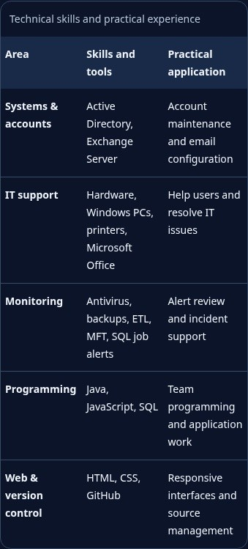  PHONE TABLE: ALL COLUMNS FIT | 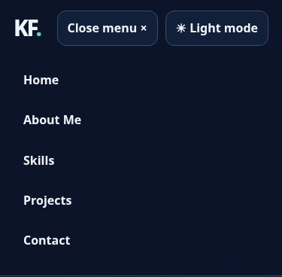  MOBILE MENU: EXPANDED STATE

