**COMP 3133 | LAB 01 | KAILIE FIELD | 100627702**

Due Date: 19 January 2025

**[ SCREENSHOTS ]**

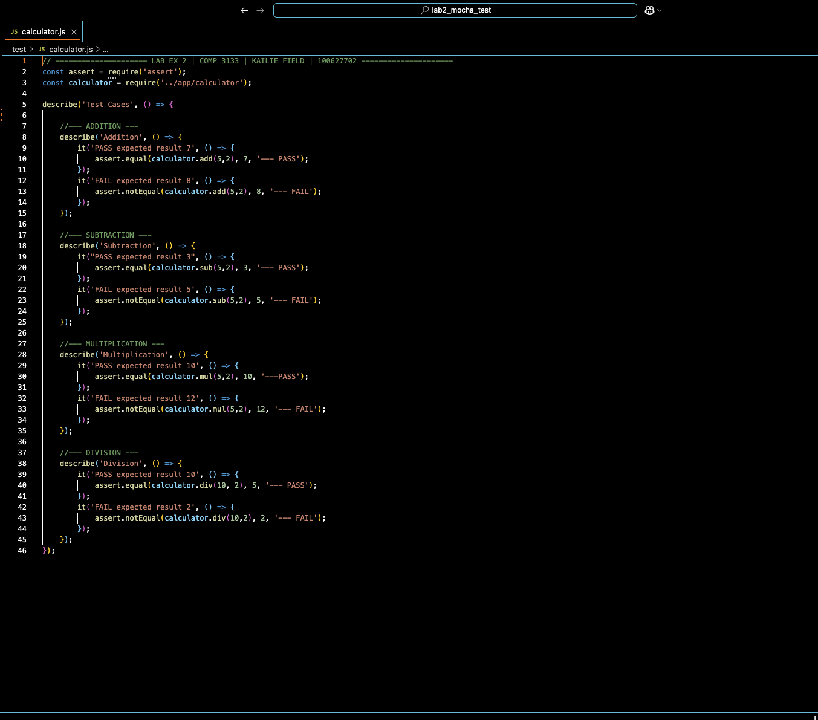 [ SOURCE CODE && OUPUT TXT FILES ]:

