Nanshan Li

UNI: nl2643

Date: Feb 3 2019

**Applied Machine Learning Homework 1**

Task 0

I Nanshan Li, UNI nl2643, consent to audio recording made during the lecture to be posted publicly under a CC-0 license.

This includes any accidental recordings of my voice.

Nanshan Li

Task 1.1

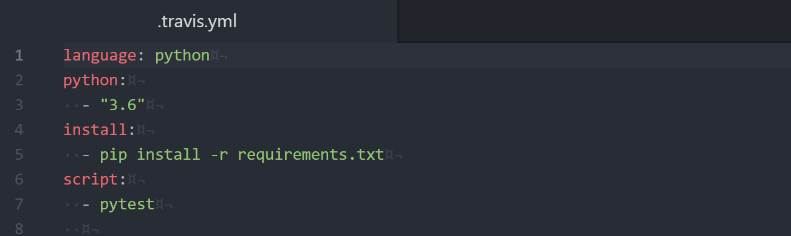

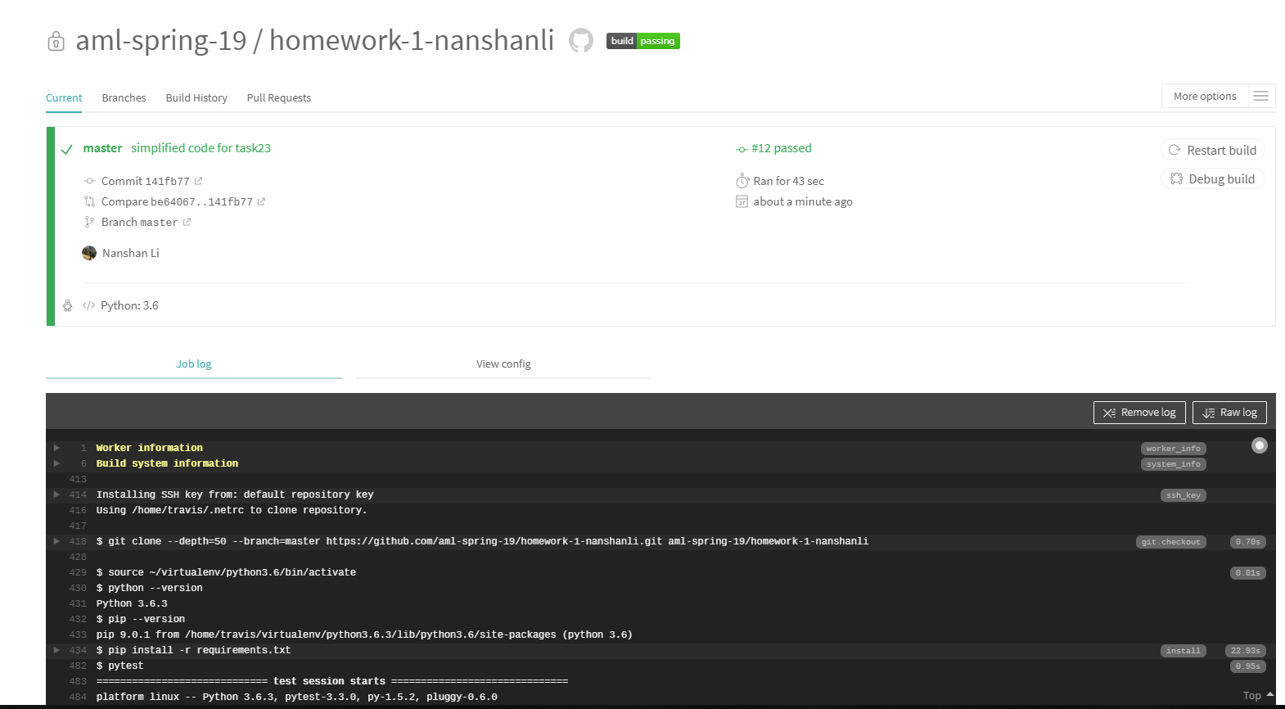

[**https://travis-ci.com/aml-spring-19/homework-1-nanshanli**](https://travis-ci.com/aml-spring-19/homework-1-nanshanli)

Task 1.2

**task12.py**

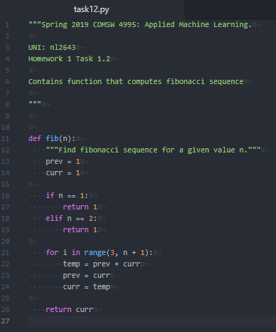

**test_task12.py**

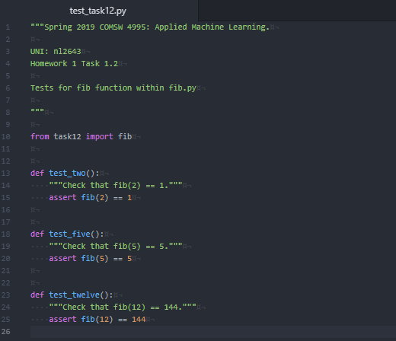

Task 1.3

**test_task13.py**

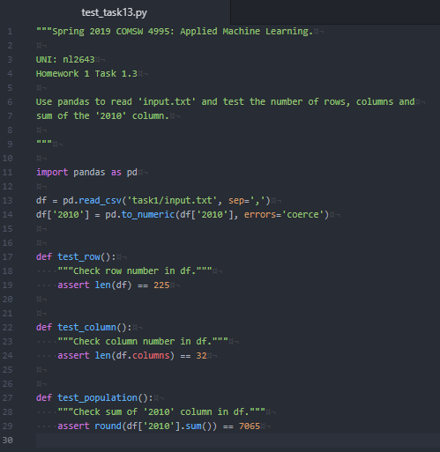

Task 2.1

**task21.py**

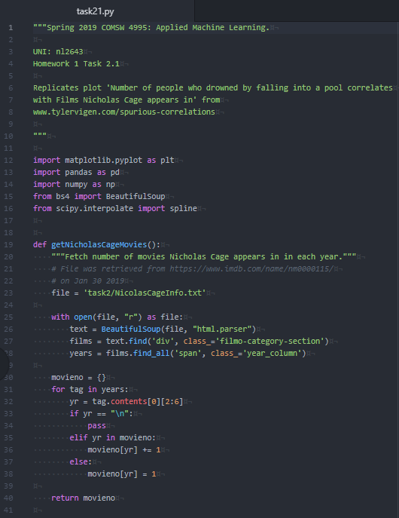

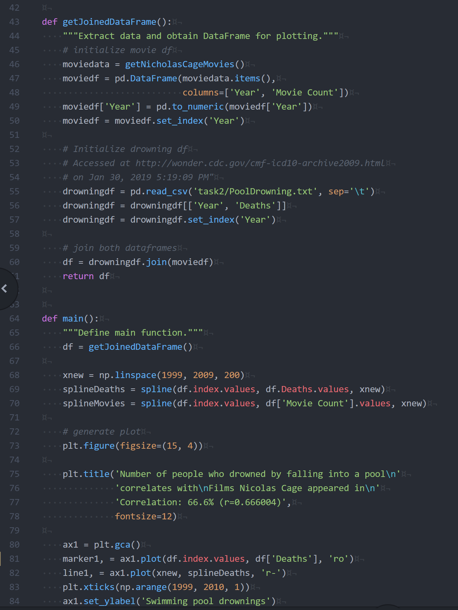 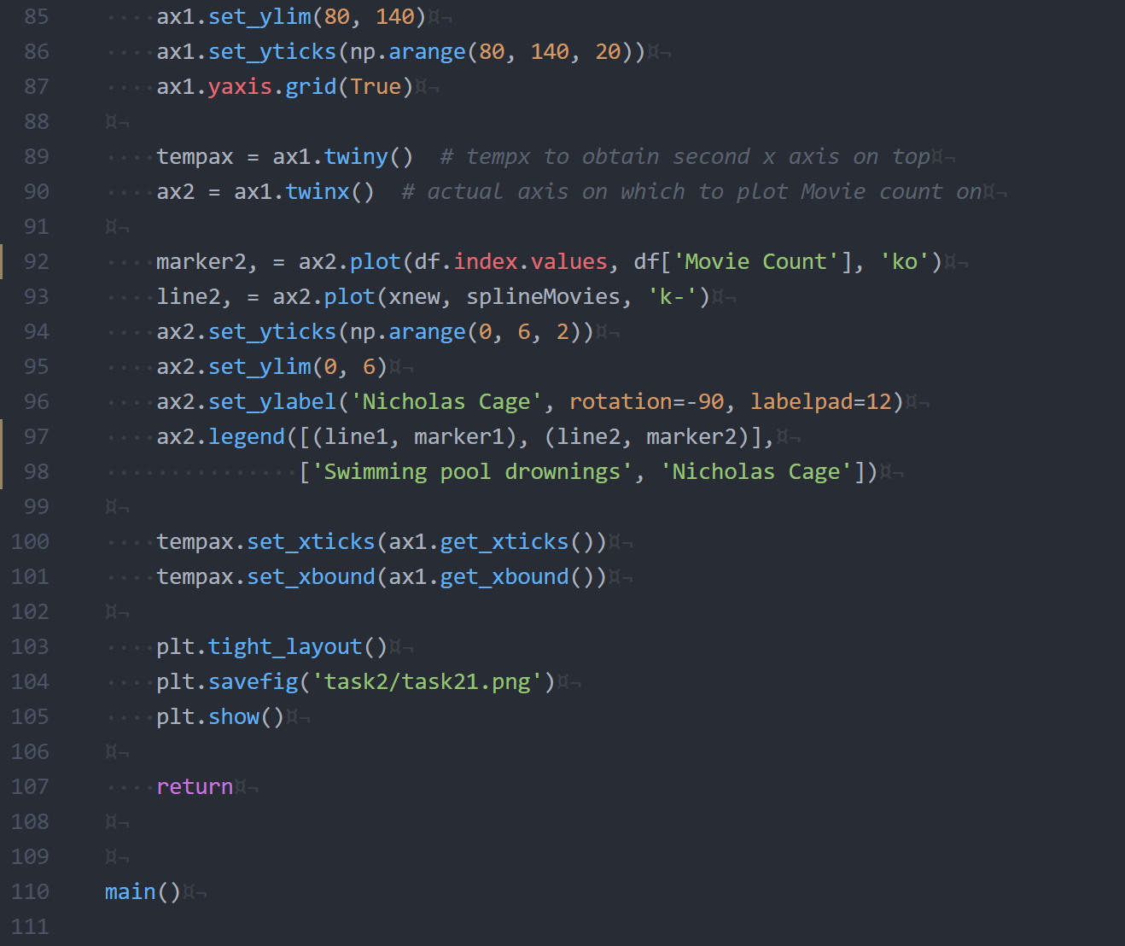

**task21.png**

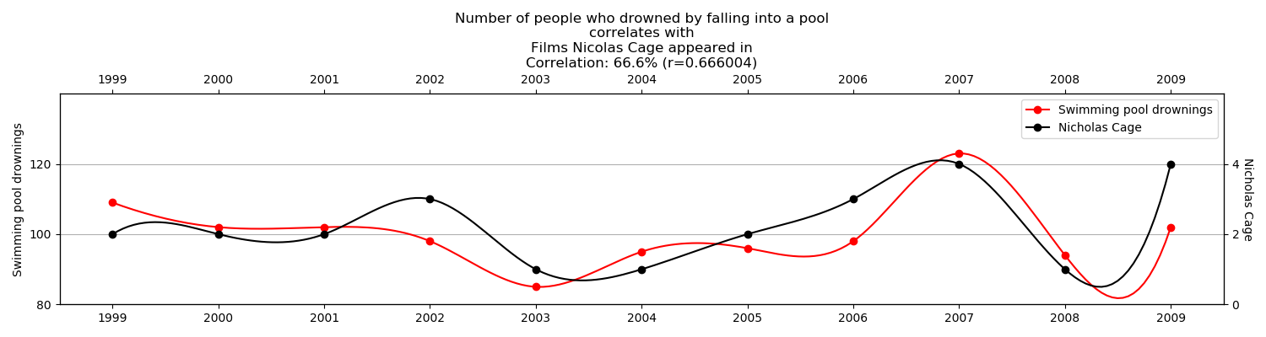

Task 2.2

**task22.py**

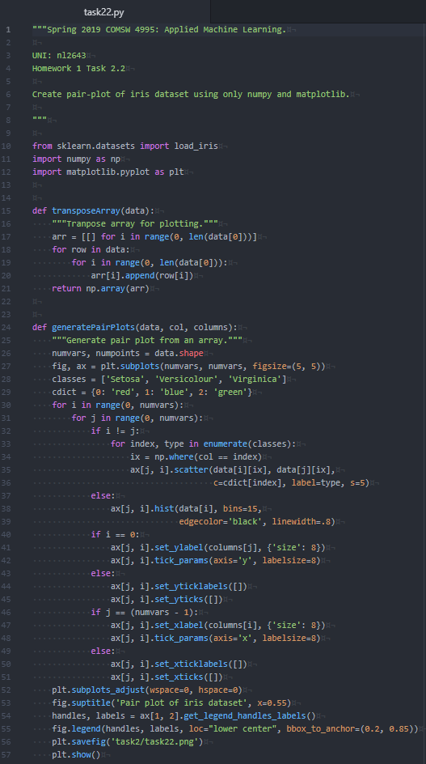

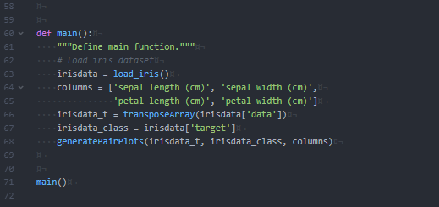

**task22.png**

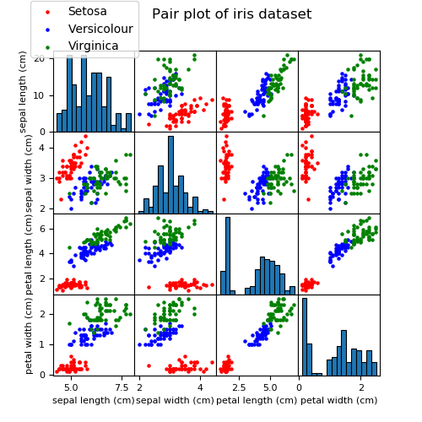

Task 2.3

**task23.py**

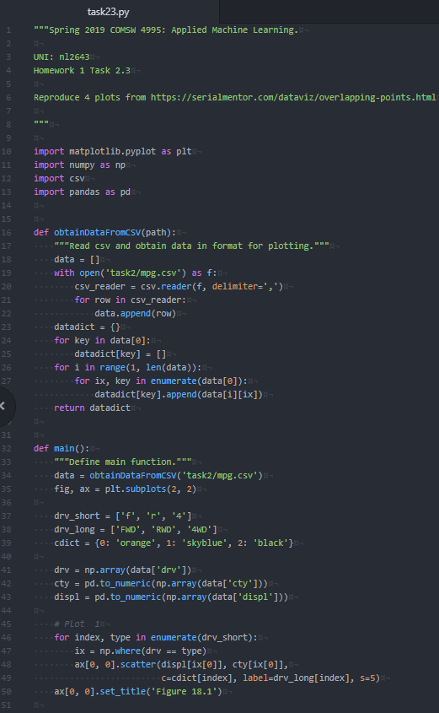

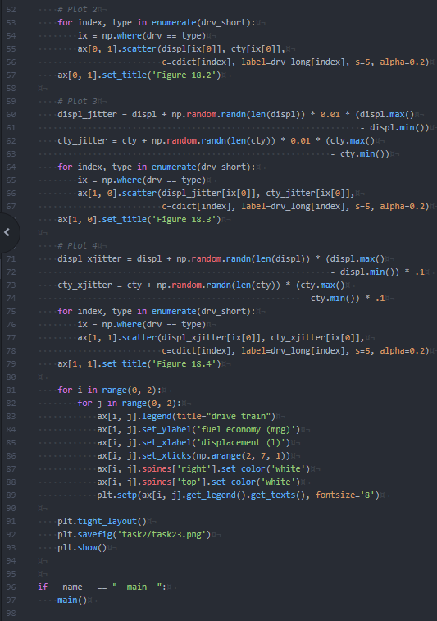

**task23.png**