1. **Dataset Summary**

New York Property Valuation and Assessment Data was **provided by NYC Department of Finance (DOF) on September 2, 2011**. This Dataset has **32 fields** and **1070994 records**. Dataset represents NYC properties assessments for purpose to calculate Property Tax, Grant eligible properties Exemptions and/or Abatements. Data collected and entered into the system by various City employee, like Property Assessors, Property Exemption specialists, ACRIS reporting, Department of Building reporting, etc.

1. **Field Summary**

**Numerical Fields**

In this dataset there are 14 numerical fields. Table 1 represents some basic statistic summary for each numerical field. Fields that marked in red are fields of low percentage populated.

|  |  |  |  |  |  |  |  |  |
| --- | --- | --- | --- | --- | --- | --- | --- | --- |
| **Field Name** | **Count** | **Unique Values** | **Value with Zero** | **% Populated** | **Mean** | **Max** | **Min** | **SD** |
| LTFRONT | 1,070,994 | 1,297 | 169,108 | 100.00% | 3.66E+01 | 1.00E+04 | 0.00E+00 | 7.40E+01 |
| LTDEPTH | 1,070,994 | 1,370 | 170,128 | 100.00% | 8.89E+01 | 1.00E+04 | 0.00E+00 | 7.64E+01 |
| STORIES | 1,014,730 | 112 | n/a | 94.75% | 5.01E+00 | 1.19E+02 | 1.00E+00 | 8.37E+00 |
| FULLVAL | 1,070,994 | 109,324 | 13,007 | 100.00% | 8.74E+05 | 6.15E+09 | 0.00E+00 | 1.16E+07 |
| AVLAND | 1,070,994 | 70,921 | 13,009 | 100.00% | 8.51E+04 | 2.67E+09 | 0.00E+00 | 4.06E+06 |
| AVTOT | 1,070,994 | 112,914 | 13,007 | 100.00% | 2.27E+05 | 4.67E+09 | 0.00E+00 | 6.88E+06 |
| EXLAND | 1,070,994 | 33,419 | 491,699 | 100.00% | 3.64E+04 | 4.67E+09 | 0.00E+00 | 3.98E+06 |
| EXTOT | 1,070,994 | 64,255 | 432,572 | 100.00% | 9.12E+04 | 2.67E+09 | 0.00E+00 | 6.51E+06 |
| BLDFRONT | 1,070,994 | 612 | 228,815 | 100.00% | 2.30E+01 | 7.58E+03 | 0.00E+00 | 3.56E+01 |
| BLDDEPTH | 1,070,994 | 621 | 228,853 | 100.00% | 3.99E+01 | 9.39E+03 | 0.00E+00 | 4.27E+01 |
| AVLAND2 | 282,726 | 58,592 | n/a | 26.40% | 2.46E+05 | 2.37E+09 | 3.00E+00 | 6.18E+06 |
| AVTOT2 | 282,732 | 111,361 | n/a | 26.40% | 7.14E+05 | 4.50E+09 | 3.00E+00 | 1.17E+07 |
| EXLAND2 | 87,449 | 22,196 | n/a | 8.17% | 3.51E+05 | 2.37E+09 | 1.00E+00 | 1.08E+07 |
| EXTOT2 | 130,828 | 48,349 | n/a | 12.22% | 6.57E+05 | 4.50E+09 | 7.00E+00 | 1.61E+07 |

**Table 1.**

**Categorical Fields**

There are 18 categorical fields included in this dataset. Summary information for each categorical fields is shown as Table 2. Fields that marked in red are fields of low percentage populated.

|  |  |  |  |  |
| --- | --- | --- | --- | --- |
| **Field Name** | **Count** | **Unique Values** | **Most Common** | **% Populated** |
| RECORD | 1,070,994 | 1,070,994 | Uniform Distributed | 100.00% |
| BBLE | 1,070,994 | 1,070,994 | Uniform Distributed | 100.00% |
| B | 1,070,994 | 5 | 4(33.43%) | 100.00% |
| BLOCK | 1,070,994 | 13,984 | 3944(0.36%) | 100.00% |
| LOT | 1,070,994 | 6,366 | 1(2.28%) | 100.00% |
| EASEMENT | 4,636 | 13 | E(89.47%) | 0.43% |
| OWNER | 1,039,249 | 863,348 | PARKCHESTER PRESERVAT (0.58%) | 97.04% |
| BLDGCL | 1,070,994 | 200 | R4(13.06%) | 100.00% |
| TAXCLASS | 1,070,994 | 11 | 1(61.69%) | 100.00% |
| EXT | 354,305 | 4 | G(75.35%) | 33.08% |
| EXCD1 | 638,488 | 130 | 1017(0.1%) | 59.62% |
| STADDR | 1,070,318 | 839,281 | 501 SURF AVENUE(0.08%) | 99.94% |
| ZIP | 1,041,104 | 197 | 10314(2.36%) | 97.21% |
| EXMPTCL | 15,579 | 15 | X1(44.37%) | 1.45% |
| EXCD2 | 92,948 | 61 | 65777(6.1%) | 8.68% |
| PERIOD | 1,070,994 | 1 | FINAL | 100.00% |
| YEAR | 1,070,994 | 1 | 2010/11 | 100.00% |
| VALTYPE | 1,070,994 | 1 | AC-TR | 100.00% |

**Table 2.**

1. **Fields Description**
2. **RECORD**

**RECORD** represents the numbering for each record. There are 1070994 unique values in the dataset which means each record has one corresponding **RECORD**.

1. **BBLE**

**BBLE** is the concatenation of **B**, **BLOCK**, **LOT**, and **EASEMENT**. There are 1070994 unique values of **BBLE**, which means every record is associated with one unique value.

1. **B**

**B** is borough codes. (1 = Manhattan, 2 = Bronx, 3 = Brooklyn, 4 = Queens, 5 = Staten Island) The bar chart below shows the count for each borough code.

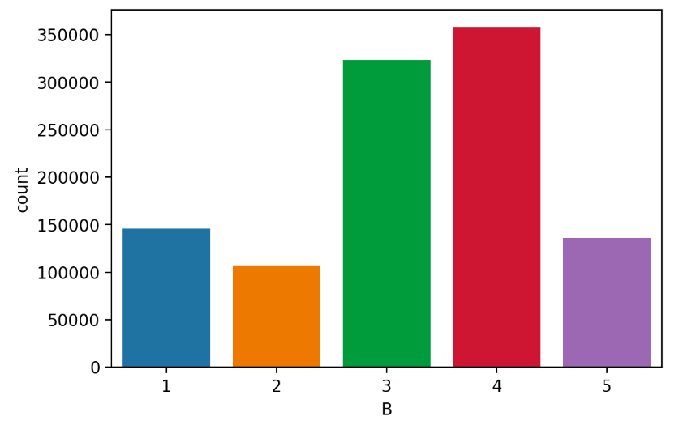

1. **BLOCK**

**BLOCK** represents the valid block ranges by borough codes. The bar chart below shows the count for top 15 most common values.

* Manhattan: 1 to 2,255
* Bronx: 2,260 to 5,958
* Brooklyn: 1 to 8,955
* Queens: 1 to 16,350
* Staten Island: 1 to 8,050

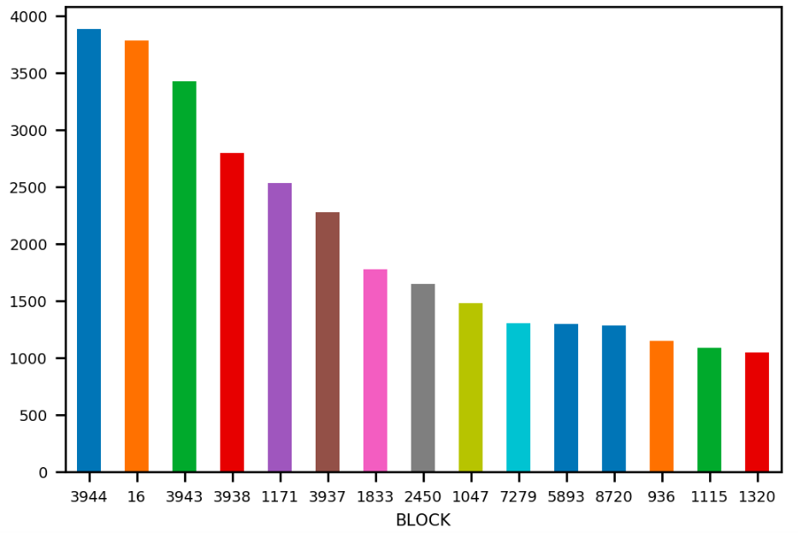

1. **LOT**

**LOT** is the unique code within borough codes and block ranges. The bar chart below shows the top 10 most common values in **LOT**.

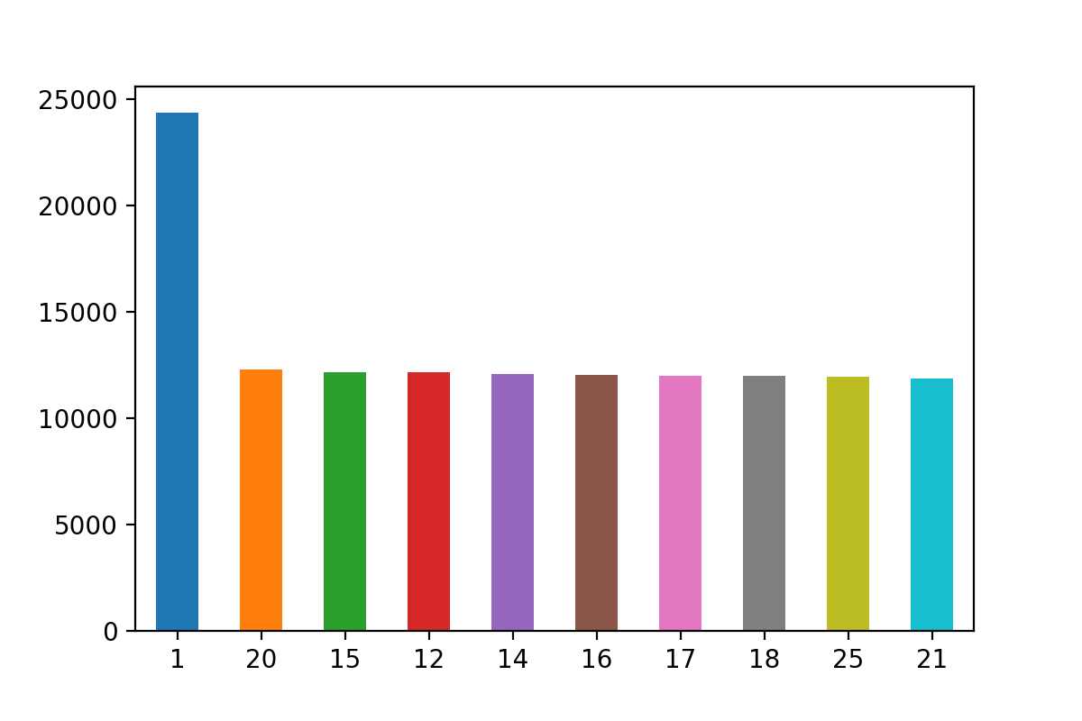

1. **EASEMENT**

**EASEMENT** is a legal right to use another's land for a specific limited purpose. The bar chart below shows the log scale count for each value.

* A: Indicates the portion of the Lot that has an Air Easement
* B: Indicates Non-Air Rights
* E: Indicates the portion of the lot that has a Land Easement
* F through M Are duplicates of 'E'N: Indicates Non-Transit Easement
* P: Indicates Piers
* R: Indicates Railroads
* S: Indicates Street
* U: Indicates U.S. Government

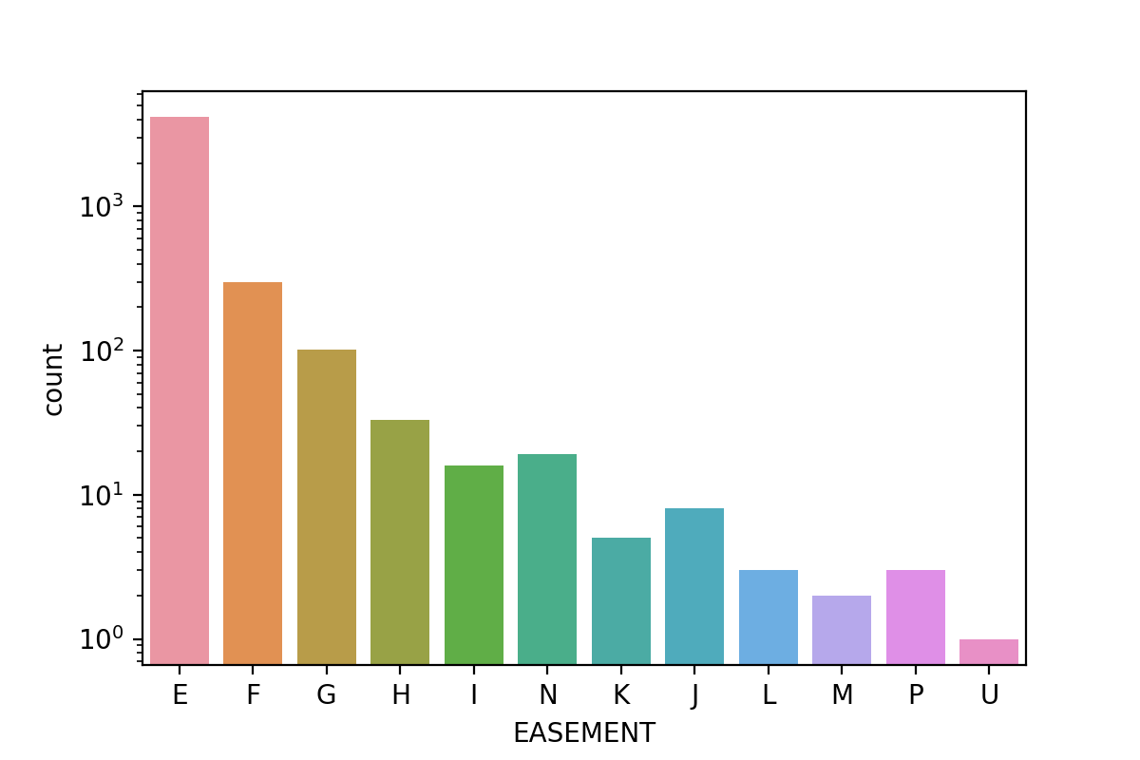

1. **OWNER**

**OWNER** represents the property owner’s name. The following graph shows the count fir top 10 owners.

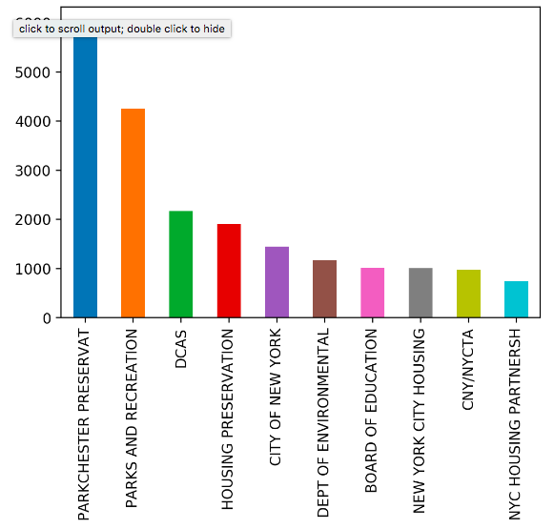

1. **BLDGCL**

**BLDGCL** indicates the Building Class. Besides, there is a direct correlation between the Building Class and Tax Class. Bar chart below shows the count of top 10 Building Class.

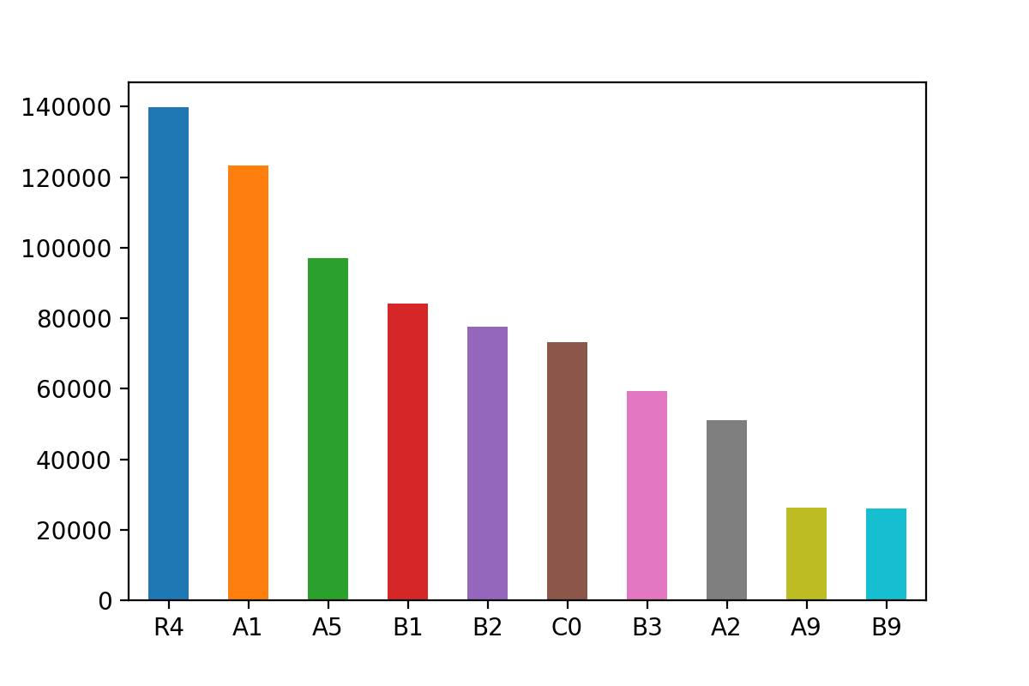

1. **TAXCLASS**

**TAXCLASS** is the current Property Tax Class Code (NYS classification). The following graph shows count of all Tax Class.

* Tax Class 1 = 1-3 unit residences
* Tax Class 1A = 1-3 story condominiums originally a condo
* Tax Class 1B = residential vacant land
* Tax Class 1C = 1-3 unit 1-3 condominiums originally Tax Class 1
* Tax Class 1D = select bungalow colonies
* Tax Class 2 = apartments
* Tax Class 2A = apartments with 4-6 units
* Tax Class 2B = apartments with 7-10 units
* Tax Class 2C = coops/ condos with 2-10 units
* Tax Class 3 = utilities (except Ceiling Rail Roads)
* Tax Class 4A = utilities - Ceiling Rail Roads
* Tax Class 4 = all others

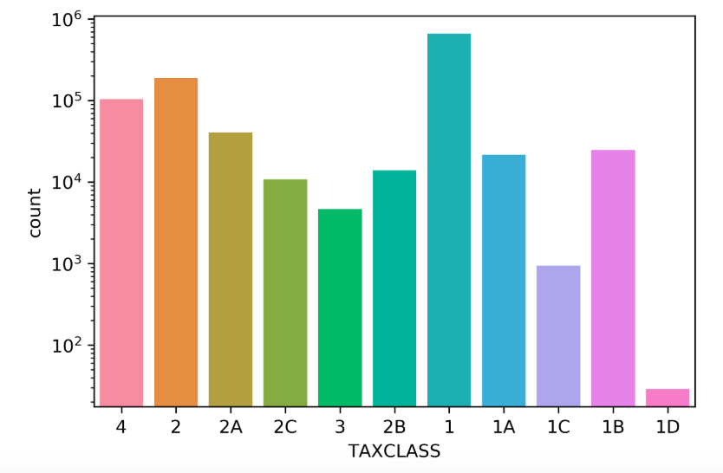

1. **LTFRONT**

**LTFRONT** indicates lot frontage in feet. The graph below is the log scale density plot of **LTFRONT.**

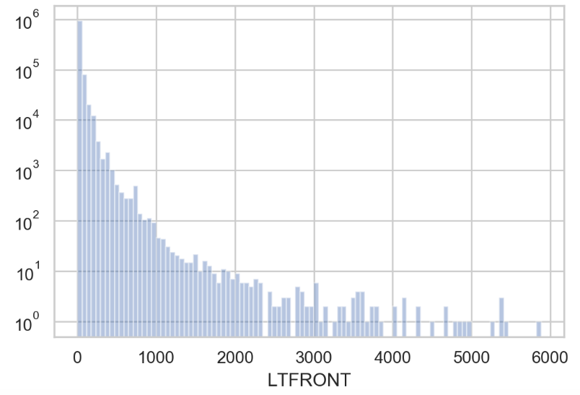

1. **LTDEPTH**

**LTDEPTH** indicates lot depth in feet.The graph below is the density plot of **LTDEPTH** with depth limited to 600 feet.

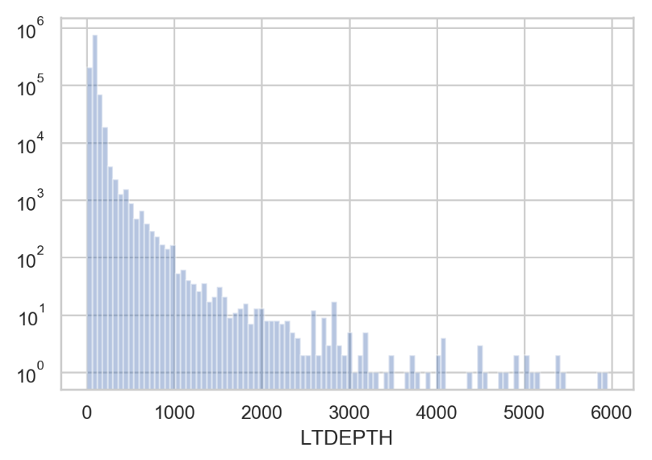

1. **EXT**

**EXT** means property extension. The bar chart below shows count for all extension types.

* E = extension
* G = garage
* EG = extension and garage

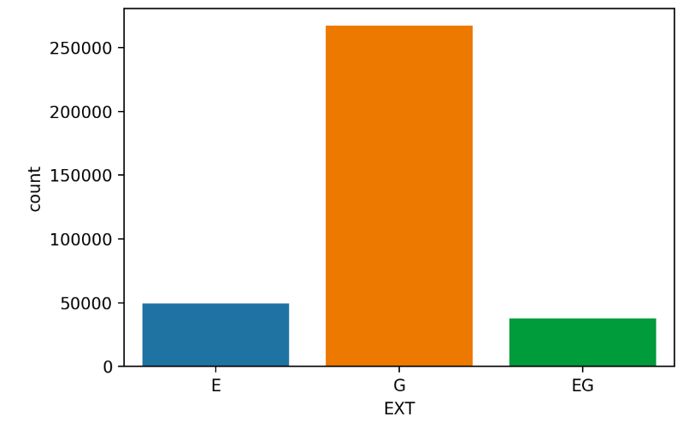

1. **STORIES**

**STORIES** represents the number of floors for the building. The following graph is the distribution of **STORIES.**

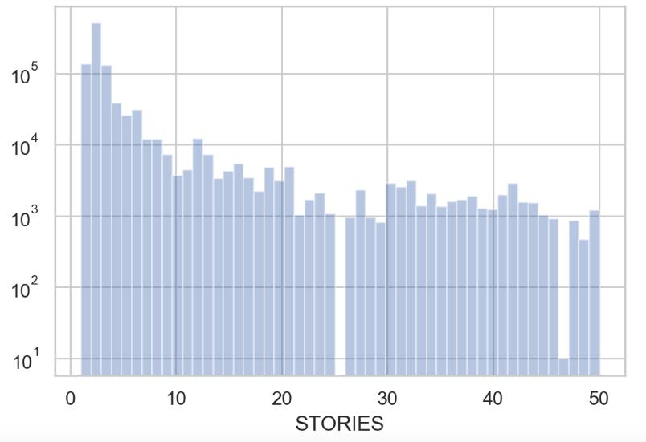

1. **FULLVAL**

**FULLVAL** represents total market value of the property. The graph shows the log scale distribution of FULLVAL with value limited to one billion.

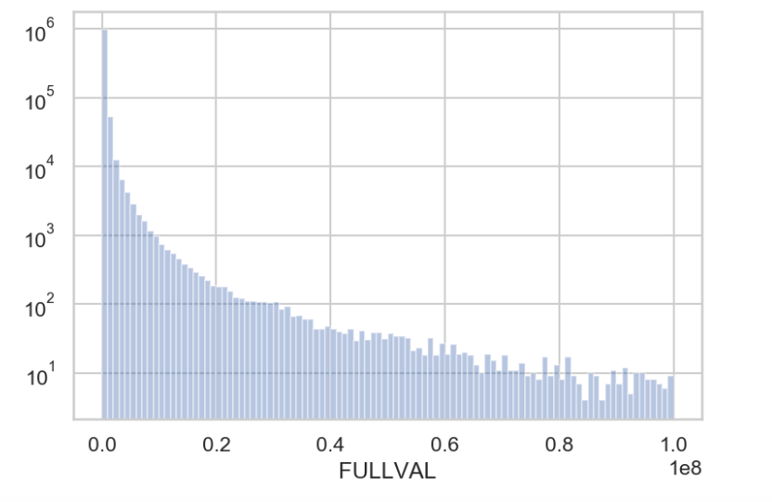

1. **AVLAND**

**AVLAND** is the Assessed land value. The following is the log scale distribution of **AVLAND** with value limited to 10 million.

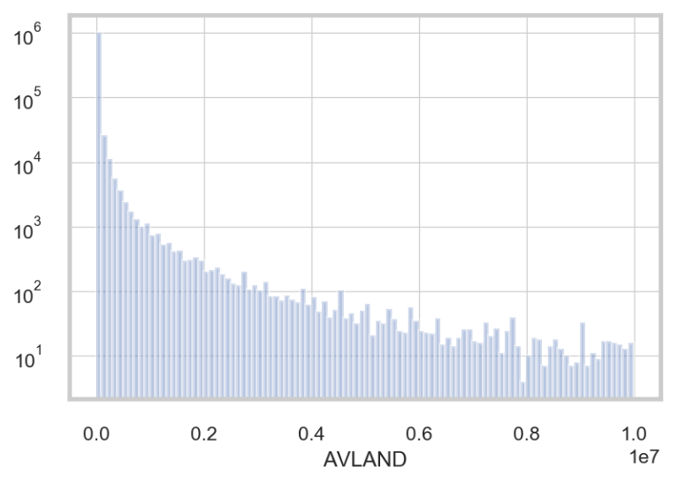

1. **AVTOT**

**AVTOT** is the Assessed Values, which is typically less than the market value. The following is the log scale distribution of **AVTOT** with value limited to one billion.

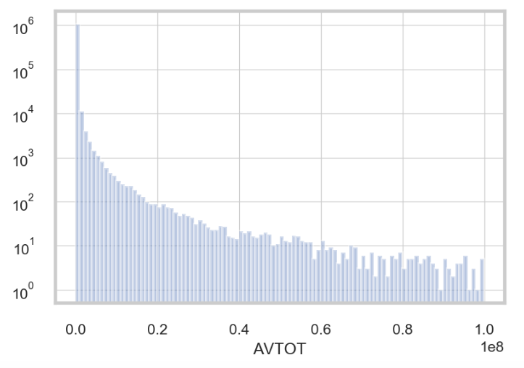

1. **EXLAND**

**EXLAND** represents exempt land value. The following graph shows log scale **EXLAND** with land value limited to 100,000.

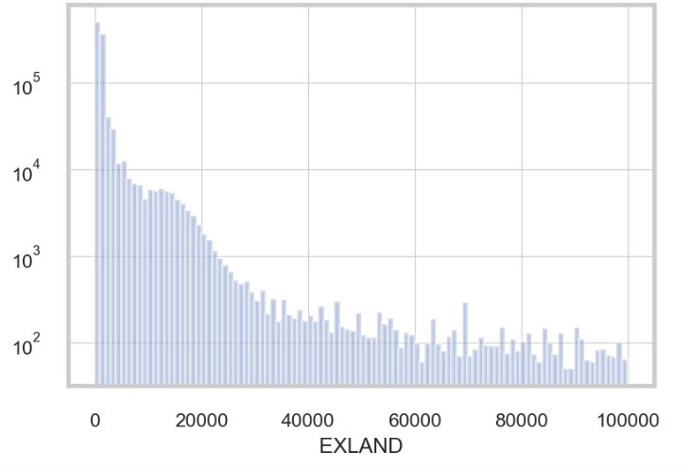

1. **EXTOT**

**EXTOT** shows exempt total value. The following graph shows log scale EXTOT with land value limited to one billion.

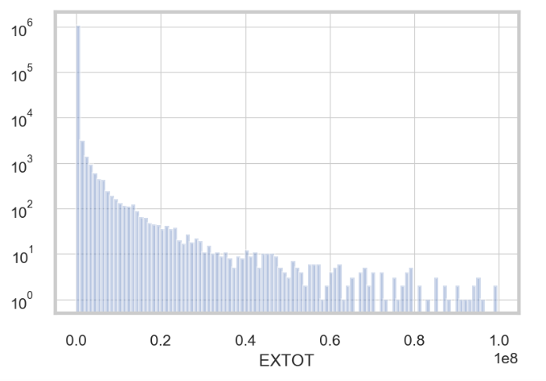

1. **EXCD1**

The Bar chart below shows the log scale count for top 15 values of **EXCD1.**

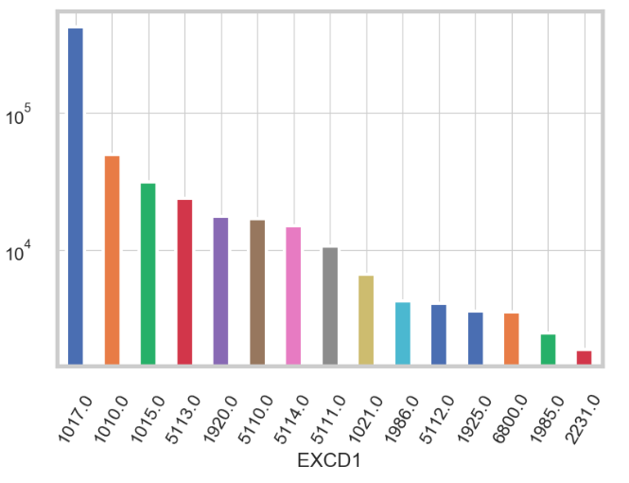

1. **STADDR**

**STADDR** is the street name for the property. The bar chart below shows the count of top 15 most common street names for STADDR.

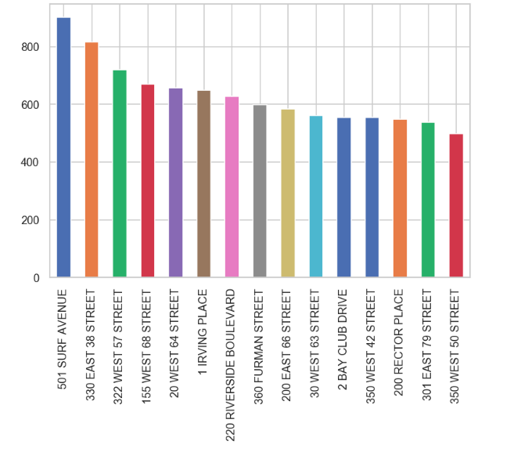

1. **ZIP**

**ZIP** is postal zip code for the property. The below graph shows the count for top 15 most common zip codes.

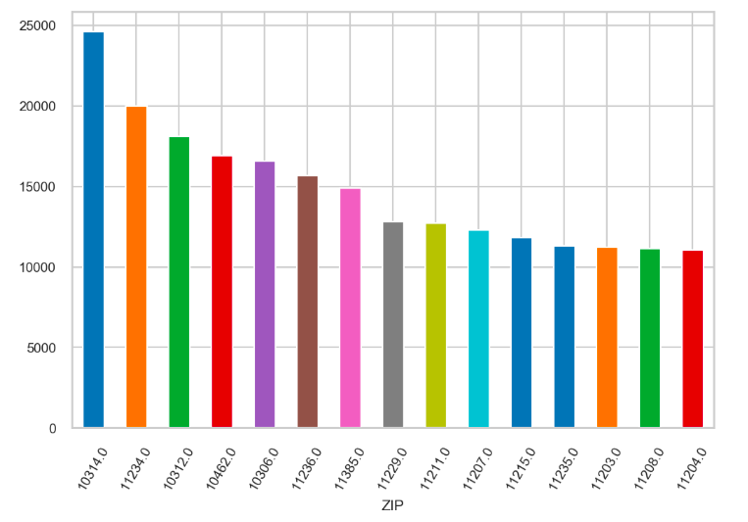

1. **EXMPTCL**

**EXMPTCL** represents exempt class, which is used for fully exempt properties only. Bar chart below shows count for all exempt classes.

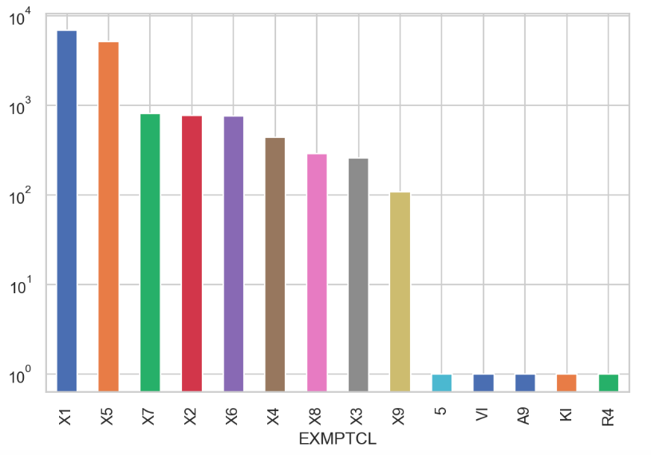

1. **BLDFRONT**

**BLDFRONT** indicates the building frontage in feet. Graph below shows the log scale distribution of **BLDFRONT** with frontage feet limited to 1,000.

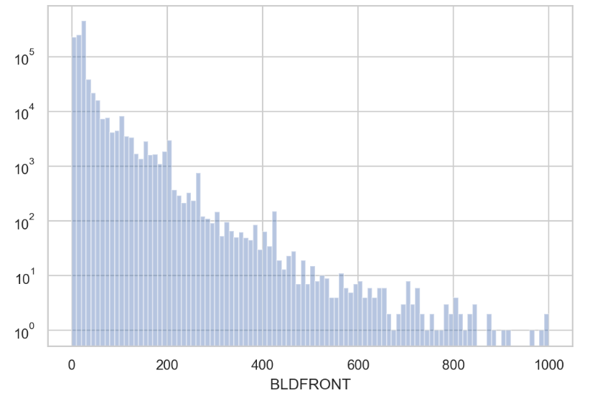

1. **BLDDEPTH**

**BLDDEPTH** indicates building depth in feet. The following graph shows the log scale distribution of **BLDDEPTH** with depth limited to 300 feet.

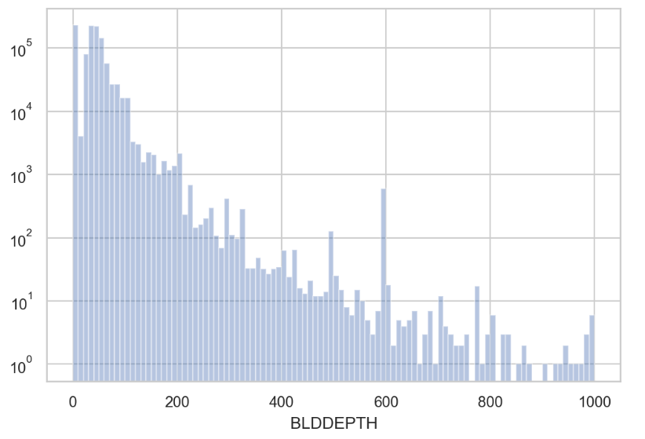

1. **AVLAND2**

**AVLAND** is the land value. The following graph is the distribution of **AVLAND2** with value limited to 200,000.

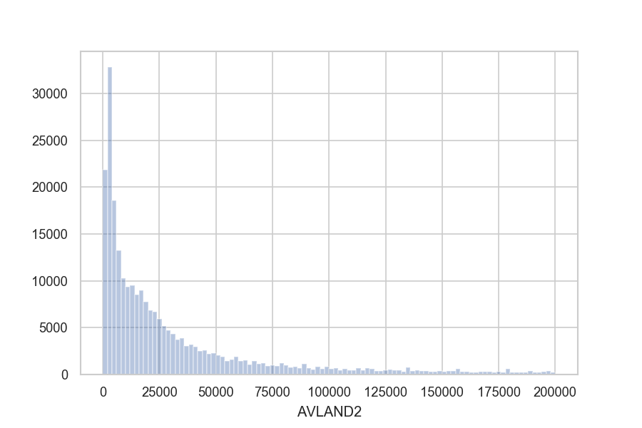

1. **AVTOT2**

The following graph is the distribution of **AVTOT2** with value limited to 1,000,000.

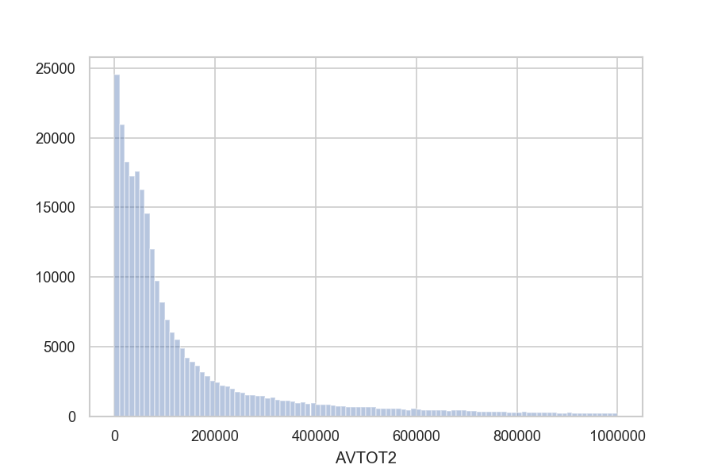

1. **EXLAND2**

**EXLAND2** represents exempt land value. The following graph shows log scale **EXLAND**2 with land value limited to 40,000.

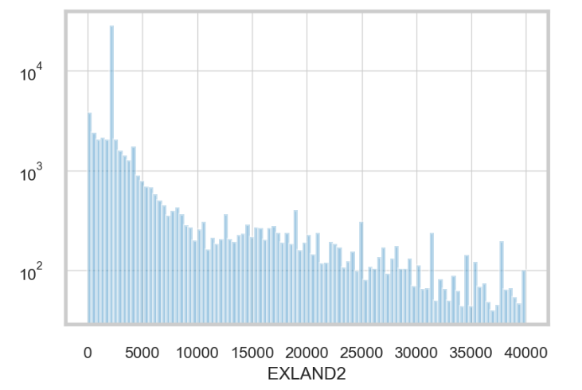

1. **EXTOT2**

The following graph shows log scale distribution of **EXTOT**2 with value limited to 250,000.

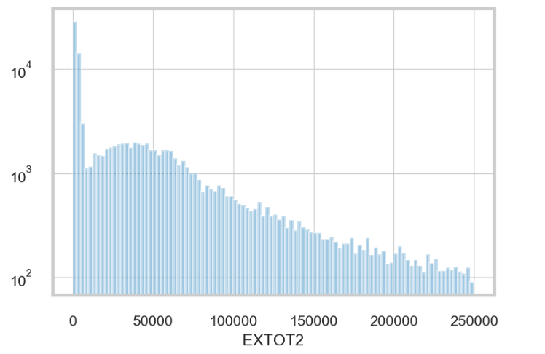

1. **EXCD2**

The Bar chart below shows the log scale count for top 15 most common values of **EXCD2.**

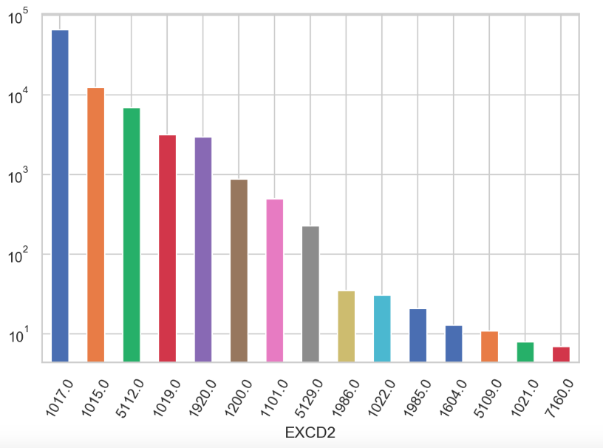

1. **PERIOD**

**PERIOD** contains only one value which is “FINAL”. All 1070994 records are belonging to “FINAL”.

1. **YEAR**

**YEAR** is the four-digits year of the file. The only value is “2010/11”. All 1070994 records are under “2010/11”.

1. **VALTYPE**

**VALTYPE** includes only one value, which is “AC-TR”. All 1070994 records are under “AC-TR”.