User Guide

说明:本说明文档用于Lake Topo软件的使用说明，请在使用前详细阅读。由于本软件并未考虑任何商业化，因此在软件编译上略显粗糙，可能存在未考虑周到的逻辑问题。虽然尽量为主要的操作流程预留了空间，但是依旧建议使用者遵循本说明内容，避免不合理的操作引发未知错误。本软件所有生成的数据均统一至WGS84坐标系，如果需要中途添加数据请确保投影统一。

This user manual is intended for the operation instructions of Lake Topo software. Please read it carefully before use. As this software was not developed with any commercial considerations, its compilation may appear somewhat rudimentary, potentially containing overlooked logical issues. While we have endeavored to accommodate the main operational procedures, users are still advised to follow the instructions herein to avoid triggering unknown errors through improper operations. All data generated by this software is uniformly projected in the WGS84 coordinate system. If you need to add data during the process, please ensure the projection is consistent. Currently, the projection conversion function has not been added, and the system is temporarily unable to automatically detect and convert projections during calculations.

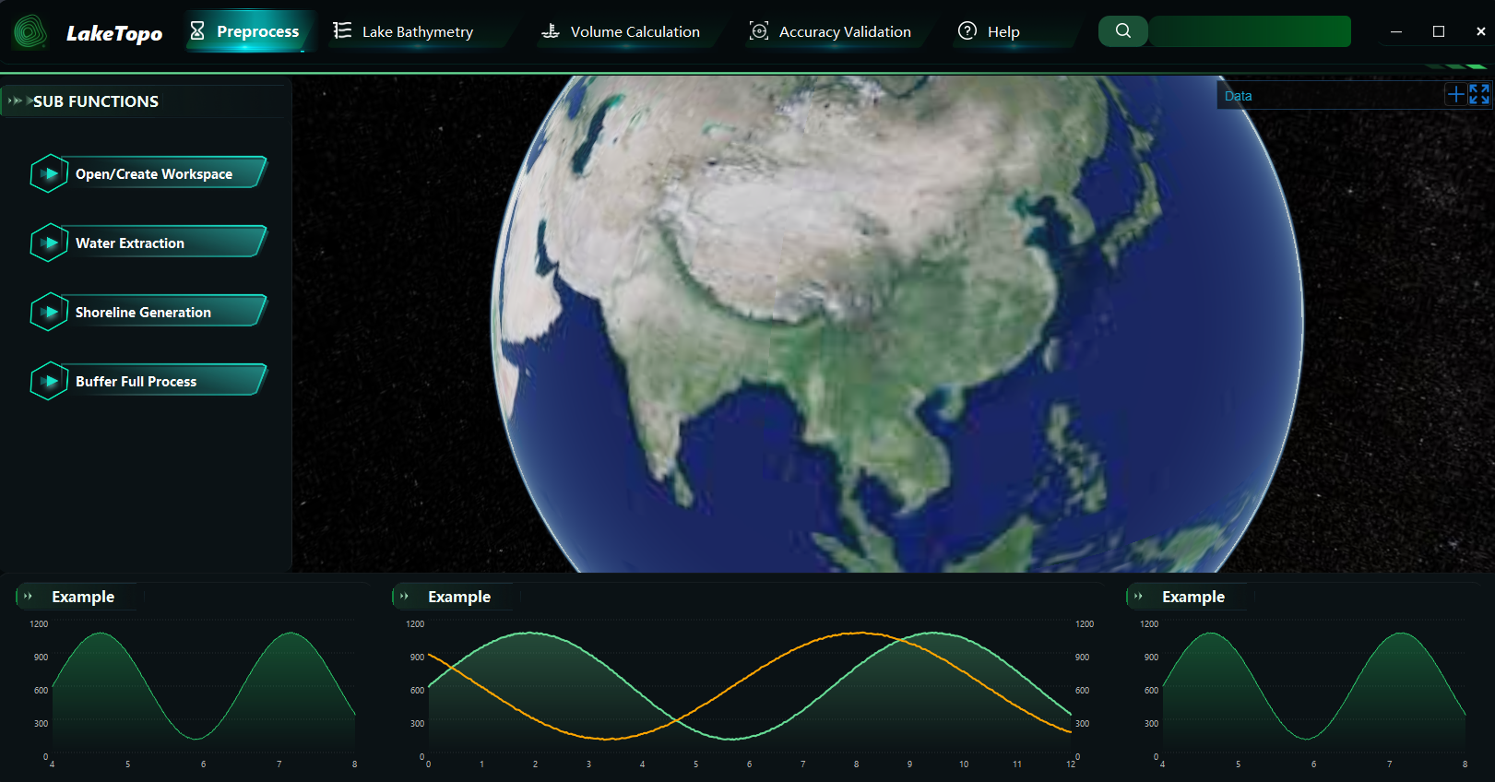
软件主界面如图所示，目前共有preprocess，lake bathymetry，volume calculation和accuracy validation四个主模块。右上角的添加数据支持添加tif格式和shp格式的数据加载至中间的3维地球可视化查看，其中tif格式数据需确保为正常的高程类数据以避免加载失败。搜索栏暂时未添加交互功能。接下来本指南会按照一次完整水深预测验证的流程逐模块阐明各部分使用细则
The main interface of the software is shown in the figure, currently consisting of four main modules: preprocess, lake bathymetry, volume calculation, and accuracy validation. The " Data" button in the upper right corner supports loading data in TIF and SHP formats into the central 3D globe visualization. Note that TIF format data must be valid elevation data to avoid loading failures. The search bar currently does not have interactive functionality. This guide will subsequently explain the detailed usage of each module step by step following the complete workflow of a bathymetric prediction and validation process.

  - Preprocess
Open/create workspace
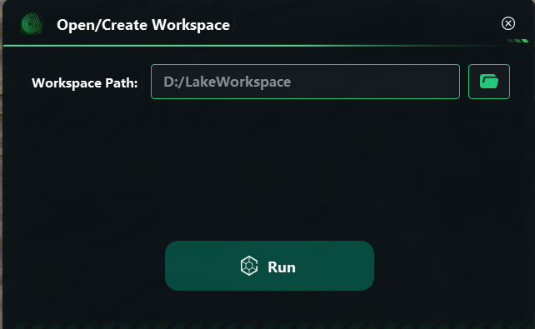
用于打开已有或创建新的工作空间，每次打开该软件时都要先确定该路径，后续所有文件处理及保存均在此路径下。需注意后续如果某些预处理没有自定义文件名输出的选项，则会将该文件夹名作为命名，例如将文件夹命名为test1，在下一步water extraction中输出的水域范围tif会被命名为test1_extent.tif。
Used to open an existing or create a new workspace. Each time the software is opened, this path must be determined first, and all subsequent file processing and saving will occur under this path. Please note that if some preprocessing steps do not have the option to customize the output filename, the folder name will be used as the naming convention. For example, if the folder is named "test1", the water extent TIFF output in the next water extraction step will be named "test1_extent.tif".

Water extraction
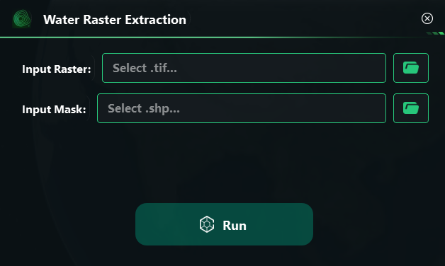
该功能用于提取栅格形式的水体二值范围，输入预先准备好的地形DEM与湖泊面shp，输出二值湖泊范围tif (name_extent.tif)
This function is used to extract the binary range of water bodies in raster format. It takes a pre-prepared terrain DEM and lake polygon SHP as input, and outputs a binary lake boundary TIF (name_extent.tif).

Shoreline generation
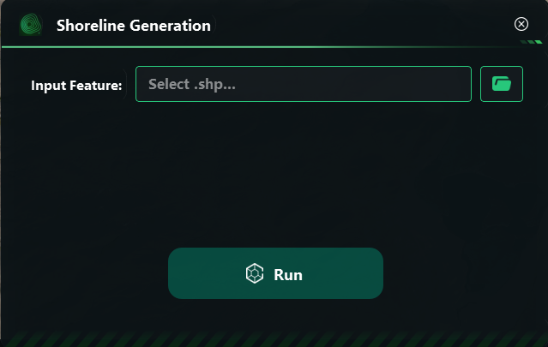
该功能从读取的湖泊面shp提取得到湖泊边缘线shp (shoreline.shp)
This function extracts the lake shoreline SHP from the read lake surface SHP.

Buffer full process
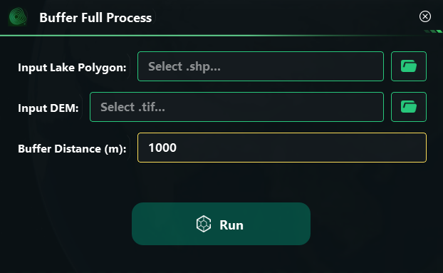
该功能输入为湖泊面shp和原始地表DEM数据，设置缓冲区宽度后输出：1.包含缓冲区的湖泊面shp (name_buffer.shp) 2.包含缓冲区的湖泊及周边地形tif (name_merit.tif) 3.包含缓冲区的湖泊及周边坡度tif (name_slope.tif)
The function takes a lake polygon SHP and the original land surface DEM data as input. After setting the buffer width, it outputs: 1. A lake polygon SHP with the buffer (name_buffer.shp); 2. A TIF file of the lake and surrounding terrain within the buffer (name_merit.tif); 3. A TIF file of the lake and surrounding slope within the buffer (name_slope.tif).

Batch Projection to WGS84
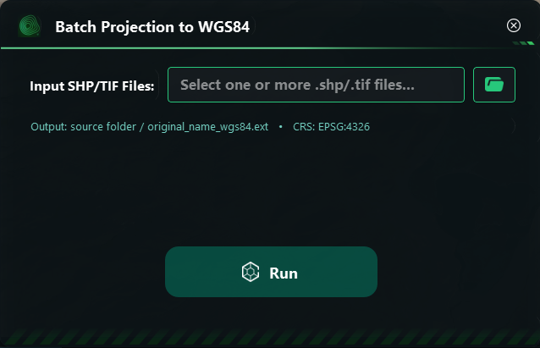
该功能帮助使用者将准备的数据中投影不一致的部分统一转换为WGS84，通过按住ctrl键选择多个文件。
This feature helps users convert parts of the prepared data with inconsistent projections to WGS84 by holding down the Ctrl key to select multiple files.

  - Lake bathymetry
Gen. Prediction Points
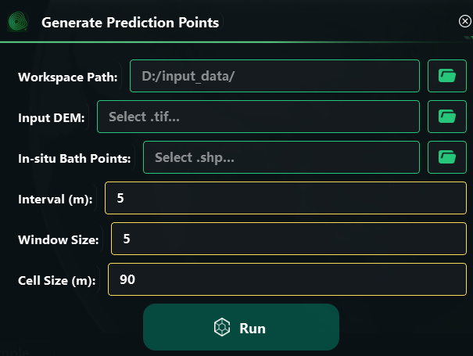
该功能输入为工作空间路径，可自选的地形DEM（如未指定会默认选择buffer full process中生成的merit.tif）以及需要事先准备的实测测深点shp，在设置预测点相关参数后会计算并得到：1.MLData中用作后续训练的txt文件 2.tif格式的shoreline和实测点文件
The input for this feature is the workspace path, an optional terrain DEM (if not specified, the merit.tif generated in the buffer full process will be selected by default), and a pre-prepared measured bathymetric point SHP file. After setting the relevant parameters for the prediction points, it will calculate and generate: 1. A TXT file in MLData for subsequent training, and 2. Shoreline and measured point files in TIF format.

Gen. Prediction Depth
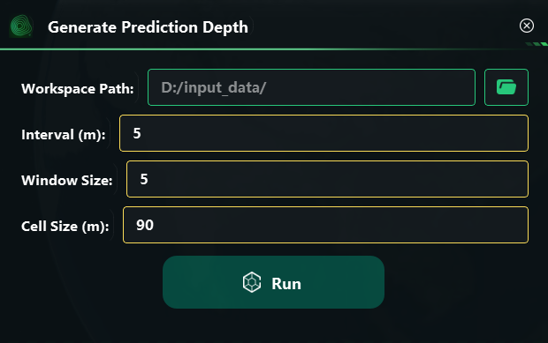
该功能为机器学习生成预测点水深的主要模块，通过设置工作空间路径，自动读取MLData中前置文件与其余相关文件，设置全湖平均分布的预测点相关参数，在多轮优化后得到最优结果，输出temp_ML中的预测点shp
目前并未添加可视化加载进度条，因此在机器学习预测深度部分可能会遇到点击确定后长时间无反应情况，请不要点击软件界面导致未知的卡死，只要没出现未响应软件就依旧在正常运行，请耐心等待至出现task completed弹窗
This function serves as the main module for machine learning to generate predicted water depth points. By setting the workspace path, it automatically reads the pre-processing files and other related files in MLData, configures parameters for lake-wide uniformly distributed prediction points, and obtains the optimal results after multiple rounds of optimization, outputting the predicted point SHP files in temp_ML.
Currently, there is no visual loading progress bar implemented. Therefore, during the machine learning prediction phase, you may experience a prolonged unresponsive state after clicking "OK." Please refrain from interacting with the software interface to avoid potential freezes. As long as the software does not display a "Not Responding" message, it is still operating normally. Kindly wait patiently until the "Task Completed" pop-up window appears.

Terrain generation
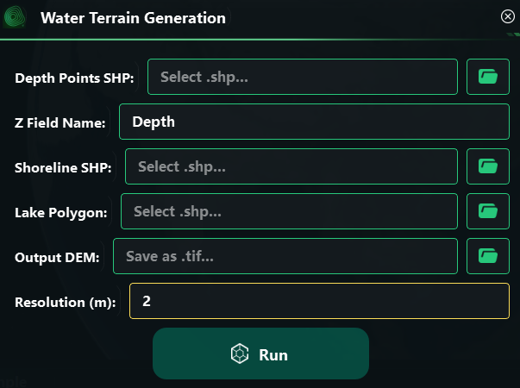
该功能通过利用生成的预测点shp、湖岸线shp、湖泊面shp，通过自定义的分辨率实现从点到面的水深预测，输出得到水深分布的tif文件
This feature utilizes generated prediction point SHP files, shoreline SHP files, and lake surface SHP files to achieve depth prediction from points to surfaces with a user-defined resolution, outputting a TIF file of the water depth distribution.

Elevation adjustment
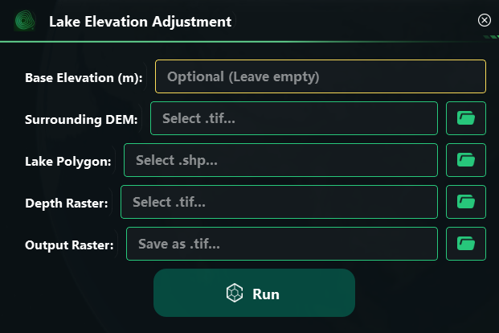
该部分通过设置原始地形DEM、湖泊面shp与上一步得到的水深tif，通过计算得到湖盆区域的高程DEM
This section calculates the elevation DEM of the lake basin area by setting up the original terrain DEM, the lake surface SHP, and the water depth TIF obtained in the previous step.

Mosaic DEM
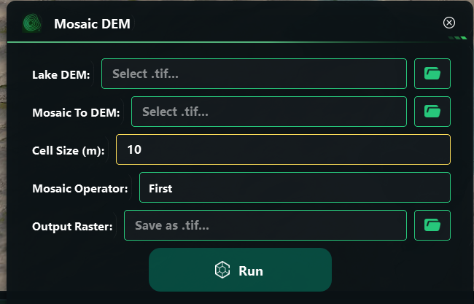
该部分主要是将得到的湖盆高程DEM镶嵌至之前的原始地形DEM得到完整的湖盆及周边地区的真实地表高程DEM，可设置分辨率与镶嵌计算方法
This section mainly involves mosaicking the obtained lake basin elevation DEM into the original terrain DEM to obtain a complete and accurate surface elevation DEM of the lake basin and its surrounding areas. The resolution and mosaic calculation method can be set.

  - Volume Calculation
Lake volume calculation
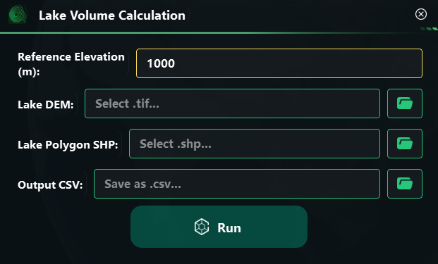
该部分通过输入最终的湖盆DEM与湖泊面shp，计算的到该湖泊预测的水储量。如果不设置湖泊面shp也可设置统一的岸线高程（二者均设置的情况下会优先采用shp）
This section calculates the predicted water storage of the lake by inputting the final lake basin DEM and the lake surface SHP. If the lake surface SHP is not set, a uniform shoreline elevation can be specified (if both are set, the SHP will take priority).

E-V Curve
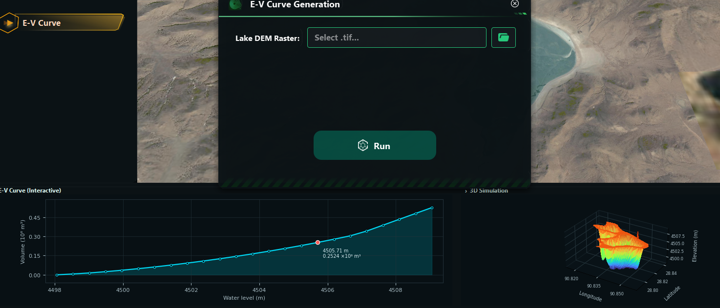
该部分通过设置湖盆DEM计算并绘制E-V图。底部可调整模拟水位来显示不同水位下的储量及3D模拟图
This section calculates and plots the E-V diagram by setting the lake basin DEM. The bottom allows adjusting the simulated water level to display the reserves and 3D simulation at different water levels.

  - Accuracy Validation
Prediction accuracy
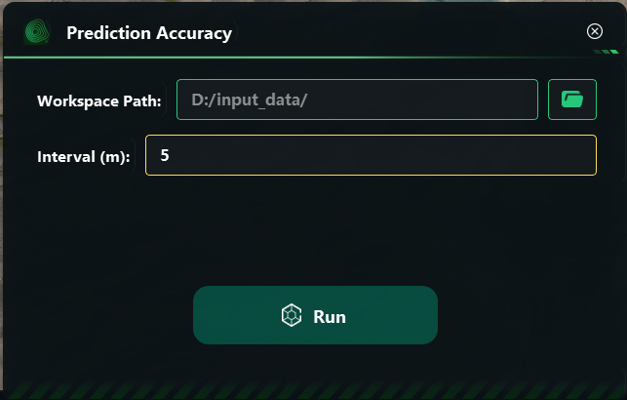
该部分通过设置工作空间路径，运行后自动读取需要的文件（需要所有前置工作全部完成），验证精度并输出结果csv与散点图
This section sets the workspace path, automatically reads the required files (all prerequisite tasks must be completed), verifies accuracy, and outputs the results in CSV format along with a scatter plot.

Depth line check
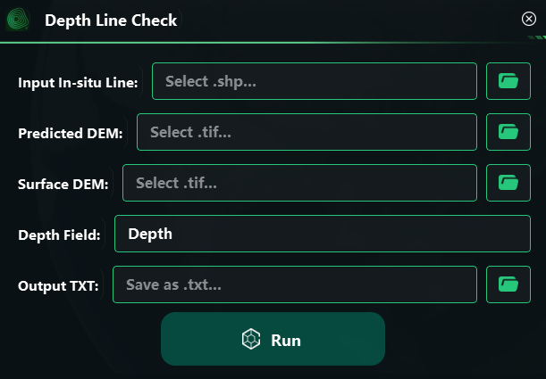
该功能通过设置实测点shp、预测得到的湖盆DEM与原始的地表DEM，设置实测点shp中水深字段名，最后验证沿实测线的预测精度分布情况，输出结果txt。
This function verifies the accuracy distribution of predictions along measured lines by setting the measured point SHP, the predicted lake basin DEM, and the original surface DEM, and specifying the water depth field name in the measured point SHP, ultimately outputting the results in a TXT file.

