Kailyn Philpot
003071160

Breaking Down the 90s Hit Formula

Objective

This project looks at popular songs from the 1990s to find out what made them hits. By looking at things like song tempo, how much music vs. vocals they had, how long the songs were, and which artists had the most hits, we can see what patterns helped songs become successful during that decade.

Introduction

The 1990s was a big decade for music, especially for R&B, pop, and rap. These genres dominated the charts and shaped the sound of the era. This project, Breaking Down the 90s Hit Formula, explores what made songs popular by looking at things like tempo, vocals, song length, and which artists had the most hits. The goal is to find patterns in the music that helped define a 90s hit. The dataset we analyzed features over 900 classic 1990s songs and their detailed audio features pulled from Spotify– factors like tempo, danceability, loudness, valence, and more. With over 500 artists represented, this dataset gave us the chance to explore not only what made music in the 90s sound the way it did, but to also ask:

Method

For this project, no data wrangling or data cleansing was needed. The dataset was already clean, organized, and ready for analysis. I was able to work directly with the provided features—such as artist names, tempo, popularity, instrumentalness, and song duration—using visualization tools like bar charts and histograms to explore patterns and trends in the data.

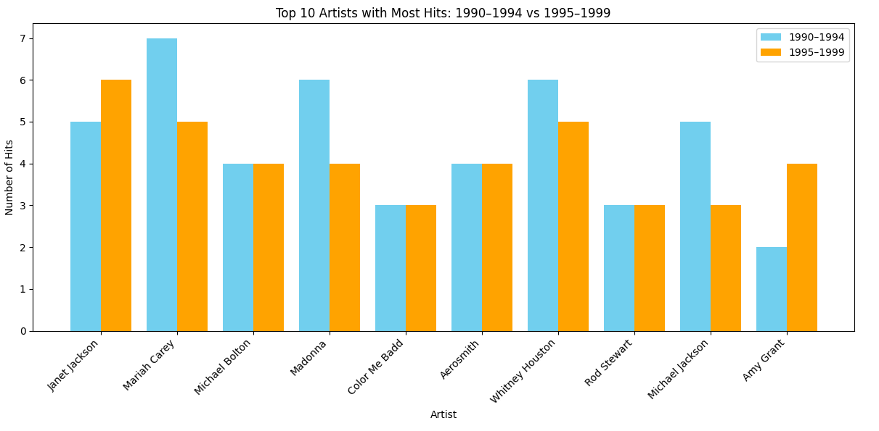
Data Visualization

This visualization compares the number of hit songs by top artists during the first half (1990–1994) and the second half (1995–1999) of the 1990s. It reveals that artists such as Mariah Carey, Michael Jackson, Madonna, and Whitney Houston had significantly more hits in the earlier half of the decade. This trend can be explained by a combination of factors. These artists were already global superstars entering the 1990s, with strong momentum carried over from the late 1980s. Many of their most successful and iconic albums were released early in the decade—such as Michael Jackson's Dangerous (1991) and Mariah Carey's Music Box (1993). As the decade progressed, there was a noticeable shift in mainstream music trends, with the
rise of R&B, hip hop, and alternative pop influencing the charts. Artists like TLC, Brandy, and Dru Hill gained more popularity in the latter half, signaling a generational and genre shift in what defined a hit during the 90s. This chart helps visualize those changes in musical influence and industry dynamics over time.

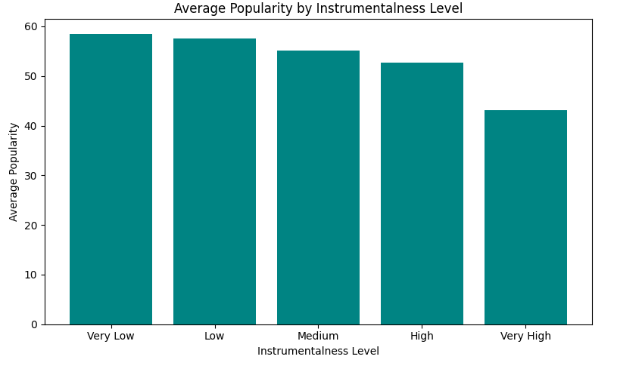

This graph shows the connection between how popular a song was and how much of it was instrumental. The data makes it clear: the most popular songs in the 90s had low instrumentality, meaning they had a lot of vocals. This makes sense because the biggest genres during that time were R&B, pop, and hip hop which focus heavily on vocals, lyrics, and melodies. People were more drawn to songs with singing or rapping, not ones that were mostly instrumental. So, the graph helps show that in the 90s, hits were all about the voice which is consistent with common knowledge of what music was known for in the 90s.

Summary of Insights

The data visualizations reveal several key trends in what made a hit song in the 1990s. First, songs with lower instrumentalism—meaning they featured more vocals—were consistently more popular. This reflects the dominance of genres like R&B, pop, and hip hop during the decade, all of which emphasize vocal performance and lyrical content. In terms of song duration, most 90s hits were between three and four-and-a-half minutes long, showing a clear preference for radio-friendly lengths that fit mainstream listening habits. Lastly, the breakdown of top artists between the early and late 90s shows a noticeable shift in the music scene. Major stars like Mariah Carey, Michael Jackson, Madonna, and Whitney Houston had more hits in the first half of the decade, while newer acts like Brandy, TLC, and Dru Hill gained popularity in the latter half. This suggests a transition in musical influence, with newer genres and emerging artists reshaping what defined a popular song by the end of the 90s.

References

Bumpkin, The. “1990s Classic Hits (with Spotify Data).” Kaggle, 30 July 2024,
www.kaggle.com/datasets/thebumpkin/1990s-classic-hits-with-spotify-data?resource=download.
“The History of R&B Music.” Pro Music Tutor Blog,
www.promusictutor.com/blog/the-history-of-rb-music-2/. Accessed 23 Apr. 2025.

