Adrian Granturk
P. O. Box 681 – 00625 Nairobi, Kenya
Email: agranturk@gmail.com, Tel: +254 796 169 070

Dear sir/madam,

I am writing to express my strong interest in the advertised position. With a background in gender and development and a passion for advancing gender equality and social justice, I am excited about the opportunity to contribute to your team and make a meaningful impact.

During my academic and professional journey, I have gained valuable experience and skills that align well with the requirements of this position. I have just completed my course work in Gender and Development Studies and will be graduating December 2024 from Kenyatta University, where my coursework focused extensively on gender studies, development theory, and women's empowerment initiatives. Additionally, my one year of experience working in as an intern at MAMA CBO, has equipped me with a comprehensive understanding of the complexities surrounding gender issues in diverse cultural and socioeconomic contexts.

In my previous role at MAMA CBO, I supported several projects aimed at promoting gender mainstreaming in development programs. Through strategic planning, capacity building workshops, and advocacy campaigns, I assisted in organizing workshops, seminars and community outreaches to promote gender mainstreaming in programme interventions. These experiences have honed my ability to analyse gender dynamics, identify systemic barriers, and implement effective strategies to address them.

Furthermore, I have undergone training and certification in professional foundations from ALX also I’m enrolled at Mediacrest digital taking a course on digital marketing and AI. my strong communication and interpersonal skills have enabled me to facilitate dialogue and foster partnerships with various stakeholders, including government agencies, NGOs, and community-based organizations. I am adept at conducting research, collecting and analysing data, and presenting findings in a compelling manner to inform evidence-based decision-making and policy formulation.

I am eager to contribute my expertise and collaborate with your team to advance these important goals. I am confident that my dedication, skills, and passion for gender equality make me a strong fit for this role.

Thank you for considering my application. I am enthusiastic about the opportunity to further discuss how my background and experiences align with your needs . I am available for an interview at your earliest convenience.

Sincerely,
Adrian Granturk
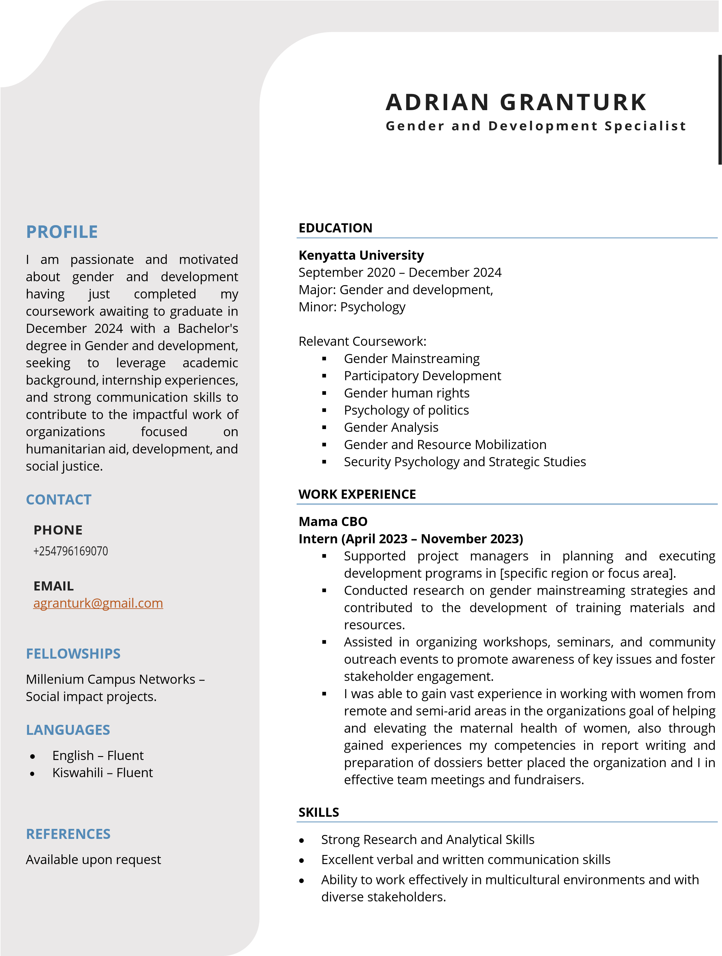

References
1. Winnie Chelagat
Founder, MAMA.CBO
Phone: +254 717 691 415
1. Dr. Sarah Barasa
Lecturer, Kenyatta University
Email: barasa.sarah@ku.ac.ke
Phone: +254 721 634 626
1. Esther Bande
Head of Partnerships, Communications and Reporting - WFP Ghana
Email: bande6@gmail.com
Phone: 0721 413 819

