Chapter:01

**1. Define what a project is and provide examples of IT projects. List various attributes of projects and describe the common constraints that project managers must deal with.**

Answer: A project is a temporary endeavor undertaken to create a unique product, service, or result. Examples of IT projects include software development, system upgrades, and implementation of new technologies. Projects have specific attributes such as a defined scope, objectives, a timeline, and resource requirements. Common constraints in project management include scope, time, cost, quality, risk, and resources. These constraints require careful balancing to ensure project success.

**定义什么是项目，并提供IT项目的示例。列出项目的各种属性并描述项目管理中常见的约束。**

回答：项目是为了创造独特的产品、服务或结果而进行的临时性工作。IT项目的示例包括软件开发、系统升级和新技术的实施。项目具有特定的属性，例如明确的范围、目标、时间表和资源需求。项目管理中的常见约束包括范围、时间、成本、质量、风险和资源。这些约束需要仔细平衡以确保项目成功。

**2. Define project management and discuss its key elements, including project stakeholders, project management knowledge areas, common tools and techniques, and the criteria for project success.**

**Answer:** Project management is the application of knowledge, skills, tools, and techniques to project activities to meet project requirements. Key elements include:

**Project Stakeholders**: Individuals or organizations actively involved in the project or whose interests may be affected.

**Project Management Knowledge Areas**: Include integration, scope, schedule, cost, quality, resource, communication, risk, procurement, and stakeholder management.

**Common Tools and Techniques**: Gantt charts, Critical Path Method (CPM), Earned Value Management (EVM), and software tools like Microsoft Project.

**Project Success Criteria**: Meeting project objectives within agreed-upon scope, time, and cost constraints while satisfying stakeholder expectations.

**定义项目管理并讨论其关键要素，包括项目利益相关者、项目管理知识领域、常见工具和技术，以及项目成功的标准。**

**回答：** 项目管理是应用知识、技能、工具和技术以满足项目需求的过程。关键要素包括：

**项目利益相关者**：积极参与项目或其利益可能受到项目影响的个人或组织。

**项目管理知识领域**：包括整合管理、范围管理、进度管理、成本管理、质量管理、资源管理、沟通管理、风险管理、采购管理和干系人管理。

**常见工具和技术**：甘特图、关键路径法（CPM）、挣值管理（EVM）和项目管理软件工具（如Microsoft Project）。

**项目成功标准**：在约定的范围、时间和成本约束内实现项目目标，同时满足利益相关者的期望。

Chapter:02

**Distinguish between project and product life cycles.**

Answer:

The project life cycle refers to the stages a project goes through from initiation to closure. These stages typically include initiation, planning, execution, monitoring and controlling, and closure. Each stage involves specific tasks and deliverables to ensure the project progresses towards its objectives.

The product life cycle, on the other hand, encompasses the entire lifespan of a product from its initial concept to its retirement from the market. The stages include development, introduction, growth, maturity, and decline. Each stage involves different marketing, production, and financial strategies to maximize the product’s profitability and market presence.

For example, a project to develop a new software application will follow the project life cycle stages until the software is launched. After launch, the software enters the product life cycle, where it will go through market introduction, growth in user adoption, maturity in market saturation, and eventually decline as newer technologies emerge.

**区分项目生命周期和产品生命周期。**

回答：

项目生命周期指的是一个项目从启动到收尾所经历的各个阶段。这些阶段通常包括启动、规划、执行、监控和控制以及收尾。每个阶段涉及特定的任务和可交付成果，以确保项目向其目标推进。

产品生命周期则涵盖了从产品概念到市场退出的整个生命周期。阶段包括开发、引入、成长、成熟和衰退。每个阶段涉及不同的市场、生产和财务策略，以最大化产品的盈利能力和市场存在。

例如，一个开发新软件应用程序的项目将遵循项目生命周期阶段直到软件上线。上线后，软件进入产品生命周期，包括市场引入、用户采用的增长、市场饱和的成熟阶段，最终在新技术出现时的衰退阶段。

Chapter03:

**1.Describe the five project management process groups, the typical level of activity for each, and the interactions among them.**

Answer:

The five project management process groups are:

**Initiating:** This group involves defining and authorizing the project or a project phase. Key activities include developing the project charter and identifying stakeholders. The level of activity is usually high at the beginning as the project's purpose and objectives are established.

**Planning:** This group focuses on establishing the scope, objectives, and course of action to achieve project goals. Activities include developing the project management plan, scope management, schedule development, cost estimating, and risk planning. The level of activity is also high, particularly at the start and during phase transitions.

**Executing:** This group involves coordinating people and resources, as well as integrating and performing the activities of the project in accordance with the project management plan. Key activities include performing quality assurance, acquiring and managing the project team, and directing and managing project work. The level of activity is typically the highest in this group.

**Monitoring and Controlling:** This group involves tracking, reviewing, and regulating the progress and performance of the project. Activities include performance measurement, reporting, risk monitoring, and implementing changes. The level of activity is continuous throughout the project lifecycle to ensure alignment with the project plan.

**Closing:** This group involves finalizing all project activities to formally complete the project or phase. Key activities include obtaining formal acceptance of deliverables, closing procurements, and documenting lessons learned. The level of activity is high at the end of the project or phase.

The interactions among these process groups are iterative and dynamic. Initiating and planning often revisit previous decisions as new information emerges. Executing is closely monitored and controlled to ensure alignment with the plan. Closing ensures that all aspects of the project are finalized and lessons are documented for future reference.

**描述项目管理的五个过程组，每个过程组的典型活动水平及其相互作用。**

回答：

项目管理的五个过程组如下：

启动：该过程组涉及定义和授权项目或项目阶段。主要活动包括制定项目章程和识别利益相关者。活动水平通常在项目开始时很高，因为项目的目的和目标在此时确定。

规划：该过程组的重点是确定项目的范围、目标和行动计划，以实现项目目标。活动包括制定项目管理计划、范围管理、进度开发、成本估算和风险规划。活动水平在项目开始时和阶段转换时也很高。

执行：该过程组涉及协调人员和资源，并根据项目管理计划执行和完成项目活动。主要活动包括执行质量保证、获取和管理项目团队，以及指导和管理项目工作。该过程组的活动水平通常最高。

监控和控制：该过程组涉及跟踪、审查和调节项目的进展和绩效。活动包括绩效测量、报告、风险监控和实施变更。活动水平贯穿项目生命周期，以确保与项目计划的一致性。

收尾：该过程组涉及最终完成所有项目活动，以正式完成项目或阶段。主要活动包括获得可交付成果的正式验收、关闭采购和记录经验教训。活动水平在项目或阶段结束时很高。

这些过程组之间的相互作用是迭代和动态的。启动和规划经常会根据新的信息重新评估先前的决策。执行与监控和控制紧密相连，以确保与计划的一致性。收尾确保所有项目方面得到最终确定，并记录经验教训供未来参考。

**2.Relate the project management process groups to the project management knowledge areas. << 10 marks>>**

Answer:

The project management knowledge areas encompass a broad set of competencies required for effective project management, and they intersect with the process groups as follows:

**Integration Management:** Involves coordinating all elements of the project, spanning all five process groups. Key processes include developing the project charter, project management plan, direct and manage project work, and close project or phase.

**Scope Management:** Involves defining and controlling what is included in the project. It primarily intersects with planning (collect requirements, define scope, create WBS) and monitoring and controlling (validate and control scope).

**Schedule Management:** Focuses on managing the project schedule. It intersects mainly with planning (define activities, sequence activities, estimate durations, develop schedule) and monitoring and controlling (control schedule).

**Cost Management:** Involves planning and controlling the project budget. It intersects with planning (estimate costs, determine budget) and monitoring and controlling (control costs).

**Quality Management:** Ensures that the project meets the required quality standards. It intersects with planning (plan quality management), executing (manage quality), and monitoring and controlling (control quality).

**Resource Management:** Involves managing the project team and physical resources. It intersects with planning (plan resource management, estimate activity resources), executing (acquire, develop, and manage team), and monitoring and controlling (control resources).

**Communications Management:** Ensures timely and appropriate generation, collection, and dissemination of project information. It intersects with planning (plan communications), executing (manage communications), and monitoring and controlling (monitor communications).

**Risk Management:** Involves identifying, analyzing, and responding to project risks. It intersects with planning (plan risk management, identify risks, perform qualitative and quantitative risk analysis, plan risk responses) and monitoring and controlling (implement risk responses, monitor risks).

**Procurement Management:** Involves acquiring goods and services from external sources. It intersects with planning (plan procurement management), executing (conduct procurements), and monitoring and controlling (control procurements).

**Stakeholder Management:** Ensures effective engagement of stakeholders. It intersects with initiating (identify stakeholders), planning (plan stakeholder engagement), executing (manage stakeholder engagement), and monitoring and controlling (monitor stakeholder engagement).

**将项目管理过程组与项目管理知识领域联系起来。**

**回答：** 项目管理知识领域涵盖了有效项目管理所需的一系列广泛的能力，并且与过程组有如下交叉：

1. **整合管理**：涉及协调项目的所有元素，跨越所有五个过程组。关键过程包括制定项目章程、项目管理计划、指导和管理项目工作以及项目或阶段收尾。
2. **范围管理**：涉及定义和控制项目包含的内容。主要与规划（收集需求、定义范围、创建WBS）和监控和控制（验证和控制范围）交叉。
3. **进度管理**：专注于管理项目进度。主要与规划（定义活动、排序活动、估算持续时间、制定进度计划）和监控和控制（控制进度）交叉。
4. **成本管理**：涉及规划和控制项目预算。主要与规划（估算成本、确定预算）和监控和控制（控制成本）交叉。
5. **质量管理**：确保项目满足所需的质量标准。与规划（规划质量管理）、执行（管理质量）和监控和控制（控制质量）交叉。
6. **资源管理**：涉及管理项目团队和物质资源。与规划（规划资源管理、估算活动资源）、执行（获取、发展和管理团队）和监控和控制（控制资源）交叉。
7. **沟通管理**：确保项目信息的及时和适当的生成、收集和分发。与规划（规划沟通管理）、执行（管理沟通）和监控和控制（监控沟通）交叉。
8. **风险管理**：涉及识别、分析和应对项目风险。与规划（规划风险管理、识别风险、执行定性和定量风险分析、规划风险应对）和监控和控制（实施风险应对、监控风险）交叉。
9. **采购管理**：涉及从外部来源获取商品和服务。与规划（规划采购管理）、执行（进行采购）和监控和控制（控制采购）交叉。
10. **干系人管理**：确保有效的利益相关者参与。与启动（识别干系人）、规划（规划干系人参与）、执行（管理干系人参与）和监控和控制（监控干系人参与）交叉。

Chapter:04

**Describe project management plan development, understand the content of these plans, and describe approaches for creating them.**

**Answer:** A project management plan is a comprehensive document that guides project execution and control. The development process includes:

1. **Defining Project Scope**: Clarifying the project's objectives, deliverables, and scope boundaries.
2. **Creating a Schedule**: Listing project activities, estimating durations, and developing a timeline.
3. **Cost Planning**: Estimating project costs and creating a budget.
4. **Quality Management Plan**: Defining quality standards and quality control measures.
5. **Resource Management Plan**: Identifying project team and material resource needs and developing strategies for acquiring and managing these resources.
6. **Communication Plan**: Determining stakeholder communication needs and methods.
7. **Risk Management Plan**: Identifying project risks and developing risk response strategies.
8. **Procurement Management Plan**: Defining procurement needs and strategies.
9. **Stakeholder Management Plan**: Developing strategies and measures for engaging stakeholders.

Approaches for creating the project management plan include:

* **Team Collaboration**: Involving the project team and key stakeholders in the planning process to ensure all critical inputs are considered.
* **Expert Judgment**: Leveraging advice and experience from seasoned project managers or domain experts.
* **Project Management Software**: Utilizing tools like Microsoft Project or Primavera for plan development and tracking.

**描述项目管理计划的开发，了解这些计划的内容，并描述创建这些计划的方法。**

**回答：** 项目管理计划是指导项目执行和控制的综合文件，开发过程包括：

1. **定义项目范围**：明确项目的目标、可交付成果和范围边界。
2. **制定进度计划**：列出项目活动、时间估算和时间表。
3. **制定成本计划**：估算项目成本，制定预算。
4. **质量管理计划**：定义项目质量标准和质量控制措施。
5. **资源管理计划**：确定项目团队和物质资源需求，制定资源获取和管理策略。
6. **沟通管理计划**：确定干系人沟通需求和沟通方法。
7. **风险管理计划**：识别项目风险，制定风险应对策略。
8. **采购管理计划**：定义采购需求和采购策略。
9. **干系人管理计划**：制定干系人参与策略和管理措施。

创建项目管理计划的方法包括：

* **团队协作**：项目经理与项目团队和主要干系人一起制定计划，确保所有关键意见得到考虑。
* **专家判断**：借鉴有经验的项目经理或领域专家的建议和经验。
* **项目管理软件**：使用项目管理工具（如Microsoft Project、Primavera）进行计划的编制和跟踪。

2. **Discuss considerations for agile/adaptive environments.**

**Answer:** In agile/adaptive environments, project management must consider the following factors:

1. **Flexibility**: Agile methodologies emphasize the ability to adapt to changes. Project plans need to be adjustable to accommodate new requirements and market changes.
2. **Iterative Development**: Projects are developed in short cycles (sprints), with each cycle delivering a portion of the product, allowing for continuous user feedback and improvement.
3. **Customer Collaboration**: Agile methodologies value continuous involvement of customers and stakeholders, ensuring the project meets user needs through frequent communication and feedback.
4. **Self-organizing Teams**: Agile teams have a high degree of autonomy and decision-making power, with members collaboratively taking responsibility and completing tasks.
5. **Continuous Improvement**: Regular retrospectives (e.g., sprint reviews) help teams identify improvement opportunities and continuously optimize workflows and methods.
6. **Lightweight Documentation**: Agile methodologies focus on simplifying documentation, recording only essential information and decisions to reduce unnecessary documentation burden.

For example, in software development projects, using Scrum can facilitate quick responses to changes and continuous delivery of high-quality products through short sprints, daily stand-ups, and iterative reviews.

**讨论敏捷/自适应环境中的考虑因素。**

**回答：** 在敏捷/自适应环境中，项目管理需要考虑以下因素：

1. **灵活性**：敏捷方法强调应对变化的灵活性，项目计划需要能够快速调整以适应新需求和市场变化。
2. **迭代开发**：项目以短周期（如冲刺）进行迭代开发，每个周期结束时交付部分可用产品，获得用户反馈并进行改进。
3. **客户协作**：敏捷方法重视客户和干系人的持续参与，通过频繁的沟通和反馈，确保项目符合用户需求。
4. **自组织团队**：敏捷团队具有较高的自主权和决策能力，团队成员共同承担责任，协作完成任务。
5. **持续改进**：通过定期回顾（如冲刺回顾），团队识别改进机会，不断优化工作流程和方法。
6. **轻量级文档**：敏捷方法强调简化文档，重点记录关键信息和决策，减少不必要的文档负担。

例如，在软件开发项目中，使用Scrum方法可以通过短期冲刺、每日站会和迭代评审，确保项目团队快速响应变化并持续交付高质量的产品。

Chapter 05:

**1. Discuss the process for creating a work breakdown structure using the analogy, top-down, bottom-up, and mind-mapping approaches.**

**Answer:** Creating a Work Breakdown Structure (WBS) involves breaking down the project into smaller, manageable components. Different approaches include:

**Analogy Approach**:

Use a similar past project as a reference.

Adapt the WBS from the previous project to fit the current project’s needs.

This approach is useful when there is a similar project for comparison.

**Top-Down Approach**:

Start with the overall project goal.

Decompose the project into major deliverables and further break them down into smaller tasks.

This hierarchical approach ensures all aspects of the project are considered from the beginning.

**Bottom-Up Approach**:

Identify the lowest-level tasks first.

Aggregate these tasks into higher-level deliverables and components.

This approach is useful when detailed information about specific tasks is available.

**Mind-Mapping Approach**:

Use a visual mind map to brainstorm project components and tasks.

Organize these components into a structured WBS.

This approach is effective for capturing ideas in a non-linear manner and then structuring them hierarchically.

Each approach helps in creating a comprehensive WBS that outlines all the work required for the project, ensuring nothing is overlooked.

**讨论使用类比法、自上而下法、自下而上法和思维导图法创建工作分解结构（WBS）的过程。**

**回答：** 创建工作分解结构（WBS）涉及将项目分解为更小的、可管理的组件。不同的方法包括：

**类比法**：

使用类似的过去项目作为参考。

适应以前项目的WBS，以适应当前项目的需求。

这种方法在有类似项目进行比较时非常有用。

**自上而下法**：

从整体项目目标开始。

将项目分解为主要可交付成果，再进一步分解为更小的任务。

这种层次方法确保从一开始就考虑项目的所有方面。

**自下而上法**：

首先识别最低层次的任务。

将这些任务聚合成更高级别的可交付成果和组件。

这种方法在有详细的具体任务信息时非常有用。

**思维导图法**：

使用视觉思维导图头脑风暴项目组件和任务。

将这些组件组织成结构化的WBS。

这种方法有效捕捉非线性方式的想法，然后将其层次化。

每种方法都有助于创建全面的WBS，概述项目所需的所有工作，确保没有遗漏。

**Describe the Work Breakdown Structure (WBS) for an online library system. << 10 marks>>**

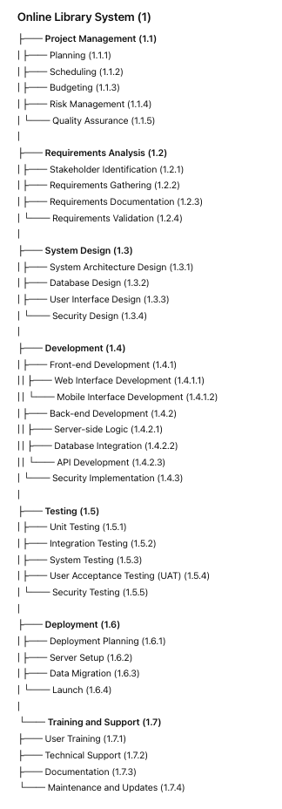

**Chapter:06 <<10 marks>>**

1. **Given the following project activities, durations, and dependencies, identify the critical path, calculate the total project duration, and determine the earliest and latest start and finish times for each activity:**

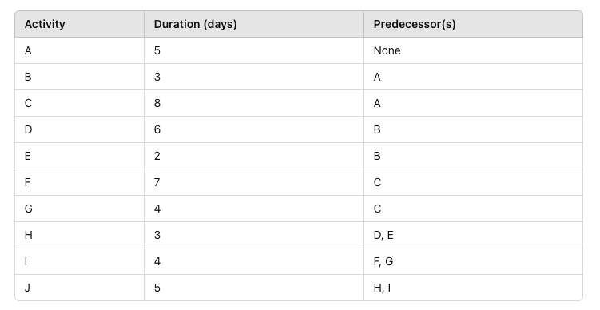

* **Draw the network diagram.**
* **Identify all possible paths from start to finish.**
* **Calculate the total duration of each path.**
* **Determine the critical path and its duration.**

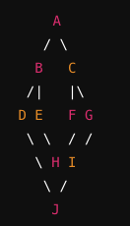

Critical Path: **A -> C -> F -> I -> J**

**Total Project Duration: 29 days**

1. **Using the PERT method, calculate the expected duration of an activity given the following time estimates:**

Optimistic time (O): 4 days

Most likely time (M): 7 days

Pessimistic time (P): 10 days

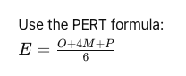

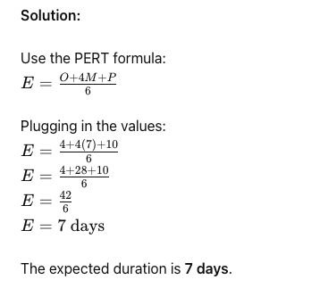

1. **Given the following project activities and their respective early start (ES), early finish (EF), late start (LS), and late finish (LF) times, calculate the total float for each activity:**

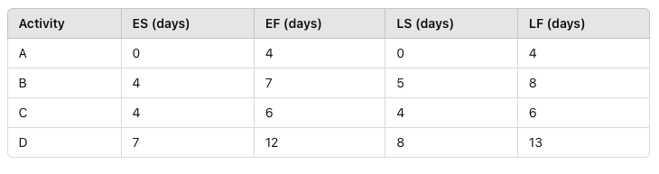

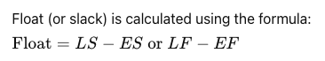

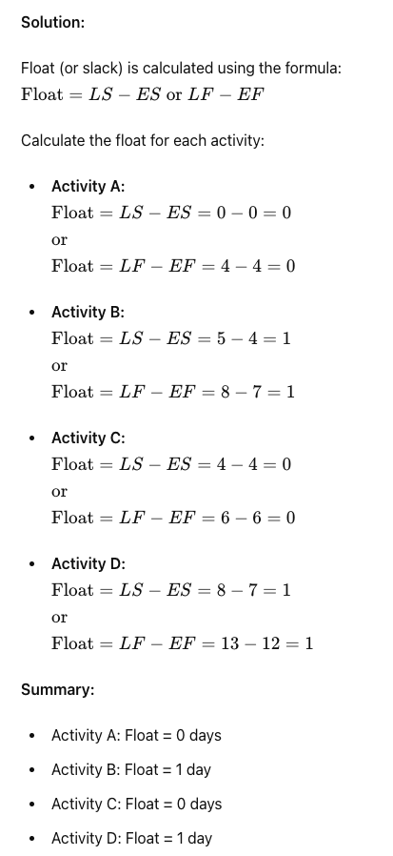

Chapter:07 <<5 /10 marks>>

1. **A project has a total budget (BAC) of $200,000 and is planned to last 10 months. At the end of the 5th month, the following data is available:**

Planned Value (PV): $100,000

Earned Value (EV): $90,000

Actual Cost (AC): $110,000

Calculate the following:

a) Schedule Variance (SV)

b) Cost Variance (CV)

c) Schedule Performance Index (SPI)

d) Cost Performance Index (CPI)

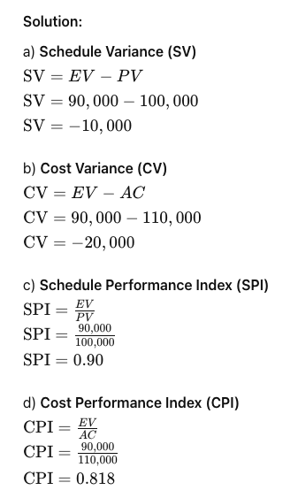

1. **Using the data from Question 1, calculate the following:**

a) Estimate at Completion (EAC) assuming the CPI remains the same.

b) Estimate to Complete (ETC) assuming the CPI remains the same.

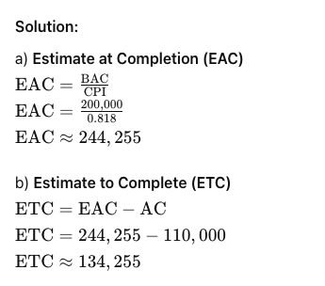

1. **You are managing a project that has the following cost-related data available:**

The total budget at completion (BAC) is $1,000,000.

The project is planned to last 18 months.

At the end of the 10th month, the actual cost (AC) incurred is $600,000.

The planned value (PV) at the end of the 10th month is $700,000.

The remaining work is expected to have a cost performance index (CPI) of 0.85.

The project has encountered unforeseen risks, requiring an additional $100,000 in risk mitigation measures moving forward.

Based on this data, calculate the following:

* 1. Estimate at Completion (EAC) assuming the CPI for the remaining work will be as given.
  2. Estimate to Complete (ETC) considering the additional $100,000 for risk mitigation.
  3. To-Complete Performance Index (TCPI) required to achieve the BAC.
  4. New Budget at Completion (BAC) if the additional $100,000 is included in the project budget.
  5. To-Complete Performance Index (TCPI) required to achieve the new BAC

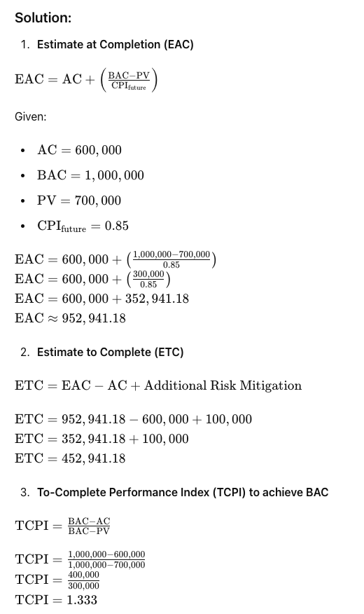

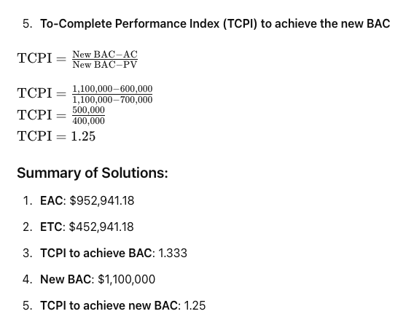

Chapter:11

1. **List common sources of risks on IT projects.**

**Technical Risks:** Inadequate technology, system failures, software bugs.

**Project Management Risks:** Poor planning, unclear requirements, scope creep.

**Organizational Risks:** Resource availability, organizational changes, stakeholder conflicts.

**External Risks:** Regulatory changes, market fluctuations, vendor reliability.

**Security Risks:** Data breaches, cyber-attacks, compliance issues.

**列出IT项目中的常见风险来源。**

**技术风险：** 技术不足、系统故障、软件漏洞。

**项目管理风险：** 规划不当、需求不明确、范围蔓延。

**组织风险：** 资源可用性、组织变更、利益相关者冲突。

**外部风险：** 法规变化、市场波动、供应商可靠性。

**安全风险：** 数据泄露、网络攻击、合规问题。

1. **What are the key elements of planning risk management?**

**Risk Management Plan:** Defines how to approach, plan, and execute risk management activities.

**Risk Identification:** Process of identifying risks that might affect the project.

**Risk Analysis:** Qualitative and quantitative methods to analyze risks.

**Risk Response Planning:** Strategies to enhance opportunities and reduce threats.

**Risk Monitoring and Control:** Tracking identified risks, monitoring residual risks, identifying new risks, and evaluating risk process effectiveness.

**风险管理规划的关键要素是什么？**

**风险管理计划：** 定义如何进行风险管理活动的方法、计划和执行。

**风险识别：** 识别可能影响项目的风险的过程。

**风险分析：** 使用定性和定量方法分析风险。

**风险应对规划：** 增强机会和减少威胁的策略。

**风险监控和控制：** 跟踪已识别的风险，监控残留风险，识别新风险，并评估风险过程的有效性。

Chapter:12

1. **Discuss how to conduct procurements and strategies for obtaining seller responses, selecting sellers, and awarding contracts.**

**Conducting procurements involves the following steps:**

**Obtaining Seller Responses: This includes creating and distributing Request for Proposals (RFPs), Request for Quotations (RFQs), and Invitations for Bid (IFBs). Strategies to encourage responses include clear communication, competitive bidding, and leveraging existing networks.**

**Selecting Sellers: Evaluation of seller responses against the source selection criteria is performed. This may involve scoring models, expert judgment, and multi-criteria analysis to ensure a fair and thorough selection process.**

**Awarding Contracts: Once a seller is selected, contract negotiations are conducted to finalize terms and conditions. The contract is then formally awarded, and both parties sign the agreement to commence the project work.**

**讨论如何进行采购以及获得卖方响应、选择卖方和授予合同的策略。**

进行采购包括以下步骤：

**获取卖方响应：**这包括创建和分发请求建议书（RFP）、请求报价（RFQ）和招标邀请（IFB）。鼓励响应的策略包括清晰的沟通、竞争性投标和利用现有网络。

**选择卖方**：根据源选择标准评估卖方响应。这可能涉及评分模型、专家判断和多标准分析，以确保公平和彻底的选择过程。

**授予合同：**一旦选择了卖方，进行合同谈判以确定条款和条件。然后正式授予合同，双方签署协议以开始项目工作。

Scrum (15 marks)

**Question: What is Scrum and how does it benefit project management?**

**Answer:**

Scrum is an Agile framework for managing complex projects, typically software development. It promotes an iterative, incremental approach to optimize predictability and control risk. Scrum is well-regarded for its flexibility, collaborative nature, and ability to deliver high-value products to customers efficiently.

**Overview of Scrum:** Scrum divides projects into time-boxed iterations called "Sprints," usually lasting two to four weeks. Each Sprint aims to produce a potentially shippable product increment. The framework includes defined roles, events, and artifacts to guide the process.

**Key Roles:**

1. **Product Owner:** The Product Owner represents stakeholders and is responsible for maximizing the product's value. They manage the Product Backlog, ensuring it is clear, prioritized, and conveys what is needed for the product.
2. **Scrum Master:** The Scrum Master facilitates the process, helps remove impediments, and ensures the team adheres to Scrum practices. They act as a coach, supporting the team in self-organization and continuous improvement.
3. **Development Team:** This is a cross-functional group responsible for delivering the product increment. They self-organize to decide how to accomplish the work within a Sprint.

**Core Events:**

1. **Sprint Planning:** The team collaborates to define what can be delivered in the upcoming Sprint and how to achieve it. The Product Owner presents prioritized items from the Product Backlog, and the team selects those they commit to completing.
2. **Daily Scrum:** A short, daily meeting where team members synchronize their work and plan for the next 24 hours. Each member answers three questions: What did I do yesterday? What will I do today? Are there any impediments?
3. **Sprint Review:** At the end of each Sprint, the team demonstrates the increment to stakeholders, gathers feedback, and discusses what to do next. This ensures continuous alignment with stakeholder needs and expectations.
4. **Sprint Retrospective:** The team reflects on the Sprint, identifying what went well, what could be improved, and how to enhance their processes. This fosters a culture of continuous improvement.

**Scrum Artifacts:**

1. **Product Backlog:** An evolving list of product requirements ordered by priority. The Product Owner manages it, ensuring it reflects the current needs and goals of the project.
2. **Sprint Backlog:** A list of tasks the Development Team commits to completing during the Sprint. It includes selected items from the Product Backlog and a plan for delivering them.
3. **Increment:** The sum of all completed Product Backlog items at the end of a Sprint, representing a potentially shippable product.

**Benefits of Scrum:**

1. **Flexibility and Adaptability:** Scrum's iterative nature allows for frequent reassessment and adaptation of plans based on feedback and changing requirements.
2. **Improved Collaboration:** The defined roles and regular meetings foster better communication and collaboration among team members and stakeholders.
3. **Enhanced Transparency:** Scrum's emphasis on visibility ensures all stakeholders are aware of the project's progress, risks, and any issues.
4. **Faster Delivery:** By focusing on delivering small increments of value, Scrum enables quicker releases, allowing for faster feedback and adjustment cycles.
5. **Continuous Improvement:** Regular retrospectives promote a culture of learning and improvement, helping teams to enhance their processes continuously.

In conclusion, Scrum is a powerful framework that supports Agile principles, enabling teams to manage complex projects efficiently. By emphasizing collaboration, flexibility, and continuous delivery of value, Scrum helps organizations respond swiftly to changes and deliver high-quality products that meet customer needs.

**问题：什么是 Scrum，它如何有助于项目管理？**

**回答：**

Scrum 是一种用于管理复杂项目的敏捷框架，通常用于软件开发。它提倡一种迭代、增量的方法，以优化可预测性并控制风险。Scrum 因其灵活性、协作性和高效交付高价值产品的能力而备受推崇。

**Scrum 概述：** Scrum 将项目划分为称为“冲刺”的时间盒迭代，通常持续两到四周。每个冲刺的目标是生产一个可交付的产品增量。该框架包括定义的角色、事件和工件，以指导整个过程。

**关键角色：**

1. **产品负责人 (Product Owner)：** 产品负责人代表利益相关者，负责最大化产品的价值。他们管理产品待办事项列表，确保其清晰、优先排序并传达产品需求。
2. **Scrum Master：** Scrum Master 促进过程，帮助消除障碍，确保团队遵循 Scrum 实践。他们充当教练，支持团队自组织和持续改进。
3. **开发团队 (Development Team)：** 这是一个跨职能团队，负责交付产品增量。他们自组织决定如何在冲刺内完成工作。

**核心事件：**

1. **冲刺规划 (Sprint Planning)：** 团队协作定义在即将到来的冲刺中可以交付的内容以及如何实现。产品负责人展示优先级排序的产品待办事项，团队选择承诺完成的项目。
2. **每日 Scrum (Daily Scrum)：** 每日简短会议，团队成员同步工作并计划接下来24小时的工作。每个成员回答三个问题：昨天我做了什么？今天我将做什么？有没有任何障碍？
3. **冲刺评审 (Sprint Review)：** 每个冲刺结束时，团队向利益相关者展示增量产品，收集反馈，并讨论接下来的工作。这确保了与利益相关者需求和期望的持续对齐。
4. **冲刺回顾 (Sprint Retrospective)：** 团队反思冲刺，找出做得好的地方、可以改进的地方以及如何优化流程。这促进了持续改进的文化。

**Scrum 工件：**

1. **产品待办事项列表 (Product Backlog)：** 一个不断发展的产品需求列表，按优先级排序。产品负责人管理它，确保它反映项目的当前需求和目标。
2. **冲刺待办事项列表 (Sprint Backlog)：** 开发团队承诺在冲刺期间完成的任务列表。包括从产品待办事项列表中选定的项目和交付它们的计划。
3. **增量 (Increment)：** 每个冲刺结束时所有完成的产品待办事项的总和，代表一个可交付的产品。

**Scrum 的优势：**

1. **灵活性和适应性：** Scrum 的迭代性质允许根据反馈和变化的需求频繁重新评估和调整计划。
2. **改进的协作：** 定义的角色和定期会议促进了团队成员和利益相关者之间更好的沟通与协作。
3. **增强的透明性：** Scrum 强调可见性，确保所有利益相关者了解项目的进展、风险和任何问题。
4. **更快的交付：** 通过专注于交付小型增量价值，Scrum 使得更快速的发布成为可能，从而允许更快的反馈和调整周期。
5. **持续改进：** 定期的回顾促进了学习和改进的文化，帮助团队不断优化他们的流程。

总之，Scrum 是一个支持敏捷原则的强大框架，使团队能够高效地管理复杂项目。通过强调协作、灵活性和持续交付价值，Scrum 帮助组织快速响应变化并交付满足客户需求的高质量产品。