**Задание 1.**

a)

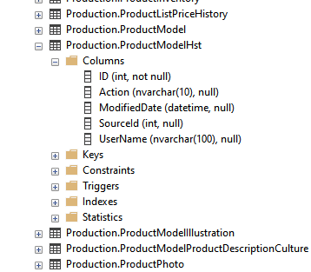

b)

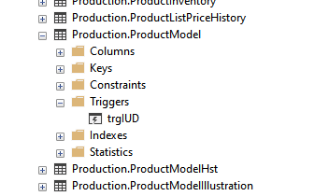

c)

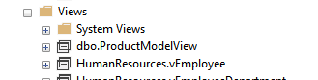

d)

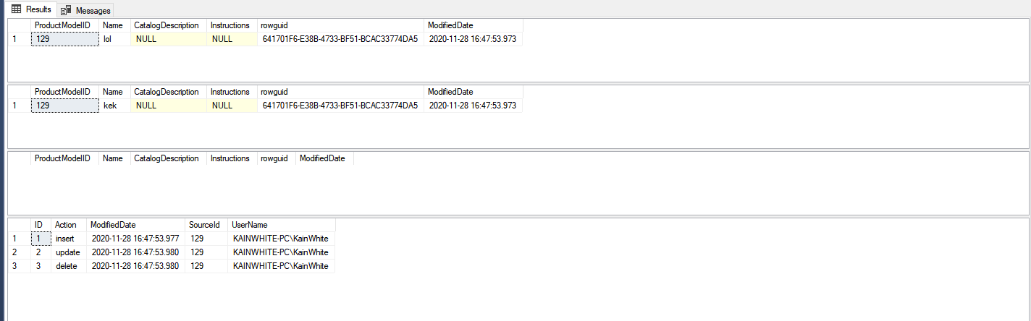

select * from Production.ProductModelHst;

delete from ProductModelView where [Name] = 'kek';

select * from ProductModelView where [Name] = 'kek';

update ProductModelView set [Name] = 'kek' where [Name] = 'lol';

select * from ProductModelView where [Name] = 'kek';

insert into ProductModelView ([Name]) values ('lol');

select * from ProductModelView where [Name] like 'lol';

**Задание 2.**

a), b)

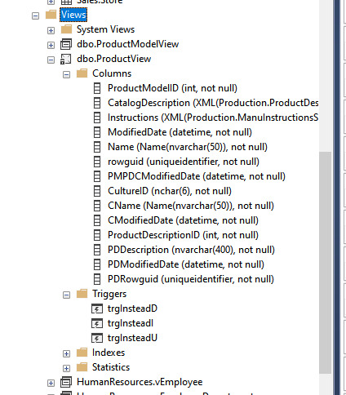

c)

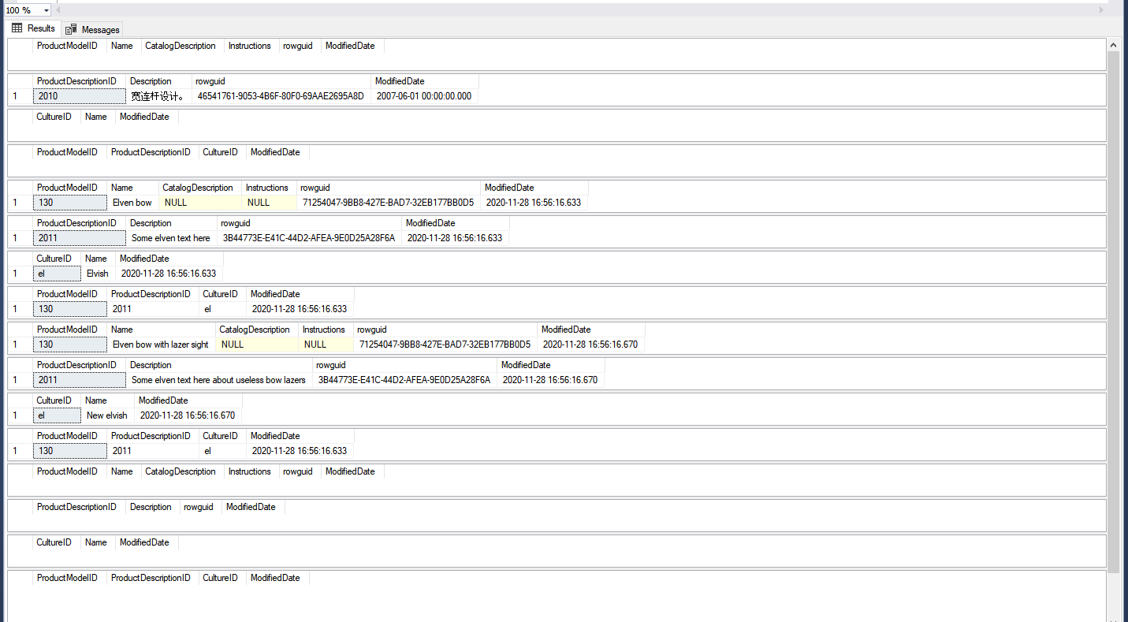

**Selects after delete**

**Selects after update**

Selects before operations

**Selects after insert**