1. Созданные scalar-valued и table-valued функции

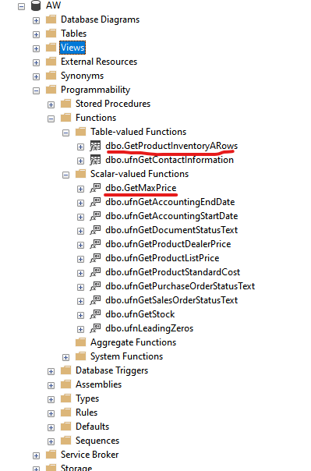

1. Применение функции с cross apply и outer apply

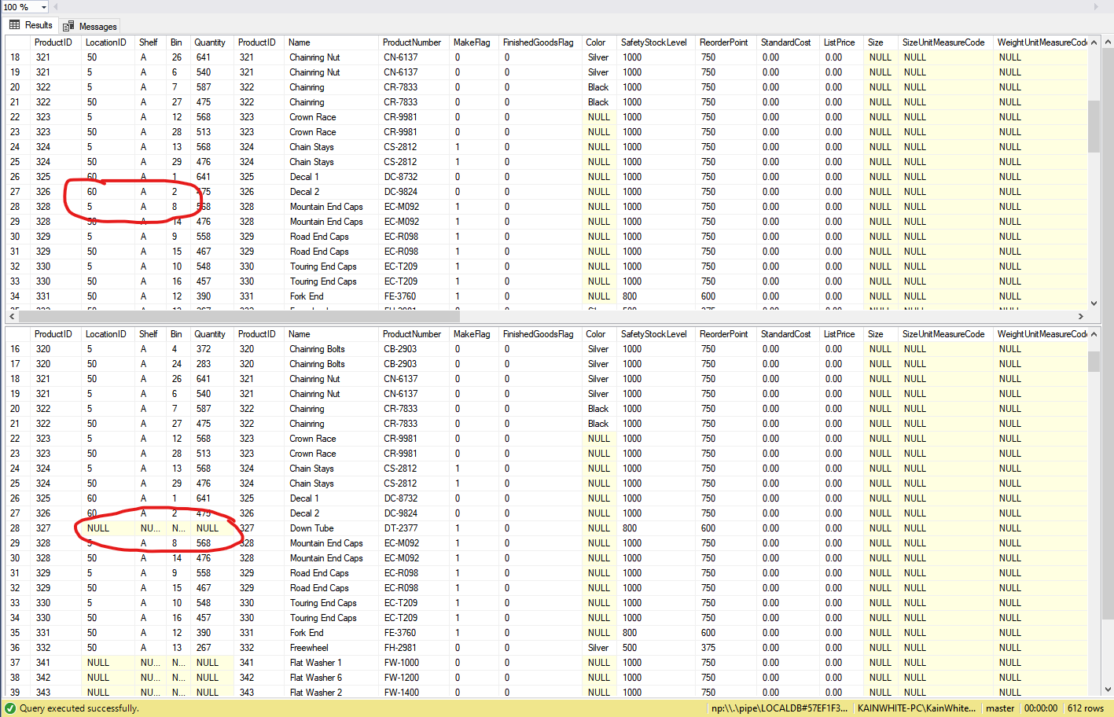

select

p.ProductID,

LocationID,

Shelf,

Bin,

Quantity,

*

from Production.Product p

outer apply dbo.GetProductInventoryARows(ProductID, 2);

select

p.ProductID,

LocationID,

Shelf,

Bin,

Quantity,

*

from Production.Product p

cross apply dbo.GetProductInventoryARows(ProductID, 2);

1. Код преобразования в multistatement table-valued функцию:

if object_id('dbo.GetProductInventoryARows') is not null drop function dbo.GetProductInventoryARows;

go

create function dbo.GetProductInventoryARows(@productId int, @rowCount int)

returns @productInventoryARows table (

ProductId int,

LocationId smallint,

Shelf nvarchar(10),

Bin tinyint,

Quantity smallint,

rowguid uniqueidentifier,

ModifiedDate datetime)

as

begin

insert into @productInventoryARows

select top (@rowCount) *

from Production.ProductInventory

where ProductID = @productId and Shelf = 'A'

order by Quantity desc;

return;

end;

go