Q2 Weather Recognition
For Image classification problem, it is always the prior choice to use a well pretrained model(typically on Imagenet) to fine-tuning on our datasets. Therefore, I choose the ResNet34 as my backbone and add a 3-layer MLP linear protocol to perform the downstream tasks.

Design of DataLoader
Firstly, I create a Q2Dataset object which is the sub object of the torch.utils.data.Dataset. During the construction, I first used the regular expression to extract the labels hided in the file name. Then I converted the label into the one-hot encoding label for subsequent classification process.

Then, I use the PIL library which is very suitable for image processing to load the image and convert them into PIL Image format. After that, I use torchvision.transforms to do some image augmentation(Like random rotation) and convert all the PIL Image into Pytorch Tensor. Notice that I resized all the Image to (255,255) with respect to height and width of the iamge. And there is no image augmentation for the data in the test datasets(when testing on train dataset in our case)

Finally, we can get our DataLoader. We do the shuffle operation during training to avoid the order of the image becoming a feature. Batch size is set to 16, and use 2 workers to load the data.

Below is the screen shot of my DataLoader and Dataset.
DataLoader:
Dataset
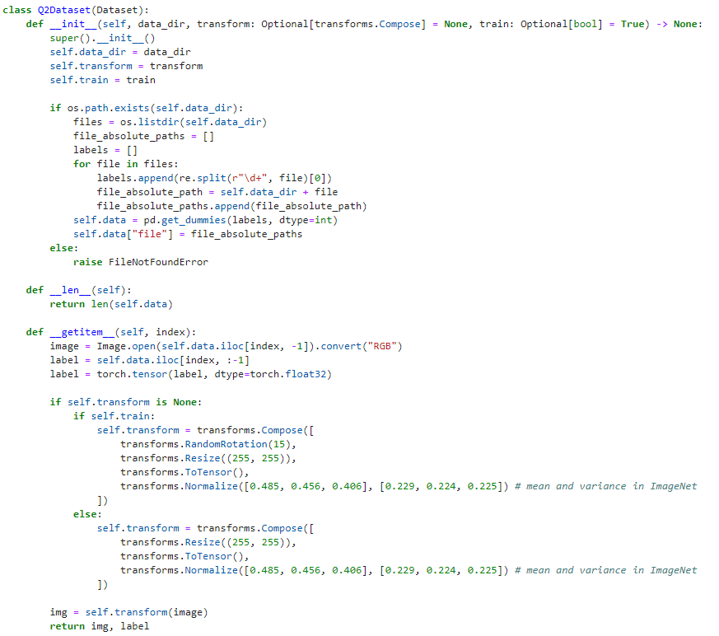

Design of Model
I use the ResNet34 as my backbone to extract the features of image and project it into the embedding layer and use a 3-layer MLP as a linear protocol to deal with the classification problem.

ResNet34 is easy with bunch of Convolution layers and use the skip connnection in each block. The benefit of this design is that it can avoid gradient vanishing which allows us to optimize and train a much deeper network.

The 3-layer MLP is also very simple. Each Linear block contains a linear projection layer, a batch normalization layer and a ReLU activation layer. With 3 linear blocks, we can learn a non-linear mapping to the output space.

Here is the screenshot of my network architecture:
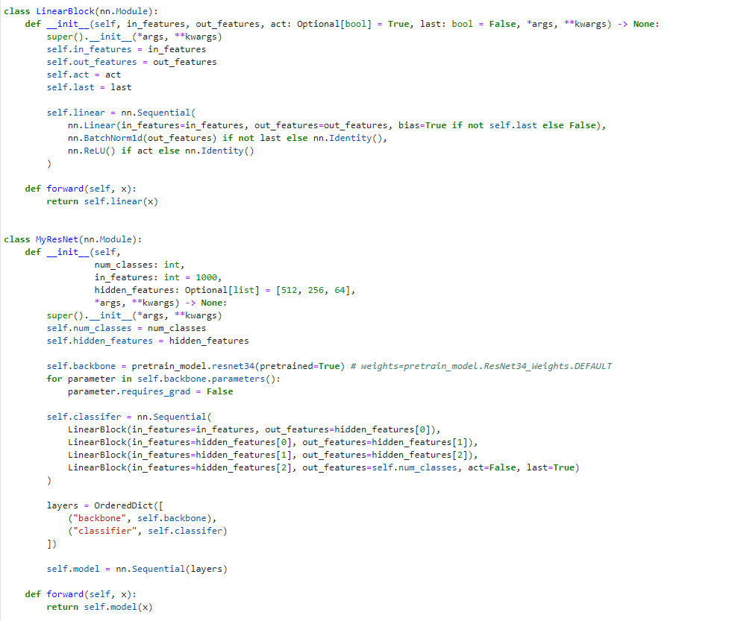

Training process and Result
I carefully tuned the hyper paramters, and I found that it is important to have a proper leanring rate. In this case, I set the learning rate to 3e-5 and reach 98% accuracy on the training dataset.
Here is the screen shot of my process and results.
