Q4 Recommendation and Business Analysis
To get a better and comprehensive insight into the retail supermarket, we should first do some Data Exploration to provide a summary of the dataset, including its basic statistics.

Data Exploration
From the table and the summary information, we can find that there are some missing values in the dataset.
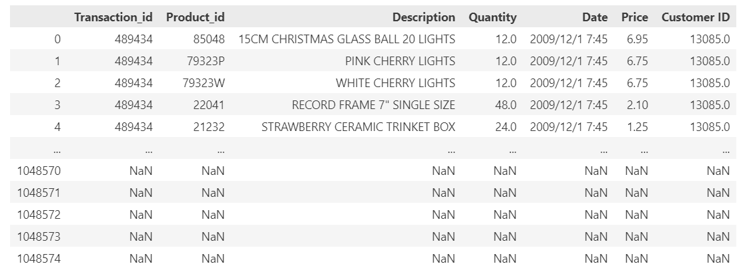
Figure 1 Overview of the data

We simply drop all the samples with missing values and get a complete dataset. And we can also find there are some outliers in the data, for example: the quantity and the price should not have negative value.
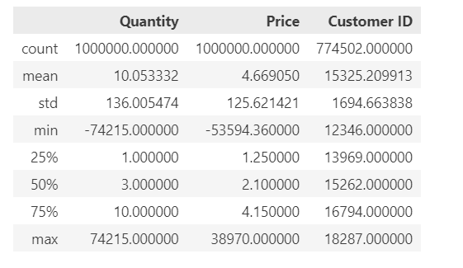
Figure 2 Outlier Detection
After remove all the anomalies, we can get a normal one as below:
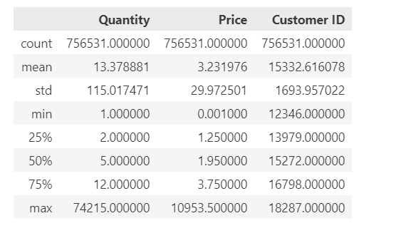
Figure 3 Normal Data

Visualization and BA

Customer Side
For a supermarket or any business, customer loyalty is essentially important. We can analysis the relationship of number of transactions per customer and their corresponding frequency and draw a bar plot.
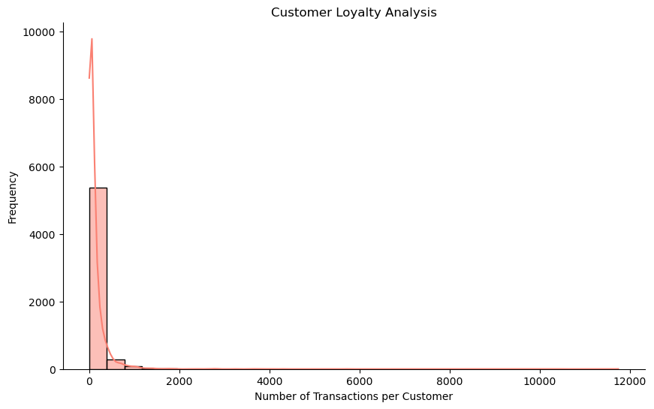
Figure 4 Customer Loyalty
Repeat customer and big spenders are also very important to a supermarket because they can contribute a significant portion of the profits.

We analysis top10 customers by transaction amount and number of repeat purchases and give the plots as below:
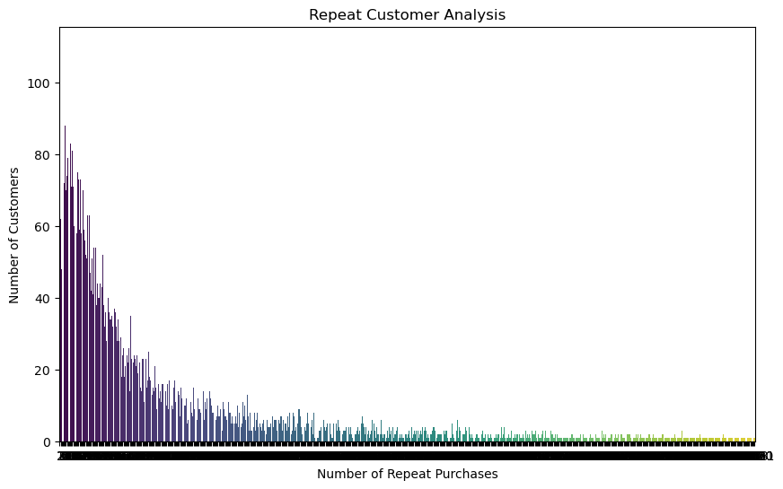
Figure 5 Repeat Customer Analysis
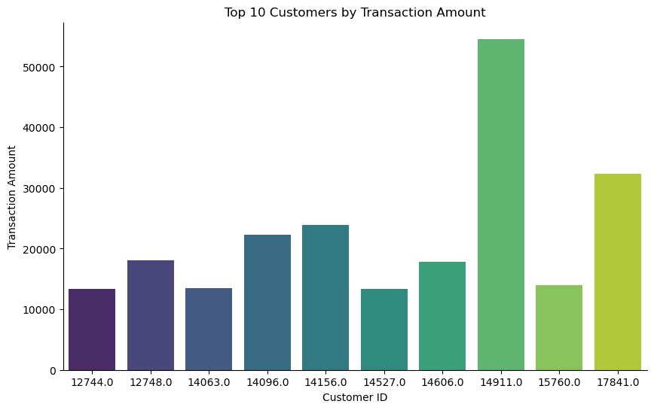
Figure 6 Top10 customers by transaction amount

Product side
Products are the key to the success of a business, supermarkets are no exception, how to introduce goods according to the sales volume and customer preferences is also an important factor in the success of running a good supermarket.

Therefore, we analyze the product metrics from different perspectives as follows:
Firstly, we analyze the distribution of the product prices and find that most of the product price are below 100, which consistent with our common sense.
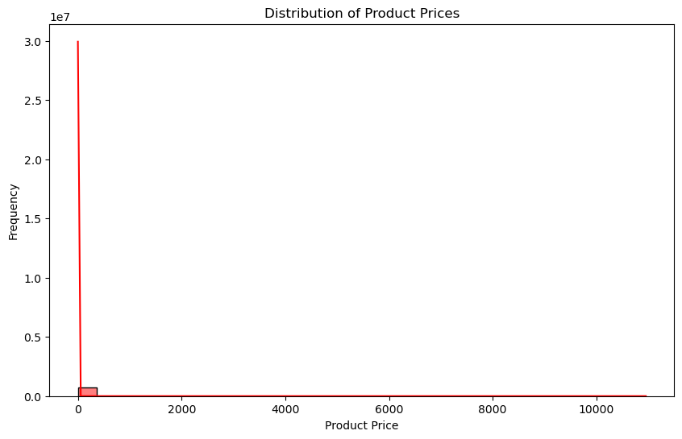
Figure 7 Distribution of Product Price
We also analyze the best selling products by quantity and their contribution to the sale
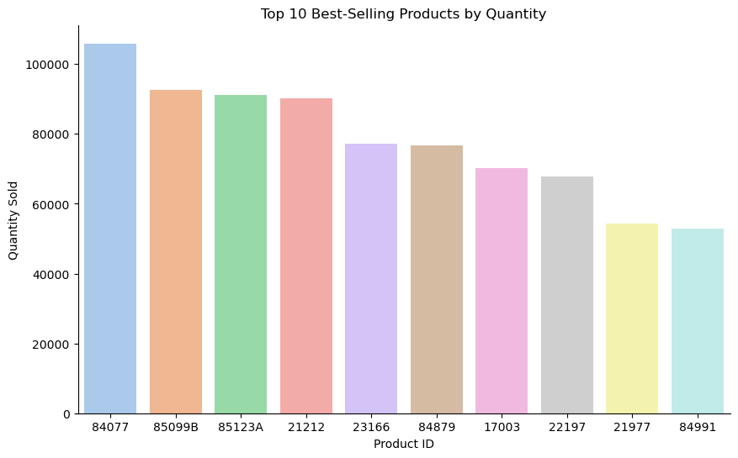
Figure 8 Best-selling products
The best selling products is product with id: 84077. But product 84077 is cheap, it is not the most major contribution to the total sale.
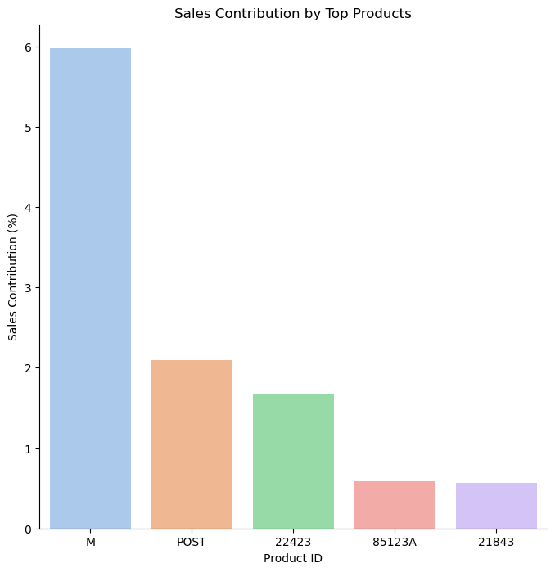
Figure 9 Sales Contribution by Top Products
The sales volume of a product is also related to the season, and we analyzed the relationship between some products and the season.
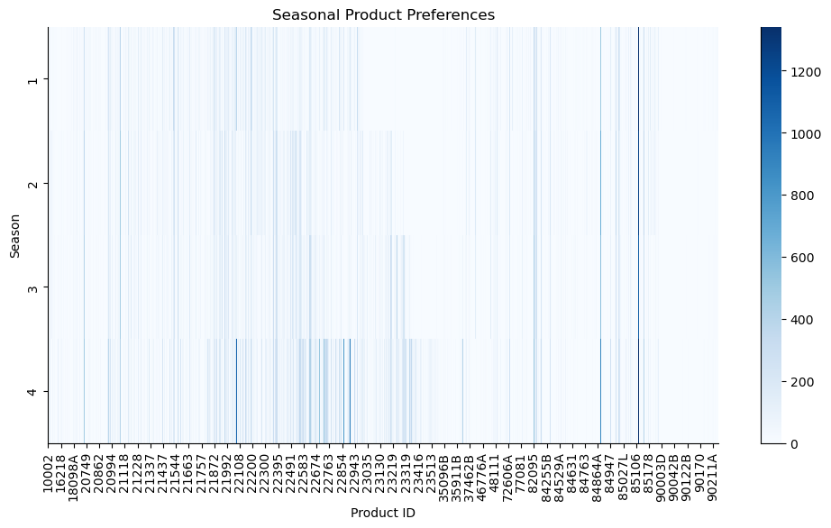
Figure 10 Seasonal Product Preferences
We can see products like 22108 is higly related to the season which means we don’t need to introduce it in the other seasons.

Sales and Price
Here we show the relationship between the quantity of a good purchased and its price
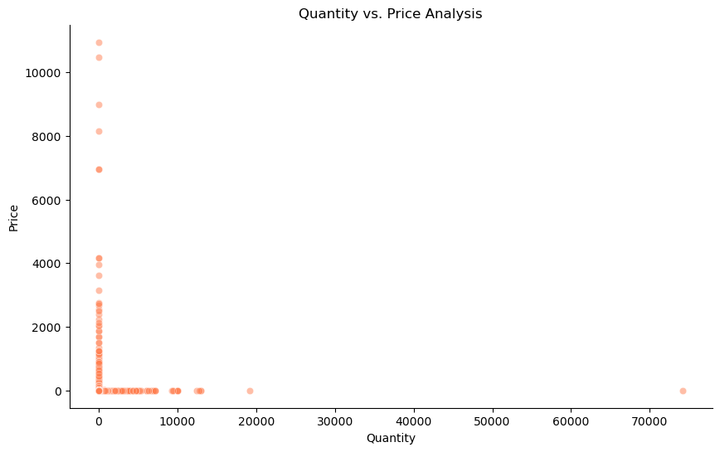
Figure 11 Quantity and Price Analysis
It can be seen that items purchased in high volumes are usually less expensive, items purchased in low volumes are more expensive, and there are also items purchased in low volumes that are less expensive, and these items are usually not essential for everyday life

We also show how this store's sales relate to the time of day as below:
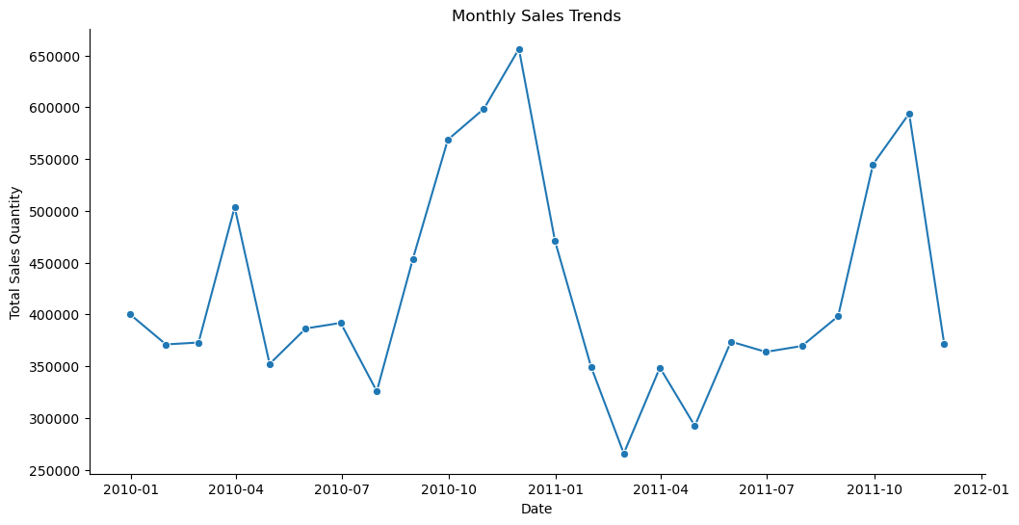
Figure 12 Monthly Sales Trends
In 2010-10 to 2011-3, there were large fluctuations in sales

Association Rule Analysis
In this task, I use FP-Tree to analyze the transaction sets. Unlike Apriori, FP-Growth does not generate candidate itemsets explicitly, which reduces the number of passes over the data. And also FP-Growth is known for its efficiency, especially in scenarios with large datasets and a large number of frequent itemsets. This is really important and let me choose this algorithm. With the minimum support 0.01, we can get the result as below:
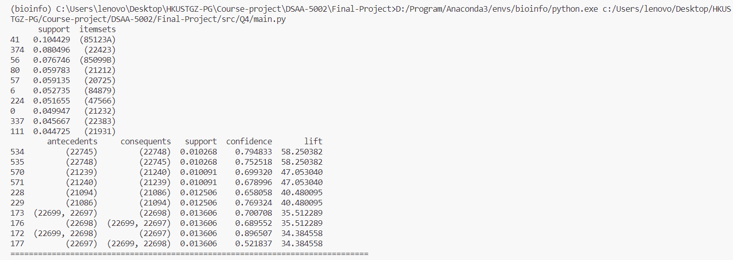
When arranging items, these items can be placed together:
- (22745) (22748)
- (21239) (21240)
- (21094) (21086)
- (22699, 22697) (22698)
At the same time, introduce more of the following products:
(85123A, 22423, 85009B, 21212)

