Q7 Social Media Network Analysis
Task 1: Calculate and plot the clustering coefficient and degree distribution of the network.
The coefficient os 0.0808
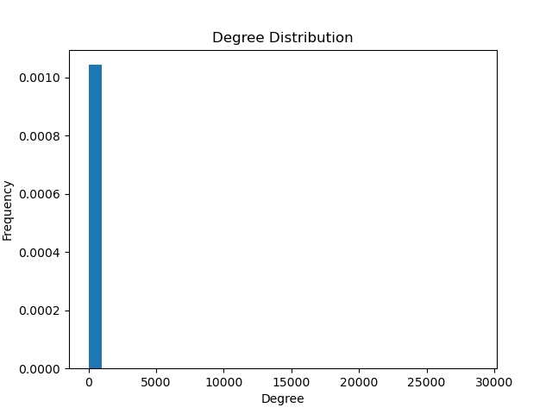
Task2: Identify the most influential nodes in a network and analyze them. Use centrality metrics such as degree centrality and visualization
Top 10 Influential Nodes: ['1072', '363', '35661', '106', '482709', '663931', '929', '808', '27837', '108624']

Task3: Identify Isolated Nodes in the network and Recognize Connected Components in the Network
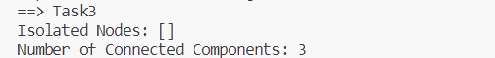
The number of connected components are 3

Task4: Calculate Average shortest path Length of the network
Task5: Calculate the Diameter of the network
Task6: Detect Community Structures in the Network. Please employ community detection algorithms (e.g., Louvain algorithm) to find community structures within the network.

