**Exercise:**

Create Gantt Chart and Network Diagram in Microsoft Project with above mention projects.

* Social website like (Facebook, Twitter etc.)

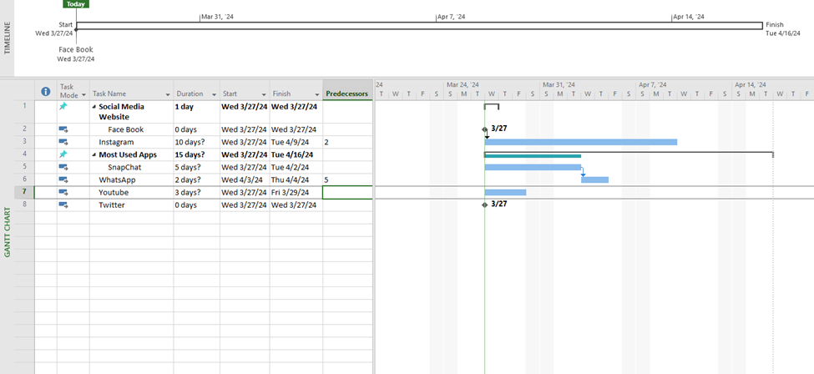

* Hospital Management System

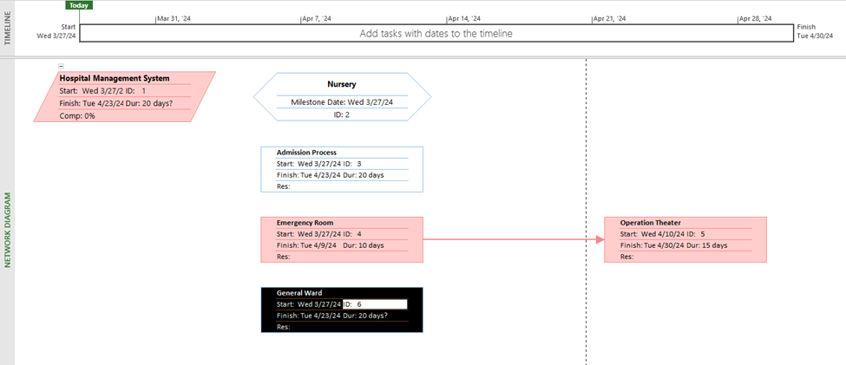

* Faculty Management System



