**LAB 1**

**1.1. OBJECTIVE**

Use MATLAB for mathematical computations and visualizations.

**1.3. EXERCISES**

**1.3.1. Task 01**

Compute the following. Use ℎ𝑒𝑙𝑝 if required. In all cases, take 𝑥 as your roll number.

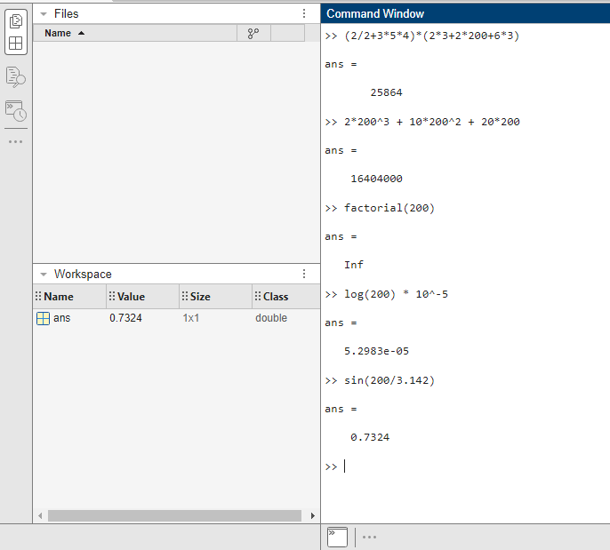

**1.3.2. Task 02**

Consider the following array. Give the MATLAB command and the output for the following.

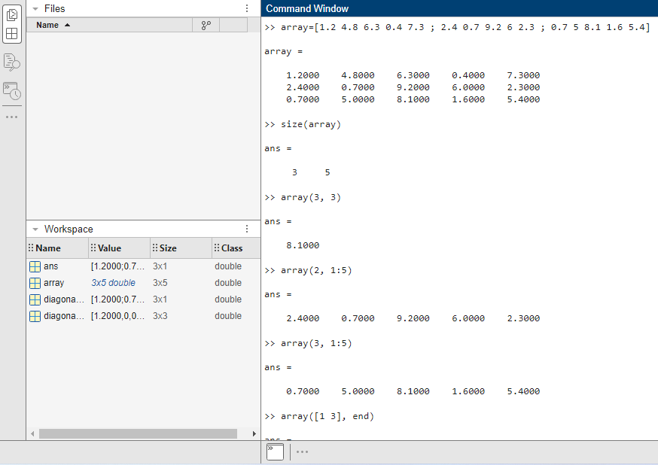

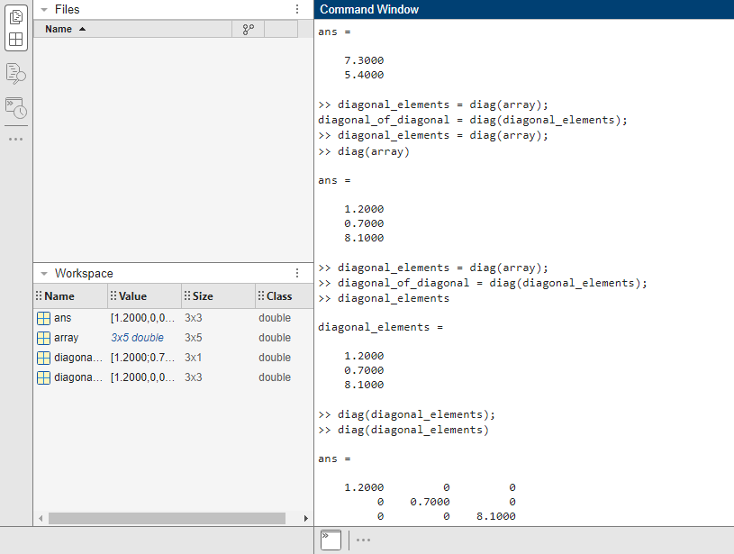







**1.3.3. Task 03**

Attach screenshots of your code and output.

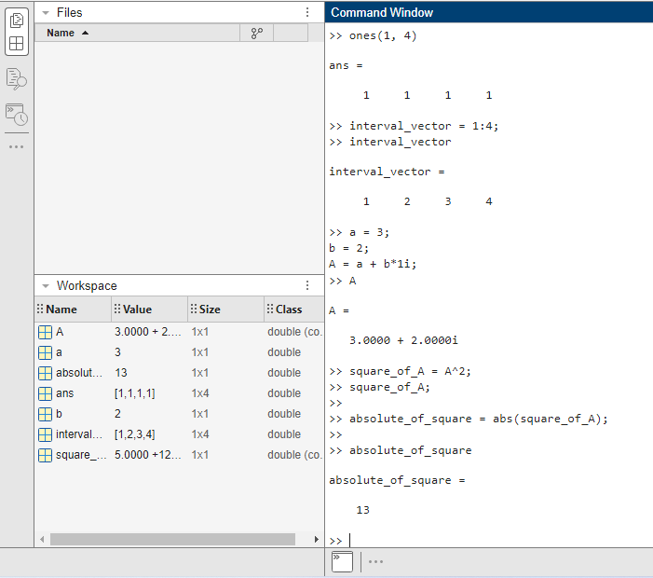

**1.3.4. Task 04**

Give the size and contents of the following. Attach screenshots of your code and output.

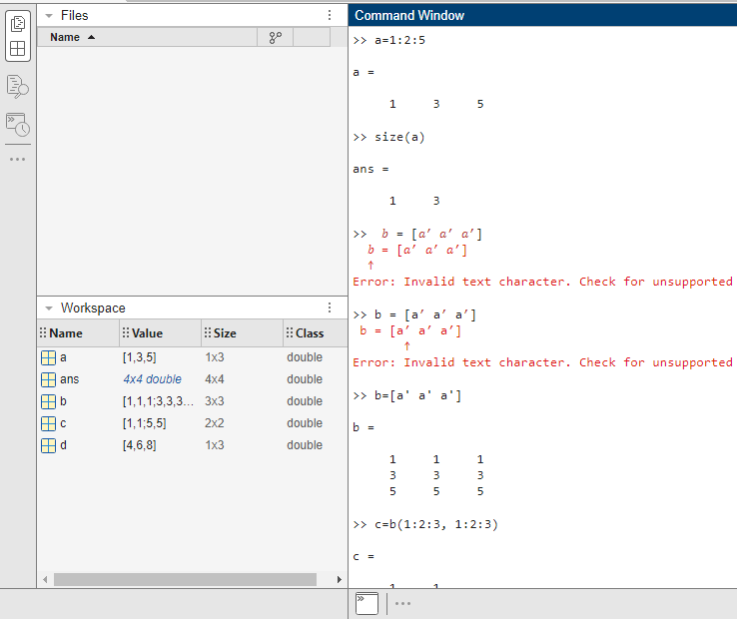



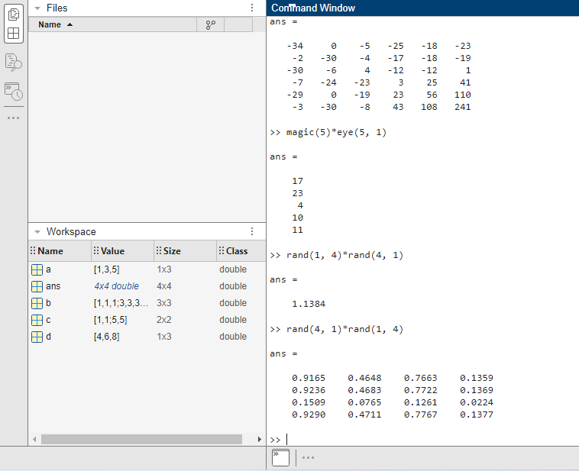

**1.3.5. Task 05**

Attach screenshots of your code and output.

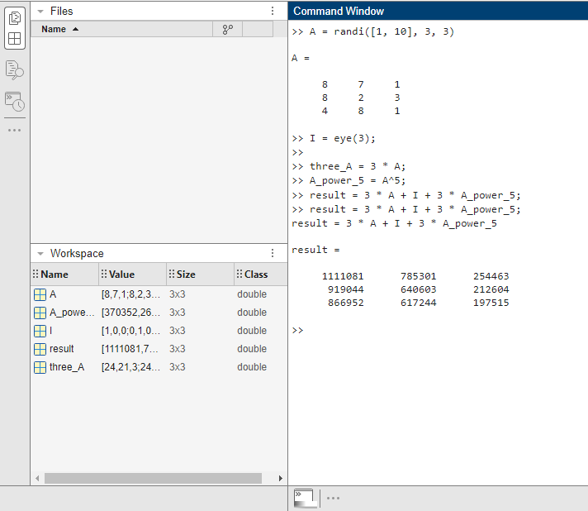

**1.3.6. Task 06**

Attach screenshots of your code and output.

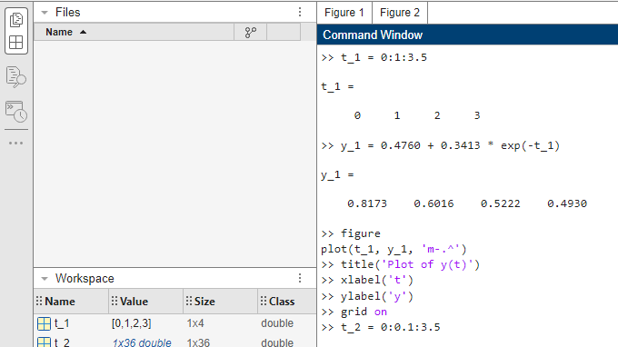

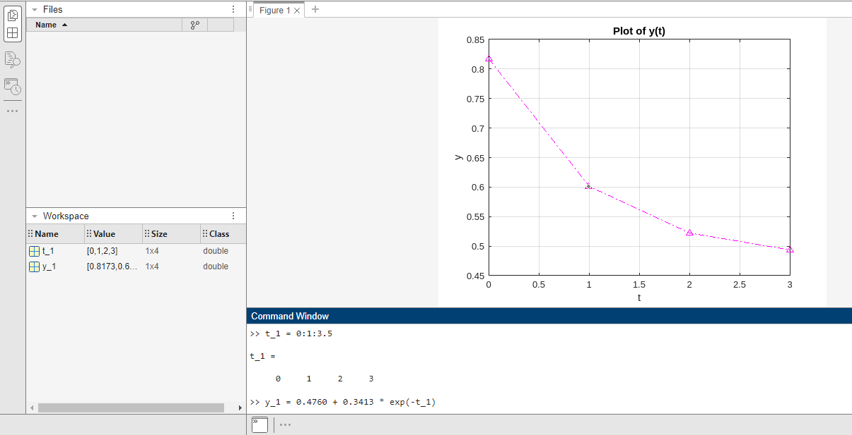

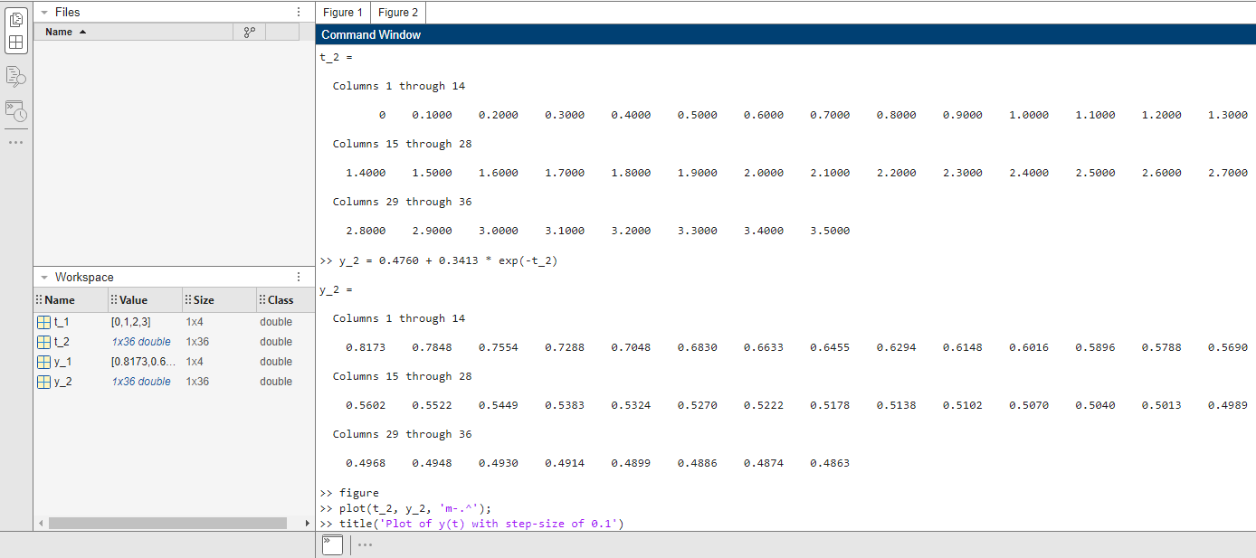



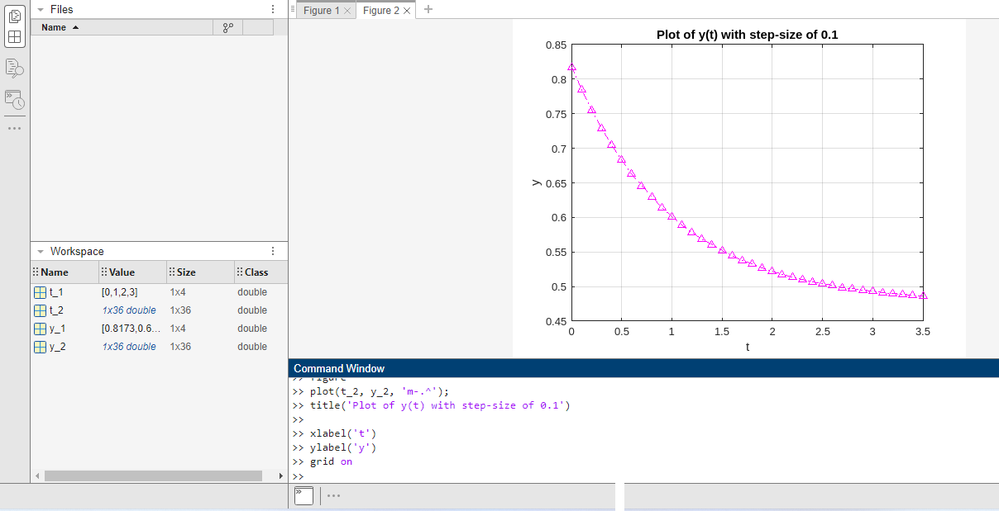

**1.3.7. Task 07**

Attach screenshots of your code and output.

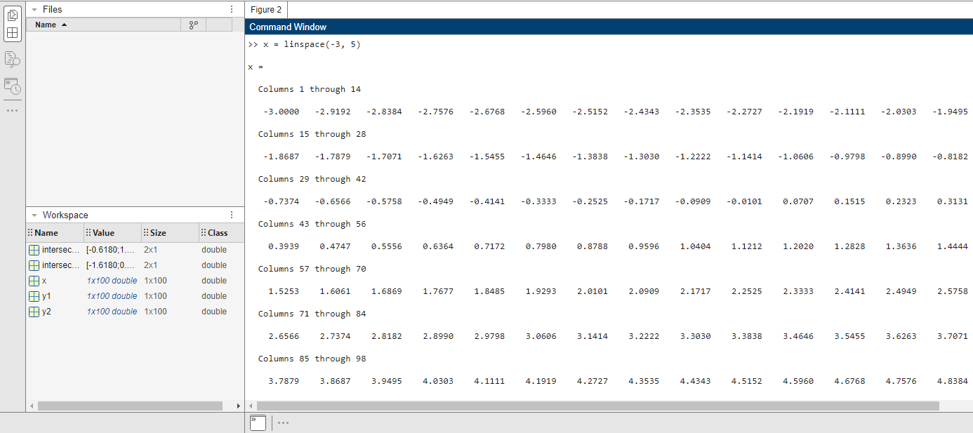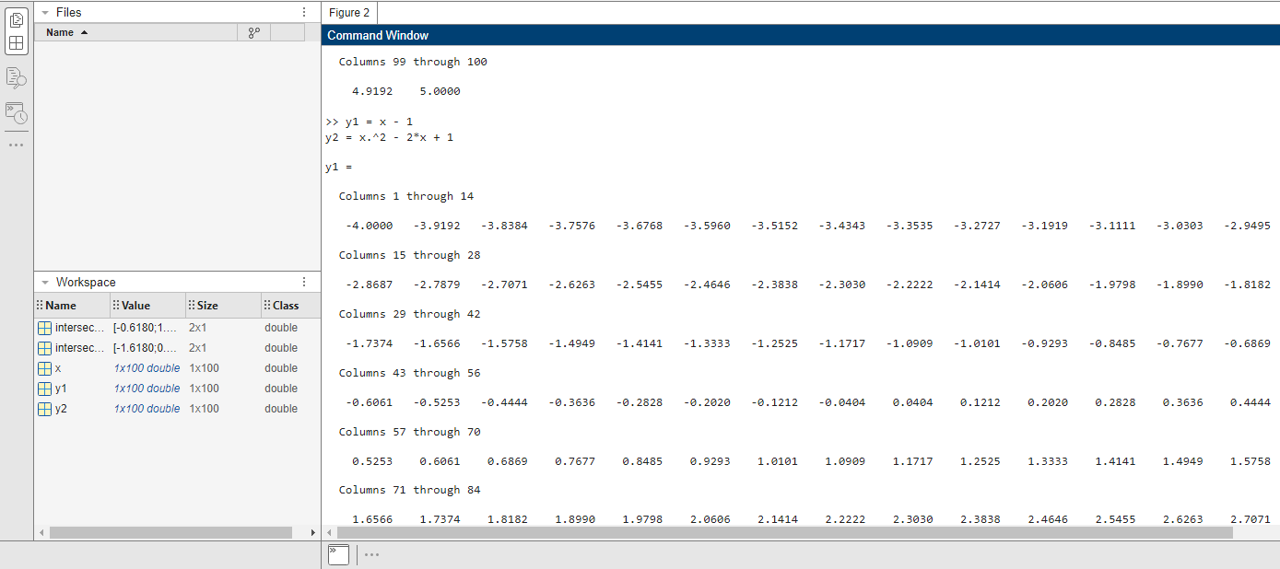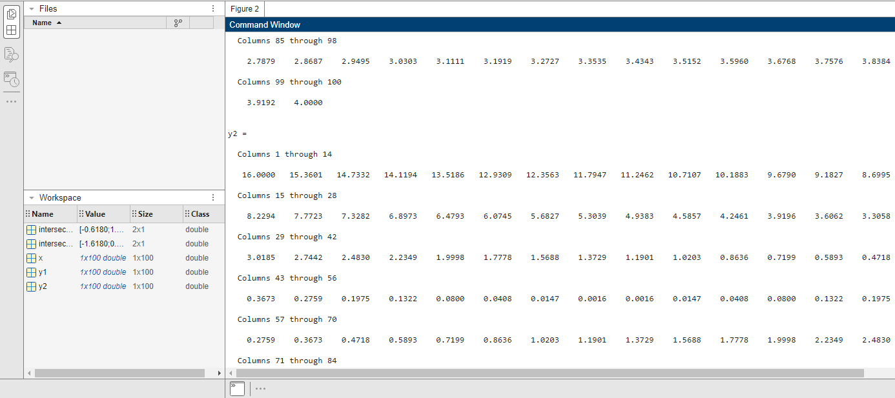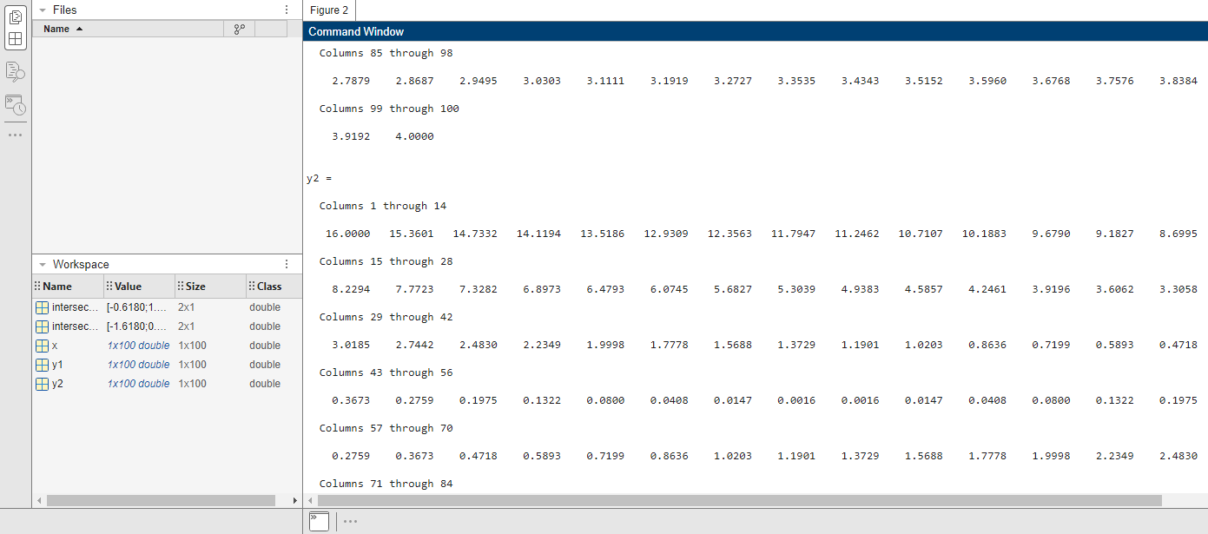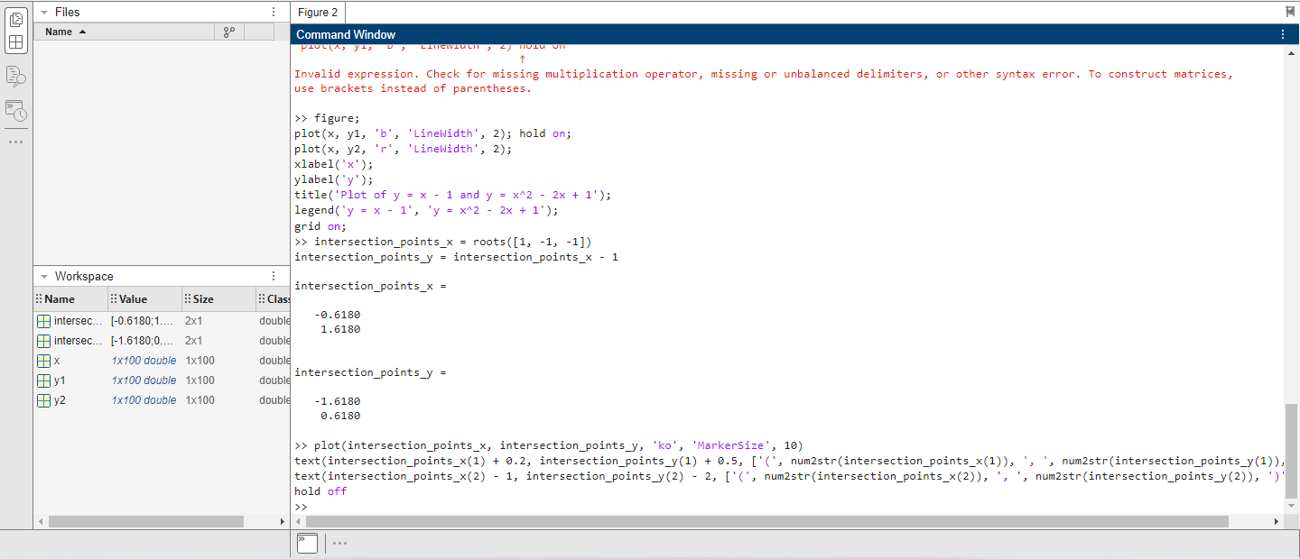

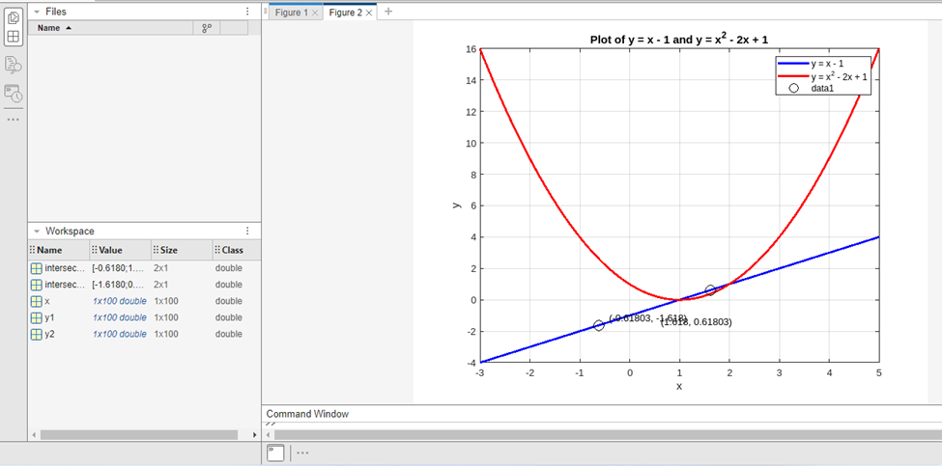

**1.3.8. Task 08**

Solve the following linear system of equations. Attach screenshots of your code and output.

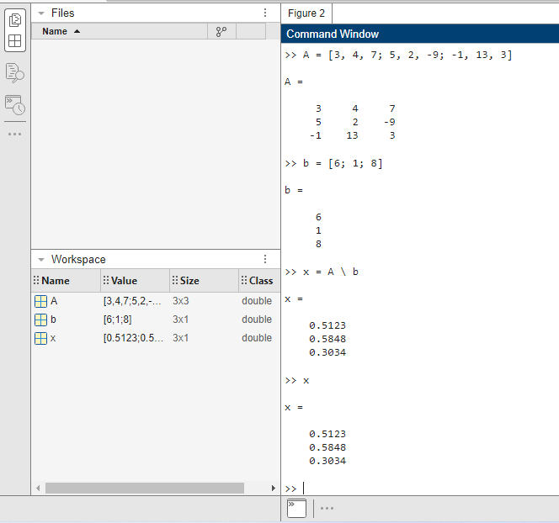

**1.3.9. Task 09**

Run the following code suppressing the output wherever necessary. Attach screenshots of your Code and output.

