Lab # 2

INTRODUCTION TO MIPS Assembly Language

**OBJECTIVE**

To **explain** the basics of MIPS Assembly language to the students.

**LAB TASK**

1. Write an assembly program that Print a string of characters.

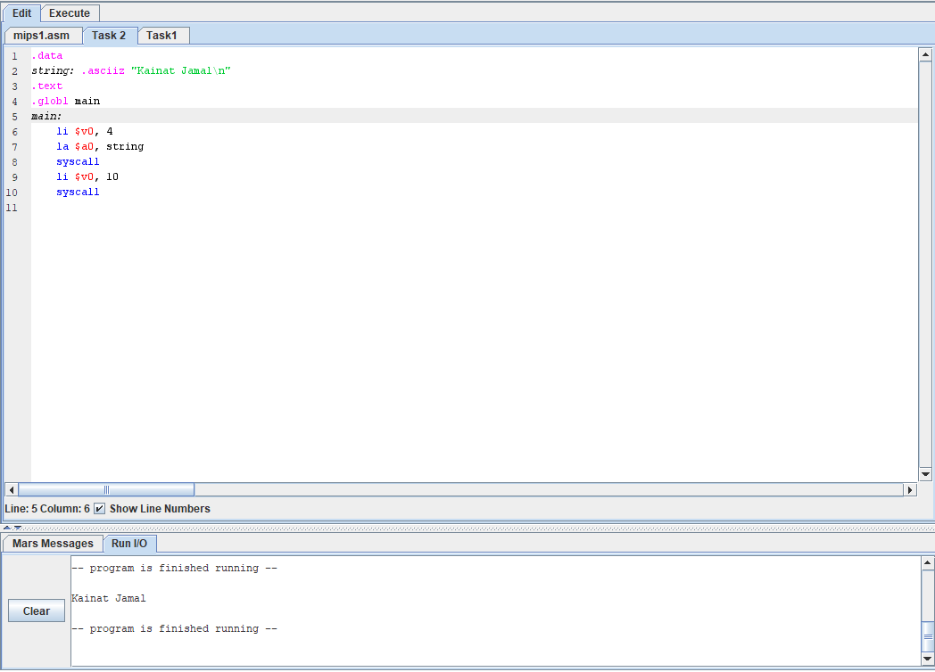

1. Write a program to prompt and read an integer from a user.

