GAME DESIGN DOCUMENT
Little Knight
A 2D Action Platformer

Game Title | Little Knight
Version | 1.0.0
Date | March 2026
Author / Team | Kainoah Vann
Engine | Unity 6 LTS
Platform(s) | PC (Windows / macOS)
Genre | 2D Platformer / Action
Status | Active Development

Version History

Date | Version | Changes Made
3/20/2026 | 1.0.0 | GDD Created

1. Project Info

Game Title | Little Knight
Author / Team | Kainoah Vann
Platform(s) | PC — Windows 10/11 & macOS 13+
Engine | Unity 6 LTS
Design Tools | GitHub (version control)
Art Tools | Itch.io Free Assets / Piskel Sprite Editor
Audio Tools | Itch.io Free Assets
Monetization | Academic Project

2. Game Overview & Vision

A. High Concept
Little Knight is a small 2D platformer where a new knight adventures through 3 different biomes with nothing but his lightning spell, fighting his way through enemies and dangerous terrain to get back home.

B. Game Summary
The player navigates through 3 levels with enemies, hazards, and difficult terrain with the goal to reach the end of all 3 levels. There are collectable coins as well as potential secret paths and shortcuts. The core gameplay loop is running, shooting enemies, collecting coins, and reaching the exit.

C. Player Journey Snapshot

First 10 Minutes
Player spawns in Level 01. The jumps are simple, and there are only a few enemies patrolling large areas, giving the player the option of shooting it or jumping over it. There are coins that lead the direction of adventure, and large gaps filled with water show that it must be avoided. The game is small, and the door to level 2 can be found quickly

Mid/Late-Game Session
After level 1, players already understand the core concept of the game. Platform patterns get more complicated, enemies are around every corner, and sometimes coins may be misleading you (or showing you a better path!)

D. Unique Selling Points (Game Pillars)
• Snappy Physics — Fall multiplier & low-jump tuning create 'game-feel' that rewards skillful input
• Reactive Camera — Cinemachine shake on hits, landings, and deaths adds physical weight to every action
• Simple-to-Learn Combat — Single fire button, directional Lightnings, instant enemy feedback
• Lives-Based Pressure — 3-life system with score persistence creates meaningful stakes without frustration

E. Target Audience
Fans of platformers looking for a short, fun game to fill that 2D platformer itch.

F. Genre & Inspirations
Title | Inspiration Element
Super Mario | Simple platformer consisting of jumping and patrolling enemies
Megaman | Platformer with simple combat

G. Tone, Look & Feel
Bright and vibrant pixel art. The tone is very upbeat, and even enemies are bright and happy. The game is overall very bright and happy to add to that simple, comforting platformer game

3. Core Gameplay Design

A. Core Gameplay Loop

Step | Action | Change | Reward
1 — Explore | Navigate tile platforms | New zones revealed | Sense of discovery
2 — Encounter | Enemies patrol paths | Threat introduced | Tension builds
3 — Fight | Shoot Lightnings / evade | Enemies eliminated | path opens
4 — Collect | Grab coins (100 pts each) | Score increases | Satisfaction
5 — Progress | Reach level exit trigger | New level loads | loop resets

B. Player Progression
- Level 1: Introduce mechanics in a simple way (easy jumps, minimal enemies)
- Level 2: Ramping up difficulty, harder jumps and more enemies
- Level 3 (Final): Hardest level, lots of jumps and enemies, unsure paths, and secret jumps
- Coins collected add to player score throughout gameplay

C. Controls & Input
Input | Action | Notes
A / D or ← / → | Move left / right | Instant direction change (GetAxisRaw — no acceleration)
Space / W / ↑ | Jump | Hold = full arc (jumpForce: 18), tap = short hop (lowJumpMultiplier: 2.0×)
Left Mouse / Fire1 | Shoot Lightning | Direction = player facing; 0.3s fire rate; speed 15 u/s
Escape | Pause menu | Time.timeScale = 0; Resume / Quit to Menu options

D. Difficulty & Challenge
• No difficulty selector
• Lives system (3 lives) with unlimited retries from level start provides forgiving loop
• Hazard system uses instant-kill damage (999) via Hazard.cs — spikes, pits, lava

E. Feedback Systems
Event | Visual Feedback | Audio Feedback | Camera Feedback
Player jumps | Sprite leaves ground and spins | PlayJump() SFX | —
Player lands | isGrounded triggers and player stops spinning | — | Shake(0.5, 0.1s)
Player hit | Invincibility flash (1.5s, 20Hz blink) | PlayHit() SFX | Shake(2.0, 0.3s)
Lightning hits enemy | Enemy Die() called | — | Shake(1.0, 0.15s)
Enemy dies | destroy (0.8s) | — | Shake(1.0, 0.15s)
Coin collect | Coin destroy | PlayCollect() SFX | —
Player dies | Death animation; gravity/collider off | PlayDeath() SFX | Shake(3.0, 0.5s)

4. Game Mechanics & Systems

A. Core Mechanics

Movement System (PlayerMovement.cs)
• Rigidbody2D-based movement with custom gravity multipliers
• moveSpeed: 8 u/s | jumpForce: 18 | fallMultiplier: 2.5× | lowJumpMultiplier: 2.0×
• Horizontal input via GetAxisRaw — instant direction change, no momentum accumulation
• Fall multiplier applied when rb.linearVelocity.y < 0 (faster descent)
• Low-jump multiplier applied when Jump button released mid-air (shorter arc)
• Ground check via Physics2D.OverlapCircle at groundCheck transform, radius 0.15, on Ground layer

Shooting System (PlayerShooter.cs + Lightning.cs)
• Player fires Lightning prefabs from a FirePoint child Transform
• Lightning speed: 15 u/s | Gravity scale: 0 (horizontal flight) | Lifetime: 3s | Damage: 1
• Fire rate: 0.3s cooldown (Time.time check)
• Direction determined by SpriteRenderer.flipX — faces player's current direction
• Lightnings destroyed on: enemy hit, Ground layer collision, or lifetime expiry
• Enemy hit triggers Die() + CameraShake + Lightning Destroy()

Player State Machine (PlayerMovement.cs Animator)
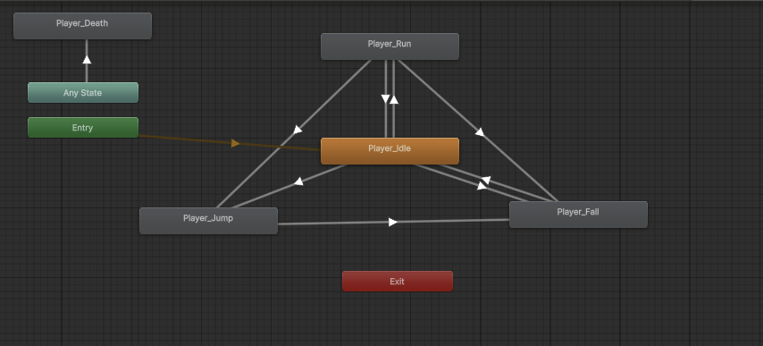

Health & Invincibility System (PlayerHealth.cs)
• maxHealth: 3 | Displayed as 3 heart UI images (full/empty sprites)
• Invincibility window: 1.5s after taking damage (isInvincible flag)
• Invincibility flash: sprite enabled/disabled at 20Hz using Mathf.Sin
• On death: deathParticles spawned, OnDeath() freezes all movement, GameOver() called after 1s

B. Side Mechanics
- Collectable Coins - Trigger based, UI coin indicator
- Multiple Levels - 3 levels total

C. Interaction Mechanics
All interactions use Unity Collider2D triggers. No 'use' key — proximity/overlap is sufficient.
• Level exits: trigger overlap → 1-second delay → LoadNextLevel() via LevelExit.cs
• Collectibles: trigger overlap → AddScore(100) → PlayCollect() → Destroy(gameObject)
• Hazards: trigger overlap → TakeDamage(999) — instant kill on any hazard contact
• Enemies: collision → TakeDamage(damageAmount) via EnemyHurt.cs

D. Economy & Resources
Resource | How Earned | How Spent | Notes
Coins | Scattered in levels (Collectible.cs) | Cosmetic only | 100 pts each
Lightnings | Unlimited | — | Infinite ammo; fire-rate gated
Lives | Start with 3 | Lost on death
Score | Coins | Cosmetic | Persisted in GameSession singleton

5. Narrative, World & Characters

A. Themes & Emotional Arc
Core Themes: Feeling lost in a strange world, more confident in the unknown as time goes on. The Knight must traverse through various different terrains and biomes but persists to get home.

B. Story Overview
A small knight wakes up in the middle of a forest, with no idea where he is or what he is doing. The only thing he can think to do is keep moving forward. He has lost all his equipment besides his armor, which is too heavy to allow him to swim, and his signature lightning bolt spell. The story is told through the wild, and random biomes showing how lost the knight is and his adventure through the world.

C. Worldbuilding
- Setting: The world in general, shown through 3 biomes - forest, ice, desert
- Rules: The knight's armor is too heavy to swim, avoid water. Enemies are wild and look to hurt you
- Zones: Forest -> Ice mountain -> Desert/Oasis

D. Main Characters
Character | Role | Description
Knight | Player character | A small, simple, unremarkable knights with a lightning spell in his back pocket
Patrol Enemy | Tier 1 enemy | Ground patrol between LeftEdge/RightEdge markers. moveSpeed: 3 u/s. Dies in 1 Lightning hit. Ground-ledge detection prevents it from walking off platforms.

E. Player Agency
Linear path with minor options in the last level (shortcut available if the player finds it)

6. Level & Encounter Design

A. Objectives
• Primary: Reach the level exit alive
• Secondary: Collect all coins
• Optional: Defeat all enemies in zone

B. Structure & Layout — Level 01 Overview

Zone | Theme | Key Challenge | Enemy Count
Zone A — Intro | Forest | Learn run/jump/shoot; first enemy encounter | 1
Zone B — Vertical | Ice Mountain | Tall vertical section | 5
Zone C — Final | Desert/Oasis | Vertical and multiple enemies plus hidden paths | 16

C. Gameplay Flow (Level 01 Beat Sheet)
- Beat 1 (30s): See platform -> run right, jump, collect coins
- Beat 2 (1m): See Slime -> decide to shoot or jump -> see more jumps
- Beat 3 (2m): More jumps -> see exit
- Beat 4: (3m) : Jump gap and go next level

D. Interactive Elements
• Trigger zones: level exit (1s delay), coin collectibles (instant), hazards (instant damage)
• Enemy patrol markers: LeftEdge and RightEdge child GameObjects define each enemy's range
• Ground detection: GroundDetect child on each enemy prevents them falling off ledges

E. Progression Gates
- All levels progress by touching door at the end

F. Environmental Storytelling
- No buildings, all in the wild
- Random Direction of platforms, this knight is lost
- No clear destination - the knight forgot who he is
- No other human-like people - the knight is alone

7. UI, UX & Accessibility

A. HUD Layout
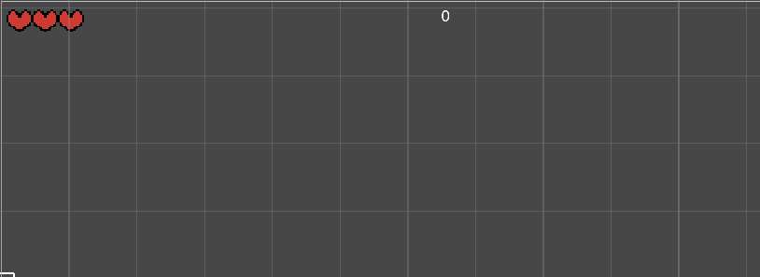

B. Core UI Elements
Element | Position | Description
Heart Health | Top-Left | 3 heart icons using Image[] array; full/empty Sprites swap on TakeDamage() — PlayerHealth.cs UpdateHeartUI()
Score Display | Top-Center | TextMeshProUGUI; updates via GameSession.AddScore(); persisted across scenes via DontDestroyOnLoad
Pause Overlay | Full-screen panel | pausePanel GameObject toggled by PauseMenu.cs on Escape key; Time.timeScale = 0 while active

C. Menus & Screens
• Main Menu: Title card + Start (loads Scene index 1) / Quit buttons — MainMenu.cs
• Pause Menu: Resume / Quit to Menu (Time.timeScale = 0) — PauseMenu.cs
• Game Over Screen: Lives = 0 → SceneManager.LoadScene('GameOver') — GameSession.cs
• Win Screen: All levels complete → SceneManager.LoadScene('Win') — GameSession.cs

D. UX Flow
Main Menu → [Start] → Level Load → Gameplay → [Exit trigger] → Level Complete Screen → Next Level OR [Game Over] → Game Over Screen → [Try Again] → Level Reload

E. Onboarding
- Level 01 is simple and easy. Giving simple jumps and one enemy to fight
- Player learns by playing, same as all other platformer games so players with experience will intuitively understand it

8. Audio Design

A. Audio Architecture
The AudioManager.cs singleton handles all SFX playback. It persists across scenes via DontDestroyOnLoad and uses two AudioSource components — one for music (musicSource), one for SFX (sfxSource) using PlayOneShot for overlap-friendly playback. All game systems call AudioManager.Instance?.PlayX() methods.

B. Current Audio Events (AudioManager.cs)
Event Method | Trigger Location | Type | Notes
PlayJump() | PlayerMovement.cs — HandleJump() | One-shot SFX | Called on Jump button press while grounded
PlayShoot() | PlayerShooter.cs — Shoot() | One-shot SFX | Called on Fire1 input; rate-limited to 0.3s
PlayHit() | PlayerHealth.cs — TakeDamage() | One-shot SFX | Called on any damage taken (not during invincibility)
PlayDeath() | PlayerMovement.cs — OnDeath() | One-shot SFX | Called on player death; music should stop/duck
PlayCollect() | Collectible.cs — OnTriggerEnter2D() | One-shot SFX | Called on coin/collectible pickup

C. Music System
- Same music throughout the game taken from a free asset collection to give an upbeat-retro platformer vibe

D. Full Audio Asset List

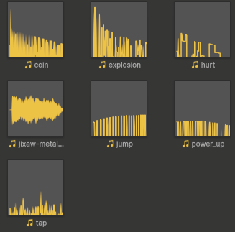


9. Production Notes

A. Team Roles
Role | Name / Assigned To | Responsibilities
Lead Designer | Kainoah Vann | Complete Game creation

C. Out-of-Scope Features
• Multiplayer / co-op mode
• Enemy AI pathfinding (A* or NavMesh) — patrol-only in v1.0
• Procedural level generation
• In-game currency shop
• Achievement system
• Mobile / controller support
• Save/load system — GameSession resets on game over

E. Post-Launch / Roadmap
- Potential features include more levels, more enemy types, different hazards, moving platforms, etc.
--- END OF DOCUMENT ---
[YOUR GAME TITLE] GDD v1.0 | [COURSE NAME] | March 2026

